UNITED STATES

SECURITIES AND EXCHANGE COMMISSION

Washington, DC 20549-1004

___________________

FORM 8-K

___________________

CURRENT REPORT

Pursuant to Section 13 or 15(d) of

the Securities Exchange Act of 1934

Date of Report (Date of earliest event reported) July 25, 2018

___________________

GENERAL MOTORS COMPANY

(Exact name of registrant as specified in its charter)

___________________

DELAWARE | 001-34960 | 27-0756180
(State or other jurisdiction of | 001-34960 | (I.R.S. Employer
incorporation) | (Commission File Number) | Identification No.)
300 Renaissance Center, Detroit, Michigan |  | 48265-3000
(Address of principal executive offices) |  | (Zip Code)

(313) 667-1500

(Registrant's telephone number, including area code)

Not Applicable

(Former name or former address, if changed since last report)

__________________

Check the appropriate box below if the Form 8-K filing is intended to simultaneously satisfy the filing obligation of the registrant under any of the following provisions:

- Written communications pursuant to Rule 425 under the Securities Act (17 CFR 230.425)

- Soliciting material pursuant to Rule 14a-12 under the Exchange Act (17-CFR 240.14a-12)

- Pre-commencement communications pursuant to Rule 14d-2(b) under the Exchange Act (17 CFR 240.14d-2(b))

- Pre-commencement communications pursuant to Rule 13e-4(c) under the Exchange Act (17 CFR 240.13e-4(c))

Indicate by check mark whether the registrant is an emerging growth company as defined in Rule 405 of the Securities Act of 1933 (§230.405 of this chapter) or Rule 12b-2 of the Securities Exchange Act of 1934 (§240.12b-2 of this chapter). Emerging growth company ☐

If an emerging growth company, indicate by check mark if the registrant has elected not to use the extended transition period for complying with any new or revised financial accounting standards provided pursuant to Section 13(a) of the Exchange Act. ☐

ITEM 2.02 Results of Operations and Financial Condition

On July 25, 2018 General Motors Company (GM) issued a news release and supplemental materials on the subject of its 2018 second quarter earnings. The news release and supplemental materials are attached as Exhibit 99.1 and Exhibit 99.2.

Charts furnished to securities analysts in connection with GM's 2018 second quarter earnings release are available on GM's website at www.gm.com/investors/earnings-releases.html.

ITEM 9.01 Financial Statements and Exhibits

 |  |  |  | EXHIBIT
Exhibit |  | Description
Exhibit 99.1 |  | News Release Dated July 25, 2018
Exhibit 99.2 |  | Financial Highlights Dated July 25, 2018

SIGNATURE

Pursuant to the requirements of the Securities Exchange Act of 1934, the registrant has duly caused this report to be signed on its behalf by the undersigned hereunto duly authorized.

 | GENERAL MOTORS COMPANY (Registrant)
By: | /s/ THOMAS S. TIMKO
Date: July 25, 2018
Date: July 25, 2018 | Thomas S. Timko, Vice President, Global Business Solutions and Chief
 | Accounting Officer

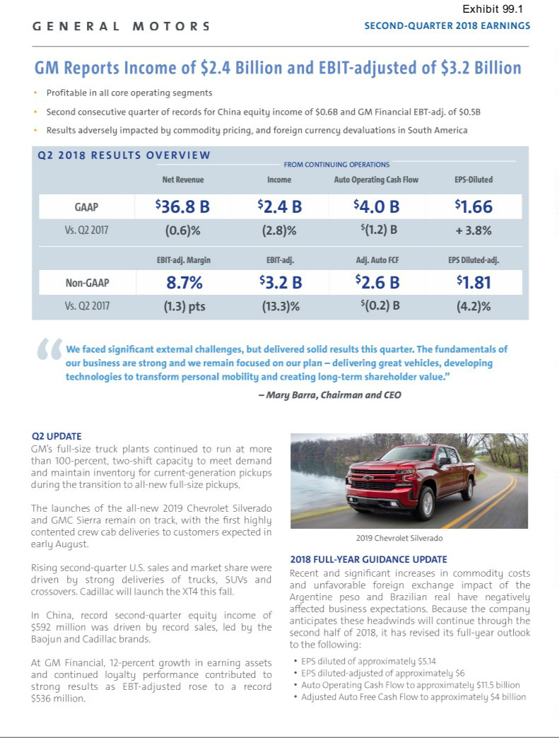

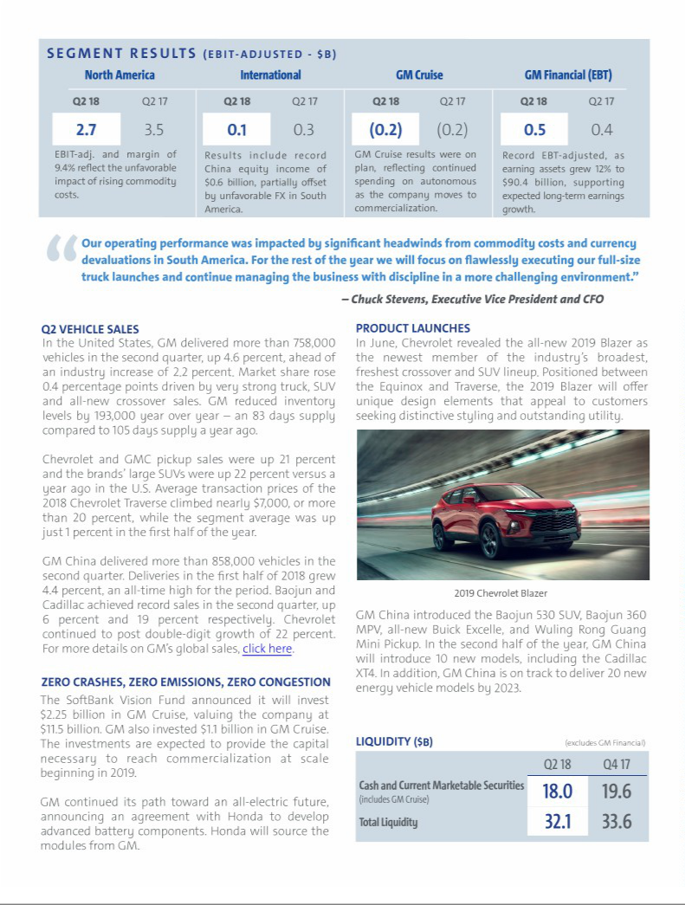

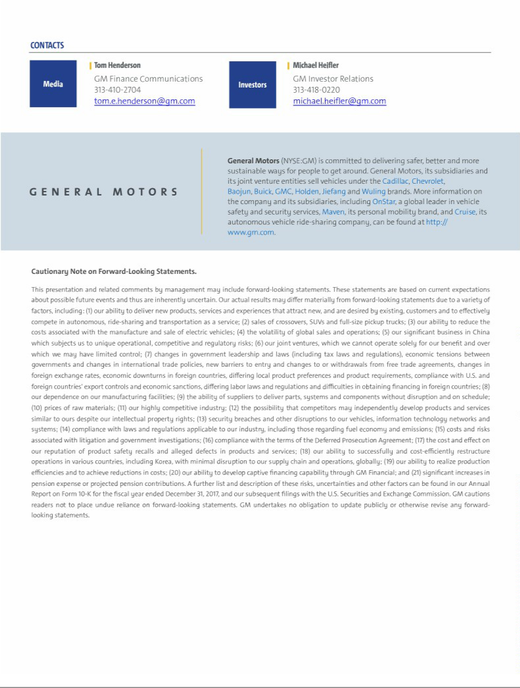

Exhibit 99.2

General Motors Company and Subsidiaries

Supplemental Material

(Unaudited)

Unless otherwise indicated, General Motors Company's (GM) non-GAAP measures are related to our continuing operations and not our discontinued operations. GM's non-GAAP measures include earnings before interest and taxes (EBIT)-adjusted, presented net of noncontrolling interests, Core EBIT-adjusted, earnings per share (EPS)-diluted-adjusted, effective tax rate-adjusted (ETR-adjusted), return on invested capital-adjusted (ROIC-adjusted) and adjusted automotive free cash flow. GM's calculation of these non-GAAP measures may not be comparable to similarly titled measures of other companies due to potential differences between companies in the method of calculation. As a result, the use of these non-GAAP measures has limitations and should not be considered superior to, in isolation from, or as a substitute for, related U.S. GAAP measures.

These non-GAAP measures allow management and investors to view operating trends, perform analytical comparisons and benchmark performance between periods and among geographic regions to understand operating performance without regard to items we do not consider a component of our core operating performance. Furthermore, these non-GAAP measures allow investors the opportunity to measure and monitor our performance against our externally communicated targets and evaluate the investment decisions being made by management to improve ROIC-adjusted. Management uses these measures in its financial, investment and operational decision-making processes, for internal reporting and as part of its forecasting and budgeting processes. Further, our Board of Directors uses certain of these and other measures as key metrics to determine management performance under our performance-based compensation plans. For these reasons we believe these non-GAAP measures are useful for our investors.

EBIT-adjusted EBIT-adjusted is presented net of noncontrolling interests and is used by management and can be used by investors to review our consolidated operating results because it excludes automotive interest income, automotive interest expense and income taxes as well as certain additional adjustments that are not considered part of our core operations. Examples of adjustments to EBIT include but are not limited to impairment charges on long-lived assets and other exit costs resulting from strategic shifts in our operations or discrete market and business conditions and costs arising from the ignition switch recall and related legal matters. For EBIT-adjusted and our other non-GAAP measures, once we have made an adjustment in the current period for an item, we will also adjust the related non-GAAP measure in any future periods in which there is a significant impact from the item.

Core EBIT-adjusted Core EBIT-adjusted is used by management and can be used by investors to review our core consolidated operating results. Core EBIT-adjusted begins with EBIT-adjusted and excludes the EBIT-adjusted results of GM Cruise. Previously Core EBIT-adjusted excluded the EBIT-adjusted results of autonomous vehicle operations, including GM Cruise, Maven and our investment in Lyft. The measure was changed to align with segment reporting. All periods presented have been recast to reflect the changes.

EPS-diluted-adjusted EPS-diluted-adjusted is used by management and can be used by investors to review our consolidated diluted EPS results on a consistent basis. EPS-diluted-adjusted is calculated as net income attributable to common stockholders-diluted less income (loss) from discontinued operations on an after-tax basis, adjustments noted above for EBIT-adjusted and certain income tax adjustments divided by weighted-average common shares outstanding-diluted. Examples of income tax adjustments include the establishment or reversal of significant deferred tax asset valuation allowances.

ETR-adjusted ETR-adjusted is used by management and can be used by investors to review the consolidated effective tax rate for our core operations on a consistent basis. ETR-adjusted is calculated as Income tax expense less the income tax related to the adjustments noted above for EBIT-adjusted and the income tax adjustments noted above for EPS-diluted-adjusted divided by Income before income taxes less adjustments.

ROIC-adjusted ROIC-adjusted is used by management and can be used by investors to review our investment and capital allocation decisions. We define ROIC-adjusted as EBIT-adjusted for the trailing four quarters divided by ROIC-adjusted average net assets, which is considered to be the average equity balances adjusted for average automotive debt and interest liabilities, exclusive of capital leases; average net pension and OPEB liabilities; and average automotive and other net income tax assets during the same period. Adjustments to the average equity balances exclude assets and liabilities classified as either assets held for sale or liabilities held for sale.

Adjusted automotive free cash flow Adjusted automotive free cash flow is used by management and can be used by investors to review the liquidity of our automotive operations and to measure and monitor our performance against our capital allocation program and evaluate our automotive liquidity against the substantial cash requirements of our automotive operations. We measure adjusted automotive free cash flow as automotive operating cash flow from continuing operations less capital expenditures adjusted for management actions. Management actions can include voluntary events such as discretionary contributions to employee benefit plans or nonrecurring specific events such as a plant closure that are considered special for EBIT-adjusted purposes.

1

General Motors Company and Subsidiaries

Supplemental Material

(Unaudited)

The following table reconciles segment profit (loss) to Net income attributable to stockholders under U.S. GAAP (dollars in millions):

 |  | Three Months Ended |  |  |  |  |  | Six Months Ended
 |  | June 30, 2018 |  |  | June 30, 2017 |  |  | June 30, 2018 |  |  | June 30, 2017
Operating segments
GM North America (GMNA) | $ | 2,670 |  | $ | 3,475 |  | $ | 4,903 |  | $ | 6,946
GM International (GMI) |  | 143 |  |  | 317 |  |  | 332 |  |  | 495
GM Cruise |  | (154) |  |  | (157) |  |  | (320) |  |  | (290)
General Motors Financial Company, Inc. (GM Financial)(a) |  | 536 |  |  | 357 |  |  | 979 |  |  | 585
Total operating segments |  | 3,195 |  |  | 3,992 |  |  | 5,894 |  |  | 7,736
Corporate and eliminations(b) |  | (3) |  |  | (310) |  |  | (92) |  |  | (500)
EBIT-adjusted |  | 3,192 |  |  | 3,682 |  |  | 5,802 |  |  | 7,236
Adjustments
GMI restructuring(c) |  | (196) |  |  | (540) |  |  | (1,138) |  |  | (540)
Ignition switch recall and related legal matters(d) |  | — |  |  | (114) |  |  | — |  |  | (114)
Total adjustments |  | (196) |  |  | (654) |  |  | (1,138) |  |  | (654)
Automotive interest income |  | 72 |  |  | 68 |  |  | 136 |  |  | 125
Automotive interest expense |  | (159) |  |  | (132) |  |  | (309) |  |  | (279)
Income tax expense |  | (519) |  |  | (534) |  |  | (985) |  |  | (1,321)
Income from continuing operations(e) |  | 2,390 |  |  | 2,430 |  |  | 3,506 |  |  | 5,107
Loss from discontinued operations, net of tax(f) |  | — |  |  | 770 |  |  | 70 |  |  | 839
Net income attributable to stockholders | $ | 2,390 |  | $ | 1,660 |  | $ | 3,436 |  | $ | 4,268
__________
- GM Financial amounts represent earnings before income taxes-adjusted.

- GM's automotive operations' interest income and interest expense, Maven, legacy costs from the Opel and Vauxhall businesses and certain other assets in Europe (the Opel/Vauxhall Business), which are primarily pension costs, corporate expenditures and certain nonsegment specific revenues and expenses are recorded centrally in Corporate.

- These adjustments were excluded because of a strategic decision to rationalize our core operations by exiting or significantly reducing our presence in various international markets to focus resources on opportunities expected to deliver higher returns. The adjustments primarily consist of supplier claims and employee separation charges in the three months ended June 30, 2018 and asset impairments and employee separation charges in the six months ended June 30, 2018, all in Korea. The adjustment in the three and six months ended June 30, 2017 primarily consists of asset impairments and other restructuring actions in India, South Africa and Venezuela.

- These adjustments were excluded because of the unique events associated with the ignition switch recall. These events included various investigations, inquiries, and complaints from constituents.
- Net of Net (income) loss attributable to noncontrolling interests.

- Represents the results of the Opel/Vauxhall Business and our European financing subsidiaries and branches (the Fincos, and together with the Opel/Vauxhall Business, the European Business).

2

General Motors Company and Subsidiaries

Supplemental Material

(Unaudited)

The following table reconciles Net income (loss) attributable to stockholders under U.S. GAAP to EBIT-adjusted (dollars in millions):

 |  |  |  |  |  |  |  |  |  |  | Three Months Ended
 |  |  | June 30, |  |  |  |  |  | March 31, |  |  |  |  |  | December 31, |  |  |  |  |  | September 30,
 |  |  | 2018 |  |  | 2017 |  |  | 2018 |  |  | 2017 |  |  | 2017 |  |  | 2016 |  |  | 2017 |  |  | 2016
 | Net income (loss) attributable to stockholders | $ | 2,390 |  | $ | 1,660 |  | $ | 1,046 |  | $ | 2,608 |  | $ | (5,151) |  | $ | 1,835 |  | $ | (2,981) |  | $ | 2,773
 | (Income) loss from discontinued operations, net of tax |  | — |  |  | 770 |  |  | 70 |  |  | 69 |  |  | 277 |  |  | 120 |  |  | 3,096 |  |  | (5)
 | Income tax expense |  | 519 |  |  | 534 |  |  | 466 |  |  | 787 |  |  | 7,896 |  |  | 303 |  |  | 2,316 |  |  | 902
 | Automotive interest expense |  | 159 |  |  | 132 |  |  | 150 |  |  | 147 |  |  | 145 |  |  | 150 |  |  | 151 |  |  | 145
 | Automotive interest income |  | (72) |  |  | (68) |  |  | (64) |  |  | (57) |  |  | (82) |  |  | (45) |  |  | (59) |  |  | (43)
 | Adjustments
 | GMI restructuring(a) |  | 196 |  |  | 540 |  |  | 942 |  |  | — |  |  | — |  |  | — |  |  | — |  |  | —
 | Ignition switch recall and related legal matters(a) |  | — |  |  | 114 |  |  | — |  |  | — |  |  | — |  |  | 235 |  |  | — |  |  | (110)
 | Total adjustments |  | 196 |  |  | 654 |  |  | 942 |  |  | — |  |  | — |  |  | 235 |  |  | — |  |  | (110)
 | EBIT-adjusted | $ | 3,192 |  | $ | 3,682 |  | $ | 2,610 |  | $ | 3,554 |  | $ | 3,085 |  | $ | 2,598 |  | $ | 2,523 |  | $ | 3,662
________
- Refer to the reconciliation of segment profit (loss) to Net income attributable to stockholders under U.S. GAAP within the previous section for the details of each individual adjustment.

The following table reconciles EBIT-adjusted to Core EBIT-adjusted:

 |  | Three Months Ended |  |  |  |  |  | Six Months Ended
 |  | June 30, 2018 |  |  | June 30, 2017 |  |  | June 30, 2018 |  |  | June 30, 2017
EBIT-adjusted(a) | $ | 3,192 |  | $ | 3,682 |  | $ | 5,802 |  | $ | 7,236
EBIT loss-adjusted – GM Cruise |  | 154 |  |  | 157 |  |  | 320 |  |  | 290
Core EBIT-adjusted | $ | 3,346 |  | $ | 3,839 |  | $ | 6,122 |  | $ | 7,526

________

- Refer to the reconciliation of Net income (loss) attributable to stockholders under U.S. GAAP to EBIT-adjusted.

3

General Motors Company and Subsidiaries

Supplemental Material

(Unaudited)

The following table reconciles diluted earnings per common share under U.S. GAAP to EPS-diluted-adjusted (dollars in millions):

 |  |  |  |  |  | Three Months Ended |  |  |  |  |  |  |  |  |  |  |  | Six Months Ended
 |  |  | June 30, 2018 |  |  |  |  |  | June 30, 2017 |  |  |  |  |  | June 30, 2018 |  |  |  |  |  | June 30, 2017
 |  |  | Amount |  |  | Per Share |  |  | Amount |  |  | Per Share |  |  | Amount |  |  | Per Share |  |  | Amount |  |  | Per Share
 | Diluted earnings per common share | $ | 2,375 |  | $ | 1.66 |  | $ | 1,660 |  | $ | 1.09 |  | $ | 3,407 |  | $ | 2.38 |  | $ | 4,268 |  | $ | 2.80
 | Diluted loss per common share – discontinued
 | operations |  | — |  |  | — |  |  | 770 |  |  | 0.51 |  |  | 70 |  |  | 0.05 |  |  | 839 |  |  | 0.55
 | Adjustments(a) |  | 196 |  |  | 0.14 |  |  | 654 |  |  | 0.43 |  |  | 1,138 |  |  | 0.80 |  |  | 654 |  |  | 0.43
 | Tax effect on adjustment(b) |  | 20 |  |  | 0.01 |  |  | (208) |  |  | (0.14) |  |  | 20 |  |  | 0.01 |  |  | (208) |  |  | (0.14)
 | EPS-diluted-adjusted | $ | 2,591 |  | $ | 1.81 |  | $ | 2,876 |  | $ | 1.89 |  | $ | 4,635 |  | $ | 3.24 |  | $ | 5,553 |  | $ | 3.64
________
- Refer to the reconciliation of segment profit (loss) to Net income attributable to stockholders under U.S. GAAP within the previous section for the details of each individual adjustment.
- The tax effect of each adjustment is determined based on the tax laws and valuation allowance status of the jurisdiction in which the adjustment relates.

The following table reconciles our effective tax rate under U.S. GAAP to ETR-adjusted (dollars in millions):

 |  |  |  |  |  |  | Three Months Ended |  |  |  |  |  |  |  |  |  |  |  |  |  |  |  | Six Months Ended
 |  |  |  | June 30, 2018 |  |  |  |  |  |  |  | June 30, 2017 |  |  |  |  |  |  |  | June 30, 2018 |  |  |  |  |  |  |  | June 30, 2017
 |  | Income |  |  |  |  |  |  |  | Income |  |  |  |  |  |  |  | Income |  |  |  |  |  |  |  | Income
 |  | before |  |  |  |  |  |  |  | before |  |  |  |  |  |  |  | before |  |  |  |  |  |  |  | before
 |  | income |  | Income tax |  |  | Effective tax |  |  | income |  | Income tax |  |  | Effective tax |  |  | income |  | Income tax |  |  | Effective tax |  |  | income |  | Income tax |  |  | Effective tax
 |  | taxes |  |  | expense |  | rate |  |  | taxes |  |  | expense |  | rate |  |  | taxes |  |  | expense |  | rate |  |  | taxes |  |  | expense |  | rate
Effective tax rate | $ | 2,885 |  | $ | 519 |  | 18.0% |  | $ | 2,967 |  | $ | 534 |  | 18.0% |  | $ | 4,461 |  | $ | 985 |  | 22.1% |  | $ | 6,440 |  | $ | 1,321 |  | 20.5%
Adjustments(a)(b) |  | 237 |  |  | (20) |  |  |  |  | 654 |  |  | 208 |  |  |  |  | 1,179 |  |  | (20) |  |  |  |  | 654 |  |  | 208
ETR-adjusted | $ | 3,122 |  | $ | 499 |  | 16.0% |  | $ | 3,621 |  | $ | 742 |  | 20.5% |  | $ | 5,640 |  | $ | 965 |  | 17.1% |  | $ | 7,094 |  | $ | 1,529 |  | 21.6%
________
- Refer to the reconciliation of segment profit (loss) to Net income attributable to stockholders under U.S. GAAP within the previous section for the details of each individual adjustment. Net income attributable to noncontrolling interests for these adjustments of $41 million are included in the three and six months ended June 30, 2018.
- The tax effect of each adjustment is determined based on the tax laws and valuation allowance status of the jurisdiction in which the adjustment relates.

4

General Motors Company and Subsidiaries

Supplemental Material

(Unaudited)

We define return on equity (ROE) as Net income (loss) attributable to stockholders for the trailing four quarters divided by average equity for the same period. Management uses average equity to provide comparable amounts in the calculation of ROE. The following table summarizes the calculation of ROE (dollars in billions):

 |  |  | Four Quarters Ended
 |  |  | June 30, 2018 |  |  | June 30, 2017
 | Net income (loss) attributable to stockholders | $ | (4.7) |  | $ | 8.9
 | Average equity(a) | $ | 37.2 |  | $ | 45.1
 | ROE |  | (12.6)% |  |  | 19.7%
________
- Includes equity of noncontrolling interests where the corresponding earnings (loss) are included in EBIT-adjusted.

The following table summarizes the calculation of ROIC-adjusted (dollars in billions):

 |  |  | Four Quarters Ended
 |  |  | June 30, 2018 |  |  | June 30, 2017
 | EBIT-adjusted(a) | $ | 11.4 |  | $ | 13.5
 | Average equity(b) | $ | 37.2 |  | $ | 45.1
 | Add: Average automotive debt and interest liabilities (excluding capital leases) |  | 13.5 |  |  | 10.0
 | Add: Average automotive net pension & OPEB liability |  | 19.9 |  |  | 21.5
 | Less: Average automotive and other net income tax asset |  | (24.5) |  |  | (32.2)
 | ROIC-adjusted average net assets | $ | 46.1 |  | $ | 44.4
 | ROIC-adjusted |  | 24.7% |  |  | 30.4%
________
- Refer to the reconciliation of Net income (loss) attributable to stockholders under U.S. GAAP to EBIT-adjusted within a previous section.

- Includes equity of noncontrolling interests where the corresponding earnings (loss) are included in EBIT-adjusted.

The following table reconciles Net automotive cash provided by (used in) operating activities from continuing operations under U.S. GAAP to adjusted automotive free cash flow (dollars in millions):

 |  | Three Months Ended |  |  |  |  |  | Six Months Ended
 |  | June 30, 2018 |  |  | June 30, 2017 |  |  | June 30, 2018 |  |  | June 30, 2017
Net automotive cash provided by operating activities – continuing operations | $ | 3,986 |  | $ | 5,186 |  | $ | 2,923 |  | $ | 6,369
Less: Capital expenditures – continuing operations |  | (2,065) |  |  | (2,426) |  |  | (4,305) |  |  | (4,136)
Add: Adjustment for Korea restructuring |  | 676 |  |  | — |  |  | 676 |  |  | —
Adjusted automotive free cash flow – continuing operations |  | 2,597 |  |  | 2,760 |  |  | (706) |  |  | 2,233
Net automotive cash provided by (used in) operating activities – discontinued operations |  | — |  |  | (176) |  |  | — |  |  | 131
Less: capital expenditures – discontinued operations |  | — |  |  | (246) |  |  | — |  |  | (516)
Adjusted automotive free cash flow | $ | 2,597 |  | $ | 2,338 |  | $ | (706) |  | $ | 1,848

5

General Motors Company and Subsidiaries

Supplemental Material

(Unaudited)

The following tables summarize key financial information by segment (dollars in millions):

 |  |  |  |  |  |  |  |  |  |  |  |  |  | Total |  |  |  |  |  | GM
 |  | GMNA |  |  | GMI |  |  | Corporate |  |  | Eliminations |  |  | Automotive |  | GM Cruise |  |  |  | Financial |  |  | Eliminations |  |  | Total
Three Months Ended June 30, 2018
Net sales and revenue | $ | 28,501 |  | $ | 4,758 |  | $ | 50 |  |  |  |  | $ | 33,309 |  | $ | — |  | $ | 3,488 |  | $ | (37) |  | $ | 36,760
Expenditures for property | $ | 1,835 |  | $ | 229 |  | $ | 2 | $ |  | (1) |  | $ | 2,065 |  | $ | — |  | $ | 14 |  | $ | — |  | $ | 2,079
Depreciation and amortization | $ | 1,114 |  | $ | 137 |  | $ | 13 | $ |  | — |  | $ | 1,264 |  | $ | 2 |  | $ | 1,833 |  | $ | — |  | $ | 3,099
Impairment charges | $ | 28 |  | $ | 2 |  | $ | — | $ |  | — |  | $ | 30 |  | $ | — |  | $ | — |  | $ | — |  | $ | 30
Equity income(a) | $ | 3 |  | $ | 589 |  | $ | — | $ |  | — |  | $ | 592 |  | $ | — |  | $ | 45 |  | $ | — |  | $ | 637
 |  |  |  |  |  |  |  |  |  |  |  |  |  | Total |  |  |  |  |  | GM
 |  | GMNA |  |  | GMI |  |  | Corporate |  |  | Eliminations |  |  | Automotive |  | GM Cruise |  |  |  | Financial |  |  | Eliminations |  |  | Total
Three Months Ended June 30, 2017
Net sales and revenue | $ | 28,437 |  | $ | 5,512 |  | $ | 52 |  |  |  |  | $ | 34,001 |  | $ | — |  | $ | 2,990 |  | $ | (7) |  | $ | 36,984
Expenditures for property | $ | 2,307 |  | $ | 117 |  | $ | 3 | $ |  | (1) |  | $ | 2,426 |  | $ | 3 |  | $ | 27 |  | $ | — |  | $ | 2,456
Depreciation and amortization | $ | 1,187 |  | $ | 178 |  | $ | 9 | $ |  | — |  | $ | 1,374 |  | $ | 1 |  | $ | 1,586 |  | $ | — |  | $ | 2,961
Impairment charges | $ | 34 |  | $ | 199 |  | $ | — | $ |  | — |  | $ | 233 |  | $ | — |  | $ | — |  | $ | — |  | $ | 233
Equity income(a) | $ | 1 |  | $ | 487 |  | $ | — | $ |  | — |  | $ | 488 |  | $ | — |  | $ | 42 |  | $ | — |  | $ | 530
 |  |  |  |  |  |  |  |  |  |  |  |  |  | Total |  |  |  |  |  | GM
 |  | GMNA |  |  | GMI |  |  | Corporate |  |  | Eliminations |  |  | Automotive |  | GM Cruise |  |  |  | Financial |  |  | Eliminations |  |  | Total
Six Months Ended June 30, 2018
Net sales and revenue | $ | 56,319 |  | $ | 9,606 |  | $ | 99 |  |  |  |  | $ | 66,024 |  | $ | — |  | $ | 6,899 |  | $ | (64) |  | $ | 72,859
Expenditures for property | $ | 3,899 |  | $ | 391 |  | $ | 16 | $ |  | (1) |  | $ | 4,305 |  | $ | 12 |  | $ | 34 |  | $ | — |  | $ | 4,351
Depreciation and amortization | $ | 2,223 |  | $ | 290 |  | $ | 24 | $ |  | — |  | $ | 2,537 |  | $ | 3 |  | $ | 3,656 |  | $ | — |  | $ | 6,196
Impairment charges | $ | 53 |  | $ | 461 |  | $ | — | $ |  | — |  | $ | 514 |  | $ | — |  | $ | — |  | $ | — |  | $ | 514
Equity income(a) | $ | 5 |  | $ | 1,183 |  | $ | — | $ |  | — |  | $ | 1,188 |  | $ | — |  | $ | 97 |  | $ | — |  | $ | 1,285
 |  |  |  |  |  |  |  |  |  |  |  |  |  | Total |  |  |  |  |  | GM
 |  | GMNA |  |  | GMI |  |  | Corporate |  |  | Eliminations |  |  | Automotive |  | GM Cruise |  |  |  | Financial |  |  | Eliminations |  |  | Total
Six Months Ended June 30, 2017
Net sales and revenue | $ | 57,775 |  | $ | 10,650 |  | $ | 226 |  |  |  |  | $ | 68,651 |  | $ | — |  | $ | 5,738 |  | $ | (139) |  | $ | 74,250
Expenditures for property | $ | 3,835 |  | $ | 297 |  | $ | 5 | $ |  | (1) |  | $ | 4,136 |  | $ | 3 |  | $ | 47 |  | $ | — |  | $ | 4,186
Depreciation and amortization | $ | 2,289 |  | $ | 369 |  | $ | 11 | $ |  | (1) |  | $ | 2,668 |  | $ | 1 |  | $ | 3,014 |  | $ | — |  | $ | 5,683
Impairment charges | $ | 49 |  | $ | 200 |  | $ | 5 | $ |  | — |  | $ | 254 |  | $ | — |  | $ | — |  | $ | — |  | $ | 254
Equity income(a) | $ | 6 |  | $ | 991 |  | $ | — | $ |  | — |  | $ | 997 |  | $ | — |  | $ | 88 |  | $ | — |  | $ | 1,085
________
- Includes Automotive China equity income of $592 million and $509 million in the three months ended June 30, 2018 and 2017 and $1.2 billion and $1.0 billion in the six months ended June 30, 2018 and 2017.

6

General Motors Company and Subsidiaries

Supplemental Material

(Unaudited)

Vehicle Sales

GM presents both wholesale and retail vehicle sales data to assist in the analysis of our revenue and our market share. GM does not currently export vehicles to Cuba, Iran, North Korea, Sudan, or Syria. Accordingly these countries are excluded from industry sales data and corresponding calculation of GM's market share.

Wholesale vehicle sales data, which represents sales directly to dealers and others, including sales to fleet customers, is the measure that correlates to GM's revenue from the sale of vehicles, which is the largest component of Automotive net sales and revenue. Wholesale vehicle sales exclude vehicles sold by joint ventures. In the six months ended June 30, 2018, 34.7% of our wholesale vehicle sales volume was generated outside the U.S. The following table summarizes total wholesale vehicle sales of new vehicles by automotive segment (vehicles in thousands):

 | Three Months Ended |  |  |  | Six Months Ended
 | June 30, 2018 |  | June 30, 2017 |  | June 30, 2018 |  | June 30, 2017
GMNA(a) | 923 |  | 894 |  | 1,816 |  | 1,834
GMI(b) | 281 |  | 319 |  | 547 |  | 618
Total | 1,204 |  | 1,213 |  | 2,363 |  | 2,452
Discontinued operations | — |  | 303 |  | — |  | 606
__________
- Wholesale vehicle sales related to transactions with the European Business were insignificant for all periods presented.

- Wholesale vehicle sales include 46 and 94 vehicles related to transactions with the European Business for the three and six months ended June 30, 2017.

7

General Motors Company and Subsidiaries

Supplemental Material

(Unaudited)

Retail vehicle sales data, which represents sales to end customers based upon the good faith estimates of management, including sales to fleet customers, does not correlate directly to the revenue GM recognizes during the period. However retail vehicle sales data is indicative of the underlying demand for GM vehicles. Market share information is based primarily on retail vehicle sales volume. In countries where retail vehicle sales data is not readily available, other data sources such as wholesale or forecast volumes are used to estimate retail vehicle sales to end customers.

Retail vehicle sales data includes all sales by joint ventures on a total vehicle basis, not based on the percentage of ownership in the joint venture. Certain joint venture agreements in China allow for the contractual right to report vehicle sales of non-GM trademarked vehicles by those joint ventures. Retail vehicle sales data includes vehicles used by dealers under courtesy transportation programs. Certain fleet sales that are accounted for as operating leases are included in retail vehicle sales at the time of delivery to daily rental car companies. The following table summarizes total retail sales, or estimated sales where retail sales volume is not available, by geographic region (vehicles in thousands):

 | Three Months Ended |  |  |  | Six Months Ended
 | June 30, 2018 |  | June 30, 2017 |  | June 30, 2018 |  | June 30, 2017
United States
Chevrolet – Cars | 126 |  | 157 |  | 247 |  | 311
Chevrolet – Trucks | 261 |  | 217 |  | 484 |  | 419
Chevrolet – Crossovers | 141 |  | 123 |  | 288 |  | 238
Cadillac | 39 |  | 38 |  | 76 |  | 72
Buick | 53 |  | 60 |  | 110 |  | 110
GMC | 138 |  | 130 |  | 269 |  | 264
Total United States | 758 |  | 725 |  | 1,474 |  | 1,414
Canada, Mexico and Other | 154 |  | 154 |  | 265 |  | 281
Total North America(a) | 912 |  | 879 |  | 1,739 |  | 1,695
Asia/Pacific, Middle East and Africa
Chevrolet | 230 |  | 219 |  | 447 |  | 428
Wuling | 248 |  | 241 |  | 533 |  | 564
Buick | 230 |  | 275 |  | 502 |  | 525
Baojun | 199 |  | 188 |  | 443 |  | 391
Cadillac | 51 |  | 43 |  | 108 |  | 85
Other | 28 |  | 48 |  | 51 |  | 91
Total Asia/Pacific, Middle East and Africa(a)(b) | 986 |  | 1,014 |  | 2,084 |  | 2,084
South America(a)(c) | 164 |  | 160 |  | 332 |  | 308
Total in GM markets | 2,062 |  | 2,053 |  | 4,155 |  | 4,087
Total Europe | 1 |  | 290 |  | 2 |  | 601
Total Worldwide | 2,063 |  | 2,343 |  | 4,157 |  | 4,688
_______
- Sales of Opel/Vauxhall outside of Europe were insignificant in the three and six months ended June 30, 2018 and 2017.

- Includes Industry and GM sales in India and South Africa. As of December 31, 2017 we have ceased sales of Chevrolet for the domestic markets in India and South Africa.

- Primarily Chevrolet.

8

General Motors Company and Subsidiaries

Supplemental Material

(Unaudited)

The vehicle sales at GM's China joint ventures presented in the following table are included in GM's retail vehicle sales on the preceding page (vehicles in thousands):

 |  | Three Months Ended |  |  |  |  |  |  | Six Months Ended
 |  | June 30, 2018 |  |  | June 30, 2017 |  |  |  | June 30, 2018 |  |  |  | June 30, 2017
SAIC General Motors Sales Co., Ltd. |  | 411 |  |  | 424 |  |  |  | 868 |  |  |  | 810
SAIC GM Wuling Automobile Co., Ltd. and FAW-GM Light Duty Commercial
Vehicle Co., Ltd. |  | 447 |  |  | 428 |  |  |  | 976 |  |  |  | 956
 |  | Three Months Ended |  |  |  |  |  |  | Six Months Ended
 |  | June 30, 2018 |  |  | June 30, 2017 |  |  |  | June 30, 2018 |  |  |  | June 30, 2017
Market Share
United States – Cars |  | 10.4% |  |  | 11.2% |  |  |  | 10.6% |  |  |  | 11.6%
United States – Trucks |  | 26.3% |  |  | 24.4% |  |  |  | 25.6% |  |  |  | 24.8%
United States – Crossovers |  | 13.7% |  |  | 14.5% |  |  |  | 15.0% |  |  |  | 14.8%
Total United States |  | 16.5% |  |  | 16.1% |  |  |  | 16.8% |  |  |  | 16.4%
Total North America |  | 16.1% |  |  | 15.7% |  |  |  | 16.2% |  |  |  | 16.0%
Total Asia/Pacific, Middle East and Africa |  | 8.4% |  |  | 8.9% |  |  |  | 8.7% |  |  |  | 9.1%
Total South America |  | 14.6% |  |  | 15.8% |  |  |  | 15.0% |  |  |  | 15.8%
Total GM Market |  | 11.1% |  |  | 11.5% |  |  |  | 11.2% |  |  |  | 11.5%
Total Europe |  | —% |  |  | 5.7% |  |  |  | —% |  |  |  | 5.9%
Total Worldwide |  | 8.6% |  |  | 10.2% |  |  |  | 8.8% |  |  |  | 10.3%
United States fleet sales as a percentage of retail vehicle sales |  | 22.1% |  |  | 19.1% |  |  |  | 22.5% |  |  |  | 19.9%
North America capacity two shift utilization |  | 102.8% |  |  | 103.5% |  |  |  | 100.9% |  |  |  | 104.7%

9

General Motors Company and Subsidiaries

Combining Income Statement Information

(In millions) (Unaudited)

 |  |  |  |  |  |  |  |  |  | Three Months Ended June 30, 2018 |  |  |  |  |  |  |  |  |  |  |  |  |  |  |  |  |  |  |  |  |  |  |  |  |  |  | Three Months Ended June 30, 2017
 |  |  | Automotive |  |  |  |  | GM Cruise |  |  |  |  |  | GM Financial |  |  |  |  |  | Eliminations |  |  |  |  |  | Combined |  |  |  |  |  | Automotive |  |  |  |  | GM Cruise |  |  |  |  | GM Financial |  |  |  |  |  | Eliminations |  |  |  |  | Combined
Net sales and revenue
Automotive |  | $ | 33,309 |  |  |  |  | $ |  |  | — | $ |  |  |  | — |  |  | $ |  | (34) |  | $ |  |  | 33,275 |  |  | $ |  |  | 34,001 |  | $ |  |  | — |  |  | $ |  |  | — |  | $ |  |  | (3) |  |  | $ |  | 33,998
GM Financial |  |  |  | — |  |  |  |  |  |  | — |  |  |  | 3,488 |  |  |  |  |  | (3) |  |  |  |  | 3,485 |  |  |  |  |  |  | — |  |  |  | — |  |  |  |  |  | 2,990 |  |  |  |  | (4) |  |  |  |  | 2,986
Total net sales and revenue |  |  | 33,309 |  |  |  |  |  |  |  | — |  |  |  | 3,488 |  |  |  |  |  | (37) |  |  |  |  | 36,760 |  |  |  |  |  | 34,001 |  |  |  |  | — |  |  |  |  |  | 2,990 |  |  |  |  | (7) |  |  |  |  | 36,984
Costs and expenses
Automotive and other cost of |  |  | 29,948 |  |  |  |  |  | 157 |  |  |  |  |  |  | — |  |  |  |  | (34) |  |  |  |  | 30,071 |  |  |  |  |  | 29,387 |  |  |  |  | 152 |  |  |  |  |  | — |  |  |  |  | (4) |  |  |  |  | 29,535
sales |  |  |  |  |  |  |  |  |  |  |  |  |  |  |  |  |  |  |  |  |  |  |  |  |  |  |  |  |  |  |  |  |  |  |  |  |  |  |  |  |  |  |  |  |  |  |  |  |  |  |  |  | 29,535
GM Financial interest,
operating and other |  |  |  | — |  |  |  |  |  |  | — |  |  |  | 2,997 |  |  |  |  |  | (1) |  |  |  |  | 2,996 |  |  |  |  |  |  | — |  |  |  | — |  |  |  |  |  | 2,675 |  |  |  |  | — |  |  |  |  | 2,675
expenses |  |  |  |  |  |  |  |  |  |  | — |  |  |  |  |  |  |  |  |  |  |  |  |  |  |  |  |  |  |  |  |  | — |  |  |  |  |  |  |  |  |  |  |  |  |  |  |  |  |  |  |  | 2,675
Automotive and other selling,
general and administrative |  |  | 2,219 |  |  |  |  |  | (3) |  |  |  |  |  |  | — |  |  |  |  | — |  |  |  |  | 2,216 |  |  |  |  |  | 2,472 |  |  |  |  | 5 |  |  |  |  |  | — |  |  |  |  | — |  |  |  |  | 2,477
expense |  |  |  |  |  |  |  |  |  |  |  |  |  |  |  |  |  |  |  |  |  |  |  |  |  |  |  |  |  |  |  |  |  |  |  |  |  |  |  |  |  |  |  |  |  |  |  |  |  |  |  |  | 2,477
Total costs and expenses |  |  | 32,167 |  |  |  |  |  | 154 |  |  |  |  |  | 2,997 |  |  |  |  |  | (35) |  |  |  |  | 35,283 |  |  |  |  |  | 31,859 |  |  |  |  | 157 |  |  |  |  |  | 2,675 |  |  |  |  | (4) |  |  |  |  | 34,687
Operating income (loss) |  |  | 1,142 |  |  |  |  |  | (154) |  |  |  |  |  | 491 |  |  |  |  |  | (2) |  |  |  |  | 1,477 |  |  |  |  |  | 2,142 |  |  |  |  | (157) |  |  |  |  |  | 315 |  |  |  |  | (3) |  |  |  |  | 2,297
Automotive interest expense |  |  | 161 |  |  |  |  |  | 1 |  |  |  |  |  |  | — |  |  |  |  | (3) |  |  |  |  | 159 |  |  |  |  |  | 135 |  |  |  |  | — |  |  |  |  |  | — |  |  |  |  | (3) |  |  |  |  | 132
Interest income and other non- |  |  | 931 |  |  |  |  |  |  |  | — |  |  |  |  | — |  |  |  |  | (1) |  |  |  |  | 930 |  |  |  |  |  | 272 |  |  |  |  | — |  |  |  |  |  | — |  |  |  |  | — |  |  |  |  | 272
operating income, net |  |  |  |  |  |  |  |  |  |  | — |  |  |  |  |  |  |  |  |  |  |  |  |  |  |  |  |  |  |  |  |  |  |  |  |  |  |  |  |  |  |  |  |  |  |  |  |  |  |  |  |  | 272
Equity income |  |  | 592 |  |  |  |  |  |  |  | — |  |  |  | 45 |  |  |  |  |  | — |  |  |  |  | 637 |  |  |  |  |  | 488 |  |  |  |  | — |  |  |  |  |  | 42 |  |  |  |  | — |  |  |  |  | 530
Income (loss) before income |  | $ | 2,504 |  |  |  |  | $ | (155) |  |  | $ |  |  | 536 |  |  |  | $ |  | — |  |  |  |  | 2,885 |  |  | $ |  |  | 2,767 |  | $ |  |  | (157) |  |  | $ |  |  | 357 |  | $ |  |  | — |  |  |  |  | 2,967
taxes |  | $ |  |  |  |  |  |  |  |  |  |  |  |  |  |  |  |  | $ |  |  |  |  |  |  |  |  |  |  |  |  |  |  |  |  |  |  |  |  |  |  |  |  |  |  |  |  |  |  |  |  |  | 2,967
Income tax expense |  |  |  |  |  |  |  |  |  |  |  |  |  |  |  |  |  |  |  |  |  |  |  |  |  | 519 |  |  |  |  |  |  |  |  |  |  |  |  |  |  |  |  |  |  |  |  |  |  |  |  |  |  | 534
Income from continuing |  |  |  |  |  |  |  |  |  |  |  |  |  |  |  |  |  |  |  |  |  |  |  |  |  | 2,366 |  |  |  |  |  |  |  |  |  |  |  |  |  |  |  |  |  |  |  |  |  |  |  |  |  |  | 2,433
operations |  |  |  |  |  |  |  |  |  |  |  |  |  |  |  |  |  |  |  |  |  |  |  |  |  |  |  |  |  |  |  |  |  |  |  |  |  |  |  |  |  |  |  |  |  |  |  |  |  |  |  |  | 2,433
Loss from discontinued |  |  |  |  |  |  |  |  |  |  |  |  |  |  |  |  |  |  |  |  |  |  |  |  |  |  | — |  |  |  |  |  |  |  |  |  |  |  |  |  |  |  |  |  |  |  |  |  |  |  |  |  | 770
operations, net of tax |  |  |  |  |  |  |  |  |  |  |  |  |  |  |  |  |  |  |  |  |  |  |  |  |  |  |  |  |  |  |  |  |  |  |  |  |  |  |  |  |  |  |  |  |  |  |  |  |  |  |  |  | 770
Net income |  |  |  |  |  |  |  |  |  |  |  |  |  |  |  |  |  |  |  |  |  |  |  |  |  | 2,366 |  |  |  |  |  |  |  |  |  |  |  |  |  |  |  |  |  |  |  |  |  |  |  |  |  |  | 1,663
Net (income) loss attributable to |  |  |  |  |  |  |  |  |  |  |  |  |  |  |  |  |  |  |  |  |  |  |  |  |  | 24 |  |  |  |  |  |  |  |  |  |  |  |  |  |  |  |  |  |  |  |  |  |  |  |  |  |  | (3)
noncontrolling interests |  |  |  |  |  |  |  |  |  |  |  |  |  |  |  |  |  |  |  |  |  |  |  |  |  |  |  |  |  |  |  |  |  |  |  |  |  |  |  |  |  |  |  |  |  |  |  |  |  |  |  |  | (3)
Net income attributable to |  |  |  |  |  |  |  |  |  |  |  |  |  |  |  |  |  |  |  |  |  |  | $ |  |  | 2,390 |  |  |  |  |  |  |  |  |  |  |  |  |  |  |  |  |  |  |  |  |  |  |  |  | $ |  | 1,660
stockholders |  |  |  |  |  |  |  |  |  |  |  |  |  |  |  |  |  |  |  |  |  |  |  |  |  |  |  |  |  |  |  |  |  |  |  |  |  |  |  |  |  |  |  |  |  |  |  |  |  |  |  |  | 1,660
Net income attributable to |  |  |  |  |  |  |  |  |  |  |  |  |  |  |  |  |  |  |  |  |  |  | $ |  |  | 2,375 |  |  |  |  |  |  |  |  |  |  |  |  |  |  |  |  |  |  |  |  |  |  |  |  | $ |  | 1,660
common stockholders |  |  |  |  |  |  |  |  |  |  |  |  |  |  |  |  |  |  |  |  |  |  |  |  |  |  |  |  |  |  |  |  |  |  |  |  |  |  |  |  |  |  |  |  |  |  |  |  |  |  |  |  | 1,660
 |  |  |  |  |  |  |  | Six Months Ended June 30, 2018 |  |  |  |  |  |  |  |  |  |  |  |  |  |  |  |  |  |  |  |  |  |  |  |  |  |  |  |  | Six Months Ended June 30, 2017
 | Automotive |  |  |  |  | GM Cruise |  |  |  |  | GM Financial |  |  |  |  | Eliminations |  |  |  |  |  |  | Combined |  |  |  |  |  |  | Automotive |  |  |  |  | GM Cruise |  |  |  |  | GM Financial |  |  |  |  |  |  | Eliminations |  |  |  |  |  | Combined
Net sales and revenue
Automotive | $ | 66,024 |  |  |  | $ |  | — | $ |  |  |  |  | — | $ |  |  |  |  | (58) | $ |  | 65,966 |  |  |  |  |  | $ 68,651 |  |  |  |  | $ |  |  | — |  | $ |  |  |  | — |  | $ |  |  | (134) |  |  | $ 68,517
GM Financial |  |  | — |  |  |  |  | — |  |  |  | 6,899 |  |  |  |  |  |  |  | (6) |  |  | 6,893 |  |  |  |  |  |  |  |  | — |  |  |  |  | — |  |  | 5,738 |  |  |  |  |  |  |  | (5) |  |  |  |  | 5,733
Total net sales and |  | 66,024 |  |  |  |  |  | — |  |  |  | 6,899 |  |  |  |  |  |  |  | (64) |  |  | 72,859 |  |  |  |  |  | 68,651 |  |  |  |  |  |  |  | — |  |  | 5,738 |  |  |  |  |  |  |  | (139) |  |  |  |  | 74,250
revenue |  |  |  |  |  |  |  | — |  |  |  |  |  |  |  |  |  |  |  | (64) |  |  |  |  |  |  |  |  |  |  |  |  |  |  |  |  |  |  |  |  |  |  |  |  |  |  |  | (139) |  |  |  |  | 74,250

Costs and expenses

Automotive and other cost of sales

GM Financial interest, operating and other expenses

Automotive and other selling, general and administrative expense

Total costs and expenses

Operating income (loss)

Automotive interest expense

Interest income and other non-operating income, net

Equity income

Income (loss) before income taxes

Income tax expense

Income from continuing operations

Loss from discontinued operations, net of tax

Net income

Net (income) loss attributable to noncontrolling interests

Net income attributable to stockholders

 | 60,009 |  | 305 |  |  | — |  |  | (59) |  |  | 60,255 |  |  | 59,152 |  | 280 |  |  | — |  |  | (136) |  |  | 59,296
 | — |  | — |  |  | 6,017 |  |  | (7) |  |  | 6,010 |  |  | — |  | — |  |  | 5,241 |  |  | — |  |  | 5,241
 | 4,573 |  | 15 |  |  | — |  |  | — |  |  | 4,588 |  |  | 4,823 |  | 10 |  |  | — |  |  | — |  |  | 4,833
 | 64,582 |  | 320 |  |  | 6,017 |  |  | (66) |  |  | 70,853 |  |  | 63,975 |  | 290 |  |  | 5,241 |  |  | (136) |  |  | 69,370
 | 1,442 |  | (320) |  |  | 882 |  |  | 2 |  |  | 2,006 |  |  | 4,676 |  | (290) |  |  | 497 |  |  | (3) |  |  | 4,880
 | 313 |  | 1 |  |  | — |  |  | (5) |  |  | 309 |  |  | 282 |  | — |  |  | — |  |  | (3) |  |  | 279
 | 1,480 |  | — |  |  | — |  |  | (1) |  |  | 1,479 |  |  | 754 |  | — |  |  | — |  |  | — |  |  | 754
 | 1,188 |  | — |  |  | 97 |  |  | — |  |  | 1,285 |  |  | 997 |  | — |  |  | 88 |  |  | — |  |  | 1,085
$ | 3,797 |  | $ (321) |  | $ | 979 |  | $ | 6 |  |  | 4,461 | $ |  | 6,145 |  | $ (290) |  | $ | 585 |  | $ | — |  |  | 6,440
 |  |  |  |  |  |  |  |  |  |  |  | 985 |  |  |  |  |  |  |  |  |  |  |  |  |  | 1,321
 |  |  |  |  |  |  |  |  |  |  |  | 3,476 |  |  |  |  |  |  |  |  |  |  |  |  |  | 5,119
 |  |  |  |  |  |  |  |  |  |  |  | 70 |  |  |  |  |  |  |  |  |  |  |  |  |  | 839
 |  |  |  |  |  |  |  |  |  |  |  | 3,406 |  |  |  |  |  |  |  |  |  |  |  |  |  | 4,280
 |  |  |  |  |  |  |  |  |  |  |  | 30 |  |  |  |  |  |  |  |  |  |  |  |  |  | (12)
 |  |  |  |  |  |  |  |  | $ |  |  | 3,436 |  |  |  |  |  |  |  |  |  |  | $ |  |  | 4,268

Net income attributable to | $ 3,407 | $ 4,268
common stockholders | $ 3,407 | $ 4,268

10

General Motors Company and Subsidiaries

Basic and Diluted Earnings per Share

(Unaudited)

The following table summarizes basic and diluted earnings (loss) per share (in millions, except per share amounts):

 |  | Three Months Ended |  |  |  |  |  | Six Months Ended
 |  | June 30, 2018 |  |  | June 30, 2017 |  |  | June 30, 2018 |  |  | June 30, 2017
Basic earnings per share
Income from continuing operations(a) | $ | 2,390 |  | $ | 2,430 |  | $ | 3,506 |  | $ | 5,107
Less: cumulative dividends on subsidiary preferred stock |  | (15) |  |  | — |  |  | (29) |  |  | —
Income from continuing operations attributable to common stockholders |  | 2,375 |  |  | 2,430 |  |  | 3,477 |  |  | 5,107
Loss from discontinued operations, net of tax |  | — |  |  | 770 |  |  | 70 |  |  | 839
Net income attributable to common stockholders | $ | 2,375 |  | $ | 1,660 |  | $ | 3,407 |  | $ | 4,268

Weighted-average common shares outstanding

Basic earnings per common share – continuing operations $

Basic loss per common share – discontinued operations $

Basic earnings per common share $

Diluted earnings per share

Income from continuing operations attributable to common stockholders – diluted(a) $

Loss from discontinued operations, net of tax – diluted $

Net income attributable to common stockholders – diluted $

1,410 |  | 1,497 |  | 1,409 |  | 1,501
1.68 | $ | 1.62 | $ | 2.47 | $ | 3.40
— | $ | 0.51 | $ | 0.05 | $ | 0.56
1.68 | $ | 1.11 | $ | 2.42 | $ | 2.84
2,375 | $ | 2,430 | $ | 3,477 | $ | 5,107
— | $ | 770 | $ | 70 | $ | 839
2,375 | $ | 1,660 | $ | 3,407 | $ | 4,268

Weighted-average common shares outstanding – diluted |  | 1,431 |  | 1,519 |  | 1,430 |  | 1,525
Diluted earnings per common share – continuing operations | $ | 1.66 | $ | 1.60 | $ | 2.43 | $ | 3.35
Diluted loss per common share – discontinued operations | $ | — | $ | 0.51 | $ | 0.05 | $ | 0.55
Diluted earnings per common share | $ | 1.66 | $ | 1.09 | $ | 2.38 | $ | 2.80
Potentially dilutive securities(b) |  | 4 |  | 6 |  | 4 |  | 6

__________

- Net of Net (income) loss attributable to noncontrolling interests.

- Potentially dilutive securities attributable to outstanding stock options and Restricted Stock Units were excluded from the computation of diluted EPS because the securities would have had an antidilutive effect.

11

General Motors Company and Subsidiaries

Combining Balance Sheet Information

(In millions, except per share amounts) (Unaudited)

 |  |  |  |  |  | June 30, 2018 |  |  |  |  |  |  |  |  |  |  |  | December 31, 2017
 |  | Automotive |  | GM Cruise |  | GM Financial |  | Reclassifications/Eliminations |  |  | Combined |  | Automotive |  | GM Cruise |  |  | GM Financial |  | Reclassifications/Eliminations |  |  | Combined
ASSETS
Current Assets
Cash and cash equivalents | $ | 9,074 |  | $ 2,001 |  | $ 4,012 |  | $ | — |  | $ 15,087 |  | $ 11,224 |  | $ 23 |  | $ | 4,265 |  | $ | — |  | $ 15,512
Marketable securities |  | 6,924 |  | — |  | — |  |  | — |  | 6,924 |  | 8,313 |  | — |  |  | — |  |  | — |  | 8,313
Accounts and notes receivable,
net(a) |  | 8,937 |  | — |  | 1,540 |  |  | (814) |  | 9,663 |  | 7,759 |  | — |  |  | 806 |  |  | (401) |  | 8,164
GM Financial receivables, net(b) |  | — |  | — |  | 22,446 |  |  | (441) |  | 22,005 |  | — |  | — |  |  | 20,901 |  |  | (380) |  | 20,521
Inventories |  | 10,833 |  | — |  | — |  |  | — |  | 10,833 |  | 10,663 |  | — |  |  | — |  |  | — |  | 10,663
Equipment on operating leases, net |  | 690 |  | — |  | — |  |  | — |  | 690 |  | 1,106 |  | — |  |  | — |  |  | — |  | 1,106
Other current assets |  | 1,613 |  | 4 |  | 3,632 |  |  | — |  | 5,249 |  | 1,394 |  | 2 |  |  | 3,069 |  |  | — |  | 4,465
Total current assets |  | 38,071 |  | 2,005 |  | 31,630 |  |  | (1,255) |  | 70,451 |  | 40,459 |  | 25 |  |  | 29,041 |  |  | (781) |  | 68,744

Non-current Assets

GM Financial receivables, net(b)

Equity in net assets of nonconsolidated affiliates

Property, net

Goodwill and intangible assets, net

Equipment on operating leases, net

Deferred income taxes

Other assets

Total non-current assets

Total Assets

LIABILITIES AND EQUITY

Current Liabilities

— |  | — |  | 23,054 |  |  | (58) |  | 22,996 |  | — |  | — |  |  | 21,271 |  |  | (63) |  | 21,208
7,528 |  | — |  | 1,260 |  |  | — |  | 8,788 |  | 7,886 |  | — |  |  | 1,187 |  |  | — |  | 9,073
37,698 |  | 46 |  | 259 |  |  | — |  | 38,003 |  | 35,960 |  | 34 |  |  | 259 |  |  | — |  | 36,253
3,683 |  | 679 |  | 1,358 |  |  | — |  | 5,720 |  | 3,803 |  | 679 |  |  | 1,367 |  |  | — |  | 5,849
— |  | — |  | 44,054 |  |  | — |  | 44,054 |  | — |  | — |  |  | 42,882 |  |  | — |  | 42,882
23,182 |  | (46) |  | 149 |  |  | — |  | 23,285 |  | 23,301 |  | (72) |  |  | 315 |  |  | — |  | 23,544
4,451 |  | — |  | 893 |  |  | — |  | 5,344 |  | 4,000 |  | — |  |  | 929 |  |  | — |  | 4,929
76,542 |  | 679 |  | 71,027 |  |  | (58) |  | 148,190 |  | 74,950 |  | 641 |  |  | 68,210 |  |  | (63) |  | 143,738
$ 114,613 |  | $ 2,684 |  | $ 102,657 |  | $ | (1,313) |  | $ 218,641 |  | $ 115,409 |  | $ 666 |  | $ | 97,251 |  | $ | (844) |  | $ 212,482

Accounts payable (principally trade)
(a)

Short-term debt and current portion of long-term debt

Automotive(b)

GM Financial

Accrued liabilities

Total current liabilities

Non-current Liabilities

Long-term debt

Automotive(b)

GM Financial

Postretirement benefits other than pensions

Pensions

Other liabilities

Total non-current liabilities

Total Liabilities

Commitments and contingencies

Equity

$ 24,870 |  | $ | 9 |  | $ | 595 |  | $ | (814) |  | $ 24,660 |  | $ 23,692 |  | $ | 4 |  | $ | 634 |  | $ | (401) |  | $ 23,929
3,248 |  |  | — |  |  | — |  |  | (441) |  | 2,807 |  | 2,895 |  |  | — |  |  | — |  |  | (380) |  | 2,515
— |  |  | — |  |  | 25,457 |  |  | — |  | 25,457 |  | — |  |  | — |  |  | 24,450 |  |  | — |  | 24,450
22,940 |  |  | 32 |  |  | 4,396 |  |  | — |  | 27,368 |  | 22,518 |  |  | 26 |  |  | 3,452 |  |  | — |  | 25,996
51,058 |  |  | 41 |  |  | 30,448 |  |  | (1,255) |  | 80,292 |  | 49,105 |  |  | 30 |  |  | 28,536 |  |  | (781) |  | 76,890
11,070 |  |  | — |  |  | — |  |  | (58) |  | 11,012 |  | 11,050 |  |  | — |  |  | — |  |  | (63) |  | 10,987
— |  |  | — |  |  | 58,983 |  |  | — |  | 58,983 |  | — |  |  | — |  |  | 56,267 |  |  | — |  | 56,267
5,853 |  |  | — |  |  | — |  |  | — |  | 5,853 |  | 5,998 |  |  | — |  |  | — |  |  | — |  | 5,998
11,986 |  |  | — |  |  | 3 |  |  | — |  | 11,989 |  | 13,743 |  |  | — |  |  | 3 |  |  | — |  | 13,746
10,037 |  |  | 20 |  |  | 1,819 |  |  | — |  | 11,876 |  | 10,682 |  |  | 7 |  |  | 1,705 |  |  | — |  | 12,394
38,946 |  |  | 20 |  |  | 60,805 |  |  | (58) |  | 99,713 |  | 41,473 |  |  | 7 |  |  | 57,975 |  |  | (63) |  | 99,392
90,004 |  |  | 61 |  |  | 91,253 |  |  | (1,313) |  | 180,005 |  | 90,578 |  |  | 37 |  |  | 86,511 |  |  | (844) |  | 176,282

Common stock, $0.01 par value |  | 14 |  | — |  | — |  |  | — |  | 14 |  | 14 |  | — |  |  | — |  |  | — |  | 14
Preferred stock, $0.01 par value |  | — |  | — |  | — |  |  | — |  | — |  | — |  | — |  |  | — |  |  | — |  | —
Additional paid-in capital(c) |  | 25,465 |  | — |  | 955 |  |  | (955) |  | 25,465 |  | 25,371 |  | — |  |  | 985 |  |  | (985) |  | 25,371
Retained earnings |  | 5,790 |  | 1,723 |  | 11,360 |  |  | — |  | 18,873 |  | 6,499 |  | 629 |  |  | 10,499 |  |  | — |  | 17,627
Accumulated other comprehensive
loss |  | (7,260) |  | — |  | (911) |  |  | — |  | (8,171) |  | (7,267) |  | — |  |  | (744) |  |  | — |  | (8,011)
Total stockholders’ equity |  | 24,009 |  | 1,723 |  | 11,404 |  |  | (955) |  | 36,181 |  | 24,617 |  | 629 |  |  | 10,740 |  |  | (985) |  | 35,001
Noncontrolling interests(c) |  | 600 |  | 900 |  | — |  |  | 955 |  | 2,455 |  | 214 |  | — |  |  | — |  |  | 985 |  | 1,199
Total Equity |  | 24,609 |  | 2,623 |  | 11,404 |  |  | — |  | 38,636 |  | 24,831 |  | 629 |  |  | 10,740 |  |  | — |  | 36,200
Total Liabilities and Equity | $ | 114,613 |  | $ 2,684 |  | $ 102,657 |  | $ | (1,313) |  | $ 218,641 |  | $ 115,409 |  | $ 666 |  | $ | 97,251 |  | $ | (844) |  | $ 212,482

_________
- Eliminations include GM Financial accounts receivable of $736 million offset by Automotive accounts payable and Automotive accounts receivable of $76 million offset by GM Financial accounts payable at June 30, 2018 and GM Financial accounts receivable of $309 million offset by Automotive accounts payable and Automotive accounts receivable of $92 million offset by GM Financial accounts payable at December 31, 2017.
- Eliminations include GM Financial loan receivable of $499 million and $443 million offset by an Automotive loan payable at June 30, 2018 and December 31, 2017.
- Reclassification of GM Financial Cumulative Perpetual Preferred Stock, Series A. The preferred stock is classified as noncontrolling interests in our condensed consolidated balance sheet.

12

General Motors Company and Subsidiaries

Combining Cash Flow Information

(In millions) (Unaudited)

 |  | Six Months Ended June 30, 2018 |  |  |  |  |  | Six Months Ended June 30, 2017
Automotive | GM Cruise | GM Financial | Reclassification/Eliminations | Combined |  | Automotive | GM Cruise | GM Financial | Reclassification/Eliminations | Combined
Cash flows from operating activities

Income (loss) from continuing operations

Depreciation and impairment of Equipment on operating leases, net

Depreciation, amortization and impairment charges on Property, net

Foreign currency remeasurement and transaction losses

Undistributed earnings of nonconsolidated affiliates, net

Pension contributions and OPEB payments

Pension and OPEB income, net

Provision for deferred taxes

Change in other operating assets and liabilities(a)(b)

Net cash provided by (used in) operating activities – continuing operations

Net cash provided by operating activities – discontinued operations

Net cash provided by (used in) operating activities

Cash flows from investing activities

Expenditures for property

Available-for-sale marketable securities, acquisitions

Available-for-sale marketable securities, liquidations

Purchases of finance receivables, net(a)(b)

Principal collections and recoveries on finance receivables(b)

Purchases of leased vehicles, net

Proceeds from termination of leased vehicles

Other investing activities(c)

Net cash used in investing activities – continuing operations

Net cash provided by (used in) investing activities – discontinued operations

Net cash used in investing activities

Cash flows from financing activities

$ 2,973 |  | $ (296) |  | $ | 793 | $
102 |  | — |  |  | 3,621
2,949 |  | 3 |  |  | 35
91 |  | — |  |  | 15
807 |  | — |  |  | (97)
(932) |  | — |  |  | —
(627) |  | — |  |  | —
470 |  | (26) |  |  | 142
(2,910) |  | 44 |  |  | (944)
2,923 |  | (275) |  |  | 3,565
— |  | — |  |  | —
2,923 |  | (275) |  |  | 3,565
(4,305) |  | (12) |  |  | (34)
(1,571) |  | — |  |  | —
2,886 |  | — |  |  | —
— |  | — |  |  | (11,635)
— |  | — |  |  | 7,593
— |  | — |  |  | (9,122)
— |  | — |  |  | 5,303
(1,367) |  | — |  |  | —
(4,357) |  | (12) |  |  | (7,895)
166 |  | — |  |  | —
(4,191) |  | (12) |  |  | (7,895)

6 | $ 3,476 |  | $ 4,986 |  | $ (307) |  | $ | 440 |  | $ | — |  | $ 5,119
— | 3,723 |  | 162 |  | — |  |  | 2,993 |  |  | — |  | 3,155
— | 2,987 |  | 2,760 |  | 1 |  |  | 21 |  |  | — |  | 2,782
— | 106 |  | 95 |  | — |  |  | 10 |  |  | — |  | 105
— | 710 |  | 575 |  | — |  |  | (88) |  |  | — |  | 487
— | (932) |  | (753) |  | — |  |  | — |  |  | — |  | (753)
— | (627) |  | (405) |  | — |  |  | — |  |  | — |  | (405)
— | 586 |  | 1,162 |  | 17 |  |  | 124 |  |  | — |  | 1,303
(666) | (4,476) |  | (2,213) |  | 82 |  |  | (345) |  |  | (1,889) |  | (4,365)
(660) | 5,553 |  | 6,369 |  | (207) |  |  | 3,155 |  |  | (1,889) |  | 7,428
— | — |  | 131 |  | — |  |  | 176 |  |  | (176) |  | 131
(660) | 5,553 |  | 6,500 |  | (207) |  |  | 3,331 |  |  | (2,065) |  | 7,559
— | (4,351) |  | (4,136) |  | (3) |  |  | (47) |  |  | — |  | (4,186)
— | (1,571) |  | (2,149) |  | — |  |  | — |  |  | — |  | (2,149)
— | 2,886 |  | 4,872 |  | — |  |  | — |  |  | — |  | 4,872
857 | (10,778) |  | — |  | — |  |  | (12,459) |  |  | 1,882 |  | (10,577)
(173) | 7,420 |  | — |  | — |  |  | 6,020 |  |  | (17) |  | 6,003
— | (9,122) |  | — |  | — |  |  | (9,884) |  |  | — |  | (9,884)
— | 5,303 |  | — |  | — |  |  | 2,724 |  |  | — |  | 2,724
1,374 | 7 |  | (187) |  | — |  |  | (12) |  |  | 261 |  | 62
2,058 | (10,206) |  | (1,600) |  | (3) |  |  | (13,658) |  |  | 2,126 |  | (13,135)
— | 166 |  | (511) |  | — |  |  | (364) |  |  | 87 |  | (788)
2,058 | (10,040) |  | (2,111) |  | (3) |  |  | (14,022) |  |  | 2,213 |  | (13,923)
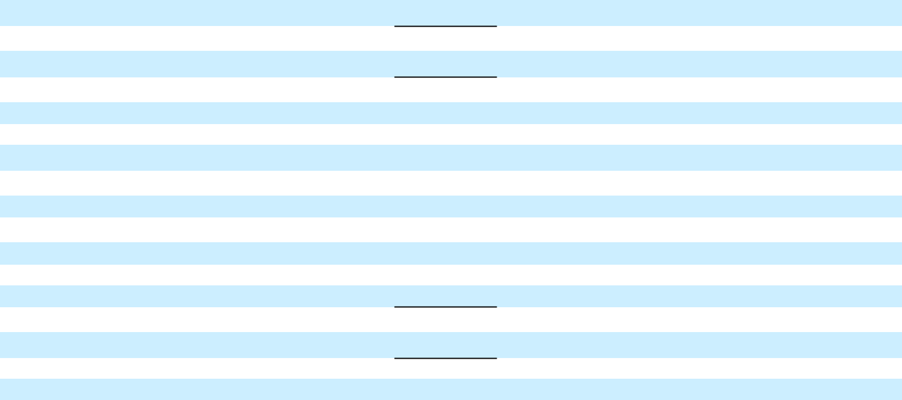

Net increase (decrease) in short-term debt

Proceeds from issuance of debt (original maturities greater than three months)(c)

Payments on debt (original maturities greater than three months)

Payments to purchase common stock

Proceeds from issuance of preferred stock(c)

Dividends paid

Other financing activities

Net cash provided by (used in) financing activities – continuing operations

Net cash provided by (used in) financing activities – discontinued operations

Net cash provided by (used in) financing activities

Effect of exchange rate changes on cash, cash equivalents and restricted cash

Net increase (decrease) in cash, cash equivalents and restricted cash

Cash, cash equivalents and restricted cash at beginning of period

Cash, cash equivalents and restricted cash at end of period

Cash, cash equivalents and restricted cash – continuing operations at end of period

Cash, cash equivalents and restricted cash – discontinued operations at end of period

 | (51) |  |  | — |  |  | 695 |  |  | — |  |  | 644 |  |  | (62) |  |  | — |  |  | (351) |  |  | — |  |  | (413)
 | 2,321 |  |  | 274 |  |  | 20,836 |  |  | (274) |  |  | 23,157 |  |  | 428 |  |  | 261 |  |  | 26,703 |  |  | (261) |  |  | 27,131
 | (1,898) |  |  | — |  |  | (16,918) |  |  | (24) |  |  | (18,840) |  |  | (456) |  |  | — |  |  | (12,891) |  |  | 16 |  |  | (13,331)
 | (100) |  |  | — |  |  | — |  |  | — |  |  | (100) |  |  | (1,496) |  |  | — |  |  | — |  |  | — |  |  | (1,496)
 | 361 |  |  | 2,000 |  |  | — |  |  | (1,100) |  |  | 1,261 |  |  | — |  |  | — |  |  | — |  |  | — |  |  | —
 | (1,074) |  |  | — |  |  | (30) |  |  | — |  |  | (1,104) |  |  | (1,145) |  |  | — |  |  | — |  |  | — |  |  | (1,145)
 | (262) |  |  | (9) |  |  | (92) |  |  | — |  |  | (363) |  |  | (116) |  |  | (26) |  |  | (95) |  |  | — |  |  | (237)
 | (703) |  |  | 2,265 |  |  | 4,491 |  |  | (1,398) |  |  | 4,655 |  |  | (2,847) |  |  | 235 |  |  | 13,366 |  |  | (245) |  |  | 10,509
 | — |  |  | — |  |  | — |  |  | — |  |  | — |  |  | (131) |  |  | — |  |  | 65 |  |  | 97 |  |  | 31
 | (703) |  |  | 2,265 |  |  | 4,491 |  |  | (1,398) |  |  | 4,655 |  |  | (2,978) |  |  | 235 |  |  | 13,431 |  |  | (148) |  |  | 10,540
 | (185) |  |  | — |  |  | (60) |  |  | — |  |  | (245) |  |  | 131 |  |  | — |  |  | 78 |  |  | — |  |  | 209
 | (2,156) |  |  | 1,978 |  |  | 101 |  |  | — |  |  | (77) |  |  | 1,542 |  |  | 25 |  |  | 2,818 |  |  | — |  |  | 4,385
 | 11,258 |  |  | 23 |  |  | 6,567 |  |  | — |  |  | 17,848 |  |  | 9,857 |  |  | 1 |  |  | 5,302 |  |  | — |  |  | 15,160
$ | 9,102 |  | $ | 2,001 |  | $ | 6,668 |  | $ | — |  | $ | 17,771 |  | $ | 11,399 |  | $ | 26 |  | $ | 8,120 |  | $ | — |  | $ | 19,545
$ | 9,102 |  | $ | 2,001 |  | $ | 6,668 |  | $ | — |  | $ | 17,771 |  | $ | 11,397 |  | $ | 26 |  | $ | 7,497 |  | $ | — |  | $ | 18,920
$ | — |  | $ | — |  | $ | — |  | $ | — |  | $ | — |  | $ | 2 |  | $ | — |  | $ | 623 |  | $ | — |  | $ | 625

- Reclassifications of $541 million and $1,685 million in the six months ended June 30, 2018 and 2017 for purchases/collections of wholesale finance receivables resulting from vehicles sold by GM to dealers that have arranged their inventory floor plan financing through GM Financial.
- Eliminations include $216 million and $197 million in Purchases of finance receivables, net in the six months ended June 30, 2018 and 2017 and $173 million in Principal collections and recoveries on finance receivables in the six months ended June 30, 2018 related to the re-timing of cash receipts and payments between Automotive and GM Financial.
- Eliminations include $1,374 million and $261 million in the six months ended June 30, 2018 and 2017 for Automotive cash injections in GM Cruise, inclusive of the $1.1 billion investment in GM Cruise Preferred Shares in the six months ended June 30, 2018.

13

