UNITED STATES

SECURITIES AND EXCHANGE COMMISSION

Washington, DC 20549-1004

___________________

FORM 8-K

___________________

CURRENT REPORT

Pursuant to Section 13 or 15(d) of

the Securities Exchange Act of 1934

Date of Report (Date of earliest event reported) October 24, 2017

___________________

GENERAL MOTORS COMPANY

(Exact name of registrant as specified in its charter)

___________________

DELAWARE | 001-34960 | 27-0756180
(State or other jurisdiction of | 001-34960 | (I.R.S. Employer
incorporation) | (Commission File Number) | Identification No.)
300 Renaissance Center, Detroit, Michigan |  | 48265-3000
(Address of principal executive offices) |  | (Zip Code)

(313) 667-1500

(Registrant's telephone number, including area code)

Not Applicable

(Former name or former address, if changed since last report)

__________________

Check the appropriate box below if the Form 8-K filing is intended to simultaneously satisfy the filing obligation of the registrant under any of the following provisions:

- Written communications pursuant to Rule 425 under the Securities Act (17 CFR 230.425)

- Soliciting material pursuant to Rule 14a-12 under the Exchange Act (17-CFR 240.14a-12)

- Pre-commencement communications pursuant to Rule 14d-2(b) under the Exchange Act (17 CFR 240.14d-2(b))

- Pre-commencement communications pursuant to Rule 13e-4(c) under the Exchange Act (17 CFR 240.13e-4(c))

Indicate by check mark whether the registrant is an emerging growth company as defined in Rule 405 of the Securities Act of 1933 (§230.405 of this chapter) or Rule 12b-2 of the Securities Exchange Act of 1934 (§240.12b-2 of this chapter). Emerging growth company ☐

If an emerging growth company, indicate by check mark if the registrant has elected not to use the extended transition period for complying with any new or revised financial accounting standards provided pursuant to Section 13(a) of the Exchange Act. ☐

ITEM 2.02 Results of Operations and Financial Condition

On October 24, 2017 General Motors Company (GM) issued a news release and supplemental materials on the subject of its 2017 third quarter earnings.

The news release and supplemental materials are attached as Exhibit 99.1 and Exhibit 99.2.

Charts furnished to securities analysts in connection with GM's 2017 third quarter earnings release are available on GM's website at www.gm.com/investors/earnings-releases.html.

ITEM 9.01 Financial Statements and Exhibits

 |  |  |  | EXHIBIT
Exhibit |  | Description
Exhibit 99.1 |  | News Release Dated October 24, 2017
Exhibit 99.2 |  | Financial Highlights Dated October 24, 2017

SIGNATURE

Pursuant to the requirements of the Securities Exchange Act of 1934, the registrant has duly caused this report to be signed on its behalf by the undersigned hereunto duly authorized.

 | GENERAL MOTORS COMPANY (Registrant)
By: | /s/ THOMAS S. TIMKO
Date: October 24, 2017
Date: October 24, 2017 | Thomas S. Timko, Vice President, Global Business Services and Chief
 | Accounting Officer

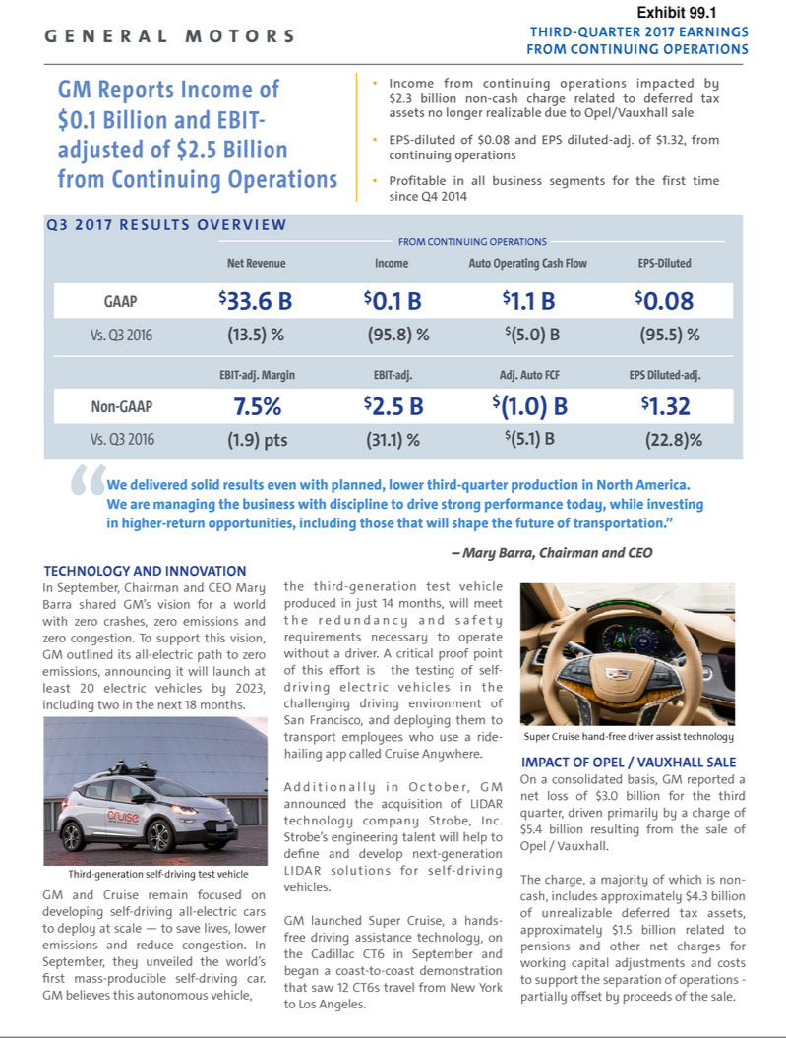

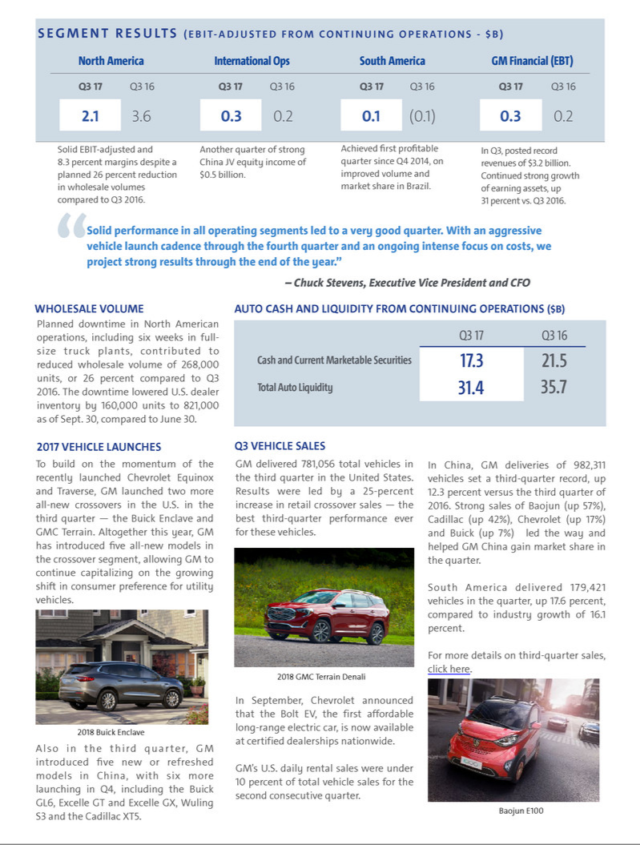

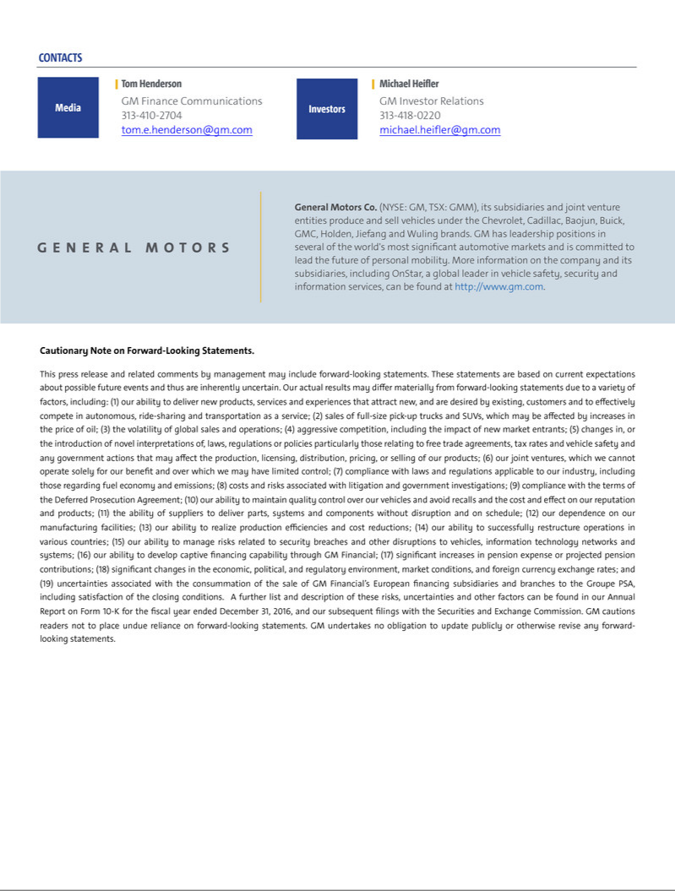

Exhibit 99.2

General Motors Company and Subsidiaries

Supplemental Material

(Unaudited)

Unless otherwise indicated, General Motors Company's (GM) non-GAAP measures are related to our continuing operations and not our discontinued operations nor assets and liabilities held for sale. GM's non-GAAP measures include earnings before interest and taxes (EBIT)-adjusted, presented net of noncontrolling interests, earnings per share (EPS)-diluted-adjusted, effective tax rate-adjusted (ETR-adjusted), return on invested capital-adjusted (ROIC-adjusted) and adjusted automotive free cash flow. GM's calculation of these non-GAAP measures may not be comparable to similarly titled measures of other companies due to potential differences between companies in the method of calculation. As a result, the use of these non-GAAP measures has limitations and should not be considered superior to, in isolation from, or as a substitute for, related U.S. GAAP measures.

These non-GAAP measures allow management and investors to view operating trends, perform analytical comparisons and benchmark performance between periods and among geographic regions to understand operating performance without regard to items we do not consider a component of our core operating performance. Furthermore, these non-GAAP measures allow investors the opportunity to measure and monitor our performance against our externally communicated targets and evaluate the investment decisions being made by management to improve ROIC-adjusted. Management uses these measures in its financial, investment and operational decision-making processes, for internal reporting and as part of its forecasting and budgeting processes. Further, our Board of Directors uses certain of these and other measures as key metrics to determine management performance under our performance-based compensation plans. For these reasons we believe these non-GAAP measures are useful for our investors.

EBIT-adjusted is presented net of noncontrolling interests and is used by management and can be used by investors to review our consolidated operating results because it excludes automotive interest income, automotive interest expense and income taxes as well as certain additional adjustments that are not considered part of our core operations. Examples of adjustments to EBIT include but are not limited to impairment charges related to goodwill; impairment charges on long-lived assets and other exit costs resulting from strategic shifts in our operations or discrete market and business conditions; costs arising from the ignition switch recall and related legal matters; and certain currency devaluations associated with hyperinflationary economies. For EBIT-adjusted and our other non-GAAP measures, once we have made an adjustment in the current period for an item, we will also adjust the related non-GAAP measure in any future periods in which there is an impact from the item.

EPS-diluted-adjusted is used by management and can be used by investors to review our consolidated diluted earnings per share results on a consistent basis. EPS-diluted-adjusted is calculated as net income attributable to common stockholders-diluted less income (loss) from discontinued operations on an after-tax basis, adjustments noted above for EBIT-adjusted, gains or losses on the extinguishment of debt obligations on an after-tax basis and certain income tax adjustments divided by weighted-average common shares outstanding-diluted. Examples of income tax adjustments include the establishment or reversal of significant deferred tax asset valuation allowances.

ETR-adjusted is used by management and can be used by investors to review the consolidated effective tax rate for our core operations on a consistent basis. ETR-adjusted is calculated as Income tax expense less the income tax related to the adjustments noted above for EBIT-adjusted and the income tax adjustments noted above for EPS-diluted-adjusted divided by Income before income taxes less adjustments.

ROIC-adjusted is used by management and can be used by investors to review our investment and capital allocation decisions. We define ROIC-adjusted as EBIT-adjusted for the trailing four quarters divided by ROIC-adjusted average net assets, which is considered to be the average equity balances adjusted for average automotive debt and interest liabilities, exclusive of capital leases; average automotive net pension and OPEB liabilities; and average automotive net income tax assets during the same period. Adjustments to the average equity balances exclude assets and liabilities classified as either assets held for sale or liabilities held for sale.

Adjusted automotive free cash flow is used by management and can be used by investors to review the liquidity of our automotive operations and to measure and monitor our performance against our capital allocation program and evaluate our automotive liquidity against the substantial cash requirements of our automotive operations. We measure adjusted automotive free cash flow as automotive operating cash flow from continuing operations less capital expenditures adjusted for management actions, primarily related to strengthening our balance sheet, such as prepayments of debt and discretionary contributions to employee benefit plans.

1

General Motors Company and Subsidiaries

Supplemental Material

(Unaudited)

The following table reconciles segment profit (loss) to Net income (loss) attributable to stockholders under U.S. GAAP (dollars in millions):

 |  | Three Months Ended |  |  |  |  |  | Nine Months Ended
 | September 30, 2017 |  |  | September 30, 2016 |  |  | September 30, 2017 |  |  | September 30, 2016
Operating segments
GM North America (GMNA) | $ | 2,068 |  | $ | 3,579 |  | $ | 9,014 |  | $ | 9,708
GM International Operations (GMIO) |  | 337 |  |  | 220 |  |  | 974 |  |  | 844
GM South America (GMSA) |  | 52 |  |  | (118) |  |  | (90) |  |  | (300)
General Motors Financial Company, Inc. (GM Financial)(a) |  | 310 |  |  | 193 |  |  | 895 |  |  | 600
Total operating segments |  | 2,767 |  |  | 3,874 |  |  | 10,793 |  |  | 10,852
Corporate and eliminations(b) |  | (244) |  |  | (212) |  |  | (1,034) |  |  | (602)
EBIT-adjusted |  | 2,523 |  |  | 3,662 |  |  | 9,759 |  |  | 10,250
Special items
GMIO restructuring(c) |  | — |  |  | — |  |  | (460) |  |  | —
Venezuela deconsolidation(d) |  | — |  |  | — |  |  | (80) |  |  | —
Ignition switch recall and related legal matters(e) |  | — |  |  | 110 |  |  | (114) |  |  | (65)
Total special items |  | — |  |  | 110 |  |  | (654) |  |  | (65)
Automotive interest income |  | 59 |  |  | 43 |  |  | 184 |  |  | 137
Automotive interest expense |  | (151) |  |  | (145) |  |  | (430) |  |  | (413)
Income tax expense(f) |  | (2,316) |  |  | (902) |  |  | (3,637) |  |  | (2,436)
Income from continuing operations(g) |  | 115 |  |  | 2,768 |  |  | 5,222 |  |  | 7,473
Income (loss) from discontinued operations, net of tax(h) |  | (3,096) |  |  | 5 |  |  | (3,935) |  |  | 119
Net income (loss) attributable to stockholders | $ | (2,981) |  | $ | 2,773 |  | $ | 1,287 |  | $ | 7,592
__________
- GM Financial amounts represent earnings before income taxes-adjusted.

- GM's automotive operations' interest income and interest expense, Maven, legacy costs from the Opel and Vauxhall business and certain other assets in Europe (the Opel/Vauxhall Business), which are primarily pension costs, corporate expenditures including autonomous vehicle-related engineering and other costs and certain nonsegment specific revenues and expenses, are recorded centrally in Corporate.

- This adjustment was excluded because of a strategic decision to rationalize our core operations by exiting or significantly reducing our presence in various international markets to focus resources on opportunities expected to deliver higher returns. The adjustment primarily consists of asset impairments, sales incentives, inventory provisions, dealer restructuring, employee separations and other contract cancellation costs in India and South Africa.

- This adjustment was excluded because we ceased operations and terminated employment relationships in Venezuela due to causes beyond our control, which included adverse political and economic conditions, including the seizure of our manufacturing facility.
- These adjustments were excluded because of the unique events associated with the ignition switch recall. These events included the creation of the Ignition Switch Compensation Program, as well as various investigations, inquiries, and complaints from various constituents.
- Income tax expense includes a special item of $1.8 billion in the three and nine months ended September 30, 2017 related to the establishment of a valuation allowance on deferred tax assets that will no longer be realizable as a result of the sale of the Opel/Vauxhall Business, partially offset by tax benefits related to tax settlements.
- Net of Net (income) loss attributable to noncontrolling interests.

- Represents the results of the Opel/Vauxhall Business and our European financing subsidiaries and branches (the Fincos, and together with the Opel/Vauxhall Business, the European Business).

2

General Motors Company and Subsidiaries

Supplemental Material

(Unaudited)

The following table reconciles Net income (loss) attributable to stockholders under U.S. GAAP to EBIT-adjusted (dollars in millions):

 |  |  |  |  |  |  |  |  |  |  |  | Three Months Ended
 |  |  | September 30, |  |  |  |  |  | June 30, |  |  |  |  |  | March 31, |  |  |  |  |  | December 31,
 |  |  | 2017 |  |  | 2016 |  |  | 2017 |  |  | 2016 |  |  | 2017 |  |  | 2016 |  |  | 2016 |  |  | 2015
 | Net income (loss) attributable to stockholders | $ | (2,981) |  | $ | 2,773 |  | $ | 1,660 |  | $ | 2,866 |  | $ | 2,608 |  | $ | 1,953 |  | $ | 1,835 |  | $ | 6,266
 | (Income) loss from discontinued operations, net of tax |  | 3,096 |  |  | (5) |  |  | 770 |  |  | (106) |  |  | 69 |  |  | (8) |  |  | 120 |  |  | 230
 | Income tax expense (benefit)(a) |  | 2,316 |  |  | 902 |  |  | 534 |  |  | 877 |  |  | 787 |  |  | 657 |  |  | 303 |  |  | (3,139)
 | Gain on extinguishment of debt |  | — |  |  | — |  |  | — |  |  | — |  |  | — |  |  | — |  |  | — |  |  | (449)
 | Automotive interest expense |  | 151 |  |  | 145 |  |  | 132 |  |  | 144 |  |  | 147 |  |  | 124 |  |  | 150 |  |  | 109
 | Automotive interest income |  | (59) |  |  | (43) |  |  | (68) |  |  | (50) |  |  | (57) |  |  | (44) |  |  | (45) |  |  | (40)
 | Adjustments
 | GMIO restructuring(a) |  | — |  |  | — |  |  | 460 |  |  | — |  |  | — |  |  | — |  |  | — |  |  | —
 | Venezuela deconsolidation(a) |  | — |  |  | — |  |  | 80 |  |  | — |  |  | — |  |  | — |  |  | — |  |  | —
 | Ignition switch recall and related legal matters(a) |  | — |  |  | (110) |  |  | 114 |  |  | 115 |  |  | — |  |  | 60 |  |  | 235 |  |  | 60
 | Other |  | — |  |  | — |  |  | — |  |  | — |  |  | — |  |  | — |  |  | — |  |  | (18)
 | Total adjustments |  | — |  |  | (110) |  |  | 654 |  |  | 115 |  |  | — |  |  | 60 |  |  | 235 |  |  | 42
 | EBIT-adjusted | $ | 2,523 |  | $ | 3,662 |  | $ | 3,682 |  | $ | 3,846 |  | $ | 3,554 |  | $ | 2,742 |  | $ | 2,598 |  | $ | 3,019
________
- Refer to the reconciliation of segment profit (loss) to Net income (loss) attributable to stockholders under U.S. GAAP within the previous section for adjustment details.

3

General Motors Company and Subsidiaries

Supplemental Material

(Unaudited)

The following table reconciles diluted earnings (loss) per common share under U.S. GAAP to EPS-diluted-adjusted (dollars in millions):

 |  |  |  |  |  | Three Months Ended |  |  |  |  |  |  |  |  |  |  |  | Nine Months Ended
 |  |  | September 30, 2017 |  |  |  |  |  | September 30, 2016 |  |  |  |  |  | September 30, 2017 |  |  |  |  |  | September 30, 2016
 |  |  | Amount |  |  | Per Share |  |  | Amount |  |  | Per Share |  |  | Amount |  |  | Per Share |  |  | Amount |  |  | Per Share
 | Diluted earnings (loss) per common share | $ | (2,983) |  | $ | (2.03) |  | $ | 2,773 |  | $ | 1.76 |  | $ | 1,285 |  | $ | 0.85 |  | $ | 7,591 |  | $ | 4.81
 | Diluted (earnings) loss per common share – discontinued
 | operations |  | 3,096 |  |  | 2.11 |  |  | (5) |  |  | (0.00) |  |  | 3,935 |  |  | 2.61 |  |  | (119) |  |  | (0.08)
 | Adjustments(a) |  | — |  |  | — |  |  | (110) |  |  | (0.07) |  |  | 654 |  |  | 0.43 |  |  | 65 |  |  | 0.04
 | Tax effect on adjustments(b) |  | — |  |  | — |  |  | 41 |  |  | 0.02 |  |  | (208) |  |  | (0.14) |  |  | (25) |  |  | (0.01)
 | Tax adjustment(c) |  | 1,828 |  |  | 1.24 |  |  | — |  |  | — |  |  | 1,828 |  |  | 1.22 |  |  | — |  |  | —
 | EPS-diluted-adjusted | $ | 1,941 |  | $ | 1.32 |  | $ | 2,699 |  | $ | 1.71 |  | $ | 7,494 |  | $ | 4.97 |  | $ | 7,512 |  | $ | 4.76
________
- Refer to the reconciliation of segment profit (loss) to Net income (loss) attributable to stockholders under U.S. GAAP within the previous section for adjustment details.

- The tax effect of each adjustment is determined based on the tax laws and valuation allowance status of the jurisdiction in which the adjustment relates.

- This adjustment represents the tax expense related to the establishment of a valuation allowance on deferred tax assets that will no longer be realizable as a result of the sale of the Opel/Vauxhall Business, partially offset by tax benefits related to tax settlements.

The following table reconciles our effective tax rate under U.S. GAAP to ETR-adjusted (dollars in millions):

 |  |  |  |  | Three Months Ended |  |  |  |  |  |  |  |  |  |  |  |  |  | Nine Months Ended
 | September 30, 2017 |  |  |  |  |  |  | September 30, 2016 |  |  |  |  |  |  | September 30, 2017 |  |  |  |  |  |  | September 30, 2016
Income |  |  |  |  |  |  | Income |  |  |  |  |  |  | Income |  |  |  |  |  |  | Income
before |  |  |  |  |  |  | before |  |  |  |  |  |  | before |  |  |  |  |  |  | before
income |  |  | Income tax |  | Effective tax |  | income |  |  | Income tax |  | Effective tax |  | income |  |  | Income tax |  | Effective tax |  | income |  |  | Income tax |  | Effective tax
taxes |  |  | expense |  | rate |  | taxes |  |  | expense |  | rate |  | taxes |  |  | expense |  | rate |  | taxes |  |  | expense |  | rate

Effective tax rate | $ | 2,430 |  | $ | 2,316 | 95.3% | $ | 3,609 |  | $ | 902 | 25.0% | $ | 8,870 |  | $ | 3,637 | 41.0% | $ | 9,810 |  | $ | 2,436
Adjustments(a) |  | — |  |  | — |  |  | (110) |  |  | (41) |  |  | 654 |  |  | 208 |  |  | 65 |  |  | 25
Tax adjustment(b) |  |  |  |  | (1,828) |  |  |  |  |  | — |  |  |  |  |  | (1,828) |  |  |  |  |  | —
ETR-adjusted | $ | 2,430 |  | $ | 488 | 20.1% | $ | 3,499 |  | $ | 861 | 24.6% | $ | 9,524 |  | $ | 2,017 | 21.2% | $ | 9,875 |  | $ | 2,461
________
- Refer to the reconciliation of segment profit (loss) to Net income (loss) attributable to stockholders under U.S. GAAP within the previous section for adjustment details.

- Refer to the reconciliation of diluted earnings (loss) per common share under U.S. GAAP to EPS-diluted-adjusted within the previous section for adjustment details.

24.8%

24.9%

4

General Motors Company and Subsidiaries

Supplemental Material

(Unaudited)

We define return on equity (ROE) as Net income attributable to stockholders for the trailing four quarters divided by average equity for the same period. Management uses average equity to provide comparable amounts in the calculation of ROE. The following table summarizes the calculation of ROE (dollars in billions):

 |  |  | Four Quarters Ended
 |  |  | September 30, 2017 |  |  | September 30, 2016
 | Net income attributable to stockholders | $ | 3.1 |  | $ | 13.9
 | Average equity | $ | 44.5 |  | $ | 42.7
 | ROE |  | 7.0% |  |  | 32.5%
 | The following table summarizes the calculation of ROIC-adjusted (dollars in billions):
 |  |  | Four Quarters Ended
 |  |  | September 30, 2017 |  |  | September 30, 2016
 | EBIT-adjusted(a) | $ | 12.4 |  | $ | 13.3
 | Average equity | $ | 44.5 |  | $ | 42.7
 | Add: Average automotive debt and interest liabilities (excluding capital leases) |  | 10.8 |  |  | 9.4
 | Add: Average automotive net pension & OPEB liability |  | 21.2 |  |  | 22.6
 | Less: Average automotive net income tax asset |  | (31.7) |  |  | (33.1)
 | ROIC-adjusted average net assets | $ | 44.8 |  | $ | 41.6
 | ROIC-adjusted |  | 27.6% |  |  | 31.9%
________
- Refer to the reconciliation of Net income (loss) attributable to stockholders under U.S. GAAP to EBIT-adjusted in a preceding section.

The following table reconciles Net automotive cash provided by operating activities from continuing operations under U.S. GAAP to adjusted automotive free cash flow (dollars in millions):

 |  |  | Three Months Ended |  |  |  |  |  | Nine Months Ended
 |  | September 30, 2017 |  |  | September 30, 2016 |  |  | September 30, 2017 |  |  | September 30, 2016
Net automotive cash provided by operating activities – continuing operations | $ |  | 1,103 |  | $ | 6,083 |  | $ | 7,265 |  | $ | 9,787
Less: capital expenditures |  |  | (2,148) |  |  | (2,050) |  |  | (6,287) |  |  | (6,044)
Adjustment – discretionary pension plan contributions |  |  | — |  |  | — |  |  | — |  |  | 1,982
Adjusted automotive free cash flow – continuing operations |  |  | (1,045) |  |  | 4,033 |  |  | 978 |  |  | 5,725
Net automotive cash provided by (used in) operating activities – discontinued
operations |  |  | (116) |  |  | (328) |  |  | 15 |  |  | 294
Less: capital expenditures – discontinued operations |  |  | (137) |  |  | (222) |  |  | (653) |  |  | (791)
Adjusted automotive free cash flow | $ |  | (1,298) |  | $ | 3,483 |  | $ | 340 |  | $ | 5,228
 | 5

General Motors Company and Subsidiaries

Supplemental Material

(Unaudited)

The following tables summarize key financial information by segment (dollars in millions):

 |  |  |  |  |  |  |  |  |  |  |  |  |  |  |  |  | Total |  |  | GM
 |  | GMNA |  |  | GMIO |  |  | GMSA |  |  | Corporate |  |  | Eliminations |  |  | Automotive |  |  | Financial |  |  | Eliminations |  |  | Total
Three Months Ended September 30, 2017
Net sales and revenue | $ | 24,819 |  | $ | 3,007 |  | $ | 2,569 |  | $ | 80 |  |  |  |  | $ | 30,475 |  | $ | 3,161 |  | $ | (13) |  | $ | 33,623
Expenditures for property | $ | 2,023 |  | $ | 53 |  | $ | 62 |  | $ | 9 |  | $ | 1 |  | $ | 2,148 |  | $ | 19 |  | $ | — |  | $ | 2,167
Depreciation and amortization | $ | 1,210 |  | $ | 101 |  | $ | 65 |  | $ | 11 |  | $ | — |  | $ | 1,387 |  | $ | 1,743 |  | $ | — |  | $ | 3,130
Impairment charges | $ | 10 |  | $ | 7 |  | $ | — |  | $ | — |  | $ | — |  | $ | 17 |  | $ | — |  | $ | — |  | $ | 17
Equity income(a) | $ | 2 |  | $ | 457 |  | $ | — |  | $ | — |  | $ | — |  | $ | 459 |  | $ | 41 |  | $ | — |  | $ | 500
 |  |  |  |  |  |  |  |  |  |  |  |  |  |  |  |  | Total |  |  | GM
 |  | GMNA |  |  | GMIO |  |  | GMSA |  |  | Corporate |  |  | Eliminations |  |  | Automotive |  |  | Financial |  |  | Eliminations |  |  | Total
Three Months Ended September 30, 2016
Net sales and revenue | $ | 31,085 |  | $ | 3,376 |  | $ | 2,029 |  | $ | 40 |  |  |  |  | $ | 36,530 |  | $ | 2,360 |  | $ | (1) |  | $ | 38,889
Expenditures for property | $ | 1,850 |  | $ | 123 |  | $ | 75 |  | $ | 2 |  | $ | — |  | $ | 2,050 |  | $ | 20 |  | $ | — |  | $ | 2,070
Depreciation and amortization | $ | 1,088 |  | $ | 116 |  | $ | 75 |  | $ | 2 |  | $ | (1) |  | $ | 1,280 |  | $ | 1,249 |  | $ | — |  | $ | 2,529
Impairment charges | $ | 3 |  | $ | 2 |  | $ | — |  | $ | — |  | $ | — |  | $ | 5 |  | $ | — |  | $ | — |  | $ | 5
Equity income(a) | $ | 3 |  | $ | 459 |  | $ | — |  | $ | — |  | $ | — |  | $ | 462 |  | $ | 35 |  | $ | — |  | $ | 497
 |  |  |  |  |  |  |  |  |  |  |  |  |  |  |  |  | Total |  |  | GM
 |  | GMNA |  |  | GMIO |  |  | GMSA |  |  | Corporate |  |  | Eliminations |  |  | Automotive |  |  | Financial |  |  | Eliminations |  |  | Total
Nine Months Ended September 30, 2017
Net sales and revenue | $ | 82,594 |  | $ | 9,400 |  | $ | 6,826 |  | $ | 306 |  |  |  |  | $ | 99,126 |  | $ | 8,899 |  | $ | (152) |  | $ | 107,873
Expenditures for property | $ | 5,858 |  | $ | 196 |  | $ | 216 |  | $ | 17 |  | $ | — |  | $ | 6,287 |  | $ | 66 |  | $ | — |  | $ | 6,353
Depreciation and amortization | $ | 3,499 |  | $ | 327 |  | $ | 208 |  | $ | 23 |  | $ | (1) |  | $ | 4,056 |  | $ | 4,757 |  | $ | — |  | $ | 8,813
Impairment charges | $ | 59 |  | $ | 204 |  | $ | 3 |  | $ | 5 |  | $ | — |  | $ | 271 |  | $ | — |  | $ | — |  | $ | 271
Equity income(a) | $ | 8 |  | $ | 1,448 |  | $ | — |  | $ | — |  | $ | — |  | $ | 1,456 |  | $ | 129 |  | $ | — |  | $ | 1,585
 |  |  |  |  |  |  |  |  |  |  |  |  |  |  |  |  | Total |  |  | GM
 |  | GMNA |  |  | GMIO |  |  | GMSA |  |  | Corporate |  |  | Eliminations |  |  | Automotive |  |  | Financial |  |  | Eliminations |  |  | Total
Nine Months Ended September 30, 2016
Net sales and revenue | $ | 87,815 |  | $ | 9,923 |  | $ | 5,011 |  | $ | 113 |  |  |  |  | $ | 102,862 |  | $ | 6,429 |  | $ | (3) |  | $ | 109,288
Expenditures for property | $ | 5,353 |  | $ | 417 |  | $ | 269 |  | $ | 7 |  | $ | (2) |  | $ | 6,044 |  | $ | 58 |  | $ | — |  | $ | 6,102
Depreciation and amortization | $ | 3,185 |  | $ | 330 |  | $ | 202 |  | $ | 12 |  | $ | (3) |  | $ | 3,726 |  | $ | 3,290 |  | $ | — |  | $ | 7,016
Impairment charges | $ | 44 |  | $ | 65 |  | $ | — |  | $ | — |  | $ | — |  | $ | 109 |  | $ | — |  | $ | — |  | $ | 109
Equity income(a) | $ | 162 |  | $ | 1,446 |  | $ | — |  | $ | — |  | $ | — |  | $ | 1,608 |  | $ | 109 |  | $ | — |  | $ | 1,717
________
- Includes Automotive China equity income of $459 million in the three months ended September 30, 2017 and 2016 and $1.5 billion and $1.4 billion in the nine months ended September 30, 2017 and 2016.

6

General Motors Company and Subsidiaries

Supplemental Material

(Unaudited)

Vehicle Sales

GM presents both wholesale and retail vehicle sales data to assist in the analysis of our revenue and our market share. GM does not currently export vehicles to Cuba, Iran, North Korea, Sudan or Syria. Accordingly these countries are excluded from industry sales data and corresponding calculation of GM's market share.

Wholesale vehicle sales data (vehicles in thousands), which represents sales directly to dealers and others, including sales to fleet customers, is the measure that correlates to GM's revenue from the sale of vehicles, which is the largest component of Automotive net sales and revenue. Wholesale vehicle sales exclude vehicles sold by joint ventures. In the nine months ended September 30, 2017, 39.2% of our wholesale vehicle sales volume was generated outside the U.S. The following table summarizes total wholesale vehicle sales of new vehicles by automotive segment:

 |  | Three Months Ended |  |  |  | Nine Months Ended
 |  | September 30, 2017 |  | September 30, 2016 |  | September 30, 2017 |  | September 30, 2016
 | GMNA(a) | 762 |  | 1,030 |  | 2,596 |  | 2,908
 | GMIO(b) | 136 |  | 160 |  | 452 |  | 500
 | GMSA(a) | 185 |  | 153 |  | 487 |  | 400
 | Total | 1,083 |  | 1,343 |  | 3,535 |  | 3,808
 | Discontinued operations | 90 |  | 268 |  | 696 |  | 904
__________
- Wholesale vehicle sales related to transactions with the European Business were insignificant for the three and nine months ended September 30, 2017 and 2016.

- Wholesale vehicle sales include 37 and 24 vehicles related to transactions with the European Business for the three months ended September 30, 2017 and 2016 and 131 and 94 vehicles for the nine months ended September 30, 2017 and 2016.

7

General Motors Company and Subsidiaries

Supplemental Material

(Unaudited)

Retail vehicle sales data, which represents sales to end customers based upon the good faith estimates of management, including sales to fleet customers, does not correlate directly to the revenue GM recognizes during the period. However retail vehicle sales data is indicative of the underlying demand for GM vehicles. Market share information is based primarily on retail vehicle sales volume. In countries where retail vehicle sales data is not readily available, other data sources such as wholesale or forecast volumes are used to estimate retail vehicle sales to end customers.

Retail vehicle sales data includes all sales by joint ventures on a total vehicle basis, not based on the percentage of ownership in the joint venture. Certain joint venture agreements in China allow for the contractual right to report vehicle sales of non-GM trademarked vehicles by those joint ventures. Retail vehicle sales data includes vehicles used by dealers under courtesy transportation programs and vehicles sold through the dealer registration channel primarily in Europe. This sales channel consists primarily of dealer demonstrator, loaner and self-registered vehicles which are not eligible to be sold as new vehicles after being registered by dealers. Certain fleet sales that are accounted for as operating leases are included in retail vehicle sales at the time of delivery to daily rental car companies. The following table summarizes total industry retail sales, or estimated sales where retail sales volume is not available, by geographic region (vehicles in thousands):

 | Three Months Ended |  |  |  | Nine Months Ended
 | September 30, 2017 |  | September 30, 2016 |  | September 30, 2017 |  | September 30, 2016
United States
Chevrolet – Cars | 159 |  | 174 |  | 471 |  | 548
Chevrolet – Trucks | 246 |  | 241 |  | 665 |  | 665
Chevrolet – Crossovers | 142 |  | 110 |  | 380 |  | 320
Cadillac | 42 |  | 46 |  | 114 |  | 119
Buick | 50 |  | 66 |  | 160 |  | 170
GMC | 142 |  | 136 |  | 406 |  | 390
Total United States | 781 |  | 773 |  | 2,196 |  | 2,212
Canada, Mexico and Other | 144 |  | 146 |  | 423 |  | 416
Total North America(a) | 925 |  | 919 |  | 2,619 |  | 2,628
Asia/Pacific, Middle East and Africa
Chevrolet | 243 |  | 243 |  | 670 |  | 692
Wuling | 236 |  | 293 |  | 801 |  | 969
Buick | 311 |  | 284 |  | 836 |  | 844
Baojun | 249 |  | 149 |  | 640 |  | 478
Cadillac | 46 |  | 30 |  | 131 |  | 81
Other | 45 |  | 46 |  | 136 |  | 150
Total Asia/Pacific, Middle East and Africa(a)(b)(c) | 1,130 |  | 1,045 |  | 3,214 |  | 3,214
South America(a)(d) | 179 |  | 153 |  | 487 |  | 422
Total in GM markets | 2,234 |  | 2,117 |  | 6,320 |  | 6,264
Total Europe | 83 |  | 274 |  | 684 |  | 897
Total Worldwide | 2,317 |  | 2,391 |  | 7,004 |  | 7,161
_______
- Sales of Opel/Vauxhall outside of Europe were insignificant in the three and nine months ended September 30, 2017 and 2016.

- In the three months ended March 31, 2017, we began using estimated vehicle registrations data as the basis for calculating industry volume and market share in China. In the three and nine months ended September 30, 2016, wholesale volumes were used for Industry, GM and Market Share. Our retail sales in China were 908 and 2,718 in the three and nine months ended September 30, 2016.

- Includes Industry and GM sales in India and South Africa. We intend to phase out sales of Chevrolet in the Indian and South African markets by the end of 2017.

- Primarily Chevrolet.

8

General Motors Company and Subsidiaries

Supplemental Material

(Unaudited)

The vehicle sales at GM's China joint ventures presented in the following table are included in GM's retail vehicle sales on the preceding page (vehicles in thousands):

 |  | Three Months Ended |  |  |  |  |  | Nine Months Ended
 |  | September 30, 2017 |  |  | September 30, 2016 |  |  | September 30, 2017 |  |  |  | September 30, 2016
SAIC General Motors Sales Co., Ltd.(a) |  | 497 |  |  | 433 |  |  | 1,307 |  |  |  | 1,243
SAIC GM Wuling Automobile Co., Ltd. and FAW-GM Light Duty
Commercial Vehicle Co., Ltd.(a) |  | 485 |  |  | 441 |  |  | 1,441 |  |  |  | 1,447
 |  | Three Months Ended |  |  |  |  |  | Nine Months Ended
 |  | September 30, 2017 |  |  | September 30, 2016 |  |  | September 30, 2017 |  |  |  | September 30, 2016
Market Share
United States – Cars |  | 11.4% |  |  | 12.5% |  |  | 11.5% |  |  |  | 12.6%
United States – Trucks |  | 27.2% |  |  | 27.8% |  |  | 25.6% |  |  |  | 26.4%
United States – Crossovers |  | 15.4% |  |  | 13.3% |  |  | 15.0% |  |  |  | 13.2%
Total United States |  | 17.3% |  |  | 17.0% |  |  | 16.7% |  |  |  | 16.6%
Total North America |  | 16.7% |  |  | 16.5% |  |  | 16.3% |  |  |  | 16.1%
Total Asia/Pacific, Russia, Middle East and Africa(a) |  | 9.3% |  |  | 9.0% |  |  | 9.2% |  |  |  | 9.2%
Total South America |  | 16.1% |  |  | 15.9% |  |  | 15.9% |  |  |  | 15.6%
Total GM Market |  | 11.9% |  |  | 11.7% |  |  | 11.6% |  |  |  | 11.6%
Total Europe |  | 1.9% |  |  | 6.4% |  |  | 4.7% |  |  |  | 6.4%
Total Worldwide |  | 10.0% |  |  | 10.6% |  |  | 10.2% |  |  |  | 10.5%
United States fleet sales as a percentage of retail vehicle
sales |  | 17.4% |  |  | 15.5% |  |  | 19.0% |  |  |  | 19.1%
North America capacity two shift utilization |  | 86.2% |  |  | 115.3% |  |  | 98.6% |  |  |  | 106.6%
_______
- In the three months ended March 31, 2017, we began using estimated vehicle registrations data as the basis for calculating industry volume and market share in China. In the three and nine months ended September 30, 2016, wholesale volumes were used for Industry, GM and Market Share.

9

General Motors Company and Subsidiaries

Combining Income Statement Information

(In millions) (Unaudited)

 |  |  |  | Three Months Ended September 30, 2017 |  |  |  |  |  |  |  |  |  |  | Three Months Ended September 30, 2016
 |  | Automotive |  |  | GM Financial |  |  | Eliminations |  |  | Combined |  |  | Automotive |  |  | GM Financial |  |  | Eliminations |  |  | Combined
Net sales and revenue
Automotive | $ | 30,475 |  | $ | — |  | $ | (9) |  | $ | 30,466 |  | $ | 36,530 | $ |  | — |  | $ | — |  | $ | 36,530
GM Financial |  | — |  |  | 3,161 |  |  | (4) |  |  | 3,157 |  |  | — |  |  | 2,360 |  |  | (1) |  |  | 2,359
Total net sales and revenue |  | 30,475 |  |  | 3,161 |  |  | (13) |  |  | 33,623 |  |  | 36,530 |  |  | 2,360 |  |  | (1) |  |  | 38,889
Costs and expenses
Automotive cost of sales |  | 26,522 |  |  | — |  |  | (11) |  |  | 26,511 |  |  | 31,140 |  |  | — |  |  | (1) |  |  | 31,139
GM Financial interest, operating and other
expenses |  | — |  |  | 2,892 |  |  | — |  |  | 2,892 |  |  | — |  |  | 2,202 |  |  | — |  |  | 2,202
Automotive selling, general and
administrative expense |  | 2,304 |  |  | — |  |  | — |  |  | 2,304 |  |  | 2,400 |  |  | — |  |  | — |  |  | 2,400
Total costs and expenses |  | 28,826 |  |  | 2,892 |  |  | (11) |  |  | 31,707 |  |  | 33,540 |  |  | 2,202 |  |  | (1) |  |  | 35,741
Operating income |  | 1,649 |  |  | 269 |  |  | (2) |  |  | 1,916 |  |  | 2,990 |  |  | 158 |  |  | — |  |  | 3,148
Automotive interest expense |  | 153 |  |  | — |  |  | (2) |  |  | 151 |  |  | 145 |  |  | — |  |  | — |  |  | 145
Interest income and other non-operating
income, net |  | 165 |  |  | — |  |  | — |  |  | 165 |  |  | 109 |  |  | — |  |  | — |  |  | 109
Equity income |  | 459 |  |  | 41 |  |  | — |  |  | 500 |  |  | 462 |  |  | 35 |  |  | — |  |  | 497
Income before income taxes |  | 2,120 |  |  | 310 |  |  | — |  |  | 2,430 |  |  | 3,416 |  |  | 193 |  |  | — |  |  | 3,609
Income tax expense |  | 2,204 |  |  | 112 |  |  | — |  |  | 2,316 |  |  | 837 |  |  | 65 |  |  | — |  |  | 902
Income from continuing operations |  | (84) |  |  | 198 |  |  | — |  |  | 114 |  |  | 2,579 |  |  | 128 |  |  | — |  |  | 2,707
Income (loss) from discontinued operations,
net of tax |  | (3,112) |  |  | 16 |  |  | — |  |  | (3,096) |  |  | (24) |  |  | 29 |  |  | — |  |  | 5
Net income (loss) |  | (3,196) |  |  | 214 |  |  | — |  |  | (2,982) |  |  | 2,555 |  |  | 157 |  |  | — |  |  | 2,712
Net loss attributable to noncontrolling
interests |  | 1 |  |  | — |  |  | — |  |  | 1 |  |  | 61 |  |  | — |  |  | — |  |  | 61
Net income (loss) attributable to
stockholders | $ | (3,195) |  | $ | 214 |  | $ | — |  | $ | (2,981) |  | $ | 2,616 | $ |  | 157 |  | $ | — |  | $ | 2,773
Net income (loss) attributable to common
stockholders | $ | (3,195) |  | $ | 212 |  | $ | — |  | $ | (2,983) |  | $ | 2,616 | $ |  | 157 |  | $ | — |  | $ | 2,773
 |  |  |  | Nine Months Ended September 30, 2017 |  |  |  |  |  |  |  |  |  |  | Nine Months Ended September 30, 2016
 |  | Automotive |  |  | GM Financial |  |  | Eliminations |  |  | Combined |  |  | Automotive |  |  | GM Financial |  |  | Eliminations |  |  | Combined
Net sales and revenue
Automotive | $ | 99,126 |  | $ | — |  | $ | (143) |  | $ | 98,983 |  | $ | 102,862 | $ |  | — |  | $ | — |  | $ | 102,862
GM Financial |  | — |  |  | 8,899 |  |  | (9) |  |  | 8,890 |  |  | — |  |  | 6,429 |  |  | (3) |  |  | 6,426
Total net sales and revenue |  | 99,126 |  |  | 8,899 |  |  | (152) |  |  | 107,873 |  |  | 102,862 |  |  | 6,429 |  |  | (3) |  |  | 109,288
Costs and expenses
Automotive cost of sales |  | 85,308 |  |  | — |  |  | (147) |  |  | 85,161 |  |  | 87,764 |  |  | — |  |  | (3) |  |  | 87,761
GM Financial interest, operating and other
expenses |  | — |  |  | 8,133 |  |  | — |  |  | 8,133 |  |  | — |  |  | 5,938 |  |  | — |  |  | 5,938
Automotive selling, general and
administrative expense |  | 7,141 |  |  | — |  |  | — |  |  | 7,141 |  |  | 7,378 |  |  | — |  |  | — |  |  | 7,378
Total costs and expenses |  | 92,449 |  |  | 8,133 |  |  | (147) |  |  | 100,435 |  |  | 95,142 |  |  | 5,938 |  |  | (3) |  |  | 101,077
Operating income |  | 6,677 |  |  | 766 |  |  | (5) |  |  | 7,438 |  |  | 7,720 |  |  | 491 |  |  | — |  |  | 8,211
Automotive interest expense |  | 435 |  |  | — |  |  | (5) |  |  | 430 |  |  | 413 |  |  | — |  |  | — |  |  | 413
Interest income and other non-operating
income, net |  | 277 |  |  | — |  |  | — |  |  | 277 |  |  | 295 |  |  | — |  |  | — |  |  | 295
Equity income |  | 1,456 |  |  | 129 |  |  | — |  |  | 1,585 |  |  | 1,608 |  |  | 109 |  |  | — |  |  | 1,717
Income before income taxes |  | 7,975 |  |  | 895 |  |  | — |  |  | 8,870 |  |  | 9,210 |  |  | 600 |  |  | — |  |  | 9,810
Income tax expense |  | 3,380 |  |  | 257 |  |  | — |  |  | 3,637 |  |  | 2,310 |  |  | 126 |  |  | — |  |  | 2,436
Income from continuing operations |  | 4,595 |  |  | 638 |  |  | — |  |  | 5,233 |  |  | 6,900 |  |  | 474 |  |  | — |  |  | 7,374
Income (loss) from discontinued operations,
net of tax |  | (3,766) |  |  | (169) |  |  | — |  |  | (3,935) |  |  | 17 |  |  | 102 |  |  | — |  |  | 119
Net income |  | 829 |  |  | 469 |  |  | — |  |  | 1,298 |  |  | 6,917 |  |  | 576 |  |  | — |  |  | 7,493
Net (income) loss attributable to
noncontrolling interests |  | (11) |  |  | — |  |  | — |  |  | (11) |  |  | 99 |  |  | — |  |  | — |  |  | 99
Net income attributable to stockholders | $ | 818 |  | $ | 469 |  | $ | — |  | $ | 1,287 |  | $ | 7,016 | $ |  | 576 |  | $ | — |  | $ | 7,592
Net income attributable to common
stockholders | $ | 818 |  | $ | 467 |  | $ | — |  | $ | 1,285 |  | $ | 7,016 | $ |  | 576 |  | $ | — |  | $ | 7,592

10

General Motors Company and Subsidiaries

Basic and Diluted Earnings per Share

(Unaudited)

The following table summarizes basic and diluted earnings (loss) per share (in millions, except per share amounts):

 |  | Three Months Ended |  |  |  |  |  | Nine Months Ended
 |  | September 30, 2017 |  |  | September 30, 2016 |  |  | September 30, 2017 |  |  | September 30, 2016
Basic earnings per share
Income from continuing operations(a) | $ | 115 |  | $ | 2,768 |  | $ | 5,222 |  | $ | 7,473
Less: cumulative dividends on GM Financial preferred stock |  | (2) |  |  | — |  |  | (2) |  |  | —
Income from continuing operations attributable to common stockholders |  | 113 |  |  | 2,768 |  |  | 5,220 |  |  | 7,473
Income (loss) from discontinued operations, net of tax |  | (3,096) |  |  | 5 |  |  | (3,935) |  |  | 119
Net income (loss) attributable to common stockholders | $ | (2,983) |  | $ | 2,773 |  | $ | 1,285 |  | $ | 7,592
Weighted-average common shares outstanding |  | 1,445 |  |  | 1,550 |  |  | 1,483 |  |  | 1,548
Basic earnings per common share – continuing operations | $ | 0.08 |  | $ | 1.79 |  | $ | 3.52 |  | $ | 4.83
Basic earnings (loss) per common share – discontinued operations | $ | (2.14) |  | $ | — |  | $ | (2.65) |  | $ | 0.07
Basic earnings (loss) per common share | $ | (2.06) |  | $ | 1.79 |  | $ | 0.87 |  | $ | 4.90
Diluted earnings per share
Income from continuing operations attributable to common stockholders – diluted(a) | $ | 113 |  | $ | 2,768 |  | $ | 5,220 |  | $ | 7,472
Income (loss) from discontinued operations, net of tax – diluted | $ | (3,096) |  | $ | 5 |  | $ | (3,935) |  | $ | 119
Net income (loss) attributable to common stockholders – diluted | $ | (2,983) |  | $ | 2,773 |  | $ | 1,285 |  | $ | 7,591
Weighted-average common shares outstanding – diluted |  | 1,472 |  |  | 1,574 |  |  | 1,507 |  |  | 1,578
Diluted earnings per common share – continuing operations | $ | 0.08 |  | $ | 1.76 |  | $ | 3.46 |  | $ | 4.73
Diluted earnings (loss) per common share – discontinued operations | $ | (2.11) |  | $ | — |  | $ | (2.61) |  | $ | 0.08
Diluted earnings (loss) per common share | $ | (2.03) |  | $ | 1.76 |  | $ | 0.85 |  | $ | 4.81
__________
(a) Net of Net (income) loss attributable to noncontrolling interests.

11

General Motors Company and Subsidiaries

Combining Balance Sheet Information

(In millions, except per share amounts) (Unaudited)

ASSETS

Current Assets

Cash and cash equivalents

Marketable securities

Accounts and notes receivable, net(a)

GM Financial receivables, net(b)

Inventories

Equipment on operating leases, net

Other current assets

Current assets held for sale(c)(d)

Total current assets

Non-current Assets

GM Financial receivables, net(b)

Equity in net assets of nonconsolidated affiliates

Property, net

Goodwill and intangible assets, net

Equipment on operating leases, net

Deferred income taxes

Other assets

Non-current assets held for sale

Total non-current assets

Total Assets

LIABILITIES AND EQUITY

 |  |  |  | September 30, 2017 |  |  |  |  |  |  |  |  |  |  |  | December 31, 2016
 |  |  |  |  |  |  | Reclassifications / |  |  |  |  |  |  |  |  |  |  |  | Reclassifications /
 | Automotive |  |  | GM Financial |  |  | Eliminations |  |  | Combined |  |  | Automotive |  |  | GM Financial |  |  | Eliminations |  |  | Combined
$ | 8,816 |  | $ | 3,976 |  | $ | — |  | $ | 12,792 |  | $ | 9,759 |  | $ | 2,815 |  | $ | — |  | $ | 12,574
 | 8,454 |  |  | — |  |  | — |  |  | 8,454 |  |  | 11,841 |  |  | — |  |  | — |  |  | 11,841
 | 9,826 |  |  | 779 |  |  | (592) |  |  | 10,013 |  |  | 8,568 |  |  | 801 |  |  | (669) |  |  | 8,700
 | — |  |  | 19,779 |  |  | (380) |  |  | 19,399 |  |  | — |  |  | 16,474 |  |  | (347) |  |  | 16,127
 | 11,789 |  |  | — |  |  | — |  |  | 11,789 |  |  | 11,040 |  |  | — |  |  | — |  |  | 11,040
 | 1,632 |  |  | — |  |  | — |  |  | 1,632 |  |  | 1,110 |  |  | — |  |  | — |  |  | 1,110
 | 2,006 |  |  | 2,903 |  |  | — |  |  | 4,909 |  |  | 1,658 |  |  | 1,975 |  |  | — |  |  | 3,633
 | 49 |  |  | 7,581 |  |  | — |  |  | 7,630 |  |  | 4,591 |  |  | 6,883 |  |  | (296) |  |  | 11,178
 | 42,572 |  |  | 35,018 |  |  | (972) |  |  | 76,618 |  |  | 48,567 |  |  | 28,948 |  |  | (1,312) |  |  | 76,203
 | — |  |  | 21,085 |  |  | (64) |  |  | 21,021 |  |  | — |  |  | 17,001 |  |  | — |  |  | 17,001
 | 7,701 |  |  | 1,119 |  |  | — |  |  | 8,820 |  |  | 8,052 |  |  | 944 |  |  | — |  |  | 8,996
 | 34,932 |  |  | 246 |  |  | — |  |  | 35,178 |  |  | 32,389 |  |  | 214 |  |  | — |  |  | 32,603
 | 4,483 |  |  | 1,371 |  |  | — |  |  | 5,854 |  |  | 4,783 |  |  | 1,366 |  |  | — |  |  | 6,149
 | — |  |  | 41,775 |  |  | — |  |  | 41,775 |  |  | — |  |  | 34,342 |  |  | — |  |  | 34,342
 | 30,625 |  |  | 98 |  |  | — |  |  | 30,723 |  |  | 32,931 |  |  | 241 |  |  | — |  |  | 33,172
 | 4,083 |  |  | 922 |  |  | — |  |  | 5,005 |  |  | 3,038 |  |  | 811 |  |  | — |  |  | 3,849
 | — |  |  | 4,508 |  |  | — |  |  | 4,508 |  |  | 5,295 |  |  | 4,080 |  |  | — |  |  | 9,375
 | 81,824 |  |  | 71,124 |  |  | (64) |  |  | 152,884 |  |  | 86,488 |  |  | 58,999 |  |  | — |  |  | 145,487
$ | 124,396 |  | $ | 106,142 |  | $ | (1,036) |  | $ | 229,502 |  | $ | 135,055 |  | $ | 87,947 |  | $ | (1,312) |  | $ | 221,690

Current Liabilities

Accounts payable (principally trade)(a)

Short-term debt and current portion of long-term debt Automotive(b)

GM Financial

Accrued liabilities

Current liabilities held for sale(c)

Total current liabilities

Non-current Liabilities

Long-term debt

Automotive(b)

GM Financial

Postretirement benefits other than pensions

Pensions

Other liabilities

Non-current liabilities held for sale

Total non-current liabilities

Total Liabilities

Commitments and contingencies

Equity

Common stock, $0.01 par value

Preferred stock, $0.01 par value

Additional paid-in capital(e)

Retained earnings

Accumulated other comprehensive loss

Total stockholders’ equity

Noncontrolling interests(e)

Total Equity

Total Liabilities and Equity

_________

$ | 23,151 |  | $ | 706 |  | $ | (592) |  | $ | 23,265 |  | $ | 23,305 |  | $ | 696 |  | $ | (668) |  | $ | 23,333
 | 1,507 |  |  | — |  |  | (380) |  |  | 1,127 |  |  | 1,407 |  |  | — |  |  | (347) |  |  | 1,060
 | — |  |  | 24,480 |  |  | — |  |  | 24,480 |  |  | — |  |  | 22,737 |  |  | — |  |  | 22,737
 | 23,453 |  |  | 3,150 |  |  | — |  |  | 26,603 |  |  | 23,219 |  |  | 2,675 |  |  | (1) |  |  | 25,893
 | — |  |  | 6,374 |  |  | — |  |  | 6,374 |  |  | 7,092 |  |  | 5,362 |  |  | (296) |  |  | 12,158
 | 48,111 |  |  | 34,710 |  |  | (972) |  |  | 81,849 |  |  | 55,023 |  |  | 31,470 |  |  | (1,312) |  |  | 85,181
 | 12,572 |  |  | — |  |  | (64) |  |  | 12,508 |  |  | 9,500 |  |  | — |  |  | — |  |  | 9,500
 | — |  |  | 54,558 |  |  | — |  |  | 54,558 |  |  | — |  |  | 41,826 |  |  | — |  |  | 41,826
 | 5,758 |  |  | — |  |  | — |  |  | 5,758 |  |  | 5,803 |  |  | — |  |  | — |  |  | 5,803
 | 14,116 |  |  | 3 |  |  | — |  |  | 14,119 |  |  | 15,261 |  |  | 3 |  |  | — |  |  | 15,264
 | 11,194 |  |  | 1,549 |  |  | — |  |  | 12,743 |  |  | 11,125 |  |  | 1,290 |  |  | — |  |  | 12,415
 | — |  |  | 4,490 |  |  | — |  |  | 4,490 |  |  | 3,295 |  |  | 4,331 |  |  | — |  |  | 7,626
 | 43,640 |  |  | 60,600 |  |  | (64) |  |  | 104,176 |  |  | 44,984 |  |  | 47,450 |  |  | — |  |  | 92,434
 | 91,751 |  |  | 95,310 |  |  | (1,036) |  |  | 186,025 |  |  | 100,007 |  |  | 78,920 |  |  | (1,312) |  |  | 177,615
 | 14 |  |  | — |  |  | — |  |  | 14 |  |  | 15 |  |  | — |  |  | — |  |  | 15
 | — |  |  | — |  |  | — |  |  | — |  |  | — |  |  | — |  |  | — |  |  | —
 | 25,782 |  |  | 985 |  |  | (985) |  |  | 25,782 |  |  | 26,982 |  |  | 1 |  |  | — |  |  | 26,983
 | 13,472 |  |  | 10,758 |  |  | — |  |  | 24,230 |  |  | 15,903 |  |  | 10,265 |  |  | — |  |  | 26,168
 | (6,872) |  |  | (911) |  |  | — |  |  | (7,783) |  |  | (8,091) |  |  | (1,239) |  |  | — |  |  | (9,330)
 | 32,396 |  |  | 10,832 |  |  | (985) |  |  | 42,243 |  |  | 34,809 |  |  | 9,027 |  |  | — |  |  | 43,836
 | 249 |  |  | — |  |  | 985 |  |  | 1,234 |  |  | 239 |  |  | — |  |  | — |  |  | 239
 | 32,645 |  |  | 10,832 |  |  | — |  |  | 43,477 |  |  | 35,048 |  |  | 9,027 |  |  | — |  |  | 44,075
$ | 124,396 |  | $ | 106,142 |  | $ | (1,036) |  | $ | 229,502 |  | $ | 135,055 |  | $ | 87,947 |  | $ | (1,312) |  | $ | 221,690

- Eliminations primarily include Automotive accounts receivable of $253 million offset by GM Financial accounts payable, GM Financial accounts receivable of $339 million offset by Automotive accounts payable at September 30, 2017 and Automotive accounts receivable of $322 million offset by GM Financial accounts payable, GM Financial accounts receivable of $347 million offset by Automotive accounts payable at December 31, 2016.
- Eliminations include GM Financial loan receivable of $444 million and $347 million offset by an Automotive loan payable at September 30, 2017 and December 31, 2016.
- Eliminations include GM Financial assets held for sale of $217 million primarily related to wholesale and commercial lending receivables offset by Automotive liabilities held for sale at December 31, 2016, Automotive assets held for sale of $79 million primarily trade receivables offset by GM Financial liabilities held for sale at December 31, 2016.

- Automotive Current assets held for sale to be terminated per the terms of the Master Agreement to sell the European Business.
- Reclassification of GM Financial Cumulative Perpetual Preferred Stock, Series A. The preferred stock is classified as noncontrolling interests in our condensed consolidated balance sheet.

12

General Motors Company and Subsidiaries

Combining Cash Flow Information

(In millions) (Unaudited)

 | Nine Months Ended September 30, 2017 |  |  |  |  | Nine Months Ended September 30, 2016
Automotive | GM Financial | Reclassification/Eliminations | Combined |  | Automotive | GM Financial | Reclassification | Combined
Cash flows from operating activities

Income from continuing operations

Depreciation, amortization and impairment charges

Foreign currency remeasurement and transaction (gains) losses

Undistributed earnings of nonconsolidated affiliates, net

Pension contributions and OPEB payments

Pension and OPEB income, net

Provision for deferred taxes

Change in other operating assets and liabilities(a)

Net cash provided by operating activities – continuing operations

Net cash provided by operating activities – discontinued operations

Net cash provided by operating activities Cash flows from investing activities

$ | 4,595 |  | $ | 638 |  | $ | — |  | $ | 5,233 |  | $ | 6,900 |  | $ | 474 |  | $ | — |  | $ | 7,374
 | 4,327 |  |  | 4,757 |  |  | — |  |  | 9,084 |  |  | 3,835 |  |  | 3,290 |  |  | — |  |  | 7,125
 | (21) |  |  | 9 |  |  | — |  |  | (12) |  |  | 140 |  |  | 3 |  |  | — |  |  | 143
 | 499 |  |  | (129) |  |  | — |  |  | 370 |  |  | 380 |  |  | 20 |  |  | — |  |  | 400
 | (1,109) |  |  | — |  |  | — |  |  | (1,109) |  |  | (3,097) |  |  | — |  |  | — |  |  | (3,097)
 | (646) |  |  | — |  |  | — |  |  | (646) |  |  | (587) |  |  | — |  |  | — |  |  | (587)
 | 3,295 |  |  | 222 |  |  | — |  |  | 3,517 |  |  | 2,148 |  |  | 46 |  |  | — |  |  | 2,194
 | (3,675) |  |  | (702) |  |  | (1,684) |  |  | (6,061) |  |  | 68 |  |  | (261) |  |  | (1,078) |  |  | (1,271)
 | 7,265 |  |  | 4,795 |  |  | (1,684) |  |  | 10,376 |  |  | 9,787 |  |  | 3,572 |  |  | (1,078) |  |  | 12,281
 | 15 |  |  | 243 |  |  | (194) |  |  | 64 |  |  | 294 |  |  | 286 |  |  | (272) |  |  | 308
 | 7,280 |  |  | 5,038 |  |  | (1,878) |  |  | 10,440 |  |  | 10,081 |  |  | 3,858 |  |  | (1,350) |  |  | 12,589

Expenditures for property

Available-for-sale marketable securities, acquisitions

Trading marketable securities, acquisitions

Available-for-sale marketable securities, liquidations

Trading marketable securities, liquidations

Acquisition of companies/investments, net of cash acquired

Purchases of finance receivables, net(a)

Principal collections and recoveries on finance receivables

Purchases of leased vehicles, net

Proceeds from termination of leased vehicles

Other investing activities

Net cash (used in) investing activities – continuing operations

Net cash (used in) investing activities – discontinued operations

Net cash (used in) investing activities Cash flows from financing activities

(6,287) |  | (66) |  | — |  | (6,353) |  | (6,044) |  | (58) |  | — |  | (6,102)
(4,499) |  | — |  | — |  | (4,499) |  | (8,613) |  | — |  | — |  | (8,613)
— |  | — |  | — |  | — |  | (249) |  | — |  | — |  | (249)
7,901 |  | — |  | — |  | 7,901 |  | 8,090 |  | — |  | — |  | 8,090
— |  | — |  | — |  | — |  | 846 |  | — |  | — |  | 846
(5) |  | — |  | — |  | (5) |  | (802) |  | — |  | — |  | (802)
— |  | (16,824) |  | 1,690 |  | (15,134) |  | — |  | (11,467) |  | 1,078 |  | (10,389)
— |  | 9,410 |  | (47) |  | 9,363 |  | — |  | 7,368 |  | — |  | 7,368
— |  | (14,809) |  | — |  | (14,809) |  | — |  | (14,959) |  | — |  | (14,959)
— |  | 4,649 |  | — |  | 4,649 |  | — |  | 1,799 |  | — |  | 1,799
97 |  | 1 |  | — |  | 98 |  | 161 |  | 39 |  | — |  | 200
(2,793) |  | (17,639) |  | 1,643 |  | (18,789) |  | (6,611) |  | (17,278) |  | 1,078 |  | (22,811)
(3,613) |  | (468) |  | 109 |  | (3,972) |  | (780) |  | (680) |  | 272 |  | (1,188)
(6,406) |  | (18,107) |  | 1,752 |  | (22,761) |  | (7,391) |  | (17,958) |  | 1,350 |  | (23,999)

Net increase (decrease) in short-term debt

Proceeds from issuance of debt (original maturities greater than three months)

Payments on debt (original maturities greater than three months)

Payments to purchase common stock

Proceeds from issuance of GM Financial preferred stock

Dividends paid

Other financing activities

Net cash provided by (used in) financing activities – continuing operations

Net cash provided by (used in) financing activities – discontinued operations

Net cash provided by (used in) financing activities

Effect of exchange rate changes on cash, cash equivalents and restricted cash

Net transactions with Automotive/GM Financial

Net increase (decrease) in cash, cash equivalents and restricted cash

Cash, cash equivalents and restricted cash at beginning of period

Cash, cash equivalents and restricted cash at end of period

Cash, cash equivalents and restricted cash – continuing operations at end of period

Cash, cash equivalents and restricted cash – discontinued operations at end of period

 | (69) |  |  | (305) |  |  | — |  |  | (374) |  |  | 12 |  |  | (301) |  |  | — |  |  | (289)
 | 3,691 |  |  | 39,357 |  |  | — |  |  | 43,048 |  |  | 2,235 |  |  | 28,363 |  |  | — |  |  | 30,598
 | (754) |  |  | (25,280) |  |  | — |  |  | (26,034) |  |  | (424) |  |  | (14,870) |  |  | — |  |  | (15,294)
 | (2,994) |  |  | — |  |  | — |  |  | (2,994) |  |  | (1,501) |  |  | — |  |  | — |  |  | (1,501)
 | — |  |  | 985 |  |  | — |  |  | 985 |  |  | — |  |  | — |  |  | — |  |  | —
 | (1,701) |  |  | — |  |  | — |  |  | (1,701) |  |  | (1,782) |  |  | — |  |  | — |  |  | (1,782)
 | (185) |  |  | (131) |  |  | 45 |  |  | (271) |  |  | (60) |  |  | (112) |  |  | — |  |  | (172)
 | (2,012) |  |  | 14,626 |  |  | 45 |  |  | 12,659 |  |  | (1,520) |  |  | 13,080 |  |  | — |  |  | 11,560
 | (124) |  |  | 63 |  |  | 81 |  |  | 20 |  |  | (15) |  |  | 600 |  |  | — |  |  | 585
 | (2,136) |  |  | 14,689 |  |  | 126 |  |  | 12,679 |  |  | (1,535) |  |  | 13,680 |  |  | — |  |  | 12,145
 | 250 |  |  | 112 |  |  | — |  |  | 362 |  |  | 30 |  |  | 22 |  |  | — |  |  | 52
 | — |  |  | — |  |  | — |  |  | — |  |  | (80) |  |  | 80 |  |  | — |  |  | —
 | (1,012) |  |  | 1,732 |  |  | — |  |  | 720 |  |  | 1,105 |  |  | (318) |  |  | — |  |  | 787
 | 9,858 |  |  | 5,302 |  |  | — |  |  | 15,160 |  |  | 12,390 |  |  | 4,942 |  |  | — |  |  | 17,332
$ | 8,846 |  | $ | 7,034 |  | $ | — |  | $ | 15,880 |  | $ | 13,495 |  | $ | 4,624 |  | $ | — |  | $ | 18,119
$ | 8,846 |  | $ | 6,469 |  | $ | — |  | $ | 15,315 |  | $ | 13,493 |  | $ | 3,899 |  | $ | — |  | $ | 17,392
$ | — |  | $ | 565 |  | $ | — |  | $ | 565 |  | $ | 2 |  | $ | 725 |  | $ | — |  | $ | 727

_________
- Reclassifications of $1.4 billion and $1.1 billion in the nine months ended September 30, 2017 and 2016 for purchases/collections of wholesale finance receivables resulting from vehicles sold by GM to dealers that have arranged their inventory floor plan financing through GM Financial.

13

