UNITED STATES

SECURITIES AND EXCHANGE COMMISSION

Washington, D.C. 20549

SCHEDULE 14A

Proxy Statement Pursuant to Section 14(a) of the Securities

Exchange Act of 1934

☑ Filed by the Registrant ☐ Filed by a Party other than the Registrant
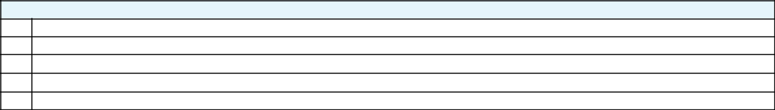

Check the appropriate box:

- Preliminary Proxy Statement

- CONFIDENTIAL, FOR USE OF THE COMMISSION ONLY (AS PERMITTED BY RULE 14a-6(e)(2))

- Definitive Proxy Statement

- Definitive Additional Materials

- Soliciting Material Pursuant to ss.240.14a-12

 |  | GENERAL MOTORS COMPANY
 |  | (Name of Registrant as Specified In Its Charter)
 |  | (Name of Person(s) Filing Proxy Statement, if other than the Registrant)
Payment of Filing Fee (Check the appropriate box):
☑ | No fee required.
☐ | Fee computed on table below per Exchange Act Rules 14a-6(i)(14) and 0-11.
 | (1) | Title of each class of securities to which transaction applies:
 | (2) | Aggregate number of securities to which transaction applies:
 | (3) | Per unit price or other underlying value of transaction computed pursuant to Exchange Act Rule 0-11 (set forth the amount on which the filing fee is calculated
 |  | and state how it was determined):
 | (4) | Proposed maximum aggregate value of transaction:
 | (5) | Total fee paid:
☐ | Fee paid previously with preliminary materials.
☐ | Check box if any part of the fee is offset as provided by Exchange Act Rule 0-11(a)(2) and identify the filing for which the offsetting fee was paid
 | previously. Identify the previous filing by registration statement number, or the Form or Schedule and the date of its filing.
 | (1) | Amount Previously Paid:
 | (2) | Form, Schedule or Registration Statement No.:
 | (3) | Filing Party:
 | (4) | Date Filed:



