UNITED STATES

SECURITIES AND EXCHANGE COMMISSION
Washington, DC 20549-1004

FORM 8-K

CURRENT REPORT

PURSUANT TO SECTION 13 OR 15(d) OF

THE SECURITIES EXCHANGE ACT OF 1934

Date of Report (Date of earliest event reported) September 7, 2011

GENERAL MOTORS COMPANY

(Exact Name of Registrant as Specified in its Charter)

001-34960

DELAWARE

27-0756180

(Commission

File Number)

(State or other jurisdiction

of incorporation)

(I.R.S. Employer

Identification No.)

300 Renaissance Center, Detroit, Michigan

48265-3000

(Address of Principal Executive Offices)

(Zip Code)

(313) 556-5000

(Registrant’s telephone number, including area code)

Not Applicable

(Former name or former address, if changed since last report)

Check the appropriate box below if the Form 8-K filing is intended to simultaneously satisfy the filing obligation of the registrant under any of the following provisions:

- Written communications pursuant to Rule 425 under the Securities Act (17 CFR 230.425)

- Soliciting material pursuant to Rule 14a-12 under the Exchange Act (17-CFR 240.14a-12)

- Pre-commencement communications pursuant to Rule 14d-2(b) under the Exchange Act (17 CFR 240.14d-2(b))

- Pre-commencement communications pursuant to Rule 13e-4(c) under the Exchange Act (17 CFR 240.13e-4(c))

TABLE OF CONTENTS

ITEM 8.01 Other Events

Signature

Index to Exhibits

Presentation Webcast Charts Dated September 7, 2011

ITEM 8.01 Other Events

On September 7, 2011, Mr. Stephen Girsky, Vice Chairman, conducted a webcast presentation hosted by Credit Suisse to provide an update on General Motors Company financial and operating strategy and the role of GM Ventures. The presentation related thereto is attached as Exhibit 99.1.

EXHIBITS

Exhibit |  | Description |  |  | Method of Filing
Exhibit | 99.1 |  | Presentation | Charts
 |  | Dated September 7, 2011 |  |  | Attached as Exhibit

SIGNATURE

Pursuant to the requirements of the Securities Exchange Act of 1934, the Registrant has duly caused this report to be signed on its behalf by the undersigned hereunto duly authorized.

GENERAL MOTORS COMPANY

(Registrant)

Date: September 9, 2011 By: /s/ Nick S. Cyprus

Nick S. Cyprus

Vice President, Controller and Chief Accounting

Officer

Exhibit 99.1
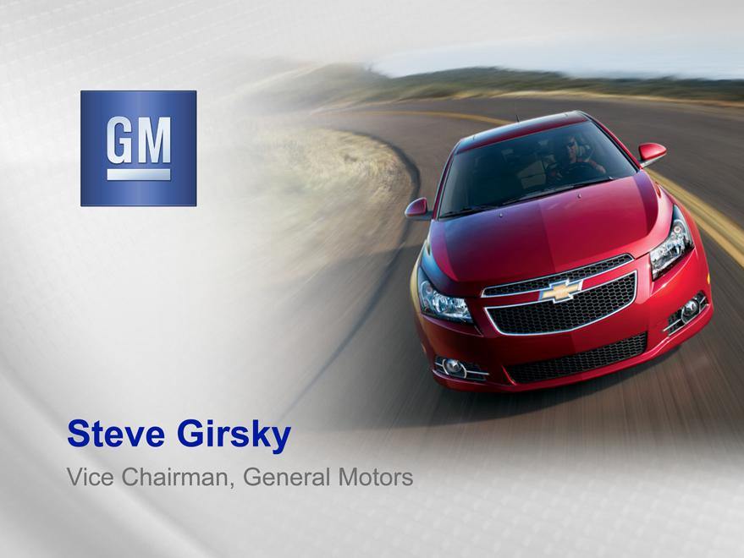

Exhibit 99.1
Steve Girsky
Vice Chairman, General Motors

FORWARDInthispresentationLOOKINGandinSTATEMENTSrelatedcomments by our management, our use of the words “expect,” “anticipate,” “possible,” “potential,” “target,” “believe,” “commit,” “intend,” “continue,” “may,” “would,” “could,”

reasonable,“should,”“project,”butthese“projected,”statements are“positioned”notguaranteesorsimilarofanyexpressionseventsorfinancialisintendedresults,toidentifyandourforwardactual resultslookingmaystatementsdiffermateriallythatrepresentdue toour varietycurrent ofjudgmentimportantaboutfactors.possibleAmongfutureotherevents.items,Wesuchbelievefactorsthesemightjudgmentsinclude:areour ability to realize production efficiencies and to achieve reductions in costs as a of our restructuring initiatives and labor our ability to maintain quality control over our vehicles and avoid material
modifications;
vehicle recalls; our suppliers’ ability to deliver parts, systems and components at such_{technology;}timestoallow us to meet production schedul_{vehicle}our ability to maintain adequate liquidity and financing sources and an appropriate
level of debt, including as required to fund our planned significant investment in new our ability to realize successful applications of new technology; and our ability to continue to attract new _{customers,} particularly for our new products.
GM’ most recent annual report on Form 10-K and quarterly reports on Form 10-Q provides information about these and other factors, which we may revise or supplement in future reports to the SEC.

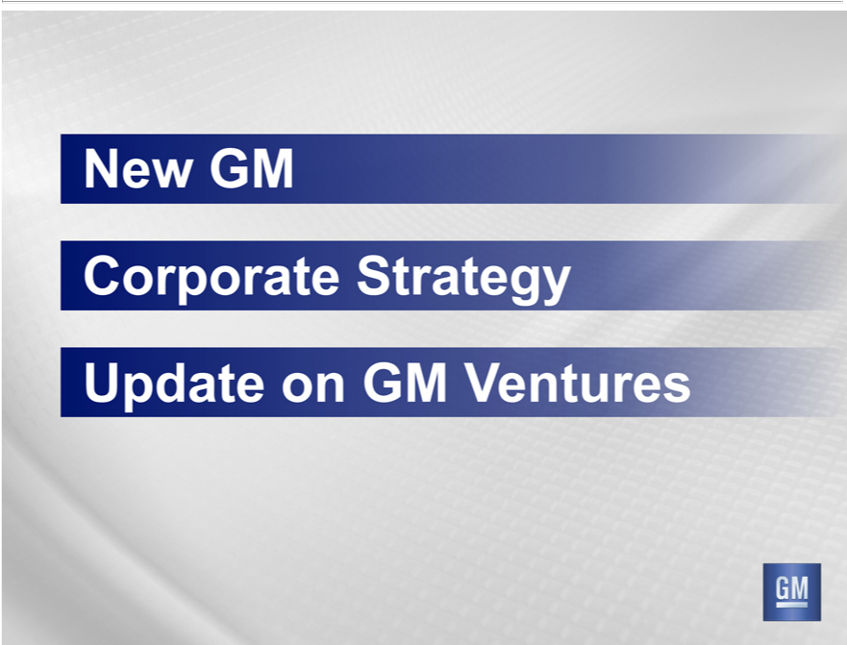

New GM
UpdateCorporateon StrategyGMVentures

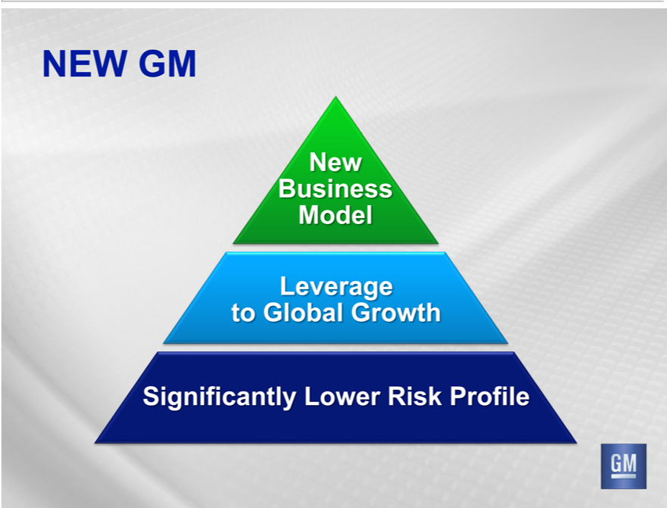

_{New}EWBusinessGM Model
SignificantlyLeveragetoGlobalLowerGrowthRiskProfile

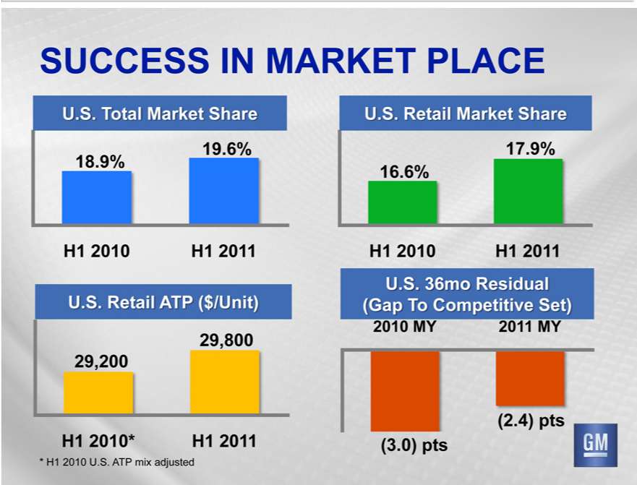

_{SUCCESS} IN MARKET PLACE
. . Total Market Share
19⁸.6%^{9%}
H1 201⁰
1
29,800U.S.Retail ATP ($/Unit)
H1 201^{0*}
1
17U.S.⁶.9%^{6%}Retail Market Share
H1 201⁰
1
2010U.S. 36moMY2011ResidualMY (Gap To Competitive Set)
(2³.4)⁰⁾ pts
* H1 2010 U.S. ATP mix adjusted

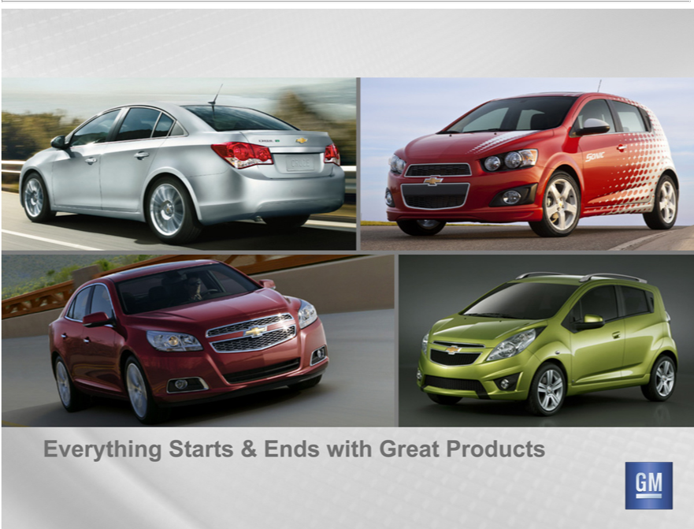

Everything Starts & Ends with Great Products



Everything Starts & Ends with Great Products

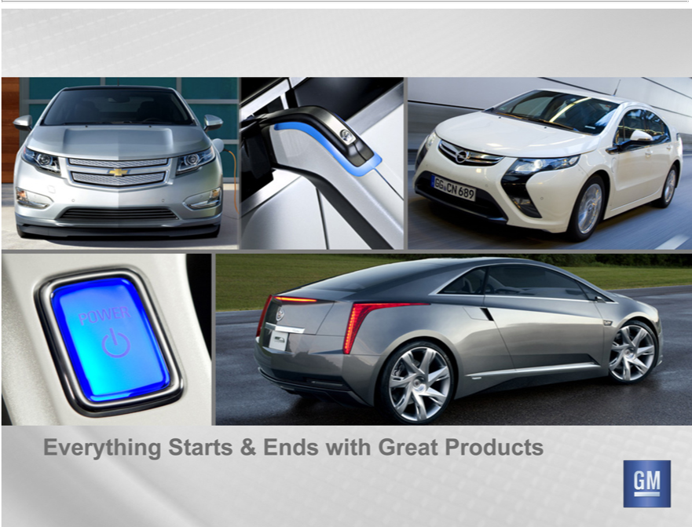

Everything Starts & Ends with Great Products

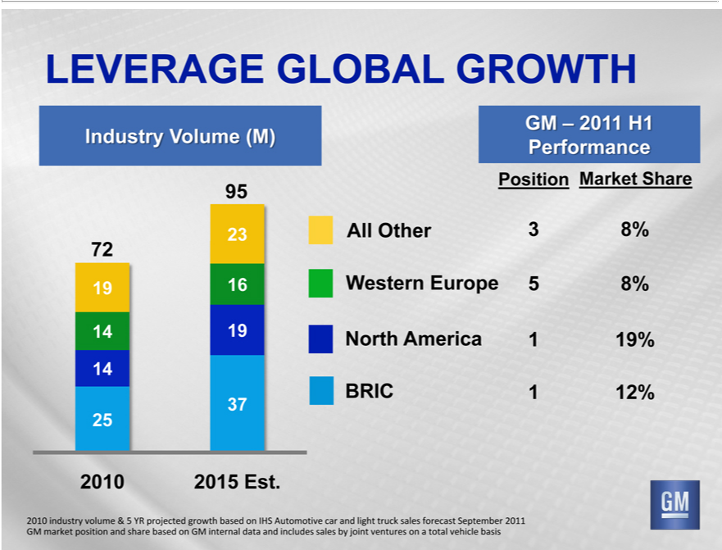

 | GLOBAL GROWTH
LEVERAGEIndustryolume (M)
72
9
14
5
2010
95
23
6
19
37
2015 Est.
GM – 2011 H1 Performance
Position Market Share
All Other 3 8%
Western Europe 5 8%
North America 1 19%
BRIC 1 12% |  | forecast September 2011
2010 industry volume & 5 YR projected growth based on IHS Automotive car and light truck |  | forecast September 2011
GM market position and share based on GM internal data and includes sales by joint ventures onsalestotal vehicle basis

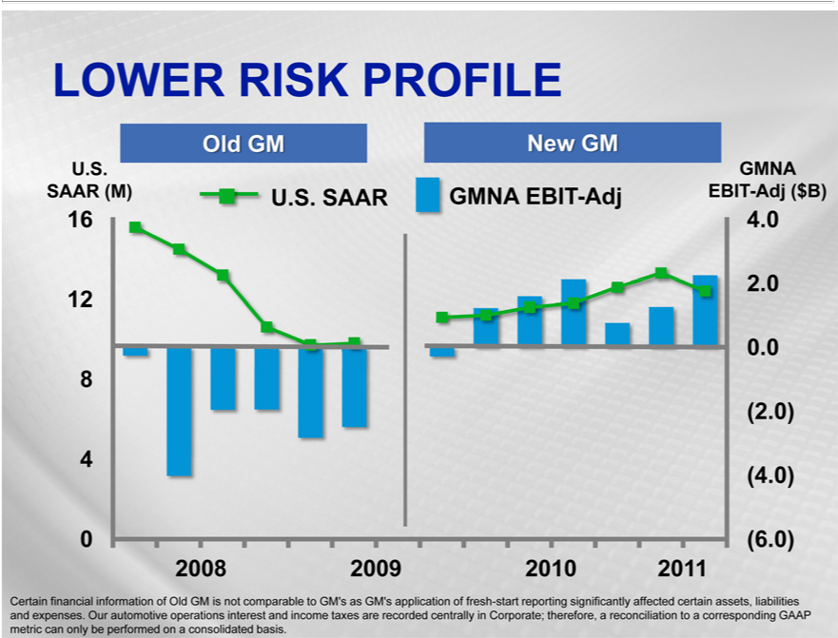

LOWER RISK PROFILE
Old GM
New GM
U. .
SAAR (M)
 | 6
12
8
4
0
U.S. SAAR
GMNA EBIT-Adj
2008 2009 2010 2011
GMNA EBIT-Adj ($B)
4
2
0.0
2
4
(6.0) |  | of fresh-start reporting significantly affected | assets, liabilities and expenses. Our automotive operations interest and
Certain financial information of Old GM is not comparable to GM’s as GM’s |  | of fresh-start reporting significantly affected
income taxes are recorded centrally in Corporate; therefore, a reconciliation toapplicationcorresponding GAAP metric can only be performed oncertainconsolidated basis.

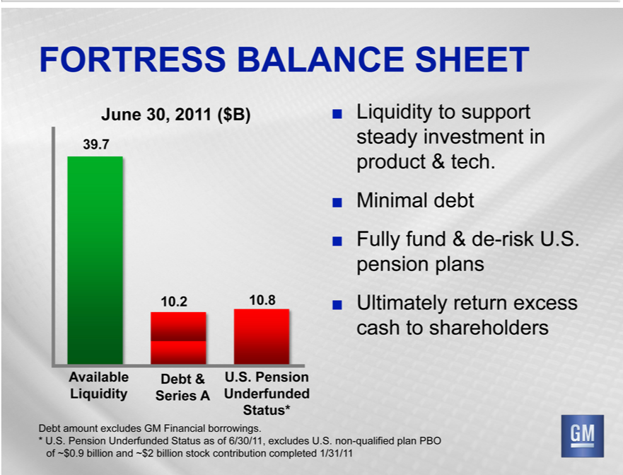

JuneFORTRESS30,2011BALANCE($B) SHEET
39 7
10.²
8
Available
DebtLiquidity&
UnderfundedSeries^{..PensionA}
Status*
MinimalLiquidity_{fund}toebtsupport steady investment in product & tech.
•
UltimatelyFully &returnde-riskexcessU.S.cashpensiontoshareholdersplans
Debt amount excludes GM Financial borrowings.
* U.S. Pension Underfunded Status as of 6/30/11, excludes U.S. non-qualified plan PBO of ~$0.9 billion and ~$2 billion stock contribution completed 1/31/11

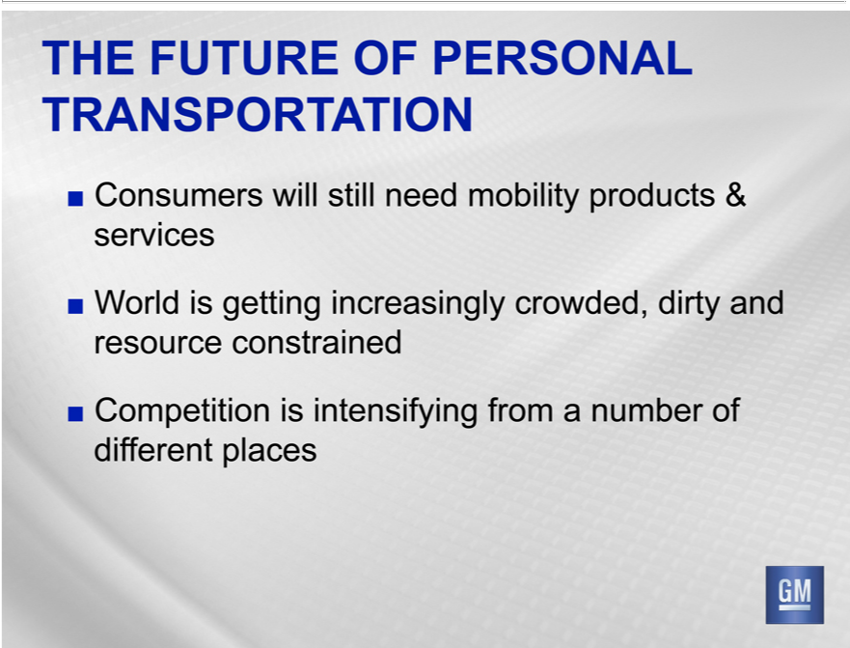

TRANSPORFUTUREATION
HE OF PERSONAL
Consumers will still need mobility produc^{dirty}s & services
•
CompetitionWorldisgettingisintensifyingincreasinglyfromcrowded,anumber ofanddifferentresourceplacesconstrained

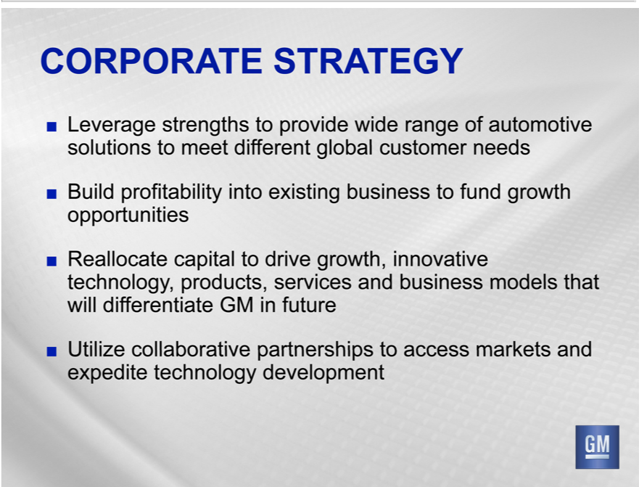

CORPORATE STRATEGY
Leverage strengths^{into}provide wide range of automotive solutions to meet different global customer needs
Build profitability existing business to fund growth opportunities
• Reallocate capital to drive growth, innovative technology, products, services and business models that will differentiate GM in future Utilize collaborative partnerships to access markets and expedite technology development

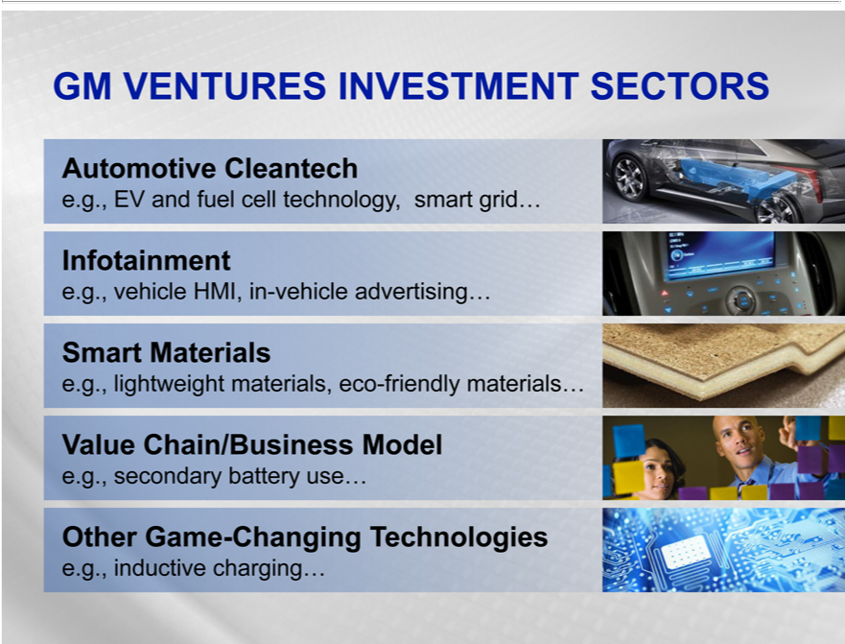

AutomotiveGMVENTURES^{Cleantech}INVESTMENT SECTORS
Infotainment.g.,.g.,EVand fuel cell technology, smart grid…
SmartvehicleMaterialsHMI, in-vehicle advertising…
Valuee.g.,lightweightChain/Businessmaterials,Modeleco-friendly materials…
_{Other}.g.,secondaryGame-Changingbattery use…Technologies
.g., inductive charging…

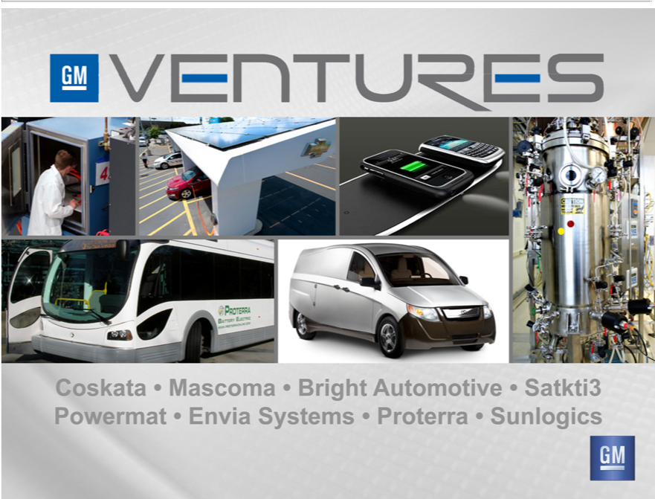

PowermatCoskata• Mascoma•EnviaSystems•Bright• AutomotiveProterra•Sunlogics•Satkti3

