UNITED STATES

SECURITIES AND EXCHANGE COMMISSION

Washington, DC 20549-1004

___________________

FORM 8-K

___________________

CURRENT REPORT

Pursuant to Section 13 or 15(d) of

the Securities Exchange Act of 1934

Date of Report (Date of earliest event reported) February 6, 2018

___________________

GENERAL MOTORS COMPANY

(Exact name of registrant as specified in its charter)

___________________

DELAWARE | 001-34960 | 27-0756180
(State or other jurisdiction of | 001-34960 | (I.R.S. Employer
incorporation) | (Commission File Number) | Identification No.)
300 Renaissance Center, Detroit, Michigan |  | 48265-3000
(Address of principal executive offices) |  | (Zip Code)

(313) 667-1500

(Registrant's telephone number, including area code)

Not Applicable

(Former name or former address, if changed since last report)

__________________

Check the appropriate box below if the Form 8-K filing is intended to simultaneously satisfy the filing obligation of the registrant under any of the following provisions:

- Written communications pursuant to Rule 425 under the Securities Act (17 CFR 230.425)

- Soliciting material pursuant to Rule 14a-12 under the Exchange Act (17-CFR 240.14a-12)

- Pre-commencement communications pursuant to Rule 14d-2(b) under the Exchange Act (17 CFR 240.14d-2(b))

- Pre-commencement communications pursuant to Rule 13e-4(c) under the Exchange Act (17 CFR 240.13e-4(c))

Indicate by check mark whether the registrant is an emerging growth company as defined in Rule 405 of the Securities Act of 1933 (§230.405 of this chapter) or Rule 12b-2 of the Securities Exchange Act of 1934 (§240.12b-2 of this chapter). Emerging growth company ☐

If an emerging growth company, indicate by check mark if the registrant has elected not to use the extended transition period for complying with any new or revised financial accounting standards provided pursuant to Section 13(a) of the Exchange Act. ☐

ITEM 2.02 Results of Operations and Financial Condition

On February 6, 2018 General Motors Company (GM) issued a news release and supplemental materials on the subject of its 2017 fourth quarter and full year consolidated earnings. The news release and supplemental materials are attached as Exhibit 99.1 and Exhibit 99.2.

Charts furnished to securities analysts in connection with GM's 2017 fourth quarter and full year consolidated earnings release are available on GM's website at www.gm.com/investors/earnings-releases.html.

ITEM 9.01 Financial Statements and Exhibits

 |  |  |  | EXHIBIT
Exhibit |  | Description
Exhibit 99.1 |  | News Release Dated February 6, 2018
Exhibit 99.2 |  | Financial Highlights Dated February 6, 2018

SIGNATURE

Pursuant to the requirements of the Securities Exchange Act of 1934, the registrant has duly caused this report to be signed on its behalf by the undersigned hereunto duly authorized.

 | GENERAL MOTORS COMPANY (Registrant)
By: | /s/ THOMAS S. TIMKO
Date: February 6, 2018
Date: February 6, 2018 | Thomas S. Timko, Vice President, Global Business Solutions and Chief
 | Accounting Officer

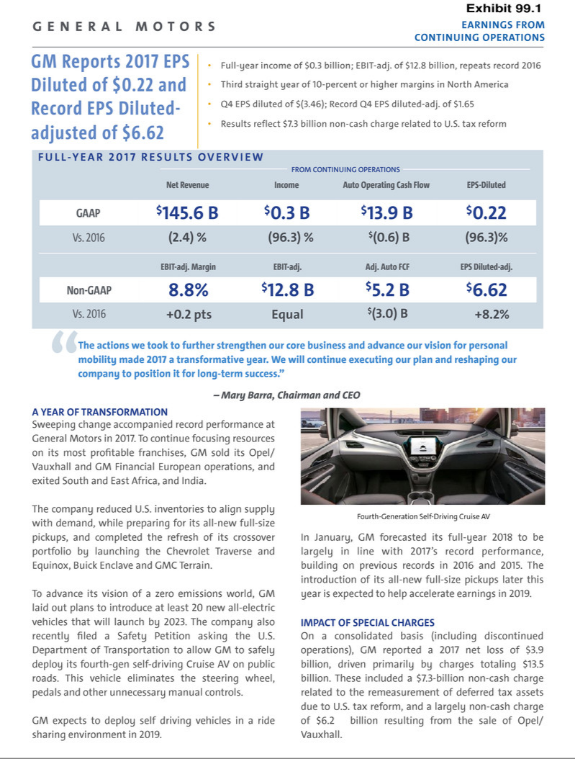

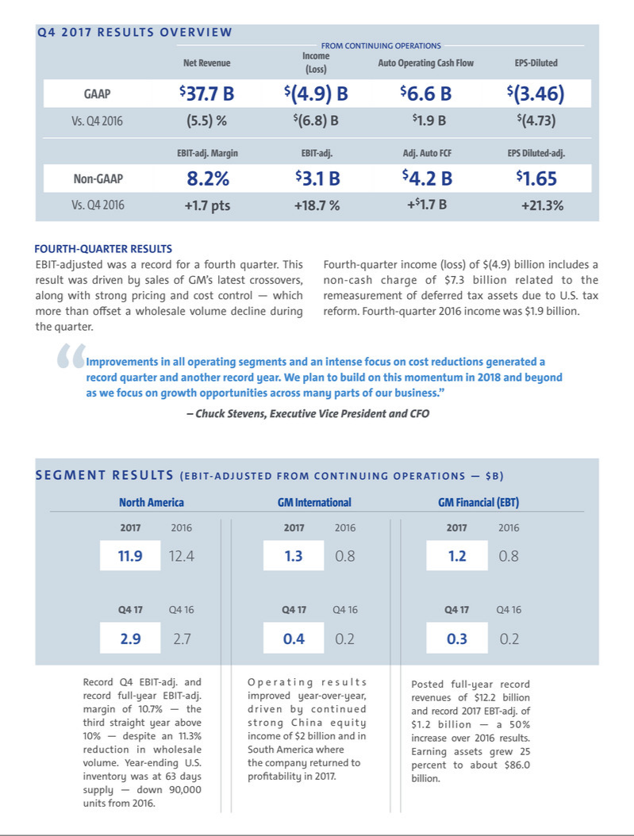

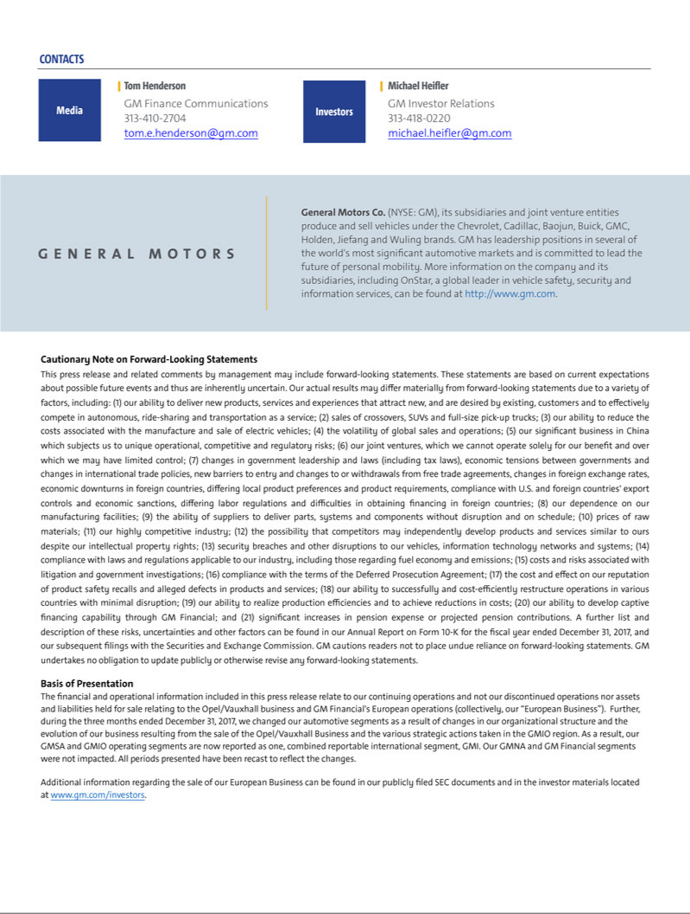

Exhibit 99.2

General Motors Company and Subsidiaries

Supplemental Material

(Unaudited)

Unless otherwise indicated, General Motors Company's (GM) non-GAAP measures are related to our continuing operations and not our discontinued operations or our assets and liabilities held for sale. GM's non-GAAP measures include earnings before interest and taxes (EBIT)-adjusted, presented net of noncontrolling interests, earnings per share (EPS)-diluted-adjusted, effective tax rate-adjusted (ETR-adjusted), return on invested capital-adjusted (ROIC-adjusted) and adjusted automotive free cash flow. GM's calculation of these non-GAAP measures may not be comparable to similarly titled measures of other companies due to potential differences between companies in the method of calculation. As a result, the use of these non-GAAP measures has limitations and should not be considered superior to, in isolation from, or as a substitute for, related U.S. GAAP measures.

These non-GAAP measures allow management and investors to view operating trends, perform analytical comparisons and benchmark performance between periods and among geographic regions to understand operating performance without regard to items we do not consider a component of our core operating performance. Furthermore, these non-GAAP measures allow investors the opportunity to measure and monitor our performance against our externally communicated targets and evaluate the investment decisions being made by management to improve ROIC-adjusted. Management uses these measures in its financial, investment and operational decision-making processes, for internal reporting and as part of its forecasting and budgeting processes. Further, our Board of Directors uses certain of these and other measures as key metrics to determine management performance under our performance-based compensation plans. For these reasons we believe these non-GAAP measures are useful for our investors.

EBIT-adjusted EBIT-adjusted is presented net of noncontrolling interests and is used by management and can be used by investors to review our consolidated operating results because it excludes automotive interest income, automotive interest expense and income taxes as well as certain additional adjustments that are not considered part of our core operations. Examples of adjustments to EBIT include but are not limited to impairment charges related to goodwill; impairment charges on long-lived assets and other exit costs resulting from strategic shifts in our operations or discrete market and business conditions; costs arising from the ignition switch recall and related legal matters; and certain currency devaluations associated with hyperinflationary economies. For EBIT-adjusted and our other non-GAAP measures, once we have made an adjustment in the current period for an item, we will also adjust the related non-GAAP measure in any future periods in which there is an impact from the item.

EPS-diluted-adjusted EPS-diluted-adjusted is used by management and can be used by investors to review our consolidated diluted EPS results on a consistent basis. EPS-diluted-adjusted is calculated as net income attributable to common stockholders-diluted less income (loss) from discontinued operations on an after-tax basis, adjustments noted above for EBIT-adjusted, gains or losses on the extinguishment of debt obligations on an after-tax basis and certain income tax adjustments divided by weighted-average common shares outstanding-diluted. Examples of income tax adjustments include the establishment or reversal of significant deferred tax asset valuation allowances.

ETR-adjusted ETR-adjusted is used by management and can be used by investors to review the consolidated effective tax rate for our core operations on a consistent basis. ETR-adjusted is calculated as Income tax expense less the income tax related to the adjustments noted above for EBIT-adjusted and the income tax adjustments noted above for EPS-diluted-adjusted divided by Income before income taxes less adjustments.

ROIC-adjusted ROIC-adjusted is used by management and can be used by investors to review our investment and capital allocation decisions. We define ROIC-adjusted as EBIT-adjusted for the trailing four quarters divided by ROIC-adjusted average net assets, which is considered to be the average equity balances adjusted for average automotive debt and interest liabilities, exclusive of capital leases; average automotive net pension and other postretirement benefits (OPEB) liabilities; and average automotive net income tax assets during the same period. Adjustments to the average equity balances exclude assets and liabilities classified as either assets held for sale or liabilities held for sale.

Adjusted automotive free cash flow Adjusted automotive free cash flow is used by management and can be used by investors to review the liquidity of our automotive operations and to measure and monitor our performance against our capital allocation program and evaluate our automotive liquidity against the substantial cash requirements of our automotive operations. We measure adjusted automotive free cash flow as automotive operating cash flow from continuing operations less capital expenditures adjusted for management actions, primarily related to strengthening our balance sheet, such as prepayments of debt and discretionary contributions to employee benefit plans.

1

General Motors Company and Subsidiaries

Supplemental Material

(Unaudited)

The following table reconciles segment profit to Net income (loss) attributable to stockholders under U.S. GAAP (dollars in millions):

 |  | Three Months Ended |  |  |  |  |  | Years Ended
 |  | December 31, 2017 |  | December 31, 2016 |  |  | December 31, 2017 |  |  | December 31, 2016
Operating segments
GM North America (GMNA) | $ | 2,875 |  | $ | 2,680 |  | $ | 11,889 |  | $ | 12,388
GM International (GMI)(a) |  | 416 |  |  | 223 |  |  | 1,300 |  |  | 767
General Motors Financial Company, Inc. (GM Financial)(b) |  | 301 |  |  | 163 |  |  | 1,196 |  |  | 763
Total operating segments |  | 3,592 |  |  | 3,066 |  |  | 14,385 |  |  | 13,918
Corporate and eliminations(c) |  | (507) |  |  | (468) |  |  | (1,541) |  |  | (1,070)
EBIT-adjusted |  | 3,085 |  |  | 2,598 |  |  | 12,844 |  |  | 12,848
Special items
GMI restructuring(d) |  | — |  |  | — |  |  | (460) |  |  | —
Venezuela-related matters(e) |  | — |  |  | — |  |  | (80) |  |  | —
Ignition switch recall and related legal matters(f) |  | — |  |  | (235) |  |  | (114) |  |  | (300)
Total special items |  | — |  |  | (235) |  |  | (654) |  |  | (300)
Automotive interest income |  | 82 |  |  | 45 |  |  | 266 |  |  | 182
Automotive interest expense |  | (145) |  |  | (150) |  |  | (575) |  |  | (563)
Income tax expense(g) |  | (7,896) |  |  | (303) |  |  | (11,533) |  |  | (2,739)
Income (loss) from continuing operations(h) |  | (4,874) |  |  | 1,955 |  |  | 348 |  |  | 9,428
(Loss) from discontinued operations, net of tax(i) |  | (277) |  |  | (120) |  |  | (4,212) |  |  | (1)
Net income (loss) attributable to stockholders | $ | (5,151) |  | $ | 1,835 |  | $ | (3,864) |  | $ | 9,427
__________
- During the three months ended December 31, 2017, we changed our automotive segments as a result of changes in our organizational structure and the evolution of our business resulting from the sale of the Opel and Vauxhall businesses and certain other assets in Europe (the Opel/Vauxhall Business) and the various strategic actions taken in the GM International Operations (GMIO) region. As a result, our GM South America (GMSA) and GMIO operating segments are now reported as one, combined reportable international segment, GMI. Our GMNA and GM Financial segments were not impacted. All periods presented have been recast to reflect the changes. Refer to the reconciliation of key financial information of our GMIO and GMSA operating segments under U.S. GAAP to key financial information of GMI within a following section for details.

- GM Financial amounts represent earnings before income taxes-adjusted.

- GM's automotive operations' interest income and interest expense, Maven, legacy costs from the Opel/Vauxhall Business, which are primarily pension costs, corporate expenditures including autonomous vehicle-related engineering and other costs and certain nonsegment specific revenues and expenses are recorded centrally in Corporate.
- This adjustment was excluded because of a strategic decision to rationalize our core operations by exiting or significantly reducing our presence in various international markets to focus resources on opportunities expected to deliver higher returns. The adjustment primarily consists of asset impairments, sales incentives, inventory provisions, dealer restructuring, employee separations and other contract cancellation costs in India and South Africa.

- This adjustment was excluded because we ceased operations and terminated employment relationships in Venezuela.

- These adjustments were excluded because of the unique events associated with the ignition switch recall. These events included the creation of the Ignition Switch Recall Compensation Program, as well as various investigations, inquiries and complaints from constituents.
- Income tax expense includes a special item of $9.1 billion in the year ended December 31, 2017 which represents the tax expense of $7.3 billion related to U.S. tax reform legislation recorded in the three months ended December 31, 2017 and the establishment of a valuation allowance against deferred tax assets of $2.3 billion that will no longer be realizable as a result of the sale of the Opel/Vauxhall Business, partially offset by tax benefits related to tax settlements.

- Net of Net loss attributable to noncontrolling interests.

- Represents the results of the Opel/Vauxhall Business and our European financing subsidiaries and branches (the Fincos, and together with the Opel/Vauxhall Business, the European Business).

2

General Motors Company and Subsidiaries

Supplemental Material

(Unaudited)

The following table reconciles diluted earnings (loss) per common share under U.S. GAAP to EPS-diluted-adjusted (dollars in millions):

 |  |  |  |  | Three Months Ended |  |  |  |  |  |  |  |  |  |  |  | Years Ended
 |  | December 31, 2017 |  |  |  |  |  | December 31, 2016 |  |  |  |  |  | December 31, 2017 |  |  |  |  |  | December 31, 2016
 |  | Amount |  |  | Per Share |  |  | Amount |  |  | Per Share |  |  | Amount |  |  | Per Share |  |  | Amount |  |  | Per Share
Diluted earnings (loss) per common share | $ | (5,165) |  | $ | (3.65) |  | $ | 1,835 |  | $ | 1.19 |  | $ | (3,880) |  | $ | (2.60) |  | $ | 9,427 |  | $ | 6.00
Impact of including dilutive securities(a) |  |  |  |  | 0.07 |  |  |  |  |  | — |  |  |  |  |  | — |  |  |  |  |  | —
Diluted loss per common share – discontinued
operations |  | 277 |  |  | 0.19 |  |  | 120 |  |  | 0.08 |  |  | 4,212 |  |  | 2.82 |  |  | 1 |  |  | —
Adjustments(b) |  | — |  |  | — |  |  | 235 |  |  | 0.15 |  |  | 654 |  |  | 0.44 |  |  | 300 |  |  | 0.19
Tax effect on adjustments(c) |  | — |  |  | — |  |  | (89) |  |  | (0.06) |  |  | (208) |  |  | (0.14) |  |  | (114) |  |  | (0.07)
Tax adjustments(d) |  | 7,271 |  |  | 5.04 |  |  | — |  |  | — |  |  | 9,099 |  |  | 6.10 |  |  | — |  |  | —
EPS-diluted-adjusted | $ | 2,383 |  | $ | 1.65 |  | $ | 2,101 |  | $ | 1.36 |  | $ | 9,877 |  | $ | 6.62 |  | $ | 9,614 |  | $ | 6.12
________
- Represents the dilutive effect of warrants and awards under stock incentive plans. Refer to the table below for the effect on weighted-average common shares outstanding – diluted-adjusted.
- Refer to the reconciliation of segment profit to Net income (loss) attributable to stockholders under U.S. GAAP for adjustment details.

- The tax effect of each adjustment is determined based on the tax laws and valuation allowance status of the jurisdiction to which the adjustment relates.

- In the year ended December 31, 2017 these adjustments consist of the tax expense of $7.3 billion related to U.S. tax reform legislation recorded in the three months ended December 31, 2017 and the establishment of a valuation allowance against deferred tax assets of $2.3 billion that will no longer be realizable as a result of the sale of the Opel/Vauxhall Business, partially offset by tax benefits related to tax settlements.

The following table reconciles weighted-average common shares outstanding – diluted under U.S. GAAP to weighted-average common shares outstanding – diluted-adjusted used in the calculation of EPS-diluted-adjusted (shares in millions):

 | Three Months Ended |  |  |  | Years Ended
 | December 31, 2017 |  | December 31, 2016 |  | December 31, 2017 |  | December 31, 2016
Weighted-average common shares outstanding – diluted | 1,414 |  | 1,546 |  | 1,492 |  | 1,570
Dilutive effect of warrants and awards under stock incentive plans | 30 |  | — |  | — |  | —
Weighted-average common shares outstanding – diluted-adjusted | 1,444 |  | 1,546 |  | 1,492 |  | 1,570

The following table reconciles our effective tax rate under U.S. GAAP to ETR-adjusted (dollars in millions):

 |  |  |  |  |  |  | Years Ended December 31,
 |  |  |  |  | 2017 |  |  |  |  |  |  |  | 2016
 |  | Income before |  |  | Income tax |  | Effective tax |  |  | Income before |  |  | Income tax |  | Effective tax
 |  | income taxes |  |  | expense |  | rate |  |  | income taxes |  |  | expense |  | rate
Effective tax rate | $ | 11,863 |  | $ | 11,533 | 97.2% |  |  | $ | 12,008 |  | $ | 2,739 | 22.8%
Adjustments(a) |  | 654 |  |  | 208 |  |  |  |  | 300 |  |  | 114
Tax adjustments(b) |  |  |  |  | (9,099) |  |  |  |  |  |  |  | —
ETR-adjusted | $ | 12,517 |  | $ | 2,642 | 21.1% |  |  | $ | 12,308 |  | $ | 2,853 | 23.2%
________
- Refer to the reconciliation of segment profit to Net income (loss) attributable to stockholders under U.S. GAAP for adjustment details.

- Refer to the reconciliation of diluted earnings (loss) per common share under U.S. GAAP to EPS-diluted-adjusted within a previous section for adjustment details.

3

General Motors Company and Subsidiaries

Supplemental Material

(Unaudited)

We define return on equity (ROE) as Net income (loss) attributable to stockholders for the trailing four quarters divided by average equity for the same period. Management uses average equity to provide comparable amounts in the calculation of ROE. The following table summarizes the calculation of ROE (dollars in billions):

 |  |  | Years Ended December 31,
 |  |  | 2017 |  |  | 2016
Net income (loss) attributable to stockholders | $ |  | (3.9) |  | $ | 9.4
Average equity | $ |  | 42.2 |  | $ | 43.6
ROE |  |  | (9.2)% |  |  | 21.6%
The following table summarizes the calculation of ROIC-adjusted (dollars in billions):
 |  |  | Years Ended December 31,
 |  |  | 2017 |  |  | 2016
EBIT-adjusted(a) | $ |  | 12.8 |  | $ | 12.8
Average equity | $ |  | 42.2 |  | $ | 43.6
Add: Average automotive debt and interest liabilities (excluding capital leases) |  |  | 11.6 |  |  | 9.9
Add: Average automotive net pension & OPEB liability |  |  | 21.0 |  |  | 22.0
Less: Average automotive net income tax asset |  |  | (29.3) |  |  | (32.8)
ROIC-adjusted average net assets | $ |  | 45.5 |  | $ | 42.7
ROIC-adjusted |  |  | 28.2% |  |  | 30.1%
________
- Refer to the reconciliation of segment profit to Net income (loss) attributable to stockholders under U.S. GAAP for adjustment details.

The following table reconciles Net automotive cash provided by operating activities from continuing operations under U.S. GAAP to adjusted automotive free cash flow (dollars in millions):

 |  |  | Three Months Ended |  |  |  |  |  | Years Ended
 |  | December 31, 2017 |  |  | December 31, 2016 |  |  | December 31, 2017 |  |  | December 31, 2016
 | Net automotive cash provided by operating activities – continuing operations | $ | 6,607 |  | $ | 4,707 |  | $ | 13,872 |  | $ | 14,494
 | Less: capital expenditures – continuing operations |  | (2,072) |  |  | (2,247) |  |  | (8,359) |  |  | (8,291)
 | Adjustments
 | Discretionary U.S. pension plan contributions |  | — |  |  | — |  |  | — |  |  | 1,982
 | U.K. pension plan contribution(a) |  | 198 |  |  | — |  |  | 198 |  |  | —
 | GM Financial dividend(a) |  | (550) |  |  | — |  |  | (550) |  |  | —
 | Total adjustments |  | (352) |  |  | — |  |  | (352) |  |  | 1,982
 | Adjusted automotive free cash flow – continuing operations |  | 4,183 |  |  | 2,460 |  |  | 5,161 |  |  | 8,185
 | Net automotive cash used in operating activities – discontinued operations |  | (51) |  |  | (405) |  |  | (36) |  |  | (111)
 | Less: capital expenditures – discontinued operations |  | — |  |  | (352) |  |  | (653) |  |  | (1,143)
 | Adjusted automotive free cash flow | $ | 4,132 |  | $ | 1,703 |  | $ | 4,472 |  | $ | 6,931
________

- These cash flows were excluded because they resulted from the sale of the European Business.

4

General Motors Company and Subsidiaries

Supplemental Material

(Unaudited)

The following tables summarize key financial information by segment (dollars in millions):

 |  |  |  |  |  |  |  |  |  |  |  |  |  | Total |  |  | GM
 |  | GMNA |  |  | GMI(a) |  |  | Corporate |  |  | Eliminations |  |  | Automotive |  |  | Financial |  |  | Eliminations |  |  | Total
Three Months Ended December 31, 2017
Net sales and revenue | $ | 28,751 |  | $ | 5,694 |  | $ | 36 |  |  |  |  | $ | 34,481 |  | $ | 3,252 |  | $ | (18) |  | $ | 37,715
Expenditures for property | $ | 1,846 |  | $ | 195 |  | $ | 31 |  | $ | — |  | $ | 2,072 |  | $ | 28 |  | $ | — |  | $ | 2,100
Depreciation and amortization | $ | 1,155 |  | $ | 173 |  | $ | 10 |  | $ | — |  | $ | 1,338 |  | $ | 1,816 |  | $ | — |  | $ | 3,154
Impairment charges | $ | 19 |  | $ | 4 |  | $ | — |  | $ | — |  | $ | 23 |  | $ | — |  | $ | — |  | $ | 23
Equity income(b) | $ | — |  | $ | 503 |  | $ | — |  | $ | — |  | $ | 503 |  | $ | 44 |  | $ | — |  | $ | 547
 |  |  |  |  |  |  |  |  |  |  |  |  |  | Total |  |  | GM
 |  | GMNA |  |  | GMI(a) |  |  | Corporate |  |  | Eliminations |  |  | Automotive |  |  | Financial |  |  | Eliminations |  |  | Total
Three Months Ended December 31, 2016
Net sales and revenue | $ | 31,298 |  | $ | 6,009 |  | $ | 36 |  |  |  |  | $ | 37,343 |  | $ | 2,554 |  | $ | (1) |  | $ | 39,896
Expenditures for property | $ | 1,985 |  | $ | 257 |  | $ | 5 |  | $ | — |  | $ | 2,247 |  | $ | 35 |  | $ | — |  | $ | 2,282
Depreciation and amortization | $ | 1,107 |  | $ | 170 |  | $ | 7 |  | $ | (2) |  | $ | 1,282 |  | $ | 1,388 |  | $ | — |  | $ | 2,670
Impairment charges | $ | 21 |  | $ | 3 |  | $ | — |  | $ | — |  | $ | 24 |  | $ | — |  | $ | — |  | $ | 24
Equity income (loss)(b) | $ | (3) |  | $ | 525 |  | $ | — |  | $ | — |  | $ | 522 |  | $ | 43 |  | $ | — |  | $ | 565
 |  |  |  |  |  |  |  |  |  |  |  |  |  | Total |  |  | GM
 |  | GMNA |  |  | GMI(a) |  |  | Corporate |  |  | Eliminations |  |  | Automotive |  |  | Financial |  |  | Eliminations |  |  | Total
Year Ended December 31, 2017
Net sales and revenue | $ | 111,345 |  | $ | 21,920 |  | $ | 342 |  |  |  |  | $ | 133,607 |  | $ | 12,151 |  | $ | (170) |  | $ | 145,588
Expenditures for property | $ | 7,704 |  | $ | 607 |  | $ | 48 |  | $ | — |  | $ | 8,359 |  | $ | 94 |  | $ | — |  | $ | 8,453
Depreciation and amortization | $ | 4,654 |  | $ | 708 |  | $ | 33 |  | $ | (1) |  | $ | 5,394 |  | $ | 6,573 |  | $ | — |  | $ | 11,967
Impairment charges | $ | 78 |  | $ | 211 |  | $ | 5 |  | $ | — |  | $ | 294 |  | $ | — |  | $ | — |  | $ | 294
Equity income(b) | $ | 8 |  | $ | 1,951 |  | $ | — |  | $ | — |  | $ | 1,959 |  | $ | 173 |  | $ | — |  | $ | 2,132
 |  |  |  |  |  |  |  |  |  |  |  |  |  | Total |  |  | GM
 |  | GMNA |  |  | GMI(a) |  |  | Corporate |  |  | Eliminations |  |  | Automotive |  |  | Financial |  |  | Eliminations |  |  | Total
Year Ended December 31, 2016
Net sales and revenue | $ | 119,113 |  | $ | 20,943 |  | $ | 149 |  |  |  |  | $ | 140,205 |  | $ | 8,983 |  | $ | (4) |  | $ | 149,184
Expenditures for property | $ | 7,338 |  | $ | 943 |  | $ | 12 |  | $ | (2) |  | $ | 8,291 |  | $ | 93 |  | $ | — |  | $ | 8,384
Depreciation and amortization | $ | 4,292 |  | $ | 702 |  | $ | 19 |  | $ | (5) |  | $ | 5,008 |  | $ | 4,678 |  | $ | — |  | $ | 9,686
Impairment charges | $ | 65 |  | $ | 68 |  | $ | — |  | $ | — |  | $ | 133 |  | $ | — |  | $ | — |  | $ | 133
Equity income(b) | $ | 159 |  | $ | 1,971 |  | $ | — |  | $ | — |  | $ | 2,130 |  | $ | 152 |  | $ | — |  | $ | 2,282
________
- During the three months ended December 31, 2017, we changed our automotive segments as a result of changes in our organizational structure and the evolution of our business resulting from the sale of the Opel/Vauxhall Business and the various strategic actions taken in the GMIO region. As a result, our GMSA and GMIO operating segments are now reported as one, combined reportable international segment, GMI. Our GMNA and GM Financial segments were not impacted. All periods presented have been recast to reflect the changes. Refer to the reconciliation of key financial information of our GMIO and GMSA operating segments under U.S. GAAP to key financial information of GMI within the following section for details.

- Includes Automotive China equity income of $504 million and $525 million in the three months ended December 31, 2017 and 2016 and $2.0 billion in the years ended December 31, 2017 and 2016.

5

General Motors Company and Subsidiaries

Supplemental Material

(Unaudited)

The following tables reconcile key financial information of our GMIO and GMSA operating segments under U.S. GAAP to key financial information of GMI (dollars in millions):

 |  | GMIO |  |  | GMSA |  |  | GMI
Three Months Ended December 31, 2017
Net sales and revenue | $ | 2,908 |  | $ | 2,786 |  | $ | 5,694
Earnings before interest and taxes-adjusted | $ | 339 |  | $ | 77 |  | $ | 416
Expenditures for property | $ | 62 |  | $ | 133 |  | $ | 195
Depreciation and amortization | $ | 102 |  | $ | 71 |  | $ | 173
Impairment charges | $ | 4 |  | $ | — |  | $ | 4
Equity income | $ | 503 |  | $ | — |  | $ | 503
 |  | GMIO |  |  | GMSA |  |  | GMI
Three Months Ended December 31, 2016
Net sales and revenue | $ | 3,796 |  | $ | 2,213 |  | $ | 6,009
Earnings (loss) before interest and taxes-adjusted | $ | 289 |  | $ | (66) |  | $ | 223
Expenditures for property | $ | 168 |  | $ | 89 |  | $ | 257
Depreciation and amortization | $ | 111 |  | $ | 59 |  | $ | 170
Impairment charges | $ | 3 |  | $ | — |  | $ | 3
Equity income | $ | 525 |  | $ | — |  | $ | 525
 |  | GMIO |  |  | GMSA |  |  | GMI
Year Ended December 31, 2017
Net sales and revenue | $ | 12,308 |  | $ | 9,612 |  | $ | 21,920
Earnings (loss) before interest and taxes-adjusted | $ | 1,313 |  | $ | (13) |  | $ | 1,300
Expenditures for property | $ | 258 |  | $ | 349 |  | $ | 607
Depreciation and amortization | $ | 429 |  | $ | 279 |  | $ | 708
Impairment charges | $ | 208 |  | $ | 3 |  | $ | 211
Equity income | $ | 1,951 |  | $ | — |  | $ | 1,951
 |  | GMIO |  |  | GMSA |  |  | GMI
Year Ended December 31, 2016
Net sales and revenue | $ | 13,719 |  | $ | 7,224 |  | $ | 20,943
Earnings (loss) before interest and taxes-adjusted | $ | 1,133 |  | $ | (366) |  | $ | 767
Expenditures for property | $ | 585 |  | $ | 358 |  | $ | 943
Depreciation and amortization | $ | 441 |  | $ | 261 |  | $ | 702
Impairment charges | $ | 68 |  | $ | — |  | $ | 68
Equity income | $ | 1,971 |  | $ | — |  | $ | 1,971

6

General Motors Company and Subsidiaries

Supplemental Material

(Unaudited)

Vehicle Sales

GM presents both wholesale and retail vehicle sales data to assist in the analysis of our revenue and our market share. GM does not currently export vehicles to Cuba, Iran, North Korea, Sudan or Syria. Accordingly these countries are excluded from industry sales data and corresponding calculation of GM's market share.

Wholesale vehicle sales data, which represents sales directly to dealers and others, including sales to fleet customers, is the measure that correlates to GM's revenue from the sale of vehicles, which is the largest component of Automotive net sales and revenue. Wholesale vehicle sales exclude vehicles sold by joint ventures. In the year ended December 31, 2017 39% of our wholesale vehicle sales volume was generated outside the U.S. The following table summarizes total wholesale vehicle sales of new vehicles by automotive segment (vehicles in thousands):

 |  | Three Months Ended |  |  |  | Years Ended
 |  | December 31, 2017 |  | December 31, 2016 |  | December 31, 2017 |  | December 31, 2016
 | GMNA(a) | 915 |  | 1,050 |  | 3,511 |  | 3,958
 | GMI(b) | 328 |  | 355 |  | 1,267 |  | 1,255
 | Total | 1,243 |  | 1,405 |  | 4,778 |  | 5,213
 | Discontinued operations | — |  | 295 |  | 696 |  | 1,199
__________
- Wholesale vehicle sales related to transactions with the European Business were insignificant for the three months and years ended December 31, 2017 and 2016.

- Wholesale vehicle sales include 34 vehicles related to transactions with the European Business for the three months ended December 31, 2016 and 131 and 128 vehicles for the years ended December 31, 2017 and 2016.

7

General Motors Company and Subsidiaries

Supplemental Material

(Unaudited)

Retail vehicle sales data, which represents sales to end customers based upon the good faith estimates of management, including sales to fleet customers, does not correlate directly to the revenue GM recognizes during the period. However retail vehicle sales data is indicative of the underlying demand for GM vehicles. Market share information is based primarily on retail vehicle sales volume. In countries where retail vehicle sales data is not readily available, other data sources such as wholesale or forecast volumes are used to estimate retail vehicle sales to end customers.

Retail vehicle sales data includes all sales by joint ventures on a total vehicle basis, not based on the percentage of ownership in the joint venture. Certain joint venture agreements in China allow for the contractual right to report vehicle sales of non-GM trademarked vehicles by those joint ventures. Retail vehicle sales data includes vehicles used by dealers under courtesy transportation programs and vehicles sold through the dealer registration channel, primarily in Europe. This sales channel consists primarily of dealer demonstrator, loaner and self-registered vehicles which are not eligible to be sold as new vehicles after being registered by dealers. Certain fleet sales that are accounted for as operating leases are included in retail vehicle sales at the time of delivery to daily rental car companies. The following table summarizes total industry retail sales, or estimated sales where retail sales volume is not available, by geographic region (vehicles in thousands):

 | Three Months Ended |  |  |  | Years Ended
 | December 31, 2017 |  | December 31, 2016 |  | December 31, 2017 |  | December 31, 2016
United States
Chevrolet – Cars | 147 |  | 188 |  | 617 |  | 736
Chevrolet – Trucks | 261 |  | 251 |  | 926 |  | 915
Chevrolet – Crossovers | 142 |  | 125 |  | 522 |  | 445
Cadillac | 43 |  | 51 |  | 156 |  | 170
Buick | 59 |  | 60 |  | 219 |  | 230
GMC | 155 |  | 155 |  | 562 |  | 547
Total United States | 807 |  | 830 |  | 3,002 |  | 3,043
Canada, Mexico and Other | 150 |  | 171 |  | 574 |  | 587
Total North America(a) | 957 |  | 1,001 |  | 3,576 |  | 3,630
Asia/Pacific, Middle East and Africa
Chevrolet | 310 |  | 328 |  | 981 |  | 1,020
Wuling | 340 |  | 384 |  | 1,141 |  | 1,352
Buick | 347 |  | 339 |  | 1,183 |  | 1,183
Baojun | 356 |  | 277 |  | 997 |  | 755
Cadillac | 53 |  | 44 |  | 184 |  | 125
Other | 49 |  | 49 |  | 184 |  | 199
Total Asia/Pacific, Middle East and Africa(a)(b)(c) | 1,455 |  | 1,421 |  | 4,670 |  | 4,634
South America(a)(d) | 181 |  | 161 |  | 669 |  | 583
Total in GM markets | 2,593 |  | 2,583 |  | 8,915 |  | 8,847
Total Europe | 1 |  | 264 |  | 685 |  | 1,161
Total Worldwide | 2,594 |  | 2,847 |  | 9,600 |  | 10,008
_______
- Sales of Opel/Vauxhall outside of Europe were insignificant in the three months and years ended December 31, 2017 and 2016.

- In the three months ended March 31, 2017 we began using estimated vehicle registrations data as the basis for calculating industry volume and market share in China. In the three months and year ended December 31, 2016, wholesale volumes were used for Industry, GM and Market Share. Our retail sales in China were 1,152 and 3,871 in the three months and year ended December 31, 2016.

- Includes sales in India and South Africa. As of December 31, 2017 we have ceased sales of Chevrolet for the domestic markets in India and South Africa.

- Primarily Chevrolet.

8

General Motors Company and Subsidiaries

Supplemental Material

(Unaudited)

The vehicle sales at GM's China joint ventures presented in the following table are included in GM's retail vehicle sales on the preceding page (vehicles in thousands):

 |  | Three Months Ended |  |  |  |  |  | Years Ended
 |  | December 31, 2017 |  |  | December 31, 2016 |  |  | December 31, 2017 |  |  |  | December 31, 2016
SAIC General Motors Sales Co., Ltd.(a) |  | 598 |  |  | 563 |  |  | 1,906 |  |  |  | 1,806
SAIC GM Wuling Automobile Co., Ltd. and FAW-GM Light Duty
Commercial Vehicle Co., Ltd.(a) |  | 694 |  |  | 661 |  |  | 2,135 |  |  |  | 2,108
 |  | Three Months Ended |  |  |  |  |  | Years Ended
 |  | December 31, 2017 |  |  | December 31, 2016 |  |  | December 31, 2017 |  |  |  | December 31, 2016
Market Share
United States – Cars |  | 11.7% |  |  | 13.9% |  |  | 11.5% |  |  |  | 12.9%
United States – Trucks |  | 28.4% |  |  | 28.5% |  |  | 26.4% |  |  |  | 27.0%
United States – Crossovers |  | 15.5% |  |  | 14.7% |  |  | 15.1% |  |  |  | 13.6%
Total United States |  | 18.1% |  |  | 18.4% |  |  | 17.1% |  |  |  | 17.0%
Total North America |  | 17.6% |  |  | 18.0% |  |  | 16.6% |  |  |  | 16.6%
Total Asia/Pacific, Middle East and Africa(a) |  | 10.3% |  |  | 10.2% |  |  | 9.5% |  |  |  | 9.5%
Total South America |  | 16.5% |  |  | 16.8% |  |  | 16.1% |  |  |  | 15.9%
Total GM Market |  | 12.5% |  |  | 12.6% |  |  | 11.9% |  |  |  | 11.9%
Total Europe |  | —% |  |  | 5.8% |  |  | 3.6% |  |  |  | 6.2%
Total Worldwide |  | 10.3% |  |  | 11.4% |  |  | 10.2% |  |  |  | 10.8%
United States fleet sales as a percentage of retail vehicle
sales |  | 19.9% |  |  | 21.0% |  |  | 19.2% |  |  |  | 19.6%
North America capacity two shift utilization |  | 97.6% |  |  | 113.2% |  |  | 98.4% |  |  |  | 108.3%
_______
- In the three months ended March 31, 2017 we began using estimated vehicle registrations data as the basis for calculating industry volume and market share in China. In the three months and year ended December 31, 2016, wholesale volumes were used for Industry, GM and Market Share.

9

General Motors Company and Subsidiaries

Combining Income Statement Information

(In millions) (Unaudited)

 |  |  |  |  | Year Ended December 31, 2017 |  |  |  |  |  |  |  |  |  |  |  | Year Ended December 31, 2016
 |  | Automotive |  |  | GM Financial |  |  | Eliminations |  |  | Combined |  |  | Automotive |  |  | GM Financial |  |  | Eliminations |  |  | Combined
Net sales and revenue
Automotive | $ | 133,607 |  | $ | — |  | $ | (158) |  | $ | 133,449 |  | $ | 140,205 |  | $ | — |  | $ | — |  | $ | 140,205
GM Financial |  | — |  |  | 12,151 |  |  | (12) |  |  | 12,139 |  |  | — |  |  | 8,983 |  |  | (4) |  |  | 8,979
Total net sales and revenue |  | 133,607 |  |  | 12,151 |  |  | (170) |  |  | 145,588 |  |  | 140,205 |  |  | 8,983 |  |  | (4) |  |  | 149,184
Costs and expenses
Automotive cost of sales |  | 115,032 |  |  | — |  |  | (163) |  |  | 114,869 |  |  | 120,503 |  |  | — |  |  | (4) |  |  | 120,499
GM Financial interest, operating and other
expenses |  | — |  |  | 11,128 |  |  | — |  |  | 11,128 |  |  | — |  |  | 8,372 |  |  | (3) |  |  | 8,369
Automotive selling, general and
administrative expense |  | 9,575 |  |  | — |  |  | — |  |  | 9,575 |  |  | 10,354 |  |  | — |  |  | — |  |  | 10,354
Total costs and expenses |  | 124,607 |  |  | 11,128 |  |  | (163) |  |  | 135,572 |  |  | 130,857 |  |  | 8,372 |  |  | (7) |  |  | 139,222
Operating income |  | 9,000 |  |  | 1,023 |  |  | (7) |  |  | 10,016 |  |  | 9,348 |  |  | 611 |  |  | 3 |  |  | 9,962
Automotive interest expense |  | 582 |  |  | — |  |  | (7) |  |  | 575 |  |  | 563 |  |  | — |  |  | — |  |  | 563
Interest income and other non-operating
income, net |  | 290 |  |  | — |  |  | — |  |  | 290 |  |  | 330 |  |  | — |  |  | (3) |  |  | 327
Equity income |  | 1,959 |  |  | 173 |  |  | — |  |  | 2,132 |  |  | 2,130 |  |  | 152 |  |  | — |  |  | 2,282
Income before income taxes |  | 10,667 |  |  | 1,196 |  |  | — |  |  | 11,863 |  |  | 11,245 |  |  | 763 |  |  | — |  |  | 12,008
Income tax expense |  | 11,500 |  |  | 33 |  |  | — |  |  | 11,533 |  |  | 2,686 |  |  | 53 |  |  | — |  |  | 2,739
Income (loss) from continuing operations |  | (833) |  |  | 1,163 |  |  | — |  |  | 330 |  |  | 8,559 |  |  | 710 |  |  | — |  |  | 9,269
Income (loss) from discontinued operations,
net of tax |  | (3,797) |  |  | (415) |  |  | — |  |  | (4,212) |  |  | (119) |  |  | 118 |  |  | — |  |  | (1)
Net income (loss) |  | (4,630) |  |  | 748 |  |  | — |  |  | (3,882) |  |  | 8,440 |  |  | 828 |  |  | — |  |  | 9,268
Net loss attributable to noncontrolling
interests |  | 18 |  |  | — |  |  | — |  |  | 18 |  |  | 159 |  |  | — |  |  | — |  |  | 159
Net income (loss) attributable to
stockholders | $ | (4,612) |  | $ | 748 |  | $ | — |  | $ | (3,864) |  | $ | 8,599 |  | $ | 828 |  | $ | — |  | $ | 9,427
Net income (loss) attributable to common
stockholders | $ | (4,612) |  | $ | 732 |  | $ | — |  | $ | (3,880) |  | $ | 8,599 |  | $ | 828 |  | $ | — |  | $ | 9,427

10

General Motors Company and Subsidiaries

Basic and Diluted Earnings per Share

(Unaudited)

The following table summarizes basic and diluted earnings (loss) per share (in millions, except per share amounts):

 |  | Three Months Ended |  |  |  |  |  | Years Ended
 |  | December 31, 2017 |  |  | December 31, 2016 |  |  | December 31, 2017 |  |  | December 31, 2016
Basic earnings per share
Income (loss) from continuing operations(a) | $ | (4,874) |  | $ | 1,955 |  | $ | 348 |  | $ | 9,428
Less: cumulative dividends on GM Financial preferred stock |  | (14) |  |  | — |  |  | (16) |  |  | —
Income (loss) from continuing operations attributable to common stockholders |  | (4,888) |  |  | 1,955 |  |  | 332 |  |  | 9,428
(Loss) from discontinued operations, net of tax |  | (277) |  |  | (120) |  |  | (4,212) |  |  | (1)
Net income (loss) attributable to common stockholders | $ | (5,165) |  | $ | 1,835 |  | $ | (3,880) |  | $ | 9,427
Weighted-average common shares outstanding |  | 1,414 |  |  | 1,516 |  |  | 1,465 |  |  | 1,540
Basic earnings (loss) per common share – continuing operations | $ | (3.46) |  | $ | 1.29 |  | $ | 0.23 |  | $ | 6.12
Basic (loss) per common share – discontinued operations | $ | (0.19) |  | $ | (0.08) |  | $ | (2.88) |  | $ | —
Basic earnings (loss) per common share | $ | (3.65) |  | $ | 1.21 |  | $ | (2.65) |  | $ | 6.12
Diluted earnings per share
Income (loss) from continuing operations attributable to common stockholders – | $ | (4,888) |  | $ | 1,955 |  | $ | 332 |  | $ | 9,428
diluted(a) | $ | (4,888) |  | $ | 1,955 |  | $ | 332 |  | $ | 9,428
(Loss) from discontinued operations, net of tax – diluted | $ | (277) |  | $ | (120) |  | $ | (4,212) |  | $ | (1)
Net income (loss) attributable to common stockholders – diluted | $ | (5,165) |  | $ | 1,835 |  | $ | (3,880) |  | $ | 9,427
Weighted-average common shares outstanding – diluted |  | 1,414 |  |  | 1,546 |  |  | 1,492 |  |  | 1,570
Diluted earnings (loss) per common share – continuing operations | $ | (3.46) |  | $ | 1.27 |  | $ | 0.22 |  | $ | 6.00
Diluted (loss) per common share – discontinued operations | $ | (0.19) |  | $ | (0.08) |  | $ | (2.82) |  | $ | —
Diluted earnings (loss) per common share | $ | (3.65) |  | $ | 1.19 |  | $ | (2.60) |  | $ | 6.00
__________
(a) Net of Net (income) loss attributable to noncontrolling interests.

11

General Motors Company and Subsidiaries

Combining Balance Sheet Information

(In millions, except per share amounts) (Unaudited)

ASSETS

Current Assets

Cash and cash equivalents

Marketable securities

Accounts and notes receivable, net(a)

GM Financial receivables, net(b)

Inventories

Equipment on operating leases, net

Other current assets

Current assets held for sale(c)

Total current assets

Non-current Assets

GM Financial receivables, net(b)

Equity in net assets of nonconsolidated affiliates

Property, net

Goodwill and intangible assets, net

Equipment on operating leases, net

Deferred income taxes

Other assets

Non-current assets held for sale

Total non-current assets

Total Assets

LIABILITIES AND EQUITY

 |  |  |  | December 31, 2017 |  |  |  |  |  |  |  |  |  |  |  | December 31, 2016
 |  |  |  |  |  |  | Reclassifications / |  |  |  |  |  |  |  |  |  |  |  | Reclassifications /
 | Automotive |  |  | GM Financial |  |  | Eliminations |  |  | Combined |  |  | Automotive |  |  | GM Financial |  |  | Eliminations |  |  | Combined
$ | 11,247 |  | $ | 4,265 |  | $ | — |  | $ | 15,512 |  | $ | 9,759 |  | $ | 2,815 |  | $ | — |  | $ | 12,574
 | 8,313 |  |  | — |  |  | — |  |  | 8,313 |  |  | 11,841 |  |  | — |  |  | — |  |  | 11,841
 | 7,759 |  |  | 806 |  |  | (401) |  |  | 8,164 |  |  | 8,568 |  |  | 801 |  |  | (669) |  |  | 8,700
 | — |  |  | 20,901 |  |  | (380) |  |  | 20,521 |  |  | — |  |  | 16,474 |  |  | (347) |  |  | 16,127
 | 10,663 |  |  | — |  |  | — |  |  | 10,663 |  |  | 11,040 |  |  | — |  |  | — |  |  | 11,040
 | 1,106 |  |  | — |  |  | — |  |  | 1,106 |  |  | 1,110 |  |  | — |  |  | — |  |  | 1,110
 | 1,396 |  |  | 3,069 |  |  | — |  |  | 4,465 |  |  | 1,658 |  |  | 1,975 |  |  | — |  |  | 3,633
 | — |  |  | — |  |  | — |  |  | — |  |  | 4,591 |  |  | 6,883 |  |  | (296) |  |  | 11,178
 | 40,484 |  |  | 29,041 |  |  | (781) |  |  | 68,744 |  |  | 48,567 |  |  | 28,948 |  |  | (1,312) |  |  | 76,203
 | — |  |  | 21,271 |  |  | (63) |  |  | 21,208 |  |  | — |  |  | 17,001 |  |  | — |  |  | 17,001
 | 7,886 |  |  | 1,187 |  |  | — |  |  | 9,073 |  |  | 8,052 |  |  | 944 |  |  | — |  |  | 8,996
 | 35,994 |  |  | 259 |  |  | — |  |  | 36,253 |  |  | 32,389 |  |  | 214 |  |  | — |  |  | 32,603
 | 4,482 |  |  | 1,367 |  |  | — |  |  | 5,849 |  |  | 4,783 |  |  | 1,366 |  |  | — |  |  | 6,149
 | — |  |  | 42,882 |  |  | — |  |  | 42,882 |  |  | — |  |  | 34,342 |  |  | — |  |  | 34,342
 | 23,229 |  |  | 315 |  |  | — |  |  | 23,544 |  |  | 32,931 |  |  | 241 |  |  | — |  |  | 33,172
 | 4,000 |  |  | 929 |  |  | — |  |  | 4,929 |  |  | 3,038 |  |  | 811 |  |  | — |  |  | 3,849
 | — |  |  | — |  |  | — |  |  | — |  |  | 5,295 |  |  | 4,080 |  |  | — |  |  | 9,375
 | 75,591 |  |  | 68,210 |  |  | (63) |  |  | 143,738 |  |  | 86,488 |  |  | 58,999 |  |  | — |  |  | 145,487
$ | 116,075 |  | $ | 97,251 |  | $ | (844) |  | $ | 212,482 |  | $ | 135,055 |  | $ | 87,947 |  | $ | (1,312) |  | $ | 221,690

Current Liabilities

Accounts payable (principally trade)(a)

Short-term debt and current portion of long-term debt Automotive(b)

GM Financial

Accrued liabilities

Current liabilities held for sale(c)

Total current liabilities

Non-current Liabilities

Long-term debt

Automotive(b)

GM Financial

Postretirement benefits other than pensions

Pensions

Other liabilities

Non-current liabilities held for sale

Total non-current liabilities

Total Liabilities

Commitments and contingencies

Equity

Common stock, $0.01 par value

Preferred stock, $0.01 par value

Additional paid-in capital(d)

Retained earnings

Accumulated other comprehensive loss

Total stockholders’ equity

Noncontrolling interests(d)

Total Equity

Total Liabilities and Equity

_________

$ | 23,696 |  | $ | 634 |  | $ | (401) |  | $ | 23,929 |  | $ | 23,305 |  | $ | 696 |  | $ | (668) |  | $ | 23,333
 | 2,895 |  |  | — |  |  | (380) |  |  | 2,515 |  |  | 1,407 |  |  | — |  |  | (347) |  |  | 1,060
 | — |  |  | 24,450 |  |  | — |  |  | 24,450 |  |  | — |  |  | 22,737 |  |  | — |  |  | 22,737
 | 22,544 |  |  | 3,452 |  |  | — |  |  | 25,996 |  |  | 23,219 |  |  | 2,675 |  |  | (1) |  |  | 25,893
 | — |  |  | — |  |  | — |  |  | — |  |  | 7,092 |  |  | 5,362 |  |  | (296) |  |  | 12,158
 | 49,135 |  |  | 28,536 |  |  | (781) |  |  | 76,890 |  |  | 55,023 |  |  | 31,470 |  |  | (1,312) |  |  | 85,181
 | 11,050 |  |  | — |  |  | (63) |  |  | 10,987 |  |  | 9,500 |  |  | — |  |  | — |  |  | 9,500
 | — |  |  | 56,267 |  |  | — |  |  | 56,267 |  |  | — |  |  | 41,826 |  |  | — |  |  | 41,826
 | 5,998 |  |  | — |  |  | — |  |  | 5,998 |  |  | 5,803 |  |  | — |  |  | — |  |  | 5,803
 | 13,743 |  |  | 3 |  |  | — |  |  | 13,746 |  |  | 15,261 |  |  | 3 |  |  | — |  |  | 15,264
 | 10,689 |  |  | 1,705 |  |  | — |  |  | 12,394 |  |  | 11,125 |  |  | 1,290 |  |  | — |  |  | 12,415
 | — |  |  | — |  |  | — |  |  | — |  |  | 3,295 |  |  | 4,331 |  |  | — |  |  | 7,626
 | 41,480 |  |  | 57,975 |  |  | (63) |  |  | 99,392 |  |  | 44,984 |  |  | 47,450 |  |  | — |  |  | 92,434
 | 90,615 |  |  | 86,511 |  |  | (844) |  |  | 176,282 |  |  | 100,007 |  |  | 78,920 |  |  | (1,312) |  |  | 177,615
 | 14 |  |  | — |  |  | — |  |  | 14 |  |  | 15 |  |  | — |  |  | — |  |  | 15
 | — |  |  | — |  |  | — |  |  | — |  |  | — |  |  | — |  |  | — |  |  | —
 | 25,371 |  |  | 985 |  |  | (985) |  |  | 25,371 |  |  | 26,982 |  |  | 1 |  |  | — |  |  | 26,983
 | 7,128 |  |  | 10,499 |  |  | — |  |  | 17,627 |  |  | 15,903 |  |  | 10,265 |  |  | — |  |  | 26,168
 | (7,267) |  |  | (744) |  |  | — |  |  | (8,011) |  |  | (8,091) |  |  | (1,239) |  |  | — |  |  | (9,330)
 | 25,246 |  |  | 10,740 |  |  | (985) |  |  | 35,001 |  |  | 34,809 |  |  | 9,027 |  |  | — |  |  | 43,836
 | 214 |  |  | — |  |  | 985 |  |  | 1,199 |  |  | 239 |  |  | — |  |  | — |  |  | 239
 | 25,460 |  |  | 10,740 |  |  | — |  |  | 36,200 |  |  | 35,048 |  |  | 9,027 |  |  | — |  |  | 44,075
$ | 116,075 |  | $ | 97,251 |  | $ | (844) |  | $ | 212,482 |  | $ | 135,055 |  | $ | 87,947 |  | $ | (1,312) |  | $ | 221,690

- Eliminations primarily include Automotive accounts receivable of $92 million offset by GM Financial accounts payable, GM Financial accounts receivable of $309 million offset by Automotive accounts payable at December 31, 2017 and Automotive accounts receivable of $322 million offset by GM Financial accounts payable, GM Financial accounts receivable of $347 million offset by Automotive accounts payable at December 31, 2016.
- Eliminations include GM Financial loan receivable of $443 million and $347 million offset by an Automotive loan payable at December 31, 2017 and December 31, 2016.
- Eliminations include GM Financial assets held for sale of $217 million primarily related to wholesale and commercial lending receivables offset by Automotive liabilities held for sale and Automotive assets held for sale of $79 million primarily related to trade receivables offset by GM Financial liabilities held for sale at December 31, 2016.

- Reclassification of GM Financial Cumulative Perpetual Preferred Stock, Series A. The preferred stock is classified as noncontrolling interests in our condensed consolidated balance sheet.

12

General Motors Company and Subsidiaries

Combining Cash Flow Information

(In millions) (Unaudited)

 |  |  |  | Year Ended December 31, 2017 |  |  |  |  |  |  |  |  |  |  |  | Year Ended December 31, 2016
 |  | Automotive |  | GM Financial |  | Reclassification/Eliminations |  |  |  | Combined |  |  | Automotive |  | GM Financial |  |  |  | Reclassification |  |  | Combined
Cash flows from operating activities
Income (loss) from continuing operations | $ | (833) |  | $ 1,163 |  | $ | — |  | $ | 330 |  | $ | 8,559 |  | $ | 710 |  | $ | — |  | $ | 9,269
Depreciation, amortization and impairment charges |  | 5,688 |  | 6,573 |  |  | — |  |  | 12,261 |  |  | 5,141 |  |  | 4,678 |  |  | — |  |  | 9,819
Foreign currency remeasurement and transaction losses |  | 43 |  | 9 |  |  | — |  |  | 52 |  |  | 225 |  |  | 4 |  |  | — |  |  | 229
Undistributed earnings of nonconsolidated affiliates, net |  | 41 |  | (173) |  |  | — |  |  | (132) |  |  | 7 |  |  | (22) |  |  | — |  |  | (15)
Pension contributions and OPEB payments |  | (1,636) |  | — |  |  | — |  |  | (1,636) |  |  | (3,453) |  |  | (1) |  |  | — |  |  | (3,454)
Pension and OPEB (income) expense, net |  | (935) |  | 1 |  |  | — |  |  | (934) |  |  | (769) |  |  | — |  |  | — |  |  | (769)
Provision (benefit) for deferred taxes |  | 10,902 |  | (22) |  |  | — |  |  | 10,880 |  |  | 2,279 |  |  | (51) |  |  | — |  |  | 2,228
Change in other operating assets and liabilities(a)(b) |  | (571) |  | 72 |  |  | (2,516) |  |  | (3,015) |  |  | 2,883 |  |  | (119) |  |  | (2,184) |  |  | 580
Other operating activities(c) |  | 1,173 |  | (1,089) |  |  | (552) |  |  | (468) |  |  | (378) |  |  | (516) |  |  | — |  |  | (894)
Net cash provided by operating activities – continuing
operations |  | 13,872 |  | 6,534 |  |  | (3,068) |  |  | 17,338 |  |  | 14,494 |  |  | 4,683 |  |  | (2,184) |  |  | 16,993
Net cash provided by (used in) operating activities –
discontinued operations |  | (36) |  | 220 |  |  | (194) |  |  | (10) |  |  | (111) |  |  | 264 |  |  | (539) |  |  | (386)
Net cash provided by operating activities |  | 13,836 |  | 6,754 |  |  | (3,262) |  |  | 17,328 |  |  | 14,383 |  |  | 4,947 |  |  | (2,723) |  |  | 16,607

Cash flows from investing activities

Expenditures for property

Available-for-sale marketable securities, acquisitions

Trading marketable securities, acquisitions

Available-for-sale marketable securities, liquidations

Trading marketable securities, liquidations

Acquisition of companies/investments, net of cash acquired

Purchases of finance receivables, net(a)(b)

Principal collections and recoveries on finance receivables(b)

Purchases of leased vehicles, net

Proceeds from termination of leased vehicles

Other investing activities

Net cash used in investing activities – continuing operations

Net cash provided by (used in) investing activities – discontinued operations

Net cash used in investing activities

Cash flows from financing activities

(8,359) |  | (94) |  | — |  | (8,453) |  | (8,291) |  | (93) |  | — |  | (8,384)
(5,503) |  | — |  | — |  | (5,503) |  | (15,182) |  | — |  | — |  | (15,182)
— |  | — |  | — |  | — |  | (262) |  | — |  | — |  | (262)
9,007 |  | — |  | — |  | 9,007 |  | 10,871 |  | — |  | — |  | 10,871
— |  | — |  | — |  | — |  | 872 |  | — |  | — |  | 872
(41) |  | — |  | — |  | (41) |  | (804) |  | — |  | — |  | (804)
— |  | (22,108) |  | 2,783 |  | (19,325) |  | — |  | (16,562) |  | 2,184 |  | (14,378)
— |  | 12,854 |  | (276) |  | 12,578 |  | — |  | 9,899 |  | — |  | 9,899
— |  | (19,180) |  | — |  | (19,180) |  | — |  | (19,495) |  | — |  | (19,495)
— |  | 6,667 |  | — |  | 6,667 |  | — |  | 2,554 |  | — |  | 2,554
179 |  | (1) |  | — |  | 178 |  | 161 |  | 1 |  | — |  | 162
(4,717) |  | (21,862) |  | 2,507 |  | (24,072) |  | (12,635) |  | (23,696) |  | 2,184 |  | (34,147)
(3,613) |  | 4 |  | 109 |  | (3,500) |  | (1,130) |  | (905) |  | 539 |  | (1,496)
(8,330) |  | (21,858) |  | 2,616 |  | (27,572) |  | (13,765) |  | (24,601) |  | 2,723 |  | (35,643)

Net increase (decrease) in short-term debt

Proceeds from issuance of debt (original maturities greater than three months)

Payments on debt (original maturities greater than three months)

Payments to purchase common stock

Proceeds from issuance of GM Financial preferred stock

Dividends paid(c)

Other financing activities

Net cash provided by (used in) financing activities – continuing operations

Net cash provided by (used in) financing activities – discontinued operations

Net cash provided by (used in) financing activities

Effect of exchange rate changes on cash, cash equivalents and restricted cash

Net transactions with Automotive/GM Financial

Net increase (decrease) in cash, cash equivalents and restricted cash

Cash, cash equivalents and restricted cash at beginning of period

Cash, cash equivalents and restricted cash at end of period

Cash, cash equivalents and restricted cash – continuing operations at end of period

Cash, cash equivalents and restricted cash – discontinued operations at end of period

_________

 | (35) |  |  | (105) |  |  | — |  |  | (140) |  |  | 27 |  |  | (309) |  |  | — |  |  | (282)
 | 3,824 |  |  | 48,363 |  |  | — |  |  | 52,187 |  |  | 2,423 |  |  | 39,613 |  |  | — |  |  | 42,036
 | (1,123) |  |  | (32,469) |  |  | — |  |  | (33,592) |  |  | (679) |  |  | (20,048) |  |  | — |  |  | (20,727)
 | (4,492) |  |  | — |  |  | — |  |  | (4,492) |  |  | (2,500) |  |  | — |  |  | — |  |  | (2,500)
 | — |  |  | 985 |  |  | — |  |  | 985 |  |  | — |  |  | — |  |  | — |  |  | —
 | (2,233) |  |  | (550) |  |  | 550 |  |  | (2,233) |  |  | (2,368) |  |  | — |  |  | — |  |  | (2,368)
 | (165) |  |  | (155) |  |  | 15 |  |  | (305) |  |  | (32) |  |  | (131) |  |  | — |  |  | (163)
 | (4,224) |  |  | 16,069 |  |  | 565 |  |  | 12,410 |  |  | (3,129) |  |  | 19,125 |  |  | — |  |  | 15,996
 | (126) |  |  | 219 |  |  | 81 |  |  | 174 |  |  | (28) |  |  | 1,109 |  |  | — |  |  | 1,081
 | (4,350) |  |  | 16,288 |  |  | 646 |  |  | 12,584 |  |  | (3,157) |  |  | 20,234 |  |  | — |  |  | 17,077
 | 267 |  |  | 81 |  |  | — |  |  | 348 |  |  | (172) |  |  | (41) |  |  | — |  |  | (213)
 | — |  |  | — |  |  | — |  |  | — |  |  | 179 |  |  | (179) |  |  | — |  |  | —
 | 1,423 |  |  | 1,265 |  |  | — |  |  | 2,688 |  |  | (2,532) |  |  | 360 |  |  | — |  |  | (2,172)
 | 9,858 |  |  | 5,302 |  |  | — |  |  | 15,160 |  |  | 12,390 |  |  | 4,942 |  |  | — |  |  | 17,332
$ | 11,281 |  | $ | 6,567 |  | $ | — |  | $ | 17,848 |  | $ | 9,858 |  | $ | 5,302 |  | $ | — |  | $ | 15,160
$ | 11,281 |  | $ | 6,567 |  | $ | — |  | $ | 17,848 |  | $ | 9,857 |  | $ | 4,630 |  | $ | — |  | $ | 14,487
$ | — |  | $ | — |  | $ | — |  | $ | — |  | $ | 1 |  | $ | 672 |  | $ | — |  | $ | 673

- Reclassifications of $2.1 billion and $2.2 billion in the years ended December 31, 2017 and 2016 for purchases/collections of wholesale finance receivables resulting from vehicles sold by GM to dealers that have arranged their inventory floor plan financing through GM Financial.
- Eliminations include $313 million in change in other operating assets and liabilities, $524 million in purchases of finance receivables, net, and $276 million in principal collections and recoveries on finance receivables related to retiming of cash receipts and payments between Automotive and GM Financial.
- Eliminations include dividends issued by GM Financial to Automotive.

13

