Table of Contents

UNITED STATES

SECURITIES AND EXCHANGE COMMISSION

Washington, D.C. 20549

SCHEDULE 14A

Proxy Statement Pursuant to Section 14(a) of the Securities

Exchange Act of 1934

☑ Filed by the Registrant ☐ Filed by a Party other than the Registrant

Check the appropriate box:
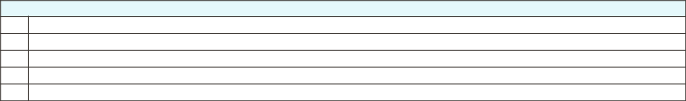

- Preliminary Proxy Statement

- CONFIDENTIAL, FOR USE OF THE COMMISSION ONLY (AS PERMITTED BY RULE 14a-6(e)(2))

- Definitive Proxy Statement

- Definitive Additional Materials

- Soliciting Material under ss.240.14a-12

GENERAL MOTORS COMPANY

300 Renaissance Center, Detroit, Michigan 48265

(Name of Registrant as Specified In Its Charter)

(Name of Person(s) Filing Proxy Statement, if other than the Registrant)

Payment of Filing Fee (Check all boxes that apply):
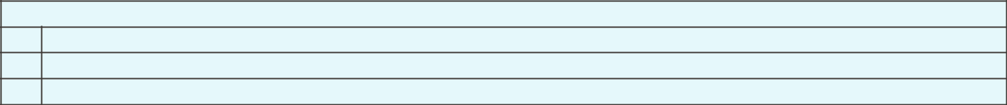

- No fee required

- Fee paid previously with preliminary materials

- Fee computed on table in exhibit required by Item 25(b) per Exchange Act Rules 14a-6(i)(1) and 0-11

Table of Contents


Table of Contents


Table of Contents

NOTICE OF 2023 ANNUAL MEETING OF SHAREHOLDERS

April 28, 2023

Dear Fellow Shareholders:

The Board of Directors of General Motors Company invites you to attend the 2023 Annual Meeting of Shareholders.

At the Annual Meeting, you will be asked to:

- Elect the 13 Board-recommended director nominees named in this Proxy Statement;

- Ratify the selection of Ernst & Young LLP as the Company’s independent registered public accounting firm for 2023;

- Approve, on an advisory basis, named executive officer compensation;

- Approve an amendment to the Company’s 2020 Long-Term Incentive Plan to increase the number of shares available for issuance thereunder;

- Vote on Rule 14a-8 shareholder proposals, if properly presented at the meeting; and

- Transact any other business that is properly presented at the meeting.

A list of the Company’s registered shareholders will be available for examination for any purpose that is germane to the meeting for ten business days before the Annual Meeting. Shareholders may request to review the list by emailing the Company at shareholder.relations@gm.com.

This Proxy Statement is provided in conjunction with GM’s solicitation of proxies to be used at the Annual Meeting. For additional information about how to attend our Annual Meeting, see “General Information About the Annual Meeting” starting on page 105.

Thank you for your continued investment in General Motors Company.

By Order of the Board of Directors,
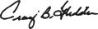

Craig B. Glidden

Corporate Secretary
300 Renaissance Center
Detroit, Michigan 48265

Meeting Information
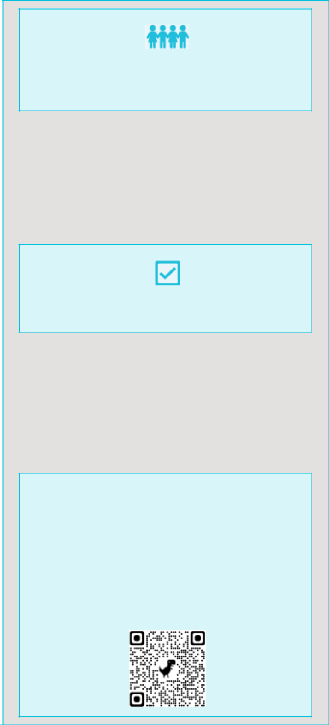

Date: June 20, 2023

Time: 11:30 a.m. Eastern Time

Place: Online via live webcast at:

virtualshareholdermeeting.com/GM2023

Record Date: April 21, 2023

Your Vote Is Important

Please promptly submit your vote by internet or telephone, or by signing, dating, and returning the enclosed proxy card or voting instruction form in the postage-paid envelope provided so that your shares will be represented and voted at the meeting.

We are first mailing these proxy materials to our shareholders on or about April 28, 2023.

How to Access the Proxy Materials Online

Important Notice Regarding the Availability of Proxy Materials for the 2023 Annual Meeting of Shareholders to be Held on June 20, 2023:

Our Proxy Statement and 2022 Annual Report are available at investor.gm.com/shareholder. You may also scan the QR code below with your smartphone or other mobile device to view our Proxy Statement and Annual Report.

i

Table of Contents


TO OUR FELLOW SHAREHOLDERS:

Building on Record Performance in 2022 by Ramping EV Production in 2023 and Beyond

Last year was a year of leadership for GM: we were the best-selling automaker in the U.S., with the best initial quality and the highest customer loyalty. We also led the industry in key segments, gained the most U.S. market share, and were the fastest-growing of any high-volume manufacturer in total U.S. fleet sales. Despite a difficult industry environment, we delivered record financial performance. Our U.S. hourly employees shared in our success, earning record profit sharing of $500 million, bringing the three-year total payout to $1.2 billion.

Looking ahead, we expect 2023 will be another strong year for GM, and a breakout year for our Ultium Platform. We are executing a product strategy across our ICE and EV portfolios designed to support strong pricing and grow our market share, especially with all-electric vehicles like the Cadillac LYRIQ and the Chevrolet Silverado EV, Blazer EV, and affordable Equinox EV. We are also accelerating businesses and technologies that will further drive revenue generation and profit growth, like BrightDrop and Cruise.

Board Evolution with Purpose and Impact

Delivering strong financial results during this period of high investment demonstrates the importance of recruiting strong directors to make sure our Board evolves with our business and remains a competitive advantage. We are executing our strategic Board refreshment and succession plan, which has bolstered the Board’s expertise with new, diverse directors that have deep industry knowledge in software, marketing, and cybersecurity. As we continue our work to refresh the Board, we would like to recognize Carol Stephenson, who is retiring from the Board and not standing for re-election at the Annual Meeting. The Board extends its sincere appreciation for Carol’s exemplary service since 2009 — particularly her insights that have helped enhance our compensation programs by strengthening the link between pay and performance.

On the ballot for the first time as director nominees this year are Joanne Crevoiserat, Jon McNeill, and Jan Tighe. Combined with our other director nominees, we believe these additions help create a Board with the right balance of skills, qualifications, and experience to create unprecedented opportunities for GM, drive long-term shareholder value, and execute our vision of a world with zero crashes, zero emissions, and zero congestion.

Annual Meeting Preview

At the Annual Meeting, we will provide an update on the Company’s transformation and performance, vote on several items related to our business, and shareholders will have the opportunity to ask questions. We encourage you to review this Proxy Statement to learn more about the Board, our governance practices, compensation programs and philosophy, and other important developments and priorities at GM.

Let us close by thanking you for your continued investment in GM.

Sincerely,
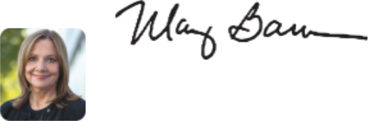
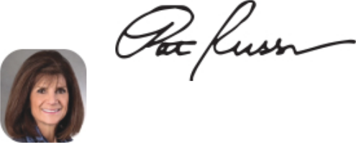

Mary T. Barra

Chair and Chief Executive Officer

Patricia F. Russo Independent Lead Director

ii

Table of Contents

TABLE OF CONTENTS

PROXY SUMMARY |  |  |  |  |  |  |  |  |  |  |  |  |  |  |  |  |  |  |  |  |  |  |  |  |  |  |  |  |  |  |  |  |  |  |  |  | 1
ITEM NO. 1 – ANNUAL ELECTION OF DIRECTORS |  |  |  |  |  |  |  |  |  |  |  |  |  |  |  |  |  |  |  |  |  |  |  |  |  |  |  |  |  |  |  |  |  |  |  |  | 12
Board Experience and Expertise |  |  |  |  |  |  |  |  |  |  |  |  |  |  |  |  |  |  |  |  |  |  |  |  |  |  |  |  |  |  |  |  |  |  |  |  | 13
 | Skills Matrix |  |  |  |  |  |  |  |  |  |  |  |  |  |  |  |  |  |  |  |  |  |  |  |  |  |  |  |  |  |  |  |  |  |  |  | 13
 | Director Nominee Biographies |  |  |  |  |  |  |  |  |  |  |  |  |  |  |  |  |  |  |  |  |  |  |  |  |  |  |  |  |  |  |  |  |  |  |  | 14
Board Membership Criteria, Refreshment, and Succession |  |  |  |  |  |  |  |  |  |  |  |  |  |  |  |  |  |  |  |  |  |  |  |  |  |  |  |  |  |  |  |  |  |  |  |  | 21
 | Planning |  |  |  |  |  |  |  |  |  |  |  |  |  |  |  |  |  |  |  |  |  |  |  |  |  |  |  |  |  |  |  |  |  |  |  | 21
 |  |  |  |  |  |  |  |  |  |  |  |  |  |  |  |  |  |  |  |  |  |  |  |  |  |  |  |  |  |  |  |  |  |  |  |  | 23
Non-Employee Director Compensation |  |  |  |  |  |  |  |  |  |  |  |  |  |  |  |  |  |  |  |  |  |  |  |  |  |  |  |  |  |  |  |  |  |  |  |  | 23
CORPORATE GOVERNANCE |  |  |  |  |  |  |  |  |  |  |  |  |  |  |  |  |  |  |  |  |  |  |  |  |  |  |  |  |  |  |  |  |  |  |  |  | 28
The Board of Directors |  |  |  |  |  |  |  |  |  |  |  |  |  |  |  |  |  |  |  |  |  |  |  |  |  |  |  |  |  |  |  |  |  |  |  |  | 28
Board Leadership Structure and Composition |  |  |  |  |  |  |  |  |  |  |  |  |  |  |  |  |  |  |  |  |  |  |  |  |  |  |  |  |  |  |  |  |  |  |  |  | 29
Board Committees |  |  |  |  |  |  |  |  |  |  |  |  |  |  |  |  |  |  |  |  |  |  |  |  |  |  |  |  |  |  |  |  |  |  |  |  | 30
Board and Committee Oversight of Risk |  |  |  |  |  |  |  |  |  |  |  |  |  |  |  |  |  |  |  |  |  |  |  |  |  |  |  |  |  |  |  |  |  |  |  |  | 34
The Board’s Governance Policies and |  |  |  |  |  |  |  |  |  |  |  |  |  |  |  |  |  |  | Practices |  |  |  |  |  |  |  |  |  |  |  |  |  |  |  |  |  | 37
Corporate Political Contributions and Lobbying |  |  |  |  |  |  |  |  |  |  |  |  |  |  |  |  |  |  |  |  |  |  |  |  |  |  |  |  |  |  |  |  |  |  |  |  | 41
 | Expenditures |  |  |  |  |  |  |  |  |  |  |  |  |  |  |  |  |  |  |  |  |  |  |  |  |  |  |  |  |  |  |  |  |  |  |  | 41
Certain Relationships and Related Party Transactions |  |  |  |  |  |  |  |  |  |  |  |  |  |  |  |  |  |  |  |  |  |  |  |  |  |  |  |  |  |  |  |  |  |  |  |  | 42
SECURITY OWNERSHIP INFORMATION |  |  |  |  |  |  |  |  |  |  |  |  |  |  |  |  |  |  |  |  |  |  |  |  |  |  |  |  |  |  |  |  |  |  |  |  | 44
ITEM NO. 2 – PROPOSAL TO RATIFY THE SELECTION
 |  |  |  | OF ERNST & YOUNG LLP AS THE
 |  |  |  | COMPANY’S INDEPENDENT REGISTERED |  |  |  |  |  |  |  |  |  |  |  |  |  |  |  |  |  |  |  |  |  |  |  |  |  |  |  |  |  |  |  |  | 46
 |  |  |  | PUBLIC ACCOUNTING FIRM FOR 2023 |  |  |  |  |  |  |  |  |  |  |  |  |  |  |  |  |  |  |  |  |  |  |  |  |  |  |  |  |  |  |  |  | 46
AUDIT COMMITTEE REPORT |  |  |  |  |  |  |  |  |  |  |  |  |  |  |  |  |  |  |  |  |  |  |  |  |  |  |  |  |  |  |  |  |  |  |  |  | 47
Fees Paid to Independent Registered Public Accounting |  |  |  |  |  |  |  |  |  |  |  |  |  |  |  |  |  |  |  |  |  |  |  |  |  |  |  |  |  |  |  |  |  |  |  |  | 49
 | Firm |  |  |  |  |  |  |  |  |  |  |  |  |  |  |  |  |  |  |  |  |  |  |  |  |  |  |  |  |  |  |  |  |  |  |  | 49
ITEM NO. 3 – PROPOSAL TO APPROVE, ON AN
 |  |  |  | ADVISORY BASIS, NAMED EXECUTIVE |  |  |  |  |  |  |  |  |  |  |  |  |  |  |  |  |  |  |  |  |  |  |  |  |  |  |  |  |  |  |  |  | 50
 |  |  |  | OFFICER COMPENSATION |  |  |  |  |  |  |  |  |  |  |  |  |  |  |  |  |  |  |  |  |  |  |  |  |  |  |  |  |  |  |  |  | 50
COMPENSATION DISCUSSION AND ANALYSIS |  |  |  |  |  |  |  |  |  |  |  |  |  |  |  |  |  |  |  |  |  |  |  |  |  |  |  |  |  |  |  |  |  |  |  |  | 51
Our Company Performance |  |  |  |  |  |  |  |  |  |  |  |  |  |  |  |  |  |  |  |  |  |  |  |  |  |  |  |  |  |  |  |  |  |  |  |  | 52
Compensation Overview |  |  |  |  |  |  |  |  |  |  |  |  |  |  |  |  |  |  |  |  |  |  |  |  |  |  |  |  |  |  |  |  |  |  |  |  | 54
Compensation Principles |  |  |  |  |  |  |  |  |  |  |  |  |  |  |  |  |  |  |  |  |  |  |  |  |  |  |  |  |  |  |  |  |  |  |  |  | 59
Compensation Elements |  |  |  |  |  |  |  |  |  |  |  |  |  |  |  |  |  |  |  |  |  |  |  |  |  |  |  |  |  |  |  |  |  |  |  |  | 59
Performance Measures |  |  |  |  |  |  |  |  |  |  |  |  |  |  |  |  |  |  |  |  |  |  |  |  |  |  |  |  |  |  |  |  |  |  |  |  | 61
Performance Results and Compensation Decisions |  |  |  |  |  |  |  |  |  |  |  |  |  |  |  |  |  |  |  |  |  |  |  |  |  |  |  |  |  |  |  |  |  |  |  |  | 64
Compensation Policies and Governance Practices |  |  |  |  |  |  |  |  |  |  |  |  |  |  |  |  |  |  |  |  |  |  |  |  |  |  |  |  |  |  |  |  |  |  |  |  | 70
Compensation Committee Report |  |  |  |  |  |  |  |  |  |  |  |  |  |  |  |  |  |  |  |  |  |  |  |  |  |  |  |  |  |  |  |  |  |  |  |  | 73

EXECUTIVE COMPENSATION TABLES |  |  |  |  |  |  |  |  |  |  |  |  |  |  |  |  |  |  |  |  |  |  |  |  |  |  |  |  |  |  |  |  |  | 74
Summary Compensation Table |  |  |  |  |  |  |  |  |  |  |  |  |  |  |  |  |  |  |  |  |  |  |  |  |  |  |  |  |  |  |  |  |  | 74
Grants of Plan-Based Awards |  |  |  |  |  |  |  |  |  |  |  |  |  |  |  |  |  |  |  |  |  |  |  |  |  |  |  |  |  |  |  |  |  | 76
Outstanding Equity Awards at Fiscal Year-End |  |  |  |  |  |  |  |  |  |  |  |  |  |  |  |  |  |  |  |  |  |  |  |  |  |  |  |  |  |  |  |  |  | 77
Option Exercises and Stock Vested |  |  |  |  |  |  |  |  |  |  |  |  |  |  |  |  |  |  |  |  |  |  |  |  |  |  |  |  |  |  |  |  |  | 78
Pension Benefits |  |  |  |  |  |  |  |  |  |  |  |  |  |  |  |  |  |  |  |  |  |  |  |  |  |  |  |  |  |  |  |  |  | 78
Nonqualified Deferred Compensation Plan |  |  |  |  |  |  |  |  |  |  |  |  |  |  |  |  |  |  |  |  |  |  |  |  |  |  |  |  |  |  |  |  |  | 80
Potential Payments Upon Termination |  |  |  |  |  |  |  |  |  |  |  |  |  |  |  |  |  |  |  |  |  |  |  |  |  |  |  |  |  |  |  |  |  | 81
CEO Pay Ratio |  |  |  |  |  |  |  |  |  |  |  |  |  |  |  |  |  |  |  |  |  |  |  |  |  |  |  |  |  |  |  |  |  | 84
Pay Versus Performance |  |  |  |  |  |  |  |  |  |  |  |  |  |  |  |  |  |  |  |  |  |  |  |  |  |  |  |  |  |  |  |  |  | 85
Equity Compensation Plan Information |  |  |  |  |  |  |  |  |  |  |  |  |  |  |  |  |  |  |  |  |  |  |  |  |  |  |  |  |  |  |  |  |  | 87
ITEM NO. 4 – PROPOSAL TO APPROVE AMENDMENT
 |  |  |  | NO. 1 TO THE COMPANY’S 2020 LONG-
 |  |  |  | TERM INCENTIVE PLAN TO INCREASE |  |  |  |  |  |  |  |  |  |  |  |  |  |  |  |  |  |  |  |  |  |  |  | THE
 |  |  |  | NUMBER OF SHARES AVAILABLE FOR |  |  |  |  |  |  |  |  |  |  |  |  |  |  |  |  |  |  |  |  |  |  |  |  |  |  |  |  |  | 88
 |  |  |  | ISSUANCE THEREUNDER |  |  |  |  |  |  |  |  |  |  |  |  |  |  |  |  |  |  |  |  |  |  |  |  |  |  |  |  |  | 88
ITEM NO. 5 – SHAREHOLDER PROPOSAL
 |  |  |  | REQUESTING A REPORT ON |  |  |  |  |  |  |  |  |  |  |  |  |  |  | THE |  |  |  |  |  |  |  |  |  |  |  |  |  |  | 98
 |  |  |  | COMPANY’S OPERATIONS IN CHINA |  |  |  |  |  |  |  |  |  |  |  |  |  |  |  |  |  |  |  |  |  |  |  |  |  |  |  |  |  | 98
ITEM NO. 6 – SHAREHOLDER PROPOSAL REGARDING |  |  |  |  |  |  |  |  |  |  |  |  |  |  |  |  |  |  |  |  |  |  |  |  |  |  |  |  |  |  |  |  |  | 100
 |  |  |  | SHAREHOLDER WRITTEN CONSENT |  |  |  |  |  |  |  |  |  |  |  |  |  |  |  |  |  |  |  |  |  |  |  |  |  |  |  |  |  | 100
ITEM NO. 7 – SHAREHOLDER PROPOSAL REGARDING
 |  |  |  | SUSTAINABLE MATERIALS |  |  |  |  |  |  |  |  |  |  |  |  |  |  |  |  |  |  |  |  |  |  |  |  |  |  |  |  |  | 102
 |  |  |  | PROCUREMENT TARGETS |  |  |  |  |  |  |  |  |  |  |  |  |  |  |  |  |  |  |  |  |  |  |  |  |  |  |  |  |  | 102
GENERAL INFORMATION ABOUT THE ANNUAL |  |  |  |  |  |  |  |  |  |  |  |  |  |  |  |  |  |  |  |  |  |  |  |  |  |  |  |  |  |  |  |  |  | 105
 | MEETING |  |  |  |  |  |  |  |  |  |  |  |  |  |  |  |  |  |  |  |  |  |  |  |  |  |  |  |  |  |  |  |  | 105
HELPFUL RESOURCES AND DEFINED TERMS AND |  |  |  |  |  |  |  |  |  |  |  |  |  |  |  |  |  |  |  |  |  |  |  |  |  |  |  |  |  |  |  |  |  | 111
 | COMMONLY USED ACRONYMS |  |  |  |  |  |  |  |  |  |  |  |  |  |  |  |  |  |  |  |  |  |  |  |  |  |  |  |  |  |  |  |  | 111
APPENDIX A: NON-GAAP FINANCIAL MEASURES |  |  |  |  |  |  |  |  |  |  |  |  |  |  |  |  |  |  |  |  |  |  |  |  |  |  |  |  |  |  |  |  |  | A-1
APPENDIX B: AMENDMENT NO. 1 TO THE GENERAL
 | MOTORS COMPANY 2020 LONG-TERM INCENTIVE |  |  |  |  |  |  |  |  |  |  |  |  |  |  |  |  |  |  |  |  |  |  |  |  |  |  |  |  |  |  |  |  | B-1
 | PLAN |  |  |  |  |  |  |  |  |  |  |  |  |  |  |  |  |  |  |  |  |  |  |  |  |  |  |  |  |  |  |  |  | B-1

Cautionary Note on Forward-Looking Statements: This Proxy Statement may include “forward-looking statements” within the meaning of the U.S. federal securities laws. Forward-looking statements are any statements other than statements of historical fact. Forward-looking statements represent our current judgement about possible future events. In making these statements, we rely upon assumptions and analysis based on our experience and perception of historical trends, current conditions, and expected future developments, as well as other factors we consider appropriate under the circumstances. We believe these judgements are reasonable, but these statements are not guarantees of any future events or financial results, and our actual results may differ materially due to a variety of factors, many of which are described in our 2022 Form 10-K and our other filings with the SEC. We caution readers not to place undue reliance on forward-looking statements. Forward-looking statements speak only as of the date they are made, and we undertake no obligation to update publicly or otherwise revise any forward-looking statements, whether as a result of new information, future events, or other factors that affect the subject of these statements, except where we are expressly required to do so by law.

Non-GAAP financial measures: See our 2022 Form 10-K and our other filings with the SEC for a description of certain non-GAAP measures used in this Proxy Statement, along with a description of various uses for such measures. Our calculation of these non-GAAP measures are set forth within these reports and Appendix A to this Proxy Statement, and may not be comparable to similarly titled measures of other companies due to potential differences between companies in the method of calculation. As a result, the use of these non-GAAP measures has limitations and should not be considered superior to, in isolation from, or as a substitute for, related GAAP measures. When we present our total company EBIT-adjusted, GM Financial is presented on an EBT-adjusted basis.

Additional Information: References to “record” or “best” performance (or similar statements) in this Proxy Statement refer to General Motors Company, as established in 2009. In addition, certain figures included in the charts and tables in this Proxy Statement may not sum due to rounding. Simulated models and pre-production models are shown throughout; production vehicles will vary. For information on models shown, including availability, see each GM brand website for details.

iii

Table of Contents


PROXY SUMMARY

Annual Meeting Overview

TIME & DATE | PLACE | RECORD DATE | MATERIALS
11:30 a.m. Eastern Time | Virtual Meeting | April 21, 2023 | Available at
June 20, 2023 | virtualshareholdermeeting.com/GM2023 |  | investor.gm.com/shareholder

Proxy Voting Roadmap

Shareholders will be asked to vote on the following matters at the Annual Meeting:

 |  |  | BOARD VOTE | PAGE
 |  | VOTING MATTER | RECOMMENDATION | REFERENCE
 | Item 1: | Annual Election of Directors | FOR | 12
 | Item 1: | Annual Election of Directors | each director nominee | 12
 | Item 2: | Proposal to Ratify the Selection of Ernst & Young LLP as | FOR | 46
 |  | the Company’s Independent Registered Public Accounting | FOR | 46
 |  | Firm for 2023
 | Item 3: | Proposal to Approve, on an Advisory Basis, Named | FOR | 50
 |  | Executive Officer Compensation | FOR | 50
 | Item 4: | Proposal to Approve Amendment No. 1 to the Company’s | FOR | 88
 |  | 2020 Long-Term Incentive Plan to Increase the Number of | FOR | 88
 |  | Shares Available for Issuance Thereunder
 | Item 5: | Shareholder Proposal Requesting a Report on the | AGAINST | 98
 |  | Company’s Operations in China | AGAINST | 98
 | Item 6: | Shareholder Proposal Regarding Shareholder Written | AGAINST | 100
 |  | Consent | AGAINST | 100
 | Item 7: | Shareholder Proposal Regarding Sustainable Materials | AGAINST | 102
 |  | Procurement Targets | AGAINST | 102
 |  |  |  | 1

Table of Contents

Snapshot of Your 2023 Board Nominees
 |  |  | Director
 | Name & Principal Occupation | Age | Since | Independent | Committee Memberships
 | Mary T. Barra
 | Chair and Chief Executive Officer | 61 | 2014 |  | Executive – Chair
 | General Motors Company
 | Aneel Bhusri | 57 | 2021 |  | Compensation
 | Chairman, Co-Founder & Co-Chief Executive Officer | 57 | 2021
 | Chairman, Co-Founder & Co-Chief Executive Officer | 57 | 2021 |  | Governance
 | Workday, Inc.
 | Wesley G. Bush |  |  |  | Audit
 | Wesley G. Bush | 62 | 2019 |  | Compensation – Chair
 | Retired Chairman & Chief Executive Officer | 62 | 2019
 | Retired Chairman & Chief Executive Officer | 62 | 2019 |  | Executive
 | Northrop Grumman Corporation
 | Northrop Grumman Corporation |  |  |  | Finance
 | Joanne C. Crevoiserat |  |  |  | Audit
 | Chief Executive Officer | 59 | 2022 |  | Finance
 | Tapestry, Inc. |  |  |  | Governance
 | Linda R. Gooden |  |  |  | Audit
 | Retired Executive Vice President,
 | Retired Executive Vice President, | 70 | 2015 |  | Executive
 | Information Systems & Global Solutions | 70 | 2015
 | Information Systems & Global Solutions |  |  |  | Risk and Cybersecurity – Chair
 | Lockheed Martin Corporation
 | Joseph Jimenez |  |  |  | Compensation
 | Joseph Jimenez | 63 | 2015 |  | Executive
 | Retired Chief Executive Officer | 63 | 2015
 | Retired Chief Executive Officer | 63 | 2015 |  | Finance – Chair
 | Novartis AG
 | Novartis AG |  |  |  | Risk and Cybersecurity
 | Jonathan McNeill | 55 | 2022 |  | None
 | Co-Founder and Chief Executive Officer | 55 | 2022
 | DVx Ventures
 | Judith A. Miscik | 64 | 2018 |  | Finance
 | Chief Executive Officer | 64 | 2018
 | Chief Executive Officer | 64 | 2018 |  | Risk and Cybersecurity
 | Global Strategic Insights
 | Patricia F. Russo |  |  |  | Compensation
 | Patricia F. Russo | 70 | 2009 |  | Executive
 | Chair | 70 | 2009
 | Chair | 70 | 2009 |  | Finance
 | Hewlett Packard Enterprise Company
 | Hewlett Packard Enterprise Company |  |  |  | Governance – Chair
 | Thomas M. Schoewe |  |  |  | Audit – Chair
 | Retired Executive Vice President & | 70 | 2011 |  | Executive
 | Chief Financial Officer | 70 | 2011 |  | Finance
 | Wal-Mart Stores, Inc. |  |  |  | Risk and Cybersecurity
 | Mark A. Tatum | 53 | 2021 |  | Audit
 | Deputy Commissioner & Chief Operating Officer | 53 | 2021
 | Deputy Commissioner & Chief Operating Officer | 53 | 2021 |  | Governance
 | National Basketball Association
 | Jan E. Tighe | 60 | 2023 |  | None
 | Retired Vice Admiral | 60 | 2023
 | U.S. Navy
 | Devin N. Wenig | 56 | 2018 |  | Risk and Cybersecurity
 | Retired President & Chief Executive Officer | 56 | 2018
 | eBay Inc.
2














Table of Contents
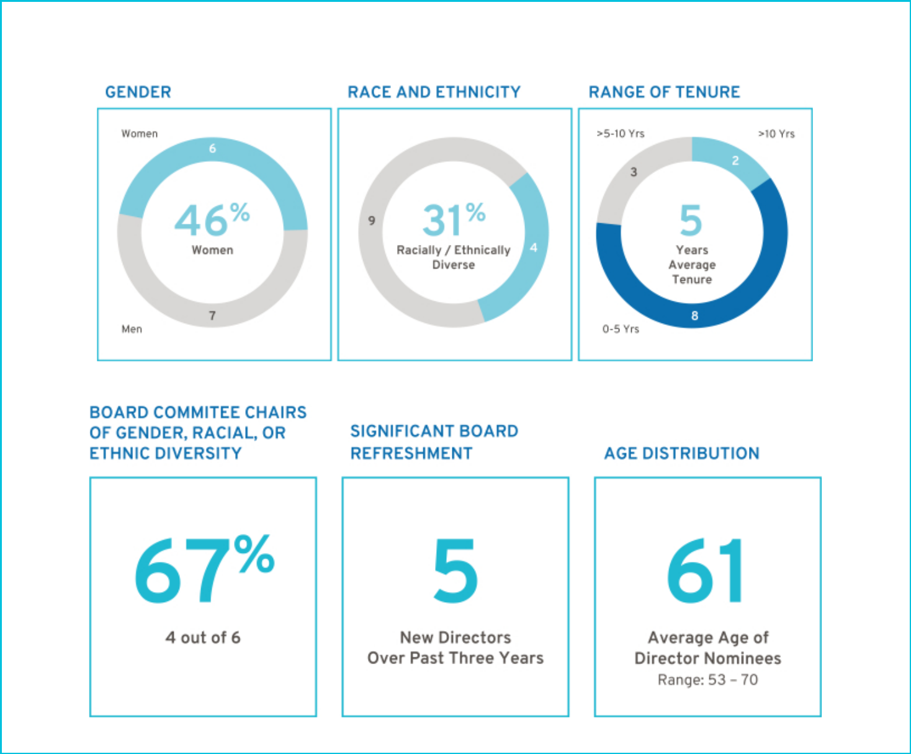

- 2023 Board Nominee Statistics

3

Table of Contents


2022 Business Highlights

- Financial Highlights

$9.9B | Net income attributable to stockholders | $14.5B | EBIT-adjusted⁽¹⁾
6.3% | Net income margin | 9.2% | EBIT-adjusted⁽¹⁾ margin
$6.13 | EPS-diluted | $7.59 | EPS-diluted-adjusted⁽¹⁾
$156.7B | Revenue | $19.1B | Automotive operating cash flow
$39.5B | Automotive liquidity at year-end⁽²⁾ | $2.8B | Returned to shareholders via dividends and share
$39.5B | Automotive liquidity at year-end⁽²⁾ | $2.8B | repurchases
3.6M | Wholesale units | 9.2% | Global Market Share
1.1M | Full-size pickups, midsize pickups, and full-size | 16.0% | U.S. Market Share
1.1M | SUVs sold in the U.S. | 16.0% | U.S. Market Share
16.3K | EVs sold In the U.S. | $51K | U.S. average transaction price

- Non-GAAP financial measure. Refer to Appendix A for a reconciliation of non-GAAP financial measures to their closest comparable GAAP measure.

- Consists of cash, cash equivalents, marketable debt securities, and borrowing capacity under our revolving credit facilities.

u | Performance Highlights
 | U.S. Market Leader |  | Opened Ultium Cells JV
 | #1 in total sales |  | Opened Ultium Cells JV
 | #1 in full-size pickup trucks | Record Chevrolet Bolt EV and | battery plant in Warren, OH;
 | #1 in full-size, large luxury SUVs | Bolt EUV deliveries | Spring Hill, TN opening in mid-2023;
 | #1 in luxury sports cars |  | Lansing, MI opening in late 2024
 |  | Cruise became the first commercial,
 | Largest U.S. market share increase of | driverless ridehail service in a major city | Secured all EV raw material for 1M units
 | any automotive manufacturer, up 1.6pp, | when it launched in San Francisco, | of North American capacity in 2025,
 | with record ATPs | followed by commercial expansion into the | including more sustainable, local sourcing
 |  | Phoenix area and Austin

4

Table of Contents
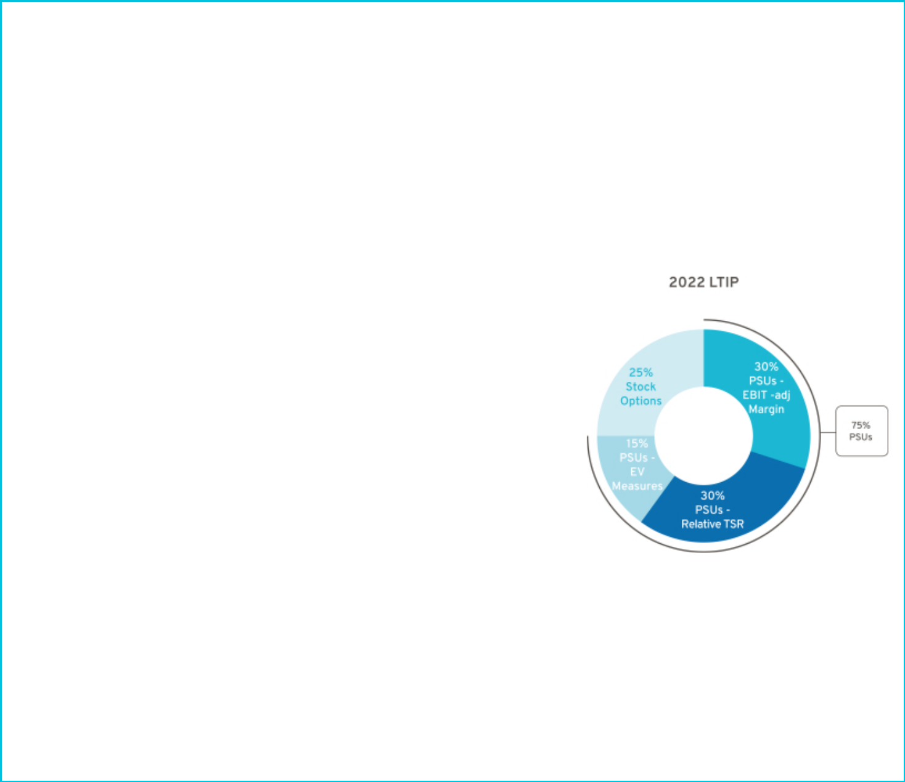

Compensation Highlights

Our executive compensation program is designed to focus our leaders on key areas that drive the business forward, align to the short-term and long-term interests of our shareholders, and reward our leaders for delivering on the Company’s strategy and vision.

- 2022 LTIP Design Changes

The 2022 LTIP is designed to align our executive compensation program with our all-electric future by driving leadership accountability for delivering on our EV commitments, directing additional focus on Company growth, which will better support our expansion into new markets and technologies, and aligning leadership with shareholder interest in stock price appreciation. The 2022 LTIP continues to have a mix of PSUs and stock options, and PSUs now include the following performance measures:

PSUs – 75%

EBIT-adjusted Margin – Focuses leaders to pursue profitable growth opportunities and drive higher absolute margins on existing revenue bases.

Relative TSR – Focuses leaders to deliver shareholder returns that outperform our OEM peer group.

EV Measures – Focuses leaders to execute on our EV commitment of 1 million units of annual capacity in North America in 2025:

• GMNA EV Volume

• GMNA EV Launch Timing

• GMNA EV Launch Quality (modifier)

Stock Options – 25%

Stock options continue to align leadership with shareholder interest in long-term stock price appreciation.

- New Compensation Committee Leadership

In August 2022, Wesley Bush took over as the Compensation Committee Chair, replacing Carol Stephenson who transitioned to being a member of the Committee in anticipation of her retirement from the Board this year. Please see Mr. Bush’s letter to shareholders, which can be found on page 51. In his letter, he discusses the Compensation Committee’s key priorities for the year and its ongoing efforts to evolve our executive compensation program to align with shareholder feedback.

5

Table of Contents
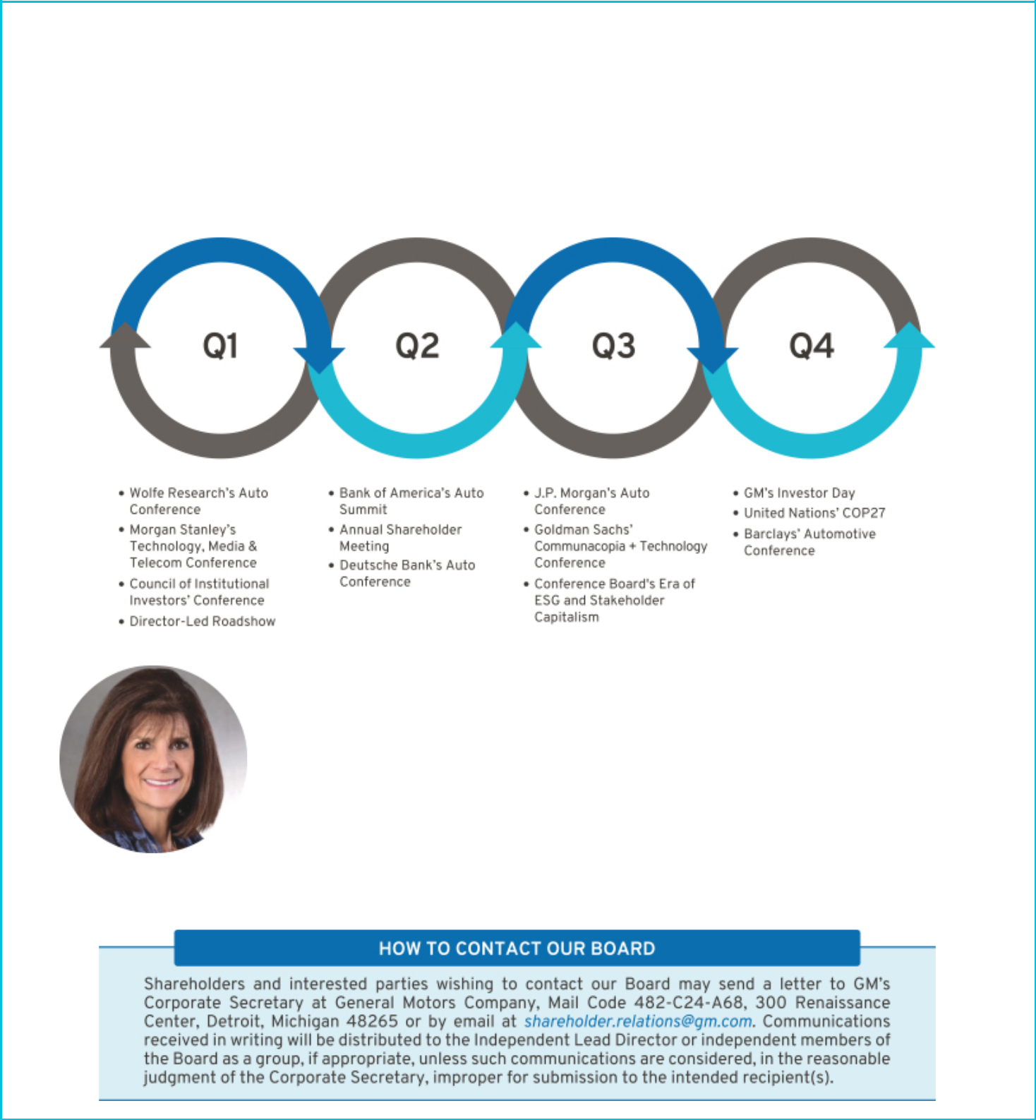

Shareholder Engagement

The Company has an extensive shareholder outreach program and engages with institutional investors and other stakeholders to help the Board and management gain feedback on a variety of topics. The feedback received from these sessions is communicated to the Governance Committee and Compensation Committee throughout the year. In 2022, members of our Board or management team conducted over 45 stakeholder engagements, including with shareholders representing a majority of our common stock. In addition to those sessions, we participate in a number of activities throughout the year that provide the opportunity to communicate our strategy to shareholders and listen to a diverse set of opinions. A sample of such activity in 2022 included:

“As the Independent Lead Director, I help make sure the Board receives regular input from our shareholders. Every year since 2016, the Board has invited at least one institutional shareholder to a Board meeting to provide its perspective on the Company’s strategic direction. In addition, I regularly meet with investors to discuss the Board’s composition and evolving skills, oversight of ESG risks and opportunities, enhancements to our executive compensation plans, critical public policy issues, and our ongoing efforts to build a more sustainable and resilient supply chain.”

Patricia F. Russo

Independent Lead Director

6

Table of Contents


The table below provides a summary of common themes we have heard that led to boardroom discussion and action:

Message Actions

Requested to disclose Board priorities for future director recruitment and the succession plan with regards to diversity.

For a discussion of the actions taken to further evolve the Board’s composition, see page 21. We also amended our Corporate Governance Guidelines to formalize the Board’s (long-standing) practice of including highly qualified women and individuals from minority groups in the pool of candidates from which Board nominees are chosen. We also clarified that our definition of diversity includes nationality, gender, age, ethnicity, and sexual orientation.

Encouraged to modernize the Board’s approach to equity grants for non-employee Directors.

The Governance Committee conducted a comprehensive review of our non-employee director compensation program, which resulted in increasing the mandatory deferral requirement and stock ownership requirements. For more discussion of the changes, see page 23.

Prior shareholder proposals asked the Board to lower the Company’s threshold to call a special meeting.

In response to discussions with our shareholders, the Board recently amended GM’s Bylaws to provide that any shareholder or group of shareholders that own an aggregate of at least 15 percent of GM’s outstanding common stock may call a special meeting.

Encouraged to return capital to shareholders as part of the Company’s capital allocation strategy.

In 2022, we reinstated the Company’s quarterly dividend and reinstated our share repurchase program, which had been temporarily paused at the outset of the COVID-19 pandemic. Following input from the Board, we felt that management had made significant progress on its key strategic initiatives and became confident in the Company’s capacity to fund growth while also returning capital to shareholders.

Encouraged to continue to be transparent with the Company’s public policy priorities and take more action to create a resilient and secure supply chain ecosystem that incorporates decarbonization priorities and human rights.

We continued work with the Climate Action 100+ to publish the Company’s second Sustainability Advocacy Report, which discloses the company’s efforts to advocate for EV provisions within the Inflation Reduction Act of 2022 and the Infrastructure Investment and Jobs Act of 2021, which we believe support the goals of the Paris Agreement.

One of the main focus areas this year will be to continue momentum on building a resilient supply chain supporting our transition to EVs. Two recent examples of our actions include a $650 million equity investment and supply agreement with Lithium Americas Corp. to supply lithium sourced from the United States and a supply agreement with U.S. Steel for a U.S.-sourced sustainable steel solution that results in 75 percent fewer emissions. We also recently joined the First Movers Coalition with sustainable procurement commitments covering concrete, steel, and aluminum.

Encouraged to affirm that each director has sufficient time and availability to comply with the Company’s expectations.

We amended our Corporate Governance Guidelines to formalize an existing practice of the Governance Committee to ensure that each director has sufficient time to commit to the Company. In 2022, this review determined that each director nominee is fulfilling their obligations as a director of the Company.

7

Table of Contents


Environmental, Social, and Governance Highlights

- Environmental Highlights

  - GM joined the First Movers Coalition with concrete, steel, and aluminum commitments

  - GM has secured enough renewable energy to power its U.S. sites by 2025 based on current projections

  - New Ultium Cells LLC battery plant opened in Ohio to support the scaling of production of our EVs

  - Record sales of Chevrolet Bolt EV and Bolt EUV in 2022

Addressing Environmental Impact | GM recognizes the importance of taking action to limit our environmental impact. We are
 | focused on continuing to enhance the sustainability of our business. This includes
 | identifying and managing climate-related risks and opportunities, and setting ambitious
 | goals to reduce our impact. One of our goals is to be carbon neutral in our products and
 | operations by 2040. Prioritizing transparency, we annually report on our GHG emissions
 | in our Sustainability Report. We have also set environmental sustainability goals related
 | to energy, water, and waste. For more information on our sustainability goals, progress,
 | and our strategy, please see our 2022 Sustainability Report available at
 | gmsustainability.com.
Enhancing Supply Chain | To drive resiliency and sustainability across our supply chain, GM is engaging with
Resiliency | suppliers, industry groups, and nonprofits. In 2022, we enhanced our Supplier Code of
 | Conduct and invited Tier 1 suppliers to sign our ESG Partnership Pledge to demonstrate
 | their commitment to principles of sustainability and human rights. By the end of 2022,
 | 68 percent of our direct suppliers, by budgeted annual purchase value, had committed to
 | the Pledge. We are also focused on forging long-term strategic relationships to build a
 | North America-focused supply chain that spans the EV battery ecosystem — from raw
 | materials to battery cells. In 2022, we announced several new strategic supply
 | arrangements.
Funding the Future | In 2022, GM published a Sustainable Finance Framework, which we believe will help
 | further align our financing activities with our sustainability strategy, and issued $2.25
 | billion of green bonds under the Framework, the proceeds of which were allocated to
 | clean transportation solutions, as described in our Framework.
Collaboration and Integration | Sustainability is an important part of GM’s work to support an all-electric future, our
 | sustainability strategy is weaved into our business strategy and both are focused on
 | providing growth and long-term value. Working towards our sustainability and EV goals
 | requires strong cross-functional collaboration. This work is overseen by our Board and
 | executed by senior leaders across GM, including through our Office of Sustainability and
 | ESG Disclosure Committee.
Advocating and Engaging | Accelerating the transition to a more sustainable, electric future requires collaboration
 | across society. GM engages with businesses, nonprofits, and governments to develop
 | sustainability initiatives, including public policy solutions to support decarbonizing
 | transportation and the grid. For more information about our advocacy, please see our
 | 2022 Sustainability Advocacy Report, available at investor.gm.com/esg.

8

Table of Contents


- Social Highlights

  - GM recognized as a DiversityInc Top 50 company for the 7th consecutive year

  - Top-ranked automotive corporation in the J.D. Power Initial Quality Study

  - Recognized in the top 50 companies in the 2023 JUST 100 rankings

  - $60 million donated to nonprofits, including 400+ U.S.-based organizations, and 158,000+ employee volunteer hours

 | Empowering Employees | Our employees drive the innovation that powers GM. They create our products and are
 |  | there every step of the journey — from the idea stage to the first time a vehicle is turned
 |  | on. Our success is a result of their vision and dedication. Our Earn a Living. Make a Life.
 |  | initiative celebrates some of the amazing people behind our products. We remain focused
 |  | on offering competitive benefits and salaries to employees. We continue to add to the
 |  | suite of learning, mentoring, and professional development opportunities available to
 |  | employees.
 | A Culture of Safety | We envision a world with zero crashes. This vision and our customers’ safety is at the
 |  | heart of what we do. Workplace safety is also a priority across GM. Safety efforts are
 |  | focused on five tactical dimensions – culture, knowledge, systems, data, and risk
 |  | mitigation – in support of our overriding commitment to live the values that return people
 |  | home safely. Every person. Every site. Every day.
 | A Diverse & Inclusive Workforce | Maintaining a diverse, talented workforce and a workplace where all employees can
 |  | thrive is a key priority at GM. From recruiting and hiring, to career progression and
 |  | leadership training, we are working to continuously advance the inclusivity of our
 |  | workplace. For more information about DE&I at GM, please see our 2022 Sustainability
 |  | Report.
 | Dealer and Supplier Engagement | The impact of our Company extends beyond our own operations. GM recognizes this and
 |  | engages with dealers and suppliers to support positive change. At the dealership level,
 |  | GM is proud of our Minority Dealer Development Program and Women’s Retail Network.
 |  | We also have a longstanding supplier diversity program, and in 2022, spent
 |  | approximately $4.4 billion with diverse Tier 1 North American suppliers. We engage with
 |  | suppliers to help align their actions with our values as a company. Our ESG Partnership
 |  | Pledge invites certain suppliers to make key commitments related to the environment and
 |  | labor, and we continue to enhance visibility across our supply chain. Additionally, in 2022,
 |  | we published our first Corporate Human Rights Benchmark disclosure.
 | Supporting Communities | We create jobs and support local economies in the communities where we live and work.
 |  | GM’s corporate giving seeks to fund inclusive and sustainable solutions to common social
 |  | issues, with a focus on STEM education, community development, vehicle and road
 |  | safety, and the city of Detroit. For more information, please see our 2022 Corporate
 |  | Giving Report.
 | Innovative and Accessible | As we move toward a carbon neutral future, we aspire to lead positive change and
 | Technology | implement inclusive solutions that address everyone’s unique needs. One way in which
 |  | we’re doing this is through our Ultium Platform, which is powering our expanding lineup of
 |  | a wide range EVs across most segments and price points, helping to put everyone in an
 |  | EV. We are also working to increase EV charging infrastructure and expand the
 |  | availability of driverless rideshare services through Cruise.
 |  | 9

Table of Contents
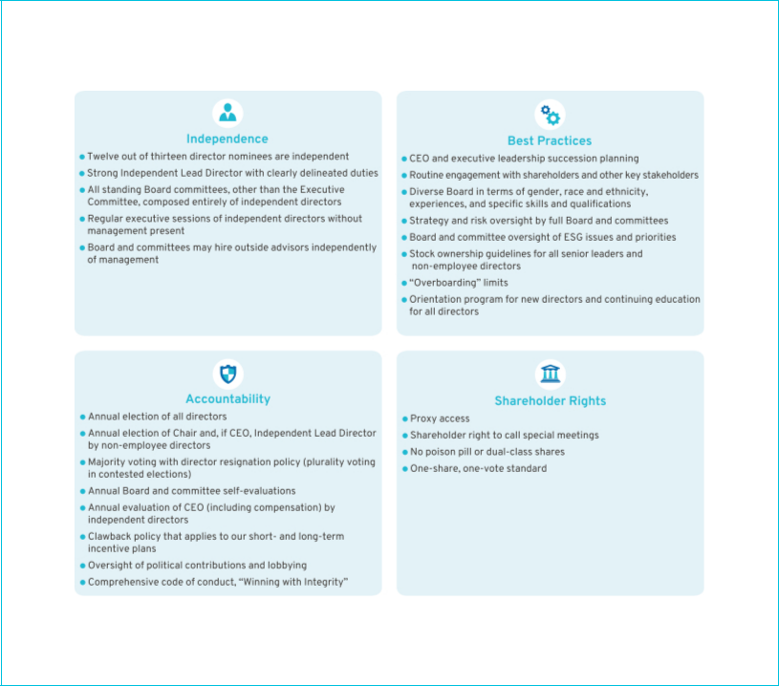

- Governance Highlights

The Board is committed to governance structures and practices that protect shareholder value and important shareholder rights, including the following:

The Governance Committee regularly reviews these structures and practices and makes updates as appropriate. For example, in April 2023, in response to shareholder feedback and in consideration of governance best practices, the Board lowered the threshold for shareholders to call a special meeting to shares representing 15 percent of the Company’s voting power.

10

Table of Contents
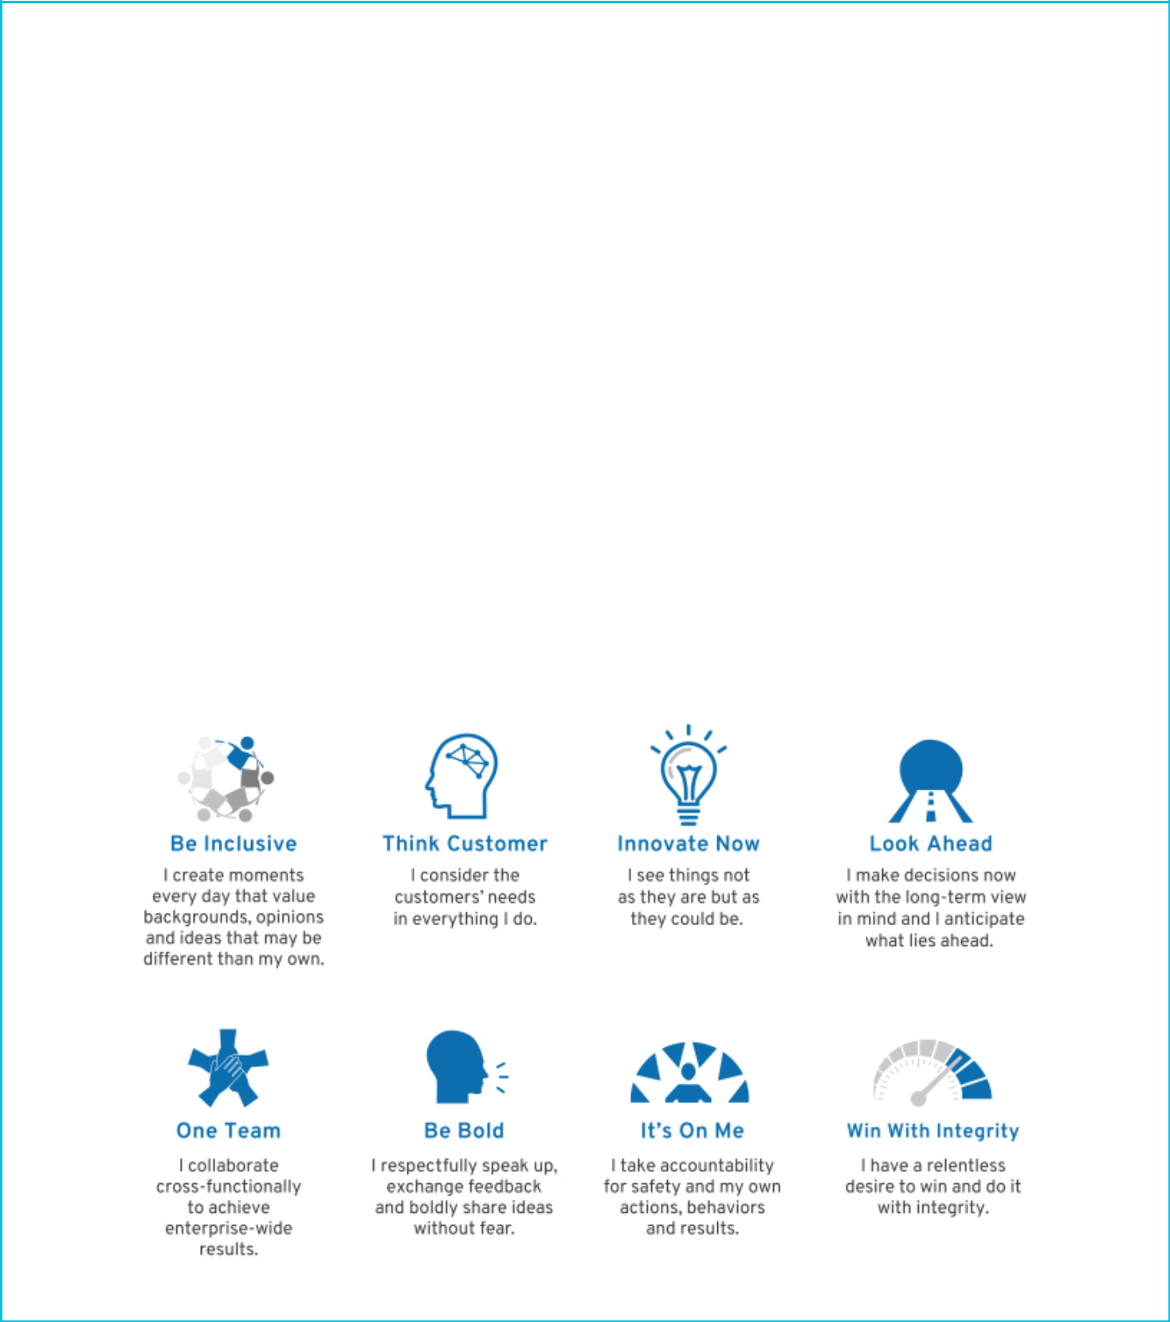

Our Purpose, Values, and Behaviors

- Our Purpose

To provide greater focus during a period of unprecedented change, we created a statement on the collective purpose of the GM team. It’s a simple but powerful statement that honors our heritage of innovation, captures who we are when we’re at our best, and guides us into our future:

We pioneer the innovations that move and connect people to what matters.

- Our Values

Customers

We put the customer at the center of everything we do. We listen intently to our customers’ needs. Each interaction matters. Safety and quality are foundational commitments, never compromised.

Excellence

We act with integrity. We are driven by ingenuity and innovation. We have the courage to do and say what’s difficult. Each of us takes accountability for results, drives for continued efficiencies, and has the tenacity to win.

Relationships Seek Truth

Our success depends on our relationships inside and outside We pursue facts, respectfully challenge assumptions, and the Company. We encourage diverse thinking and clearly define objectives. When we disagree, we provide collaboration from all over the world to create great customer additional context and consider multiple perspectives. experiences.

- Our Behaviors

11

Table of Contents

ITEM NO. 1: ANNUAL ELECTION OF DIRECTORS

At the Annual Meeting, 13 directors will be nominated for election to GM’s Board of Directors. The Governance Committee evaluated the nominees in accordance with the Committee’s charter and our Corporate Governance Guidelines and submitted the nominees to the Board for approval.

The Board believes that the director nominees’ diverse backgrounds, attributes, and experiences provide valuable insights for the Board’s oversight of the Company. Nine of the 13 nominees, or 69 percent, bring gender, racial, or ethnic diversity to the Board, including four of the six committee chairs.

Of the 13 director nominees, ten were previously elected at the 2022 annual meeting. Joanne C. Crevoiserat and Jonathan McNeill were elected to the Board in August 2022 and September 2022, respectively. Jan E. Tighe’s nomination is submitted by the Board for inclusion in this Proxy Statement and, if elected by shareholders, she will join the Board immediately following the Annual Meeting. Further information on the Board’s composition, as well as each nominee’s qualifications and relevant experience, are provided on the following pages.

As noted previously in this Proxy Statement, Carol Stephenson is not standing for re-election this year in accordance with the Company’s non-employee director retirement guidelines. We are grateful for the expertise and leadership she brought to the Board, including as Chair of the Compensation Committee from 2015 to 2022.

If elected, the director nominees will serve on the Board until the next annual meeting of shareholders, or until their successors are duly elected and qualified, or until their earlier resignation or removal. If any nominee becomes unable to serve, proxies will be voted for the election of such other person as the Board may designate, unless the Board chooses to reduce the number of directors standing for election. Each of the nominees has consented to being named in this Proxy Statement and serving on the Board if elected.

The Board recommends a vote FOR each of the nominees identified in this
Proxy Statement. | FOR

12

Table of Contents

Board Experience and Expertise

- Skills Matrix

Our director nominees collectively possess the expertise, leadership skills, and diversity of experiences and backgrounds to oversee management’s execution of its growth strategy and protect long-term shareholder value. The skills matrix below summarizes certain qualifications used by the Governance Committee in their evaluation of our director nominees.

 | Public Co. |  |  |  | Risk |  |  |  | ESG
Director | CEO | Industry | Manufacturing | Technology | Management | Finance | Marketing | Cyber | Expertise
M. Barra |  |  |  |  |  |  |  |  | SG
A. Bhusri |  |  |  |  |  |  |  |  | SG
W. Bush |  |  |  |  |  |  |  |  | ESG
J. Crevoiserat |  |  |  |  |  |  |  |  | ESG
L. Gooden |  |  |  |  |  |  |  |  | SG
J. Jimenez |  |  |  |  |  |  |  |  | EG
J. McNeill |  |  |  |  |  |  |  |  | ESG
J. Miscik |  |  |  |  |  |  |  |  | G
P. Russo |  |  |  |  |  |  |  |  | SG
T. Schoewe |  |  |  |  |  |  |  |  | SG
M. Tatum |  |  |  |  |  |  |  |  | SG
J. Tighe |  |  |  |  |  |  |  |  | SG
D. Wenig |  |  |  |  |  |  |  |  | G

To supplement the skills matrix, since 2021, the Board has also undertaken an annual ESG self-evaluation. The evaluation is designed to ensure that the Board possesses the requisite skills and expertise to oversee the Company’s ESG opportunities, priorities, and risks. The Governance Committee, led by our Independent Lead Director, leads this effort by asking directors to consider their expertise across 20 key ESG subject matter areas. Upon the conclusion of this evaluation in 2022, the Board determined that it has strong ESG expertise and possesses a broad range of skills, qualifications, and attributes that will support the Company’s sustainability commitments. Results of the Board’s ESG self-evaluation are represented on the skills matrix above and are highlighted in each of the director nominee biographies below.

13

Table of Contents
u | Director Nominee Biographies
 |  | Director Since: 2014 | Director Since: 2009
 |  | Age: 61 | Age: 70
 |  | Independent: No | Independent: Yes
 |  | Gender: Female | Gender: Female
 |  | Race/Ethnicity: White | Race/Ethnicity: White



Mary T. Barra

Chair & CEO,

General Motors Company

Committees: Executive (Chair)

Other Public Company Directorships: The Walt Disney

Company

Prior Public Company Directorships: General

Dynamics Corporation

Prior Experience: Ms. Barra is Chair and CEO of General Motors. She has served as Chair of the Board of Directors since January 2016 and has served as CEO since January 2014. Prior to becoming CEO, Ms. Barra served as GM’s Executive Vice President, Global Product Development, Purchasing and Supply Chain from 2013 to 2014; Senior Vice President, Global Product Development from 2011 to 2013; Vice President, Global Human Resources from 2009 to 2011; and Vice President, Global Manufacturing Engineering from 2008 to 2009. Ms. Barra began her career with GM in 1980.

Reasons for Nomination: Ms. Barra has in-depth knowledge of the Company and the global automotive industry; extensive senior leadership, strategic planning, operational, and business experience; and a strong engineering background with experience in global product development.

Spotlight on ESG Expertise: Ms. Barra has developed social expertise – in particular, workplace safety and human capital management – during her career at GM, which has included various senior leadership roles. As Chair and CEO, she has spearheaded many initiatives to align the Company’s culture with its transformation efforts and holds herself and the leadership team accountable for the development of GM employees. GM benefits from Ms. Barra’s experience in these areas as it seeks to be a safe and inclusive workplace.

14

Patricia F. Russo

Chair,

Hewlett Packard Enterprise Company

Committees: Compensation, Executive, Finance, Governance (Chair)

Other Public Company Directorships: Hewlett Packard Enterprise Company (Chair), KKR Management LLC, and Merck & Co. Inc.

Prior Public Company Directorships: Hewlett-Packard

Company and Arconic, Inc.

Prior Experience: Ms. Russo served as Lead Director of Hewlett-Packard Company’s board of directors from 2014 to 2015. She was GM’s Independent Lead Director from March 2010 to January 2014, and in 2021, she was re-appointed to that role. Ms. Russo served as CEO of Alcatel -Lucent S.A. from 2006 to 2008; Chairman and CEO of Lucent Technologies, Inc. from 2003 to 2006; and President and CEO of Lucent Technologies from 2002 to 2006.

Reasons for Nomination: Ms. Russo has extensive senior leadership experience in corporate strategy, finance, sales and marketing, technology, and leadership development, as well as experience managing business-critical technology disruptions.

Spotlight on ESG Expertise: Ms. Russo has developed deep governance expertise – in particular, board governance
– during her tenure as chair of Hewlett Packard Enterprise Company and service on the JUST Capital board. In these capacities, among others, she advocates for enhanced ESG standards for directors and the inclusion of ESG metrics to drive strategic decisions. GM benefits from Ms. Russo’s experience as it works to continue to provide ESG disclosures that are meaningful to our investors and other stakeholders.

Table of Contents


Director Since: 2021
Age: 57
Independent: Yes
Gender: Male
Race/Ethnicity: Indian

American

Aneel Bhusri

Chairman, Co-Founder & Co-CEO,

Workday, Inc.

Committees: Compensation, Governance

Other Public Company Directorships: Workday, Inc.

Prior Public Company Directorships: Okta, Inc., Cloudera, Inc., Pure Storage, Inc., and Intel Corporation

Prior Experience: Mr. Bhusri is a Co-Founder and Co-CEO of Workday, Inc. and Chairman of its board. Before co-founding Workday in 2005, he held a number of leadership positions at PeopleSoft, Inc., including serving as Vice Chairman of the board and Senior Vice President responsible for product strategy, business development, and marketing. In addition to his role at Workday, Mr. Bhusri is an advisor at Greylock Partners, a leading venture capital firm.

Reasons for Nomination: Mr. Bhusri has extensive expertise in software, technology, and fostering growth companies from the start-up phase into mature, public companies. He also has strong leadership experience gained through his role as the CEO of a large, public technology company.

Spotlight on ESG Expertise: Mr. Bhusri has developed social expertise as the Co-Founder and Co-CEO of Workday. In that capacity, he advocates for human capital management solutions that focus, in part, on employee engagement. GM benefits from Mr. Bhusri’s experience in this area as it takes steps to be the most inclusive company in the world and seeks to minimize the impacts of the transition to EVs on employees.

Director Since: 2019

Age: 62
Independent: Yes
Gender: Male

Race/Ethnicity: White

Wesley G. Bush

Retired Chairman & CEO,

Northrop Grumman Corporation

Committees: Audit, Compensation (Chair), Finance

Other Public Company Directorships: Dow Inc. and Cisco

Systems Inc.

Prior Public Company Directorships: Norfolk Southern Corporation and Northrop Grumman Corporation

Prior Experience: Mr. Bush served as Chairman of Northrop Grumman’s board of directors from 2011 to 2019. He also served as the CEO of Northrop Grumman from 2010 to 2018. Prior to that, Mr. Bush served in numerous leadership roles at Northrop Grumman, including President and Chief Operating Officer, CFO, and President of the company’s Space Technology sector. He also served in a variety of leadership positions at TRW, Inc., before it was acquired by Northrop Grumman in 2002.

Reasons for Nomination: Mr. Bush has valuable experience in leading a manufacturing enterprise known for its advanced engineering and technology. He also has strong financial acumen gained through his finance leadership roles and has knowledge of key governance issues, including risk management.

Spotlight on ESG Expertise: Mr. Bush has developed environmental expertise as a member of the board of Conservation International. In that capacity, he leverages his scientific training to advocate for natural climate solutions. GM benefits from Mr. Bush’s experience in this area as it seeks to create a world with zero emissions.

15

Table of Contents


Director Since: 2022
Age: 59
Independent: Yes
Gender: Female

Race/Ethnicity: White

Joanne C. Crevoiserat

CEO,

Tapestry, Inc.

Committees: Audit, Finance, Governance

Other Public Company Directorships: Tapestry, Inc.

Prior Public Company Directorships: At Home Group

Inc.

Prior Experience: Since October 2020, Ms. Crevoiserat has been CEO and a member of the board of Tapestry, Inc. Prior to her appointment as interim CEO in July 2020, she served as the CFO. She also previously served in senior roles at Abercrombie & Fitch Co., Kohl’s Inc., Wal-Mart Stores, Inc., and May Department Stores.

Reasons for Nomination: Ms. Crevoiserat has cultivated an extensive background in financial expertise and brand development. Her leadership capabilities demonstrated through her various senior leadership retail positions help the company as it grows its global consumer brands through consumer-centric, digital, and data-driven initiatives.

Spotlight on ESG Expertise: Ms. Crevoiserat developed social and environmental expertise – in particular, human rights, supply chain, and compliance – through her experience in the retail industry as she provides oversight of sustainable material sourcing. GM benefits from Ms. Crevoiserat’s experience in this area as it seeks to build a more sustainable supply chain aligned with its vision of zero emissions.

16

Director Since: 2015

Age: 70
Independent: Yes
Gender: Female
Race/Ethnicity: African

American

Linda R. Gooden

Retired Executive Vice President, Information Systems & Global Solutions, Lockheed Martin Corporation

Committees: Audit, Executive, Risk and Cybersecurity (Chair)

Other Public Company Directorships: The Home Depot, Inc. and Bright Health Group, Inc.

Prior Public Company Directorships: WGL Holdings, Inc., Washington Gas & Light Company, a subsidiary of WGL Holdings, Inc., and Automatic Data Processing, Inc.

Prior Experience: Ms. Gooden served as Executive Vice President, Information Systems and Global Solutions of Lockheed Martin Corporation from 2007 to 2013. She also served as Lockheed Martin’s Deputy Executive Vice President, Information and Technology Services from October to December 2006, and as its President, Information Technology from 1997 to December 2006.

Reasons for Nomination: Ms. Gooden has strong leadership capabilities demonstrated through her various senior leadership positions at Lockheed Martin. She also has significant expertise in operations and strategic planning, as well as an extensive background in information technology and cybersecurity.

Spotlight on ESG Expertise: Ms. Gooden developed social expertise through her leadership in the cybersecurity industry. In that capacity, she leverages her technical training to advocate for stringent privacy and data protection controls. GM benefits from Ms. Gooden’s experience in this area as it develops innovative software and autonomous driving solutions.

Table of Contents



Director Since: 2015 Director Since: 2022
Age: 63 Age: 55
Independent: Yes Independent: Yes
Gender: Male Gender: Male
Race/Ethnicity: Hispanic Race/Ethnicity: White

Joseph Jimenez

Retired CEO,

Novartis AG

Committees: Compensation, Executive, Finance (Chair), Risk and Cybersecurity

Other Public Company Directorships: The Procter & Gamble Co., Century Therapeutics, Inc., and Graphite Bio, Inc.

Prior Public Company Directorships: Colgate-Palmolive Company and AstraZeneca plc

Prior Experience: Since 2019, Mr. Jimenez served as Co-Founder and Managing Partner of Aditum Bio, a biotechnology-focused venture capital firm. Prior to that, he served as CEO of Novartis AG from 2010 until his retirement in 2018. Mr. Jimenez led Novartis’ Pharmaceuticals Division from October 2007 to 2010 and its Consumer Health Division in 2007. From 2006 to 2007, he served as Advisor to the Blackstone Group L.P. Mr. Jimenez was also Executive Vice President, President, and CEO of Heinz Europe from 2002 to 2006; and President and CEO of H.J. Heinz Company North America from 1999 to 2002.

Reasons for Nomination: Mr. Jimenez has served as the CEO of a global company with significant research and development and capital spending in a highly regulated environment. He also has significant experience in finance, strategic planning, and consumer branding and marketing.

Spotlight on ESG Expertise: Mr. Jimenez developed environmental expertise addressing reductions in greenhouse gases, waste, effluents, and consumption of natural resources for various manufacturing facilities during his career as a pharmaceutical executive. GM benefits from his experience in this area as it transitions its manufacturing capabilities for an EV future.

Jonathan McNeill

Co-Founder and CEO,

DVx Ventures

Committees: None

Other Public Company Directorships: Lululemon Athletica

Prior Public Company Directorships: None

Prior Experience: Since 2020, Mr. McNeill has served as CEO of DVx Ventures, a company focused on early-stage startups. Prior to founding DVx Ventures, he served as Chief Operating Officer of Lyft, Inc. from 2018 to 2019. From 2015 to 2018, he also served as President, global sales, delivery and service of Tesla, Inc., and led the team growing revenues from $2 billion to over $20 billion annually, across 33 countries.

Reasons for Nomination: Mr. McNeill has deep experience as both an entrepreneur and as an executive at scale. He is a demonstrated leader in the EV space with expertise in business models, software architecture, and cyber. Through his experience as a senior leader, he has founded and scaled multiple technology and retail companies. His innovative and entrepreneurial experience provide critical insights for the Company’s various growth businesses.

Spotlight on ESG Expertise: Mr. McNeill developed environmental expertise – in particular, on greenhouse gas emissions, air quality, and product design and lifecycle management – through his industry experience while driving adoption of EVs. GM benefits from Mr. McNeill’s experience in this area as it seeks to disrupt and become the leader in the EV and AV markets.

17

Table of Contents



Director Since: 2018 Director Since: 2011
Age: 64 Age: 70
Independent: Yes Independent: Yes
Gender: Female Gender: Male
Race/Ethnicity: White Race/Ethnicity: White

Judith A. Miscik

CEO,

Global Strategic Insights

Committees: Finance, Risk and Cybersecurity

Other Public Company Directorships: Morgan Stanley

and HP, Inc.

Prior Public Company Directorships: EMC Corporation

and Pivotal Software, Inc.

Prior Experience: Ms. Miscik is the CEO of Global Strategic Insights and a Senior Advisor at Lazard Geopolitical Advisory. Previous to her current roles, she served as CEO and Vice Chairman of Kissinger Associates, Inc. from 2017 to 2022 and before that in other senior leadership positions. Prior to joining Kissinger Associates, Ms. Miscik was the Global Head of Sovereign Risk at Lehman Brothers from 2005 to 2008; and from 2002 to 2005, she served as Deputy Director for Intelligence at the U.S. Central Intelligence Agency, where she worked from 1983 to 2005.

Reasons for Nomination: Ms. Miscik has a unique and extensive background in intelligence, security, government affairs, and risk analysis, bringing valuable experience in assessing and mitigating geopolitical and macroeconomic risks in both the public and the private sectors.

Spotlight on ESG Expertise: Ms. Miscik has developed governance expertise – in particular, risk management – through years serving as a senior leader in the intelligence community, in various senior roles in the private sector, and through her role as Vice Chairman of the Council on Foreign Relations. GM benefits from Ms. Miscik’s experience in this area as it seeks to navigate various geopolitical risks and advocates for climate solutions.

18

Thomas M. Schoewe

Retired Executive Vice President & CFO,

Wal-Mart Stores, Inc.

Committees: Audit (Chair), Executive, Finance, Risk and Cybersecurity

Other Public Company Directorships: Northrop Grumman

Corporation

Prior Public Company Directorships: KKR Management

LLC and PulteGroup, Inc.

Prior Experience: Mr. Schoewe served as Executive Vice President and CFO of Wal-Mart Stores, Inc. from 2000 to 2011. Prior to joining Wal-Mart, he held several senior roles at the Black & Decker Corporation, including CFO from 1993 to 1999. Before joining Black & Decker, Mr. Schoewe worked for Beatrice Companies where he was CFO and Controller of one of its subsidiaries, Beatrice Consumer Durables Inc.

Reasons for Nomination: Mr. Schoewe has extensive financial experience acquired through positions held as the CFO of large public companies, as well as expertise in internal controls, risk management, and mergers and acquisitions. He also has significant international experience through his service as an executive of large public companies with substantial international operations and large-scale transformational installations of global enterprise information technologies.

Spotlight on ESG Expertise: Mr. Schoewe developed social expertise – in particular, supply chain management – during his tenure as CFO at Black & Decker and Wal-Mart and currently as a member of the Audit Committee Leadership Network. In his current capacity, he leverages his training to advocate for improved performance of audit committees and more rigorous controls of ESG disclosures. GM benefits from Mr. Schoewe’s experience as we continue our efforts to provide comprehensive and meaningful ESG disclosures.

Table of Contents


Director Since: 2021
Age: 53
Independent: Yes
Gender: Male
Race/Ethnicity: Black,

Asian

Mark A. Tatum

Deputy Commissioner & Chief Operating Officer,

National Basketball Association

Committees: Audit, Governance

Other Public Company Directorships: None

Prior Public Company Directorships: None

Prior Experience: Mr. Tatum joined the National Basketball Association (NBA) in 1999 and was appointed NBA Deputy Commissioner and Chief Operating Officer in 2014. Prior to that, he served in numerous leadership roles at the NBA, including Executive Vice President of Global Marketing Partnerships, Senior Vice President and Vice President of Business Development, Senior Director and Group Manager of Marketing Properties, and Director of Marketing Partnerships.

Reasons for Nomination: Mr. Tatum has extensive senior leadership experience in marketing and sales strategy, managing media relationships, and global business operations. He also has significant expertise driving customer engagement and operations globally through his leadership roles in the NBA.

Spotlight on ESG Expertise: Mr. Tatum has developed social expertise – in particular, in DE&I issues – as President of the NBA’s Social Justice Coalition as well as President of the NBA Foundation. In these roles, he advocates for social and racial justice and is working to drive economic opportunity and empowerment in the Black community. GM benefits from his experience in this area as it evolves its culture and seeks to become the most inclusive company in the world.

Director Since: 2023

Age: 60
Independent: Yes
Gender: Female

Race/Ethnicity: White

Jan E. Tighe

Retired Vice Admiral

U.S. Navy

Committees: None

Other Public Company Directorships: The Goldman Sachs Group, Inc., Huntsman Corporation, and IronNet Inc.

Prior Public Company Directorships: The Progressive Corporation (not standing for re-election at Progressive’s annual meeting on May 12, 2023)

Prior Experience: Vice Admiral Tighe retired from the U.S. Navy in 2018, having served as the Deputy Chief of Naval Operations for Information Warfare and Director of Naval Intelligence. Her prior Flag Officer assignments include command of the Navy’s Fleet Cyber Command, President of the Naval Postgraduate School, and Deputy Director of Operations at U.S. Cyber Command.

Reasons for Nomination: Vice Admiral Tighe cultivated her unique operational experience in complex cybersecurity matters, including operational technologies, information systems technology, technology risk management, and strategic assessments while serving in global operations roles for the U.S. Navy and the National Security Agency.

Spotlight on ESG Expertise: Vice Admiral Tighe has developed social expertise – in particular, in cybersecurity and data privacy – during her service as Commander of Fleet Cyber Command and Deputy Chief of Naval Operations for Information Warfare, where she managed key cybersecurity policies for both operational and information technology. GM will benefit from her experience in this area as it deploys more advanced EV and AV technologies and deals with enhanced regulatory expectations.

19

Table of Contents


Director Since: 2018
Age: 56
Independent: Yes
Gender: Male

Race/Ethnicity: White

Devin N. Wenig

Retired President & CEO,

eBay Inc.

Committees: Risk and Cybersecurity

Other Public Company Directorships: None

Prior Public Company Directorships: eBay Inc.

Prior Experience: Mr. Wenig served as President and CEO of eBay Inc. and as a member of its board of directors from July 2015 to August 2019. Prior to that time, he served as President of eBay’s Marketplaces business from September 2011 to July 2015. Prior to joining eBay, Mr. Wenig was CEO of Thomson Reuters Corporation’s largest division, Thomson Reuters Markets, from 2008 to 2011; Chief Operating Officer of Reuters Group plc from 2006 to 2008; and President of Reuters’ business divisions from 2003 to 2006.

Reasons for Nomination: Mr. Wenig has extensive senior leadership experience in software and technology, global operations, and strategic planning. He also has significant expertise leading both high-growth companies from the start-up phase and large, complex organizations.

Spotlight on ESG Expertise: Mr. Wenig has developed social expertise as founder of the Wenig Family Charitable Trust. In that capacity, he helps facilitate technology and data-led solutions to issues of inequality and access in the United States. GM benefits from his experience in this area as it expands its philanthropic efforts, such as our commitment to climate justice through our Climate Fund, dedicated to helping close equity gaps in the transition to EVs and other sustainable technology.

20

Table of Contents

Board Membership Criteria, Refreshment, and Succession Planning

The selection of qualified directors is fundamental to the Board’s successful oversight of GM’s strategy and enterprise risks. We seek directors who bring diverse viewpoints and perspectives, possess a variety of skills, professional experiences, and backgrounds, and effectively represent the long-term interests of shareholders. The priorities for recruiting new directors are continually evolving based on the Company’s strategic needs. It is important that the Board remains a strategic asset capable of overseeing and helping management address the risks, trends, and opportunities GM is facing now and in the future.

In evaluating potential director candidates, the Governance Committee considers, among other factors, the criteria included on the skills matrix on page 13, the skills and experience of our current directors, and certain additional characteristics that it believes one or more directors of the Board should possess based on an assessment of the needs of the Board at that time. In every case, director candidates must be able to contribute significantly to the Board’s discussion and decision-making on the broad array of complex issues facing GM. The Governance Committee also engages a reputable, qualified search firm to help identify and evaluate potential candidates. In addition, GM’s Corporate Governance Guidelines

include the general policy that non-employee directors will not stand for election after reaching age 72, with any exceptions requiring approval by the Board (there are currently no exceptions).

In 2022, the Governance Committee reviewed its Board succession plan and five-year roadmap on a quarterly basis to ensure the Board holds the relevant and necessary talent to serve the Company and its shareholders. The Governance Committee believes its succession planning and assessment will allow it to continue important recruitment efforts and identify new skill sets required as the Company’s strategy evolves. As a result of this work, the Board elected Ms. Crevoiserat and Mr. McNeill in 2022 and nominated Vice Admiral Tighe in 2023. The Governance Committee made these nominations by employing the process described below in the “Director Recruitment Process” section on page 22 and considering, among other factors, shareholders’ interest in board refreshment, preserving the Board’s diversity, and adding directors with experience in technology, industry, marketing, and cybersecurity. The Board believes its new directors will help ensure a seamless transition over the next several years as some directors retire in due course, as well as bolster its expertise as GM continues to execute its EV and growth strategy.

- Board Diversity

Aligned with GM’s aspiration to be the most inclusive company in the world, our Board believes that candidates should reflect the diverse backgrounds of GM’s global workforce and customer base. In 2022, the Board amended the Company’s Corporate Governance Guidelines to clarify the Company’s commitment to actively seeking highly qualified women and individuals from minority groups to include in the pool from which Board nominees are selected. Our Board recognizes the value of overall diversity and

considers members’ and candidates’ opinions, perspectives, personal and professional experiences, and backgrounds, including gender, race, ethnicity, nationality, and sexual orientation. We believe the judgment and perspectives offered by a diverse Board improves the quality of decision-making and enhances the Company’s business performance. Such diversity can help the Board respond more effectively to the needs of customers, shareholders, employees, suppliers, and other stakeholders.

21

Table of Contents

- Candidate Recommendations

The Governance Committee will consider director candidates recommended by shareholders. The Governance Committee will review the qualifications and experience of each recommended candidate using the same criteria

- Director Recruitment Process

for candidates proposed by Board members and communicate its decision to the candidate or the shareholder who made the recommendation. Shareholder nominations must be submitted to the Company by the deadlines found on page 109.
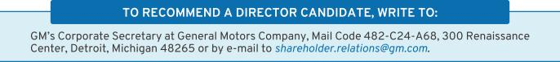
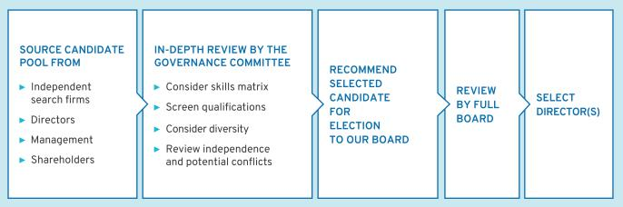

22

Table of Contents

Non-Employee Director Compensation

Our non-employee directors receive cash compensation as well as equity compensation in the form of GM Deferred Share Units for their Board service under the Company’s Director

Compensation Plan. Compensation for our non-employee directors is set by the Board at the recommendation of the Governance Committee.

- Guiding Principles

• Fairly compensate directors for their responsibilities and time commitments.


• Attract and retain highly qualified directors by offering a compensation program consistent with those at companies of similar size, scope, and complexity.

• Align the interests of directors with our shareholders by providing a significant portion of compensation in equity and requiring directors to continue to own our common stock (or common stock equivalents) throughout their tenure on the Board.

• Provide compensation that is simple and transparent to shareholders.

- Annual Review Process

The Governance Committee annually assesses the form and amount of non-employee director compensation and recommends changes, if appropriate, to the Board. As part of its annual review in 2022, the Governance Committee retained a compensation consultant and outside legal counsel to assist in its review of director compensation data and practices. For purposes of this exercise, the Governance Committee primarily benchmarked against the executive compensation peer group described in the “Peer Group for Compensation Benchmarking” section on page 57.

In December 2022, following its review of GM’s non-employee director compensation structure,

the Governance Committee recommended, and the Board approved, the following program updates: (i) an increase in non-employee director compensation in recognition of the inflationary environment, (ii) an increase in the mandatory DSU deferral from 50 percent to 60 percent, and (iii) an increase in the stock ownership requirement from $500,000 to $650,000 within five years. Non-employee director compensation for 2023 is set forth in detail below. The Board believes these changes further align the non-employee director compensation program with shareholder interests through increased stock ownership.

- Director Stock Ownership and Holding Requirements

• Each non-employee director is required to own our common stock or DSUs with a market value of at least $650,000.


• Each non-employee director has up to five years from the date they are first elected to the Board to meet this ownership requirement.

• Non-employee directors are prohibited from selling any GM securities or derivatives of GM securities, such as DSUs, while they are members of the Board.

• Ownership guidelines are reviewed each year to confirm they continue to be effective in aligning the interests of the Board and our shareholders.

All of our non-employee directors are in compliance with our stock retention requirements.

23

Table of Contents

- Annual Compensation

The 2022 and 2023 compensation for non-employee directors is described in the table below. The Independent Lead Director and committee chairs receive additional compensation due to the increased workload and additional responsibilities associated with these positions. In particular, Ms. Russo’s compensation as Independent Lead Director reflects the

additional time commitment for this role, which includes, among other responsibilities, attending all committee meetings and attending meetings with the Company’s CEO. For additional information about the roles and responsibilities of our Independent Lead Director, see “The Role of the Independent Lead Director” on page 29.

 | 2022 | 2023
Compensation Element | Structure | Structure
Compensation Element | ($) | ($)
Board Retainer | 305,000 | 325,000
Independent Lead Director Fee | 100,000 | 100,000
Audit Committee Chair Fee | 35,000 | 35,000
All Other Committee Chair Fees (excluding the Executive
Committee) | 25,000 | 25,000

Starting in 2023, non-employee directors are required to defer at least 60 percent (compared to 50 percent in 2022) of their annual Board retainer into DSUs under the Director Compensation Plan. Directors may elect to defer their remaining Board retainer or amounts payable (if any) for serving as

a committee chair or Independent Lead Director into additional DSUs. The fees for a director who joins or leaves the Board or assumes additional responsibilities during the year are prorated for the director’s period of service.

- How Deferred Share Units Work

Each DSU is equal in value to one share of GM common stock and is fully vested upon grant, but does not have voting rights. DSUs will not be available for disposition until after the director leaves the Board. After leaving the Board, the director will receive a cash payment or payments based on the number of DSUs in the director’s account valued at the average daily closing market price for the quarter immediately

preceding payment. Directors will be paid in a lump sum or in annual installments for up to five years, based on their deferral elections. All DSUs granted are rounded up to the nearest whole unit. Any portion of the retainer that is deferred into DSUs may also earn dividend equivalents, which are credited at the end of each calendar year to each director’s account in the form of additional DSUs. DSUs granted are determined as follows:
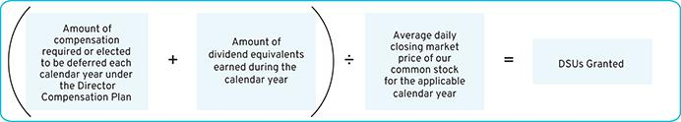

24

Table of Contents

- Other Compensation

We provide certain additional benefits to non-employee directors.

Type |  | Purpose
u | Company Vehicles | We provide directors with the use of Company vehicles and electric vehicle charging stations
 |  | to provide feedback on our products as well as enhance the public image of our vehicles.
 |  | Retired directors also receive the use of a Company vehicle for a period of time. Participants
 |  | are charged with imputed income based on the lease value of the vehicles and are
 |  | responsible for associated taxes.
u | Personal Accident | We provide personal accident insurance coverage in the event of accidental death or
 | Insurance⁽¹⁾ | dismemberment. Directors are responsible for associated taxes on the imputed income from
 |  | the coverage.

- Ms. Barra, our sole employee director, does not receive additional compensation for her Board service other than the personal accident insurance benefit described above, the value of which is reported for Ms. Barra in the Summary Compensation Table on page 74.

Non-employee directors are not eligible to participate in any of the savings or retirement programs available to our employees. Other than as described in this section, there are no separate benefit plans for directors.

2022 Non-Employee Director Compensation Table

The table below shows the compensation that each non-employee director received for their 2022 Board and committee service.

 | Fees Earned or | Stock Awards⁽²⁾ | All Other | Total
Director | Paid in Cash⁽¹⁾ | Stock Awards⁽²⁾ | Compensation⁽³⁾ | Total
Director | ($) | ($) | ($) | ($)
Aneel Bhusri | 152,500 | 127,529 | 10,969 | 290,998
Wesley G. Bush⁽⁴⁾ | 195,000 | 127,529 | 15,490 | 338,019
Joanne C. Crevoiserat⁽⁵⁾ | 57,950 | 51,974 | 2,226 | 112,150
Linda R. Gooden | 177,500 | 127,529 | 18,823 | 323,852
Joseph Jimenez | 177,500 | 127,529 | 42,740 | 347,769
Jonathan McNeill⁽⁶⁾ | 38,125 | 34,784 | 60 | 72,969
Jane L. Mendillo⁽⁷⁾ | 68,625 | 51,503 | 14,870 | 134,998
Judith A. Miscik | 152,500 | 127,529 | 16,819 | 296,848
Patricia F. Russo | 277,500 | 127,529 | 23,723 | 428,752
Thomas M. Schoewe | 187,500 | 127,529 | 45,240 | 360,269
Carol M. Stephenson | 165,000 | 127,529 | 33,928 | 326,457
Mark A. Tatum | 152,500 | 127,529 | 24,990 | 305,019
Devin N. Wenig | 182,500 | 127,529 | 28,263 | 338,292
Margaret C. Whitman⁽⁸⁾ | 79,850 | 62,705 | 2,432 | 144,987

- As described above, a director may elect to defer all or a portion of their annual cash retainer into DSUs. This column reflects director compensation eligible to be paid in cash, which consists of 50 percent (for 2022) of the annual Board retainer and any applicable fees for committee chairs, the Independent Lead Director, and in the case of Mr. Bush and Mr. Wenig, for service on the Cruise LLC board of directors. Each of the following directors elected to

25

Table of Contents

receive DSUs in lieu of such amounts eligible to be paid in cash in the following amounts: Mr. Bhusri — $152,500; Mr. Bush — $195,000; Ms. Crevoiserat — $57,950; Mr. Jimenez — $177,500; Mr. McNeill — $19,063; Ms. Mendillo — $68,625; Ms. Russo — $277,500; Ms. Stephenson — $82,500; Mr. Wenig — $182,500; and Ms. Whitman — $79,850.

- Reflects aggregate grant date fair value of DSUs granted in 2022, which does not include any cash fees that directors voluntarily elected to receive as DSUs. Grant date fair value is calculated by multiplying the number of DSUs granted by the closing price of GM common stock on December 30, 2022, which was $33.64. The holders of DSUs may also receive dividend equivalents, which are reinvested in additional DSUs based on the market price of the common stock on the date the dividends are paid.

- The following table provides more information on the type and amount of benefits included in the All Other Compensation column.

 | Company
 | Vehicle | Other^{(b)} | Total
Director | Program^{(a)} | Other^{(b)} | Total
Director | ($) | ($) | ($)
Aneel Bhusri | 10,729 | 240 | 10,969
Wesley G. Bush | 15,250 | 240 | 15,490
Joanne C. Crevoiserat | 2,146 | 80 | 2,226
Linda R. Gooden | 18,583 | 240 | 18,823
Joseph Jimenez | 42,500 | 240 | 42,740
Jonathan McNeill | — | 60 | 60
Jane L. Mendillo | 14,750 | 120 | 14,870
Judith A. Miscik | 16,579 | 240 | 16,819
Patricia F. Russo | 23,483 | 240 | 23,723
Thomas M. Schoewe | 45,000 | 240 | 45,240
Carol M. Stephenson | 33,688 | 240 | 33,928
Mark A. Tatum | 24,750 | 240 | 24,990
Devin N. Wenig | 28,023 | 240 | 28,263
Margaret C. Whitman | 2,292 | 140 | 2,432

  - The Company vehicle program includes the estimated annual lease value of the Company vehicles driven by directors. We include the annual lease value because it is more reflective of the value of the Company vehicle perquisite than the Company’s incremental costs, which are generally significantly lower because the Company manufactures and ordinarily disposes of Company vehicles for a profit, resulting in minimal incremental costs, if any. Taxes related to imputed income are the responsibility of the director.

  - Reflects the cost of premiums for providing personal accident insurance (annual premium cost of $240 per person is prorated, as applicable, for the period of service).

- Mr. Bush was appointed Chair of the Compensation Committee on June 13, 2022.

- Ms. Crevoiserat joined the Board on August 15, 2022.

- Mr. McNeill joined the Board on September 30, 2022.

- Ms. Mendillo retired from the Board on June 13, 2022.

- Ms. Whitman retired from the Board on July 15, 2022.

26

Table of Contents

[THIS PAGE INTENTIONALLY LEFT BLANK]

Table of Contents

CORPORATE GOVERNANCE

The Board of Directors

GM is governed by a Board of Directors and committees of the Board that meet throughout the year to ensure that the CEO and other senior management are operating the Company in a competent and ethical manner. The Board is elected by our shareholders to oversee and provide guidance on the Company’s business and affairs. It is the ultimate decision-making body of the Company, except for those matters reserved for shareholders by law or pursuant to the Company’s corporate governance documents. Among other things, the Board oversees the Company’s strategy

and execution of the strategic plan. In addition, it oversees management’s proper safeguarding of the assets of the Company, maintenance of appropriate financial and other internal controls, compliance with applicable laws and regulations, and proper governance. The Board is committed to sound corporate governance policies and practices that are designed and routinely assessed to enable the Company to operate its business responsibly, with integrity, and to position GM to compete more effectively, sustain its success, and build long-term shareholder value.

- Board Size

The Board sets the number of directors from time to time by a resolution adopted by a majority of the Board. The Governance Committee reassesses the suitability of the Board’s size at least annually. The Board has the flexibility to increase or decrease the size of the Board as circumstances warrant, though the Company’s Certificate of Incorporation limits the total number of directors to 17. There are currently 13 members of the

Board. If all of the Board’s nominees are elected, the Board will be composed of 13 members immediately following the Annual Meeting as a result of Ms. Stephenson’s retirement and Vice Admiral Tighe’s election. If any nominee is unable to serve as a director, or if any director leaves the Board between annual meetings, the Board may reduce the number of directors or elect an individual to fill the resulting vacancy.

- Director Independence

GM’s Bylaws and Corporate Governance Guidelines define our standards for director independence and reflect applicable NYSE and SEC requirements. At least two-thirds of our directors must be independent under these standards. In addition, all members of the Audit Committee and the Compensation Committee must meet heightened independence standards under applicable NYSE and SEC rules. For a director to be “independent,” they must have no disqualifying relationships, as defined in the NYSE standards, and the Board must determine that the director has no material relationship with the Company other than the individual’s service as a director.

The Governance Committee completed its annual assessment in February 2023 regarding the independence of each director and made recommendations to the Board. Consistent with the standards described above, the Board has reviewed all relationships between the Company

28

and each director and director nominee and considered all relevant quantitative and qualitative criteria. The Board has affirmatively determined that, other than Ms. Barra who serves as our CEO, all directors and director nominees are currently independent and, if applicable, were independent throughout 2022. In addition, the Board affirmatively determined that all of the director nominees who currently serve on the Audit Committee and the Compensation Committee are independent as required by the heightened NYSE and SEC criteria described above.

In recommending to the Board that it determine each non-employee director is independent, the Governance Committee considered whether there were any other facts or circumstances that might impair a director’s independence. The Governance Committee also considered that GM, in the ordinary course of business during the last three years, has sold fleet vehicles to, and purchased

Table of Contents

products and services from, companies at which some of our directors serve as non-employee directors or executives. The Board determined that these transactions were not material to GM or the other companies involved and that none of our directors had a material interest in the transactions with these companies. In each case,

these transactions were in the ordinary course of business for GM and the other companies involved and were on terms and conditions available to similarly situated customers and suppliers. Therefore, the Board determined they did not impair such directors’ independence.

Board Leadership Structure and Composition

The Board has the flexibility to decide when the positions of Board Chair and CEO should be combined or whether an independent director should serve as Board Chair. This allows the Board to choose the leadership structure that it believes will best serve the interests of our shareholders at any particular time. In January 2016, the Board recombined the positions of Board Chair and CEO under the leadership of Ms. Barra and designated an Independent Lead Director.

Since then, each year the Board has voted to elect Ms. Barra as Board Chair. The Board believes that Ms. Barra’s in-depth knowledge of GM’s business and vision for the future bring focused leadership

to the Board and, therefore, combining the role of Board Chair and CEO while electing a strong Independent Lead Director results in the optimal Board leadership structure for GM at this time.

Ms. Russo is the Board’s Independent Lead Director, a role she has held since 2021. Ms. Russo joined our Board in 2009 and previously served as the Independent Lead Director from 2010 to 2014. Her extensive knowledge of GM’s business and experience collaborating with our management team uniquely qualifies her to provide strong, independent leadership and strategic direction to the Board at this time.

- The Role of the Independent Lead Director

The role of the Independent Lead Director is to provide strong, independent leadership to the Board and assist the other independent directors in overseeing and shaping the partnership between management and the Board. Below is a summary of the key duties and responsibilities of GM’s Independent Lead Director.

• Presiding over all Board meetings when the Board Chair is not present, including executive sessions of non-management directors, and advising the Board Chair of any actions taken;


• Providing Board leadership if circumstances arise in which the Board Chair actually has, potentially has, or is perceived to have, a conflict of interest;

• Calling executive sessions for non-management directors, relaying feedback from these sessions to the Board Chair, and implementing decisions made by the non-management directors;

• Leading non-management directors in the annual evaluation of the CEO’s performance, communicating the results of that evaluation to the CEO, and overseeing CEO succession planning;

• Approving Board meeting agendas to ensure sufficient time for discussion of all items;

• Advising on the scope, quality, quantity, and timeliness of the flow of information between management and the Board;

• Serving as a liaison between non-management directors and the Board Chair when requested to do so (although all non-management directors have direct and complete access to the Board Chair at any time they may deem necessary or appropriate);

• Interviewing all director candidates and making recommendations to the Governance Committee and the Board;

• Being available to advise the Board committee chairs in fulfilling their designated roles and responsibilities to the Board; and

• Engaging, when requested to do so, with shareholders.

29

Table of Contents

Board Committees

The Board has six standing committees: Audit, Executive, Executive Compensation, Finance, Governance and Corporate Responsibility, and Risk and Cybersecurity. The key responsibilities, recent activities, and focus areas of each committee, together with their current membership (not including Ms. Stephenson, who still sits on her assigned committees but is not standing for re-election at the Annual Meeting) and the number of meetings held in 2022, are set forth below. In addition to committee meetings, each committee chair regularly meets with management throughout the year to discuss and preview committee business, shape agendas, and facilitate efficient meetings. The Board Chair, Ms. Barra, and the Independent Lead Director, Ms. Russo, attend all committee meetings to serve as a resource and to identify topics requiring the Board’s attention. The Board has determined that each member of the Audit, Compensation, Finance, Governance, and Risk and Cybersecurity Committees is independent according to applicable SEC and NYSE requirements and our Corporate Governance Guidelines. Each committee’s charter is available at investor.gm.com/esg.

- Board and Committee Meetings and Attendance

In 2022, the Board held nine meetings and the average director attendance at Board and committee meetings was 98 percent. Each director standing for re-election attended at least 93 percent of the total meetings of the Board and the respective committees on which they served in 2022. In addition, the six Board committees held a combined 20 meetings throughout the year, focused on critical topics, including batteries and other key components of EVs; updates on the supply chain with a focus on sourcing raw materials and rare earth elements; and other sustainability issues, including over 70 specific ESG-related topics.

Directors are encouraged to attend our annual meetings of shareholders. All directors that stood for election in 2022 attended the 2022 annual meeting.

- Executive Sessions

Independent directors have an opportunity to meet in executive session without management present as part of each regularly scheduled Board and committee meeting. Executive sessions are chaired by our Independent Lead Director or the respective committee chair.

During executive sessions of the Board, the independent directors may review CEO performance, compensation, and succession planning; strategy; key enterprise risks; future Board agendas and the flow of information to directors; corporate governance matters; and any other matters of importance to the Company raised during a meeting or otherwise presented by the independent directors.

The non-management directors, all of whom are independent, met in executive session of the Board six times in 2022, in addition to numerous executive sessions of the committees.

- Delegation and Access to Outside Advisors

Each committee may delegate its authority to members of management and also form and delegate authority to subcommittees consisting of one or more members when it deems it appropriate. The Board and each Board committee can select and retain the services of outside advisors at the Company’s expense.

30

Table of Contents


AUDIT


 | Wesley G. Bush
 | Joanne C. Crevoiserat
 | Linda R. Gooden
 | Thomas M. Schoewe
Thomas M. Schoewe | Mark A. Tatum
Thomas M. Schoewe | Meetings held in 2022: 8
Chair | Meetings held in 2022: 8

Key Responsibilities:

- Monitors the effectiveness of GM’s financial reporting processes and systems, as well as disclosure and internal controls;

- Selects and engages GM’s external auditors and reviews and evaluates the audit process;
● Reviews and evaluates the scope and performance of the internal audit function;

- Facilitates ongoing communications about GM’s financial position and affairs among the Board and the external auditors, GM’s financial and senior management, and GM’s internal audit staff;

- Reviews GM’s policies and procedures regarding ethics and compliance, including the office of the Chief Compliance Officer;

- Reviews GM’s ESG reporting processes and control procedures and annually approves GM’s Sustainability Report (along with the Governance Committee); and

● Oversees the preparation of the Audit Committee Report and related disclosures for the annual proxy statement.
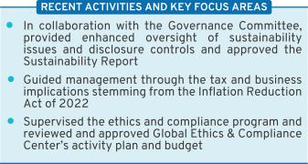

EXECUTIVE COMPENSATION


 | Aneel Bhusri
 | Wesley G. Bush
 | Joseph Jimenez
 | Patricia F. Russo
Wesley G. Bush | Meetings held in 2022: 3
Chair | Meetings held in 2022: 3


Key Responsibilities:

- Reviews the Company’s executive compensation policies, practices, and programs;
● Reviews and approves corporate goals and objectives for compensation, evaluates performance (along with the full Board), and determines compensation levels for the CEO;
- Reviews and approves compensation of NEOs, executive officers, and other senior leaders under its purview;

- Reviews compensation policies and practices so that the plans do not encourage unnecessary or excessive risk-taking; and

- Reviews the Company’s compensation policies and practices in an effort to promote diversity and inclusion.
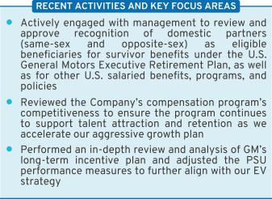

31

Table of Contents

 | FINANCE
 | Wesley G. Bush
 | Joanne C. Crevoiserat
 | Joseph Jimenez
 | Judith A. Miscik
 | Patricia F. Russo
Joseph Jimenez | Thomas M. Schoewe
Chair | Meetings held in 2022: 3


Key Responsibilities:

- Reviews financial policies, strategies, and capital structure;
- Reviews the Company’s cash management policies and proposed capital allocation plans, capital expenditures, dividend actions, stock repurchase programs, issuances of debt or equity securities, and credit facility and other borrowings;

- Reviews any significant financial exposures and risks, including foreign exchange, interest rate, and commodities exposures, and the use of derivatives to hedge those exposures;

- Reviews the regulatory compliance, administration, financing, investment performance, risk and liability profile, and funding of the Company’s pension obligations; and
- Reviews any strategic investments and similar transactions, including investments in our battery supply chain.
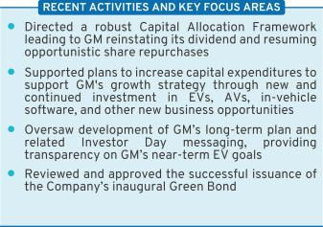

GOVERNANCE AND

CORPORATE RESPONSIBILITY

Aneel Bhusri

Joanne C. Crevoiserat
Patricia F. Russo
Mark A. Tatum

Patricia F. Russo
Chair | Meetings held in 2022: 4

Key Responsibilities:

- Reviews the Company’s corporate governance framework, including all significant governance policies and procedures;

- Monitors Company policies and strategies related to corporate responsibility, sustainability, and political contributions and lobbying activities;

- Reviews the appropriate composition of the Board and recommends director nominees;
- Monitors the self-evaluation process of the Board and committees;
- Recommends compensation of non-employee directors

to the Board;

● Oversees the Company’s development of ESG initiatives, strategies, policies, and practices related to sustainability and corporate responsibility;

● Reviews and approves, in consultation with the Audit Committee, the Company’s annual Sustainability Report; and

● Reviews and approves related party transactions and any potential director conflicts of interest, as applicable.
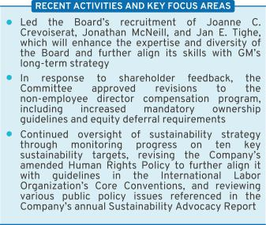

32

Table of Contents


RISK AND CYBERSECURITY

Linda R. Gooden
Joseph Jimenez
Judith A. Miscik
Thomas M. Schoewe
Devin N. Wenig

Linda R. Gooden
Chair | Meetings held in 2022: 3
Key Responsibilities:
● Reviews | the Company’s key | strategic, enterprise,
and cybersecurity risks;
● Reviews | privacy risk, including | potential impact to
the Company’s employees, customers, and other stakeholders;

● Reviews the Company’s risk management framework and management’s implementation of risk policies, procedures, and governance to assess their effectiveness;

- Reviews management’s evaluation of strategic and operating risks, including risk concentrations, product safety, quarterly information security reports, mitigating measures, and the types and levels of risk that are acceptable in the pursuit and protection of shareholder value; and

- Reviews the Company’s risk culture, including the integration of risk management into the Company’s behaviors, decision-making, and processes.
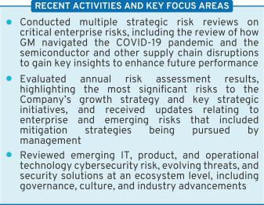

 | EXECUTIVE
 | Mary T. Barra
 | Wesley G. Bush
 | Linda R. Gooden
 | Joseph Jimenez
 | Patricia F. Russo
Mary T. Barra | Thomas M. Schoewe
Chair | Meetings held in 2022: 0


The Board has an Executive Committee composed of the Board Chair and CEO, the Independent Lead Director, and the chairs of all other standing committees. The Executive Committee is chaired by Ms. Barra, and it can act on certain limited matters for the full Board in intervals between meetings of the Board. The Executive Committee meets as necessary, and all actions by the Executive Committee are reported and ratified at the next succeeding Board meeting. Because the Board addressed all items throughout the year at Board meetings, no Executive Committee meetings were needed in 2022.

33

Table of Contents

Board and Committee Oversight of Risk

- Role of the Board of Directors

The Board has overall responsibility for risk oversight and focuses on the most significant risks facing the Company. The Board discharges its risk oversight responsibilities, in part, through delegation to its committees. The Company’s risk governance is facilitated through a top-down and bottom-up communication structure, with the tone established at the top by Ms. Barra, our Board Chair and CEO, and other members of management, specifically the Senior Leadership Team. The Senior Leadership Team also utilizes our Risk Advisory Council, an executive-level body with delegates from each business unit, to discuss and monitor the most significant enterprise and emerging risks in a cross-functional setting. They are tasked with championing risk management practices and integrating them into their functional or regional business units.
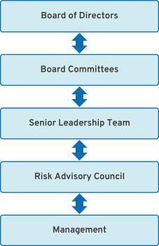

- Role of the Board Committees

Each of the Board’s committees has a critical role to play in the overall execution of the Board’s risk oversight duties. The Board delegates oversight for certain risks to each committee based on the risk categories relevant to the subject matter of the committee. The Risk and Cybersecurity Committee Chair coordinates with the chairs of the other committees to support them in managing the relationship between risk management policies and practices and their respective oversight responsibilities. The Risk and Cybersecurity Committee also assists the Board by monitoring the overall effectiveness of the Company’s risk management framework and processes. For example, GM’s Strategic Risk Management team conducts an annual risk assessment, which the Risk and Cybersecurity Committee reviews and receives detailed management updates regularly throughout the year.

Below is a summary of the key risk oversight responsibilities that the Board has delegated to its committees.

- Audit Committee: Oversees risks related to (i) financial reporting, internal disclosure controls (including with respect to ESG issues, reporting, and disclosures), and auditing matters; and (ii) legal, regulatory, and compliance programs.

- Executive Compensation Committee: Oversees risks related to executive and employee compensation plans, including by designing compensation plans that promote prudent risk management and do not encourage excessive risk-taking.

- Finance Committee: Oversees risks related to (i) significant financial exposures and contingent liabilities of the Company; (ii) regulatory compliance of employee-defined benefit plans; and (iii) M&A activity and impacts from changes to the Company’s shareholder base.

- Governance and Corporate Responsibility Committee: Oversees risks related to (i) public policy and political activities;

  - director independence and related party transactions; (iii) the sustainability of our operations and products; and
  - ESG disclosures in consultation with the Audit Committee.

- Risk and Cybersecurity Committee: Oversees risks related to the Company’s key strategic, enterprise, and cybersecurity risks, including climate change, workplace and product safety, and privacy.

34

Table of Contents

- Cybersecurity Risk Oversight

Each quarter, the Risk and Cybersecurity Committee reviews management’s Cybersecurity Maturity Scorecard, which leverages both the National Institute of Standards and Technology cybersecurity framework and the Capability Maturity Model Integration maturity rating. Management discusses various topics, including information security, manufacturing cybersecurity, and product cybersecurity, and provides intelligence briefings on notable cyber events impacting the industry. The briefings summarize the vulnerabilities that led to the event, provide insight into what happened, and highlight learnings that GM can leverage in the future.

GM’s Cybersecurity organization, which was recently restructured to report to the Company’s Executive Vice President – Legal, Public Policy, Cybersecurity, and Strategic Technology Initiatives to reflect the best practice of creating an independent cybersecurity office, aligns cybersecurity domains across GM, GM Financial, Cruise, and our other growth businesses (such as BrightDrop and OnStar Insurance). It also enables GM to leverage both business and technical experts to accelerate the development and execution of security solutions. Our global team is charged with executing enterprise, product, and manufacturing cybersecurity programs with a focus on security architecture, penetration testing, cyber risk management, incident response, vulnerability management, intelligence, awareness and training, and governance. GM applies a defense-in-depth cybersecurity strategy, making it more difficult for attackers to breach our defenses and allowing for

quick detection, deflection, and counteraction of attempts at unauthorized access. Beyond the GM ecosystem, GM leverages a Third-Party Cybersecurity Program to minimize disruption to GM’s business and production operations, strengthen supply chain resilience in response to cyber-related events, and ensure the integrity of components and systems used in GM’s products and services.

GM also includes multi-domain cybersecurity training as part of its annual corporate required training program. In addition, training and awareness is integrated and continues throughout the year, utilizing various delivery methods such as phishing awareness campaigns, live training sessions, and informational articles. GM continues to invest heavily in cybersecurity, including through our over 500 dedicated employees. These employees have diverse skillsets and include pen-testers, cryptologists, analysts, architects, data analysts, security engineers, program managers, and “true hackers.” In addition, the Company protects itself and shareholder interests through comprehensive information security and cybersecurity policies. The Cybersecurity team uses a balanced approach in validating the efficacy of its risk management program, leveraging cybersecurity resources and GM’s internal audit services, as well as engaging with external, third-party auditors and other experts at least annually across the domains. In 2022, GM did not have any material cybersecurity incidents or any material customer privacy complaints from regulatory bodies or outside parties.

- Privacy Risk Oversight

In recent years, GM’s Strategic Risk Management team determined that privacy risks were increasing in significance due to the enactment of new and more stringent U.S. and global regulations on the use and protection of personal information, especially as we move toward a software-defined vehicle. Accordingly, the Risk and Cybersecurity Committee has taken steps to continue to enhance its oversight of GM’s data privacy policies and practices. Pursuant to its

charter, the Committee is responsible for overseeing GM’s privacy risks relating to the Company’s employees, customers, and other stakeholders. The Committee also devotes portions of its meetings to discuss critical privacy issues with management, including GM’s processes and policies designed to ensure compliance with emerging state, federal, and international laws and regulations.

35

Table of Contents

- ESG Risk Oversight

The Board oversees ESG principles throughout the enterprise and has delegated specific ESG oversight responsibilities to each of its committees. In 2021, the committees further incorporated ESG responsibilities into their charters in recognition that ESG impacts all aspects of the business.


Audit Committee | • Reviews the processes and control procedures over ESG disclosures
 | • Oversees the internal audit function, which includes coverage of controls around ESG
 | disclosures
 | • Reviews and approves the annual Sustainability Report
Compensation Committee | • Makes an annual determination as to whether the Company’s ESG goals and milestones
 | are effectively integrated into compensation programs
 | • Considers shareholder feedback relative to the alignment of GM’s sustainability goals
Finance Committee | • Reviews changes to our shareholder composition, including the impact of ESG-oriented
 | investors
Governance Committee | • Oversees ESG initiatives, strategies, and policies that have a material impact on the
 | Company
 | • Tracks an ESG scorecard of 10 key targets and conducts annual reviews of ESG topics
 | • Manages the Board’s shareholder engagement program
 | • Reviews and approves the annual Sustainability Report
Risk and Cybersecurity | • Reviews GM’s strategic, operational, and cybersecurity risks, including workplace safety,
Committee | vehicle cybersecurity safety, climate change, and privacy risk
 | • Considers climate change as part of its key strategic and operational risk management
 | framework

At the management level, GM’s Senior Leadership Team establishes and executes the Company’s ESG strategy. This cross-functional group of senior leaders drives GM’s ESG initiatives throughout the Company – from global product development, portfolio planning, manufacturing, and supply chain to human resources (including DE&I and other workforce matters), legal, compliance, social, and community impact projects. The Senior Leadership Team is supported in this work by the Company’s Office of Sustainability and ESG Disclosure Committee.

GM’s Chief Sustainability Officer, reporting to the Executive Vice President of Global Manufacturing and Sustainability, is the enterprise-wide leader for sustainability initiatives, who develops and coordinates sustainability strategy and efforts across the Company. GM’s Chief of Diversity, Equity, and Inclusion, reporting to the Senior Vice President and Chief People Officer, is the enterprise-wide leader for DE&I initiatives, who develops and coordinates DE&I strategy and efforts across the Company.

36

Table of Contents

The Board’s Governance Policies and Practices

- Code of Conduct: “Winning with Integrity”

The Board is committed to the highest legal and ethical standards in fulfilling its responsibilities. We have adopted a code of business conduct and ethics, “Winning with Integrity,” that applies to everyone in our Company, at every level, including employees, executives, Board members and, as applicable, subsidiaries that GM controls. This Code of Conduct forms the foundation for compliance with corporate policies and procedures and creates a Company-wide focus on uncompromising integrity in every aspect of our operations. It embodies our expectations on a number of topics, including workplace and vehicle safety; DE&I; conflicts of interest; protection of confidential information; insider trading; competition and fair dealing; human rights; community involvement and corporate citizenship; political activities and lobbying; preservation and use of Company assets; and compliance with laws and regulations. Employees are expected to report any conduct that they believe in good faith to be an actual or apparent violation of our Code of Conduct. The Code of Conduct is available at investor.gm.com/esg.

In addition, GM’s Insider Trading Policy prohibits all GM directors and employees, including

executive officers, from trading in GM securities while in possession of material non-public information about the Company, trading any GM derivatives (e.g., put or call options), engaging in short sales, or otherwise engaging in hedging activities, and pledging of GM securities. This policy is posted on our website at investor.gm.com/esg.
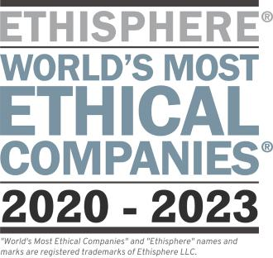

- Corporate Governance Guidelines

Our Corporate Governance Guidelines form a transparent framework for the effective governance of the Company. The Corporate Governance Guidelines address matters such as the respective roles and responsibilities of the Board and management, the Board’s leadership structure, the responsibilities of the Independent Lead Director, director independence, Board membership criteria, Board committees, and Board and CEO evaluations. The Governance Committee annually reviews the Corporate Governance Guidelines and periodically recommends to the Board the adoption of amendments in response to changing regulations, evolving best practices, and shareholder concerns.

Last year, this review led to a number of enhancements and refinements, including, among other changes: adding context to the Board’s oversight of ESG and risk management; clarifying that a former CEO can remain on the Board if serving as executive chair; supplementing the Board’s diversity policy and its perspectives on recruitment of candidates from minority groups; adding more insight into the Board’s perspective on its retirement policy; and disclosing the Governance Committee’s practice of reviewing each director’s time and availability commitments. A summary of our corporate governance best practices is discussed in the “Governance Highlights” section on page 10.

37

Table of Contents

- CEO Succession Planning

Our Independent Lead Director oversees the CEO succession planning process and leads, at least annually, the Board’s discussion of CEO succession planning. During this review, our CEO provides the Board with recommendations for, and evaluations of, potential CEO successors and discusses developmental plans for these successors. Directors engage with CEO candidates

- Board and Committee Evaluations

The Governance Committee annually reviews the form and process for Board and committee self-evaluations. The Board’s evaluation process is based on extensive benchmarking, engagement with shareholders, and internal discussion. In 2022, the self-evaluation process for the Board and its committees included (i) committee evaluations led by each committee chair; (ii) interviews between the Board Chair and CEO and each director nominee; and

- an executive session of the Board to review the feedback received by the Board Chair and CEO. In addition, the Independent Lead Director met in executive session after each Board meeting without the Board Chair and CEO to gather feedback from the other non-employee directors.

and senior management talent at Board and committee meetings and other forums to enable directors to personally assess candidates. The Board reviews management succession planning in the ordinary course of business as well as contingency planning in the event of an emergency or unanticipated event.
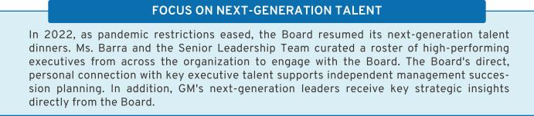

The Board believes this process provides ample opportunity to provide feedback on Board, committee, and individual director performance. The Board is committed to implementing feedback from its self-evaluations. Recent examples of changes to practices include evolving the composition of the Board, conducting extensive reviews of the Company’s marketing, software and digital strategies, focusing on supply chain sustainability and battery raw material costs, and prioritizing Board meetings outside Company headquarters to increase interaction with employees and experience the transformation efforts.

- Annual Evaluation of CEO

Each year, the Board reviews the CEO’s performance against her annual strategic goals. The non-management directors, meeting separately in executive session, annually conduct a formal evaluation of the CEO, which is communicated to the CEO by the Independent Lead Director and Compensation Committee Chair. The evaluation is based on both objective and subjective criteria, including, but not limited to, the Company’s financial

38

performance, accomplishment of ongoing initiatives in furtherance of the Company’s long-term strategic objectives, and development of the Company’s senior management talent. The results of the evaluation are considered by the Compensation Committee in determining the compensation of the CEO as further described in the “Compensation Discussion and Analysis” section beginning on page 51.

Table of Contents

- Director Orientation and Continuing Education

All new directors complete the Company’s director orientation program within the first year of their election. The orientation enables new directors to become familiar with the Company’s business and strategic plans, significant financial matters, core values and behaviors, compliance programs, corporate governance practices, and other key policies and practices. As part of the orientation, they meet individually with the Board Chair and CEO, President, General Counsel, and other key members of the Senior Leadership Team. They also attend a meeting of each Board committee at least once before being assigned to committees by the Board.

Continuing education opportunities are also provided to keep directors updated with information

about the Company and its strategy, operations, products, and other matters relevant to Board service. Board members are also encouraged to visit GM facilities and dealers and attend auto shows and other key corporate and industry events to enhance their understanding of the Company and its competitors in the automotive industry. Examples of such educational opportunities in 2022 included touring the Company’s new engineering facility in Concord, North Carolina and receiving in-depth competitor reviews throughout the year. In addition, all directors are encouraged to attend, at our expense, director continuing education programs sponsored by governance organizations and other institutions.
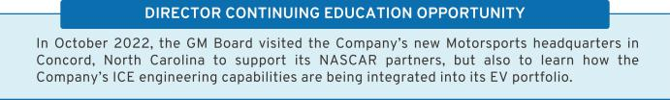

39

Table of Contents

- Director Service on Other Public Company Boards

The Board recognizes that service on other public company boards provides directors valuable experience that benefits the Company. The Board also believes, however, that it is critical that directors dedicate sufficient time to their service on the Company’s Board. Directors are expected to advise the Board Chair, Independent Lead Director, or Governance Committee Chair in advance of accepting an invitation to serve on another board of directors or any audit committee of another public company’s board. This allows the Governance Committee to assess the impact of the director joining another board based on various factors relevant to the specific situation, including the nature and extent of a director’s other professional obligations and the time commitment required by the new position. The Governance Committee conducts an annual review of director commitment levels and affirms that all directors are able to comply with the Company’s expectations on a director’s time and availability. Sometimes, for example, the

Governance Committee determines that directors who are engaged in active, full-time employment have less time to devote to board service than a director whose principal occupation is serving on boards. Our Corporate Governance Guidelines provide that, without obtaining the approval of the Board:

- A director may not serve on the boards of more than four other public companies (excluding nonprofits and subsidiaries); and

- No member of the Audit Committee may serve on more than two other public company audit committees.

The Board also prefers that senior members of management not serve on the board of more than one other public company or for-profit entity, and requires that executive officers obtain the approval of the Governance Committee prior to accepting an invitation to serve on an outside board. At this time, all members of management are in compliance with these guidelines.

- Compensation Committee Interlocks and Insider Participation

Mses. Russo and Stephenson and Messrs. Bhusri, Bush, and Jimenez serve on the Compensation Committee and Ms. Whitman served on it until her departure from the Board in July 2022. As of the date of this Proxy Statement, no member of the Compensation Committee was or is a GM officer or

employee, and no executive officer of the Company served or serves on a compensation committee or board of any company that employed or employs any member of the Company’s Compensation Committee or Board.

40

Table of Contents

Corporate Political Contributions and Lobbying Expenditures

- Board Oversight

We participate in the legislative, regulatory, and political processes to help shape public policy that supports our industry, reflects our values and principles, and advances our vision for the future of mobility. To guide our activities and ensure compliance with applicable laws and regulations, the Board has adopted a Company Policy on Corporate Political Contributions and Expenditures (“Political Contributions Policy”).

The Governance Committee oversees the Political Contributions Policy and annually reviews the Company’s engagement in the public policy process. The Governance Committee also annually reviews all corporate political contributions, GM PAC contributions and expenditures, and the process by which such contributions and

expenditures are made. GM PAC expenditures are funded entirely by voluntary director and employee contributions and are guided by a board of directors and a steering committee using defined criteria set forth in the Political Contributions Policy.

Management provides updates to the Governance Committee on a regular basis regarding the Company’s lobbying expenditures. In addition, the full Board receives frequent updates from management regarding significant global policy issues facing the Company. The Board uses this report to continuously assess which issues are most important to the Company’s long-term interests and which organizations the Company is working with to advance those interests.

- Transparency and Disclosure

To promote political transparency and accountability, GM publishes an annual voluntary report of political contributions. In addition, GM files publicly available federal Lobbying Disclosure Act reports each quarter, which disclose GM’s lobbying expenditures, describe the legislative issues on which we have lobbied, and identify the individuals who lobbied on behalf of GM. GM also files similar periodic reports with state agencies. For the fifth consecutive year, the Center for Political Accountability’s Zicklin Index of Corporate

Political Disclosure and Accountability, which benchmarks the political disclosure and accountability policies and practices of leading U.S. public companies, recognized the quality of our disclosures and ranked GM among the First Tier of S&P 500 companies, and in 2022, for the first time, GM received a recognition as a top tier “trendsetter.” You can view our 2022 U.S. Political Engagement Overview, Priorities, and Trade Association Disclosures on our website at investor.gm.com/esg.
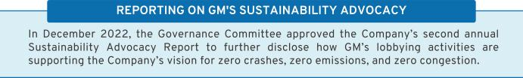

41

Table of Contents

Certain Relationships and Related Party Transactions

Our Code of Conduct requires all of our employees and directors to avoid any activity that is in conflict with our business interests. In addition, the Board has adopted a Related Party Transaction Policy regarding the review and approval of related party transactions, which was updated in December 2021.

Under the Related Party Transactions Policy, which is administered by our Governance Committee, directors and executive officers must report any potential related party transactions on an annual basis (including transactions involving immediate family members) to the General Counsel to determine whether the transaction constitutes a related party transaction. If any member of the Governance Committee has a potential interest in any related party transaction, such member is recused and will abstain from voting on the approval of the related party transaction.

For purposes of our Related Party Transactions Policy, a related party transaction includes

transactions in which our Company (or a subsidiary) is a participant, the amount involved exceeds $ 120,000, and the related party has or will have a direct or indirect material interest. Related parties of our Company consist of directors (including nominees for election as directors), executive officers, shareholders beneficially owning more than 5 percent of the Company’s voting securities, and the immediate family members of these individuals. Once a potential related party transaction has been identified, the Governance Committee reviews all of the relevant facts and circumstances and approves or disapproves entry into the transaction. As required under SEC rules, we disclose all related party transactions annually in our proxy statement, even in cases when the arrangements predate a relationship with the director or predate the director’s relationship with the Company. When a transaction is ongoing, the transactions are still reviewed annually for reasonableness and fairness to the Company.

- Factors Used in Assessing Related Party Transactions


• Whether the terms of the related party transaction are fair to the Company and on the same basis as if the transaction had occurred on an arm’s-length basis;

• Whether there are any compelling business reasons for the Company to enter into the related party transaction and the nature of alternative transactions, if any;

• Whether grants or contributions made by the Company under one of its grant programs are in accordance with the Company’s corporate contribution guidelines;

• Whether the related party transaction would impair the independence of an otherwise independent director; and

• Whether the related party transaction would present an improper conflict of interest for any director or executive officer of the Company, taking into account the specific facts and circumstances of such transaction.

42

Table of Contents

- 2022 Related Party Transactions

In 2022, two holders of 5 percent or more of the Company’s common stock (BlackRock, Inc. and The Vanguard Group) provided investment management services to Company-sponsored pension plans. In addition, in 2022, GM entered into a real estate contract for design studio space in the United Kingdom that is owned by BlackRock. The contract value is under $5 million for the duration of the ten-year lease.

The SEC has identified employment of immediate family members of directors and executive officers as per-se related party transactions and subject to disclosure if the $120,000 threshold is met. In 2022, the following immediate family members of executive officers were employed by General Motors or its subsidiaries and had total compensation in excess of $120,000: the daughter of Mark L. Reuss, our President, is employed by GM in the Marketing organization;

the wife of Julian Blissett, our Executive Vice President and President, GM China, is employed by GM in the Global Manufacturing organization; and the son of Craig B. Glidden, our Executive Vice President, Legal, Public Policy, Cybersecurity, Strategic Technology Initiatives, General Counsel, and Corporate Secretary, is employed by Cruise as a Manager, Reliability and Lifecycle Planning.

NEOs may be eligible to reimburse personal travel expenses pursuant to time-sharing agreements that the Company may enter into from time to time, subject to Federal Aviation Administration regulations. In 2022, pursuant to such an agreement, Mr. Reuss reimbursed the Company $223,256 for his personal use of corporate aircraft, including certain taxes. For additional information about NEO’s personal use of corporate aircraft, see page 60 under “Perquisites and Other Compensation.”

43

Table of Contents

SECURITY OWNERSHIP INFORMATION

Security Ownership of Directors, Named Executive Officers, and Certain Other Beneficial Owners

The following table and accompanying footnotes show information regarding the beneficial ownership of GM’s issued and outstanding common stock by (i) each of our directors and NEOs, and all directors and executive officers as a group, in each case as of March 31, 2023, and (ii) each person known by us to beneficially own more than 5 percent of our issued and outstanding common stock as of the dates indicated in the footnotes. All directors and executive officers have sole voting and dispositive power over their shares, and none of the shares shown as beneficially owned by directors and executive officers are pledged as security for any obligation. The Percentage of Outstanding Shares is based on 1,390,070,034 shares issued and outstanding as of March 31, 2023.

 | Shares of Common | Percentage of
 | Stock Beneficially | Outstanding
Name | Owned | Shares
Non-Employee Directors⁽¹⁾
Aneel Bhusri | 47,646⁽²⁾ | *
Wesley G. Bush | _{20,000}(2),(9) | *
Joanne C. Crevoiserat | ₀(2) | *
Linda R. Gooden | 1,000⁽²⁾ | *
Joseph Jimenez | _{32,330}(2),(10) | *
Jonathan McNeill | ₀(2) | *
Judith A. Miscik | ₀(2) | *
Patricia F. Russo | 25,000⁽²⁾ | *
Thomas M. Schoewe | 22,005⁽²⁾ | *
Carol M. Stephenson | 800⁽²⁾ | *
Mark A. Tatum | ₀(2) | *
Devin N. Wenig | ₀(2) | *
Named Executive Officers⁽¹⁾
Mary T. Barra | 4,168,112^{(3),(11)} | *
Paul A. Jacobson | 271,070⁽³⁾ | *
Mark L. Reuss | 972,075⁽³⁾ | *
Douglas L. Parks | 375,102⁽³⁾ | *
Stephen K. Carlisle | 287,027⁽³⁾ | *
All Directors and Executive Officers as a Group (21 persons),
including the foregoing | 7,437,865⁽⁴⁾ | *
Certain Other Beneficial Owners⁽⁵⁾
BlackRock, Inc.⁽⁶⁾ | 125,771,387 | 9.0%
The Vanguard Group⁽⁷⁾ | 110,305,628 | 7.9%
Capital Research Global Investors⁽⁸⁾ | 78,403,820 | 5.6%
- Less than 1 percent.

- c/o General Motors Company, 300 Renaissance Center, Detroit, Michigan 48265.

44

Table of Contents

- These amounts represent common stock only and do not include DSUs, which are unit equivalents of our common stock. For more information about how DSUs work, see page 24. Directors hold the following number of DSUs: 8,844 DSUs for Mr. Bhusri; 30,363 DSUs for Mr. Bush; 3,100 DSUs for Ms. Crevoiserat; 32,872 DSUs for Ms. Gooden; 64,042 DSUs for Mr. Jimenez; 1,555 DSUs for Mr. McNeill; 16,288 DSUs for Ms. Miscik; 68,833 DSUs for Ms. Russo; 46,856 DSUs for Mr. Schoewe; 87,104 DSUs for Ms. Stephenson; 5,894 DSUs for Mr. Tatum; and 38,957 DSUs for Mr. Wenig.

- These amounts include shares that may be acquired upon exercise of stock options that are currently exercisable or will become exercisable within 60 days of April 1, 2023, as follows: 2,502,827 shares for Ms. Barra; 115,223 shares for Mr. Jacobson; 679,802 shares for Mr. Reuss; 264,412 shares for Mr. Parks; and 168,535 shares for Mr. Carlisle.

- These include shares that individuals in the group may acquire upon exercise of stock options that are currently exercisable or will become exercisable within 60 days of April 1, 2023.

- The Company is permitted to rely on the information reported by each beneficial owner in filings with the SEC and has no reason to believe that the information is incomplete or inaccurate or that the beneficial owner should have filed an amended report and did not.

- Based solely on information set forth in a Schedule 13G/A filed with the SEC on January 25, 2023, BlackRock, Inc., reported that it and its subsidiaries listed on Exhibit A to Schedule 13G/A were the beneficial owners of 125,771,387 shares of GM’s outstanding common stock as of December 31, 2022. BlackRock reported having sole voting power over 114,836,260 shares and sole dispositive power over 125,771,387 shares. No shared voting or dispositive powers were reported. The address for BlackRock, Inc., is 55 East 52nd Street, New York, New York 10055.

- Based solely on information set forth in a Schedule 13G/A filed with the SEC on February 9, 2023, The Vanguard Group reported that it was the beneficial owner of 110,305,628 shares of GM’s outstanding common stock as of December 31, 2022. The Vanguard Group reported having shared voting power over 1,927,225 shares, sole dispositive power over 104,668,748 shares, and shared dispositive power over 5,636,880 shares. No sole voting power was reported. The address for The Vanguard Group is 100 Vanguard Boulevard, Malvern, Pennsylvania 19355.

- Based solely on information set forth in a Schedule 13G/A filed with the SEC on February 14, 2023, Capital Research Global Investors reported that it is the beneficial owner of 78,403,820 shares of GM’s outstanding common stock as of December 31, 2022. Capital Research Global Investors reported having sole voting power over 78,399,962 shares and sole dispositive power over 78,403,820 shares. No shared voting or dispositive powers were reported. The address for Capital Research Global Investors is 333 South Hope Street, 55th Floor, Los Angeles, California 90071.

- These shares are held indirectly in the Wesley G. Bush Revocable Trust.

- This amount includes 330 shares of common stock that Mr. Jimenez holds indirectly through a limited liability company owned but not managed by him.

- This amount includes 285,000 shares that are held indirectly in the Mary T. Barra Grantor Retained Annuity Trust Agreement #2.

Delinquent Section 16(a) Reports

Federal securities laws require that our directors and executive officers and shareholders that own more than 10 percent of our common stock report to the SEC and the Company certain changes in ownership information within specified periods. Based solely on a review of the reports furnished to us or filed with the SEC, and upon information furnished by these people, we believe that during 2022, our directors and executive officers timely complied with the requirements of Section 16(a) of the Securities Exchange Act of 1934, except for one Form 4 filing for Julian Blissett reporting a vesting transaction, which was filed late due to an administrative error.

45

Table of Contents

ITEM NO. 2: PROPOSAL TO RATIFY THE SELECTION OF ERNST & YOUNG LLP AS THE COMPANY’S INDEPENDENT REGISTERED PUBLIC ACCOUNTING FIRM FOR 2023

The Audit Committee is directly responsible for the appointment, compensation, retention, and oversight of the Company’s independent registered public accounting firm retained to audit the Company’s financial statements. The Audit Committee evaluates the selection of the Company’s independent auditors each year and determines whether to re-engage the current independent auditors or consider other firms. Following this process, the Audit Committee made the determination to re-engage Ernst & Young LLP as the Company’s independent auditors for the fiscal year ending December 31, 2023.

Criteria for Re-Engaging EY. EY has served as the Company’s independent registered public accounting firm since 2017 when the Audit Committee selected the firm as part of a competitive and comprehensive request for proposal process. Through this process, the Audit Committee evaluated firms based on several key factors, including audit quality; the benefits of tenure versus fresh perspective; cultural fit and business acumen; innovation and technology; auditor independence; and the appropriateness of fees relative to both efficiency and audit quality. These critical factors continue to drive the Audit Committee’s priorities with respect to the selection and retention of the Company’s independent auditors. Based on its annual review, the Audit Committee believes that the continued retention of EY as our independent auditors is in the best interests of our shareholders.

Shareholder Ratification of Our Selection of EY. As a matter of good corporate governance, the Board submits the selection of the independent auditors to our shareholders for ratification. If shareholders do not ratify the selection of EY, the Audit Committee will reconsider whether to engage EY, but may ultimately determine to engage EY or another audit firm without resubmitting the matter to shareholders. Even if the shareholders ratify the selection of EY, the Audit Committee may, in its sole discretion, terminate the engagement of EY and direct the appointment of another independent registered public accounting firm at any time during the year, although it has no current intention to do so.

We Expect EY to Attend Our Annual Meeting. We expect that representatives of EY will be present at the Annual Meeting. They will have an opportunity to make a statement if they so desire and are expected to be available to respond to appropriate questions from shareholders.

For additional information concerning the Audit Committee and its activities with EY, see the “Audit Committee Report” below.

The Board recommends a vote FOR the proposal to ratify the selection of
Ernst & Young LLP as the Company’s independent registered public | FOR
accounting firm for 2023. | FOR

46

Table of Contents

AUDIT COMMITTEE REPORT

The Audit Committee of the Board of Directors of General Motors Company is a standing committee composed of five independent directors: Thomas M. Schoewe (Chair), Wesley G. Bush, Joanne C. Crevoiserat, Linda R. Gooden, and Mark A. Tatum.
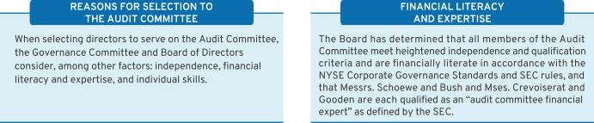

Purpose

The Audit Committee’s core purpose is to assist the Board by providing oversight of:

- The quality and integrity of GM’s financial statements;

- The effectiveness of GM’s financial reporting process and systems of disclosure controls and internal controls;

- The qualifications, performance, and independence of GM’s external auditors and their audit process;

- The scope and performance of GM’s internal audit function; and

- GM’s policies and procedures regarding ethics and legal risk.

The Audit Committee operates under a written charter adopted by the Audit Committee and approved by the Board of Directors. The Audit Committee’s charter is posted on our website at investor.gm.com/esg. The Audit Committee’s charter is reviewed at least once annually and is updated as necessary to address changes in regulatory requirements, authoritative guidance, evolving best practices, and shareholder feedback.

Management is responsible for the Company’s internal controls and the financial reporting process and has delivered its opinion on the effectiveness of the Company’s controls. EY is responsible for performing an independent audit of the Company’s consolidated financial statements and opining on the effectiveness of internal controls over financial reporting in accordance with the standards of the Public Company Accounting Oversight Board (United States) (the “PCAOB”) and issuing its reports thereon. As provided in its charter, the Audit Committee’s responsibilities include monitoring and overseeing these processes.

Required Disclosures

In 2022, the Audit Committee met eight times and fulfilled all of its core charter obligations. Consistent with its charter responsibilities, the Audit Committee met and held discussions with management and EY regarding the Company’s audited financial statements and internal controls for the year ended December 31, 2022. In this context, management represented to the Audit Committee that the Company’s consolidated financial statements were prepared in accordance with accounting principles generally accepted in the United States. The Audit Committee reviewed and discussed the consolidated financial statements with management and EY and further discussed with EY the matters required to be discussed by the requirements of the PCAOB and the SEC. This review included a discussion with management and EY of the quality, not merely the acceptability, of GM’s accounting principles, the reasonableness of significant estimates and judgments, and the clarity of disclosure in GM’s financial

47

Table of Contents

statements, including the disclosures related to critical accounting estimates and critical audit matters. EY also provided to the Audit Committee the written disclosures and letter required by the applicable requirements of the PCAOB concerning independence, and the Audit Committee discussed with EY the auditor’s independence. The Audit Committee also considered and determined that the provision of non-audit services to GM is compatible with maintaining EY’s independence. The Audit Committee concluded that EY was independent from the Company and management.

For additional information about GM’s policies and procedures related to the approval of EY’s audit and non-audit services, see “Policy for Approval of Audit and Permitted Non-Audit Services” on page 49.

Recommendation

Based upon the Audit Committee’s discussions with management and EY as described in this report and the Audit Committee’s review of the representation of management and the reports of EY to the Audit Committee, the Audit Committee recommended to the Board of Directors, and the Board of Directors approved, the inclusion of the audited consolidated financial statements in the Company’s Annual Report on Form 10-K for the year ended December 31, 2022, as filed with the SEC on January 31, 2023.

Audit Committee
Thomas M. Schoewe (Chair)
Wesley G. Bush
Joanne C. Crevoiserat
Linda R. Gooden

Mark A. Tatum

The preceding Audit Committee Report shall not be deemed incorporated by reference by any general statement incorporating by reference this Proxy Statement or any portion hereof into any filing under the Securities Act of 1933, as amended, or the Securities Exchange Act of 1934, as amended, and shall not otherwise be deemed filed thereunder.

48

Table of Contents

Fees Paid to Independent Registered Public Accounting Firm

The following table summarizes the fees for professional services provided by EY for the audit of GM’s annual financial statements and internal control over financial reporting for the years ended December 31, 2022 and 2021, together with the fees billed for other services rendered by EY during these periods. The numbers in the table below may not sum due to rounding.

 | 2022 | 2021
Type of Fees | ($ in millions) | ($ in millions)
Audit | 21 | 21
Audit-Related | 5 | 8
Tax | 2 | 3
Subtotal | 27 | 31
All Other
Services | 2 | 1
TOTAL | 29 | 32

Audit-Related Fees – Includes fees for assurance and related services that are traditionally performed by the independent registered public accounting firm. More specifically, these services include employee benefit plan audits, comfort letters in connection with financing transactions, financial due diligence, other attestation services, and consultations concerning financial accounting and reporting standards.

Tax Fees – Includes fees for tax compliance, tax planning, and tax advice. Tax compliance involves preparation of original and amended tax returns and claims for refunds. Tax planning and tax advice encompass a diverse range of services, including assistance with tax audits and appeals, tax advice related to mergers and acquisitions and employee benefit plans, and requests for rulings or technical advice from taxing authorities.

All Other Fees – Includes fees for services that are not contained in the above categories and consists of permissible advisory services.

Audit Fees – Includes fees for the integrated audit of the
Company’s annual consolidated financial statements and
internal control over financial reporting, including reviews of
the interim financial statements contained in the Company’s
Quarterly Reports on Form 10-Q and audits of statutory

financial statements.

Policy for Approval of Audit and Permitted Non-Audit Services

The services performed by EY in 2022 were preapproved in accordance with the pre-approval policy and procedures established by the Audit Committee. This policy requires that, prior to the provision of services by the auditor, the Audit Committee will be presented, for consideration, with a description of the types of Audit-Related, Tax, and All Other Services expected to be performed by the auditor during the fiscal year, with amounts budgeted for each category. Subject to these preapproved budgets, any requests for individual services falling within these categories for less than $1 million may be approved by management, while any such requests for $1 million or more not specifically contemplated and approved by the Audit Committee must be

submitted to the Audit Committee Chair for pre-approval and must be reported to the full Audit Committee at its next regularly scheduled meeting. Management must report actual spending for each category to the full Audit Committee periodically throughout the year.

These services are actively monitored (both spending and work content) by the Audit Committee to maintain the appropriate objectivity and independence in EY’s core work, which is the audit of the Company’s annual consolidated financial statements and internal controls. The Audit Committee determined that all services provided by EY in 2022 were compatible with maintaining the independence of EY.

49

Table of Contents

ITEM NO. 3: PROPOSAL TO APPROVE, ON AN ADVISORY BASIS, NAMED EXECUTIVE OFFICER COMPENSATION

Executive compensation is an important matter for our shareholders. The Dodd-Frank Wall Street Reform and Consumer Protection Act requires that we provide you with the opportunity to vote to approve, on a non-binding, advisory basis, the compensation of our NEOs as disclosed in this Proxy Statement in accordance with the compensation disclosure rules of the SEC (sometimes referred to as “Say-on-Pay”). The Board has adopted a policy providing for an annual Say-on-Pay advisory vote.

The Compensation Committee has approved the compensation arrangements for our NEOs described in the “Compensation Discussion and Analysis” section beginning on page 51 and the accompanying executive compensation tables beginning on page 74. We urge you to read the Compensation Discussion and Analysis for a more complete understanding of our executive compensation plans, including our compensation principles, our objectives, and the 2022 compensation of our NEOs.

We are asking shareholders to vote in favor of the following resolution:

RESOLVED, that the compensation paid to the Company’s named executive officers, as disclosed pursuant to Item 402 of Regulation S-K, including the Compensation Discussion and Analysis, executive compensation tables, and the related narrative discussion, is hereby APPROVED.

Although the vote on this item is non-binding, the Board and the Compensation Committee value the opinions of our shareholders and will consider the outcome of the vote when making future compensation decisions for NEOs.

The next Say-on-Pay vote will occur at our 2024 annual meeting and the next advisory vote on the frequency of future Say-on-Pay votes will occur at our 2026 annual meeting.


The Board recommends a vote FOR the advisory proposal to approve
named executive officer compensation. | FOR

50

Table of Contents

COMPENSATION DISCUSSION AND ANALYSIS

Dear Shareholders:

On behalf of the Compensation Committee, I want to thank you for your support of the Company’s executive compensation program, as evidenced by last year’s Say-on-Pay proposal receiving over 92 percent support from shareholders. The Compensation Committee represents our shareholders, and we recognize our obligation to align the Company’s executive compensation program with our shareholders’ interest in driving long-term value creation.

In August of 2022, Carol Stephenson transitioned from being your Compensation Committee Chair to a member of the Committee until her anticipated retirement later this year. I am grateful for Carol’s leadership of our Committee and for her mentorship during the Chair transition. I want to recognize Carol for fostering change during her tenure by modernizing the Company’s compensation plans with an emphasis on driving enhanced shareholder alignment, including a focus on the importance of EV growth. Under her leadership, we have implemented competitive executive compensation plans built on a foundation of pay-for-performance, while attracting, motivating, and retaining our top-tier talent amidst significant transformation for the industry and the Company. Please see page 54 for a detailed description of the plan changes over the past several years.

One of the priorities of our Committee is to continue to ensure that the Board responds to your views on executive compensation. The feedback we most frequently receive relates to aligning compensation to our EV strategy and incorporating ESG performance in compensation decisions. Please see page 62 for a description of the 2022 LTIP design, which now includes GMNA EV metrics for volume, launch timing, and launch quality. When determining short-term incentives, the Committee uses a rigorous assessment process against pre-established financial and operational goals, safety results, and other measures, including ESG outcomes. Please see pages 65-69 for 2022 STIP results for each NEO. We believe these actions demonstrate our commitment to linking executive compensation to the Company’s strategy and responding to shareholder feedback.

The Company faced many challenges last year, including increased commodity and supply chain disruptions, but was still able to deliver record financial performance and lead the industry in total U.S. sales, all while accelerating our EV strategy. The Compensation Discussion and Analysis that follows describes a strong alignment between the Company’s demonstrated performance and compensation outcomes for each NEO. The Committee believes these accomplishments warrant recognition; however, we understand the market has not yet fully recognized this success and that total shareholder return did not perform at the desired level in 2022. In recognition of this, we have held Ms. Barra’s 2023 target compensation at the same level as it was in 2022, as it is highly aligned with shareholder outcomes. We continue to believe that we have an extraordinary CEO and leadership team who are driving the transformation of the Company and the industry as demonstrated by its track record of delivering on its commitments to shareholders quarter-after-quarter, and continuing to demonstrate excellent execution of our strategy in a turbulent environment.

The Compensation Committee looks forward to your continued feedback as we work to continue to align our executive compensation program with shareholders’ interests, encourage management to make decisions that drive long-term value creation, and attract and retain the talent required to accelerate the Company’s critical transition to EVs.

Sincerely,


Wesley G. Bush

Compensation Committee Chair

51

Table of Contents

Our Company Performance

“General Motors’s ability to grow EV sales is the payoff for many years of investment in R&D, design, engineering, manufacturing, our supply chain, and a new EV customer experience that is designed to be the best in the industry. Our multi-brand, multi-segment, multi-price point EV strategy gives us incredible leverage to grow revenue and market share, and we believe our Ultium Platform and vertical integration will allow us to continuously improve battery performance and costs.”

- Mary T. Barra, Chair and CEO
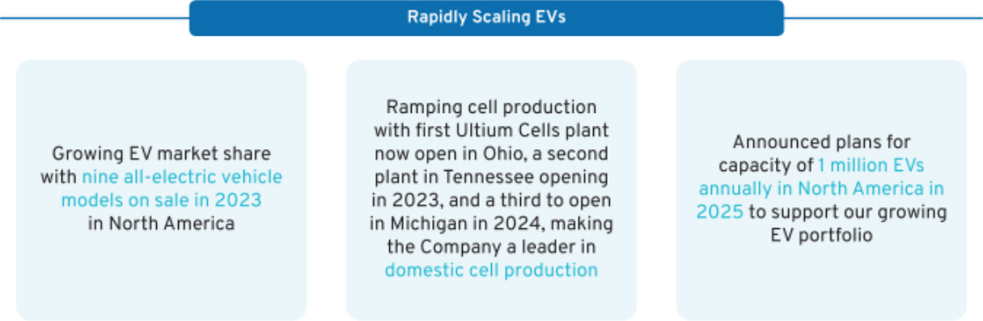
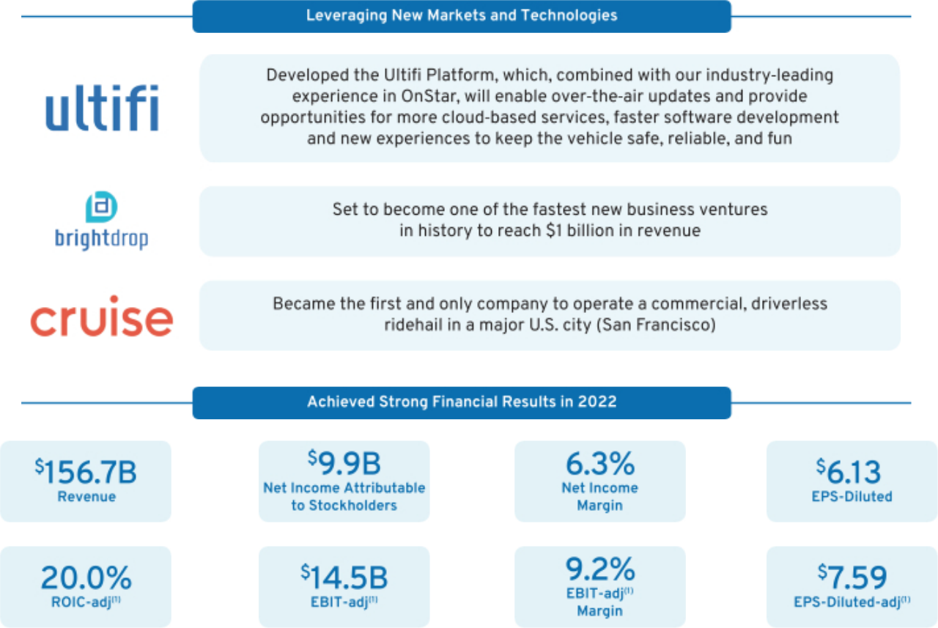

- Non-GAAP financial measure. Refer to Appendix A for a reconciliation of Non-GAAP financial measures to their closest comparable GAAP measure.

52

Table of Contents

Delivered record revenue of $156.7 billion, strong net income attributable to stockholders of $9.9 billion, record EBIT-adjusted of $14.5 billion, exceptional cash flow, and reinstated a quarterly shareholder dividend

Generated EBT-adjusted of $4.1 billion and paid $1.7 billion in dividends to GM

Detailed plans at investor event for GM’s rapidly growing portfolio of EVs to become solidly profitable in 2025 in North America as the Company scales EV capacity in the region to more than 1 million units annually

Announced investment of more than $6 billion in U.S. manufacturing in 2022, supporting nearly 3,600 jobs across multiple sectors of production

Announced GM Energy, a holistic ecosystem of energy management products and services made available through Ultium Home, Ultium Commercial, and Ultium Charge 360. This cohesive system of offerings will provide solutions for home, commercial and EV customers

Expanded internationally with DHL Express Canada as BrightDrop’s newest customer. Began production of BrightDrop Zevo 600 electric delivery van and scaled production in January, with Zevo 400 production to begin later this year

Surpassed 1 million fully driverless miles. Became first and only commercial driverless ridehail service at San Francisco launch, quickly followed by commercial expansion into Phoenix area and Austin

Delivered third consecutive year of full-size pickup truck leadership, ninth consecutive year of full and midsize truck leadership, and 48th consecutive year as the market leader in full-size SUVs

Introduced three EVs set to launch this year in America’s most popular vehicle segments and are poised to conquest new customers to GM at 40 percent or better

Ranked highest among all brands in J.D. Power Sales Satisfaction Index, unveiled first EV in China, and committed to an all-electric vehicle portfolio in North America by 2030

Achieved record volume and retail market share, and continued as industry’s No. 1 premium truck brand with 46 percent of retail sales in Denali or AT4 trims. Sierra recorded best retail share ever and 5 consecutive years of share growth. Unveiled the GMC Sierra EV Denali Edition 1, joining the GMC HUMMER EV Pickup and SUV

Began deliveries of the Cadillac LYRIQ, the brand’s first all-electric vehicle, with production ramping this year. Unveiled Cadillac CELESTIQ. Delivered year-over-year sales growth of 14 percent and fortified Escalade’s position as the No. 1 luxury SUV in the United States, leading its nearest competitor by six points of retail market share

Recognized as one of the Clean Energy Buyers Association’s top 10 energy customers in 2022, advancing the clean energy transition through voluntary procurement of clean energy in the United States

Conquested business of more than 300 major commercial accounts over the last several years, leading to GM’s best year for commercial deliveries since 2006

Led among all automakers in J.D. Power’s Initial Quality Study, improving results while the rest of the industry went backwards. Chevrolet had six top-ranked vehicles and the Corvette was the highest-ranked nameplate in the industry

Represents ESG Results

53

Table of Contents

Compensation Overview

- Our Named Executive Officers

Mary T. Barra

Chair and Chief Executive Officer


Paul A. Jacobson

Executive Vice President and Chief Financial Officer


Mark L. Reuss

President


Douglas L. Parks

Executive Vice President, Global Product Development, Purchasing and Supply Chain


Stephen K. Carlisle

Executive Vice President and President, North America

Positions as of December 31, 2022.

- Compensation Program Evolution

Our executive compensation program is designed to focus our leaders on key areas that drive the business forward and align to the short-term and long-term interests of our shareholders. The Compensation Committee regularly reviews and discusses plan performance at each meeting. The Compensation Committee considers many factors when electing to make plan changes for future incentive plans, including results, market trends, and feedback from its independent compensation consultant and shareholders. The timeline below shows the actions we have taken to develop executive compensation plans that align the interests of our senior leaders with those of our shareholders.
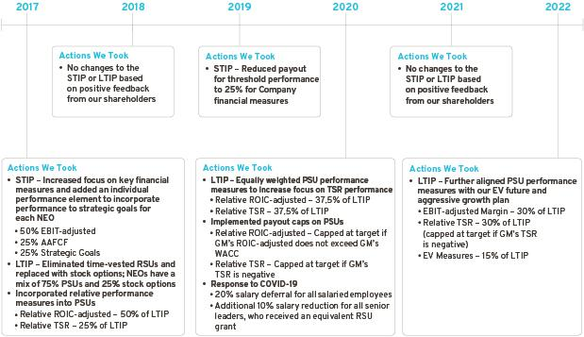

54

Table of Contents

- Compensation Governance and Best Practices

WHAT WE DO

- Provide short-term and long-term incentive plans with performance targets aligned to business goals

- Maintain a Compensation Committee composed entirely of independent directors who are advised by an independent compensation consultant

- Require stock ownership for all senior leaders to align with the interests of our shareholders

- Engage with shareholders and other stakeholders on various topics with members of management and directors, including our Compensation Committee and our Independent Lead Director

- Include non-compete and non-solicitation terms in all grant agreements with senior leaders

- Maintain an Insider Trading Policy requiring directors, executive officers, and all other senior leaders to trade only during pre-established periods after receiving preclearance from the GM legal staff

- Require equity awards to have double trigger (change in control and termination of employment) vesting provisions

- Complete an annual risk review evaluating incentive compensation plans

- Require short-term cash and long-term equity awards for all executive officers to be subject to clawback and cancellation provisions

- Conduct an annual audit of senior executive expenses and perquisites that is reviewed by the Audit Committee

WHAT WE DON’T DO

- Provide gross-up payments to cover personal income taxes or excise taxes pertaining to executive severance benefits

- Pay above-market interest on deferred compensation in retirement plans

- Allow any director or employee to engage in hedging or pledging of GM securities

- Reward executives for excessive, imprudent, inappropriate, or unnecessary risk-taking

- Allow the repricing, spring-loading, or backdating of equity awards

55

Table of Contents

- 2022 STIP and 2022 LTIP Overview

The 2022 STIP is designed to focus our leaders on key financial measures (75% of STIP) and strategic goals (25% of STIP). The total payout for the STIP ranges from 0 to 200 percent based on performance against pre-established targets. The Compensation Committee determines performance to strategic goals using a rigorous assessment process that evaluates final results against pre-established operational goals, safety results, and other measures, including ESG outcomes. The payout for strategic goals performance occurs only if threshold performance of at least one financial measure is met.

The 2022 LTIP design features stock options (25% of total LTIP) to align our senior leaders with shareholders’ interest in stock price appreciation and PSUs (75% of total LTIP) with performance measures that drive long-term results. PSU performance measures include EBIT-adjusted Margin (30% of total LTIP), Relative TSR (30% of total LTIP), and GMNA EV Measures (15% of total LTIP). Relative TSR performance payout is capped at target if GM’s TSR is negative over the performance period.

Focusing performance on EBIT-adjusted, AAFCF, and strategic goals in the short term, combined with the PSU performance measures described above in the long term, provide direct alignment of our executive compensation program with the interests of our shareholders, and link the long-term compensation of our executives to the long-term EV strategy of the Company.
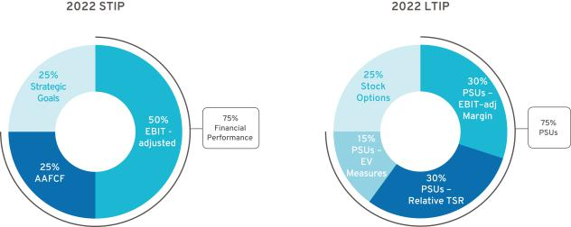

- Peer Group for 2022–2024 LTIP Performance

The Compensation Committee uses the following OEMs in the Dow Jones Automobiles & Parts Titans 30 Index to measure relative performance for the Relative TSR measure in the 2022–2024 PSU awards. The companies in the index represent our global competition and are subject to similar macroeconomic forces.

Dow Jones Automobiles & Parts Titans 30 Index – OEM Peer Group⁽¹⁾

Bayerische Motoren Werke AG | Mercedes-Benz Group AG⁽²⁾ | Suzuki Motor Corporation
Ford Motor Company | Nissan Motor Co., Ltd. | Tesla, Inc.
Honda Motor Co., Ltd. | Renault SA | Toyota Motor Corporation
Hyundai Motor Company | Stellantis NV | Volkswagen AG
Kia Corporation | Subaru Corporation

- GM is a member of the Dow Jones Automobiles & Parts Titans 30 Index. Our performance is determined on a continuous ranking for performance relative to the OEM peer group.
- Daimler AG changed its name to Mercedes-Benz Group AG on February 1, 2022.

56

Table of Contents

- Peer Group for Compensation Benchmarking

The Compensation Committee annually reviews the peer group for compensation benchmarking comparisons and makes updates as needed to align with the established criteria and the Company’s strategy. We do not limit the peer group to our industry alone because we believe compensation practices for NEOs at other large U.S.-based multinational companies affect our ability to attract and retain diverse talent around the globe.

The Compensation Committee considered the following factors when selecting the peer group used to inform 2022 target compensation levels for our NEOs:
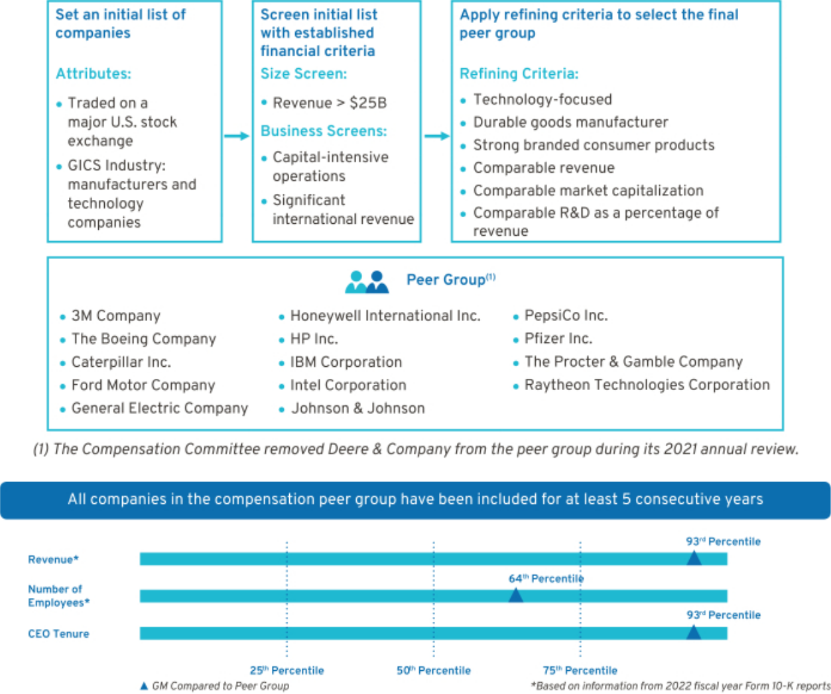

- How We Use Benchmarking Data to Assess Compensation

We benchmark pay practices and compensation levels against the proxy statement disclosures of our peer group. In addition, we use executive compensation surveys and competitive data to benchmark executive positions and adjust this data to reflect GM’s size and market-expected compensation trends. Furthermore, the Compensation Committee reviews an analysis completed by its independent compensation consultant of the competitive position of each of our executives relative to its benchmark data.

57

Table of Contents

We review each element of total direct compensation (base salary, STIP, and LTIP) compared with the market. An individual element or an individual’s total direct compensation may be positioned above or below the market due to a variety of considerations, such as specific responsibilities, experience, and performance to attract and retain top talent needed to execute on our vision.

- How We Plan Compensation
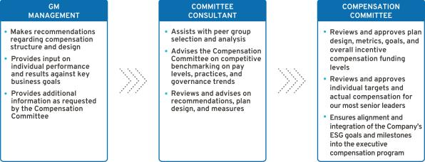

- Performance-Based Compensation Structure

Our incentive plans are designed to optimize long-term financial returns for our shareholders and reward our NEOs for delivering on the Company’s strategy and vision of zero crashes, zero emissions, and zero congestion. The 2022 performance-based structure incorporated short-term and long-term incentives tied to financial and operational measures to drive Company performance for fiscal year 2022 and beyond. The Compensation Committee believes a majority of the compensation opportunity should be in the form of equity to align the interests of executives with those of shareholders.
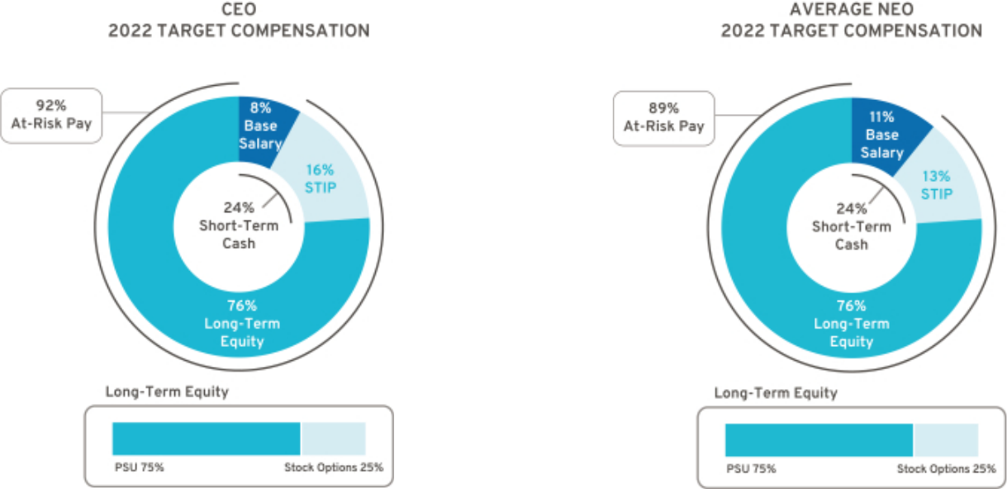

58

Table of Contents

Compensation Principles

The compensation provided to our executives is guided by pay-for-performance and the following principles:

Align with Shareholders – Compensation paid should align directly with the long-term interests of our shareholders, and our executives should share with them in the performance and value of our common stock.

Enable Company Strategy – Compensation should be based on challenging Company performance and strategic goals, which are within our executives’ control, and reward performance aligned with GM’s strategy, values, and expected behaviors.

Market-Competitive – Target compensation should have an appropriate mix of short-term and long-term pay elements and should be competitive with that paid to individuals at peer group companies so that it attracts, motivates, and retains talent.

Avoid Excessive Risk-Taking – Compensation structure should avoid incentivizing unnecessary and excessive risk-taking.

Simple Design – Compensation plans should be easy to understand and communicate, and minimize unintended consequences.

Compensation Elements

- Compensation Structure

The 2022 compensation structure is market-competitive and includes the following pay elements:
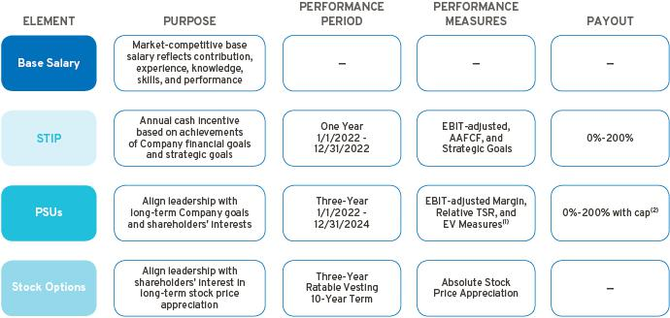

- EV Measures are comprised of GMNA EV Volume, GMNA EV Launch Timing, and GMNA EV Launch Quality (modifier).

- Relative TSR is capped at target if GM’s TSR is negative over the performance period.

59

Table of Contents

- Perquisites and Other Compensation

We provide perquisites and other compensation to our NEOs consistent with market practices. The following perquisites and other compensation were provided in 2022:

Personal Air Travel – Due to security reasons identified by an independent third-party security consultant, Company policy prohibits Ms. Barra from using commercial air travel for business and personal use. As a result, the Company pays the costs associated with both business and personal use of aircraft. Other NEOs may travel on company aircraft in certain circumstances with prior approval from the CEO or the Senior Vice President and Chief People Officer. All NEOs, including our CEO, incur imputed income when aircraft is used for personal travel and do not receive any tax gross-up payments. Aircraft travel by NEOs for an annual executive physical through the Executive Physical Program is included under Personal Travel in the “Perquisites and Other Personal Benefits” table. NEOs may be eligible to reimburse for personal travel pursuant to time-sharing agreements that the Company may enter into from time-to-time, subject to Federal Aviation Administration regulations.

Security – NEOs may receive security services, including home security systems and monitoring, for specific security-related reasons identified by independent third-party security consultants. We maintain security staff to provide all employees with a safe and secure environment, which aligns to and reinforces our safety culture.

Company Vehicle Programs – NEOs are eligible to participate in the Executive Company Vehicle Program and may use evaluation vehicles for the purpose of providing feedback on Company products. In addition, NEOs are eligible to use driver services provided by the Company in accordance with Company policies.

Executive Physicals – The health and wellness of our workforce is a priority, and all employees are encouraged to complete an annual physical. NEOs are eligible to receive a comprehensive wellness examination with an approved provider. The cost of meals, lodging, and ground transportation for NEOs who traveled for an annual executive physical through the Executive Physical Program is included under Executive Physicals in the “Perquisites and Other Personal Benefits” table. These wellness visits promote employee well-being and enable employees to take appropriate steps in the event of illness or a medical condition that may impact their ability to perform their duties.

Financial Counseling – NEOs are eligible to receive financial counseling, estate planning, and tax preparation services through an approved provider. These services allow our NEOs to focus on Company business and ensure accurate personal tax reporting.

- 2022 Target Compensation

Our total target direct compensation for each NEO in 2022 was as follows:

 |  |  |  |  | LTIP
 |  |  |  |  |  |  | Total Target
 |  |  |  | Total Target Cash |  | Stock | Direct
 | Base Salary | STIP | STIP | Compensation | PSUs(1) | Options | Compensation
Name | ($) | (%) | ($) | ($) | ($) | ($) | ($)
Mary T. Barra | 2,100,000 | 200% | 4,200,000 | 6,300,000 | 14,625,000 | 4,875,000 | 25,800,000
Paul A. Jacobson | 1,000,000 | 125% | 1,250,000 | 2,250,000 | 5,362,500 | 1,787,500 | 9,400,000
Mark L. Reuss | 1,350,000 | 125% | 1,687,500 | 3,037,500 | 7,471,875 | 2,490,625 | 13,000,000
Douglas L. Parks | 875,000 | 125% | 1,093,800 | 1,968,800 | 4,523,400 | 1,507,800 | 8,000,000
Stephen K. Carlisle | 875,000 | 125% | 1,093,800 | 1,968,800 | 4,523,400 | 1,507,800 | 8,000,000

- The number of PSUs awarded is determined by using the target PSU value divided by the closing stock price on the date of grant for the EBIT-adjusted Margin and EV Measures portions of the award, and the results of the Monte Carlo analysis for the Relative TSR portion of the award.

60

Table of Contents

Performance Measures

- How We Set Performance Targets

The Compensation Committee approves the performance measures for the STIP and LTIP annually. The Compensation Committee reviews recommendations from management, receives input from its independent compensation consultant, evaluates the annual budget and long-term business plan, and reviews prior year performance to approve value-creating goals tied to long-term shareholder value.

- 2022 STIP Performance Measures

STIP performance measures are linked to the Company’s annual financial goals and strategic goals that drive our long-term strategy. The Compensation Committee annually reviews and approves STIP performance measures that align with shareholders’ interests.

The Compensation Committee approves strategic goals that align to delivering on our long-term Company strategy and objectives. Strategic goals cover the following five areas:

Our People – Attracting, retaining, and engaging our people by providing the best employee experience that supports and invests in DE&I, while living values and behaviors that return people home safely every day.

Products, Software, and Services – Creating leading technologies and innovations that deliver customer value, and executing launch excellence with best-in-class product quality to achieve our vision of a world of zero crashes, zero emissions, and zero congestion.

Citizenship – Prioritizing actions that are inclusive for the communities in which we live and work, including implementation of our plan to be carbon neutral in our global products and operations by 2040 and to eliminate tailpipe emissions from new U.S. light-duty vehicles by 2035.

Enterprise – Maximizing our EV opportunity through scale and cost optimization by expanding manufacturing capabilities and operational excellence, while exceeding our financial and structural cost objectives.

Customer Experience – Reimagining the customer experience, while in pursuit of EV leadership and enhancing human experiences across the GM ecosystem.

Following the performance period, the Compensation Committee uses a scorecard to assess individual performance results to the strategic goals above and makes final compensation decisions as discussed beginning on page 65.

STIP awards, if any, are determined based on final Company financial performance and the Compensation Committee’s assessment of performance to strategic goals for each NEO. 2022 STIP targets were aligned to the business plan and to the guidance provided in connection with our earnings release for the year ended December 31, 2021. The targets for EBIT-adjusted and AAFCF were set above the prior year’s results. The table below describes each STIP performance measure – its weight, its target, and the leadership behavior each measure drives.

STIP Performance | Weight | Target | Leadership Behaviors
Measure | Weight | Target | Leadership Behaviors
EBIT-adjusted ($B)⁽¹⁾ | 50% | $15.6 | Focus on operating results and driving strong profitability
AAFCF ($B)⁽²⁾ | 25% | $8.6 | Focus on driving strong cash flow to invest in the business and returning
AAFCF ($B)⁽²⁾ | 25% | $8.6 | capital to shareholders
Strategic Goals | 25% | 25 pts. | Focus on performance that aligns to the Company vision, our broad social
Strategic Goals | 25% | 25 pts. | responsibilities, and drives business results

- Measure adjusted for incentive purposes and excludes the impact of Cruise. For a description of how EBIT-adjusted is calculated, see Appendix A.

- Measure adjusted for incentive purposes and excludes payments related to certain recall-related expenses attributable to events occurring in 2014. For a description of how AAFCF is calculated, see Appendix A.

61

Table of Contents

The potential payouts for each Company performance measure range from 0 to 200 percent of target based on actual Company performance. The payout for threshold performance is 25 percent for both EBIT-adjusted and AAFCF; performance below threshold results in a 0 percent payout. Final STIP awards are calculated as follows:
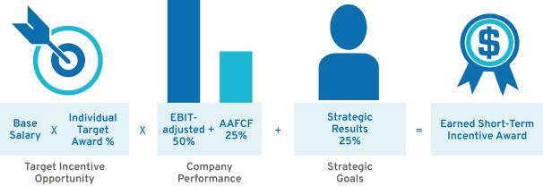

- 2022–2024 LTIP Performance Measures

Grants made under the LTIP are intended to link the financial interests of NEOs with the long-term interests of shareholders. When determining grant amounts, the Compensation Committee considers factors such as individual responsibilities, experience, and performance. In addition, the Compensation Committee factors relevant market compensation comparison data and input provided by its independent compensation consultant. The structure includes 75 percent PSUs and 25 percent stock options. PSUs cliff-vest following a three-year performance period and stock options vest ratably over three years.

PSUs are based on EBIT-adjusted Margin performance, Relative TSR performance against our OEM peer group shown on page 56, and EV performance measures. Relative TSR performance payout is capped at target if GM’s TSR is negative over the performance period. The PSU performance measures align our executive compensation program with our all-electric future and direct additional focus on Company growth and ESG performance, which will better support our path to EV leadership and expansion into new markets and technologies. The table below describes each PSU performance measure — its weight, its target, and the leadership behavior each measure drives.

PSU Performance | Weight | Target⁽²⁾ | Leadership Behaviors
Measure | Weight | Target⁽²⁾ | Leadership Behaviors
EBIT-adjusted Margin | 40% | – | Focus on pursuing profitable growth opportunities and driving higher
EBIT-adjusted Margin | 40% | – | margins on existing revenue bases
Relative TSR | 40% | 50th | Focus on delivering shareholder returns that outperform our OEM peer
Relative TSR | 40% | Percentile⁽³⁾ | group
EV Measures⁽¹⁾ | 20% | – | Focus on executing our commitment to an all-electric future
- EV Measures are comprised of GMNA EV Volume, GMNA EV Launch Timing, and GMNA EV Launch Quality (modifier).

- The performance targets for EBIT-adjusted Margin and EV Measures are not being provided at this time as providing this information will allow competitors insight into our business that could substantially harm our growth strategy.

- Relative TSR is capped at target if GM’s TSR is negative over the performance period.

62

Table of Contents

The 2022–2024 PSUs vest and deliver following the completion of the three-year performance period beginning January 1, 2022, and can be earned at a level between 0 and 200 percent of target. Final PSU awards are calculated as follows:
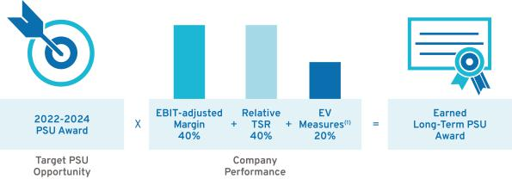

- EV Measures are comprised of GMNA EV Volume, GMNA EV Launch Timing, and GMNA EV Launch Quality (modifier).

- Summary of Outstanding Performance Awards

Each PSU award features a three-year performance period resulting in overlapping awards that, in aggregate, cover a five-year period. The potential payout for each PSU award ranges from 0 to 200 percent. The table below illustrates the performance period for the three outstanding PSU awards as of the filing date of this Proxy Statement, and the corresponding performance measures and weights.
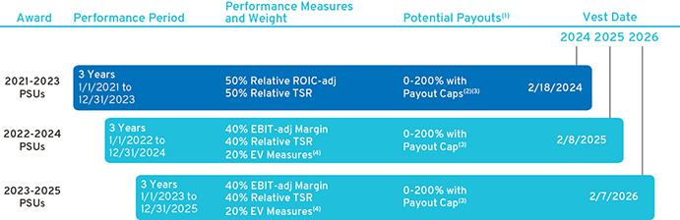

- The performance of each PSU award will be measured and determined at the end of the performance period.

- Relative ROIC-adjusted is capped at target if GM’s ROIC-adjusted does not exceed GM’s WACC.

- Relative TSR is capped at target if GM’s TSR is negative over the performance period.

- EV Measures are comprised of GMNA EV Volume, GMNA EV Launch Timing, and GMNA EV Launch Quality (modifier).

63

Table of Contents

Performance Results and Compensation Decisions

- 2022 STIP Results

The Company financial performance portion of the 2022 STIP award was calculated based on the Company’s achievement of EBIT-adjusted and AAFCF performance measures. The Company achieved above target results for both of these performance measures through wholesale volume growth and robust pricing across the portfolio. The Company also delivered other strong 2022 financial results and key business highlights as detailed in the “Our Company Performance” section on page 52. In addition to the Company’s financial measures, a portion of each NEO’s STIP evaluates their performance against pre-established strategic goals.

Final STIP performance approved by the Compensation Committee is displayed below.

STIP Measure | Weight | Threshold | Target | Maximum | Performance
 |  |  |  |  | Result
EBIT-adjusted ($B)⁽¹⁾ | 50% | $9.7 | $15.6 | $17.6 | $16.4
AAFCF ($B)⁽²⁾ | 25% | $2.7 | $8.6 | $10.6 | $10.5
Strategic Goals⁽³⁾ | 25% | 0 pts. | 25 pts. | 50 pts. | 30-35 pts.
Performance Payout |  |  |  | 149%—154% of Target

- Measure adjusted for incentive purposes and excludes the impact of Cruise. For a description of how EBIT-adjusted is calculated, see Appendix A.

- Measure adjusted for incentive purposes and excludes payments related to certain recall-related expenses attributable to events occurring in 2014. For a description of how AAFCF is calculated, see Appendix A.

- Performance results to strategic goals are discussed beginning on page 65.

- 2020–2022 LTIP Results

The 2020-2022 PSUs vested on February 12, 2023, based on Company performance for the three-year performance period beginning January 1, 2020, against pre-established performance targets for Relative ROIC-adjusted and Relative TSR. Final LTIP performance approved by the Compensation Committee is displayed below.

 |  |  | Percentile
 |  |  |  |  | Performance
LTIP Measure | Weight | Threshold | Target | Maximum | Result
Relative ROIC-adjusted | 50% | ₃₅th | ₆₀th | 100th | 92nd Percentile
Relative TSR | 50% | 25th | 50th | 75th | 49th Percentile
Performance Payout |  |  |  |  | 139% of Target

The Company continues to focus on ROIC and delivering best results among the OEMs, while driving TSR performance with a focus on the long-term interest of our shareholders. We continue to prioritize and focus on investing in new and existing businesses, including opportunities in EV, AV, and connected services to achieve strong, profitable growth with solid return on investment.

64

Table of Contents

- Compensation Decisions for Mary T. Barra

Chair and Chief Executive Officer

The Compensation Committee made the following pay decisions based on performance, competitive market data, and feedback from its independent compensation consultant:

Base Salary – Held base salary at $2,100,000.

Short-Term Incentive – Awarded 30 points out of a 25-point target and 50-point maximum for the strategic goals portion for the 2022 STIP performance year. In determining the number of points earned, the Compensation Committee considered these results for Ms. Barra:

- Led the Company to strong net income attributable to stockholders of $9.9 billion and record EBIT-adjusted of $14.5 billion. Our employees shared in this success: eligible U.S. hourly employees earned record profit sharing totaling $500 million, bringing the three-year total to $1.2 billion;
- Announced investment of more than $6 billion in U.S. manufacturing in 2022, supporting nearly 3,600 jobs across multiple sectors of production; and
- Championed GM’s recently launched purpose of “pioneering the innovations that move and connect people to what matters,” as well as other highlights below.

Our People

• Continued to prioritize our safety culture resulting in reductions in permanently disabling injuries and lost workdays

• Continued progress in attracting and retaining diverse and critical technical talent by optimizing our recruitment process

Products, Software, and Services

• Accelerated GM’s EV strategy – expected to deliver 1 million units of annual capacity in North America in 2025 – with a roadmap to deliver low-to-mid single digit EBIT margins, before the benefits from the clean vehicle tax credits, by the same year
• Increased GM’s ownership stake in Cruise to approximately 80%, capitalizing on the opportunity to advance Company leadership in AV, expanded commercial operations in San Francisco, and quickly entered Austin and Phoenix markets

• Positioned Company to rapidly expand revenue from software services, building on industry-leading connectivity with OnStar

Citizenship

• Received 2022 ENERGY STAR Partner of the Year – Sustained Excellence Award from U.S. Environmental Protection Agency and U.S. Department of Energy for the 11th year for GM’s commitment to fighting climate change and protecting public health

• Sourced 100% of the renewable energy needed to power all our U.S. sites by 2025, 25 years ahead of our initial target of 2050
• Ranked among the top 50 in the JUST 100 rankings, leading the Automobile and Parts industry for leadership in workforce advancement and our commitment to sustainability and environmental stewardship

Enterprise

• Generated a record $156.7 billion in revenue, strong EPS-diluted of $6.13 with record EPS-diluted-adjusted of $7.59, and exceptional cash flow
• Delivered four quarters of profitability in GM International despite a volatile environment, driven by favorable pricing and volume
• Positioned GM to deliver the policy goals of the clean energy tax credits, introducing millions of customers to EVs and creating clean energy jobs in the U.S.

Customer Experience

• Ranked as top manufacturer in overall loyalty by S&P Global Mobility for the 8th consecutive year

• Announced GM Energy, a holistic ecosystem of energy management products and services for EV residential and commercial customers


Despite accelerating the EV transformation and record financial performance in 2022, the Compensation Committee has determined to hold Ms. Barra’s 2023 target compensation constant in reflection of the 2022 TSR result and Ms. Barra’s current position versus peers.
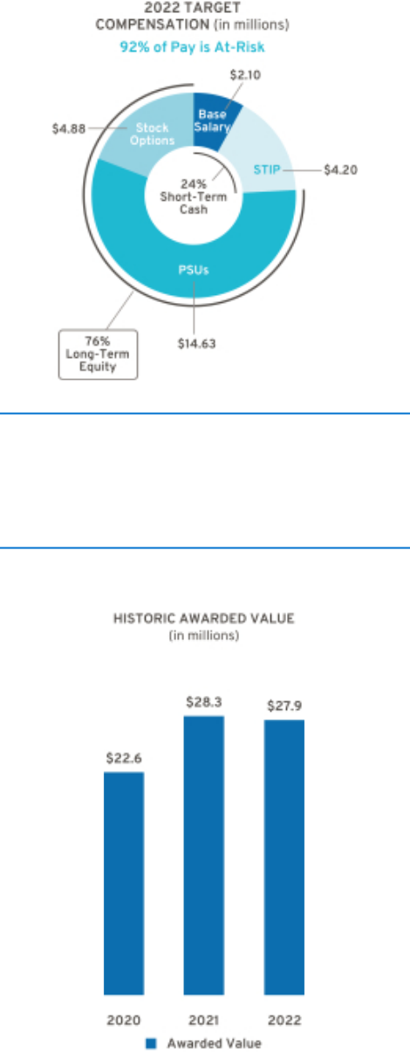

Awarded Value reflects the amount included in the Summary Compensation Table, excluding change in pension value and all other compensation.

Long-Term Incentive – In February 2022, awarded an annual LTIP grant of $19.5 million, consisting of 75 percent PSUs and 25 percent stock options.

Total awarded compensation for 2022, including salary, STIP, and LTIP, is displayed below.

Pay Element | Majority of Pay Is At-Risk | Awarded Value
Base Salary | Only Fixed Pay Element | $2,100,000
STIP | Performance to Metrics | $6,258,000
PSUs | Performance to Metrics and Stock Price | $14,625,000
Stock Options | Performance to Stock Price | $4,875,010
TOTAL |  | $27,858,010

Represents ESG Results

65

Table of Contents

- Compensation Decisions for Paul A. Jacobson

Executive Vice President and Chief Financial Officer

The Compensation Committee made the following pay decisions based on performance, competitive market data, and feedback from its independent compensation consultant and management:

Base Salary – Held base salary at $1,000,000.

Short-Term Incentive – Awarded 30 points out of a 25-point target and 50-point maximum for the strategic goals portion for the 2022 STIP performance year. In determining the number of points earned, the Compensation Committee considered these results for Mr. Jacobson:

- Generated record revenue of $156.7 billion, strong net income attributable to stockholders of $9.9 billion, and record EBIT-adjusted of $14.5 billion, driven by the team overcoming numerous challenges in 2022 and offsetting more than $5 billion of commodity and logistics headwinds;

- Drove exceptional cash flow while internally funding $9.8 billion of investment into the Company; and
- Achieved GM Financial EBT-adjusted of $4.1 billion and $1.7 billion in dividends paid back to GM, as well as other highlights below.

Our People

• Continued to prioritize our safety culture resulting in reductions in permanently disabling injuries and lost workdays

• Served as executive champion of GM’s African Ancestry Network employee resource group which has chapters across the globe

Products, Software, and Services

• Provided investors with a new set of Key Performance Indicators for the 2023-2025 timeframe to track Company progress on key priorities such as targets for EV growth and profitability
• Attracted the biggest companies in package delivery through BrightDrop business, including Walmart, Hertz, Verizon, and FedEx; BrightDrop is on track to reach $1 billion in revenue in 2023

Citizenship

• Led the Company’s first Green Bond offering of $2.25 billion in investment-grade Green Bonds – the second-largest green deal offering from a corporation outside the financial industry – aligning GM’s balance sheet with its ESG strategy

• Recognized in the S&P’s Sustainability Yearbook under a Gold Class Distinction

Enterprise

• Maintained investment-grade balance sheet and returned significant capital to shareholders by establishing a quarterly dividend, repurchasing $2.5 billion of stock, and retiring 64 million shares
• Established partnership agreements and alliances with companies including Honda, POSCO Chemical, Pilot Company, and others to advance key Company initiatives in building technical capabilities, enhancing supply chain resiliency, and driving EV adoption

• Supported Ultium Cells Holdings LLC’s successful application of a $2.5 billion loan from the U.S. Department of Energy to help finance construction of battery cell plants in Ohio, Tennessee, and Michigan

Customer Experience

• Achieved largest number of vehicle models receiving the highest segment ranking in J.D. Power 2022 U.S. Initial Quality Study


Long-Term Incentive – In February 2022, awarded an annual LTIP grant of $7.15 million, consisting of 75 percent PSUs and 25 percent stock options.

Total awarded compensation for 2022, including salary, STIP, and LTIP, is displayed below.

Pay Element | Majority of Pay Is At-Risk | Awarded Value
Base Salary | Only Fixed Pay Element | $1,000,000
STIP | Performance to Metrics | $1,862,500
PSUs | Performance to Metrics and Stock Price | $5,362,500
Stock Options | Performance to Stock Price | $1,787,513
TOTAL |  | $10,012,513

Awarded Value reflects the amount included in the Summary Compensation Table, excluding change in pension value and all other compensation.
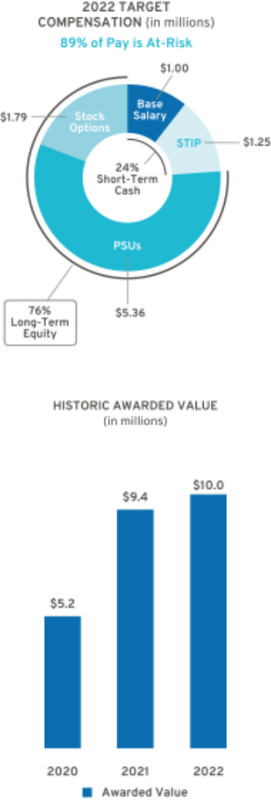

Represents ESG Results

66

Table of Contents

- Compensation Decisions for Mark L. Reuss

President

The Compensation Committee made the following pay decisions based on performance, competitive market data, and feedback from its independent compensation consultant and management:

Base Salary – Effective January 1, 2022, increased base salary from $1,300,000 to $1,350,000.

Short-Term Incentive – Awarded 35 points out of a 25-point target and 50-point maximum for the strategic goals portion for the 2022 STIP performance year. In determining the number of points earned, the Compensation Committee considered these results for Mr. Reuss:

- Developed a winning product portfolio that has earned leadership in key segments, including pickups, full-size SUVs, sports cars, and affordable EVs;

- Optimized our EV volume acceleration plan to maximize volume and profitability to scale to 1 million units of annual EV capacity in North America in 2025; and
- Executed multi-brand, multi-price point ICE and EV strategy designed to earn new customers and bolster GM’s industry-leading loyalty, as well as other highlights below.

Our People

• Continued to prioritize our safety culture resulting in reductions in permanently disabling injuries and lost workdays

• Received top 2022 Rainbow PUSH Coalition Automotive Diversity Scorecard

Products, Software, and Services

• Led and improved rankings in initial quality, while the rest of the industry went backwards, according to J.D. Power’s annual Initial Quality Survey, with GM leading among all OEMs, Buick leading among brands, six top-ranked vehicles from Chevrolet, and the Corvette nameplate ranking highest overall
• Leveraged Ultium Platform to create a new portfolio of EVs for Chevrolet, Buick, GMC, Cadillac, and BrightDrop, enabling GM to compete in nearly 70% of U.S. vehicle segments by 2025
• Introduced new generation of vehicles, including the Chevrolet Trax and Montana, with reduced operational complexity while still offering best-in-class performance in entry-level segments

Citizenship

• Named one of 2022’s Michiganians of the Year by the Detroit News for leading technology and manufacturing investment and job creation, and leadership in numerous regional non-profit organizations

• Provided $60 million in funding to nonprofit organizations working to help create inclusive solutions to social issues around the world

Enterprise

• Developed the Ultium and Ultifi Platforms launching now, which support rapid growth of electric and software-defined vehicles, creating new revenue and profit opportunities
• Executed plan to increase manufacturing capacity for HD pickups, enabling GM to expand lead over the nearest competitor to approximately 115,000 units
• Announced plans for five assembly plants in the U.S., Canada, and Mexico to be building EVs

Customer Experience

• Launched new digital retail platform with our U.S. dealer partners to enhance the shopping and purchase experience for customers, while achieving faster order-to-delivery times and reducing inventory costs for GM and its dealers
• Extended OnStar Guardian skill for Amazon Alexa to all OnStar Guardian Members in the U.S. with an Alexa-enabled device


Long-Term Incentive – In February 2022, awarded an annual LTIP grant of $9.96 million, consisting of 75 percent PSUs and 25 percent stock options.

Total awarded compensation for 2022, including salary, STIP, and LTIP, is displayed below.

Pay Element | Majority of Pay Is At-Risk | Awarded Value
Base Salary | Only Fixed Pay Element | $1,350,000
STIP | Performance to Metrics | $2,598,800
PSUs | Performance to Metrics and Stock Price | $7,471,875
Stock Options | Performance to Stock Price | $2,490,626
TOTAL |  | $13,911,301

Awarded Value reflects the amount included in the Summary Compensation Table, excluding change in pension value and all other compensation.
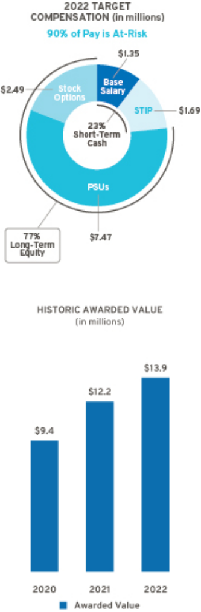

Represents ESG Results

67

Table of Contents

- Compensation Decisions for Douglas L. Parks

Executive Vice President, Global Product Development, Purchasing and Supply Chain

The Compensation Committee made the following pay decisions based on performance, competitive market data, and feedback from its independent compensation consultant and management:

Base Salary – Effective January 1, 2022, increased base salary from $850,000 to $875,000.

Short-Term Incentive – Awarded 30 points out of a 25-point target and 50-point maximum for the strategic goals portion for the 2022 STIP performance year. In determining the number of points earned, the Compensation Committee considered these results for Mr. Parks:

- Accelerated launch plans and capital allocation to support the widest range of EVs of any manufacturer in North America, enabled by the Ultium Platform;

- Secured multiple binding agreements with battery raw material suppliers to support 1 million units of annual EV capacity in North America in 2025; and
- Announced $650 million investment in Lithium Americas Corp. to help fund development of the Thacker Pass lithium mine, representing the largest-ever investment by an automaker to produce battery raw materials, as well as other highlights below.

Our People

• Continued to prioritize our safety culture resulting in reductions in permanently disabling injuries and lost workdays

• Ranked among Top 50 companies for diversity by DiversityInc based on six key areas of diversity and inclusion management

Products, Software, and Services

• Doubled the Super Cruise network, enabling hands-free driving on more than 400,000 miles of compatible highways and continue to prepare for the launch of Ultra Cruise, which will offer destination-to-destination hands-free driving in 95% of all driving scenarios

• Opened the first Ultium Cells plant and scaling battery production to meet pent-up demand for the Cadillac LYRIQ, GMC HUMMER EV Pickup, and BrightDrop Zevo 600

Citizenship

• Launched the ESG Supplier Pledge, bringing suppliers in on the commitment to carbon neutrality, the development of social responsibility programs, and implementation of sustainable procurement
• Spent more than $17 billion with diverse suppliers over past five years and contributed to community initiatives in collaboration with diverse suppliers
• Working with partners like the Department of Energy’s U.S. Advanced Battery Consortium, Lithium Recycling Inc., Cirba Solutions, and others to establish pathways to reacquire metals from batteries for reuse in future battery cells and support the development of recycled material in new cells

Enterprise

• Advancing state-of-the-art technologies to develop batteries at a lower cost while increasing energy density
• Opened the Wallace Battery Cell Innovation Center, accelerating development and commercialization of future EV batteries
• Creating a domestic supply chain for EVs in North America through direct sourcing of critical battery raw materials, further accelerated by the clean energy tax credits

Customer Experience

• Continued to work towards launching Ultium Platform, enabling an entire lineup of high-volume crossovers, SUVs, full-size pickups, and low-roof luxury cars, all from the same core architecture
• Continued work on the Ultifi Platform, which will begin showing initial customer benefits on certain equipped vehicles later this year


Long-Term Incentive – In February 2022, awarded an annual LTIP grant of $6.03 million, consisting of 75 percent PSUs and 25 percent stock options.

Total awarded compensation for 2022, including salary, STIP, and LTIP, is displayed below.

Pay Element | Majority of Pay Is At-Risk | Awarded Value
Base Salary | Only Fixed Pay Element | $875,000
STIP | Performance to Metrics | $1,629,800
PSUs | Performance to Metrics and Stock Price | $4,523,400
Stock Options | Performance to Stock Price | $1,507,806
TOTAL |  | $8,536,006
68

Awarded Value reflects the amount included in the Summary Compensation Table, excluding change in pension value and all other compensation.
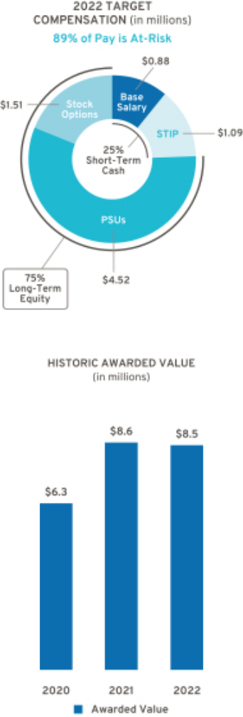

Represents ESG Results

Table of Contents

- Compensation Decisions for Stephen K. Carlisle

Executive Vice President and President, North America

The Compensation Committee made the following pay decisions based on performance, competitive market data, and feedback from its independent compensation consultant and management:

Base Salary – Effective January 1, 2022, increased base salary from $850,000 to $875,000.

Short-Term Incentive – Awarded 30 points out of a 25-point target and 50-point maximum for the strategic goals portion for the 2022 STIP performance year. In determining the number of points earned, the Compensation Committee considered these results for Mr. Carlisle:

- Led the industry in total U.S. sales and delivered largest year-over-year increase in U.S. market share of any OEM;

- Achieved strong 10.1 percent EBIT-adjusted margin in North America; and

- Maintained U.S. full-size pickup truck leadership for the third consecutive year and full-size SUV leadership for the 48th consecutive year, as well as other highlights below.

Our People

• Continued to prioritize our safety culture resulting in reductions in permanently disabling injuries and lost workdays

• Named one of Canada’s Best Employers for 2022 by Forbes

Products, Software, and Services

• Led GM’s expansion of truck leadership as the Company again earned the No. 1 position in sales of pickups and full-size SUVs, with Chevrolet and GMC outselling the nearest competitor by 350,000 vehicles

• Announced GM Energy, a holistic ecosystem of energy management products and services including Ultium Home, Ultium Commercial, and Ultium Charge 360

Citizenship

• Achieved goal of investing 10 percent of media spend in diverse-owned and targeted media, and on track to maintain this commitment in 2023

• Celebrated 50 years of the GM Minority Dealer Development program, the industry’s first, longest-running, and most comprehensive minority dealer program
• Announced partnership with dealers to install up to 40,000 Level 2 charging stalls in communities across the U.S. and Canada

Enterprise

• Executed historic agreement with Hertz to expand EV offerings to rental customers, with agreement for Hertz to order up to 175,000 EVs over the next five years, driving a wave of electrification for fleet customers
• Captured business of more than 300 major commercial accounts over last several years, leading to GM’s best year for commercial deliveries since 2006
• Achieved best-ever annual revenue and eight consecutive quarters of record growth in Customer Care & Aftersales, including $1 billion in gross revenue through Chevrolet, Buick, GMC, and Cadillac accessories business

Customer Experience

• Led Buick to achieve top ranking in sales satisfaction among mass market brands
• Launched new digital retail platform with U.S. dealer partners to reimagine every aspect of the sales, service, and parts network to enhance how customers shop and how GM manages inventory, while reducing inventory costs for GM and its dealers

Awarded Value reflects the amount included in the Summary Compensation Table, excluding change in pension value and all other compensation.
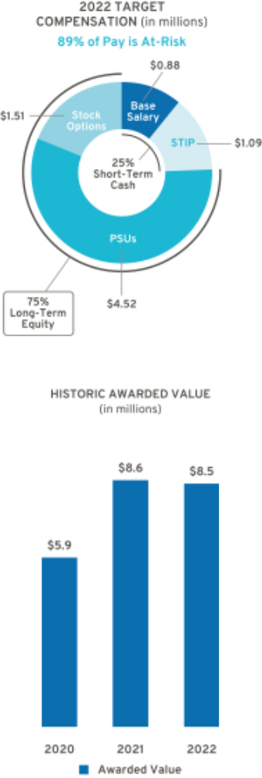

Long-Term Incentive – In February 2022, awarded an annual LTIP grant of $6.03 million, consisting of 75 percent PSUs and 25 percent stock options.

Total awarded compensation for 2022, including salary, STIP, and LTIP, is displayed below.

Pay Element | Majority of Pay Is At-Risk | Awarded Value
Base Salary | Only Fixed Pay Element | $875,000
STIP | Performance to Metrics | $1,629,800
PSUs | Performance to Metrics and Stock Price | $4,523,400
Stock Options | Performance to Stock Price | $1,507,806
TOTAL |  | $8,536,006

Represents ESG Results

69

Table of Contents

Compensation Policies and Governance Practices

u Stock Ownership Requirements

The Company requires our senior leaders to own GM stock to align their interests with those of our shareholders. Our stock ownership requirements:

- Cover all senior leaders

- Establish a multiple of each executive’s base salary

- Set a five-year time frame to meet ownership requirements

- Require senior leaders to continually hold shares to maintain ownership requirements

- Allow the opportunity to own either a required number of shares or the total dollar value of shares to meet ownership requirements

- Count only actual share holdings and unvested RSUs (i.e., excludes stock options and unvested PSUs)

- Ongoing refreshment of stock ownership requirements after each five-year requirement is met

The table below shows the stock ownership requirement by level in the Company. As of December 31, 2022, all NEOs have met or are on track to meet stock ownership requirements by their respective dates.
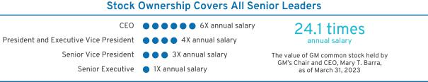

- Compensation Risk Assessment

Annually, the Compensation Committee reviews the potential impact of our compensation programs on organizational risk. The Compensation Committee discusses the compensation programs and risk mitigation features when evaluating whether the programs encourage or reward employees for engaging in excessive, imprudent, inappropriate, or unnecessary risk-taking. The committee also confirms the alignment of the compensation programs to the Company’s sustainability risks and opportunities.

The annual risk review, completed on December 5, 2022, with assistance from our human resources, audit, and legal organizations, involved analyzing our current compensation programs in relation to risk. Our analysis concluded that our compensation programs include the following risk mitigation features:

Mix of Pay Elements – Base salary, STIP, PSUs, and stock options are included in the executive compensation program.

Short-Term and Long-Term Plans – The mix of our short-term and long-term compensation plans appropriately reward employees while balancing risk through the delayed payment of long-term awards.

Adjustments to Compensation – Maximum payout caps are in place for incentive compensation, and the Compensation Committee has the ability to apply negative discretion.

Compensation Committee Oversight – Our Compensation Committee reviews plan performance and approves all executive compensation plans and payouts.

Multiple Performance Measures – Multiple performance measures work together to balance risk in our incentive compensation plans.

Stock Ownership Requirements – All senior leaders are subject to stock ownership requirements of at least one times their salary, as described above.

70

Table of Contents

Clawback and Cancellation Provisions – All awards are subject to our Policy on Recoupment of Incentive Compensation, as described below. In addition, cancellation provisions apply to all outstanding STIP and LTIP awards.

In 2022, the Compensation Committee determined that our compensation programs have sufficient risk mitigation features and do not encourage or reward employees for engaging in excessive, imprudent, inappropriate, or unnecessary risk-taking. Based on the Compensation Committee’s review, it was determined our compensation programs are low risk.

- Policy on Recoupment of Incentive Compensation

Under our Policy on Recoupment of Incentive Compensation (available on our website at investor.gm.com/esg), the Compensation Committee is empowered to recoup (“clawback”) compensation paid to executive officers and other executives under its purview. In the event of employee misconduct that causes specified financial or reputational damage, a materially inaccurate performance calculation, or an accounting restatement, the Compensation Committee may seek to clawback paid incentive compensation. The Compensation Committee may also cancel outstanding equity-based awards granted to any covered employee if that employee engages in conduct detrimental to the Company. This policy was expanded in 2020 to cover additional executives and scenarios of misconduct beyond only an accounting restatement.

 |  | Cancellation and | Cancellation of
 | Clawback Policy | Clawback Due to Violation | Unvested
 | Clawback Policy | of Non-Compete and | and Outstanding
 |  | Non-Solicitation Terms | Awards
 | Executive officers and | Approximately 250 | All employees that
 | other executives under | Approximately 250 | All employees that
Covered Population | other executives under | Approximately 250 | receive awards through
Covered Population | the purview of the | senior leaders | receive awards through
 | the purview of the | senior leaders | STIP or LTIP
 | Compensation Committee |  | STIP or LTIP
 | Following employee
 | misconduct that causes
 | specified financial or | Employee violates
Event Applicable | reputational damage, a | Employee violates | Employee engages in
Event Applicable | materially inaccurate | non-compete or | conduct deemed detrimental
 | performance calculation, | non-solicitation terms | to the Company
 | or an accounting
 | restatement, as defined
 | by the policy
Awards Subject to | STIP, PSUs, RSUs, | PSUs, RSUs, and | STIP, PSUs, RSUs,
Cancellation, | STIP, PSUs, RSUs, | PSUs, RSUs, and | STIP, PSUs, RSUs,
Forfeiture, and/or | and Stock Options | Stock Options | and Stock Options
Recoupment

- Trading GM Securities

Our Insider Trading Policy, which applies to (i) directors, executive officers, and employees of GM, (ii) such persons’ family members, and (iii) GM contractors and consultants who have access to material nonpublic information concerning GM (collectively, “Insiders”), prohibits Insiders from buying or selling GM securities when in possession of material nonpublic information and during other closed periods. Any sale or purchase of common stock by directors, executive officers, and all other senior leaders must be made during pre-established periods after receiving preclearance by a member of the GM legal staff or pursuant to a pre-approved and pre-established Rule 10b5-1 trading plan.

71

Table of Contents

Trading in GM derivatives (i.e., puts or calls), engaging in short sales or otherwise engaging in hedging activities, and pledging of GM securities is prohibited for all Insiders. This policy is posted on our website at investor.gm.com/esg.

- Tax Considerations

The Tax Cuts and Jobs Act enacted on December 22, 2017, modified IRC Section 162(m) to, among other things, limit the federal tax deduction for annual individual compensation paid to $1 million for NEOs beginning with the 2018 tax year. Previously, compensation paid in excess of $1 million could be deducted if it was performance-based. The Tax Cuts and Jobs Act includes a transition relief rule in which these changes do not apply to compensation payable pursuant to a written binding contract in effect on November 2, 2017, and is not materially modified after that date. To the extent it is applicable to our existing arrangements, the Compensation Committee may avail itself of this rule. The Compensation Committee continues to closely align executive pay with performance, regardless of the performance-based exception being removed under IRC Section 162(m).

- Compensation Committee and Consultant Independence

Our Compensation Committee is composed entirely of independent directors as determined by the Board under NYSE and SEC rules, and as defined for various regulatory purposes. Under its charter, the Compensation Committee has the authority to hire outside consultants and advisors at the Company’s expense.

For 2022, the Compensation Committee retained the services of Frederic W. Cook & Co., Inc. (“FW Cook”), an independent consultant, for advice related to the compensation of NEOs and other executive compensation-related matters. FW Cook takes direction from, and is solely responsible to, the Compensation Committee and does not provide services to the Company’s management. A representative from FW Cook attended all Compensation Committee meetings, either in person or virtually, consulted with and advised the Compensation Committee members on executive compensation, including the structure and amounts of various pay elements, and developed executive benchmarking data. The Compensation Committee is also aided in its deliberations by in-house legal counsel.

The Compensation Committee annually reviews the performance of its compensation consultant and considers the following factors when assessing the independence of FW Cook in accordance with NYSE standards:

- Services provided to GM management outside the services provided to the Compensation Committee;

- Fees paid as a percentage of FW Cook’s total revenue;

- Policies and procedures designed to prevent conflicts of interest;

- Any business or personal relationships between members of the Compensation Committee and FW Cook;

- GM stock ownership by employees of FW Cook; and

- Any business or personal relationships between GM and FW Cook.

After reviewing the performance and independence of its consultant, the Compensation Committee determined FW Cook was independent based on the standards above.

- Employment and Termination Agreements

The Company has no employment or pre-defined termination agreements with any of our 2022 NEOs. All NEOs participate in the General Motors LLC U.S. Executive Severance Program filed as an exhibit to the Company’s 2022 Form 10-K.

72

Table of Contents

Compensation Committee Report

The Compensation Committee has reviewed and discussed with management the Compensation Discussion and Analysis and, based on that review and discussion, has recommended to the Board of Directors that the Compensation Discussion and Analysis be included in this Proxy Statement and incorporated by reference into the Company’s Annual Report on Form 10-K for the year ended December 31, 2022, as filed with the U.S. Securities and Exchange Commission on January 31, 2023.

Compensation Committee

Wesley G. Bush (Chair)
Aneel Bhusri
Joseph Jimenez
Patricia F. Russo
Carol M. Stephenson

73

Table of Contents

EXECUTIVE COMPENSATION TABLES

Summary Compensation Table

 |  |  |  |  |  |  | Change in
 |  |  |  |  |  |  | Pension
 |  |  |  |  |  | Nonequity | Value and
Name and |  |  |  | Stock | Option | Nonequity | NQ Deferred | All Other
Name and |  | Salary | Bonus | Stock | Option | Incentive Plan | Compensation | All Other | Total
Principal | Year | Salary | Bonus | Awards(2) | Awards(3) | Compensation(4) | Earnings(5) | Compensation(6) | Total
Position(1) | Year | ($) | ($) | ($) | ($) | ($) | ($) | ($) | ($)
Mary T. Barra | 2022 | 2,100,000 | — | 14,625,000 | 4,875,010 | 6,258,000 | — | 1,121,560 | 28,979,570
Chair and Chief | 2021 | 2,100,000 | — | 14,582,198 | 3,937,507 | 7,644,000 | — | 873,075 | 29,136,780
Executive Officer
Executive Officer | 2020 | 1,995,000 | — | 13,093,722 | 3,750,002 | 3,780,000 | 423,608 | 615,655 | 23,657,987
Paul A. Jacobson | 2022 | 1,000,000 | — | 5,362,500 | 1,787,513 | 1,862,500 | — | 223,425 | 10,235,938
Executive Vice
Executive Vice | 2021 | 1,000,000 | — | 4,860,724 | 1,312,502 | 2,250,000 | — | 155,422 | 9,578,648
President and Chief
Financial Officer | 2020 | 83,333 | — | 4,475,128 | 525,001 | 88,600 | — | 7,610 | 5,179,672
Mark L. Reuss | 2022 | 1,350,000 | — | 7,471,875 | 2,490,626 | 2,598,800 | — | 438,250 | 14,349,551
President | 2021 | 1,300,000 | — | 6,180,076 | 1,668,752 | 3,038,800 | — | 348,119 | 12,535,747
 | 2020 | 1,235,000 | — | 5,217,207 | 1,487,501 | 1,462,500 | 333,492 | 227,702 | 9,963,402
Douglas L. Parks | 2022 | 875,000 | — | 4,523,400 | 1,507,806 | 1,629,800 | — | 243,260 | 8,779,266
Executive Vice
Executive Vice | 2021 | 850,000 | — | 4,617,717 | 1,246,876 | 1,933,800 | — | 187,084 | 8,835,477
President, Global
President, Global | 2020 | 767,500 | — | 3,543,682 | 1,021,888 | 977,500 | 260,113 | 163,025 | 6,733,708
Product Development,
Purchasing and Supply
Chain
Stephen K. Carlisle | 2022 | 875,000 | — | 4,523,400 | 1,507,806 | 1,629,800 | — | 258,960 | 8,794,966
Executive Vice | 2021 | 850,000 | — | 4,617,717 | 1,246,876 | 1,933,800 | — | 331,811 | 8,980,204
President and
President and | 2020 | 711,136 | — | 3,390,773 | 875,009 | 920,000 | 232,390 | 160,155 | 6,289,463
President, North
America

- Titles reflect position as of December 31, 2022.

- Stock Awards displays the grant date fair value of PSUs issued under the LTIP, computed in accordance with Financial Accounting Standards Board (“FASB”) Accounting Standards Codification (“ASC”) Topic 718. PSUs will vest based on GM’s performance against EBIT-adjusted Margin, Relative TSR, and EV Measures. The assumptions used for the Monte Carlo valuation of the Relative TSR portion of the PSUs are summarized below:

 |  |  | Risk-Free |  | Valuation Price as a
Grant Date | Stock Price | Implied Volatility | Interest Rate | Valuation Price | Percent of Target
2/8/2022 | $49.46 | 41% | 1.57% | $53.42 | 108.0%

There is no dividend yield, as dividends are assumed to be reinvested for the TSR calculation. The maximum award for PSUs for the 2022–2024 performance period is 200% of PSUs granted. If the maximum level of performance is achieved, the grant date fair values for the 2022 PSUs would be $29,250,000 (Ms. Barra), $10,725,000 (Mr. Jacobson), $14,943,750 (Mr. Reuss), $9,046,800 (Mr. Parks), and $9,046,800 (Mr. Carlisle).

- Option Awards displays the grant date fair value of stock options issued under the LTIP, computed in accordance with FASB ASC Topic 718 using a Black-Scholes valuation. The assumptions used for the Black-Scholes valuation of the stock options are summarized below:

Grant Date | Dividend Yield | Implied Volatility | Risk-Free Interest Rate | Expected Option Life | Grant Date Fair Value
2/8/2022 | 1.60% | 41% | 1.88% | 6.00 years | $17.52

- All NEOs were eligible for a payment under the STIP for 2022 performance based on the Company’s achievement of annual performance goals and individual performance. Individual performance decisions for each NEO are determined by the Compensation Committee; results are discussed beginning on page 65.

- These amounts represent the actuarial change in the present value of the NEO’s accrued benefit for 2022 attributed to year-over-year variances in applicable discount rates, lump sum interest rates, mortality rates, and employer contributions to tax-qualified and non-tax-qualified plans, as described in “Pension Benefits” on page 78. The

74

Table of Contents

Company does not credit interest at above-market rates to any deferred retirement accounts, and no interest amounts are included in these totals. In 2022, the actuarial present value decreased in the amount of $493,068 (Ms. Barra), $389,602 (Mr. Reuss), $332,677 (Mr. Parks), and $305,416 (Mr. Carlisle). Mr. Jacobson is not eligible to participate in DB pension plans based on his date of service.

- The amounts included as All Other Compensation are described in the table below.

All Other Compensation

 | M.T. Barra | P.A. Jacobson | M.L. Reuss | D.L. Parks | S.K. Carlisle
 | ($) | ($) | ($) | ($) | ($)
Perquisites and Other Personal Benefits⁽¹⁾ | 430,013 | 48,595 | 112,751 | 30,332 | 28,267
Employer Contributions to Savings Plans⁽²⁾ | 668,640 | 170,000 | 317,328 | 203,528 | 203,528
Life and Other Insurance Benefits⁽³⁾ | 22,907 | 4,830 | 8,171 | 9,400 | 9,400
Other⁽⁴⁾ | — | — | — | — | 17,765
TOTAL | 1,121,560 | 223,425 | 438,250 | 243,260 | 258,960

- The amounts included as Perquisites and Other Personal Benefits are described in the table below.

- Includes employer contributions to tax-qualified and non-tax-qualified savings and retirement plans during 2022.

- Includes premiums paid by the Company for Group Variable Universal Life insurance for executives. For Ms. Barra, the amount also includes premiums paid by the Company for providing personal accident insurance for members of the Board. NEOs are responsible for any ordinary income taxes resulting from the cost of Company-paid premiums.

- Reflects tax equalization payments in connection with Mr. Carlisle’s international assignment in Canada, which ended in May 2018. These tax equalization payments are made under a policy that applies to all employees on international assignment at the request of the Company to ensure an employee does not receive any undue tax burden or benefit had the employee remained in their home country. For Mr. Carlisle, the trailing tax payments made after the end of his assignment are to address any foreign tax obligations relating to equity awards earned while on international assignment.

Perquisites and Other Personal Benefits

 | M.T. Barra | P.A. Jacobson | M.L. Reuss | D.L. Parks | S.K. Carlisle
 | ($) | ($) | ($) | ($) | ($)
Personal Travel⁽¹⁾ | 254,037 | 12,289 | 67,635 | — | —
Security⁽²⁾ | 147,767 | — | 9,139 | — | —
Company Vehicle Programs⁽³⁾ | 13,260 | 30,159 | 21,075 | 14,668 | 15,207
Executive Physical⁽⁴⁾ | 4,589 | 6,147 | 4,542 | 5,304 | 2,700
Financial Counseling⁽⁵⁾ | 10,360 | — | 10,360 | 10,360 | 10,360
Other⁽⁶⁾ | — | — | — | — | —
TOTAL | 430,013 | 48,595 | 112,751 | 30,332 | 28,267

- Personal travel, pursuant to Company policy as discussed on page 60, includes incremental costs (fuel, flight crew expenses, landing fees, ground transportation fees, and other miscellaneous variable expenses) associated with aircraft use. Ms. Barra serves on outside boards, which we view as directly and integrally related to her role as Chair and CEO and her professional development. The cost of travel to outside boards for 2022 was $110,437 and is excluded from the amount above.

- Includes the incremental cost of providing security services and residential security system monitoring for Ms. Barra and Mr. Reuss as recommended by an independent third-party security consultant. For security personnel employed by the Company, the cost is the actual incremental cost of expenses incurred by the security personnel. Total salary, wages, and benefits are not allocated, as the Company already incurs these costs for business purposes.

- Includes the cost of providing cars, drivers, and the estimated annual lease value of Company vehicles, inclusive of fuel and insurance, driven by NEOs. The annual lease value is included because it is more reflective of the

75

Table of Contents

value of the Company vehicle perquisite than of the Company’s incremental costs, which are generally significantly lower because the Company manufactures and ordinarily disposes of Company vehicles for a profit, resulting in minimal incremental costs, if any. Taxes related to imputed income are the responsibility of each participant.

- Reflects costs associated with executive physicals with an approved provider as discussed on page 60.

- Reflects costs associated with financial counseling and estate planning services with an approved provider.

- Occasionally, unused tickets from sponsorship agreements are made available for personal use. Tickets are included in sponsorship agreements and typically result in no incremental costs to the Company. In 2022, there were no incremental costs associated with the personal use of tickets to GM-sponsored events. Occasionally, limited souvenirs may be included as part of a sponsorship agreement and no incremental costs are incurred by the Company.

Grants of Plan-Based Awards

STIP awards for the 2022 performance year were made under the terms of the 2017 STIP. Equity awards granted to each NEO were made under the terms of the 2020 LTIP. PSUs vest and deliver at the end of the performance period and can be earned at a level between 0 and 200 percent of target. PSUs are based on the achievement of performance conditions relating to EBIT-adjusted Margin, Relative TSR, and EV Measures over a three-year performance period from January 1, 2022, to December 31, 2024. Stock options vest ratably over a three-year period.

 |  |  |  |  |  |  |  |  |  | All Other | All Other
 |  |  |  | Estimated Future Payouts |  |  | Estimated Future Payouts |  |  | Stock | Option | Exercise | Grant Date
 |  |  |  | Under Non-Equity Incentive |  |  | Under Equity Incentive |  |  | Awards: | Awards: | or Base | Grant Date
 |  |  |  |  | Plan Awards |  | Plan Awards |  |  | Number of | Number of | Price of | Fair Value
 |  |  |  |  |  |  |  |  |  | Shares of | Securities | Option | of Stock
Name | Award | Grant | Approval | Threshold | Target | Maximum | Threshold | Target | Maximum | Stock or | Underlying | Awards | and Option
Name | Type | Date | Date | ($) | ($) | ($) | (#) | (#) | (#) | Units (#) | Options (#) | ($/share) | Awards ($)⁽¹⁾
Mary T. Barra | STIP | 1/1/2022 | 12/6/2021 | 262,500 | 4,200,000 | 8,400,000
 | Options | 2/8/2022 | 12/6/2021 |  |  |  |  |  |  |  | 278,254 | 49.46 | 4,875,010
 | PSU | 2/8/2022 | 12/6/2021 |  |  |  | 28,693 | 286,926 | 573,852 |  |  |  | 14,625,000
Paul A. Jacobson | STIP | 1/1/2022 | 12/6/2021 | 78,125 | 1,250,000 | 2,500,000
 | Options | 2/8/2022 | 12/6/2021 |  |  |  |  |  |  |  | 102,027 | 49.46 | 1,787,513
 | PSU | 2/8/2022 | 12/6/2021 |  |  |  | 10,521 | 105,207 | 210,414 |  |  |  | 5,362,500
Mark L. Reuss | STIP | 1/1/2022 | 12/6/2021 | 105,469 | 1,687,500 | 3,375,000
 | Options | 2/8/2022 | 12/6/2021 |  |  |  |  |  |  |  | 142,159 | 49.46 | 2,490,626
 | PSU | 2/8/2022 | 12/6/2021 |  |  |  | 14,659 | 146,590 | 293,180 |  |  |  | 7,471,875
Douglas L. Parks | STIP | 1/1/2022 | 12/6/2021 | 68,363 | 1,093,800 | 2,187,600
 | Options | 2/8/2022 | 12/6/2021 |  |  |  |  |  |  |  | 86,062 | 49.46 | 1,507,806
 | PSU | 2/8/2022 | 12/6/2021 |  |  |  | 8,874 | 88,744 | 177,488 |  |  |  | 4,523,400
Stephen K. Carlisle | STIP | 1/1/2022 | 12/6/2021 | 68,363 | 1,093,800 | 2,187,600
 | Options | 2/8/2022 | 12/6/2021 |  |  |  |  |  |  |  | 86,062 | 49.46 | 1,507,806
 | PSU | 2/8/2022 | 12/6/2021 |  |  |  | 8,874 | 88,744 | 177,488 |  |  |  | 4,523,400

- This column shows the aggregate grant date fair value of equity awards granted to the NEOs in 2022. The aggregate grant date fair value is the amount that the Company expects to expense in its financial statements over the vesting schedule. All grant date fair values have been computed in accordance with FASB ASC Topic 718.

76

Table of Contents

Outstanding Equity Awards at Fiscal Year-End

 |  |  |  | Option Awards |  |  |  |  | Stock Awards⁽¹⁾
 |  |  |  |  |  |  |  |  |  | Equity | Equity
 |  |  |  |  |  |  |  |  |  | Equity | Incentive
 |  |  |  |  |  |  |  |  |  | Incentive | Plan Awards:
 |  |  | Number of | Number of |  |  |  |  | Market | Plan Awards: | Market or
 |  |  | Number of | Number of |  |  |  | Number | Market | Number of | Payout Value
 |  |  | Securities | Securities |  |  |  | Number | Value of | Unearned | of Unearned
 |  |  | Underlying | Underlying |  |  |  | of Shares | Shares or | Shares, Units, | Shares, Units,
 |  |  | Unexercised | Unexercised | Option | Option |  | or Units of | Units of | or Other | or Other
 |  | Grant | Options | Options | Option |  |  | Stock That | Stock That | Rights That | Rights That
 |  | Grant | Exercisable | Unexercisable | Exercise | Expiration |  | Have Not | Have Not | Have Not | Have Not
Name |  | Date | (#) | (#) | Price ($) | Date |  | Vested (#) | Vested ($) | Vested (#) | Vested ($)
Mary T. Barra | 2/8/2022 |  | — | 278,254⁽²⁾ | 49.46 | 2/8/2032 |  |  |  | 286,926⁽⁷⁾⁽⁸⁾ | 9,652,191⁽⁸⁾
 | 2/18/2021 |  | 64,879 | 129,758⁽³⁾ | 52.16 | 2/18/2031 |  |  |  | 226,467⁽⁷⁾⁽⁸⁾ | 7,618,350⁽⁸⁾
 | 2/12/2020 |  | 496,032 | 248,016⁽⁴⁾ | 35.49 | 2/12/2030 |  | 440,618⁽⁵⁾ | 14,822,390
Paul A. Jacobson | 2/8/2022 |  | — | 102,027⁽²⁾ | 49.46 | 2/8/2032 |  |  |  | 105,207⁽⁷⁾⁽⁸⁾ | 3,539,163⁽⁸⁾
 | 2/18/2021 |  | 21,627 | 43,252⁽³⁾ | 52.16 | 2/18/2031 |  |  |  | 75,489⁽⁷⁾⁽⁸⁾ | 2,539,450⁽⁸⁾
 | 12/1/2020 |  | 25,307 | 12,654⁽⁴⁾ | 44.68 | 2/12/2030 |  | 76,976⁽⁵⁾⁽⁶⁾ | 2,589,473
Mark L. Reuss | 2/8/2022 |  | — | 142,159⁽²⁾ | 49.46 | 2/8/2032 |  |  |  | 146,590⁽⁷⁾⁽⁸⁾ | 4,931,288⁽⁸⁾
 | 2/18/2021 |  | 27,497 | 54,992⁽³⁾ | 52.16 | 2/18/2031 |  |  |  | 95,979⁽⁷⁾⁽⁸⁾ | 3,228,734⁽⁸⁾
 | 2/12/2020 |  | 196,760 | 98,379⁽⁴⁾ | 35.49 | 2/12/2030 |  | 174,779⁽⁵⁾ | 5,879,566
Douglas L. Parks | 2/8/2022 |  | — | 86,062⁽²⁾ | 49.46 | 2/8/2032 |  |  |  | 88,744⁽⁷⁾⁽⁸⁾ | 2,985,348⁽⁸⁾
 | 2/18/2021 |  | 20,545 | 41,090⁽³⁾ | 52.16 | 2/18/2031 |  |  |  | 71,715⁽⁷⁾⁽⁸⁾ | 2,412,493⁽⁸⁾
 | 10/1/2020 |  | 22,278 | 11,139⁽⁴⁾ | 30.38 | 2/12/2030 |  | 45,686⁽⁵⁾ | 1,536,877
 | 2/12/2020 |  | 91,145 | 45,572⁽⁴⁾ | 35.49 | 2/12/2030 |  | 80,962⁽⁵⁾ | 2,723,562
Stephen K. Carlisle | 2/8/2022 |  | — | 86,062⁽²⁾ | 49.46 | 2/8/2032 |  |  |  | _{88,744}(7)(8) | 2,985,348⁽⁸⁾
 | 2/18/2021 |  | 20,545 | 41,090⁽³⁾ | 52.16 | 2/18/2031 |  |  |  | _{71,715}(7)(8) | 2,412,493⁽⁸⁾
 | 12/1/2020 |  |  |  |  |  |  | 9,334⁽⁵⁾ | 313,996
 | 10/1/2020 |  | 16,524 | 16,525⁽⁴⁾ | 30.38 | 2/12/2030 |  | 67,774⁽⁵⁾ | 2,279,917
 | 2/12/2020 |  | 25,215 | 25,215⁽⁴⁾ | 35.49 | 2/12/2030 |  | 44,797⁽⁵⁾ | 1,506,971

- The awards are valued based on the closing price of GM common stock on the NYSE on December 30, 2022, which was $33.64.

- Stock options granted on February 8, 2022, vest ratably each February 8 of 2023, 2024, and 2025.

- Stock options granted on February 18, 2021, vest ratably each February 18 of 2022, 2023, and 2024.

- Stock options granted on February 12, 2020, October 1, 2020, and December 1, 2020, vest ratably each February 12 of 2021, 2022, and 2023.

- 2020-2022 PSU awards granted on February 12, 2020, October 1, 2020, and December 1, 2020, cliff-vested on February 13, 2023, upon determination of results for the performance period January 1, 2020–December 31, 2022. The final performance of the 2020– 2022 PSU award was 139% and is discussed on page 64.

- RSU awards granted to Mr. Jacobson on December 1, 2020, vest ratably each December 1 of 2022 and 2023.

- 2022-2024 PSU awards granted on February 8, 2022, cliff-vest on February 8, 2025, upon determination of results for the performance period January 1, 2022–December 31, 2024. 2021-2023 PSU awards granted on February 18, 2021, cliff-vest on February 18, 2024, upon determination of results for the performance period January 1, 2021–December 31, 2023.

- Assumes target-level payout of PSU awards. The number of shares (and market value of such shares) for maximum-level payout with respect to unvested 2022–2024 PSUs granted on February 8, 2022, outstanding as of December 31, 2022, for Ms. Barra is 573,852 ($19,304,381); for Mr. Jacobson is 210,414 ($7,078,327); Mr. Reuss is 293,180 ($9,862,575); for Mr. Parks is 177,488 ($5,970,696); and for Mr. Carlisle is 177,488 ($5,970,696). The number of shares (and market value of such shares) for maximum-level payout with respect to unvested 2021–2023 PSUs granted on February 18, 2021, outstanding as of December 31, 2022, for Ms. Barra is 452,934 ($15,236,700); for Mr. Jacobson is 150,978 ($5,078,900); Mr. Reuss is 191,958 ($6,457,467); for Mr. Parks is 143,430 ($4,824,985); and for Mr. Carlisle is 143,430 ($4,824,985).

77

Table of Contents

Option Exercises and Stock Vested

 | Option Awards⁽¹⁾ |  |  | Stock Awards⁽²⁾
 | Number of Shares | Value Realized on |  | Number of Shares | Value Realized on
Name | Acquired on | Exercise |  | Acquired on Vesting | Vesting
Name | Exercise (#) | ($) |  | (#) | ($)
Mary T. Barra | — | — |  | 504,347 | 24,627,264
Paul A.
Jacobson | — | — |  | 27,977 | 1,131,110
Mark L. Reuss | — | — |  | 171,693 | 8,383,769
Douglas L.
Parks | — | — |  | 26,292 | 1,283,838
Stephen K.
Carlisle | — | — |  | 49,184 | 2,401,655

- The aggregate dollar value realized upon exercise is computed by multiplying the number of shares at exercise by the difference between the market price of GM common stock and the exercise price of the options.

- The aggregate dollar value realized upon vesting is computed by multiplying the number of shares vested by the closing price of GM common stock on the vesting date.

Pension Benefits

- GM Salaried Retirement Plan

Eligibility and Vesting: The GM Salaried Retirement Plan (“SRP”) is a funded, tax-qualified retirement plan that covers eligible employees hired prior to January 1, 2007. Employees who commenced service on or after January 1, 2007, are eligible to participate only in DC plans. Employees are vested in the SRP after five years of qualifying service. The plan permitted employee contributions, which vested immediately, until December 31, 2006. All DB accruals were frozen on September 30, 2012, with service continuing towards eligibility to retire.

Benefit Formula:

Service Prior to January 1, 2001: The plan provided benefits on both a contributory and noncontributory formula. The contributory formula factors the contributions of the employee and earnings for each fiscal year. The formulas were frozen effective December 31, 2006, and effective January 1, 2007, employees continued to participate in the SRP under a new formula that provided a pension accrual equal to 1.25 percent of the employee’s eligible earnings up to the IRS-prescribed limits for tax-qualified plans. The 1.25 percent accruals were frozen September 30, 2012.

Service from January 1, 2001, to December 31, 2006: The plan provided benefits under a cash balance formula with pay credits based on age through December 31, 2006, when the formula was frozen, with balances continuing to earn interest credits thereafter.

Time and Form of Payment: For employees hired prior to January 1, 2001, the accumulated benefit an employee earns over his or her career with the Company is payable starting after retirement. Normal retirement age is defined as age 65. Employees who commenced service prior to 1988 may elect early retirement after 30 years of credited service or 85 points, based on combined age and service, or age 60 and 10 or more years of service, with certain age-reduction factors applied. As of December 31, 2022, Ms. Barra and Messrs. Reuss, Parks, and Carlisle were eligible for early retirement. The plan also provides Social Security supplements for those hired prior to 1988. For employees hired on or after January 1, 1988, and prior to December 31, 2000, Social Security supplements are not payable and age-reduction factors are greater for retirements prior to age 62. The plan provides a single-life annuity, a spousal joint and survivor annuity, a contingent annuitant optional form of payment, or a 100 percent lump sum option. For employees hired from January 1, 2001, to December 31, 2006, the plan provides a single-life annuity, a contingent annuitant optional form of payment, or a 100 percent lump sum option.

78

Table of Contents

Tax Code Limitations on Benefits: Section 415(b)(1)(A) of the IRC limits the benefits payable under the SRP. For 2022, the maximum single life annuity a NEO could have received under these limits was $245,000 per year. This ceiling is actuarially adjusted in accordance with IRS rules to reflect employee contributions, actual forms of distribution, and actual retirement dates.

- GM Executive Retirement Plan

Eligibility and Vesting: The GM Executive Retirement Plan (“DB ERP”) is an unfunded, non-tax-qualified retirement plan that covers eligible executives to provide retirement benefits above amounts available under our other pension programs.

Benefit Formula:

Service Prior to January 1, 2007: The supplemental pension equals the greater of (a) 2 percent of the average monthly base salary multiplied by all years of contributory service less the sum of all benefits payable under the SRP plus the maximum Social Security benefit as of January 2007 multiplied by all years of contributory service or (b) 1.5 percent of the average monthly base salary plus annual incentive plan compensation multiplied by all years of contributory service, up to a maximum of 35 years, less the sum of all benefits payable under the SRP plus 100 percent of the maximum Social Security benefit as of January 2007. In both cases, the base salary and annual incentive plan payments are determined using the highest 60 months out of the last 120 months as of December 31, 2006. These DB accruals were frozen on December 31, 2006, with service continuing towards eligibility to retire.

Service from January 1, 2007, to September 30, 2012: For employees hired prior to January 1, 2001, the supplemental pension equals 1.25 percent of annual base salary plus short-term incentive payments and is applicable to amounts in excess of the IRS-prescribed limit applicable to tax-qualified plans. These DB accruals were frozen on September 30, 2012, with service continuing towards eligibility to retire.

Time and Form of Payment: Normal retirement age under the plan is age 65; however, employees who commenced service prior to January 1, 2007, may retire at age 60 with 10 or more years of service without any reduction in benefits. Employees may also retire at age 55 with 10 or more years of service with benefits reduced using the same factors as are utilized for early retirement under the SRP. As of December 31, 2022, Ms. Barra and Messrs. Reuss, Parks, and Carlisle were eligible for early retirement. The DB ERP is payable as a five-year certain annuity, with payments starting upon the retirement of the executive and continuing for 60 months.

- GM Canadian Retirement Program for Salaried Employees

Eligibility and Vesting: The GM Canadian Retirement Program for Salaried Employees (“GM Canada Salaried Plan”) is a funded DB plan open to all GM Canada employees hired prior to January 1, 2007, when it closed to new entrants. The plan permitted employee contributions, which vested immediately, until December 31, 2012. All DB accruals were frozen on December 31, 2012, with service continuing towards eligibility to retire.

Benefit Formula:

Service Prior to January 1, 2007: 1.0 percent of final 3-year average pay plus 0.75 percent of final 3-year average pay in excess of 3-year average Yearly Maximum Pensionable Earnings (“YMPE”) per year of contributory service (the 1.0 percent formula is subject to a Minimum Basic Benefit of $ 67 per month per year of contributory service prior to January 1, 2007, if retiring on or after October 1, 2006). Average pay and average YMPE were frozen as of December 31, 2006, for all those active as of December 31, 2006, except for Quebec active members, whose future earnings and YMPE growth are reflected.

Time and Form of Payment: Normal retirement age is defined as age 65. Employees who commenced service prior to 1988 may elect early retirement after 30 years of credited service, 85 points, based on combined age and service, or age 60 and 10 or more years of service, with certain age-reduction factors

79

Table of Contents

applied. As of December 31, 2022, Mr. Carlisle was eligible for early retirement. The plan also provides bridging supplements. The plan provides a single-life annuity, a spousal joint and survivor annuity, a contingent annuitant optional form of payment, or a 100 percent lump sum option.

Tax Code Limitations on Benefits: The Income Tax Act of Canada limits the benefits payable from a registered pension plan.

The table below reflects pension benefits as of December 31, 2022, provided by the respective plans.

 |  | Number of Years | Present Value of | Payments During
 |  | of Eligible Credited | Accumulated | Payments During
 |  | Service as of | Benefits⁽²⁾ | Last Fiscal Year
Name | Plan Name | December 31, 2022⁽¹⁾ | ($) | ($)
Mary T. Barra | SRP | 40.3 | 1,160,682 | —
 | DB ERP | 40.3 | 999,386 | —
Paul A. Jacobson⁽³⁾ | — | — | — | —
Mark L. Reuss | SRP | 35.8 | 911,737 | —
 | DB ERP | 35.8 | 651,129 | —
Douglas L. Parks | SRP | 37.7 | 1,014,821 | —
 | DB ERP | 37.7 | 403,319 | —
Stephen K. Carlisle⁽⁴⁾ | SRP | 38.6 | 779,678 | —
 | DB ERP | 38.6 | 354,272 | —
 | GM Canada Salaried Plan | 38.6 | 171,267 | —

- Eligible service recognizes credited service under the frozen qualified SRP in addition to future service to determine retirement eligibility.

- The present value of the SRP benefit amount shown takes into consideration the ability to elect a joint and survivor annuity form of payment as well as the ability to elect to receive the annuity as a lump sum. For SRP and DB ERP benefits, the present value represents the value of the benefit payable at age 60 (or immediately if over age 60). Present values shown here are based on the mortality and discount rate assumptions used in the December 31, 2022, FASB ASC Topic 715, “Compensation-Retirement Benefits,” except where needed to meet proxy statement requirements. The discount rates used for calculations as of December 31, 2022, for the SRP is 5.54%; for the DB ERP is 5.41%; and for the GM Canada Salaried Plan is 5.19%.

- Mr. Jacobson is only eligible to participate in DC plans offered by the Company based on his date of service.

- Mr. Carlisle is a participant in the GM Canada Salaried Plan due to his service with GM Canada.

Nonqualified Deferred Compensation Plan

We maintain certain deferred compensation programs and arrangements for executives.

The DC ERP allows for the equalization of benefits for highly compensated salaried employees under the Retirement Savings Plan when such employees’ contribution and benefit levels exceed the maximum limitations on contributions and benefits imposed by Section 2004 of Employment Retirement Income Security Act of 1974, commonly known as ERISA, as amended, and Sections 401(a)(17) and 415(c)(1)(A) of the IRC, as amended. The DC ERP is maintained as an unfunded plan, and we bear all expenses for administration of the plan and payment of amounts to participants.

80

Table of Contents

Aggregate account balances disclosed below include both vested and unvested contributions made by the Company. Contributions made prior to 2007 vested immediately. Contributions made between January 1, 2007, and September 30, 2012, vest when the participant attains age 55 with 10 years of service, and the benefit is payable as a five-year certain annuity with payments starting upon the retirement of the executive and continuing for 60 months. Contributions made on or after October 1, 2012, vest when the participant attains three years of service, regardless of age, and the benefit is payable as a 100 percent lump sum upon the retirement of the executive.

The table below reflects December 31, 2022, balances for the nonqualified deferred compensation plan and any contributions, earnings, or withdrawals during the year.

 |  | Executive | Registrant | Aggregate | Aggregate | Aggregate
 |  | Contributions | Contributions | Earnings | Withdrawals | Balance at
 |  | in the Last | in the Last | in the Last | and | 2022 Fiscal
 |  | Fiscal Year | Fiscal Year⁽¹⁾ | Fiscal Year⁽²⁾ | Distributions | Year End⁽³⁾
Name | Plan | ($) | ($) | ($) | ($) | ($)
Mary T. Barra | DC ERP | — | 651,140 | (759,247) | — | 4,736,297
Paul A. Jacobson | DC ERP | — | 151,133 | (23,490) | — | 193,669
Mark L. Reuss | DC ERP | — | 306,078 | (407,925) | — | 2,157,252
Douglas L. Parks | DC ERP | — | 179,395 | (168,044) | — | 1,060,442
Stephen K. Carlisle | DC ERP | — | 192,590 | 17,358 | — | 1,056,204

- The amounts shown are included in All Other Compensation in the Summary Compensation Table.

- The amounts shown are not reported in Change in Pension Value and Nonqualified Deferred Compensation Earnings in the Summary Compensation Table because we do not pay above-market earnings on deferred compensation in retirement plans.

- The following amounts have been included in the Summary Compensation Table in prior years: $3,121,184 (Ms. Barra), $63,888 (Mr. Jacobson), $1,457,850 (Mr. Reuss), $228,016 (Mr. Parks), and $255,439 (Mr. Carlisle).

Potential Payments Upon Termination

The Company does not maintain individual employment agreements with any NEO that provide guaranteed payments in the event of a termination of employment or change in control. In the event that a NEO’s position with the Company is eliminated, including the elimination of the NEO’s position as a result of a change in control, the NEO would be eligible for a severance payment under the Executive Severance Program.

The table below shows the potential payments to each NEO assuming a termination of employment on December 31, 2022, due to the following events: voluntary separation or termination for cause, qualifying termination under the Executive Severance Program, full career status retirement, disability, death, or change in control with termination of employment. Each of the separation events is described in more detail below. These provisions are generally applicable to participants in each of the respective plans and are not reserved only for NEOs. The payments below are in addition to the present value of the accumulated benefits from each NEO’s qualified and nonqualified pension plans shown in the “Pension Benefits” table on page 80 and the aggregate balance due to each NEO that is shown in the Nonqualified Deferred Compensation Plan table above.

81

Table of Contents

For purposes of the following table, the Company describes these terminations and potential payments:

Voluntary Separation or Termination for Cause — A voluntary separation occurs when an executive voluntarily terminates employment with the Company. A full career status retirement receives different treatment, as discussed below. A termination for cause occurs when an executive is dismissed from employment by the Company for cause, which is considered to include, but is not limited to, the executive’s gross negligence, willful misconduct, or violation of state or federal securities laws. Under each of these scenarios, the executive generally forfeits all outstanding equity awards and is not eligible for any award or payment under the STIP.

Executive Severance Program — A separation occurs when an executive’s position is eliminated, or the Company and an executive agree to mutually end the employment relationship. An executive will be eligible to receive a severance payment from the Company calculated based on his or her position and reflected as a multiple of base salary, COBRA, and a STIP award at target. An executive may receive cash payments of the value of the equity awards that are scheduled to vest within the next year after separation at the time of vesting. Unvested stock options are usually forfeited. An executive is also eligible for outplacement assistance based on position. All potential payments are contingent upon the executive entering into a mutual separation agreement.

Full Career Status Retirement — A full career status retirement occurs when an executive reaches the age of 55 with 10 or more years of continuous service with the Company, or reaches the age of 62 or older, at which time the executive voluntarily separates from the Company. An executive who enters into a separation or severance agreement cannot also elect full career status retirement.

In the event of a full career status retirement, the executive is generally eligible for a prorated STIP award based on his or her retirement date in the performance year and once final performance has been determined. RSUs granted in the year of the retirement date are prorated based on the retirement date, and continue to vest in accordance with the vesting schedule. RSUs granted prior to the year of the retirement date will continue to vest in accordance with the vesting schedule. PSUs granted in the year of the retirement date are prorated based on the retirement date, and will be adjusted for final Company performance and be settled following approval of such performance. PSUs granted prior to the year of the retirement date will remain outstanding until the end of the performance period, at which time they will be adjusted for final Company performance and be settled following approval of such performance. Stock options granted in the year of the retirement date are prorated based on the retirement date, and continue to vest in accordance with the vesting schedule. Stock options granted prior to the year of the retirement date will continue to vest in accordance with the vesting schedule.

Disability — Disability occurs when an executive terminates employment by reason of his or her inability to engage in any gainful activity due to a medically determinable physical or mental impairment that can be expected to result in death or can be expected to last for a continuous period of not less than 12 months. The executive is eligible for a full-year STIP award related to the year in which termination occurs once final Company performance has been determined. RSUs will continue to vest in accordance with the vesting schedule. PSUs will remain outstanding until the end of the performance period, at which time they will be adjusted for final Company performance and be settled following approval of such performance. Stock options will continue to vest in accordance with the vesting schedule.

Death — Following the death of an executive, the beneficiary of the executive is eligible to receive the full-year STIP award subject to adjustment for final Company performance. RSUs immediately vest in full and are settled within 90 days of death. PSUs will remain outstanding until the end of the performance period, at which time they will be adjusted for final Company performance and be settled following approval of such performance. Stock options immediately vest upon death.

Change in Control (Double Trigger) — In the event of a termination of employment resulting from a change in control, an executive will be eligible for severance under the Executive Severance Program that

82

Table of Contents

provides a severance payment based on position and a multiple of base salary and COBRA. An executive will also receive a STIP award at target and the STIP award for the prior year if such award has been determined but not paid. If the STIP award for the prior year has not been determined, the award shall be determined at target and paid. All RSU awards will generally vest and become payable immediately prior to the change in control. For PSUs, the performance period will end immediately prior to the change in control and awards will be determined based on actual performance and converted to a time-based award. Stock options immediately vest and are exercisable upon termination as a result of a change in control.

Amounts shown below are calculated by assuming that the relevant employment termination event occurred on December 31, 2022.

 |  | Voluntary
 |  | Separation or | Executive |  |  |  | Change in
 | Compensation | Termination | Severance |  |  |  | Control with
Name | _{Element}(1)(2)(3) | for Cause | Program | Retirement⁽⁴⁾ | Disability | Death | Termination
Mary T. Barra | Cash | — | 4,245,380 | — | — | — | 4,230,380
 | STIP | — | 4,200,000 | 6,048,000 | 6,048,000 | 6,048,000 | 4,200,000
 | LTIP | — | 14,822,390 | 32,092,931 | 32,092,931 | 32,092,931 | 32,092,931
 | TOTAL | — | 23,267,770 | 38,140,931 | 38,140,931 | 38,140,931 | 40,523,311
Paul A. Jacobson | Cash | — | 1,529,073 | — | — | — | 1,514,073
 | STIP | — | 1,250,000 | — | 1,800,000 | 1,800,000 | 1,250,000
 | LTIP | — | 1,648,326 | — | 8,668,085 | 8,668,085 | 8,668,085
 | TOTAL | — | 4,427,399 | — | 10,468,085 | 10,468,085 | 11,432,158
Mark L. Reuss | Cash | — | 2,062,785 | — | — | — | 2,047,785
 | STIP | — | 1,687,500 | 2,430,000 | 2,430,000 | 2,430,000 | 1,687,500
 | LTIP | — | 5,879,566 | 14,039,588 | 14,039,588 | 14,039,588 | 14,039,588
 | TOTAL | — | 9,629,851 | 16,469,588 | 16,469,588 | 16,469,588 | 17,774,873
Douglas L. Parks | Cash | — | 1,350,285 | — | — | — | 1,335,285
 | STIP | — | 1,093,800 | 1,575,100 | 1,575,100 | 1,575,100 | 1,093,800
 | LTIP | — | 4,296,752 | 9,694,593 | 9,694,593 | 9,694,593 | 9,694,593
 | TOTAL | — | 6,740,837 | 11,269,693 | 11,269,693 | 11,269,693 | 12,123,678
Stephen K. Carlisle | Cash | — | 1,345,216 | — | — | — | 1,330,216
 | STIP | — | 1,093,800 | 1,575,100 | 1,575,100 | 1,575,100 | 1,093,800
 | LTIP | — | 4,154,756 | 9,552,597 | 9,552,597 | 9,552,597 | 9,552,597
 | TOTAL | — | 6,593,772 | 11,127,697 | 11,127,697 | 11,127,697 | 11,976,613

- Cash amounts shown for Executive Severance Program and Change in Control with Termination are based on the Executive Severance Program. Payments are 2X base salary for the CEO and 1.5X base salary for all other NEOs. Under the Executive Severance Program, the CEO is eligible for a cash payment equal to 24 months of COBRA premiums and the other NEOs are eligible for a cash payment equal to 18 months of COBRA premiums. There are no cash payments due upon Voluntary Separation or Termination for Cause, Retirement, Disability, or Death.

- STIP amounts shown under Retirement, Disability, and Death are based on final company performance. STIP amounts shown for Executive Severance Program and Change in Control with Termination reflect target-level performance. Executives forfeit STIP awards for Voluntary Separation or Termination for Cause.

- LTIP amounts shown reflect the value of any unvested RSU awards, PSU awards, and stock options that may vest upon termination. The value of the awards is based on the closing price of GM common stock on December 30, 2022, of $33.64. Under the Executive Severance Program, structure equity awards are delivered in cash once vested; the value displayed reflects the value of awards that would be subject to payment based on awards outstanding as of December 31, 2022.

- Ms. Barra and Messrs. Reuss, Parks, and Carlisle were eligible for full career status retirement as of December 31, 2022.

83

Table of Contents

CEO Pay Ratio

Our CEO, who leads our global workforce of 167,000 employees (104,000 located in the United States and 63,000 non-U.S. employees) as of December 31, 2022, earned $28,979,570 in total compensation in 2022 as reported in the Summary Compensation Table.

To identify our new median employee for 2022, we:

- Excluded all employees (7,574) in the following 27 countries under the SEC’s 5 percent de minimis exception: Argentina (1,481), Australia (196), Chile (218), China (910), Colombia (1,164), Ecuador (406), Egypt (700), Germany (91), India (321), Indonesia (8), Ireland (469), Israel (740), Italy (1), Japan (36), New Zealand (14), Peru (35), Philippines (473), Russia (1), Singapore (4), South Africa (8), Switzerland (37), Taiwan (8), Thailand (48), United Arab Emirates (180), United Kingdom (11), Uruguay (8), and Uzbekistan (6);

- Calculated year-to-date payroll as of November 1, 2022, for all employees excluding the CEO;

- Identified the middle 51 employees using year-to-date payroll converted to U.S. dollars as a consistently applied compensation measure;

- Calculated annual total compensation for the 51 middle employees based on the same SEC requirements that apply to determine total compensation in the Summary Compensation Table; and

- Re-ranked all middle 51 employees and selected the median employee.

At GM, we believe that fair and equitable pay is an essential element of any successful organization, and we invest in our employees with market-competitive pay and benefits. We compensate our employees to create alignment with the short-term and long-term goals tied to the success of the Company and with our vision of zero crashes, zero emissions, and zero congestion.

Based on our calculation, we can reasonably estimate that our median employee earned $80,034 in 2022. The ratio of our CEO’s compensation to that of our median employee is estimated to be 362:1.

The rules outlined by the SEC for identifying the median employee and calculating the pay ratio based on that employee’s annual total compensation allow companies to adopt a variety of methodologies to calculate the median employee, excluding up to 5 percent of the workforce, and make reasonable estimates and assumptions that may impact their employee populations. As a result, the pay ratio reported by other companies may not be comparable to the pay ratio reported above. Other companies have different employee populations, compensation practices, and the ability to utilize different methodologies, exclusions, estimates, and assumptions in calculating their own pay ratios.

84

Table of Contents

Pay Versus Performance

Pursuant to Item 402(v) of Regulation S-K, we are providing the following information about the relationship between CAP for the Company’s CEO and non-CEO NEOs and certain aspects of the financial performance of the Company. The CAP values disclosed do not reflect the actual amount of compensation paid to our NEOs during the applicable year. The Compensation Committee does not utilize CAP as a basis for making compensation decisions. For information regarding compensation decisions made by our Compensation Committee, refer to the “Compensation Discussion and Analysis” section beginning on page 51.

 |  |  | Average |  | Value of Initial Fixed $100
 |  |  | Summary
 | Summary |  | Compensation | Average | Investment Based On:
 | Compensation |  | Table Total | CAP
 | Table Total | CAP | for Non-CEO | to Non-CEO |  | Peer Group |  | Net | EBIT-
 | for CEO⁽¹⁾ | to CEO⁽³⁾ | NEOs⁽²⁾ | NEOs⁽³⁾ | _{TSR}(4) | TSR⁽⁵⁾ |  | Income⁽⁶⁾ | adjusted⁽⁷⁾
Year | ($) | ($) | ($) | ($) | ($) | ($) |  | ($B) | ($B)
2022 | 28,979,570 | (16,991,516) | 10,539,930 | (2,724,335) | 94 | 128 |  | 9.708 | 14.474
2021 | 29,136,780 | 76,096,506 | 9,982,519 | 19,443,928 | 164 | 188 |  | 9.945 | 14.295
2020 | 23,657,987 | 45,185,399 | 6,632,869 | 5,817,820 | 116 | 151 |  | 6.321 | 9.710

- Ms. Barra served as our CEO in 2022, 2021, and 2020.

- Non-CEO NEOs in 2022 and 2021 included Messrs. Jacobson, Reuss, Parks, and Carlisle. Non-CEO NEOs in 2020 included Messrs. Jacobson, Reuss, Parks, and Carlisle, Ms. Dhivya Suryadevara (Former Executive Vice President and Chief Financial Officer), Mr. John Stapleton (Vice President and Chief Financial Officer, North America and Former Acting Chief Financial Officer), and Mr. Barry Engle (Former Executive Vice President and President, North America).

- Reflects CAP values computed in accordance with Item 402(v) of Regulation S-K and FASB ASC Topic 718.

 | 2022 |  |  | 2021 |  |  | 2020
 |  | Average |  |  | Average |  |  | Average
 | CEO | Non-CEO NEOs |  | CEO | Non-CEO NEOs |  | CEO | Non-CEO NEOs
SCT Total | 28,979,570 | 10,539,930 |  | 29,136,780 | 9,982,519 |  | 23,657,987 | 6,632,869
Less: Change in Actuarial Present Value
Reported in the “Change in Pension
Value and NQ Deferred Compensation
Earnings” Column of the SCT | — | — |  | — | — |  | (423,608) | (141,675)
Plus: Service Cost for Pension Plans | — | — |  | — | — |  | — | 149
Less: Amount Reported in the “Stock
Awards” Column of the SCT | (14,625,000) | (5,470,294) |  | (14,582,198) | (5,069,059) |  | (13,093,722) | (3,793,686)
Plus: Year-end Fair Value of Outstanding
and Unvested Stock Awards Granted in
the Covered Year | 8,629,590 | 3,227,799 |  | 18,914,281 | 6,574,982 |  | 18,050,565 | 3,545,877
Change in Fair Value of Outstanding and
Unvested Stock Awards Granted in Prior
Years | (25,258,220) | (7,683,634) |  | 25,646,494 | 5,307,302 |  | 10,087,483 | 768,879
Change in Fair Value of Stock Awards
that Vested in the Covered Year | (4,942,601) | (732,230) |  | 5,626,432 | 646,960 |  | (847,866) | (1,522)
Less: Fair Value of Stock Awards
Forfeited During the Covered Year | — | — |  | — | — |  | — | (1,617,289)
Less: Amount Reported in the “Option
Awards” Column of the SCT | (4,875,010) | (1,823,438) |  | (3,937,507) | (1,368,752) |  | (3,750,002) | (974,378)
Plus: Year-end Fair Value of Outstanding
and Unvested Option Awards Granted in
the Covered Year | 2,584,980 | 966,880 |  | 3,694,210 | 1,284,177 |  | 10,379,470 | 1,434,466
Change in Fair Value of Outstanding and
Unvested Option Awards Granted in Prior
Years | (5,055,582) | (1,267,702) |  | 6,628,520 | 1,281,139 |  | 2,881,004 | 231,707
 |  |  |  |  |  |  |  | 85

Table of Contents

 | 2022 |  |  |  | 2021 |  |  | 2020
 |  | Average |  |  | Average |  |  | Average
 | CEO | Non-CEO NEOs |  | CEO | Non-CEO NEOs |  | CEO | Non-CEO NEOs
Change in Fair Value of Option Awards that
Vested in the Covered Year | (2,429,243) | (481,646) |  | 4,969,494 | 804,660 |  | (1,755,912) | (177,797)
Less: Fair Value of Option Awards Forfeited
During the Covered Year | — | — |  | — | — |  | — | (89,780)
CAP Total | (16,991,516) | (2,724,335) |  | 76,096,506 | 19,443,928 |  | 45,185,399 | 5,817,820

- Represents the cumulative TSR of the Company of an initial investment of $100 for the measurement period beginning December 31, 2019, and ending December 31, 2022, 2021, or 2020, respectively, calculated in accordance with Item 201(e) of Regulation S-K as required under Item 402(v) of Regulation S-K.

- Represents the cumulative TSR of the Dow Jones Automobiles & Parts Titans 30 Index (the “Peer Group TSR”) of an initial investment of $100 for the measurement period beginning December 31, 2019, and ending December 31, 2022, 2021, or 2020, respectively, calculated in accordance with Item 201(e) of Regulation S-K as required under Item 402(v) of Regulation S-K.

- Reflects net income as shown in the Company’s Annual Report on Form 10-K for the years ended December 31, 2022, 2021, and 2020.

- Reflects EBIT-adjusted, the company-selected measure for 2022, as shown in the Company’s Annual Report on Form 10-K for the years ended December 31, 2022, 2021, and 2020. Refer to Appendix A for a reconciliation of EBIT-adjusted to its closest comparable GAAP measure. Please note EBIT-adjusted may not have been the company-selected measure for 2021 and 2020, and we may determine a different measure to be the company-selected measure in future years.

Tabular List of Most-Important Measures

EBIT-adjusted

EBIT-adjusted Margin

Relative TSR

- Relationship Between CAP Disclosed in the Pay Versus Performance Table and Other Table Elements
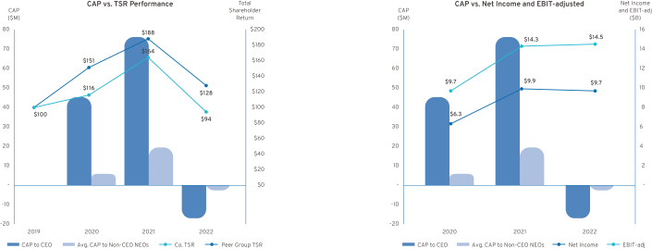

The CAP values for both our CEO and non-CEO NEOs have decreased significantly year-over-year as the majority of compensation paid to our executives is aligned to shareholders and delivered in equity. As a result, the CAP values for 2022 are negative due to the decline in TSR, despite our strong net income and record EBIT-adjusted performance.

86

Table of Contents

Equity Compensation Plan Information

The following table provides information as of December 31, 2022, about the Company’s common stock that may be issued upon the exercise of options, warrants, and rights under all the Company’s equity compensation plans.

 |  |  | Number of Securities
 |  |  | Remaining Available for
 | Number of Securities to | Weighted-Average Exercise | Future Issuance Under
 | be Issued Upon Exercise | Weighted-Average Exercise | Equity Compensation Plan
 | of Outstanding Options, | Price of Outstanding Options, | (excluding securities
 | Warrants, and Rights | Warrants, and Rights | reflected in column (A))
Plan Category | (A) | (B) | (C)
Equity
compensation plans
approved by
security holders | 34,117,956⁽¹⁾ | $39.46 | 37,273,501⁽³⁾
Equity
compensation plans
not approved by
security holders⁽²⁾ | — | — | —(4)
Total | 34,117,956 | $39.46 | 37,273,501

- The number includes the following:

  - 18,692,742 shares represent options.
  - 13,363,347 shares represent PSU awards assuming performance is achieved at target. For performance above target, awards may be settled in common stock, cash, or a combination of both.

  - 2,061,867 shares represent RSUs.

- 2016 Equity Incentive Plan — refer to Note 21 in our 2016 Form 10-K.

- Excludes 2,885,331 shares which will remain unused under our 2014 Long-Term Incentive Plan.

- Excludes 15,187 shares which will remain unused under our 2016 Equity Incentive Plan.

The following table provides information on share usage for awards granted and performance awards vested/earned during fiscal year 2022 under the Company’s equity compensation plans.

 | Granted | Performance Awards
 | Granted | Vested/Earned
RSUs | 1,400,000 | —
PSUs | 5,800,000 | 6,900,000
Time-Based Stock Options | 3,100,000 | —
Performance-Based Stock Options | — | —
 |  | 87

Table of Contents

ITEM NO. 4: PROPOSAL TO APPROVE AMENDMENT NO. 1 TO THE COMPANY’S 2020 LONG-TERM INCENTIVE PLAN TO INCREASE THE NUMBER OF SHARES AVAILABLE FOR ISSUANCE THEREUNDER

The Board recommends shareholders vote FOR the approval of Amendment No. 1 to the 2020 Long-Term Incentive Plan (the “2020 LTIP”) which increases by 27 million the number of shares available for issuance thereunder, thereby allowing for the continuation of equity awards to support our performance-based compensation programs. Long-term, equity-based compensation is a critical component of our executive compensation structure that allows the Company to continue to attract, motivate, and retain the top-tier talent necessary to deliver long-term results to our shareholders amidst significant transformation for the industry and the Company.

In June 2020, the 2020 LTIP and a request for 50 million shares were approved by 96.5% of our shareholders who voted on the matter. As of March 31, 2023, approximately 20 million shares remain available for issuance under the 2020 LTIP. Under Amendment No. 1 to the 2020 LTIP, we are seeking approval for an additional 27 million shares of our common stock so the Company can continue to provide equity-based compensation as approved by the Compensation Committee. In determining the number of shares requested, the Company took several factors into consideration, such as market trends, feedback from investors, the compensation levels we anticipate in the future, the types of awards that may be granted under the 2020 LTIP, the potential dilution, and the number of shares currently remaining under the 2020 LTIP. As of the record date, the closing price of our common stock on the NYSE was $33.55 per share.

Upon approval, Amendment No. 1 to the 2020 LTIP, which is attached as Appendix B, will become effective on June 21, 2023, thereby increasing the overall number of shares available for issuance under the 2020 LTIP by 27 million, increasing the number of shares available for issuance pursuant to incentive stock option awards under the 2020 LTIP by that same 27 million, and extending the expiration date of the 2020 LTIP by approximately three years to June 21, 2033. We expect the requested shares under Amendment No. 1, plus the remaining shares that are available for issuance under the 2020 LTIP, to be sufficient for a period of two to three years, with an anticipated annual burn rate of approximately 1%. We plan to seek shareholder approval of our equity plans on a regular basis to confirm continued shareholder support of their terms. We intend to file with the SEC a registration statement on Form S-8 covering the additional requested shares issuable under the 2020 LTIP.

If our shareholders do not approve Amendment No. 1, the 2020 LTIP will remain in effect in accordance with its terms, subject to its original expiration date. However, without approval of Amendment No. 1 by our shareholders, there eventually will be insufficient shares available under the 2020 LTIP to grant new awards. In this event, the Compensation Committee will be required to revise its compensation philosophy and formulate cash-based programs to attract, motivate, and retain top-tier talent.

- Key Facts and Features of the 2020 LTIP

The 2020 LTIP allows the Compensation Committee to continue to approve equity awards to support our performance-based compensation programs and align the long-term interests of our executives and shareholders.

- We are seeking shareholder approval of Amendment No. 1, which authorizes an additional 27 million shares for issuance under the 2020 LTIP, representing 1.9% of the outstanding shares of our common stock as of the record date, which may be granted in the form of stock options, SARs, restricted stock, RSUs, performance awards, or other stock-based awards.

88

Table of Contents

- We expect the requested shares under Amendment No. 1, plus the remaining shares that are available for issuance under the 2020 LTIP, to be sufficient for a period of two to three years, with an anticipated annual burn rate of approximately 1%.

- All employees (approximately 167,000 as of December 31, 2022) are eligible to receive awards under the 2020 LTIP, and we intend to grant equity to approximately 1,700 employees (which includes our 9 executive officers) representing approximately 1% of our global workforce.

- Twelve non-employee directors are eligible to receive awards under the 2020 LTIP, subject to an annual limit of $750,000 per director for awards granted plus cash fees paid for service as a member of the Board. We have not granted any awards to our non-employee directors in the past, and no such awards are contemplated under the non-employee director compensation program at this time. However, we have the flexibility to update the program as appropriate. The 2020 LTIP also allows awards to be granted to certain Company consultants and advisors, although none have received awards in the past, nor do we currently intend to make such awards in the future.

The 2020 LTIP contains key features that protect shareholders’ interests and align to our compensation principles and practices discussed in the Compensation Discussion and Analysis:

- Minimum Vesting Periods – Generally, no stock options or SARs will vest prior to the first anniversary of the vesting commencement date. Restricted stock, RSUs, and performance awards will generally vest over a period of not less than three years from the vesting commencement date.

- Double-Trigger Change in Control – Awards that are continued or converted into similar awards of the successor company will not accelerate vesting based solely on a change in control, and gross-ups are not provided to cover personal income taxes or excise taxes.

- No Payment of Dividend Equivalents until Awards are Earned – Restricted stock, RSUs, performance awards, and other stock-based awards will only receive dividend equivalent payments once awards are earned and settled. Stock options and SARs are generally not eligible for dividend equivalents.

- No “Evergreen” Provisions – The 2020 LTIP does not allow for automatic increases in the number of shares available under the plan.

- No Repricing of Stock Options or SARs – The repricing of stock options or SARs, or any other action that has the effect of reducing the exercise price of stock options or SARs, including voluntary surrender and re-grant, or the exchange of underwater stock options or SARs for cash or any other security, is prohibited without shareholder approval (other than adjustments in connection with a corporate transaction or restructuring).

- No Discounted Stock Options or SARs – The 2020 LTIP prohibits granting stock options or SARs with an exercise price less than the fair market value of GM common stock on the date of grant.

- No Recycling of Shares – Shares surrendered or withheld in payment for any grant, purchase, exercise price of an award or taxes related to an award, and shares repurchased in the open market using stock option proceeds will not again become available for grant.

- Clawback/Recoupment – Any awards granted under the 2020 LTIP are subject to the Company’s clawback and cancellation policies.

89

Table of Contents

- Potential Equity Dilution and Historical Annual Share Usage

While equity-based awards are an important part of our performance-based compensation programs, we are mindful of our responsibility to our shareholders to exercise judgment in granting these awards. The table below provides a summary of outstanding awards and shares available as of December 31, 2022, and March 31, 2023.

 | As of | As of
 | December 31, 2022 | March 31, 2023
Stock Options Outstanding under the Plans | 18,700,000 | 22,900,000
Vested and Unexercised | 12,900,000 | 16,000,000
Unvested | 5,800,000 | 6,900,000
Weighted Average Exercise Price of Stock Options Outstanding | $39.46 | $39.88
Weighted Average Remaining Term of Stock Options Outstanding | 6.23 | 6.83
Full Value Awards Outstanding under the Plans | 15,400,000 | 18,300,000
Outstanding PSUs (at target) | 13,350,000 | 15,700,000
Outstanding RSUs | 2,050,000 | 2,600,000
Total Awards Outstanding under the Plans⁽¹⁾ | 34,100,000 | 41,200,000⁽⁵⁾
Shares Available under the Plans⁽²⁾ | 37,273,501⁽³⁾ | 20,593,541⁽³⁾⁽⁴⁾⁽⁵⁾

- Includes awards outstanding under the 2020 LTIP and the Company’s predecessor plans (i.e., the 2014 Long-Term Incentive Plan and the 2017 Long-Term Incentive Plan; there are no awards outstanding under the 2016 Equity Incentive Plan). As of March 31, 2023, the awards outstanding under the Company’s predecessor plans are vested and unexercised stock options.

- New awards are granted under the 2020 LTIP, effective June 17, 2020, when the plan was approved by our shareholders. To the extent shares remained available for issuance under the Company’s predecessor plans, such shares were only used to settle outstanding awards that were granted under such plans prior to June 17, 2020.

- Excludes 2,885,331 shares which will remain unused under our 2014 Long-Term Incentive Plan and excludes 15,187 shares which will remain unused under our 2016 Equity Incentive Plan.

- Excludes 2,621,441 shares which will remain unused under our 2017 Long-Term Incentive Plan.

- In March 2023, the Company announced a voluntary separation program for certain salaried employees, primarily located in the United States. The program is expected to result in forfeitures of outstanding awards, which will impact the number of shares available for issuance under the plans.

Shares Requested under Amendment No. 1 to the 2020 LTIP: | 27,000,000
GM Common Stock Outstanding as of the Record Date: | 1,390,123,499

Overhang — As of March 31, 2023, there were approximately 20.6 million shares authorized and available for issuance under the 2020 LTIP and 41.2 million shares subject to awards outstanding under all the Company’s existing equity incentive plans, representing 4.5% of the common stock outstanding as of the record date on a fully diluted basis (the “Overhang Percentage”). The 27 million shares requested under Amendment No. 1 to the 2020 LTIP would increase the Overhang Percentage to approximately 6.4%. We believe this represents a reasonable amount of potential equity dilution that will allow us to continue granting equity awards, which is an important component of our executive compensation structure.

90

Table of Contents

Share Usage — The annual share usage under the Company’s equity incentive plans for the last three fiscal years is presented below. The features of these plans are discussed further in Note 22 to the Consolidated Financial Statements, “Stock Incentive Plans” in our 2022 Form 10-K.

 |  |  |  | 3-Year
 | 2022 | 2021 | 2020 | Average
A Full Value Awards Granted During Fiscal Year | 7,200,000 | 4,400,000 | 7,200,000
PSUs Granted (at target) | 5,800,000 | 3,600,000 | 5,000,000
RSUs Granted | 1,400,000 | 800,000 | 2,200,000
B Stock Options Granted During Fiscal Year | 3,100,000 | 1,700,000 | 6,100,000
Time-Based Stock Options Granted | 3,100,000 | 1,700,000 | 6,100,000
Performance Stock Options Granted | — | — | —
C Total Awards Granted During Fiscal Year [A + B] | 10,300,000 | 6,100,000 | 13,300,000
D Basic Weighted-Average GM Common Stock Outstanding | 1,445,000,000 | 1,451,000,000 | 1,433,000,000
Burn Rate Including Performance Awards Granted [C / D] | 0.7% | 0.4% | 0.9% | 0.7%
Burn Rate Including Performance Awards Vested/Earned [C⁽¹⁾ / D] | 0.8% | 0.6% | 1.4% | 0.9%

- Awards with performance conditions include PSUs and performance stock options. The following table details the amounts granted and vested or earned in the last three fiscal years to all eligible participants:

 |  | Number of
 | Number of | Performance
 | PSUs | Stock Options
2020
Granted | 5,000,000 | —
Vested or Earned | 7,500,000 | 4,200,000
2021
Granted | 3,600,000 | —
Vested or Earned | 6,700,000 | —
2022
Granted | 5,800,000 | —
Vested or Earned | 6,900,000 | —
 |  | 91

Table of Contents

- Summary of the 2020 LTIP

The principal features of the 2020 LTIP, as proposed to be amended, are summarized below. The following summary does not purport to be a complete description of all the provisions of the 2020 LTIP. It is qualified in its entirety by reference to the complete text of Amendment No. 1, as set forth in Appendix B, as well as the full text of the 2020 LTIP, which was filed as an exhibit to our 2020 Proxy Statement, available at investor.gm.com/sec-filings or on the SEC’s website at www.sec.gov.

Key Provisions | Description
Eligible Participants | Officers, employees, consultants, advisors, and non-employee directors who are designated by
 | the Compensation Committee to participate in the 2020 LTIP.
Shares Subject to Plan | The 2020 LTIP initially authorized a pool of 50 million shares of common stock when it was
 | approved by our shareholders effective June 17, 2020. If Amendment No. 1 is approved by our
 | shareholders, an additional 27 million shares of our common stock will be authorized for
 | issuance under the 2020 LTIP effective June 21, 2023, from which stock options, SARs,
 | restricted stock, RSUs, performance awards, and other stock-based awards may be granted.
 | The maximum number of shares that may be issued as incentive stock options shall not exceed
 | the sum of the initially authorized share pool plus the shares requested under Amendment No. 1.
Plan Administration | The 2020 LTIP is administered by the Compensation Committee, which has the authority to:
 | designate the eligible individuals who will receive awards; determine the type, amounts and
 | terms and conditions of awards (including vesting terms); determine amounts payable that may
 | be deferred; interpret and administer the 2020 LTIP; prescribe the form of award documentation
 | under the 2020 LTIP; establish, amend, suspend, or waive any rules and regulations under the
 | 2020 LTIP; and make any other determinations or take any other actions to administer the 2020
 | LTIP. Subject to the limits established by the Compensation Committee, the Compensation
 | Committee may delegate to one or more members of the Compensation Committee or officers of
 | the Company (including the CEO) the authority to grant awards and take other actions under the
 | 2020 LTIP.
Award Types | Stock options, SARs, restricted stock, RSUs, performance awards, other stock-based awards,
 | and cash incentive awards.
Stock Options and | The Compensation Committee is authorized to grant stock options to purchase shares of
SARs | common stock (including incentive stock options) and SARs, which provide the right to receive a
 | payment or a number of shares equal to the increase in value above the exercise price. The
 | exercise price of stock options and SARs may not be lower than the fair market value of the
 | underlying shares on the date of grant. The term of any stock option will not be more than ten
 | years and two days (or for SARs or incentive stock options, ten years) from the date of grant.
Restricted Stock and | The Compensation Committee is authorized to grant restricted stock and RSUs, which provide
RSUs | the right to receive the value of the underlying shares, either in cash, shares, or a combination
 | thereof.
Performance Awards | The Compensation Committee is authorized to grant performance awards, which may be
 | denominated in cash, shares, units, or a combination thereof, to be earned upon the
 | achievement of performance conditions specified by the Compensation Committee.

92

Table of Contents

Key Provisions | Description
Performance Measures | A performance award may be subject to a formula established in advance based on the
 | achievement during the performance period of one or more of the following performance criteria,
 | expressed on an absolute or an adjusted basis, and which may be based on an absolute or
 | relative measure (e.g., relative to the performance of other companies or an index):
 | Asset turnover, cash flow, contribution margin, cost objectives, cost reduction, earnings before
 | interest and taxes (EBIT), earnings before interest, taxes, depreciation and amortization
 | (EBITDA), earnings per share, economic value added, free cash flow, increase in customer
 | base, inventory turnover, liquidity, market share, net income, net income margin, operating cash
 | flow, operating profit, operating profit margin, pre-tax income, productivity, profit margin, quality
 | (internal or external measures), return on assets, return on net assets, return on capital, return
 | on invested capital, return on equity, revenue, revenue growth, stockholder value, stock price,
 | total shareholder return, warranty experience, and/or any other objective or subjective measure
 | determined by the Compensation Committee in its sole discretion.
Adjustments | With respect to the applicable performance period, if the Compensation Committee determines
 | that a change in the business, operations, corporate structure, or capital structure of the
 | Company, or the manner in which it conducts its business, or other events or circumstances
 | render the applicable performance measures unsuitable, the Compensation Committee may in
 | its discretion modify such performance objectives or the related minimum acceptable level of
 | achievement, in whole or part, as the Compensation Committee deems appropriate and
 | equitable.
Dividend Equivalent | Restricted stock, RSUs, performance awards, and other stock-based awards will generally
Rights | provide dividend equivalent rights, which will accrue and be paid upon vesting or settlement of
 | awards, provided that no dividend payments will be made with respect to shares that are not
 | ultimately earned and settled unless otherwise determined by the Compensation Committee.
 | Stock options and SARs will not be eligible for dividend equivalent rights unless otherwise
 | determined by the Compensation Committee.
Minimum Vesting | Stock options and SARs: In general, no portion of an award is intended to vest prior to the first
Period | anniversary of the vesting commencement date; however, the Compensation Committee may
 | provide for shorter vesting if appropriate under the circumstances.
 | Restricted Stock, RSUs, and Performance Awards: Awards will generally vest in whole or in part
 | over a period of not less than three years from the vesting commencement date; however, the
 | Compensation Committee may provide for shorter vesting if appropriate under the
 | circumstances.
Effect of Termination of | Except as otherwise provided for in an award agreement, or as the Compensation Committee
Service | may determine in any individual case, a participant’s outstanding awards will be treated as set
 | forth below upon his or her termination of service:
 | Death:
 | • Stock options and SARs immediately vest and remain exercisable until the earlier of three
 | years after death or the original expiration date.
 | • Restricted stock and RSUs vest and are settled within 90 days after death.
 | • Performance awards will have any service-based vesting waived, will be earned based upon
 | the achievement of the applicable performance conditions, and will be paid or settled on the
 | scheduled settlement date(s).
 | 93

Table of Contents

Key Provisions | Description
 | Disability:
 | • Stock options and SARs continue to vest and become exercisable in accordance with the
 | vesting schedule and remain exercisable until the original expiration date.
 | • Restricted stock and RSUs continue to vest and settle on the scheduled settlement date(s).
 | • Performance awards will have any service-based vesting waived, will be earned based upon
 | the achievement of the applicable performance conditions, and will be paid or settled on the
 | scheduled settlement date(s).
 | Full Career Status Termination (age 55 or older with ten or more years of continuous service or
 | age 62 or older):
 | • Stock options and SARs continue to vest and become exercisable in accordance with the
 | vesting schedule and remain exercisable until the original expiration date; provided that the
 | amount of the award will be prorated if termination occurs prior to the one-year anniversary of
 | the grant.
 | • Restricted stock and RSUs continue to vest and settle on the scheduled settlement date(s);
 | provided that the amount of the award will be prorated if termination occurs prior to the
 | one-year anniversary of the grant.
 | • Performance awards will have any service-based vesting waived, will be earned based upon
 | the achievement of the applicable performance conditions, and will be paid or settled on the
 | schedules settlement date(s); provided that the award will be prorated if termination occurs
 | within the first year of the performance period.
 | Other Terminations, including Termination Pursuant to an Approved Separation Agreement or
 | Program:
 | • The participant will not be entitled to retain any portion of an award; provided that any vested
 | stock options or SARs shall remain exercisable until the earlier of 90 days after termination or
 | the original expiration date.
Change in Control | The 2020 LTIP generally provides for double-trigger change in control vesting provisions such
 | that if awards are continued or converted into similar awards of the successor company, the
 | awards will be subject to accelerated vesting in the event of a participant’s termination of service
 | by the Company without cause or by the participant for good reason within 24 months after the
 | change in control. If awards are not continued or converted into similar awards of the successor
 | company, then the awards will have accelerated vesting immediately prior to the change in
 | control.
 | With respect to any outstanding performance awards, the performance period will end
 | immediately prior to such change in control, achievement of the applicable performance criteria
 | will be determined at such time, and the number of shares deemed earned will be converted into
 | a time vesting award that will be paid or settled on the scheduled settlement date(s), provided
 | that such awards will be subject to accelerated vesting in the event of the participant’s
 | termination of service by the Company without cause or by the participant for good reason within
 | 24 months after the change in control.
Clawback / | Any awards granted under the 2020 LTIP (including any amounts or benefits payable under such
Recoupment | awards) will be subject to the Company’s clawback or recoupment policies. The Company
 | currently maintains the General Motors Policy on Recoupment of Incentive Compensation, which
 | is available at investor.gm.com/esg.

94

Table of Contents

Key Provisions | Description
Plan Amendments | The 2020 LTIP may be amended by the Board of Directors or the Compensation Committee,
 | generally subject to shareholder approval to the extent required by applicable law or applicable
 | stock exchange rules and the consent of the affected participant if the amendment would
 | materially adversely affect the rights of such participant under any outstanding award, and
 | subject to certain other limitations included in the 2020 LTIP.
Plan Term | Amendment No. 1 to the 2020 LTIP is effective as of June 21, 2023, subject to the approval of
 | shareholders, and no awards will be granted under the 2020 LTIP after June 21, 2033, or such
 | earlier time as the maximum number of shares available for issuance under the 2020 LTIP have
 | been issued or the Board terminates the 2020 LTIP.

- Plan Benefits

The dollar value and number of awards to be granted in the future to eligible participants under the 2020 LTIP are generally not currently determinable because the value and number of such awards are subject to the discretion of the Compensation Committee.

- Federal Income Tax Consequences for Awards

Applicable disclosure rules require us to include a brief summary of the federal income tax consequences applicable to awards that may be granted under the 2020 LTIP. This summary is not intended to be exhaustive, does not constitute tax advice and, among other things, does not describe state, local or foreign tax consequences, which may be substantially different.

Non-Qualified Stock Options — When a participant exercises a stock option, the amount by which the fair market value of the stock underlying the stock option on the date of exercise exceeds the aggregate exercise price of the stock option is taxed as ordinary income to the participant in the year of exercise and generally will be allowed as a deduction for federal income tax purposes to the Company in the same year. When a participant disposes of shares acquired by the exercise of the stock option, any amount received in excess of the fair market value of the shares on the date of exercise will be treated as a long-term or short-term capital gain to the participant, depending upon the holding period of the shares. If the amount received is less than the market value of the shares on the date of exercise, the loss will be treated as a long-term or short-term capital loss, depending upon the holding period of the shares.

Incentive Stock Options — When a participant exercises an incentive stock option while employed by the Company or a subsidiary or within the three-month (one year for disability) period after termination of service, no ordinary income (other than alternative minimum tax) will be recognized by the participant at that time. If the shares acquired upon exercise are not disposed of until more than two years after the stock option was granted and one year after the date of exercise, the excess of the sale proceeds over the aggregate exercise price of such shares will be treated as long-term capital gain to the participant, and the Company will not be entitled to a tax deduction under such circumstances. However, if the shares are disposed of prior to such date (a “disqualifying disposition”), any portion of the proceeds representing the excess of the fair market value of such shares at the time of exercise over the aggregate exercise price (but generally not more than the amount of gain realized on the disposition) will generally be ordinary income to the participant at the time of such disqualifying disposition and the Company generally will be entitled to a federal tax deduction equal to the amount of ordinary income so recognized by the participant. If an incentive stock option is exercised more than three months (one year for disability) after termination of service, the tax consequences are the same as described above for non-qualified stock options.

95

Table of Contents

Restricted Stock — A participant generally will not be taxed upon the grant of restricted stock, but rather will recognize ordinary income in an amount equal to the fair market value of the stock at the time the stock vests. The Company will be entitled to a deduction at the time when, and in the amount that, the participant recognizes ordinary income on account of such vesting. Under Section 83(b) of the IRC, a participant may elect to recognize ordinary income at the time the restricted stock is awarded in an amount equal to the fair market value of the restricted stock at that time, notwithstanding the fact that such restricted stock is unvested. If such an election is made, no additional taxable income will be recognized by such participant at the time the restricted stock vests. The Company generally will be entitled to a tax deduction at the time when, and to the extent that, ordinary income is recognized by the participant.

RSUs — A participant generally will not be taxed upon the grant of RSUs (including PSUs), but rather will recognize ordinary income in an amount equal to the fair market value of the shares received at the time of settlement of such an award in shares or the cash payment received if the award is settled in cash. The Company generally will be entitled to a tax deduction at the same time and in the same amount.

Other Awards — With respect to other awards granted under the 2020 LTIP, including other stock-based awards and cash incentive awards, a participant generally will recognize ordinary income equal to the payment received with respect to an award paid in cash and/or the fair market value of any shares or other property received. The Company generally will be entitled to a tax deduction at the same time and in the same amount.

Under Section 162(m) of the IRC, the deductibility of compensation paid to certain individuals is limited to $1,000,000 per person per year. These individuals include our CEO, CFO, and certain other executive officers (including, but not necessarily limited to, our next three other most highly compensated named executive officers other than the CEO and CFO, and certain individuals who were subject to Section 162(m) at the Company for the 2017 calendar year or later).


The Board recommends a vote FOR the approval of Amendment No. 1 to the

Company’s 2020 Long-Term Incentive Plan to increase the number of shares _{FOR} available for issuance thereunder.

96

Table of Contents

[THIS PAGE INTENTIONALLY LEFT BLANK]

Table of Contents

ITEM NO.5: SHAREHOLDER PROPOSAL REQUESTING A REPORT ON THE COMPANY’S OPERATIONS IN CHINA

The National Legal and Policy Center, 107 Park Washington Court, Falls Church, Virginia 22046, owner of 100 shares of GM common stock, has given notice that it intends to present for action at the Annual Meeting the following shareholder proposal. The shareholder proponent is responsible for the content of the proposal for which we and our Board accept no responsibility.

RESOLVED: Shareholders request that, beginning in 2023, General Motors Company (“GM”) report annually to shareholders on the nature and extent to which corporate operations depend on, and are vulnerable to, Communist China, which is a serial human rights violator, a geopolitical threat, and an adversary to the United States. The report should exclude confidential business information but provide shareholders with a sense of the Company’s reliance on activities conducted within, and under control of, the Communist Chinese government.

Supporting Statement: CNN reported in 2021 that “Beijing has made it clear that multinational corporations have to follow its rules if they wish to operate in the country, and gaining favor can require … abiding by restrictive regulations ... Many companies have traditionally been willing to play along, given how enticing the giant economy is as a market.”

GM manufacturers most of its vehicles for the Chinese market within the communist nation, and equally owns “Shanghai GM” with Chinese state-owned SAIC Motor Cop, among other partnerships. The company relies on raw materials, supplies, finished products, labor and/or services from Chinese-controlled entities – and depends on access to its consumer market. GM’s ambitious electric vehicle production goals mean many badly-needed metals come through Chinese-owned mines globally.

China is a serial violator of human and political rights. China is also a hostile adversary of the U.S. for many reasons, including:

- China intends to displace the U.S. as the lone global superpower by 2049;

- The U.S. has committed to defend Taiwan, which China has militaristically asserted is part of its country and may attempt to seize by force;

- U.S. – China relations are tense over a number of issues including China’s military expansion; egregious human rights violations; actions related to the COVID pandemic; elimination of freedom in Hong Kong; and environmental pollution.

China – and by extension the companies it controls – is also identified in the U.S. State Department’s 2022 Trafficking in Persons Report as a state sponsor of human trafficking. It is now subject to the Uyghur Forced Labor Prevention Act, which imposes strict verification of parts and products imported from China, that they are not generated from slave labor.

A July 2022 joint statement from the leaders of the British and American domestic intelligence agencies warned that the Communist Chinese Party is the greatest threat to the international order. “We consistently see that it’s the Chinese government that poses the biggest long-term threat to our economic and national security, and by ‘our,’ I mean both of our nations, along with our allies in Europe and elsewhere,” said FBI Director Christopher Wray.

Given the controversial, if not dangerous, nature of doing business in and with China, shareholders have the right to know the extent to which GM’s business operations depend on Communist China.

98

Table of Contents

The Board of Directors recommends a vote AGAINST this proposal for the following reasons:

GM is investing in U.S. manufacturing and developing a North America-focused supply chain to mitigate supply chain risk and reduce exposure to geopolitical and other supply chain uncertainties.

GM is accelerating its transformation to drive revenue and margin growth through scalable EV and software platforms and continued manufacturing excellence. As a global company, GM relies on a complex supply chain and works with vendors worldwide. While much of the “upstream” raw materials and “midstream” processing capabilities for EVs are distributed around the world, with a current concentration in Asia, GM is investing heavily in domestic manufacturing and developing a more secure, sustainable, and localized EV supply chain.

We are also pursuing direct-sourcing strategies to secure battery raw materials. Our supply chain strategy is designed to comply with content requirements under international agreements like the U.S.-Mexico-Canada Agreement and recent U.S. legislation like the Inflation Reduction Act, which has the potential to provide significant financial benefits to GM and its customers while driving U.S. EV and battery cell production. In addition, our direct-sourcing efforts enable us to conduct enhanced due diligence and impose compliance requirements throughout the supply chain. These actions support GM’s plan to have the capacity to build one million EVs annually in North America in 2025, with the majority of components (by value) to be processed or manufactured in North America. We believe our manufacturing footprint, portfolio planning, and sourcing strategy will significantly reduce our exposure to geopolitical and other supply chain risks.

our Supplier Code of Conduct and Terms and Conditions, up to and including the termination of business relationships.

The requested report is unnecessary and duplicative, as GM already follows robust and transparent reporting practices.

Details of GM’s China operations are already included in GM’s filings with the U.S. Securities and Exchange Commission, such as our Annual Report on Form 10-K, which are available at investor.gm.com, including information relating to the impact of our China joint ventures on our financial results and detailed and specific risk factors discussing the material risks related to our operations in China.

Additionally, we report on progress and developments related to supply chain governance, human rights, and compliance in our annual Sustainability Report. Specifically, GM makes disclosures aligned with relevant Global Reporting Initiatives and Sustainability Accounting Standards Board standards. GM also engages regularly with shareholders and other stakeholders on these and other critical geopolitical issues. GM will continue to provide robust public disclosure on its actions and engagement on human rights matters, including with respect to our expanding engagement with providers of raw materials throughout our supply chain. For more information, visit gmsustainability.com.

Therefore, the Board of Directors recommends a vote AGAINST this shareholder proposal.

GM’s policies reflect our strong focus on building a

sustainable and ethical supply chain.

GM is deeply committed to respecting human rights, which
is underscored across our corporate policies, including our
Supplier Code of Conduct, Human Rights Policy, and
Conflict Minerals Policy (all of which are available at
investor.gm.com/esg) and our Supplier Terms and
Conditions. In addition, we expect our Tier 1 suppliers to
abide by the expectations outlined in our Supplier Code of
Conduct, and we survey all active suppliers within GM’s
SupplyPower portal annually and ask them to confirm that
they comply with and cascade GM’s Supplier Code of
Conduct or an equivalent code of conduct throughout their
own supply chains. GM is committed to responding swiftly

and appropriately to violations or alleged violations of

99

Table of Contents

ITEM NO. 6: SHAREHOLDER PROPOSAL REGARDING SHAREHOLDER WRITTEN CONSENT

John Lauve, 200 N. Saginaw St., Holly, Michigan 48442, owner of 62 shares of GM common stock, has given notice that he intends to present for action at the Annual Meeting the following shareholder proposal. The shareholder proponent is responsible for the content of the proposal for which we and our Board accept no responsibility.

Proposal 6 – Shareholder Right to Act by Written Consent

Shareholders request that our board of directors take the necessary steps to permit written consent by shareholders entitled to cast the minimum number of votes that would be necessary to authorize the action at a meeting at which all shareholders entitled to vote thereon were present and voting. This includes shareholder ability to initiate any appropriate topic for written consent.

Any action taken by written consent still needs more than 65% supermajority approval from the shares that normally cast ballots at the GM annual meeting to equal the required majority from the GM shares outstanding. Action by written consent can save the cost of a special shareholder meeting and can raise important matters that cannot wait until the next annual shareholder meeting.

This proposal topic received impressive 49% support at the 2021 GM annual meeting.

Please vote yes:

Shareholder Right to Act by Written Consent — Proposal 6

100

Table of Contents

The Board of Directors recommends a vote AGAINST this proposal for the following reasons:

A simple majority written consent provision could deprive shareholders, especially smaller shareholders, of their right to be involved in important Company business.

Your Board believes that all shareholders – not just a simple majority – should have an opportunity to hear about, and express their views on, important shareholder proposals. Because a written consent need not be distributed to all shareholders entitled to vote on a matter, actions permitted to be taken by a simple majority of shareholders could deprive many shareholders of the critical opportunity to assess, discuss, deliberate, and vote on pending actions.

Further, a simple majority written consent provision could enable a group of shareholders (including special interest investors and those who accumulate a short-term voting position, including through the borrowing of shares) to approve their own proposed actions. The proposal would permit these shareholders to bypass our existing procedural protections and procedures for major corporate actions. Most significantly, the Board and management would not have the opportunity to consider the merits of the proposed action and provide its recommendation for shareholder consideration. Accordingly, shareholder action by written consent could be used to pursue individual agendas or significant corporate actions that neither enhance long-term shareholder value nor advance the interests of shareholders as a whole.

GM’s shareholders already have the ability to advance concerns through annual and special meetings.

Shareholders have the right to propose business at our annual meetings under SEC Rule 14a-8 (the provision the proponent used to bring this proposal), and the Company’s Bylaws include a proxy access provision that allows our shareholders to include their own director nominees in the Company’s proxy materials along with the candidates nominated by the Board. Further, shareholders who are able to demonstrate a modest level of support for their concerns (15 percent of shares that would be entitled to vote on a matter, a threshold that was recently reduced from 25 percent by the Board) can call for a special meeting of shareholders. The Board believes that these mechanisms are preferable to a simple majority written consent provision because they provide all shareholders with the opportunity to be involved in important Company business.

GM’s commitment to shareholder engagement and governance best practices provides a meaningful voice for shareholders.

The Board already provides shareholders with the ability to voice their opinions and ensure accountability and responsiveness to shareholders. The Company has numerous corporate governance policies and practices that reinforce such accountability and responsiveness, including annual director elections; majority voting in uncontested director elections; no supermajority voting provisions; annual say-on-pay vote; no shareholder rights plan (“poison pill”); significant board refreshment; a strong Independent Lead Director with clearly delineated leadership duties; and in addition to proxy access, a policy of considering director candidates recommended by shareholders. Additionally, GM’s shareholders have always been allowed to voice their concerns and ask questions live during our annual meetings.

Further, active shareholder engagement and responsiveness to shareholder feedback are important to both our Board and management. Members of management, including the CEO, and members of the Board, including our Independent Lead Director, regularly engage with shareholders and other stakeholders throughout the year to gain feedback on a variety of topics. For example, in response to feedback communicated during these shareholder engagements, the Company made changes to its long-term incentive plan to further align executive compensation with the Company’s EV strategy, enhanced its Human Rights Policy, and published its first Public Policy Supplement (disclosing how our lobbying efforts align with the Paris Agreement).

Therefore, the Board of Directors recommends a vote AGAINST this shareholder proposal.

101

Table of Contents

ITEM NO. 7: SHAREHOLDER PROPOSAL REGARDING SUSTAINABLE MATERIALS PROCUREMENT TARGETS

Amy Floyd, owner of 150 shares of GM common stock, has given notice that she intends to present for action at the Annual Meeting the following shareholder proposal. The shareholder proponent is responsible for the content of the proposal for which we and our Board accept no responsibility. We will promptly provide Ms. Floyd’s address upon a shareholder’s request given to our Corporate Secretary at General Motors Company, Mail Code 482-C24-A68, 300 Renaissance Center, Detroit, Michigan 48265 or by e-mail to shareholder.relations@gm.com.

Whereas: Vehicle manufacturing relies on extraction, processing, and manufacturing of natural resources such as aluminum, steel, rubber and leather – activities associated with intensive environmental degradation and substantial greenhouse gas (GHG) emissions:

- The aluminum and steel sectors emit billions of tons of carbon dioxide pollution annually, accounting for approximately 13% of global GHG emissions., In 2019, vehicle manufacturers consumed 18% of aluminum and 11% of steel, globally.

- Clearing forests for cattle raising is a leading cause of deforestation in Brazil, a country considered a major source of leather for U.S. auto manufacturers.

- Unsustainable practices used to expand rubber tree cultivation in Southeast Asia and in Africa threaten the destruction of biodiverse ecosystems.

General Motors (GM) is working on important sustainability initiatives but has not set trackable procurement goals with clear indicia of progress.

For example, GM is a member of the Global Platform for Sustainable Natural Rubber (GPSNR), with reporting requirements on deforestation and sustainability concerns regarding natural rubber. Yet, GM has not publicly disclosed applicable information about its tire (or leather) deforestation risks or approaches to mitigate those risks. Nor has it set related procurement targets.

In November, GM joined the First Movers Coalition, an organization that urges companies to use their purchasing power to stimulate demand for low carbon materials. GM has yet to set purchasing targets for aluminum and steel aligned with the coalition’s recommended targets.

Meanwhile, competitors Volvo and Mercedes-Benz have taken steps to improve the sustainability of the steel supply chain by participating in the ResponsibleSteel™ standard and certification initiative. Volvo has signed on to the SteelZero initiative, pledging to procure 50% net-zero steel by 2030 and 100% by 2050. Similarly, Audi, BMW, and Mercedes-Benz, participate in the Aluminum Stewardship Initiative, a standard-setting organization that promotes sustainable and responsible aluminum mining and production.

Resolved: Proponents request that the Company develop a feasible plan to establish procurement targets for sustainable materials within its supply chain and include annual disclosure of progress toward attainment of such targets.

SUPPORTING STATEMENT: Shareholders recommend that the plan be prepared at reasonable cost and omitting proprietary information, and, in their discretion, encourage the board and management as they develop and implement a plan, to consider:

- Disaggregating sourcing information for GM’s full supply chains, e.g., mines, smelters, processors, manufacturers, farms, and tanneries

- Enhancing disclosure on tire and leather suppliers, deforestation risk associated with these materials, and risk mitigation measures

102

Table of Contents

- Joining global value chain emissions reduction initiatives such as ResponsibleSteel, SteelZero, and the Aluminum Stewardship Initiative

- Adopting ambitious near-term procurement targets for:

  - Carbon-free aluminum and steel, aligned with First Mover Coalition targets

  - Eliminating deforestation and native vegetation conversion from GM’s supply chain by 2025, as recommended by the Science Based Targets initiative

- Assessing challenges and strategies for attaining the procurement targets.

103

Table of Contents

The Board of Directors recommends a vote AGAINST this proposal for the following reasons:

GM is committed to incorporating responsibly sourced materials into its supply chain and is working to increase the sustainable materials used to make its vehicles.

As we transform our business to support production of EVs, we are not only considering end-of-life reusability and recyclability, but also working to ensure the use of sustainable materials in our vehicles from inception. This will be accomplished through our comprehensive Materials Commodity Management Plan, which includes purchased steel, aluminum, plastics, EV battery cell materials, textiles, and more. The plan aims to procure increasingly sustainable materials, with a focus on reducing carbon emissions through process innovation, recycled material content, renewable and fossil free energy for electricity, and carbon capture utilization and storage. The plan drives collaboration with our suppliers and applies data-driven strategies that can be customized to the specific attributes of each commodity. In addition, GM has a number of policies that document our commitment to responsibly sourced materials, including our Sustainable Natural Rubber Policy and our Responsible Minerals Sourcing Policy, in addition to our Global Environmental Policy, all which are

available at:
gmsustainability.com/esg-resources-and-downloads.html.

Our vision of a world with zero emissions extends beyond GM and includes our suppliers.

We know that our suppliers’ commitment is a critical component of our vision of zero crashes, zero emissions, and zero congestion. GM’s cross-functional teams work directly with suppliers to integrate sustainability into all aspects of our supply chain. In 2021, we launched our ESG Partnership Pledge, which invites our Tier 1 suppliers to embrace sustainability in a holistic manner, focusing on commitments related to environmental, social, and governance topics. By the end of 2022, 68 percent of our direct suppliers, by budgeted annual purchase value, had committed to the Pledge. Further, GM is working with CDP and EcoVadis, independent third parties, to rate and understand the sustainability performance of our supply base.

GM collaborates with, and is an active member of, organizations inside and outside the automotive industry to develop sustainable and socially responsible supply chain programs.

We work closely with many industry and supply chain-focused organizations, including the Automotive Industry Action Group (AIAG), where we actively participate in the Responsible Materials

Work Group and sit on the Corporate Responsibility Steering Committee, and the Suppliers Partnership for the Environment, which convenes companies in the automotive value chain, in partnership with U.S. Environmental Protection Agency, to advance projects with positive environmental, economic and community impact. GM has also partnered with the AIAG to provide business ethics, environment, and human rights and working conditions training to our employees and suppliers. Additionally, as the proponent acknowledges, GM is a member of the Global Platform for Sustainable Natural Rubber (GPSNR) and the First Movers Coalition.

The proposal is unnecessary because GM has already set an ambitious sustainable sourcing strategy, which includes commitments to sustainable sourcing, high expectations for our suppliers, and transparent reporting practices.

As part of the ESG Partnership Pledge described above, GM is asking its suppliers to commit to carbon neutrality for their Scope 1 and Scope 2 emissions relevant to products or services provided to GM, with a target of (i) 2035 for manufacturing suppliers that provide vehicle components and purchased equipment and (ii) 2038 for raw materials suppliers that provide raw materials or logistics. In addition, we joined the First Movers Coalition late last year when we made our first procurement commitment aligned with the goals of the Coalition with respect to concrete, and we recently announced additional procurement commitments that are also aligned with the goals of the Coalition with respect to steel and aluminum.

We believe GM’s approach to supply chain sourcing and sustainability, which is described in our annual Sustainability Report, will encourage the development of low-carbon procurement technologies and enhance the supply of sustainably sourced materials, which are not currently available in sufficient quantities to support industry needs. Further, as a member of GPSNR, we report progress in implementing our Sustainable Natural Rubber Policy annually. GM will continue to provide robust public disclosure on its actions and engagements, including our expanding engagement with providers of raw materials throughout our supply chain. Visit gmsustainability.com for more information.

Therefore, the Board of Directors recommends a vote AGAINST this shareholder proposal.

104

Table of Contents

GENERAL INFORMATION ABOUT THE ANNUAL MEETING

Voting and Meeting Information

- Board Recommendations and Vote Requirements*

 |  |  |  |  | Effect of
Agenda |  | Board | Vote Requirement for | Effect of | Broker
Item | Description | Recommendation | Approval | Abstentions | Non-Votes
 |  | FOR
1 | Annual Election of Directors | each director | Majority of votes cast | No effect | No effect
 |  | nominee
 | Proposal to Ratify the Selection of
2 | Ernst & Young LLP as the Company’s | FOR |  |  | Discretionary
2 | Independent Registered Public | FOR |  |  | vote
 | Accounting Firm for 2023
 | Proposal to Approve, on an Advisory
3 | Basis, Named Executive Officer | FOR |  |  | No effect
 | Compensation
 |  |  | Majority of shares present
 | Proposal to Approve Amendment No. 1 |  | Majority of shares present | Counted as
 | to the Company’s 2020 Long-Term |  | (in person or by proxy) | “AGAINST”
4 | Incentive Plan to Increase the Number | FOR | and entitled to vote |  | No effect
 | of Shares Available for Issuance
 | Thereunder
 | Shareholder Proposal Requesting a
5 | Report on the Company’s Operations in | AGAINST |  |  | No effect
 | China
6 | Shareholder Proposal Regarding | AGAINST |  |  | No effect
6 | Shareholder Written Consent | AGAINST |  |  | No effect
 | Shareholder Proposal Regarding
7 | Sustainable Materials Procurement | AGAINST |  |  | No effect
 | Targets

- See sections 1.7 and 2.2(c) of the Company’s Bylaws for a description of the vote requirements and the impact of abstentions and broker non-votes on the meeting agenda items listed above.

- Other Matters to Be Presented at the Annual Meeting

We do not know of any matters to be voted on by shareholders at the Annual Meeting other than those included in this Proxy Statement. If any matter other than the election of directors or items 2 through 7 in this Proxy Statement is properly presented at the meeting, your executed proxy gives the Proxies discretionary authority to vote your shares in accordance with their best judgment with respect to the matter presented.

105

Table of Contents

- Attending the Virtual Annual Meeting

The Annual Meeting will be held virtually again this year. If circumstances warrant, the Board and certain members of management may dial in to the webinar from remote locations and will not be present in person.

How to Participate in | 1. Visit virtualshareholdermeeting.com/GM2023; and
the Annual Meeting | 2. Enter the 16-digit control number included on your Notice, on your proxy card (if you
Online | received a printed copy of the proxy materials), or on the instructions that accompanied
 | your proxy materials.
 | You may begin to log into the meeting platform beginning at 11:15 a.m. Eastern Time on
 | June 20, 2023. The meeting will begin promptly at 11:30 a.m. Eastern Time.
How to Participate in | Call (877) 328-2502 (toll free) or (412) 317-5419 (international) to listen to the meeting
the Annual Meeting | proceedings. If you join via phone, you will not be able to vote your shares during the
Without Internet | meeting.
Access
How to Participate in | Visit virtualshareholdermeeting.com/GM2023 and register as a guest. If you join as a guest,
the Annual Meeting | you will not be able to vote your shares or ask questions during the meeting.
Without a 16-digit
Control Number
For Help with | Call (844) 986-0822 (U.S.) or (303) 562-9302 (international) for assistance.
Technical Difficulties
Additional Questions | Email GM Shareholder Relations at shareholder.relations@gm.com or call (313) 667-1432.

- Submitting Questions for Our Online Meeting


1. Log in to proxyvote.com;
Submitting Questions 2. Enter your 16-digit control number; and
Before the Meeting 3. Once past the login screen, click on “Questions for Management,” type in your question, and click “Submit.”

1. Log in to the online meeting platform at virtualshareholdermeeting.com/GM2023, type your

Submitting Questions question in the “Ask a Question” field, and click “Submit”; or
During the Meeting 2. Call (877) 328-2502 (toll free) or (412) 317-5419 (international) and press *1 when we announce the question and answer session has opened.

Only shareholders with a valid control number will be allowed to ask questions.

Questions pertinent to meeting matters will be answered during the meeting, subject to time constraints. If there are questions pertinent to meeting matters that cannot be answered during the meeting due to time constraints, management will post answers to a representative set of such questions at investor.gm.com/shareholder. The questions and answers will be available as soon as practicable after the meeting and will remain available until GM’s 2024 proxy statement is filed.

106

Table of Contents

- Voting at the Annual Meeting

Shareholders of record and beneficial owners who join the Annual Meeting online will be able to vote their shares electronically during the meeting. However, even if you plan to participate in the Annual Meeting online, we recommend that you also vote by proxy so that your votes will be counted if you later decide not to participate in the Annual Meeting.

- Quorum

The presence of the holders of a majority of the outstanding shares of our common stock, in person or by proxy, will constitute a quorum for transacting business at the Annual Meeting. Abstentions and broker non-votes are counted as present for purposes of establishing a quorum at the meeting.

- Proxies

The Board appointed the following officers to act as Proxies: Mary T. Barra, Craig B. Glidden, and John S. Kim. If you sign and return your proxy card or voting instruction form with voting instructions, one or more of the Proxies will vote your shares as you direct on the matters described in this Proxy Statement. If you sign and return your proxy card or voting instruction form without voting instructions, one or more of the Proxies will vote your shares as recommended by the Board.

- Who Can Vote

If you are a holder of the Company’s common stock as of the close of business on April 21, 2023, or you hold a valid proxy, you are entitled to vote at the Annual Meeting. On that date, the Company had 1,390,123,499 shares of common stock outstanding and entitled to vote. Each share of our common stock entitles the holder to one vote.

- Voting Without Attending the Annual Meeting

To vote your shares without attending the Annual Meeting, please follow the instructions for voting provided on the Notice, on your proxy card, or on the voting instructions form. When you timely submit your proxy or voting instructions in the proper form, your shares will be voted according to your instructions. If you sign, date, and return the proxy card or voting instructions form without specifying how you wish to cast your vote, your shares will be voted by the Proxies according to the recommendations of the Board, as indicated above. Internet and telephone voting are available 24 hours a day through 11:59 p.m. Eastern Time on Monday, June 19, 2023.

- Revoking Your Proxy

After you have submitted your proxy or voting instructions by Internet, telephone, or mail, you may revoke it at any time until it is voted at the Annual Meeting. Your attendance at the Annual Meeting will not cause your previously granted proxy to be revoked unless you specifically make that request or vote your shares electronically during the meeting.

107

Table of Contents

To revoke your proxy, follow the instructions below.

Shareholders of Record |  | Street Name Shareholders
• Grant a new proxy bearing a later date (which |  | • Notify your broker, bank, or nominee in accordance with
automatically revokes the earlier proxy); |  | that entity’s procedures for revoking your voting
• Send a written notice of revocation to the General |  | instructions; or
• Send a written notice of revocation to the General |  | • Participate in the Annual Meeting and vote your shares
Motors Company Corporate Secretary at Mail Code |  | • Participate in the Annual Meeting and vote your shares
482-C24-A68, 300 Renaissance Center, Detroit, |  | electronically during the meeting.
Michigan 48265;
• E-mail the General Motors Company Corporate
Secretary at shareholder.relations@gm.com; or
• Participate in the Annual Meeting and vote your
shares electronically during the meeting.

- Annual Meeting Voting Results

Our independent inspector of elections, Broadridge Financial Services, Inc., will tabulate the vote at the Annual Meeting. We will provide voting results on our website and in a Current Report on Form 8-K filed with the SEC.

- “Shareholder of Record” and “Beneficial Shareholder”

If your shares are owned directly in your name in an account with GM’s stock transfer agent, Computershare Trust Company, N.A., you are considered the “shareholder of record” of those shares in your account. If your shares are held in an account with a broker, bank, or other nominee as custodian on your behalf, you are considered a “beneficial shareholder” of those shares, which are held in street name. The broker, bank, or other nominee is considered the shareholder of record for those shares. As the beneficial owner, you have the right to instruct the broker, bank, or other nominee on how to vote the shares in your account. In order for your shares to be voted in the way you would like, you must provide voting instructions to your broker, bank, or other nominee by the deadline provided in the proxy materials you receive from your broker, bank, or other nominee. If you do not provide voting instructions to your broker, bank, or other nominee, whether your shares can be voted on your behalf depends on the type of item being considered for vote. Under NYSE rules, brokers are permitted to exercise discretionary voting authority only on “routine” matters. Therefore, your broker may vote on Item No. 2 (“Proposal to Ratify the Selection of Ernst & Young LLP as the Company’s Independent Registered Public Accounting Firm for 2023”) even if you do not provide voting instructions because it is considered a routine matter. Your broker is not permitted to vote on the other agenda items if you do not provide voting instructions because those items involve matters that are considered nonroutine.

- Householding

SEC rules permit companies to send a single Proxy Statement and Annual Report or Notice to two or more shareholders that share the same address, subject to certain conditions. Each shareholder will continue to receive a separate proxy card or voting instruction form, and it will include the unique 16-digit control number that is needed to vote those shares and to access and vote during the Annual Meeting. This “householding” rule will benefit both the shareholders and GM by reducing the volume of duplicate information shareholders receive and reducing GM’s printing and mailing costs.

If one set of these documents was sent to your household for the use of all GM shareholders in your household and one or more of you would prefer to receive additional sets or if multiple copies of these documents were sent to your household and you want to receive one set, please contact Broadridge

108

Table of Contents

Financial Solutions, Inc., by calling toll-free at (866) 540-7095 or by writing to Broadridge Financial Solutions, Inc., Householding Department, 51 Mercedes Way, Edgewood, New York 11717.

If a broker, bank, or other nominee holds your shares, please contact your broker, bank, or other nominee directly if you have questions about delivery of materials, require additional copies of the Proxy Statement or Annual Report, or wish to receive multiple copies of proxy materials, which would require you to state that you do not consent to householding.

- Shareholder Proposals and Director Nominations for the 2024 Annual Meeting

Type of Proposal | Rule 14a-8 Proposals by | Director Nominees for | Other Proposals or
 | Shareholders for Inclusion in | Inclusion in Next Year’s | Nominees for Presentation
 | Next Year’s Proxy Statement | Proxy Statement (Proxy | at Next Year’s Annual
 |  | Access) | Meeting (including under
 |  |  | Rule 14a-19)
Rules/Provisions | SEC rules and our Bylaws | Our Bylaws permit a | Our Bylaws require that any
 | permit shareholders to submit | shareholder or group of | shareholder proposal,
 | proposals for inclusion in our | shareholders (up to 20) who | including a director
 | Proxy Statement if the | have owned a significant | nomination, that is not
 | shareholder and the proposal | amount of common stock (at | submitted for inclusion in
 | meet the requirements | least 3 percent) for a | next year’s Proxy
 | specified in SEC Rule 14a-8. | significant amount of time (at | Statement (either under
 |  | least three years) to submit | SEC Rule 14a-8 or our
 |  | director nominees (up to 20 | proxy access bylaw), but is
 |  | percent of the Board or two | instead sought to be
 |  | directors, whichever is | presented directly at next
 |  | greater) for inclusion in our | year’s annual meeting must
 |  | Proxy Statement if the | be received at our principal
 |  | shareholder(s) and the | executive offices no earlier
 |  | nominee(s) satisfy the | than 180 days and no later
 |  | requirements specified in our | than 120 days before the
 |  | Bylaws. | first anniversary of this
 |  |  | year’s Annual Meeting.
Deadline for Submitting | Proposals must be received at | Proposals must be received at our principal executive offices
These Proposals | our principal executive offices | no earlier than December 23, 2023, and no later than
 | no later than 11:59 p.m. | 11:59 p.m. Eastern Time on February 21, 2024.
 | Eastern Time on
 | December 30, 2023.
Where to Send These | Mail proposals to our Corporate Secretary at Mail Code 482-C24-A68, 300 Renaissance
Proposals | Center, Detroit, Michigan 48265 or send proposals by e-mail to
 | shareholder.relations@gm.com.
What to Include | Proposals must conform to | Proposals must include information required by
 | and include the information | our Bylaws, which are available on our website at
 | required by SEC Rule 14a-8. | investor.gm.com/esg, and all requirements in Rule 14a-
 |  | 19(b), if applicable.
 |  |  | 109

Table of Contents

- Annual Report and Other Investor Materials

You may download a copy of our 2022 Annual Report and 2023 Proxy Statement at investor.gm.com/shareholder. Our other SEC filings are available at investor.gm.com/sec-filings. Alternatively, you may request a printed copy of these publications by writing to Shareholder Relations at General Motors Company, Mail Code 482-C24-A68, 300 Renaissance Center, Detroit, Michigan 48265 or by e-mail to shareholder.relations@gm.com. Our 2022 Sustainability Report, ESG policies, compliance documents, and political contributions and lobbying disclosures can be found at gmsustainability.com. The reports and information contained in, or that can be accessed from, our websites, are not incorporated by reference into, and are not part of, this Proxy Statement.

- Cost of Proxy Solicitation

We will pay our cost for soliciting proxies for the Annual Meeting. The Company will distribute proxy materials and follow-up reminders, if any, by mail and electronic means. We have engaged Innisfree M&A Incorporated, a professional proxy solicitation firm located at 501 Madison Avenue, 20th Floor, New York, New York 10022, to assist with the solicitation of proxies and to provide related advice and informational support for a service fee, plus customary disbursements. We expect to pay Innisfree a base fee of $20,000, plus expenses, and up to an additional approximately $500,000, depending on the level of services actually provided. GM directors, officers, and employees may also solicit proxies by mail, telephone, or personal visits. They will not receive any additional compensation for their services.

GM will provide copies of these proxy materials to banks, brokerage houses, fiduciaries, and custodians holding in their names shares of our common stock beneficially owned by others so that they may forward these proxy materials to the beneficial owners. As usual, we will reimburse brokers, banks, and other nominees for their reasonable expenses in forwarding proxy materials to beneficial owners.

110

Table of Contents

HELPFUL RESOURCES

Annual Meeting: investor.gm.com/shareholder

2022 Annual Report

2023 Proxy Statement

Charters and Governance Documents:

investor.gm.com/esg

Board Committee Charters

Bylaws and Certificate of Incorporation

Corporate Governance Guidelines

Compliance Documents: investor.gm.com/esg

Company Policy on Corporate Political Contributions and Expenditures

Global Integrity Policy

GM’s Code of Conduct: “Winning with Integrity” Insider Trading Policy
Policy on Recoupment of Incentive Compensation Related Party Transactions Policy

ESG Policies: investor.gm.com/esg

Anti-Harassment Policy

Environmental Policy

Human Rights Policy

Responsible Minerals Sourcing Policy

Supplier Code of Conduct

Sustainability Framework

Investor Relations: investor.gm.com

Political Disclosures: investor.gm.com/esg

2022 Sustainability Advocacy Report

U.S. Political Engagement Overview, Priorities, and Trade

Association Disclosures

Voluntary Report of 2021 Political Contributions

Sustainability Report: gmsustainability.com

DEFINED TERMS AND COMMONLY USED ACRONYMS

2022 Form 10-K | GM’s Annual Report on Form 10-K for the year
 | ended December 31, 2022
AAFCF | Adjusted Automotive Free Cash Flow
Annual Meeting | GM’s Annual Meeting of Shareholders to be held
 | on June 20, 2023
AV | Autonomous Vehicle
Board | GM’s Board of Directors
Bylaws | GM’s Amended and Restated Bylaws, dated as
 | of April 19, 2023
CAP | Compensation Actually Paid
CEO | Chief Executive Officer
CFO | Chief Financial Officer
Code of Conduct | GM’s Code of Conduct: “Winning with Integrity”
Compensation | Executive Compensation Committee
Committee
DB | Defined Benefit
DC | Defined Contribution
DE&I | Diversity, Equity, and Inclusion
Director | General Motors Company Deferred
Compensation | Compensation Plan for Non-Employee Directors
Plan
DSU | Deferred Share Unit
EBIT | Earnings Before Interest and Taxes
EPS | Earnings Per Share
ESG | Environmental, Social, and Governance
EUV | Electric Utility Vehicle
EV | Electric Vehicle
EY | Ernst & Young LLP
GAAP | Generally Accepted Accounting Principals
GHG | Greenhouse Gas
GICS | Global Industry Classification Standard
GM, General | General Motors Company
Motors, or
the Company

GM Financial | General Motors Financial Company, Inc.
GMI | GM International
GMNA | GM North America
Governance | Governance and Corporate Responsibility
Committee | Committee
ICE | Internal Combustion Engine
IRC | Internal Revenue Code
LTIP | Long-Term Incentive Plan
M&A | Mergers and Acquisitions
NEO | Named Executive Officer
Notice | Notice Regarding the Availability of Proxy
 | Materials
NQ | Nonqualified
NYSE | New York Stock Exchange
OEM | Original Equipment Manufacturer
PAC | Political Action Committee
Proxies | Mary T. Barra, Craig B. Glidden, and John S. Kim
PSU | Performance Share Unit
R&D | Research and Development
ROIC | Return on Invested Capital
RSU | Restricted Stock Unit
SAR | Stock Appreciation Right
SCT | Summary Compensation Table
SEC | U.S. Securities and Exchange Commission
Senior Leadership | Certain members of management who report
Team | directly to the CEO or the President
shares | Unless otherwise indicated, GM’s Common Stock,
 | $0.01 par value per share
STIP | Short-Term Incentive Plan
TSR | Total Shareholder Return
WACC | Weighted Average Cost of Capital

111

Table of Contents

APPENDIX A:

NON-GAAP FINANCIAL MEASURES

Non-GAAP Reconciliations

Our Company reports its financial results in accordance with GAAP. However, management believes that certain non-GAAP financial measures provide users with additional meaningful financial information.

Our non-GAAP measures presented in this Proxy Statement include: (i) EBIT-adjusted, presented net of noncontrolling interests, (ii) EPS-diluted-adjusted, and (iii) ROIC-adjusted. Our calculation of these non-GAAP measures may not be comparable with similarly titled measures of other companies

due to potential differences between companies in the method of calculation. As a result, the use of these non-GAAP measures has limitations and should not be considered superior to, in isolation from, or as a substitute for related GAAP measures. See our 2022 Form 10-K and our subsequent filings with the SEC for additional information about the non-GAAP measures presented herein, including a description of the use of such measures. The numbers in the tables below may not sum due to rounding.

The following table reconciles Net Income Attributable to Stockholders under GAAP to EBIT-adjusted:

($B) | 2022
Net Income Attributable to Stockholders | $ | 9.9
Income Tax Expense |  | 1.9
Automotive Interest Expense |  | 1.0
Automotive Interest Income |  | (0.5)
Adjustments:
Cruise compensation modifications⁽¹⁾ | 1.1
Russia exit⁽²⁾ | 0.7
Buick dealer strategy⁽³⁾ | 0.5
Patent royalty matters⁽⁴⁾ | (0.1)
Total Adjustments |  | 2.1
EBIT-adjusted | $ | 14.5

- This adjustment was excluded because it relates to the one-time modification of Cruise stock incentive awards.

- This adjustment was excluded because it relates to the shutdown of our Russia business, including the write off of our net investment and release of accumulated translation losses into earnings.

- This adjustment was excluded because it relates to strategic activities to transition certain Buick dealers out of our dealer network as part of Buick’s EV strategy.

- This adjustment was excluded because it relates to certain royalties previously accrued with respect to past-year vehicles sales and the resolution of substantially all of these matters in 2022.

A-1

Table of Contents

The following table reconciles Diluted Earnings per Common Share under GAAP to EPS-diluted-adjusted:

($ per Share) | 2022
Diluted Earnings per Common Share | $ 6.13
Adjustments⁽¹⁾ | 1.46
Tax effect of adjustments⁽²⁾ | (0.29)
Tax adjustments⁽³⁾ | (0.33)
Deemed dividend adjustment⁽⁴⁾ | 0.63
EPS-diluted-adjusted | $ 7.59

- Refer to the reconciliation of Net Income Attributable to Stockholders under GAAP to EBIT-adjusted above for adjustment details.

- The tax effect of each adjustment is determined based on the tax laws and valuation allowance status of the jurisdiction to which the adjustment relates.

- This adjustment consists of tax benefit related to the release of a valuation allowance against deferred tax assets considered realizable as a result of Cruise tax reconsolidation.

- This adjustment consists of a deemed dividend related to the redemption of Cruise preferred shares from SoftBank Vision Fund (AIV M2) L.P.

The following table summarizes the calculation of ROIC-adjusted:

($B) | 2022
EBIT-adjusted⁽¹⁾ | $ 14.5
Average equity⁽²⁾ | 66.6
Add: Average automotive debt and interest liabilities (excluding finance leases) | 17.6
Add: Average automotive net pension and other post-retirement benefits liabilities | 9.4
Less: Average automotive net income tax asset | (21.2)
ROIC-adjusted average net assets | 72.3
ROIC-adjusted | 20.0%

- Refer to the reconciliation of Net Income Attributable to Stockholders under GAAP to EBIT-adjusted above for adjustment details.

- Includes equity of noncontrolling interests where the corresponding earnings (loss) are included in EBIT-adjusted.

A-2

Table of Contents

Adjusted Automotive Free Cash Flow

In the section titled “Compensation Discussion and Analysis,” we present one of our incentive compensation measures, adjusted automotive free cash flow, which is not prepared in accordance with GAAP. Below is a reconciliation of adjusted

automotive free cash flow (as calculated for incentive compensation purposes) to Net Automotive Cash Provided by Operating Activities, its nearest GAAP measure. The numbers in the table below may not sum due to rounding.

($B) | 2022
Net Automotive Cash Provided by Operating Activities | $19.1
Less: Capital expenditures | (9.0)
Adjustments:
Add: Patent royalty matters | 0.15
Add: Buick dealer strategy | 0.12
Add: GM Brazil indirect tax matters | 0.06
Add: Russia exit | 0.03
Add: GM Korea wage litigation | 0.03
Add: Incentive compensation adjustments⁽¹⁾ | 0.02
Total adjustments | 0.4
Adjusted Automotive Free Cash Flow (for incentive compensation purposes) | $10.5

- Reflects certain recall-related expenses attributable to events occurring in 2014.

A-3

Table of Contents

APPENDIX B:

AMENDMENT NO. 1 TO THE GENERAL MOTORS COMPANY 2020 LONG-TERM INCENTIVE PLAN

This Amendment No. 1 (the “Amendment”) to the General Motors Company 2020 Long-Term Incentive Plan (the “Plan”) is adopted by the Board of Directors (”Board”) of General Motors Company, a Delaware corporation (the “Company”) on April 20, 2023. This Amendment will become effective on June 21, 2023, following approval by the Company’s shareholders at the Company’s 2023 Annual Meeting of Shareholders.

WHEREAS, the Plan was adopted, upon receipt of approval by the Company’s shareholders, effective as of June 17, 2020.

WHEREAS, the Board desires to amend the Plan, subject to approval of the Company’s shareholders, to increase the number of shares of Company common stock available for issuance thereunder; and

WHEREAS, if the Company’s shareholders fail to approve this Amendment, the existing Plan shall continue in full force and effect.

NOW, THEREFORE, the Plan is hereby amended as follows:

1. Section 5(a) of the Plan is hereby deleted and replaced in its entirety with the following:

“(a) Subject to adjustment as provided in Section 5(c), the maximum aggregate number of Shares available for issuance under the Plan shall not exceed the sum of (i) 50,000,000 Shares, as approved by shareholders effective June 17, 2020, and
- 27,000,000 Shares, as approved by shareholders effective June 21, 2023, with each Share subject to (or deliverable with respect to) an Option, SAR, RSU or any other Award reducing the number of Shares available for issuance under the Plan by one Share. The maximum number of Shares available for issuance under Incentive Stock Options shall not exceed the sum of (i) and (ii) above.”

  - The first sentence of Section 18 of the Plan is hereby deleted and replaced in its entirety with the following:

“Term of the Plan. No Award shall be granted under the Plan after the earliest to occur of (a) June 21, 2033, (b) the maximum aggregate number of Shares available for issuance under the Plan have been issued, or (c) the Board terminates the Plan in accordance with Section 15(a).”

- Except as expressly set forth in this Amendment, all other terms and conditions of the Plan shall remain in full force and effect.

B-1

Table of Contents


Table of Contents


Table of Contents
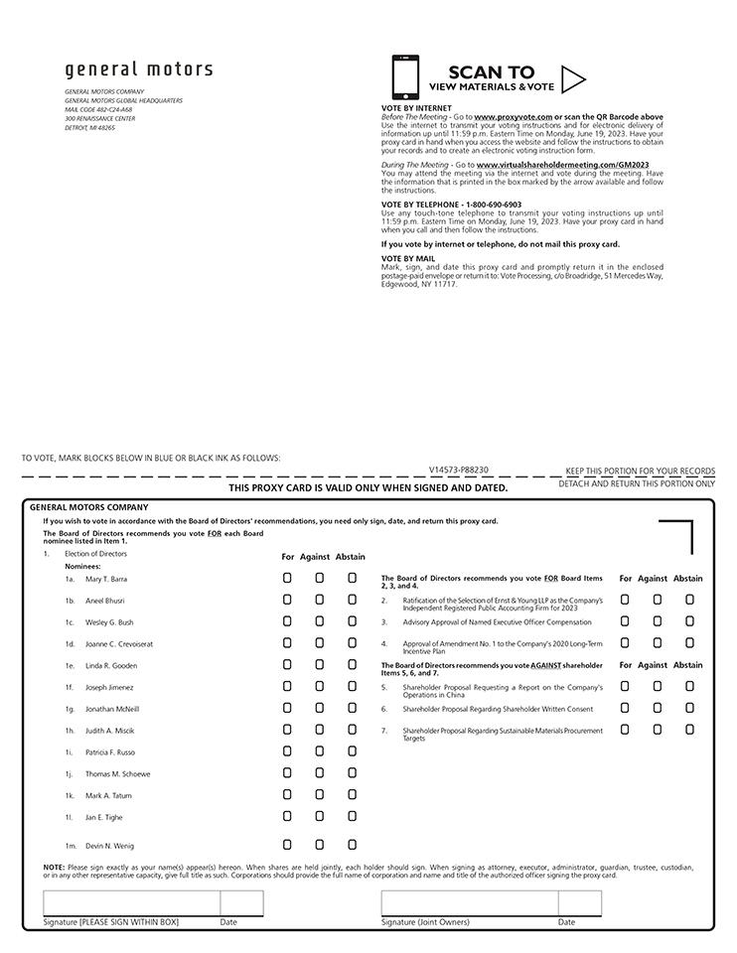

Table of Contents


