UNITED STATES SECURITIES AND EXCHANGE COMMISSION

Washington, DC 20549

___________________

FORM 8-K

___________________

CURRENT REPORT

Pursuant to Section 13 or 15(d) of

the Securities Exchange Act of 1934

Date of Report (Date of earliest event reported): July 26, 2022

___________________

GENERAL MOTORS COMPANY

(Exact name of registrant as specified in its charter)

__________________

Delaware

001-34960

27-0756180

(State or other jurisdiction of incorporation)

(Commission File Number)

(I.R.S. Employer Identification No.)

300 Renaissance Center, Detroit, Michigan

(Address of principal executive offices)

48265 -3000

(Zip Code)

(313) 667-1500

(Registrant's telephone number, including area code)

Not Applicable

(Former name or former address, if changed since last report)

__________________

Check the appropriate box below if the Form 8-K filing is intended to simultaneously satisfy the filing obligation of the registrant under any of the following provisions:

- Written communications pursuant to Rule 425 under the Securities Act (17 CFR 230.425)

- Soliciting material pursuant to Rule 14a-12 under the Exchange Act (17 CFR 240.14a-12)

- Pre-commencement communications pursuant to Rule 14d-2(b) under the Exchange Act (17 CFR 240.14d-2(b))

- Pre-commencement communications pursuant to Rule 13e-4(c) under the Exchange Act (17 CFR 240.13e-4(c))

 |  |  | Securities registered pursuant to Section 12(b) of the Act:
 | Title of each class |  |  | Trading Symbol(s) |  | Name of each exchange on which registered
Common Stock, $0.01 par value |  |  |  | GM |  |  | New York Stock Exchange

Indicate by check mark whether the registrant is an emerging growth company as defined in Rule 405 of the Securities Act of 1933 (§230.405 of this chapter) or Rule 12b-2 of the Securities Exchange Act of 1934 (§240.12b-2 of this chapter). Emerging growth company ☐

If an emerging growth company, indicate by check mark if the registrant has elected not to use the extended transition period for complying with any new or revised financial accounting standards provided pursuant to Section 13(a) of the Exchange Act. ☐

ITEM 2.02 Results of Operations and Financial Condition

On July 26, 2022 General Motors Company (GM) issued a news release and supplemental materials on the subject of its 2022 second quarter earnings. The news release and supplemental materials are attached as Exhibit 99.1 and Exhibit 99.2.

Charts furnished to securities analysts in connection with GM's 2022 second quarter earnings release are available on GM's website at www.gm.com/investors/earnings-releases.html.

ITEM 9.01 Financial Statements and Exhibits

 |  |  |  |  |  |  | EXHIBIT
 | Exhibit |  | Description
 | Exhibit 99.1 |  | News Release Dated July 26, 2022
 | Exhibit 99.2 |  | Financial Highlights Dated July 26, 2022
 | Exhibit 104 |  | Cover Page Interactive Data File (embedded within the Inline XBRL document)

SIGNATURE

Pursuant to the requirements of the Securities Exchange Act of 1934, the registrant has duly caused this report to be signed on its behalf by the undersigned hereunto duly authorized.

 | GENERAL MOTORS COMPANY (Registrant)
By: | /s/ CHRISTOPHER T. HATTO
Date: July 26, 2022 | Christopher T. Hatto, Vice President, Global Business Solutions and Chief Accounting
 | Officer

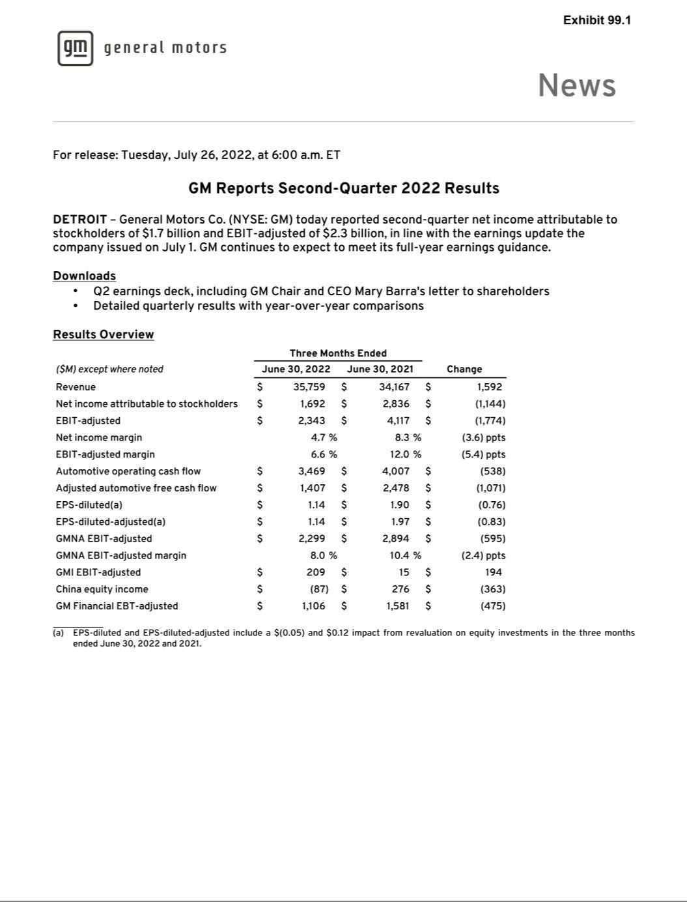

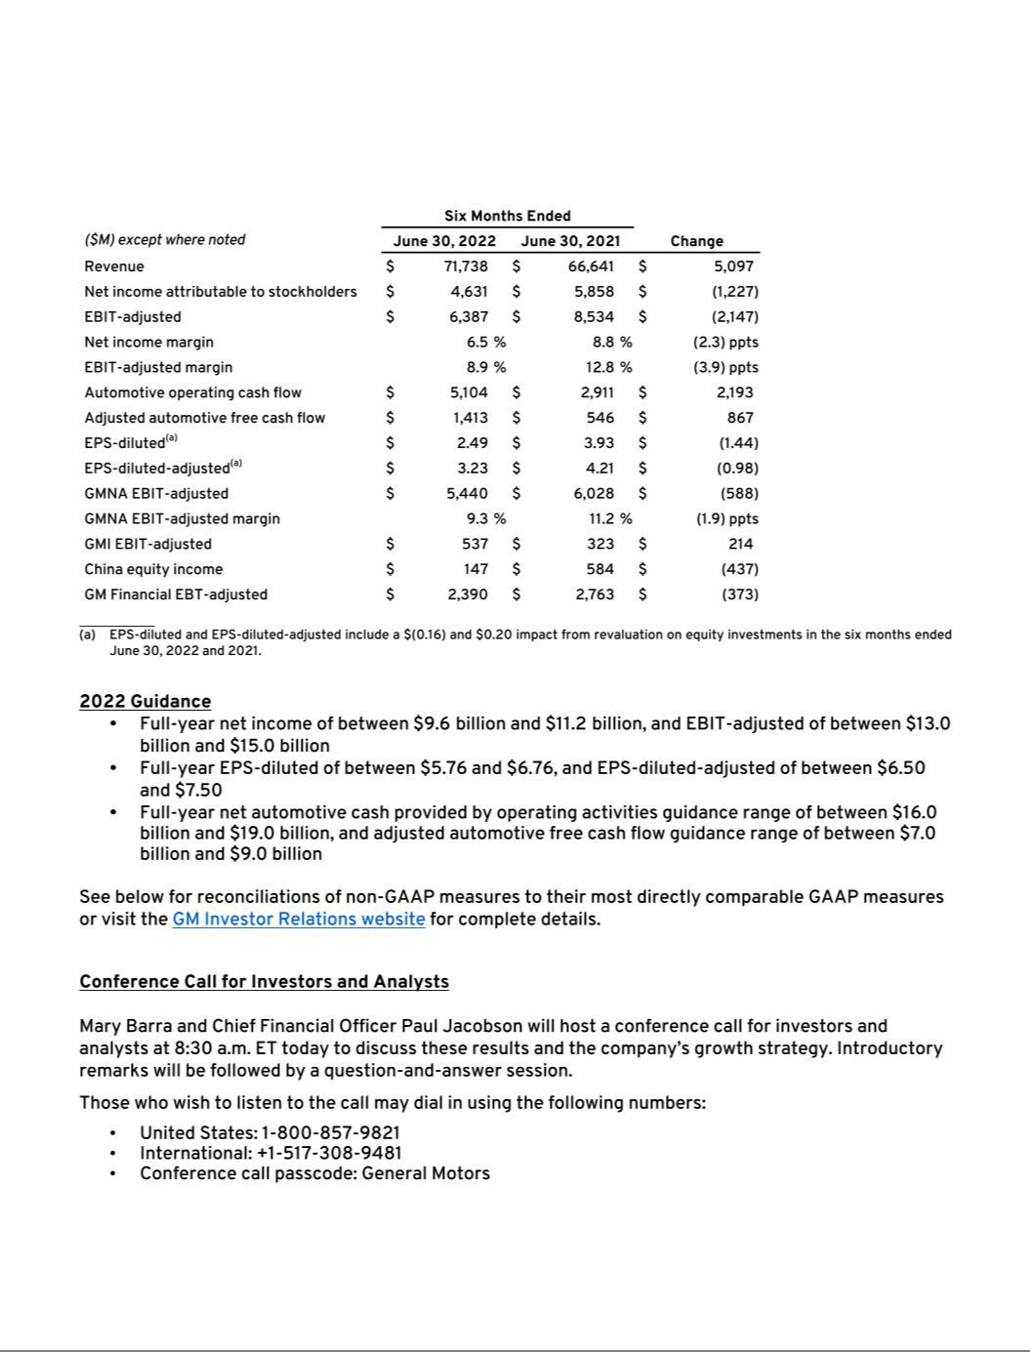

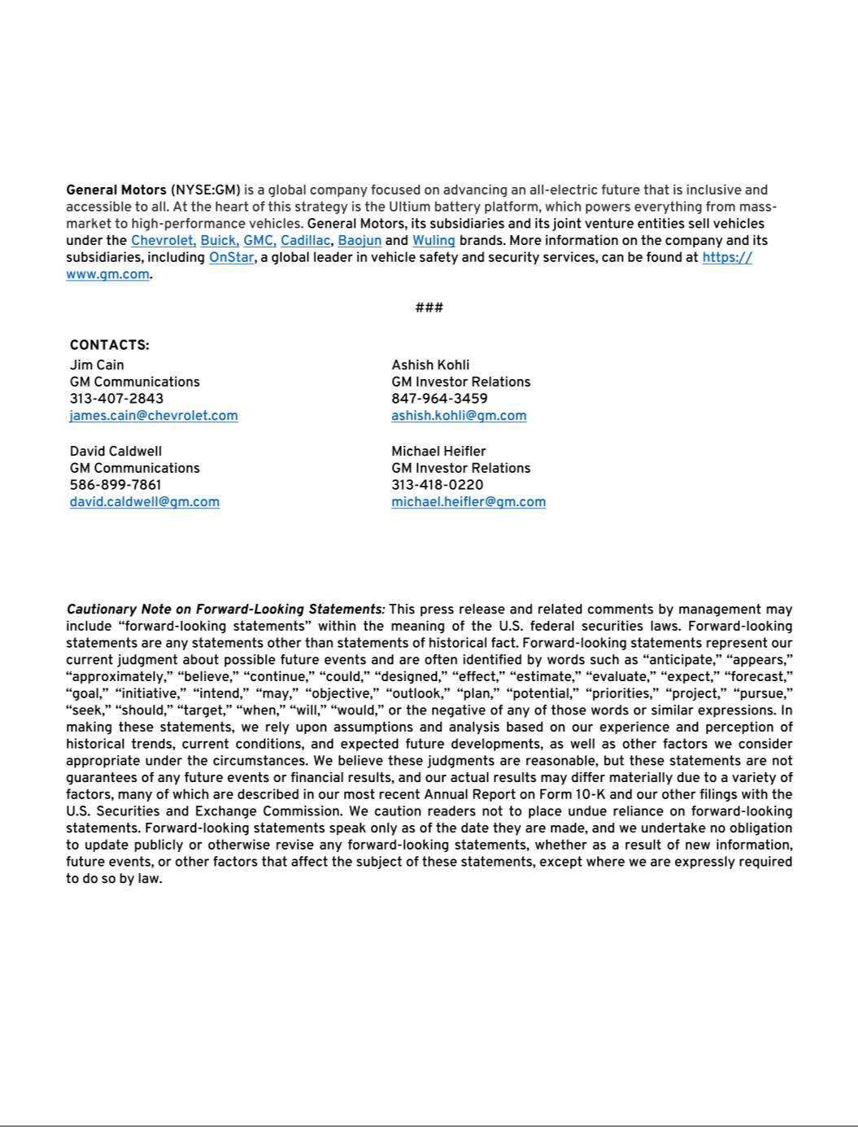

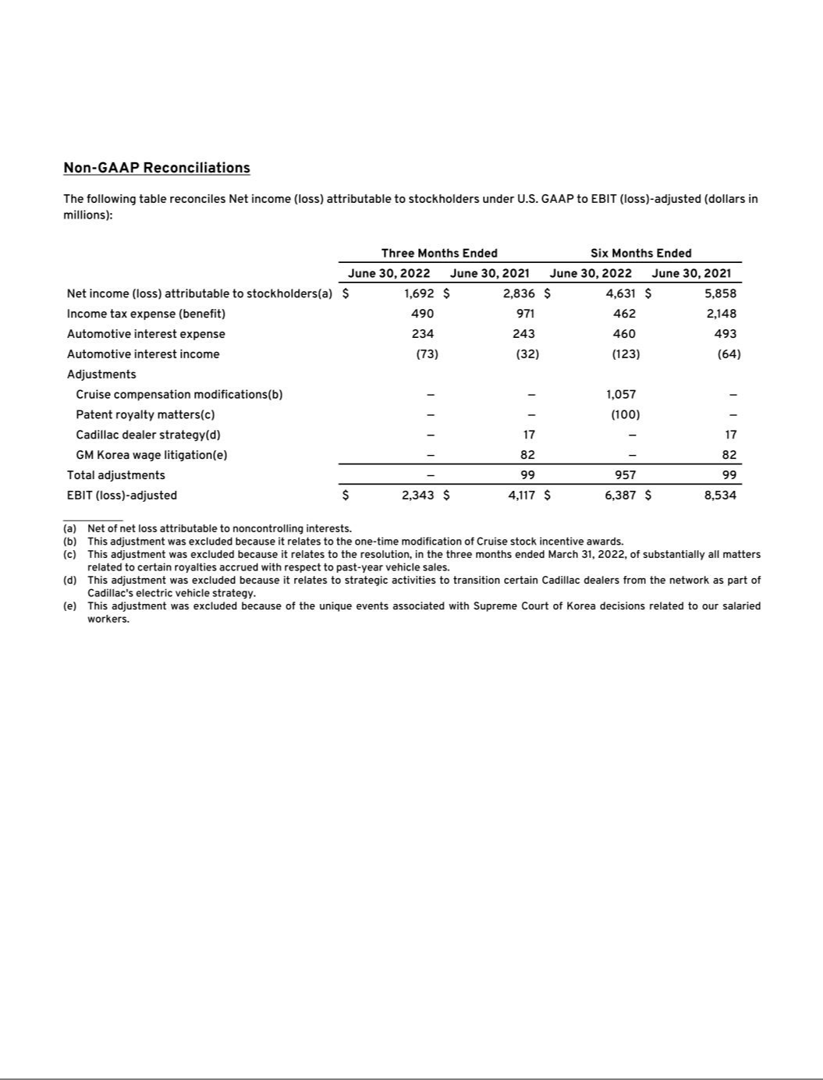

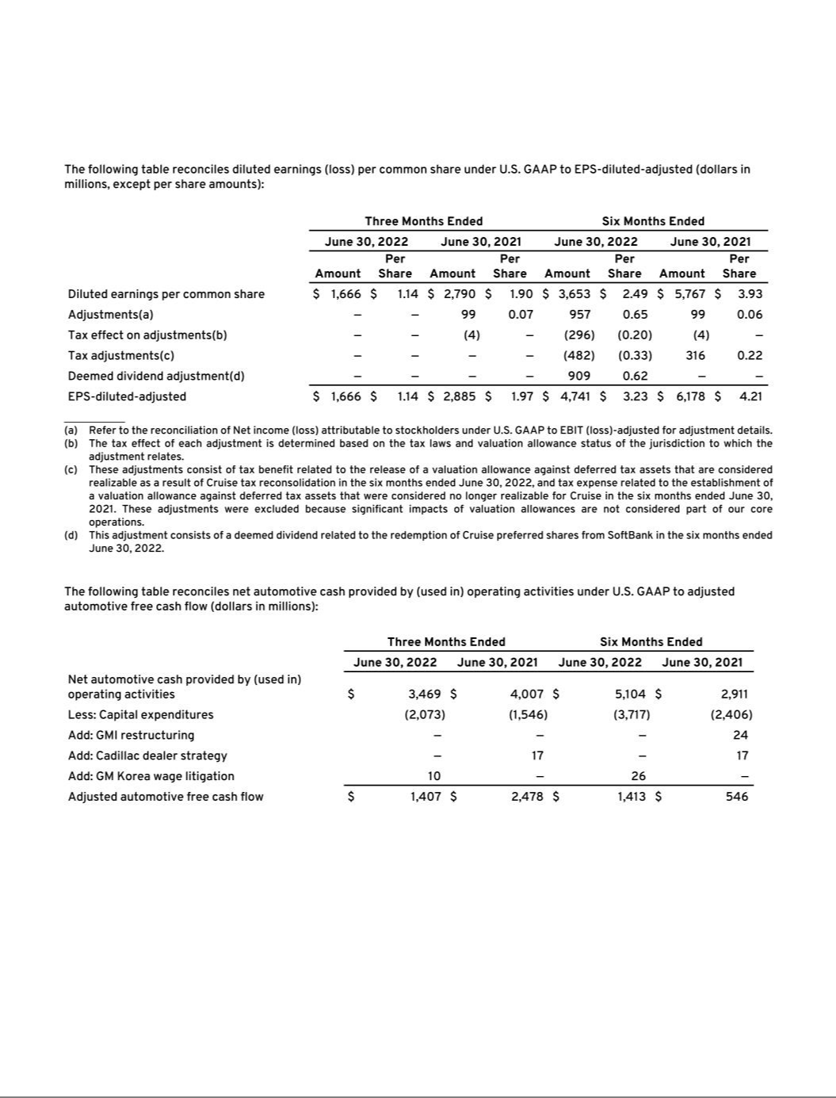

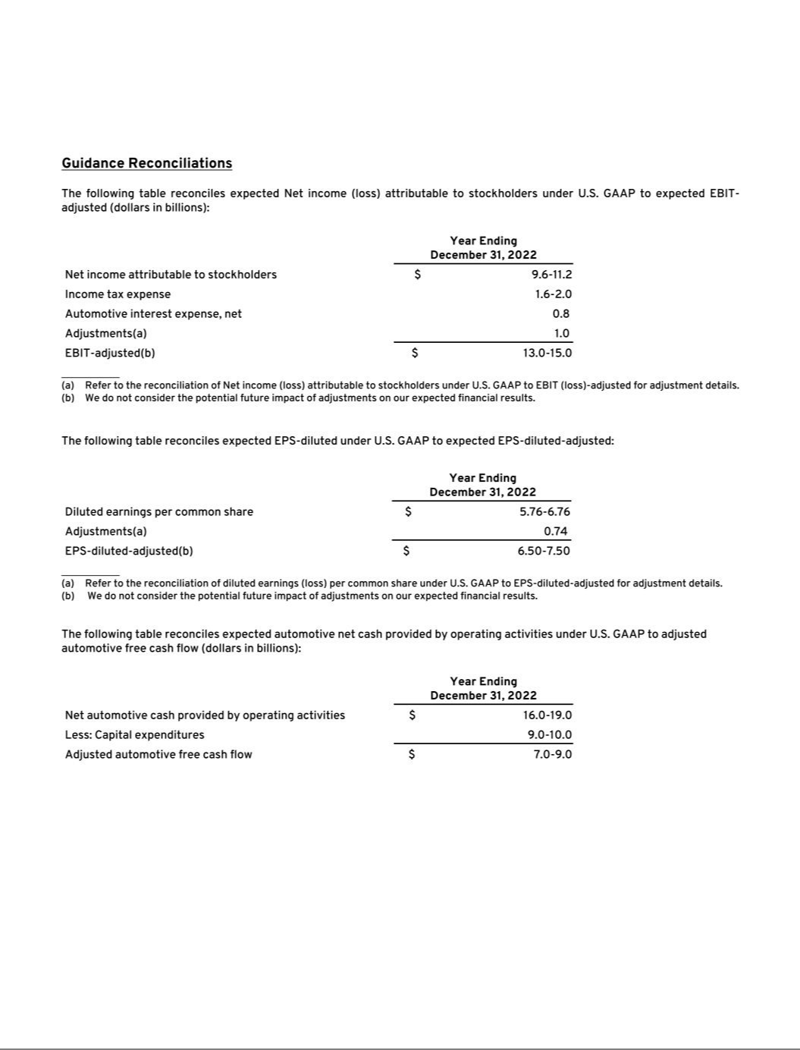

Exhibit 99.2

General Motors Company and Subsidiaries
Supplemental Material¹
(Unaudited)

General Motors Company's (GM) non-GAAP measures include: earnings before interest and taxes (EBIT)-adjusted, presented net of noncontrolling interests; earnings before income taxes (EBT)-adjusted for our General Motors Financial Company, Inc. (GM Financial) segment; earnings per share (EPS)-diluted-adjusted; effective tax rate-adjusted (ETR-adjusted); return on invested capital-adjusted (ROIC-adjusted) and adjusted automotive free cash flow. GM's calculation of these non-GAAP measures may not be comparable to similarly titled measures of other companies due to potential differences between companies in the method of calculation. As a result, the use of these non-GAAP measures has limitations and should not be considered superior to, in isolation from, or as a substitute for, related U.S. GAAP measures.

These non-GAAP measures allow management and investors to view operating trends, perform analytical comparisons and benchmark performance between periods and among geographic regions to understand operating performance without regard to items we do not consider a component of our core operating performance. Furthermore, these non-GAAP measures allow investors the opportunity to measure and monitor our performance against our externally communicated targets and evaluate the investment decisions being made by management to improve ROIC-adjusted. Management uses these measures in its financial, investment and operational decision-making processes, for internal reporting and as part of its forecasting and budgeting processes. Further, our Board of Directors uses certain of these and other measures as key metrics to determine management performance under our performance-based compensation plans. For these reasons, we believe these non-GAAP measures are useful for our investors.

EBIT-adjusted EBIT-adjusted is presented net of noncontrolling interests and is used by management and can be used by investors to review our consolidated operating results because it excludes automotive interest income, automotive interest expense and income taxes as well as certain additional adjustments that are not considered part of our core operations. Examples of adjustments to EBIT include, but are not limited to, impairment charges on long-lived assets and other exit costs resulting from strategic shifts in our operations or discrete market and business conditions; costs arising from legal matters; and certain currency devaluations associated with hyperinflationary economies. For EBIT-adjusted and our other non-GAAP measures, once we have made an adjustment in the current period for an item, we will also adjust the related non-GAAP measure in any future periods in which there is an impact from the item. Our corresponding measure for our GM Financial segment is EBT-adjusted because interest income and interest expense are part of operating results when assessing and measuring the operational and financial performance of the segment.

EPS-diluted-adjusted EPS-diluted-adjusted is used by management and can be used by investors to review our consolidated diluted EPS results on a consistent basis. EPS-diluted-adjusted is calculated as net income attributable to common stockholders-diluted less adjustments noted above for EBIT-adjusted and certain income tax adjustments divided by weighted-average common shares outstanding-diluted. Examples of income tax adjustments include the establishment or reversal of significant deferred tax asset valuation allowances.

ETR-adjusted ETR-adjusted is used by management and can be used by investors to review the consolidated effective tax rate for our core operations on a consistent basis. ETR-adjusted is calculated as Income tax expense less the income tax related to the adjustments noted above for EBIT-adjusted and the income tax adjustments noted above for EPS-diluted-adjusted divided by Income before income taxes less adjustments. When we provide an expected adjusted effective tax rate, we do not provide an expected effective tax rate because the U.S. GAAP measure may include significant adjustments that are difficult to predict.

ROIC-adjusted ROIC-adjusted is used by management and can be used by investors to review our investment and capital allocation decisions. We define ROIC-adjusted as EBIT-adjusted for the trailing four quarters divided by ROIC-adjusted average net assets, which is considered to be the average equity balances adjusted for average automotive debt and interest liabilities, exclusive of finance leases; average automotive net pension and other postretirement benefits (OPEB) liabilities; and average automotive net income tax assets during the same period.

Adjusted automotive free cash flow Adjusted automotive free cash flow is used by management and can be used by investors to review the liquidity of our automotive operations and to measure and monitor our performance against our capital allocation program and evaluate our automotive liquidity against the substantial cash requirements of our automotive operations. We measure adjusted automotive free cash flow as automotive operating cash flow from operations less capital expenditures adjusted for management actions. Management actions can include voluntary events such as discretionary contributions to employee benefit plans or nonrecurring specific events such as a closure of a facility that are considered special for EBIT-adjusted purposes.

________

- Certain columns and rows may not add due to rounding.

1

General Motors Company and Subsidiaries

Supplemental Material

(Unaudited)

The following table reconciles Net income (loss) attributable to stockholders under U.S. GAAP to segment profit (loss) (dollars in millions):

 |  | Three Months Ended |  |  |  |  |  | Six Months Ended
 |  | June 30, 2022 |  |  | June 30, 2021 |  |  | June 30, 2022 |  |  | June 30, 2021
Net income (loss) attributable to stockholders(a) | $ | 1,692 |  | $ | 2,836 |  | $ | 4,631 |  | $ | 5,858
Income tax expense (benefit) |  | 490 |  |  | 971 |  |  | 462 |  |  | 2,148
Automotive interest expense |  | 234 |  |  | 243 |  |  | 460 |  |  | 493
Automotive interest income |  | (73) |  |  | (32) |  |  | (123) |  |  | (64)
Adjustments
Cruise compensation modifications(b) |  | — |  |  | — |  |  | 1,057 |  |  | —
Patent royalty matters(c) |  | — |  |  | — |  |  | (100) |  |  | —
Cadillac dealer strategy(d) |  | — |  |  | 17 |  |  | — |  |  | 17
GM Korea wage litigation(e) |  | — |  |  | 82 |  |  | — |  |  | 82
Total adjustments |  | — |  |  | 99 |  |  | 957 |  |  | 99
EBIT(loss)-adjusted |  | 2,343 |  |  | 4,117 |  |  | 6,387 |  |  | 8,534
Operating segments
GM North America (GMNA) |  | 2,299 |  |  | 2,894 |  |  | 5,440 |  |  | 6,028
GM International (GMI) |  | 209 |  |  | 15 |  |  | 537 |  |  | 323
Cruise |  | (543) |  |  | (332) |  |  | (868) |  |  | (561)
GM Financial(f) |  | 1,106 |  |  | 1,581 |  |  | 2,390 |  |  | 2,763
Total operating segments |  | 3,072 |  |  | 4,158 |  |  | 7,499 |  |  | 8,553
Corporate and eliminations(g) |  | (728) |  |  | (41) |  |  | (1,112) |  |  | (19)
EBIT(loss)-adjusted | $ | 2,343 |  | $ | 4,117 |  | $ | 6,387 |  | $ | 8,534

__________

- Net of net loss attributable to noncontrolling interests.
- This adjustment was excluded because it relates to the one-time modification of Cruise stock incentive awards.

- This adjustment was excluded because it relates to the resolution of royalty matters accrued with respect to past-year vehicle sales in the three months ended March 31, 2022.
- This adjustment was excluded because it relates to strategic activities to transition certain Cadillac dealers from the network as part of Cadillac's electric vehicle strategy.

- This adjustment was excluded because of the unique events associated with Supreme Court of Korea decisions related to our salaried workers.

- GM Financial amounts represent EBT-adjusted.

- GM's automotive interest income and interest expense, legacy costs from the Opel/Vauxhall Business (primarily pension costs), corporate expenditures and certain nonsegment specific revenues and expenses are recorded centrally in Corporate.

2

General Motors Company and Subsidiaries

Supplemental Material

(Unaudited)

The following table reconciles Net income (loss) attributable to stockholders under U.S. GAAP to EBIT (loss)-adjusted (dollars in millions):

 |  |  |  |  |  |  |  |  |  |  | Three Months Ended
 |  | June 30, |  |  |  |  |  | March 31, |  |  |  |  |  | December 31, |  |  |  |  |  | September 30,
 |  | 2022 |  |  | 2021 |  |  | 2022 |  |  | 2021 |  |  | 2021 |  |  | 2020 |  |  | 2021 |  |  | 2020
Net income (loss) attributable to stockholders | $ | 1,692 |  | $ | 2,836 |  | $ | 2,939 |  | $ | 3,022 |  | $ | 1,741 |  | $ | 2,846 |  | $ | 2,420 |  | $ | 4,045
Income tax expense (benefit) |  | 490 |  |  | 971 |  |  | (28) |  |  | 1,177 |  |  | 471 |  |  | 642 |  |  | 152 |  |  | 887
Automotive interest expense |  | 234 |  |  | 243 |  |  | 226 |  |  | 250 |  |  | 227 |  |  | 275 |  |  | 230 |  |  | 327
Automotive interest income |  | (73) |  |  | (32) |  |  | (50) |  |  | (32) |  |  | (44) |  |  | (46) |  |  | (38) |  |  | (51)
Adjustments
Cruise compensation modifications(a) |  | — |  |  | — |  |  | 1,057 |  |  | — |  |  | — |  |  | — |  |  | — |  |  | —
Patent royalty matters(b) |  | — |  |  | — |  |  | (100) |  |  | — |  |  | 250 |  |  | — |  |  | — |  |  | —
GM Brazil indirect tax matters(c) |  | — |  |  | — |  |  | — |  |  | — |  |  | 194 |  |  | — |  |  | — |  |  | —
Cadillac dealer strategy(d) |  | — |  |  | 17 |  |  | — |  |  | — |  |  | — |  |  | 99 |  |  | 158 |  |  | —
GMI restructuring(e) |  | — |  |  | — |  |  | — |  |  | — |  |  | — |  |  | 26 |  |  | — |  |  | 76
GM Korea wage litigation(f) |  | — |  |  | 82 |  |  | — |  |  | — |  |  | — |  |  | — |  |  | — |  |  | —
Ignition switch recall and related legal |  | — |  |  | — |  |  | — |  |  | — |  |  | — |  |  | (130) |  |  | — |  |  | —
matters(g) |  | — |  |  | — |  |  | — |  |  | — |  |  | — |  |  | (130) |  |  | — |  |  | —
Total adjustments |  | — |  |  | 99 |  |  | 957 |  |  | — |  |  | 444 |  |  | (5) |  |  | 158 |  |  | 76
EBIT (loss)-adjusted | $ | 2,343 |  | $ | 4,117 |  | $ | 4,044 |  | $ | 4,417 |  | $ | 2,839 |  | $ | 3,712 |  | $ | 2,922 |  | $ | 5,284

________

- This adjustment was excluded because it relates to the one-time modification of Cruise stock incentive awards.

- These adjustments were excluded because they relate to certain royalties accrued with respect to past-year vehicle sales in the three months ended December 31, 2021, and the resolution of substantially all of these matters in the three months ended March 31, 2022.
- This adjustment was excluded because it relates to a settlement with third parties in the three months ended December 31, 2021 relating to retrospective recoveries of indirect taxes in Brazil realized in prior periods.

- These adjustments were excluded because they relate to strategic activities to transition certain Cadillac dealers from the network as part of Cadillac's electric vehicle strategy.

- These adjustments were excluded because of a strategic decision to rationalize our core operations by exiting or significantly reducing our presence in various international markets to focus resources on opportunities expected to deliver higher returns. These adjustments primarily consist of employee separation charges in the three months ended December 31, 2020 and supplier claims in the three months ended September 30, 2020.
- This adjustment was excluded because of the unique events associated with Supreme Court of Korea decisions related to our salaried workers.

- This adjustment was excluded because of the unique events associated with the ignition switch recall.

3

General Motors Company and Subsidiaries

Supplemental Material

(Unaudited)

The following table reconciles diluted earnings (loss) per common share under U.S. GAAP to EPS-diluted-adjusted (dollars in millions, except per share amounts):

 |  |  |  |  | Three Months Ended |  |  |  |  |  |  |  |  |  |  |  | Six Months Ended
 |  | June 30, 2022 |  |  |  |  |  | June 30, 2021 |  |  |  |  |  | June 30, 2022 |  |  |  |  |  | June 30, 2021
 |  | Amount |  |  | Per Share |  |  | Amount |  |  | Per Share |  |  | Amount |  |  | Per Share |  |  | Amount |  |  | Per Share
Diluted earnings per common share | $ | 1,666 |  | $ | 1.14 |  | $ | 2,790 |  | $ | 1.90 |  | $ | 3,653 |  | $ | 2.49 |  | $ | 5,767 |  | $ | 3.93
Adjustments(a) |  | — |  |  | — |  |  | 99 |  |  | 0.07 |  |  | 957 |  |  | 0.65 |  |  | 99 |  |  | 0.06
Tax effect on adjustments(b) |  | — |  |  | — |  |  | (4) |  |  | — |  |  | (296) |  |  | (0.20) |  |  | (4) |  |  | —
Tax adjustments(c) |  | — |  |  | — |  |  | — |  |  | — |  |  | (482) |  |  | (0.33) |  |  | 316 |  |  | 0.22
Deemed dividend adjustment(d) |  | — |  |  | — |  |  | — |  |  | — |  |  | 909 |  |  | 0.62 |  |  | — |  |  | —
EPS-diluted-adjusted | $ | 1,666 |  | $ | 1.14 |  | $ | 2,885 |  | $ | 1.97 |  | $ | 4,741 |  | $ | 3.23 |  | $ | 6,178 |  | $ | 4.21

________

- Refer to the reconciliation of Net income (loss) attributable to stockholders under U.S. GAAP to segment profit (loss) for adjustment details.
- The tax effect of each adjustment is determined based on the tax laws and valuation allowance status of the jurisdiction to which the adjustment relates.

- These adjustments consist of tax benefit related to the release of a valuation allowance against deferred tax assets that are considered realizable as a result of Cruise tax reconsolidation in the six months ended June 30, 2022, and tax expense related to the establishment of a valuation allowance against deferred tax assets that were considered no longer realizable for Cruise in the six months ended June 30, 2021. These adjustments were excluded because significant impacts of valuation allowances are not considered part of our core operations.
- This adjustment consists of a deemed dividend related to the redemption of Cruise preferred shares from SoftBank in the six months ended June 30, 2022.

The following table reconciles our effective tax rate under U.S. GAAP to ETR-adjusted (dollars in millions):

 |  |  |  |  |  |  | Three Months Ended |  |  |  |  |  |  |  |  |  |  |  |  |  |  |  | Six Months Ended
 |  |  |  | June 30, 2022 |  |  |  |  |  |  |  | June 30, 2021 |  |  |  |  |  |  |  | June 30, 2022 |  |  |  |  |  |  |  | June 30, 2021
 | Income before |  |  |  | Income tax |  | Effective tax |  | Income before |  |  |  | Income tax |  | Effective tax |  | Income before |  |  |  | Income tax |  | Effective tax |  | Income before |  |  |  | Income tax |  | Effective tax
 |  |  |  |  | expense |  |  |  |  |  |  |  | expense |  |  |  |  |  |  |  | expense |  |  |  |  |  |  |  | expense |  | Effective tax
 | income taxes |  |  |  | (benefit) |  | rate |  | income taxes |  |  |  | (benefit) |  | rate |  | income taxes |  |  |  | (benefit) |  | rate |  | income taxes |  |  |  | (benefit) |  | rate
Effective tax rate | $ | 2,132 |  | $ | 490 |  | 23.0 % |  | $ | 3,750 |  | $ | 971 |  | 25.9 % |  | $ | 4,912 |  | $ | 462 |  | 9.4 % |  | $ | 7,941 |  | $ | 2,148 |  | 27.0 %
Adjustments(a) |  | — |  |  | — |  |  |  |  | 124 |  |  | 4 |  |  |  |  | 1,053 |  |  | 296 |  |  |  |  | 124 |  |  | 4
Tax adjustment(b) |  |  |  |  | — |  |  |  |  |  |  |  | — |  |  |  |  |  |  |  | 482 |  |  |  |  |  |  |  | (316)
ETR-adjusted | $ | 2,132 |  | $ | 490 |  | 23.0 % |  | $ | 3,874 |  | $ | 975 |  | 25.2 % |  | $ | 5,965 |  | $ | 1,240 |  | 20.8 % |  | $ | 8,065 |  | $ | 1,836 |  | 22.8 %

________

- Refer to the reconciliation of Net income (loss) attributable to stockholders under U.S. GAAP to segment profit (loss) for adjustment details. These adjustments include Net income attributable to noncontrolling interests where applicable. The tax effect of each adjustment is determined based on the tax laws and valuation allowance status of the jurisdiction to which the adjustment relates.
- Refer to the reconciliation of diluted earnings per common share under U.S. GAAP to EPS-diluted-adjusted for adjustment details.

4

General Motors Company and Subsidiaries

Supplemental Material

(Unaudited)

We define return on equity (ROE) as Net income (loss) attributable to stockholders for the trailing four quarters divided by average equity for the same period. Management uses average equity to provide comparable amounts in the calculation of ROE. The following table summarizes the calculation of ROE (dollars in billions):

 |  | Four Quarters Ended
 | June 30, 2022 |  |  |  | June 30, 2021
Net income (loss) attributable to stockholders | $ | 8.8 |  | $ | 12.7
Average equity(a) | $ | 62.4 |  | $ | 49.2
ROE |  | 14.1 % |  |  | 25.9 %

________

(a) Includes equity of noncontrolling interests where the corresponding earnings (loss) are included in Net income (loss) attributable to stockholders.

The following table summarizes the calculation of ROIC-adjusted (dollars in billions):

 |  | Four Quarters Ended
 | June 30, 2022 |  |  |  | June 30, 2021
EBIT (loss)-adjusted(a) | $ | 12.1 |  | $ | 17.5
Average equity(b) | $ | 62.4 |  | $ | 49.2
Add: Average automotive debt and interest liabilities (excluding finance leases) |  | 16.8 |  |  | 20.3
Add: Average automotive net pension & OPEB liability |  | 12.1 |  |  | 17.8
Less: Average automotive and other net income tax asset |  | (21.6) |  |  | (23.2)
ROIC-adjusted average net assets | $ | 69.7 |  | $ | 64.1
ROIC-adjusted |  | 17.4 % |  |  | 27.3 %

________

- Refer to the reconciliation of Net income (loss) attributable to stockholders under U.S. GAAP to EBIT (loss)-adjusted for adjustment details.

- Includes equity of noncontrolling interests where the corresponding earnings (loss) are included in EBIT (loss)-adjusted.

5

General Motors Company and Subsidiaries

Supplemental Material

(Unaudited)

The following table reconciles Net automotive cash provided by (used in) operating activities under U.S. GAAP to adjusted automotive free cash flow (dollars in millions):

 |  | Three Months Ended |  |  |  |  |  | Six Months Ended
 |  | June 30, 2022 |  |  | June 30, 2021 |  |  | June 30, 2022 |  |  | June 30, 2021
Net automotive cash provided by (used in) operating activities | $ | 3,469 |  | $ | 4,007 |  | $ | 5,104 |  | $ | 2,911
Less: Capital expenditures |  | (2,073) |  |  | (1,546) |  |  | (3,717) |  |  | (2,406)
Add: GMI restructuring |  | — |  |  | — |  |  | — |  |  | 24
Add: Cadillac dealer strategy |  | — |  |  | 17 |  |  | — |  |  | 17
Add: GM Korea wage litigation |  | 10 |  |  | — |  |  | 26 |  |  | —
Adjusted automotive free cash flow | $ | 1,407 |  | $ | 2,478 |  | $ | 1,413 |  | $ | 546

The following tables summarize key financial information by segment (dollars in millions):

 |  | GMNA |  |  | GMI |  |  | Corporate |  |  | Eliminations |  |  | Total |  |  | Cruise |  |  | GM |  | Reclassifications/Eliminations |  |  |  | Total
 |  |  |  |  |  |  |  |  |  |  |  |  |  | Automotive |  |  |  |  |  | Financial |  |  |  |  |  | Total
Three Months Ended June 30, 2022
Net sales and revenue | $ | 28,760 |  | $ | 3,807 |  | $ | 47 |  | $ | — |  | $ | 32,614 |  | $ | 25 |  | $ | 3,146 |  | $ | (26) |  | $ | 35,759
Expenditures for property | $ | 1,894 |  | $ | 178 |  | $ | 1 |  | $ | — |  | $ | 2,073 |  | $ | 87 |  | $ | 9 |  | $ | — |  | $ | 2,168
Depreciation and amortization | $ | 1,476 |  | $ | 131 |  | $ | 6 |  | $ | — |  | $ | 1,613 |  | $ | 12 |  | $ | 1,218 |  | $ | — |  | $ | 2,844
Impairment charges | $ | 11 |  | $ | — |  | $ | — |  | $ | — |  | $ | 11 |  | $ | — |  | $ | — |  | $ | — |  | $ | 11
Equity income(a) | $ | (6) |  | $ | (89) |  | $ | — |  | $ | — |  | $ | (95) |  | $ | — |  | $ | 50 |  | $ | — |  | $ | (45)
 |  | GMNA |  |  | GMI |  |  | Corporate |  |  | Eliminations |  |  | Total |  |  | Cruise |  |  | GM |  | Reclassifications/Eliminations |  |  |  | Total
 |  |  |  |  |  |  |  |  |  |  |  |  |  | Automotive |  |  |  |  |  | Financial |  |  |  |  |  | Total
Three Months Ended June 30, 2021
Net sales and revenue | $ | 27,932 |  | $ | 2,792 |  | $ | 21 |  | $ | — |  | $ | 30,745 |  | $ | 25 |  | $ | 3,426 |  | $ | (29) |  | $ | 34,167
Expenditures for property | $ | 1,412 |  | $ | 126 |  | $ | 8 |  | $ | — |  | $ | 1,546 |  | $ | 19 |  | $ | 8 |  | $ | — |  | $ | 1,573
Depreciation and amortization | $ | 1,281 |  | $ | 137 |  | $ | 4 |  | $ | — |  | $ | 1,422 |  | $ | 13 |  | $ | 1,579 |  | $ | — |  | $ | 3,014
Impairment charges | $ | — |  | $ | — |  | $ | — |  | $ | — |  | $ | — |  | $ | 4 |  | $ | — |  | $ | — |  | $ | 4
Equity income (a) | $ | 3 |  | $ | 274 |  | $ | — |  | $ | — |  | $ | 277 |  | $ | — |  | $ | 50 |  | $ | — |  | $ | 327
 |  | GMNA |  |  | GMI |  |  | Corporate |  |  | Eliminations |  |  | Total |  |  | Cruise |  |  | GM |  | Reclassifications/Eliminations |  |  |  | Total
 |  |  |  |  |  |  |  |  |  |  |  |  |  | Automotive |  |  |  |  |  | Financial |  |  |  |  |  | Total
Six Months Ended June 30, 2022
Net sales and revenue | $ | 58,216 |  | $ | 7,120 |  | $ | 100 |  | $ | — |  | $ | 65,437 |  | $ | 51 |  | $ | 6,302 |  | $ | (52) |  | $ | 71,738
Expenditures for property | $ | 3,415 |  | $ | 299 |  | $ | 3 |  | $ | — |  | $ | 3,717 |  | $ | 91 |  | $ | 18 |  | $ | 2 |  | $ | 3,829
Depreciation and amortization | $ | 2,980 |  | $ | 265 |  | $ | 11 |  | $ | — |  | $ | 3,256 |  | $ | 25 |  | $ | 2,454 |  | $ | — |  | $ | 5,735
Impairment charges | $ | 11 |  | $ | — |  | $ | — |  | $ | — |  | $ | 11 |  | $ | — |  | $ | — |  | $ | — |  | $ | 11
Equity income(a) | $ | — |  | $ | 143 |  | $ | — |  | $ | — |  | $ | 144 |  | $ | — |  | $ | 104 |  | $ | — |  | $ | 247
 |  | GMNA |  |  | GMI |  |  | Corporate |  |  | Eliminations |  |  | Total |  |  | Cruise |  |  | GM |  | Reclassifications/Eliminations |  |  |  | Total
 |  |  |  |  |  |  |  |  |  |  |  |  |  | Automotive |  |  |  |  |  | Financial |  |  |  |  |  | Total
Six Months Ended June 30, 2021
Net sales and revenue | $ | 53,889 |  | $ | 5,878 |  | $ | 40 |  | $ | — |  | $ | 59,807 |  | $ | 55 |  | $ | 6,833 |  | $ | (54) |  | $ | 66,641
Expenditures for property | $ | 2,176 |  | $ | 220 |  | $ | 10 |  | $ | — |  | $ | 2,406 |  | $ | 32 |  | $ | 13 |  | $ | — |  | $ | 2,451
Depreciation and amortization | $ | 2,479 |  | $ | 269 |  | $ | 10 |  | $ | — |  | $ | 2,758 |  | $ | 24 |  | $ | 3,247 |  | $ | — |  | $ | 6,029
Impairment charges | $ | — |  | $ | — |  | $ | — |  | $ | — |  | $ | — |  | $ | 4 |  | $ | — |  | $ | — |  | $ | 4
Equity income (a) | $ | 7 |  | $ | 581 |  | $ | — |  | $ | — |  | $ | 588 |  | $ | — |  | $ | 104 |  | $ | — |  | $ | 692

________

(a) Includes Automotive China equity income (loss) of ($87) million and $276 million in the three months ended June 30, 2022 and 2021 and $147 million and $584 million in the six months ended June 30, 2022 and 2021.

6

General Motors Company and Subsidiaries

Supplemental Material

(Unaudited)

Vehicle Sales

GM presents both wholesale and total vehicle sales data to assist in the analysis of our revenue and our market share. Cuba, Iran, North Korea, Sudan and Syria are subject to broad economic sanctions. Accordingly, these countries are excluded from industry sales data and the corresponding calculation of GM's market share. Also, as of March 2022, GM is no longer importing vehicles or parts to Russia, Belarus and other sanctioned provinces in Ukraine.

Wholesale vehicle sales data consists of sales to GM's dealers and distributors as well as sales to the U.S. Government and excludes vehicles sold by our joint ventures. Wholesale vehicle sales data correlates to GM's revenue recognized from the sale of vehicles, which is the largest component of Automotive net sales and revenue. In the six months ended June 30, 2022, 30.2% of our wholesale vehicle sales volume was generated outside the U.S. The following table summarizes wholesale vehicle sales by automotive segment (vehicles in thousands):

 |  | Three Months Ended |  |  |  |  |  | Six Months Ended
 | June 30, 2022 |  |  | June 30, 2021 |  |  | June 30, 2022 |  |  |  | June 30, 2021
GMNA |  | 662 |  |  | 642 |  |  | 1,356 |  |  | 1,306
GMI |  | 155 |  |  | 118 |  |  | 292 |  |  | 275
Total |  | 817 |  |  | 760 |  |  | 1,648 |  |  | 1,581

7

General Motors Company and Subsidiaries

Supplemental Material

(Unaudited)

Total vehicle sales data represents: (1) retail sales (i.e., sales to consumers who purchase new vehicles from dealers or distributors); (2) fleet sales (i.e., sales to large and small businesses, governments, and daily rental car companies); and (3) vehicles used by dealers in their business. Total vehicle sales data for periods presented prior to 2022 reflect courtesy transportation vehicles used by U.S. dealers in their business; beginning in 2022, we stopped including such dealership courtesy transportation vehicles in total vehicle sales until such time as those vehicles were sold to the end customer. Total vehicle sales data includes all sales by joint ventures on a total vehicle basis, not based on our percentage ownership interest in the joint venture. Certain joint venture agreements in China allow for the contractual right to report vehicle sales of non-GM trademarked vehicles by those joint ventures, which are included in the total vehicle sales we report for China. While total vehicle sales data does not correlate directly to the revenue GM recognizes during a particular period, we believe it is indicative of the underlying demand for GM vehicles. Total vehicle sales data represents management's good faith estimate based on sales reported by GM's dealers, distributors, and joint ventures, commercially available data sources such as registration and insurance data, and internal estimates and forecasts when other data is not available.

The following table summarizes total vehicle sales by geographic region (vehicles in thousands):

 |  | Three Months Ended |  |  |  |  | Six Months Ended
 | June 30, 2022 |  |  |  | June 30, 2021 |  | June 30, 2022 |  |  | June 30, 2021
United States
Chevrolet – Cars |  | 50 |  |  | 24 |  | 91 |  |  | 78
Chevrolet – Trucks |  | 210 |  |  | 235 |  | 399 |  |  | 438
Chevrolet – Crossovers |  | 128 |  |  | 174 |  | 241 |  |  | 346
Cadillac |  | 34 |  |  | 36 |  | 62 |  |  | 73
Buick |  | 29 |  |  | 66 |  | 48 |  |  | 112
GMC |  | 132 |  |  | 153 |  | 253 |  |  | 283
Total United States |  | 582 |  |  | 688 |  | 1,095 |  |  | 1,330
Canada, Mexico and Other |  | 105 |  |  | 106 |  | 193 |  |  | 210
Total North America |  | 687 |  |  | 794 |  | 1,288 |  |  | 1,540
Asia/Pacific, Middle East and Africa
Chevrolet |  | 170 |  |  | 174 |  | 332 |  |  | 325
Wuling |  | 273 |  |  | 354 |  | 611 |  |  | 704
Buick |  | 128 |  |  | 226 |  | 292 |  |  | 450
Baojun |  | 11 |  |  | 52 |  | 31 |  |  | 138
Cadillac |  | 39 |  |  | 66 |  | 88 |  |  | 126
Other |  | 6 |  |  | 5 |  | 10 |  |  | 13
Total Asia/Pacific, Middle East and Africa |  | 627 |  |  | 876 |  | 1,363 |  |  | 1,756
South America(a) |  | 107 |  |  | 88 |  | 197 |  |  | 205
Total in GM markets |  | 1,421 |  |  | 1,757 |  | 2,848 |  |  | 3,502
Total Europe |  | — |  |  | — |  | 1 |  |  | 1
Total Worldwide |  | 1,422 |  |  | 1,758 |  | 2,849 |  |  | 3,502

_______

(a) Primarily Chevrolet

The vehicle sales at GM's China joint ventures presented in the following table are included in the preceding vehicle sales table (vehicles in thousands):

 |  | Three Months Ended |  |  |  |  |  | Six Months Ended
 | June 30, 2022 |  |  | June 30, 2021 |  |  | June 30, 2022 |  |  |  | June 30, 2021
SAIC General Motors Sales Co., Ltd. |  | 205 |  |  | 353 |  |  | 468 |  |  | 700
SAIC GM Wuling Automobile Co., Ltd. |  | 279 |  |  | 398 |  |  | 629 |  |  | 831

8

General Motors Company and Subsidiaries

Supplemental Material

(Unaudited)

 |  | Three Months Ended |  |  |  |  | Six Months Ended
 | June 30, 2022 |  |  |  | June 30, 2021 |  | June 30, 2022 |  |  | June 30, 2021
Market Share
United States – Cars |  | 7.6 % |  |  | 2.9 % |  | 7.3 % |  |  | 4.8 %
United States – Trucks |  | 32.0 % |  |  | 32.4 % |  | 31.9 % |  |  | 31.1 %
United States – Crossovers |  | 11.4 % |  |  | 12.7 % |  | 10.6 % |  |  | 12.8 %
Total United States |  | 16.2 % |  |  | 15.3 % |  | 15.7 % |  |  | 15.6 %
Total North America |  | 15.6 % |  |  | 14.8 % |  | 15.2 % |  |  | 15.2 %
Total Asia/Pacific, Middle East and Africa |  | 6.6 % |  |  | 7.7 % |  | 6.7 % |  |  | 7.5 %
Total South America |  | 11.8 % |  |  | 9.8 % |  | 11.6 % |  |  | 11.5 %
Total GM Market |  | 9.6 % |  |  | 9.9 % |  | 9.3 % |  |  | 9.9 %
Total Worldwide |  | 7.6 % |  |  | 8.0 % |  | 7.5 % |  |  | 8.0 %
United States fleet sales as a percentage of retail vehicle sales |  | 21.8 % |  |  | 14.3 % |  | 22.7 % |  |  | 15.8 %
North America capacity two-shift utilization |  | 96.7 % |  |  | 87.9 % |  | 96.4 % |  |  | 92.0 %

9

General Motors Company and Subsidiaries

Combining Income Statement Information

(In millions) (Unaudited)

 |  |  |  |  |  | Three Months Ended June 30, 2022 |  |  |  |  |  |  |  |  |  |  |  |  |  |  |  | Three Months Ended June 30, 2021
 |  | Automotive |  |  | Cruise |  |  |  | GM Financial |  | Reclassifications/Eliminations |  |  |  | Combined |  |  | Automotive |  |  | Cruise |  |  | GM Financial |  | Reclassifications/Eliminations |  |  |  | Combined
Net sales and revenue
Automotive | $ | 32,614 |  | $ | 25 | $ |  |  | — |  | $ | (25) |  | $ | 32,614 | $ |  | 30,745 |  | $ | 25 | $ |  | — |  | $ | (26) |  | $ | 30,744
GM Financial |  | — |  |  | — |  |  |  | 3,146 |  |  | (1) |  |  | 3,145 |  |  | — |  |  | — |  |  | 3,426 |  |  | (3) |  |  | 3,423
Total net sales and revenue |  | 32,614 |  |  | 25 |  |  |  | 3,146 |  |  | (26) |  |  | 35,759 |  |  | 30,745 |  |  | 25 |  |  | 3,426 |  |  | (29) |  |  | 34,167
Costs and expenses
Automotive and other cost of sales |  | 28,765 |  |  | 496 |  |  |  | — |  |  | (1) |  |  | 29,261 |  |  | 26,953 |  |  | 313 |  |  | — |  |  | — |  |  | 27,266
GM Financial interest, operating and other |  | — |  |  | — |  |  |  | 2,089 |  |  | — |  |  | 2,089 |  |  | — |  |  | — |  |  | 1,895 |  |  | (1) |  |  | 1,894
expenses |  |  |  |  | — |  |  |  | 2,089 |  |  |  |  |  | 2,089 |  |  |  |  |  | — |  |  | 1,895 |  |  | (1) |  |  | 1,894
Automotive and other selling, general and |  | 2,160 |  |  | 134 |  |  |  | — |  |  | — |  |  | 2,293 |  |  | 2,050 |  |  | 75 |  |  | — |  |  | — |  |  | 2,125
administrative expense |  | 2,160 |  |  | 134 |  |  |  |  |  |  |  |  |  | 2,293 |  |  | 2,050 |  |  | 75 |  |  |  |  |  |  |  |  | 2,125
Total costs and expenses |  | 30,925 |  |  | 630 |  |  |  | 2,089 |  |  | (1) |  |  | 33,643 |  |  | 29,003 |  |  | 388 |  |  | 1,895 |  |  | (1) |  |  | 31,285
Operating income (loss) |  | 1,689 |  |  | (605) |  |  |  | 1,057 |  |  | (25) |  |  | 2,116 |  |  | 1,742 |  |  | (363) |  |  | 1,531 |  |  | (28) |  |  | 2,882
Automotive interest expense |  | 234 |  |  | — |  |  |  | — |  |  | — |  |  | 234 |  |  | 246 |  |  | — |  |  | — |  |  | (3) |  |  | 243
Interest income and other non-operating income |  | 262 |  |  | 5 |  |  |  | — |  |  | 28 |  |  | 295 |  |  | 757 |  |  | 2 |  |  | — |  |  | 25 |  |  | 784
(loss), net |  | 262 |  |  | 5 |  |  |  |  |  |  | 28 |  |  | 295 |  |  | 757 |  |  | 2 |  |  |  |  |  | 25 |  |  | 784
Equity income (loss) |  | (95) |  |  | — |  |  |  | 50 |  |  | — |  |  | (45) |  |  | 277 |  |  | — |  |  | 50 |  |  | — |  |  | 327
Income (loss) before income taxes | $ | 1,623 |  | $ | (600) | $ |  |  | 1,106 |  | $ | 3 |  | $ | 2,132 | $ |  | 2,530 |  | $ | (361) | $ |  | 1,581 |  | $ | — |  | $ | 3,750
Income tax expense (benefit) |  |  |  |  |  |  |  |  |  |  |  |  |  |  | 490 |  |  |  |  |  |  |  |  |  |  |  |  |  |  | 971
Net income (loss) |  |  |  |  |  |  |  |  |  |  |  |  |  |  | 1,642 |  |  |  |  |  |  |  |  |  |  |  |  |  |  | 2,779

Net loss (income) attributable to noncontrolling interests

Net income (loss) attributable to stockholders

Net income (loss) attributable to common stockholders

 |  |  |  |  | 50 |  |  |  |  |  |  | 57
 |  |  | $ |  | 1,692 |  |  |  |  |  | $ | 2,836
 |  |  | $ |  | 1,666 |  |  |  |  |  | $ | 2,790
 |  | Six Months Ended June 30, 2022 |  |  |  |  |  |  | Six Months Ended June 30, 2021
Automotive | Cruise | GM Financial | Reclassifications/Eliminations |  | Combined |  | Automotive | Cruise | GM Financial | Reclassifications/Eliminations | Combined

Net sales and revenue
Automotive | $ | 65,437 |  | $ | 51 |  | $ | — |  | $ | (50) |  | $ | 65,437 | $ |  | 59,807 |  | $ | 55 |  | $ | — |  | $ | (51) |  | $ | 59,811
GM Financial |  | — |  |  | — |  |  | 6,302 |  |  | (2) |  |  | 6,301 |  |  | — |  |  | — |  |  | 6,833 |  |  | (3) |  |  | 6,830
Total net sales and revenue |  | 65,437 |  |  | 51 |  |  | 6,302 |  |  | (52) |  |  | 71,738 |  |  | 59,807 |  |  | 55 |  |  | 6,833 |  |  | (54) |  |  | 66,641
Costs and expenses
Automotive and other cost of sales |  | 56,987 |  |  | 1,628 |  |  | — |  |  | (1) |  |  | 58,614 |  |  | 51,841 |  |  | 540 |  |  | — |  |  | — |  |  | 52,381
GM Financial interest, operating and other |  | — |  |  | — |  |  | 4,015 |  |  | (1) |  |  | 4,015 |  |  | — |  |  | — |  |  | 4,174 |  |  | (1) |  |  | 4,173
expenses |  |  |  |  |  |  |  | 4,015 |  |  | (1) |  |  | 4,015 |  |  |  |  |  |  |  |  | 4,174 |  |  | (1) |  |  | 4,173
Automotive and other selling, general and |  | 4,266 |  |  | 532 |  |  | — |  |  | — |  |  | 4,797 |  |  | 3,791 |  |  | 137 |  |  | — |  |  | — |  |  | 3,928
administrative expense |  | 4,266 |  |  | 532 |  |  |  |  |  |  |  |  | 4,797 |  |  | 3,791 |  |  | 137 |  |  |  |  |  |  |  |  | 3,928
Total costs and expenses |  | 61,252 |  |  | 2,159 |  |  | 4,015 |  |  | (2) |  |  | 67,426 |  |  | 55,632 |  |  | 677 |  |  | 4,174 |  |  | (1) |  |  | 60,482
Operating income (loss) |  | 4,184 |  |  | (2,108) |  |  | 2,287 |  |  | (50) |  |  | 4,313 |  |  | 4,175 |  |  | (622) |  |  | 2,659 |  |  | (53) |  |  | 6,159
Automotive interest expense |  | 460 |  |  | 2 |  |  | — |  |  | (2) |  |  | 460 |  |  | 495 |  |  | — |  |  | — |  |  | (3) |  |  | 493
Interest income and other non-operating |  | 754 |  |  | 3 |  |  | — |  |  | 55 |  |  | 812 |  |  | 1,529 |  |  | 13 |  |  | — |  |  | 41 |  |  | 1,583
income (loss), net |  | 754 |  |  | 3 |  |  |  |  |  | 55 |  |  | 812 |  |  | 1,529 |  |  | 13 |  |  |  |  |  | 41 |  |  | 1,583
Equity income (loss) |  | 144 |  |  | — |  |  | 104 |  |  | — |  |  | 247 |  |  | 588 |  |  | — |  |  | 104 |  |  | — |  |  | 692
Income (loss) before income taxes | $ | 4,622 |  | $ | (2,107) |  | $ | 2,390 |  | $ | 7 |  | $ | 4,912 | $ |  | 5,796 |  | $ | (609) |  | $ | 2,763 |  | $ | (9) |  | $ | 7,941
Income tax expense (benefit) |  |  |  |  |  |  |  |  |  |  |  |  |  | 462 |  |  |  |  |  |  |  |  |  |  |  |  |  |  | 2,148
Net income (loss) |  |  |  |  |  |  |  |  |  |  |  |  |  | 4,449 |  |  |  |  |  |  |  |  |  |  |  |  |  |  | 5,793
Net loss (income) attributable to noncontrolling |  |  |  |  |  |  |  |  |  |  |  |  |  | 181 |  |  |  |  |  |  |  |  |  |  |  |  |  |  | 65
interests |  |  |  |  |  |  |  |  |  |  |  |  |  | 181 |  |  |  |  |  |  |  |  |  |  |  |  |  |  | 65
Net income (loss) attributable to |  |  |  |  |  |  |  |  |  |  |  |  | $ | 4,631 |  |  |  |  |  |  |  |  |  |  |  |  |  | $ | 5,858
stockholders |  |  |  |  |  |  |  |  |  |  |  |  | $ | 4,631 |  |  |  |  |  |  |  |  |  |  |  |  |  | $ | 5,858
Net income (loss) attributable to common |  |  |  |  |  |  |  |  |  |  |  |  | $ | 3,653 |  |  |  |  |  |  |  |  |  |  |  |  |  | $ | 5,767
stockholders |  |  |  |  |  |  |  |  |  |  |  |  | $ | 3,653 |  |  |  |  |  |  |  |  |  |  |  |  |  | $ | 5,767

10

General Motors Company and Subsidiaries

Basic and Diluted Earnings per Share

(Unaudited)

The following table summarizes basic and diluted earnings per share (in millions, except per share amounts):

 |  | Three Months Ended |  |  |  |  |  | Six Months Ended
 | June 30, 2022 |  |  |  | June 30, 2021 |  |  | June 30, 2022 |  |  | June 30, 2021
Basic earnings per share
Net income (loss) attributable to stockholders | $ | 1,692 |  | $ | 2,836 |  | $ | 4,631 |  | $ | 5,858
Less: cumulative dividends on subsidiary preferred stock(a) |  | (26) |  |  | (46) |  |  | (978) |  |  | (91)
Net income (loss) attributable to common stockholders | $ | 1,666 |  | $ | 2,790 |  | $ | 3,653 |  | $ | 5,767
Weighted-average common shares outstanding |  | 1,458 |  |  | 1,451 |  |  | 1,458 |  |  | 1,449
Basic earnings per common share | $ | 1.14 |  | $ | 1.92 |  | $ | 2.51 |  | $ | 3.98
Diluted earnings per share
Net income (loss) attributable to common stockholders – diluted | $ | 1,666 |  | $ | 2,790 |  | $ | 3,653 |  | $ | 5,767
Weighted-average common shares outstanding – diluted |  | 1,465 |  |  | 1,468 |  |  | 1,468 |  |  | 1,466
Diluted earnings per common share | $ | 1.14 |  | $ | 1.90 |  | $ | 2.49 |  | $ | 3.93
Potentially dilutive securities(b) |  | 10 |  |  | 2 |  |  | 10 |  |  | 2

__________

- Includes a $909 million deemed dividend related to the redemption of Cruise preferred shares from SoftBank in the six months ended June 30, 2022.

- Potentially dilutive securities attributable to outstanding stock options at June 30, 2022 and 2021 and Restricted Stock Units at June 30, 2022, were excluded from the computation of diluted earnings per share (EPS) because the securities would have had an antidilutive effect.

11

General Motors Company and Subsidiaries

Combining Balance Sheet Information

(In millions, except per share amounts) (Unaudited)

 |  |  |  |  |  |  |  | June 30, 2022 |  |  |  |  |  |  |  |  |  |  |  |  |  |  | December 31, 2021
 |  | Automotive |  |  | Cruise |  |  | GM Financial |  | Reclassifications/Eliminations |  |  |  | Combined |  |  | Automotive |  |  | Cruise |  |  | GM Financial |  | Reclassifications/Eliminations |  |  |  | Combined
ASSETS
Current Assets
Cash and cash equivalents | $ | 9,596 |  | $ | 1,839 |  | $ | 5,275 |  | $ | — |  | $ | 16,710 |  | $ | 14,541 |  | $ | 1,578 |  | $ | 3,948 |  | $ | — |  | $ | 20,067
Marketable debt securities |  | 8,312 |  |  | 1,820 |  |  | — |  |  | (7) |  |  | 10,124 |  |  | 7,076 |  |  | 1,551 |  |  | — |  |  | (19) |  |  | 8,609
Accounts and notes receivable, net(a) |  | 11,460 |  |  | — |  |  | 1,637 |  |  | (679) |  |  | 12,417 |  |  | 7,553 |  |  | 1 |  |  | 532 |  |  | (691) |  |  | 7,394
GM Financial receivables, net |  | — |  |  | — |  |  | 28,612 |  |  | (133) |  |  | 28,479 |  |  | — |  |  | — |  |  | 26,812 |  |  | (163) |  |  | 26,649
Inventories |  | 16,861 |  |  | — |  |  | — |  |  | (2) |  |  | 16,859 |  |  | 12,990 |  |  | — |  |  | — |  |  | (2) |  |  | 12,988
Other current assets |  | 2,169 |  |  | 246 |  |  | 4,409 |  |  | (319) |  |  | 6,504 |  |  | 2,167 |  |  | 179 |  |  | 4,301 |  |  | (250) |  |  | 6,396
Total current assets |  | 48,397 |  |  | 3,905 |  |  | 39,933 |  |  | (1,141) |  |  | 91,094 |  |  | 44,326 |  |  | 3,309 |  |  | 35,592 |  |  | (1,124) |  |  | 82,103
Non-current Assets
GM Financial receivables, net |  | — |  |  | — |  |  | 38,234 |  |  | (7) |  |  | 38,227 |  |  | — |  |  | — |  |  | 36,167 |  |  | — |  |  | 36,167
Equity in net assets of nonconsolidated affiliates |  | 7,972 |  |  | — |  |  | 1,760 |  |  | — |  |  | 9,733 |  |  | 7,960 |  |  | — |  |  | 1,717 |  |  | — |  |  | 9,677
Property, net |  | 41,706 |  |  | 95 |  |  | 143 |  |  | — |  |  | 41,943 |  |  | 40,858 |  |  | 105 |  |  | 152 |  |  | — |  |  | 41,115
Goodwill and intangible assets, net |  | 2,945 |  |  | 727 |  |  | 1,341 |  |  | — |  |  | 5,013 |  |  | 3,012 |  |  | 736 |  |  | 1,339 |  |  | — |  |  | 5,087
Equipment on operating leases, net |  | — |  |  | — |  |  | 35,307 |  |  | — |  |  | 35,307 |  |  | — |  |  | — |  |  | 37,929 |  |  | — |  |  | 37,929
Deferred income taxes |  | 20,935 |  |  | 1,001 |  |  | (897) |  |  | — |  |  | 21,038 |  |  | 21,653 |  |  | — |  |  | (501) |  |  | — |  |  | 21,152
Other assets |  | 9,861 |  |  | 321 |  |  | 985 |  |  | (6) |  |  | 11,161 |  |  | 10,358 |  |  | 339 |  |  | 812 |  |  | (21) |  |  | 11,488
Total non-current assets |  | 83,419 |  |  | 2,143 |  |  | 76,874 |  |  | (13) |  |  | 162,423 |  |  | 83,842 |  |  | 1,180 |  |  | 77,615 |  |  | (21) |  |  | 162,615
Total Assets | $ | 131,815 |  | $ | 6,049 |  | $ | 116,807 |  | $ | (1,154) |  | $ | 253,517 |  | $ | 128,167 |  | $ | 4,489 |  | $ | 113,207 |  | $ | (1,145) |  | $ | 244,718
LIABILITIES AND EQUITY
Current Liabilities
Accounts payable (principally trade)(a) | $ | 25,724 |  | $ | 160 |  | $ | 658 |  | $ | (652) |  | $ | 25,890 |  | $ | 20,065 |  | $ | 140 |  | $ | 855 |  | $ | (669) |  | $ | 20,391
Short-term debt and current portion of long-term
debt
Automotive |  | 794 |  |  | 28 |  |  | — |  |  | (160) |  |  | 662 |  |  | 624 |  |  | 27 |  |  | — |  |  | (188) |  |  | 463
GM Financial |  | — |  |  | — |  |  | 31,644 |  |  | — |  |  | 31,644 |  |  | — |  |  | — |  |  | 33,257 |  |  | — |  |  | 33,257
Accrued liabilities |  | 15,656 |  |  | 965 |  |  | 4,903 |  |  | (320) |  |  | 21,203 |  |  | 16,879 |  |  | 230 |  |  | 3,439 |  |  | (251) |  |  | 20,297
Total current liabilities |  | 42,173 |  |  | 1,153 |  |  | 37,205 |  |  | (1,133) |  |  | 79,398 |  |  | 37,568 |  |  | 397 |  |  | 37,550 |  |  | (1,108) |  |  | 74,408
Non-current Liabilities
Long-term debt
Automotive |  | 16,115 |  |  | 7 |  |  | — |  |  | — |  |  | 16,121 |  |  | 16,348 |  |  | 7 |  |  | — |  |  | — |  |  | 16,355
GM Financial |  | — |  |  | — |  |  | 61,960 |  |  | — |  |  | 61,960 |  |  | — |  |  | — |  |  | 59,304 |  |  | — |  |  | 59,304
Cruise |  | — |  |  | 7 |  |  | — |  |  | (7) |  |  | — |  |  | — |  |  | — |  |  | — |  |  | — |  |  | —
Postretirement benefits other than pensions |  | 5,629 |  |  | — |  |  | — |  |  | — |  |  | 5,629 |  |  | 5,743 |  |  | — |  |  | — |  |  | — |  |  | 5,743
Pensions |  | 7,352 |  |  | — |  |  | 6 |  |  | — |  |  | 7,358 |  |  | 8,002 |  |  | — |  |  | 5 |  |  | — |  |  | 8,008
Other liabilities |  | 11,931 |  |  | 462 |  |  | 2,289 |  |  | (6) |  |  | 14,677 |  |  | 12,560 |  |  | 488 |  |  | 2,058 |  |  | (21) |  |  | 15,085
Total non-current liabilities |  | 41,027 |  |  | 476 |  |  | 64,254 |  |  | (13) |  |  | 105,744 |  |  | 42,654 |  |  | 495 |  |  | 61,368 |  |  | (21) |  |  | 104,495
Total Liabilities |  | 83,200 |  |  | 1,630 |  |  | 101,459 |  |  | (1,146) |  |  | 185,142 |  |  | 80,222 |  |  | 892 |  |  | 98,918 |  |  | (1,129) |  |  | 178,903
Noncontrolling interest - Cruise Stock Incentive
Awards |  | — |  |  | 115 |  |  | — |  |  | — |  |  | 115 |  |  | — |  |  | — |  |  | — |  |  | — |  |  | —
Equity
Common stock, $0.01 par value |  | 15 |  |  | — |  |  | — |  |  | — |  |  | 15 |  |  | 15 |  |  | — |  |  | — |  |  | — |  |  | 15
Additional paid-in capital(b) |  | 27,218 |  |  | 23 |  |  | 1,492 |  |  | (1,472) |  |  | 27,261 |  |  | 27,065 |  |  | 55 |  |  | 1,551 |  |  | (1,611) |  |  | 27,061
Retained earnings |  | 28,330 |  |  | 2,170 |  |  | 15,057 |  |  | (2) |  |  | 45,554 |  |  | 27,920 |  |  | 42 |  |  | 13,985 |  |  | (9) |  |  | 41,937
Accumulated other comprehensive loss |  | (7,669) |  |  | (6) |  |  | (1,201) |  |  | — |  |  | (8,876) |  |  | (8,025) |  |  | 4 |  |  | (1,248) |  |  | — |  |  | (9,269)
Total stockholders’ equity |  | 47,893 |  |  | 2,187 |  |  | 15,348 |  |  | (1,474) |  |  | 63,954 |  |  | 46,974 |  |  | 100 |  |  | 14,288 |  |  | (1,620) |  |  | 59,744
Noncontrolling interests(b) |  | 722 |  |  | 2,117 |  |  | — |  |  | 1,467 |  |  | 4,306 |  |  | 971 |  |  | 3,496 |  |  | — |  |  | 1,603 |  |  | 6,071
Total Equity |  | 48,616 |  |  | 4,304 |  |  | 15,348 |  |  | (8) |  |  | 68,260 |  |  | 47,945 |  |  | 3,597 |  |  | 14,289 |  |  | (16) |  |  | 65,815
Total Liabilities and Equity | $ | 131,816 |  | $ | 6,049 |  | $ | 116,807 |  | $ | (1,154) |  | $ | 253,517 |  | $ | 128,167 |  | $ | 4,489 |  | $ | 113,207 |  | $ | (1,145) |  | $ | 244,718

_________

- Eliminations primarily include: GM Financial accounts and notes receivable from Automotive of $502 million offset by Automotive accounts payable and Automotive accounts receivable from GM Financial of $80 million offset by GM Financial accounts payable at June 30, 2022; and GM Financial accounts and notes receivable of $301 million offset by Automotive accounts payable and Automotive accounts receivable of $313 million offset by GM Financial accounts payable at December 31, 2021.
- Primarily reclassification of GM Financial Cumulative Perpetual Preferred Stock, Series A, B and C. The preferred stock is classified as noncontrolling interests in our condensed consolidated balance sheets.

12

General Motors Company and Subsidiaries

Combining Cash Flow Information

(In millions) (Unaudited)

 |  | Six Months Ended June 30, 2022 |  |  |  |  | Six Months Ended June 30, 2021
Automotive | Cruise | GM FinancialReclassifications/Eliminations | Combined |  | Automotive | Cruise | GM Financial | Reclassifications/Eliminations | Combined

Cash flows from operating activities

Net income (loss) $

Depreciation and impairment of Equipment on
operating leases, net

Depreciation, amortization and impairment
charges on Property, net

Foreign currency remeasurement and transaction (gains) losses

Undistributed earnings of nonconsolidated affiliates, net

Pension contributions and OPEB payments

Pension and OPEB income, net

Provision (benefit) for deferred taxes

Change in other operating assets and liabilities(a)
(c)

Net cash provided by (used in) operating activities

Cash flows from investing activities Expenditures for property

Available-for-sale marketable securities, acquisitions

Available-for-sale marketable securities, liquidations

Purchases of finance receivables, net(a)

Principal collections and recoveries on finance receivables(a)

Purchases of leased vehicles, net

Proceeds from termination of leased vehicles Other investing activities(b)

Net cash provided by (used in) investing activities

Cash flows from financing activities

3,717 | $ | (1,076) |  | $ | 1,801 |  | $ | 7 |  | $ | 4,449 |  | $ | 4,654 |  | $ | (925) |  | $ | 2,073 |  | $ | (9) |  | $ | 5,793
— |  | — |  |  | 2,427 |  |  | — |  |  | 2,427 |  |  | — |  |  | — |  |  | 3,218 |  |  | — |  |  | 3,218
3,267 |  | 26 |  |  | 27 |  |  | — |  |  | 3,320 |  |  | 2,758 |  |  | 28 |  |  | 29 |  |  | — |  |  | 2,815
76 |  | — |  |  | (1) |  |  | — |  |  | 75 |  |  | (19) |  |  | — |  |  | (6) |  |  | — |  |  | (25)
(123) |  | — |  |  | (77) |  |  | — |  |  | (201) |  |  | 120 |  |  | — |  |  | (104) |  |  | — |  |  | 16
(401) |  | — |  |  | — |  |  | — |  |  | (401) |  |  | (425) |  |  | — |  |  | — |  |  | — |  |  | (425)
(602) |  | — |  |  | 1 |  |  | — |  |  | (602) |  |  | (804) |  |  | — |  |  | 1 |  |  | — |  |  | (803)
699 |  | (1,032) |  |  | 411 |  |  | — |  |  | 79 |  |  | 1,302 |  |  | 316 |  |  | 195 |  |  | — |  |  | 1,813
(1,529) |  | 1,305 |  |  | (2,223) |  |  | (1,473) |  |  | (3,919) |  |  | (4,677) |  |  | 86 |  |  | (1,789) |  |  | 2,404 |  |  | (3,974)
5,104 |  | (776) |  |  | 2,366 |  |  | (1,465) |  |  | 5,228 |  |  | 2,911 |  |  | (494) |  |  | 3,617 |  |  | 2,394 |  |  | 8,428
(3,717) |  | (91) |  |  | (18) |  |  | (2) |  |  | (3,829) |  |  | (2,406) |  |  | (32) |  |  | (13) |  |  | — |  |  | (2,451)
(3,684) |  | (1,920) |  |  | — |  |  | — |  |  | (5,605) |  |  | (1,248) |  |  | (2,842) |  |  | — |  |  | — |  |  | (4,090)
2,197 |  | 1,646 |  |  | — |  |  | (4) |  |  | 3,838 |  |  | 5,261 |  |  | 1,677 |  |  | — |  |  | (12) |  |  | 6,926
— |  | — |  |  | (18,021) |  |  | 792 |  |  | (17,229) |  |  | — |  |  | — |  |  | (17,478) |  |  | (7) |  |  | (17,485)
— |  | — |  |  | 13,763 |  |  | (103) |  |  | 13,660 |  |  | — |  |  | — |  |  | 15,620 |  |  | (3,674) |  |  | 11,946
— |  | — |  |  | (6,203) |  |  | — |  |  | (6,203) |  |  | — |  |  | — |  |  | (12,391) |  |  | (48) |  |  | (12,439)
— |  | — |  |  | 7,549 |  |  | — |  |  | 7,549 |  |  | — |  |  | — |  |  | 10,868 |  |  | — |  |  | 10,868
(4,484) |  | — |  |  | (21) |  |  | 4,096 |  |  | (409) |  |  | (1,318) |  |  | (5) |  |  | (14) |  |  | 1,052 |  |  | (285)
(9,689) |  | (366) |  |  | (2,951) |  |  | 4,778 |  |  | (8,227) |  |  | 289 |  |  | (1,202) |  |  | (3,408) |  |  | (2,689) |  |  | (7,010)
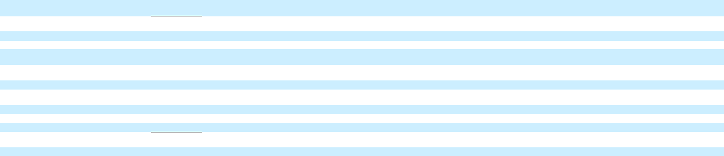

Net increase (decrease) in short-term debt

Proceeds from issuance of debt (original maturities greater than three months)

Payments on debt (original maturities greater than three months)

Issuance (redemptions) of subsidiary preferred stock(b)

Dividends paid(c)

Other financing activities

Net cash provided by (used in) financing activities

Effect of exchange rate changes on cash, cash equivalents and restricted cash

Net increase (decrease) in cash, cash equivalents and restricted cash

Cash, cash equivalents and restricted cash at
beginning of period
Cash, cash equivalents and restricted cash at | $
end of period | $
_________

16 |  | — |  |  | 999 |  |  | — |  |  | 1,015 |  |  | (4) |  |  | — |  |  | 2,369 |  |  | — |  |  | 2,365
1 |  | 9 |  |  | 23,594 |  |  | (9) |  |  | 23,596 |  |  | 265 |  |  | 25 |  |  | 25,690 |  |  | (25) |  |  | 25,955
(68) |  | — |  |  | (22,192) |  |  | (4) |  |  | (22,264) |  |  | (632) |  |  | (18) |  |  | (26,499) |  |  | 114 |  |  | (27,035)
— |  | 1,960 |  |  | — |  |  | (4,087) |  |  | (2,127) |  |  | — |  |  | 2,736 |  |  | — |  |  | (1,000) |  |  | 1,736
(8) |  | (53) |  |  | (809) |  |  | 790 |  |  | (81) |  |  | (2) |  |  | (32) |  |  | (1,260) |  |  | 1,200 |  |  | (94)
(303) |  | (511) |  |  | (84) |  |  | (3) |  |  | (901) |  |  | 5 |  |  | 4 |  |  | (105) |  |  | 5 |  |  | (90)
(362) |  | 1,404 |  |  | 1,508 |  |  | (3,312) |  |  | (762) |  |  | (367) |  |  | 2,714 |  |  | 194 |  |  | 295 |  |  | 2,837
(80) |  | — |  |  | 14 |  |  | — |  |  | (66) |  |  | (8) |  |  | — |  |  | 1 |  |  | — |  |  | (7)
(5,025) |  | 263 |  |  | 936 |  |  | — |  |  | (3,827) |  |  | 2,826 |  |  | 1,018 |  |  | 404 |  |  | — |  |  | 4,248
14,774 |  | 1,584 |  |  | 7,183 |  |  | — |  |  | 23,542 |  |  | 14,225 |  |  | 766 |  |  | 8,126 |  |  | — |  |  | 23,117
9,749 | $ | 1,847 |  | $ | 8,119 |  | $ | — $ |  |  | 19,715 |  | $ | 17,051 |  | $ | 1,784 |  | $ | 8,530 |  | $ | — $ |  |  | 27,365
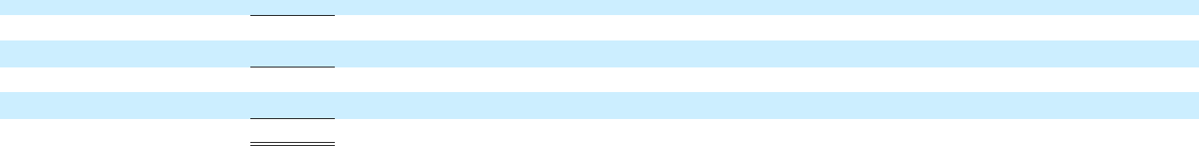

- Includes reclassifications of $0.6 billion and $3.5 billion in the six months ended June 30, 2022 and 2021 for purchases/collections of wholesale finance receivables resulting from vehicles sold by GM to dealers that have arranged their inventory floor plan financing through GM Financial.
- Includes reclassification of $2.1 billion redemption of Cruise preferred shares from SoftBank in the six months ended June 30, 2022. Eliminations include $2.0 billion and $1.0 billion in the six months ended June 30, 2022 and 2021 for Automotive investment in Cruise.
- Eliminations include dividends issued by GM Financial to Automotive.

13

