Table of Contents

UNITED STATES

SECURITIES AND EXCHANGE COMMISSION

Washington, DC 20549-1004

FORM 8-K

CURRENT REPORT

PURSUANT TO SECTION 13 OR 15(d) OF
THE SECURITIES EXCHANGE ACT OF 1934

Date of Report (Date of earliest event reported) April 7, 2010

GENERAL MOTORS COMPANY

(Exact Name of Company as Specified in its Charter)

333-160471

DELAWARE

27-0756180

(Commission File Number)

(State or other jurisdiction of

incorporation)

(I.R.S. Employer

Identification No.)

300 Renaissance Center, Detroit, Michigan

48265-3000

(Address of Principal Executive Offices)

(Zip Code)

(313) 556-5000

(Company’s telephone number, including area code)

Not Applicable

(Former name or former address, if changed since last report)

Check the appropriate box below if the Form 8-K filing is intended to simultaneously satisfy the filing obligation of the company under any of the following provisions:

- Written communications pursuant to Rule 425 under the Securities Act (17 CFR 230.425)

- Soliciting material pursuant to Rule 14a-12 under the Exchange Act (17-CFR 240.14a-12)

- Pre-commencement communications pursuant to Rule 14d-2(b) under the Exchange Act (17 CFR 240.14d-2(b))

- Pre-commencement communications pursuant to Rule 13e-4(c) under the Exchange Act (17 CFR 240.13e-4(c))

Table of Contents

TABLE OF CONTENTS

ITEM 2.02 RESULTS OF OPERATIONS AND FINANCIAL CONDITIONS ITEM 9.01 FINANCIAL STATEMENTS AND EXHIBITS SIGNATURES

INDEX TO EXHIBITS

News Release Dated April 7, 2010 and Financial Statements

Charts Furnished to Securities Analysts

Table of Contents

ITEM 2.02 RESULTS OF OPERATIONS AND FINANCIAL CONDITIONS

On April 7, 2010, a news release was issued on the subject of fresh-start accounting and included information regarding consolidated earnings for General Motors Company (GM). The news release did not include certain financial statements, related footnotes and certain other financial information that will be filed with the Securities and Exchange Commission as part of GM’s Annual Report on Form 10-K. The news release and financial statements are incorporated as Exhibit 99.1.

Charts furnished to securities analysts in connection with GM’s fourth quarter 2009 earnings release are attached as Exhibit 99.2.

ITEM 9.01 |  | FINANCIAL STATEMENTS AND EXHIBITS
 |  |  |  |  | EXHIBITS
Exhibits |  |  | Description |  |  |  |  | Method of Filing
Exhibit 99.1 |  |  | News Release Dated April 7, 2010 and Financial Statements |  |  |  |  | Attached as Exhibit
Exhibit 99.2 |  |  | Charts Furnished to Securities Analysts |  |  |  |  | Attached as Exhibit

Table of Contents

SIGNATURE

Pursuant to the requirements of the Securities Exchange Act of 1934, the Company has duly caused this report to be signed on its behalf by the undersigned hereunto duly authorized.

GENERAL MOTORS COMPANY

(Company)

Date: April 9, 2010 By: /S/ NICK S. CYPRUS

Nick S. Cyprus
Vice President, Controller and Chief Accounting Officer

Exhibit 99.1

GM Communications

300 Renaissance Center

Detroit, Michigan 48265

For Release: April 7, 2010

9:45 a.m. Eastern Time

GM Completes Fresh-Start Accounting

DETROIT, Mich. – General Motors Company announced that it had completed fresh-start accounting, and would be filing its third quarter 2009 Form 10-Q and 2009 Form 10-K with the SEC today.

“We are building the foundation that will allow us to return to public ownership,” said Chris Liddell, GM vice chairman and CFO. “Completing fresh-start accounting is an important step in that process.”

The new company, which was formed on July 10, 2009 through the acquisition of substantially all the assets and certain liabilities of Motors Liquidation Company (formerly General Motors Corporation), had to complete the process of adopting fresh-start accounting to record the acquisition and establishment of the new GM as well as determine the fair value of assets and liabilities and implement new accounting policies.

The following table provides a summary of GM’s financial results for the period ended December 31, 2009 under fresh-start accounting.

 |  | July 10-Dec. 31, ‘09
($ bils)
 | Global revenue | $57.5
Net income/(loss) attributed to stockholders |  | $(4.3)
 | Net cash provided by operating activities | $1.0

The $4.3 billion net loss includes the pre-tax impact of a $2.6 billion settlement loss related to the UAW retiree medical plan and a $1.3 billion foreign currency re-measurement loss.

Going public will enable the company to invest in designing, building and selling the world’s best vehicles, attract the best people and access the capital markets. One of the most important measures in establishing the foundation for going public is the company’s ability to return to sustainable profitability.

“As the results for 2009 show there is still significant work to be done. However, I continue to believe we have a chance of achieving profitability in 2010,” said Liddell. “We are also dedicated to delivering on our commitments to our stakeholders. For example we remain committed to repaying the outstanding balance of the U.S. Treasury and Export Development Canada loans by June 2010 at the latest.”

# # #

Forward-Looking Statements:

In this press release and in related comments by our management, our use of the words “expect,” “anticipate,” “possible,” “potential,” “target,” “believe,” “commit,” “intend,” “continue,” “may,” “would,” “could,” “should,” “project,” “projected,” “positioned” or similar expressions is intended to identify forward-looking statements that represent our current judgment about possible future events. We believe these judgments are reasonable, but these statements are not guarantees of any events or financial results, and our actual results may differ materially due to a variety of important factors. Among other items, such factors might include: our ability to comply with the requirements of our credit agreements with the U.S. Treasury and EDC and to repay those agreements as planned; our ability to realize production efficiencies and to achieve reductions in costs as a result of our restructuring initiatives and labor modifications; our ability to maintain quality control over our vehicles and avoid material vehicle recalls; our ability to maintain adequate liquidity and financing sources and an appropriate level of debt, including as required to fund our planning significant investment in new technology and our ability to realize successful vehicle applications of new technology.

GM’s most recent annual report on Form 10-K will provide information about these and other factors, which we may revise or supplement in future reports to the SEC.

Contacts:

Reneé Rashid-Merem

Office 313.665.3128

Cell 313.701.8560

renee.rashid-merem@gm.com

Randy Arickx

Office 313.667.0006

Cell 313.268.7070

randy.c.arickx@gm.com

Exhibit 1

General Motors Company and Subsidiaries

Supplemental Material

General Motors Company was formed by the United States Department of the Treasury in 2009 originally as a Delaware limited liability company, Vehicle Acquisition Holdings LLC, and subsequently converted to a Delaware corporation, NGMCO, Inc. On July 10, 2009 this company acquired substantially all of the assets and assumed certain liabilities of General Motors Corporation (363 Sale) and changed its name to General Motors Company (GM). General Motors Corporation is sometimes referred to, for the periods on or before July 9, 2009, as Old GM. Prior to July 10, 2009 Old GM operated the business of the Company, and pursuant to the agreement with the SEC Staff, the accompanying consolidated financial statements include the financial statements and related information of Old GM as it is GM’s predecessor entity solely for accounting and financial reporting purposes. On July 10, 2009 in connection with the 363 Sale, General Motors Corporation changed its name to Motors Liquidation Company (MLC). MLC continues to exist as a distinct legal entity for the sole purpose of liquidating its remaining assets and liabilities.

The accompanying tables and charts for securities analysts include earnings before interest and taxes (EBIT), which is not prepared in accordance with Accounting Principles Generally Accepted in the United States of America (GAAP) and has not been audited or reviewed by GM’s independent auditors. EBIT is therefore considered a non-GAAP financial measure. The accompanying charts for securities analysts also contain a reconciliation from EBIT to its most comparable GAAP financial measure.

Management believes EBIT provides meaningful supplemental information regarding GM’s operating results because it excludes amounts that management does not consider part of operating results when assessing and measuring the operational and financial performance of the organization. Management believes these measures allow it to readily view operating trends, perform analytical comparisons, benchmark performance among geographic regions and assess whether GM’s plan to return to profitability is on target. Accordingly, GM believes EBIT is useful in allowing for greater transparency of supplemental information used by management in its financial and operational decision-making.

GM is filing an Annual Report on Form 10-K for the year ended December 31, 2009, a Quarterly Report on Form 10-Q for the quarter ended September 30, 2009 and a Registration Statement on Form 10 pursuant to an agreement with the SEC Staff, as described in a no-action letter issued to Old GM by the SEC Staff on July 9, 2009 regarding GM’s filing requirements and those of MLC.

Certain prior period amounts have been reclassified in the consolidated statements of operations to conform to the current period presentation, primarily due to the adoption of ASC 810-10, “Consolidation” and ASC 470-20, “Debt with Conversions and Other Options,” which have retrospective application.

In the year ended 2009 certain data such as vehicle sales, market share data and production volume combine GM’s data in the period July 10, 2009 through December 31, 2009 with Old GM’s data in the period January 1, 2009 through July 9, 2009 for comparative purposes.

1

General Motors Company and Subsidiaries

Supplemental Material

(Unaudited)

 |  |  | Three Months Ended |  |  |  |  | Year Ended
 |  |  | December 31, |  |  |  |  | December 31,
 |  |  | 2009 |  |  | 2008 |  | 2009 |  |  | 2008
 |  |  |  |  |  | (Units | in thousands)
 | Worldwide Production Volume(a)(b)(c)
 | GMNA – Cars |  | 235 |  |  | 365 |  | 727 |  |  | 1,543
 | GMNA – Trucks |  | 381 |  |  | 450 |  | 1,186 |  |  | 1,906
 | Total GMNA
 |  |  | 616 |  |  | 815 |  | 1,913 |  |  | 3,449
 | GMIO |  | 1,040 |  |  | 619 |  | 3,456 |  |  | 3,145
 | GME |  | 266 |  |  | 214 |  | 1,134 |  |  | 1,550
 | Total Worldwide |  | 1,922 |  |  | 1,648 |  | 6,503 |  |  | 8,144

- Production volume represents the number of vehicles manufactured by GM’s and Old GM’s assembly facilities and also includes vehicles produced by certain joint ventures.

- Includes SGM, SGMW and FAW-GM joint venture production. Ownership of 50% in SGM, 34% in SGMW and 50% in FAW-GM, under the joint venture agreements, allows for significant rights as a member as well as the contractual right to report SGMW and FAW-GM production volume in China. These entities are not consolidated for financial reporting purposes. Income and losses related to these entities are recorded in Equity income, net of tax.
- Production data may include rounding differences.

2

General Motors Company and Subsidiaries

Supplemental Material

(Unaudited)

 |  |  | Three Months Ended |  |  |  |  | Year Ended
 |  |  | December 31, |  |  |  |  | December 31,
 |  |  | 2009 |  |  | 2008 |  | 2009 |  |  | 2008
 | Vehicle Unit Deliveries(a)(b)(c)
 | United States
 | Chevrolet – Cars |  | 133 |  |  | 132 |  | 546 |  |  | 715
 | Chevrolet – Trucks |  | 219 |  |  | 209 |  | 799 |  |  | 1,086
 | Cadillac |  | 36 |  |  | 32 |  | 109 |  |  | 161
 | Buick |  | 30 |  |  | 24 |  | 102 |  |  | 137
 | GMC |  | 78 |  |  | 71 |  | 260 |  |  | 377
 | Other Non-Core Divisions |  | 42 |  |  | 80 |  | 269 |  |  | 504
 | Total United States |  | 538 |  |  | 547 |  | 2,084 |  |  | 2,981
 | Canada, Mexico and Other |  | 100 |  |  | 127 |  | 400 |  |  | 585
 | Total GMNA(d) |  | 637 |  |  | 675 |  | 2,485 |  |  | 3,565
 | GMIO
 | Chevrolet |  | 427 |  |  | 310 |  | 1,491 |  |  | 1,456
 | Buick |  | 134 |  |  | 69 |  | 448 |  |  | 281
 | GM Daewoo |  | 41 |  |  | 19 |  | 121 |  |  | 121
 | Holden |  | 36 |  |  | 32 |  | 126 |  |  | 140
 | Wuling |  | 247 |  |  | 149 |  | 1,001 |  |  | 606
 | FAW-GM |  | 26 |  |  | — |  | 35 |  |  | —
 | Other |  | 26 |  |  | 29 |  | 104 |  |  | 150
 | Total GMIO(e)
 |  |  | 937 |  |  | 608 |  | 3,326 |  |  | 2,754
 | GME
 | Opel/Vauxhall |  | 265 |  |  | 284 |  | 1,209 |  |  | 1,458
 | Chevrolet |  | 107 |  |  | 121 |  | 426 |  |  | 510
 | Saab |  | 5 |  |  | 13 |  | 27 |  |  | 66
 | Other |  | 1 |  |  | 1 |  | 5 |  |  | 8
 | Total GME(e)
 |  |  | 378 |  |  | 419 |  | 1,667 |  |  | 2,043
 | Total Worldwide |  | 1,952 |  |  | 1,702 |  | 7,478 |  |  | 8,362

- Includes HUMMER, Saab, Saturn and Pontiac vehicle sales data.

- Includes SGM, SGMW and FAW-GM joint venture sales. Ownership of 50% in SGM, 34% in SGMW and 50% in FAW-GM, under the joint venture agreements, allows for significant rights as a member as well as the contractual right to report SGMW and FAW-GM joint venture vehicle sales in China as part of global market share. These entities are not consolidated for financial reporting purposes. Income and losses related to these entities are recorded in Equity income, net of tax.
- Vehicle sales data may include rounding differences.

- Vehicle sales represent sales to the ultimate customer.

- Vehicle sales primarily represent estimated sales to the ultimate customer.

3

General Motors Company and Subsidiaries

Supplemental Material

(Unaudited)

 |  | Three Months Ended |  |  |  | Year Ended
 |  | December 31, |  |  |  | December 31,
 |  | 2009 | 2008 |  |  | 2009 |  | 2008
 | Market Share(a)(b)
 | United States – Cars | 15.5% | 18.2% |  |  | 16.3% |  | 18.6%
 | United States – Trucks | 24.5% | 24.5% |  |  | 23.1% |  | 25.5%
 | Total United States | 20.2% | 21.5% |  |  | 19.6% |  | 22.1%
 | Total GMNA(c) | 19.3% | 21.0% |  |  | 19.0% |  | 21.5%
 | Total GMIO(d) | 10.4% | 9.6% |  |  | 10.3% |  | 9.6%
 | Total GME(d) | 8.3% | 9.2% |  |  | 8.9% |  | 9.3%
 | Total Worldwide | 11.6% | 12.0% |  |  | 11.6% |  | 12.4%
 | U.S. Retail/Fleet Mix
 | % Fleet Sales - Cars | 34.6% | 45.6% |  |  | 29.0% |  | 34.8%
 | % Fleet Sales - Trucks | 20.5% | 23.2% |  |  | 21.6% |  | 22.4%
 | Total Vehicles | 25.8% | 32.2% |  |  | 24.7% |  | 27.6%
 | GMNA Capacity Utilization(e) | 61.5% | 72.1% |  |  | 48.0% |  | 74.7%

- Includes HUMMER, Saab, Saturn and Pontiac vehicle sales data.

- Includes SGM, SGMW and FAW-GM joint venture sales. Ownership of 50% in SGM, 34% in SGMW and 50% in FAW-GM, under the joint venture agreements, allows for significant rights as a member as well as the contractual right to report SGMW and FAW-GM joint venture vehicle sales in China as part of global market share. These entities are not consolidated for financial reporting purposes. Income and losses related to these entities are recorded in Equity income, net of tax.
- Vehicle sales represent sales to the ultimate customer.

- Vehicle sales primarily represent estimated sales to the ultimate customer.

- Two shift rated, annualized.

 |  |  | Successor |  |  | Predecessor
 |  |  | December 31, |  |  | December 31,
 |  |  | 2009 |  |  | 2008
 | Worldwide Employment (thousands)
 | GMNA(a) |  | 102 |  |  | 116
 | GMIO |  | 61 |  |  | 70
 | GME |  | 53 |  |  | 55
 | Corporate |  | 1 |  |  | 2
 | Total Worldwide |  | 217 |  |  | 243
 | United States — Salaried(a)(b)(d) |  | 26 |  |  | 29
 | United States — Hourly(a)(c) |  | 51 |  |  | 62

- Includes additional 11,000 employees due to the acquisition of Nexteer, of which 2,000 are U.S. salaried employees, 5,000 are U.S. hourly employees and 4,000 are employees located outside the U.S.
- 5,000 U.S. salaried employees irrevocably accepted the 2009 Salaried Window Program (a voluntary program, subject to management approval, to reduce salaried headcount based on individual eligibility and employees elections made) option or the GM severance program option.
- 13,000 U.S. hourly employees elected to participate in Old GM’s 2009 Special Attrition Programs, which were introduced in February and June of 2009 and offered cash and other incentives for individuals who elected to retire or voluntarily terminate employment.
- Includes employees in GMNA and Corporate.

 |  |  | Successor |  |  |  |  | Predecessor
 |  |  | July 10, 2009 |  |  | January 1, 2009 |  |  |  | Twelve Months
 |  |  | Through |  |  |  | Through |  |  | Ended
 |  | December 31, 2009 |  |  |  |  | July 9, 2009 |  | December 31, 2008
Worldwide Payroll (billions) | $ |  | 6.2 |  | $ |  | 6.2 | $ |  | 16.8
 | 4

General Motors Company and Subsidiaries

Consolidated Statements of Operations

(Dollars in millions)

(Unaudited)

 |  |  |  | Successor |  |  |  |  | Predecessor
 |  |  |  | July 10, 2009 |  |  | January 1, 2009
 |  |  |  | Through |  |  |  | Through |  |  |  | Year Ended
 |  |  | December 31, 2009 |  |  |  |  | July 9, 2009 |  |  | December 31, 2008
 | Net sales and revenue
 | Sales | $ |  | 57,329 |  | $ |  | 46,787 |  | $ |  | 147,732
 | Other revenue |  |  | 145 |  |  |  | 328 |  |  |  | 1,247
 | Total net sales and revenue
 | Total net sales and revenue |  |  | 57,474 |  |  |  | 47,115 |  |  |  | 148,979
 | Costs and expenses
 | Cost of sales |  |  | 56,381 |  |  |  | 55,814 |  |  |  | 149,257
 | Selling, general and administrative expense |  |  | 6,006 |  |  |  | 6,161 |  |  |  | 14,253
 | Other expenses, net |  |  | 15 |  |  |  | 1,235 |  |  |  | 6,699
 | Total costs and expenses |  |  | 62,402 |  |  |  | 63,210 |  |  |  | 170,209
 | Operating loss
 | Operating loss |  |  | (4,928) |  |  |  | (16,095) |  |  |  | (21,230)
 | Equity in income (loss) of and disposition of interest in GMAC |  |  | — |  |  |  | 1,380 |  |  |  | (6,183)
 | Interest expense |  |  | (694) |  |  |  | (5,428) |  |  |  | (2,525)
 | Interest income and other non-operating income, net |  |  | 440 |  |  |  | 852 |  |  |  | 424
 | Gain (loss) on extinguishment of debt |  |  | (101) |  |  |  | (1,088) |  |  |  | 43
 | Reorganization gains, net |  |  | — |  |  |  | 128,155 |  |  |  | —
Income (loss) before income taxes and equity income
 |  |  |  | (5,283) |  |  |  | 107,776 |  |  |  | (29,471)
 | Income tax expense (benefit) |  |  | (1,000) |  |  |  | (1,166) |  |  |  | 1,766
 | Equity income, net of tax |  |  | 497 |  |  |  | 61 |  |  |  | 186
 | Net income (loss) |  |  | (3,786) |  |  |  | 109,003 |  |  |  | (31,051)
 | Less: Net (income) loss attributable to noncontrolling interests |  |  | (511) |  |  |  | 115 |  |  |  | 108
 | Net income (loss) attributable to stockholders |  |  | (4,297) |  |  |  | 109,118 |  |  |  | (30,943)
 | Less: Cumulative dividends on preferred stock |  |  | 131 |  |  |  | — |  |  |  | —
 | Net income (loss) attributable to common stockholders |  | $ | (4,428) |  | $ |  | 109,118 |  | $ |  | (30,943)
Earnings (loss) per share
 | Basic
 | Income (loss) attributable to common stockholders | $ |  | (10.73) |  | $ |  | 178.63 |  | $ |  | (53.47)
 | Weighted-average common shares outstanding |  |  | 413 |  |  |  | 611 |  |  |  | 579
 | Diluted
 | Income (loss) attributable to common stockholders | $ |  | (10.73) |  | $ |  | 178.55 |  | $ |  | (53.47)
 | Weighted-average common shares outstanding |  |  | 413 |  |  |  | 611 |  |  |  | 579
 | Cash dividends per common share | $ |  | — |  | $ |  | — |  | $ |  | 0.50
Amounts attributable to common stockholders:
 | Income (loss) of tax | $ |  | (4,428) |  | $ |  | 109,118 |  | $ |  | (30,943)
 |  | 5

General Motors Company and Subsidiaries

Consolidated Balance Sheets

(In millions, except share amounts)

(Unaudited)

 |  |  | Successor |  |  | Predecessor
 |  | December 31, |  |  |  | December 31,
 |  |  | 2009 |  |  |  | 2008
 | ASSETS
Current Assets
 | Cash and cash equivalents | $ | 22,679 |  |  | $ | 14,053
 | Marketable securities |  | 134 |  |  |  | 141
 | Total cash, cash equivalents and marketable securities |  | 22,813 |  |  |  | 14,194
 | Restricted cash |  | 13,917 |  |  |  | 672
 | Accounts and notes receivable (net of allowance of $250 and $422) |  | 7,518 |  |  |  | 7,918
 | Inventories |  | 10,107 |  |  |  | 13,195
 | Assets held for sale |  | 388 |  |  |  | —
 | Equipment on operating leases, net |  | 2,727 |  |  |  | 5,142
 | Other current assets and deferred income taxes |  | 1,777 |  |  |  | 3,146
 | Total current assets |  | 59,247 |  |  |  | 44,267
 | Non-Current Assets
 | Restricted cash |  | 1,489 |  |  |  | 1,917
 | Equity in net assets of nonconsolidated affiliates |  | 7,936 |  |  |  | 2,146
 | Assets held for sale |  | 530 |  |  |  | —
 | Equipment on operating leases, net |  | 3 |  |  |  | 442
 | Property, net |  | 18,687 |  |  |  | 39,665
 | Goodwill |  | 30,672 |  |  |  | —
 | Intangible assets, net |  | 14,547 |  |  |  | 265
 | Deferred income taxes |  | 564 |  |  |  | 98
 | Prepaid pension |  | 98 |  |  |  | 109
 | Other assets |  | 2,522 |  |  |  | 2,130
 | Total non-current assets |  | 77,048 |  |  |  | 46,772
 | Total Assets | $ | 136,295 |  |  | $ | 91,039
 | LIABILITIES AND EQUITY (DEFICIT)
 | Current Liabilities
 | Accounts payable (principally trade) | $ | 18,725 |  |  | $ | 22,259
 | Short-term debt and current portion of long-term debt |  | 10,221 |  |  |  | 16,920
 | Liabilities held for sale |  | 355 |  |  |  | —
 | Postretirement benefits other than pensions |  | 846 |  |  |  | 4,002
 | Accrued expenses |  | 22,288 |  |  |  | 32,427
 | Total current liabilities |  | 52,435 |  |  |  | 75,608
 | Non-Current Liabilities
 | Long-term debt |  | 5,562 |  |  |  | 29,018
 | Liabilities held for sale |  | 270 |  |  |  | —
 | Postretirement benefits other than pensions |  | 8,708 |  |  |  | 28,919
 | Pensions |  | 27,086 |  |  |  | 25,178
 | Other liabilities and deferred income taxes |  | 13,279 |  |  |  | 17,392
 | Total non-current liabilities |  | 54,905 |  |  |  | 100,507
 | Total liabilities |  | 107,340 |  |  |  | 176,115
 | Commitments and contingencies
 | Preferred stock, $0.01 par value (1,000,000,000 shares authorized and 360,000,000 shares issued and outstanding at December 31, 2009) |  | 6,998 |  |  |  | —
 | Equity (Deficit)
 | Old GM
 | Preferred stock, no par value (6,000,000 shares authorized, no shares issued and outstanding) |  | — |  |  |  | —
 | Preference stock, $0.10 par value (100,000,000 shares authorized, no shares issued and outstanding) |  | — |  |  |  | —
 | Common stock, $1 2/3 par value common stock (2,000,000,000 shares authorized, 800,937,541 shares issued and 610,483,231 shares
 | outstanding at December 31, 2008) |  | — |  |  |  | 1,017
 | General Motors Company
 | Common stock, $0.01 par value (2,500,000,000 shares authorized and 500,000,000 shares issued and outstanding at December 31, 2009) |  | 5 |  |  |  | —
 | Capital surplus (principally additional paid-in capital) |  | 24,050 |  |  |  | 16,489
 | Accumulated deficit |  | (4,394) |  |  |  | (70,727)
 | Accumulated other comprehensive income (loss) |  | 1,588 |  |  |  | (32,339)
Total stockholders’ equity (deficit)
 |  |  | 21,249 |  |  |  | (85,560)
 | Noncontrolling interests |  | 708 |  |  |  | 484
Total equity (deficit) |  |  | 21,957 |  |  |  | (85,076)
 | Total Liabilities and Equity (Deficit) | $ | 136,295 |  |  | $ | 91,039

6

General Motors Company and Subsidiaries

Supplemental Material

(Unaudited)

Old GM

January 1, 2009 Through July 9, 2009

In the period January 1, 2009 through July 9, 2009, Old GM recorded the following Reorganization gains, net, arising from the 363 Sale and fresh-start reporting:

 |  |  | Predecessor
 |  | January 1, 2009
 |  |  | Through
 |  |  | July 9, 2009
Change in net assets resulting from the application of fresh-start reporting | $ |  | 33,829
Fair value of New GM’s Series A Preferred Stock, common shares and warrants issued in 363 Sale |  |  | 20,532
Gain from the conversion of debt owed to UST to equity |  |  | 31,561
Gain from the conversion of debt owed to EDC to equity |  |  | 5,964
Gain from the modification and measurement of GM’s VEBA obligation |  |  | 7,731
Gain from the modification and measurement of other employee benefit plans |  |  | 4,585
Gain from the settlement of net liabilities retained by MLC via the 363 Sale |  |  | 25,177
Income tax benefit for release of valuation allowances and other tax adjustments |  |  | 710
Other 363 Sale adjustments |  |  | (21)
Amount recorded in Income tax benefit |  |  | (710)
Other losses, net |  |  | (1,203)
Total Reorganization gains, net
Total Reorganization gains, net | $ |  | 128,155
7

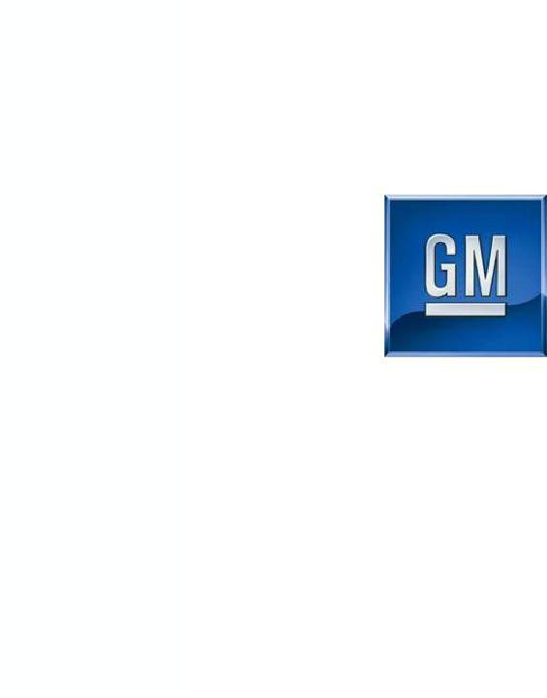
Exhibit 99.2

General Motors Company

April 7, 2010

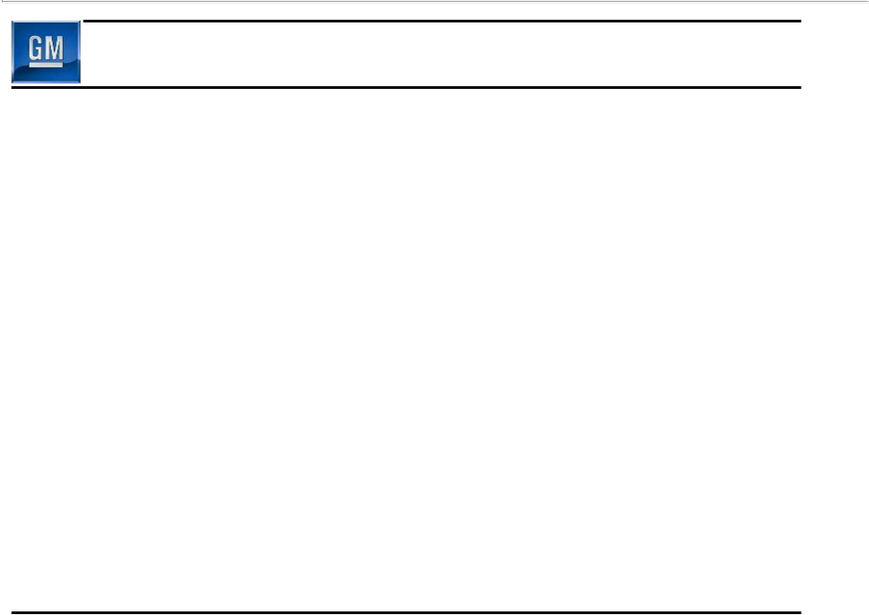
Forward Looking Statements

In this presentation and in related comments by our management, our use of the words “expect,” “anticipate,” “possible,” “potential,” “believe,” “intend,” “target,” “may,” “would,” “could,” “should,” “project,” “projected,” “positioned” or similar expressions is intended to identify forward-looking statements that represent our current judgment about possible future events. We believe these judgments are reasonable, but these statements are not guarantees of any events or financial results, and our actual results may differ materially due to a variety of important factors.

Among other items, such factors might include: our ability to comply with the requirements of our credit agreements with the U.S. Treasury and EDC and to repay those agreements as planned; our ability to realize production efficiencies and to achieve reductions in costs as a result of our restructuring initiatives and labor modifications; our ability to maintain quality control over our vehicles and avoid material vehicle recalls; our ability to maintain adequate liquidity and financing sources and an appropriate level of debt, including as required to fund our planning significant investment in new technology, and our ability to realize successful vehicle applications of new technology.

Our most recent annual report on Form 10-K provides information about these and other factors, which may be revised or supplemented in future reports to the SEC on Form 10-Q or 8-K.

1

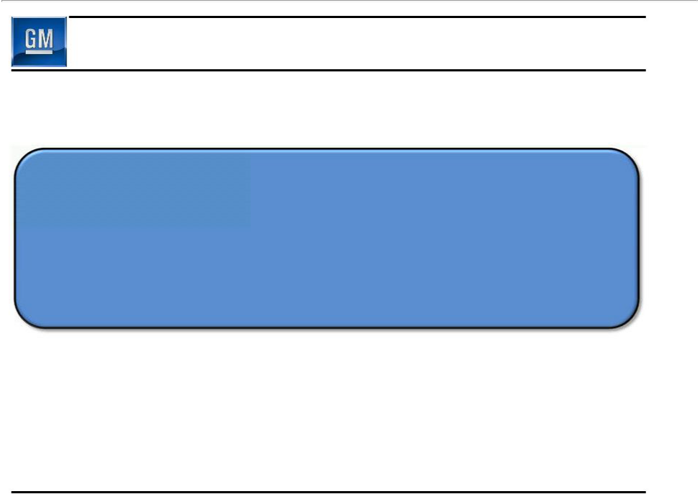
Vision Statement

Design, Build & Sell

the World’s Best Vehicles

2

Key 2010 CY Launches

2011 Chevy Cruze 2011 Buick Regal 2011 Chevy Volt

GMNA

2011 Opel Meriva ^{2011 Opel Astra Wagon} 2011 Chevy Orlando

GME
Coming Soon

2011 Chevy Sail 2011 Buick Excelle 2011 Chevy Spark

GMIO

3

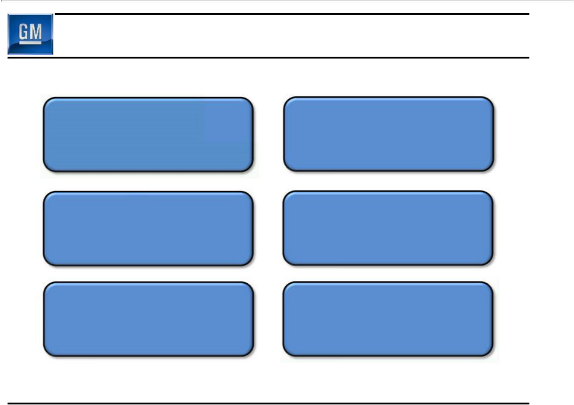
Rebuild First Class Relationships

Customers Dealers

Communities Union Partners

Employees Suppliers

4

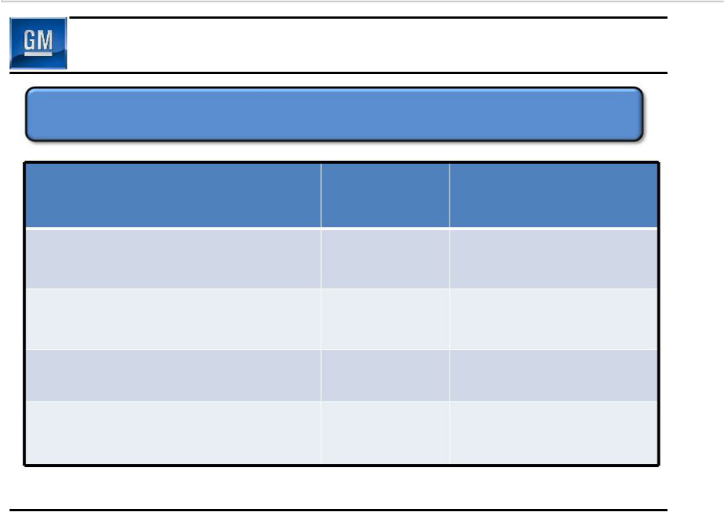
Summary of 2009 Results

Return to profitability a key priority

 | Q4 | July 10 – Dec 31
Global Revenue | $32.3B | $57.5B
EBIT | $(4.0)B | $(4.8)B
Total Net Income/(Loss) | $(3.4)B | $(4.3)B
Net cash provided/(used) | (1.9) | 1.0
operating activities | (1.9) | 1.0

Memo: Total net income/(loss) excludes preferred dividends

5

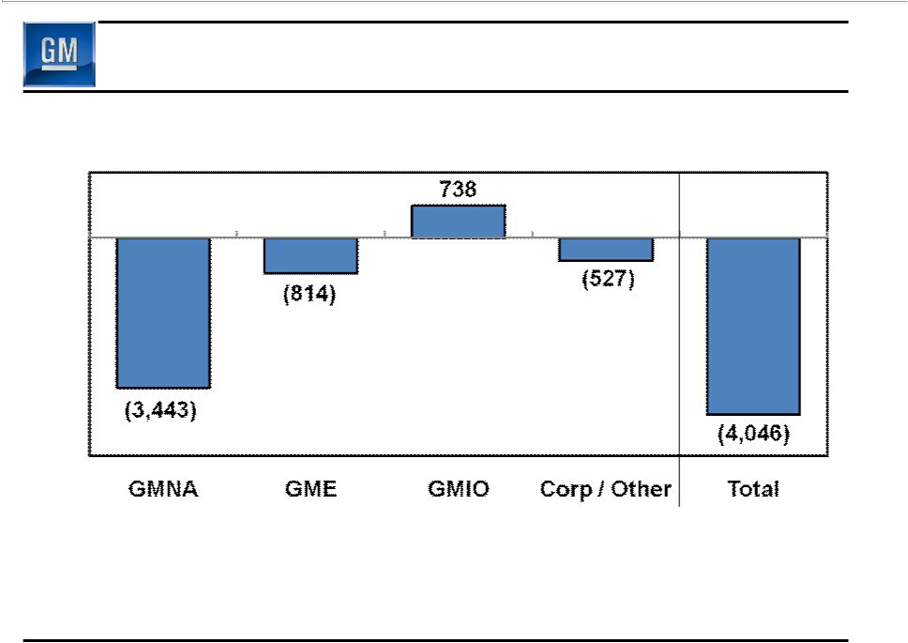
Q4 2009 EBIT

($M)

Memo: Old GM EBIT

Q4 2008 (3,403) (1,855) (1,074) (2,321) (8,653)

6

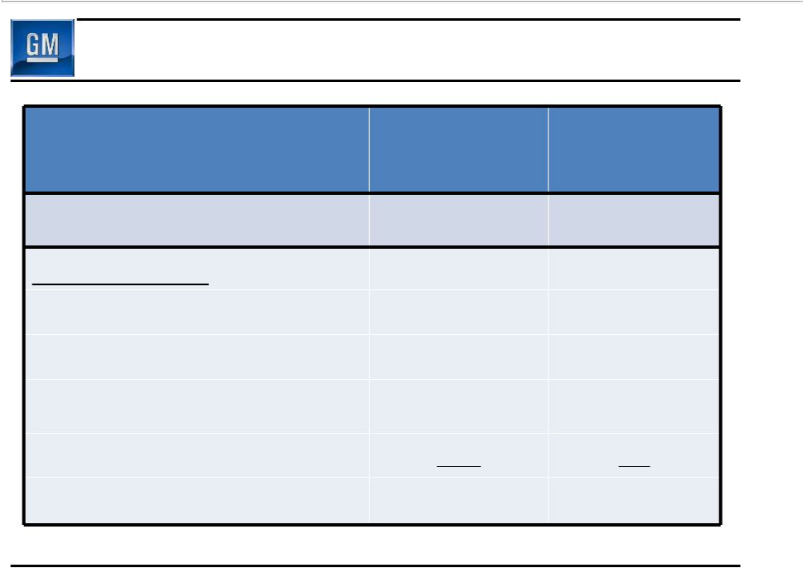
Sustainable Financial Strength

 | Old GM | New GM
($B) | Dec 31, 2008 | Dec 31, 2009
Cash & marketable securities * | 14.2 | 36.2
Key Obligations:
Debt | 45.9 | 15.8
Preferred Stock | n/a | 7.0
Underfunded Pensions | 25.6 | 27.5
Underfunded OPEB | 32.9 | 9.6
Total Key Obligations | 104.4 | 59.9

* Includes UST & Canadian HC Trust Restricted Cash

7

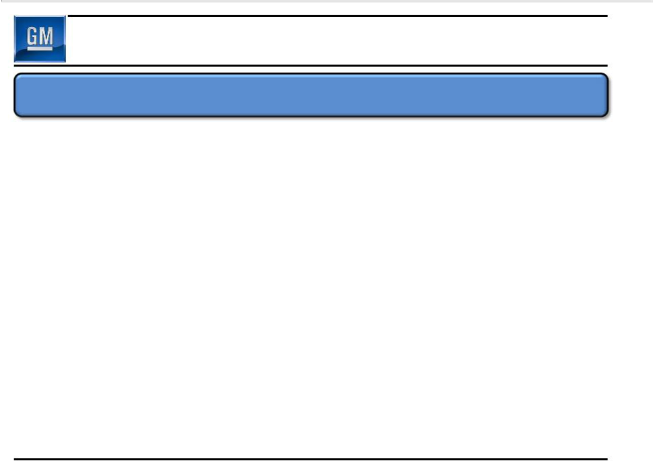
Integrity & Reliability in Public Reporting

Fresh-start accounting a key milestone for going public

- Requirement resulting from 363 transaction

- Resets the basis for accounting to fair value as of July 10 and results in a new entity for financial reporting purposes

- Substantially all of GM’s assets and liabilities recorded at fair value as of July 10, similar to purchase accounting

– Adjustments recorded to ledgers & subledgers

– More than 1 million asset records adjusted

- Initiative was a major undertaking

8

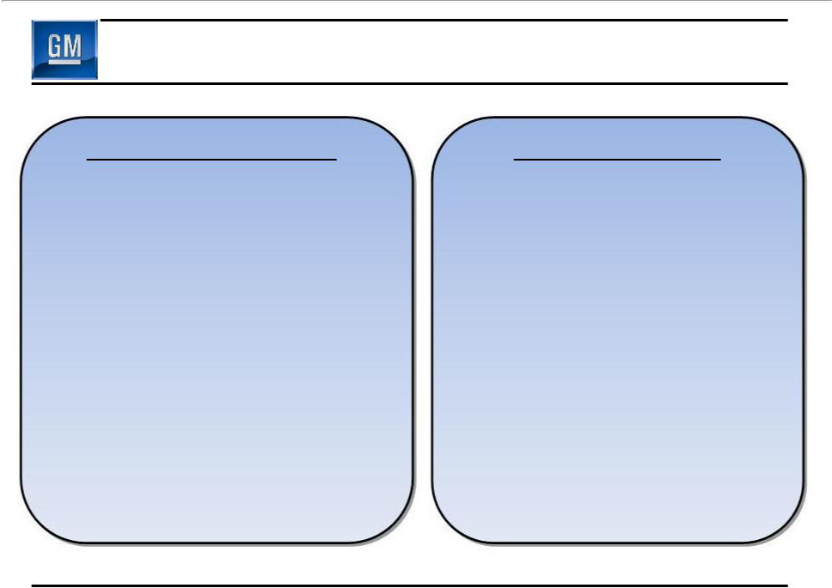
July 10 Reorg & Fresh-Start

July 10 Reorganization

- $83B reduction in liabilities extinguished through 363 sale & issued common equity, warrants & preferred stock fair valued at $20B

- $8B reduction in OPEB related to Revised UAW Settlement Agreement

- $4B reduction in pension and OPEB resulting from July 10 implementation of modification to benefit plans

July 10 Fresh-Start

- Recognition of $30B goodwill

- Recognition of $16B intangible assets

- $19B balance in property, plant & equipment which is an $18B reduction

- $8B balance in equity & cost based investments

9

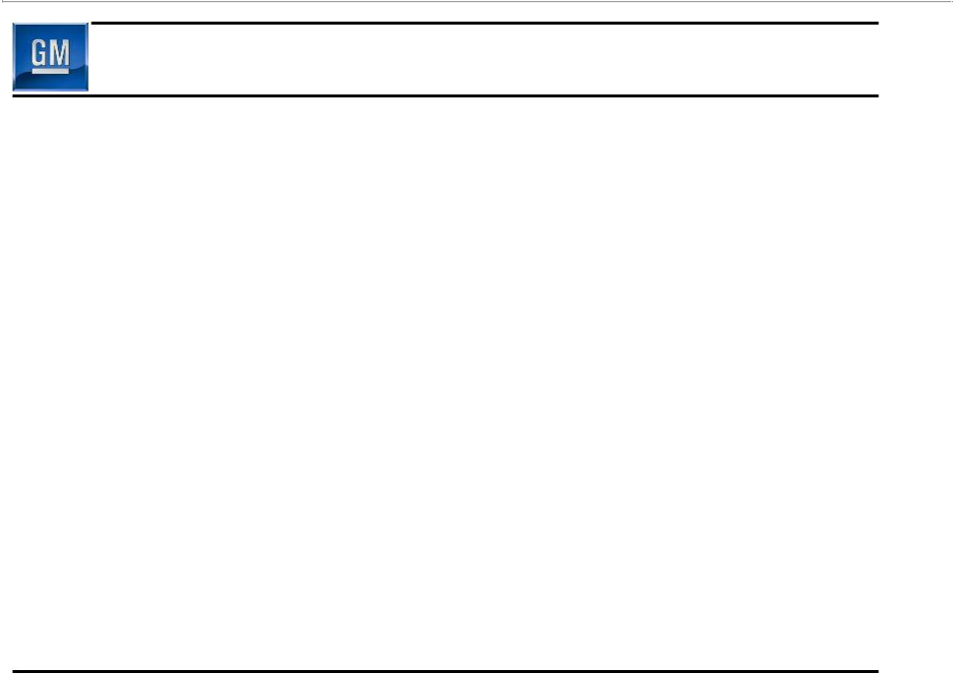
Commitments to Stakeholders

- Original government loans of $8.4B

– Paid $2.4B to UST & $0.4B to EDC through Mar 31

– Outstanding balance to be repaid in full by June at the latest

10

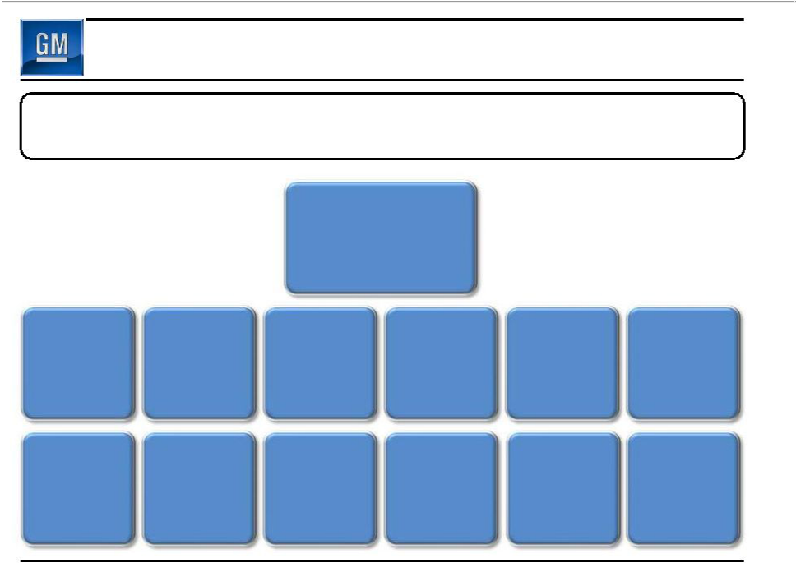
New Leadership Team

12 of 13 EC members new to company or in new positions since July 2009 (Tom Stephens appointed to current position May 2009)

Ed Whitacre

Chairman & CEO

Tom Stephens | Steve Girsky | Chris Liddell | Nick Reilly | Mark Reuss | Tim Lee
Vice Chairman | Vice Chairman | Vice Chairman | President | President | President
Vice Chairman | Corp. Strategy &
Global Prod. Ops | Bus. Dev. | CFO | Europe | North America | International Ops.

Selim Bingol | Mary Barra | Mike Millikin | Terry Kline | John Montford | Bob Lutz
Selim Bingol | V.P. Human | Mike Millikin | V.P. Information | Senior Advisor | Bob Lutz
V.P. Comm . | V.P. Human | V.P. Legal | V.P. Information | Senior Advisor | Vice Chairman
 | Resources |  | Technology | Gov’t Relations

11

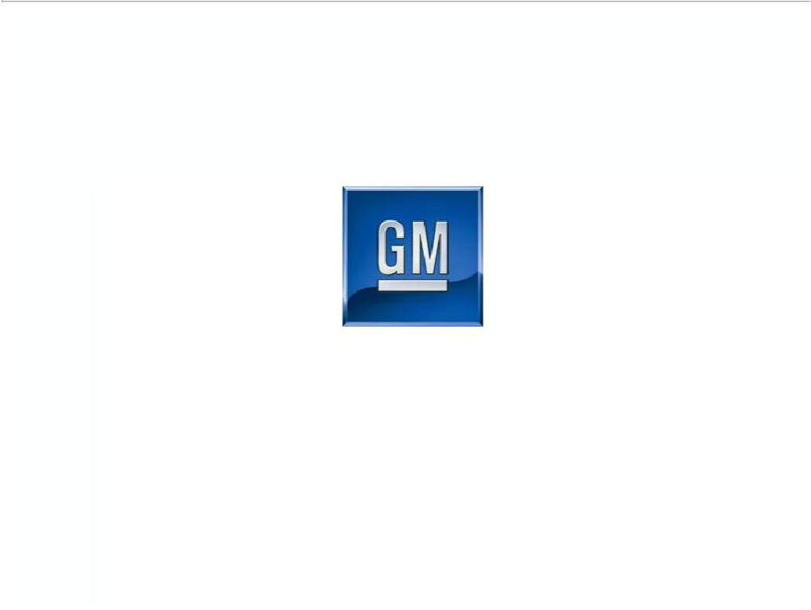

General Motors Company

Select Supplemental Financial Information

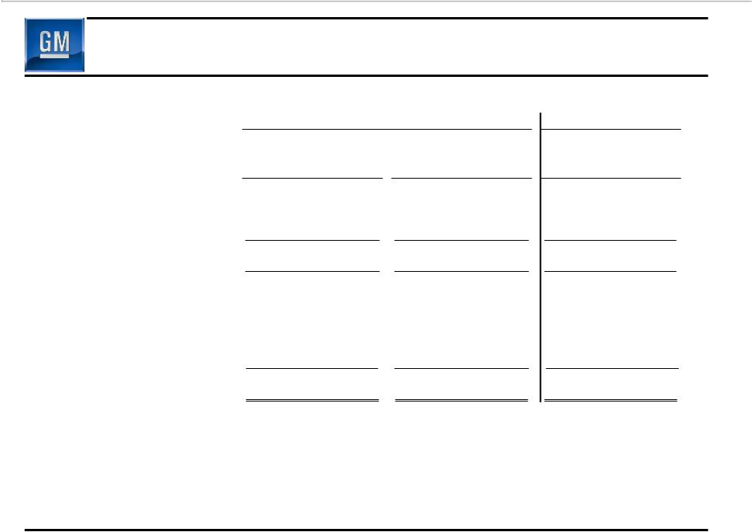
EBIT Reconciliation

 |  | Successor |  |  |  | Predecessor
 |  | July 10, 2009 |  | October 1, 2009 |  | October 1, 2008
 |  | Through |  | Through |  | Through
Operating segments (EBIT) | December 31, 2009 |  | December 31, 2009 |  | December 31, 2008
Operating segments (EBIT) |  |  | $ | (3,443) | $ | (3,403)
GMNA | $ | (4,820)
GMIO |  | 1,198 |  | 738 |  | (1,074)
GME |  | (805) |  | (814) |  | (1,855)
Total operating segments |  | (4,427) |  | (3,519) |  | (6,332)
Corporate and eliminations |  | (360) |  | (527) |  | (2,321)
Income (loss) attributable to
stockholders before interest and
income taxes |  | (4,787) |  | (4,046) |  | (8,653)
Interest income |  | 184 |  | 75 |  | 102
Interest expense |  | 694 |  | 329 |  | 308
Income tax expense (benefits) |  | (1,000) |  | (861) |  | 737
Net income (loss) attributable to | $ | (4,297) | $ | (3,439) | $ | (9,596)
stockholders

13

