Table of Contents

UNITED STATES

SECURITIES AND EXCHANGE COMMISSION
Washington, DC 20549-1004

FORM 8-K

CURRENT REPORT

PURSUANT TO SECTION 13 OR 15(d) OF

THE SECURITIES EXCHANGE ACT OF 1934

Date of Report (Date of earliest event reported) August 4, 2011

GENERAL MOTORS COMPANY

(Exact Name of Registrant as Specified in its Charter)

001-34960

DELAWARE

27-0756180

(Commission

File Number)

(State or other jurisdiction

of incorporation)

(I.R.S. Employer

Identification No.)

300 Renaissance Center, Detroit, Michigan

48265-3000

(Address of Principal Executive Offices)

(Zip Code)

(313) 556-5000

(Registrant’s telephone number, including area code)

Not Applicable

(Former name or former address, if changed since last report)

Check the appropriate box below if the Form 8-K filing is intended to simultaneously satisfy the filing obligation of the registrant under any of the following provisions:

- Written communications pursuant to Rule 425 under the Securities Act (17 CFR 230.425)

- Soliciting material pursuant to Rule 14a-12 under the Exchange Act (17-CFR 240.14a-12)

- Pre-commencement communications pursuant to Rule 14d-2(b) under the Exchange Act (17 CFR 240.14d-2(b))

- Pre-commencement communications pursuant to Rule 13e-4(c) under the Exchange Act (17 CFR 240.13e-4(c))

Table of Contents

TABLE OF CONTENTS

ITEM 2.02 RESULTS OF OPERATIONS AND FINANCIAL CONDITION

ITEM 9.01 FINANCIAL STATEMENTS AND EXHIBITS

SIGNATURES

INDEX TO EXHIBITS

News Release Dated August 4, 2011 and Financial Statements

Charts Furnished to Securities Analysts

Table of Contents

ITEM 2.02 RESULTS OF OPERATIONS AND FINANCIAL CONDITION

On August 4, 2011 a news release was issued on the subject of second quarter 2011 consolidated earnings for General Motors Company (GM). The news release did not include certain financial statements, related footnotes and certain other financial information that will be filed with the Securities and Exchange Commission as part of GM’s Quarterly Report on Form 10-Q. The news release and financial statements are incorporated as Exhibit 99.1.

Charts furnished to securities analysts in connection with GM’s second quarter 2011 earnings release are attached as Exhibit 99.2.

ITEM 9.01 FINANCIAL STATEMENTS AND EXHIBITS

 |  |  |  |  |  | EXHIBITS
 | Exhibits |  |  | Description |  |  |  | Method of Filing
Exhibit 99.1 |  |  | News Release Dated |  |  |  |  | Attached as Exhibit
 |  |  | August 4, 2011 and
 |  |  | Financial Statements
Exhibit 99.2 |  |  | Charts Furnished to |  |  |  |  | Attached as Exhibit
 |  |  | Securities Analysts

Table of Contents

SIGNATURE

Pursuant to the requirements of the Securities Exchange Act of 1934, the Registrant has duly caused this report to be signed on its behalf by the undersigned hereunto duly authorized.

GENERAL MOTORS COMPANY

(Registrant)

Date: August 4, 2011 By: /s/ NICK S. CYPRUS

(Nick S. Cyprus

Vice President, Controller and Chief Accounting

Officer)

Exhibit 99.1


For Release: Aug. 4, 2011, 7:30 a.m. EDT

GM Net Income Increases 89 percent to $2.5 Billion

Net income of $1.54 per share; EBIT of $3.0 billion

DETROIT – General Motors Co. (NYSE: GM) today announced second quarter net income attributable to common stockholders of $2.5 billion, or $1.54 per fully-diluted share, marking the company’s sixth consecutive profitable quarter. In the second quarter of 2010, GM’s net income attributable to common stockholders was $1.3 billion, or 85 cents per fully-diluted share.

Revenue increased $6.2 billion to $39.4 billion, compared with the second quarter of 2010. Earnings before interest and tax (EBIT) adjusted was $3.0 billion compared with $2.0 billion in the second quarter of 2010. There were no special items in either period.

“GM’s investments in fuel economy, design and quality are paying off around the world as our global market share growth and financial results bear out,” said Dan Akerson, chairman and CEO. “Our progress has been steady and we’re preparing to launch more new products this year, including the Chevrolet Sonic in North America, the Opel/Vauxhall Zafira in Europe and the Baojun 630 in China to keep the momentum going.”

GM Results Overview (in billions except for per share amounts)

 | Q2 2010 |  | Q2 2011
Revenue | $ | 33.2 | $ | 39.4
Net income attributable to common stockholders | $ | 1.3 | $ | 2.5
Earnings per share (EPS) diluted | $ | 0.85 | $ | 1.54
EBIT-adjusted | $ | 2.0 | $ | 3.0
Special items | $ | 0 | $ | 0
Automotive net cash flow from operating activities | $ | 3.8 | $ | 5.0
Automotive free cash flow | $ | 2.8 | $ | 3.8

- GM North America (GMNA) reported EBIT-adjusted of $2.2 billion, an improvement of $0.6 billion compared with the second quarter of 2010.

- GM Europe (GME) reported EBIT-adjusted of $0.1 billion, an improvement of $0.3 billion compared with the second quarter of 2010. In the second quarter of 2011, GME incurred restructuring costs of approximately $100 million which was approximately $200 million less than in the second quarter of 2010.

- GM International Operations (GMIO) reported EBIT-adjusted of $0.6 billion, up $0.1 billion from the second quarter of 2010.

- GM South America (GMSA) reported EBIT-adjusted of $0.1 billion, down $0.1 billion from the second quarter of 2010.

For the quarter, automotive cash flow from operating activities was $5.0 billion and automotive free cash flow was $3.8 billion.

GM ended the quarter with very strong total automotive liquidity of $39.7 billion. Automotive cash and marketable securities, including Canadian Health Care Trust restricted cash, was $33.8 billion compared with $30.6 billion at the end of the first quarter of 2011.

Based on current industry outlook, the company expects that EBIT-adjusted in the second half of 2011 will be modestly lower than in the first half and that its full-year 2011 EBIT-adjusted will show solid improvement over 2010.

“Our earnings and cash flow are solid and we’re going to keep working on the fundamentals of strong brands, great products and operating leverage to create profitable growth around the world,” said Dan Ammann, senior vice president and CFO.

About General Motors – General Motors (NYSE: GM, TSX: GMM), one of the world’s largest automakers, traces its roots back to 1908. With its global headquarters in Detroit, GM employs 208,000 people in every major region of the world and does business in more than 120 countries. GM and its strategic partners produce cars and trucks in 30 countries, and sell and service these vehicles through the following brands: Baojun, Buick, Cadillac, Chevrolet, GMC, Daewoo, Holden, Isuzu, Jiefang, Opel, Vauxhall, and Wuling. GM’s largest national market is China, followed by the United States, Brazil, the United Kingdom, Germany, Canada, and Italy. GM’s OnStar subsidiary is the industry leader in vehicle safety, security and information services. More information on the new General Motors can be found at www.gm.com.

Contacts:

Reneé Rashid-Merem

Office 313-665-3128

Cell 313-701-8560

renee.rashid-merem@gm.com

Randy Arickx

Office 313-667-0006

Cell 313-268-7070

randy.c.arickx@gm.com

Forward-Looking Statements

In this press release and in related comments by our management, our use of the words “expect,” “anticipate,” “possible,” “potential,” “target,” “believe,” “commit,” “intend,” “continue,” “may,” “would,” “could,” “should,” “project,” “projected,” “positioned” or similar expressions is intended to identify forward-looking statements that represent our current judgment about possible future events. We believe these judgments are reasonable, but these statements are not guarantees of any events or financial results, and our actual results may differ materially due to a variety of important factors. Among other items, such factors might include: our ability to realize production efficiencies and to achieve reductions in costs as a result of our restructuring initiatives and labor modifications; our ability to maintain quality control over our vehicles and avoid material vehicle recalls; our ability to maintain adequate liquidity and financing sources and an appropriate level of debt, including as required to fund our planned significant investment in new technology; the ability of our suppliers to timely deliver parts, components and systems; our ability to realize successful vehicle applications of new technology; and our ability to continue to attract new customers, particularly for our new products. GM’s most recent annual report on Form 10-K and quarterly reports on Form 10-Q provides information about these and other factors, which we may revise or supplement in future reports to the SEC.

2

Exhibit 1

General Motors Company and Subsidiaries

Supplemental Material

(Unaudited)

The accompanying tables and charts for securities analysts include earnings before interest and taxes (EBIT), EBIT adjusted and Automotive free cash flow which are not prepared in accordance with Accounting Principles Generally Accepted in the United States of America (U.S. GAAP) and have not been audited or reviewed by GM’s independent auditors. EBIT, EBIT adjusted and Automotive free cash flow are considered non-GAAP financial measures.

Management believes these non-GAAP financial measures provide meaningful supplemental information regarding GM’s operating results because they exclude amounts that management does not consider part of operating results when assessing and measuring the operational and financial performance of the organization. Management believes these measures allow it to readily view operating trends, perform analytical comparisons and benchmark performance among geographic regions. Accordingly, GM believes these non-GAAP financial measures are useful in allowing for greater transparency of GM’s core operations and they are therefore used by management in its financial and operational decision-making.

While management believes that these non-GAAP financial measures provide useful information, they are not operating measures under U.S. GAAP and there are limitations associated with their use. GM’s calculation of these non-GAAP financial measures may not be completely comparable to similarly titled measures of other companies due to potential differences between companies in their method of calculation. As a result, the use of these non-GAAP financial measures has limitations and should not be considered in isolation from, or as a substitute for, other measures such as Net income or Net income attributable to common stockholders. Due to these limitations, these non-GAAP financial measures are used as a supplement to U.S. GAAP measures.

The following table summarizes the reconciliation of EBIT to its most comparable U.S. GAAP measure (dollars in millions):

 |  |  | Three Months Ended |  |  |  |  | Six Months Ended
 |  |  | June 30, |  |  |  |  | June 30,
 |  |  | 2011 |  | 2010 |  |  | 2011 |  | 2010
 | Operating segments
 | GMNA(a) |  | $ 2,249 |  | $ 1,592 |  |  | $5,147 |  | $2,810
 | GME(a)(b) |  | 102 |  | (160) |  |  | (288) |  | (637)
 | GMIO(a)(b) |  | 573 |  | 504 |  |  | 1,053 |  | 1,412
 | GMSA(a)(b) |  | 57 |  | 195 |  |  | 147 |  | 460
 | GM Financial(c) |  | 144 |  |  | — |  | 274 |  |  | —
 | Total operating segments |  | 3,125 |  | 2,131 |  |  | 6,333 |  | 4,045
 | Corporate and eliminations |  | (163) |  | (98) |  |  | 154 |  | (188)
 | EBIT(c) |  | 2,962 |  |  | 2,033 |  | 6,487 |  |  | 3,857
 | Interest income |  | 124 |  | 114 |  |  | 251 |  | 204
 | Automotive interest expense |  | 155 |  | 250 |  |  | 304 |  | 587
 | Income tax expense (benefit) |  | (61) |  | 361 |  |  | 76 |  | 870
 | Net income attributable to stockholders |  | 2,992 |  |  | 1,536 |  | 6,358 |  |  | 2,604
Less: cumulative dividends on preferred stock |  |  | 214 |  | 202 |  |  | 429 |  | 405
 | Less: undistributed earnings allocated to Series B Preferred Stock participating security |  | 254 |  |  | — |  | 542 |  |  | —
Net income attributable to common stockholders |  |  | $ 2,524 |  | $ 1,334 |  |  | $5,387 |  | $2,199

- Interest and income taxes are recorded centrally in Corporate; therefore, there are no reconciling items for GM’s automotive operating segments between EBIT and Net income attributable to stockholders.

- In the year ended December 31, 2010 GM changed its managerial and financial reporting structure so that certain entities geographically located within Russia and Uzbekistan were transferred from GM’s GME segment to GM’s GMIO segment and certain entities geographically located in Brazil, Argentina, Colombia, Ecuador, Venezuela, Bolivia, Chile, Paraguay, Peru and Uruguay were transferred from GM’s GMIO segment to GM’s newly created GMSA segment. GM has retrospectively revised the segment presentation for all periods presented.

- GM Financial amounts represent income before income taxes. GM Financial was not a subsidiary for the three and six months ended June 30, 2010.

3

General Motors Company and Subsidiaries

Supplemental Material

(Unaudited)

The following table summarizes the reconciliation of EBIT adjusted to EBIT (dollars in millions):

 |  |  |  | Three Months Ended |  |  |  |  | Six Months Ended
 |  |  |  | June 30, |  |  |  |  | June 30,
 |  |  |  | 2011 |  | 2010 |  |  | 2011 | 2010
 |  | EBIT adjusted (a) |  | $ 2,962 |  | $ 2,033 |  |  | $5,004 |  | $3,734
 |  | Special items |  | — |  | — |  |  | 1,483 |  | 123
 |  | EBIT (a) |  | $ 2,962 |  | $ 2,033 |  | $6,487 |  | $3,857
(a) | GM Financial amounts included in EBIT and EBIT adjusted represent income before income taxes.

Special Items

In the six months ended June 30, 2011 special items included:

- Gain of $1.6 billion in GMNA related to the sale of GM’s Class A Membership Interests in Delphi Automotive LLP;

- Gain of $339 million in Corporate related to the sale of 100% of the Ally Financial Preferred Stock;

- Impairment charge of $395 million in GME related to goodwill; and

- Charge of $106 million in GMIO related to GM’s India joint venture.

In the six months ended June 30, 2010 special items included a gain of $123 million in GME related to the sale of Saab Automobile AB to Spyker Cars NV.

The following table summarizes the reconciliation of Automotive free cash flow to Automotive Net cash provided by operating activities (dollars in millions):

 |  | Three Months Ended |  |  |  |  | Six Months Ended
 |  | June 30, |  |  |  |  | June 30,
 |  | 2011 |  | 2010 |  |  | 2011 | 2010
Automotive
Free cash flow | $ 3,789 |  |  | $ 2,834 |  | $1,871 |  | $3,844
Capital expenditures |  | 1,172 |  | 1,011 |  |  | 2,494 |  | 1,851
Net cash provided by operating activities | $ 4,961 |  |  | $ 3,845 |  | $4,365 |  | $5,695
 | 4

General Motors Company and Subsidiaries

Supplemental Material

(Unaudited)

The following tables summarize selected data by segment (dollars in millions):

 |  |  |  |  |  |  |  |  |  |  |  |  |  |  |  |  |  |  |  |  | Total |  |  | GM
 |  | GMNA |  |  |  | GME |  |  | GMIO |  | GMSA |  |  | Corporate |  |  | Eliminations |  |  | Automotive |  |  | Financial |  |  |  | Eliminations |  |  |  | Total
 | Three Months Ended June 30, 2011
 | Total net sales and revenue | $ | 23,128 |  | $ | 7,459 | $ |  | 6,616 |  | $4,363 |  |  | $ | 14 |  | $ | (2,537) |  | $ | 39,043 |  | $ | 330 |  | $ |  | — | $ |  | 39,373
 | Depreciation, amortization and impairment of long-
 | lived assets and finite-lived intangible assets | $ | 990 |  | $ | 374 | $ |  | 123 |  | $ | 115 |  | $ | 13 |  | $ | — |  | $ | 1,615 |  | $ | 19 |  | $ |  | — | $ |  | 1,634
Equity income, net of tax and gain on disposal of
 | investments | $ | 3 |  | $ | — | $ |  | 379 |  | $ | — |  | $ | — |  | $ | — |  | $ | 382 |  | $ | — |  | $ |  | — | $ |  | 382
 |  |  |  |  |  |  |  |  |  |  |  |  |  |  |  |  |  |  |  |  | Total |  |  | GM
 |  | GMNA |  |  |  | GME |  |  | GMIO |  | GMSA |  |  | Corporate |  |  | Eliminations |  |  | Automotive |  |  | Financial |  |  |  | Eliminations |  |  |  | Total
 | Six Months Ended June 30, 2011
 | Total net sales and revenue | $ | 45,238 |  | $ | 14,329 | $ |  | 12,043 |  | $8,259 |  |  | $ | 30 |  | $ | (4,957) |  | $ | 74,942 |  | $ | 625 |  | $ |  | — | $ |  | 75,567
 | Depreciation, amortization and impairment of long-
 | lived assets and finite-lived intangible assets | $ | 1,967 |  | $ | 714 | $ |  | 239 |  | $ | 231 |  | $ | 26 |  | $ | — |  | $ | 3,177 |  | $ | 33 |  | $ |  | — | $ |  | 3,210
Equity income, net of tax and gain on disposal of
 | investments(a) | $ | 1,732 |  | $ | — | $ |  | 794 |  | $ | — |  | $ | — |  | $ | — |  | $ | 2,526 |  | $ | — |  | $ |  | — | $ |  | 2,526

- Includes a gain of $1.6 billion in GMNA recorded on the sale of GM’s Class A Membership Interests in Delphi Automotive LLP.

 |  |  |  |  |  |  |  |  |  |  |  |  |  |  |  |  |  |  |  |  |  |  |  |  | Total
 |  |  | GMNA |  |  |  |  | GME |  |  | GMIO |  | GMSA |  |  |  | Corporate |  |  |  | Eliminations |  |  | Automotive |  |  |  |  | Total
 | Three Months Ended June 30, 2010
 | Total net sales and revenue | $ |  | 20,266 |  | $ |  | 6,044 |  | $ | 5,331 |  | $3,608 |  |  | $ |  | 32 |  | $ |  | (2,107) |  | $ | 33,174 |  | $ |  | 33,174
 | Depreciation, amortization and impairment of long-lived assets and finite-
 | lived intangible assets | $ |  | 1,082 |  | $ |  | 359 |  | $ | 94 |  | $ | 126 |  | $ |  | 15 |  | $ |  | — |  | $ | 1,676 |  | $ |  | 1,676
Equity income (loss), net of tax and gain on disposal of investments |  | $ |  | 41 |  | $ |  | 4 |  | $ | 368 |  | $ | (3) |  | $ |  | 1 |  | $ |  | — |  | $ | 411 |  | $ |  | 411
 |  |  |  |  |  |  |  |  |  |  |  |  |  |  |  |  |  |  |  |  |  |  |  |  | Total
 |  |  | GMNA |  |  |  |  | GME |  |  | GMIO |  | GMSA |  |  |  | Corporate |  |  |  | Eliminations |  |  | Automotive |  |  |  |  | Total
 | Six Months Ended June 30, 2010
 | Total net sales and revenue | $ |  | 39,552 |  | $ |  | 11,505 |  | $ | 10,316 |  | $6,932 |  |  | $ |  | 77 |  | $ |  | (3,732) |  | $ | 64,650 |  | $ |  | 64,650
 | Depreciation, amortization and impairment of long-lived assets and finite-
 | lived intangible assets | $ |  | 2,223 |  | $ |  | 744 |  | $ | 159 |  | $ | 261 |  | $ |  | 66 |  | $ |  | — |  | $ | 3,453 |  | $ |  | 3,453
Equity income (loss), net of tax and gain on disposal of investments |  | $ |  | 75 |  | $ |  | 11 |  | $ | 730 |  | $ | (3) |  | $ |  | 1 |  | $ |  | — |  | $ | 814 |  | $ |  | 814
 |  |  |  |  |  | 5

General Motors Company and Subsidiaries

Supplemental Material

(Unaudited)

The following tables summarize worldwide employment and payroll:

 |  |  |  |  | June 30, 2011 |  |  |  |  | December 31, 2010
 | Worldwide Employment (in thousands)
 | GMNA |  |  | 98 |  |  |  |  |  |  | 96
 | GME |  |  | 41 |  |  |  |  |  |  | 40
 | GMIO |  |  | 33 |  |  |  |  |  |  | 32
 | GMSA |  |  | 33 |  |  |  |  |  |  | 31
 | GM Financial |  |  |  | 3 |  |  |  |  |  | 3
 | Total Worldwide |  |  |  | 208 |  |  |  |  |  | 202
U.S. – Salaried |  |  |  | 29 |  |  |  |  |  |  | 28
 | U.S. – Hourly |  |  | 50 |  |  |  |  |  |  | 49
 |  |  | Three Months Ended |  |  |  |  |  | Six Months Ended
 |  |  |  | June 30, |  |  |  |  |  |  | June 30,
 |  |  | 2011 | 2010 |  |  |  |  | 2011 |  | 2010
 | Worldwide Payroll (in billions) |  | $ 3.6 |  |  | $ 3.2 |  |  | $ 6.9 |  |  | $ 6.3
 |  | 6

General Motors Company and Subsidiaries

Supplemental Material

(Unaudited)

 |  | Three Months Ended |  |  |  | Six Months Ended
 |  | June 30, |  |  |  | June 30,
 |  | 2011 |  | 2010 |  | 2011 |  | 2010
Production Volume (units in thousands)(a)
GMNA – Cars |  | 308 |  | 279 |  | 593 |  | 523
GMNA – Trucks |  | 516 |  | 452 |  | 1,017 |  | 876
Total GMNA
 |  | 824 |  | 731 |  | 1,610 |  | 1,399
GME |  | 326 |  | 331 |  | 670 |  | 636
GMIO - Consolidated Entities |  | 310 |  | 268 |  | 567 |  | 516
GMIO - Joint Ventures(b) |  | 693 |  | 697 |  | 1,402 |  | 1,351
Total GMIO
 |  | 1,003 |  | 965 |  | 1,969 |  | 1,867
GMSA |  | 247 |  | 230 |  | 478 |  | 440
Total Worldwide
 |  | 2,400 |  | 2,257 |  | 4,727 |  | 4,342

- Production volume includes vehicles produced by certain joint ventures.

- The joint venture agreements with SGMW and FAW-GM allow for significant rights as a member as well as the contractual right to report SGMW and FAW-GM joint venture production in China.

7

General Motors Company and Subsidiaries

Supplemental Material

(Unaudited)

 |  | Three Months Ended |  |  |  | Six Months Ended
 |  | June 30, |  |  |  | June 30,
 |  | 2011 |  | 2010(a) |  | 2011 |  | 2010(a)(b)
Vehicle Sales (units in thousands)(c)(d)(e)
United States
Chevrolet – Cars |  | 249 | 192 |  |  | 430 | 348
Chevrolet – Trucks |  | 239 | 252 |  |  | 475 | 434
Cadillac |  | 36 | 35 |  |  | 76 | 65
Buick |  | 49 | 38 |  |  | 94 | 70
GMC |  | 97 | 83 |  |  | 187 | 152
Other |  | — |  | 3 |  | — | 11
Total United States |  | 669 |  | 603 |  | 1,262 | 1,081
Canada, Mexico and Other |  | 115 |  | 113 |  | 206 | 199
Total GMNA |  | 784 |  | 716 |  | 1,468 | 1,280
GME
Opel/Vauxhall |  | 339 | 314 |  |  | 659 | 608
Chevrolet |  | 143 | 128 |  |  | 252 | 233
Other |  | 1 |  | 2 |  | 2 | 6
Total GME
 |  | 483 |  | 443 |  | 912 | 847
GMIO
Chevrolet |  | 268 | 219 |  |  | 527 | 445
Wuling |  | 267 | 303 |  |  | 604 | 637
Buick |  | 159 | 132 |  |  | 325 | 254
GM Daewoo |  | 1 | 32 |  |  | 17 | 60
Holden |  | 35 | 37 |  |  | 66 | 73
FAW-GM |  | 14 | 22 |  |  | 30 | 50
GMC |  | 12 | 9 |  |  | 19 | 17
Cadillac |  | 9 | 5 |  |  | 17 | 10
Other |  | 15 |  | 11 |  | 29 | 23
Total GMIO(f)(g) |  | 780 |  | 771 |  | 1,635 | 1,567
GMSA
Chevrolet |  | 270 | 229 |  |  | 515 | 466
Other |  | 3 |  | 3 |  | 6 | 6
Total GMSA |  | 273 |  | 231 |  | 521 | 472
Total Worldwide
 |  | 2,320 |  | 2,162 |  | 4,536 | 4,166

- Includes HUMMER, Saturn and Pontiac vehicle sales data.

- Includes Saab Automobile AB (Saab) vehicle sales data through February 2010.

- Vehicle sales data may include rounding differences.

- Certain fleet sales that are accounted for as operating leases are included in vehicle sales at the time of delivery to the daily rental car companies.

- GMNA vehicle sales primarily represent sales to the ultimate customer. GME, GMIO and GMSA vehicle sales primarily represent estimated sales to the ultimate customer. In countries where end customer data is not readily available other data sources, such as wholesale volumes, are used to estimate vehicle sales.

- Includes the following joint venture vehicle sales (units in thousands):

 | Three Months Ended |  |  |  |  | Six Months Ended
 |  |  | June 30, |  |  |  | June 30,
 | 2011 |  | 2010 |  |  | 2011 | 2010
Joint venture sales in China
SGM | 290 |  | 245 |  |  | 600 | 480
SGMW and FAW-GM | 296 |  | 340 |  |  | 672 | 727
Joint venture sales in India
HKJV | 27 |  | 28 |  |  | 55 | 51

- The joint venture agreements with SGMW and FAW-GM allow for significant rights as a member as well as the contractual right to report SGMW and FAW-GM joint venture vehicle sales in China as part of GM’s global market share.

8

General Motors Company and Subsidiaries

Supplemental Material

(Unaudited)

 | Three Months Ended |  |  |  | Six Months Ended
 |  | June 30, |  |  |  |  | June 30,
 | 2011 |  | 2010(a) |  | 2011 |  |  | 2010(a)(b)
Market Share(c)(d)(e)
United States – Cars | 18.4% |  | 15.2% |  | 17.0% |  | 15.0%
United States – Trucks | 21.6% |  | 23.4% |  | 22.0% |  | 22.8%
Total United States | 20.0% |  | 19.4% |  | 19.6% |  | 18.9%
Total GMNA | 19.1% |  | 18.7% |  | 18.7% |  | 18.3%
Total GME | 9.1% |  | 8.8% |  | 8.8% |  | 8.7%
Total GMIO(f)(g) | 9.6% |  | 8.9% |  | 9.4% |  | 8.9%
Total GMSA | 19.2% |  | 19.5% |  | 19.0% |  | 20.1%
Total Worldwide | 12.2% |  | 11.6% |  | 11.8% |  | 11.3%
U.S. Retail/Fleet Mix
% Fleet Sales – Cars | 38.6% |  | 42.4% |  | 34.3% |  | 40.6%
% Fleet Sales – Trucks | 29.2% |  | 28.2% |  | 25.2% |  | 25.9%
Total Vehicles | 34.8% |  | 35.5% |  | 30.3% |  | 33.9%
GMNA Capacity Utilization(h) | 103.0% |  | 93.2% |  | 98.7% |  | 89.5%

- Includes HUMMER, Saturn and Pontiac vehicle sales data.

- Includes GM Saab vehicle sales data through February 2010.

- Market share information is based on vehicle sales volume.

- Certain fleet sales that are accounted for as operating leases are included in vehicle sales at the time of delivery to the daily rental car companies.

- GMNA vehicle sales primarily represent sales to the ultimate customer. GME, GMIO and GMSA vehicle sales primarily represent estimated sales to the ultimate customer. In countries where end customer data is not readily available other data sources, such as wholesale volumes, are used to estimate vehicle sales.

- Includes the following joint venture vehicle sales (units in thousands):

 | Three Months Ended |  |  |  |  | Six Months Ended
 |  |  | June 30, |  |  |  | June 30,
 | 2011 |  | 2010 |  |  | 2011 | 2010
Joint venture sales in China
SGM | 290 |  | 245 |  |  | 600 | 480
SGMW and FAW-GM | 296 |  | 340 |  |  | 672 | 727
Joint venture sales in India
HKJV | 27 |  | 28 |  |  | 55 | 51

- The joint venture agreements with SGMW and FAW-GM allow for significant rights as a member as well as the contractual right to report SGMW and FAW-GM joint venture vehicle sales in China as part of GM’s global market share.

- Two shift rated, annualized.

9

General Motors Company and Subsidiaries

Condensed Consolidated Income Statements

(In millions)

(Unaudited)

 |  |  |  | Three Months Ended |  |  |  |  |  |  | Six Months Ended
 |  |  |  | June 30, |  |  |  |  |  |  | June 30,
 |  |  |  | 2011 |  |  |  | 2010 |  |  | 2011 |  |  | 2010
 | Net sales and revenue
 | Automotive sales and revenue | $ |  | 39,043 |  | $ |  | 33,174 |  | $ | 74,942 |  | $ | 64,650
 | GM Financial revenue |  |  | 330 |  |  |  | — |  |  | 625 |  |  | —
 | Total net sales and revenue |  |  | 39,373 |  |  |  | 33,174 |  |  | 75,567 |  |  | 64,650
 | Costs and expenses
 | Automotive cost of sales |  |  | 33,793 |  |  |  | 28,609 |  |  | 65,478 |  |  | 56,163
 | GM Financial operating and other expenses |  |  | 186 |  |  |  | — |  |  | 351 |  |  | —
 | Automotive selling, general and administrative expense |  |  | 2,924 |  |  |  | 2,623 |  |  | 5,918 |  |  | 5,307
 | Other automotive expenses, net |  |  | 19 |  |  |  | 39 |  |  | 25 |  |  | 85
 | Total costs and expenses |  |  | 36,922 |  |  |  | 31,271 |  |  | 71,772 |  |  | 61,555
 | Goodwill impairment charges |  |  | — |  |  |  | — |  |  | 395 |  |  | —
 | Operating income |  |  | 2,451 |  |  |  | 1,903 |  |  | 3,400 |  |  | 3,095
 | Automotive interest expense |  |  | 155 |  |  |  | 250 |  |  | 304 |  |  | 587
 | Interest income and other non-operating income (expense), net |  |  | 308 |  |  |  | (91) |  |  | 912 |  |  | 357
 | Loss on extinguishment of debt |  |  | 10 |  |  |  | — |  |  | 10 |  |  | 1
Income before income taxes and equity income |  |  |  | 2,594 |  |  |  | 1,562 |  |  | 3,998 |  |  | 2,864
 | Income tax expense (benefit) |  |  | (61) |  |  |  | 361 |  |  | 76 |  |  | 870
 | Equity income, net of tax and gain on disposal of investments |  |  | 382 |  |  |  | 411 |  |  | 2,526 |  |  | 814
 | Net income |  |  | 3,037 |  |  |  | 1,612 |  |  | 6,448 |  |  | 2,808
 | Net income attributable to noncontrolling interests |  |  | (45) |  |  |  | (76) |  |  | (90) |  |  | (204)
 | Net income attributable to stockholders |  | $ | 2,992 |  |  | $ | 1,536 |  | $ | 6,358 |  | $ | 2,604
Net income attributable to common stockholders
 |  | $ |  | 2,524 |  | $ |  | 1,334 |  | $ | 5,387 |  | $ | 2,199
 |  | 10

General Motors Company and Subsidiaries

Basic and Diluted Earnings per Share

(Unaudited)

In the three and six months ended June 30, 2011 GM was required to use the two-class method for calculating earnings per share as the applicable market value of GM’s common stock was outside the range of $33.00 to $39.60 per common share in the period ended June 30, 2011.

The following table summarizes basic and diluted earnings per share for three and six months ended June 30, 2011 (in millions, except per share amounts):

 |  |  |  |  | Basic |  |  |  |  |  | Diluted
 |  |  | Three Months |  |  | Six Months |  |  | Three Months |  |  | Six Months
 |  |  |  | Ended |  |  | Ended |  |  | Ended |  |  | Ended
 |  |  | June 30, 2011 |  |  | June 30, 2011 |  |  | June 30, 2011 |  |  | June 30, 2011
 | Net income attributable to common stockholders
 | Net income attributable to stockholders | $ |  | 2,992 | $ |  | 6,358 | $ |  | 2,992 | $ |  | 6,358
 | Less: cumulative dividends on preferred stock and undistributed earnings allocated to Series B
 | Preferred Stock participating security(a) |  |  | 468 |  |  | 971 |  |  | 447 |  |  | 924
Net income attributable to common stockholders |  | $ |  | 2,524 | $ |  | 5,387 | $ |  | 2,545 | $ |  | 5,434
 | Weighted-average shares outstanding
 | Weighted-average common shares outstanding |  |  | 1,505 |  |  | 1,505 |  |  | 1,505 |  |  | 1,505
 | Dilutive effect of warrants |  |  | — |  |  | — |  |  | 147 |  |  | 154
 | Dilutive effect of restricted stock units |  |  | — |  |  | — |  |  | 2 |  |  | 2
 | Weighted-average common shares outstanding-diluted |  |  | 1,505 |  |  | 1,505 |  |  | 1,654 |  |  | 1,661
Earnings per share |  | $ |  | 1.68 | $ |  | 3.58 | $ |  | 1.54 | $ |  | 3.27

- Includes cumulative dividends on preferred stock of $214 million and $429 million in the three and six months ended June 30, 2011. Earnings of $254 million and $542 million for the three and six months ended June 30, 2011 have been allocated to the Series B Preferred Stock holders for the basic earnings per share calculation. Earnings of $233 million and $495 million for the three and six months ended June 30, 2011 have been allocated to the Series B Preferred Stock holders for the diluted earnings per share calculation.

The following table summarizes basic and diluted earnings per share for three and six months ended June 30, 2010 (in millions, except per share amounts):

 |  |  |  |  |  | Basic |  |  |  |  |  |  | Diluted
 |  |  | Three Months |  |  |  | Six Months |  |  |  | Three Months |  |  | Six Months
 |  |  |  | Ended |  |  |  | Ended |  |  |  | Ended |  |  | Ended
 |  |  | June 30, 2010 |  |  |  | June 30, 2010 |  |  |  | June 30, 2010 |  |  | June 30, 2010
 | Net income attributable to common stockholders
 | Net income attributable to stockholders | $ |  | 1,536 |  | $ |  | 2,604 |  | $ |  | 1,536 | $ |  | 2,604
 | Less: cumulative dividends on preferred stock |  |  | 202 |  |  |  | 405 |  |  |  | 202 |  |  | 405
Net income attributable to common stockholders
 |  |  | $ | 1,334 |  | $ |  | 2,199 |  | $ |  | 1,334 | $ |  | 2,199
 | Weighted-average shares outstanding
 | Weighted-average common shares outstanding |  |  | 1,500 |  |  |  | 1,500 |  |  |  | 1,500 |  |  | 1,500
 | Dilutive effect of warrants |  |  | — |  |  |  | — |  |  |  | 67 |  |  | 67
Weighted-average common shares outstanding-diluted |  |  |  | 1,500 |  |  |  | 1,500 |  |  |  | 1,567 |  |  | 1,567
 | Earnings per share | $ |  | 0.89 |  | $ |  | 1.47 |  | $ |  | 0.85 | $ |  | 1.40
 |  | 11

General Motors Company and Subsidiaries

Condensed Consolidated Balance Sheets

(In millions, except share amounts)

(Unaudited)

 |  |  | June 30, 2011 |  |  |  | December 31, 2010
 | ASSETS
 | Automotive Current Assets
 | Cash and cash equivalents | $ |  | 20,471 |  | $ |  | 21,061
 | Marketable securities |  |  | 12,298 |  |  |  | 5,555
 | Accounts and notes receivable (net of allowance of $363 and $252) |  |  | 11,789 |  |  |  | 8,699
 | Inventories |  |  | 14,105 |  |  |  | 12,125
 | Equipment on operating leases, net |  |  | 4,180 |  |  |  | 2,568
 | Other current assets and deferred income taxes |  |  | 3,141 |  |  |  | 3,045
 | Total current assets |  |  | 65,984 |  |  |  | 53,053
 | Automotive Non-current Assets
 | Equity in net assets of nonconsolidated affiliates |  |  | 7,160 |  |  |  | 8,529
 | Property, net |  |  | 20,989 |  |  |  | 19,235
 | Goodwill |  |  | 28,767 |  |  |  | 30,513
 | Intangible assets, net |  |  | 11,083 |  |  |  | 11,882
 | Other assets and deferred income taxes |  |  | 4,323 |  |  |  | 4,754
 | Total non-current assets |  |  | 72,322 |  |  |  | 74,913
 | Total Automotive Assets |  |  | 138,306 |  |  |  | 127,966
 | GM Financial Assets
 | Finance receivables, net (including gross finance receivables transferred to SPEs of $8,333 and $7,156) |  |  | 8,587 |  |  |  | 8,197
 | Restricted cash |  |  | 1,125 |  |  |  | 1,090
 | Goodwill |  |  | 1,279 |  |  |  | 1,265
 | Other assets |  |  | 1,118 |  |  |  | 380
 | Total GM Financial Assets |  |  | 12,109 |  |  |  | 10,932
Total Assets |  | $ |  | 150,415 |  | $ |  | 138,898
 | LIABILITIES AND EQUITY
 | Automotive Current Liabilities
 | Accounts payable (principally trade) | $ |  | 25,412 |  | $ |  | 21,497
 | Short-term debt and current portion of long-term debt (including debt at GM Korea of $157 and $70) |  |  | 2,027 |  |  |  | 1,616
 | Accrued liabilities (including derivative liabilities at GM Korea of $19 and $111) |  |  | 26,409 |  |  |  | 24,044
 | Total current liabilities |  |  | 53,848 |  |  |  | 47,157
 | Automotive Non-current Liabilities
 | Long-term debt (including certain debt at GM Korea of $8 and $835) |  |  | 2,690 |  |  |  | 3,014
 | Postretirement benefits other than pensions |  |  | 9,379 |  |  |  | 9,294
 | Pensions |  |  | 21,389 |  |  |  | 21,894
 | Other liabilities and deferred income taxes |  |  | 12,887 |  |  |  | 13,021
 | Total non-current liabilities |  |  | 46,345 |  |  |  | 47,223
 | Total Automotive Liabilities |  |  | 100,193 |  |  |  | 94,380
 | GM Financial Liabilities
 | Securitization notes payable |  |  | 6,881 |  |  |  | 6,128
 | Credit facilities |  |  | 423 |  |  |  | 832
 | Other liabilities |  |  | 886 |  |  |  | 399
 | Total GM Financial Liabilities |  |  | 8,190 |  |  |  | 7,359
 | Total Liabilities |  |  | 108,383 |  |  |  | 101,739
 | Commitments and contingencies
 | Equity
 | Preferred stock, $0.01 par value, 2,000,000,000 shares authorized:
 | Series A (276,101,695 shares issued and outstanding (each with a $25.00 liquidation preference) at June 30, 2011 and December 31,
 | 2010) |  |  | 5,536 |  |  |  | 5,536
 | Series B (100,000,000 shares issued and outstanding (each with a $50.00 liquidation preference)at June 30, 2011 and December 31,
2010) |  |  |  | 4,855 |  |  |  | 4,855
 | Common stock, $0.01 par value (5,000,000,000 shares authorized, 1,561,450,455 and
 | 1,500,844,394 shares issued and outstanding at June 30, 2011 and 1,500,136,998 shares issued and outstanding at December 31,
 | 2010) |  |  | 15 |  |  |  | 15
 | Capital surplus (principally additional paid-in capital) |  |  | 24,412 |  |  |  | 24,257
 | Retained earnings |  |  | 4,729 |  |  |  | 266
 | Accumulated other comprehensive income |  |  | 1,571 |  |  |  | 1,251
 | Total stockholders’ equity |  |  | 41,118 |  |  |  | 36,180
 | Noncontrolling interests |  |  | 914 |  |  |  | 979
 | Total Equity |  |  | 42,032 |  |  |  | 37,159
Total Liabilities and Equity |  | $ |  | 150,415 |  | $ |  | 138,898
12

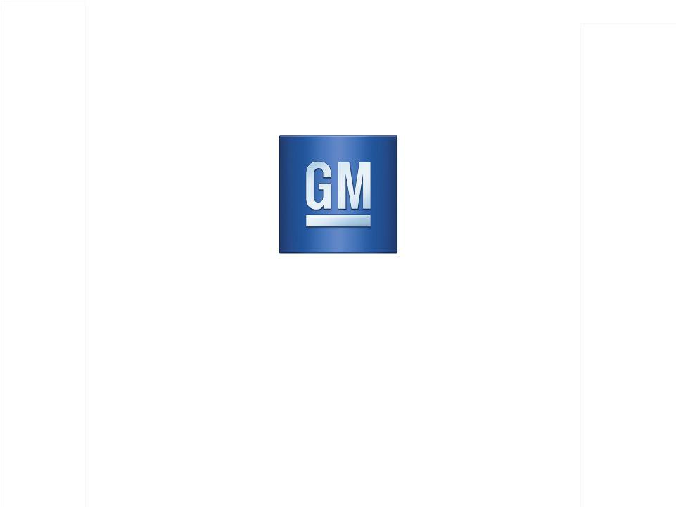
Exhibit 99.2

General Motors Company

Q2 2011 Results

August 4, 2011

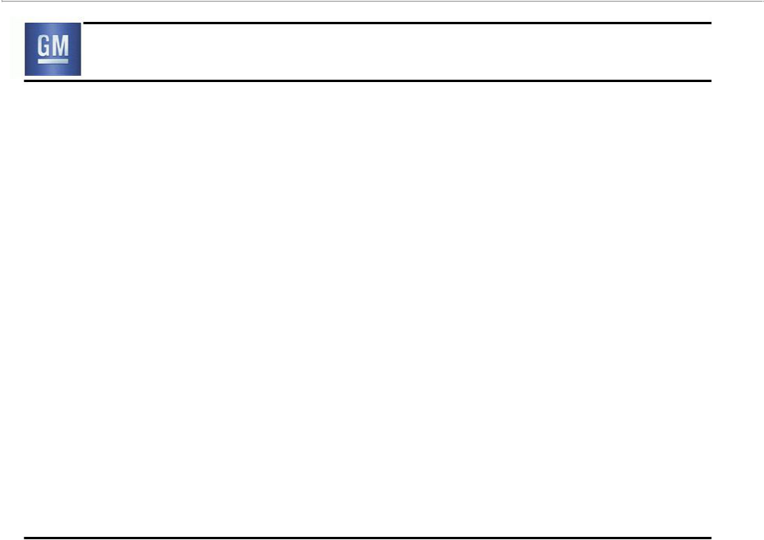
Forward Looking Statements

In this presentation and in related comments by our management, our use of the words “expect,” “anticipate,” “possible,” “potential,” “target,” “believe,” “commit,” “intend,” “continue,” “may,” “would,” “could,” “should,” “project,” “projected,” “positioned” or similar expressions is intended to identify forward looking statements that represent our current judgment about possible future events. We believe these judgments are reasonable, but these statements are not guarantees of any events or financial results, and our actual results may differ materially due to a variety of important factors. Among other items, such factors might include: our ability to realize production efficiencies and to achieve reductions in costs as a result of our restructuring initiatives and labor modifications; our ability to maintain quality control over our vehicles and avoid material vehicle recalls; our suppliers’ ability to deliver parts, systems and components at such times to allow us to meet production schedules; our ability to maintain adequate liquidity and financing sources and an appropriate level of debt, including as required to fund our planned significant investment in new technology; our ability to realize successful vehicle applications of new technology; and our ability to continue to attract new customers, particularly for our new products.

GM's most recent annual report on Form 10-K and quarterly report on Form 10-Q provides information about these and other factors, which we may revise or supplement in future reports to the SEC.

1

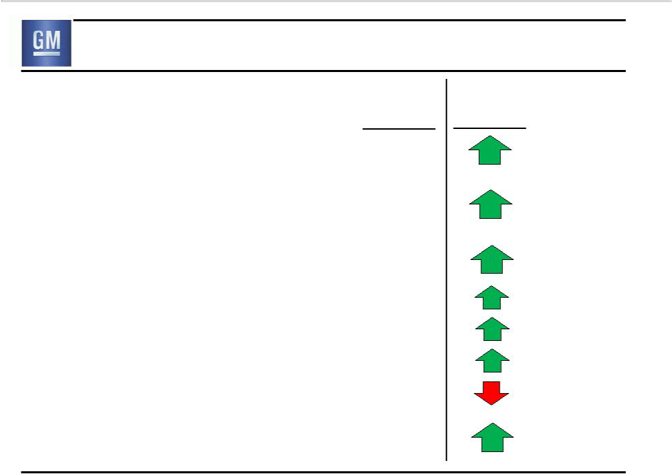
Second Quarter 2011 Highlights

 | Q2 ‘11 | F/(U) vs.
 | Q2 ‘11 | Q2 ‘10
Global Deliveries | 2.3M
Net Revenue | $39.4B
EBIT - Adj. | $3.0B
- GMNA | $2.2B
- GME | $0.1B
- GMIO | $0.6B
- GMSA | $0.1B
Auto Free Cash Flow | $3.8B

2

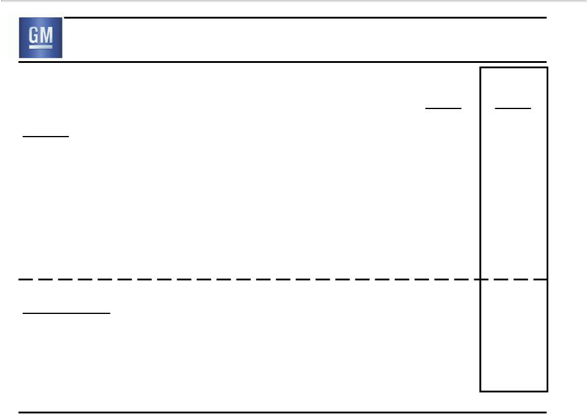
Summary of Q2 2011 Results

 | Q2 | Q2
 | 2010 | 2011
GAAP
Net Revenue ($B) | 33.2 | 39.4
Operating Income ($B) | 1.9 | 2.5
Net Income to Common Stockholders ($B) | 1.3 | 2.5
EPS – Diluted ($/Share) | 0.85 | 1.54
Non- GAAP
EBIT- Adj. ($B) | 2.0 | 3.0
Automotive Free Cash Flow ($B) | 2.8 | 3.8
Note: Starting Q4 2010 EBIT-Adj. includes GM Financial on an Earnings Before Tax (EBT) basis |  | 3

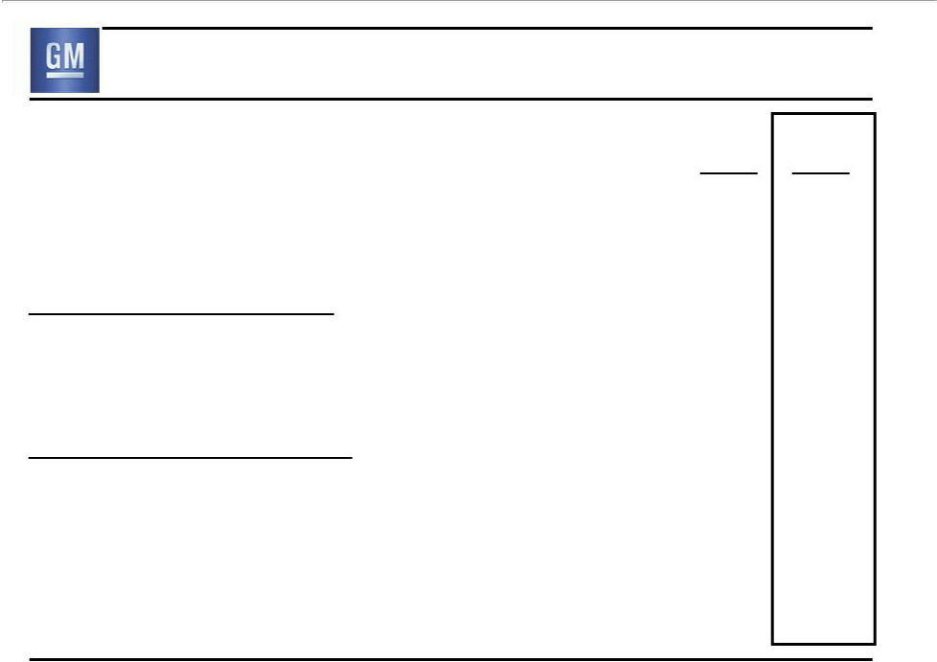
Net Income Impact of Special Items

 | Q2 | Q2
 | 2010 | 2011
Net Income to Common Stockholders ($B) | 1.3 | 2.5
EPS – Diluted ($/Share) | 0.85 | 1.54
Special Items Included ($B):
None | - | -

Total Impact of Special Items:

Net Income to Common Stockholders ($B)

-

-

EPS – Diluted ($/Share)

-

-

4

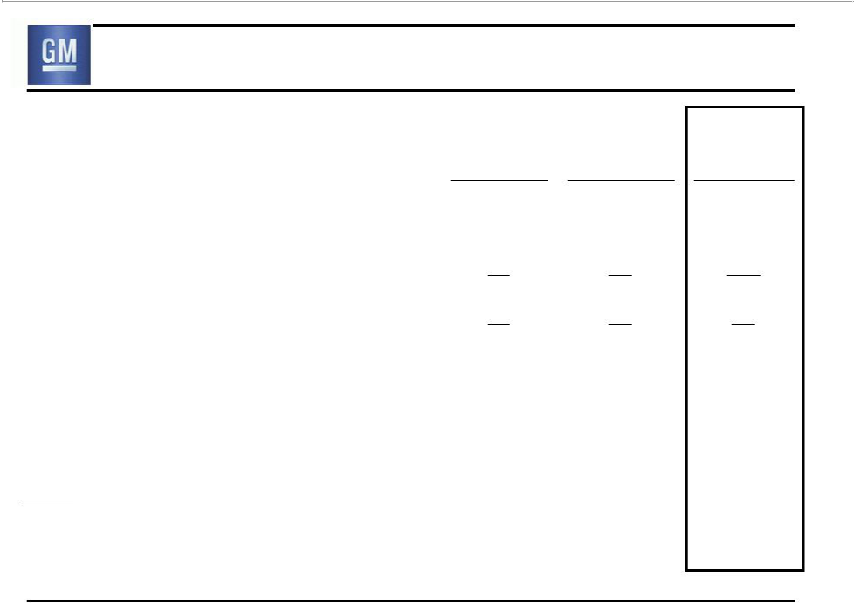
Info Item: Fully Diluted EPS Calculation

 | Q2 | Q1 | Q2
 | 2010 | 2011 | 2011
Net income to stockholders ($B) | 1.5 | 3.4 | 3.0
Cumulative dividend on Series A | (0.2) | (0.2) | (0.2)
Cumulative dividend on Series B | n/a | (0.1) | (0.1)
Undistributed earnings allocated to Series B | n/a | 0.0 | (0.3)
Net income to common ($B) | 1.3 | 3.2 | 2.5
Add back Series B Preferred dividend | n/a | 0.1 | 0.0
Net income to common – diluted EPS calc. ($B) | 1.3 | 3.2 | 2.5
Fully diluted share count (M) | 1,567 | 1,817 | 1,654
Memo: Series B equivalents included | n/a | 148 | 0
EPS – Diluted ($/share) | 0.85 | 1.77 | 1.54
Memo:
Average stock price in $33.00 - $39.60 range | n/a | Y | N
EPS calculation method | n/a | If Converted | Two-Class
Note: Results may not foot due to rounding |  |  | 5

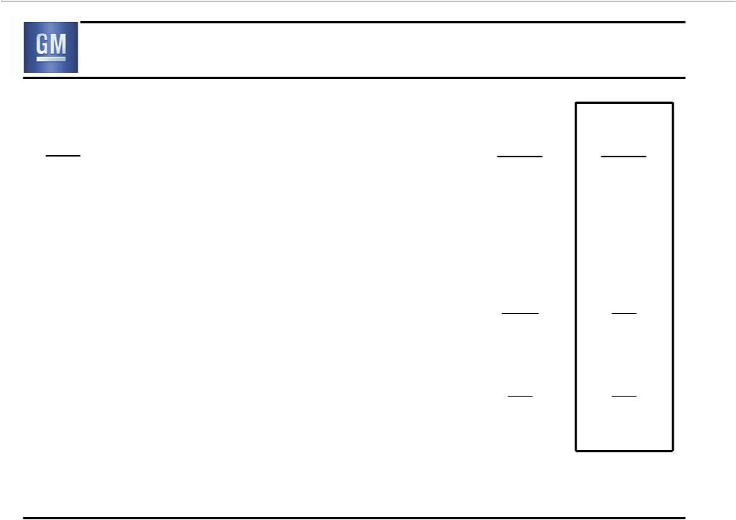
Q2 Operating Income Walk to EBIT- Adj.

 | Q2 | Q2
($B) | 2010 | 2011
Operating Income | 1.9 | 2.5
Equity Income | 0.4 | 0.4
Non-Controlling Interests | (0.1) | 0.0
Non-Operating Income | (0.2) | 0.2
Earnings Before Interest & Taxes (EBIT) | 2.0 | 3.0
Less Special Items | 0.0 | 0.0
EBIT- Adj. | 2.0 | 3.0
Note: Starting Q4 2010 EBIT & EBIT-Adj. include GM Financial on an Earnings Before Tax (EBT) basis
Note: Results may not foot due to rounding |  | 6

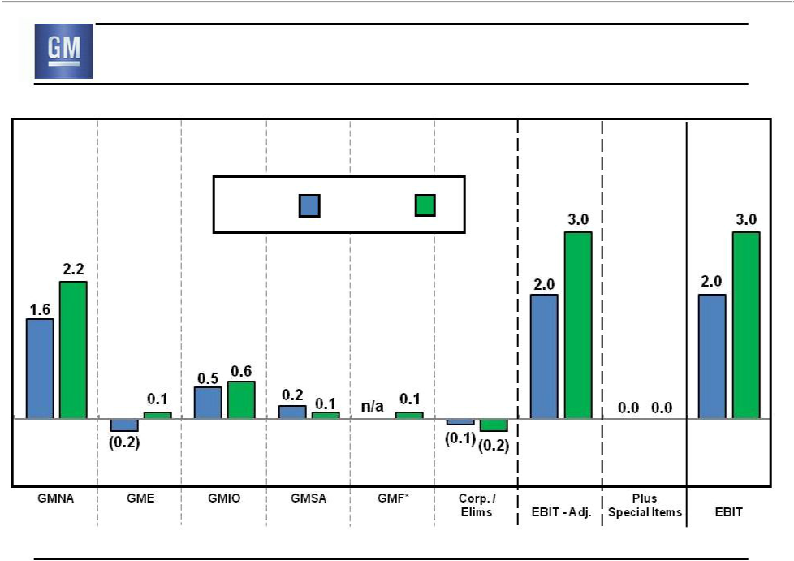
Q2 EBIT & EBIT- Adj.

($B)

GMNA | GME | GMIO | GMSA | GMF* | Corp./ | EBIT-Adj. | Plus
 |  |  |  |  | Elims | EBIT-Adj. | Special ItemsEBIT
 |  | Q2 2010 |  | Q2 2011

Note: Results may not foot due to rounding * GMF at an Earnings Before Tax basis (EBT) ⁷

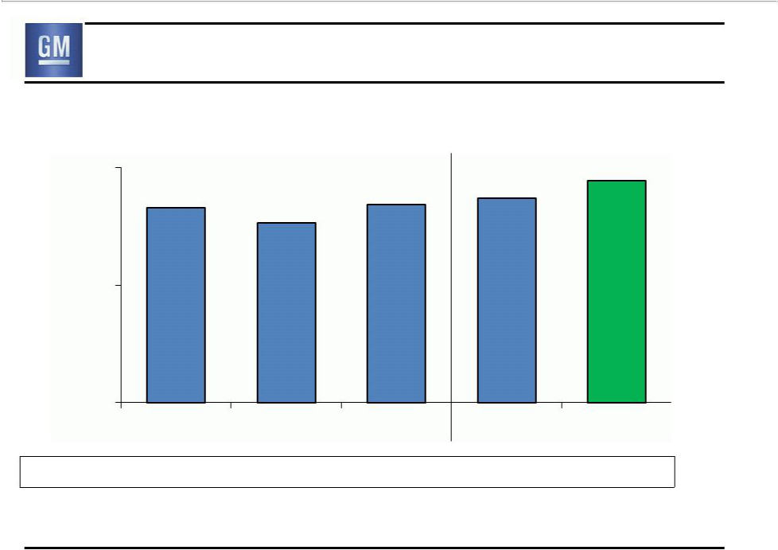
Global Deliveries

(000’s)
2,400 |  | 2,320
2,162 | 2,179 | 2,216
 | 2,068

1,700

1,000

 | Q2 2010 | Q3 2010 | Q4 2010 | Q1 2011 | Q2 2011
Global Share | 11.6% | 11.4% | 11.5% | 11.4% | 12.2%

GM deliveries & market share include vehicles sold around the world under GM and JV brands, and through GM-branded distribution network

8

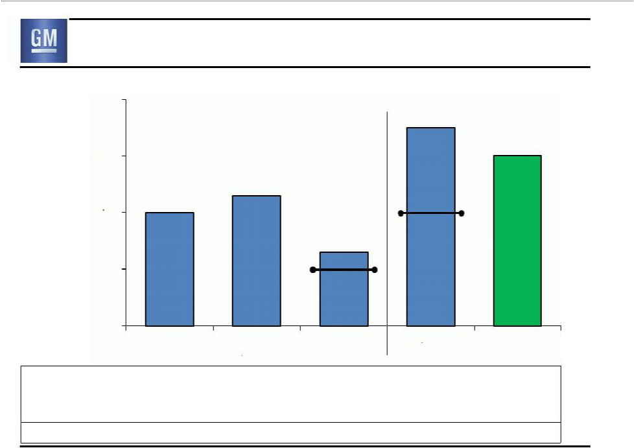
Earnings Before Interest & Taxes

($B)

4.0

3.5

3.0

2.0

1.0

0.0

Revenue ($B)

Oper Inc % Rev EBIT-Adj % Rev.

Production (000’s)

3.0

2.3

2.0

 |  |  | 2.0
 |  | 1.3 | EBIT-Adj.
 |  | 1.0
 |  | EBIT-Adj.
Q2 | Q3 | Q4 | Q1 | Q2
2010 | 2010 | 2010 | 2011 | 2011
33.2 | 34.1 | 36.9 | 36.2 | 39.4
5.7% | 5.4% | 0.6% | 2.6% | 6.2%
6.1% | 6.7% | 2.8% | 5.6% | 7.5%
2,257 | 2,104 | 2,269 | 2,327 | 2,400

Note: Starting Q4 2010 EBIT & EBIT-Adj. include GM Financial on an Earnings Before Tax (EBT) basis | 9

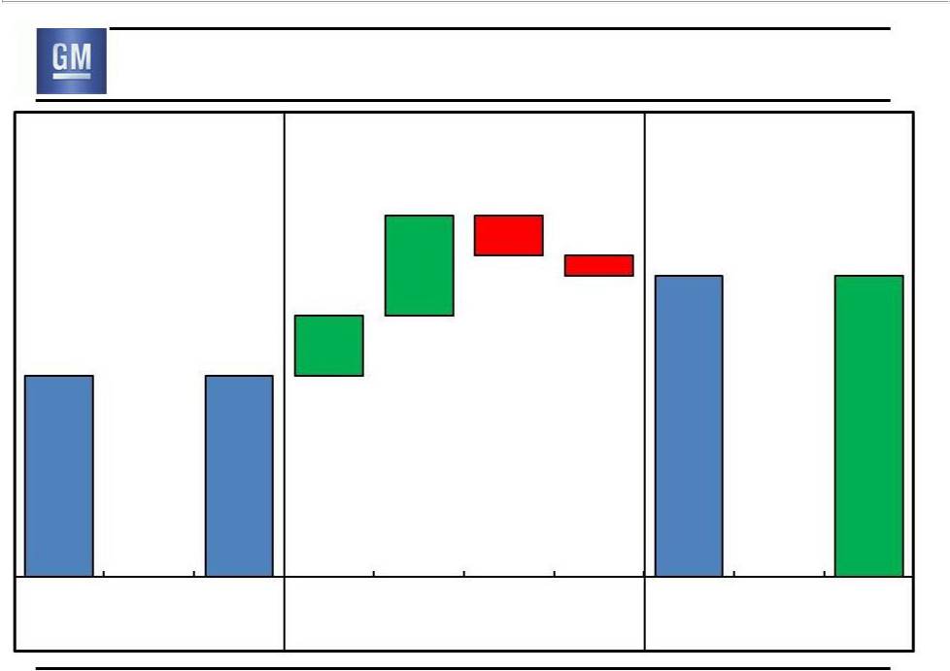
Consolidated EBIT – Q2 2010 vs. Q2 2011

Q2 2010 | $1.0B Improvement |  | Q2 2011
EBIT ($B) |  |  | EBIT ($B)
EBIT ($B) | 1.0 | (0.4) | EBIT ($B)
 |  | (0.2)
 |  | 3.0 | 3.0
 | 0.6
2.0 | 2.0

 | 0.0 |  |  |  |  |  |  | 0.0
EBIT | Less Special | EBIT-Adj. | Volume / | Price | Cost | Other | EBIT-Adj. | Plus Special | EBIT
 | Items |  | Mix |  |  |  |  | Items
 |  |  |  |  |  |  |  |  | 10

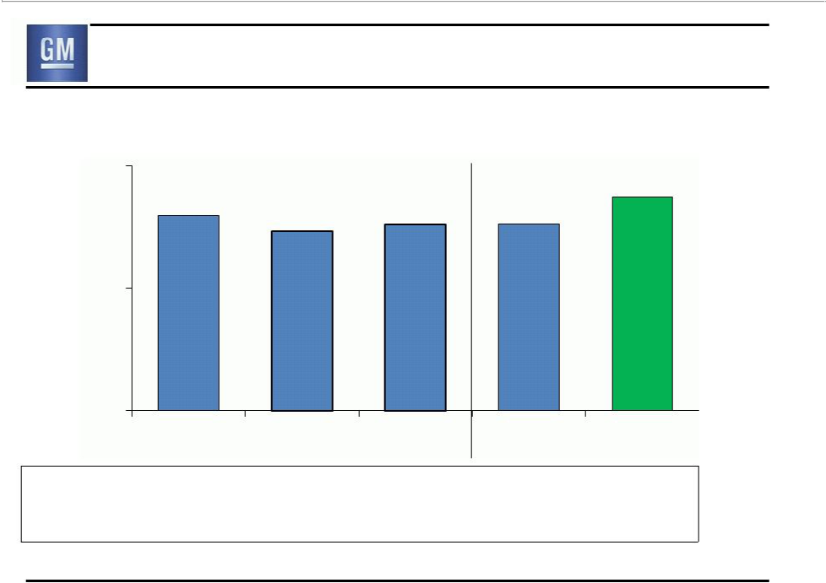
GMNA Deliveries

(000’s)

900
784

716 | 660 | 685 | 684

450

0
 | Q2 2010 | Q3 2010 | Q4 2010 | Q1 2011 | Q2 2011
GMNA Share | 18.7% | 17.7% | 18.5% | 18.3% | 19.1%
U.S. Share | 19.4% | 18.3% | 19.1% | 19.0% | 20.0%

11

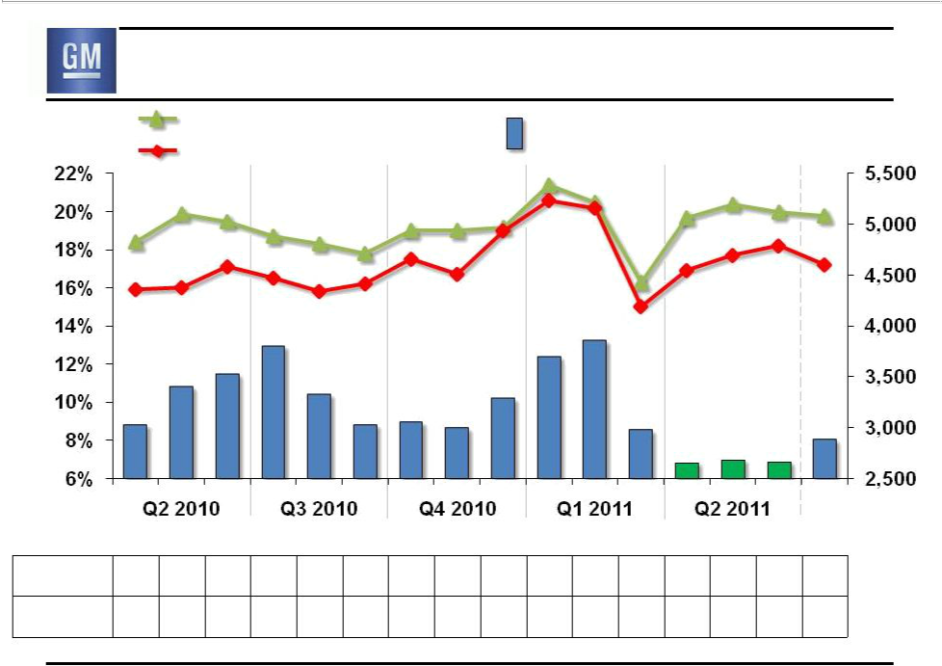
Key GMNA Performance Indicators

 | U.S. Total Share | Avg. GM U.S. Retail | $/Unit
Share | U.S. Retail Share | Incentive | $/Unit

 |  |  |  |  |  |  |  |  |  |  |  |  | Jul
 |  |  |  |  |  |  |  |  |  |  |  |  | 2011
Avg. U.S. Retail Incentive as % of ATP |  |  |  |  |  |  |  |  |  |  |  |  | est.
GM % | 9.9 11.2 | 11.7 | 12.6 | 10.7 | 9.6 | 9.6 9.4 | 10.4 | 12.6 | 13.2 | 9.8 | 8.9 9.1 | 8.9 | 9.5
GM vs. Ind. | 0.95 1.03 | 1.10 | 1.12 | 1.01 | 0.95 | 1.02 0.97 | 1.00 | 1.26 | 1.23 | 0.96 | 1.00 1.10 | 1.01 | 0.98
(GM % / Ind. %)
Note: Incentive & ATP Information Based on J.D. Power and Associates Power Information Network data |  |  |  |  |  |  |  |  |  |  |  |  | 12

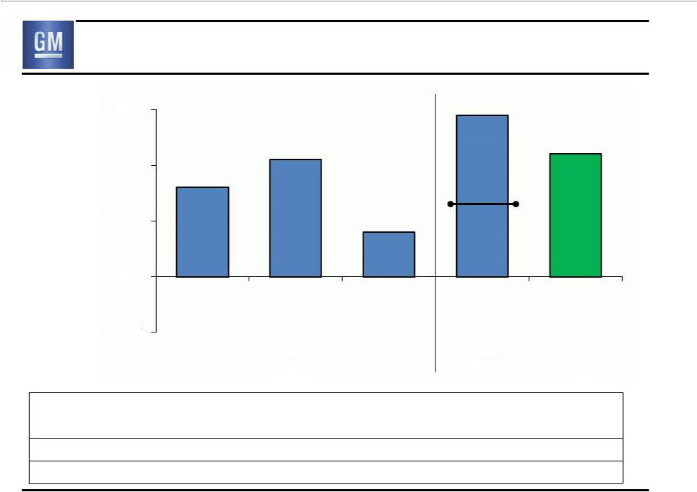
GMNA Earnings Before Interest & Taxes

($B)

3.0 |  |  |  | 2.9
2.0 |  | 2.1
2.0 | 1.6
1.0 |  |  | 0.8 | 1.3
1.0 |  |  | 0.8 | EBIT-Adj.
0.0
(1.0) | Q2 | Q3 | Q4 | Q1
 | 2010 | 2010 | 2010 | 2011
Revenue ($B) | 20.3 | 21.5 | 22.0 | 22.1
EBIT-Adj % Rev | 7.9% | 9.9% | 3.4% | 5.7%
Production (000’s) | 731 | 707 | 703 | 786
U.S. Dealer Inv (000’s) | 438 | 478 | 511 | 574

2.2

Q2

2011

23.1

9.7%

824

605

13

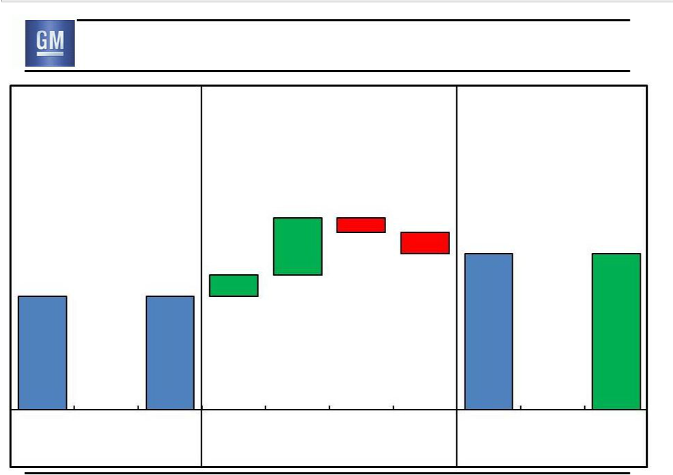
GMNA EBIT – Q2 2010 vs. Q2 2011

Q2 2010 | $0.6B Improvement | Q2 2011
EBIT ($B) | $0.6B Improvement | EBIT ($B)

0.8 (0.2)

0.3

1.6 1.6

(0.3)

2.2 2.2

 | 0.0 |  |  |  |  |  |  | 0.0
EBIT | Less Special | EBIT-Adj. | Volume / | Price | Cost | Other | EBIT-Adj. | Plus Special | EBIT
 | Items |  | Mix |  |  |  |  | Items
 |  |  |  |  |  |  |  |  | 14

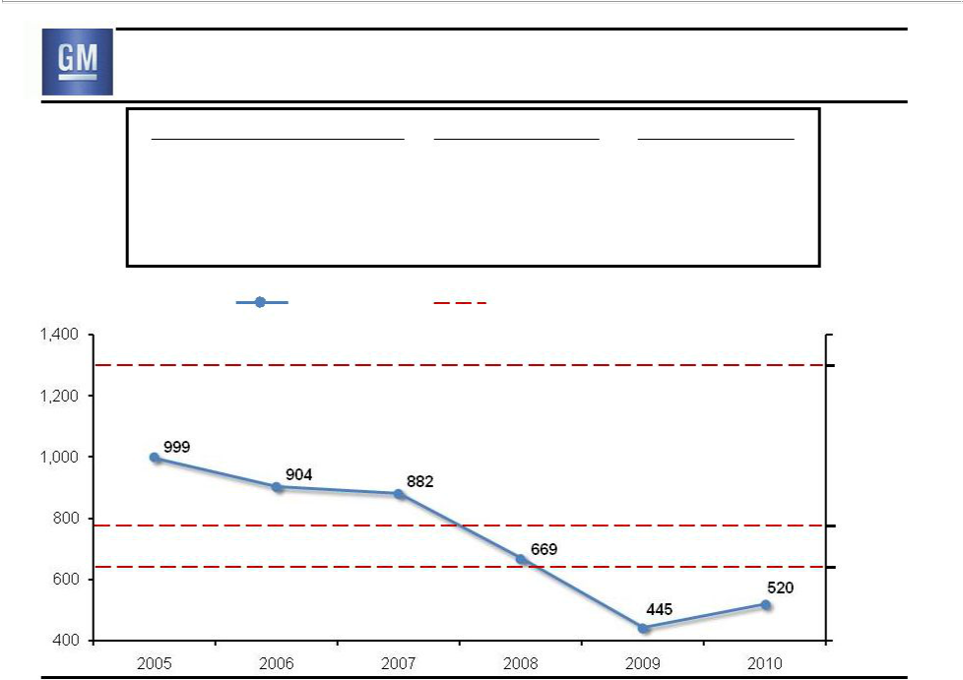
Info Item: U.S. Full-size Pickup Dealer Stock

 | U.S. Dealer Stock | Units (000’s) | Days Supply
 | December 2010 | 159 | 70
 | June 2011 | 219 | 122
 | July 2011 | 209 | 115
 | December 2011 Objective | ~200 | ~90
U.S. Sales | GM U.S. F/S | GM U.S. Country Of Sale
(000’s) | Pickup Sales | F/S Pickup Capacity

U.S. Country of Sale Capacity* (000’s)

- Plant Capacity 1,300

Normal

- Plant Capacity ~780

2012

- Plant Capacity ~640

* Capacity on three-shift basis | 15

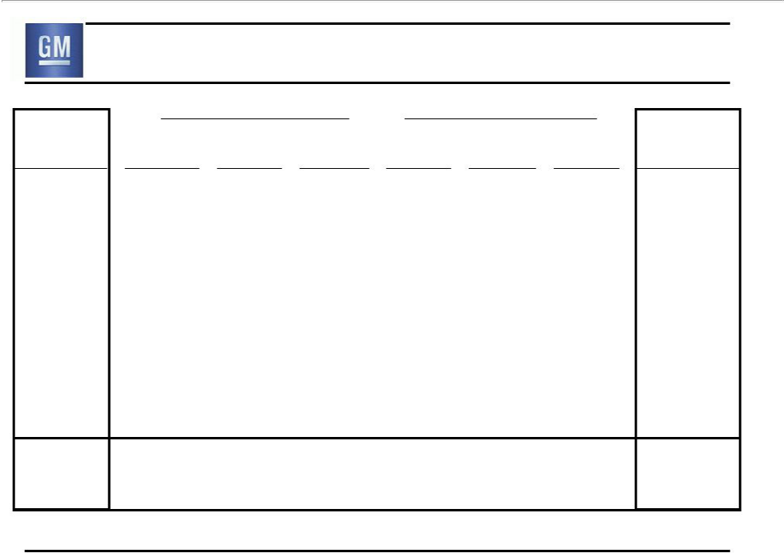
Info Item: GMNA EBIT-Adj (Sequential & Y-o-Y)

EBIT-Adj.

(prior period)

$1.6B

(Q2 2010)

$2.1B

(Q3 2010)

$0.8B

(Q4 2010)

$1.3B

(Q1 2011)

$1.6B

(Q2 2010)

 |  |  | ($B) | C$
Volume | Mix | Price | Cost | NML | Other
0.1 | 0.2 | 0.6 | 0.0 | (0.4) | 0.0
0.4 | (0.9) | (0.3) | (0.5) | 0.0 | 0.0
0.2 | 0.1 | (0.1) | 0.2 | 0.0 | 0.1
0.0 | 0.2 | 0.6 | 0.0 | 0.2 | (0.1)
0.6 | (0.3) | 0.8 | (0.2) | (0.2) | (0.1)

EBIT-Adj.

(current period)

$2.1B

(Q3 2010)

$0.8B

(Q4 2010)

$1.3B

(Q1 2011)

$2.2B

(Q2 2011)

$2.2B

(Q2 2011)

Note: Results may not foot due to rounding | 16

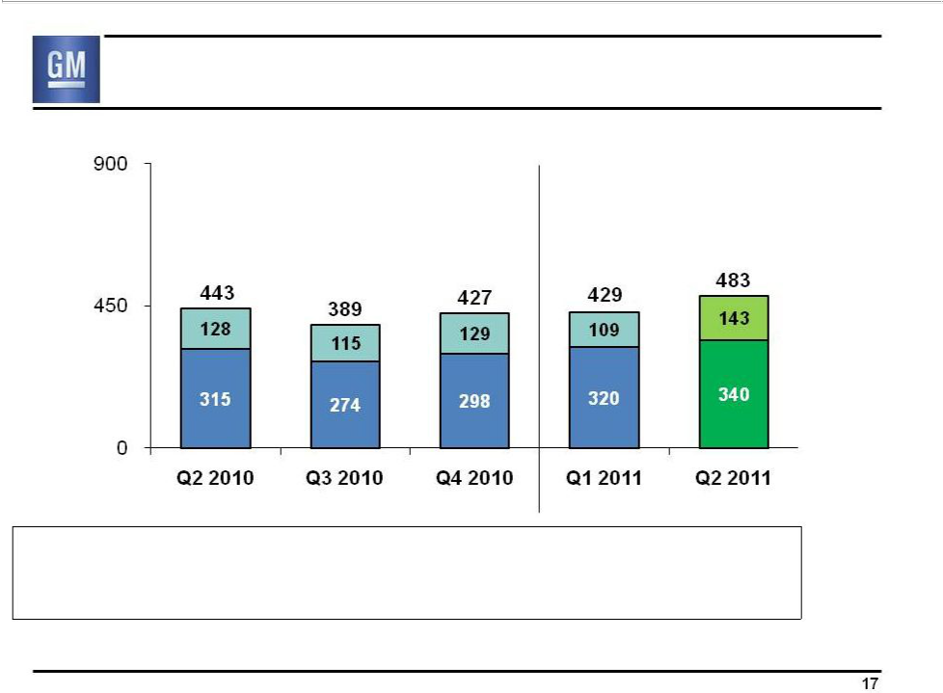
GME Deliveries

(000’s)

Chevrolet

GME Excl.

Chevrolet

GME Share | 8.8% | 8.9% | 9.0% | 8.5% | 9.1%
Germany Share | 8.0% | 8.5% | 9.0% | 8.2% | 8.9%
U.K. Share | 13.8% | 12.6% | 12.4% | 12.6% | 13.3%

GME deliveries and market share include unit sales of Chevrolets produced by GMIO and delivered to customers in GME. Revenue and associated costs of these unit sales are reported by GMIO

17

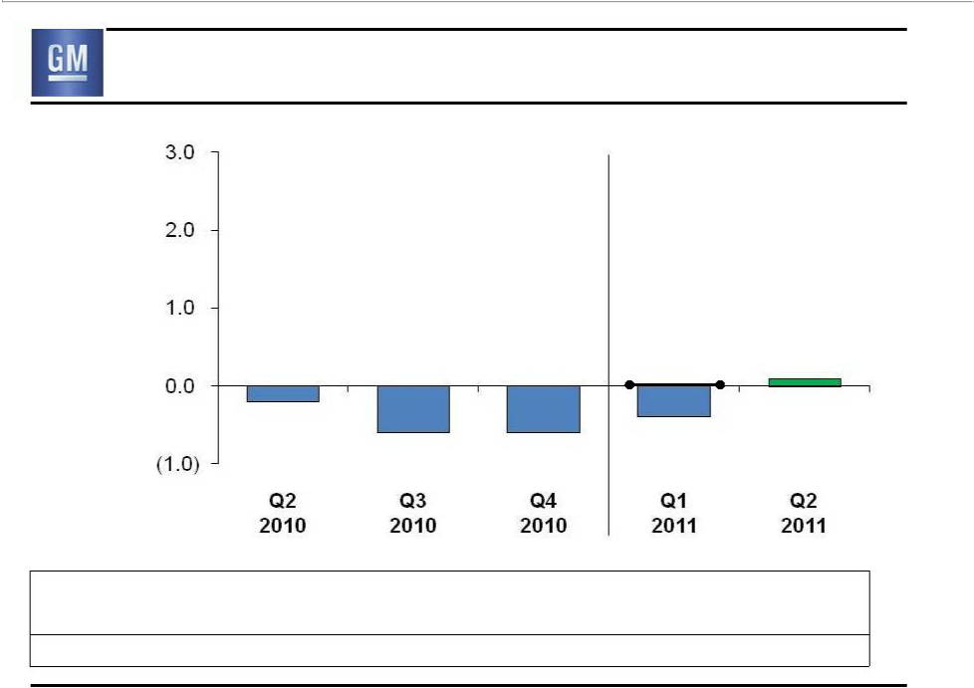
GME Earnings Before Interest & Taxes

($B)

(0.2)

0.0 _{0.1}

EBIT-Adj.

(0.4)
(0.6) (0.6)

Revenue ($B) | 6.0 | 5.7 | 6.9 | 6.9 | 7.5
EBIT-Adj % Rev | (2.6)% | (9.9)% | (9.2)% | 0.1% | 1.4%
Production (000’s) | 331 | 286 | 313 | 344 | 326

18

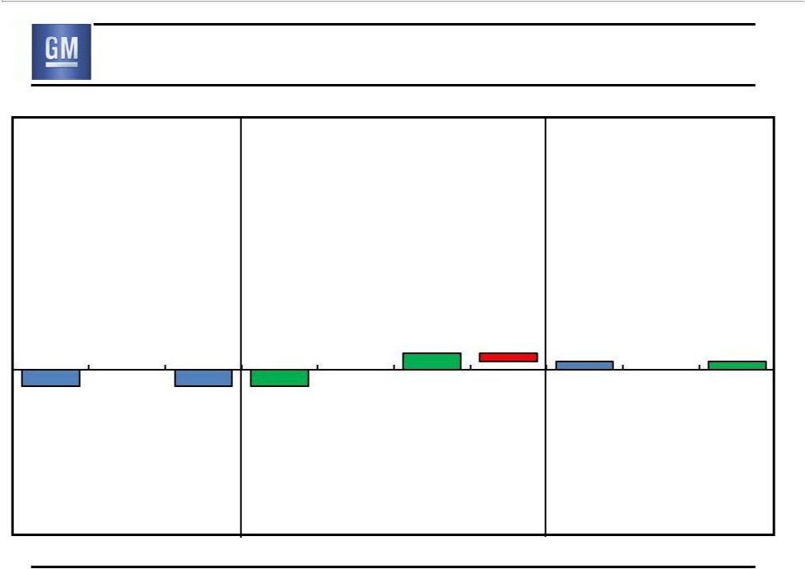
GME EBIT – Q2 2010 vs. Q2 2011

Q2 2010 | $0.3B Improvement | Q2 2011
EBIT ($B) | $0.3B Improvement | EBIT ($B)

 | 0.2 | 0.2 | (0.1) | 0.1 |  | 0.1
0.0 | 0.2 | 0.0 |  | 0.1 | 0.0 | 0.1
(0.2) | (0.2)

EBIT | Less Special | EBIT-Adj. | Volume / | Price | Cost | Other | EBIT-Adj. | Plus Special | EBIT
 | Items |  | Mix |  |  |  |  | Items

19

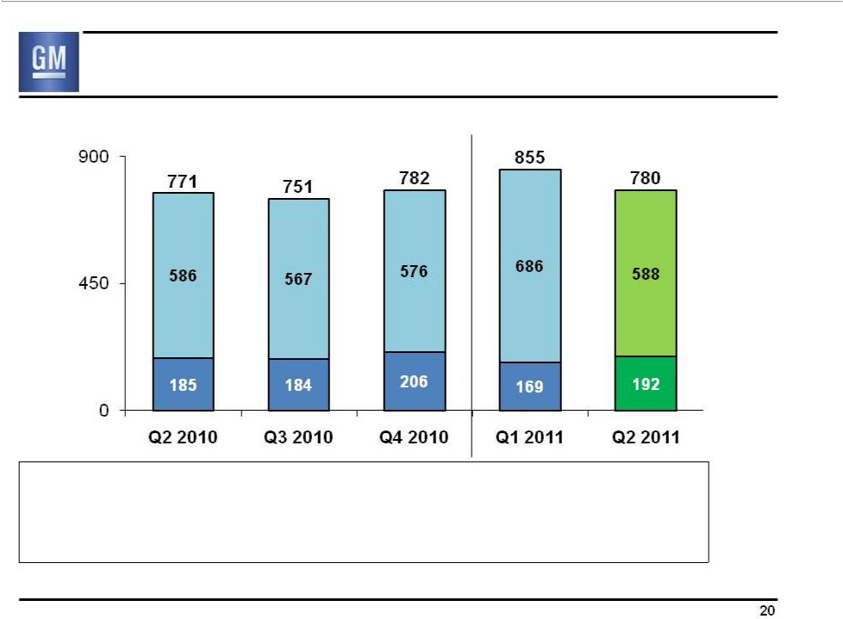
GMIO Deliveries

(000’s)

China

GMIO Excl.

China

GMIO Share | 8.9% | 8.7% | 8.6% | 9.2% | 9.6%
China Share | 13.1% | 13.6% | 11.6% | 13.6% | 13.3%
India Share | 4.0% | 3.0% | 3.4% | 3.1% | 3.4%

20

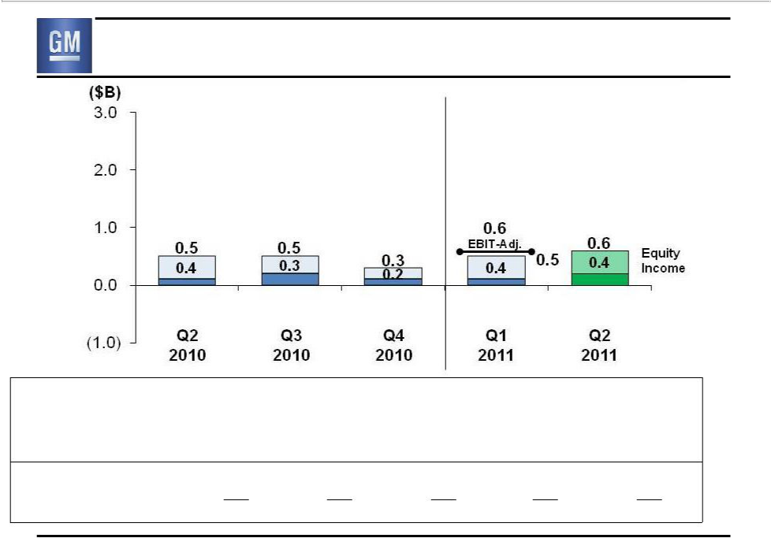
GMIO Earnings Before Interest & Taxes

Revenue ($B) | 5.3 | 5.1 | 6.1 | 5.4
EBIT margin from | 3.7% | 4.5% | 2.0% | 3.0%
consolidated operations*
Total China JV NI/Rev** | 12.6% | 11.9% | 7.7% | 12.0%
Consolidated Prod. (000’s) | 268 | 235 | 265 | 257
Joint Venture Prod. (000’s) | 697 | 631 | 747 | 709
Total Production (000’s) | 965 | 866 | 1,012 | 966

- Excludes equity income and non-controlling interest adjustment. See supplementary schedule S9 for additional details. ** Revenue not consolidated in GM results, pro-rata share of earnings reported as equity inc.

6.6

3.4%

11.1%

310

693

1,003

21

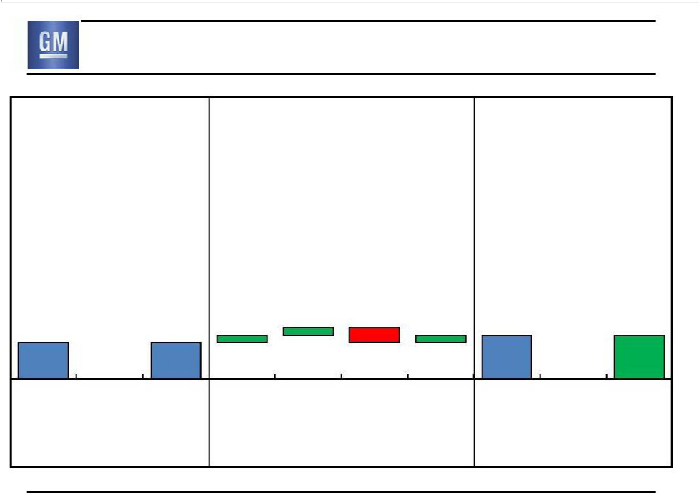
GMIO EBIT – Q2 2010 vs. Q2 2011

Q2 2010 | $0.1B Improvement | Q2 2011
EBIT ($B) | $0.1B Improvement | EBIT ($B)

0.5 |  | 0.5 | 0.1 | 0.1 | (0.2) | 0.1 | 0.6 |  | 0.6
 | 0.0 |  |  |  |  |  |  | 0.0
EBIT | Less Special | EBIT-Adj. | Volume / | Price | Cost | Other | EBIT-Adj. | Plus Special | EBIT
 | Items |  | Mix |  |  |  |  | Items

22

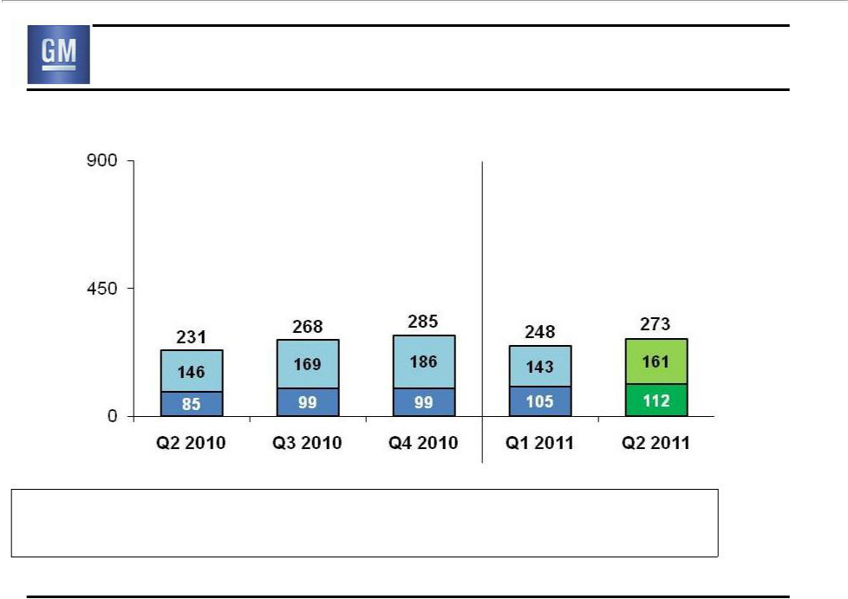
GMSA Deliveries

(000’s)

Brazil

GMSA Other

GMSA Share | 19.5% | 19.8% | 19.6% | 18.7% | 19.2%
Brazil Share | 18.4% | 18.3% | 18.4% | 17.3% | 17.6%

23

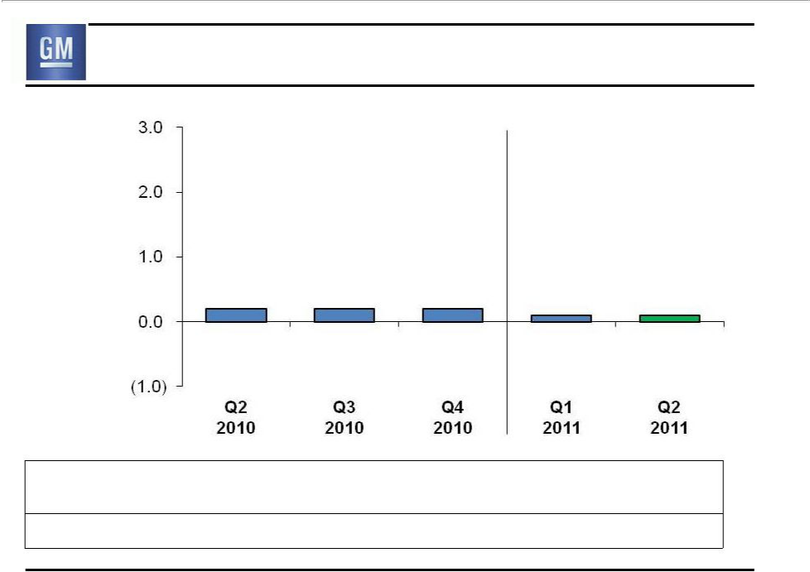
GMSA Earnings Before Interest & Taxes

($B)

0.2 | 0.2 | 0.2 | 0.1 | 0.1

Revenue ($B) | 3.6 | 4.0 | 4.5 | 3.9 | 4.4
EBIT-Adj % Rev | 5.4% | 4.1% | 4.4% | 2.3% | 1.3%
Production (000’s) | 230 | 245 | 241 | 231 | 247

24

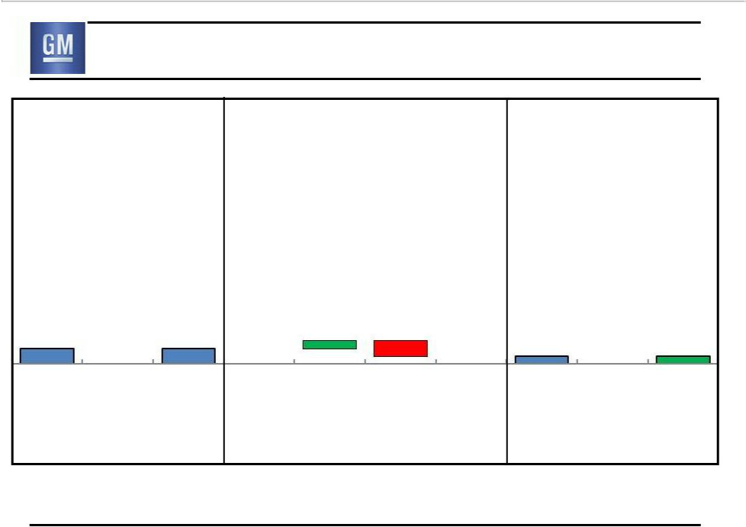
GMSA EBIT – Q2 2010 vs. Q2 2011

Q2 2010 | $0.1B Reduction | Q2 2011
EBIT ($B) | $0.1B Reduction | EBIT ($B)

0.2 |  | 0.2 |  | 0.1 | (0.2) |  | 0.1 |  | 0.1
0.2 | 0.0 | 0.2 | 0.0 |  |  | 0.0 | 0.1 | 0.0 | 0.1
EBIT | Less Special | EBIT-Adj. | Volume / | Price | Cost | Other | EBIT-Adj. | Plus Special | EBIT
 | Items |  | Mix |  |  |  |  | Items

25

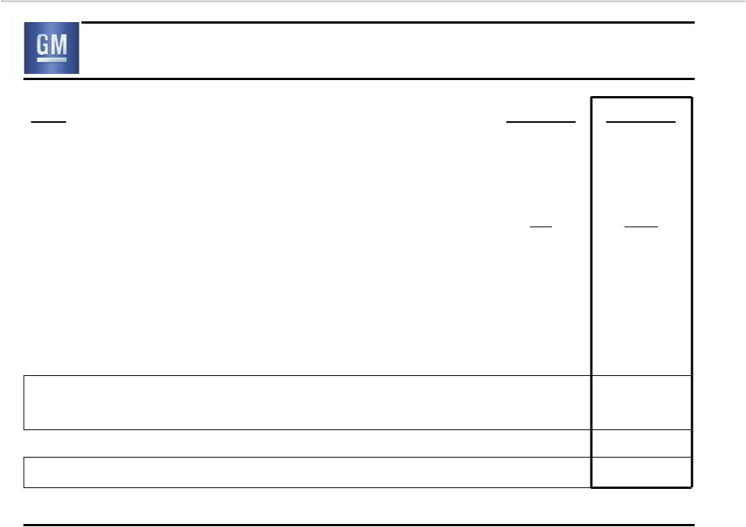
Automotive Free Cash Flow

($B)

Net Income to Common Stockholders

Add-back Non-Controlling Interests, Preferred Dividends & undistributed earnings allocated to Series B

Deduct Non-Auto (GM Financial)

Automotive Net Income

Depreciation / Amortization

Working Capital

Pension / OPEB – Cash in Excess of Expense

Other

Automotive Net Cash Provided/(Used)

Operating Activities

Capital Expenditures

Automotive Free Cash Flow

Note: Results may not foot due to rounding

Q2 2010 Q2 2011

1.3 2.5

0.3 0.5

n/a (0.2)

1.6 2.9

1.7 1.6

0.0 0.1

(0.2) (0.4)

0.7 0.7

3.8 5.0

(1.0) (1.2)

2.8 3.8

26

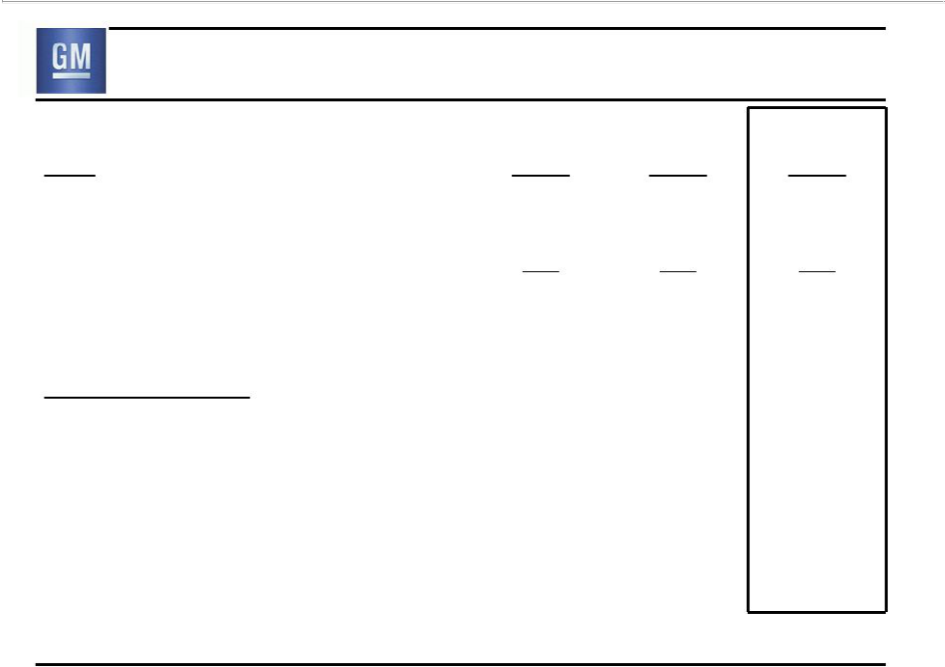
Key Automotive Balance Sheet Items

 | Jun. 30 | Mar. 31 | Jun. 30
($B) | 2010 | 2011 | 2011
Cash & marketable securities* | 32.5 | 30.6 | 33.8
Available Credit Facilities | 1.1 | 5.9 | 5.9
Available Liquidity* | 33.6 | 36.5 | 39.7
Key Obligations:
Debt | 8.2 | 5.0 | 4.7
Series A Preferred Stock | 7.0 | 5.5 | 5.5
U.S. Pension Underfunded Status** | 15.8 | 11.2*** | 10.8***
Unfunded OPEB | 9.3 | 10.0 | 10.0

* Includes Canadian HC Trust restricted cash
** Excludes U.S. non-qualified plan PBO of ~$0.9 billion
*** Excludes ~$2B stock contribution completed 1/13/11 that will be counted as a plan asset starting in July 2011 | 27

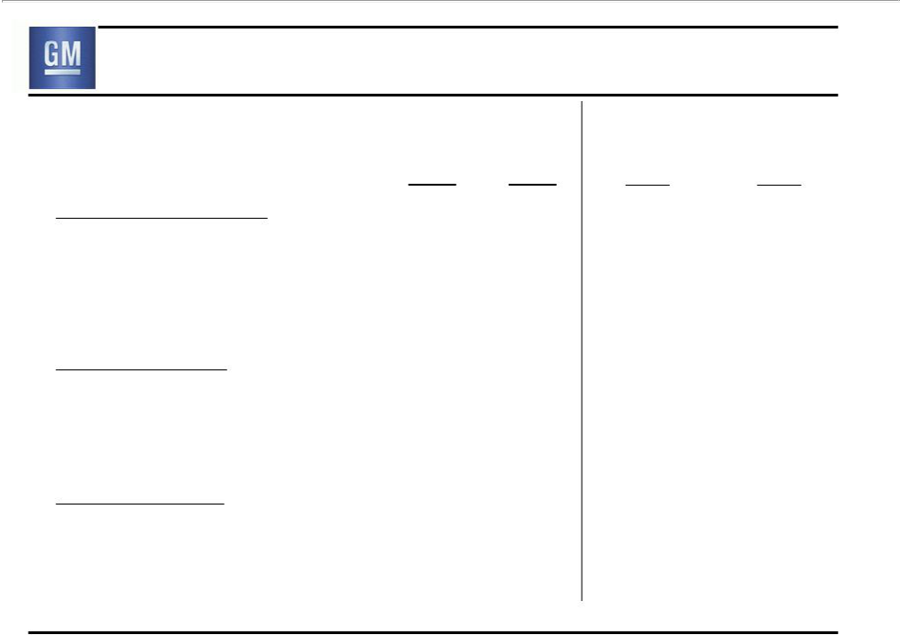
GM Financial

Industry Avg. (Excl. GM)

 | Q2 | Q2 | Q2 | Q2
 | 2010 | 2011 | 2010 | 2011
GM Sales Penetrations
U.S. Subprime (<=620) | 4.9% | 6.8% | 4.2% | 5.1%
U.S. Lease | 6.5% | 13.3% | 20.9% | 21.2%
Canada Lease | 2.7% | 8.4% | 15.8% | 19.0%
GM / GMF Linkage
GM as % of GMF Originations | 14.0% | 38.0%
(GM New / GMF Loan & Lease)
GMF as % of GM U.S. S/P & Lease | 11.1% | 18.1%
GMF Performance
GMF Credit Losses | 4.5% | 2.4%
(annualized net charge-offs as % avg. receivables)
EBT ($M) | 139* | 144
GM Sales Penetrations based on JD Power PIN
* GM acquired GMF in Oct. 2010, prior to this GMF was an independent entity and not consolidated into GM results. Q2 2010 does not |  |  |  | 28
reflect purchase accounting and is not directly comparable to Q2 | 2011

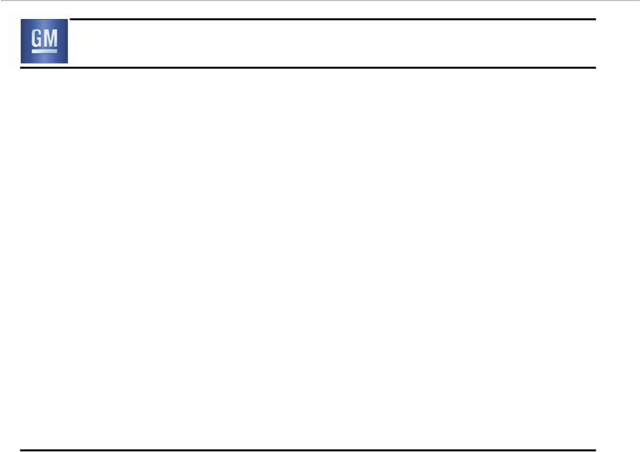
Second Quarter Summary

- Solid second quarter results

  - Continued success in the marketplace

  - Improved GMNA margins

  - Continued progress in Europe

- Good progress, but more to do

  - Flawless execution of H2 production launches

  - Focus on cost containment

  - Leverage global growth

- Based on current industry outlook, expect H2 2011 EBIT-Adj. to be modestly lower than H1, and full-year 2011 EBIT-Adj. to show solid improvement over 2010

29

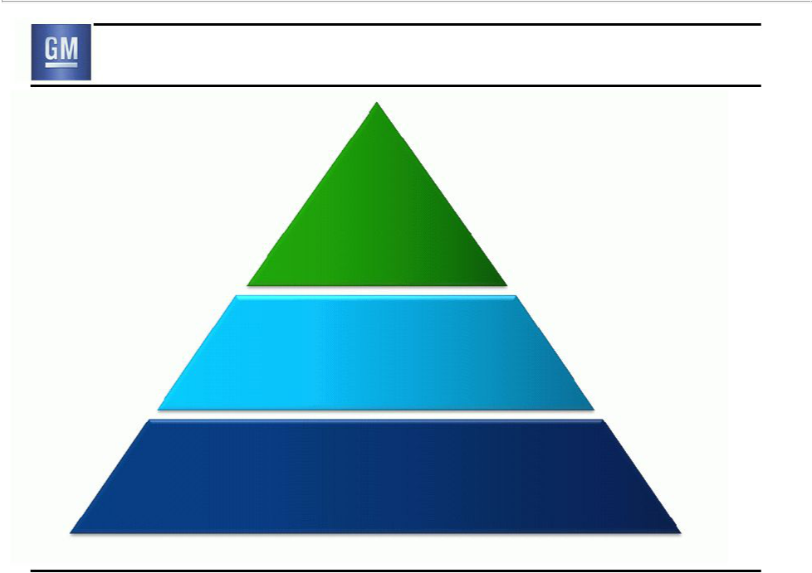
New GM

New
Business

Model

Leverage
to Global Growth

Significantly Lower Risk Profile

30

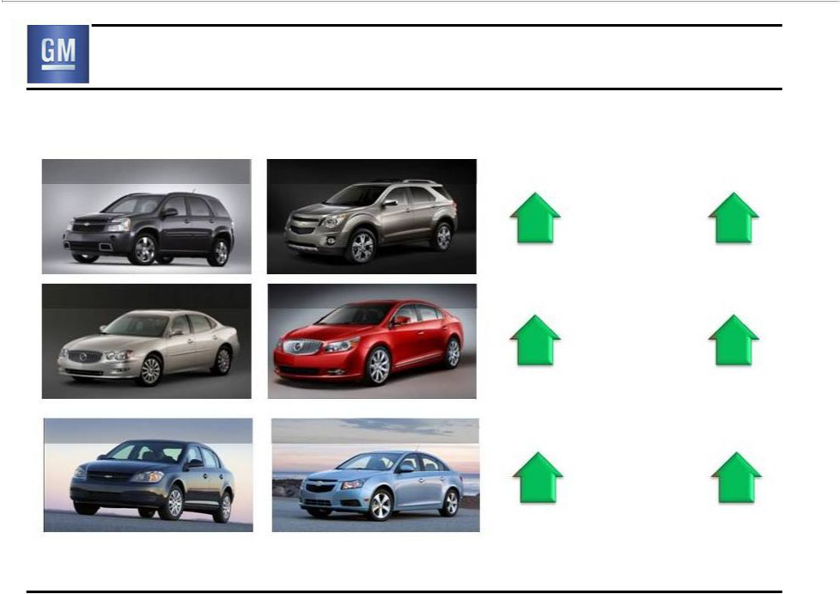
Success in Marketplace

Prior Current

Chevrolet Equinox, Q2 2009 Chevrolet Equinox, Q2 2011

Buick LaCrosse, Q2 2009 Buick LaCrosse, Q2 2011

Chevrolet Cobalt, Q2 2010 Chevrolet Cruze, Q2 2011

Segment | Average | 36 month
Retail Market Transaction Residual
Share | Price (ATP) | Value
14.6% |  | 49%
 | + $3,800
4.7% |  | 31%
15.5% |  | 45%
 | + $7,000
5.3% |  | 31%
12.5% |  | 48%
 | + $4,200
6.2% |  | 41%

Residual value based on ALG 36 mo. May/June | 31

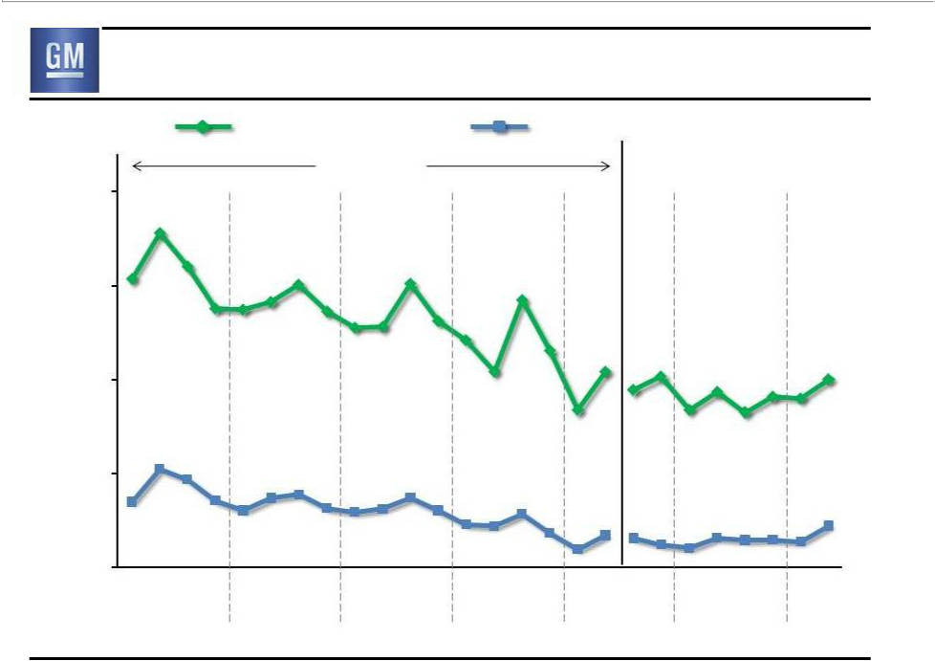
Success in Marketplace

GM Total U.S. | GM Global Share
Share | GM Global Share
Old GM | New GM
30%

25%

20%

15%

10%

2005 2006 2007 2008 2009 2010 2011

32

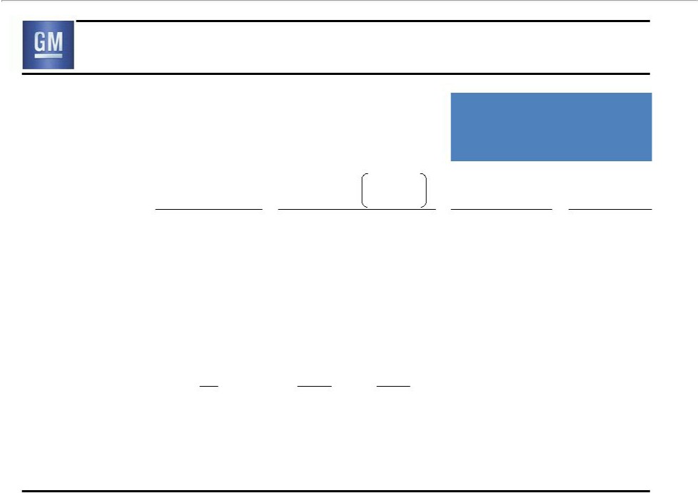
Leverage Global Growth

 | Industry
 | Volume
 | 2010*
 | (Millions)
BRIC | 25
- China | 17
North America | 14
Western Europe | 14
All Other | 19
 | 72

5 YR Industry

Growth

2010-2015E*

% Global

(Millions) Growth

+ 12 |  | 50%
+ 8 |  | 33%
+ | 6 | 25%
+ | 2 | 8%
+ | 4 | 17%
+ 24 |  | 100%

2011 H1 GM

Performance

Market Market

Position** Share**

1 12%

1 >13%

1 19%

5 8%

3 8%

- 2010 industry volume & 5 YR projected growth based on IHS Automotive car and light truck sales forecast July 2011 ** GM market position and share based on GM internal data and includes sales by joint ventures on a total vehicle basis

33

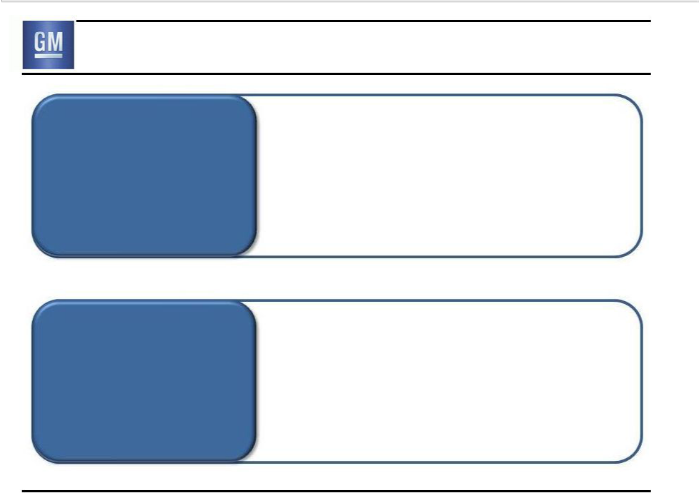
Significantly Lower Risk Profile

Break-Even at Bottom of Cycle

Fortress

Balance Sheet

- Profitable in all regions, Q2 2011

- H1 GMNA EBIT-Adj. $3.5B, US SAAR 12.8M

- H1 GME EBIT-Adj. $0.1B, +$0.9B vs. 2010

- $39.7B Automotive Liquidity

- $4.7B Automotive Debt

- $10.8B underfunded status of U.S. qualified pension plans

34

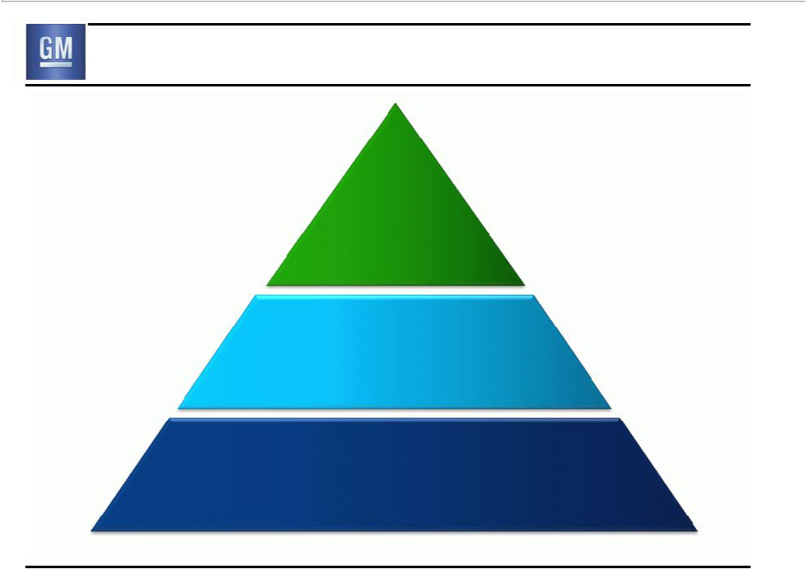
New GM

New
Business

Model

Leverage
to Global Growth

Significantly Lower Risk Profile

35



General Motors Company

Select Supplemental Financial Information

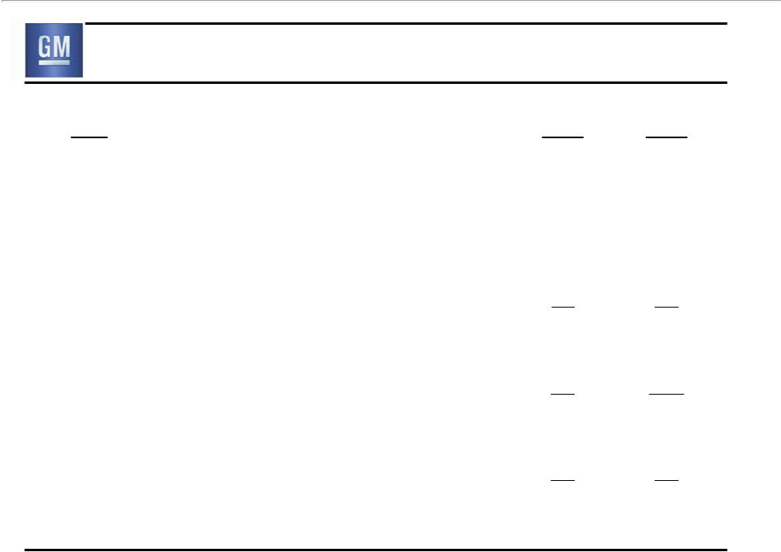
EBIT Walk to Net Income to Common Stockholders

 | Q2 | Q2
($B) | 2010 | 2011
GMNA | 1.6 | 2.2
GME | (0.2) | 0.1
GMIO | 0.5 | 0.6
GMSA | 0.2 | 0.1
Corp & Elims | (0.1) | (0.2)
GMF | n/a | 0.1
Total EBIT | 2.0 | 3.0
Interest Expense / (Income) | 0.1 | 0.0
Income Tax Expense / (Benefit) | 0.4 | (0.1)
Net Income to Stockholders | 1.5 | 3.0
Undistributed earnings allocated to Series B (Basic) | n/a | 0.3
Dividends on Preferred Stock | 0.2 | 0.2
Net Income to Common Stockholders | 1.3 | 2.5
Note: Starting Q4 2010 EBIT includes GM Financial on an Earnings Before Tax (EBT) basis
Note: Results may not foot due to rounding |  | S1

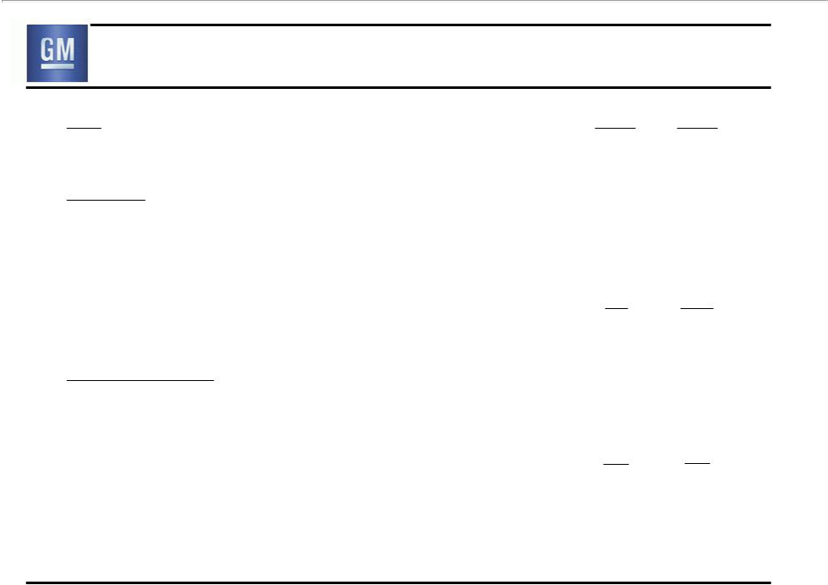
Reconciliation of Q2 2011 EBIT-Adj.

 | Q2 | Q2
($B) | 2010 | 2011
Net Income to Common Stockholders | 1.3 | 2.5
Add Back:
Undistributed earnings allocated to Series B (Basic) | n/a | 0.3
Dividends on Preferred Stock | 0.2 | 0.2
Interest Expense / (Income) | 0.1 | 0.0
Income Tax Expense / (Benefit) | 0.4 | (0.1)
Earnings Before Interest & Taxes (EBIT) | 2.0 | 3.0
Less Special Items:
None | 0.0 | 0.0
Total Special Items | 0.0 | 0.0
EBIT – Adj. | 2.0 | 3.0

Note: Starting Q4 2010 EBIT includes GM Financial on an Earnings Before Tax (EBT) basis
Note: Results may not foot due to rounding | S2

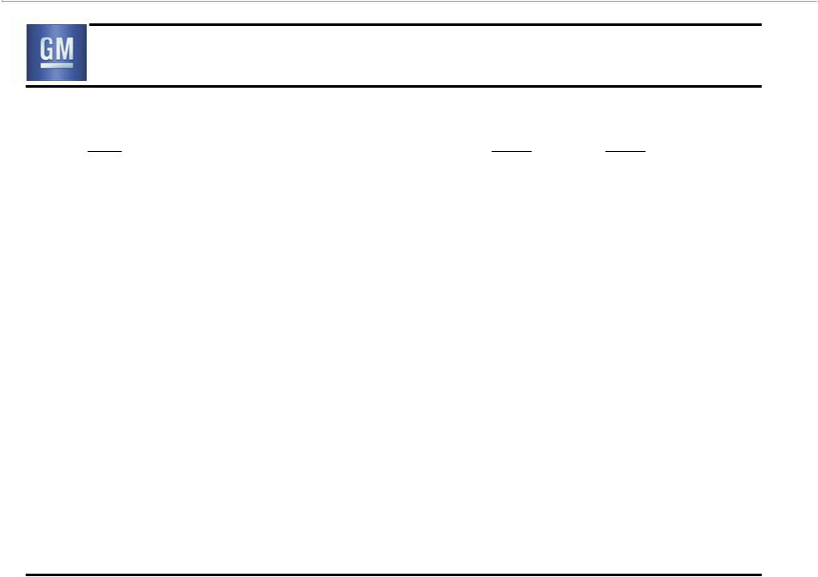
Q2 2011 Special Items

 | Q2 | Q2
($B) | 2010 | 2011
Total GMNA | 0.0 | 0.0
Total GME | 0.0 | 0.0
Total GMIO | 0.0 | 0.0
Total GMSA | 0.0 | 0.0
Total Corp. | 0.0 | 0.0
Total Special Items | 0.0 | 0.0

S3

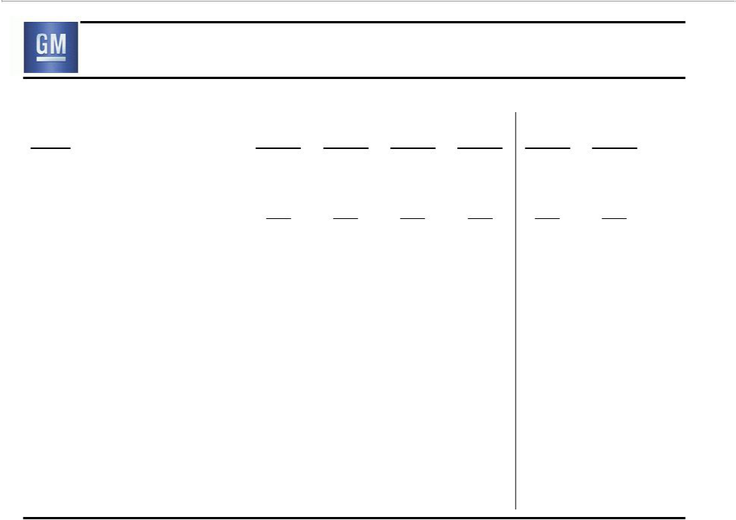
Restructuring (not included in special items)

 | Q1 | Q2 | Q3 | Q4 | Q1 | Q2
($B) | 2010 | 2010 | 2010 | 2010 | 2011 | 2011
GMNA – Dealer Related | 0.0 | 0.0 | 0.0 | 0.0 | 0.0 | 0.0
GMNA – Non-Dealer | 0.1 | 0.0 | 0.1 | 0.2 | 0.0 | 0.0
Related
Total GMNA | 0.1 | 0.0 | 0.1 | 0.2 | 0.0 | 0.0
Total GME | (0.3) | (0.2) | (0.1) | (0.1) | 0.0 | (0.1)
Total GMIO | 0.0 | 0.0 | 0.0 | 0.0 | 0.0 | 0.0
Total GMSA | 0.0 | 0.0 | 0.0 | 0.0 | 0.0 | 0.0
Total | (0.2) | (0.2) | (0.1) | 0.1 | (0.1) | (0.1)
Note: Results may not foot due to rounding |  |  |  |  |  | S4

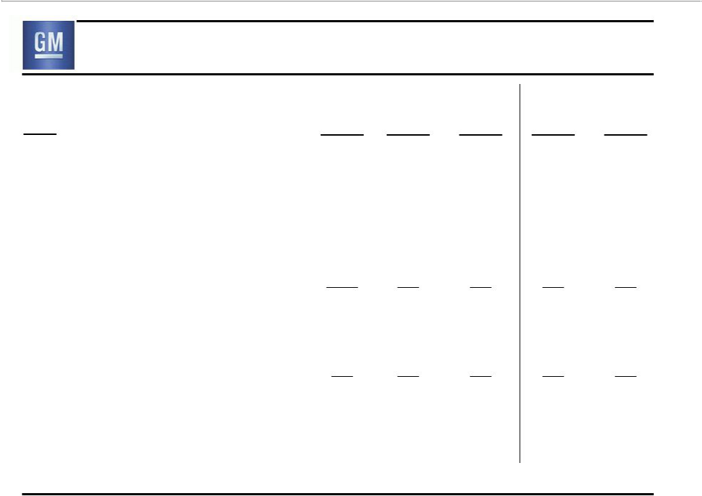
Operating Income Walk to EBIT- Adj

($B)

Operating Income

Equity Income

Non-Controlling Interests

Non-Operating Income/(Expense)

Earnings Before Interest & Taxes (EBIT)

Less Special Items

EBIT- Adj.

Q2 Q3 Q4 Q1 Q2

2010 2010 2010 2011 2011

1.9 1.8 0.2 0.9 2.5

0.4 0.4 0.3 2.1 0.4

(0.1) (0.1) (0.1) 0.0 0.0

(0.2) 0.1 0.9 0.5 0.2

2.0 2.3 1.3 3.5 3.0

0.0 0.0 0.3 1.5 0.0

2.0 2.3 1.0 2.0 3.0

Note: Starting Q4 2010 EBIT & EBIT-Adj. include GM Financial on an Earnings Before Tax (EBT) basis

Note: Results may not foot due to rounding | S5

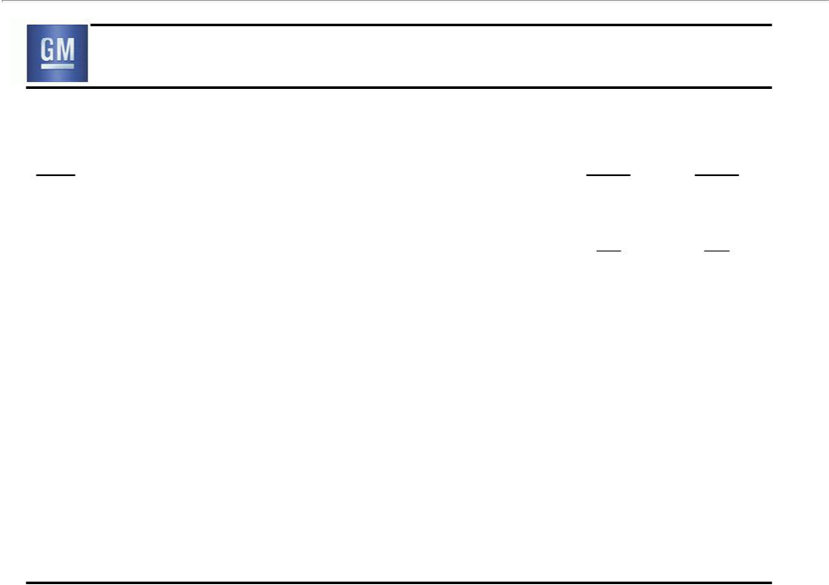
Reconciliation of Automotive Free Cash Flow

 | Q2 | Q2
($B) | 2010 | 2011
Net cash provided by operating activities | 3.8 | 5.1
Less net cash provided by operating activities-GM Financial | n/a | 0.1
Automotive Net Cash Provided/(Used) | 3.8 | 5.0
Operating Activities | 3.8 | 5.0
Capital expenditures | (1.0) | (1.2)
Automotive Free Cash Flow | 2.8 | 3.8

Note: Results may not foot due to rounding | S6

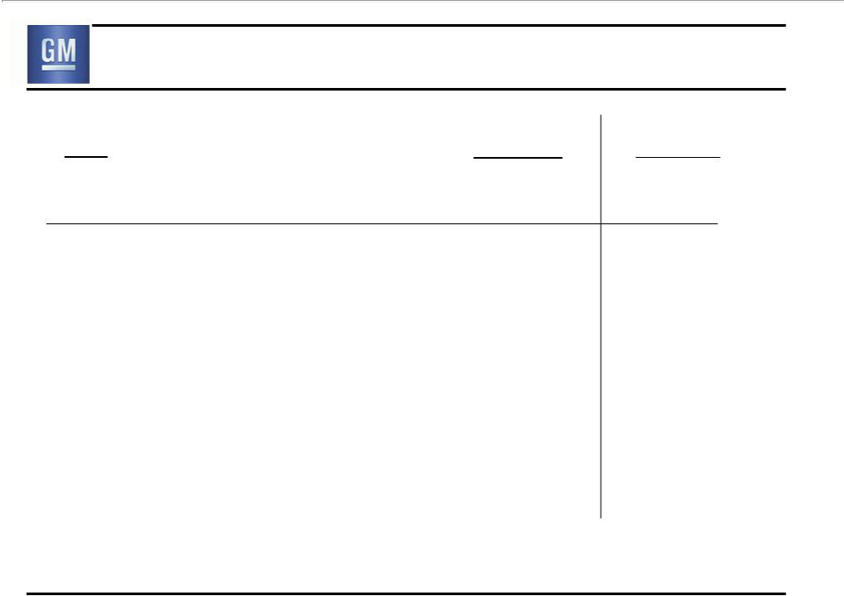
GM Financial – Key Metrics

($M)

Earnings Before Tax

Total Originations

GM new vehicles as % of total

Finance Receivables

Delinquencies (>30 days)*

Annualized net charge-offs as % of avg. receivables

* Excludes finance receivables in repossession

Q2 2011 | Memo:
Q2 2011 | Q2 2010**
144 | 139
1,522 | 906
38.0% | 14.0%
9,110 | 8,734
6.1% | 8.9%
2.4% | 4.5%

** GM acquired GMF in Oct. 2010, prior to this GMF was an independent entity and not consolidated into GM results. Q2 2010 does not _{S7} reflect purchase accounting and is not directly comparable to Q2 2011

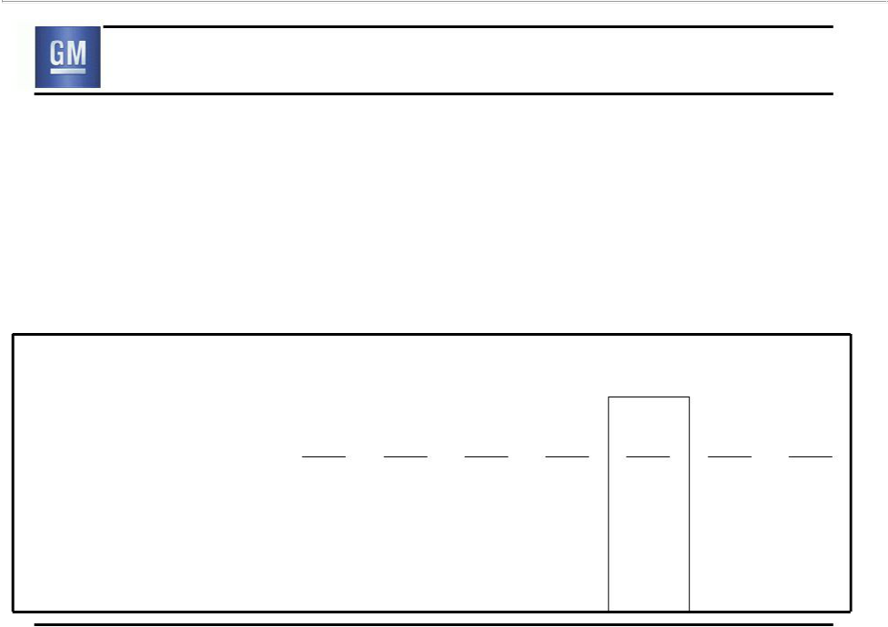
Info Item: GMNA – C$ Net Monetary Liability

- GM Canada balance sheet includes ~CAD $7B Net Monetary Liability (NML) position, primarily pension, OPEB and accrued liabilities

- USD value of NML will vary due to difference in period end to period end FX

- Since GM Canada is USD functional, translation exchange realized as non-cash charge recorded to GMNA P&L

GMNA CAD NML Translational Impact

 | Q1 | Q2 | Q3 | Q4 | CY | Q1 | Q2
 | 2010 | 2010 | 2010 | 2010 | 2010 | 2011 | 2011
Non-Cash EBIT Impact ($B) | $(0.2) | $0.2 | $(0.2) | $(0.2) | $(0.4) | $(0.2) | $0.0
Period End FX (CAD per USD) | 1.0164 | 1.0491 | 1.0269 | 0.9980 | 0.9980 | 0.9713 | 0.9730
Inc/(Dec) vs. Prior Period | (0.0323) | 0.0327 | (0.0222) | (0.0289) | (0. 0507) | (0.0267) | 0.0017
 |  |  |  |  |  |  | S8

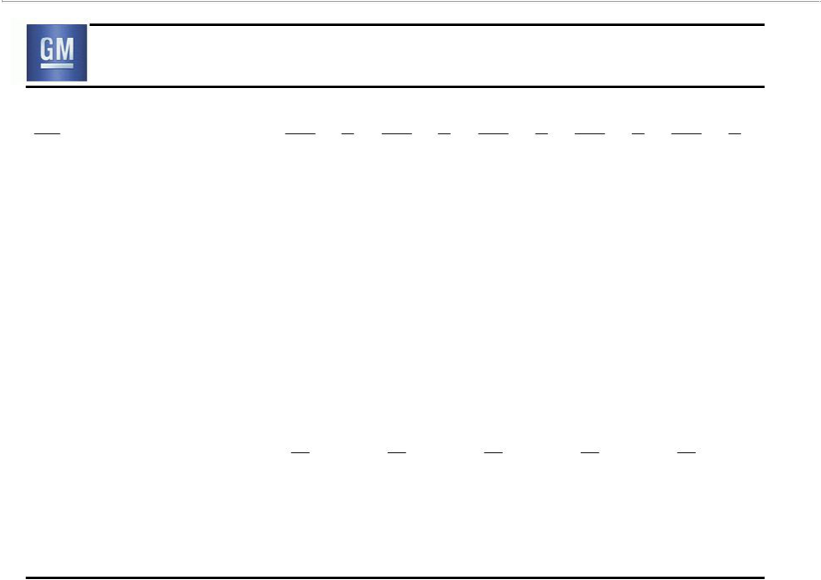
Calculation of EBIT-Adj. as a Percent of Revenue

 | Q2 |  | Q3 |  | Q4 |  | Q1 |  | Q2
($B) | 2010 | % | 2010 | % | 2010 | % | 2011 | % | 2011 | %
Consolidated
Revenue | 33.2 |  | 34.1 |  | 36.9 |  | 36.2 |  | 39.4
Operating Income | 1.9 | 5.7% | 1.8 | 5.4% | 0.2 | 0.6% | 0.9 | 2.6% | 2.5 | 6.2%
EBIT-Adj. | 2.0 | 6.1% | 2.3 | 6.7% | 1.0 | 2.8% | 2.0 | 5.6% | 3.0 | 7.5%
GMIO
Revenue | 5.3 |  | 5.1 |  | 6.1 |  | 5.4 |  | 6.6
Operating Income | 0.3 | 5.2% | 0.1 | 2.5% | 0.1 | 1.1% | 0.1 | 1.8% | 0.2 | 2.3%
Non-Operating Income (Expense) | (0.1) |  | 0.1 |  | 0.1 |  | 0.0 |  | 0.1
Plus Special Items * | 0.0 |  | 0.0 |  | 0.0 |  | 0.1 |  | 0.0
EBIT from consolidated operations | 0.2 | 3.7% | 0.2 | 4.5% | 0.1 | 2.0% | 0.2 | 3.0% | 0.2 | 3.4%

* Q1 2011 includes $67 million charge recorded as a special item

Note: EBIT-Adj. includes GMF on an Earnings Before Tax (EBT) basis; Results may not foot due to rounding | S9

