Table of Contents

UNITED STATES

SECURITIES AND EXCHANGE COMMISSION
Washington, DC 20549-1004

FORM 8-K

CURRENT REPORT

PURSUANT TO SECTION 13 OR 15(d)
OF THE SECURITIES EXCHANGE ACT OF 1934

Date of Report (Date of earliest event reported) November 16, 2009

GENERAL MOTORS COMPANY

(Exact Name of Company as Specified in its Charter)

333-160471

DELAWARE

27-0383222

(Commission File Number)

(State or other jurisdiction

of incorporation)

(I.R.S. Employer

Identification No.)

300 Renaissance Center, Detroit, Michigan

48265-3000

(Address of Principal Executive Offices)

(Zip Code)

(313) 556-5000

(Company’s telephone number, including area code)

Not Applicable

(Former name or former address, if changed since last report)

Check the appropriate box below if the Form 8-K filing is intended to simultaneously satisfy the filing obligation of the company under any of the following provisions:

- Written communications pursuant to Rule 425 under the Securities Act (17 CFR 230.425)

- Soliciting material pursuant to Rule 14a-12 under the Exchange Act (17-CFR 240.14a-12)

- Pre-commencement communications pursuant to Rule 14d-2(b) under the Exchange Act (17 CFR 240.14d-2(b))

- Pre-commencement communications pursuant to Rule 13e-4(c) under the Exchange Act (17 CFR 240.13e-4(c))

Table of Contents

TABLE OF CONTENTS

ITEM 2.02 RESULTS OF OPERATIONS AND FINANCIAL CONDITIONS

ITEM 9.01 FINANCIAL STATEMENTS AND EXHIBITS

SIGNATURES

INDEX TO EXHIBITS

News Release Dated November 16, 2009 and Financial Statements

Charts Furnished to Securities Analysts

Table of Contents

ITEM 2.02. RESULTS OF OPERATIONS AND FINANCIAL CONDITIONS

On November 16, 2009, a news release was issued on the subject of third quarter 2009 consolidated managerial earnings for General Motors Company (GM). The news release did not include certain financial statements, related footnotes and certain other financial information that will be filed pursuant to an agreement with the Securities and Exchange Commission as part of GM’s Current Report on Form 8-K. The news release and financial statements are incorporated as Exhibit 99.1.

Charts furnished to securities analysts in connection with GM’s third quarter 2009 managerial earnings release are attached as Exhibit 99.2.

ITEM 9.01 |  | FINANCIAL STATEMENTS AND EXHIBITS
 |  |  | EXHIBITS
Exhibits |  |  |  | Description |  |  | Method of Filing
Exhibit 99.1 |  | News Release Dated November 16, 2009 and Financial |  |  |  |  | Attached as Exhibit
 |  | Statements
Exhibit 99.2 |  | Charts Furnished to Securities Analysts |  |  |  |  | Attached as Exhibit

Table of Contents

SIGNATURE

Pursuant to the requirements of the Securities Exchange Act of 1934, the Company has duly caused this report to be signed on its behalf by the undersigned hereunto duly authorized.

GENERAL MOTORS COMPANY

(Company)

Date: November 19, 2009 By: /s/ NICK S. CYPRUS

Nick S. Cyprus
Vice President, Controller and Chief Accounting Officer

Exhibit 99.1
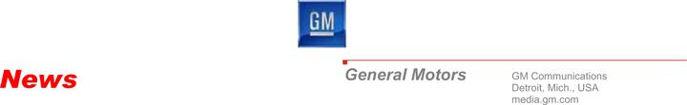

For Release November 16, 2009, 7:00 a.m. ET

General Motors Announces the New Company’s

July 10-September 30 Preliminary Managerial Results

- Operating actions result in EBIT loss before special items of $261 million and managerial net loss of $1.2 billion

- Continued progress on structural cost reductions

- Healthier balance sheet with significantly lower debt

- $3.3 billion positive managerial operating cash flow favorably impacted by working capital; $42.6 billion third quarter liquidity position expected to decline materially in the fourth quarter

- Accelerated plan to repay U.S. and Canadian taxpayers; first $1.2 billion payment in December

DETROIT – General Motors Company (GM) released today preliminary non-GAAP managerial results1 for its first 83 days of operation, providing an initial look at its financial performance since it began operations as a new company on July 10, 2009.

“We have significantly more work to do, but today’s results provide evidence of the solid foundation we’re building for the new GM. With a healthier balance sheet and a competitive cost structure, our focus is on driving top line performance. We’ll achieve that by winning customers over, one at a time, with vehicles that deliver performance and value,” said GM President and CEO Fritz Henderson.

Preliminary Non-GAAP Managerial Results

 |  |  |  | “Old GM” |  |  |  | GM
($mils) |  |  | July 1-July 9, 2009 |  |  |  | July 10-Sept. 30, 2009
 | Net revenue | $ |  | 1,637 |  | $ |  | 26,352
 | Earnings before interest and taxes (before special items) | $ |  | (627) |  | $ |  | (261)
 | Net interest | $ |  | (209) |  | $ |  | (250)
 | Special items | $ |  | 79,6722 |  | $ |  | (505)
 | Earnings before taxes | $ |  | 78,836 |  | $ |  | (1,016)
 | Taxes | $ |  | 522 |  | $ |  | (135)
 | Total managerial income/(loss) | $ |  | 79,358 |  | $ |  | (1,151)
 | Managerial operating cash flow (before special items)($bils) | $ |  | (3.6) |  | $ |  | 3.3
 | Global cash and cash-related balance ($bils) | $ |  | 37.6 |  | $ |  | 42.6

- See the “Editor’s Notes” section of this release for details on the presentation of the reporting.
- Special items for July 1-July 9, 2009 includes a reorganization gain of $80.7 billion.

Revenue

GM posted revenue of $28.0 billion in the third quarter of 2009 (July 1-Sept. 30, 2009), which was up approximately $4.9 billion compared to the revenue recognized by General Motors Corporation, or “Old GM,” in the second quarter of 2009.

The improvement was largely attributed to a higher global seasonally adjusted annual rate (SAAR) of 67.8 million units in the third quarter, compared to 62.7 million units in the second quarter of 2009, and GM’s stabilizing global share. In China, Brazil, India and Russia (BRIC), GM had 13.0 percent of the combined market share in the third quarter, up 0.2 percentage points from the second quarter of 2009.

GM’s global share was 11.9 percent in the third quarter, up 0.3 percentage points from the first half of the year for Old GM. GM’s U.S. market share in the third quarter was 19.5 percent, flat in relation to Old GM’s U.S. share for the first half of the year.

GM finished the third quarter with U.S. dealer inventories of approximately 424,000 vehicles; a reduction of approximately 158,000 units from the end of the second quarter.

Contributing to GM’s sales in the U.S. was the strong retail performance of some of its newest vehicles, including the Chevrolet Camaro and GMC Terrain, as well as the Chevrolet Equinox, Buick LaCrosse and Cadillac SRX which are generating higher average transaction prices and higher residual values than previous model year vehicles.

In other markets around the world, strong consumer appeal for a number of GM’s newest vehicles including the Holden and Chevrolet Cruze, Daewoo Matiz Creative, Opel/Vauxhall Astra and Chevrolet Agile are helping to reclaim global share. In fact, the Astra recently claimed its first major award by winning the prestigious Golden Steering Wheel award by the Auto Bild magazine and the Agile was just elected the 2010 Car of the Year by AutoEsporte magazine in Brazil.

The China market in particular is proving to be a strong contributor for the company’s results. Maintaining a leading market share position in China, GM and its joint venture partners continue to see an upward trend, selling more than 478,000 vehicles in the third quarter of 2009, up from approximately 451,000 and 364,000 units in the second and first quarters, respectively.

Managerial Results

After the inclusion of special items, GM’s managerial earnings before tax for the July 10-Sept. 30 period was a loss of $1.0 billion. GM recorded special items for the same period of $505 million, attributed primarily to dealer restructuring, attrition-related charges and Delphi.3 For the July 10-Sept. 30 period GM posted a managerial loss after-tax of $1.2 billion.

GM managerial earnings before interest and taxes (EBIT) before special items for the July 10-Sept. 30 period was a loss of $261 million, with GM North America reporting a loss of $651 million and GM International Operations reporting a profit of $238 million. Managerial earnings before interest, taxes, depreciation and amortization (EBITDA) was $1.5 billion before special items.

- Details on all special items are included in the “Highlights” section of this release.

2

Total structural cost for the company has been significantly reduced by the resizing and delayering of the company including salaried and hourly headcount reductions, engineering savings and volume related savings. GM structural cost for the period July 10-Sept. 30, 2009 was $9.1 billion. Structural cost for Old GM for the period Jan. 1-July 9, 2009 was $22.0 billion. For the 9-month period ending September 30, 2008, Old GM had structural cost of $37.8 billion.

Structural Cost

 |  |  | “Old GM” |  | “Old GM” |  |  |  |  | GM
 |  | Jan. 1-Sept. 30, |  |  | Jan. 1-July 9, |  |  |  | July 10-Sept. 30,
(bils) |  |  | 2008 |  |  | 2009 |  |  |  | 2009
Total Structural Cost | $ |  | 37.8 | $ |  | 22.0 |  |  | $ | 9.1

While financial statements between Old GM and GM are not comparable, the above structural costs breakdowns for the two companies are provided for perspective.

Balance Sheet and Cash

For the period July 10-Sept. 30, GM had positive managerial operating cash flow before special items of $3.3 billion, reflecting the favorable working capital impact from production start up, timing of supplier payments and lower capital spending. The favorable working capital impact is not expected to repeat itself in the fourth quarter (see the “Looking Ahead” section below). For the period July 1-July 9, Old GM had negative operating cash flow of $3.6 billion, reflecting extremely low production in North America.

As of September 30, 2009, cash and marketable securities totaled $42.6 billion. Included in this amount was $17.4 billion held in escrowed funds from the United States Treasury (UST) and Export Development Canada (EDC), with $8.1 billion of this amount allocable for future repayments of the UST and EDC loans, $2.8 billion for the recently completed Delphi settlement and $900 million for healthcare in Canada, leaving a remaining escrow cash balance of $5.6 billion.

In light of improving global economic conditions, stabilizing industry sales and its healthier cash position, GM announced today that it plans to accelerate repayment of its outstanding $6.7 billion in UST loans as well as the C$1.5 billion (US$1.4 billion) in EDC loans ahead of the scheduled maturity date of July 2015.

GM plans to repay the United States, Canadian and Ontario government loans in quarterly installments from escrowed funds, beginning next month with an initial $1.2 billion payment to be made in December ($1.0 billion to the UST and $192 million to the EDC), followed by quarterly payments. Any escrowed funds available as of June 30, 2010 would be used to repay the UST and EDC loans unless the escrowed funds were extended one year by the UST. Any balance of funds would be released to GM after the repayment of the UST and EDC loans.

In addition, the company has begun to repay the German government loans which were extended to support Opel, and had a balance of €900 million (~US$1.3 billion) as of

September 30, 2009. Opel has already repaid €500 million (~US$0.7 billion) of that in November, and will repay the remaining €400 million (~US$0.6 billion) balance by the end of the month. The cash balance in Europe as of September 30, 2009 was US$2.9 billion.

GM’s total debt as of September 30, 2009 was $17 billion, including $6.7 billion in U.S. government loans, $1.4 billion in Canadian government loans, $1.3 billion in German government loans and $7.6 billion in other debt globally. The $17 billion debt level does not include the UAW or CAW VEBA notes or preferred stock, which are $2.5 billion, $0.7 billion and $9 billion, respectively.

3

While GM has reached settlements for the UAW and CAW VEBAs, the debt associated with the agreements will not be recognized until all preconditions are met and they become effective, which will be December 31, 2009 or later. Prior to the start of the new GM, total debt of Old GM was $94.7 billion as of July 9, 2009.

Looking Ahead

Globally, GM expects total vehicle industry volume to moderate in the fourth quarter of 2009, with an estimated SAAR to be approximately 65.4 million units, down from 67.8 million units in the third quarter. Following the expiration of the successful ‘Cash for Clunkers’ stimulus program in the U.S. which contributed to GM’s strong sales in the third quarter, the company anticipates the U.S. industry total vehicle SAAR volume in the fourth quarter will be approximately 10.7 million units, compared to 11.7 million units in the third quarter.

Looking ahead to 2010, GM anticipates modest growth, with total industry volumes estimated at 62 to 65 million units, with a modest recovery in the U.S. market where the outlook for the 2010 calendar year for total vehicles is estimated at 11-12 million units.

GM expects to have negative net cash flows in the fourth quarter of 2009 due to a number of factors including cash outflows relating to the Delphi settlement of $2.8 billion, the working capital impact of payment term adjustments of approximately $2 billion, payments for U.S., Canada, Ontario and Germany government loans of approximately $2.5 billion and continuing restructuring cash costs of approximately $1 billion. As a result, global cash balances at the end of 2009 are expected to be materially lower than third quarter levels of $42.6 billion.

# # #

Contacts:

Reneé Rashid-Merem

313-665-3128 (office)

313-701-8560 (cell)

renee.rashid-merem@gm.com

Randy Arickx

313-667-0006 (office)

313-268-7070 (cell)

randy.c.arickx@gm.com

Tom Wilkinson

313-667-0366 (office)

313-378-6233 (cell)

tom.wilkinson@gm.com

4

Editors Notes:

Results presented in this press release reflect unaudited condensed consolidated managerial results for the new company for the period July 10 through September 30, 2009, unless otherwise noted as the full quarter. The managerial financial statements do not comply with Generally Accepted Accounting Principles (GAAP), as they do not reflect the application of Fresh Start reporting for the new company, which encompasses the determination of the fair value of its assets and liabilities. Assets and liabilities are currently based on the historical cost basis acquired from Motors Liquidation Company or Old GM. GM continues to analyze time periods in which revenues and expenses were recorded along with allocations of certain assets and liabilities as acquired from Old GM. As a new company, results for GM are not comparable to prior period information for Motors Liquidation Company. GM intends to complete its Fresh Start reporting by March 31, 2010. The company intends to file a Form 8-K with the SEC today for the three- and nine-month periods ended September 30, 2009, encompassing information for both GM and its predecessor company, Motors Liquidation Company.

Forward-Looking Statements:

In this press release and in related comments by our management, our use of the words “expect,” “anticipate,” “ensure,” “promote,” “target,” “believe,” “improve,” “intend,” “enable,” “continue,” “will,” “may,” “would,” “could,” “should,” “project,” “projected,” “positioned” or similar expressions is intended to identify forward-looking statements that represent our current judgment about possible future events. We believe these judgments are reasonable, but these statements are not guarantees of any events or financial results, and our actual results may differ materially due to a variety of important factors. Among other items, such factors might include: our ability to comply with the requirements of our credit agreements with the U.S. Treasury as well as the EDC and VEBA; our ability to maintain adequate liquidity and financing sources and an appropriate level of debt; our ability to realize production efficiencies and to achieve reductions in costs as a result of our restructuring initiatives and labor modifications; our ability to restore consumers’ confidence in our viability as a continuing entity and our ability to continue to attract customers, particularly for our new products, including cars and crossover vehicles; significant changes in the competitive environment and the effect of competition on our markets, including on our pricing policies; and overall strength and stability of general economic conditions and of the automotive industry, both in the United States and in global markets.

About General Motors:

GM, one of the world’s largest automakers, traces its roots back to 1908. With its global headquarters in Detroit, GM employs 209,000 people in every major region of the world and does business in some 140 countries. GM and its strategic partners produce cars and trucks in 34 countries, and sell and service these vehicles through the following brands: Buick, Cadillac, Chevrolet, GMC, GM Daewoo, Holden, Opel, Vauxhall and Wuling. GM’s largest national market is the United States, followed by China, Brazil, the United Kingdom, Canada, Russia and Germany. GM’s OnStar subsidiary is the industry leader in vehicle safety, security and information services. GM acquired its operations from Motors Liquidation Company on

July 10, 2009, and references to prior periods in this and other press materials refer to operations of Motors Liquidation Company or Old GM. More information on the new GM can be found at www.gm.com.

5

Exhibit 1

General Motors Company and Subsidiaries

Supplemental Material

In accordance with the agreement with the SEC staff, the accompanying unaudited condensed consolidated managerial financial statements include the financial statements and related information of Old GM, the entity from whom GM purchased substantially all of the assets and assumed certain liabilities and obligations. Prior to July 10, 2009 the business of GM was operated by Old GM, GM’s predecessor entity for accounting and financial reporting purposes.

The 363 Sale resulted in a new entity, General Motors Company, which is the successor entity for accounting and financial reporting purposes. Because GM is a new reporting entity, the financial statements are not comparable to the financial statements of Old GM.

Also consistent with the no-action relief granted by the SEC staff, these unaudited condensed consolidated managerial financial statements do not comply with United States generally accepted accounting principles (U.S. GAAP).

This press release, the accompanying tables and the charts for analysts include unaudited condensed consolidated managerial financial statements which do not comply with U.S. GAAP. They do not reflect any adjustments which would result from the application of fresh-start reporting pursuant to Accounting Standards Codification topic (ASC) 852, “Reorganizations” including, for example, fresh-start adjustments resulting from asset and liability valuations (including the adjustments required to allocate GM’s business enterprise value to its assets and liabilities in conformity with the procedures specified in ASC 805, “Business Combinations”). GM continues to analyze the time period in which revenues and expenses were recorded in addition to the allocation of assets and liabilities at July 10, 2009 between GM and Old GM. Accordingly, these unaudited condensed consolidated managerial financial statements utilize the historical cost basis of the assets and liabilities of Old GM prior to the 363 Sale.

These unaudited condensed consolidated managerial financial statements will change when U.S. GAAP is applied. Such changes could be and are likely to be material. Further, because these unaudited condensed consolidated managerial financial statements have not been prepared in accordance with U.S. GAAP, they have limitations, are not comparable to similarly titled financial statements of other companies and should not be considered as a substitute for financial statements prepared in accordance with U.S. GAAP or other measures of performance or liquidity prepared in accordance with U.S. GAAP.

GM will file a Form 10-Q for the period ended September 30, 2009 and Form 10-K for the period ending December 31, 2009 with the SEC in 2010 that will include financial statements that comply with U.S. GAAP and the rules and regulations of the SEC.

These unaudited condensed consolidated managerial financial statements have not been audited or reviewed by our independent auditors and, accordingly, they express no opinion or any other form of assurance on them.

This press release and the charts for analysts also include the following adjusted financial measures, which are based on the unaudited condensed consolidated managerial financial statements: (1) adjusted managerial net income; (2) adjusted managerial earnings before interest and income tax; and (3) managerial cash flow. Certain prior period amounts have been reclassified in the consolidated managerial statements of operations and related summaries to conform to the current period presentation, primarily due to the adoption of ASC 810-10, “Consolidation” and ASC 470-20, “Debt with Conversions and Other Options,” which have retrospective application.

1

General Motors Company and Subsidiaries

Supplemental Material

Management believes these adjusted financial measures provide meaningful supplemental information regarding GM’s operating results because they exclude amounts that GM management does not consider part of operating results when assessing and measuring the operational and financial performance of the organization. GM management believes these measures allow it to readily view operating trends, perform analytical comparisons, benchmark performance among geographic regions and assess whether GM’s plan to return to profitability is on target. Also, GM management uses adjusted net income and adjusted earnings before interest and income taxes for forecasting purposes and in determining future capital investment allocations. Accordingly, GM believes these financial measures are useful in allowing for greater transparency of supplemental information used by management in its financial and operational decision-making. While GM believes that these adjusted financial measures provide useful supplemental information, there are limitations associated with the use of these adjusted financial measures.

2

General Motors Company and Subsidiaries

Schedule of Special Items

(Dollars in millions)

(Unaudited)

 |  |  |  | Successor |  |  |  |  |  |  |  |  |  | Predecessor
 |  |  |  | July 10, 2009 |  |  | July 1, 2009 |  |  |  | January 1, 2009 |  |  |  |  | Three Months |  |  |  | Nine Months
 |  |  |  | Through |  |  |  | Through |  |  |  | Through |  |  |  | Ended |  |  |  | Ended
 |  |  | September 30, 2009 |  |  |  | July 9, 2009 |  |  |  |  | July 9, 2009 |  |  | September 30, 2008 |  |  |  | September 30, 2008
 | Managerial results
 | Earnings before interest and taxes (EBT) |  | $ | (1,016) |  |  | $ | 78,836 |  | $ |  | 57,829 |  | $ |  | (2,484) |  | $ |  | (20,318)
 | Managerial net income/(loss) attributable to
 | stockholders |  | $ | (1,151) |  |  | $ | 79,358 |  | $ |  | 58,909 |  | $ |  | (2,552) |  | $ |  | (21,347)
Pre-tax special items
 | Restructuring and special attrition programs |  |  | 452 |  |  |  | 384 |  |  |  | 4,443 |  |  |  | 642 |  |  |  | 5,517
 | Delphi related |  |  | 112 |  |  |  | 41 |  |  |  | 988 |  |  |  | 652 |  |  |  | 4,136
 | Saab related |  |  | (59) |  |  |  | 23 |  |  |  | 912 |  |  |  | — |  |  |  | —
 | Accelerated discount amortization on
 | DIP financing |  |  | — |  |  |  | 600 |  |  |  | 2,220 |  |  |  | — |  |  |  | —
 | Reorganization gains, net |  |  | — |  |  |  | (80,720) |  |  |  | (79,563) |  |  |  | — |  |  |  | —
 | GMAC related |  |  | — |  |  |  | — |  |  |  | (868) |  |  |  | 251 |  |  |  | 3,037
 | Impairments |  |  | — |  |  |  | — |  |  |  | 291 |  |  |  | — |  |  |  | —
 | Gain on extinguishment of debt |  |  | — |  |  |  | — |  |  |  | (906) |  |  |  | — |  |  |  | —
 | Salaried post-65 settlement |  |  | — |  |  |  | — |  |  |  | — |  |  |  | 1,704 |  |  |  | 1,704
 | UAW VEBA curtailment gain |  |  | — |  |  |  | — |  |  |  | — |  |  |  | (4,901) |  |  |  | (4,901)
 | Other |  |  | — |  |  |  | — |  |  |  | (152) |  |  |  | (1) |  |  |  | 486
 | Total pre-tax special items
 |  |  |  | 505 |  |  |  | (79,672) |  |  |  | (72,635) |  |  |  | (1,653) |  |  |  | 9,979
 | Tax special items |  |  | — |  |  |  | — |  |  |  | — |  |  |  | — |  |  |  | 394
 | Net interest expense before special items(a) |  |  | 250 |  |  |  | 209 |  |  |  | 3,025 |  |  |  | 487 |  |  |  | 1,664
 | Managerial results before special items
 | Earnings before taxes (EBIT) |  | $ | (261) |  |  | $ | (627) |  | $ |  | (11,781) |  | $ |  | (3,650) |  | $ |  | (8,675)
 | Managerial net loss attributable to stockholders |  | $ | (646) |  |  | $ | (314) |  | $ |  | (13,726) |  | $ |  | (4,205) |  | $ |  | (10,974)

- Excludes $600 million and $2.2 billion of accelerated discount amortization on DIP financing for the periods July 1, 2009 through July 9, 2009 and January 1, 2009 through July 9, 2009.

3

General Motors Company and Subsidiaries

Schedule of Special Items

Restructuring and special attrition programs

GM

As part of achieving and sustaining long-term viability and the viability of the dealer network, GM determined that a reduction in the number of U.S. and Canadian dealerships was necessary. GM’s plan is to reduce dealerships in the U.S. to approximately 3,600 to 4,000 by October 31, 2010. Wind-down agreements have been executed with 2,042 retail dealers as of October 31, 2009. The retail dealers executing wind-down agreements have agreed to terminate their dealer agreements prior to October 31, 2010. A portion of the total wind-down payments were paid upon signing the termination agreement and the remainder will either be paid when the dealer has liquidated its new vehicle inventory and complied with other provisions of the termination agreement or over time as the dealer sells down its inventory. In the period July 10, 2009 through September 30, 2009, GM recorded charges of $320 million related to the dealer wind-down agreements, including additional dealer incentives recorded as a reduction of revenue.

In the period July 10, 2009 through September 30, 2009, GM recorded charges of $132 million primarily due to 1,700 employees accepting the early retirement program extended to certain U.S. salaried employees in 2009 and separation programs in Germany and Australia.

Old GM

In the period January 1, 2009 through July 9, 2009, GMNA recorded restructuring and special attrition program charges of $3.7 billion due to: (1) $1.4 billion for the effect of the Job Opportunity Bank Program replaced by the Supplemental Unemployment Benefit (SUB) and Transitional Support Program (TSP); (2) $1.3 billion primarily related to net curtailment losses for hourly and salaried pension plans and adjustments due to employees participating in the 2009 Special Attrition Program; (3) $1.0 billion primarily related to postemployment benefit charges in the United States related to 13,000 hourly employees who participated in 2009 special attrition programs, including the cost of subsequent program enhancements.

In the period January 1, 2009 through July 9, 2009, GMNA recorded charges of $638 million related to the dealer wind-down agreements, including additional dealer incentives recorded as a reduction of revenue.

In the period January 1, 2009 through July 9, 2009, GMIO recorded charges of $90 million, primarily related to facility idlings and employee separation programs in Europe, Australia and South Africa.

In the three and nine months ended September 30, 2008, GMNA recorded restructuring charges primarily related to various restructuring initiatives and 2008 special attrition programs. GMNA recorded third quarter charges of $22 million for the 2008 Special Attrition Programs and year to date charges of $3.5 billion for preretirement and retirement pension and benefit incentives and cash buyouts for employees leaving under the 2008 Special Attrition Programs. During the third quarter and year to date, GMNA also recorded charges of $591 million and $1.7 billion for additional wage and benefit costs related to the capacity actions and plant idlings in the U.S. and Canada.

In the three and nine months ended September 30, 2008, GMIO recorded charges of $29 million and $329 million for separation programs primarily in Belgium, France, Germany, the United Kingdom and Australia.

4

General Motors Company and Subsidiaries

Schedule of Special Items

Delphi related

GM

In the period July 10, 2009 through September 30, 2009, GM recorded charges of $112 million to write-off advances made to Delphi under the credit agreement.

Old GM

In the period January 1, 2009 through July 9, 2009, Old GM charges of $988 million to write-off advances made to Delphi under credit agreements and the payment terms acceleration agreement and to record the estimated losses associated with the Delphi Benefit Guarantee Agreement arising from the PBGC’s assumption of the Delphi benefit plans.

In the three and nine months ended September 30, 2008, Old GM charges of $652 million and $4.1 billion for increased liabilities under the Delphi-GM Settlement Agreements, primarily due to expectations of increased obligations and lower estimates of the expected amount of recoveries associated with the Delphi Benefit Guarantee Agreements, updated to reflect certain conditions related to the credit markets and challenges in the auto industry.

Saab related

GM

GM acquired Old GM’s investment in Saab Automobile AB (Saab) as part of the 363 Sale. On August 18, 2009 GM signed a stock purchase agreement with Koenigsegg Group AB regarding the sale of 100% of the shares of Saab, and on August 24, 2009 Saab exited its reorganization proceeding. As a result, in the period July 10, 2009 through September 30, 2009, GM reflected Saab assets and liabilities on its books as Held for Sale and recorded a favorable adjustment of $59 million for previously recorded commitments and obligations.

Old GM

On February 20, 2009, Saab filed for reorganization under a self-managed Swedish court process, which is similar to U.S. Chapter 11 bankruptcy protection. The reorganization filing resulted in the loss of control necessary for consolidation and therefore GM deconsolidated Saab on February 20, 2009. In the period January 1, 2009 through July 9, 2009, GM recorded charges of $912 million primarily related to GM’s net investment in, and advances to, Saab and other commitments and obligations, including a commitment to provide up to $150 million of debtor-in-possession financing.

Accelerated amortization of discount on DIP financing

Old GM

In the periods January 1, 2009 through July 9, 2009 and July 1, 2009 through July 9, 2009, Old GM recorded accelerated amortization of $2.2 billion and $600 million on the discount of the DIP financing.

5

General Motors Company and Subsidiaries

Schedule of Special Items

Reorganization gains, net

Old GM

The following table summarizes Old GM’s Reorganization gains, net (dollars in millions):

 |  |  |  | Predecessor
 | July 1, 2009 |  |  |  | January 1, 2009
 |  | Through |  |  |  | Through
 | July 9, 2009 |  |  |  |  | July 9, 2009
Professional fees | $ | — |  | $ |  | (39)
Gain due to conversion of DIP Facility to equity in GM |  | 27,939 |  |  |  | 27,939
Gain due to conversion of UST and EDC funding to equity in GM |  | 25,700 |  |  |  | 25,700
Gains resulting from Old GM debt and other liabilities not assumed in 363 Sale |  | 29,867 |  |  |  | 29,867
Issuance of GM common and preferred stock |  | (2,505) |  |  |  | (2,505)
Loss on extinguishment of debt |  | — |  |  |  | (958)
Loss on contract rejections and settlements of claims |  | (281) |  |  |  | (441)
Total reorganization gains, net | $ | 80,720 |  |  | $ | 79,563

GMAC related

Old GM

In the period January 1, 2009 through July 9, 2009, Old GM recorded a net gain on debt extinguishment of $483 million and $385 million representing our proportionate share of GMAC’s debt extinguishment. On May 29, 2009, the UST exercised this option to convert Old GM’s UST GMAC Loan of $884 outstanding debt to 190,921 shares of GMAC’s Class B Common Membership Interests. The outstanding principal and interest of the debt was extinguished, and Old GM recognized a net gain on extinguishment of $483 million. The net gain on extinguishment of debt was comprised of a $2.5 billion gain on the disposition of GMAC Common Membership Interests, a $2.0 billion loss on extinguishment of the UST GMAC Loan and a gain of $8 million related to the extinguishment of accrued interest. GMAC converted its status to a C corporation effective June 30, 2009. At that date, the accounting treatment for the investment in GMAC was reevaluated and it was determined that accounting for GMAC as a cost method investment rather than an equity method investee was more appropriate due to a lack of significant influence over GMAC.

In the three and nine months ended September 30, 2008, charges of $251 million and $3.0 billion were recorded for impairments of GM’s investment in Common and Preferred Membership Interests of GMAC.

Impairments

Old GM

In the period January 1, 2009 through July 9, 2009, Old GM recorded charges of $291 million primarily related to long-lived asset impairments.

Gain on extinguishment of debt

Old GM

On March 4, 2009, Old GM entered into an agreement to amend a $1.5 billion U.S. term loan. Because the terms of the amended U.S. term loan were substantially different than the original terms, primarily due to the revised borrowing rate, the amendment was accounted for as a debt extinguishment. As a result, GM recorded the amended U.S. term loan at fair value and recorded a gain of $906 million for the extinguishment of the original loan facility.

6

General Motors Company and Subsidiaries

Schedule of Special Items

Salaried post-65 settlement

Old GM

In the three and nine months ended September 30, 2008, Old GM charges of $1.7 billion were recorded for the recognition of a settlement loss associated with the elimination of healthcare coverage for U.S. salaried retirees over age 65 beginning January 1, 2009. The settlement loss was recorded for participants over age 65 at January 1, 2009 and considers the cost of the increased pension benefit provided to those affected participants to help offset the cost of Medicare and supplemental coverage.

UAW VEBA curtailment gain

Old GM

In the three and nine months ended September 30, 2008 a gain of $4.9 billion were recorded for the recognition of a net curtailment gain specific to the accelerated recognition of unamortized net prior service credits due to the Settlement Agreement for the UAW hourly medical plan becoming effective in the third quarter of 2008.

Other

Old GM

In the period January 1, 2009 through July 9, 2009, Old GM recorded $152 million of favorable adjustments to the Joint Training Funds reserve based on the 2009 revised contract with the UAW.

In the three months ended September 30, 2009, net $1 million gain related to charges of $47 million for 600 salaried employees who irrevocably accepted an offer under the 2008 salaried window retirement program as of September 30, 2008 and a $48 million gain on the sale of its Oklahoma City facility, which was sold in the three months ended September 30, 2008.

In the nine months ended September 30, 2008, Old GM recorded a net charge of $486 related to the following: (1) a charge of $340 million for additional pension expense related to the unamortized prior service costs from prior CAW labor contracts; (2) a charge of $197 related to Old GM’s agreement to provide upfront support to American Axle to end the work stoppage that affected approximately 30 plants in North America; (3) a gain of $50 million on the sale of Old GM’s common equity interest in Electro-Motive Diesel, Inc; and (4) a net gain of $1 million related to the 2008 salaried window program and sale of its Oklahoma City facility.

Tax adjustments

Old GM

In the nine months ended September 30, 2008, Old GM recorded an adjustment of $394 million related to a first quarter net charge for a valuation allowance on net deferred tax assets in Spain and the United Kingdom.

7

General Motors Company and Subsidiaries

Operating Statistics

(Unaudited)

 |  |  | Three Months Ended |  |  |  | Nine Months Ended
 |  |  | September 30, |  |  |  | September 30,
 |  |  | 2009 |  | 2008 |  | 2009 | 2008
 |  |  |  |  | (Units in |  | thousands)
 | Worldwide Production Volume (a) (b) (c)
 | GMNA – Cars |  | 205 |  | 436 |  | 491 | 1,178
 | GMNA – Trucks |  | 326 |  | 479 |  | 806 | 1,456
 | Total GMNA
 |  |  | 531 |  | 915 |  | 1,297 | 2,634
 | GMIO (a) |  | 1,166 |  | 1,124 |  | 3,268 | 3,862
 | Total Worldwide
 |  |  | 1,697 |  | 2,039 |  | 4,565 | 6,496
 | Vehicle Unit Deliveries (a) (c) (d) (e)
 | United States
 | Chevrolet – Cars |  | 172 |  | 196 |  | 413 | 583
 | Chevrolet – Trucks |  | 223 |  | 300 |  | 579 | 877
 | Cadillac |  | 24 |  | 41 |  | 73 | 130
 | Buick |  | 25 |  | 42 |  | 72 | 113
 | GMC |  | 63 |  | 109 |  | 182 | 306
 | Pontiac |  | 63 |  | 73 |  | 152 | 226
 | Saturn |  | 17 |  | 57 |  | 60 | 159
 | Other |  | 4 |  | 12 |  | 15 | 40
 | Total United States |  | 593 |  | 828 |  | 1,547 | 2,433
 | Canada, Mexico and Other |  | 98 |  | 150 |  | 301 | 456
 | Total GMNA |  | 691 |  | 978 |  | 1,848 | 2,889
 | GMIO (f)
 | Chevrolet |  | 494 |  | 496 |  | 1,381 | 1,535
 | Opel/Vauxhall |  | 306 |  | 336 |  | 963 | 1,208
 | Buick |  | 117 |  | 65 |  | 313 | 212
 | GM Daewoo |  | 33 |  | 31 |  | 80 | 102
 | Holden |  | 31 |  | 35 |  | 91 | 107
 | Wuling (g) |  | 262 |  | 128 |  | 754 | 457
 | FAW-GM (g) |  | 9 |  | — |  | 9 |  | —
 | Other |  | 27 |  | 44 |  | 85 | 145
 | Total GMIO |  | 1,278 |  | 1,135 |  | 3,676 | 3,767
 | Total Worldwide
 |  |  | 1,969 |  | 2,113 |  | 5,523 | 6,656

- Vehicle sales and production volume will not be affected by fresh-start reporting; therefore, for the three and nine months ended September 30, 2009, GM’s vehicle sales and production volume for the period July 10, 2009 through September 30, 2009 is presented with Old GM’s vehicle sales and production volume for the periods July 1, 2009 through July 9, 2009 and January 1, 2009 through July 9, 2009 for comparison purposes.

- Production volume represents the number of vehicles manufactured by our and Old GM’s assembly facilities and also includes vehicles produced by certain joint ventures, including GM Daewoo, Shanghai GM and SAIC-GM Wuling Automobile Co., Ltd. (SGMW) and FAW-GM Light Duty Commercial Vehicle Co., Ltd. (FAW-GM) joint venture production.

- Vehicle sales and production data may include rounding differences.

- Vehicle sales primarily represent sales to the ultimate customer.

- Includes HUMMER, Saab, Saturn and Pontiac vehicle sales data.

- Consistent with industry practice, vehicle sales information includes estimates of industry sales in certain countries where public reporting is not legally required or otherwise available on a consistent basis.

- Includes GM Daewoo, Shanghai GM and SAIC-GM Wuling Automobile Co., Ltd. (SGMW) and FAW-GM Light Duty Commercial Vehicle Co., Ltd. (FAW-GM) joint venture sales. Ownership of 34% in SGMW and 50% in FAW-GM, under the joint venture agreement, allows for significant rights as a member as well as the contractual right to report SGMW and FAW-GM Light Duty Commercial sales in China as part of global market share.

8

General Motors Company and Subsidiaries

Operating Statistics

(Unaudited)

 | Three Months Ended |  |  |  |  | Nine Months Ended
 | September 30, |  |  |  |  | September 30,
 | 2009 |  |  | 2008 |  | 2009 |  |  | 2008
Market Share (a)
United States – Cars | 16.5% |  |  | 20.3% |  | 16.5% |  |  | 18.7%
United States – Trucks | 22.8% |  |  | 28.4% |  | 22.6% |  |  | 25.8%
Total United States | 19.5% |  |  | 24.3% |  | 19.5% |  |  | 22.2%
Total GMNA | 18.7% |  |  | 23.4% |  | 18.9% |  |  | 21.7%
Total GMIO (a) (b) (c) | 9.9% |  |  | 9.4% |  | 9.8% |  |  | 9.5%
Total Worldwide | 11.9% |  |  | 13.0% |  | 11.7% |  |  | 12.6%
U.S. Retail/Fleet Mix (a)
% Fleet Sales – Cars | 29.8% |  |  | 40.3% |  | 27.3% |  |  | 32.5%
% Fleet Sales – Trucks | 21.2% |  |  | 21.7% |  | 22.0% |  |  | 22.2%
Total Vehicles | 25.1% |  |  | 29.5% |  | 24.3% |  |  | 26.6%
GMNA Capacity Utilization (d) | 53.3% |  |  | 79.0% |  | 43.4% |  |  | 75.5%

- Vehicle sales, market share, U.S. retail/fleet mix and GMNA capacity utilization will not be affected by fresh-start reporting; therefore, for the three and nine months ended September 30, 2009, our vehicle sales and production volume for the period July 10, 2009 through September 30, 2009 is presented with Old GM’s vehicle sales and production volume for the periods July 1, 2009 through July 9, 2009 and January 1, 2009 through July 9, 2009 for comparison purposes.

- Consistent with industry practice, vehicle sales information includes estimates of industry sales in certain countries where public reporting is not legally required or otherwise available on a consistent basis.

- Includes GM Daewoo, Shanghai GM and SAIC-GM Wuling Automobile Co., Ltd. (SGMW) and FAW-GM Light Duty Commercial joint venture sales. Ownership of 34% in SGMW and 50% in FAW-GM, under the joint venture agreement, allows for significant rights as a member as well as the contractual right to report SGMW and FAW-GM Light Duty Commercial sales in China as part of global market share.

- Two shift rated, annualized.

9

General Motors Company and Subsidiaries

Operating Statistics

(Unaudited)

 | Successor |  |  | Predecessor
 | September 30, |  |  | December 30,
 | 2009 |  |  | 2008
Worldwide Employment (thousands)
GMNA (b) | 92 |  |  | 116
GMIO | 115 |  |  | 125
Corporate and Other | 2 |  |  | 2
Total Worldwide | 209 |  |  | 243
United States – Salaried (a) (c) | 27 |  |  | 29
United States – Hourly (a) (b) | 48 |  |  | 62

- Includes employees in GMNA and Corporate and other.

- In the nine months ended September 30, 2009, 7,000 U.S. hourly employees elected to participate in Old GM’s 2009 Special Attrition Program, which was introduced in February of 2009. In addition, 6,000 U.S. hourly employees elected to participate in Old GM’s Second Special Attrition Program, which was introduced in June of 2009.
- Subsequent to September 30, 2009, 3,000 U.S. salaried employees have irrevocably accepted the 2009 Salaried Window Program option or the GM Severance Program option.

 |  |  | Successor |  |  |  |  |  |  |  |  | Predecessor
 |  |  | July 10, 2009 |  |  | July 1, 2009 |  |  |  | January 1, 2009 |  |  |  | Three Months |  |  | Nine Months
 |  |  | through |  |  |  | through |  |  |  | through |  |  | Ended |  |  | Ended
 |  | September 30, 2009 |  |  |  | July 9, 2009 |  |  |  |  | July 9, 2009 |  | September 30, 2008 |  |  | September 30, 2008
Worldwide Payroll (billions) | $ |  | 2.9 |  | $ |  | 0.3 |  | $ |  | 6.2 | $ |  | 4.4 | $ |  | 13.0
 |  |  |  | 10

General Motors Company and Subsidiaries

Condensed Consolidated Managerial Statements of Operations

(Dollars in millions)

(Not audited or reviewed)

 |  |  | Successor |  |  |  |  |  |  |  |  | Predecessor
 |  |  | July 10, 2009 |  |  | July 1, 2009 |  |  | January 1, 2009 |  |  |  |  | Three Months |  |  |  | Nine Months
 |  |  | Through |  |  |  | Through |  |  | Through |  |  |  | Ended |  |  |  | Ended
 |  | September 30, 2009 |  |  |  | July 9, 2009 |  |  |  | July 9, 2009 |  |  | September 30, 2008 |  |  |  | September 30, 2008
 | Net sales and revenue
 | Sales | $ | 26,274 |  |  | $ | 1,629 |  | $ | 46,786 |  | $ |  | 37,503 |  | $ |  | 117,120
 | Other revenue |  | 78 |  |  |  | 8 |  |  | 328 |  |  |  | 305 |  |  |  | 1,081
 | Total net sales and revenue
 | Total net sales and revenue |  | 26,352 |  |  |  | 1,637 |  |  | 47,114 |  |  |  | 37,808 |  |  |  | 118,201
 | Costs and expenses
 | Cost of sales |  | 24,765 |  |  |  | 1,943 |  |  | 57,473 |  |  |  | 34,521 |  |  |  | 116,219
 | Selling, general and administrative expense |  | 2,653 |  |  |  | 732 |  |  | 6,230 |  |  |  | 3,251 |  |  |  | 10,704
 | Other expenses, net |  | (17) |  |  |  | 21 |  |  | 1,323 |  |  |  | 919 |  |  |  | 5,226
 | Total costs and expenses |  | 27,401 |  |  |  | 2,696 |  |  | 65,026 |  |  |  | 38,691 |  |  |  | 132,149
 | Operating loss
 | Operating loss |  | (1,049) |  |  |  | (1,059) |  |  | (17,912) |  |  |  | (883) |  |  |  | (13,948)
 | Equity in income (loss) of GMAC |  | — |  |  |  | — |  |  | 1,373 |  |  |  | (1,235) |  |  |  | (4,777)
 | Interest expense |  | (356) |  |  |  | (823) |  |  | (5,428) |  |  |  | (595) |  |  |  | (2,217)
 | Interest income and other non-operating income, net |  | 334 |  |  |  | 23 |  |  | 827 |  |  |  | 78 |  |  |  | 165
 | Gain (loss) on extinguishment of debt |  | — |  |  |  | — |  |  | (1,088) |  |  |  | 43 |  |  |  | 97
 | Reorganization gains, net |  | — |  |  |  | 80,720 |  |  | 79,563 |  |  |  | — |  |  |  | —
Income (loss) before income taxes and equity income
 |  |  | (1,071) |  |  |  | 78,861 |  |  | 57,335 |  |  |  | (2,592) |  |  |  | (20,680)
 | Income tax expense (benefit) |  | 135 |  |  |  | (522) |  |  | (1,080) |  |  |  | 68 |  |  |  | 1,029
 | Equity income, net of tax |  | 212 |  |  |  | 15 |  |  | 278 |  |  |  | 50 |  |  |  | 310
 | Managerial net income (loss) |  | (994) |  |  |  | 79,398 |  |  | 58,693 |  |  |  | (2,610) |  |  |  | (21,399)
 | Less: Managerial net (income) loss attributable to noncontrolling
 | interests |  | (157) |  |  |  | (40) |  |  | 216 |  |  |  | 58 |  |  |  | 52
 | Managerial net income (loss) attributable to stockholders |  | (1,151) |  |  |  | 79,358 |  |  | 58,909 |  |  |  | (2,552) |  |  |  | (21,347)
 | Less: Accumulated preferred dividends |  | 146 |  |  |  | — |  |  | — |  |  |  | — |  |  |  | —
 | Managerial net income (loss) attributable to common
 | stockholders | $ | (1,297) |  |  | $ | 79,358 |  | $ | 58,909 |  | $ |  | (2,552) |  | $ |  | (21,347)
 |  |  | 11

General Motors Company and Subsidiaries

Condensed Consolidated Managerial Balance Sheets

(Dollars in millions)

(Not audited or reviewed)

 |  |  | Successor |  |  | Predecessor
 |  | September 30, |  |  |  | December 31,
 |  |  | 2009 |  |  |  | 2008
 | ASSETS
 | Current Assets
 | Cash and cash equivalents | $ | 25,092 |  |  | $ | 14,053
 | Marketable securities |  | 137 |  |  |  | 141
 | Total cash and marketable securities |  | 25,229 |  |  |  | 14,194
 | Restricted cash and marketable securities |  | 17,987 |  |  |  | —
 | Accounts and notes receivable, net |  | 6,895 |  |  |  | 7,918
 | Inventories |  | 9,812 |  |  |  | 13,195
 | Assets held for sale |  | 492 |  |  |  | —
 | Equipment on operating leases, net |  | 2,708 |  |  |  | 5,142
 | Other current assets and deferred income taxes |  | 1,722 |  |  |  | 3,146
 | Total current assets
 | Total current assets |  | 64,845 |  |  |  | 43,595
 | Non-Current Assets
 | Equity in net assets of nonconsolidated affiliates |  | 2,245 |  |  |  | 2,146
 | Property, net |  | 35,700 |  |  |  | 39,665
 | Intangible assets, net |  | 201 |  |  |  | 265
 | Deferred income taxes |  | 557 |  |  |  | 98
 | Prepaid pension |  | 123 |  |  |  | 109
 | Equipment on operating leases, net |  | 2 |  |  |  | 442
 | Restricted cash and marketable securities |  | 2,327 |  |  |  | 2,589
 | Other assets |  | 1,451 |  |  |  | 2,130
 | Total non-current assets
 | Total non-current assets |  | 42,606 |  |  |  | 47,444
 | Total Assets | $ | 107,451 |  |  | $ | 91,039
 | LIABILITIES AND DEFICIT
 | Current Liabilities
 | Accounts payable (principally trade) | $ | 20,213 |  |  | $ | 22,259
 | Short-term debt and current portion of long-term debt |  | 12,842 |  |  |  | 16,920
 | Liabilities held for sale |  | 492 |  |  |  | —
 | Postretirement benefits other than pensions |  | 1,625 |  |  |  | 4,001
 | Accrued expenses |  | 24,575 |  |  |  | 32,428
 | Total current liabilities |  | 59,747 |  |  |  | 75,608
 | Non-Current Liabilities
 | Long-term debt |  | 4,197 |  |  |  | 29,018
 | Postretirement benefits other than pensions |  | 30,077 |  |  |  | 28,919
 | Pensions |  | 27,549 |  |  |  | 25,178
 | Other liabilities and deferred income taxes |  | 14,035 |  |  |  | 17,392
 | Total non-current liabilities |  | 75,858 |  |  |  | 100,507
Total Liabilities
 |  |  | 135,605 |  |  |  | 176,115
 | Commitments and contingencies
 | Preferred stock, $0.01 par value (1,000,000,000 shares authorized, 360,000,000 shares issued and 100,000,000 shares outstanding at
 | September 30, 2009) |  | 2,500 |  |  |  | —
 | Deficit
 | Old GM
 | Preferred stock, no par value (6,000,000 shares authorized, no shares issued and outstanding) |  | — |  |  |  | —
 | Preference stock, $0.10 par value (100,000,000 shares authorized, no shares issued and outstanding) |  | — |  |  |  | —
 | Common Stock, $1 2/3 par value common stock (2,000,000,000 shares authorized, 800,937,541 shares issued and outstanding at
 | December 31, 2008) |  | — |  |  |  | 1,017
 | General Motors Company
 | Common stock, $0.01 par value (2,500,000,000 shares authorized, 500,000,000 shares
 | issued and 412,500,000 outstanding at September 30, 2009) |  | 5 |  |  |  | —
 | Capital surplus (principally additional paid-in capital) |  | 17,512 |  |  |  | 16,489
 | Retained earnings (Accumulated deficit) |  | (13,011) |  |  |  | (70,727)
 | Accumulated other comprehensive loss |  | (35,557) |  |  |  | (32,339)
 | Total stockholders’ deficit |  | (31,051) |  |  |  | (85,560)
 | Noncontrolling interests |  | 397 |  |  |  | 484
 | Total deficit |  | (30,654) |  |  |  | (85,076)
Total Liabilities and Deficit
 |  | $ | 107,451 |  |  | $ | 91,039
12

Exhibit 99.2
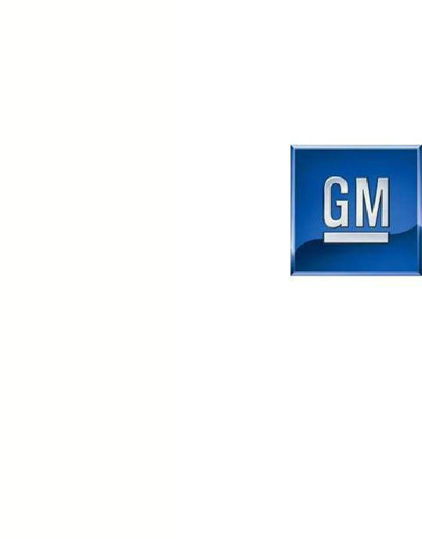

General Motors Company

Preliminary Results

July 10, 2009 – Sept. 30, 2009

Nov 16, 2009

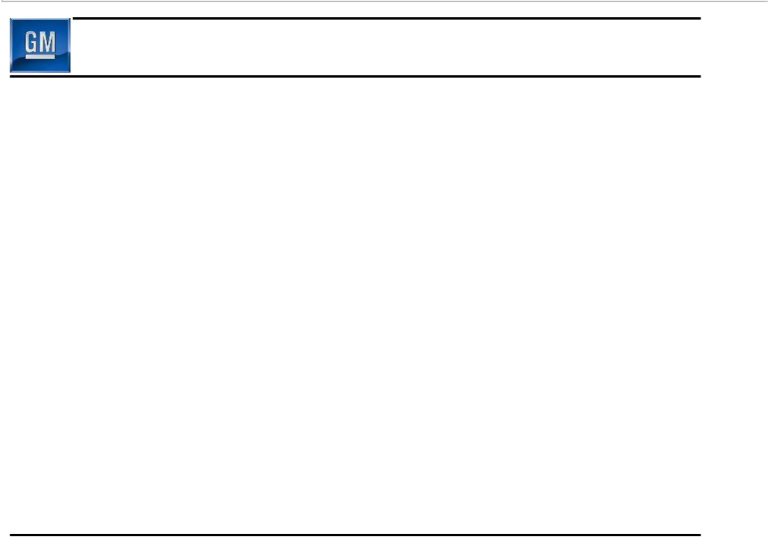
Forward Looking Statements

In this presentation and in related comments by our management, our use of the words “expect,” “anticipate,” “ensure,” “promote,” “target,” “believe,” “improve,” “intend,” “enable,” “continue,” “will,” “may,” “would,” “could,” “should,” “project,” “projected,” “positioned” or similar expressions is intended to identify forward-looking statements that represent our current judgment about possible future events. We believe these judgments are reasonable, but these statements are not guarantees of any events or financial results, and our actual results may differ materially due to a variety of important factors. Among other items, such factors might include: our ability to comply with the requirements of our credit agreements with the U.S. Treasury as well as the EDC and VEBA; our ability to maintain adequate liquidity and financing sources and an appropriate level of debt; our ability to realize production efficiencies and to achieve reductions in costs as a result of our restructuring initiatives and labor modifications; our ability to restore consumers’ confidence in our viability as a continuing entity and our ability to continue to attract customers, particularly for our new products, including cars and crossover vehicles; significant changes in the competitive environment and the effect of competition on our markets, including on our pricing policies; and overall strength and stability of general economic conditions and of the automotive industry, both in the United States and in global markets.

1

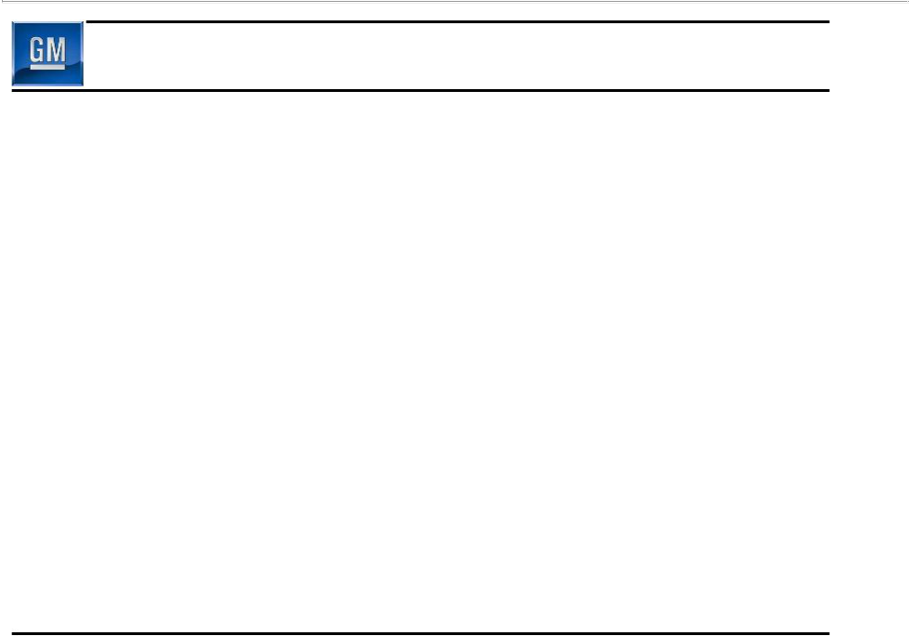
Preliminary Managerial Results

- General Motors Company is a private company and voluntary filer with United States Securities & Exchange Commission (SEC)

– Per agreement with SEC, GM will file under Form 8-K unaudited condensed consolidated managerial financial statements for period July 10 – Sept. 30, 2009 and include information related to Old GM

- Consolidated managerial financial statements do not comply with Generally Accepted Accounting Principles (GAAP)

– Assets & liabilities valued at historical cost basis (Old GM prior to 363 sale)
– Fixed asset impairment testing and benefit plan remeasurementshave not been performed

– Results do not reflect application of fresh-start reporting and other adjustments and will change significantly when these adjustments are applied to comply with GAAP
– We will continue to analyze time periods in which revenues and expenses were recorded along with allocation of certain assets and liabilities

- GM is a new entity and financial statements are not comparable to those of Old GM

- In 2010, GM will file Forms 10-Q and 10-K, including GAAP compliant financials, for periods ending Sept. 30, 2009 and Dec. 31, 2009, respectively

2

Changes in Presentation

- Q3 2009 preliminary managerial financial results have been segregated into two periods

– July 1 through July 9 Old GM

– July 10 through Sept 30 New GM

- Former Europe, Latin America/Africa/Middle East and Asia Pacific segments combined into GMIO Segment

– Consistent with operating structure to streamline business and speed decision making

- Due to lack of significant influence over GMAC, GM has changed accounting treatment for investment to cost method from prior equity method

– GM’s common equity ownership in GMAC is 24.5%, 9.9% is held directly, and 14.6% is held in an independent trust

3

Highlight of Major Achievements

- Encouraging vehicle launches globally

– U.S.: Chevrolet Camaro & Equinox, Cadillac SRX, Buick LaCrosse, GMC Terrain
– GMIO: Holden Cruze, Daewoo Matiz Creative, Chevrolet Agile, Opel Astra

- Fewer brands, dealers & nameplates

- Significantly improved cost structure

– Competitive wage structure in place

– ~19% reduction in total U.S. employment from YE 2008 through September 30

- Healthier balance sheet with lower leverage

- Resolution of Delphi restructuring

- New BOD and leaner executive team

- New operating structure

- Accelerating change in GM’s culture

4

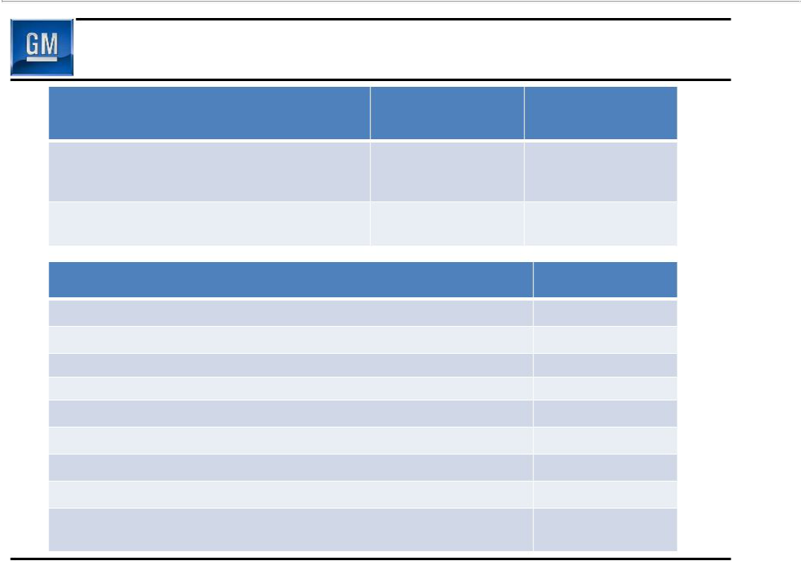
Preliminary Results Overview

 | 3Q 2009 | Status vs.
 | Actual | H1 2009
Global Market Share | 11.9% | 0.3 p.p. increase
U.S. Market Share | 19.5% | Unchanged
China Market Share | 13.5% | 0.1 ppt. increase
Ending U.S. Dealer Inventory (000’s) | 424K | 158K reduction
 |  | (vs. June 30)

July 10 – Sept. 30 Preliminary Managerial Results | $Billion
Net Revenue | $26.5
EBIT | $(0.3)
Net Interest | $(0.2)
Special Items | $(0.5)
EBT | $(1.0)
Total Managerial Income/(Loss) | $(1.2)
Managerial OCF (Before Special Items) | $3.3
Memo: EBITDA (Before Special Items) | $1.5

September 30 Cash Balance | $42.6
Including $17.4B in escrow | $42.6

5

Q3 Global Sales Results

 |  |  |  | Memo:
 |  |  |  | Viability Plan
Total Global | 1Q09 | 2Q09 | 3Q09 | 3Q09 *
- Net Revenue ($B) | 22.4 | 23.1 | 28.0 | 23.5
- Industry SAAR (Mil) | 57.7 | 62.7 | 67.8 | 56.5
- Market Share | 11.2% | 11.9% | 11.9% | 11.2%
- Production Volume (000) | 1,330 | 1,538 | 1,697 | N/A
- Deliveries (000) | 1,617 | 1,937 | 1,969 | 1,554
GMNA
- GMNA Net Revenue ($B) | 12.3 | 11.4 | 15.5 | 14.7
- U.S. Industry SAAR (Mil) | 9.7 | 9.8 | 11.7 | 10.8
- U.S. Market Share | 18.4% | 20.5% | 19.5% | 18.8%
- GMNA Production Volume (000) | 371 | 395 | 531 | 532
- GMNA Deliveries (000) | 501 | 657 | 691 | 621
GMIO
- Net Revenue ($B) | 11.2 | 11.7 | 12.9 | 9.4
- Market Share | 9.6% | 9.9% | 9.9% | 8.9%
- Production Volume (000) | 959 | 1,143 | 1,166 | N/A
- Deliveries (000) | 1,116 | 1,281 | 1,278 | 933

Production includes consolidated operations, proportion of JV volume allocated per JV agreement & third party facilities when GM engineering resources, tooling and material is used in exchange for an assembly fee

- Viability Plan based on 5/31 plan filed with U.S. Bankruptcy court in support of 363 sale, adjusted to include full year consolidation of GME and other items (see supplemental slides for detail)

6

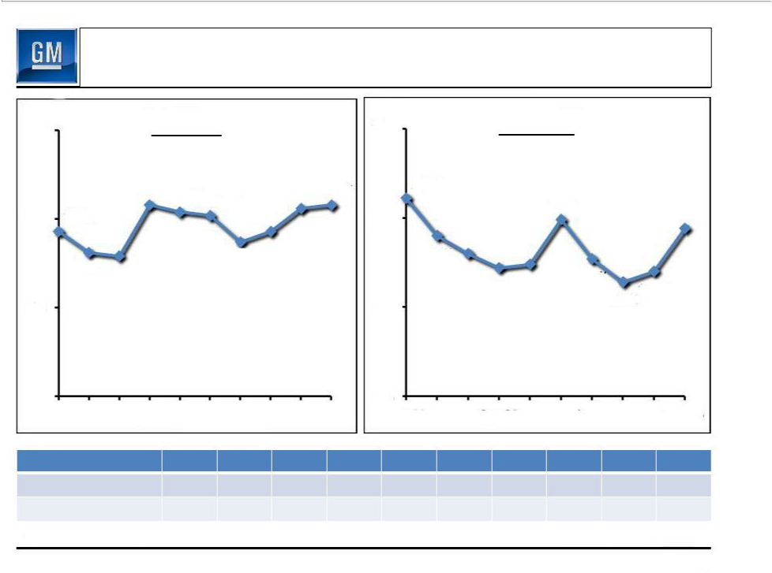
U.S. Market Performance 2009 Oct CYTD

25% | Total Share |  |  | 25% | Retail Share
 | 20.8% | 20.4% | 20.6%^{20.8%} | 21.1%
 | 20.8% | 20.4% | 20.6%^{20.8%} |  | 19.9%
 |  | 20.2% |  | 20% | 19.9% | 19.4%
20% | 19.3% | 19.3% |  | 20% |  | 19.4%
 |  | 18.7% |  | 19.0%
 | 18.1%_{17.9%} | 18.7% |  | 18.0% | 17.7%
 |  |  |  |  | 17.2% ^{17.4%} | 17.0%
15% |  |  |  | 15% | 16.4% | 17.0%

10% |  |  |  | 10%
Jan-09 | Apr-09 | Jul-09 | Oct-09 |  | Jan-09 | Apr-09 |  | Jul-09 |  | Oct-09
Core Brands | Jan | Feb | Mar | Apr | May | Jun | Jul | Aug | Sep | Oct
Total Share | 16.7% | 15.0% | 14.8% | 18.4% | 18.0% | 16.4% | 15.8% | 16.2% | 18.6% | 19.0%
Retail Share | 18.1% | 16.1% | 15.1% | 14.7% | 14.8% | 16.0% | 14.7% | 13.8% | 15.7% | 18.5%

All data prior to July 10, 2009 refers to Old GM. New GM acquired operations from Old GM on July 10, 2009

7

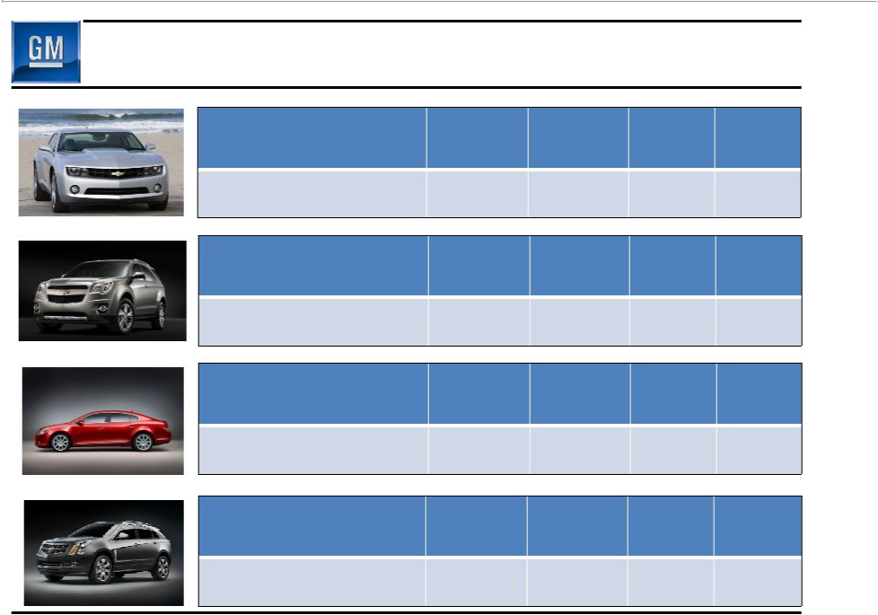
U.S. Product Launch Performance

2010 Chevrolet

Camaro

U.S. Market Performance

vs. predecessor CY 2008

2010 Chevrolet

Equinox

U.S. Market Performance

vs. predecessor CY 2008

2010 Buick

Lacrosse

U.S. Market Performance

vs. predecessor CY 2008

2010 Cadillac SRX

U.S. Market Performance

vs. predecessor CY 2008

Share of | Average | ATP vs. | 36 month
Segment | Transaction | Segment | Residual
(Jul–Oct ‘09) | Price (ATP) | Average | Value
~ 43.9% | ~ $34,800 | 116% | 52.6%
N/A | N/A | N/A | N/A
Share of | Average | ATP vs. | 36 month
Segment | Transaction | Segment | Residual
(Jul–Oct ‘09) | Price (ATP) | Average | Value
~ 7.6% | ~ $25,500 | 110% | 43.4%
+ 1.4 ppt. | + $4,100 | + 12.9 ppt. | + 5.4 ppt.
Share of | Average | ATP vs. | 36 month
Segment | Transaction | Segment | Residual
(Aug–Oct ‘09) | Price (ATP) | Average | Value
~ 4.1% | ~ $31,700 | 117% | 45.3%
- 0.5 ppt. | + $9,400 | + 26.1 ppt. | + 5.6 ppt.
Share of | Average | ATP vs. | 36 month
Segment | Transaction | Segment | Residual
(Sep–Oct ‘09) | Price (ATP) | Average | Value
~ 12.0% | ~ $40,300 | 92% | 50.7%
+ 6.8 ppt. | + $4,300 | + 5.9 ppt. | + 14.2 ppt.
 |  |  | 8

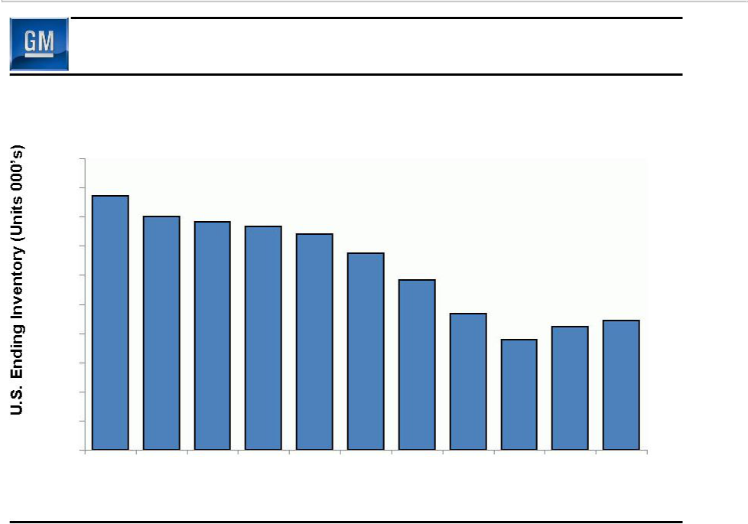
U.S. Dealer Inventory

1,000
900 | 872
900 | 801 | 781
800 | 801 | 781 | 767 | 741
700 |  |  |  | 674
700 |  |  |  | 582
600 |  |  |  | 582
500 |  |  |  | 466 | 424 | 444

400 | 379

300

200

100

0

Dec-08 Jan-09 Feb-09 Mar-09 Apr-09 May-09 Jun-09 Jul-09 Aug-09 Sep-09 Oct-09

All data prior to July 10, 2009 refers to Old GM. New GM acquired operations from Old GM on July 10, 2009

9

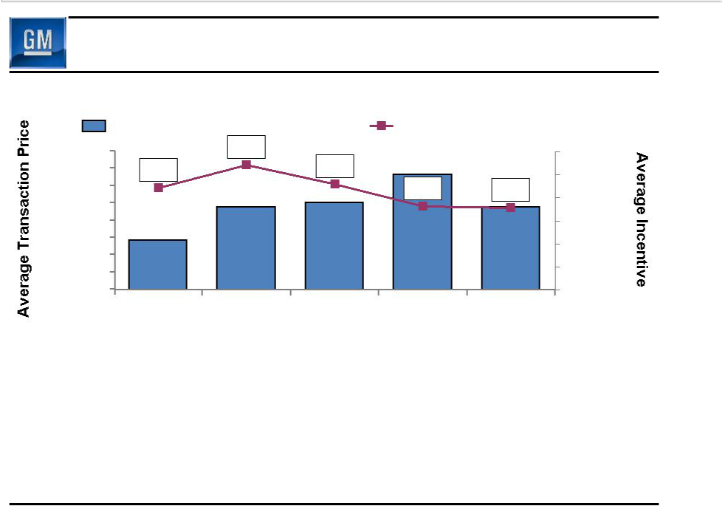
U.S. Pricing

 | Average Retail Transaction Price |  |  | Average Retail Incentive
28,500 |  | 5,433 |  |  |  | 6,000
28,000 | 4,427 |  | 4,589 |  |  | 5,000
27,500 |  |  |  | 3,641 | 3,561 | 5,000
27,500 |  |  |  | 3,641 | 3,561 | 4,000
27,000 |  |  |  |  |  | 4,000
26,500 |  |  |  | 28,179 |  | 3,000
26,000 |  | 27,001 | 27,156 | 28,179 | 26,996 | 2,000
25,500 | 25,788 | 27,001 | 27,156 |  | 26,996 | 2,000
25,500 | 25,788 |  |  |  |  | 1,000
25,000 | 25,788 |  |  |  |  | 1,000
24,500 |  |  |  |  |  | -
 | 3Q08 | 4Q08 | 1Q09 | 2Q09 | 3Q09

- Average retail transaction prices trending favorably

– Aided by continued performance of launch vehicles

– U.S. CARS Program significantly increased sales rate, but negatively impacted 3Q09 average retail transaction price due to increased mix of small vehicles

- Focus on dealer inventory management has favorably impacted retail
incentives

Average transaction price and incentive based on JD Power PIN data

10

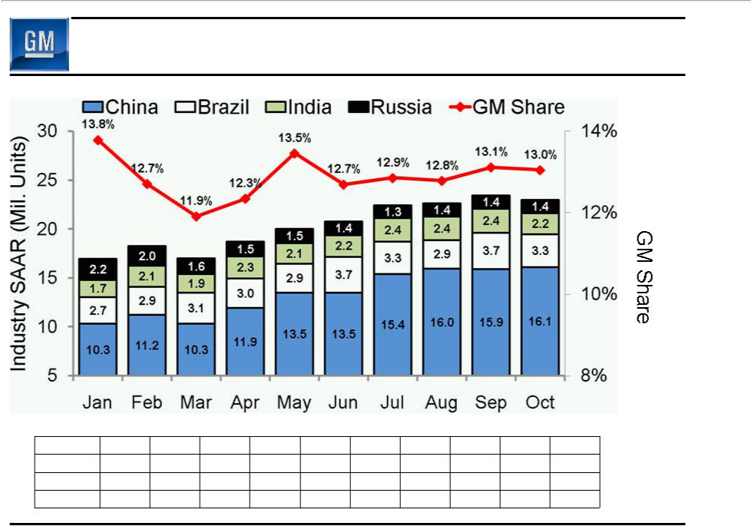
BRIC Industry Market Performance 2009 CYTD

_{22.4} _{22.7} ^{23.4} 23.0

20.0 ^{20.8}
_{18.2} 18.7
16.9 16.9

Share by Country
China | 15.1% | 13.8% | 12.4% | 13.0% | 14.0% | 12.6% | 13.2% | 13.4% | 13.5% | 13.8%
Brazil | 19.3% | 17.9% | 18.2% | 17.3% | 19.4% | 19.5% | 19.6% | 19.5% | 20.0% | 18.8%
India | 2.4% | 2.8% | 2.4% | 2.9% | 3.0% | 2.5% | 2.6% | 3.1% | 3.6% | 3.7%
Russia | 11.6% | 11.2% | 9.8% | 9.3% | 11.1% | 11.4% | 9.3% | 7.8% | 7.6% | 7.5%

All data prior to July 10, 2009 refers to Old GM. New GM acquired operations from Old GM on July 10, 2009

11

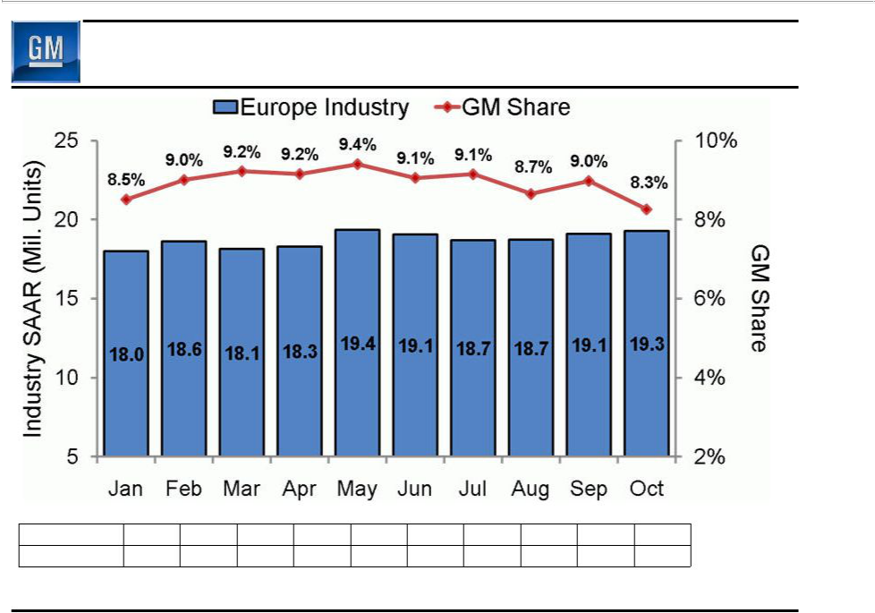
Europe Industry Market Performance 2009 CYTD

Share by Brand

Opel/Vauxhall 6.1% 6.3% 7.0% 6.8% 6.9% 6.6% 6.7% 6.0% 6.8% 6.0% Chevrolet 2.2% 2.5% 1.9% 2.1% 2.4% 2.3% 2.3% 2.6% 2.1% 2.2%

Memo: Industry includes Western, Central, Eastern and Other Europe (Incl. Russia)

All data prior to July 10, 2009 refers to Old GM. New GM acquired operations from Old GM on July 10, 2009

12

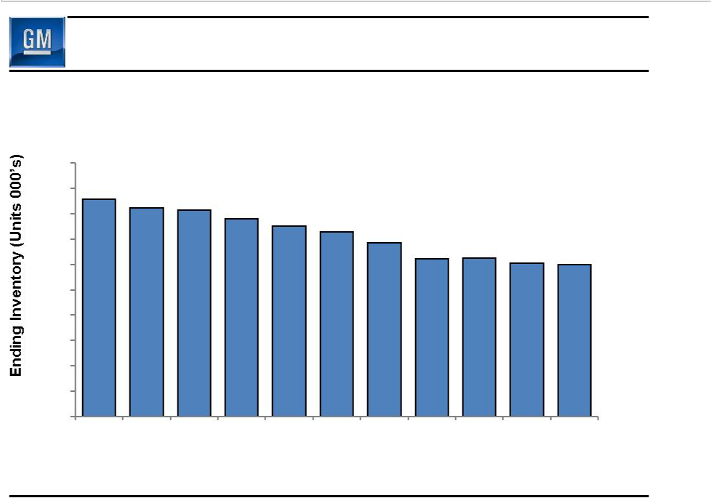
Europe 2009 GM & Dealer Inventories – Key Markets

Western/Central Europe & Russia

Opel/Vauxhall/Chevrolet/Saab

500
450 | 429 | 411 | 407 | 390
400 |  | 411 | 407 | 390 | 375
400 |  |  |  | 390 | 375 | 364
400 |  |  |  |  | 375 | 364 | 342
350 |  |  |  |  |  | 364 | 342
350 |  |  |  |  |  |  | 342 | 313
350 |  |  |  |  |  |  | 311 | 313 | 303 | 299
300

250

200

150

100

50

0

Dec-08 Jan-09 Feb-09 Mar-09 Apr-09 May-09 Jun-09 Jul-09 Aug-09 Sep-09 Oct-09

13

Opel

- November 4, GM’s Board of Directors decided to retain Opel

– Deemed best long-term and least costly solution

- Decision based on:

– Improving business conditions

– Considerable complexity and uncertainty with potential sale

- Next steps include:

– Work cooperatively and diligently on restructuring with all stakeholders including employees and governments

– Discuss financing from European governments

- Opel Bridge Loan balance €900M on Sept 30

– Repaid €500M as of Nov 13

– Remaining €400M to be repaid by the end of Nov

14

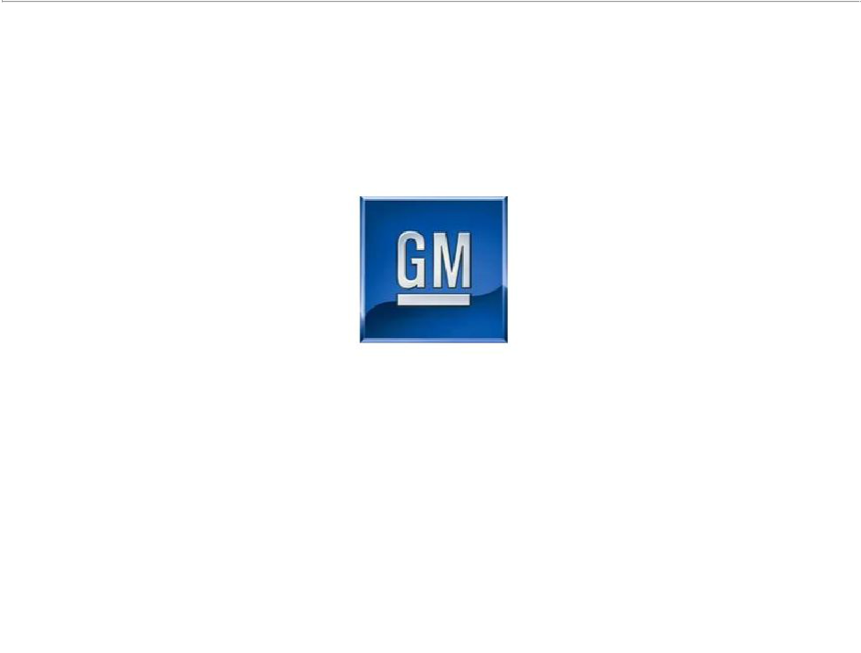

General Motors Company

Review of Preliminary Managerial Results

15

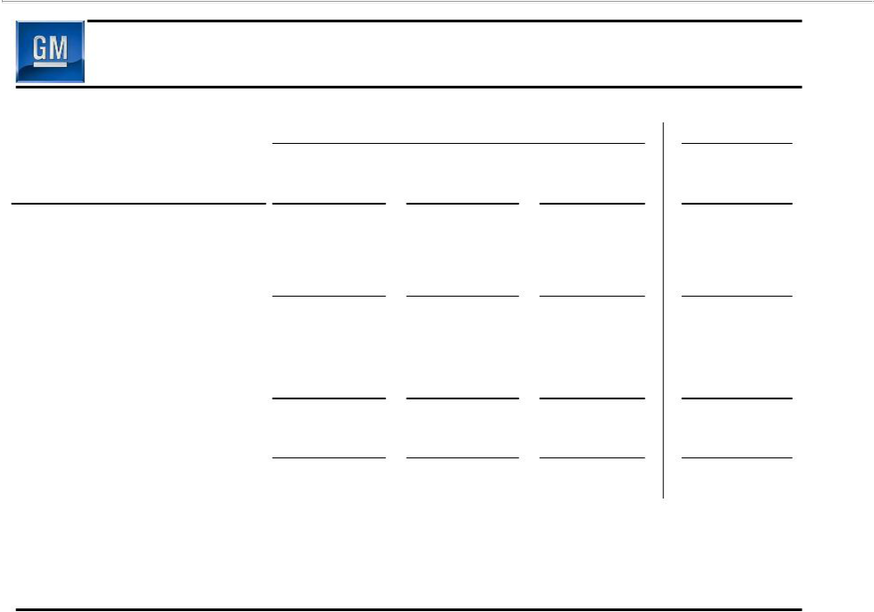
Preliminary Managerial Results

 |  |  |  | Old GM |  |  |  | New GM
 |  |  |  |  |  | July 1 - |  | July 10 -
($ Millions) |  | 1Q09 |  | 2Q09 | July 9, 2009 |  | Sept. 30, 2009
GMNA | $ | (2,764) | $ | (4,058) | $ | (532) | $ | (651)
GMIO |  | (1,216) |  | (1,181) |  | (81) |  | 238
Corp. / Other (Including Elims) |  | (15) |  | (440) |  | (14) |  | 152
GMAC Equity Income/(Loss) |  | (885) |  | (596) |  | 0 |  | 0
EBIT (Before Special Items) |  | (4,880) |  | (6,275) |  | (627) |  | (261)
Memo: EBITDA |  | (2,603) |  | (2,502) |  | (184) |  | 1,532
Net Interest |  | (1,136) |  | (1,679) |  | (209) |  | (250)
Special Items |  | (73) |  | (6,964) |  | 79,672* |  | (505)
Total EBT |  | (6,089) |  | (14,918) |  | 78,836 |  | (1,016)
Taxes |  | 114 |  | 444 |  | 522 |  | (135)
Total Managerial Net |  | (5,975) |  | (14,474) |  | 79,358 |  | (1,151)
Income/(Loss) |  | (5,975) |  | (14,474) |  | 79,358 |  | (1,151)

* Special items (July 1-July 9, 2009) includes reorganization gain of $80.7B

16

Preliminary Special Items

 |  | Old GM |  | New GM
($ Millions) |  |  | July 1 - | July 10 -
($ Millions) | 1Q09 | 2Q09 | July 9, 2009 | Sept. 30, 2009
Restructuring & Special Attrition Programs | (116) | (3,943) | (384) | (452)
Delphi Related | (135) | (812) | (41) | (112)
SAAB Related | (822) | (67) | (23) | 59
Accelerated Discount Amortization on DIP Financing | - | (1,620) | (600) | -
Reorganization Gains, Net | - | (1,157) | 80,720 | -
GMAC Related | 385 | 483 | - | -
Impairments | (291) | - | - | -
Gain on Extinguishment of Debt | 906 | - | - | -
Other | - | 152 | - | -
Total Special Items | (73) | (6,964) | 79,672 | (505)

17

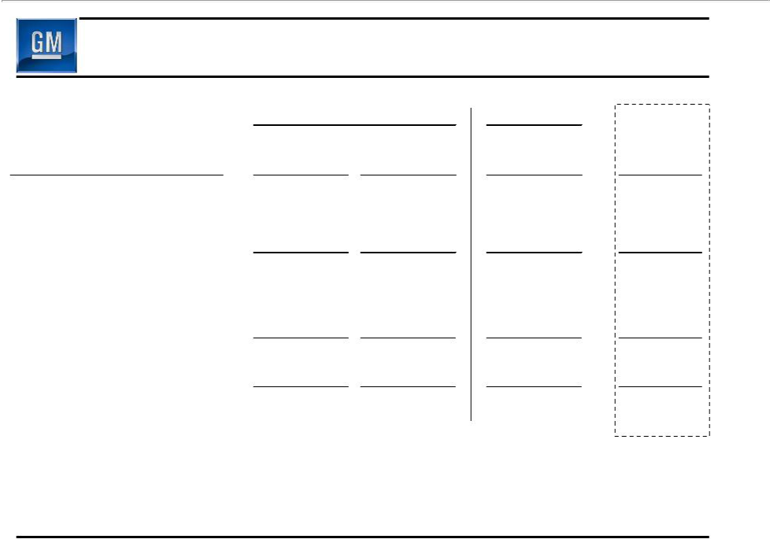
Preliminary Managerial Results

 |  | Old GM |  |  |  | New GM |  | Memo:
 |  |  |  | July 1 - |  | July 10 - | Viability Plan
($ Millions) |  | 3Q08 | July 9, 2009 |  | Sept. 30, 2009 |  |  | 3Q09 **
GMNA | $ | (2,015) | $ | (532) | $ | (651) | $ | (2,094)
GMIO |  | (447) |  | (81) |  | 238 |  | (967)
Corp. / Other (Including Elims) |  | 47 |  | (14) |  | 152 |  | (518)
GMAC Equity Income/(Loss) |  | (1,235) |  | 0 |  | 0 |  | N/A
Total EBIT (Before Special Items) |  | (3,650) |  | (627) |  | (261) |  | (3,579)
Memo: EBITDA |  | (1,682) |  | (184) |  | 1,532 |  | (1,277)
Net Interest |  | (487) |  | (209) |  | (250) |  | (620)
Special Items |  | 1,653 |  | 79,672 * |  | (505) |  | N/A
Total EBT |  | (2,484) |  | 78,836 |  | (1,016) |  | (4,199)
Taxes |  | (68) |  | 522 |  | (135)
Total Managerial Net |  | (2,552) |  | 79,358 |  | (1,151) |  | (4,199)
Income/(Loss) |  | (2,552) |  | 79,358 |  | (1,151) |  | (4,199)

  - Special items (July 1-July 9, 2009) includes reorganization gain of $80.7B

* * Viability Plan based on 5/31 plan filed with U.S. Bankruptcy court in support of 363 sale, adjusted to include full year consolidation of GME and other items (see supplemental slides for detail)

18

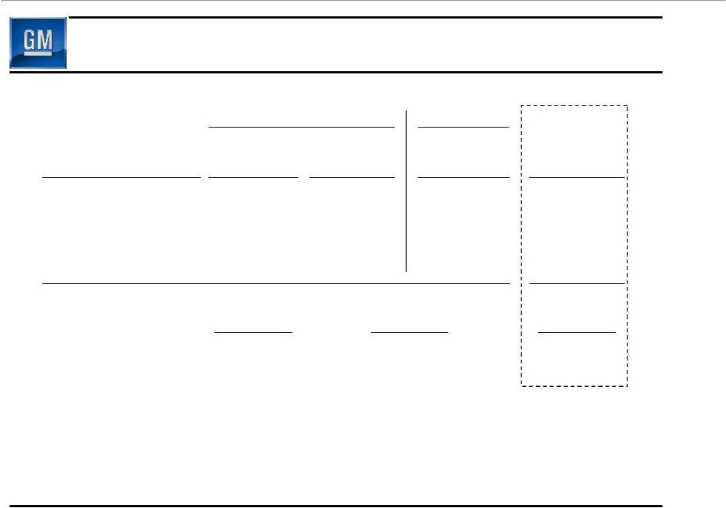
GMNA Preliminary Managerial Results Before Special Items

 |  | Old GM | New GM | Memo:
 |  | July 1 - | July 10 - | Viability Plan
($ Millions) | 3Q08 | July 9, 2009 | Sept. 30, 2009 | 3Q09 *
Revenue | $22,544 | $398 | $15,252 | $14,652
EBIT | (2,015) | (532) | (651) | (2,094)
EBIT Margin | (8.9)% | (133.7)% | (4.3)% | (14.3)%
Memo: EBITDA | (760) | (204) | 577 | (741)
 |  |  |  | Viability Plan
 | 3Q08 |  | 3Q09 | 3Q09
GMNA Production (000's) | 915 |  | 531 | 532

- Viability Plan based on 5/31 plan filed with U.S. Bankruptcy court in support of 363 sale, adjusted to include full year consolidation of GME and other items (see supplemental slides for detail)

19

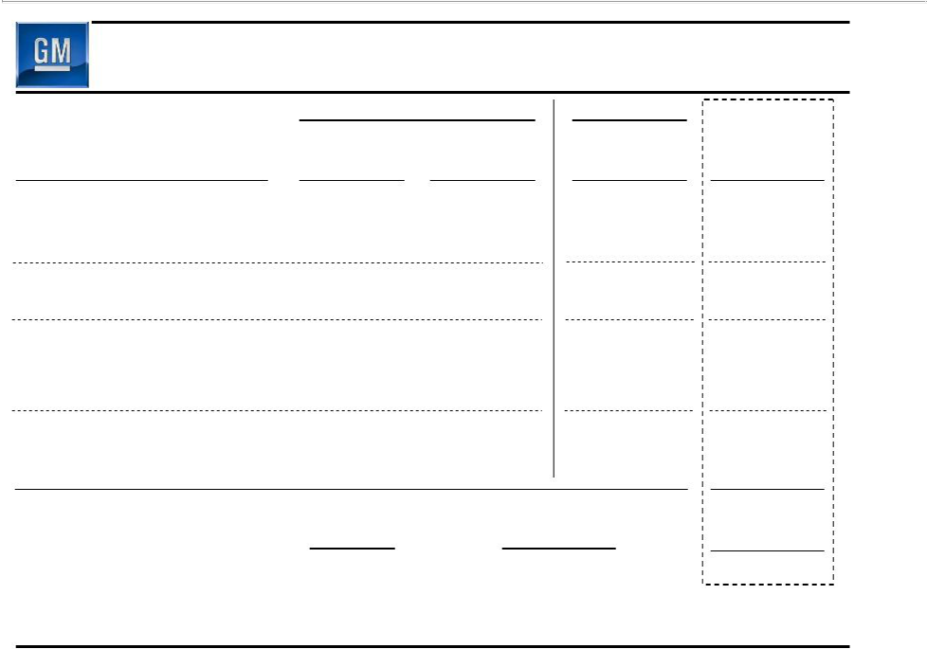
GMIO Preliminary Managerial Results Before Special Items

 |  | Old GM | New GM | Memo:
 |  | July 1 - | July 10 - | Viability Plan
($ Millions) | 3Q08 | July 9, 2009 | Sept. 30, 2009 | 3Q09 *
Revenue | $15,714 | $1,147 | $11,775 | $9,397
Income/(Loss) Before Interest, | (569) | (63) | 167 | (1,101)
Taxes, Equity Income
Equity Income | 71 | 8 | 217 | 82
Non-Controlling Interests | 51 | (26) | (146) | 52
EBIT | (447) | (81) | 238 | (967)
EBIT Margin | (2.8)% | (7.1)% | 2.0% | (10.3)%
Memo: EBITDA | 211 | 26 | 745 | (64)
Memo: EBIT ** - Europe | n/a | n/a | (437) | n/a
- LAAM | n/a | n/a | 245 | n/a
- Asia Pacific | n/a | n/a | 429 | n/a
 |  |  |  | Viability Plan
 | 3Q08 |  | 3Q09 | 3Q09
GMIO Production (000's) | 1,124 |  | 1,166 | N/A

- Viability Plan based on 5/31 plan filed with U.S. Bankruptcy court in support of 363 sale, adjusted to include full year consolidation of GME and other items (see supplemental slides for detail)

** Excludes IO eliminations

20

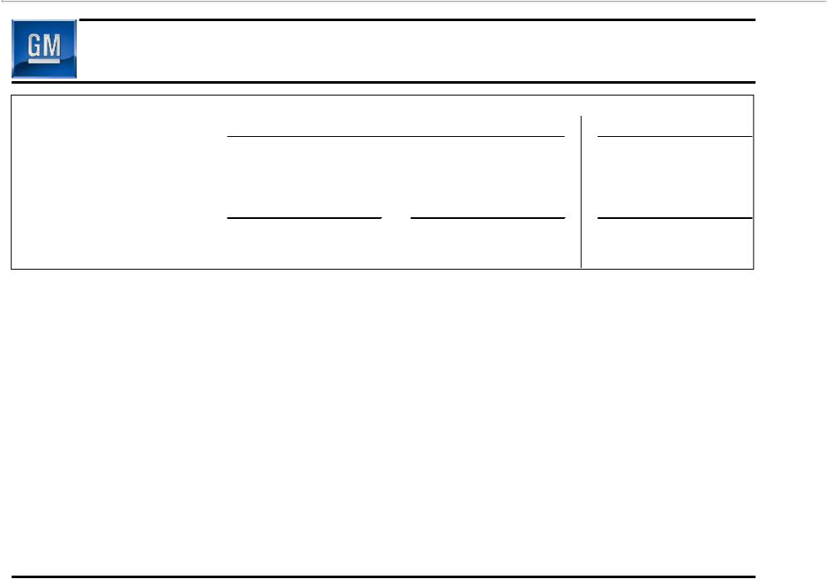
Automotive Structural Cost Summary

 | Old GM |  | New GM
 | 9 Months | January 1 | July 10
 | Ended | Through | Through
 | September 30, 2008 | July 9, 2009 | September 30, 2009
Total Structural Cost ($Bil) | $37.8B | $22.0B | $9.1B

Structural cost performance achieved through:

– Salaried headcount reduction

– Hourly headcount reduction

– Engineering savings

– Volume related savings

– Media spending

21

Total Debt

September 30, 2009 vs. July 9, 2009

Old GM

120

- 94.7

(49.5)

- billion 60 40

(26.8)

20

(1.2)
-

New GM

($ billions) | Sept 30
UST | 6.7
EDC (C$1.5) | 1.4
Supplier Support | 0.3
Adam Opel Bridge Loan (€0.9) | 1.3
Total Government | 9.7
GMNA (Ex. Gov't) | 1.5
GMIO (Ex. Gov't) | 4.8
Capital Leases & Other | 1.0
Total Debt | 17.0

^{17.2} 17.0

Old GM Debt | Government | Unsecured Bonds | UST Debt Left at | New GM Debt | New GM Debt
Balance @ | Equitization* | Left at Old GM | Old GM | Balance @ | Balance @
7/9/2009 |  |  |  | 7/10/2009 | 9/30/2009**

* Does not include equitizationof $3.9B received from EDC post July 10th

** Total debt as of 9/30/2009 does not include $9B preferred stock, $2.5B UAW VEBA note, or $0.7B CAW note

22

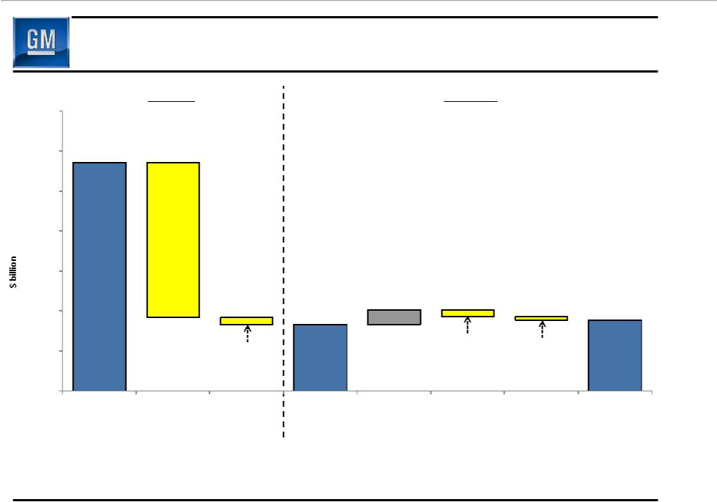
Total Liabilities

September 30, 2009 vs. July 9, 2009

 |  | Old GM |  | New GM
240
220 | 214.2
200
180 |  | (77.5)
160
140 |  |  | 133.2 | 7.4 |  | 135.6
120 |  | (3.5) |  | (3.4) | (1.6)
100
 | Total Old GM | Debt Equitizedor Other Liabilities | Total New GM | Accounts PayablePensions & OPEB Other |  | Total New GM
 | Liabilities @ | Left at Old GM Equitizedor Left at | Liabilities @ |  |  | Liabilities @
 | 7/9/2009 | Old GM | 7/10/2009 |  |  | 9/30/2009 *

- Total liabilities as of 9/30/2009 do not reflect the impact of the employee healthcare settlement agreements reached with our various constituencies

23

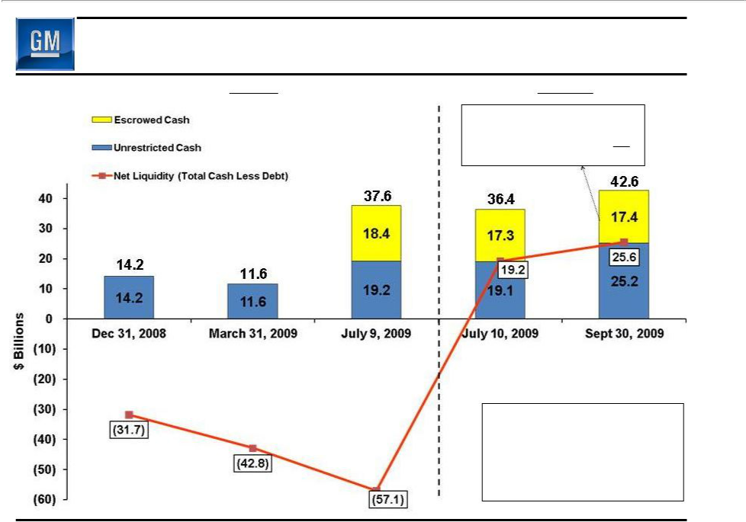
Liquidity Walk

Old GM | New GM
 | Repayment of UST/EDC Debt | 8.1
 | Delphi | 2.8
 | Canada Healthcare | 0.9
 | Remaining Escrow | 5.6
 | Total Escrowed Cash | 17.4

Debt Balance Does Not Include:

• $2.5B UAW VEBA Note

• $0.7B CAW Note

• $9.0B Preferred Stock

24

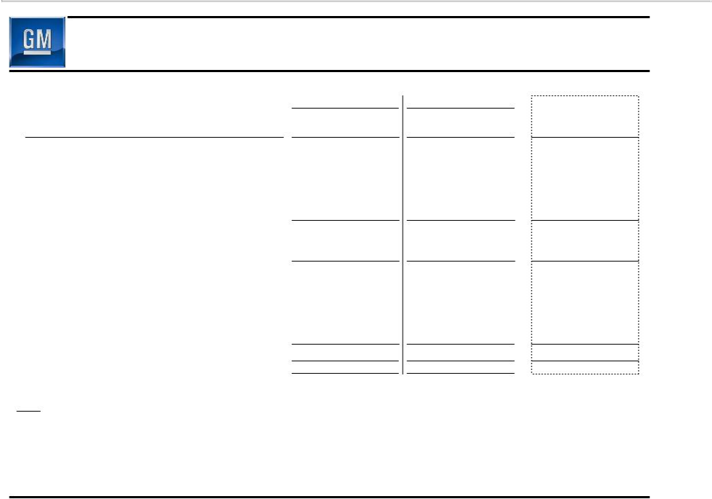
Managerial Cash Flow Summary

 | Old GM | New GM | Memo:
($ Billions) | July 1 -9, 2009 | July 10 - Sept. 30, 2009 | Viability Plan 3Q 2009*
Earnings Before Tax | 78.8 | (1.0) | (4.2)
Depreciation & Amortization | 0.4 | 1.8 | 2.3
Capital Expenditures | (0.6) | (0.6) | (1.4)
Change in Receivables, Payables & Inventory | (2.7) | 8.2 | 3.8
Pension & OPEB Expense (Net of Payments) | - | (3.9) | (4.2)
Accrued Expenses & Other | (79.5) | (1.2) | (0.5)
Managerial Operating Cash Flow before Special Items | (3.6) | 3.3 | (4.2)
Cash Restructuring Costs | (0.1) | (0.9) | (1.5)
Delphi Related | - | (0.2) | (3.0)
Special Cash Charges | (0.1) | (1.1) | (4.5)
Managerial Operating Cash Flow after Special Cash Charges | (3.7) | 2.2 | (8.7)
Non-Operating Related
Change in Debt | 23.7 | (0.4) | 15.6
Proceeds from Investment by EDC | - | 4.0 | 3.9
Other | 0.1 | 0.4 | (3.0)
Total Non-Operating Related | 23.8 | 4.0 | 16.5
Net Change in Cash and Cash-related | 20.1 | 6.2 | 7.8

Note: The $20.1 billion net change in cash and cash-related includes $1.2 billion of UST DIP that was subsequently carved-out and left behind with MLC, while the Viability Plan cash flow walk recognized a $1.0B outflow.

- Viability Plan based on 5/31 plan filed with U.S. Bankruptcy court in support of 363 sale, adjusted to include full year consolidation of GME and other items (see supplemental slides for detail)

25

Escrow Account

- $16.4B from the DIP Facility deposited in a US escrow established on July 10

– $2.8B drawn to date for Delphi related payments
– Escrow to expire in June 2010 and undrawn funds used to repay UST loan; GM may request one year extension subject to UST agreement

– Remaining funds to be distributed to GM

- US escrow originally established to cover certain contingencies anticipated in GM’s viability plan which are not expected to materialize

– Underlying performance also better than viability plan

- As a result GM has entered into an agreement with UST to repay
$1.2B/quarter ($1B to UST and $192M to Canadian government) from US escrow funds starting Q4 2009 until GM completes an IPO

– Begin process of repaying taxpayer funds and reduce negative carry on interest
– Balance of the terms remain unchanged versus original agreement including June 2010 expiration date of escrow and potential for one year extension

- In addition C$5.0B deposited in escrow for Canadian pension and healthcare contributions

– C$1.0B remains in escrow to fund Canadian Health Care Trust

26

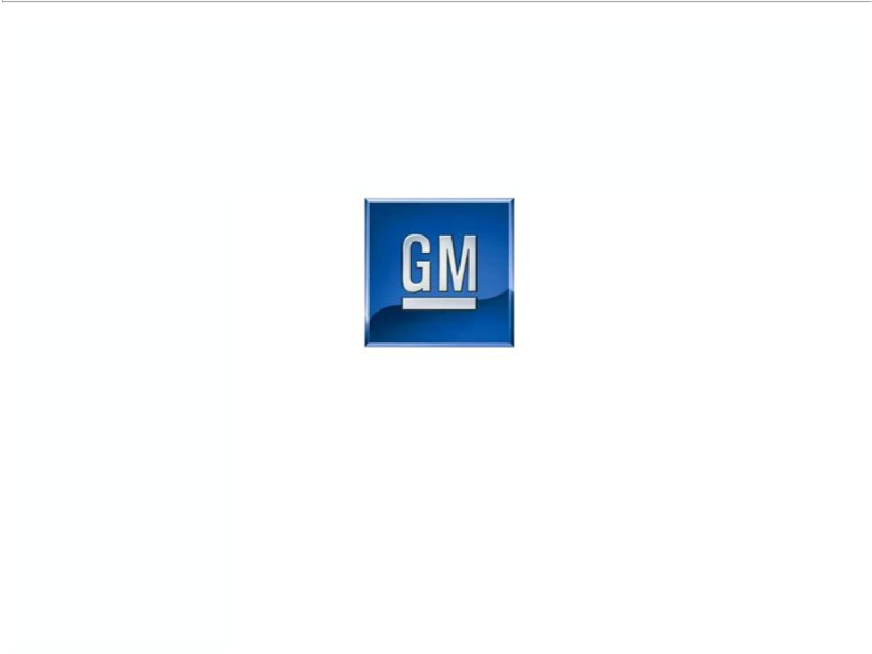

General Motors Company

Forward Perspectives

27

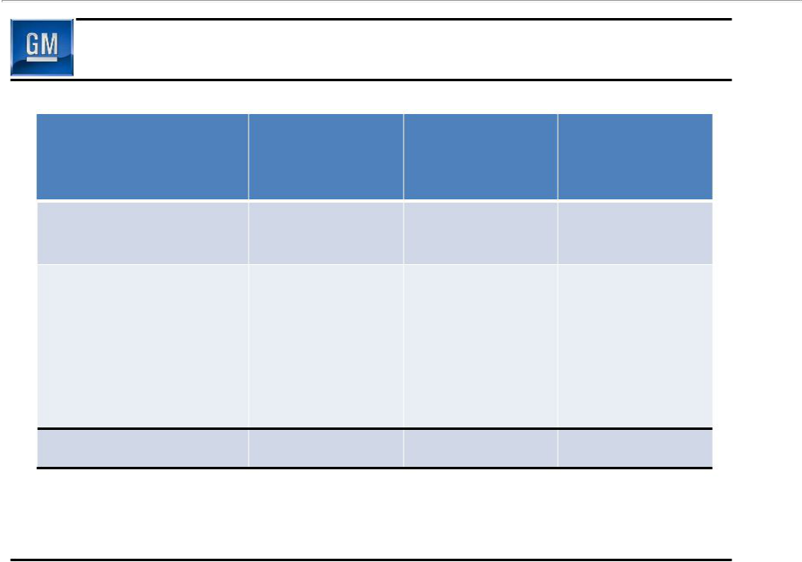
Global Industry Outlook Q4 & CY 2009

SAAR * (Mil)

Total Including Heavy

GMNA

U.S.

GMIO

Brazil

Russia

India

China

Germany

Global Total

Q3 2009 | Q4 2009 | CY 2009
Actual | Outlook | Outlook
14.2 | 13.3 | 13.0
11.7 | 10.7 | 10.5
53.6 | 52.1 | 50.3
3.3 | 3.2 | 3.2
1.4 | 1.3 | 1.5
2.4 | 2.5 | 2.2
15.7 | 13.4 | 13.0
4.0 | 3.6 | 4.1
67.8 | 65.4 | 63.3

* SAAR – Seasonally Adjusted Annualized Rate

28

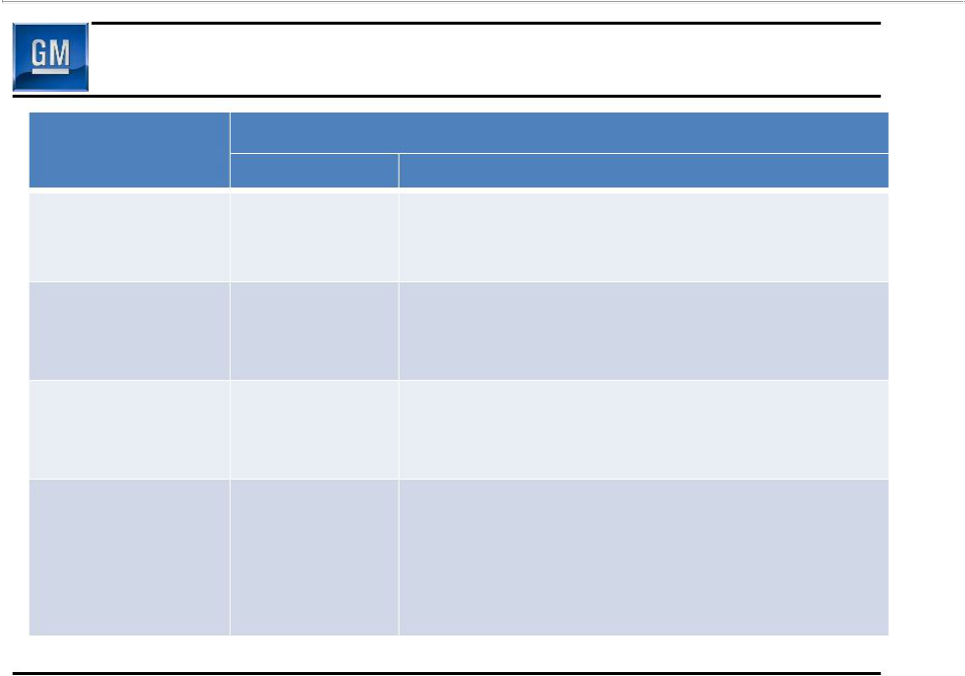
Fourth Quarter Perspectives

Item Fav/(Unfav)

Market (Unfavorable)

GM’s Market

Performance / Favorable

Production

Cost Drivers (Unfavorable)

Net Cash Flow (Unfavorable)

Status vs. Q3

Drivers

- Moderating global markets

- End of various vehicle tax incentives

- Launch product strength

- Balanced U.S. dealer inventory

- U.S. pricing flat to slightly down

- Increased media

- Increased engineering

- Higher capital expenditures

- Favorable Q3 working capital

- Supplier payment terms to net 47 days ~$(2.0)B

- Delphi ~$(2.8)B

- Continued restructuring costs ~$(1.0)B

- Repayment various gov’t loans ~$(2.5)B

29

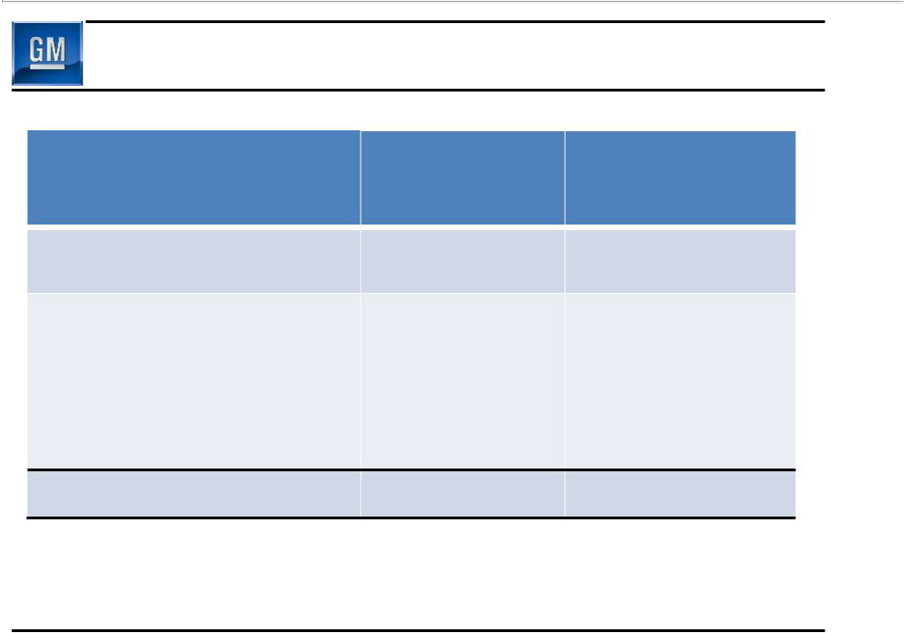
Global Industry Outlook CY 2009 & 2010

Units (Mil)

Total Including Heavy

GMNA

U.S.

GMIO

Brazil

Russia

India

China

Germany

Global Total

 | Preliminary
CY 2009 | CY 2010
Outlook | Outlook
13.0 | 13.5-14.5
10.5 | 11.0 | – 12.0
50.3 | 48.5 – 50.5
3.2 | 3.1 | – 3.3
1.5 | 1.4 | – 1.5
2.2 | 2.4 | – 2.5
13.0 | 12.0 | – 13.8
4.1 | 2.9 | – 3.1
63.3 | 62.0– 65.0

30

Q3 Summary

- Recorded $1.2B managerial loss ….significantly more work to do

- Positive managerial operating cash flow favorably impacted by:

– Working capital driven by supplier payments & production start up

– Low level of capital spending

- Third quarter GM global deliveries and market share ahead of Viability Plan

– U.S. share also ahead of Viability Plan

- Strong structural cost performance

- Balance sheet significantly de-levered

- Stronger cash balances

– Begin process of UST/EDC repayment

– Fourth quarter global cash balances materially lower due to number of special factors

31

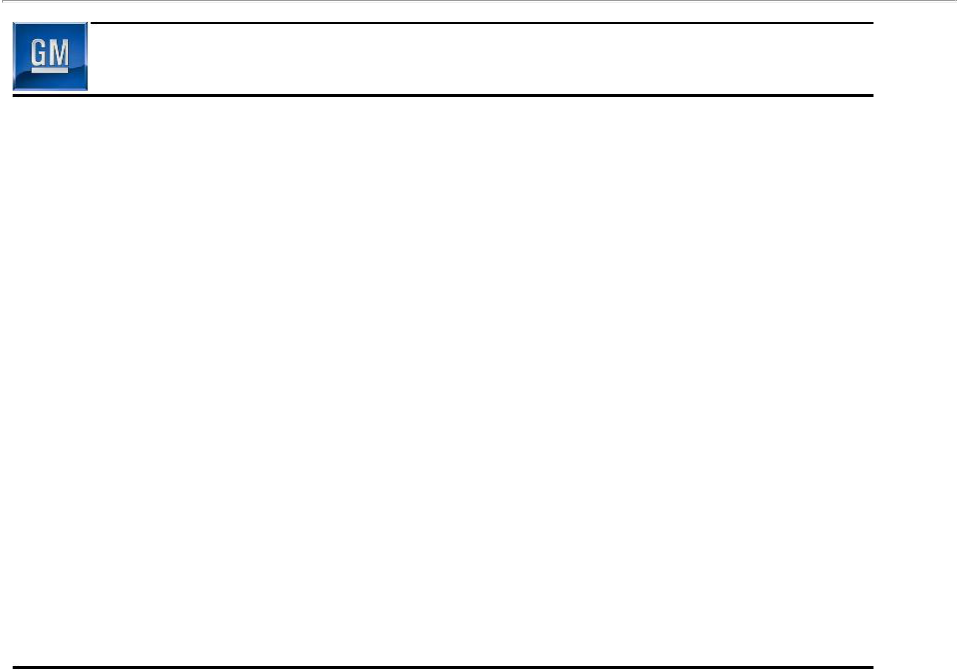
Key Focus Areas

- Drive profitable top line market and revenue performance

- European restructuring

- Continued execution of North American Operating Plan

- Reinvention of GM Culture

32

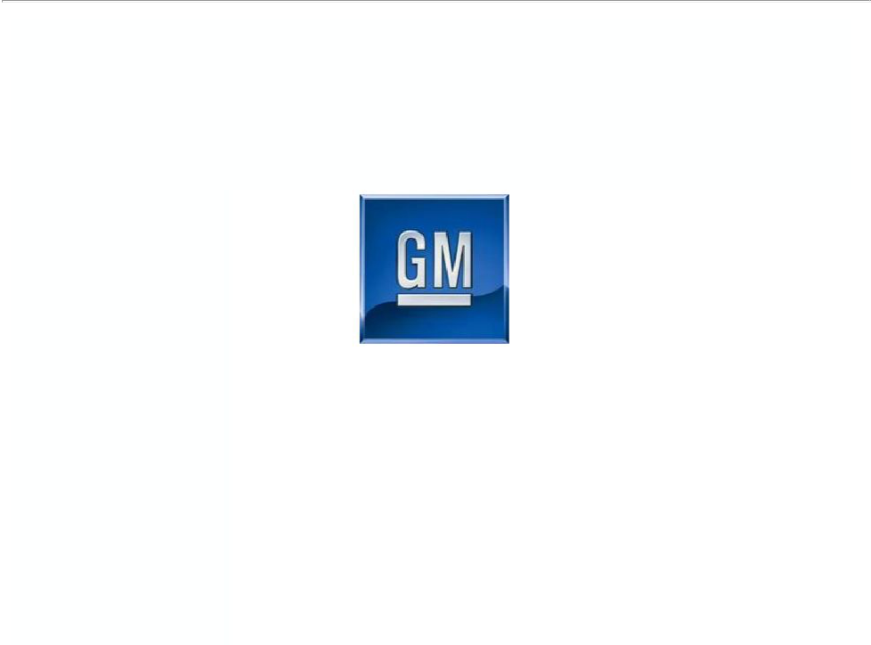

General Motors Company

Supplemental Charts

S-0

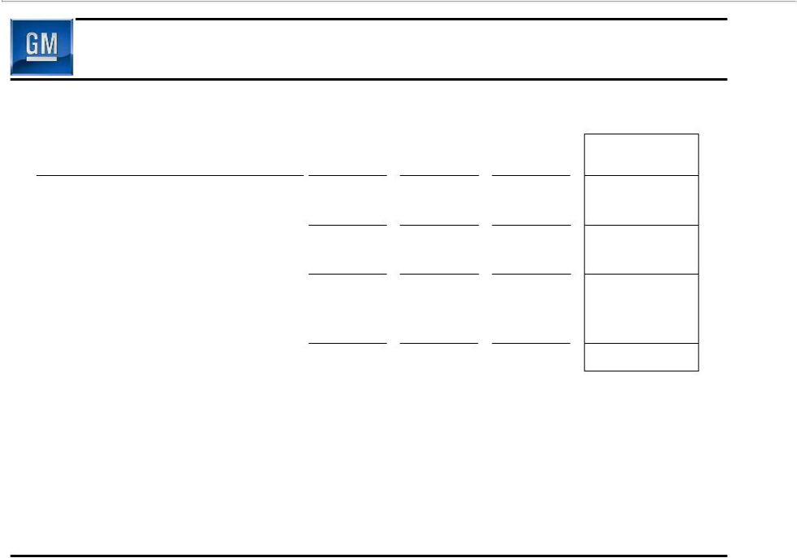
Viability Plan Filed in Support of 363 Sale

Adjusted to Include Full Year Consolidation of GME & Other Items

 | 5/31/2009 |  | Adjusted | Memo:
 | Viability Plan |  | Viability Plan | Adjusted Viability Plan
($ Millions) | CY 2009 | Adjustments * | CY 2009 | 3Q 2009
GMNA | (10,847) | (82) | (10,929) | (2,094)
GMIO | (3,495) | (1,012) | (4,507) | (967)
Auto Eliminations | (134) | - | (134) | (89)
Total Automotive EBIT Excluding Special Items | (14,476) | (1,094) | (15,570) | (3,150)
Corp Other | (1,077) | 81 | (996) | (429)
GMAC ** | N/A | - | N/A | N/A
Total EBIT Excluding Special Items | (15,553) | (1,013) | (16,566) | (3,579)
Equity Income | 308 | (308) | 0
Minority Interest | 499 | (499) | 0
Interest | (2,786) | 13 | (2,773) | (620)
Total EBT Excluding Special Items | (17,532) | (1,807) | (19,339) | (4,199)

- Adjusted to include Jun – Dec 2009 consolidation of GME, reclassification of equity income and minority interest to EBIT and inclusion of FIO EBT

** GMAC excluded from 5/31/2009 Viability Plan

S-1

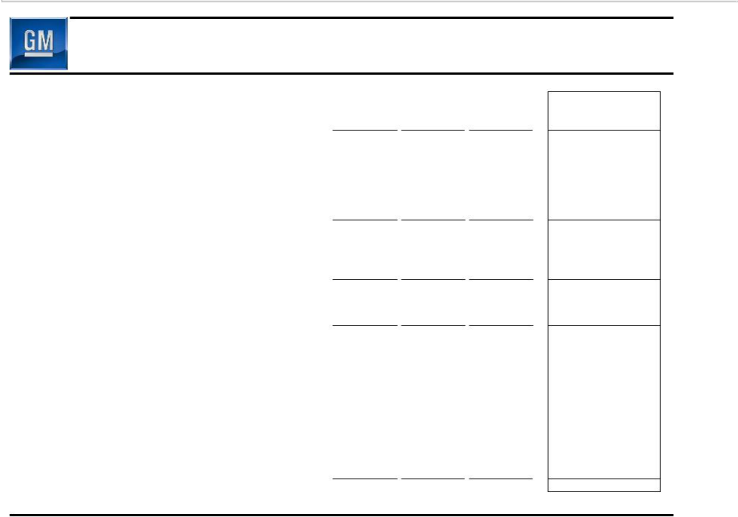
Viability Plan Filed in Support of 363 Sale – Managerial OCF

Adjusted to Include Full Year Consolidation of GME & Other Items

 | 5/31/2009 |  | Adjusted | Memo:
 | Viability Plan |  | Viability Plan | Adjusted Viability Plan
$ Billions | CY 2009 | Adjustments | CY 2009 | 3Q 2009
Total EBT Excluding Special Items | (17.5) | (1.8) | (19.3) | (4.2)
Depreciation & Amortization | 7.7 | 1.6 | 9.3 | 2.3
Capital Expenditures | (5.0) | (1.0) | (6.0) | (1.4)
Change in Receivables, Payables & Inventory | 1.0 | 0.9 | 1.9 | 3.8
Pension & OPEB Expense, (Net of Payments) | (5.8) | - | (5.8) | (4.2)
Accrued Expenses & Other | (6.2) | (0.9) | (7.1) | (0.5)
Managerial Operating Cash Flow | (25.8) | (1.2) | (27.0) | (4.2)
Asset Sales | 0.1 | - | 0.1 | -
Delphi Impact | (3.7) | - | (3.7) | (3.0)
Cash Restructuring Costs | (4.2) | (1.2) | (5.4) | (1.5)
Managerial Operating Cash Flow After Special Items | (33.5) | (2.4) | (36.0) | (8.7)
GMAC Asset Carve-out Cash Flows | 1.0 | - | 1.0 | 0.3
GMAC Distributions / GMAC Flows | (2.5) | - | (2.5) | 0.3
Managerial Operating Cash Flow After GMAC Related Flows | (35.0) | (2.4) | (37.5) | (8.1)
VEBA Withdrawals (Salaried and Hourly) | 0.0 | - | 0.0 | -
UAW/CAW IT VEBA Contribuitons | (1.0) | 0.1 | (0.9) | (0.9)
Credit Facillity Draws / (Repayments) | (5.4) | - | (5.4) | (4.7)
Debt Maturities | (3.3) | - | (3.3) | (2.2)
Debt Financing | 0.3 | - | 0.3 | -
US Government Funding | 45.5 | - | 45.5 | 19.7
Canadian Government Funding | 9.5 | - | 9.5 | 5.9
Non-US/Canadian Government Funding | - | 3.3 | 3.3 | 0.8
Gov't Loan for GMAC Rights Offering | 0.9 | - | 0.9 | -
Other Non-Operating Cash Flows | (10.1) | 1.3 | (8.8) | (2.7)
Net Cash Flow | 1.3 | 2.3 | 3.6 | 7.8

S-2

