UNITED STATES

SECURITIES AND EXCHANGE COMMISSION

Washington, DC 20549-1004

___________________

FORM 8-K

___________________

CURRENT REPORT

Pursuant to Section 13 or 15(d) of

the Securities Exchange Act of 1934

Date of Report (Date of earliest event reported) April 26, 2018

___________________

GENERAL MOTORS COMPANY

(Exact name of registrant as specified in its charter)

___________________

DELAWARE | 001-34960 | 27-0756180
(State or other jurisdiction of | 001-34960 | (I.R.S. Employer
incorporation) | (Commission File Number) | Identification No.)
300 Renaissance Center, Detroit, Michigan |  | 48265-3000
(Address of principal executive offices) |  | (Zip Code)

(313) 667-1500

(Registrant's telephone number, including area code)

Not Applicable

(Former name or former address, if changed since last report)

__________________

Check the appropriate box below if the Form 8-K filing is intended to simultaneously satisfy the filing obligation of the registrant under any of the following provisions:

- Written communications pursuant to Rule 425 under the Securities Act (17 CFR 230.425)

- Soliciting material pursuant to Rule 14a-12 under the Exchange Act (17-CFR 240.14a-12)

- Pre-commencement communications pursuant to Rule 14d-2(b) under the Exchange Act (17 CFR 240.14d-2(b))

- Pre-commencement communications pursuant to Rule 13e-4(c) under the Exchange Act (17 CFR 240.13e-4(c))

Indicate by check mark whether the registrant is an emerging growth company as defined in Rule 405 of the Securities Act of 1933 (§230.405 of this chapter) or Rule 12b-2 of the Securities Exchange Act of 1934 (§240.12b-2 of this chapter). Emerging growth company ☐

If an emerging growth company, indicate by check mark if the registrant has elected not to use the extended transition period for complying with any new or revised financial accounting standards provided pursuant to Section 13(a) of the Exchange Act. ☐

ITEM 2.02 Results of Operations and Financial Condition

On April 26, 2018 General Motors Company (GM) issued a news release and supplemental materials on the subject of its 2018 first quarter earnings. The news release and supplemental materials are attached as Exhibit 99.1 and Exhibit 99.2.

Charts furnished to securities analysts in connection with GM's 2018 first quarter earnings release are available on GM's website at www.gm.com/investors/earnings-releases.html.

ITEM 9.01 Financial Statements and Exhibits

 |  |  |  | EXHIBIT
Exhibit |  | Description
Exhibit 99.1 |  | News Release Dated April 26, 2018
Exhibit 99.2 |  | Financial Highlights Dated April 26, 2018

SIGNATURE

Pursuant to the requirements of the Securities Exchange Act of 1934, the registrant has duly caused this report to be signed on its behalf by the undersigned hereunto duly authorized.

 | GENERAL MOTORS COMPANY (Registrant)
By: | /s/ THOMAS S. TIMKO
Date: April 26, 2018
Date: April 26, 2018 | Thomas S. Timko, Vice President, Global Business Solutions and Chief
 | Accounting Officer

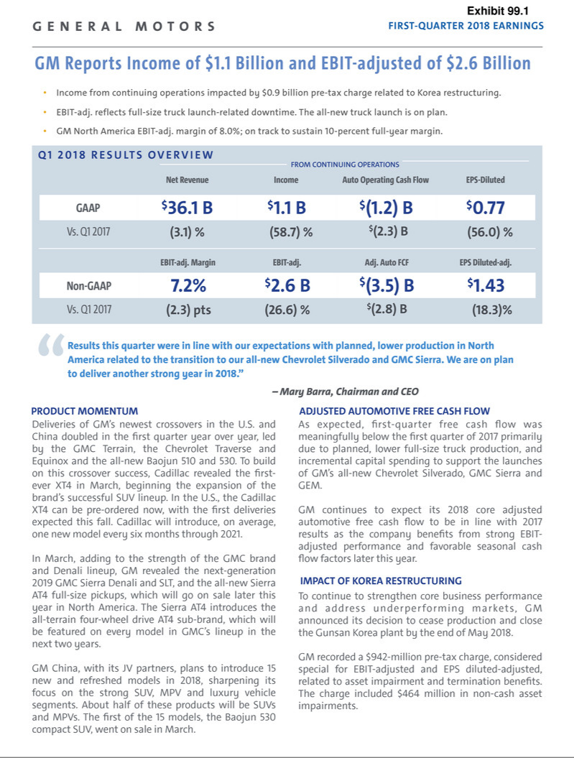

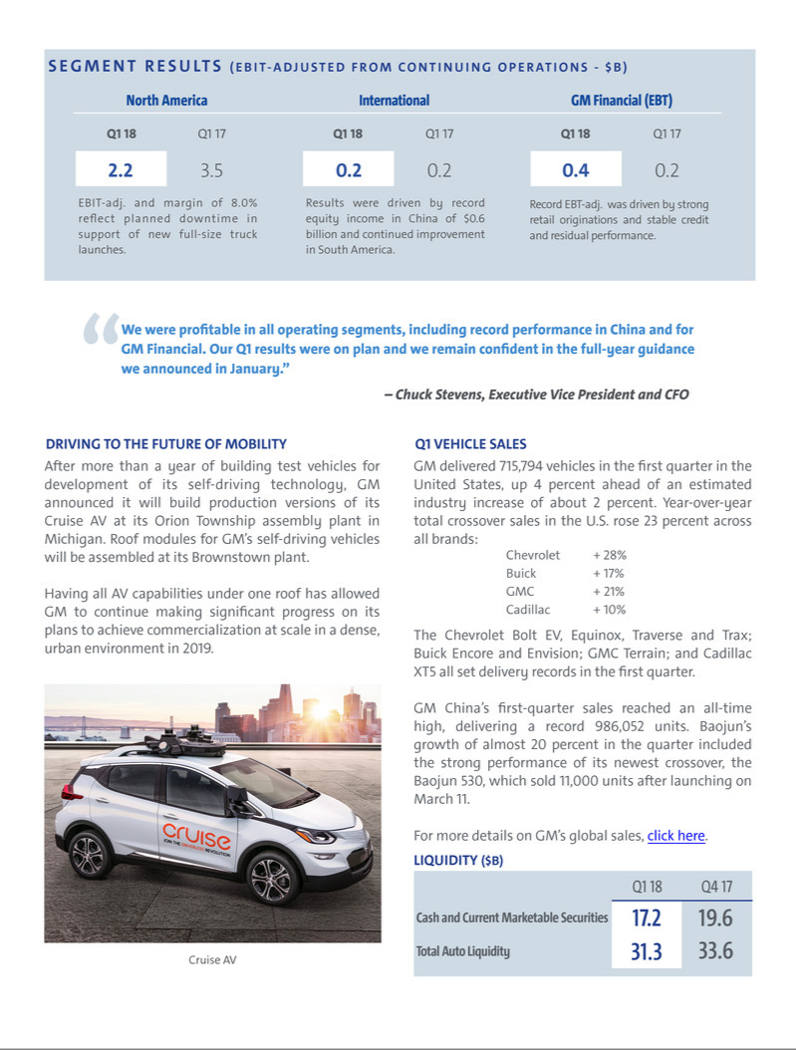

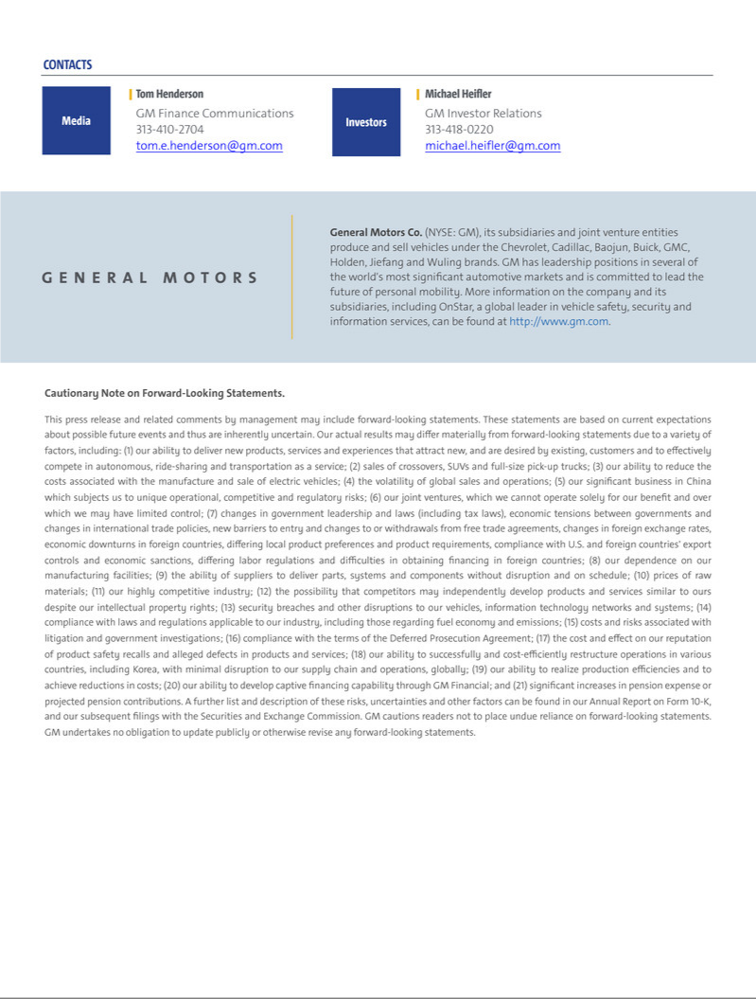

Exhibit 99.2

General Motors Company and Subsidiaries

Supplemental Material

(Unaudited)

Unless otherwise indicated, General Motors Company's (GM) non-GAAP measures are related to our continuing operations and not our discontinued operations. GM's non-GAAP measures include earnings before interest and taxes (EBIT)-adjusted, presented net of noncontrolling interests, Core EBIT-adjusted, earnings per share (EPS)-diluted-adjusted, effective tax rate-adjusted (ETR-adjusted), return on invested capital-adjusted (ROIC-adjusted), adjusted automotive free cash flow and Core adjusted automotive free cash flow. GM's calculation of these non -GAAP measures may not be comparable to similarly titled measures of other companies due to potential differences between companies in the method of calculation. As a result, the use of these non-GAAP measures has limitations and should not be considered superior to, in isolation from, or as a substitute for, related U.S. GAAP measures.

These non-GAAP measures allow management and investors to view operating trends, perform analytical comparisons and benchmark performance between periods and among geographic regions to understand operating performance without regard to items we do not consider a component of our core operating performance. Furthermore, these non-GAAP measures allow investors the opportunity to measure and monitor our performance against our externally communicated targets and evaluate the investment decisions being made by management to improve ROIC-adjusted. Management uses these measures in its financial, investment and operational decision-making processes, for internal reporting and as part of its forecasting and budgeting processes. Further, our Board of Directors uses certain of these and other measures as key metrics to determine management performance under our performance-based compensation plans. For these reasons we believe these non-GAAP measures are useful for our investors.

EBIT-adjusted EBIT-adjusted is presented net of noncontrolling interests and is used by management and can be used by investors to review our consolidated operating results because it excludes automotive interest income, automotive interest expense and income taxes as well as certain additional adjustments that are not considered part of our core operations. Examples of adjustments to EBIT include but are not limited to impairment charges on long-lived assets and other exit costs resulting from strategic shifts in our operations or discrete market and business conditions; costs arising from the ignition switch recall and related legal matters; and certain currency devaluations associated with hyperinflationary economies. For EBIT-adjusted and our other non-GAAP measures, once we have made an adjustment in the current period for an item, we will also adjust the related non-GAAP measure in any future periods in which there is a significant impact from the item.

Core EBIT-adjusted Core EBIT-adjusted is used by management and can be used by investors to review our core consolidated operating results. Core EBIT-adjusted begins with EBIT-adjusted and excludes the EBIT-adjusted results of our autonomous vehicle operations, including Cruise Automation Inc. (Cruise), Maven and our investment in Lyft.

EPS-diluted-adjusted EPS-diluted-adjusted is used by management and can be used by investors to review our consolidated diluted EPS results on a consistent basis. EPS-diluted-adjusted is calculated as net income attributable to common stockholders-diluted less income (loss) from discontinued operations on an after-tax basis, adjustments noted above for EBIT-adjusted and certain income tax adjustments divided by weighted-average common shares outstanding-diluted. Examples of income tax adjustments include the establishment or reversal of significant deferred tax asset valuation allowances.

ETR-adjusted ETR-adjusted is used by management and can be used by investors to review the consolidated effective tax rate for our core operations on a consistent basis. ETR-adjusted is calculated as Income tax expense less the income tax related to the adjustments noted above for EBIT-adjusted and the income tax adjustments noted above for EPS-diluted-adjusted divided by Income before income taxes less adjustments.

ROIC-adjusted ROIC-adjusted is used by management and can be used by investors to review our investment and capital allocation decisions. We define ROIC-adjusted as EBIT-adjusted for the trailing four quarters divided by ROIC-adjusted average net assets, which is considered to be the average equity balances adjusted for average automotive debt and interest liabilities, exclusive of capital leases; average automotive net pension and OPEB liabilities; and average automotive net income tax assets during the same period. Adjustments to the average equity balances exclude assets and liabilities classified as either assets held for sale or liabilities held for sale.

Adjusted automotive free cash flow Adjusted automotive free cash flow is used by management and can be used by investors to review the liquidity of our automotive operations and to measure and monitor our performance against our capital allocation program and evaluate our automotive liquidity against the substantial cash requirements of our automotive operations. We measure adjusted automotive free cash flow as automotive operating cash flow from continuing operations less capital expenditures adjusted for management actions. Management actions can include voluntary events such as discretionary contributions to employee benefit plans or nonrecurring specific events such as a plant closure that are considered special for EBIT-adjusted purposes.

Core adjusted automotive free cash flow Core adjusted automotive free cash flow is used by management and can be used by investors to review the liquidity of our automotive operations and to measure and monitor our performance against our capital allocation program and evaluate our automotive liquidity against the substantial cash requirements of our automotive operations. Core adjusted automotive free cash flow begins with adjusted automotive free cash flow from continuing operations and excludes the free cash flows of our autonomous vehicle operations, including Cruise, Maven and our investment in Lyft.

1

General Motors Company and Subsidiaries

Supplemental Material

(Unaudited)

The following table reconciles segment profit to Net income attributable to stockholders under U.S. GAAP (dollars in millions):

 |  | Three Months Ended
 |  | March 31, 2018 |  |  | March 31, 2017
Operating segments
GM North America (GMNA) | $ | 2,233 |  | $ | 3,471
GM International (GMI) |  | 189 |  |  | 178
General Motors Financial Company, Inc. (GM Financial)(a) |  | 443 |  |  | 228
Total operating segments |  | 2,865 |  |  | 3,877
Corporate and eliminations(b) |  | (255) |  |  | (323)
EBIT-adjusted |  | 2,610 |  |  | 3,554
Adjustments - GMI restructuring(c) |  | (942) |  |  | —
Automotive interest income |  | 64 |  |  | 57
Automotive interest expense |  | (150) |  |  | (147)
Income tax expense |  | (466) |  |  | (787)
Income from continuing operations(d) |  | 1,116 |  |  | 2,677
Loss from discontinued operations, net of tax(e) |  | 70 |  |  | 69
Net income attributable to stockholders | $ | 1,046 |  | $ | 2,608
__________
- GM Financial amounts represent earnings before income taxes-adjusted.

- GM's automotive operations' interest income and interest expense, Maven, legacy costs from the Opel and Vauxhall businesses and certain other assets in Europe (the Opel/Vauxhall Business), which are primarily pension costs, corporate expenditures including autonomous vehicle-related engineering and other costs and certain nonsegment specific revenues and expenses are recorded centrally in Corporate.

- This adjustment was excluded because of a strategic decision to rationalize our core operations by exiting or significantly reducing our presence in various international markets to focus resources on opportunities expected to deliver higher returns. The adjustment primarily consists of asset impairments and employee separation costs in Korea.

- Net of Net (income) loss attributable to noncontrolling interests.

- Represents the results of the Opel/Vauxhall Business and our European financing subsidiaries and branches (the Fincos, and together with the Opel/Vauxhall Business, the European Business).

2

General Motors Company and Subsidiaries

Supplemental Material

(Unaudited)

The following table reconciles Net income (loss) attributable to stockholders under U.S. GAAP to EBIT-adjusted (dollars in millions):

 |  |  |  |  |  |  |  |  |  |  | Three Months Ended
 |  |  | March 31, |  |  |  |  |  | December 31, |  |  |  |  |  | September 30, |  |  |  |  |  | June 30,
 |  |  | 2018 |  |  | 2017 |  |  | 2017 |  |  | 2016 |  |  | 2017 |  |  | 2016 |  |  | 2017 |  |  | 2016
 | Net income (loss) attributable to stockholders | $ | 1,046 |  | $ | 2,608 |  | $ | (5,151) |  | $ | 1,835 |  | $ | (2,981) |  | $ | 2,773 |  | $ | 1,660 |  | $ | 2,866
 | (Income) loss from discontinued operations, net of tax |  | 70 |  |  | 69 |  |  | 277 |  |  | 120 |  |  | 3,096 |  |  | (5) |  |  | 770 |  |  | (106)
 | Income tax expense |  | 466 |  |  | 787 |  |  | 7,896 |  |  | 303 |  |  | 2,316 |  |  | 902 |  |  | 534 |  |  | 877
 | Automotive interest expense |  | 150 |  |  | 147 |  |  | 145 |  |  | 150 |  |  | 151 |  |  | 145 |  |  | 132 |  |  | 144
 | Automotive interest income |  | (64) |  |  | (57) |  |  | (82) |  |  | (45) |  |  | (59) |  |  | (43) |  |  | (68) |  |  | (50)
 | Adjustments
 | GMI restructuring(a) |  | 942 |  |  | — |  |  | — |  |  | — |  |  | — |  |  | — |  |  | 540 |  |  | —
 | Ignition switch recall and related legal matters(b) |  | — |  |  | — |  |  | — |  |  | 235 |  |  | — |  |  | (110) |  |  | 114 |  |  | 115
 | Total adjustments |  | 942 |  |  | — |  |  | — |  |  | 235 |  |  | — |  |  | (110) |  |  | 654 |  |  | 115
 | EBIT-adjusted | $ | 2,610 |  | $ | 3,554 |  | $ | 3,085 |  | $ | 2,598 |  | $ | 2,523 |  | $ | 3,662 |  | $ | 3,682 |  | $ | 3,846
________
- These adjustments were excluded because of a strategic decision to rationalize our core operations by exiting or significantly reducing our presence in various international markets to focus resources on opportunities expected to deliver higher returns. The adjustment in the three months ended March 31, 2018 primarily consists of asset impairments and employee separation costs in Korea. The adjustment in the three months ended June 30, 2017 primarily consists of asset impairments and other restructuring actions in India, South Africa and Venezuela.

- These adjustments were excluded because of the unique events associated with the ignition switch recall, which included various investigations, inquiries, and complaints from constituents.

The following table reconciles EBIT-adjusted to Core EBIT-adjusted:

 |  | Three Months Ended |  |  |  |  |  | Year Ended
 |  | March 31, 2018 |  |  | March 31, 2017 |  |  | December 31, 2017
EBIT-adjusted(a) | $ | 2,610 |  | $ | 3,554 |  | $ | 12,844
EBIT loss-adjusted – autonomous vehicle operations |  | 188 |  |  | 148 |  |  | 706
Core EBIT-adjusted | $ | 2,798 |  | $ | 3,702 |  | $ | 13,550

________

- Refer to the reconciliation of Net income (loss) attributable to stockholders under U.S. GAAP to EBIT-adjusted.

3

General Motors Company and Subsidiaries

Supplemental Material

(Unaudited)

The following table reconciles diluted earnings per common share under U.S. GAAP to EPS-diluted-adjusted (dollars in millions):

 |  |  |  |  | Three Months Ended
 |  | March 31, 2018 |  |  |  |  |  | March 31, 2017
 |  | Amount |  |  | Per Share |  |  | Amount |  |  | Per Share
Diluted earnings per common share | $ | 1,032 |  | $ | 0.72 |  | $ | 2,608 |  | $ | 1.70
Diluted loss per common share – discontinued operations |  | 70 |  |  | 0.05 |  |  | 69 |  |  | 0.05
Adjustment – GMI restructuring |  | 942 |  |  | 0.66 |  |  | — |  |  | —
EPS-diluted-adjusted | $ | 2,044 |  | $ | 1.43 |  | $ | 2,677 |  | $ | 1.75

The following table reconciles our effective tax rate under U.S. GAAP to ETR-adjusted (dollars in millions):

 |  |  |  |  |  |  |  | Three Months Ended
 |  |  | March 31, 2018 |  |  |  |  |  |  |  |  | March 31, 2017
 |  | Income before |  |  |  | Income tax |  | Effective tax |  |  | Income before |  |  |  | Income tax |  | Effective tax
 |  | income taxes |  |  |  | expense |  | rate |  |  | income taxes |  |  |  | expense |  | rate
Effective tax rate | $ | 1,576 | $ |  |  | 466 | 29.6% |  |  | $ | 3,473 | $ |  |  | 787 | 22.7%
Adjustment – GMI restructuring |  | 942 |  |  |  | — |  |  |  |  | — |  |  |  | —
ETR-adjusted | $ | 2,518 | $ |  |  | 466 | 18.5% |  |  | $ | 3,473 | $ |  |  | 787 | 22.7%

4

General Motors Company and Subsidiaries

Supplemental Material

(Unaudited)

We define return on equity (ROE) as Net income (loss) attributable to stockholders for the trailing four quarters divided by average equity for the same period. Management uses average equity to provide comparable amounts in the calculation of ROE. The following table summarizes the calculation of ROE (dollars in billions):

 |  |  |  | Four Quarters Ended
 |  |  |  | March 31, 2018 |  |  |  |  | March 31, 2017
 | Net income (loss) attributable to stockholders | $ |  | (5.4) |  |  |  | $ | 10.1
 | Average equity | $ |  | 39.3 |  |  |  | $ | 44.8
 | ROE |  |  | (13.8)% |  |  |  |  | 22.5%
 | The following table summarizes the calculation of ROIC-adjusted (dollars in billions):
 |  |  |  | Four Quarters Ended
 |  |  |  | March 31, 2018 |  |  |  |  | March 31, 2017
 | EBIT-adjusted(a) | $ |  | 11.9 |  |  |  | $ | 13.7
 | Average equity | $ |  | 39.3 |  |  |  | $ | 44.8
 | Add: Average automotive debt and interest liabilities (excluding capital leases) |  |  | 12.7 |  |  |  |  | 10.0
 | Add: Average automotive net pension & OPEB liability |  |  | 20.6 |  |  |  |  | 21.5
 | Less: Average automotive net income tax asset |  |  | (26.9) |  |  |  |  | (32.4)
 | ROIC-adjusted average net assets | $ |  | 45.7 |  |  |  | $ | 43.9
 | ROIC-adjusted |  |  | 26.0% |  |  |  |  | 31.1%
________
- Refer to the reconciliation of Net income (loss) attributable to stockholders under U.S. GAAP to EBIT-adjusted in a preceding section.

The following table reconciles Net automotive cash provided by (used in) operating activities from continuing operations under U.S. GAAP to adjusted automotive free cash flow (dollars in millions):

 |  | Three Months Ended
 |  | March 31, 2018 |  |  | March 31, 2017
Net automotive cash provided by (used in) operating activities – continuing operations | $ | (1,212) |  | $ | 1,090
Less: capital expenditures – continuing operations |  | (2,252) |  |  | (1,710)
Adjusted automotive free cash flow – continuing operations |  | (3,464) |  |  | (620)
Net automotive cash provided by operating activities – discontinued operations |  | — |  |  | 307
Less: capital expenditures – discontinued operations |  | — |  |  | (270)
Adjusted automotive free cash flow | $ | (3,464) |  | $ | (583)

The following table reconciles adjusted automotive free cash flow to Core adjusted automotive free cash flow (dollars in millions):

 |  | Three Months Ended |  |  |  |  |  | Year Ended
 |  | March 31, 2018 |  |  | March 31, 2017 |  |  | December 31, 2017
Adjusted automotive free cash flow – continuing operations(a) | $ | (3,464) |  | $ | (620) |  | $ | 5,161
Net automotive cash used in operating activities – autonomous vehicle operations |  | 167 |  |  | 77 |  |  | 524
Capital expenditures – autonomous vehicles operations |  | 12 |  |  | — |  |  | 34
Core adjusted automotive free cash flow | $ | (3,285) |  | $ | (543) |  | $ | 5,719
__________
- Refer to the reconciliation of adjusted automotive free cash flow.

5

General Motors Company and Subsidiaries

Supplemental Material

(Unaudited)

The following tables summarize key financial information by segment (dollars in millions):

 |  |  |  |  |  |  |  |  |  |  |  |  |  | Total |  |  | GM
 |  | GMNA |  |  | GMI |  |  | Corporate |  |  | Eliminations |  |  | Automotive |  |  | Financial |  |  | Eliminations |  |  | Total
Three Months Ended March 31, 2018
Net sales and revenue | $ | 27,818 |  | $ | 4,848 |  | $ | 49 |  |  |  |  | $ | 32,715 |  | $ | 3,411 |  | $ | (27) |  | $ | 36,099
Expenditures for property | $ | 2,064 |  | $ | 162 |  | $ | 26 |  | $ | — |  | $ | 2,252 |  | $ | 20 |  | $ | — |  | $ | 2,272
Depreciation and amortization | $ | 1,109 |  | $ | 153 |  | $ | 12 |  | $ | — |  | $ | 1,274 |  | $ | 1,823 |  | $ | — |  | $ | 3,097
Impairment charges | $ | 25 |  | $ | 459 |  | $ | — |  | $ | — |  | $ | 484 |  | $ | — |  | $ | — |  | $ | 484
Equity income(a) | $ | 2 |  | $ | 594 |  | $ | — |  | $ | — |  | $ | 596 |  | $ | 52 |  | $ | — |  | $ | 648
 |  |  |  |  |  |  |  |  |  |  |  |  |  | Total |  |  | GM
 |  | GMNA |  |  | GMI |  |  | Corporate |  |  | Eliminations |  |  | Automotive |  |  | Financial |  |  | Eliminations |  |  | Total
Three Months Ended March 31, 2017
Net sales and revenue | $ | 29,338 |  | $ | 5,138 |  | $ | 174 |  |  |  |  | $ | 34,650 |  | $ | 2,748 |  | $ | (132) |  | $ | 37,266
Expenditures for property | $ | 1,528 |  | $ | 180 |  | $ | 2 |  | $ | — |  | $ | 1,710 |  | $ | 20 |  | $ | — |  | $ | 1,730
Depreciation and amortization | $ | 1,102 |  | $ | 191 |  | $ | 2 |  | $ | (1) |  | $ | 1,294 |  | $ | 1,428 |  | $ | — |  | $ | 2,722
Impairment charges | $ | 15 |  | $ | 1 |  | $ | 5 |  | $ | — |  | $ | 21 |  | $ | — |  | $ | — |  | $ | 21
Equity income(a) | $ | 5 |  | $ | 504 |  | $ | — |  | $ | — |  | $ | 509 |  | $ | 46 |  | $ | — |  | $ | 555
________
- Includes Automotive China equity income of $597 million and $504 million in the three months ended March 31, 2018 and 2017.

6

General Motors Company and Subsidiaries

Supplemental Material

(Unaudited)

Vehicle Sales

GM presents both wholesale and retail vehicle sales data to assist in the analysis of our revenue and our market share. GM does not currently export vehicles to Cuba, Iran, North Korea, Sudan or Syria. Accordingly these countries are excluded from industry sales data and corresponding calculation of GM's market share.

Wholesale vehicle sales data, which represents sales directly to dealers and others, including sales to fleet customers, is the measure that correlates to GM's revenue from the sale of vehicles, which is the largest component of Automotive net sales and revenue. Wholesale vehicle sales exclude vehicles sold by joint ventures. In the three months ended March 31, 2018, 34.9% of our wholesale vehicle sales volume was generated outside the U.S. The following table summarizes total wholesale vehicle sales of new vehicles by automotive segment (vehicles in thousands):

 | Three Months Ended
 | March 31, 2018 |  | March 31, 2017
GMNA(a) | 893 |  | 940
GMI(b) | 266 |  | 299
Total | 1,159 |  | 1,239
Discontinued operations | — |  | 303
__________
- Wholesale vehicle sales related to transactions with the European Business were insignificant for the three months ended March 31, 2017.

- Wholesale vehicle sales include 48 vehicles related to transactions with the European Business for the three months ended March 31, 2017.

7

General Motors Company and Subsidiaries

Supplemental Material

(Unaudited)

Retail vehicle sales data, which represents sales to end customers based upon the good faith estimates of management, including sales to fleet customers, does not correlate directly to the revenue GM recognizes during the period. However retail vehicle sales data is indicative of the underlying demand for GM vehicles. Market share information is based primarily on retail vehicle sales volume. In countries where retail vehicle sales data is not readily available, other data sources such as wholesale or forecast volumes are used to estimate retail vehicle sales to end customers.

Retail vehicle sales data includes all sales by joint ventures on a total vehicle basis, not based on the percentage of ownership in the joint venture. Certain joint venture agreements in China allow for the contractual right to report vehicle sales of non-GM trademarked vehicles by those joint ventures. Retail vehicle sales data includes vehicles used by dealers under courtesy transportation programs and vehicles sold through the dealer registration channel. This sales channel consists primarily of dealer demonstrator, loaner and self-registered vehicles which are not eligible to be sold as new vehicles after being registered by dealers. Certain fleet sales that are accounted for as operating leases are included in retail vehicle sales at the time of delivery to daily rental car companies. The following table summarizes total industry retail sales, or estimated sales where retail sales volume is not available by geographic region (vehicles in thousands):

 | Three Months Ended
 | March 31, 2018 |  | March 31, 2017
United States
Chevrolet – Cars | 121 |  | 154
Chevrolet – Trucks | 223 |  | 203
Chevrolet – Crossovers | 147 |  | 115
Cadillac | 37 |  | 34
Buick | 57 |  | 50
GMC | 131 |  | 134
Total United States | 716 |  | 690
Canada, Mexico and Other | 111 |  | 126
Total North America(a) | 827 |  | 816
Asia/Pacific, Middle East and Africa
Chevrolet | 216 |  | 209
Wuling | 289 |  | 324
Buick | 272 |  | 250
Baojun | 244 |  | 204
Cadillac | 57 |  | 41
Other | 23 |  | 42
Total Asia/Pacific, Middle East and Africa(a)(b)(c) | 1,101 |  | 1,070
South America(a)(d) | 167 |  | 148
Total in GM markets | 2,095 |  | 2,034
Total Europe | 1 |  | 310
Total Worldwide | 2,096 |  | 2,344
_______
- Sales of Opel/Vauxhall outside of Europe were insignificant in the three months ended March 31, 2018 and 2017.

- We use estimated vehicle registrations data as the basis for calculating industry volume and market share in China.

- Includes Industry and GM sales in India and South Africa. As of December 31, 2017 we have ceased sales of Chevrolet for the domestic markets in India and South Africa.

- Primarily Chevrolet.

8

General Motors Company and Subsidiaries

Supplemental Material

(Unaudited)

The vehicle sales at GM's China joint ventures presented in the following table are included in GM's retail vehicle sales on the preceding page (vehicles in thousands):

 |  | Three Months Ended
 |  | March 31, 2018 |  |  |  | March 31, 2017
SAIC General Motors Sales Co., Ltd.(a) |  | 457 |  |  |  | 386
SAIC GM Wuling Automobile Co., Ltd. and FAW-GM Light Duty Commercial Vehicle Co., Ltd.(a) |  | 529 |  |  |  | 527
 |  | Three Months Ended
 |  | March 31, 2018 |  |  |  | March 31, 2017
Market Share
United States – Cars |  | 10.9% |  |  |  | 11.9%
United States – Trucks |  | 24.8% |  |  |  | 25.2%
United States – Crossovers |  | 16.4% |  |  |  | 15.1%
Total United States |  | 17.0% |  |  |  | 16.8%
Total North America |  | 16.3% |  |  |  | 16.3%
Total Asia/Pacific, Middle East and Africa(a) |  | 9.0% |  |  |  | 9.2%
Total South America |  | 15.5% |  |  |  | 15.7%
Total GM Market |  | 11.4% |  |  |  | 11.6%
Total Europe |  | —% |  |  |  | 6.1%
Total Worldwide |  | 9.0% |  |  |  | 10.4%
United States fleet sales as a percentage of retail vehicle sales |  | 23.0% |  |  |  | 20.7%
North America capacity two shift utilization |  | 99.0% |  |  |  | 106.0%
_______
- We use estimated vehicle registrations data as the basis for calculating industry volume and market share in China.

9

General Motors Company and Subsidiaries

Combining Income Statement Information

(In millions) (Unaudited)

 |  |  |  |  | Three Months Ended March 31, 2018 |  |  |  |  |  |  |  |  |  |  | Three Months Ended March 31, 2017
 |  | Automotive |  |  | GM Financial |  |  | Eliminations |  |  | Combined |  |  | Automotive |  |  | GM Financial |  |  | Eliminations |  |  | Combined
Net sales and revenue
Automotive | $ | 32,715 |  | $ | — |  | $ | (24) |  | $ | 32,691 |  | $ | 34,650 |  | $ | — |  | $ | (131) |  | $ | 34,519
GM Financial |  | — |  |  | 3,411 |  |  | (3) |  |  | 3,408 |  |  | — |  |  | 2,748 |  |  | (1) |  |  | 2,747
Total net sales and revenue |  | 32,715 |  |  | 3,411 |  |  | (27) |  |  | 36,099 |  |  | 34,650 |  |  | 2,748 |  |  | (132) |  |  | 37,266

Costs and expenses

Automotive cost of sales

GM Financial interest, operating and other expenses

Automotive selling, general and administrative expense

Total costs and expenses

Operating income

Automotive interest expense

Interest income and other non-operating income, net

Equity income

Income before income taxes

Income tax expense

Income from continuing operations

(Income) loss from discontinued operations, net of tax

Net income

Net (income) loss attributable to noncontrolling interests
Net income attributable to stockholders $

Net income attributable to common

stockholders $

30,209 |  | — |  |  | (25) |  |  | 30,184 |  |  | 29,893 |  |  | — |  |  | (132) |  |  | 29,761
— |  | 3,020 |  |  | (6) |  |  | 3,014 |  |  | — |  |  | 2,566 |  |  | — |  |  | 2,566
2,372 |  | — |  |  | — |  |  | 2,372 |  |  | 2,356 |  |  | — |  |  | — |  |  | 2,356
32,581 |  | 3,020 |  |  | (31) |  |  | 35,570 |  |  | 32,249 |  |  | 2,566 |  |  | (132) |  |  | 34,683
134 |  | 391 |  |  | 4 |  |  | 529 |  |  | 2,401 |  |  | 182 |  |  | — |  |  | 2,583
152 |  | — |  |  | (2) |  |  | 150 |  |  | 147 |  |  | — |  |  | — |  |  | 147
549 |  | — |  |  | — |  |  | 549 |  |  | 482 |  |  | — |  |  | — |  |  | 482
596 |  | 52 |  |  | — |  |  | 648 |  |  | 509 |  |  | 46 |  |  | — |  |  | 555
1,127 |  | 443 |  |  | 6 |  |  | 1,576 |  |  | 3,245 |  |  | 228 |  |  | — |  |  | 3,473
397 |  | 69 |  |  | — |  |  | 466 |  |  | 740 |  |  | 47 |  |  | — |  |  | 787
730 |  | 374 |  |  | 6 |  |  | 1,110 |  |  | 2,505 |  |  | 181 |  |  | — |  |  | 2,686
64 |  | — |  |  | 6 |  |  | 70 |  |  | 93 |  |  | (24) |  |  | — |  |  | 69
666 |  | 374 |  |  | — |  |  | 1,040 |  |  | 2,412 |  |  | 205 |  |  | — |  |  | 2,617
6 |  | — |  |  | — |  |  | 6 |  |  | (9) |  |  | — |  |  | — |  |  | (9)
672 | $ | 374 |  | $ | — |  | $ | 1,046 |  | $ | 2,403 |  | $ | 205 |  | $ | — |  | $ | 2,608
672 | $ | 360 |  | $ | — |  | $ | 1,032 |  | $ | 2,403 |  | $ | 205 |  | $ | — |  | $ | 2,608
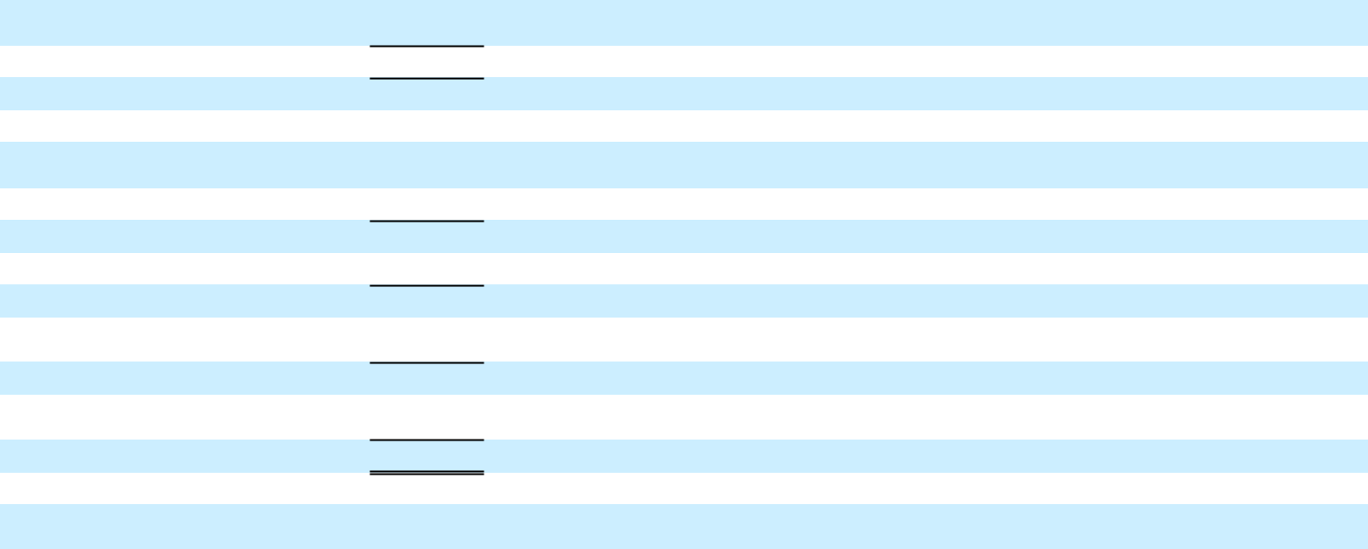

10

General Motors Company and Subsidiaries

Basic and Diluted Earnings per Share

(Unaudited)

The following table summarizes basic and diluted earnings (loss) per share (in millions, except per share amounts):

 |  | Three Months Ended
 |  | March 31, 2018 |  |  | March 31, 2017
Basic earnings per share
Income from continuing operations(a) | $ | 1,116 |  | $ | 2,677
Less: cumulative dividends on GM Financial preferred stock |  | (14) |  |  | —
Income from continuing operations attributable to common stockholders |  | 1,102 |  |  | 2,677
Loss from discontinued operations, net of tax |  | 70 |  |  | 69
Net income attributable to common stockholders | $ | 1,032 |  | $ | 2,608
Weighted-average common shares outstanding |  | 1,408 |  |  | 1,505
Basic earnings per common share – continuing operations | $ | 0.78 |  | $ | 1.78
Basic loss per common share – discontinued operations | $ | 0.05 |  | $ | 0.05
Basic earnings per common share | $ | 0.73 |  | $ | 1.73
Diluted earnings per share
Income from continuing operations attributable to common stockholders – diluted(a) | $ | 1,102 |  | $ | 2,677
Loss from discontinued operations, net of tax – diluted | $ | 70 |  | $ | 69
Net income attributable to common stockholders – diluted | $ | 1,032 |  | $ | 2,608
Weighted-average common shares outstanding – diluted |  | 1,430 |  |  | 1,532
Diluted earnings per common share – continuing operations | $ | 0.77 |  | $ | 1.75
Diluted loss per common share – discontinued operations | $ | 0.05 |  | $ | 0.05
Diluted earnings per common share | $ | 0.72 |  | $ | 1.70
Potentially dilutive securities(b) |  | 4 |  |  | —
__________
- Net of Net (income) loss attributable to noncontrolling interests.

- Potentially dilutive securities attributable to outstanding stock options and Restricted Stock Units were excluded from the computation of diluted earnings per share because the securities would have had an antidilutive effect.

11

General Motors Company and Subsidiaries

Combining Balance Sheet Information

(In millions, except per share amounts) (Unaudited)

ASSETS

Current Assets

Cash and cash equivalents

Marketable securities

Accounts and notes receivable, net(a)

GM Financial receivables, net(b)

Inventories

Equipment on operating leases, net

Other current assets

Total current assets

Non-current Assets

GM Financial receivables, net(b)

Equity in net assets of nonconsolidated affiliates

Property, net

Goodwill and intangible assets, net

Equipment on operating leases, net

Deferred income taxes

Other assets

Total non-current assets

Total Assets

LIABILITIES AND EQUITY

 |  |  |  | March 31, 2018 |  |  |  |  |  |  |  |  |  |  |  | December 31, 2017
 |  |  |  |  |  |  | Reclassifications / |  |  |  |  |  |  |  |  |  |  |  | Reclassifications /
 | Automotive |  |  | GM Financial |  |  | Eliminations |  |  | Combined |  |  | Automotive |  |  | GM Financial |  |  | Eliminations |  |  | Combined
$ | 10,078 |  | $ | 4,178 |  | $ | — |  | $ | 14,256 |  | $ | 11,247 |  | $ | 4,265 |  | $ | — |  | $ | 15,512
 | 7,110 |  |  | — |  |  | — |  |  | 7,110 |  |  | 8,313 |  |  | — |  |  | — |  |  | 8,313
 | 10,126 |  |  | 1,433 |  |  | (790) |  |  | 10,769 |  |  | 7,759 |  |  | 806 |  |  | (401) |  |  | 8,164
 | — |  |  | 21,571 |  |  | (414) |  |  | 21,157 |  |  | — |  |  | 20,901 |  |  | (380) |  |  | 20,521
 | 11,461 |  |  | — |  |  | — |  |  | 11,461 |  |  | 10,663 |  |  | — |  |  | — |  |  | 10,663
 | 789 |  |  | — |  |  | — |  |  | 789 |  |  | 1,106 |  |  | — |  |  | — |  |  | 1,106
 | 1,642 |  |  | 4,251 |  |  | — |  |  | 5,893 |  |  | 1,396 |  |  | 3,069 |  |  | — |  |  | 4,465
 | 41,206 |  |  | 31,433 |  |  | (1,204) |  |  | 71,435 |  |  | 40,484 |  |  | 29,041 |  |  | (781) |  |  | 68,744
 | — |  |  | 22,202 |  |  | (56) |  |  | 22,146 |  |  | — |  |  | 21,271 |  |  | (63) |  |  | 21,208
 | 8,602 |  |  | 1,281 |  |  | — |  |  | 9,883 |  |  | 7,886 |  |  | 1,187 |  |  | — |  |  | 9,073
 | 37,057 |  |  | 264 |  |  | — |  |  | 37,321 |  |  | 35,994 |  |  | 259 |  |  | — |  |  | 36,253
 | 4,421 |  |  | 1,369 |  |  | — |  |  | 5,790 |  |  | 4,482 |  |  | 1,367 |  |  | — |  |  | 5,849
 | — |  |  | 43,444 |  |  | — |  |  | 43,444 |  |  | — |  |  | 42,882 |  |  | — |  |  | 42,882
 | 23,278 |  |  | 260 |  |  | — |  |  | 23,538 |  |  | 23,229 |  |  | 315 |  |  | — |  |  | 23,544
 | 4,212 |  |  | 957 |  |  | — |  |  | 5,169 |  |  | 4,000 |  |  | 929 |  |  | — |  |  | 4,929
 | 77,570 |  |  | 69,777 |  |  | (56) |  |  | 147,291 |  |  | 75,591 |  |  | 68,210 |  |  | (63) |  |  | 143,738
$ | 118,776 |  | $ | 101,210 |  | $ | (1,260) |  | $ | 218,726 |  | $ | 116,075 |  | $ | 97,251 |  | $ | (844) |  | $ | 212,482

Current Liabilities

Accounts payable (principally trade)(a)

Short-term debt and current portion of long-term debt Automotive(b)

GM Financial

Accrued liabilities

Total current liabilities

Non-current Liabilities

Long-term debt

Automotive(b)

GM Financial

Postretirement benefits other than pensions

Pensions

Other liabilities

Total non-current liabilities

Total Liabilities

Commitments and contingencies

Equity

Common stock, $0.01 par value

Preferred stock, $0.01 par value

Additional paid-in capital(c)

Retained earnings

Accumulated other comprehensive loss

Total stockholders’ equity

Noncontrolling interests(c)

Total Equity

Total Liabilities and Equity

_________

$ | 26,121 |  | $ | 708 |  | $ | (790) |  | $ | 26,039 |  | $ | 23,696 |  | $ | 634 |  | $ | (401) |  | $ | 23,929
 | 4,755 |  |  | — |  |  | (414) |  |  | 4,341 |  |  | 2,895 |  |  | — |  |  | (380) |  |  | 2,515
 | — |  |  | 25,006 |  |  | — |  |  | 25,006 |  |  | — |  |  | 24,450 |  |  | — |  |  | 24,450
 | 23,255 |  |  | 4,075 |  |  | — |  |  | 27,330 |  |  | 22,544 |  |  | 3,452 |  |  | — |  |  | 25,996
 | 54,131 |  |  | 29,789 |  |  | (1,204) |  |  | 82,716 |  |  | 49,135 |  |  | 28,536 |  |  | (781) |  |  | 76,890
 | 11,013 |  |  | — |  |  | (56) |  |  | 10,957 |  |  | 11,050 |  |  | — |  |  | (63) |  |  | 10,987
 | — |  |  | 58,514 |  |  | — |  |  | 58,514 |  |  | — |  |  | 56,267 |  |  | — |  |  | 56,267
 | 5,927 |  |  | — |  |  | — |  |  | 5,927 |  |  | 5,998 |  |  | — |  |  | — |  |  | 5,998
 | 13,206 |  |  | 3 |  |  | — |  |  | 13,209 |  |  | 13,743 |  |  | 3 |  |  | — |  |  | 13,746
 | 10,241 |  |  | 1,704 |  |  | — |  |  | 11,945 |  |  | 10,689 |  |  | 1,705 |  |  | — |  |  | 12,394
 | 40,387 |  |  | 60,221 |  |  | (56) |  |  | 100,552 |  |  | 41,480 |  |  | 57,975 |  |  | (63) |  |  | 99,392
 | 94,518 |  |  | 90,010 |  |  | (1,260) |  |  | 183,268 |  |  | 90,615 |  |  | 86,511 |  |  | (844) |  |  | 176,282
 | 14 |  |  | — |  |  | — |  |  | 14 |  |  | 14 |  |  | — |  |  | — |  |  | 14
 | — |  |  | — |  |  | — |  |  | — |  |  | — |  |  | — |  |  | — |  |  | —
 | 25,337 |  |  | 955 |  |  | (955) |  |  | 25,337 |  |  | 25,371 |  |  | 985 |  |  | (985) |  |  | 25,371
 | 6,100 |  |  | 10,928 |  |  | — |  |  | 17,028 |  |  | 7,128 |  |  | 10,499 |  |  | — |  |  | 17,627
 | (7,398) |  |  | (683) |  |  | — |  |  | (8,081) |  |  | (7,267) |  |  | (744) |  |  | — |  |  | (8,011)
 | 24,053 |  |  | 11,200 |  |  | (955) |  |  | 34,298 |  |  | 25,246 |  |  | 10,740 |  |  | (985) |  |  | 35,001
 | 205 |  |  | — |  |  | 955 |  |  | 1,160 |  |  | 214 |  |  | — |  |  | 985 |  |  | 1,199
 | 24,258 |  |  | 11,200 |  |  | — |  |  | 35,458 |  |  | 25,460 |  |  | 10,740 |  |  | — |  |  | 36,200
$ | 118,776 |  | $ | 101,210 |  | $ | (1,260) |  | $ | 218,726 |  | $ | 116,075 |  | $ | 97,251 |  | $ | (844) |  | $ | 212,482

- Eliminations include GM Financial accounts receivable of $658 million offset by Automotive accounts payable and Automotive accounts receivable of $132 million offset by GM Financial accounts payable at March 31, 2018 and GM Financial accounts receivable of $309 million offset by Automotive accounts payable and Automotive accounts receivable of $92 million offset by GM Financial accounts payable at December 31, 2017.
- Eliminations include GM Financial loan receivable of $470 million and $443 million offset by an Automotive loan payable at March 31, 2018 and December 31, 2017.
- Reclassification of GM Financial Cumulative Perpetual Preferred Stock, Series A. The preferred stock is classified as noncontrolling interests in our condensed consolidated balance sheet.

12

General Motors Company and Subsidiaries

Combining Cash Flow Information

(In millions) (Unaudited)

 | Three Months Ended March 31, 2018 |  |  |  |  | Three Months Ended March 31, 2017
Automotive | GM Financial | Reclassification/Eliminations | Combined |  | Automotive | GM Financial | Reclassification/Eliminations | Combined
Cash flows from operating activities

Income from continuing operations | $ | 730 |  | $ | 374 | $
Depreciation, amortization and impairment charges |  | 1,758 |  |  | 1,823
Foreign currency remeasurement and transaction losses |  | 238 |  |  | 5
Undistributed earnings of nonconsolidated affiliates, net |  | (596) |  |  | (52)
Pension contributions and OPEB payments |  | (400) |  |  | —
Pension and OPEB income, net |  | (300) |  |  | —
Provision for deferred taxes |  | 318 |  |  | 47
Change in other operating assets and liabilities(a)(b) |  | (2,960) |  |  | (528)
Net cash provided by (used in) operating activities –
continuing operations |  | (1,212) |  |  | 1,669
Net cash provided by operating activities – discontinued
operations |  | — |  |  | —
Net cash provided by (used in) operating activities |  | (1,212) |  |  | 1,669

Cash flows from investing activities

6 | $ | 1,110 |  | $ | 2,505 |  | $ | 181 |  | $ | — |  | $ | 2,686
— |  | 3,581 |  |  | 1,315 |  |  | 1,428 |  |  | — |  |  | 2,743
— |  | 243 |  |  | 137 |  |  | 7 |  |  | — |  |  | 144
— |  | (648) |  |  | (508) |  |  | (47) |  |  | — |  |  | (555)
— |  | (400) |  |  | (382) |  |  | — |  |  | — |  |  | (382)
— |  | (300) |  |  | (200) |  |  | — |  |  | — |  |  | (200)
— |  | 365 |  |  | 991 |  |  | 45 |  |  | — |  |  | 1,036
(15) |  | (3,503) |  |  | (2,768) |  |  | (282) |  |  | (624) |  |  | (3,674)
(9) |  | 448 |  |  | 1,090 |  |  | 1,332 |  |  | (624) |  |  | 1,798
— |  | — |  |  | 308 |  |  | 66 |  |  | (131) |  |  | 243
(9) |  | 448 |  |  | 1,398 |  |  | 1,398 |  |  | (755) |  |  | 2,041

Expenditures for property

Available-for-sale marketable securities, acquisitions

Available-for-sale marketable securities, liquidations

Purchases of finance receivables, net(a)(b)

Principal collections and recoveries on finance receivables(b)

Purchases of leased vehicles, net

Proceeds from termination of leased vehicles

Other investing activities

Net cash used in investing activities – continuing operations

Net cash provided by (used in) investing activities – discontinued operations

Net cash used in investing activities

Cash flows from financing activities

(2,252) (20)

- —

2,062—

—(5,073)

—3,608

—(4,496)

—2,379

- —

(1,144)(3,602)

166 —

- (3,602)

— |  | (2,272) |  | (1,710) |  | (20) |  | — |  | (1,730)
— |  | (914) |  | (1,316) |  | — |  | — |  | (1,316)
— |  | 2,062 |  | 2,914 |  | — |  | — |  | 2,914
148 |  | (4,925) |  | — |  | (6,026) |  | 624 |  | (5,402)
(130) |  | 3,478 |  | — |  | 2,810 |  | (2) |  | 2,808
— |  | (4,496) |  | — |  | (4,727) |  | — |  | (4,727)
— |  | 2,379 |  | — |  | 1,079 |  | — |  | 1,079
— |  | (40) |  | 1 |  | — |  | — |  | 1
18 |  | (4,728) |  | (111) |  | (6,884) |  | 622 |  | (6,373)
— |  | 166 |  | (270) |  | (293) |  | 131 |  | (432)
18 |  | (4,562) |  | (381) |  | (7,177) |  | 753 |  | (6,805)

Net increase (decrease) in short-term debt

Proceeds from issuance of debt (original maturities greater than three months)

Payments on debt (original maturities greater than three months)

Payments to purchase common stock

Dividends paid

Other financing activities

Net cash provided by (used in) financing activities – continuing operations

Net cash used in financing activities – discontinued operations

Net cash provided by (used in) financing activities

Effect of exchange rate changes on cash, cash equivalents and restricted cash

Net transactions with Automotive/GM Financial

Net increase (decrease) in cash, cash equivalents and restricted cash

Cash, cash equivalents and restricted cash at beginning of period

Cash, cash equivalents and restricted cash at end of period

Cash, cash equivalents and restricted cash – continuing operations at end of period

Cash, cash equivalents and restricted cash – discontinued operations at end of period

- 23

1,8719,463

- (6,652)

- —

- (30)

- (40)

1,014 2,764

— —

1,014 2,764

- 8

——

(1,140) 839

11,281 6,567

$ 10,141 $ 7,406 $

$ 10,141 $ 7,406 $

$ — $ — $

— |  | 120 |  |  | — |  |  | (360) |  |  | — |  |  | (360)
— |  | 11,334 |  |  | 257 |  |  | 11,023 |  |  | — |  |  | 11,280
(14) |  | (6,832) |  |  | (172) |  |  | (4,971) |  |  | 2 |  |  | (5,141)
— |  | (100) |  |  | — |  |  | — |  |  | — |  |  | —
— |  | (566) |  |  | (573) |  |  | — |  |  | — |  |  | (573)
5 |  | (187) |  |  | (117) |  |  | (27) |  |  | — |  |  | (144)
(9) |  | 3,769 |  |  | (605) |  |  | 5,665 |  |  | 2 |  |  | 5,062
— |  | — |  |  | (5) |  |  | (10) |  |  | — |  |  | (15)
(9) |  | 3,769 |  |  | (610) |  |  | 5,655 |  |  | 2 |  |  | 5,047
— |  | 44 |  |  | 66 |  |  | 37 |  |  | — |  |  | 103
— |  | — |  |  | (112) |  |  | 112 |  |  | — |  |  | —
— |  | (301) |  |  | 361 |  |  | 25 |  |  | — |  |  | 386
— |  | 17,848 |  |  | 9,858 |  |  | 5,302 |  |  | — |  |  | 15,160
— | $ | 17,547 |  | $ | 10,219 |  | $ | 5,327 |  | $ | — |  | $ | 15,546
— | $ | 17,547 |  | $ | 10,218 |  | $ | 4,737 |  | $ | — |  | $ | 14,955
— | $ | — |  | $ | 1 |  | $ | 590 |  | $ | — |  | $ | 591


- Reclassifications of $13 million and $493 million in the three months ended March 31, 2018 and 2017 for purchases/collections of wholesale finance receivables resulting from vehicles sold by GM to dealers that have arranged their inventory floor plan financing through GM Financial.
- Eliminations include $161 million and $131 million in Purchase of finance receivables, net in the three months ended March 31, 2018 and 2017 and $129 million in Principal collections and recoveries on finance receivables in the three months ended March 31, 2018 related to the re-timing of cash receipts and payments between Automotive and GM Financial.

13

