UNITED STATES

SECURITIES AND EXCHANGE COMMISSION

Washington, DC 20549-1004

___________________

FORM 8-K

___________________

CURRENT REPORT

Pursuant to Section 13 or 15(d) of

the Securities Exchange Act of 1934

Date of Report (Date of earliest event reported) October 25, 2016

___________________

GENERAL MOTORS COMPANY

(Exact name of registrant as specified in its charter)

___________________

DELAWARE | 001-34960 | 27-0756180
(State or other jurisdiction of | 001-34960 | (I.R.S. Employer
incorporation) | (Commission File Number) | Identification No.)
300 Renaissance Center, Detroit, Michigan |  | 48265-3000
(Address of principal executive offices) |  | (Zip Code)

(313) 556-5000

(Registrant's telephone number, including area code)

Not Applicable

(Former name or former address, if changed since last report)

___________________

Check the appropriate box below if the Form 8-K filing is intended to simultaneously satisfy the filing obligation of the registrant under any of the following provisions:

- Written communications pursuant to Rule 425 under the Securities Act (17 CFR 230.425)

- Soliciting material pursuant to Rule 14a-12 under the Exchange Act (17-CFR 240.14a-12)

- Pre-commencement communications pursuant to Rule 14d-2(b) under the Exchange Act (17 CFR 240.14d-2(b))

- Pre-commencement communications pursuant to Rule 13e-4(c) under the Exchange Act (17 CFR 240.13e-4(c))

ITEM 2.02 Results of Operations and Financial Condition

On October 25, 2016 General Motors Company (GM) issued a news release and supplemental materials on the subject of its 2016 third quarter earnings.

The news release and supplemental materials are attached as Exhibit 99.1 and Exhibit 99.2.

Charts furnished to securities analysts in connection with GM's 2016 third quarter earnings release are available on GM's website at www.gm.com/investors/earnings-releases.html.

ITEM 9.01 Financial Statements and Exhibits

 |  |  |  | EXHIBIT
Exhibit |  | Description
Exhibit 99.1 |  | News Release Dated October 25, 2016
Exhibit 99.2 |  | Financial Highlights Dated October 25, 2016

SIGNATURE

Pursuant to the requirements of the Securities Exchange Act of 1934, the registrant has duly caused this report to be signed on its behalf by the undersigned hereunto duly authorized.

 |  | GENERAL MOTORS COMPANY (Registrant)
 |  | /s/ THOMAS S. TIMKO
Date: October 25, 2016 | By:
Date: October 25, 2016 | By: | Thomas S. Timko
 |  | Vice President, Controller and Chief Accounting Officer

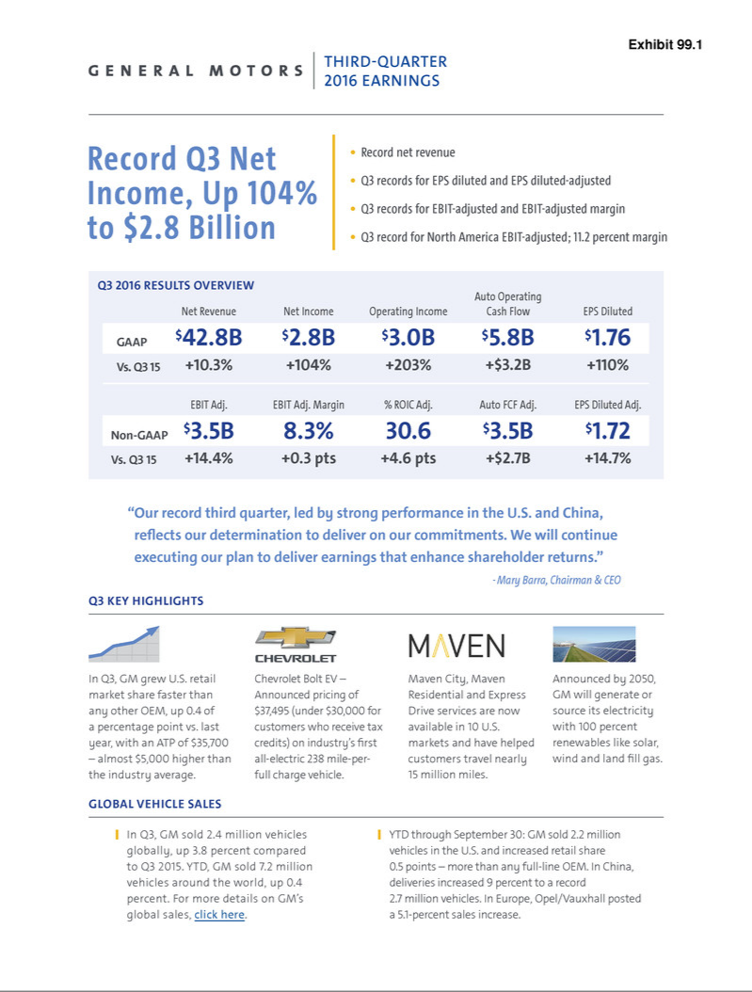

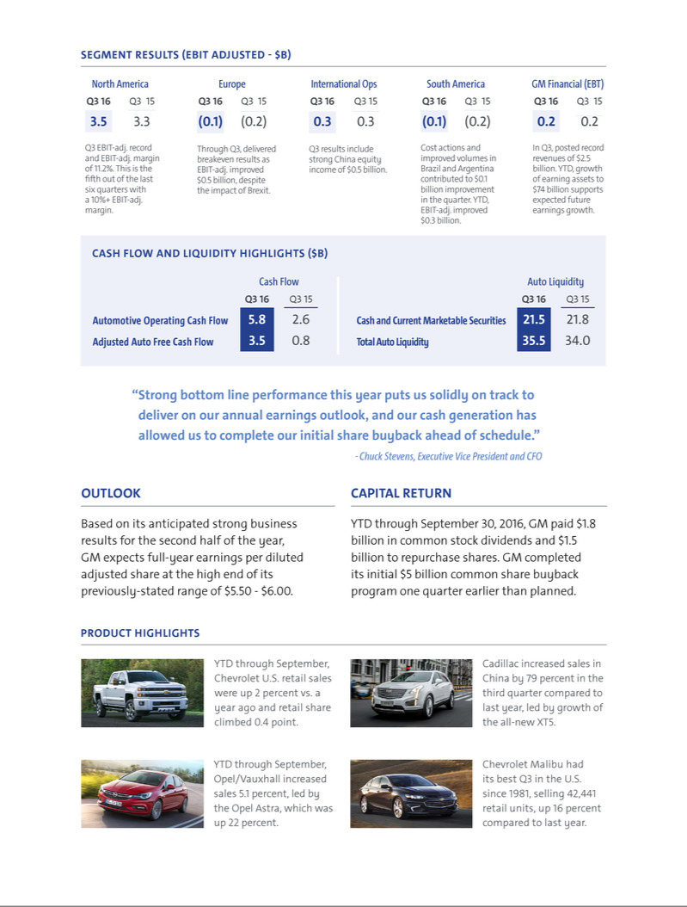

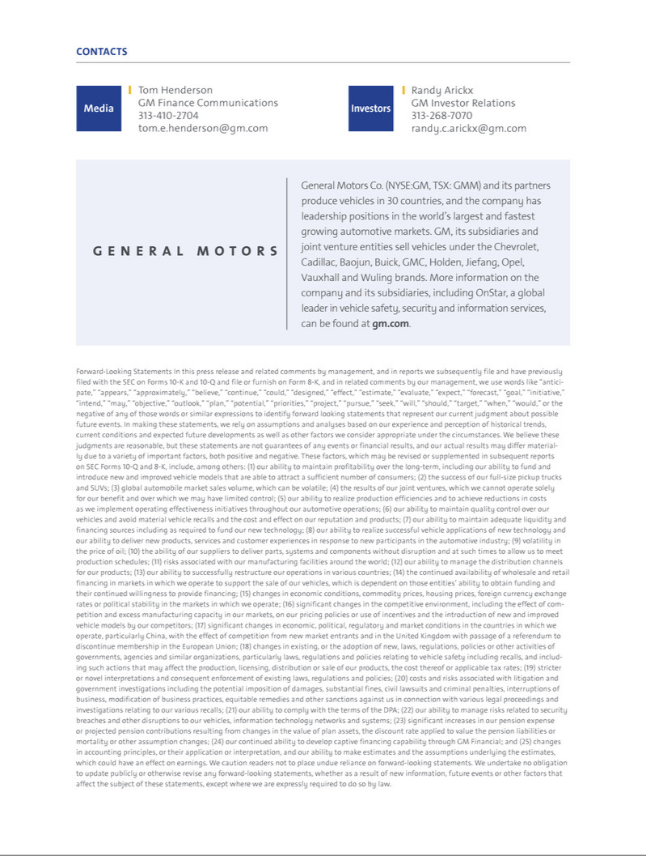

Exhibit 99.2

Exhibit 1

General Motors Company and Subsidiaries

Supplemental Material

(Unaudited)

General Motors Company's (GM) non-GAAP measures include earnings before interest and taxes adjusted for special items, presented net of noncontrolling interests (EBIT-adjusted), earnings per share (EPS)-diluted-adjusted, return on invested capital-adjusted (ROIC-adjusted) and adjusted automotive free cash flow. GM's calculation of these non-GAAP measures may not be comparable to similarly titled measures of other companies due to potential differences between companies in the method of calculation. As a result, the use of these non-GAAP measures has limitations and should not be considered superior to, in isolation from, or as a substitute for, related U.S. GAAP measures. These non-GAAP measures have not been audited or reviewed by GM's independent auditors.

These non-GAAP measures allow management and investors to view operating trends, perform analytical comparisons and benchmark performance between periods and among geographic regions to understand operating performance without regard to items we do not consider a component of our core operating performance. Furthermore, these non-GAAP measures allow investors the opportunity to measure and monitor our performance against our externally communicated targets and evaluate the investment decisions being made by management to improve ROIC-adjusted. Management uses these measures in its financial, investment and operational decision-making processes, for internal reporting and as part of its forecasting and budgeting processes. Further, our Board of Directors uses these and other measures as key metrics to determine management performance under our performance-based compensation plans. For these reasons we believe these non-GAAP measures are useful for our investors.

EBIT-adjusted is used by management and can be used by investors to review GM's consolidated operating results because it excludes automotive interest income, automotive interest expense and income taxes as well as certain additional adjustments that are not considered part of our core operations. Examples of adjustments to EBIT include but are not limited to impairment charges related to goodwill, impairment charges on long-lived assets and other exit costs resulting from strategic shifts in our operations or discrete market and business conditions; costs arising from the ignition switch recall and related legal matters; and certain currency devaluations associated with hyperinflationary economies. For EBIT-adjusted and our other non-GAAP measures, once we have made an adjustment in the current period for an item, we will also adjust the related non-GAAP measure in any future periods in which there is an impact from the item.

EPS-diluted-adjusted is used by management and can be used by investors to review GM's consolidated diluted earnings per share results on a consistent basis. EPS-diluted-adjusted is calculated as net income attributable to common stockholders-diluted less certain adjustments noted above for EBIT-adjusted and gains or losses on the extinguishment of debt obligations on an after-tax basis as well as certain income tax adjustments divided by weighted-average common shares outstanding-diluted. Examples of income tax adjustments include the establishment or reversal of significant deferred tax asset valuation allowances.

ROIC-adjusted is used by management and can be used by investors to review GM's investment and capital allocation decisions. GM defines ROIC-adjusted as EBIT-adjusted for the trailing four quarters divided by average net assets, which is considered to be the average equity balances adjusted for average automotive debt and interest liabilities, exclusive of capital leases; average automotive net pension and OPEB liabilities; and average automotive net income tax assets during the same period.

Adjusted automotive free cash flow is used by management and can be used by investors to review the liquidity of GM's automotive operations and to measure and monitor our performance against our capital allocation framework and evaluate our automotive liquidity against the substantial cash requirements of our automotive operations. GM measures adjusted automotive free cash flow as automotive cash flow from operations less capital expenditures adjusted for management actions, primarily related to strengthening its balance sheet, such as prepayments of debt and discretionary contributions to employee benefit plans.

1

General Motors Company and Subsidiaries

Supplemental Material

(Unaudited)

The following table reconciles segment profit (loss) to Net income attributable to common stockholders (dollars in millions):

 |  | Three Months Ended |  |  |  |  |  | Nine Months Ended
 | September 30, 2016 |  |  | September 30, 2015 |  |  | September 30, 2016 |  |  | September 30, 2015
Operating segments
GM North America (GMNA) | $ | 3,486 |  | $ | 3,293 |  | $ | 9,429 |  | $ | 8,255
GM Europe (GME) |  | (142) |  |  | (231) |  |  | (11) |  |  | (515)
GM International Operations (GMIO) |  | 271 |  |  | 269 |  |  | 819 |  |  | 989
GM South America (GMSA) |  | (121) |  |  | (217) |  |  | (309) |  |  | (575)
General Motors Financial Company, Inc. (GM Financial)(a) |  | 229 |  |  | 231 |  |  | 720 |  |  | 670
Total operating segments(b) |  | 3,723 |  |  | 3,345 |  |  | 10,648 |  |  | 8,824
Corporate and eliminations |  | (180) |  |  | (249) |  |  | (503) |  |  | (775)
EBIT-adjusted |  | 3,543 |  |  | 3,096 |  |  | 10,145 |  |  | 8,049
Special items
Ignition switch recall and related legal matters(c) |  | 110 |  |  | (1,500) |  |  | (65) |  |  | (1,725)
Thailand asset impairment(d) |  | — |  |  | — |  |  | — |  |  | (297)
Venezuela currency devaluation and asset impairment(e) |  | — |  |  | — |  |  | — |  |  | (720)
Russia exit costs(f) |  | — |  |  | — |  |  | — |  |  | (450)
Other |  | — |  |  | — |  |  | — |  |  | 35
Total special items |  | 110 |  |  | (1,500) |  |  | (65) |  |  | (3,157)
Automotive interest income |  | 44 |  |  | 40 |  |  | 140 |  |  | 130
Automotive interest expense |  | (148) |  |  | (112) |  |  | (422) |  |  | (330)
Income tax expense |  | (776) |  |  | (165) |  |  | (2,206) |  |  | (1,271)
Net income attributable to common stockholders | $ | 2,773 |  | $ | 1,359 |  | $ | 7,592 |  | $ | 3,421
__________
- GM Financial amounts represent earnings before income taxes-adjusted.

- GM's automotive operations' interest income, interest expense and income tax expense are recorded centrally in Corporate.

- These adjustments were excluded because of the unique events associated with the ignition switch recall. These events included the creation of the ignition switch recall compensation program, as well as various investigations, inquiries, and complaints from various constituents.
- These adjustments were excluded because of the significant restructuring of our Thailand operations and the strategic actions taken to focus on the production of pick-up trucks and SUVs.
- This adjustment was excluded because of the devaluation of the Venezuela Bolivar Fuerte (BsF), our inability to transact at the Complementary System of Foreign Currency Administration (SICAD) rate to obtain U.S. Dollars and the market restrictions imposed by the Venezuelan government.
- These adjustments were excluded because of our decision to exit the Russia market as a result of a strategic shift in our operations. The costs primarily consisted of sales incentives, dealer restructuring and other contract cancellation costs, and asset impairments.

2

General Motors Company and Subsidiaries

Supplemental Material

(Unaudited)

The following table reconciles diluted earnings per common share under U.S. GAAP to EPS-diluted-adjusted:

 |  |  |  |  | Three Months Ended |  |  |  |  |  |  |  |  |  |  |  | Nine Months Ended
 |  | September 30, 2016 |  |  |  |  |  | September 30, 2015 |  |  |  |  |  | September 30, 2016 |  |  |  |  |  | September 30, 2015
 |  | Amount |  |  | Per Share |  |  | Amount |  |  | Per Share |  |  | Amount |  |  | Per Share |  |  | Amount |  |  | Per Share
Diluted earnings per common share | $ | 2,773 |  | $ | 1.76 |  | $ | 1,357 |  | $ | 0.84 |  | $ | 7,591 |  | $ | 4.81 |  | $ | 3,418 |  | $ | 2.07
Adjustments
Ignition switch recall and related legal
matters |  | (110) |  |  | (0.07) |  |  | 1,500 |  |  | 0.93 |  |  | 65 |  |  | 0.04 |  |  | 1,725 |  |  | 1.04
Thailand asset impairment |  | — |  |  | — |  |  | — |  |  | — |  |  | — |  |  | — |  |  | 297 |  |  | 0.18
Venezuela currency devaluation and
asset impairment |  | — |  |  | — |  |  | — |  |  | — |  |  | — |  |  | — |  |  | 720 |  |  | 0.43
Russia exit costs |  | — |  |  | — |  |  | — |  |  | — |  |  | — |  |  | — |  |  | 450 |  |  | 0.27
Other |  | — |  |  | — |  |  | — |  |  | — |  |  | — |  |  | — |  |  | (35) |  |  | (0.02)
Total adjustments |  | (110) |  |  | (0.07) |  |  | 1,500 |  |  | 0.93 |  |  | 65 |  |  | 0.04 |  |  | 3,157 |  |  | 1.90
Tax effect on adjustments(a) |  | 41 |  |  | 0.03 |  |  | (226) |  |  | (0.14) |  |  | (25) |  |  | (0.01) |  |  | (354) |  |  | (0.21)
Tax adjustments(b) |  | — |  |  | — |  |  | (212) |  |  | (0.13) |  |  | — |  |  | — |  |  | (212) |  |  | (0.13)
EPS-diluted-adjusted | $ | 2,704 |  | $ | 1.72 |  | $ | 2,419 |  | $ | 1.50 |  | $ | 7,631 |  | $ | 4.84 |  | $ | 6,009 |  | $ | 3.63
________
- The tax effect of each adjustment is determined based on the tax laws and valuation allowance status of the jurisdiction in which the adjustment relates.

- These adjustments were excluded as the tax benefits resulted from our decisions to restructure our Holden operations and withdraw our Chevrolet brand from Europe, which were each considered adjustments to EBIT in prior periods.

The following table summarizes the calculation of ROIC-adjusted (dollars in billions):

 |  | Four Quarters Ended
 |  | September 30, 2016 |  |  | September 30, 2015
EBIT-adjusted | $ | 12.9 |  | $ | 10.5
Average equity | $ | 42.7 |  | $ | 35.9
Add: Average automotive debt and interest liabilities (excluding capital leases) |  | 9.5 |  |  | 8.3
Add: Average automotive net pension & OPEB liability |  | 25.2 |  |  | 29.2
Less: Average net automotive income tax asset |  | (35.2) |  |  | (33.1)
ROIC-adjusted average net assets | $ | 42.2 |  | $ | 40.3
ROIC-adjusted |  | 30.6% |  |  | 26.0%

3

General Motors Company and Subsidiaries

Supplemental Material

(Unaudited)

The following table reconciles Net income attributable to common stockholders under U.S. GAAP to EBIT-adjusted used in the calculation of ROIC-adjusted (dollars in millions):

 |  |  |  |  |  |  |  |  |  |  | Three Months Ended
 |  | September 30, |  |  |  |  |  | June 30, |  |  |  |  |  | March 31, |  |  |  |  |  | December 31,
 |  | 2016 |  |  | 2015 |  |  | 2016 |  |  | 2015 |  |  | 2016 |  |  | 2015 |  |  | 2015 |  |  | 2014
Net income attributable to common stockholders | $ | 2,773 |  | $ | 1,359 |  | $ | 2,866 |  | $ | 1,117 |  | $ | 1,953 |  | $ | 945 |  | $ | 6,266 |  | $ | 1,987
Income tax expense (benefit) |  | 776 |  |  | 165 |  |  | 871 |  |  | 577 |  |  | 559 |  |  | 529 |  |  | (3,168) |  |  | 279
Gain on extinguishment of debt |  | — |  |  | — |  |  | — |  |  | — |  |  | — |  |  | — |  |  | (449) |  |  | (200)
Automotive interest expense |  | 148 |  |  | 112 |  |  | 147 |  |  | 108 |  |  | 127 |  |  | 110 |  |  | 113 |  |  | 104
Automotive interest income |  | (44) |  |  | (40) |  |  | (52) |  |  | (41) |  |  | (44) |  |  | (49) |  |  | (39) |  |  | (56)
Adjustments
Ignition switch recall and related legal matters |  | (110) |  |  | 1,500 |  |  | 115 |  |  | 75 |  |  | 60 |  |  | 150 |  |  | 60 |  |  | —
Thailand asset impairments |  | — |  |  | — |  |  | — |  |  | 297 |  |  | — |  |  | — |  |  | — |  |  | 158
Venezuela currency devaluation and asset
impairment |  | — |  |  | — |  |  | — |  |  | 720 |  |  | — |  |  | — |  |  | — |  |  | —
Goodwill impairments |  | — |  |  | — |  |  | — |  |  | — |  |  | — |  |  | — |  |  | — |  |  | 120
Russia exit costs |  | — |  |  | — |  |  | — |  |  | 17 |  |  | — |  |  | 428 |  |  | (7) |  |  | —
Other |  | — |  |  | — |  |  | — |  |  | 1 |  |  | — |  |  | (31) |  |  | (11) |  |  | 22
Total adjustments |  | (110) |  |  | 1,500 |  |  | 115 |  |  | 1,110 |  |  | 60 |  |  | 547 |  |  | 42 |  |  | 300
EBIT-adjusted | $ | 3,543 |  | $ | 3,096 |  | $ | 3,947 |  | $ | 2,871 |  | $ | 2,655 |  | $ | 2,082 |  | $ | 2,765 |  | $ | 2,414

The following table reconciles expected diluted earnings per common share under U.S. GAAP to expected EPS-diluted-adjusted:

 | Year Ending December 31,
 | 2016
Diluted earnings per common share | $ 5.47-5.97
Adjustments(a) | 0.04
Tax effect on adjustments(b) | (0.01)
EPS-diluted-adjusted | $ 5.50-6.00
________
- Includes the adjustments disclosed in Note 16 to GM's condensed consolidated financial statements of Form 10-Q for the quarterly period ended September 30, 2016 and does not consider the potential future impact of adjustments.
- The tax effect of each adjustment is determined based on the tax laws and valuation allowance status of the jurisdiction in which the adjustment relates.

The following table reconciles Net automotive cash provided by operating activities under U.S. GAAP to adjusted automotive free cash flow (dollars in millions):

 |  | Three Months Ended |  |  |  |  |  | Nine Months Ended
 | September 30, 2016 |  |  | September 30, 2015 |  |  | September 30, 2016 |  |  | September 30, 2015
Net automotive cash provided by operating activities | $ | 5,753 |  | $ | 2,643 |  | $ | 10,021 |  | $ | 7,760
Capital expenditures |  | (2,272) |  |  | (1,815) |  |  | (6,835) |  |  | (5,260)
Adjustment – discretionary pension plan contributions |  | — |  |  | — |  |  | 1,982 |  |  | —
Adjusted automotive free cash flow | $ | 3,481 |  | $ | 828 |  | $ | 5,168 |  | $ | 2,500

4

General Motors Company and Subsidiaries

Supplemental Material

(Unaudited)

The following tables summarize key financial information by segment (dollars in millions):

 |  |  |  |  |  |  |  |  |  |  |  |  |  |  |  |  |  |  |  | Total |  |  | GM
 |  | GMNA |  |  | GME |  |  | GMIO |  |  | GMSA |  |  | Corporate |  |  | Eliminations |  |  | Automotive |  |  | Financial |  |  | Eliminations |  |  | Total
Three Months Ended September 30, 2016
Net sales and revenue | $ | 31,078 |  | $ | 4,225 |  | $ | 2,963 |  | $ | 2,029 |  | $ | 39 |  |  |  |  | $ | 40,334 |  | $ | 2,499 |  | $ | (8) |  | $ | 42,825
Expenditures for property | $ | 1,850 |  | $ | 223 |  | $ | 123 |  | $ | 75 |  | $ | 2 |  | $ | (1) |  | $ | 2,272 |  | $ | 24 |  | $ | — |  | $ | 2,296
Depreciation and amortization | $ | 1,086 |  | $ | 116 |  | $ | 114 |  | $ | 75 |  | $ | 4 |  | $ | (1) |  | $ | 1,394 |  | $ | 1,257 |  | $ | — |  | $ | 2,651
Impairment charges | $ | 2 |  | $ | 30 |  | $ | 3 |  | $ | — |  | $ | — |  | $ | — |  | $ | 35 |  | $ | — |  | $ | — |  | $ | 35
Equity income(a) | $ | 3 |  | $ | — |  | $ | 458 |  | $ | — |  | $ | — |  | $ | — |  | $ | 461 |  | $ | 36 |  | $ | — |  | $ | 497

 |  |  |  |  |  |  |  |  |  |  |  |  |  |  |  |  |  |  |  | Total |  |  | GM
 |  | GMNA |  |  | GME |  |  | GMIO |  |  | GMSA |  |  | Corporate |  |  | Eliminations |  |  | Automotive |  |  | Financial |  |  | Eliminations |  |  | Total
Three Months Ended September 30, 2015
Net sales and revenue | $ | 27,794 |  | $ | 4,556 |  | $ | 3,016 |  | $ | 1,738 |  | $ | 36 |  |  |  |  | $ | 37,140 |  | $ | 1,707 |  | $ | (4) |  | $ | 38,843
Expenditures for property | $ | 1,352 |  | $ | 210 |  | $ | 83 |  | $ | 115 |  | $ | 55 |  | $ | — |  | $ | 1,815 |  | $ | 20 |  | $ | — |  | $ | 1,835
Depreciation and amortization | $ | 928 |  | $ | 124 |  | $ | 110 |  | $ | 56 |  | $ | 4 |  | $ | (1) |  | $ | 1,221 |  | $ | 657 |  | $ | — |  | $ | 1,878
Impairment charges | $ | 81 |  | $ | 15 |  | $ | 7 |  | $ | — |  | $ | — |  | $ | — |  | $ | 103 |  | $ | — |  | $ | — |  | $ | 103
Equity income(a) | $ | 5 |  | $ | — |  | $ | 467 |  | $ | — |  | $ | — |  | $ | — |  | $ | 472 |  | $ | 30 |  | $ | — |  | $ | 502

 |  |  |  |  |  |  |  |  |  |  |  |  |  |  |  |  |  |  |  | Total |  |  | GM
 |  | GMNA |  |  | GME |  |  | GMIO |  |  | GMSA |  |  | Corporate |  |  | Eliminations |  |  | Automotive |  |  | Financial |  |  | Eliminations |  |  | Total
Nine Months Ended September 30, 2016
Net sales and revenue | $ | 87,736 |  | $ | 14,292 |  | $ | 8,467 |  | $ | 5,010 |  | $ | 113 |  |  |  |  | $ | 115,618 |  | $ | 6,866 |  | $ | (22) |  | $ | 122,462
Expenditures for property | $ | 5,350 |  | $ | 796 |  | $ | 416 |  | $ | 269 |  | $ | 7 |  | $ | (3) |  | $ | 6,835 |  | $ | 71 |  | $ | — |  | $ | 6,906
Depreciation and amortization | $ | 3,179 |  | $ | 334 |  | $ | 327 |  | $ | 202 |  | $ | 12 |  | $ | (3) |  | $ | 4,051 |  | $ | 3,313 |  | $ | — |  | $ | 7,364
Impairment charges | $ | 43 |  | $ | 84 |  | $ | 66 |  | $ | — |  | $ | — |  | $ | — |  | $ | 193 |  | $ | — |  | $ | — |  | $ | 193
Equity income(a) | $ | 162 |  | $ | — |  | $ | 1,446 |  | $ | — |  | $ | — |  | $ | — |  | $ | 1,608 |  | $ | 109 |  | $ | — |  | $ | 1,717

 |  |  |  |  |  |  |  |  |  |  |  |  |  |  |  |  |  |  |  | Total |  |  | GM
 |  | GMNA |  |  | GME |  |  | GMIO |  |  | GMSA |  |  | Corporate |  |  | Eliminations |  |  | Automotive |  |  | Financial |  |  | Eliminations |  |  | Total
Nine Months Ended September 30, 2015
Net sales and revenue | $ | 78,951 |  | $ | 13,992 |  | $ | 9,181 |  | $ | 5,939 |  | $ | 111 |  |  |  |  | $ | 108,174 |  | $ | 4,576 |  | $ | (15) |  | $ | 112,735
Expenditures for property | $ | 3,775 |  | $ | 702 |  | $ | 372 |  | $ | 350 |  | $ | 61 |  | $ | — |  | $ | 5,260 |  | $ | 64 |  | $ | — |  | $ | 5,324
Depreciation and amortization | $ | 2,793 |  | $ | 284 |  | $ | 331 |  | $ | 205 |  | $ | 12 |  | $ | (3) |  | $ | 3,622 |  | $ | 1,496 |  | $ | — |  | $ | 5,118
Impairment charges | $ | 350 |  | $ | 94 |  | $ | 312 |  | $ | 34 |  | $ | — |  | $ | — |  | $ | 790 |  | $ | — |  | $ | — |  | $ | 790
Equity income(a) | $ | 15 |  | $ | 1 |  | $ | 1,477 |  | $ | — |  | $ | — |  | $ | — |  | $ | 1,493 |  | $ | 86 |  | $ | — |  | $ | 1,579
_________
- Includes automotive China joint ventures equity income of $459 million and $463 million in the three months ended September 30, 2016 and 2015 and $1,448 million and $1,485 million in the nine months ended September 30, 2016 and 2015.

5

General Motors Company and Subsidiaries

Supplemental Material

(Unaudited)

Vehicle Sales

GM presents both wholesale and retail vehicle sales data to assist in the analysis of its revenue and market share. GM does not currently export vehicles to Cuba, Iran, North Korea, Sudan or Syria. Accordingly, these countries are excluded from industry sales data and corresponding calculations of GM's market share.

Wholesale vehicle sales data, which represents sales directly to dealers and others, is the measure that correlates to GM's revenue from the sale of vehicles, which is the largest component of Automotive net sales and revenue. Wholesale vehicle sales exclude vehicles produced by joint ventures. In the nine months ended September 30, 2016 46.1% of GM's wholesale vehicle sales volume was generated outside the U.S. The following table summarizes total wholesale vehicle sales of new vehicles by automotive segment (vehicles in thousands):

 | Three Months Ended |  |  |  | Nine Months Ended
 | September 30, 2016 |  | September 30, 2015 |  | September 30, 2016 |  | September 30, 2015
GMNA | 1,030 |  | 938 |  | 2,908 |  | 2,645
GME | 261 |  | 276 |  | 880 |  | 847
GMIO | 136 |  | 146 |  | 406 |  | 431
GMSA | 153 |  | 142 |  | 400 |  | 435
Worldwide | 1,580 |  | 1,502 |  | 4,594 |  | 4,358

6

General Motors Company and Subsidiaries

Supplemental Material

(Unaudited)

Retail vehicle sales data, which represents sales to end customers based upon the good faith estimates of management, including fleets, does not correlate directly to the revenue GM recognizes during the period. However, retail vehicle sales data is indicative of the underlying demand for GM vehicles. Market share information is based primarily on retail vehicle sales volume. In countries where end customer data is not readily available, other data sources such as wholesale or forecast volumes are used to estimate retail vehicle sales.

Retail vehicle sales data includes all sales by joint ventures on a total vehicle basis, not based on the percentage of ownership in the joint venture. Certain joint venture agreements in China allow for the contractual right to report vehicle sales on non-GM trademarked vehicles by those joint ventures. Retail vehicle sales data includes vehicles used by dealers under courtesy transportation programs and vehicles sold through the dealer registration channel primarily in Europe. This sales channel consists primarily of dealer demonstrator, loaner and self-registered vehicles which are not eligible to be sold as new vehicles after being registered by dealers. Certain fleet sales that are accounted for as operating leases are included in retail vehicle sales at the time of delivery to daily rental car companies. The following table summarizes total retail sales volume, or estimated sales volume where retail sales volume is not available, by geographic region (vehicles in thousands):

 | Three Months Ended |  |  |  | Nine Months Ended
 | September 30, 2016 |  | September 30, 2015 |  | September 30, 2016 |  | September 30, 2015
United States
Chevrolet - Cars | 174 |  | 182 |  | 548 |  | 590
Chevrolet - Trucks | 241 |  | 239 |  | 665 |  | 649
Chevrolet - Crossovers | 110 |  | 121 |  | 320 |  | 358
Cadillac | 46 |  | 45 |  | 119 |  | 126
Buick | 66 |  | 61 |  | 170 |  | 168
GMC | 136 |  | 146 |  | 390 |  | 409
Total United States | 773 |  | 794 |  | 2,212 |  | 2,300
Canada, Mexico and Other | 146 |  | 137 |  | 416 |  | 385
Total North America | 919 |  | 931 |  | 2,628 |  | 2,685
Europe
Opel/Vauxhall | 273 |  | 268 |  | 895 |  | 851
Chevrolet(a) | 10 |  | 21 |  | 28 |  | 50
Total Europe | 283 |  | 289 |  | 923 |  | 901
Asia/Pacific, Middle East and Africa
Chevrolet | 235 |  | 258 |  | 668 |  | 848
Wuling | 293 |  | 318 |  | 969 |  | 1,113
Buick | 284 |  | 238 |  | 844 |  | 686
Baojun | 149 |  | 122 |  | 478 |  | 304
Cadillac | 30 |  | 19 |  | 80 |  | 60
Other | 45 |  | 50 |  | 140 |  | 155
Total Asia/Pacific, Middle East and Africa | 1,036 |  | 1,005 |  | 3,179 |  | 3,166
South America(b) | 153 |  | 151 |  | 422 |  | 486
Total Worldwide | 2,391 |  | 2,376 |  | 7,152 |  | 7,238

_______

- Includes Buick, Cadillac and GMC sales.

- Primarily Chevrolet.

7

General Motors Company and Subsidiaries

Supplemental Material

(Unaudited)

The wholesale vehicle sales at GM's China joint ventures presented in the following table are included in GM's retail vehicle sales on the preceding page (vehicles in thousands):

 | Three Months Ended |  |  |  |  | Nine Months Ended
 | September 30, 2016 |  | September 30, 2015 |  |  | September 30, 2016 |  | September 30, 2015
SAIC General Motors Sales Co., Ltd. | 433 |  | 373 |  |  | 1,243 |  | 1,158
SAIC GM Wuling Automobile Co., Ltd. and FAW-GM Light Duty Commercial
Vehicle Co., Ltd. | 441 |  | 441 |  |  | 1,447 |  | 1,418
 | Three Months Ended |  |  |  |  | Nine Months Ended
 | September 30, 2016 |  | September 30, 2015 |  |  | September 30, 2016 |  | September 30, 2015
Market Share
United States - Cars | 12.6% |  | 11.6% |  |  | 12.6% |  | 12.4%
United States - Trucks | 25.0% |  | 25.2% |  |  | 23.6% |  | 24.4%
United States - Crossovers | 14.6% |  | 16.9% |  |  | 14.7% |  | 17.3%
Total United States | 17.0% |  | 17.1% |  |  | 16.6% |  | 17.2%
Total North America | 16.5% |  | 16.6% |  |  | 16.1% |  | 16.7%
Total Europe | 6.0% |  | 6.3% |  |  | 6.1% |  | 6.2%
Total Asia/Pacific, Middle East and Africa | 9.3% |  | 10.0% |  |  | 9.5% |  | 9.9%
Total South America | 15.9% |  | 14.1% |  |  | 15.6% |  | 15.3%
Total Worldwide | 10.7% |  | 11.1% |  |  | 10.5% |  | 11.0%
United States fleet sales as a percentage of retail vehicle sales | 15.5% |  | 17.7% |  |  | 19.1% |  | 22.8%
North America Capacity Two Shift Utilization | 115.3% |  | 106.2% |  |  | 106.6% |  | 106.0%

8

Net sales and revenue

Automotive

GM Financial

Total net sales and revenue

Costs and expenses

Automotive cost of sales

GM Financial interest, operating and other expenses

Automotive selling, general and administrative expense

Total costs and expenses

Operating income

Automotive interest expense

Interest income and other non-operating income, net

Equity income

Income before income taxes

Income tax expense

Net income

Net loss attributable to noncontrolling interests

Net income attributable to common stockholders

Net sales and revenue

Automotive

GM Financial

Total net sales and revenue

Costs and expenses

Automotive cost of sales

GM Financial interest, operating and other expenses

Automotive selling, general and administrative expense

Total costs and expenses

Operating income

Automotive interest expense

Interest income and other non-operating income, net

Equity income

Income before income taxes

Income tax expense

Net income

Net loss attributable to noncontrolling interests

Net income attributable to common stockholders

General Motors Company and Subsidiaries

Condensed Consolidating Income Statements

(In millions) (Unaudited)

 |  |  | Three Months Ended September 30, 2016 |  |  |  |  |  |  |  |  |  |  |  | Three Months Ended September 30, 2015
 | Automotive |  |  | GM Financial |  |  | Eliminations |  |  | Consolidated |  |  | Automotive |  |  | GM Financial |  |  | Eliminations |  |  | Consolidated
$ | 40,334 |  | $ | — |  | $ | — |  | $ | 40,334 |  | $ | 37,140 |  | $ | — |  | $ | — |  | $ | 37,140
 | — |  |  | 2,499 |  |  | (8) |  |  | 2,491 |  |  | — |  |  | 1,707 |  |  | (4) |  |  | 1,703
 | 40,334 |  |  | 2,499 |  |  | (8) |  |  | 42,825 |  |  | 37,140 |  |  | 1,707 |  |  | (4) |  |  | 38,843
 | 34,781 |  |  | — |  |  | (3) |  |  | 34,778 |  |  | 32,060 |  |  | — |  |  | (2) |  |  | 32,058
 | — |  |  | 2,306 |  |  | — |  |  | 2,306 |  |  | — |  |  | 1,506 |  |  | — |  |  | 1,506
 | 2,724 |  |  | — |  |  | — |  |  | 2,724 |  |  | 4,282 |  |  | — |  |  | — |  |  | 4,282
 | 37,505 |  |  | 2,306 |  |  | (3) |  |  | 39,808 |  |  | 36,342 |  |  | 1,506 |  |  | (2) |  |  | 37,846
 | 2,829 |  |  | 193 |  |  | (5) |  |  | 3,017 |  |  | 798 |  |  | 201 |  |  | (2) |  |  | 997
 | 154 |  |  | — |  |  | (6) |  |  | 148 |  |  | 114 |  |  | — |  |  | (2) |  |  | 112
 | 123 |  |  | — |  |  | (1) |  |  | 122 |  |  | 119 |  |  | — |  |  | — |  |  | 119
 | 461 |  |  | 36 |  |  | — |  |  | 497 |  |  | 472 |  |  | 30 |  |  | — |  |  | 502
 | 3,259 |  |  | 229 |  |  | — |  |  | 3,488 |  |  | 1,275 |  |  | 231 |  |  | — |  |  | 1,506
 | 704 |  |  | 72 |  |  | — |  |  | 776 |  |  | 159 |  |  | 6 |  |  | — |  |  | 165
 | 2,555 |  |  | 157 |  |  | — |  |  | 2,712 |  |  | 1,116 |  |  | 225 |  |  | — |  |  | 1,341
 | 61 |  |  | — |  |  | — |  |  | 61 |  |  | 18 |  |  | — |  |  | — |  |  | 18
$ | 2,616 |  | $ | 157 |  | $ | — |  | $ | 2,773 |  | $ | 1,134 |  | $ | 225 |  | $ | — |  | $ | 1,359
 |  |  | Nine Months Ended September 30, 2016 |  |  |  |  |  |  |  |  |  |  |  |  | Nine Months Ended September 30, 2015
 | Automotive |  |  | GM Financial |  |  | Eliminations |  |  | Consolidated |  |  | Automotive |  |  | GM Financial |  |  | Eliminations |  |  | Consolidated
$ | 115,618 |  | $ | — |  | $ | — |  | $ | 115,618 |  | $ | 108,174 |  | $ | — |  | $ | — |  | $ | 108,174
 | — |  |  | 6,866 |  |  | (22) |  |  | 6,844 |  |  | — |  |  | 4,576 |  |  | (15) |  |  | 4,561
 | 115,618 |  |  | 6,866 |  |  | (22) |  |  | 122,462 |  |  | 108,174 |  |  | 4,576 |  |  | (15) |  |  | 112,735
 | 99,801 |  |  | — |  |  | (8) |  |  | 99,793 |  |  | 95,337 |  |  | — |  |  | (8) |  |  | 95,329
 | — |  |  | 6,255 |  |  | — |  |  | 6,255 |  |  | — |  |  | 3,992 |  |  | — |  |  | 3,992
 | 8,389 |  |  | — |  |  | — |  |  | 8,389 |  |  | 10,376 |  |  | — |  |  | — |  |  | 10,376
 | 108,190 |  |  | 6,255 |  |  | (8) |  |  | 114,437 |  |  | 105,713 |  |  | 3,992 |  |  | (8) |  |  | 109,697
 | 7,428 |  |  | 611 |  |  | (14) |  |  | 8,025 |  |  | 2,461 |  |  | 584 |  |  | (7) |  |  | 3,038
 | 437 |  |  | — |  |  | (15) |  |  | 422 |  |  | 337 |  |  | — |  |  | (7) |  |  | 330
 | 380 |  |  | — |  |  | (1) |  |  | 379 |  |  | 373 |  |  | — |  |  | — |  |  | 373
 | 1,608 |  |  | 109 |  |  | — |  |  | 1,717 |  |  | 1,493 |  |  | 86 |  |  | — |  |  | 1,579
 | 8,979 |  |  | 720 |  |  | — |  |  | 9,699 |  |  | 3,990 |  |  | 670 |  |  | — |  |  | 4,660
 | 2,062 |  |  | 144 |  |  | — |  |  | 2,206 |  |  | 1,151 |  |  | 120 |  |  | — |  |  | 1,271
 | 6,917 |  |  | 576 |  |  | — |  |  | 7,493 |  |  | 2,839 |  |  | 550 |  |  | — |  |  | 3,389
 | 99 |  |  | — |  |  | — |  |  | 99 |  |  | 32 |  |  | — |  |  | — |  |  | 32
$ | 7,016 |  | $ | 576 |  | $ | — |  | $ | 7,592 |  | $ | 2,871 |  | $ | 550 |  | $ | — |  | $ | 3,421

9

General Motors Company and Subsidiaries

Basic and Diluted Earnings per Share

(Unaudited)

The following table summarizes basic and diluted earnings per share (in millions, except per share amounts):

 |  |  | Three Months Ended |  |  |  |  |  | Nine Months Ended
 |  | September 30, 2016 |  |  | September 30, 2015 |  |  | September 30, 2016 |  |  | September 30, 2015
Basic earnings per share
Net income attributable to common stockholders | $ |  | 2,773 |  | $ | 1,359 |  | $ | 7,592 |  | $ | 3,421
Weighted-average common shares outstanding |  |  | 1,550 |  |  | 1,577 |  |  | 1,548 |  |  | 1,597
Basic earnings per common share | $ |  | 1.79 |  | $ | 0.86 |  | $ | 4.90 |  | $ | 2.14
Diluted earnings per share
Net income attributable to common stockholders – diluted | $ |  | 2,773 |  | $ | 1,357 |  | $ | 7,591 |  | $ | 3,418
Weighted-average common shares outstanding – diluted |  |  | 1,574 |  |  | 1,618 |  |  | 1,578 |  |  | 1,655
Diluted earnings per common share | $ |  | 1.76 |  | $ | 0.84 |  | $ | 4.81 |  | $ | 2.07
 | 10

General Motors Company and Subsidiaries

Condensed Consolidating Balance Sheets

(In millions, except per share amounts) (Unaudited)

ASSETS

Current Assets

Cash and cash equivalents

Marketable securities

Restricted cash

Accounts and notes receivable, net(a)(c)

GM Financial receivables, net(b)

Inventories

Equipment on operating leases, net

Other current assets

Total current assets

Non-current Assets

Restricted cash

GM Financial receivables, net

Equity in net assets of nonconsolidated affiliates

Property, net

Goodwill and intangible assets, net

GM Financial equipment on operating leases, net

Deferred income taxes(c)

Other assets

Total non-current assets

Total Assets

LIABILITIES AND EQUITY

Current Liabilities

Accounts payable (principally trade)(a)

Short-term debt and current portion of long-term debt

 |  |  |  | September 30, 2016 |  |  |  |  |  |  |  |  |  |  |  | December 31, 2015
 | Automotive |  |  | GM Financial |  |  | Eliminations |  |  | Consolidated |  |  | Automotive |  |  | GM Financial |  |  | Eliminations |  |  | Consolidated
$ | 13,344 |  | $ | 2,588 |  | $ | — |  | $ | 15,932 |  | $ | 12,177 |  | $ | 3,061 |  | $ | — |  | $ | 15,238
 | 8,172 |  |  | — |  |  | — |  |  | 8,172 |  |  | 8,163 |  |  | — |  |  | — |  |  | 8,163
 | 126 |  |  | 1,518 |  |  | — |  |  | 1,644 |  |  | 180 |  |  | 1,410 |  |  | — |  |  | 1,590
 | 11,437 |  |  | 972 |  |  | (1,672) |  |  | 10,737 |  |  | 8,590 |  |  | 681 |  |  | (934) |  |  | 8,337
 | — |  |  | 20,833 |  |  | (338) |  |  | 20,495 |  |  | — |  |  | 18,281 |  |  | (230) |  |  | 18,051
 | 15,427 |  |  | — |  |  | — |  |  | 15,427 |  |  | 13,764 |  |  | — |  |  | — |  |  | 13,764
 | 2,055 |  |  | — |  |  | — |  |  | 2,055 |  |  | 2,783 |  |  | — |  |  | — |  |  | 2,783
 | 1,491 |  |  | 540 |  |  | 3 |  |  | 2,034 |  |  | 1,152 |  |  | 330 |  |  | — |  |  | 1,482
 | 52,052 |  |  | 26,451 |  |  | (2,007) |  |  | 76,496 |  |  | 46,809 |  |  | 23,763 |  |  | (1,164) |  |  | 69,408
 | 44 |  |  | 537 |  |  | — |  |  | 581 |  |  | 52 |  |  | 531 |  |  | — |  |  | 583
 | — |  |  | 20,299 |  |  | — |  |  | 20,299 |  |  | — |  |  | 18,500 |  |  | — |  |  | 18,500
 | 7,705 |  |  | 940 |  |  | — |  |  | 8,645 |  |  | 8,215 |  |  | 986 |  |  | — |  |  | 9,201
 | 34,460 |  |  | 253 |  |  | — |  |  | 34,713 |  |  | 31,010 |  |  | 219 |  |  | — |  |  | 31,229
 | 4,969 |  |  | 1,385 |  |  | — |  |  | 6,354 |  |  | 4,558 |  |  | 1,389 |  |  | — |  |  | 5,947
 | — |  |  | 31,775 |  |  | — |  |  | 31,775 |  |  | — |  |  | 20,172 |  |  | — |  |  | 20,172
 | 34,809 |  |  | 216 |  |  | — |  |  | 35,025 |  |  | 36,635 |  |  | 225 |  |  | — |  |  | 36,860
 | 3,344 |  |  | 344 |  |  | — |  |  | 3,688 |  |  | 2,142 |  |  | 296 |  |  | — |  |  | 2,438
 | 85,331 |  |  | 55,749 |  |  | — |  |  | 141,080 |  |  | 82,612 |  |  | 42,318 |  |  | — |  |  | 124,930
$ | 137,383 |  | $ | 82,200 |  | $ | (2,007) |  | $ | 217,576 |  | $ | 129,421 |  | $ | 66,081 |  | $ | (1,164) |  | $ | 194,338
$ | 28,652 |  | $ | 788 |  | $ | (812) |  | $ | 28,628 |  | $ | 24,093 |  | $ | 740 |  | $ | (771) |  | $ | 24,062

Automotive(a)(b) |  | 1,791 |  |  | — |  |  | (779) |  |  | 1,012 |  |  | 1,209 |  |  | — |  |  | (392) |  |  | 817
GM Financial(d) |  | — |  |  | 24,777 |  |  | (415) |  |  | 24,362 |  |  | — |  |  | 18,745 |  |  | — |  |  | 18,745
Accrued liabilities(c) |  | 26,257 |  |  | 2,277 |  |  | (1) |  |  | 28,533 |  |  | 26,043 |  |  | 1,550 |  |  | — |  |  | 27,593
Total current liabilities |  | 56,700 |  |  | 27,842 |  |  | (2,007) |  |  | 82,535 |  |  | 51,345 |  |  | 21,035 |  |  | (1,163) |  |  | 71,217
Non-current Liabilities
Long-term debt
Automotive |  | 9,740 |  |  | — |  |  | — |  |  | 9,740 |  |  | 7,948 |  |  | — |  |  | — |  |  | 7,948
GM Financial |  | — |  |  | 43,986 |  |  | — |  |  | 43,986 |  |  | — |  |  | 35,601 |  |  | — |  |  | 35,601
Postretirement benefits other than pensions |  | 5,621 |  |  | — |  |  | — |  |  | 5,621 |  |  | 5,685 |  |  | — |  |  | — |  |  | 5,685
Pensions |  | 17,485 |  |  | 110 |  |  | — |  |  | 17,595 |  |  | 20,804 |  |  | 107 |  |  | — |  |  | 20,911
Other liabilities(c) |  | 11,774 |  |  | 1,310 |  |  | — |  |  | 13,084 |  |  | 11,627 |  |  | 1,027 |  |  | (1) |  |  | 12,653
Total non-current liabilities |  | 44,620 |  |  | 45,406 |  |  | — |  |  | 90,026 |  |  | 46,064 |  |  | 36,735 |  |  | (1) |  |  | 82,798
Total Liabilities |  | 101,320 |  |  | 73,248 |  |  | (2,007) |  |  | 172,561 |  |  | 97,409 |  |  | 57,770 |  |  | (1,164) |  |  | 154,015
Commitments and contingencies
Equity
Common stock, $0.01 par value |  | 15 |  |  | — |  |  | — |  |  | 15 |  |  | 15 |  |  | — |  |  | — |  |  | 15
Additional paid-in capital |  | 27,240 |  |  | 1 |  |  | — |  |  | 27,241 |  |  | 27,606 |  |  | 1 |  |  | — |  |  | 27,607
Retained earnings |  | 15,417 |  |  | 10,000 |  |  | — |  |  | 25,417 |  |  | 10,870 |  |  | 9,415 |  |  | — |  |  | 20,285
Accumulated other comprehensive loss |  | (6,904) |  |  | (1,049) |  |  | — |  |  | (7,953) |  |  | (6,931) |  |  | (1,105) |  |  | — |  |  | (8,036)
Total stockholders’ equity |  | 35,768 |  |  | 8,952 |  |  | — |  |  | 44,720 |  |  | 31,560 |  |  | 8,311 |  |  | — |  |  | 39,871
Noncontrolling interests |  | 295 |  |  | — |  |  | — |  |  | 295 |  |  | 452 |  |  | — |  |  | — |  |  | 452
Total Equity |  | 36,063 |  |  | 8,952 |  |  | — |  |  | 45,015 |  |  | 32,012 |  |  | 8,311 |  |  | — |  |  | 40,323
Total Liabilities and Equity | $ | 137,383 |  | $ | 82,200 |  | $ | (2,007) |  | $ | 217,576 |  | $ | 129,421 |  | $ | 66,081 |  | $ | (1,164) |  | $ | 194,338

_________

- Eliminations include Automotive accounts receivables of $405 million offset by GM Financial accounts payables, GM Financial accounts receivables of $409 million offset by Automotive accounts payable and GM Financial notes receivables of $441 million offset by loans to Automotive at September 30, 2016 and Automotive accounts receivables of $358 million offset by GM Financial accounts payables, GM Financial accounts receivables of $409 million offset by Automotive accounts payable and GM Financial notes receivables of $163 million offset by loans to Automotive at December 31, 2015.

- Eliminations include GM Financial receivables of $338 million and $230 million offset by loans to Automotive at September 30, 2016 and December 31, 2015.
- As a result of GM's adoption of Accounting Standards Update 2015-17, certain prior year amounts have been reclassified.
- Elimination represents a $415 million loan to GM Financial under support agreement entered into in September 2014 offset by Automotive accounts and notes receivable.

11

General Motors Company and Subsidiaries

Condensed Consolidating Statements of Cash Flows

(In millions) (Unaudited)

 | Nine Months Ended September 30, 2016 |  |  |  |  | Nine Months Ended September 30, 2015
Automotive | GM Financial | Reclassification(a) | Consolidated |  | Automotive | GM Financial | Reclassification(a) | Consolidated

Cash flows from operating activities

Net income |  | 6,918 |  | $ | 575 |  | $ | —
$ |  | 6,918 |  | $ | 575 |  | $ | —
Depreciation, amortization and impairment
charges |  | 4,244 |  |  | 3,313 |  |  | —
Foreign currency remeasurement and
transaction losses |  | 262 |  |  | 8 |  |  | —
Undistributed earnings of nonconsolidated
affiliates, net |  | 380 |  |  | 20 |  |  | —
Pension contributions and OPEB payments |  | (3,103) |  |  | (3) |  |  | —
Pension and OPEB (income) expense, net |  | (427) |  |  | 4 |  |  | —
Provision for deferred taxes |  | 1,870 |  |  | 51 |  |  | —
Change in other operating assets and liabilities |  | (123) |  |  | (110) |  |  | (1,350)
Net cash provided by operating activities |  | 10,021 |  |  | 3,858 |  |  | (1,350)
Cash flows from investing activities
Expenditures for property |  | (6,835) |  |  | (71) |  |  | —
Available-for-sale marketable securities,
acquisitions |  | (8,613) |  |  | — |  |  | —
Trading marketable securities, acquisitions |  | (249) |  |  | — |  |  | —
Available-for-sale marketable securities,
liquidations |  | 8,090 |  |  | — |  |  | —
Trading marketable securities, liquidations |  | 846 |  |  | — |  |  | —
Acquisition of companies/investments, net of
cash acquired |  | (804) |  |  | — |  |  | —
Increase in restricted cash |  | (165) |  |  | (321) |  |  | —
Decrease in restricted cash |  | 204 |  |  | 198 |  |  | —
Purchases of finance receivables, net |  | — |  |  | (14,580) |  |  | 1,350
Principal collections and recoveries on finance
receivables |  | — |  |  | 9,904 |  |  | —
Purchases of leased vehicles, net |  | — |  |  | (15,051) |  |  | —
Proceeds from termination of leased vehicles |  | — |  |  | 1,801 |  |  | —
Other investing activities |  | 175 |  |  | (3)
Net cash used in investing activities
Net cash used in investing activities |  | (7,351) |  |  | (18,123) |  |  | 1,350

Cash flows from financing activities

7,493 |  | $ | 2,839 |  | $ | 550 |  | $ | — |  | 3,389
7,557 |  |  | 4,412 |  |  | 1,496 |  |  | — |  | 5,908
270 |  |  | 898 |  |  | 13 |  |  | — |  | 911
400 |  |  | 248 |  |  | (85) |  |  | — |  | 163
(3,106) |  |  | (1,193) |  |  | (3) |  |  | — |  | (1,196)
(423) |  |  | 242 |  |  | 4 |  |  | — |  | 246
1,921 |  |  | 461 |  |  | 33 |  |  | — |  | 494
(1,583) |  |  | (147) |  |  | 176 |  |  | (475) |  | (446)
12,529 |  |  | 7,760 |  |  | 2,184 |  |  | (475) |  | 9,469
(6,906) |  |  | (5,260) |  |  | (64) |  |  | — |  | (5,324)
(8,613) |  |  | (6,868) |  |  | — |  |  | — |  | (6,868)
(249) |  |  | (1,028) |  |  | — |  |  | — |  | (1,028)
8,090 |  |  | 7,485 |  |  | — |  |  | — |  | 7,485
846 |  |  | 1,441 |  |  | — |  |  | — |  | 1,441
(804) |  |  | (4) |  |  | (924) |  |  | — |  | (928)
(486) |  |  | (148) |  |  | (451) |  |  | — |  | (599)
402 |  |  | 95 |  |  | 215 |  |  | — |  | 310
(13,230) |  |  | — |  |  | (13,576) |  |  | 475 |  | (13,101)
9,904 |  |  | — |  |  | 8,718 |  |  | — |  | 8,718
(15,051) |  |  | — |  |  | (11,036) |  |  | — |  | (11,036)
1,801 |  |  | — |  |  | 662 |  |  | — |  | 662
172 |  |  | 65 |  |  | 24 |  |  |  |  | 89
(24,124) |  |  | (4,222) |  |  | (16,432) |  |  | 475 |  | (20,179)

Net increase (decrease) in short-term debt |  | 11 |  |  | 497 |  |  | — |  |  | 508 |  |  | (52) |  |  | 539 |  |  | — |  |  | 487
Proceeds from issuance of debt (original
maturities greater than three months) |  | 2,248 |  |  | 30,288 |  |  | — |  |  | 32,536 |  |  | 162 |  |  | 24,654 |  |  | — |  |  | 24,816
Payments on debt (original maturities greater
than three months) |  | (452) |  |  | (16,985) |  |  | — |  |  | (17,437) |  |  | (225) |  |  | (12,098) |  |  | — |  |  | (12,323)
Payments to purchase common stock |  | (1,501) |  |  | — |  |  | — |  |  | (1,501) |  |  | (2,888) |  |  | — |  |  | — |  |  | (2,888)
Dividends paid |  | (1,782) |  |  | — |  |  | — |  |  | (1,782) |  |  | (1,678) |  |  | — |  |  | — |  |  | (1,678)
Other financing activities |  | — |  |  | (119) |  |  | — |  |  | (119) |  |  | 54 |  |  | (124) |  |  | — |  |  | (70)
Net cash provided by (used in) financing
activities |  | (1,476) |  |  | 13,681 |  |  | — |  |  | 12,205 |  |  | (4,627) |  |  | 12,971 |  |  | — |  |  | 8,344
Effect of exchange rate changes on cash and
cash equivalents |  | 53 |  |  | 31 |  |  | — |  |  | 84 |  |  | (1,001) |  |  | (154) |  |  | — |  |  | (1,155)
Net transactions with Automotive/GM
Financial(b) |  | (80) |  |  | 80 |  |  | — |  |  | — |  |  | (59) |  |  | 59 |  |  | — |  |  | —
Net increase (decrease) in cash and cash
equivalents |  | 1,167 |  |  | (473) |  |  | — |  |  | 694 |  |  | (2,149) |  |  | (1,372) |  |  | — |  |  | (3,521)
Cash and cash equivalents at beginning of period |  | 12,177 |  |  | 3,061 |  |  | — |  |  | 15,238 |  |  | 15,980 |  |  | 2,974 |  |  | — |  |  | 18,954
Cash and cash equivalents at end of period | $ | 13,344 |  | $ | 2,588 |  | $ | — |  | $ | 15,932 |  | $ | 13,831 |  | $ | 1,602 |  | $ | — |  | $ | 15,433

_________

- Reclassification of purchases/collections of wholesale finance receivables resulting from vehicles sold by GM to dealers that have arranged their inventory floor plan financing through GM Financial.
- Amounts loaned from GM Financial to Automotive used to fund company vehicles and for commercial loans to dealers we consolidate.

12

