UNITED STATES

SECURITIES AND EXCHANGE COMMISSION
Washington, DC 20549-1004

FORM 8-K

CURRENT REPORT

PURSUANT TO SECTION 13 OR 15(d) OF
THE SECURITIES EXCHANGE ACT OF 1934

Date of Report (Date of earliest event reported) June 29, 2010

GENERAL MOTORS COMPANY

(Exact Name of Registrant as Specified in its Charter)

000-53930

DELAWARE

27-0756180

(Commission File Number)

(State or other jurisdiction of

incorporation)

(I.R.S. Employer

Identification No.)

300 Renaissance Center, Detroit, Michigan

48265-3000

(Address of Principal Executive Offices)

(Zip Code)

(313) 556-5000

(Registrant’s telephone number, including area code)

Not Applicable

(Former name or former address, if changed since last report)

Check the appropriate box below if the Form 8-K filing is intended to simultaneously satisfy the filing obligation of the registrant under any of the following provisions:

- Written communications pursuant to Rule 425 under the Securities Act (17 CFR 230.425)

- Soliciting material pursuant to Rule 14a-12 under the Exchange Act (17-CFR 240.14a-12)

- Pre-commencement communications pursuant to Rule 14d-2(b) under the Exchange Act (17 CFR 240.14d-2(b))

- Pre-commencement communications pursuant to Rule 13e-4(c) under the Exchange Act (17 CFR 240.13e-4(c))

ITEM 8.01 Other Events

On June 29, 2010, General Motors Company (GM) presented at the Global Business Conference. Extracts of the presentations related thereto are attached as Exhibit 99.1.

 |  |  |  | EXHIBIT
Exhibit |  | Description |  |  |  | Method of Filing
Exhibit 99.1 |  | Global Business Conference Presentations Dated June 29, 2010 |  |  |  | Attached as Exhibit

SIGNATURE

Pursuant to the requirements of the Securities Exchange Act of 1934, the Registrant has duly caused this report to be signed on its behalf by the undersigned hereunto duly authorized.

GENERAL MOTORS COMPANY

(Registrant)

Date: July 7, 2010 By: /s/ NICK S. CYPRUS

Nick S. Cyprus
Vice President, Controller and Chief Accounting Officer

Exhibit 99.1
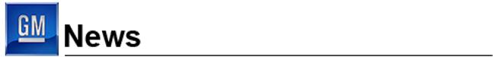

For Release: June 29, 2010

GM Hosts Global Business Conference for the Financial Community

Senior leaders provide in-depth overview of the new company’s global business

and offer hands-on driving experience in GM’s great new vehicles

DETROIT – The new General Motors today hosted a group of approximately 200 members of the financial community and other stakeholders at its first annual Global Business Conference at GM’s Technical Center in Warren, Michigan. The event was the first of its kind since the launch of the new company in July 2009.

The conference featured an in-depth review of GM’s global business, with updates by Chairman and CEO Ed Whitacre, Vice Chairman Steve Girsky, Vice Chairman and CFO, Chris Liddell, and GM’s regional presidents. Vice Chairman of Global Product Operations Tom Stephens provided a review of GM’s global product portfolio, and an early preview of some upcoming products, including the next generations of the popular Opel Insignia, Chevrolet Malibu, and Cadillac CTS.

Whitacre kicked off the conference by sharing his perspective on how he sees the company today, the progress it has made, and the opportunities ahead for GM.

“We’re not reintroducing GM today, we’re introducing a new GM, because we are a new and much different company than we were 12 months ago,” Whitacre said. “We’re creating a new GM – one that truly is different. We have a simplified focus on designing, building, and selling the world’s best vehicles. We’re producing first-rate cars and trucks that customers are buying around the world. We have a new management team that ‘gets it’ and is executing well.”

Tim Lee, president of GM’s International Operations; Jamie Ardila, president of GM South America; Nick Reilly, president of GM Europe and chairman of the management board of Opel/Vauxhall; Vice President and CFO of Opel/Vauxhall Europe, Mark James; and Mark Reuss, president of GM North America, gave a market-by-market assessment of the company’s progress.

By closely managing the business at the regional level, with specific focus on the trends in local markets, and by leveraging GM’s global capability, the company is well positioned to take advantage of anticipated growth in the global auto market.

A highlight of the day was an extensive ride-and-drive for the guests, which featured virtually all of GM’s current U.S. models from its Chevrolet, Buick, GMC, and Cadillac brands, including the all-new Chevrolet Cruze and the Chevrolet Volt extended-range electric vehicle.

Girsky shared his perspectives on how GM is operating differently today, and what global market challenges still lie ahead, including further market fragmentation and new vehicle market volatility, and outlined how GM is addressing these challenges and aligning the company to take full advantage of opportunities ahead.

Liddell concluded the day by summarizing the importance of GM’s global resources and financial strength in stabilizing and growing the business. He reinforced GM’s commitment to communicating in an open and consistent manner, and to keeping the focus on the key factors that are important to the business and its stakeholders.

“Today’s event gave us a unique opportunity to highlight the fundamental changes we’re making at GM. With global growth potential in both mature and emerging markets, a dramatically lower break-even level in North America, actions underway to restructure Europe, and a much stronger balance sheet, we are making the changes needed for long-term success,” Liddell said.

An audio replay and accompanying presentation charts are available on GM’s Investor Relations website at www.gm.com/corporate/investor_information/cal_events.

# # #

About General Motors:

General Motors, one of the world’s largest automakers, traces its roots back to 1908. With its global headquarters in Detroit, GM employs 205,000 people in every major region of the world and does business in some 157 countries. GM and its strategic partners produce cars and trucks in 31 countries, and sell and service these vehicles through the following brands: Buick, Cadillac, Chevrolet, FAW, GMC, Daewoo, Holden, Jiefang, Opel, Vauxhall and Wuling. GM’s largest national market is the United States, followed by China, Brazil, Germany, the United Kingdom, Canada, and Italy. GM’s OnStar subsidiary is the industry leader in vehicle safety, security and information services. General Motors acquired operations from General Motors Corporation on July 10, 2009, and references to prior periods in this and other press materials refer to operations of the old General Motors Corporation. More information on the new General Motors can be found at www.gm.com.

Forward-Looking Statements:

In this press release and in related comments by our management, our use of the words “expect,” “anticipate,” “possible,” “potential,” “target,” “believe,” “commit,” “intend,” “continue,” “may,” “would,” “could,” “should,” “project,” “projected,” “positioned” or similar expressions is intended to identify forward-looking statements that represent our current judgment about possible future events. We believe these judgments are reasonable, but these statements are not guarantees of any events or financial results, and our actual results may differ materially due to a variety of important factors. Among other items, such factors might include: our ability to realize production efficiencies and to achieve reductions in costs as a result of our restructuring initiatives and labor modifications; our ability to maintain quality control over our vehicles and avoid material vehicle recalls; our ability to maintain adequate liquidity and financing sources and an appropriate level of debt, including as required to fund our planning significant investment in new technology; our ability to realize successful vehicle applications of new technology; and our ability to comply with the continuing requirements related to U.S. and other government support.

GM’s most recent annual report on Form 10-K and quarterly report on Form 10-Q provides information about these and other factors, which we may revise or supplement in future reports to the SEC.

Contacts:

Reneé Rashid-Merem

Office 313.665.3128

Cell 313.701.8560

renee.rashid-merem@gm.com

Randy Arickx

Office 313.667.0006

Cell 313.268.7070

randy.c.arickx@gm.com


FORWARD LOOKING STATEMENTS

In this presentation and in related comments by our management, our use of the words “expect,” “anticipate,” “possible,” “potential,” “target,” “believe,” “commit,” “intend,” “continue,” “may,” “would,” “could,” “should,” “project,” “projected,” “positioned” or similar expressions is intended to identify forward-looking statements that represent our current judgment about possible future events. We believe these judgments are reasonable, but these statements are not guarantees of any events or financial results, and our actual results may differ materially due to a variety of important factors. Among other items, such factors might include: our ability to realize production efficiencies and to achieve reductions in costs as a result of our restructuring initiatives and labor modifications; our ability to maintain quality control over our vehicles and avoid material vehicle recalls; our ability to maintain adequate liquidity and financing sources and an appropriate level of debt, including as required to fund our planning significant investment in new technology; our ability to realize successful vehicle applications of new technology; and our ability to comply with the continuing requirements related to U.S. and other government support.

GM's most recent annual report on Form 10-K and quarterly report on Form 10-Q provides information about these and other factors, which we may revise or supplement in future reports to the SEC.



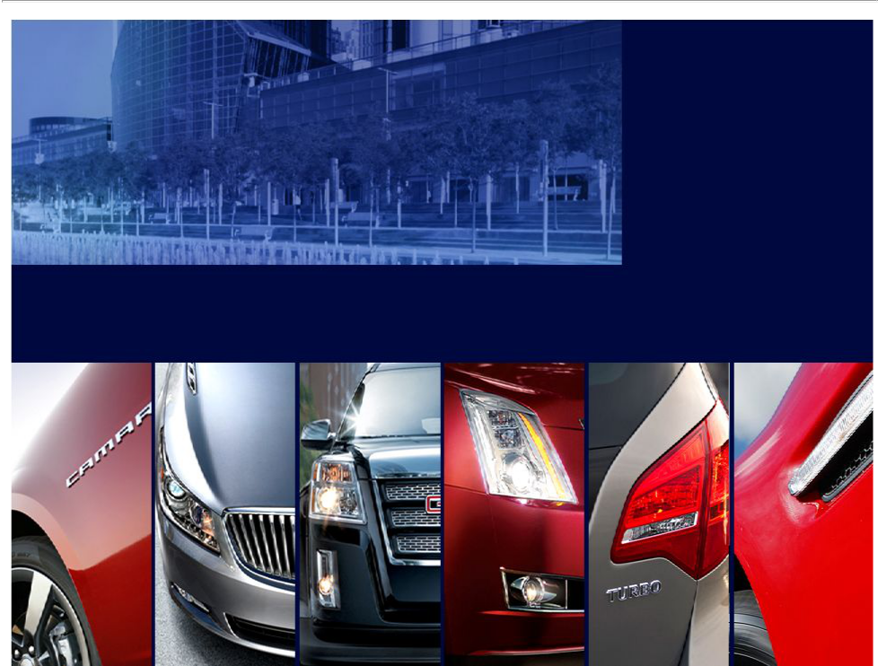

TOM STEPHENS

Vice Chairman, Global Product Operations

STEVE GIRSKY

Vice Chairman, Corporate Strategy & Business Development

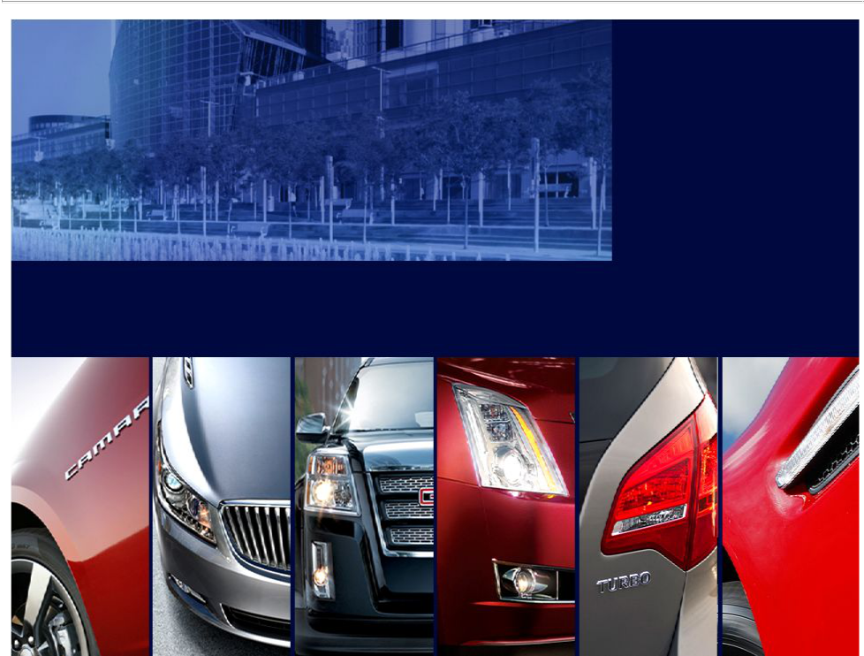

CHRIS LIDDELL

Vice Chairman & CFO

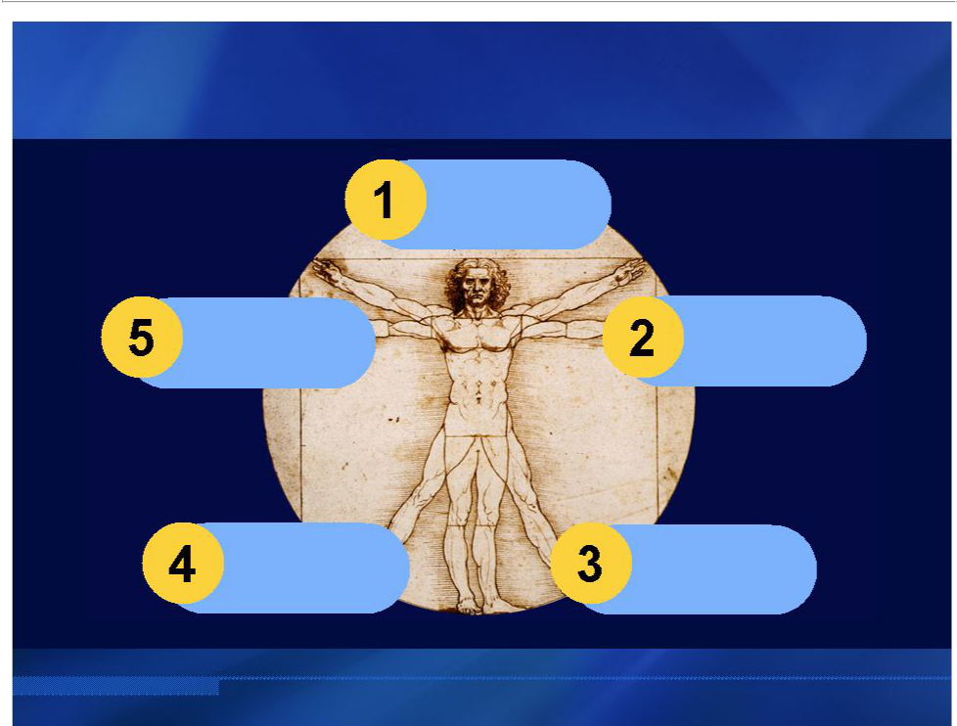
THE NEW GENERAL MOTORS

World’s

Best

Vehicles

New | Global
Management | Global
Management | Opportunity
Approach

Financial

Breakeven

Flexibility

at Bottom

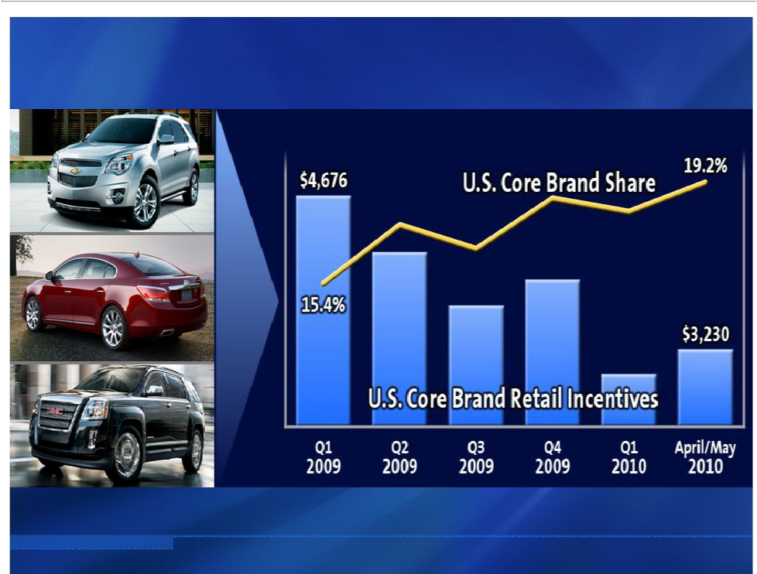
WORLD’S BEST VEHICLES

Source: Incentive information based on J.D. Power and Associates Power Information Network Data (Syndicated Report)

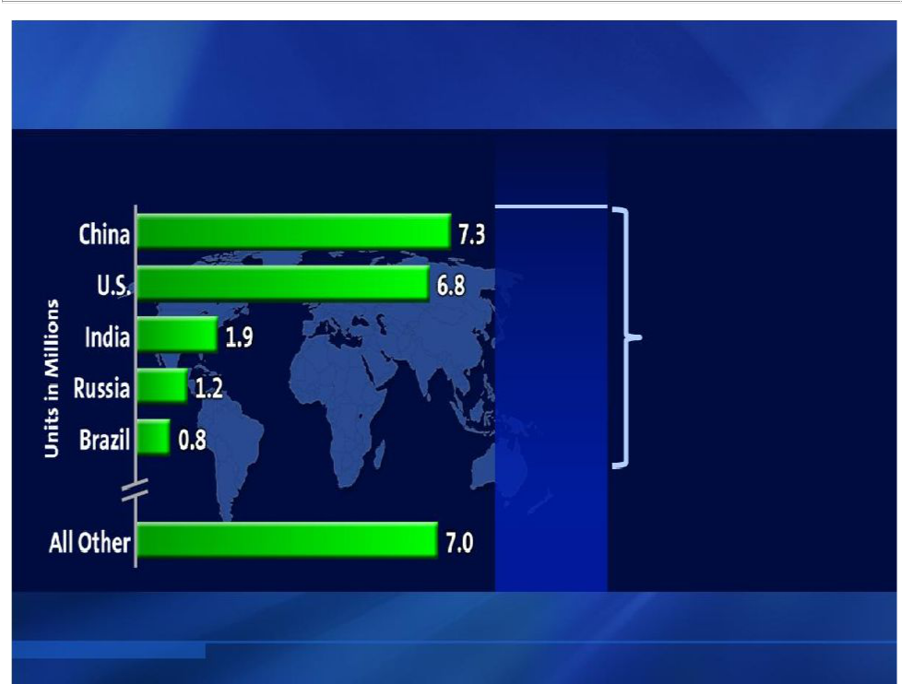
GLOBAL OPPORTUNITY

Top 5 Projected Growth Markets | 2009 GM
2009-2014E | Market Share

13% | GM
20% | Growth Opportunity
20% | 2.6 Million
3% | 2.6 Million
10% | Units
19%

8%

Source: Growth Markets per Global Insight 2009 GM Market Share per GM 2009 10-K

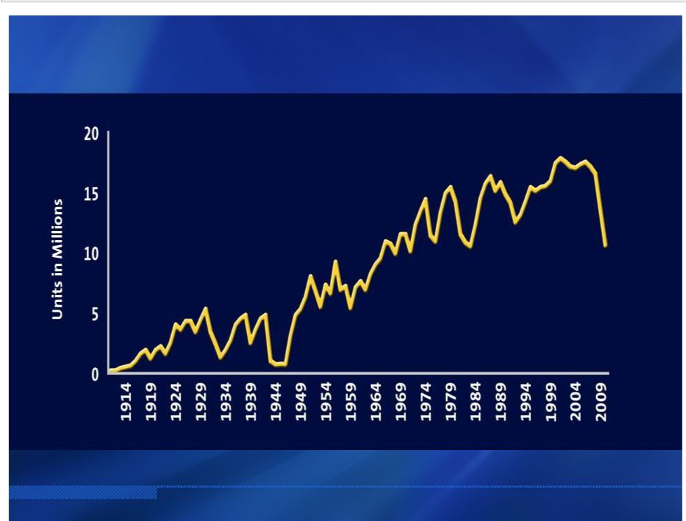
BREAKEVEN AT BOTTOM OF CYCLE

U.S. Industry

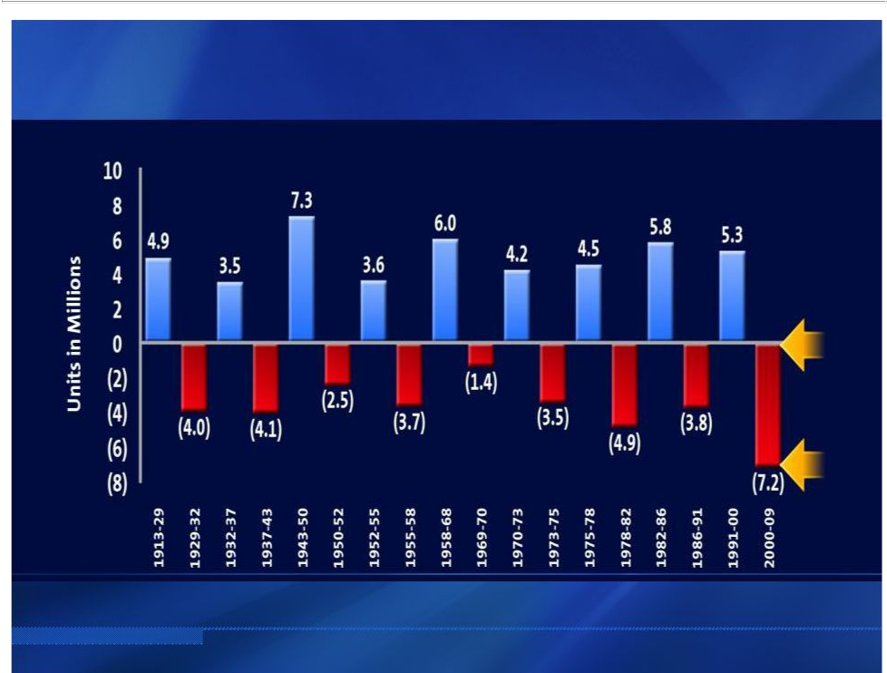
BREAKEVEN AT BOTTOM OF CYCLE

U.S. Total Auto Sales Peak – Through Swings

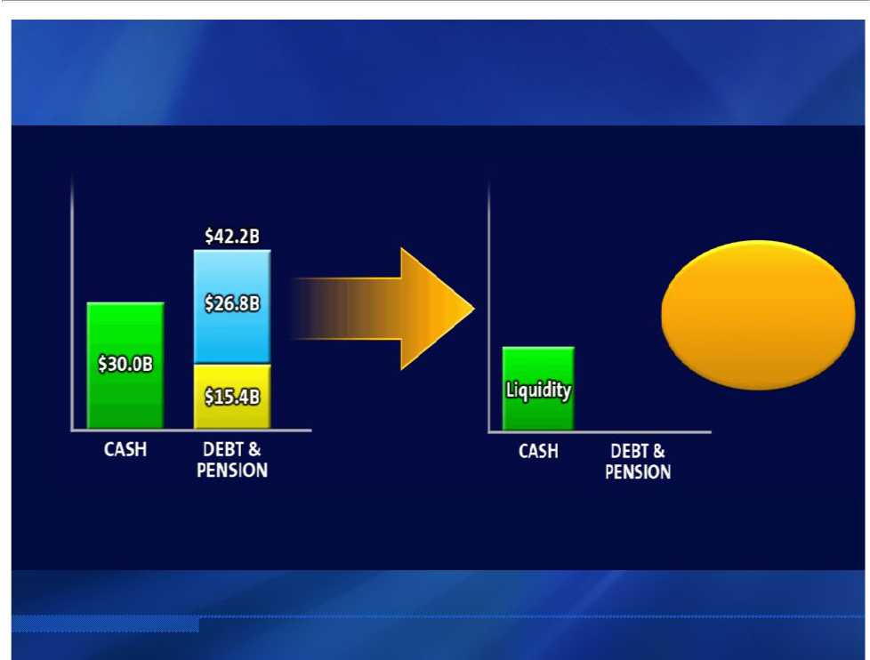
FINANCIAL FLEXIBILITY

Strong

Investment

Grade

CURRENT STATE ¹ FUTURE GOAL

- Current state reflects GM cash, debt (incl. preferred equity), and pension balances as of 3/31/10 pro forma for pay-down of UST and EDC debt

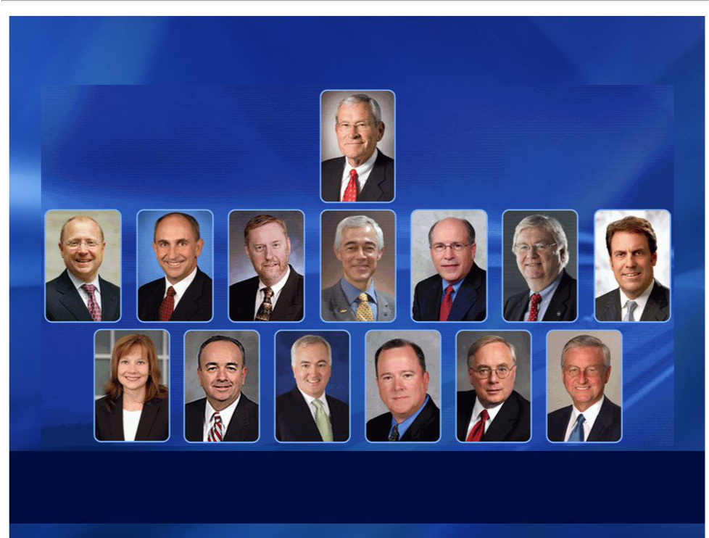
NEW MANAGEMENT APPROACH

Speed + Simplicity + Accountability



FORWARD LOOKING STATEMENTS

In this presentation and in related comments by our management, our use of the words “expect,” “anticipate,” “possible,” “potential,” “target,” “believe,” “commit,” “intend,” “continue,” “may,” “would,” “could,” “should,” “project,” “projected,” “positioned” or similar expressions is intended to identify forward-looking statements that represent our current judgment about possible future events. We believe these judgments are reasonable, but these statements are not guarantees of any events or financial results, and our actual results may differ materially due to a variety of important factors. Among other items, such factors might include: our ability to realize production efficiencies and to achieve reductions in costs as a result of our restructuring initiatives and labor modifications; our ability to maintain quality control over our vehicles and avoid material vehicle recalls; our ability to maintain adequate liquidity and financing sources and an appropriate level of debt, including as required to fund our planning significant investment in new technology; our ability to realize successful vehicle applications of new technology; and our ability to comply with the continuing requirements related to U.S. and other government support.

GM's most recent annual report on Form 10-K and quarterly report on Form 10-Q provides information about these and other factors, which we may revise or supplement in future reports to the SEC.

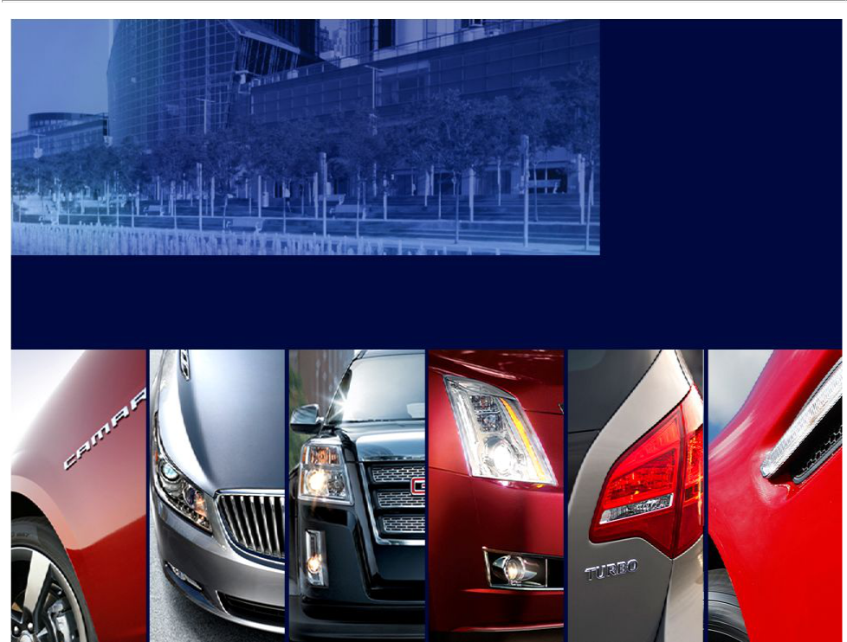

ED WHITACRE

Chairman & CEO

TIM LEE

JAIME ARDILA
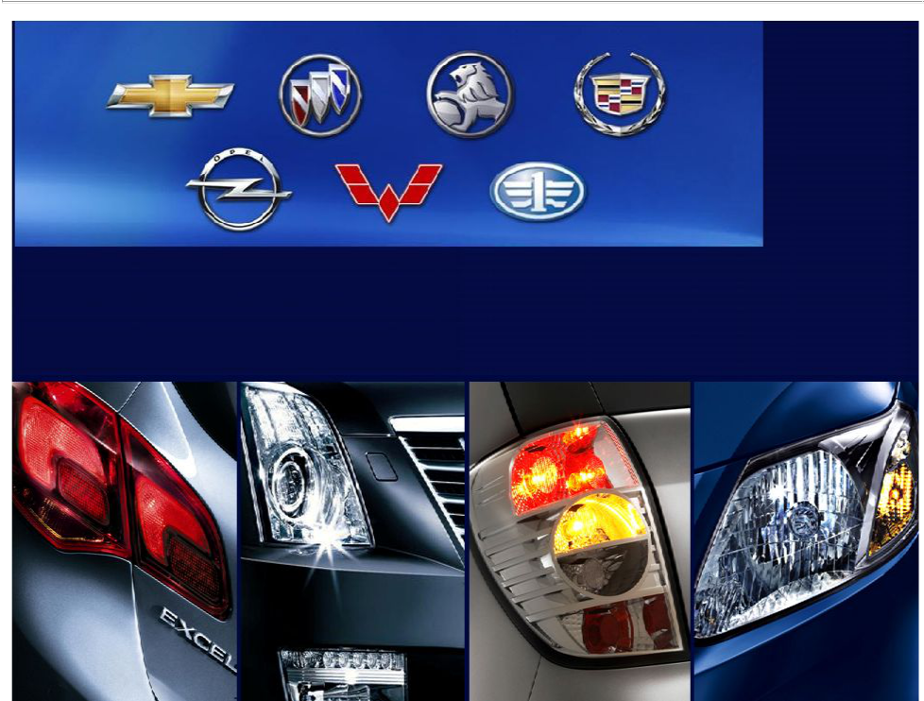

President, GM International Operations

President, GM South America

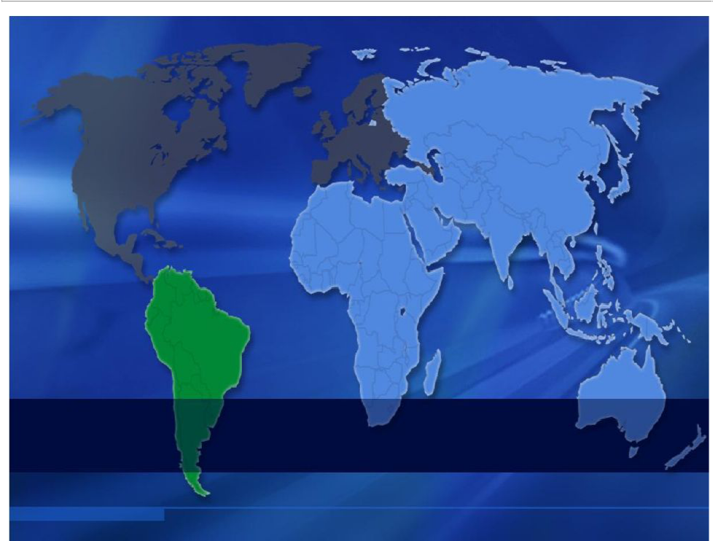

GM’s fastest growing regions

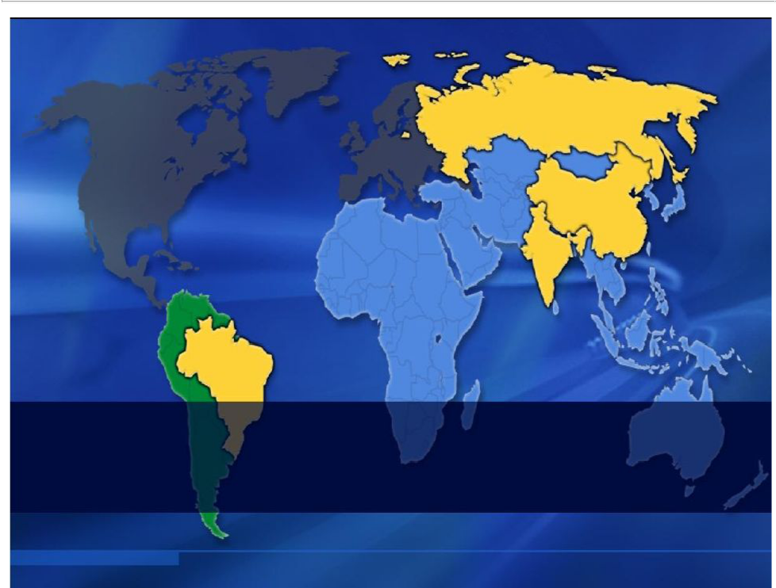

45%of global automotive industry growth through
2014 to come from BRIC countries

Source: Global Insight 2009-2014

GROWTH OPPORTUNITIES WITHIN EMERGING MARKETS

2009 GM SALES VOLUME

Australia & New Zealand 3%

Other Asia 4%

CIS 3%

Middle East 4%

 | Africa 4%
South | Other South
South | America 8%
America | America 8%
25% | Brazil 17%

CIS includes: Uzbekistan, Ukraine & Kazakhstan

China 51%

Russia 4%
India 2%

BRIC

74%

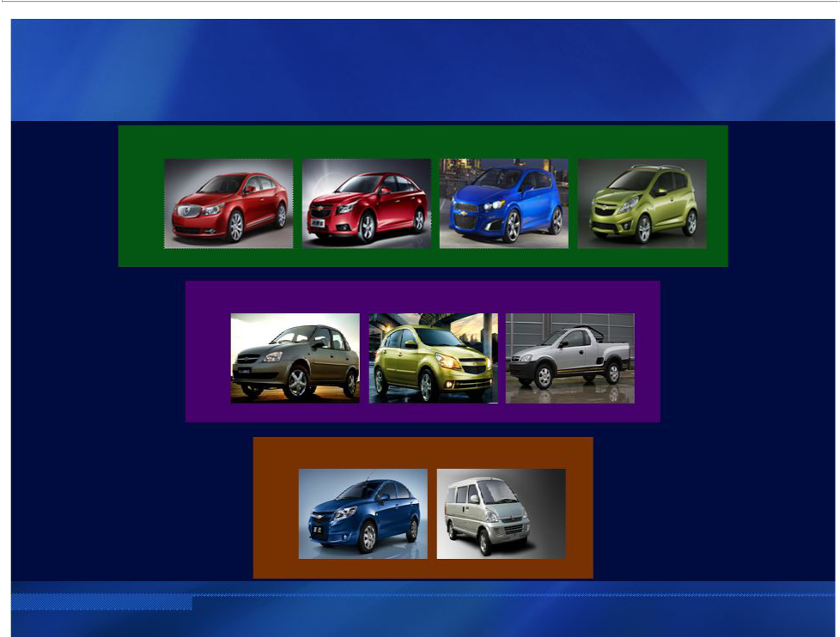
THREE-PRONG PRODUCT STRATEGY

GLOBAL ARCHITECTURES

1

Buick LaCrosse Chevrolet Cruze Chevrolet Aveo RS Chevrolet Spark

REGIONAL SOLUTIONS

2

Chevrolet Classic Chevrolet Agile Chevrolet Montana

PARTNER COLLABORATION

3

Chevrolet New Sail Wuling Rong Guang

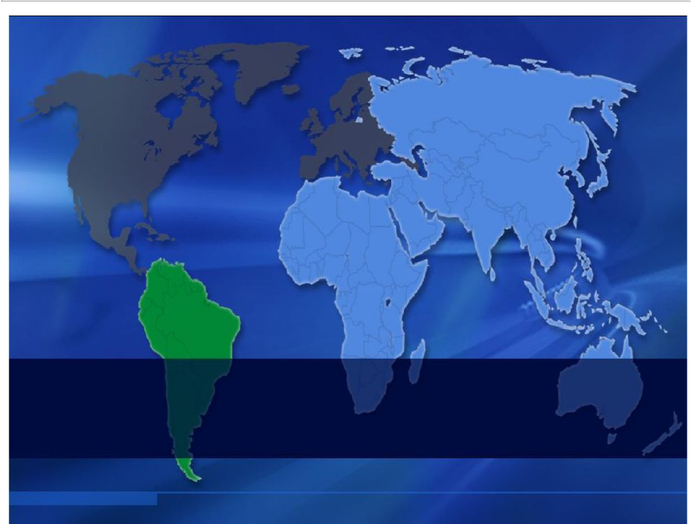

Emerging Markets
Key to GM’s Sustainable Growth

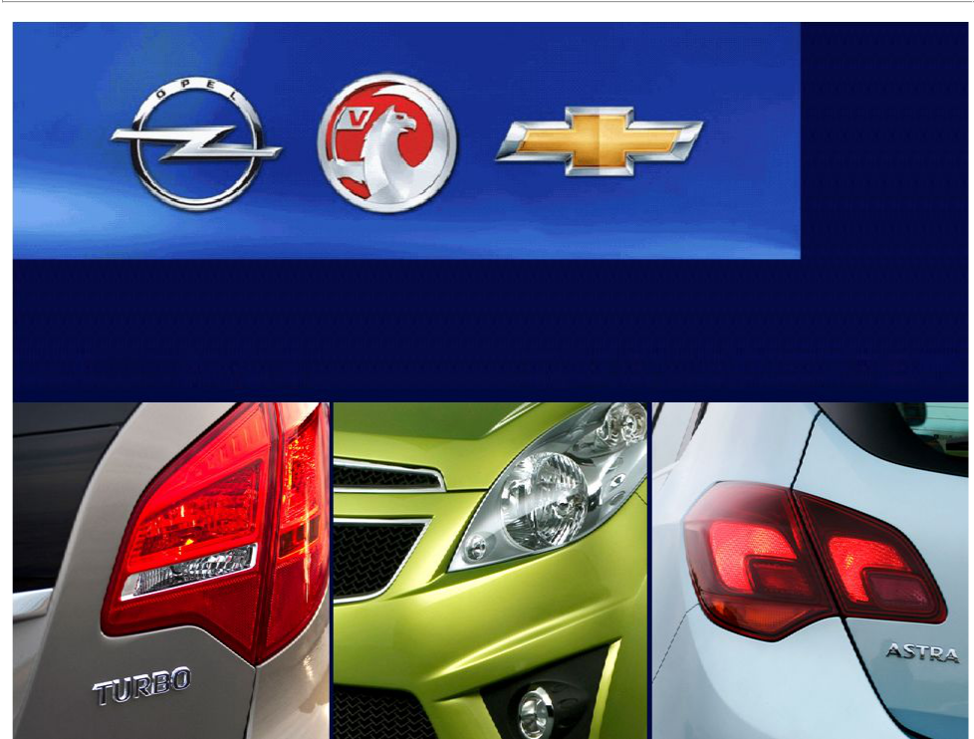

NICK REILLY

President, GM Europe and Chairman, Management Board of Opel/Vauxhall

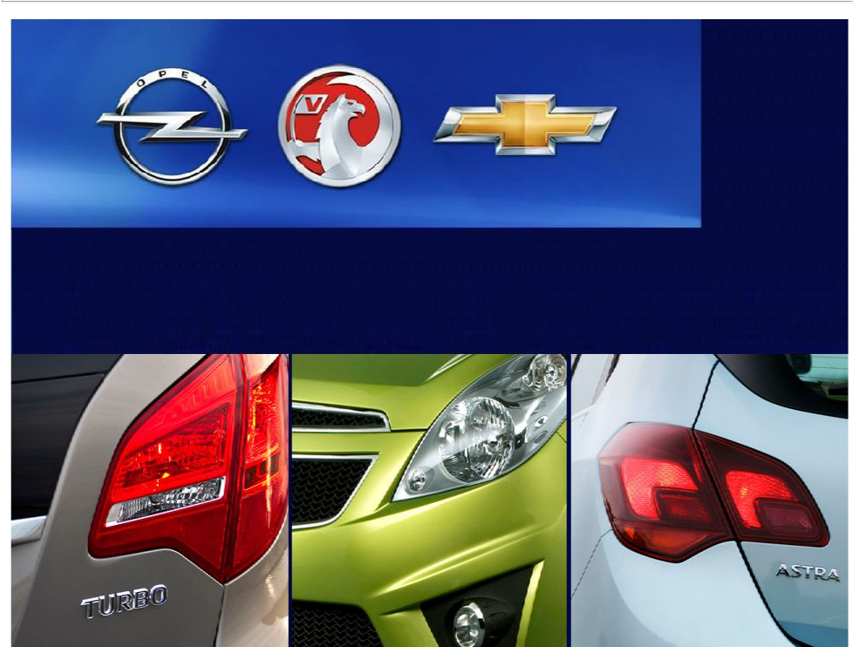

MARK JAMES

Vice President and CFO, Opel/Vauxhall Europe

TURNAROUND STARTS WITH EXCELLENT PRODUCTS

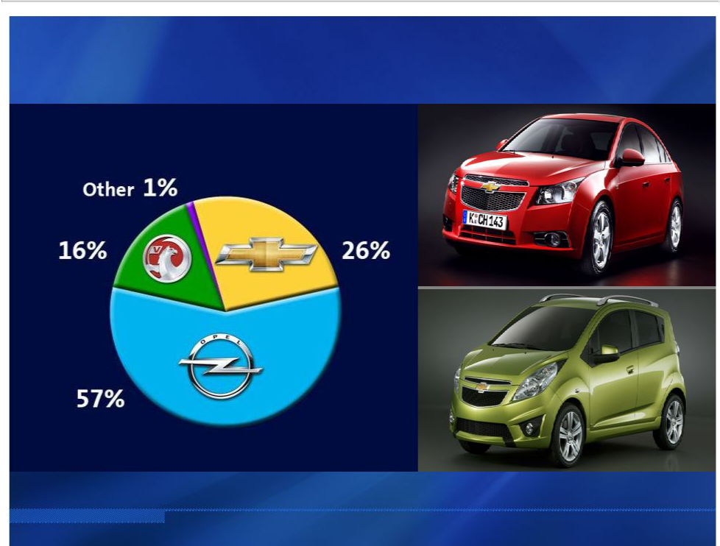
CHEVROLET IS A GROWING PART OF EUROPEAN SALES

GME 2009 SALES VOLUME


GM EUROPE RESTRUCTURING

RESTRUCTURING ELEMENTS

Antwerp facility closure

Other separation savings

Employee concessions

Other restructuring savings

Lower

Breakeven


INDUSTRY GROWTH

WESTERN & CENTRAL EUROPE

EASTERN EUROPE

CY 2014 Outlook:

18.9M

CY 2014 Outlook:

3.3M

20%

70%

CY 2010 Outlook: 15.6M CY 2010 Outlook: 1.9M

Source: Global Insight

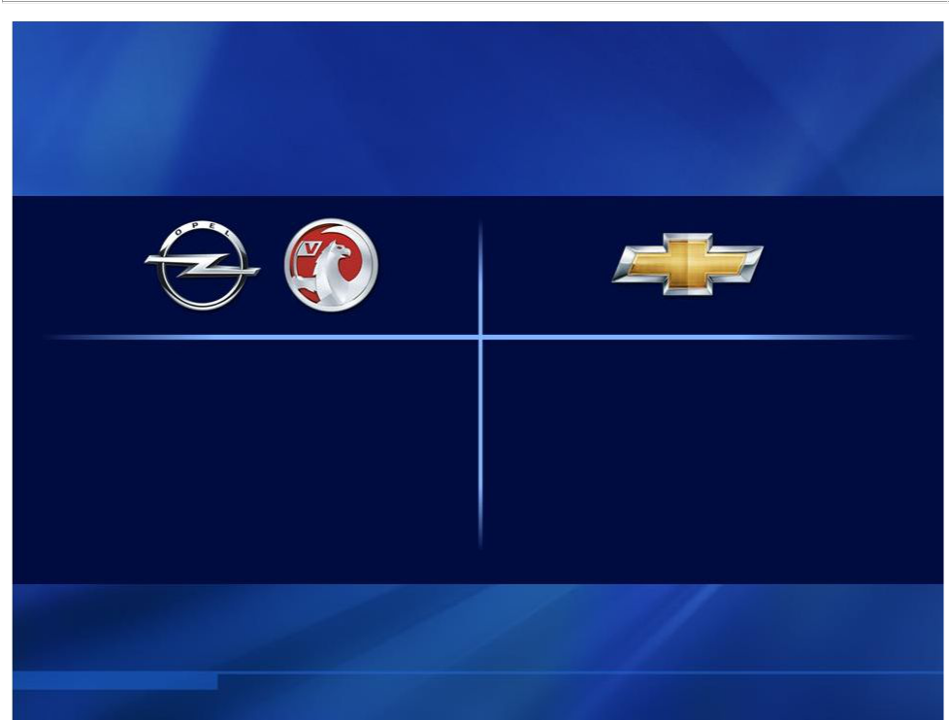
CONTINUED PRODUCT OFFENSIVE

14 | 13
Launches | Launches
through 2014 | through 2014

Product
Offensive

- Restructuring Measures

  - Breakeven in 2011…

Significant profits as markets recover

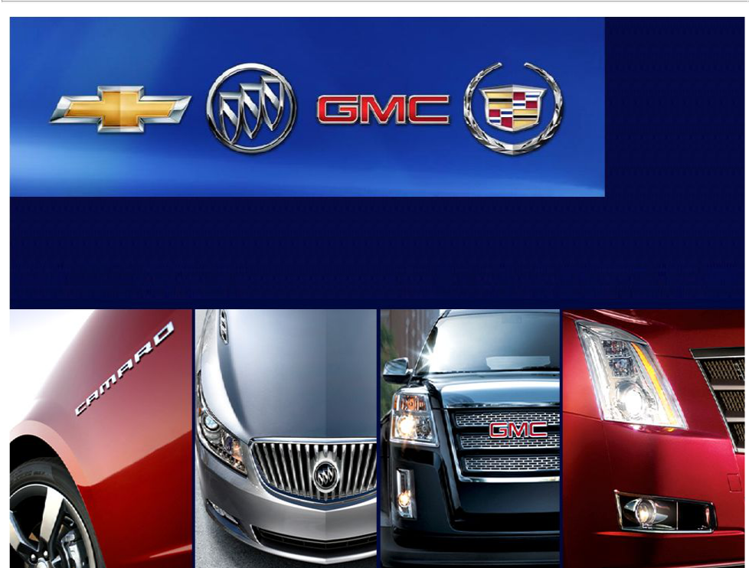

MARK REUSS

President, GM North America

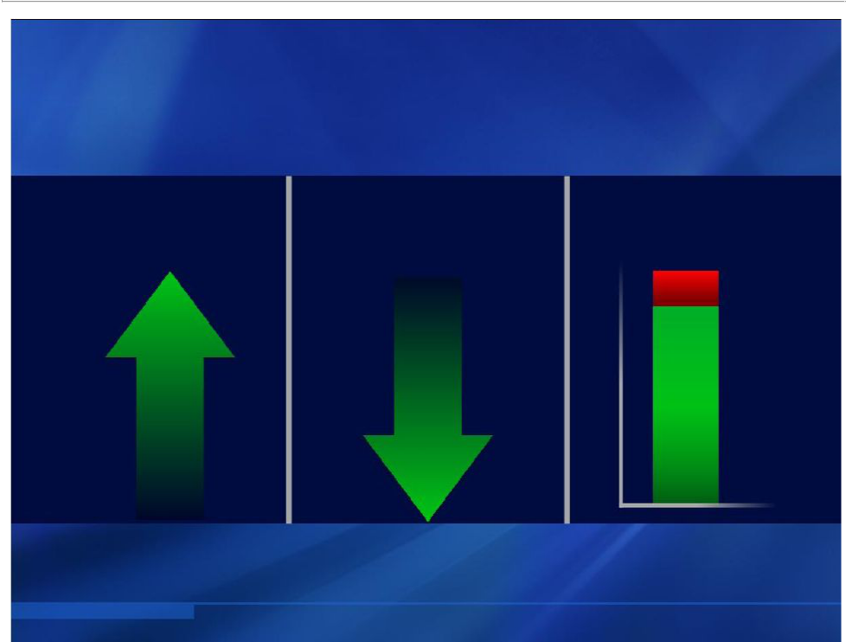
BREAKEVEN REDUCED

TRANSACTION LABOR CAPACITY

PRICES COST UTILIZATION

85%

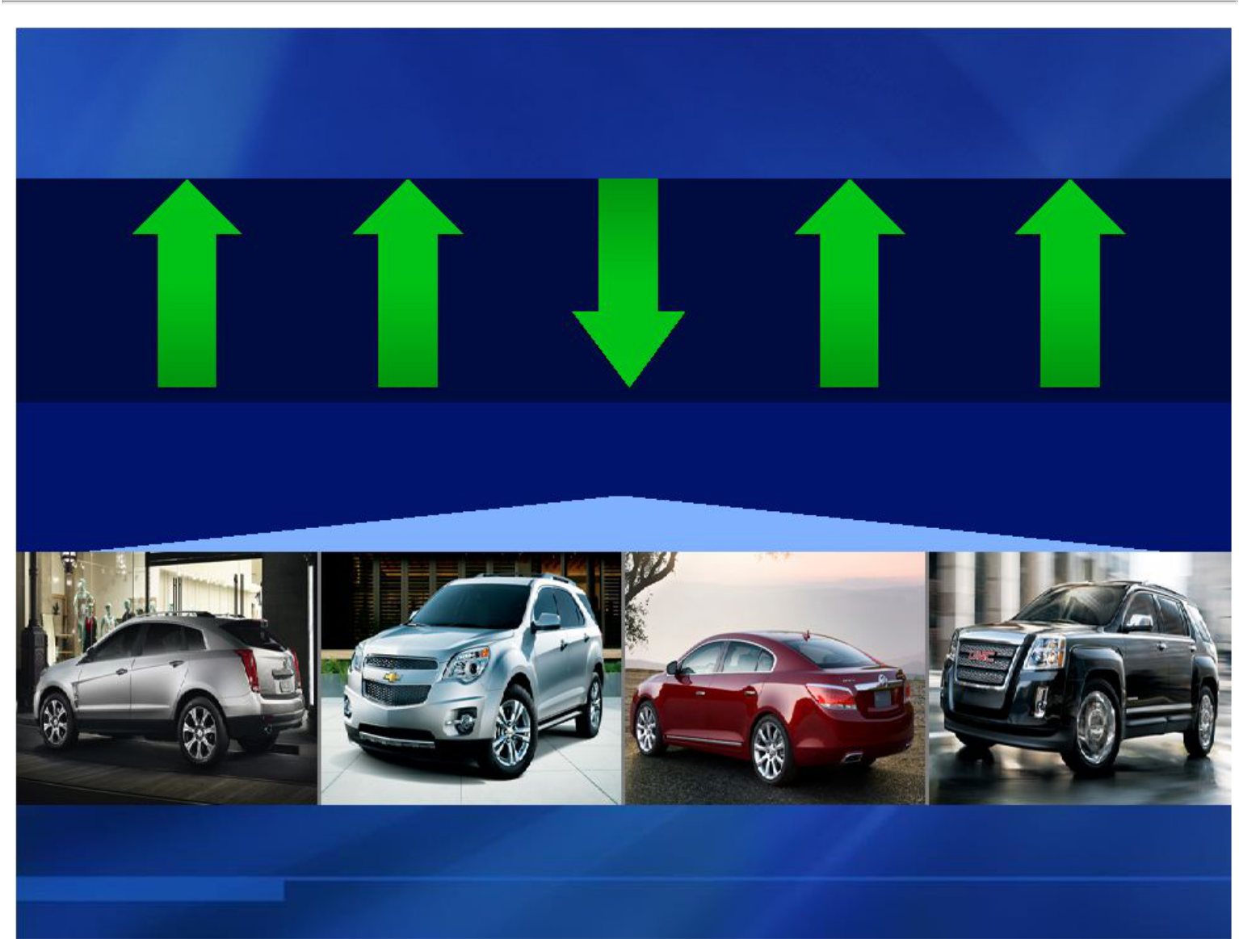
LAUNCH PRODUCT PERFORMANCE

Share of | Transaction | Incentives Consideration Residuals
Segment | Price

CADILLAC SRX | CHEVROLET | BUICK LACROSSE GMC TERRAIN
CADILLAC SRX | EQUINOX | BUICK LACROSSE GMC TERRAIN
Q1 2010 vs Q1 2009 | EQUINOX


U.S. INDUSTRY OUTLOOK

PROJECTED
GROWTH | CY 2014 Outlook: | 17.5M

45%

2010 – 2014 CY 2010 Outlook: 12.0M

Source: Global Insight

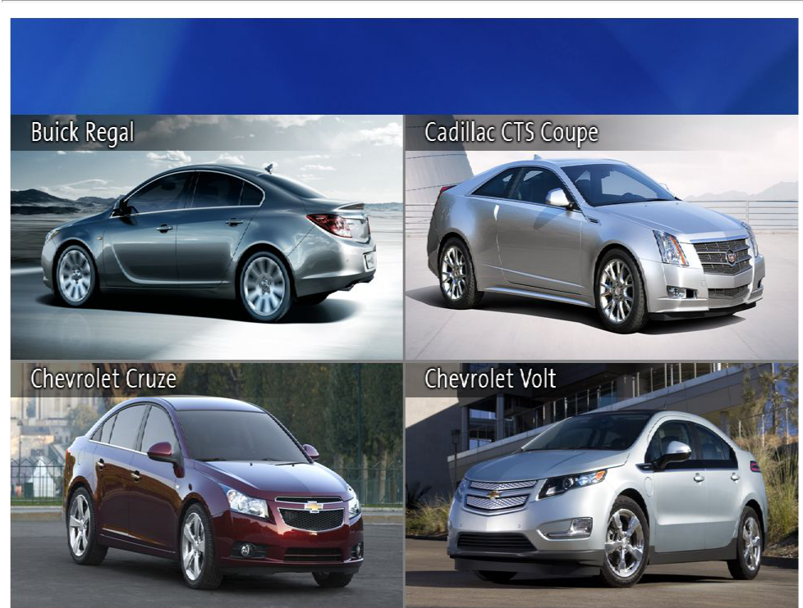
CONTINUED PRODUCT OFFENSIVE

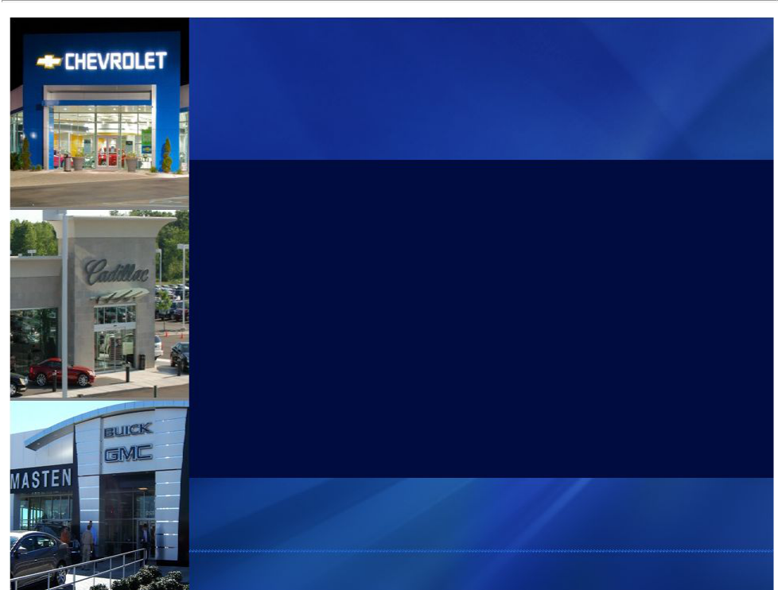
U.S. DEALER STRATEGY

- Retain strong performers

- Strategically align franchise points

- Support facility improvements

- Improved sales, share and profitability

