UNITED STATES SECURITIES AND EXCHANGE COMMISSION

Washington, DC 20549-1004

___________________

FORM 8-K

___________________

CURRENT REPORT

Pursuant to Section 13 or 15(d) of

the Securities Exchange Act of 1934

Date of Report (Date of earliest event reported) February 5, 2020

___________________

GENERAL MOTORS COMPANY

(Exact name of registrant as specified in its charter)

__________________

Delaware

001-34960

27-0756180

(State or other jurisdiction of incorporation)

(Commission File Number)

(I.R.S. Employer Identification No.)

300 Renaissance Center,

Detroit,

Michigan

48265 -3000

(Address of principal executive offices)

(Zip Code)

(313) 667-1500

(Registrant's telephone number, including area code)

Not Applicable

(Former name or former address, if changed since last report)

__________________

Check the appropriate box below if the Form 8-K filing is intended to simultaneously satisfy the filing obligation of the registrant under any of the following provisions:

- Written communications pursuant to Rule 425 under the Securities Act (17 CFR 230.425)

- Soliciting material pursuant to Rule 14a-12 under the Exchange Act (17 CFR 240.14a-12)

- Pre-commencement communications pursuant to Rule 14d-2(b) under the Exchange Act (17 CFR 240.14d-2(b))

- Pre-commencement communications pursuant to Rule 13e-4(c) under the Exchange Act (17 CFR 240.13e-4(c))

 |  |  | Securities registered pursuant to Section 12(b) of the Act:
 | Title of each class |  | Trading Symbol(s) |  |  | Name of each exchange on which registered
Common Stock, $0.01 par value |  |  |  | GM |  |  | New York Stock Exchange

Indicate by check mark whether the registrant is an emerging growth company as defined in Rule 405 of the Securities Act of 1933 (§230.405 of this chapter) or Rule 12b-2 of the Securities Exchange Act of 1934 (§240.12b-2 of this chapter). Emerging growth company ☐

If an emerging growth company, indicate by check mark if the registrant has elected not to use the extended transition period for complying with any new or revised financial accounting standards provided pursuant to Section 13(a) of the Exchange Act. ☐

ITEM 2.02 Results of Operations and Financial Condition

On February 5, 2020 General Motors Company (GM) issued a news release and supplemental materials on the subject of its 2019 fourth quarter and full year consolidated earnings. The news release and supplemental materials are attached as Exhibit 99.1 and Exhibit 99.2.

Charts furnished to securities analysts in connection with GM's 2019 fourth quarter and full year consolidated earnings release are available on GM's website at www.gm.com/investors/earnings-releases.html.

ITEM 9.01 Financial Statements and Exhibits

 |  |  |  |  | EXHIBIT
Exhibit |  | Description
Exhibit 99.1 |  | News Release Dated February 5, 2020
Exhibit 99.2 |  | Financial Highlights Dated February 5, 2020
Exhibit 104 |  | Cover Page Interactive Data File (embedded within the Inline XBRL document)

SIGNATURE

Pursuant to the requirements of the Securities Exchange Act of 1934, the registrant has duly caused this report to be signed on its behalf by the undersigned hereunto duly authorized.

 | GENERAL MOTORS COMPANY (Registrant)
By: | /s/ CHRISTOPHER T. HATTO
Date: February 5, 2020
Date: February 5, 2020 | Christopher T. Hatto, Vice President, Global Business Solutions and Chief Accounting
 | Officer

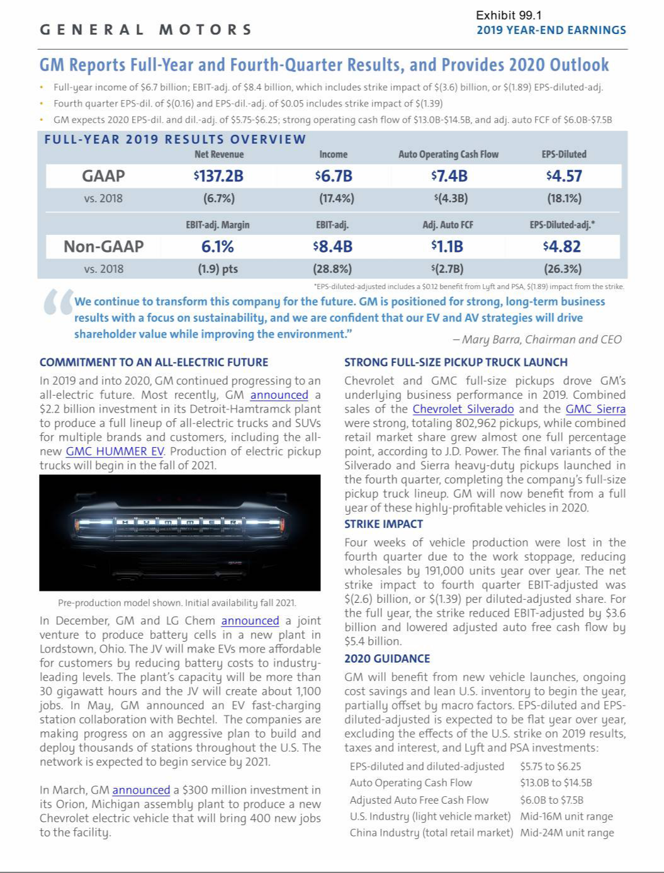

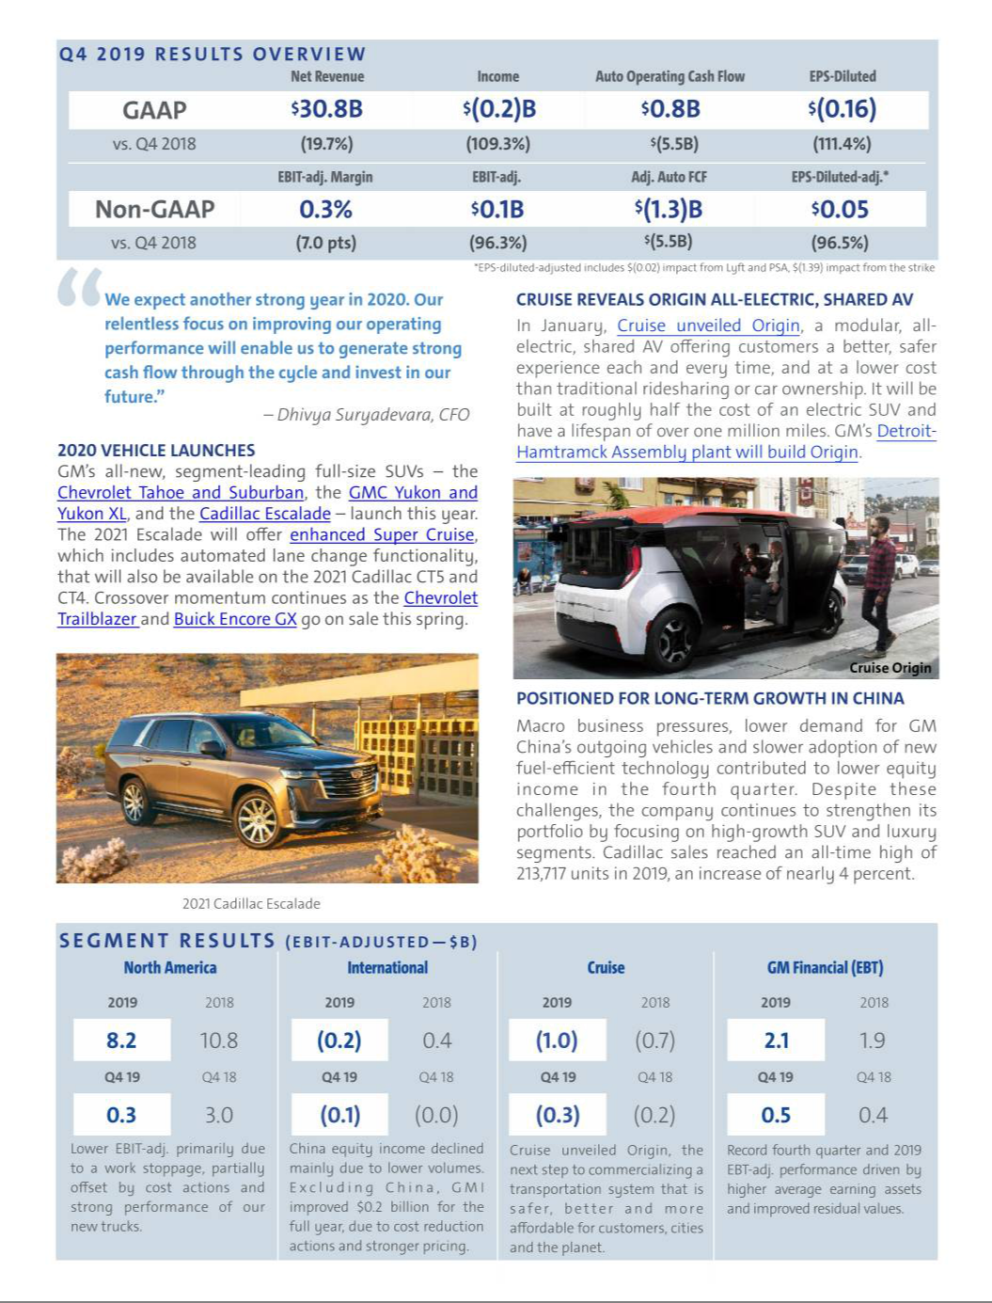

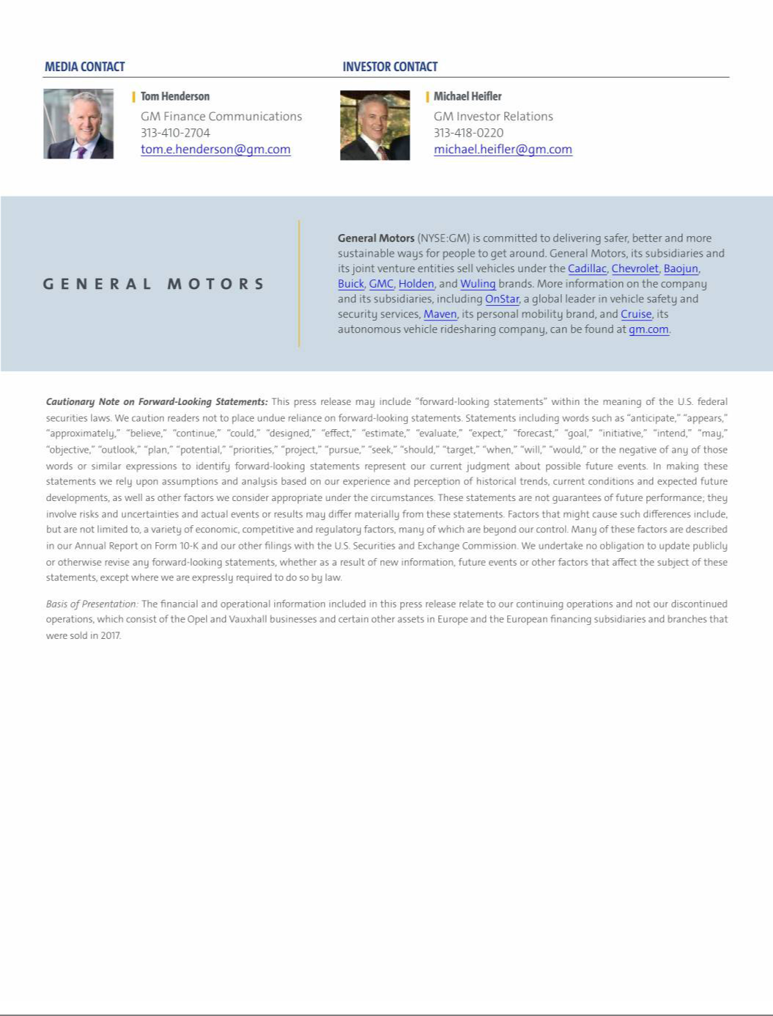

Exhibit 99.2

General Motors Company and Subsidiaries

Supplemental Material

(Unaudited)

Unless otherwise indicated, General Motors Company's (GM) non-GAAP measures are related to our continuing operations and not our discontinued operations. GM's non-GAAP measures include: earnings before interest and taxes (EBIT)-adjusted, presented net of noncontrolling interests; earnings before income taxes (EBT)-adjusted for our General Motors Financial Company, Inc. (GM Financial) segment; earnings per share (EPS)-diluted-adjusted; effective tax rate-adjusted (ETR-adjusted); return on invested capital-adjusted (ROIC-adjusted) and adjusted automotive free cash flow. GM's calculation of these non-GAAP measures may not be comparable to similarly titled measures of other companies due to potential differences between companies in the method of calculation. As a result, the use of these non-GAAP measures has limitations and should not be considered superior to, in isolation from, or as a substitute for, related U.S. GAAP measures.

These non-GAAP measures allow management and investors to view operating trends, perform analytical comparisons and benchmark performance between periods and among geographic regions to understand operating performance without regard to items we do not consider a component of our core operating performance. Furthermore, these non-GAAP measures allow investors the opportunity to measure and monitor our performance against our externally communicated targets and evaluate the investment decisions being made by management to improve ROIC-adjusted. Management uses these measures in its financial, investment and operational decision-making processes, for internal reporting and as part of its forecasting and budgeting processes. Further, our Board of Directors uses certain of these and other measures as key metrics to determine management performance under our performance-based compensation plans. For these reasons we believe these non-GAAP measures are useful for our investors.

EBIT-adjusted EBIT-adjusted is presented net of noncontrolling interests and is used by management and can be used by investors to review our consolidated operating results because it excludes automotive interest income, automotive interest expense and income taxes as well as certain additional adjustments that are not considered part of our core operations. Examples of adjustments to EBIT include but are not limited to impairment charges on long-lived assets and other exit costs resulting from strategic shifts in our operations or discrete market and business conditions; costs arising from the ignition switch recall and related legal matters; and certain currency devaluations associated with hyperinflationary economies. For EBIT-adjusted and our other non-GAAP measures, once we have made an adjustment in the current period for an item, we will also adjust the related non-GAAP measure in any future periods in which there is an impact from the item. Our corresponding measure for our GM Financial segment is EBT-adjusted.

EPS-diluted-adjusted EPS-diluted-adjusted is used by management and can be used by investors to review our consolidated diluted EPS results on a consistent basis. EPS-diluted-adjusted is calculated as net income attributable to common stockholders-diluted less income (loss) from discontinued operations on an after-tax basis, adjustments noted above for EBIT-adjusted and certain income tax adjustments divided by weighted-average common shares outstanding-diluted. Examples of income tax adjustments include the establishment or reversal of significant deferred tax asset valuation allowances.

ETR-adjusted ETR-adjusted is used by management and can be used by investors to review the consolidated effective tax rate for our core operations on a consistent basis. ETR-adjusted is calculated as Income tax expense less the income tax related to the adjustments noted above for EBIT-adjusted and the income tax adjustments noted above for EPS-diluted-adjusted divided by Income before income taxes less adjustments. When we provide an expected adjusted effective tax rate, we do not provide an expected effective tax rate because the U.S. GAAP measure may include significant adjustments that are difficult to predict.

ROIC-adjusted ROIC-adjusted is used by management and can be used by investors to review our investment and capital allocation decisions. We define ROIC-adjusted as EBIT-adjusted for the trailing four quarters divided by ROIC-adjusted average net assets, which is considered to be the average equity balances adjusted for average automotive debt and interest liabilities, exclusive of finance leases; average automotive net pension and other postretirement benefits (OPEB) liabilities; and average automotive net income tax assets during the same period. Adjustments to the average equity balances exclude assets and liabilities classified as either assets held for sale or liabilities held for sale.

Adjusted automotive free cash flow Adjusted automotive free cash flow is used by management and can be used by investors to review the liquidity of our automotive operations and to measure and monitor our performance against our capital allocation program and evaluate our automotive liquidity against the substantial cash requirements of our automotive operations. We measure adjusted automotive free cash flow as automotive operating cash flow from continuing operations less capital expenditures adjusted for management actions. Management actions can include voluntary events such as discretionary contributions to employee benefit plans or nonrecurring specific events such as a closure of a facility that are considered special for EBIT-adjusted purposes.

1

General Motors Company and Subsidiaries

Supplemental Material

(Unaudited)

The following table reconciles segment profit (loss) to Net income (loss) attributable to stockholders under U.S. GAAP (dollars in millions):

 |  | Three Months Ended |  |  |  |  |  | Years Ended
 |  | December 31, 2019 |  |  | December 31, 2018 |  |  | December 31, 2019 |  |  | December 31, 2018
Operating segments
GM North America (GMNA) | $ | 263 |  | $ | 3,041 |  | $ | 8,204 |  | $ | 10,769
GM International (GMI) |  | (120) |  |  | (48) |  |  | (202) |  |  | 423
Cruise |  | (305) |  |  | (194) |  |  | (1,004) |  |  | (728)
GM Financial(a) |  | 498 |  |  | 416 |  |  | 2,104 |  |  | 1,893
Total operating segments |  | 336 |  |  | 3,215 |  |  | 9,102 |  |  | 12,357
Corporate and eliminations(b) |  | (231) |  |  | (387) |  |  | (709) |  |  | (574)
EBIT-adjusted |  | 105 |  |  | 2,828 |  |  | 8,393 |  |  | 11,783
Adjustments
Transformation activities(c) |  | (194) |  |  | (1,327) |  |  | (1,735) |  |  | (1,327)
GM Brazil indirect tax recoveries(d) |  | — |  |  | — |  |  | 1,360 |  |  | —
FAW-GM divestiture(e) |  | (164) |  |  | — |  |  | (164) |  |  | —
GMI restructuring(f) |  | — |  |  | — |  |  | — |  |  | (1,138)
Ignition switch recall and related legal matters(g) |  | — |  |  | — |  |  | — |  |  | (440)
Total adjustments |  | (358) |  |  | (1,327) |  |  | (539) |  |  | (2,905)
Automotive interest income |  | 96 |  |  | 117 |  |  | 429 |  |  | 335
Automotive interest expense |  | (200) |  |  | (185) |  |  | (782) |  |  | (655)
Income tax (expense) benefit(h) |  | 163 |  |  | 611 |  |  | (769) |  |  | (474)
Income (loss) from continuing operations(i) |  | (194) |  |  | 2,044 |  |  | 6,732 |  |  | 8,084
Loss from discontinued operations, net of tax(j) |  | — |  |  | — |  |  | — |  |  | 70
Net income (loss) attributable to stockholders | $ | (194) |  | $ | 2,044 |  | $ | 6,732 |  | $ | 8,014
__________
- GM Financial amounts represent EBT-adjusted.

- GM's automotive interest income and interest expense, Maven, legacy costs from the Opel and Vauxhall businesses and certain other assets in Europe (the Opel/Vauxhall Business), which are primarily pension costs, corporate expenditures and certain nonsegment specific revenues and expenses are recorded centrally in Corporate.
- These adjustments were excluded because of a strategic decision to accelerate our transformation for the future to strengthen our core business, capitalize on the future of personal mobility, and drive significant cost efficiencies. The adjustments primarily consist of accelerated depreciation, supplier-related charges, pension and other curtailment charges and employee-related separation charges in the year ended December 31, 2019 and primarily employee separation charges and accelerated depreciation in the year ended December 31, 2018.
- This adjustment was excluded because of the unique events associated with decisions rendered by the Superior Judicial Court of Brazil resulting in retrospective recoveries of indirect taxes.

- This adjustment was excluded because we divested our joint venture FAW-GM Light Duty Commercial Vehicle Co., Ltd. (FAW-GM), as a result of a strategic decision by both shareholders, allowing us to focus our resources on opportunities expected to deliver higher returns.
- This adjustment was excluded because of a strategic decision to rationalize our core operations by exiting or significantly reducing our presence in various international markets to focus resources on opportunities expected to deliver higher returns. The adjustments primarily consist of employee separation charges, asset impairments and supplier claims in the year ended December 31, 2018, all in Korea.
- This adjustment was excluded because of the unique events associated with the ignition switch recall, which included various investigations, inquiries and complaints from constituents.

- Income tax (expense) benefit includes an adjustment of $1.1 billion in the year ended December 31, 2018 consisting of (1) a non-recurring tax benefit related to foreign earnings recorded in the three months ended December 31, 2018; and (2) tax effects related to U.S. tax reform legislation.
- Net of Net (income) loss attributable to noncontrolling interests.

- Represents the results of the Opel/Vauxhall Business and our European financing subsidiaries and branches (the Fincos, and together with the Opel/Vauxhall Business, the European Business).

2

General Motors Company and Subsidiaries

Supplemental Material

(Unaudited)

The following table reconciles diluted earnings (loss) per common share under U.S. GAAP to EPS-diluted-adjusted (dollars in millions, except per share amounts):

 |  |  |  |  | Three Months Ended |  |  |  |  |  |  |  |  |  |  |  | Years Ended
 |  | December 31, 2019 |  |  |  |  |  | December 31, 2018 |  |  |  |  |  | December 31, 2019 |  |  |  |  |  | December 31, 2018
 |  | Amount |  |  | Per Share |  |  | Amount |  |  | Per Share |  |  | Amount |  |  | Per Share |  |  | Amount |  |  | Per Share
Diluted earnings (loss) per common share | $ | (232) |  | $ | (0.16) |  | $ | 2,006 |  | $ | 1.40 |  | $ | 6,581 |  | $ | 4.57 |  | $ | 7,916 |  | $ | 5.53
Impact of including dilutive securities(a) |  |  |  |  | — |  |  |  |  |  | — |  |  |  |  |  | — |  |  |  |  |  | —
Diluted loss per common share – discontinued operations |  | — |  |  | — |  |  | — |  |  | — |  |  | — |  |  | — |  |  | 70 |  |  | 0.05
Adjustments(b) |  | 358 |  |  | 0.25 |  |  | 1,327 |  |  | 0.93 |  |  | 539 |  |  | 0.38 |  |  | 2,905 |  |  | 2.03
Tax effect on adjustments(c) |  | (54) |  |  | (0.04) |  |  | (327) |  |  | (0.23) |  |  | (188) |  |  | (0.13) |  |  | (416) |  |  | (0.29)
Tax adjustments(d) |  | — |  |  | — |  |  | (954) |  |  | (0.67) |  |  | — |  |  | — |  |  | (1,111) |  |  | (0.78)
EPS-diluted-adjusted | $ | 72 |  | $ | 0.05 |  | $ | 2,052 |  | $ | 1.43 |  | $ | 6,932 |  | $ | 4.82 |  | $ | 9,364 |  | $ | 6.54
________
- Represents the dilutive effect of awards under stock incentive plans. Refer to the table below for the effect on weighted-average common shares outstanding – diluted-adjusted.

- Refer to the reconciliation of segment profit (loss) to Net income (loss) attributable to stockholders under U.S. GAAP for adjustment details.

- The tax effect of each adjustment is determined based on the tax laws and valuation allowance status of the jurisdiction to which the adjustment relates.

- In the year ended December 31, 2018 the adjustment consists of: (1) a non-recurring tax benefit related to foreign earnings recorded in the three months ended December 31, 2018; and (2) tax effects related to U.S. tax reform legislation. These adjustments were excluded because impacts of tax legislation and valuation allowances are not considered part of our core operations.

The following table reconciles weighted-average common shares outstanding – diluted under U.S. GAAP to weighted-average common shares outstanding – diluted-adjusted used in the calculation of EPS-diluted-adjusted (shares in millions):

 | Three Months Ended |  |  |  | Years Ended
 | December 31, 2019 |  | December 31, 2018 |  | December 31, 2019 |  | December 31, 2018
Weighted-average common shares outstanding – diluted | 1,429 |  | 1,432 |  | 1,439 |  | 1,431
Dilutive effect of awards under stock incentive plans | 13 |  | — |  | — |  | —
Weighted-average common shares outstanding – diluted-adjusted | 1,442 |  | 1,432 |  | 1,439 |  | 1,431
 | 3

General Motors Company and Subsidiaries

Supplemental Material

(Unaudited)

The following table reconciles our effective tax rate under U.S. GAAP to ETR-adjusted (dollars in millions):

 |  |  |  |  |  |  | Years Ended December 31,
 |  |  |  |  | 2019 |  |  |  |  |  |  |  | 2018
 |  | Income before income |  |  | Income tax |  | Effective tax |  | Income before income |  |  |  | Income tax |  | Effective tax
 |  | taxes |  |  | expense |  | rate |  |  | taxes |  |  | expense |  | rate
Effective tax rate | $ | 7,436 |  | $ | 769 | 10.3% |  |  | $ | 8,549 |  | $ | 474 | 5.5%
Adjustments(a) |  | 545 |  |  | 188 |  |  |  |  | 2,946 |  |  | 416
Tax adjustments(b) |  |  |  |  | — |  |  |  |  |  |  |  | 1,111
ETR-adjusted | $ | 7,981 |  | $ | 957 | 12.0% |  |  | $ | 11,495 |  | $ | 2,001 | 17.4%
________
- Refer to the reconciliation of segment profit (loss) to Net income (loss) attributable to stockholders under U.S. GAAP for adjustment details. Net income attributable to noncontrolling interests for these adjustments is included in the years ended December 31, 2019 and 2018. The tax effect of each adjustment is determined based on the tax laws and valuation allowance status of the jurisdiction to which the adjustment relates.
- Refer to the reconciliation of diluted earnings (loss) per common share under U.S. GAAP to EPS-diluted-adjusted within the previous section for adjustment details.

We define return on equity (ROE) as Net income (loss) attributable to stockholders for the trailing four quarters divided by average equity for the same period. Management uses average equity to provide comparable amounts in the calculation of ROE. The following table summarizes the calculation of ROE (dollars in billions):

 | Years Ended December 31,
 | 2019 |  |  | 2018
Net income (loss) attributable to stockholders | $ | 6.7 |  | $ | 8.0
Average equity(a) | $ | 43.7 |  | $ | 37.4
ROE |  | 15.4% |  |  | 21.4%
________
- Includes equity of noncontrolling interests where the corresponding earnings (loss) are included in Net income (loss) attributable to stockholders.

The following table summarizes the calculation of ROIC-adjusted (dollars in billions):

 | Years Ended December 31,
 | 2019 |  |  | 2018
EBIT-adjusted(a) | $ | 8.4 |  | $ | 11.8
Average equity(b) | $ | 43.7 |  | $ | 37.4
Add: Average automotive debt and interest liabilities (excluding finance leases) |  | 14.9 |  |  | 14.4
Add: Average automotive net pension & OPEB liability |  | 16.7 |  |  | 18.3
Less: Average automotive net income tax asset |  | (23.5) |  |  | (22.7)
ROIC-adjusted average net assets | $ | 51.8 |  | $ | 47.4
ROIC-adjusted |  | 16.2% |  |  | 24.9%
________
- Refer to the reconciliation of segment profit (loss) to Net income (loss) attributable to stockholders under U.S. GAAP for adjustment details.

- Includes equity of noncontrolling interests where the corresponding earnings (loss) are included in EBIT-adjusted.

4

General Motors Company and Subsidiaries

Supplemental Material

(Unaudited)

The following table reconciles Net automotive cash provided by operating activities from continuing operations under U.S. GAAP to adjusted automotive free cash flow (dollars in millions):

 |  |  | Three Months Ended |  |  |  |  |  | Years Ended
 |  |  | December 31, 2019 |  |  | December 31, 2018 |  |  | December 31, 2019 |  |  | December 31, 2018
Net automotive cash provided by operating activities | $ |  | 769 |  | $ | 6,299 |  | $ | 7,392 |  | $ | 11,737
Less: Capital expenditures |  |  | (2,706) |  |  | (2,190) |  |  | (7,485) |  |  | (8,686)
Adjustments
Transformation activities |  |  | 460 |  |  | 19 |  |  | 1,105 |  |  | 19
GM Brazil indirect tax recoveries |  |  | (39) |  |  | — |  |  | (115) |  |  | —
FAW-GM divestiture |  |  | 204 |  |  | — |  |  | 204 |  |  | —
GMI restructuring |  |  | — |  |  | 27 |  |  | 9 |  |  | 775
Total adjustments |  |  | 625 |  |  | 46 |  |  | 1,203 |  |  | 794
Adjusted automotive free cash flow | $ |  | (1,312) |  | $ | 4,155 |  | $ | 1,110 |  | $ | 3,845
 | 5

General Motors Company and Subsidiaries

Supplemental Material

(Unaudited)

The following tables summarize key financial information by segment (dollars in millions):

 |  |  |  |  |  |  |  |  |  |  |  |  |  | Total |  |  |  |  |  | GM
 |  | GMNA |  |  | GMI |  |  | Corporate |  |  | Eliminations |  |  | Automotive |  |  | Cruise |  |  | Financial |  | Eliminations/Reclassifications |  |  |  | Total
Three Months Ended December 31, 2019
Net sales and revenue | $ | 22,706 |  | $ | 4,420 |  | $ | 68 |  |  |  |  | $ | 27,194 |  | $ | 25 |  | $ | 3,636 |  | $ | (29) |  | $ | 30,826
Expenditures for property | $ | 2,214 |  | $ | 409 |  | $ | 83 |  | $ | — |  | $ | 2,706 |  | $ | 21 |  | $ | 13 |  | $ | — |  | $ | 2,740
Depreciation and amortization | $ | 1,309 |  | $ | 154 |  | $ | 10 |  | $ | (2) |  | $ | 1,471 |  | $ | 5 |  | $ | 1,771 |  | $ | — |  | $ | 3,247
Impairment charges | $ | — |  | $ | 3 |  | $ | — |  | $ | — |  | $ | 3 |  | $ | 36 |  | $ | — |  | $ | — |  | $ | 39
Equity income(a) | $ | 1 |  | $ | 237 |  | $ | (10) |  | $ | — |  | $ | 228 |  | $ | — |  | $ | 40 |  | $ | — |  | $ | 268
 |  |  |  |  |  |  |  |  |  |  |  |  |  | Total |  |  |  |  |  | GM
 |  | GMNA |  |  | GMI |  |  | Corporate |  |  | Eliminations |  |  | Automotive |  |  | Cruise |  |  | Financial |  |  | Eliminations |  |  | Total
Three Months Ended December 31, 2018
Net sales and revenue | $ | 29,823 |  | $ | 4,960 |  | $ | 48 |  |  |  |  | $ | 34,831 |  | $ | — |  | $ | 3,599 |  | $ | (31) |  | $ | 38,399
Expenditures for property | $ | 1,942 |  | $ | 243 |  | $ | 4 |  | $ | 1 |  | $ | 2,190 |  | $ | — |  | $ | 9 |  | $ | — |  | $ | 2,199
Depreciation and amortization | $ | 1,521 |  | $ | 136 |  | $ | 14 |  | $ | (3) |  | $ | 1,668 |  | $ | 2 |  | $ | 1,971 |  | $ | — |  | $ | 3,641
Impairment charges | $ | 2 |  | $ | 3 |  | $ | — |  | $ | — |  | $ | 5 |  | $ | — |  | $ | — |  | $ | — |  | $ | 5
Equity income(a) | $ | 1 |  | $ | 305 |  | $ | — |  | $ | — |  | $ | 306 |  | $ | — |  | $ | 42 |  | $ | — |  | $ | 348
 |  |  |  |  |  |  |  |  |  |  |  |  |  | Total |  |  |  |  |  | GM
 |  | GMNA |  |  | GMI |  |  | Corporate |  |  | Eliminations |  |  | Automotive |  |  | Cruise |  |  | Financial |  | Eliminations/Reclassifications |  |  |  | Total
Year Ended December 31, 2019
Net sales and revenue | $ | 106,366 |  | $ | 16,111 |  | $ | 220 |  |  |  |  | $ | 122,697 |  | $ | 100 |  | $ | 14,554 |  | $ | (114) |  | $ | 137,237
Expenditures for property | $ | 6,305 |  | $ | 1,096 |  | $ | 84 |  | $ | — |  | $ | 7,485 |  | $ | 60 |  | $ | 47 |  | $ | — |  | $ | 7,592
Depreciation and amortization | $ | 6,112 |  | $ | 533 |  | $ | 46 |  | $ | (2) |  | $ | 6,689 |  | $ | 21 |  | $ | 7,350 |  | $ | — |  | $ | 14,060
Impairment charges | $ | 15 |  | $ | 7 |  | $ | — |  | $ | — |  | $ | 22 |  | $ | 36 |  | $ | — |  | $ | — |  | $ | 58
Equity income(a) | $ | 8 |  | $ | 1,123 |  | $ | (29) |  | $ | — |  | $ | 1,102 |  | $ | — |  | $ | 166 |  | $ | — |  | $ | 1,268
 |  |  |  |  |  |  |  |  |  |  |  |  |  | Total |  |  |  |  |  | GM
 |  | GMNA |  |  | GMI |  |  | Corporate |  |  | Eliminations |  |  | Automotive |  |  | Cruise |  |  | Financial |  |  | Eliminations |  |  | Total
Year Ended December 31, 2018
Net sales and revenue | $ | 113,792 |  | $ | 19,148 |  | $ | 203 |  |  |  |  | $ | 133,143 |  | $ | — |  | $ | 14,016 |  | $ | (110) |  | $ | 147,049
Expenditures for property | $ | 7,784 |  | $ | 883 |  | $ | 21 |  | $ | (2) |  | $ | 8,686 |  | $ | 15 |  | $ | 60 |  | $ | — |  | $ | 8,761
Depreciation and amortization | $ | 4,995 |  | $ | 562 |  | $ | 50 |  | $ | (3) |  | $ | 5,604 |  | $ | 7 |  | $ | 7,531 |  | $ | — |  | $ | 13,142
Impairment charges | $ | 55 |  | $ | 466 |  | $ | 6 |  | $ | — |  | $ | 527 |  | $ | — |  | $ | — |  | $ | — |  | $ | 527
Equity income(a) | $ | 8 |  | $ | 1,972 |  | $ | — |  | $ | — |  | $ | 1,980 |  | $ | — |  | $ | 183 |  | $ | — |  | $ | 2,163
________
- Includes Automotive China equity income of $239 million and $307 million in the three months ended December 31, 2019 and 2018 and $1.1 billion and $2.0 billion in the years ended December 31, 2019 and 2018.

6

General Motors Company and Subsidiaries

Supplemental Material

(Unaudited)

Vehicle Sales

GM presents both wholesale and total vehicle sales data to assist in the analysis of our revenue and our market share. Cuba, Iran, North Korea, Sudan and Syria are subject to broad economic sanctions. Accordingly these countries are excluded from industry sales data and the corresponding calculation of GM's market share.

Wholesale vehicle sales data consists of sales to GM's dealers and distributors as well as sales to the U.S. Government and excludes vehicles sold by our joint ventures. Wholesale vehicle sales data correlates to GM's revenue recognized from the sale of vehicles, which is the largest component of Automotive net sales and revenue. In the year ended December 31, 2019, 34% of our wholesale vehicle sales volume was generated outside the U.S. The following table summarizes wholesale vehicle sales by automotive segment (vehicles in thousands):

 | Three Months Ended |  |  |  |  | Years Ended
 | December 31, 2019 |  |  | December 31, 2018 |  | December 31, 2019 |  |  | December 31, 2018
GMNA |  | 684 |  | 896 |  | 3,214 |  |  | 3,555
GMI |  | 268 |  | 316 |  | 995 |  |  | 1,152
Total |  | 952 |  | 1,212 |  | 4,209 |  |  | 4,707
7

General Motors Company and Subsidiaries

Supplemental Material

(Unaudited)

Total vehicle sales data represents: (1) retail sales (i.e., sales to consumers who purchase new vehicles from dealers or distributors); (2) fleet sales, such as sales to large and small businesses, governments, and daily rental car companies; and (3) vehicles used by dealers in their businesses, including courtesy transportation vehicles. Total vehicle sales data includes all sales by joint ventures on a total vehicle basis, not based on our percentage ownership interest in the joint venture. Certain joint venture agreements in China allow for the contractual right to report vehicle sales of non-GM trademarked vehicles by those joint ventures, which are included in the total vehicle sales we report for China. While total vehicle sales data does not correlate directly to the revenue GM recognizes during a particular period, we believe it is indicative of the underlying demand for GM vehicles. Total vehicle sales data represents management's good faith estimate based on sales reported by GM's dealers, distributors, and joint ventures, commercially available data sources such as registration and insurance data, and internal estimates and forecasts when other data is not available.

The following table summarizes total vehicle sales by geographic region (vehicles in thousands):

 | Three Months Ended |  |  |  | Years Ended
 | December 31, 2019 |  | December 31, 2018 |  | December 31, 2019 |  |  | December 31, 2018
United States
Chevrolet – Cars | 76 |  | 111 |  | 341 |  |  | 476
Chevrolet – Trucks | 238 |  | 255 |  | 933 |  |  | 969
Chevrolet – Crossovers | 185 |  | 167 |  | 685 |  |  | 591
Cadillac | 41 |  | 41 |  | 156 |  |  | 155
Buick | 49 |  | 51 |  | 207 |  |  | 207
GMC | 147 |  | 160 |  | 565 |  |  | 556
Total United States | 736 |  | 785 |  | 2,887 |  |  | 2,954
Canada, Mexico and Other | 117 |  | 132 |  | 480 |  |  | 536
Total North America | 853 |  | 917 |  | 3,367 |  |  | 3,490
Asia/Pacific, Middle East and Africa
Chevrolet | 244 |  | 288 |  | 897 |  |  | 960
Wuling | 283 |  | 295 |  | 1,025 |  |  | 1,071
Buick | 227 |  | 267 |  | 850 |  |  | 1,020
Baojun | 180 |  | 208 |  | 608 |  |  | 840
Cadillac | 53 |  | 58 |  | 220 |  |  | 213
Other | 18 |  | 25 |  | 78 |  |  | 98
Total Asia/Pacific, Middle East and Africa | 1,005 |  | 1,141 |  | 3,678 |  |  | 4,202
South America(a) | 176 |  | 185 |  | 669 |  |  | 690
Total in GM markets | 2,034 |  | 2,243 |  | 7,714 |  |  | 8,382
Total Europe | — |  | 1 |  | 4 |  |  | 4
Total Worldwide | 2,034 |  | 2,244 |  | 7,718 |  |  | 8,386
_______
(a) Primarily Chevrolet.

The vehicle sales at GM's China joint ventures presented in the following table are included in the preceding vehicle sales table (vehicles in thousands):

 | Three Months Ended |  |  |  |  |  | Years Ended
 | December 31, 2019 |  |  | December 31, 2018 |  |  | December 31, 2019 |  |  | December 31, 2018
SAIC General Motors Sales Co., Ltd. |  | 380 |  |  | 466 |  | 1,482 |  |  | 1,749
SAIC GM Wuling Automobile Co., Ltd. |  | 456 |  |  | 499 |  | 1,612 |  |  | 1,896
8

General Motors Company and Subsidiaries

Supplemental Material

(Unaudited)

 | Three Months Ended |  |  |  | Years Ended
 | December 31, 2019 |  | December 31, 2018 |  | December 31, 2019 |  |  | December 31, 2018
Market Share
United States – Cars | 7.5% |  | 9.9% |  | 8.0% |  |  | 10.4%
United States – Trucks(a) | 29.3% |  | 32.6% |  | 29.6% |  |  | 32.3%
United States – Crossovers(a) | 14.6% |  | 13.9% |  | 14.2% |  |  | 12.7%
Total United States | 16.7% |  | 17.5% |  | 16.5% |  |  | 16.7%
Total North America | 16.1% |  | 16.9% |  | 15.9% |  |  | 16.2%
Total Asia/Pacific, Middle East and Africa | 8.1% |  | 8.8% |  | 7.8% |  |  | 8.6%
Total South America | 15.8% |  | 16.3% |  | 15.5% |  |  | 15.4%
Total GM Market | 10.8% |  | 11.5% |  | 10.7% |  |  | 11.2%
Total Worldwide | 8.8% |  | 9.5% |  | 8.5% |  |  | 8.9%
United States fleet sales as a percentage of retail vehicle sales | 19.7% |  | 19.6% |  | 21.8% |  |  | 21.3%
North America capacity two shift utilization | 72.0% |  | 93.6% |  | 88.6% |  |  | 97.0%
_______
- Certain industry vehicles have been reclassified between these vehicle segments. GM vehicles were not impacted by this change. The prior period has been recast to reflect the changes.

9

General Motors Company and Subsidiaries

Combining Income Statement Information

(In millions) (Unaudited)

 |  |  |  |  |  |  | Year Ended December 31, 2019 |  |  |  |  |  |  |  |  |  |  |  |  |  | Year Ended December 31, 2018
 |  | Automotive |  |  | Cruise |  |  | GM Financial |  | Reclassifications/Eliminations |  |  |  | Combined |  |  | Automotive |  |  | Cruise |  |  | GM Financial |  |  |  | Eliminations |  |  | Combined
Net sales and revenue
Automotive | $ | 122,697 |  | $ | 100 |  | $ | — |  | $ | (100) |  | $ | 122,697 | $ |  | 133,143 |  | $ | — | $ |  |  | — |  | $ | (98) |  | $ | 133,045
GM Financial |  | — |  |  | — |  |  | 14,554 |  |  | (14) |  |  | 14,540 |  |  | — |  |  | — |  |  |  | 14,016 |  |  | (12) |  |  | 14,004
Total net sales and revenue |  | 122,697 |  |  | 100 |  |  | 14,554 |  |  | (114) |  |  | 137,237 |  |  | 133,143 |  |  | — |  |  |  | 14,016 |  |  | (110) |  |  | 147,049
Costs and expenses
Automotive and other cost of sales |  | 109,630 |  |  | 1,026 |  |  | — |  |  | (5) |  |  | 110,651 |  |  | 120,041 |  |  | 715 |  |  |  | — |  |  | (100) |  |  | 120,656
GM Financial interest, operating and other
expenses |  | — |  |  | — |  |  | 12,616 |  |  | (2) |  |  | 12,614 |  |  | — |  |  | — |  |  |  | 12,306 |  |  | (8) |  |  | 12,298
Automotive and other selling, general and
administrative expense |  | 8,318 |  |  | 173 |  |  | — |  |  | — |  |  | 8,491 |  |  | 9,624 |  |  | 26 |  |  |  | — |  |  | — |  |  | 9,650
Total costs and expenses |  | 117,948 |  |  | 1,199 |  |  | 12,616 |  |  | (7) |  |  | 131,756 |  |  | 129,665 |  |  | 741 |  |  |  | 12,306 |  |  | (108) |  |  | 142,604
Operating income (loss) |  | 4,749 |  |  | (1,099) |  |  | 1,938 |  |  | (107) |  |  | 5,481 |  |  | 3,478 |  |  | (741) |  |  |  | 1,710 |  |  | (2) |  |  | 4,445
Automotive interest expense |  | 790 |  |  | — |  |  | — |  |  | (8) |  |  | 782 |  |  | 662 |  |  | 1 |  |  |  | — |  |  | (8) |  |  | 655
Interest income and other non-operating
income, net |  | 1,310 |  |  | 74 |  |  | — |  |  | 85 |  |  | 1,469 |  |  | 2,573 |  |  | 25 |  |  |  | — |  |  | (2) |  |  | 2,596
Equity income |  | 1,102 |  |  | — |  |  | 166 |  |  | — |  |  | 1,268 |  |  | 1,980 |  |  | — |  |  |  | 183 |  |  | — |  |  | 2,163
Income (loss) before income taxes |  | 6,371 |  |  | (1,025) |  |  | 2,104 |  |  | (14) |  |  | 7,436 |  |  | 7,369 |  |  | (717) |  |  |  | 1,893 |  |  | 4 |  |  | 8,549
Income tax expense |  |  |  |  |  |  |  |  |  |  |  |  |  | 769 |  |  |  |  |  |  |  |  |  |  |  |  |  |  |  | 474
Income from continuing operations |  |  |  |  |  |  |  |  |  |  |  |  |  | 6,667 |  |  |  |  |  |  |  |  |  |  |  |  |  |  |  | 8,075
Loss from discontinued operations, net of
tax |  |  |  |  |  |  |  |  |  |  |  |  |  | — |  |  |  |  |  |  |  |  |  |  |  |  |  |  |  | 70
Net income |  |  |  |  |  |  |  |  |  |  |  |  |  | 6,667 |  |  |  |  |  |  |  |  |  |  |  |  |  |  |  | 8,005
Net loss attributable to noncontrolling
interests |  |  |  |  |  |  |  |  |  |  |  |  |  | 65 |  |  |  |  |  |  |  |  |  |  |  |  |  |  |  | 9
Net income attributable to stockholders |  |  |  |  |  |  |  |  |  |  |  |  | $ | 6,732 |  |  |  |  |  |  |  |  |  |  |  |  |  |  | $ | 8,014
Net income attributable to common
stockholders |  |  |  |  |  |  |  |  |  |  |  |  | $ | 6,581 |  |  |  |  |  |  |  |  |  |  |  |  |  |  | $ | 7,916

10

General Motors Company and Subsidiaries

Basic and Diluted Earnings per Share

(Unaudited)

The following table summarizes basic and diluted earnings (loss) per share (in millions, except per share amounts):

 |  | Three Months Ended |  |  |  |  |  | Years Ended
 |  | December 31, 2019 |  |  | December 31, 2018 |  |  | December 31, 2019 |  |  | December 31, 2018
Basic earnings per share
Income (loss) from continuing operations(a) | $ | (194) |  | $ | 2,044 |  | $ | 6,732 |  | $ | 8,084
Less: cumulative dividends on subsidiary preferred stock |  | (38) |  |  | (38) |  |  | (151) |  |  | (98)
Income (loss) from continuing operations attributable to common stockholders |  | (232) |  |  | 2,006 |  |  | 6,581 |  |  | 7,986
Loss from discontinued operations, net of tax |  | — |  |  | — |  |  | — |  |  | 70
Net income (loss) attributable to common stockholders | $ | (232) |  | $ | 2,006 |  | $ | 6,581 |  | $ | 7,916
Weighted-average common shares outstanding |  | 1,429 |  |  | 1,412 |  |  | 1,424 |  |  | 1,411
Basic earnings (loss) per common share – continuing operations | $ | (0.16) |  | $ | 1.42 |  | $ | 4.62 |  | $ | 5.66
Basic loss per common share – discontinued operations | $ | — |  | $ | — |  | $ | — |  | $ | 0.05
Basic earnings (loss) per common share | $ | (0.16) |  | $ | 1.42 |  | $ | 4.62 |  | $ | 5.61
Diluted earnings per share
Income (loss) from continuing operations attributable to common stockholders – diluted(a) | $ | (232) |  | $ | 2,006 |  | $ | 6,581 |  | $ | 7,986
Loss from discontinued operations, net of tax – diluted | $ | — |  | $ | — |  | $ | — |  | $ | 70
Net income (loss) attributable to common stockholders – diluted | $ | (232) |  | $ | 2,006 |  | $ | 6,581 |  | $ | 7,916
Weighted-average common shares outstanding – diluted |  | 1,429 |  |  | 1,432 |  |  | 1,439 |  |  | 1,431
Diluted earnings (loss) per common share – continuing operations | $ | (0.16) |  | $ | 1.40 |  | $ | 4.57 |  | $ | 5.58
Diluted loss per common share – discontinued operations | $ | — |  | $ | — |  | $ | — |  | $ | 0.05
Diluted earnings (loss) per common share | $ | (0.16) |  | $ | 1.40 |  | $ | 4.57 |  | $ | 5.53
Potentially dilutive securities(b) |  | 7 |  |  | 9 |  |  | 7 |  |  | 9

__________

- Net of Net income (loss) attributable to noncontrolling interests.

- Potentially dilutive securities attributable to outstanding stock options were excluded from the computation of diluted EPS because the securities would have had an antidilutive effect.

11

General Motors Company and Subsidiaries

Combining Balance Sheet Information

(In millions, except per share amounts) (Unaudited)(a)

 |  |  |  |  |  |  |  | December 31, 2019 |  |  |  |  |  |  |  |  |  |  |  |  |  |  | December 31, 2018
 |  |  |  |  |  |  |  |  |  |  | Reclassifications / |  |  |  |  |  |  |  |  |  |  |  |  |  |  | Reclassifications /
 |  | Automotive |  |  | Cruise |  |  | GM Financial |  |  | Eliminations |  |  | Combined |  |  | Automotive |  |  | Cruise |  |  | GM Financial |  |  | Eliminations |  |  | Combined
ASSETS
Current Assets
Cash and cash equivalents | $ | 13,409 |  | $ | 2,349 |  | $ | 3,311 |  | $ | — |  | $ | 19,069 |  | $ | 13,670 |  | $ | 2,291 |  | $ | 4,883 |  | $ | — |  | $ | 20,844
Marketable debt securities(b) |  | 3,908 |  |  | 320 |  |  | — |  |  | (54) |  |  | 4,174 |  |  | 5,966 |  |  | 92 |  |  | — |  |  | (92) |  |  | 5,966
Accounts and notes receivable, net(c) |  | 6,614 |  |  | 2 |  |  | 1,004 |  |  | (823) |  |  | 6,797 |  |  | 5,916 |  |  | 1 |  |  | 1,430 |  |  | (798) |  |  | 6,549
GM Financial receivables, net(d) |  | — |  |  | — |  |  | 27,101 |  |  | (500) |  |  | 26,601 |  |  | — |  |  | — |  |  | 27,367 |  |  | (517) |  |  | 26,850
Inventories |  | 10,398 |  |  | — |  |  | — |  |  | — |  |  | 10,398 |  |  | 9,816 |  |  | — |  |  | — |  |  | — |  |  | 9,816
Other current assets(e) |  | 2,517 |  |  | 16 |  |  | 5,424 |  |  | (4) |  |  | 7,953 |  |  | 1,619 |  |  | 27 |  |  | 3,640 |  |  | (18) |  |  | 5,268
Total current assets |  | 36,846 |  |  | 2,687 |  |  | 36,841 |  |  | (1,383) |  |  | 74,992 |  |  | 36,987 |  |  | 2,411 |  |  | 37,320 |  |  | (1,425) |  |  | 75,293
Non-current Assets
GM Financial receivables, net(d) |  | — |  |  | — |  |  | 26,372 |  |  | (17) |  |  | 26,355 |  |  | — |  |  | — |  |  | 25,145 |  |  | (62) |  |  | 25,083
Equity in net assets of nonconsolidated affiliates |  | 7,107 |  |  | — |  |  | 1,455 |  |  | — |  |  | 8,562 |  |  | 7,860 |  |  | — |  |  | 1,355 |  |  | — |  |  | 9,215
Property, net |  | 38,374 |  |  | 150 |  |  | 226 |  |  | — |  |  | 38,750 |  |  | 38,464 |  |  | 43 |  |  | 251 |  |  | — |  |  | 38,758
Goodwill and intangible assets, net |  | 3,348 |  |  | 634 |  |  | 1,355 |  |  | — |  |  | 5,337 |  |  | 3,552 |  |  | 671 |  |  | 1,356 |  |  | — |  |  | 5,579
Equipment on operating leases, net |  | — |  |  | — |  |  | 42,055 |  |  | — |  |  | 42,055 |  |  | — |  |  | — |  |  | 43,559 |  |  | — |  |  | 43,559
Deferred income taxes |  | 24,582 |  |  | 345 |  |  | (287) |  |  | — |  |  | 24,640 |  |  | 23,935 |  |  | 70 |  |  | 77 |  |  | — |  |  | 24,082
Other assets |  | 6,123 |  |  | 413 |  |  | 863 |  |  | (53) |  |  | 7,346 |  |  | 4,880 |  |  | — |  |  | 890 |  |  | — |  |  | 5,770
Total non-current assets |  | 79,533 |  |  | 1,542 |  |  | 72,040 |  |  | (70) |  |  | 153,045 |  |  | 78,691 |  |  | 784 |  |  | 72,633 |  |  | (62) |  |  | 152,046
Total Assets | $ | 116,380 |  | $ | 4,230 |  | $ | 108,881 |  | $ | (1,454) |  | $ | 228,037 |  | $ | 115,678 |  | $ | 3,195 |  | $ | 109,953 |  | $ | (1,487) |  | $ | 227,339
LIABILITIES AND EQUITY
Current Liabilities
Accounts payable (principally trade)(c) | $ | 21,101 |  | $ | 109 |  | $ | 644 |  | $ | (836) |  | $ | 21,018 |  | $ | 22,359 |  | $ | 28 |  | $ | 707 |  | $ | (797) |  | $ | 22,297
Short-term debt and current portion of long-term debt
Automotive(d) |  | 2,397 |  |  | — |  |  | — |  |  | (500) |  |  | 1,897 |  |  | 1,452 |  |  | — |  |  | — |  |  | (517) |  |  | 935
GM Financial |  | — |  |  | — |  |  | 35,503 |  |  | — |  |  | 35,503 |  |  | — |  |  | — |  |  | 30,956 |  |  | — |  |  | 30,956
Accrued liabilities |  | 22,493 |  |  | 82 |  |  | 3,916 |  |  | (4) |  |  | 26,487 |  |  | 24,042 |  |  | 41 |  |  | 3,985 |  |  | (19) |  |  | 28,049
Total current liabilities |  | 45,990 |  |  | 192 |  |  | 40,064 |  |  | (1,341) |  |  | 84,905 |  |  | 47,853 |  |  | 69 |  |  | 35,648 |  |  | (1,333) |  |  | 82,237
Non-current Liabilities
Long-term debt
Automotive(d) |  | 12,507 |  |  | — |  |  | — |  |  | (18) |  |  | 12,489 |  |  | 13,090 |  |  | — |  |  | — |  |  | (62) |  |  | 13,028
GM Financial |  | — |  |  | — |  |  | 53,435 |  |  | — |  |  | 53,435 |  |  | — |  |  | — |  |  | 60,032 |  |  | — |  |  | 60,032
Postretirement benefits other than pensions |  | 5,935 |  |  | — |  |  | — |  |  | — |  |  | 5,935 |  |  | 5,370 |  |  | — |  |  | — |  |  | — |  |  | 5,370
Pensions |  | 12,166 |  |  | — |  |  | 4 |  |  | — |  |  | 12,170 |  |  | 11,535 |  |  | — |  |  | 3 |  |  | — |  |  | 11,538
Other liabilities |  | 10,518 |  |  | 505 |  |  | 2,176 |  |  | (53) |  |  | 13,146 |  |  | 10,167 |  |  | 35 |  |  | 2,155 |  |  | — |  |  | 12,357
Total non-current liabilities |  | 41,126 |  |  | 505 |  |  | 55,615 |  |  | (71) |  |  | 97,175 |  |  | 40,162 |  |  | 35 |  |  | 62,190 |  |  | (62) |  |  | 102,325
Total Liabilities |  | 87,114 |  |  | 697 |  |  | 95,679 |  |  | (1,410) |  |  | 182,080 |  |  | 88,015 |  |  | 104 |  |  | 97,838 |  |  | (1,395) |  |  | 184,562
Commitments and contingencies
Equity
Common stock, $0.01 par value |  | 14 |  |  | — |  |  | — |  |  | — |  |  | 14 |  |  | 14 |  |  | — |  |  | — |  |  | — |  |  | 14
Preferred stock, $0.01 par value |  | — |  |  | — |  |  | — |  |  | — |  |  | — |  |  | — |  |  | — |  |  | — |  |  | — |  |  | —
Additional paid-in capital(b)(f) |  | 26,095 |  |  | 50 |  |  | 1,283 |  |  | (1,354) |  |  | 26,074 |  |  | 25,606 |  |  | 4 |  |  | 1,373 |  |  | (1,420) |  |  | 25,563
Retained earnings(b) |  | 12,303 |  |  | 1,566 |  |  | 13,013 |  |  | (22) |  |  | 26,860 |  |  | 9,103 |  |  | 1,480 |  |  | 11,783 |  |  | (44) |  |  | 22,322
Accumulated other comprehensive loss |  | (10,062) |  |  | — |  |  | (1,094) |  |  | — |  |  | (11,156) |  |  | (7,998) |  |  | — |  |  | (1,041) |  |  | — |  |  | (9,039)
Total stockholders’ equity |  | 28,348 |  |  | 1,617 |  |  | 13,202 |  |  | (1,376) |  |  | 41,792 |  |  | 26,725 |  |  | 1,484 |  |  | 12,115 |  |  | (1,464) |  |  | 38,860
Noncontrolling interests(f) |  | 918 |  |  | 1,916 |  |  | — |  |  | 1,331 |  |  | 4,165 |  |  | 938 |  |  | 1,607 |  |  | — |  |  | 1,372 |  |  | 3,917
Total Equity |  | 29,266 |  |  | 3,533 |  |  | 13,202 |  |  | (43) |  |  | 45,957 |  |  | 27,663 |  |  | 3,091 |  |  | 12,115 |  |  | (92) |  |  | 42,777
Total Liabilities and Equity | $ | 116,380 |  | $ | 4,230 |  | $ | 108,881 |  | $ | (1,454) |  | $ | 228,037 |  | $ | 115,678 |  | $ | 3,195 |  | $ | 109,953 |  | $ | (1,487) |  | $ | 227,339
_________
- Amounts may not sum due to rounding.
- Elimination includes Cruise investment in GM common stock at December 31, 2019 and 2018.
- Eliminations primarily include GM Financial accounts receivable of $678 million offset by Automotive accounts payable and Automotive accounts receivable of $78 million offset by GM Financial accounts payable at December 31, 2019 and GM Financial accounts receivable of $729 million offset by Automotive accounts payable and Automotive accounts receivable of $63 million offset by GM Financial accounts payable at December 31, 2018.
- Eliminations include GM Financial loan receivable of $517 million and $579 million offset by an Automotive loan payable at December 31, 2019 and 2018.
- Includes the reclassification of the current portion of Equipment on operating leases, net. The prior period has been recast to reflect the changes.
- Primarily reclassification of GM Financial Cumulative Perpetual Preferred Stock, Series A and B. The preferred stock is classified as noncontrolling interests in our consolidated balance sheets.

12

General Motors Company and Subsidiaries

Combining Cash Flow Information

(In millions) (Unaudited)(a)

 |  | Year Ended December 31, 2019 |  |  |  |  |  | Year Ended December 31, 2018
Automotive | Cruise | GM Financial | Reclassifications/Eliminations | Combined |  | Automotive | Cruise | GM Financial | Reclassifications/Eliminations | Combined
Cash flows from operating activities

Income (loss) from continuing operations

Depreciation and impairment of Equipment on operating leases, net

Depreciation, amortization and impairment charges on Property, net

Foreign currency remeasurement and transaction (gains) losses

Undistributed earnings of nonconsolidated affiliates, net

Pension contributions and OPEB payments

Pension and OPEB income, net

Provision (benefit) for deferred taxes

Change in other operating assets and liabilities(b)(c)

Other operating activities(d)

Net cash provided by (used in) operating activities

Cash flows from investing activities

$ | 5,844 |  | $ | (750) |  | $ | 1,587 |  | $ | (14) |  | $ | 6,667 |  | $ | 7,075 |  | $ (583) |  | $ | 1,579 |  | $ | 4 |  | $ | 8,075
 | 55 |  |  | — |  |  | 7,277 |  |  | — |  |  | 7,332 |  |  | 140 |  | — |  |  | 7,464 |  |  | — |  |  | 7,604
 | 6,656 |  |  | 57 |  |  | 73 |  |  | — |  |  | 6,786 |  |  | 5,991 |  | 7 |  |  | 67 |  |  | — |  |  | 6,065
 | (78) |  |  | — |  |  | (8) |  |  | — |  |  | (85) |  |  | 156 |  | — |  |  | 12 |  |  | — |  |  | 168
 | 706 |  |  | — |  |  | (121) |  |  | — |  |  | 585 |  |  | 42 |  | — |  |  | (183) |  |  | — |  |  | (141)
 | (985) |  |  | — |  |  | — |  |  | — |  |  | (985) |  |  | (2,069) |  | — |  |  | — |  |  | — |  |  | (2,069)
 | (485) |  |  | — |  |  | 1 |  |  | — |  |  | (484) |  |  | (1,281) |  | — |  |  | 1 |  |  | — |  |  | (1,280)
 | (283) |  |  | (274) |  |  | 424 |  |  | — |  |  | (133) |  |  | (212) |  | (134) |  |  | 234 |  |  | — |  |  | (112)
 | (5,088) |  |  | 97 |  |  | 438 |  |  | 764 |  |  | (3,789) |  |  | 1,568 |  | 59 |  |  | (139) |  |  | (2,864) |  |  | (1,376)
 | 1,050 |  |  | 118 |  |  | (1,602) |  |  | (437) |  |  | (873) |  |  | 327 |  | 46 |  |  | (1,663) |  |  | (388) |  |  | (1,678)
 | 7,392 |  |  | (753) |  |  | 8,069 |  |  | 313 |  |  | 15,021 |  |  | 11,737 |  | (605) |  |  | 7,372 |  |  | (3,248) |  |  | 15,256

Expenditures for property

Available-for-sale marketable securities, acquisitions(e)

Available-for-sale marketable securities, liquidations

Purchases of finance receivables, net(b)(c)

Principal collections and recoveries on finance receivables(b)(c)

Purchases of leased vehicles, net

Proceeds from termination of leased vehicles

Other investing activities(f)

Net cash used in investing activities – continuing operations

Net cash provided by investing activities – discontinued operations

Net cash used in investing activities

Cash flows from financing activities

(7,485) |  | (60) |  | (47) |  | — |  | (7,592) |  | (8,686) |  | (15) |  | (60) |  | — |  | (8,761)
(2,756) |  | (1,319) |  | — |  | — |  | (4,075) |  | (2,820) |  | (90) |  | — |  | 90 |  | (2,820)
5,203 |  | 1,110 |  | — |  | (48) |  | 6,265 |  | 5,108 |  | — |  | — |  | — |  | 5,108
— |  | — |  | (25,328) |  | 790 |  | (24,538) |  | — |  | — |  | (28,888) |  | 3,217 |  | (25,671)
— |  | — |  | 23,526 |  | (1,521) |  | 22,005 |  | — |  | — |  | 17,357 |  | (309) |  | 17,048
— |  | — |  | (16,404) |  | — |  | (16,404) |  | — |  | — |  | (16,736) |  | — |  | (16,736)
— |  | — |  | 13,302 |  | — |  | 13,302 |  | — |  | — |  | 10,864 |  | — |  | 10,864
(540) |  | — |  | (3) |  | 680 |  | 138 |  | (1,283) |  | (19) |  | (53) |  | 1,394 |  | 39
(5,578) |  | (268) |  | (4,954) |  | (99) |  | (10,899) |  | (7,681) |  | (124) |  | (17,516) |  | 4,392 |  | (20,929)
— |  | — |  | — |  | — |  | — |  | 166 |  | — |  | — |  | — |  | 166
(5,578) |  | (268) |  | (4,954) |  | (99) |  | (10,899) |  | (7,515) |  | (124) |  | (17,516) |  | 4,392 |  | (20,763)

Net increase (decrease) in short-term debt

Proceeds from issuance of debt (original maturities greater than three months)(f)

Payments on debt (original maturities greater than three months)

Payment to purchase common stock(e)

Proceeds from issuance of subsidiary preferred and common stock(f)

Dividends paid(d)

Other financing activities

Net cash provided by (used in) financing activities

Effect of exchange rate changes on cash, cash equivalents and restricted cash

Net increase (decrease) in cash, cash equivalents and restricted cash

Cash, cash equivalents and restricted cash at beginning of period Cash, cash equivalents and restricted cash at end of period

Cash, cash equivalents and restricted cash – continuing operations at end of period

_________
- Amounts may not sum due to rounding.

 | (7) |  |  | — |  |  | (304) |  |  | — |  |  | (312) |  |  | 62 |  |  | — |  |  | 1,124 |  |  | — |  |  | 1,186
 | 1,403 |  |  | — |  |  | 35,535 |  |  | — |  |  | 36,937 |  |  | 4,908 |  |  | 277 |  |  | 38,893 |  |  | (277) |  |  | 43,801
 | (1,075) |  |  | — |  |  | (38,082) |  |  | — |  |  | (39,156) |  |  | (4,412) |  |  | — |  |  | (28,841) |  |  | (70) |  |  | (33,323)
 | (48) |  |  | — |  |  | — |  |  | 48 |  |  | — |  |  | (100) |  |  | — |  |  | — |  |  | (90) |  |  | (190)
 | — |  |  | 1,150 |  |  | — |  |  | (693) |  |  | 457 |  |  | 720 |  |  | 2,750 |  |  | 492 |  |  | (1,100) |  |  | 2,862
 | (2,199) |  |  | (63) |  |  | (491) |  |  | 403 |  |  | (2,350) |  |  | (2,151) |  |  | (32) |  |  | (434) |  |  | 375 |  |  | (2,242)
 | (161) |  |  | (3) |  |  | (116) |  |  | 26 |  |  | (253) |  |  | (514) |  |  | 2 |  |  | (146) |  |  | 18 |  |  | (640)
 | (2,088) |  |  | 1,084 |  |  | (3,458) |  |  | (216) |  |  | (4,677) |  |  | (1,487) |  |  | 2,997 |  |  | 11,088 |  |  | (1,144) |  |  | 11,454
 | (1) |  |  | — |  |  | 2 |  |  | — |  |  | 2 |  |  | (231) |  |  | — |  |  | (68) |  |  | — |  |  | (299)
 | (275) |  |  | 64 |  |  | (341) |  |  | — |  |  | (553) |  |  | 2,504 |  |  | 2,268 |  |  | 876 |  |  | — |  |  | 5,648
 | 13,762 |  |  | 2,291 |  |  | 7,443 |  |  | — |  |  | 23,496 |  |  | 11,258 |  |  | 23 |  |  | 6,567 |  |  | — |  |  | 17,848
$ | 13,487 |  | $ | 2,355 |  | $ | 7,102 |  | $ | — |  | $ | 22,943 |  | $ | 13,762 |  | $ | 2,291 |  | $ | 7,443 |  | $ | — |  | $ | 23,496
$ | 13,487 |  | $ | 2,355 |  | $ | 7,102 |  | $ | — |  | $ | 22,943 |  | $ | 13,762 |  | $ | 2,291 |  | $ | 7,443 |  | $ | — |  | $ | 23,496

- Includes reclassifications of $663 million and $2.6 billion in the years ended December 31, 2019 and 2018 for purchases/collections of wholesale finance receivables resulting from vehicles sold by GM to dealers that have arranged their inventory floor plan financing through GM Financial.

- Eliminations include $790 million and $611 million in Purchases of finance receivables, net in the years ended December 31, 2019 and 2018 and $858 million and $309 million in Principal collections and recoveries on finance receivables in the years ended December 31, 2019 and 2018 primarily related to the re-timing of cash receipts and payments between Automotive and GM Financial.
- Eliminations include dividends issued by GM Financial to Automotive.

- Reclassifications include $90 million in the year ended December 31, 2018 for Cruise's investment in GM common stock.

- Eliminations include $680 million and $1.4 billion in the years ended December 31, 2019 and 2018 primarily for Automotive cash injections in Cruise, inclusive of our investments of $687 million and $1.1 billion in Cruise Preferred Shares in the years ended December 31, 2019 and 2018.

13

