UNITED STATES SECURITIES AND EXCHANGE COMMISSION

Washington, DC 20549

___________________

FORM 8-K

___________________

CURRENT REPORT

Pursuant to Section 13 or 15(d) of

the Securities Exchange Act of 1934

Date of Report (Date of earliest event reported): February 10, 2021

___________________

GENERAL MOTORS COMPANY

(Exact name of registrant as specified in its charter)

__________________

Delaware

001-34960

27-0756180

(State or other jurisdiction of incorporation)

(Commission File Number)

(I.R.S. Employer Identification No.)

300 Renaissance Center, Detroit, Michigan

(Address of principal executive offices)

48265 -3000

(Zip Code)

(313) 667-1500

(Registrant's telephone number, including area code)

Not Applicable

(Former name or former address, if changed since last report)

__________________

Check the appropriate box below if the Form 8-K filing is intended to simultaneously satisfy the filing obligation of the registrant under any of the following provisions:

- Written communications pursuant to Rule 425 under the Securities Act (17 CFR 230.425)

- Soliciting material pursuant to Rule 14a-12 under the Exchange Act (17 CFR 240.14a-12)

- Pre-commencement communications pursuant to Rule 14d-2(b) under the Exchange Act (17 CFR 240.14d-2(b))

- Pre-commencement communications pursuant to Rule 13e-4(c) under the Exchange Act (17 CFR 240.13e-4(c))

 |  |  | Securities registered pursuant to Section 12(b) of the Act:
 | Title of each class |  |  | Trading Symbol(s) |  | Name of each exchange on which registered
Common Stock, $0.01 par value |  |  |  | GM |  |  | New York Stock Exchange

Indicate by check mark whether the registrant is an emerging growth company as defined in Rule 405 of the Securities Act of 1933 (§230.405 of this chapter) or Rule 12b-2 of the Securities Exchange Act of 1934 (§240.12b-2 of this chapter). Emerging growth company ☐

If an emerging growth company, indicate by check mark if the registrant has elected not to use the extended transition period for complying with any new or revised financial accounting standards provided pursuant to Section 13(a) of the Exchange Act. ☐

ITEM 2.02 Results of Operations and Financial Condition

On February 10, 2021 General Motors Company (GM) issued a news release and supplemental materials on the subject of its 2020 fourth quarter and full year consolidated earnings. The news release and supplemental materials are attached as Exhibit 99.1 and Exhibit 99.2.

Charts furnished to securities analysts in connection with GM's 2020 fourth quarter and full year consolidated earnings release are available on GM's website at www.gm.com/investors/earnings-releases.html.

ITEM 9.01 Financial Statements and Exhibits

 |  |  |  |  |  |  |  |  | EXHIBIT
 | Exhibit |  | Description
 | Exhibit 99.1 |  | News Release Dated February 10, 2021
 | Exhibit 99.2 |  | Financial Highlights Dated February 10, 2021
 | Exhibit 104 |  | Cover Page Interactive Data File (embedded within the Inline XBRL document)

SIGNATURE

Pursuant to the requirements of the Securities Exchange Act of 1934, the registrant has duly caused this report to be signed on its behalf by the undersigned hereunto duly authorized.

 | GENERAL MOTORS COMPANY (Registrant)
By: | /s/ CHRISTOPHER T. HATTO
Date: February 10, 2021 | Christopher T. Hatto, Vice President, Global Business Solutions and Chief Accounting
 | Officer

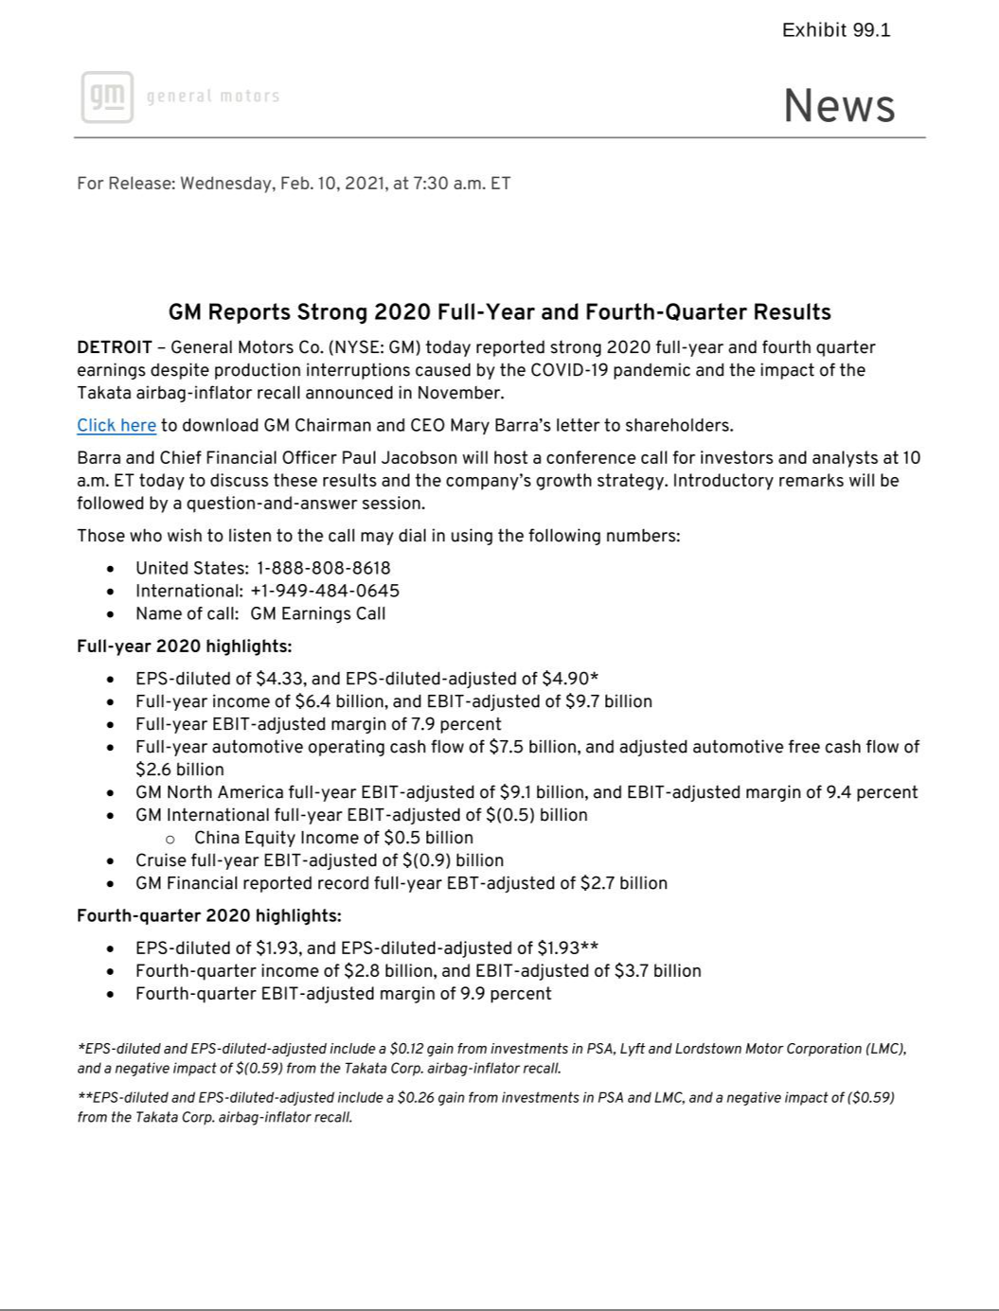

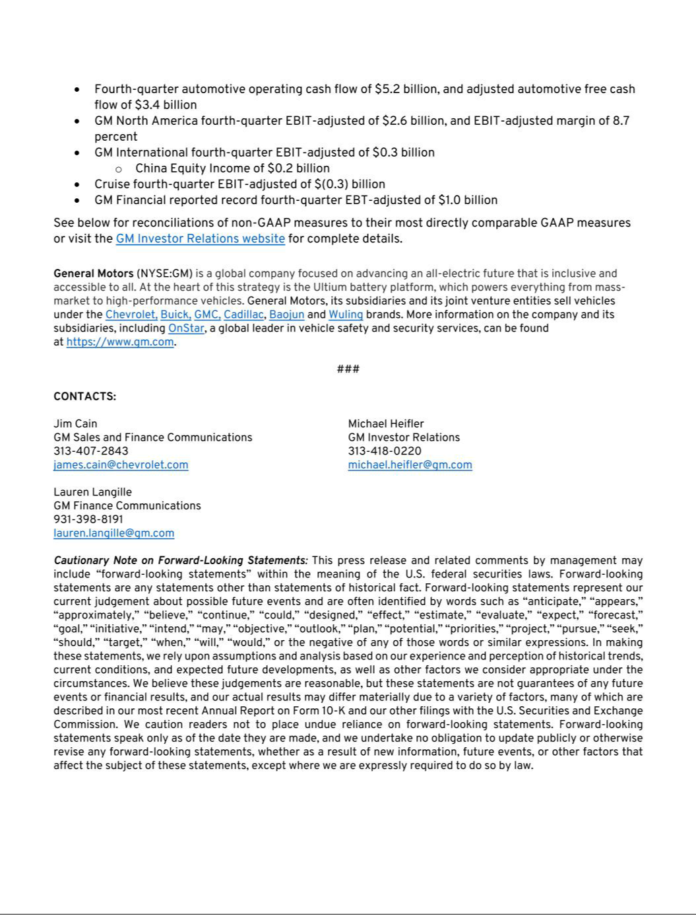

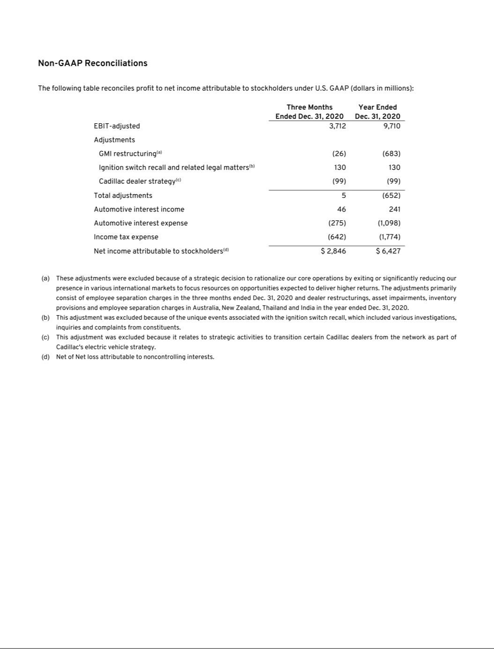

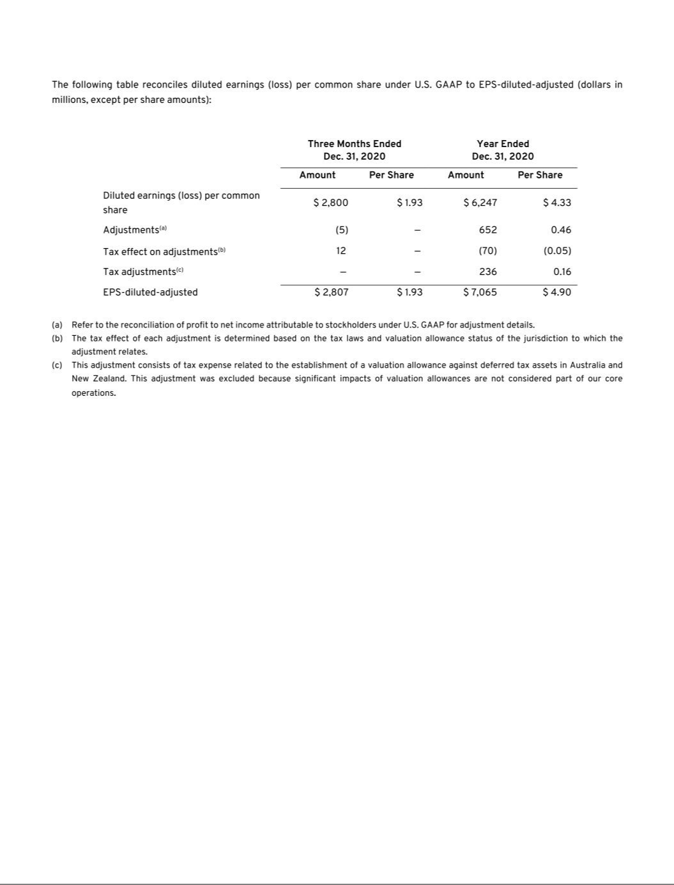

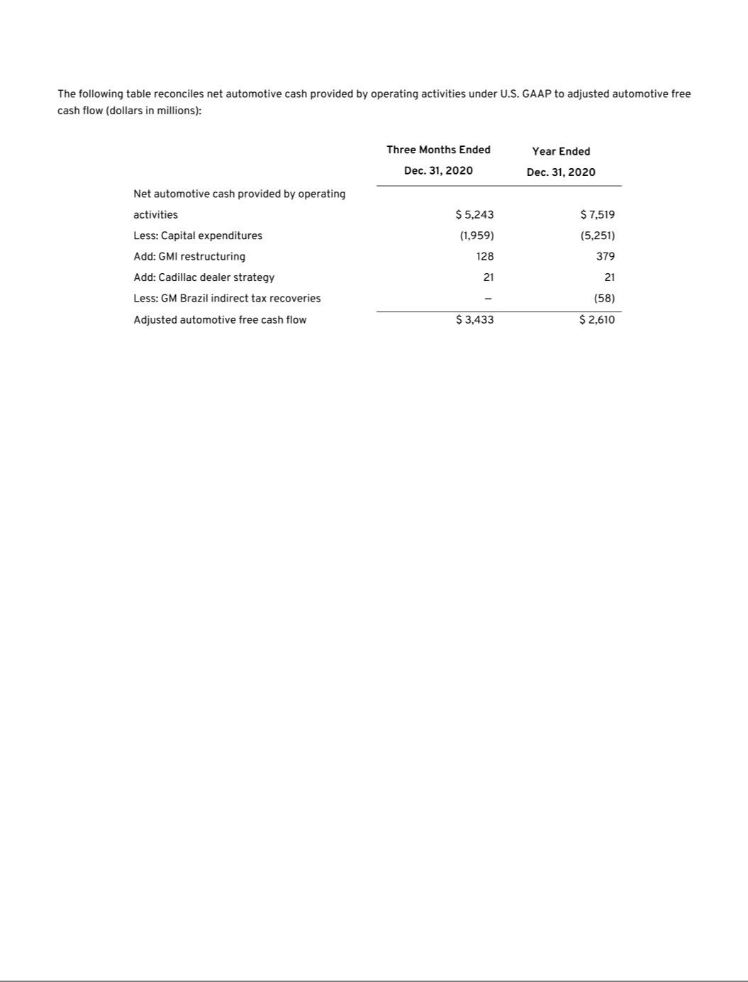

Exhibit 99.2

General Motors Company and Subsidiaries

Supplemental Material
(Unaudited)

General Motors Company's (GM) non-GAAP measures include: earnings before interest and taxes (EBIT)-adjusted, presented net of noncontrolling interests; earnings before income taxes (EBT)-adjusted for our General Motors Financial Company, Inc. (GM Financial) segment; earnings per share (EPS)-diluted-adjusted; effective tax rate-adjusted (ETR-adjusted); return on invested capital-adjusted (ROIC-adjusted) and adjusted automotive free cash flow. GM's calculation of these non-GAAP measures may not be comparable to similarly titled measures of other companies due to potential differences between companies in the method of calculation. As a result, the use of these non-GAAP measures has limitations and should not be considered superior to, in isolation from, or as a substitute for, related U.S. GAAP measures.

These non-GAAP measures allow management and investors to view operating trends, perform analytical comparisons and benchmark performance between periods and among geographic regions to understand operating performance without regard to items we do not consider a component of our core operating performance. Furthermore, these non-GAAP measures allow investors the opportunity to measure and monitor our performance against our externally communicated targets and evaluate the investment decisions being made by management to improve ROIC-adjusted. Management uses these measures in its financial, investment and operational decision-making processes, for internal reporting and as part of its forecasting and budgeting processes. Further, our Board of Directors uses certain of these and other measures as key metrics to determine management performance under our performance-based compensation plans. For these reasons we believe these non-GAAP measures are useful for our investors.

EBIT-adjusted EBIT-adjusted is presented net of noncontrolling interests and is used by management and can be used by investors to review our consolidated operating results because it excludes automotive interest income, automotive interest expense and income taxes as well as certain additional adjustments that are not considered part of our core operations. Examples of adjustments to EBIT include but are not limited to impairment charges on long-lived assets and other exit costs resulting from strategic shifts in our operations or discrete market and business conditions; costs arising from the ignition switch recall and related legal matters; and certain currency devaluations associated with hyperinflationary economies. For EBIT-adjusted and our other non-GAAP measures, once we have made an adjustment in the current period for an item, we will also adjust the related non-GAAP measure in any future periods in which there is an impact from the item. Our corresponding measure for our GM Financial segment is EBT-adjusted because interest income and interest expense are part of operating results when assessing and measuring the operational and financial performance of the segment.

EPS-diluted-adjusted EPS-diluted-adjusted is used by management and can be used by investors to review our consolidated diluted EPS results on a consistent basis. EPS-diluted-adjusted is calculated as net income attributable to common stockholders-diluted less adjustments noted above for EBIT-adjusted and certain income tax adjustments divided by weighted-average common shares outstanding-diluted. Examples of income tax adjustments include the establishment or reversal of significant deferred tax asset valuation allowances.

ETR-adjusted ETR-adjusted is used by management and can be used by investors to review the consolidated effective tax rate for our core operations on a consistent basis. ETR-adjusted is calculated as Income tax expense less the income tax related to the adjustments noted above for EBIT-adjusted and the income tax adjustments noted above for EPS-diluted-adjusted divided by Income before income taxes less adjustments. When we provide an expected adjusted effective tax rate, we do not provide an expected effective tax rate because the U.S. GAAP measure may include significant adjustments that are difficult to predict.

ROIC-adjusted ROIC-adjusted is used by management and can be used by investors to review our investment and capital allocation decisions. We define ROIC-adjusted as EBIT-adjusted for the trailing four quarters divided by ROIC-adjusted average net assets, which is considered to be the average equity balances adjusted for average automotive debt and interest liabilities, exclusive of finance leases; average automotive net pension and other postretirement benefits (OPEB) liabilities; and average automotive net income tax assets during the same period.

Adjusted automotive free cash flow Adjusted automotive free cash flow is used by management and can be used by investors to review the liquidity of our automotive operations and to measure and monitor our performance against our capital allocation program and evaluate our automotive liquidity against the substantial cash requirements of our automotive operations. We measure adjusted automotive free cash flow as automotive operating cash flow from operations less capital expenditures adjusted for management actions. Management actions can include voluntary events such as discretionary contributions to employee benefit plans or nonrecurring specific events such as a closure of a facility that are considered special for EBIT-adjusted purposes.

1

General Motors Company and Subsidiaries

Supplemental Material
(Unaudited)

The following table reconciles segment profit (loss) to Net income (loss) attributable to stockholders under U.S. GAAP (dollars in millions):

 |  | Three Months Ended |  |  |  |  |  | Years Ended
 |  | December 31, 2020 |  |  | December 31, 2019 |  |  | December 31, 2020 |  |  | December 31, 2019
Operating segments
GM North America (GMNA) | $ | 2,612 |  | $ | 263 |  | $ | 9,071 |  | $ | 8,204
GM International (GMI) |  | 283 |  |  | (120) |  |  | (528) |  |  | (202)
Cruise |  | (260) |  |  | (305) |  |  | (887) |  |  | (1,004)
GM Financial(a) |  | 1,039 |  |  | 498 |  |  | 2,702 |  |  | 2,104
Total operating segments |  | 3,674 |  |  | 336 |  |  | 10,358 |  |  | 9,102
Corporate and eliminations(b) |  | 38 |  |  | (231) |  |  | (648) |  |  | (709)
EBIT-adjusted |  | 3,712 |  |  | 105 |  |  | 9,710 |  |  | 8,393
Adjustments
GMI restructuring(c) |  | (26) |  |  | — |  |  | (683) |  |  | —
Ignition switch recall and related legal matters(d) |  | 130 |  |  | — |  |  | 130 |  |  | —
Cadillac dealer strategy(e) |  | (99) |  |  | — |  |  | (99) |  |  | —
Transformation activities(f) |  | — |  |  | (194) |  |  | — |  |  | (1,735)
GM Brazil indirect tax recoveries(g) |  | — |  |  | — |  |  | — |  |  | 1,360
FAW-GM divestiture(h) |  | — |  |  | (164) |  |  | — |  |  | (164)
Total adjustments |  | 5 |  |  | (358) |  |  | (652) |  |  | (539)
Automotive interest income |  | 46 |  |  | 96 |  |  | 241 |  |  | 429
Automotive interest expense |  | (275) |  |  | (200) |  |  | (1,098) |  |  | (782)
Income tax (expense) benefit |  | (642) |  |  | 163 |  |  | (1,774) |  |  | (769)
Net income (loss) attributable to stockholders(i) | $ | 2,846 |  | $ | (194) |  | $ | 6,427 |  | $ | 6,732

__________

- GM Financial amounts represent EBT-adjusted.
- GM's automotive interest income and interest expense, legacy costs from the Opel and Vauxhall businesses and certain other assets in Europe, which are primarily pension costs, corporate expenditures and certain nonsegment specific revenues and expenses are recorded centrally in Corporate.
- These adjustments were excluded because of a strategic decision to rationalize our core operations by exiting or significantly reducing our presence in various international markets to focus resources on opportunities expected to deliver higher returns. The adjustments primarily consist of employee separation charges in the three months ended December 31, 2020 and dealer restructurings, asset impairments, inventory provisions and employee separation charges in Australia, New Zealand, Thailand and India in the year ended December 31, 2020.
- This adjustment was excluded because of the unique events associated with the ignition switch recall, which included various investigations, inquiries and complaints from constituents.
- This adjustment was excluded because it relates to strategic activities to transition certain Cadillac dealers from the network as part of Cadillac's electric vehicle strategy.
- These adjustments were excluded because of a strategic decision to accelerate our transformation for the future to strengthen our core business, capitalize on the future of personal mobility, and drive significant cost efficiencies. The adjustments primarily consist of accelerated depreciation, supplier-related charges, pension and other curtailment charges and employee-related separation charges in the year ended December 31, 2019.

- This adjustment was excluded because of the unique events associated with decisions rendered by the Superior Judicial Court of Brazil resulting in retrospective recoveries of indirect taxes.
- This adjustment was excluded because we divested our joint venture FAW-GM Light Duty Commercial Vehicle Co., Ltd. (FAW-GM), as a result of a strategic decision by both shareholders, allowing us to focus our resources on opportunities expected to deliver higher returns.
- Net of Net loss attributable to noncontrolling interests.

2

General Motors Company and Subsidiaries

Supplemental Material
(Unaudited)

The following table reconciles diluted earnings (loss) per common share under U.S. GAAP to EPS-diluted-adjusted (dollars in millions, except per share amounts):

 |  |  |  |  | Three Months Ended |  |  |  |  |  |  |  |  |  |  |  | Years Ended
 |  | December 31, 2020 |  |  |  |  |  | December 31, 2019 |  |  |  |  |  | December 31, 2020 |  |  |  |  |  | December 31, 2019
 |  | Amount |  |  | Per Share |  |  | Amount |  |  | Per Share |  |  | Amount |  |  | Per Share |  |  | Amount |  |  | Per Share
Diluted earnings (loss) per common share | $ | 2,800 |  | $ | 1.93 |  | $ | (232) |  | $ | (0.16) |  | $ | 6,247 |  | $ | 4.33 |  | $ | 6,581 |  | $ | 4.57
Impact of including dilutive securities(a) |  |  |  |  | — |  |  |  |  |  | — |  |  |  |  |  | — |  |  |  |  |  | —
Adjustments(b) |  | (5) |  |  | — |  |  | 358 |  |  | 0.25 |  |  | 652 |  |  | 0.46 |  |  | 539 |  |  | 0.38
Tax effect on adjustments(c) |  | 12 |  |  | — |  |  | (54) |  |  | (0.04) |  |  | (70) |  |  | (0.05) |  |  | (188) |  |  | (0.13)
Tax adjustments(d) |  | — |  |  | — |  |  | — |  |  | — |  |  | 236 |  |  | 0.16 |  |  | — |  |  | —
EPS-diluted-adjusted | $ | 2,807 |  | $ | 1.93 |  | $ | 72 |  | $ | 0.05 |  | $ | 7,065 |  | $ | 4.90 |  | $ | 6,932 |  | $ | 4.82

________

- Represents the dilutive effect of awards under stock incentive plans. Refer to the table below for the effect on weighted-average common shares outstanding – diluted-adjusted.
- Refer to the reconciliation of segment profit (loss) to Net income (loss) attributable to stockholders under U.S. GAAP for adjustment details.

- The tax effect of each adjustment is determined based on the tax laws and valuation allowance status of the jurisdiction to which the adjustment relates.

- This adjustment consists of tax expense related to the establishment of a valuation allowance against deferred tax assets in Australia and New Zealand. This adjustment was excluded because significant impacts of valuation allowances are not considered part of our core operations.

The following table reconciles weighted-average common shares outstanding – diluted under U.S. GAAP to weighted-average common shares outstanding – diluted-adjusted used in the calculation of EPS-diluted-adjusted (shares in millions):

 | Three Months Ended |  |  |  | Years Ended
 | December 31, 2020 |  | December 31, 2019 |  | December 31, 2020 |  | December 31, 2019
Weighted-average common shares outstanding – diluted | 1,451 |  | 1,429 |  | 1,442 |  | 1,439
Dilutive effect of awards under stock incentive plans | — |  | 13 |  | — |  | —
Weighted-average common shares outstanding – diluted-adjusted | 1,451 |  | 1,442 |  | 1,442 |  | 1,439
 | 3

General Motors Company and Subsidiaries

Supplemental Material
(Unaudited)

The following table reconciles our effective tax rate under U.S. GAAP to ETR-adjusted (dollars in millions):

 |  |  |  |  |  |  | Years Ended December 31,
 |  |  |  |  | 2020 |  |  |  |  |  |  |  | 2019
 | Income before income |  |  |  | Income tax |  | Effective tax rate |  | Income before income |  |  |  | Income tax |  | Effective tax rate
 |  | taxes |  |  | expense |  | Effective tax rate |  | taxes |  |  |  | expense |  | Effective tax rate
Effective tax rate | $ | 8,095 |  | $ | 1,774 | 21.9 % |  |  | $ | 7,436 |  | $ | 769 | 10.3 %
Adjustments(a) |  | 652 |  |  | 70 |  |  |  |  | 545 |  |  | 188
Tax adjustments(b) |  |  |  |  | (236) |  |  |  |  |  |  |  | —
ETR-adjusted | $ | 8,747 |  | $ | 1,608 | 18.4 % |  |  | $ | 7,981 |  | $ | 957 | 12.0 %

________

- Refer to the reconciliation of segment profit (loss) to Net income (loss) attributable to stockholders under U.S. GAAP for adjustment details. Net income attributable to noncontrolling interests for these adjustments is included in the year ended December 31, 2019. The tax effect of each adjustment is determined based on the tax laws and valuation allowance status of the jurisdiction to which the adjustment relates.
- Refer to the reconciliation of diluted earnings (loss) per common share under U.S. GAAP to EPS-diluted-adjusted within the previous section for adjustment details.

We define return on equity (ROE) as Net income (loss) attributable to stockholders for the trailing four quarters divided by average equity for the same period. Management uses average equity to provide comparable amounts in the calculation of ROE. The following table summarizes the calculation of ROE (dollars in billions):

 |  | Years Ended December 31,
 |  | 2020 |  |  | 2019
 | Net income (loss) attributable to stockholders | $ | 6.4 |  | $ | 6.7
 | Average equity(a) | $ | 43.3 |  | $ | 43.7
 | ROE |  | 14.9 % |  |  | 15.4 %
________
(a) Includes equity of noncontrolling interests where the corresponding earnings (loss) are included in Net income (loss) attributable to stockholders.
 | The following table summarizes the calculation of ROIC-adjusted (dollars in billions):
 |  | Years Ended December 31,
 |  | 2020 |  |  | 2019
 | EBIT-adjusted(a) | $ | 9.7 |  | $ | 8.4
 | Average equity(b) | $ | 43.3 |  | $ | 43.7
 | Add: Average automotive debt and interest liabilities (excluding finance leases) |  | 27.8 |  |  | 14.9
 | Add: Average automotive net pension & OPEB liability |  | 17.6 |  |  | 16.7
 | Less: Average automotive net income tax asset |  | (24.0) |  |  | (23.5)
 | ROIC-adjusted average net assets | $ | 64.7 |  | $ | 51.8
 | ROIC-adjusted |  | 15.0 % |  |  | 16.2 %

________

- Refer to the reconciliation of segment profit (loss) to Net income (loss) attributable to stockholders under U.S. GAAP for adjustment details.
- Includes equity of noncontrolling interests where the corresponding earnings (loss) are included in EBIT-adjusted.

4

General Motors Company and Subsidiaries

Supplemental Material
(Unaudited)

The following table reconciles Net automotive cash provided by operating activities under U.S. GAAP to adjusted automotive free cash flow (dollars in millions):

 |  |  | Three Months Ended |  |  |  |  |  | Years Ended
 |  |  | December 31, 2020 |  |  | December 31, 2019 |  |  | December 31, 2020 |  |  | December 31, 2019
Net automotive cash provided by operating activities | $ |  | 5,243 |  | $ | 769 |  | $ | 7,519 |  | $ | 7,392
Less: Capital expenditures |  |  | (1,959) |  |  | (2,706) |  |  | (5,251) |  |  | (7,485)
Add: GMI restructuring |  |  | 128 |  |  | — |  |  | 379 |  |  | 9
Add: Cadillac dealer strategy |  |  | 21 |  |  | — |  |  | 21 |  |  | —
Add: Transformation activities |  |  | — |  |  | 460 |  |  | — |  |  | 1,105
Add: FAW-GM divestiture |  |  | — |  |  | 204 |  |  | — |  |  | 204
Less: GM Brazil indirect tax recoveries |  |  | — |  |  | (39) |  |  | (58) |  |  | (115)
Adjusted automotive free cash flow | $ |  | 3,433 |  | $ | (1,312) |  | $ | 2,610 |  | $ | 1,110
 | 5

General Motors Company and Subsidiaries

Supplemental Material
(Unaudited)

The following tables summarize key financial information by segment (dollars in millions):

 |  | GMNA |  |  | GMI |  |  | Corporate |  |  | Eliminations |  |  | Total |  |  | Cruise |  |  | GM |  | Reclassifications/Eliminations |  |  |  | Total
 |  |  |  |  |  |  |  |  |  |  |  |  |  | Automotive |  |  |  |  |  | Financial |  |  |  |  |  | Total
Three Months Ended December 31, 2020
Net sales and revenue | $ | 30,170 |  | $ | 3,894 |  | $ | 29 |  |  |  |  | $ | 34,093 |  | $ | 24 |  | $ | 3,426 |  | $ | (25) |  | $ | 37,518
Expenditures for property | $ | 1,798 |  | $ | 155 |  | $ | 6 |  | $ | — |  | $ | 1,959 |  | $ | 5 |  | $ | 8 |  | $ | — |  | $ | 1,972
Depreciation and amortization | $ | 1,203 |  | $ | 163 |  | $ | 5 |  | $ | — |  | $ | 1,371 |  | $ | 13 |  | $ | 1,678 |  | $ | — |  | $ | 3,062
Impairment charges | $ | — |  | $ | (2) |  | $ | — |  | $ | — |  | $ | (2) |  | $ | 20 |  | $ | — |  | $ | — |  | $ | 18
Equity income(a) | $ | 2 |  | $ | 249 |  | $ | — |  | $ | — |  | $ | 251 |  | $ | — |  | $ | 34 |  | $ | — |  | $ | 285
 |  | GMNA |  |  | GMI |  |  | Corporate |  |  | Eliminations |  |  | Total |  |  | Cruise |  |  | GM |  | Reclassifications/Eliminations |  |  |  | Total
 |  |  |  |  |  |  |  |  |  |  |  |  |  | Automotive |  |  |  |  |  | Financial |  |  |  |  |  | Total
Three Months Ended December 31, 2019
Net sales and revenue | $ | 22,706 |  | $ | 4,420 |  | $ | 68 |  |  |  |  | $ | 27,194 |  | $ | 25 |  | $ | 3,636 |  | $ | (29) |  | $ | 30,826
Expenditures for property | $ | 2,214 |  | $ | 409 |  | $ | 83 |  | $ | — |  | $ | 2,706 |  | $ | 21 |  | $ | 13 |  | $ | — |  | $ | 2,740
Depreciation and amortization | $ | 1,309 |  | $ | 154 |  | $ | 10 |  | $ | (2) |  | $ | 1,471 |  | $ | 5 |  | $ | 1,771 |  | $ | — |  | $ | 3,247
Impairment charges | $ | — |  | $ | 3 |  | $ | — |  | $ | — |  | $ | 3 |  | $ | 36 |  | $ | — |  | $ | — |  | $ | 39
Equity income(a) | $ | 1 |  | $ | 237 |  | $ | (10) |  | $ | — |  | $ | 228 |  | $ | — |  | $ | 40 |  | $ | — |  | $ | 268
 |  | GMNA |  |  | GMI |  |  | Corporate |  |  | Eliminations |  |  | Total |  |  | Cruise |  |  | GM |  | Reclassifications/Eliminations |  |  |  | Total
 |  |  |  |  |  |  |  |  |  |  |  |  |  | Automotive |  |  |  |  |  | Financial |  |  |  |  |  | Total
Year Ended December 31, 2020
Net sales and revenue | $ | 96,733 |  | $ | 11,586 |  | $ | 350 |  |  |  |  | $ | 108,669 |  | $ | 103 |  | $ | 13,831 |  | $ | (118) |  | $ | 122,485
Expenditures for property | $ | 4,501 |  | $ | 729 |  | $ | 21 |  | $ | — |  | $ | 5,251 |  | $ | 15 |  | $ | 34 |  | $ | — |  | $ | 5,300
Depreciation and amortization | $ | 4,739 |  | $ | 624 |  | $ | 25 |  | $ | — |  | $ | 5,388 |  | $ | 43 |  | $ | 7,245 |  | $ | — |  | $ | 12,676
Impairment charges | $ | 20 |  | $ | 99 |  | $ | — |  | $ | — |  | $ | 119 |  | $ | 20 |  | $ | — |  | $ | — |  | $ | 139
Equity income(a) | $ | 17 |  | $ | 510 |  | $ | — |  | $ | — |  | $ | 527 |  | $ | — |  | $ | 147 |  | $ | — |  | $ | 674
 |  | GMNA |  |  | GMI |  |  | Corporate |  |  | Eliminations |  |  | Total |  |  | Cruise |  |  | GM |  | Reclassifications/Eliminations |  |  |  | Total
 |  |  |  |  |  |  |  |  |  |  |  |  |  | Automotive |  |  |  |  |  | Financial |  |  |  |  |  | Total
Year Ended December 31, 2019
Net sales and revenue | $ | 106,366 |  | $ | 16,111 |  | $ | 220 |  |  |  |  | $ | 122,697 |  | $ | 100 |  | $ | 14,554 |  | $ | (114) |  | $ | 137,237
Expenditures for property | $ | 6,305 |  | $ | 1,096 |  | $ | 84 |  | $ | — |  | $ | 7,485 |  | $ | 60 |  | $ | 47 |  | $ | — |  | $ | 7,592
Depreciation and amortization | $ | 6,112 |  | $ | 533 |  | $ | 46 |  | $ | (2) |  | $ | 6,689 |  | $ | 21 |  | $ | 7,350 |  | $ | — |  | $ | 14,060
Impairment charges | $ | 15 |  | $ | 7 |  | $ | — |  | $ | — |  | $ | 22 |  | $ | 36 |  | $ | — |  | $ | — |  | $ | 58
Equity income(a) | $ | 8 |  | $ | 1,123 |  | $ | (29) |  | $ | — |  | $ | 1,102 |  | $ | — |  | $ | 166 |  | $ | — |  | $ | 1,268

________
- Includes Automotive China equity income of $248 million and $239 million in the three months ended December 31, 2020 and 2019 and $512 million and $1.1 billion in the years ended December 31, 2020 and 2019.

6

General Motors Company and Subsidiaries

Supplemental Material
(Unaudited)

Vehicle Sales

GM presents both wholesale and total vehicle sales data to assist in the analysis of our revenue and our market share. Cuba, Iran, North Korea, Sudan and Syria are subject to broad economic sanctions. Accordingly these countries are excluded from industry sales data and the corresponding calculation of GM's market share.

Wholesale vehicle sales data consists of sales to GM's dealers and distributors as well as sales to the U.S. Government and excludes vehicles sold by our joint ventures. Wholesale vehicle sales data correlates to GM's revenue recognized from the sale of vehicles, which is the largest component of Automotive net sales and revenue. In the year ended December 31, 2020, 30.5% of our wholesale vehicle sales volume was generated outside the U.S. The following table summarizes wholesale vehicle sales by automotive segment (vehicles in thousands):

 | Three Months Ended |  |  |  | Years Ended
 | December 31, 2020 |  | December 31, 2019 |  | December 31, 2020 |  |  | December 31, 2019
GMNA | 802 |  | 684 |  | 2,707 |  |  | 3,214
GMI | 216 |  | 268 |  | 663 |  |  | 995
Total | 1,018 |  | 952 |  | 3,370 |  |  | 4,209
 | 7

General Motors Company and Subsidiaries

Supplemental Material
(Unaudited)

Total vehicle sales data represents: (1) retail sales (i.e., sales to consumers who purchase new vehicles from dealers or distributors); (2) fleet sales, such as sales to large and small businesses, governments, and daily rental car companies; and (3) vehicles used by dealers in their businesses, including courtesy transportation vehicles. Total vehicle sales data includes all sales by joint ventures on a total vehicle basis, not based on our percentage ownership interest in the joint venture. Certain joint venture agreements in China allow for the contractual right to report vehicle sales of non-GM trademarked vehicles by those joint ventures, which are included in the total vehicle sales we report for China. While total vehicle sales data does not correlate directly to the revenue GM recognizes during a particular period, we believe it is indicative of the underlying demand for GM vehicles. Total vehicle sales data represents management's good faith estimate based on sales reported by GM's dealers, distributors, and joint ventures, commercially available data sources such as registration and insurance data, and internal estimates and forecasts when other data is not available.

The following table summarizes total vehicle sales by geographic region (vehicles in thousands):

 | Three Months Ended |  |  |  | Years Ended
 | December 31, 2020 |  | December 31, 2019 |  | December 31, 2020 |  |  | December 31, 2019
United States
Chevrolet – Cars | 60 |  | 76 |  | 211 |  |  | 341
Chevrolet – Trucks | 269 |  | 238 |  | 876 |  |  | 933
Chevrolet – Crossovers | 194 |  | 185 |  | 652 |  |  | 685
Cadillac | 43 |  | 41 |  | 129 |  |  | 156
Buick | 44 |  | 49 |  | 163 |  |  | 207
GMC | 161 |  | 147 |  | 516 |  |  | 565
Total United States | 771 |  | 736 |  | 2,547 |  |  | 2,887
Canada, Mexico and Other | 104 |  | 117 |  | 377 |  |  | 480
Total North America | 875 |  | 853 |  | 2,924 |  |  | 3,367
Asia/Pacific, Middle East and Africa
Chevrolet | 200 |  | 244 |  | 764 |  |  | 897
Wuling | 377 |  | 283 |  | 1,102 |  |  | 1,025
Buick | 290 |  | 227 |  | 885 |  |  | 850
Baojun | 126 |  | 180 |  | 402 |  |  | 608
Cadillac | 82 |  | 53 |  | 237 |  |  | 221
Other | 7 |  | 18 |  | 44 |  |  | 77
Total Asia/Pacific, Middle East and Africa | 1,082 |  | 1,005 |  | 3,434 |  |  | 3,678
South America(a) | 159 |  | 176 |  | 470 |  |  | 669
Total in GM markets | 2,116 |  | 2,034 |  | 6,828 |  |  | 7,714
Total Europe | — |  | — |  | 1 |  |  | 4
Total Worldwide | 2,116 |  | 2,034 |  | 6,829 |  |  | 7,718

_______

- Primarily Chevrolet.

The vehicle sales at GM's China joint ventures presented in the following table are included in the preceding vehicle sales table (vehicles in thousands):

 | Three Months Ended |  |  |  |  |  | Years Ended
 | December 31, 2020 |  |  | December 31, 2019 |  |  | December 31, 2020 |  |  | December 31, 2019
SAIC General Motors Sales Co., Ltd. |  | 455 |  |  | 380 |  | 1,407 |  |  | 1,482
SAIC GM Wuling Automobile Co., Ltd. |  | 499 |  |  | 456 |  | 1,494 |  |  | 1,612
 |  | 8

General Motors Company and Subsidiaries

Supplemental Material
(Unaudited)

 | Three Months Ended |  |  |  | Years Ended
 | December 31, 2020 |  | December 31, 2019 |  | December 31, 2020 |  |  | December 31, 2019
Market Share
United States – Cars | 7.4 % |  | 7.9 % |  | 7.1 % |  |  | 8.4 %
United States – Trucks | 33.3 % |  | 29.3 % |  | 31.0 % |  |  | 29.7 %
United States – Crossovers | 14.2 % |  | 14.3 % |  | 14.0 % |  |  | 13.9 %
Total United States | 18.0 % |  | 16.8 % |  | 17.1 % |  |  | 16.5 %
Total North America | 17.3 % |  | 16.2 % |  | 16.5 % |  |  | 15.9 %
Total Asia/Pacific, Middle East and Africa | 8.3 % |  | 8.1 % |  | 8.0 % |  |  | 7.9 %
Total South America | 15.2 % |  | 15.8 % |  | 14.9 % |  |  | 15.5 %
Total GM Market | 11.0 % |  | 10.9 % |  | 10.7 % |  |  | 10.7 %
Total Worldwide | 9.0 % |  | 8.7 % |  | 8.7 % |  |  | 8.5 %
United States fleet sales as a percentage of retail vehicle sales | 14.5 % |  | 19.7 % |  | 16.6 % |  |  | 21.8 %
North America capacity two shift utilization | 107.0 % |  | 76.1 % |  | 90.6 % |  |  | 93.7 %

9

General Motors Company and Subsidiaries

Combining Income Statement Information

(In millions) (Unaudited)

 |  |  |  |  |  |  | Year Ended December 31, 2020 |  |  |  |  |  |  |  |  |  |  |  |  |  |  | Year Ended December 31, 2019
 |  | Automotive |  |  | Cruise |  |  | GM Financial |  | Reclassifications/Eliminations |  |  |  | Combined |  |  | Automotive |  |  | Cruise |  |  | GM Financial |  | Reclassifications/Eliminations |  |  |  | Combined
Net sales and revenue
Automotive | $ | 108,669 |  | $ | 103 |  | $ | — |  | $ | (99) |  | $ | 108,673 | $ |  | 122,697 |  | $ | 100 |  | $ | — |  | $ | (100) |  | $ | 122,697
GM Financial |  | — |  |  | — |  |  | 13,831 |  |  | (19) |  |  | 13,812 |  |  | — |  |  | — |  |  | 14,554 |  |  | (14) |  |  | 14,540
Total net sales and revenue |  | 108,669 |  |  | 103 |  |  | 13,831 |  |  | (118) |  |  | 122,485 |  |  | 122,697 |  |  | 100 |  |  | 14,554 |  |  | (114) |  |  | 137,237
Costs and expenses
Automotive and other cost of sales |  | 96,711 |  |  | 829 |  |  | — |  |  | (1) |  |  | 97,539 |  |  | 109,630 |  |  | 1,026 |  |  | — |  |  | (5) |  |  | 110,651
GM Financial interest, operating and other
expenses |  | — |  |  | — |  |  | 11,276 |  |  | (2) |  |  | 11,274 |  |  | — |  |  | — |  |  | 12,616 |  |  | (2) |  |  | 12,614
Automotive and other selling, general and
administrative expense |  | 6,799 |  |  | 239 |  |  | — |  |  | — |  |  | 7,038 |  |  | 8,318 |  |  | 173 |  |  | — |  |  | — |  |  | 8,491
Total costs and expenses |  | 103,510 |  |  | 1,068 |  |  | 11,276 |  |  | (3) |  |  | 115,851 |  |  | 117,948 |  |  | 1,199 |  |  | 12,616 |  |  | (7) |  |  | 131,756
Operating income (loss) |  | 5,159 |  |  | (965) |  |  | 2,555 |  |  | (115) |  |  | 6,634 |  |  | 4,749 |  |  | (1,099) |  |  | 1,938 |  |  | (107) |  |  | 5,481
Automotive interest expense |  | 1,113 |  |  | — |  |  | — |  |  | (15) |  |  | 1,098 |  |  | 790 |  |  | — |  |  | — |  |  | (8) |  |  | 782
Interest income and other non-operating income,
net |  | 1,766 |  |  | 18 |  |  | — |  |  | 101 |  |  | 1,885 |  |  | 1,310 |  |  | 74 |  |  | — |  |  | 85 |  |  | 1,469
Equity income |  | 527 |  |  | — |  |  | 147 |  |  | — |  |  | 674 |  |  | 1,102 |  |  | — |  |  | 166 |  |  | — |  |  | 1,268
Income (loss) before income taxes |  | 6,339 |  |  | (947) |  |  | 2,702 |  |  | 1 |  |  | 8,095 |  |  | 6,371 |  |  | (1,025) |  |  | 2,104 |  |  | (14) |  |  | 7,436
Income tax expense |  |  |  |  |  |  |  |  |  |  |  |  |  | 1,774 |  |  |  |  |  |  |  |  |  |  |  |  |  |  | 769
Net income |  |  |  |  |  |  |  |  |  |  |  |  |  | 6,321 |  |  |  |  |  |  |  |  |  |  |  |  |  |  | 6,667
Net loss attributable to noncontrolling interests |  |  |  |  |  |  |  |  |  |  |  |  |  | 106 |  |  |  |  |  |  |  |  |  |  |  |  |  |  | 65
Net income attributable to stockholders |  |  |  |  |  |  |  |  |  |  |  |  | $ | 6,427 |  |  |  |  |  |  |  |  |  |  |  |  |  | $ | 6,732
Net income attributable to common
stockholders |  |  |  |  |  |  |  |  |  |  |  |  | $ | 6,247 |  |  |  |  |  |  |  |  |  |  |  |  |  | $ | 6,581

10

General Motors Company and Subsidiaries

Basic and Diluted Earnings per Share

(Unaudited)

The following table summarizes basic and diluted earnings (loss) per share (in millions, except per share amounts):

 |  | Three Months Ended |  |  |  |  |  | Years Ended
 |  | December 31, 2020 |  |  | December 31, 2019 |  |  | December 31, 2020 |  |  | December 31, 2019
Basic earnings per share
Net income (loss) attributable to stockholders | $ | 2,846 |  | $ | (194) |  | $ | 6,427 |  | $ | 6,732
Less: cumulative dividends on subsidiary preferred stock |  | (46) |  |  | (38) |  |  | (180) |  |  | (151)
Net income (loss) attributable to common stockholders | $ | 2,800 |  | $ | (232) |  | $ | 6,247 |  | $ | 6,581
Weighted-average common shares outstanding |  | 1,436 |  |  | 1,429 |  |  | 1,433 |  |  | 1,424
Basic earnings (loss) per common share | $ | 1.95 |  | $ | (0.16) |  | $ | 4.36 |  | $ | 4.62
Diluted earnings per share
Net income (loss) attributable to common stockholders – diluted | $ | 2,800 |  | $ | (232) |  | $ | 6,247 |  | $ | 6,581
Weighted-average common shares outstanding – diluted |  | 1,451 |  |  | 1,429 |  |  | 1,442 |  |  | 1,439
Diluted earnings (loss) per common share | $ | 1.93 |  | $ | (0.16) |  | $ | 4.33 |  | $ | 4.57
Potentially dilutive securities(a) |  | 7 |  |  | 7 |  |  | 7 |  |  | 7

__________

- Potentially dilutive securities attributable to outstanding stock options and restricted stock units were excluded from the computation of diluted EPS because the securities would have had an antidilutive effect.

11

General Motors Company and Subsidiaries

Combining Balance Sheet Information

(In millions, except per share amounts) (Unaudited)(a)

 |  |  |  |  |  |  |  | December 31, 2020 |  |  |  |  |  |  |  |  |  |  |  |  |  |  | December 31, 2019
 |  | Automotive |  |  | Cruise |  |  | GM Financial |  | Reclassifications/Eliminations |  |  |  | Combined |  |  | Automotive |  |  | Cruise |  |  | GM Financial |  | Reclassifications/Eliminations |  |  |  | Combined
ASSETS
Current Assets
Cash and cash equivalents | $ | 14,168 |  | $ | 761 |  | $ | 5,063 |  | $ | — |  | $ | 19,992 |  | $ | 13,409 |  | $ | 2,349 |  | $ | 3,311 |  | $ | — |  | $ | 19,069
Marketable debt securities |  | 8,103 |  |  | 972 |  |  | — |  |  | (29) |  |  | 9,046 |  |  | 3,908 |  |  | 320 |  |  | — |  |  | (54) |  |  | 4,174
Accounts and notes receivable, net(b) |  | 7,951 |  |  | 3 |  |  | 1,035 |  |  | (954) |  |  | 8,035 |  |  | 6,614 |  |  | 2 |  |  | 1,004 |  |  | (823) |  |  | 6,797
GM Financial receivables, net(c) |  | — |  |  | — |  |  | 26,607 |  |  | (398) |  |  | 26,209 |  |  | — |  |  | — |  |  | 27,101 |  |  | (500) |  |  | 26,601
Inventories |  | 10,236 |  |  | 1 |  |  | — |  |  | (2) |  |  | 10,235 |  |  | 10,398 |  |  | — |  |  | — |  |  | — |  |  | 10,398
Other current assets |  | 1,884 |  |  | 32 |  |  | 5,524 |  |  | (32) |  |  | 7,407 |  |  | 2,517 |  |  | 16 |  |  | 5,424 |  |  | (4) |  |  | 7,953
Total current assets |  | 42,342 |  |  | 1,769 |  |  | 38,228 |  |  | (1,414) |  |  | 80,924 |  |  | 36,846 |  |  | 2,687 |  |  | 36,841 |  |  | (1,383) |  |  | 74,992
Non-current Assets
GM Financial receivables, net(c) |  | — |  |  | — |  |  | 31,783 |  |  | — |  |  | 31,783 |  |  | — |  |  | — |  |  | 26,372 |  |  | (17) |  |  | 26,355
Equity in net assets of nonconsolidated affiliates |  | 6,825 |  |  | — |  |  | 1,581 |  |  | — |  |  | 8,406 |  |  | 7,107 |  |  | — |  |  | 1,455 |  |  | — |  |  | 8,562
Property, net |  | 37,325 |  |  | 123 |  |  | 184 |  |  | — |  |  | 37,632 |  |  | 38,374 |  |  | 150 |  |  | 226 |  |  | — |  |  | 38,750
Goodwill and intangible assets, net |  | 3,152 |  |  | 735 |  |  | 1,343 |  |  | — |  |  | 5,230 |  |  | 3,348 |  |  | 634 |  |  | 1,355 |  |  | — |  |  | 5,337
Equipment on operating leases, net |  | — |  |  | — |  |  | 39,819 |  |  | — |  |  | 39,819 |  |  | — |  |  | — |  |  | 42,055 |  |  | — |  |  | 42,055
Deferred income taxes |  | 23,853 |  |  | 617 |  |  | (334) |  |  | — |  |  | 24,136 |  |  | 24,582 |  |  | 345 |  |  | (287) |  |  | — |  |  | 24,640
Other assets |  | 6,129 |  |  | 382 |  |  | 805 |  |  | (53) |  |  | 7,264 |  |  | 6,123 |  |  | 413 |  |  | 863 |  |  | (53) |  |  | 7,346
Total non-current assets |  | 77,284 |  |  | 1,856 |  |  | 75,182 |  |  | (53) |  |  | 154,270 |  |  | 79,533 |  |  | 1,542 |  |  | 72,040 |  |  | (70) |  |  | 153,045
Total Assets | $ | 119,625 |  | $ | 3,625 |  | $ | 113,410 |  | $ | (1,466) |  | $ | 235,194 |  | $ | 116,380 |  | $ | 4,230 |  | $ | 108,881 |  | $ | (1,454) |  | $ | 228,037
LIABILITIES AND EQUITY
Current Liabilities
Accounts payable (principally trade)(b) | $ | 19,928 |  | $ | 93 |  | $ | 867 |  | $ | (959) |  | $ | 19,928 |  | $ | 21,101 |  | $ | 109 |  | $ | 644 |  | $ | (836) |  | $ | 21,018
Short-term debt and current portion of long-term debt
Automotive(c) |  | 1,674 |  |  | — |  |  | — |  |  | (398) |  |  | 1,276 |  |  | 2,397 |  |  | — |  |  | — |  |  | (500) |  |  | 1,897
GM Financial |  | — |  |  | — |  |  | 35,637 |  |  | — |  |  | 35,637 |  |  | — |  |  | — |  |  | 35,503 |  |  | — |  |  | 35,503
Accrued liabilities |  | 18,751 |  |  | 133 |  |  | 4,218 |  |  | (34) |  |  | 23,069 |  |  | 22,493 |  |  | 82 |  |  | 3,916 |  |  | (4) |  |  | 26,487
Total current liabilities |  | 40,353 |  |  | 226 |  |  | 40,722 |  |  | (1,391) |  |  | 79,910 |  |  | 45,990 |  |  | 192 |  |  | 40,064 |  |  | (1,341) |  |  | 84,905
Non-current Liabilities
Long-term debt
Automotive(c) |  | 16,193 |  |  | — |  |  | — |  |  | — |  |  | 16,193 |  |  | 12,507 |  |  | — |  |  | — |  |  | (18) |  |  | 12,489
GM Financial |  | — |  |  | — |  |  | 56,788 |  |  | — |  |  | 56,788 |  |  | — |  |  | — |  |  | 53,435 |  |  | — |  |  | 53,435
Postretirement benefits other than pensions |  | 6,277 |  |  | — |  |  | — |  |  | — |  |  | 6,277 |  |  | 5,935 |  |  | — |  |  | — |  |  | — |  |  | 5,935
Pensions |  | 12,897 |  |  | — |  |  | 5 |  |  | — |  |  | 12,902 |  |  | 12,166 |  |  | — |  |  | 4 |  |  | — |  |  | 12,170
Other liabilities |  | 11,151 |  |  | 539 |  |  | 1,810 |  |  | (53) |  |  | 13,447 |  |  | 10,518 |  |  | 505 |  |  | 2,176 |  |  | (53) |  |  | 13,146
Total non-current liabilities |  | 46,519 |  |  | 539 |  |  | 58,602 |  |  | (53) |  |  | 105,607 |  |  | 41,126 |  |  | 505 |  |  | 55,615 |  |  | (71) |  |  | 97,175
Total Liabilities |  | 86,872 |  |  | 764 |  |  | 99,325 |  |  | (1,444) |  |  | 185,517 |  |  | 87,114 |  |  | 697 |  |  | 95,679 |  |  | (1,410) |  |  | 182,080
Commitments and contingencies
Equity
Common stock, $0.01 par value |  | 14 |  |  | — |  |  | — |  |  | — |  |  | 14 |  |  | 14 |  |  | — |  |  | — |  |  | — |  |  | 14
Preferred stock, $0.01 par value |  | — |  |  | — |  |  | — |  |  | — |  |  | — |  |  | — |  |  | — |  |  | — |  |  | — |  |  | —
Additional paid-in capital(d) |  | 26,551 |  |  | 76 |  |  | 1,730 |  |  | (1,816) |  |  | 26,542 |  |  | 26,095 |  |  | 50 |  |  | 1,283 |  |  | (1,354) |  |  | 26,074
Retained earnings |  | 17,444 |  |  | 891 |  |  | 13,640 |  |  | (13) |  |  | 31,962 |  |  | 12,303 |  |  | 1,566 |  |  | 13,013 |  |  | (22) |  |  | 26,860
Accumulated other comprehensive loss |  | (12,213) |  |  | 10 |  |  | (1,284) |  |  | — |  |  | (13,488) |  |  | (10,062) |  |  | — |  |  | (1,094) |  |  | — |  |  | (11,156)
Total stockholders’ equity |  | 31,796 |  |  | 976 |  |  | 14,085 |  |  | (1,829) |  |  | 45,030 |  |  | 28,348 |  |  | 1,617 |  |  | 13,202 |  |  | (1,376) |  |  | 41,792
Noncontrolling interests(d) |  | 959 |  |  | 1,884 |  |  | — |  |  | 1,804 |  |  | 4,647 |  |  | 918 |  |  | 1,916 |  |  | — |  |  | 1,331 |  |  | 4,165
Total Equity |  | 32,754 |  |  | 2,861 |  |  | 14,085 |  |  | (23) |  |  | 49,677 |  |  | 29,266 |  |  | 3,533 |  |  | 13,202 |  |  | (43) |  |  | 45,957
Total Liabilities and Equity | $ | 119,625 |  | $ | 3,625 |  | $ | 113,410 |  | $ | (1,466) |  | $ | 235,194 |  | $ | 116,380 |  | $ | 4,230 |  | $ | 108,881 |  | $ | (1,454) |  | $ | 228,037

_________

- Amounts may not sum due to rounding.

- Eliminations primarily include GM Financial accounts and notes receivable of $643 million offset by Automotive accounts payable and Automotive accounts receivable of $268 million offset by GM Financial accounts payable at December 31, 2020; and GM Financial accounts receivable of $678 million offset by Automotive accounts payable and Automotive accounts receivable of $78 million offset by GM Financial accounts payable at December 31, 2019.
- Eliminations include GM Financial loan receivable of $398 million and $517 million offset by an Automotive loan payable at December 31, 2020 and 2019.

- Primarily reclassification of GM Financial Cumulative Perpetual Preferred Stock, Series A, B and C. The preferred stock is classified as noncontrolling interests in our consolidated balance sheets.

12

General Motors Company and Subsidiaries

Combining Cash Flow Information

(In millions) (Unaudited)(a)

 |  |  |  |  |  | Year Ended December 31, 2020 |  |  |  |  |  |  |  |  |  |  |  |  |  |  |  | Year Ended December 31, 2019
 |  | Automotive |  |  | Cruise |  |  | GM Financial |  | Reclassifications/Eliminations |  |  |  | Combined |  |  | Automotive |  |  | Cruise |  |  | GM Financial |  | Reclassifications/Eliminations |  |  |  | Combined
Cash flows from operating activities
Net income (loss) | $ | 4,975 |  | $ | (675) | $ |  | 2,020 |  | $ | 1 |  | $ | 6,321 |  | $ | 5,844 |  | $ | (750) |  | $ | 1,587 |  | $ | (14) |  | $ | 6,667
Depreciation and impairment of Equipment on operating leases, net |  | 3 |  |  | — |  |  | 7,175 |  |  | — |  |  | 7,178 |  |  | 55 |  |  | — |  |  | 7,277 |  |  | — |  |  | 7,332
Depreciation, amortization and impairment charges on Property, net |  | 5,504 |  |  | 63 |  |  | 70 |  |  | — |  |  | 5,637 |  |  | 6,656 |  |  | 57 |  |  | 73 |  |  | — |  |  | 6,786
Foreign currency remeasurement and transaction (gains) losses |  | 209 |  |  | — |  |  | (6) |  |  | — |  |  | 203 |  |  | (78) |  |  | — |  |  | (8) |  |  | — |  |  | (85)
Undistributed earnings of nonconsolidated affiliates, net |  | 578 |  |  | — |  |  | (54) |  |  | — |  |  | 524 |  |  | 706 |  |  | — |  |  | (121) |  |  | — |  |  | 585
Pension contributions and OPEB payments |  | (851) |  |  | — |  |  | — |  |  | — |  |  | (851) |  |  | (985) |  |  | — |  |  | — |  |  | — |  |  | (985)
Pension and OPEB income, net |  | (766) |  |  | — |  |  | 1 |  |  | — |  |  | (765) |  |  | (485) |  |  | — |  |  | 1 |  |  | — |  |  | (484)
Provision (benefit) for deferred taxes |  | 863 |  |  | (272) |  |  | 334 |  |  | — |  |  | 925 |  |  | (283) |  |  | (274) |  |  | 424 |  |  | — |  |  | (133)
Change in other operating assets and liabilities(b)(c) |  | (3,908) |  |  | 24 |  |  | 668 |  |  | 2,816 |  |  | (399) |  |  | (5,088) |  |  | 97 |  |  | 438 |  |  | 764 |  |  | (3,789)
Other operating activities(d) |  | 912 |  |  | 11 |  |  | (2,229) |  |  | (796) |  |  | (2,103) |  |  | 1,050 |  |  | 118 |  |  | (1,602) |  |  | (437) |  |  | (873)
Net cash provided by (used in) operating activities |  | 7,519 |  |  | (849) |  |  | 7,979 |  |  | 2,021 |  |  | 16,670 |  |  | 7,392 |  |  | (753) |  |  | 8,069 |  |  | 313 |  |  | 15,021
Cash flows from investing activities
Expenditures for property |  | (5,251) |  |  | (15) |  |  | (34) |  |  | — |  |  | (5,300) |  |  | (7,485) |  |  | (60) |  |  | (47) |  |  | — |  |  | (7,592)
Available-for-sale marketable securities, acquisitions |  | (13,190) |  |  | (3,014) |  |  | — |  |  | — |  |  | (16,204) |  |  | (2,756) |  |  | (1,319) |  |  | — |  |  | — |  |  | (4,075)
Available-for-sale marketable securities, liquidations |  | 9,598 |  |  | 2,368 |  |  | — |  |  | (25) |  |  | 11,941 |  |  | 5,203 |  |  | 1,110 |  |  | — |  |  | (48) |  |  | 6,265
Purchases of finance receivables, net(b)(c) |  | — |  |  | — |  |  | (30,215) |  |  | 125 |  |  | (30,090) |  |  | — |  |  | — |  |  | (25,328) |  |  | 790 |  |  | (24,538)
Principal collections and recoveries on finance receivables(b)(c) |  | — |  |  | — |  |  | 22,785 |  |  | (3,059) |  |  | 19,726 |  |  | — |  |  | — |  |  | 23,526 |  |  | (1,521) |  |  | 22,005
Purchases of leased vehicles, net |  | — |  |  | — |  |  | (15,233) |  |  | — |  |  | (15,233) |  |  | — |  |  | — |  |  | (16,404) |  |  | — |  |  | (16,404)
Proceeds from termination of leased vehicles |  | — |  |  | — |  |  | 13,399 |  |  | — |  |  | 13,399 |  |  | — |  |  | — |  |  | 13,302 |  |  | — |  |  | 13,302
Other investing activities(e) |  | 66 |  |  | (71) |  |  | 18 |  |  | (77) |  |  | (65) |  |  | (540) |  |  | — |  |  | (3) |  |  | 680 |  |  | 138
Net cash used in investing activities |  | (8,778) |  |  | (733) |  |  | (9,280) |  |  | (3,036) |  |  | (21,826) |  |  | (5,578) |  |  | (268) |  |  | (4,954) |  |  | (99) |  |  | (10,899)
Cash flows from financing activities
Net increase (decrease) in short-term debt |  | 1 |  |  | — |  |  | 273 |  |  | 3 |  |  | 277 |  |  | (7) |  |  | — |  |  | (304) |  |  | — |  |  | (312)
Proceeds from issuance of debt (original maturities greater than three
months) |  | 21,362 |  |  | — |  |  | 57,165 |  |  | — |  |  | 78,527 |  |  | 1,403 |  |  | — |  |  | 35,535 |  |  | — |  |  | 36,937
Payments on debt (original maturities greater than three months) |  | (18,364) |  |  | — |  |  | (54,470) |  |  | 171 |  |  | (72,663) |  |  | (1,075) |  |  | — |  |  | (38,082) |  |  | — |  |  | (39,156)
Proceeds from issuance of subsidiary preferred and common stock(e) |  | — |  |  | — |  |  | 492 |  |  | — |  |  | 492 |  |  | — |  |  | 1,150 |  |  | — |  |  | (693) |  |  | 457
Dividends paid(d) |  | (547) |  |  | (33) |  |  | (890) |  |  | 800 |  |  | (669) |  |  | (2,199) |  |  | (63) |  |  | (491) |  |  | 403 |  |  | (2,350)
Other financing activities |  | (316) |  |  | 26 |  |  | (162) |  |  | 40 |  |  | (412) |  |  | (209) |  |  | (3) |  |  | (116) |  |  | 74 |  |  | (253)
Net cash provided by (used in) financing activities |  | 2,135 |  |  | (7) |  |  | 2,408 |  |  | 1,015 |  |  | 5,552 |  |  | (2,088) |  |  | 1,084 |  |  | (3,458) |  |  | (216) |  |  | (4,677)
Effect of exchange rate changes on cash, cash equivalents and
restricted cash |  | (139) |  |  | — |  |  | (83) |  |  | — |  |  | (222) |  |  | (1) |  |  | — |  |  | 2 |  |  | — |  |  | 2
Net increase (decrease) in cash, cash equivalents and restricted cash |  | 738 |  |  | (1,588) |  |  | 1,024 |  |  | — |  |  | 174 |  |  | (275) |  |  | 64 |  |  | (341) |  |  | — |  |  | (553)
Cash, cash equivalents and restricted cash at beginning of period |  | 13,487 |  |  | 2,355 |  |  | 7,102 |  |  | — |  |  | 22,943 |  |  | 13,762 |  |  | 2,291 |  |  | 7,443 |  |  | — |  |  | 23,496
Cash, cash equivalents and restricted cash at end of period | $ | 14,225 |  | $ | 766 | $ |  | 8,126 |  | $ | — |  | $ | 23,117 |  | $ | 13,487 |  | $ | 2,355 |  | $ | 7,102 |  | $ | — |  | $ | 22,943

_________

- Amounts may not sum due to rounding.

- Includes reclassifications of $2.7 billion and $663 million in the years ended December 31, 2020 and 2019 for purchases/collections of wholesale finance receivables resulting from vehicles sold by GM to dealers that have arranged their inventory floor plan financing through GM Financial.

- Eliminations include $125 million and $790 million in Purchases of finance receivables, net in the years ended December 31, 2020 and 2019 and $315 million and $858 million in Principal collections and recoveries on finance receivables in the years ended December 31, 2020 and 2019 primarily related to the re-timing of cash receipts and payments between Automotive and GM Financial.
- Eliminations include dividends issued by GM Financial to Automotive.

- Eliminations include $680 million in the year ended December 31, 2019 primarily for Automotive cash injections in Cruise, inclusive of our investment of $687 million in Cruise Preferred Shares.

13

