SCHEDULE 14A
Proxy Statement Pursuant to Section 14(a)

of the Securities Exchange Act of 1934

Filed by the Registrant ☐

Filed by a Party other than the Registrant ☑

Check the appropriate box:

- Preliminary Proxy Statement
- Confidential, for Use of the Commission Only (as permitted by Rule 14a-6(e)(2))
- Definitive Proxy Statement
- Definitive Additional Materials
- Soliciting Material Under Rule 14a-12

General Motors Company

(Name of Registrant as Specified In Its Charter)

Greenlight Capital, Inc.
Greenlight Capital, L.P.
DME Advisors, LP,
DME Advisors GP, LLC
DME Capital Management, LP
Greenlight Capital Qualified, LP
Greenlight Capital (Gold), LP
Greenlight Capital Offshore Partners
Greenlight Capital Offshore Master (Gold), Ltd.
Greenlight Masters, LLC
Greenlight Masters Partners
David Einhorn

(Name of Person(s) Filing Proxy Statement, if other than the Registrant)

Payment of Filing Fee (check the appropriate box):

- No fee required.

- Fee computed on table below per Exchange Act Rule 14a-6(i)(4) and 0-11.

  - Title of each class of securities to which transaction applies:

  - Aggregate number of securities to which transaction applies:

  - Per unit price or other underlying value of transaction computed pursuant to Exchange Act Rule 0-11 (set forth the amount on which the filing fee is calculated and state how it was determined):

  - Proposed maximum aggregate value of transaction:

  - Total fee paid:

- Fee paid previously with preliminary materials.

- Check box if any part of the fee is offset as provided by Exchange Act Rule 0-11(a)(2) and identify
the filing for which the offsetting fee was paid previously. Identify the previous filing by registration statement number, or the Form or Schedule and the date of its filing.

- Amount Previously Paid:

- Form, Schedule or Registration Statement No.:

- Filing Party:

- Date Filed:

On March 28, 2017, Greenlight Capital, Inc. (“Greenlight”) issued a press release to shareholders of General Motors Company (the
“Company”) including a link to a presentation regarding the Company. A copy of the press release is filed herewith as Exhibit 1 and a copy of the presentation is filed herewith as Exhibit 2.

Information regarding participants in Greenlight’s solicitation of proxies of the shareholders of the Company in connection with the 2017 annual meeting of shareholders is filed herewith as Exhibit 3.

Exhibit 1

GREENLIGHT CAPITAL PROPOSES GM CHANGE CAPITAL STRUCTURE TO UNLOCK

SUBSTANTIAL SHAREHOLDER VALUE

Proposed Structure Would Split Common Stock into Two Separate Classes

Releases Presentation Regarding Plan’s Strategic Merits and Rationale

NEW YORK – March 28, 2017 – Greenlight Capital, Inc. (“Greenlight”) today announced a Plan that it believes would unlock substantial value for General Motors Co. (NYSE: GM) (the “Company”) shareholders without changing GM’s business strategy, capital allocation priorities or financial policy. The Plan would split GM’s common stock into two classes: one that would receive the current dividends and one that would participate in the remaining earnings and cash flows and future growth of the Company.

A presentation regarding the Plan’s strategic merits and rationale is available for download at www.greenlightcapital.com.

David Einhorn, President of Greenlight, said: “As significant, long-term shareholders, we believe in GM’s strong earnings potential. Our Plan would unlock significant value and lower GM’s cost of capital. It would provide the Company complete strategic flexibility without adding any default, refinancing, or balance sheet risk. We encourage our fellow GM shareholders to carefully review the presentation and to urge GM’s management and Board to adopt this compelling Plan.”

Strategic Rationale

Greenlight believes that adopting this Plan would lower GM’s cost of capital, improve its financial flexibility, and unlock between $13 billion and $38 billion of shareholder value.

The Company’s diverse shareholder base currently consists of a mix of value-focused and income-oriented investors united by their confidence in GM’s prospects, but with different investment objectives. The disparity in investment objectives has led to a sub-optimal shareholder base.

At its current trading value, the Company’s price/earnings ratio is approximately 5.6x and ranks as the lowest price/earnings ratio among all S&P 500 companies. GM’s shares trade at a 4.4% dividend yield despite a 24% dividend payout ratio. The shares are barely above the 2010 IPO price despite strong operating results and an equity bull market. Accordingly, GM has failed to create much long-term shareholder value. GM can fix this.

The Plan involves the creation of two classes of common stock. The two classes, which would trade separately, would have the following characteristics:

- The Dividend Shares: GM would continue to pay quarterly dividends at the current annual rate of $1.52 per share, but the dividends would now be paid on the “Dividend Shares” instead of the

existing common stock. The Dividend Shares would be distributed to GM’s existing shareholders at no cost. The Dividend Shares would appeal to yield-focused investors.

- The Capital Appreciation Shares: GM would grant its existing common stock the majority of the voting rights and participation in the rest of the Company’s earnings, cash flows, share buybacks and future growth. The Capital Appreciation Shares would appeal to and be valued appropriately by investors focused on GM’s growth prospects.

About Greenlight Capital, Inc.

Greenlight Capital, Inc. (“Greenlight”), founded in 1996, is a value-oriented investment advisor that primarily invests and trades in long and short publicly listed equity securities, as well as distressed debt when cyclically attractive. Greenlight seeks to achieve capital appreciation by buying securities with trading values materially lower than their intrinsic values and by selling short securities with trading values materially higher than their intrinsic values. Greenlight aims to achieve high absolute rates of return while minimizing the risk of capital loss.

Warning Regarding Forward Looking Statements

THIS PRESS RELEASE CONTAINS FORWARD LOOKING STATEMENTS. FORWARD LOOKING STATEMENTS CAN BE IDENTIFIED BY USE OF WORDS SUCH AS "OUTLOOK", "BELIEVE", "INTEND", "EXPECT", "POTENTIAL", "WILL", "MAY",

"SHOULD", "ESTIMATE", "ANTICIPATE", AND DERIVATIVES OR NEGATIVES OF SUCH WORDS OR SIMILAR WORDS. FORWARD LOOKING STATEMENTS IN THIS PRESS RELEASE ARE BASED UPON PRESENT BELIEFS OR EXPECTATIONS. HOWEVER, FORWARD LOOKING STATEMENTS AND THEIR IMPLICATIONS ARE NOT GUARANTEED TO OCCUR AND MAY NOT OCCUR AS A RESULT OF VARIOUS RISKS, REASONS AND UNCERTAINTIES. EXCEPT AS REQUIRED BY LAW, GREENLIGHT CAPITAL, INC. AND ITS AFFILIATES AND RELATED PERSONS UNDERTAKE NO OBLIGATION TO UPDATE ANY FORWARD LOOKING STATEMENT, WHETHER AS A RESULT OF NEW INFORMATION, FUTURE DEVELOPMENTS OR OTHERWISE.

Media Contacts:
Jonathan Gasthalter/Nathaniel Garnick
Gasthalter & Co.

(212) 257-4170

Exhibit 2
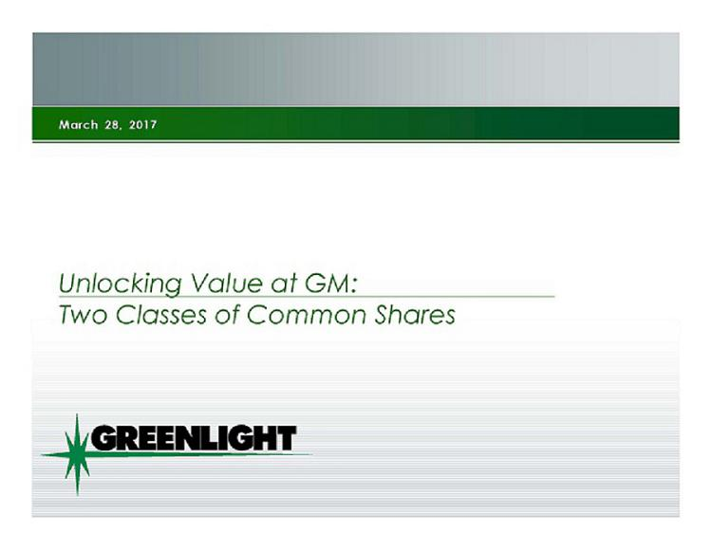

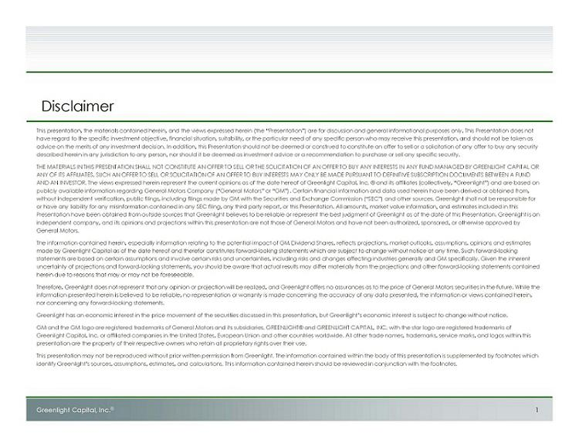

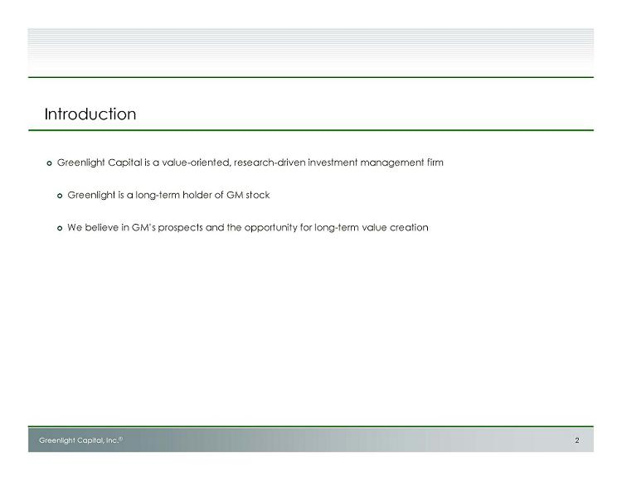

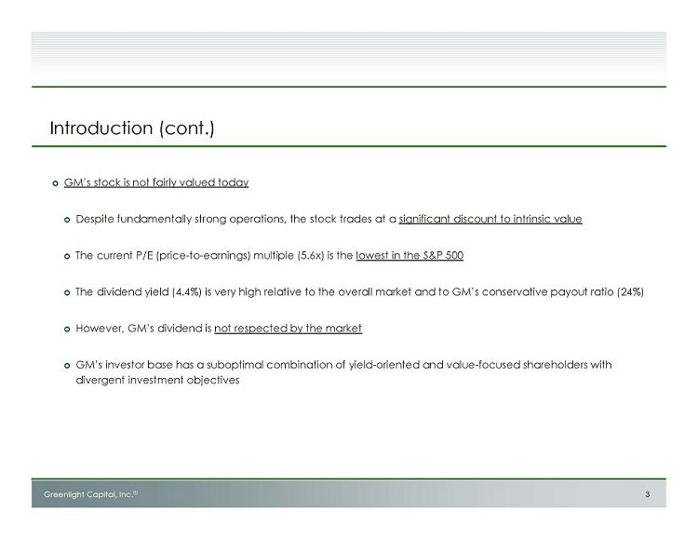

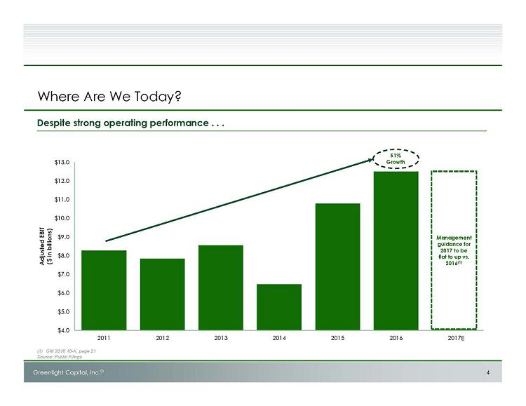

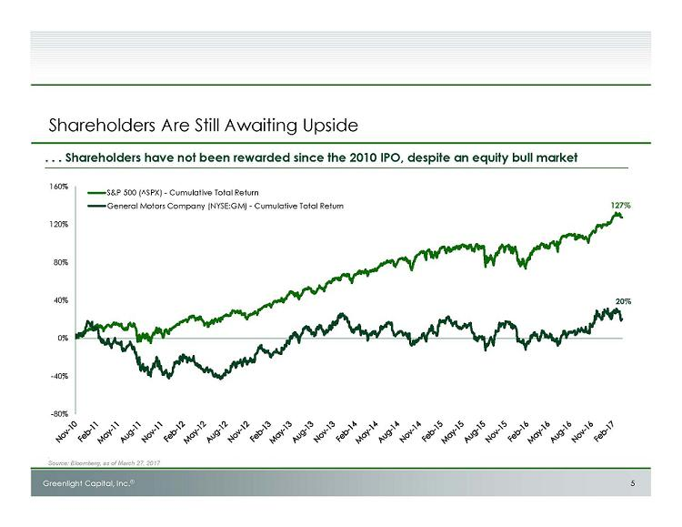

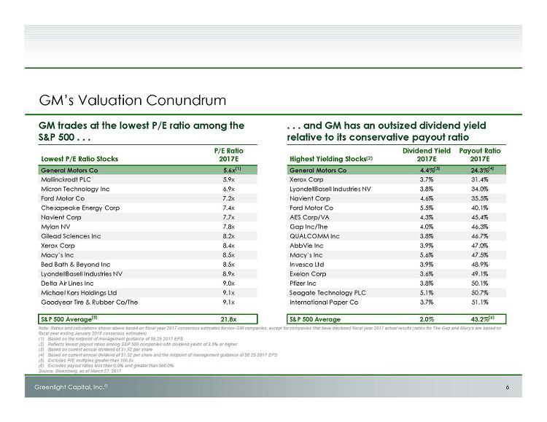

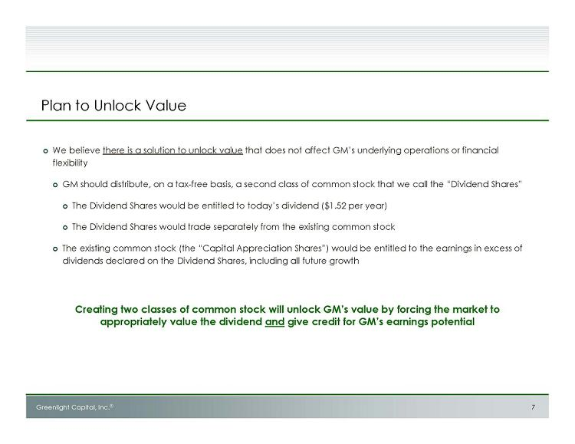

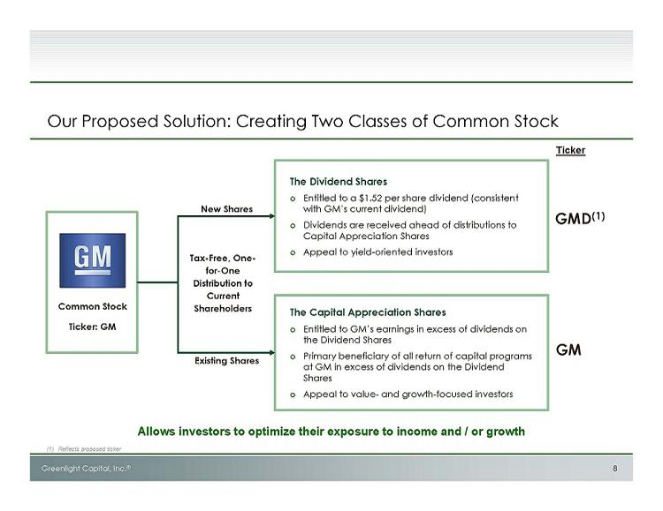

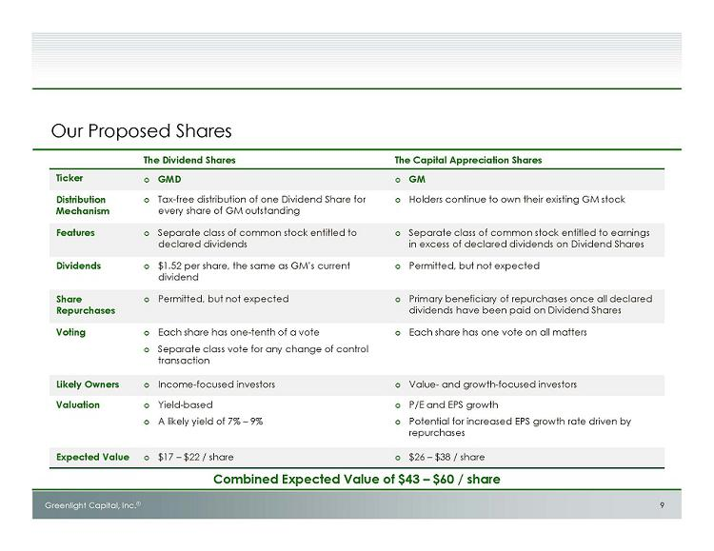

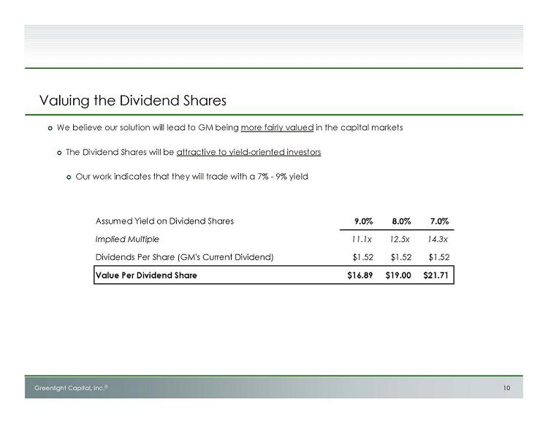

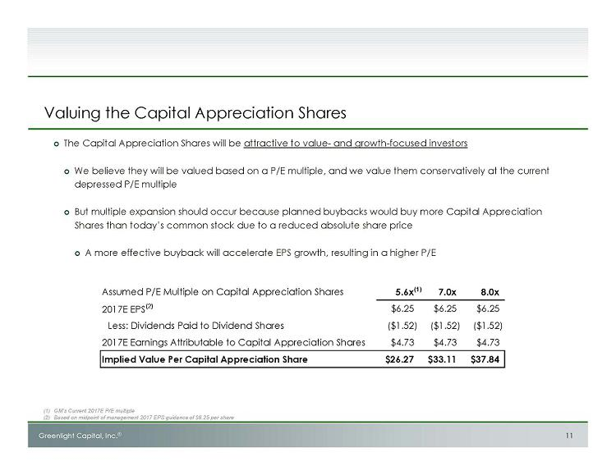

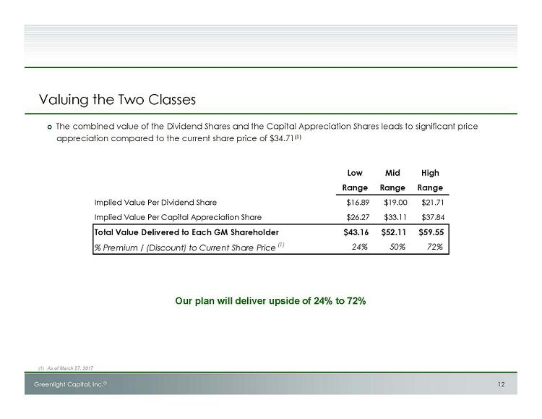

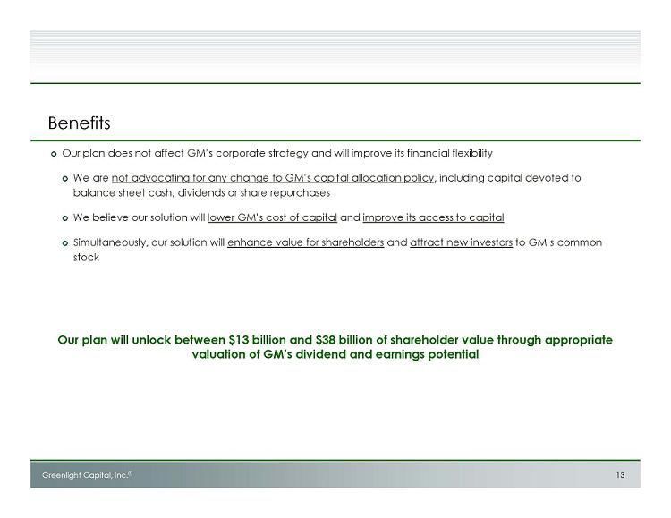

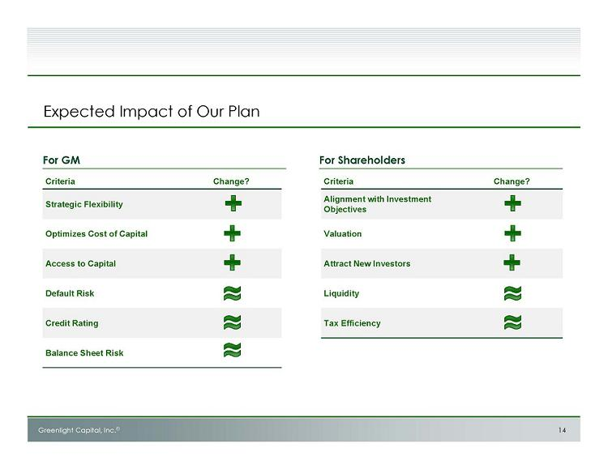

Exhibit 3

Greenlight Capital, Inc. (“Greenlight Inc.”), Greenlight Capital, L.P. (“Greenlight Fund”), DME Advisors, LP (“Advisors”), DME Capital Management, LP (“DME CM”), DME Advisors GP, LLC (“Advisors GP”), Greenlight Capital Qualified, LP (“Qualified”), Greenlight Capital (Gold), LP (“Gold”), Greenlight Capital Offshore Partners (“Offshore”), Greenlight Capital Offshore Master (Gold), Ltd. (“Gold Offshore”), Greenlight Masters Partners (“Masters Partners”), Greenlight Masters, LLC (“Masters LLC”), David Einhorn (“Mr. Einhorn”), and additional persons nominated by Greenlight Capital, L.P. to stand for election at the 2017 annual meeting of shareholders of General Motors Company (the “Nominees,” and, collectively, the “Participants”) intend to file with the Securities and Exchange Commission (the “SEC”) a definitive proxy statement and accompanying form of proxy to be used in connection with the solicitation of proxies from the shareholders of General Motors Company (the “Company”). All shareholders of the Company are advised to read the definitive proxy statement and other documents related to the solicitation of proxies by the Participants when they become available, as they will contain important information, including additional information related to the Participants. The definitive proxy statement and an accompanying proxy card will be furnished to some or all of the Company’s shareholders and will be, along with other relevant documents, available at no charge on the SEC website at http://www.sec.gov/.

INFORMATION ABOUT THE PARTICIPANTS’ INTERESTS BY SECURITY HOLDINGS

The Participants in this solicitation of proxies from shareholders of General Motors Company (the “Company”) in connection with the Company’s 2017 annual meeting of shareholders are (i) Greenlight Inc., (ii) Greenlight Fund, (iii) Advisors, (iv) DME CM, (v) Advisors GP, (vi) Qualified, (vii) Gold, (viii) Offshore, (ix) Gold Offshore, (x) Masters Partners, (xi) Masters LLC, (xii) Mr. Einhorn and (xiii) the Nominees.

The Participants may be deemed to “beneficially own” (within the meaning of Rule 13d-3 under the Exchange Act) an aggregate of 74,400,000 shares of common stock, $0.01 par value per share (the “Common Stock”), of the Company (including 19,645,000 shares of Common Stock underlying call options (the “Options”)), of which: (a) 2,373,829 shares of Common Stock are held through Greenlight Fund (including
559,000 shares of Common Stock underlying Options and 1,000 shares of Common Stock held of record by the Fund), (b) 26,579,601 shares of Common Stock are held through Offshore (including 6,316,000 shares of Common Stock underlying Options), (c) 13,396,968 shares of Common Stock are held through Qualified (including 3,178,000 shares of Common Stock underlying Options), (d) 42,350,398 shares of Common Stock (including 10,053,000 shares of Common Stock underlying Options) may be deemed to be beneficially owned by Greenlight Inc. by virtue of its beneficial ownership of shares held by Greenlight Fund, Offshore, and Qualified, to which Greenlight Inc. serves as investment manager, (e) 10,451,700 shares of Common Stock (including 4,515,000 shares of Common Stock underlying Options) may be deemed to be beneficially owned by Advisors by virtue of its beneficial ownership of shares held in a managed account, (f) 10,475,834 shares of Common Stock are held through Gold (including 2,496,000 shares of Common Stock underlying Options), (g) 10,851,868 shares of Common Stock are held through Gold Offshore (including 2,581,000 shares of Common Stock underlying Options), (h) 21,327,702 shares of Common Stock (including 5,077,000 shares of Common Stock underlying Options) may be deemed to be beneficially owned by DME CM by virtue of its beneficial ownership of shares held by Gold and Gold Offshore, to which DME CM serves as investment manager, (i) 31,779,402 shares of Common Stock (including 9,592,000 shares of Common Stock underlying Options) may be deemed to be beneficially owned by Advisors GP by virtue of being the general partner of Advisors and DME CM, (j) 270,200 shares of Common Stock are held through Masters Partners, (k) 270,200 shares of Common Stock may be deemed to be beneficially owned by Masters LLC by virtue of its beneficial ownership of shares held in Masters Partners, to which Masters LLC serves as investment manager, (l) 74,400,000 shares of Common Stock (including 19,645,000 shares of Common Stock underlying Options) may be deemed to be beneficially owned by Mr. Einhorn by virtue of his status as principal of Greenlight Inc., Advisors, DME CM, Advisors GP and Masters LLC.

