SEC Form 4

FORM 4

Check this box if no longer subject to Section 16. Form 4 or Form 5 obligations may continue. See Instruction 1(b).

UNITED STATES SECURITIES AND EXCHANGE COMMISSION
Washington, D.C. 20549
Washington, D.C. 20549 |  | OMB APPROVAL
STATEMENT OF CHANGES IN BENEFICIAL OWNERSHIP
STATEMENT OF CHANGES IN BENEFICIAL OWNERSHIP |  | OMB Number: | 3235-0287
STATEMENT OF CHANGES IN BENEFICIAL OWNERSHIP |  | Estimated average burden
Filed pursuant to Section 16(a) of the Securities Exchange Act of 1934 |  | hours per response: | 0.5
or Section 30(h) of the Investment Company Act of 1940
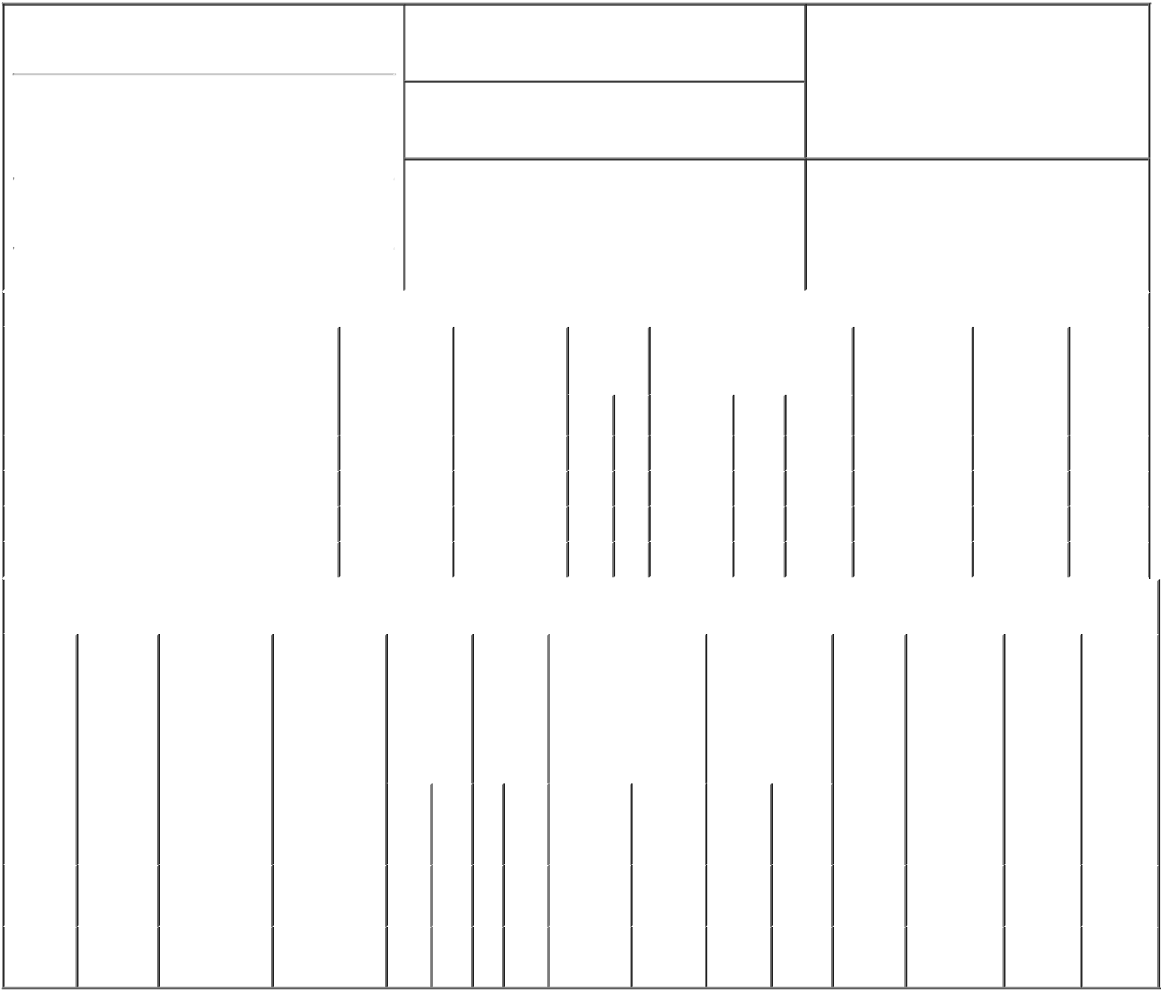

1. Name and Address of Reporting Person*
Engle Barry L II

(Last) (First) (Middle)

300 RENAISSANCE CENTER M/C: 482-C23-D24

2. Issuer Name and Ticker or Trading Symbol

General Motors Co [ GM ]

3. Date of Earliest Transaction (Month/Day/Year)

02/10/2017

- Relationship of Reporting Person(s) to Issuer (Check all applicable)

 | Director | 10% Owner
X | Officer (give title | Other (specify
X | below) | below)

Executive Vice President

 |  |  |  |  |  |  |  | 4. If Amendment, Date of Original Filed (Month/Day/Year) |  |  |  |  |  |  |  | 6. Individual or Joint/Group Filing (Check Applicable
 | (Street) |  |  |  |  |  |  |  |  |  |  |  |  |  |  | Line)
 |  |  |  |  |  |  |  |  |  |  |  |  |  |  |  |  | X Form filed by One Reporting Person
 |  | DETROIT |  | MI |  | 48265-3000
 |  |  |  | MI |  | 48265-3000 |  |  |  |  |  |  |  |  |  |  |  | Form filed by More than One Reporting
 |  |  |  |  |  |  |  |  |  |  |  |  |  |  |  |  |  | Person
 |  | (City) |  | (State) |  | (Zip) |  |  |  |  |  |  |  |  |  |  |  | Person
 |  |  |  |  | Table I - Non-Derivative Securities Acquired, Disposed of, or Beneficially Owned
 | 1. Title of Security (Instr. 3) |  |  |  |  | 2. Transaction |  |  | 2A. Deemed |  | 3. |  |  | 4. Securities Acquired (A) or |  |  |  | 5. Amount of |  | 6. Ownership |  | 7. Nature
 |  |  |  |  |  | Date |  |  | Execution Date, |  |  | Transaction |  | Disposed Of (D) (Instr. 3, 4 and |  |  |  | Securities |  | Form: Direct |  | of Indirect
 |  |  |  |  |  | (Month/Day/Year) |  |  | if any |  |  | Code (Instr. |  | 5) |  |  |  | Beneficially |  | (D) or Indirect |  | Beneficial
 |  |  |  |  |  |  |  |  | (Month/Day/Year) 8) |  |  |  |  |  |  |  |  | Owned Following |  | (I) (Instr. 4) |  | Ownership
 |  |  |  |  |  |  |  |  |  |  |  |  |  |  |  |  |  | Reported |  |  |  | (Instr. 4)
 |  |  |  |  |  |  |  |  |  |  |  | Code V |  | Amount | (A) or | Price |  | Transaction(s)
 |  |  |  |  |  |  |  |  |  |  |  | Code V |  | Amount | (D) |  |  | (Instr. 3 and 4)
 | Common Stock⁽¹⁾ |  |  |  |  | 02/10/2017 |  |  |  |  |  | M |  | 4,286 | A | $0 |  | 6,144 |  |  | D
 | Common Stock |  |  |  |  | 02/10/2017 |  |  |  |  |  | F |  | 1,355 | D | $35.17 |  | 4,789 |  |  | D
 | Common Stock⁽²⁾ |  |  |  |  | 02/11/2017 |  |  |  |  |  | M |  | 2,718 | A | $0 |  | 7,507 |  |  | D
 | Common Stock |  |  |  |  | 02/11/2017 |  |  |  |  |  | F |  | 859 | D | $35.17 |  | 6,648 |  |  | D
 |  |  |  |  | Table II - Derivative Securities Acquired, Disposed of, or Beneficially Owned
 |  |  |  |  |  | (e.g., puts, calls, warrants, options, convertible securities)
 | 1. Title of |  | 2. |  | 3. Transaction | 3A. Deemed | 4. |  |  | 5. Number | 6. Date Exercisable and |  |  |  | 7. Title and |  | 8. Price of |  | 9. Number of |  | 10. | 11. Nature
 | Derivative |  | Conversion |  | Date | Execution Date, | Transaction |  |  | of | Expiration Date |  |  |  | Amount of |  | Derivative |  | derivative |  | Ownership | of Indirect
 | Security |  | or Exercise |  | (Month/Day/Year) | if any | Code (Instr. |  |  | Derivative | (Month/Day/Year) |  |  |  | Securities |  | Security |  | Securities |  | Form: | Beneficial
 | (Instr. 3) |  | Price of |  |  | (Month/Day/Year) | 8) |  |  | Securities |  |  |  |  | Underlying |  | (Instr. 5) |  | Beneficially |  | Direct (D) | Ownership
 |  |  | Derivative |  |  |  |  |  |  | Acquired |  |  |  |  | Derivative Security |  |  |  | Owned |  | or Indirect | (Instr. 4)
 |  |  | Security |  |  |  |  |  |  | (A) or |  |  |  |  | (Instr. 3 and 4) |  |  |  | Following |  | (I) (Instr. 4)
 |  |  |  |  |  |  |  |  |  | Disposed |  |  |  |  |  |  |  |  | Reported
 |  |  |  |  |  |  |  |  |  | of (D) |  |  |  |  |  |  |  |  | Transaction(s)
 |  |  |  |  |  |  |  |  |  | (Instr. 3, 4 |  |  |  |  |  |  |  |  | (Instr. 4)
 |  |  |  |  |  |  |  |  |  | and 5)
 |  |  |  |  |  |  |  |  |  |  |  |  |  |  |  | Amount
 |  |  |  |  |  |  |  |  |  |  |  |  |  |  |  | or
 |  |  |  |  |  |  |  |  |  |  |  |  |  |  |  | Number
 |  |  |  |  |  |  |  |  |  |  | Date |  | Expiration |  |  | of
 |  |  |  |  |  |  | Code V |  |  | (A) (D) | Exercisable |  | Date |  | Title | Shares
 | Restricted |  |  |  |  |  |  |  |  |  |  |  |  |  | Common | 4,286
 | Stock |  | $0.0 |  | 02/10/2017 |  |  | M |  | 4,286 | (4) |  |  | (4) | Common | 4,286 |  | $0 | 8,571 |  | D
 |  |  | $0.0 |  | 02/10/2017 |  |  | M |  | 4,286 |  |  |  | (4) | Stock | 4,286 |  | $0 | 8,571 |  | D
 | Units⁽³⁾ |  |  |  |  |  |  |  |  |  |  |  |  |  | Stock
 | Restricted |  |  |  |  |  |  |  |  |  |  |  |  |  | Common | 2,718
 | Stock |  | $0.0 |  | 02/11/2017 |  |  | M |  | 2,718 | (4) |  |  | (4) | Common | 2,718 |  | $0 | 2,717 |  | D
 |  |  | $0.0 |  | 02/11/2017 |  |  | M |  | 2,718 |  |  |  | (4) | Stock | 2,718 |  | $0 | 2,717 |  | D
 | Units⁽⁵⁾ |  |  |  |  |  |  |  |  |  |  |  |  |  | Stock

Explanation of Responses:

- The Common Stock reported in this item was issued and delivered upon the vesting of a grant of Restricted Stock Units ("RSUs") awarded on February 10, 2016, pursuant to the Company's 2014 Long-Term Incentive Plan ("GMLTIP").

- The Common Stock reported in this item was issued and delivered upon the vesting of a grant of RSUs awarded on October 1, 2015, pursuant to the 2014 GMLTIP.

- The RSUs reported in this item were granted on February 10, 2016 and began being settled in three equal, annual installments on February 10, 2017. Each RSU represents a right to receive one share of the Company's common stock upon settlement.

- Each RSU represents a right to receive one share of the Company's common stock upon settlement. The RSUs do not have a conversion or exercise price, or a date on which they are exercisable or expire.

- The RSUs reported in this item were granted on October 1, 2015 and began being settled in three equal, annual installments on February 11, 2016. Each RSU represents a right to receive one share of the Company's common stock upon settlement.

Remarks:

/s/ Tia Y. Turk, Attorney-In- |  |  | 02/14/2017
Fact for Mr. Engle
** Signature of Reporting Person |  |  | Date

Reminder: Report on a separate line for each class of securities beneficially owned directly or indirectly.

* If the form is filed by more than one reporting person, see Instruction 4 (b)(v).

- Intentional misstatements or omissions of facts constitute Federal Criminal Violations See 18 U.S.C. 1001 and 15 U.S.C. 78ff(a). Note: File three copies of this Form, one of which must be manually signed. If space is insufficient, see Instruction 6 for procedure.
Persons who respond to the collection of information contained in this form are not required to respond unless the form displays a currently valid OMB Number.



