UNITED STATES SECURITIES AND EXCHANGE COMMISSION

Washington, DC 20549-1004

___________________

FORM 8-K

___________________

CURRENT REPORT

Pursuant to Section 13 or 15(d) of

the Securities Exchange Act of 1934

Date of Report (Date of earliest event reported) August 1, 2019

___________________

GENERAL MOTORS COMPANY

(Exact name of registrant as specified in its charter)

__________________

Delaware | 001-34960 | 27-0756180
(State or other jurisdiction of | 001-34960 | (I.R.S. Employer
incorporation) | (Commission File Number) | Identification No.)
300 Renaissance Center, Detroit, Michigan |  | 48265-3000
(Address of principal executive offices) |  | (Zip Code)
 | (313) 667-1500
(Registrant's telephone number, including area code)

Not Applicable

(Former name or former address, if changed since last report)

__________________

Check the appropriate box below if the Form 8-K filing is intended to simultaneously satisfy the filing obligation of the registrant under any of the following provisions:

- Written communications pursuant to Rule 425 under the Securities Act (17 CFR 230.425)

- Soliciting material pursuant to Rule 14a-12 under the Exchange Act (17 CFR 240.14a-12)

- Pre-commencement communications pursuant to Rule 14d-2(b) under the Exchange Act (17 CFR 240.14d-2(b))

- Pre-commencement communications pursuant to Rule 13e-4(c) under the Exchange Act (17 CFR 240.13e-4(c))

 |  | Securities registered pursuant to Section 12(b) of the Act:
Title of each class |  | Trading Symbol(s) |  |  | Name of each exchange on which registered
Common Stock |  |  | GM |  |  | New York Stock Exchange

Indicate by check mark whether the registrant is an emerging growth company as defined in Rule 405 of the Securities Act of 1933 (§230.405 of this chapter) or Rule 12b-2 of the Securities Exchange Act of 1934 (§240.12b-2 of this chapter). Emerging growth company ☐

If an emerging growth company, indicate by check mark if the registrant has elected not to use the extended transition period for complying with any new or revised financial accounting standards provided pursuant to Section 13(a) of the Exchange Act. ☐

ITEM 2.02 Results of Operations and Financial Condition

On August 1, 2019 General Motors Company (GM) issued a news release and supplemental materials on the subject of its 2019 second quarter earnings. The news release and supplemental materials are attached as Exhibit 99.1 and Exhibit 99.2.

Charts furnished to securities analysts in connection with GM's 2019 second quarter earnings release are available on GM's website at www.gm.com/investors/earnings-releases.html.

ITEM 9.01 Financial Statements and Exhibits

EXHIBIT

Exhibit |  | Description
Exhibit 99.1 |  | News Release Dated August 1, 2019
Exhibit 99.2 |  | Financial Highlights Dated August 1, 2019

SIGNATURE

Pursuant to the requirements of the Securities Exchange Act of 1934, the registrant has duly caused this report to be signed on its behalf by the undersigned hereunto duly authorized.

 | GENERAL MOTORS COMPANY (Registrant)
By: | /s/ CHRISTOPHER T. HATTO
Date: August 1, 2019
Date: August 1, 2019 | Christopher T. Hatto, Vice President, Controller and Chief Accounting Officer

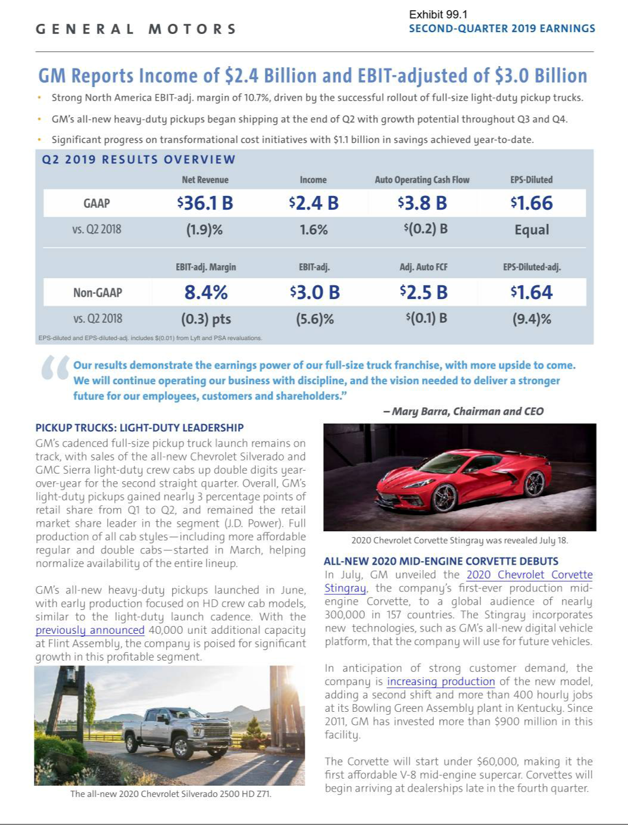

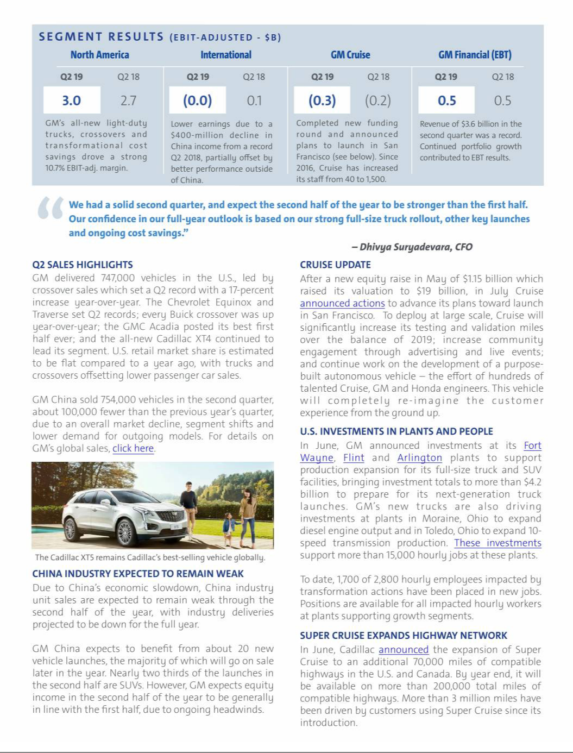

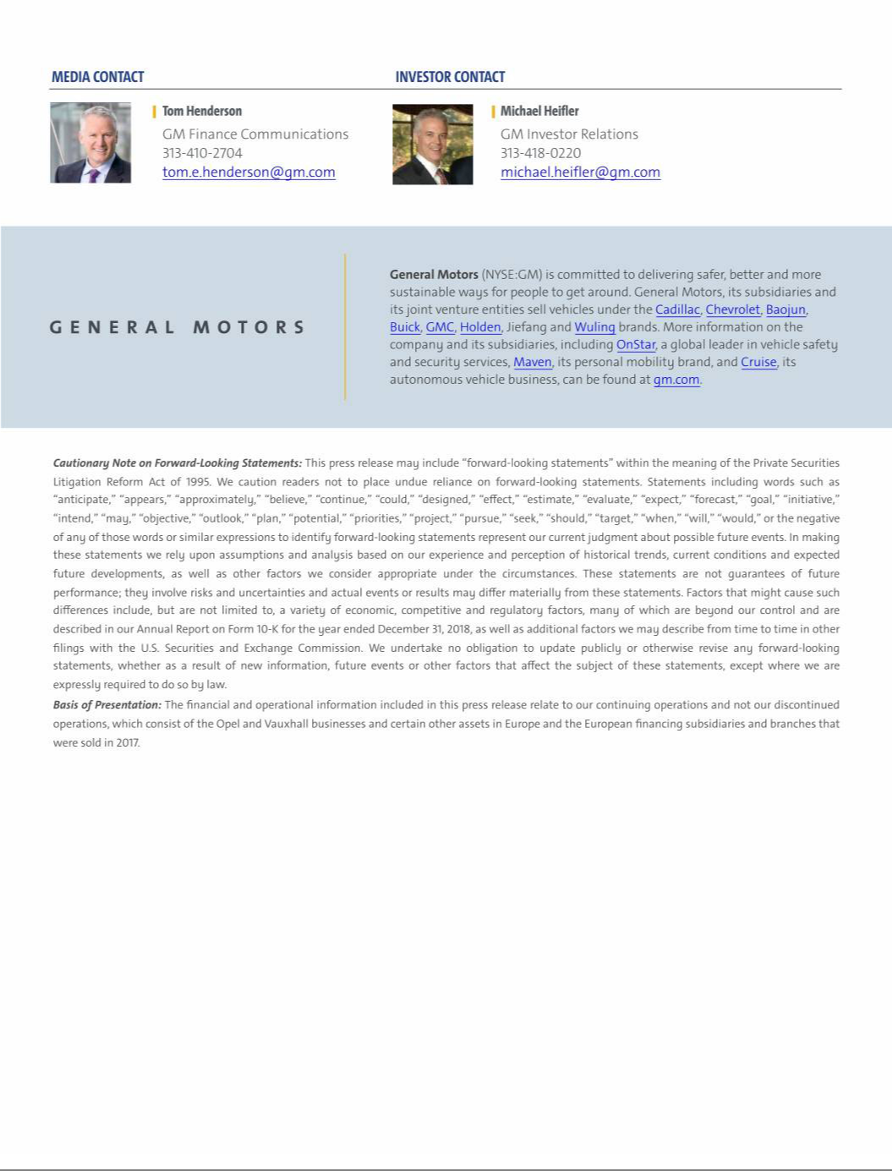

Exhibit 99.2

General Motors Company and Subsidiaries

Supplemental Material

(Unaudited)

Unless otherwise indicated, General Motors Company's (GM) non-GAAP measures are related to our continuing operations and not our discontinued operations. GM's non-GAAP measures include: earnings before interest and taxes (EBIT)-adjusted, presented net of noncontrolling interests; earnings before income taxes (EBT)-adjusted for our General Motors Financial Company, Inc. (GM Financial) segment; earnings per share (EPS)-diluted-adjusted; effective tax rate-adjusted (ETR-adjusted); return on invested capital-adjusted (ROIC-adjusted) and adjusted automotive free cash flow. GM's calculation of these non-GAAP measures may not be comparable to similarly titled measures of other companies due to potential differences between companies in the method of calculation. As a result, the use of these non-GAAP measures has limitations and should not be considered superior to, in isolation from, or as a substitute for, related U.S. GAAP measures.

These non-GAAP measures allow management and investors to view operating trends, perform analytical comparisons and benchmark performance between periods and among geographic regions to understand operating performance without regard to items we do not consider a component of our core operating performance. Furthermore, these non-GAAP measures allow investors the opportunity to measure and monitor our performance against our externally communicated targets and evaluate the investment decisions being made by management to improve ROIC-adjusted. Management uses these measures in its financial, investment and operational decision-making processes, for internal reporting and as part of its forecasting and budgeting processes. Further, our Board of Directors uses certain of these and other measures as key metrics to determine management performance under our performance-based compensation plans. For these reasons we believe these non-GAAP measures are useful for our investors.

EBIT-adjusted EBIT-adjusted is presented net of noncontrolling interests and is used by management and can be used by investors to review our consolidated operating results because it excludes automotive interest income, automotive interest expense and income taxes as well as certain additional adjustments that are not considered part of our core operations. Examples of adjustments to EBIT include but are not limited to impairment charges on long-lived assets and other exit costs resulting from strategic shifts in our operations or discrete market and business conditions; costs arising from the ignition switch recall and related legal matters; and certain currency devaluations associated with hyperinflationary economies. For EBIT-adjusted and our other non-GAAP measures, once we have made an adjustment in the current period for an item, we will also adjust the related non-GAAP measure in any future periods in which there is an impact from the item. Our corresponding measure for our GM Financial segment is EBT-adjusted.

EPS-diluted-adjusted EPS-diluted-adjusted is used by management and can be used by investors to review our consolidated diluted EPS results on a consistent basis. EPS-diluted-adjusted is calculated as net income attributable to common stockholders-diluted less income (loss) from discontinued operations on an after-tax basis, adjustments noted above for EBIT-adjusted and certain income tax adjustments divided by weighted-average common shares outstanding-diluted. Examples of income tax adjustments include the establishment or reversal of significant deferred tax asset valuation allowances.

ETR-adjusted ETR-adjusted is used by management and can be used by investors to review the consolidated effective tax rate for our core operations on a consistent basis. ETR-adjusted is calculated as Income tax expense less the income tax related to the adjustments noted above for EBIT-adjusted and the income tax adjustments noted above for EPS-diluted-adjusted divided by Income before income taxes less adjustments.

ROIC-adjusted ROIC-adjusted is used by management and can be used by investors to review our investment and capital allocation decisions. We define ROIC-adjusted as EBIT-adjusted for the trailing four quarters divided by ROIC-adjusted average net assets, which is considered to be the average equity balances adjusted for average automotive debt and interest liabilities, exclusive of capital leases; average net pension and other postretirement benefits (OPEB) liabilities; and average automotive net income tax assets during the same period. Adjustments to the average equity balances exclude assets and liabilities classified as either assets held for sale or liabilities held for sale.

Adjusted automotive free cash flow Adjusted automotive free cash flow is used by management and can be used by investors to review the liquidity of our automotive operations and to measure and monitor our performance against our capital allocation program and evaluate our automotive liquidity against the substantial cash requirements of our automotive operations. We measure adjusted automotive free cash flow as automotive operating cash flow from continuing operations less capital expenditures adjusted for management actions. Management actions can include voluntary events such as discretionary contributions to employee benefit plans or nonrecurring specific events such as a closure of a facility that are considered special for EBIT-adjusted purposes.

1

General Motors Company and Subsidiaries

Supplemental Material

(Unaudited)

The following table reconciles segment profit (loss) to Net income attributable to stockholders under U.S. GAAP (dollars in millions):

 |  | Three Months Ended |  |  |  |  |  | Six Months Ended
 |  | June 30, 2019 |  |  | June 30, 2018 |  |  | June 30, 2019 |  |  | June 30, 2018
Operating segments
GM North America (GMNA) | $ | 3,022 |  | $ | 2,670 |  | $ | 4,918 |  | $ | 4,903
GM International (GMI) |  | (48) |  |  | 143 |  |  | (17) |  |  | 332
GM Cruise |  | (279) |  |  | (154) |  |  | (448) |  |  | (320)
GM Financial(a) |  | 536 |  |  | 536 |  |  | 895 |  |  | 979
Total operating segments |  | 3,231 |  |  | 3,195 |  |  | 5,348 |  |  | 5,894
Corporate and eliminations(b) |  | (219) |  |  | (3) |  |  | (26) |  |  | (92)
EBIT-adjusted |  | 3,012 |  |  | 3,192 |  |  | 5,322 |  |  | 5,802
Adjustments
Transformation activities(c) |  | (361) |  |  | — |  |  | (1,151) |  |  | —
GM Brazil indirect tax recoveries(d) |  | 380 |  |  | — |  |  | 1,237 |  |  | —
GMI restructuring(e) |  | — |  |  | (196) |  |  | — |  |  | (1,138)
Total adjustments |  | 19 |  |  | (196) |  |  | 86 |  |  | (1,138)
Automotive interest income |  | 106 |  |  | 72 |  |  | 204 |  |  | 136
Automotive interest expense |  | (195) |  |  | (159) |  |  | (376) |  |  | (309)
Income tax expense |  | (524) |  |  | (519) |  |  | (661) |  |  | (985)
Income from continuing operations(f) |  | 2,418 |  |  | 2,390 |  |  | 4,575 |  |  | 3,506
Loss from discontinued operations, net of tax(g) |  | — |  |  | — |  |  | — |  |  | 70
Net income attributable to stockholders | $ | 2,418 |  | $ | 2,390 |  | $ | 4,575 |  | $ | 3,436
__________
- GM Financial amounts represent earnings before income taxes-adjusted.

- GM's automotive operations' interest income and interest expense, Maven, legacy costs from the Opel and Vauxhall businesses and certain other assets in Europe (the Opel/Vauxhall Business), which are primarily pension costs, corporate expenditures and certain nonsegment-specific revenues and expenses are recorded centrally in Corporate.
- These adjustments were excluded because of a strategic decision to accelerate our transformation for the future to strengthen our core business, capitalize on the future of personal mobility and drive significant cost efficiencies. The adjustments primarily consist of supplier-related charges and accelerated depreciation in the three months ended June 30, 2019 and accelerated depreciation and supplier-related charges in the six months ended June 30, 2019.
- These adjustments were excluded because of the unique events associated with decisions rendered by the Superior Judicial Court of Brazil resulting in retrospective recoveries of indirect taxes.

- These adjustments were excluded because of a strategic decision to rationalize our core operations by exiting or significantly reducing our presence in various international markets to focus resources on opportunities expected to deliver higher returns. The adjustments primarily consist of employee separation charges and asset impairments in Korea.
- Net of Net loss attributable to noncontrolling interests.

- Represents the results of the Opel/Vauxhall Business and our European financing subsidiaries and branches (the Fincos, and together with the Opel/Vauxhall Business, the European Business).

2

General Motors Company and Subsidiaries

Supplemental Material

(Unaudited)

The following table reconciles Net income (loss) attributable to stockholders under U.S. GAAP to EBIT-adjusted (dollars in millions):

 |  |  |  |  |  |  |  |  |  |  | Three Months Ended
 |  | June 30, |  |  |  |  |  | March 31, |  |  |  |  |  | December 31, |  |  |  |  |  | September 30,
 |  | 2019 |  |  | 2018 |  |  | 2019 |  |  | 2018 |  |  | 2018 |  |  | 2017 |  |  | 2018 |  |  | 2017
Net income (loss) attributable to stockholders | $ | 2,418 |  | $ | 2,390 |  | $ | 2,157 |  | $ | 1,046 |  | $ | 2,044 |  | $ | (5,151) |  | $ | 2,534 |  | $ | (2,981)
Loss from discontinued operations, net of tax |  | — |  |  | — |  |  | — |  |  | 70 |  |  | — |  |  | 277 |  |  | — |  |  | 3,096
Income tax expense (benefit) |  | 524 |  |  | 519 |  |  | 137 |  |  | 466 |  |  | (611) |  |  | 7,896 |  |  | 100 |  |  | 2,316
Automotive interest expense |  | 195 |  |  | 159 |  |  | 181 |  |  | 150 |  |  | 185 |  |  | 145 |  |  | 161 |  |  | 151
Automotive interest income |  | (106) |  |  | (72) |  |  | (98) |  |  | (64) |  |  | (117) |  |  | (82) |  |  | (82) |  |  | (59)
Adjustments
Transformation activities(a) |  | 361 |  |  | — |  |  | 790 |  |  | — |  |  | 1,327 |  |  | — |  |  | — |  |  | —
GM Brazil indirect tax recoveries(b) |  | (380) |  |  | — |  |  | (857) |  |  | — |  |  | — |  |  | — |  |  | — |  |  | —
GMI restructuring(c) |  | — |  |  | 196 |  |  | — |  |  | 942 |  |  | — |  |  | — |  |  | — |  |  | —
Ignition switch recall and related legal matters(d) |  | — |  |  | — |  |  | — |  |  | — |  |  | — |  |  | — |  |  | 440 |  |  | —
Total adjustments |  | (19) |  |  | 196 |  |  | (67) |  |  | 942 |  |  | 1,327 |  |  | — |  |  | 440 |  |  | —
EBIT-adjusted | $ | 3,012 |  | $ | 3,192 |  | $ | 2,310 |  | $ | 2,610 |  | $ | 2,828 |  | $ | 3,085 |  | $ | 3,153 |  | $ | 2,523
________
- These adjustments were excluded because of a strategic decision to accelerate our transformation for the future to strengthen our core business, capitalize on the future of personal mobility and drive significant cost efficiencies. The adjustments primarily consist of supplier-related charges and accelerated depreciation in the three months ended June 30, 2019, accelerated depreciation in the three months ended March 31, 2019 and employee separation charges and accelerated depreciation in the three months ended December 31, 2018.
- These adjustments were excluded because of the unique events associated with decisions rendered by the Superior Judicial Court of Brazil resulting in retrospective recoveries of indirect taxes.

- These adjustments were excluded because of a strategic decision to rationalize our core operations by exiting or significantly reducing our presence in various international markets to focus resources on opportunities expected to deliver higher returns. The adjustments primarily consist of employee separation charges and asset impairments in Korea.
- This adjustment was excluded because of the unique events associated with the ignition switch recall, which included various investigations, inquiries and complaints from constituents.

The following table reconciles diluted earnings per common share under U.S. GAAP to EPS-diluted-adjusted (dollars in millions, except per share amounts):

 |  |  |  |  | Three Months Ended |  |  |  |  |  |  |  |  |  |  |  | Six Months Ended
 |  | June 30, 2019 |  |  |  |  |  | June 30, 2018 |  |  |  |  |  | June 30, 2019 |  |  |  |  |  | June 30, 2018
 |  | Amount |  |  | Per Share |  |  | Amount |  |  | Per Share |  |  | Amount |  |  | Per Share |  |  | Amount |  |  | Per Share
Diluted earnings per common share | $ | 2,381 |  | $ | 1.66 |  | $ | 2,375 |  | $ | 1.66 |  | $ | 4,500 |  | $ | 3.13 |  | $ | 3,407 |  | $ | 2.38
Diluted loss per common share – discontinued operations |  | — |  |  | — |  |  | — |  |  | — |  |  | — |  |  | — |  |  | 70 |  |  | 0.05
Adjustments(a) |  | (19) |  |  | (0.01) |  |  | 196 |  |  | 0.14 |  |  | (86) |  |  | (0.06) |  |  | 1,138 |  |  | 0.80
Tax effect on adjustment(b) |  | (9) |  |  | (0.01) |  |  | 20 |  |  | 0.01 |  |  | (41) |  |  | (0.03) |  |  | 20 |  |  | 0.01
EPS-diluted-adjusted | $ | 2,353 |  | $ | 1.64 |  | $ | 2,591 |  | $ | 1.81 |  | $ | 4,373 |  | $ | 3.04 |  | $ | 4,635 |  | $ | 3.24
________
- Refer to the reconciliation of segment profit (loss) to Net income attributable to stockholders under U.S. GAAP for adjustment details.

- The tax effect of each adjustment is determined based on the tax laws and valuation allowance status of the jurisdiction to which the adjustment relates.

3

General Motors Company and Subsidiaries

Supplemental Material

(Unaudited)

The following table reconciles our effective tax rate under U.S. GAAP to ETR-adjusted (dollars in millions):

 |  |  |  |  |  |  | Three Months Ended |  |  |  |  |  |  |  |  |  |  |  |  |  |  |  | Six Months Ended
 |  |  |  | June 30, 2019 |  |  |  |  |  |  |  | June 30, 2018 |  |  |  |  |  |  |  | June 30, 2019 |  |  |  |  |  |  |  | June 30, 2018
 | Income before |  |  |  | Income tax |  | Effective tax |  | Income before |  |  |  | Income tax |  | Effective tax |  | Income before |  |  |  | Income tax |  | Effective tax |  | Income before |  |  |  | Income tax |  | Effective tax
 | income taxes |  |  |  | expense |  | rate |  | income taxes |  |  |  | expense |  | rate |  | income taxes |  |  |  | expense |  | rate |  | income taxes |  |  |  | expense |  | rate
Effective tax rate | $ | 2,927 |  | $ | 524 | 17.9% |  |  | $ | 2,885 |  | $ | 519 | 18.0% |  |  | $ | 5,209 |  | $ | 661 |  | 12.7% |  | $ | 4,461 |  | $ | 985 |  | 22.1%
Adjustments(a) |  | (16) |  |  | 9 |  |  |  |  | 237 |  |  | (20) |  |  |  |  | (83) |  |  | 41 |  |  |  |  | 1,179 |  |  | (20)
ETR-adjusted | $ | 2,911 |  | $ | 533 | 18.3% |  |  | $ | 3,122 |  | $ | 499 | 16.0% |  |  | $ | 5,126 |  | $ | 702 |  | 13.7% |  | $ | 5,640 |  | $ | 965 |  | 17.1%
________
- Refer to the reconciliation of segment profit (loss) to Net income attributable to stockholders under U.S. GAAP for adjustment details. Net income attributable to noncontrolling interests included for these adjustments is insignificant in the three and six months ended June 30, 2019 and $41 million in the three and six months ended June 30, 2018. The tax effect of each adjustment is determined based on the tax laws and valuation allowance status of the jurisdiction to which the adjustment relates.

We define return on equity (ROE) as Net income (loss) attributable to stockholders for the trailing four quarters divided by average equity for the same period. Management uses average equity to provide comparable amounts in the calculation of ROE. The following table summarizes the calculation of ROE (dollars in billions):

 |  | Four Quarters Ended
 | June 30, 2019 |  |  |  | June 30, 2018
Net income (loss) attributable to stockholders | $ | 9.2 |  | $ | (4.7)
Average equity(a) | $ | 41.1 |  | $ | 37.2
ROE |  | 22.3% |  |  | (12.6)%
________
- Includes equity of noncontrolling interests where the corresponding earnings (loss) are included in Net income (loss) attributable to stockholders.

The following table summarizes the calculation of ROIC-adjusted (dollars in billions):

 |  | Four Quarters Ended
 | June 30, 2019 |  |  |  | June 30, 2018
EBIT-adjusted(a) | $ | 11.3 |  | $ | 11.4
Average equity(b) | $ | 41.1 |  | $ | 37.2
Add: Average automotive debt and interest liabilities (excluding finance leases) |  | 14.9 |  |  | 13.5
Add: Average automotive net pension & OPEB liability |  | 16.9 |  |  | 19.9
Less: Average automotive and other net income tax asset |  | (23.1) |  |  | (24.5)
ROIC-adjusted average net assets | $ | 49.8 |  | $ | 46.1
ROIC-adjusted |  | 22.7% |  |  | 24.7%
________
- Refer to the reconciliation of Net income (loss) attributable to stockholders under U.S. GAAP to EBIT-adjusted.

- Includes equity of noncontrolling interests where the corresponding earnings (loss) are included in EBIT-adjusted.

4

General Motors Company and Subsidiaries

Supplemental Material

(Unaudited)

The following table reconciles Net automotive cash provided by operating activities from continuing operations under U.S. GAAP to adjusted automotive free cash flow (dollars in millions):

 |  | Three Months Ended |  |  |  |  |  | Six Months Ended
 |  | June 30, 2019 |  |  | June 30, 2018 |  |  | June 30, 2019 |  |  | June 30, 2018
Net automotive cash provided by operating activities | $ | 3,813 |  | $ | 3,986 |  | $ | 1,606 |  | $ | 2,923
Less: Capital expenditures |  | (1,435) |  |  | (2,065) |  |  | (3,428) |  |  | (4,305)
Add: Transformation activities |  | 172 |  |  | — |  |  | 487 |  |  | —
Add: GMI restructuring |  | — |  |  | 676 |  |  | 9 |  |  | 676
Less: GM Brazil indirect tax recoveries |  | (16) |  |  | — |  |  | (16) |  |  | —
Adjusted automotive free cash flow | $ | 2,534 |  | $ | 2,597 |  | $ | (1,342) |  | $ | (706)

The following tables summarize key financial information by segment (dollars in millions):

 |  |  |  |  |  |  |  |  |  |  |  |  |  | Total |  |  |  |  |  | GM
 |  | GMNA |  |  | GMI |  |  | Corporate |  |  | Eliminations |  |  | Automotive |  |  | GM Cruise |  |  | Financial |  | Reclassifications/Eliminations |  |  |  | Total
Three Months Ended June 30, 2019
Net sales and revenue | $ | 28,324 |  | $ | 4,047 |  | $ | 54 |  |  |  |  | $ | 32,425 |  | $ | 25 |  | $ | 3,639 |  | $ | (29) |  | $ | 36,060
Expenditures for property | $ | 1,268 |  | $ | 166 |  | $ | 1 |  | $ | — |  | $ | 1,435 |  | $ | 19 |  | $ | 8 |  | $ | — |  | $ | 1,462
Depreciation and amortization | $ | 1,409 |  | $ | 119 |  | $ | 13 |  | $ | — |  | $ | 1,541 |  | $ | 7 |  | $ | 1,848 |  | $ | — |  | $ | 3,396
Impairment charges | $ | 8 |  | $ | 3 |  | $ | — |  | $ | — |  | $ | 11 |  | $ | — |  | $ | — |  | $ | — |  | $ | 11
Equity income(a) | $ | 2 |  | $ | 233 |  | $ | (6) |  | $ | — |  | $ | 229 |  | $ | — |  | $ | 42 |  | $ | — |  | $ | 271
 |  |  |  |  |  |  |  |  |  |  |  |  |  | Total |  |  |  |  |  | GM
 |  | GMNA |  |  | GMI |  |  | Corporate |  |  | Eliminations |  |  | Automotive |  |  | GM Cruise |  |  | Financial |  |  | Eliminations |  |  | Total
Three Months Ended June 30, 2018
Net sales and revenue | $ | 28,501 |  | $ | 4,758 |  | $ | 50 |  |  |  |  | $ | 33,309 |  | $ | — |  | $ | 3,488 |  | $ | (37) |  | $ | 36,760
Expenditures for property | $ | 1,835 |  | $ | 229 |  | $ | 2 |  | $ | (1) |  | $ | 2,065 |  | $ | — |  | $ | 14 |  | $ | — |  | $ | 2,079
Depreciation and amortization | $ | 1,114 |  | $ | 137 |  | $ | 13 |  | $ | — |  | $ | 1,264 |  | $ | 2 |  | $ | 1,833 |  | $ | — |  | $ | 3,099
Impairment charges | $ | 28 |  | $ | 2 |  | $ | — |  | $ | — |  | $ | 30 |  | $ | — |  | $ | — |  | $ | — |  | $ | 30
Equity income(a) | $ | 3 |  | $ | 589 |  | $ | — |  | $ | — |  | $ | 592 |  | $ | — |  | $ | 45 |  | $ | — |  | $ | 637
 |  |  |  |  |  |  |  |  |  |  |  |  |  | Total |  |  |  |  |  | GM
 |  | GMNA |  |  | GMI |  |  | Corporate |  |  | Eliminations |  |  | Automotive |  |  | GM Cruise |  |  | Financial |  | Reclassifications/Eliminations |  |  |  | Total
Six Months Ended June 30, 2019
Net sales and revenue | $ | 55,689 |  | $ | 7,897 |  | $ | 100 |  |  |  |  | $ | 63,686 |  | $ | 50 |  | $ | 7,259 |  | $ | (57) |  | $ | 70,938
Expenditures for property | $ | 2,969 |  | $ | 458 |  | $ | 1 |  | $ | — |  | $ | 3,428 |  | $ | 23 |  | $ | 25 |  | $ | — |  | $ | 3,476
Depreciation and amortization | $ | 3,478 |  | $ | 246 |  | $ | 25 |  | $ | — |  | $ | 3,749 |  | $ | 9 |  | $ | 3,747 |  | $ | — |  | $ | 7,505
Impairment charges | $ | 15 |  | $ | 3 |  | $ | — |  | $ | — |  | $ | 18 |  | $ | — |  | $ | — |  | $ | — |  | $ | 18
Equity income(a) | $ | 4 |  | $ | 607 |  | $ | (13) |  | $ | — |  | $ | 598 |  | $ | — |  | $ | 87 |  | $ | — |  | $ | 685
 |  |  |  |  |  |  |  |  |  |  |  |  |  | Total |  |  |  |  |  | GM
 |  | GMNA |  |  | GMI |  |  | Corporate |  |  | Eliminations |  |  | Automotive |  |  | GM Cruise |  |  | Financial |  |  | Eliminations |  |  | Total
Six Months Ended June 30, 2018
Net sales and revenue | $ | 56,319 |  | $ | 9,606 |  | $ | 99 |  |  |  |  | $ | 66,024 |  | $ | — |  | $ | 6,899 |  | $ | (64) |  | $ | 72,859
Expenditures for property | $ | 3,899 |  | $ | 391 |  | $ | 16 |  | $ | (1) |  | $ | 4,305 |  | $ | 12 |  | $ | 34 |  | $ | — |  | $ | 4,351
Depreciation and amortization | $ | 2,223 |  | $ | 290 |  | $ | 24 |  | $ | — |  | $ | 2,537 |  | $ | 3 |  | $ | 3,656 |  | $ | — |  | $ | 6,196
Impairment charges | $ | 53 |  | $ | 461 |  | $ | — |  | $ | — |  | $ | 514 |  | $ | — |  | $ | — |  | $ | — |  | $ | 514
Equity income(a) | $ | 5 |  | $ | 1,183 |  | $ | — |  | $ | — |  | $ | 1,188 |  | $ | — |  | $ | 97 |  | $ | — |  | $ | 1,285
________
- Includes Automotive China equity income of $235 million and $592 million in the three months ended June 30, 2019 and 2018 and $611 million and $1.2 billion in the six months ended June 30, 2019 and 2018.

5

General Motors Company and Subsidiaries

Supplemental Material

(Unaudited)

Vehicle Sales

GM presents both wholesale and total vehicle sales data to assist in the analysis of our revenue and our market share. Cuba, Iran, North Korea, Sudan and Syria are subject to broad economic sanctions. Accordingly these countries are excluded from industry sales data and the corresponding calculation of GM's market share.

Wholesale vehicle sales data consists of sales to GM's dealers and distributors as well as sales to the U.S. Government and excludes vehicles sold by our joint ventures. Wholesale vehicle sales data correlates to GM's revenue recognized from the sale of vehicles, which is the largest component of Automotive net sales and revenue. In the six months ended June 30, 2019, 34.1% of our wholesale vehicle sales volume was generated outside the U.S. The following table summarizes wholesale vehicle sales by automotive segment (vehicles in thousands):

 | Three Months Ended |  |  |  |  | Six Months Ended
 | June 30, 2019 |  |  | June 30, 2018 |  | June 30, 2019 |  |  | June 30, 2018
GMNA | 870 |  |  | 923 |  | 1,729 |  |  | 1,816
GMI | 259 |  |  | 281 |  | 495 |  |  | 547
Total | 1,129 |  |  | 1,204 |  | 2,224 |  |  | 2,363

6

General Motors Company and Subsidiaries

Supplemental Material

(Unaudited)

Total vehicle sales data represents: (1) retail sales (i.e., sales to consumers who purchase new vehicles from dealers or distributors); (2) fleet sales, such as sales to large and small businesses, governments, and daily rental car companies; and (3) vehicles used by dealers in their businesses, including courtesy transportation vehicles. Total vehicle sales data includes all sales by joint ventures on a total vehicle basis, not based on our percentage ownership interest in the joint venture. Certain joint venture agreements in China allow for the contractual right to report vehicle sales of non-GM trademarked vehicles by those joint ventures, which are included in the total vehicle sales we report for China. While total vehicle sales data does not correlate directly to the revenue GM recognizes during a particular period, we believe it is indicative of the underlying demand for GM vehicles. Total vehicle sales data represents management's good faith estimate based on sales reported by GM's dealers, distributors, and joint ventures, commercially available data sources such as registration and insurance data, and internal estimates and forecasts when other data is not available.

The following table summarizes total vehicle sales by geographic region (vehicles in thousands):

 | Three Months Ended |  |  |  | Six Months Ended
 | June 30, 2019 |  | June 30, 2018 |  | June 30, 2019 |  |  | June 30, 2018
United States
Chevrolet – Cars | 90 |  | 126 |  | 190 |  |  | 247
Chevrolet – Trucks | 248 |  | 261 |  | 446 |  |  | 484
Chevrolet – Crossovers | 161 |  | 141 |  | 316 |  |  | 288
Cadillac | 40 |  | 39 |  | 76 |  |  | 76
Buick | 55 |  | 53 |  | 107 |  |  | 110
GMC | 153 |  | 138 |  | 277 |  |  | 269
Total United States | 747 |  | 758 |  | 1,412 |  |  | 1,474
Canada, Mexico and Other | 129 |  | 154 |  | 239 |  |  | 265
Total North America | 876 |  | 912 |  | 1,651 |  |  | 1,739
Asia/Pacific, Middle East and Africa
Chevrolet | 225 |  | 230 |  | 445 |  |  | 447
Wuling | 251 |  | 252 |  | 517 |  |  | 541
Buick | 198 |  | 230 |  | 423 |  |  | 502
Baojun | 136 |  | 199 |  | 305 |  |  | 443
Cadillac | 68 |  | 51 |  | 114 |  |  | 108
Other | 22 |  | 27 |  | 43 |  |  | 51
Total Asia/Pacific, Middle East and Africa | 900 |  | 989 |  | 1,847 |  |  | 2,092
South America(a) | 163 |  | 164 |  | 318 |  |  | 331
Total in GM markets | 1,939 |  | 2,065 |  | 3,816 |  |  | 4,162
Total Europe | 1 |  | 1 |  | 2 |  |  | 2
Total Worldwide | 1,940 |  | 2,066 |  | 3,818 |  |  | 4,164

_______

(a) Primarily Chevrolet.

7

General Motors Company and Subsidiaries

Supplemental Material

(Unaudited)

The vehicle sales at GM's China joint ventures presented in the following table are included in the preceding vehicle sales table (vehicles in thousands):

 |  | Three Months Ended |  |  |  |  |  |  |  | Six Months Ended
 |  | June 30, 2019 |  |  |  | June 30, 2018 |  |  |  | June 30, 2019 |  |  |  |  | June 30, 2018
SAIC General Motors Sales Co., Ltd. |  | 372 |  |  |  | 411 |  |  |  | 754 |  |  |  |  | 868
SAIC GM Wuling Automobile Co., Ltd. and FAW-GM Light Duty Commercial Vehicle Co.,
Ltd. |  | 382 |  |  |  | 447 |  |  |  | 814 |  |  |  |  | 976
 |  | Three Months Ended |  |  |  |  |  |  |  | Six Months Ended
 |  | June 30, 2019 |  |  |  | June 30, 2018 |  |  |  | June 30, 2019 |  |  |  |  | June 30, 2018
Market Share
United States – Cars |  | 8.1% |  |  |  | 10.3% |  |  |  | 8.8% |  |  |  |  | 10.6%
United States – Trucks(a) |  | 30.1% |  |  |  | 33.6% |  |  |  | 29.2% |  |  |  |  | 32.8%
United States – Crossovers(a) |  | 13.7% |  |  |  | 11.7% |  |  |  | 14.1% |  |  |  |  | 12.9%
Total United States |  | 16.3% |  |  |  | 16.5% |  |  |  | 16.3% |  |  |  |  | 16.7%
Total North America |  | 15.8% |  |  |  | 16.1% |  |  |  | 15.7% |  |  |  |  | 16.2%
Total Asia/Pacific, Middle East and Africa |  | 7.8% |  |  |  | 8.4% |  |  |  | 7.9% |  |  |  |  | 8.7%
Total South America |  | 15.1% |  |  |  | 14.5% |  |  |  | 15.3% |  |  |  |  | 15.0%
Total GM Market |  | 10.7% |  |  |  | 11.1% |  |  |  | 10.6% |  |  |  |  | 11.3%
Total Worldwide |  | 8.3% |  |  |  | 8.6% |  |  |  | 8.3% |  |  |  |  | 8.8%
United States fleet sales as a percentage of retail vehicle sales |  | 23.1% |  |  |  | 22.1% |  |  |  | 24.0% |  |  |  |  | 22.5%
North America capacity two shift utilization |  | 98.1% |  |  |  | 102.8% |  |  |  | 96.8% |  |  |  |  | 100.9%
________
- Certain industry vehicles have been reclassified between these vehicle segments. GM vehicles were not impacted by this change. The prior period has been recast to reflect the changes.

8

General Motors Company and Subsidiaries

Combining Income Statement Information

(In millions) (Unaudited)

 |  |  |  |  |  | Three Months Ended June 30, 2019 |  |  |  |  |  |  |  |  |  |  |  |  |  | Three Months Ended June 30, 2018
 |  | Automotive |  |  | GM Cruise |  | GM Financial |  |  | Reclassifications/Eliminations |  |  |  | Combined |  |  | Automotive |  |  | GM Cruise |  | GM Financial |  |  |  | Eliminations |  |  | Combined
Net sales and revenue
Automotive | $ | 32,425 |  | $ | 25 | $ |  | — |  | $ | (25) |  | $ | 32,425 |  | $ | 33,309 |  | $ | — |  | $ | — |  | $ | (34) |  | $ | 33,275
GM Financial |  | — |  |  | — |  |  | 3,639 |  |  | (4) |  |  | 3,635 |  |  | — |  |  | — |  |  | 3,488 |  |  | (3) |  |  | 3,485
Total net sales and revenue |  | 32,425 |  |  | 25 |  |  | 3,639 |  |  | (29) |  |  | 36,060 |  |  | 33,309 |  |  | — |  |  | 3,488 |  |  | (37) |  |  | 36,760

Costs and expenses

Automotive and other cost of sales

GM Financial interest, operating and other expenses

Automotive and other selling, general and administrative expense

Total costs and expenses

Operating income (loss)

Automotive interest expense

Interest income and other non-operating income, net

Equity income
Income (loss) before income taxes | $
Income tax expense
Income from continuing operations

Loss from discontinued operations, net of tax Net income

Net loss attributable to noncontrolling interests

Net income attributable to stockholders

28,036 |  | 292 |  |  | — |  |  | (1) |  |  | 28,327 |  |  | 29,948 |  |  | 157 |  |  | — |  |  | (34) |  |  | 30,071
— |  | — |  |  | 3,145 |  |  | (1) |  |  | 3,144 |  |  | — |  |  | — |  |  | 2,997 |  |  | (1) |  |  | 2,996
2,055 |  | 47 |  |  | — |  |  | — |  |  | 2,102 |  |  | 2,219 |  |  | (3) |  |  | — |  |  | — |  |  | 2,216
30,091 |  | 339 |  |  | 3,145 |  |  | (2) |  |  | 33,573 |  |  | 32,167 |  |  | 154 |  |  | 2,997 |  |  | (35) |  |  | 35,283
2,334 |  | (314) |  |  | 494 |  |  | (27) |  |  | 2,487 |  |  | 1,142 |  |  | (154) |  |  | 491 |  |  | (2) |  |  | 1,477
195 |  | — |  |  | — |  |  | — |  |  | 195 |  |  | 161 |  |  | 1 |  |  | — |  |  | (3) |  |  | 159
320 |  | 21 |  |  | — |  |  | 23 |  |  | 364 |  |  | 931 |  |  | — |  |  | — |  |  | (1) |  |  | 930
229 |  | — |  |  | 42 |  |  | — |  |  | 271 |  |  | 592 |  |  | — |  |  | 45 |  |  | — |  |  | 637
2,688 | $ | (293) |  | $ | 536 |  | $ | (4) |  |  | 2,927 | $ |  | 2,504 |  | $ | (155) |  | $ | 536 |  | $ | — |  |  | 2,885
 |  |  |  |  |  |  |  |  |  |  | 524 |  |  |  |  |  |  |  |  |  |  |  |  |  |  | 519
 |  |  |  |  |  |  |  |  |  |  | 2,403 |  |  |  |  |  |  |  |  |  |  |  |  |  |  | 2,366
 |  |  |  |  |  |  |  |  |  |  | — |  |  |  |  |  |  |  |  |  |  |  |  |  |  | —
 |  |  |  |  |  |  |  |  |  |  | 2,403 |  |  |  |  |  |  |  |  |  |  |  |  |  |  | 2,366
 |  |  |  |  |  |  |  |  |  |  | 15 |  |  |  |  |  |  |  |  |  |  |  |  |  |  | 24
 |  |  |  |  |  |  |  | $ |  |  | 2,418 |  |  |  |  |  |  |  |  |  |  |  | $ |  |  | 2,390
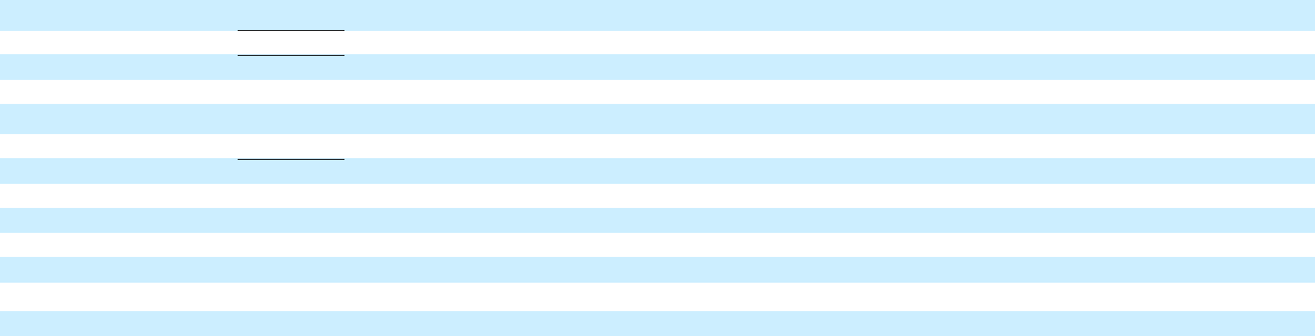

Net income attributable to common |  |  |  |  |  |  |  |  |  |  |  |  | $ | 2,381 |  |  |  |  |  |  |  |  |  |  |  |  |  | $ |  | 2,375
stockholders |  |  |  |  |  |  |  |  |  |  |  |  | $ |  |  |  |  |  |  |  |  |  |  |  |  |  |  |  |  | 2,375
 |  |  |  |  |  | Six Months Ended June 30, 2019 |  |  |  |  |  |  |  |  |  |  |  |  |  |  | Six Months Ended June 30, 2018
 |  | Automotive |  |  | GM Cruise |  | GM Financial |  |  | Reclassifications/Eliminations |  |  | Combined |  |  |  | Automotive |  |  | GM Cruise |  |  | GM Financial |  |  |  | Eliminations |  |  | Combined
Net sales and revenue
Automotive | $ | 63,686 |  | $ | 50 | $ |  | — |  | $ | (50) |  | $ | 63,686 |  | $ | 66,024 |  | $ | — | $ |  |  | — |  | $ | (58) | $ |  | 65,966
GM Financial |  | — |  |  | — |  |  | 7,259 |  |  | (7) |  |  | 7,252 |  |  | — |  |  | — |  |  |  | 6,899 |  |  | (6) |  |  | 6,893
Total net sales and revenue |  | 63,686 |  |  | 50 |  |  | 7,259 |  |  | (57) |  |  | 70,938 |  |  | 66,024 |  |  | — |  |  |  | 6,899 |  |  | (64) |  |  | 72,859

Costs and expenses

Automotive and other cost of sales

GM Financial interest, operating and other expenses

Automotive and other selling, general and administrative expense

Total costs and expenses

Operating income (loss)

Automotive interest expense

Interest income and other non-operating income, net

Equity income

56,071 |  | 487 |  | — |  | (2) |  | 56,556 |  | 60,009 |  | 305 |  | — |  | (59) |  | 60,255
— |  | — |  | 6,451 |  | (1) |  | 6,450 |  | — |  | — |  | 6,017 |  | (7) |  | 6,010
4,135 |  | 66 |  | — |  | — |  | 4,201 |  | 4,573 |  | 15 |  | — |  | — |  | 4,588
60,206 |  | 553 |  | 6,451 |  | (3) |  | 67,207 |  | 64,582 |  | 320 |  | 6,017 |  | (66) |  | 70,853
3,480 |  | (503) |  | 808 |  | (54) |  | 3,731 |  | 1,442 |  | (320) |  | 882 |  | 2 |  | 2,006
379 |  | — |  | — |  | (3) |  | 376 |  | 313 |  | 1 |  | — |  | (5) |  | 309
1,088 |  | 45 |  | — |  | 36 |  | 1,169 |  | 1,480 |  | — |  | — |  | (1) |  | 1,479
598 |  | — |  | 87 |  | — |  | 685 |  | 1,188 |  | — |  | 97 |  | — |  | 1,285

Income (loss) before income taxes | $ | 4,787 |  | $ | (458) |  | $ | 895 |  | $ | (15) |  |  | 5,209 |  | $ | 3,797 |  | $ | (321) |  | $ | 979 |  | $ | 6 |  |  | 4,461
Income tax expense |  |  |  |  |  |  |  |  |  |  |  |  |  | 661 |  |  |  |  |  |  |  |  |  |  |  |  |  |  | 985
Income from continuing operations |  |  |  |  |  |  |  |  |  |  |  |  |  | 4,548 |  |  |  |  |  |  |  |  |  |  |  |  |  |  | 3,476
Loss from discontinued operations, net |  |  |  |  |  |  |  |  |  |  |  |  |  | — |  |  |  |  |  |  |  |  |  |  |  |  |  |  | 70
of tax |  |  |  |  |  |  |  |  |  |  |  |  |  | — |  |  |  |  |  |  |  |  |  |  |  |  |  |  | 70
Net income |  |  |  |  |  |  |  |  |  |  |  |  |  | 4,548 |  |  |  |  |  |  |  |  |  |  |  |  |  |  | 3,406
Net loss attributable to noncontrolling |  |  |  |  |  |  |  |  |  |  |  |  |  | 27 |  |  |  |  |  |  |  |  |  |  |  |  |  |  | 30
interests |  |  |  |  |  |  |  |  |  |  |  |  |  | 27 |  |  |  |  |  |  |  |  |  |  |  |  |  |  | 30
Net income attributable to |  |  |  |  |  |  |  |  |  |  | $ |  |  | 4,575 |  |  |  |  |  |  |  |  |  |  |  | $ |  |  | 3,436
stockholders |  |  |  |  |  |  |  |  |  |  |  |  |  | 4,575 |  |  |  |  |  |  |  |  |  |  |  |  |  |  | 3,436
Net income attributable to common |  |  |  |  |  |  |  |  |  |  | $ |  |  | 4,500 |  |  |  |  |  |  |  |  |  |  |  | $ |  |  | 3,407
stockholders |  |  |  |  |  |  |  |  |  |  |  |  |  | 4,500 |  |  |  |  |  |  |  |  |  |  |  |  |  |  | 3,407

9

General Motors Company and Subsidiaries

Basic and Diluted Earnings per Share

(Unaudited)

The following table summarizes basic and diluted earnings (loss) per share (in millions, except per share amounts):

 |  | Three Months Ended |  |  |  |  |  | Six Months Ended
 |  | June 30, 2019 |  |  | June 30, 2018 |  |  | June 30, 2019 |  |  | June 30, 2018
Basic earnings per share
Income from continuing operations(a) | $ | 2,418 |  | $ | 2,390 |  | $ | 4,575 |  | $ | 3,506
Less: cumulative dividends on subsidiary preferred stock |  | (37) |  |  | (15) |  |  | (75) |  |  | (29)
Income from continuing operations attributable to common stockholders |  | 2,381 |  |  | 2,375 |  |  | 4,500 |  |  | 3,477
Loss from discontinued operations, net of tax |  | — |  |  | — |  |  | — |  |  | 70
Net income attributable to common stockholders | $ | 2,381 |  | $ | 2,375 |  | $ | 4,500 |  | $ | 3,407
Weighted-average common shares outstanding |  | 1,420 |  |  | 1,410 |  |  | 1,419 |  |  | 1,409
Basic earnings per common share – continuing operations | $ | 1.68 |  | $ | 1.68 |  | $ | 3.17 |  | $ | 2.47
Basic loss per common share – discontinued operations | $ | — |  | $ | — |  | $ | — |  | $ | 0.05
Basic earnings per common share | $ | 1.68 |  | $ | 1.68 |  | $ | 3.17 |  | $ | 2.42
Diluted earnings per share
Income from continuing operations attributable to common stockholders – diluted(a) | $ | 2,381 |  | $ | 2,375 |  | $ | 4,500 |  | $ | 3,477
Loss from discontinued operations, net of tax – diluted | $ | — |  | $ | — |  | $ | — |  | $ | 70
Net income attributable to common stockholders – diluted | $ | 2,381 |  | $ | 2,375 |  | $ | 4,500 |  | $ | 3,407
Weighted-average common shares outstanding – diluted |  | 1,438 |  |  | 1,431 |  |  | 1,437 |  |  | 1,430
Diluted earnings per common share – continuing operations | $ | 1.66 |  | $ | 1.66 |  | $ | 3.13 |  | $ | 2.43
Diluted loss per common share – discontinued operations | $ | — |  | $ | — |  | $ | — |  | $ | 0.05
Diluted earnings per common share | $ | 1.66 |  | $ | 1.66 |  | $ | 3.13 |  | $ | 2.38
Potentially dilutive securities(b) |  | 7 |  |  | 4 |  |  | 7 |  |  | 4
__________
- Net of Net loss attributable to noncontrolling interests.

- Potentially dilutive securities attributable to outstanding stock options and Restricted Stock Units were excluded from the computation of diluted EPS because the securities would have had an antidilutive effect.

10

General Motors Company and Subsidiaries

Combining Balance Sheet Information

(In millions, except per share amounts) (Unaudited)(a)

 |  | June 30, 2019 |  |  |  |  |  | December 31, 2018
Automotive | GM Cruise | GM Financial | Reclassifications/Eliminations | Combined |  | Automotive | GM Cruise | GM Financial | Reclassifications/Eliminations | Combined
ASSETS

Current Assets

Cash and cash equivalents

Marketable securities(b)

Accounts and notes receivable, net(c)

GM Financial receivables, net(d)

Inventories

Other current assets(e)

Total current assets

Non-current Assets

$ | 11,390 |  | $ 2,088 |  | $ | 3,594 |  | $ | — |  | $ | 17,072 |  | $ | 13,670 |  | $ 2,291 |  | $ | 4,883 |  | $ | — |  | $ | 20,844
 | 6,147 |  | 982 |  |  | — |  |  | (80) |  |  | 7,049 |  |  | 5,966 |  | 92 |  |  | — |  |  | (92) |  |  | 5,966
 | 10,068 |  | 11 |  |  | 1,077 |  |  | (794) |  |  | 10,362 |  |  | 5,916 |  | 1 |  |  | 1,430 |  |  | (798) |  |  | 6,549
 | — |  | — |  |  | 28,473 |  |  | (548) |  |  | 27,925 |  |  | — |  | — |  |  | 27,367 |  |  | (517) |  |  | 26,850
 | 11,447 |  | — |  |  | — |  |  | — |  |  | 11,447 |  |  | 9,816 |  | — |  |  | — |  |  | — |  |  | 9,816
 | 3,036 |  | 15 |  |  | 4,406 |  |  | (7) |  |  | 7,451 |  |  | 1,619 |  | 27 |  |  | 3,640 |  |  | (18) |  |  | 5,268
 | 42,089 |  | 3,096 |  |  | 37,549 |  |  | (1,430) |  |  | 81,306 |  |  | 36,987 |  | 2,411 |  |  | 37,320 |  |  | (1,425) |  |  | 75,293

GM Financial receivables, net(d) | — |  | — |  | 26,315 |  | (51) |  | 26,264 |  | — |  | — |  | 25,145 |  | (62) |  | 25,083
Equity in net assets of nonconsolidated affiliates | 6,894 |  | — |  | 1,446 |  | — |  | 8,340 |  | 7,860 |  | — |  | 1,355 |  | — |  | 9,215
Property, net | 37,826 |  | 123 |  | 239 |  | — |  | 38,188 |  | 38,464 |  | 43 |  | 251 |  | — |  | 38,758
Goodwill and intangible assets, net | 3,429 |  | 670 |  | 1,358 |  | — |  | 5,457 |  | 3,552 |  | 671 |  | 1,356 |  | — |  | 5,579
Equipment on operating leases, net | — |  | — |  | 42,938 |  | — |  | 42,938 |  | — |  | — |  | 43,559 |  | — |  | 43,559
Deferred income taxes | 23,857 |  | 199 |  | (69) |  | — |  | 23,987 |  | 23,935 |  | 70 |  | 77 |  | — |  | 24,082
Other assets | 6,252 |  | 123 |  | 933 |  | (52) |  | 7,257 |  | 4,880 |  | — |  | 890 |  | — |  | 5,770
Total non-current assets | 78,258 |  | 1,116 |  | 73,161 |  | (103) |  | 152,431 |  | 78,691 |  | 784 |  | 72,633 |  | (62) |  | 152,046

Total Assets

LIABILITIES AND EQUITY

Current Liabilities

Accounts payable (principally trade)(c)

Short-term debt and current portion of long-term debt

Automotive(d)

GM Financial

Accrued liabilities

Total current liabilities

Non-current Liabilities

Long-term debt

Automotive(d)

GM Financial

Postretirement benefits other than pensions

Pensions

Other liabilities

Total non-current liabilities

Total Liabilities

Commitments and contingencies

Equity

Common stock, $0.01 par value

Preferred stock, $0.01 par value

Additional paid-in capital(b)(f)

Retained earnings(b)

Accumulated other comprehensive loss

Total stockholders’ equity

Noncontrolling interests(f)

Total Equity

$ | 120,347 |  | $ | 4,212 |  | $ | 110,711 |  | $ | (1,533) |  | $ | 233,737 |  | $ | 115,678 |  | $ | 3,195 |  | $ | 109,953 |  | $ | (1,487) |  | $ | 227,339
$ | 22,834 |  | $ | 41 |  | $ | 656 |  | $ | (815) |  | $ | 22,717 |  | $ | 22,359 |  | $ | 28 |  | $ | 707 |  | $ | (797) |  | $ | 22,297
 | 3,038 |  |  | — |  |  | — |  |  | (548) |  |  | 2,490 |  |  | 1,452 |  |  | — |  |  | — |  |  | (517) |  |  | 935
 | — |  |  | — |  |  | 30,659 |  |  | — |  |  | 30,659 |  |  | — |  |  | — |  |  | 30,956 |  |  | — |  |  | 30,956
 | 24,430 |  |  | 87 |  |  | 3,918 |  |  | (7) |  |  | 28,428 |  |  | 24,042 |  |  | 41 |  |  | 3,985 |  |  | (19) |  |  | 28,049
 | 50,301 |  |  | 129 |  |  | 35,233 |  |  | (1,369) |  |  | 84,294 |  |  | 47,853 |  |  | 69 |  |  | 35,648 |  |  | (1,333) |  |  | 82,237
 | 13,009 |  |  | — |  |  | — |  |  | (51) |  |  | 12,957 |  |  | 13,090 |  |  | — |  |  | — |  |  | (62) |  |  | 13,028
 | — |  |  | — |  |  | 60,455 |  |  | — |  |  | 60,455 |  |  | — |  |  | — |  |  | 60,032 |  |  | — |  |  | 60,032
 | 5,357 |  |  | — |  |  | — |  |  | — |  |  | 5,357 |  |  | 5,370 |  |  | — |  |  | — |  |  | — |  |  | 5,370
 | 10,788 |  |  | — |  |  | 3 |  |  | — |  |  | 10,791 |  |  | 11,535 |  |  | — |  |  | 3 |  |  | — |  |  | 11,538
 | 10,471 |  |  | 204 |  |  | 2,171 |  |  | (52) |  |  | 12,794 |  |  | 10,167 |  |  | 35 |  |  | 2,155 |  |  | — |  |  | 12,357
 | 39,624 |  |  | 204 |  |  | 62,630 |  |  | (103) |  |  | 102,354 |  |  | 40,162 |  |  | 35 |  |  | 62,190 |  |  | (62) |  |  | 102,325
 | 89,925 |  |  | 333 |  |  | 97,862 |  |  | (1,473) |  |  | 186,648 |  |  | 88,015 |  |  | 104 |  |  | 97,838 |  |  | (1,395) |  |  | 184,562
 | 14 |  |  | — |  |  | — |  |  | — |  |  | 14 |  |  | 14 |  |  | — |  |  | — |  |  | — |  |  | 14
 | — |  |  | — |  |  | — |  |  | — |  |  | — |  |  | — |  |  | — |  |  | — |  |  | — |  |  | —
 | 25,791 |  |  | 36 |  |  | 1,373 |  |  | (1,435) |  |  | 25,765 |  |  | 25,606 |  |  | 4 |  |  | 1,373 |  |  | (1,420) |  |  | 25,563
 | 11,455 |  |  | 1,900 |  |  | 12,484 |  |  | (32) |  |  | 25,807 |  |  | 9,103 |  |  | 1,480 |  |  | 11,783 |  |  | (44) |  |  | 22,322
 | (7,762) |  |  | — |  |  | (1,009) |  |  | — |  |  | (8,770) |  |  | (7,998) |  |  | — |  |  | (1,041) |  |  | — |  |  | (9,039)
 | 29,497 |  |  | 1,936 |  |  | 12,848 |  |  | (1,467) |  |  | 42,816 |  |  | 26,725 |  |  | 1,484 |  |  | 12,115 |  |  | (1,464) |  |  | 38,860
 | 925 |  |  | 1,942 |  |  | — |  |  | 1,406 |  |  | 4,273 |  |  | 938 |  |  | 1,607 |  |  | — |  |  | 1,372 |  |  | 3,917
 | 30,422 |  |  | 3,878 |  |  | 12,848 |  |  | (60) |  |  | 47,089 |  |  | 27,663 |  |  | 3,091 |  |  | 12,115 |  |  | (92) |  |  | 42,777

Total Liabilities and Equity | $ | 120,347 | $ 4,212 | $ | 110,711 | $ | (1,533) | $ | 233,737 | $ | 115,678 | $ 3,195 | $ | 109,953 | $ | (1,487) | $ | 227,339

_________
- Amounts may not sum due to rounding.
- Elimination primarily includes GM Cruise investment in GM common stock at June 30, 2019 and December 31, 2018.
- Eliminations primarily include Automotive accounts receivable of $69 million offset by GM Financial accounts payable and GM Financial accounts receivable of $710 million offset by Automotive accounts payable at June 30, 2019 and Automotive accounts receivable of $63 million offset by GM Financial accounts payable and GM Financial accounts receivable of $729 million offset by Automotive accounts payable at December 31, 2018.
- Eliminations include GM Financial loan receivable of $599 million and $579 million offset by an Automotive loan payable at June 30, 2019 and December 31, 2018.
- Includes the reclassification of the current portion of Equipment on operating leases, net. The prior period has been recast to reflect the changes.
- Primarily reclassification of GM Financial Cumulative Perpetual Preferred Stock, Series A and B. The preferred stock is classified as noncontrolling interests in our condensed consolidated balance sheet.

11

General Motors Company and Subsidiaries

Combining Cash Flow Information

(In millions) (Unaudited)(a)

 |  |  |  |  |  |  | Six Months Ended June 30, 2019 |  |  |  |  |  |  |  |  |  |  |  |  |  |  | Six Months Ended June 30, 2018
 |  | Automotive |  |  | GM Cruise |  |  | GM Financial |  | Reclassification/Eliminations |  |  |  | Combined |  |  | Automotive |  |  | GM Cruise |  |  | GM Financial |  | Reclassification/Eliminations |  |  |  | Combined
Cash flows from operating activities
Income (loss) from continuing operations | $ | 4,209 |  | $ | (329) |  | $ | 683 |  | $ | (15) |  | $ | 4,548 |  | $ | 2,973 |  | $ | (296) |  | $ | 793 |  | $ | 6 |  | $ | 3,476
Depreciation and impairment of Equipment on operating leases,
net |  | 38 |  |  | — |  |  | 3,710 |  |  | — |  |  | 3,748 |  |  | 102 |  |  | — |  |  | 3,621 |  |  | — |  |  | 3,723
Depreciation, amortization and impairment charges on Property,
net |  | 3,729 |  |  | 9 |  |  | 37 |  |  | — |  |  | 3,775 |  |  | 2,949 |  |  | 3 |  |  | 35 |  |  | — |  |  | 2,987
Foreign currency remeasurement and transaction (gains) losses |  | (174) |  |  | — |  |  | (4) |  |  | — |  |  | (178) |  |  | 91 |  |  | — |  |  | 15 |  |  | — |  |  | 106
Undistributed earnings of nonconsolidated affiliates, net |  | 343 |  |  | — |  |  | (87) |  |  | — |  |  | 256 |  |  | 807 |  |  | — |  |  | (97) |  |  | — |  |  | 710
Pension contributions and OPEB payments |  | (570) |  |  | — |  |  | — |  |  | — |  |  | (570) |  |  | (932) |  |  | — |  |  | — |  |  | — |  |  | (932)
Pension and OPEB income, net |  | (306) |  |  | — |  |  | — |  |  | — |  |  | (306) |  |  | (627) |  |  | — |  |  | — |  |  | — |  |  | (627)
Provision (benefit) for deferred taxes |  | 30 |  |  | (129) |  |  | 178 |  |  | — |  |  | 79 |  |  | 470 |  |  | (26) |  |  | 142 |  |  | — |  |  | 586
Change in other operating assets and liabilities(b)(c) |  | (5,693) |  |  | 83 |  |  | (224) |  |  | (522) |  |  | (6,357) |  |  | (2,910) |  |  | 44 |  |  | (944) |  |  | (666) |  |  | (4,476)
Net cash provided by (used in) operating activities |  | 1,606 |  |  | (367) |  |  | 4,293 |  |  | (538) |  |  | 4,995 |  |  | 2,923 |  |  | (275) |  |  | 3,565 |  |  | (660) |  |  | 5,553
Cash flows from investing activities
Expenditures for property |  | (3,428) |  |  | (23) |  |  | (25) |  |  | — |  |  | (3,476) |  |  | (4,305) |  |  | (12) |  |  | (34) |  |  | — |  |  | (4,351)
Available-for-sale marketable securities, acquisitions |  | (1,314) |  |  | (899) |  |  | — |  |  | — |  |  | (2,213) |  |  | (1,571) |  |  | — |  |  | — |  |  | — |  |  | (1,571)
Available-for-sale marketable securities, liquidations |  | 1,244 |  |  | 26 |  |  | — |  |  | (26) |  |  | 1,244 |  |  | 2,886 |  |  | — |  |  | — |  |  | — |  |  | 2,886
Purchases of finance receivables, net(b)(c) |  | — |  |  | — |  |  | (14,670) |  |  | 914 |  |  | (13,757) |  |  | — |  |  | — |  |  | (11,635) |  |  | 857 |  |  | (10,778)
Principal collections and recoveries on finance receivables(c) |  | — |  |  | — |  |  | 12,096 |  |  | (388) |  |  | 11,708 |  |  | — |  |  | — |  |  | 7,593 |  |  | (173) |  |  | 7,420
Purchases of leased vehicles, net |  | — |  |  | — |  |  | (8,189) |  |  | — |  |  | (8,189) |  |  | — |  |  | — |  |  | (9,122) |  |  | — |  |  | (9,122)
Proceeds from termination of leased vehicles |  | — |  |  | — |  |  | 6,444 |  |  | — |  |  | 6,444 |  |  | — |  |  | — |  |  | 5,303 |  |  | — |  |  | 5,303
Other investing activities(d) |  | (587) |  |  | — |  |  | (5) |  |  | 690 |  |  | 99 |  |  | (1,367) |  |  | — |  |  | — |  |  | 1,374 |  |  | 7
Net cash used in investing activities – continuing operations |  | (4,083) |  |  | (897) |  |  | (4,349) |  |  | 1,190 |  |  | (8,140) |  |  | (4,357) |  |  | (12) |  |  | (7,895) |  |  | 2,058 |  |  | (10,206)
Net cash provided by investing activities – discontinued
operations |  | — |  |  | — |  |  | — |  |  | — |  |  | — |  |  | 166 |  |  | — |  |  | — |  |  | — |  |  | 166
Net cash used in investing activities |  | (4,083) |  |  | (897) |  |  | (4,349) |  |  | 1,190 |  |  | (8,140) |  |  | (4,191) |  |  | (12) |  |  | (7,895) |  |  | 2,058 |  |  | (10,040)
Cash flows from financing activities
Net increase (decrease) in short-term debt |  | 693 |  |  | — |  |  | 243 |  |  | — |  |  | 936 |  |  | (51) |  |  | — |  |  | 695 |  |  | — |  |  | 644
Proceeds from issuance of debt (original maturities greater than
three months)(d) |  | 986 |  |  | — |  |  | 19,525 |  |  | — |  |  | 20,511 |  |  | 2,321 |  |  | 274 |  |  | 20,836 |  |  | (274) |  |  | 23,157
Payments on debt (original maturities greater than three months) |  | (222) |  |  | — |  |  | (20,402) |  |  | — |  |  | (20,625) |  |  | (1,898) |  |  | — |  |  | (16,918) |  |  | (24) |  |  | (18,840)
Proceeds from issuance of preferred stock(d) |  | — |  |  | 1,101 |  |  | — |  |  | (687) |  |  | 414 |  |  | 361 |  |  | 2,000 |  |  | — |  |  | (1,100) |  |  | 1,261
Dividends paid |  | (1,109) |  |  | (31) |  |  | (46) |  |  | 2 |  |  | (1,184) |  |  | (1,074) |  |  | — |  |  | (30) |  |  | — |  |  | (1,104)
Other financing activities(e) |  | (215) |  |  | (4) |  |  | (78) |  |  | 33 |  |  | (264) |  |  | (362) |  |  | (9) |  |  | (92) |  |  | — |  |  | (463)
Net cash provided by (used in) financing activities |  | 132 |  |  | 1,066 |  |  | (758) |  |  | (652) |  |  | (212) |  |  | (703) |  |  | 2,265 |  |  | 4,491 |  |  | (1,398) |  |  | 4,655
Effect of exchange rate changes on cash, cash equivalents and
restricted cash |  | 20 |  |  | — |  |  | 22 |  |  | — |  |  | 42 |  |  | (185) |  |  | — |  |  | (60) |  |  | — |  |  | (245)
Net increase (decrease) in cash, cash equivalents and restricted
cash |  | (2,325) |  |  | (197) |  |  | (792) |  |  | — |  |  | (3,315) |  |  | (2,156) |  |  | 1,978 |  |  | 101 |  |  | — |  |  | (77)
Cash, cash equivalents and restricted cash at beginning of period |  | 13,762 |  |  | 2,291 |  |  | 7,443 |  |  | — |  |  | 23,496 |  |  | 11,258 |  |  | 23 |  |  | 6,567 |  |  | — |  |  | 17,848
Cash, cash equivalents and restricted cash at end of period | $ | 11,437 |  | $ | 2,093 |  | $ | 6,651 |  | $ | — |  | $ | 20,181 |  | $ | 9,102 |  | $ | 2,001 |  | $ | 6,668 |  | $ | — |  | $ | 17,771
Cash, cash equivalents and restricted cash – continuing operations
at end of period | $ | 11,437 |  | $ | 2,093 |  | $ | 6,651 |  | $ | — |  | $ | 20,181 |  | $ | 9,102 |  | $ | 2,001 |  | $ | 6,668 |  | $ | — |  | $ | 17,771
_________
- Amounts may not sum due to rounding.
- Includes reclassifications of $432 million and $541 million in the six months ended June 30, 2019 and 2018 for purchases/collections of wholesale finance receivables resulting from vehicles sold by GM to dealers that have arranged their inventory floor plan financing through GM Financial.

- Eliminations include $482 million and $216 million in Purchases of finance receivables, net in the six months ended June 30, 2019 and 2018 and $388 million and $173 million in Principal collections and recoveries on finance receivables in the six months ended June 30, 2019 and 2018 primarily related to the re-timing of cash receipts and payments between Automotive and GM Financial.
- Eliminations include $690 million and $1.4 billion in the six months ended June 30, 2019 and 2018 for Automotive cash injections in GM Cruise, inclusive of investments of $687 million and $1.1 billion in GM Cruise Preferred Shares in the six months ended June 30, 2019 and 2018.
- Includes the reclassification of Payments to purchase common stock. The prior period has been recast to reflect the changes.

12

