SEC Form 3
FORM 3 | UNITED STATES SECURITIES AND EXCHANGE COMMISSION
 | Washington, D.C. 20549
 | Washington, D.C. 20549 |  | OMB APPROVAL
 | INITIAL STATEMENT OF BENEFICIAL OWNERSHIP OF SECURITIES
 | INITIAL STATEMENT OF BENEFICIAL OWNERSHIP OF SECURITIES |  | OMB Number: | 3235-0104
 |  |  | Estimated average burden
 | Filed pursuant to Section 16(a) of the Securities Exchange Act of 1934 |  | hours per response: | 0.5
or Section 30(h) of the Investment Company Act of 1940
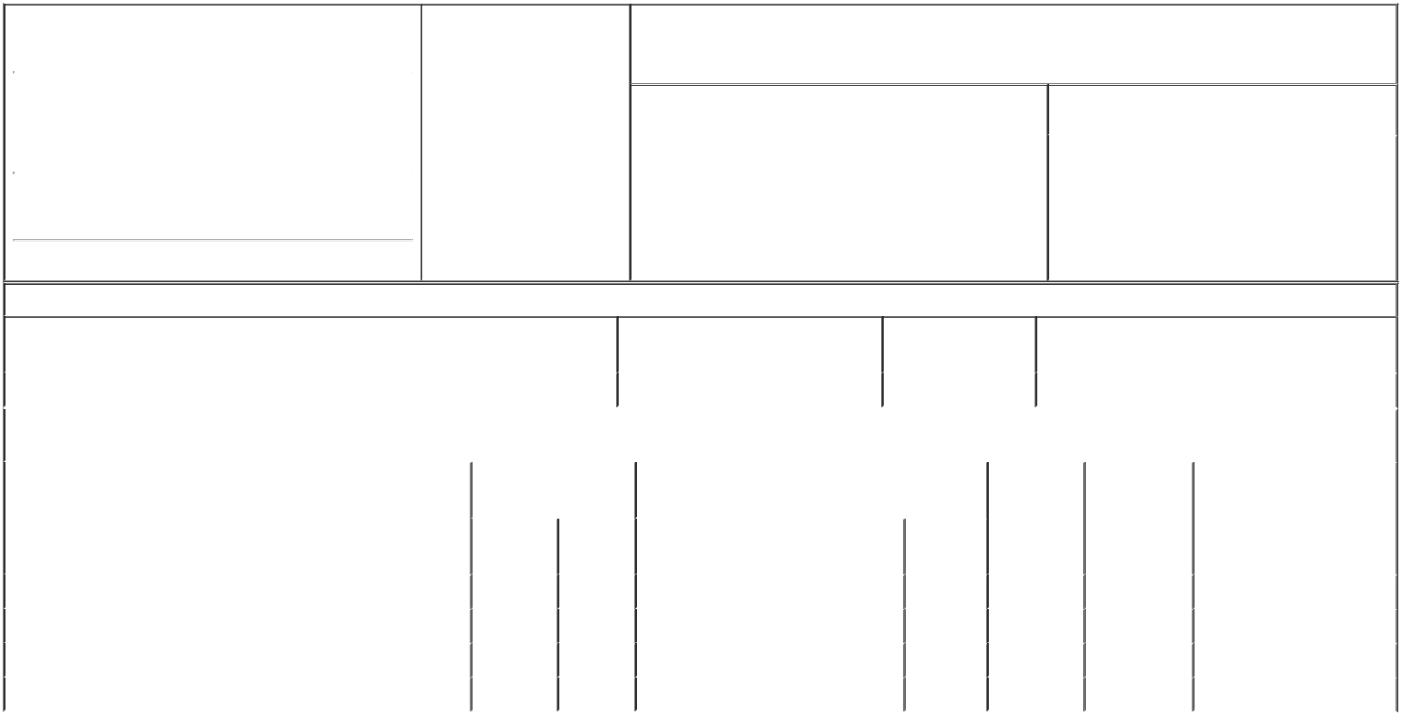

1. Name and Address of Reporting Person* |  |  |  |  | 2. Date of Event Requiring
 | MOTT RANDALL D |  |  |  | Statement (Month/Day/Year)
 |  |  |  | 06/05/2019
 | (Last) | (First) |  | (Middle)
 | 300 RENAISSANCE CENTER
 | M/C: 482-C25-A36
(Street)
 | DETROIT | MI |  | 48265-3000

3. Issuer Name and Ticker or Trading Symbol

General Motors Co [ GM ]

4. Relationship of Reporting Person(s) to Issuer |  |  | 5. | If Amendment, Date of Original Filed (Month/Day/Year)
(Check all applicable)
 | Director | 10% Owner
X | Officer (give title | Other (specify below) | 6. | Individual or Joint/Group Filing (Check Applicable Line)
X | below) | Other (specify below) |  | X | Form filed by One Reporting Person

Executive Vice President & CIO | Form filed by More than One Reporting Person

(City) (State) (Zip)

Table I - Non-Derivative Securities Beneficially Owned

1. Title of Security (Instr. 4) | 2. Amount of Securities Beneficially | 3. Ownership Form: | 4. Nature of Indirect Beneficial Ownership (Instr. 5)
 | Owned (Instr. 4) | Direct (D) or Indirect
 |  | (I) (Instr. 5)

 | Common Stock |  |  |  | 200,770 | D
 |  |  | Table II - Derivative Securities Beneficially Owned
 |  | (e.g., puts, calls, warrants, options, convertible securities)
 | 1. Title of Derivative Security (Instr. 4) |  | 2. Date Exercisable and |  | 3. Title and Amount of Securities Underlying |  | 4. | 5. Ownership | 6. Nature of Indirect Beneficial
 |  |  | Expiration Date |  | Derivative Security (Instr. 4) |  | Conversion | Form: Direct | Ownership (Instr. 5)
 |  |  | (Month/Day/Year) |  |  |  | or Exercise | (D) or Indirect
 |  |  |  |  |  |  | Price of | (I) (Instr. 5)
 |  |  |  |  |  | Amount or | Price of | (I) (Instr. 5)
 |  |  |  |  |  | Amount or | Derivative
 |  |  | Date | Expiration | Title | Number of | Security
 |  |  | Exercisable | Date | Title | Shares
 | Employee Stock Option (Right to Buy)⁽¹⁾ | (1) |  | 02/28/2025 | Common Stock | 345,705 | 31.32 | D
 | Employee Stock Option (Right to Buy)⁽²⁾ | (2) |  | 06/07/2027 | Common Stock | 80,322 | 34.34 | D
 | Employee Stock Option (Right to Buy)⁽³⁾ | (3) |  | 02/11/2028 | Common Stock | 48,310 | 41.4 | D
 | Employee Stock Option (Right to Buy)⁽⁴⁾ | (4) |  | 02/13/2029 | Common Stock | 57,084 | 39 | D
 | Explanation of Responses:

- These Stock Options were granted on July 28, 2015, (the "Grant Date") under the Company's 2014 Long-Term Incentive Plan (the "DSV Options"). Eighty percent of the 345,705 DSV Options granted have vested. The remaining 20% will vest on February 15, 2020, provided that the Company meets or exceeds the median total shareholder return of the 14 original equipment manufacturers (other than GM) on the Dow Jones Automobiles and Parts Titans 30 Index on the Grant Date for the performance period form July 28, 2015, through December 31, 2019.

- These Stock Options were granted on June 7, 2017, under the Company's 2017 Long-Term Incentive Plan (the "2017 LTIP"). Two-thirds of the 80,322 Stock Options granted have vested; the remaining one-third will vest on February 14, 2020.

- These Stock Options were granted on February 13, 2018, under the Company's 2017 LTIP. One-third of the 48,310 Stock Options granted have vested; one-third will vest on February 13, 2020; and one-third will vest on February 13, 2021.

- These Stock Options were granted on February 13, 2019, under the Company's 2017 LTIP. One-third of the 57,084 Stock Options granted will vest on February 13, 2020; and one-third will vest on February 13, 2021; and one-third will vest on February 13, 2022.

Remarks:

/s/ Tia Y. Turk, attorney-in-fact for Mr.

Mott

** Signature of Reporting Person

Reminder: Report on a separate line for each class of securities beneficially owned directly or indirectly.

* If the form is filed by more than one reporting person, see Instruction 5 (b)(v).

- Intentional misstatements or omissions of facts constitute Federal Criminal Violations See 18 U.S.C. 1001 and 15 U.S.C. 78ff(a). Note: File three copies of this Form, one of which must be manually signed. If space is insufficient, see Instruction 6 for procedure.
Persons who respond to the collection of information contained in this form are not required to respond unless the form displays a currently valid OMB Number.

06/14/2019

Date



