UNITED STATES

SECURITIES AND EXCHANGE COMMISSION
Washington, DC 20549-1004

FORM 8-K

CURRENT REPORT

PURSUANT TO SECTION 13 OR 15(d) OF THE

SECURITIES EXCHANGE ACT OF 1934

Date of Report (Date of earliest event reported) September 28, 2011

GENERAL MOTORS COMPANY

(Exact Name of Registrant as Specified in its Charter)

DELAWARE | 001-34960 | 27-0756180
(State or other jurisdiction | (Commission | (I.R.S. Employer
of incorporation) | File Number) | Identification No.)
300 Renaissance Center, Detroit, Michigan |  | 48265-3000
(Address of Principal Executive Offices) |  | (Zip Code)

(313) 556-5000

(Registrant’s telephone number, including area code)

Not Applicable

(Former name or former address, if changed since last report)

Check the appropriate box below if the Form 8-K filing is intended to simultaneously satisfy the filing obligation of the registrant under any of the following provisions:

- Written communications pursuant to Rule 425 under the Securities Act (17 CFR 230.425)

- Soliciting material pursuant to Rule 14a-12 under the Exchange Act (17-CFR 240.14a-12)

- Pre-commencement communications pursuant to Rule 14d-2(b) under the Exchange Act (17 CFR 240.14d-2(b))

- Pre-commencement communications pursuant to Rule 13e-4(c) under the Exchange Act (17 CFR 240.13e-4(c))

TABLE OF CONTENTS

ITEM 8.01 Other Events

Signature

Index to Exhibits

New Release Dated September 28, 2011

Presentation Webcast Charts Dated September 28, 2011

ITEM 8.01 Other Events

On September 28, 2011, Mr. Dan Akerson, Chairman and Chief Executive Officer and Mr. Dan Ammann, Senior Vice President and Chief Financial Officer, conducted a webcast presentation to provide a summary of the labor agreement reached with the International Union, United Automobile, Aerospace and Agricultural Implement Workers of America. The news release and presentation related thereto are attached as Exhibits 99.1 and 99.2.

 |  |  |  | EXHIBITS
Exhibit |  | Description |  |  | Method of Filing
 | 99.1
Exhibit | 99.1 | News Release
 |  | Dated September 28, 2011 |  |  | Attached as Exhibit
Exhibit 99.2 |  | Presentation Charts
 |  | Dated September 28, 2011 |  |  | Attached as Exhibit

SIGNATURE

Pursuant to the requirements of the Securities Exchange Act of 1934, the Registrant has duly caused this report to be signed on its behalf by the undersigned hereunto duly authorized.

GENERAL MOTORS COMPANY

(Registrant)

Date: September 30, 2011 By: /s/ Nick S. Cyprus

Nick S. Cyprus

Vice President, Controller and Chief Accounting

Officer

Exhibit 99.1
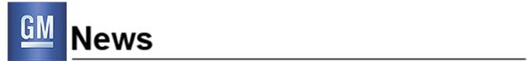

For Release: Wednesday, Sept. 28, 2011, 2:00 p.m. ET

New Labor Agreement Enables GM’s Continued Progress

Agreement maintains GM’s low break-even level, gives all employees a direct stake in the

company’s performance and protects its fortress balance sheet

DETROIT – General Motors Co. today outlined details of its 2011 labor agreement with the United Auto Workers (UAW) during a conference call with analysts and media, hosted by Chairman and Chief Executive Officer Dan Akerson and Senior Vice President and Chief Financial Officer Dan Ammann. The agreement, which has been ratified by the UAW membership (65 percent production and 63 percent skilled trades), covers 48,500 hourly GM employees.

“The agreement is a win-win for our employees and our company,” said Akerson. “It underscores the alignment between the UAW and the new GM in our efforts to drive long-term success, and gives all of our employees a direct stake in the quality of our products and our performance.”

The agreement is expected to have a limited impact on GM’s fixed cost. Instead, it recognizes hourly employees with a simpler and more transparent profit sharing plan that directly aligns with the company’s performance. In addition, a new quality performance-based bonus is being implemented that will give employees an opportunity to benefit from improvements in the initial quality of GM vehicles.

Importantly, it protects GM’s low break-even level in the event of a U.S. industry downturn, and preserves GM’s fortress balance sheet, with no pension increases and the capping of the hourly defined benefit pension plan population.

“GM and the UAW remain steadfast in our commitment to strengthen the U.S. manufacturing base, create good-paying jobs and build the high-quality, fuel-efficient cars and trucks our customers deserve,” said Akerson.

In addition to the $5.1 billion GM has invested in products and plants, and 13,000 jobs it has created or retained in the U.S. since August 2009, the company plans to make additional manufacturing investments of more than $2 billion to create or retain more than 6,300 jobs during the four-year agreement period.

Additional details about the agreement can be found on the GM Investor Relations web site at www.gm.com/investors.

General Motors (NYSE:GM, TSX: GMM), one of the world’s largest automakers, traces its roots back to 1908. With its global headquarters in Detroit, GM employs 208,000 people in every major region of the world and does business in more than 120 countries. GM and its strategic partners produce cars and trucks in 30 countries, and sell and service these vehicles through the following brands: Baojun, Buick, Cadillac, Chevrolet, GMC, Daewoo, Holden, Isuzu, Jiefang, Opel, Vauxhall, and Wuling. The global Chevrolet brand celebrates its 100th anniversary in 2011. GM’s largest national market is China, followed by the United States, Brazil, the United Kingdom, Germany, Canada, and Italy. GM’s OnStar subsidiary is the industry leader in vehicle safety, security and information services. More information on the new General Motors can be found at www.gm.com.

Forward-Looking Statements:

In this press release and in related comments by our management, our use of the words “expect,” “anticipate,” “possible,” “potential,” “target,” “believe,” “commit,” “intend,” “continue,” “may,” “would,” “could,” “should,” “project,” “projected,” “positioned” or similar expressions is intended to identify forward-looking statements that represent our current judgment about possible future events. We believe these judgments are reasonable, but these statements are not guarantees of any events or financial results, and our actual results may differ materially due to a variety of important factors. Among other items, such factors might include: our ability to realize production efficiencies and to achieve reductions in costs as a result of our restructuring initiatives and labor modifications; our ability to maintain quality control over our vehicles and avoid material vehicle recalls; our ability to maintain adequate liquidity and financing sources and an appropriate level of debt, including as required to fund our planned significant investment in new technology; the ability of our suppliers to timely deliver parts, components and systems; our ability to realize successful vehicle applications of new technology; and our ability to continue to attract new customers, particularly for our new products. GM’s most recent annual report on Form 10-K and quarterly reports on Form 10-Q provides information about these and other factors, which we may revise or supplement in future reports to the SEC.

Contacts:

Kim Carpenter

Labor Communication

Cell 248-836-7731

kimberly.carpenter@gm.com

Reneé Rashid-Merem

Financial Communication

Office 313-665-3128

Cell 313-701-8560

renee.rashid-merem@gm.com

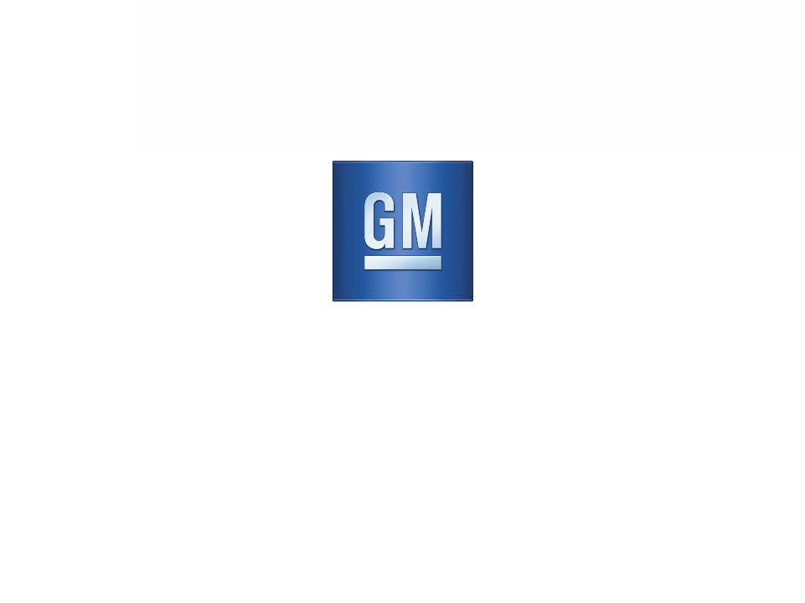
Exhibit 99.2

General Motors Company

2011 GM-UAW Labor Agreement

September 28, 2011

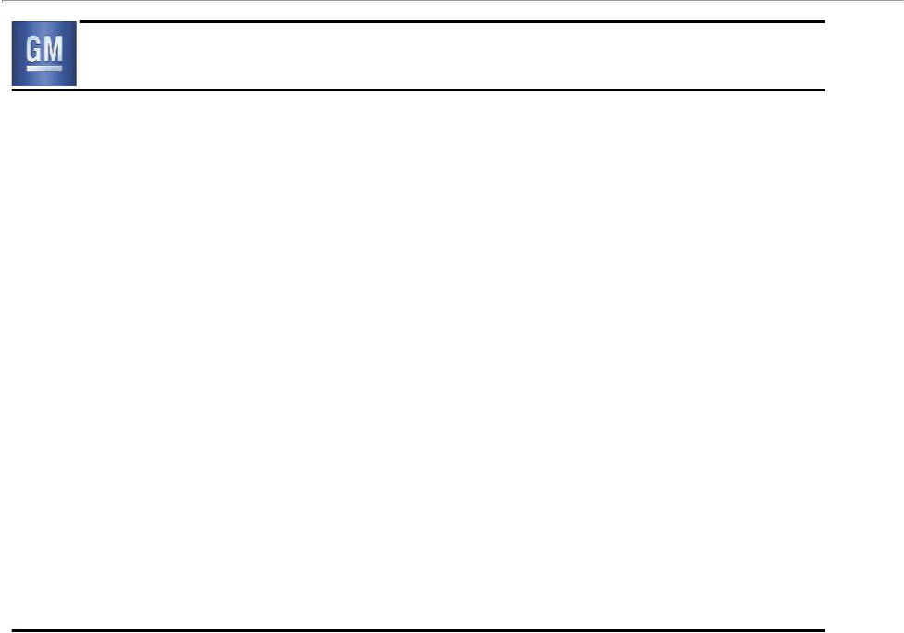
Forward Looking Statements

In this presentation and in related comments by our management, our use of the words “expect,” “anticipate,” “possible,” “potential,” “target,” “believe,” “commit,” “intend,” “continue,” “may,” “would,” “could,” “should,” “project,” “projected,” “positioned” or similar expressions is intended to identify forward looking statements that represent our current judgment about possible future events. We believe these judgments are reasonable, but these statements are not guarantees of any events or financial results, and our actual results may differ materially due to a variety of important factors. Among other items, such factors might include: our ability to realize production efficiencies and to achieve reductions in costs as a result of our restructuring initiatives and labor modifications; our ability to maintain quality control over our vehicles and avoid material vehicle recalls; our suppliers’ ability to deliver parts, systems and components at such times to allow us to meet production schedules; our ability to maintain adequate liquidity and financing sources and an appropriate level of debt, including as required to fund our planned significant investment in new technology; our ability to realize successful vehicle applications of new technology; and our ability to continue to attract new customers, particularly for our new products.

GM's most recent annual report on Form 10-K and quarterly report on Form 10-Q provides information about these and other factors, which we may revise or supplement in future reports to the SEC.

1

Key Takeaways

- Maintained GMNA break-even point

- Minimal P & L impact

- Protected our balance sheet

- Increased flexibility to add U.S. jobs

2

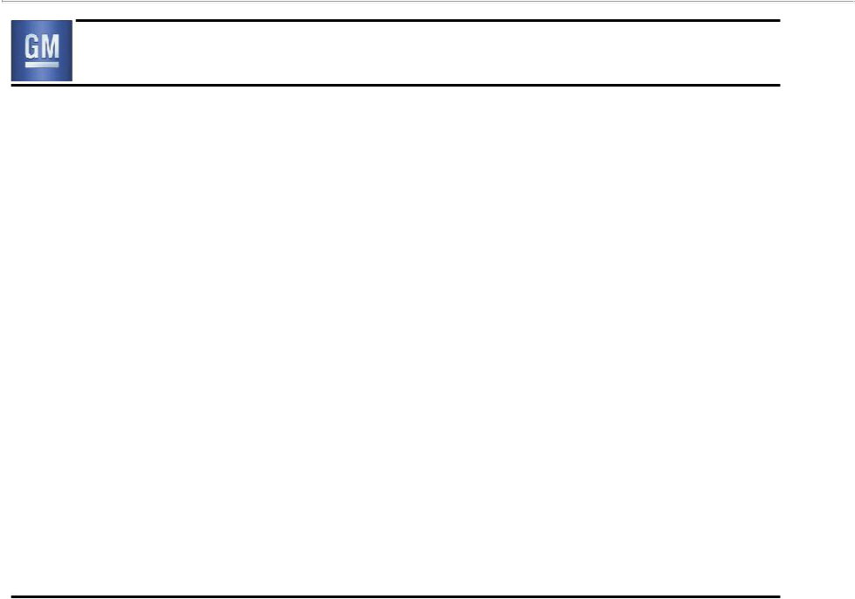
2011 GM-UAW Agreement Overview

- Key non-compensation items

– Entry Level transitioned to Defined Contribution pension plan

– No pension increases

– Permanent elimination of “JOBs Bank”

– Special Attrition Program (SAP) for skilled trades

– Elimination of Legal Services Plan for active / retiree

- Key compensation items

– Entry Level maximum wage rates increased

– No base wage increase for Tier I employees

– Cost of living (COLA) still suspended

– Lump sums and larger ratification bonus in lieu of base wage increases

– Gain sharing plan linked to quality

– Simplified and transparent profit sharing formula, which is capped

- Strategic investment in U.S manufacturing

3

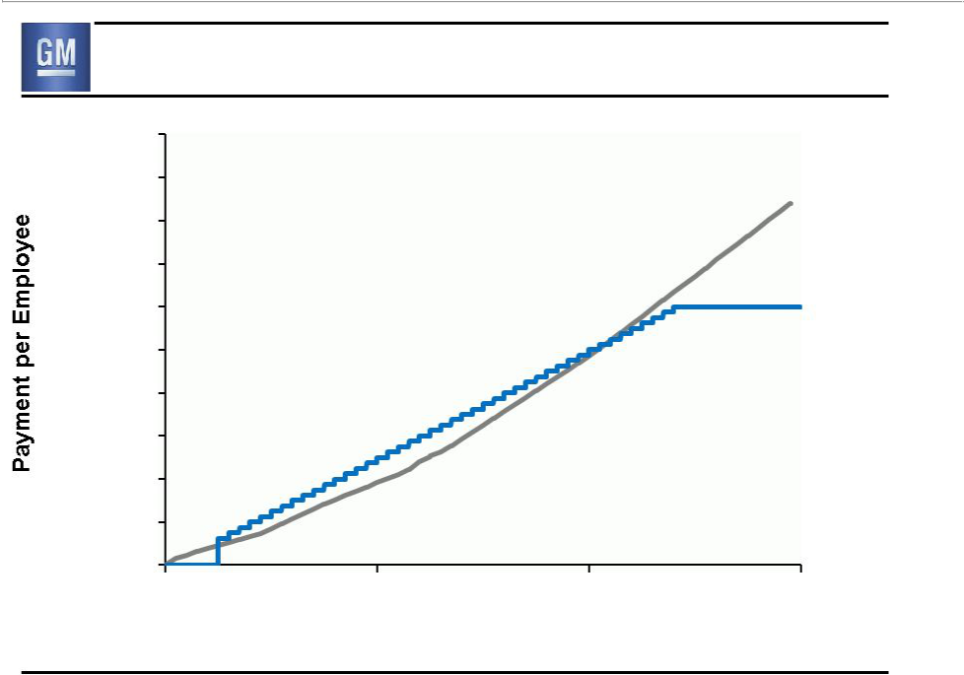
Profit Sharing Comparison

$20,000

$18,000

$16,000

$14,000

$12,000

$10,000

$8,000

$6,000

$4,000

$2,000

$-

0

* Estimate based on U.S. eligible profits as defined by old plan

Old*

(Not Capped)

New

(Capped)

5 10 15

GMNA EBIT Adjusted ($B)

4

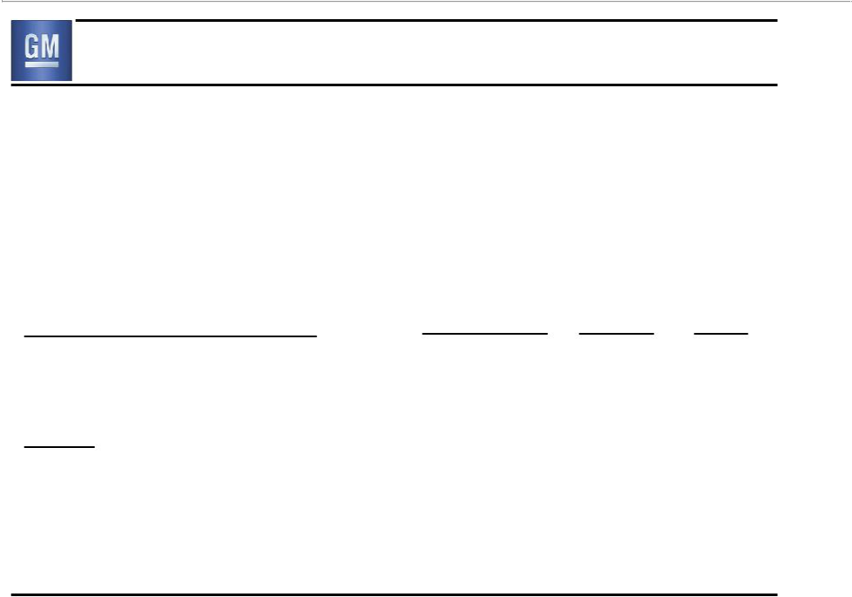
U.S. Hourly Workforce Demographics

- $10K retirement incentive for all eligible employees who retire between October 1, 2011 and September 1, 2013

- Special Attrition Program for skilled trades

– Incremental $65K retirement incentive if retired by March 31, 2012

% of U.S. Hourly Workforce | Production | Skilled | Total
Retirement Eligible – All Types | 34% | 58% | 39%
Memo: |  |  | 17%
- Detroit Competitors |  |  | 17%

Data as of 12/31/2010, Hourly Workforce Demographics Study

5

U.S. Hourly Labor Cost
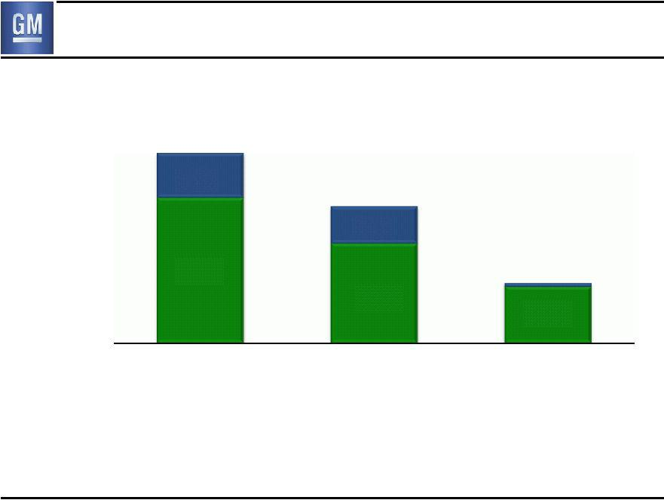

Historical Perspective

Retiree
Healthcare

Active

Year-End U.S.

Hourly Employees (000’s)

$16B

^{$4B} $11B

$3B

$12B

$8B

2005 2007

111 78

$5B

$5B

2010

49

For periods prior to July 10, 2009 information is related to General Motors Corporation (Old GM), our predecessor entity

6

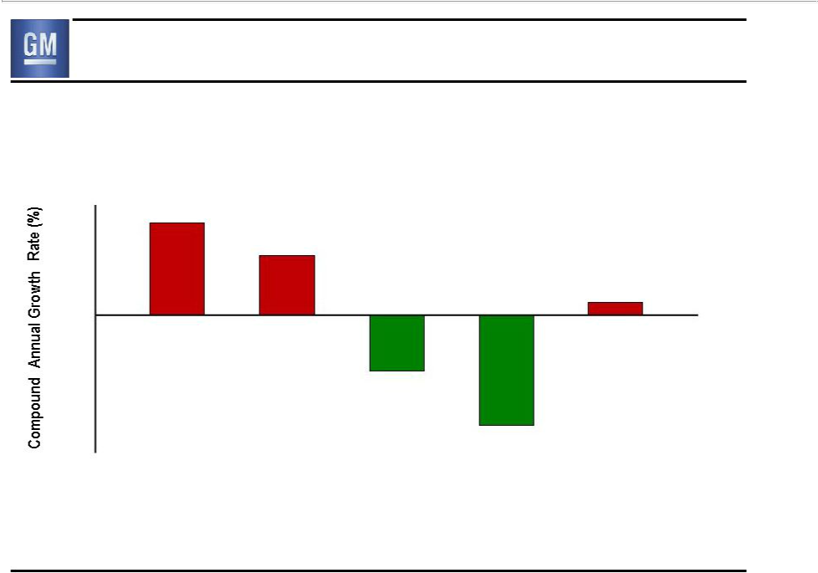
Historic GM-UAW Contract Settlement Economics

8%

6%

4%

2%

0%

-2%

-4%

-6%

-8%

-10%

Fully Loaded Active Hourly Rate CAGR 7%

4%

1%

(4)%

(8)%

‘99 ‘03 ‘07 ‘09 ‘11

For periods prior to July 10, 2009 information is related to General Motors Corporation (Old GM), our predecessor entity

7

Estimated Expense Impact

$ Millions F / (U) | 2011 CY | 2012 CY | 2013 CY
Compensation Related Impact * | (135) | (220) | (230)

Special Attrition Program | (90) | 55 | 65
(Skilled Trades) | (90) | 55 | 65

Elimination of Legal Service** | 50 | 145 | 145

Estimated Expense Impact | (175) | (20) | (20)

  - Includes ratification bonus, lump sum payments, tier II wage increase, profit sharing, and layoff provisions

- Impact from elimination ends in 2013

8

Key Takeaways

- Maintained GMNA break-even point

- Minimal P & L impact

- Protected our balance sheet

- Increased flexibility to add U.S. jobs

9

