Table of Contents

UNITED STATES

SECURITIES AND EXCHANGE COMMISSION
Washington, DC 20549-1004

FORM 8-K

CURRENT REPORT

PURSUANT TO SECTION 13 OR 15(d) OF THE

SECURITIES EXCHANGE ACT OF 1934

Date of Report (Date of earliest event reported) May 5, 2011

GENERAL MOTORS COMPANY

(Exact Name of Registrant as Specified in its Charter)

001-34960 | DELAWARE | 27-0756180
(Commission | (State or other jurisdiction | (I.R.S. Employer
File Number) | of incorporation) | Identification No.)

300 Renaissance Center, Detroit, Michigan

48265-3000

(Address of Principal Executive Offices)

(Zip Code)

(313) 556-5000

(Registrant’s telephone number, including area code)

Not Applicable

(Former name or former address, if changed since last report)

Check the appropriate box below if the Form 8-K filing is intended to simultaneously satisfy the filing obligation of the registrant under any of the following provisions:

- Written communications pursuant to Rule 425 under the Securities Act (17 CFR 230.425)

- Soliciting material pursuant to Rule 14a-12 under the Exchange Act (17-CFR 240.14a-12)

- Pre-commencement communications pursuant to Rule 14d-2(b) under the Exchange Act (17 CFR 240.14d-2(b))

- Pre-commencement communications pursuant to Rule 13e-4(c) under the Exchange Act (17 CFR 240.13e-4(c))

Table of Contents

TABLE OF CONTENTS

ITEM 2.02 RESULTS OF OPERATIONS AND FINANCIAL CONDITION

ITEM 9.01 FINANCIAL STATEMENTS AND EXHIBITS

SIGNATURES

INDEX TO EXHIBITS

News Release Dated May 5, 2011 and Financial Statements

Charts Furnished to Securities Analysts

Table of Contents

ITEM 2.02 RESULTS OF OPERATIONS AND FINANCIAL CONDITION

On May 5, 2011 a news release was issued on the subject of first quarter 2011 consolidated earnings for General Motors Company (GM). The news release did not include certain financial statements, related footnotes and certain other financial information that will be filed with the Securities and Exchange Commission as part of GM’s Quarterly Report on Form 10-Q. The news release and financial statements are incorporated as Exhibit 99.1.

Charts furnished to securities analysts in connection with GM’s first quarter 2011 earnings release are attached as Exhibit 99.2.

ITEM 9.01 FINANCIAL STATEMENTS AND EXHIBITS

 |  |  |  |  | EXHIBITS
Exhibits |  | Description |  |  |  |  |  | Method of Filing
Exhibit 99.1 |  | News Release Dated |  |  |  |  |  | Attached as Exhibit
 |  | May 5, 2011 and
 |  | Financial Statements
Exhibit 99.2 |  | Charts Furnished to |  |  |  |  |  | Attached as Exhibit
 |  | Securities Analysts

Table of Contents

SIGNATURE

Pursuant to the requirements of the Securities Exchange Act of 1934, the Registrant has duly caused this report to be signed on its behalf by the undersigned hereunto duly authorized.

GENERAL MOTORS COMPANY

(Registrant)

Date: May 5, 2011 By: s/ Nick S. Cyprus

Nick S. Cyprus

Vice President, Controller and Chief Accounting Officer

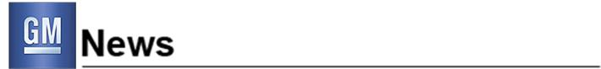
For Release: May 5, 2011, 7:30 a.m. EDT

GM Reports Net Income of $3.2 Billion

Net income of $1.77 per share including a net gain from special items of $0.82 per share

EBIT of $3.5 billion and EBIT-adjusted of $2.0 billion

GM Europe achieves breakeven results on an EBIT-adjusted basis

DETROIT – General Motors Company (NYSE: GM) today announced first quarter net income attributable to common stockholders of $3.2 billion, or $1.77 per fully-diluted share, marking the company’s fifth consecutive profitable quarter. Revenue increased $4.7 billion to $36.2 billion, compared with the first quarter of 2010.

“We are on plan,” said Dan Akerson, chairman and CEO. “GM has delivered five consecutive profitable quarters, thanks to strong customer demand for our new fuel-efficient vehicles and a competitive cost structure that allows us to leverage our strong brands around the world and focus on driving profitable automotive growth.”

Net income attributable to common stockholders includes gains of $1.6 billion and $0.3 billion respectively related to the sales of the company’s ownership interest in Delphi Automotive LLP and Ally Financial Inc. preferred stock. It also includes a $0.4 billion goodwill impairment charge at GM Europe (GME) resulting from a change in accounting standards and charges totaling $0.1 billion at GM International Operations (GMIO) related to revised tax regulations affecting the company’s India joint venture. Combined, these special items increased net income attributable to common stockholders by $1.5 billion or $0.82 per fully-diluted share.

Earnings before interest and tax (EBIT) were $3.5 billion. EBIT adjusted to exclude special items was $2.0 billion compared with $1.7 billion in the first quarter of 2010.

GM Results Overview (in billions except for per share amounts)

 |  | Q1 2010 |  | Q1 2011
 | Revenue | $ | 31.5 | $ | 36.2
Net income attributable to common stockholders |  | $ | 0.9 | $ | 3.2
 | Earnings per share (EPS) diluted | $ | 0.55 | $ | 1.77
EBIT |  | $ | 1.8 | $ | 3.5
 | Less special items | $ | 0.1 | $ | 1.5
 | EBIT – adjusted | $ | 1.7 | $ | 2.0
 | Impact of special items on EPS diluted | $ | 0.08 | $ | 0.82
Automotive net cash flow from operating activities |  | $ | 1.9 | $ | (0.6)*
 | Automotive free cash flow | $ | 1.0 | $ | (1.9)*

* Includes $2.5 billion negative impact related to wholesale advance financing agreement termination

GM North America (GMNA) reported EBIT of $2.9 billion compared with $1.2 billion in the first quarter of 2010. On an EBIT-adjusted basis, GMNA increased its earnings by $0.1 billion to $1.3 billion compared with the first quarter of 2010. The company expects GMNA’s quarterly EBIT-adjusted results to improve on average for the remainder of the year compared with the first quarter as better pricing and improved fixed cost should more than offset commodity cost increases and unfavorable mix.

GME reported EBIT of $(0.4) billion. GME’s results improved by $0.6 billion on an EBIT-adjusted basis compared with the first quarter of 2010 and it achieved a significant milestone by delivering breakeven results on that basis. Based on current plans, GME is targeting to achieve breakeven results on an EBIT-adjusted basis before restructuring for the entire year.

GMIO reported EBIT of $0.5 billion compared with $0.9 billion in the first quarter of 2010. On an EBIT-adjusted basis, GMIO earned $0.6 billion in the first quarter, a decline of $0.3 billion compared with the first quarter of 2010.

GM South America (GMSA) reported EBIT of $0.1 billion, down $0.2 billion from the first quarter of 2010. There were no adjustments in either period.

GM expects that full-year 2011 EBIT-adjusted results will show solid improvement over 2010. GM continues to expect no material impact on full-year results from the Japan crisis.

For the quarter, automotive cash flow from operating activities was $(0.6) billion and automotive free cash flow was $(1.9) billion. Both figures include the $2.5 billion cash impact of GM’s decision, announced in October 2010, to end a wholesale advance agreement with Ally Financial.

GM ended the quarter with very strong total automotive liquidity of $36.5 billion. Automotive cash and marketable securities, including Canadian Health Care Trust restricted cash, was $30.6 billion compared with $27.6 billion at the end of the fourth quarter of 2010.

“GM has great potential to deliver profitable growth around the world as the recovery continues,” said Dan Ammann, senior vice president and CFO. “While we’re encouraged, we keenly recognize we have more opportunities to leverage our scale, improve spending and investment efficiencies, and optimize our strong balance sheet.”

About General Motors – General Motors (NYSE:GM, TSX: GMM), one of the world’s largest automakers, traces its roots back to 1908. With its global headquarters in Detroit, GM employs 202,000 people in every major region of the world and does business in more than 120 countries. GM and its strategic partners produce cars and trucks in 30 countries, and sell and service these vehicles through the following brands: Baojun, Buick, Cadillac, Chevrolet, GMC, Daewoo, Holden, Isuzu, Jiefang, Opel, Vauxhall, and Wuling. GM’s largest national market is China, followed by the United States, Brazil, the United Kingdom, Germany, Canada, and Italy. GM’s OnStar subsidiary is the industry leader in vehicle safety, security and information services. More information on the new General Motors can be found at www.gm.com.

Contacts:

Reneé Rashid-Merem Office 313-665-3128 Cell 313-701-8560 renee.rashid-merem@gm.com

Randy Arickx

Office 313-667-0006

Cell 313-268-7070

randy.c.arickx@gm.com

2

Forward-Looking Statements

In this press release and in related comments by our management, our use of the words “expect,” “anticipate,” “possible,” “potential,” “target,” “believe,” “commit,” “intend,” “continue,” “may,” “would,” “could,” “should,” “project,” “projected,” “positioned” or similar expressions is intended to identify forward-looking statements that represent our current judgment about possible future events. We believe these judgments are reasonable, but these statements are not guarantees of any events or financial results, and our actual results may differ materially due to a variety of important factors. Among other items, such factors might include: our ability to realize production efficiencies and to achieve reductions in costs as a result of our restructuring initiatives and labor modifications; our ability to maintain quality control over our vehicles and avoid material vehicle recalls; our ability to maintain adequate liquidity and financing sources and an appropriate level of debt, including as required to fund our planned significant investment in new technology; the ability of our suppliers to timely deliver parts, components and systems; our ability to realize successful vehicle applications of new technology; and our ability to continue to attract new customers, particularly for our new products. GM’s most recent annual report on Form 10-K and quarterly report on Form 10-Q provides information about these and other factors, which we may revise or supplement in future reports to the SEC.

3

Exhibit 1

General Motors Company and Subsidiaries

Supplemental Material

(Unaudited)

The accompanying tables and charts for securities analysts include earnings before interest and taxes (EBIT), EBIT adjusted and Automotive free cash flow which are not prepared in accordance with Accounting Principles Generally Accepted in the United States of America (U.S. GAAP) and have not been audited or reviewed by GM’s independent auditors. EBIT, EBIT adjusted and Automotive free cash flow are considered non-GAAP financial measures.

Management believes these non-GAAP financial measures provide meaningful supplemental information regarding GM’s operating results because they exclude amounts that management does not consider part of operating results when assessing and measuring the operational and financial performance of the organization. Management believes these measures allow it to readily view operating trends, perform analytical comparisons and benchmark performance among geographic regions. Accordingly, GM believes these non-GAAP financial measures are useful in allowing for greater transparency of GM’s core operations and they are therefore used by management in its financial and operational decision-making.

While management believes that these non-GAAP financial measures provide useful information, they are not operating measures under U.S. GAAP and there are limitations associated with their use. GM’s calculation of these non-GAAP financial measures may not be completely comparable to similarly titled measures of other companies due to potential differences between companies in their method of calculation. As a result, the use of these non-GAAP financial measures has limitations and should not be considered in isolation from, or as a substitute for, other measures such as Net income or Net income attributable to common stockholders. Due to these limitations, these non-GAAP financial measures are used as a supplement to U.S. GAAP measures.

The following table summarizes the reconciliation of EBIT to its most comparable U.S. GAAP measure (dollars in millions):

 |  |  | Three Months |  |  |  | Three Months
 |  |  |  | Ended |  |  |  | Ended
 |  | March 31, 2011 |  |  |  | March 31, 2010
 | Operating segments
 | GMNA(a) | $ |  | 2,898 |  | $ |  | 1,218
 | GME(a)(b) |  |  | (390) |  |  |  | (477)
 | GMIO(a)(b) |  |  | 480 |  |  |  | 908
 | GMSA(a)(b) |  |  | 90 |  |  |  | 265
 | GM Financial(c) |  |  | 130 |  |  |  | —
 | Total operating segments |  |  | 3,208 |  |  |  | 1,914
 | Corporate and eliminations |  |  | 317 |  |  |  | (90)
 | EBIT(c) |  |  | 3,525 |  |  |  | 1,824
 | Interest income |  |  | 127 |  |  |  | 90
 | Automotive interest expense |  |  | 149 |  |  |  | 337
 | Income tax expense |  |  | 137 |  |  |  | 509
 | Net income attributable to stockholders |  |  | 3,366 |  |  |  | 1,068
 | Less: Cumulative dividends on preferred stock |  |  | 215 |  |  |  | 203
 | Net income attributable to common stockholders | $ |  | 3,151 |  | $ |  | 865

- Interest and income taxes are recorded centrally in Corporate; therefore, there are no reconciling items for GM’s automotive operating segments between EBIT and Net income attributable to stockholders.
- In the year ended December 31, 2010 GM changed its managerial and financial reporting structure so that certain entities geographically located within Russia and Uzbekistan were transferred from GM’s GME segment to GM’s GMIO segment and certain entities geographically located in Brazil, Argentina, Colombia, Ecuador, Venezuela, Bolivia, Chile, Paraguay, Peru and Uruguay were transferred from GM’s GMIO segment to GM’s newly created GMSA segment. GM has retrospectively revised the segment presentation for all periods presented.

- GM Financial amounts represent income before income taxes.

1

General Motors Company and Subsidiaries

Supplemental Material

(Unaudited)

The following table summarizes the reconciliation of EBIT adjusted to EBIT (dollars in millions):

 |  |  |  | Three Months |  | Three Months
 |  |  |  | Ended |  |  | Ended
 |  | March 31, 2011(a) |  |  | March 31, 2010
 | EBIT adjusted | $ |  | 2,042 | $ |  | 1,701
 | Special items |  |  | 1,483 |  |  | 123
 | EBIT | $ |  | 3,525 | $ |  | 1,824

- GM Financial amounts included in EBIT and EBIT adjusted represent income before income taxes.

Special Items

In the three months ended March 31, 2011 special items included:

- Gain of $1.6 billion in GMNA related to the sale of GM’s Class A Membership Interests in Delphi Automotive LLP;

- Gain of $339 million in Corporate related to the sale of 100% of the Ally Financial Preferred Stock;

- Impairment charge of $395 million in GME related to goodwill; and

- Charge of $106 million in GMIO related to GM’s India joint venture.

In the three months ended March 31, 2010 special items included a gain of $123 million in GME related to the sale of Saab Automobile AB to Spyker Cars

NV.

The following table summarizes the reconciliation of Automotive free cash flow to Automotive Net cash provided by (used in) operating activities (dollars in millions):

 |  | Three Months |  |  |  | Three Months
 |  |  | Ended |  |  |  | Ended
 | March 31, 2011 |  |  |  | March 31, 2010
Automotive
Free cash flow | $ |  | (1,918) |  | $ |  | 1,010
Capital expenditures |  |  | 1,322 |  |  |  | 840
Net cash provided by (used in) operating activities |  | $ | (596) |  |  | $ | 1,850
 | 2

General Motors Company and Subsidiaries

Supplemental Material

(Unaudited)

The following tables summarize selected data by segment (dollars in millions):

 |  |  |  |  |  |  |  |  |  |  |  |  |  |  |  |  |  |  |  |  |  |  |  | Total |  |  | GM
 |  | GMNA |  |  |  |  | GME |  | GMIO |  |  | GMSA |  |  |  | Corporate |  |  | Eliminations |  |  | Automotive |  |  |  | Financial |  |  | Eliminations |  |  |  | Total
 | Three Months Ended March 31, 2011
 | Total net sales and revenue | $ | 22,110 |  | $ |  | 6,870 |  | $ | 5,427 | $ |  | 3,896 |  | $ |  | 16 | $ |  | (2,420) |  | $ |  | 35,899 | $ |  | 295 |  | $ | — | $ |  | 36,194
 | Depreciation, amortization and impairment of long-
 | lived assets and finite-lived intangible assets | $ | 977 |  | $ |  | 340 |  | $ | 116 | $ |  | 116 |  | $ |  | 13 | $ |  | — |  | $ |  | 1,562 | $ |  | 14 |  | $ | — | $ |  | 1,576
Equity income, net of tax and gain on disposal of
 | investments(a) | $ | 1,729 |  | $ |  | — |  | $ | 415 | $ |  | — |  | $ |  | — | $ |  | — |  | $ |  | 2,144 | $ |  | — |  | $ | — | $ |  | 2,144

- Includes a gain of $1.6 billion recorded on the sale of GM’s Class A Membership Interests in Delphi Automotive LLP.

 |  |  |  |  |  |  |  |  |  |  |  |  |  |  |  |  |  |  |  |  |  |  |  |  |  |  |  |  |  |  | Total
 |  |  |  | GMNA |  |  |  | GME |  |  | GMIO |  |  |  |  | GMSA |  |  |  | Corporate |  |  |  |  | Eliminations |  |  |  | Automotive |  |  |  |  | Total
 | Three Months Ended March 31, 2010
 | Total net sales and revenue |  | $ |  | 19,286 | $ |  | 5,461 |  | $4,985 |  |  |  |  | $ |  | 3,324 |  |  | $ | 45 |  | $ |  |  | (1,625) |  | $ |  |  | 31,476 | $ |  | 31,476
 | Depreciation, amortization and impairment of long-lived assets and
 | finite-lived intangible assets |  | $ |  | 1,174 | $ |  | 384 |  | $ |  | 65 |  |  | $ |  | 129 |  |  | $ | 51 |  | $ |  |  | — |  | $ |  |  | 1,803 | $ |  | 1,803
Equity income, net of tax and gain on disposal of investments |  |  | $ |  | 34 | $ |  | 7 |  | $ |  | 362 |  |  | $ |  | — |  |  | $ | — |  | $ |  |  | — |  | $ |  |  | 403 | $ |  | 403
 | The following tables summarize worldwide employment and payroll:
 |  |  |  |  |  |  |  |  |  |  |  | March 31, 2011 |  |  |  |  |  |  |  |  |  |  | December 31, 2010
 |  | Worldwide Employment (thousands)
 |  | GMNA |  |  |  |  |  |  |  |  |  |  |  |  |  |  | 97 |  |  |  |  |  |  |  |  |  |  | 96
 |  | GME |  |  |  |  |  |  |  |  |  |  |  |  |  |  | 40 |  |  |  |  |  |  |  |  |  |  | 40
 |  | GMIO |  |  |  |  |  |  |  |  |  |  |  |  |  |  | 33 |  |  |  |  |  |  |  |  |  |  | 32
 |  | GMSA |  |  |  |  |  |  |  |  |  |  |  |  |  |  | 32 |  |  |  |  |  |  |  |  |  |  | 31
 |  | GM Financial |  |  |  |  |  |  |  |  |  |  |  |  |  |  | 3 |  |  |  |  |  |  |  |  |  |  | 3
 |  | Total Worldwide |  |  |  |  |  |  |  |  |  |  |  |  |  |  | 205 |  |  |  |  |  |  |  |  | 202
 | U.S. – Salaried |  |  |  |  |  |  |  |  |  |  |  |  |  |  |  | 28 |  |  |  |  |  |  |  |  |  |  | 28
 |  | U.S. – Hourly |  |  |  |  |  |  |  |  |  |  |  |  |  |  | 49 |  |  |  |  |  |  |  |  |  |  | 49
 |  |  |  |  |  |  |  |  |  |  |  |  | Three Months |  |  |  |  |  |  |  |  |  |  |  | Three Months
 |  |  |  |  |  |  |  |  |  |  |  |  | Ended |  |  |  |  |  |  |  |  |  |  |  |  | Ended
 |  |  |  |  |  |  |  |  |  |  |  |  | March 31, 2011 |  |  |  |  |  |  |  |  |  |  |  | March 31, 2010
 |  | Worldwide Payroll (billions) |  |  |  |  |  |  |  |  |  | $ |  |  |  |  | 3.3 |  |  |  |  |  | $ |  |  |  |  | 3.0
 |  |  |  |  | 3

General Motors Company and Subsidiaries

Supplemental Material

(Unaudited)

 |  | Three Months |  | Three Months
 |  | Ended |  | Ended
 | March 31, 2011 |  | March 31, 2010
Production Volume (units in thousands)(a)
GMNA – Cars | 284 |  | 244
GMNA – Trucks |  | 502 |  | 424
Total GMNA | 786 |  | 668
GME | 344 |  | 305
GMIO - Consolidated Entities | 257 |  | 248
GMIO - Joint Ventures(b) |  | 709 |  | 654
Total GMIO | 966 |  | 902
GMSA | 231 |  | 210
Total Worldwide |  | 2,327 |  | 2,085

- Production volume includes vehicles produced by certain joint ventures.

- The joint venture agreements with SGMW (44%) in the three months ended March 31, 2011 and (34%) in the three months ended March 31, 2010 and FAW-GM (50%) allows for significant rights as a member as well as the contractual right to report SGMW and FAW-GM joint venture production in China.

4

General Motors Company and Subsidiaries

Supplemental Material

(Unaudited)

 |  | Three Months |  | Three Months
 |  | Ended |  | Ended
 | March 31, 2011 |  | March 31, 2010(a)(b)
Vehicle Sales (units in thousands)(c)(d)(e)
United States
Chevrolet – Cars | 181 |  | 156
Chevrolet – Trucks | 235 |  | 182
Cadillac | 41 |  | 29
Buick | 45 |  | 32
GMC | 91 |  | 69
Other |  | 0 |  | 8
Total United States | 593 |  | 477
Canada, Mexico and Other |  | 92 |  | 86
Total GMNA | 684 |  | 564
GME
Opel/Vauxhall | 320 |  | 295
Chevrolet | 112 |  | 105
Other | 1 |  | 4
Total GME |  | 433 |  | 404
GMIO
Chevrolet | 256 |  | 220
Wuling | 337 |  | 334
Buick | 166 |  | 122
GM Daewoo | 16 |  | 28
Holden | 32 |  | 36
FAW-GM | 17 |  | 28
GMC | 7 |  | 8
Cadillac | 8 |  | 4
Other |  | 17 |  | 11
Total GMIO(f)(g) | 855 |  | 790
GMSA
Chevrolet | 247 |  | 237
Other |  | 3 |  | 4
Total GMSA | 250 |  | 241
Total Worldwide |  | 2,221 |  | 1,999

- Includes HUMMER, Saturn and Pontiac vehicle sales data.

- Includes GM Saab Automobile AB (Saab) vehicle sales data through February 2010.

- Vehicle sales data may include rounding differences.

- Certain fleet sales that are accounted for as operating leases are included in vehicle sales at the time of delivery to the daily rental car companies.

- GMNA vehicle sales primarily represent sales to the ultimate customer. GME, GMIO and GMSA vehicle sales primarily represent estimated sales to the ultimate customer. In countries where end customer data is not readily available other data sources, such as wholesale volumes, are used to estimate vehicle sales.

- Includes the following joint venture vehicle sales:

 |  | Three Months |  | Three Months
 |  | Ended |  | Ended
 | March 31, 2011 |  | March 31, 2010
Joint venture sales in China
SGM | 310 |  | 235
SGMW and FAW-GM | 376 |  | 388
Joint venture sales in India
HKJV | 29 |  | 22

- The joint venture agreements with SGMW (44%) in the three months ended March 31, 2011 and (34%) in the three months ended March 31, 2010 and FAW-GM (50%) allow for significant rights as a member as well as the contractual right to report SGMW and FAW-GM joint venture vehicle sales in China as part of GM’s global market share.

5

General Motors Company and Subsidiaries

Supplemental Material

(Unaudited)

 |  | Three Months |  |  | Three Months
 |  | Ended |  |  | Ended
 | March 31, 2011 |  |  | March 31, 2010(a)(b)
Market Share(c)(d)(e)
United States – Cars | 15.4% |  |  | 14.8%
United States – Trucks | 22.4% |  |  | 22.0%
Total United States | 19.0% |  |  | 18.4%
Total GMNA | 18.3% |  |  | 17.8%
Total GME | 8.6% |  |  | 8.5%
Total GMIO(f)(g) | 9.2% |  |  | 8.8%
Total GMSA | 18.8% |  |  | 20.7%
Total Worldwide | 11.5% |  |  | 11.1%
U.S. Retail/Fleet Mix
% Fleet Sales – Cars | 28.6% |  |  | 40.6%
% Fleet Sales – Trucks | 20.5% |  |  | 24.5%
Total Vehicles | 23.6% |  |  | 30.9%
GMNA Capacity Utilization(h) | 99.1% |  |  | 85.1%

- Includes HUMMER, Saturn and Pontiac vehicle sales data.

- Includes GM Saab vehicle sales data through February 2010.

- Market share information is based on vehicle sales volume.

- Certain fleet sales that are accounted for as operating leases are included in vehicle sales at the time of delivery to the daily rental car companies.

- GMNA vehicle sales primarily represent sales to the ultimate customer. GME, GMIO and GMSA vehicle sales primarily represent estimated sales to the ultimate customer. In countries where end customer data is not readily available other data sources, such as wholesale volumes, are used to estimate vehicle sales.

- Includes the following joint venture vehicle sales (units in thousands):

 |  | Three Months |  | Three Months
 |  | Ended |  | Ended
 | March 31, 2011 |  | March 31, 2010
Joint venture sales in China
SGM | 310 |  | 235
SGMW and FAW-GM | 376 |  | 388
Joint venture sales in India
HKJV | 29 |  | 22

- The joint venture agreements with SGMW (44%) in the three months ended March 31, 2011 and (34%) in the three months ended March 31, 2010 and FAW-GM (50%) allow for significant rights as a member as well as the contractual right to report SGMW and FAW-GM joint venture vehicle sales in China as part of GM’s global market share.
- Two shift rated, annualized.

6

General Motors Company and Subsidiaries

Condensed Consolidated Income Statements

(In millions, except per share amounts)

(Unaudited)

 |  |  | Three Months |  |  |  | Three Months
 |  |  |  | Ended |  |  |  | Ended
 |  |  |  | March |  |  |  | March
 |  |  |  | 31, 2011 |  |  |  | 31, 2010
 | Net sales and revenue
 | Automotive sales | $ |  | 35,879 |  | $ |  | 31,422
 | GM Financial revenue |  |  | 295 |  |  |  | —
 | Other automotive revenue |  |  | 20 |  |  |  | 54
 | Total net sales and revenue |  |  | 36,194 |  |  |  | 31,476
Costs and expenses
 | Automotive cost of sales |  |  | 31,685 |  |  |  | 27,553
 | GM Financial operating and other expenses |  |  | 165 |  |  |  | —
 | Automotive selling, general and administrative expense |  |  | 2,994 |  |  |  | 2,684
 | Other automotive expenses, net |  |  | 6 |  |  |  | 46
 | Total costs and expenses |  |  | 34,850 |  |  |  | 30,283
 | Goodwill impairment charges |  |  | 395 |  |  |  | —
 | Operating income |  |  | 949 |  |  |  | 1,193
 | Automotive interest expense |  |  | 149 |  |  |  | 337
 | Interest income and other non-operating income, net |  |  | 604 |  |  |  | 447
 | Loss on extinguishment of debt |  |  | — |  |  |  | (1)
 | Income before income taxes and equity income |  |  | 1,404 |  |  |  | 1,302
 | Income tax expense |  |  | 137 |  |  |  | 509
 | Equity income, net of tax and gain on disposal of investments |  |  | 2,144 |  |  |  | 403
Net income
 |  |  |  | 3,411 |  |  |  | 1,196
 | Net income attributable to noncontrolling interests |  |  | (45) |  |  |  | (128)
Net income attributable to stockholders
 |  |  |  | 3,366 |  |  |  | 1,068
 | Less: Cumulative dividends on preferred stock |  |  | 215 |  |  |  | 203
Net income attributable to common stockholders
 |  |  | $ | 3,151 |  | $ |  | 865
 | Earnings per share
 | Basic and Diluted
 | Net income attributable to common stockholders – basic | $ |  | 3,151 |  | $ |  | 865
 | Addition of preferred dividends to holders of Series B Preferred Stock |  |  | 59 |  |  |  | —
 | Net income attributable to common stockholders – diluted |  | $ | 3,210 |  | $ |  | 865
Basic and Diluted
 | Weighted-average common shares outstanding – basic |  |  | 1,504 |  |  |  | 1,500
 | Dilutive effect of warrants |  |  | 162 |  |  |  | 67
 | Dilutive effect of conversion of Series B Preferred Stock |  |  | 148 |  |  |  | —
 | Dilutive effect of restricted stock units |  |  | 3 |  |  |  | —
 | Weighted-average common shares outstanding – diluted |  |  | 1,817 |  |  |  | 1,567
 | Basic earnings per share | $ |  | 2.09 |  | $ |  | 0.58
 | Diluted earnings per share | $ |  | 1.77 |  | $ |  | 0.55
 |  | 7

General Motors Company and Subsidiaries

Condensed Consolidated Balance Sheets

(In millions, except share amounts)

(Unaudited)

 |  | March 31, 2011 |  |  |  | December 31, 2010
 | ASSETS
 | Automotive Current Assets
 | Cash and cash equivalents | $ | 20,975 |  | $ |  | 21,061
 | Marketable securities |  | 8,618 |  |  |  | 5,555
 | Total cash, cash equivalents and marketable securities |  | 29,593 |  |  |  | 26,616
 | Accounts and notes receivable (net of allowance of $336 and $252) |  | 12,990 |  |  |  | 8,699
 | Inventories |  | 13,991 |  |  |  | 12,125
 | Equipment on operating leases, net |  | 3,099 |  |  |  | 2,568
 | Other current assets and deferred income taxes |  | 3,276 |  |  |  | 3,045
 | Total current assets |  | 62,949 |  |  |  | 53,053
 | Automotive Non-current Assets
 | Equity in net assets of nonconsolidated affiliates |  | 6,937 |  |  |  | 8,529
 | Property, net |  | 19,944 |  |  |  | 19,235
 | Goodwill |  | 28,752 |  |  |  | 30,513
 | Intangible assets, net |  | 11,488 |  |  |  | 11,882
 | Other assets and deferred income taxes |  | 4,249 |  |  |  | 4,754
 | Total non-current assets |  | 71,370 |  |  |  | 74,913
 | Total Automotive Assets |  | 134,319 |  |  |  | 127,966
 | GM Financial Assets
 | Finance receivables, net (including finance receivables transferred to special purpose entities of $8,603 and
$7,156) |  |  | 8,276 |  |  |  | 8,197
 | Restricted cash |  | 1,201 |  |  |  | 1,090
 | Goodwill |  | 1,265 |  |  |  | 1,265
 | Other assets (including leased assets transferred to special purpose entities of $188 at March 31, 2011) |  | 785 |  |  |  | 380
 | Total GM Financial Assets |  | 11,527 |  |  |  | 10,932
 | Total Assets | $ | 145,846 |  | $ |  | 138,898
 | LIABILITIES AND EQUITY
 | Automotive Current Liabilities
 | Accounts payable (principally trade) | $ | 24,739 |  | $ |  | 21,497
 | Short-term debt and current portion of long-term debt (including debt at GM Korea of $117 and $70) |  | 1,743 |  |  |  | 1,616
 | Accrued liabilities (including derivative liabilities at GM Korea of $49 and $111) |  | 25,200 |  |  |  | 24,044
 | Total current liabilities |  | 51,682 |  |  |  | 47,157
 | Automotive Non-current Liabilities
 | Long-term debt (including debt at GM Korea of $8 and $835) |  | 3,268 |  |  |  | 3,014
 | Postretirement benefits other than pensions |  | 9,396 |  |  |  | 9,294
 | Pensions |  | 21,660 |  |  |  | 21,894
 | Other liabilities and deferred income taxes |  | 12,851 |  |  |  | 13,021
 | Total non-current liabilities |  | 47,175 |  |  |  | 47,223
 | Total Automotive Liabilities |  | 98,857 |  |  |  | 94,380
 | GM Financial Liabilities
 | Securitization notes payable |  | 6,061 |  |  |  | 6,128
 | Credit facilities |  | 1,412 |  |  |  | 832
 | Other liabilities |  | 430 |  |  |  | 399
 | Total GM Financial Liabilities |  | 7,903 |  |  |  | 7,359
Total Liabilities |  |  | 106,760 |  |  |  | 101,739
 | Commitments and contingencies
 | Equity
 | Preferred stock, $0.01 par value, 2,000,000,000 shares authorized:
 | Series A (276,101,695 shares issued and outstanding (each with a $25.00 liquidation preference) at
 | March 31, 2011 and December 31, 2010) |  | 5,536 |  |  |  | 5,536
 | Series B (100,000,000 shares issued and outstanding (each with a $50.00 liquidation preference) at
 | March 31, 2011 and December 31, 2010) |  | 4,855 |  |  |  | 4,855
 | Common stock, $0.01 par value (5,000,000,000 shares authorized, 1,560,755,989 and 1,500,149,928 shares
 | issued and outstanding at March 31, 2011 and 1,500,136,998 shares issued and outstanding at December 31,
2010) |  |  | 15 |  |  |  | 15
 | Capital surplus (principally additional paid-in capital) |  | 24,347 |  |  |  | 24,257
 | Retained earnings |  | 1,951 |  |  |  | 266
 | Accumulated other comprehensive income |  | 1,494 |  |  |  | 1,251
Total stockholders’ equity |  |  | 38,198 |  |  |  | 36,180
 | Noncontrolling interests |  | 888 |  |  |  | 979
Total Equity |  |  | 39,086 |  |  |  | 37,159
 | Total Liabilities and Equity | $ | 145,846 |  | $ |  | 138,898

8

Exhibit 99.2
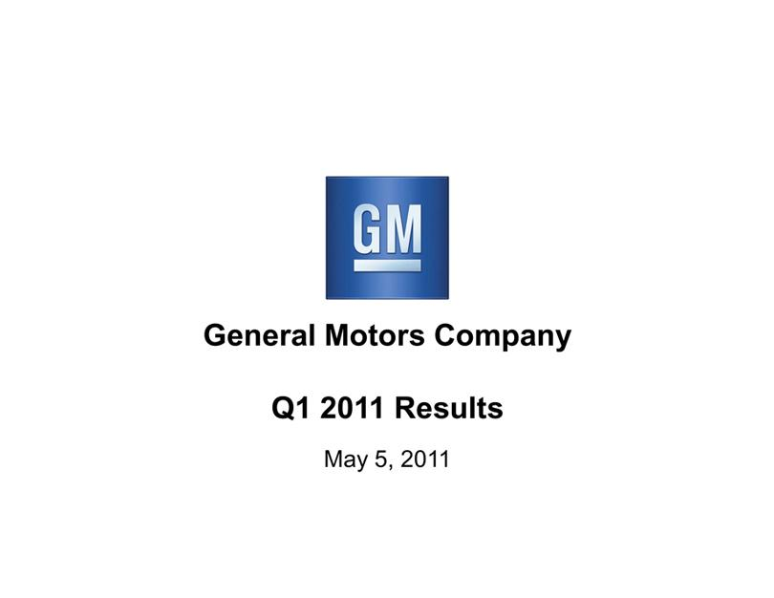

Exhibit 99.2
General Motors Company
Q1 2011 Results
May 5, 2011

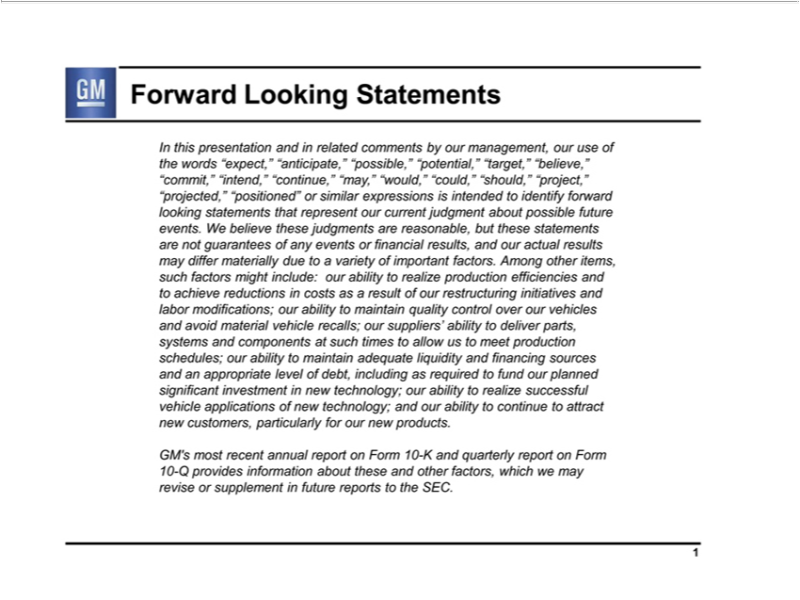

ForwardInthispre“should,”LookingentationStatementsandinrelated comments by our management, our use of the words “expect,” “anticipate,” “possible,” “potential,” “target,” “believe,” “commit,” “intend,” “continue,” “may,” “would,”

judgments“could,” are reasonable,“projct,”but“projected,”thesestatements“positioned”arenotguaranteesorsimilar expressionsofanyeventsis orintendedfinancialto results,identifyandforwardouractuallookingresultsstatementsmaydifferthat materiallyrepresentourduelaborcurrenttovarietyjudgmentofimportantaboutpossiblefactors.futureAmongevents.otherWitems,believesuchthese factors might include: ourmaterialablity to realize production efficiencies and to achieve reductions in costs as a result of our restructuring initiatives and modifications; our ability to maintain quality control over
andour vehiclesfinancingandsourcesavoidand an appropriatevehiclerecalls;level ofourdebt,suppliers’includingabilityasrequiredtodeliverto parts,fund oursystemsplannedandsignificantcomponentsinvestmentatsuchtimesinnewto allowtechnology;ustomeetour abilityproductiontorealizeschedules;successfulourabilityvehicletoapplicationsmaintainadequateofnew liquidity technology; and ability to to attract new customers, particularly for our new products.

GM’s most recent annual reportcontinueForm 10-K and quarterly report on Form 10-Q provides information about these and other factors, which we may revise or supplement in future reports to the SEC. 1

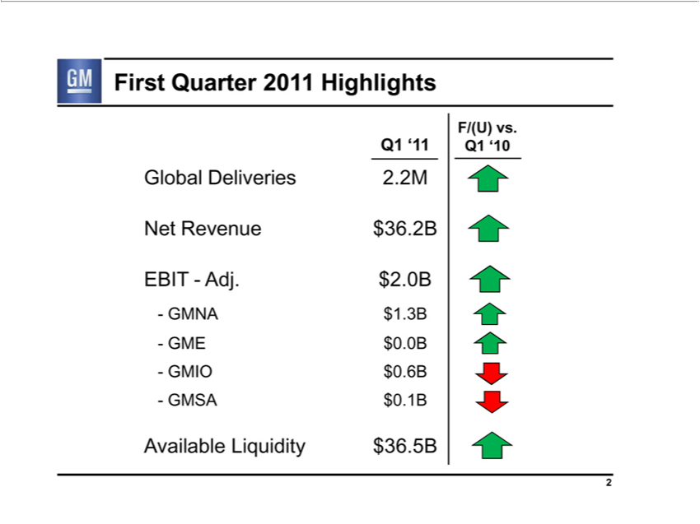

FirstQ1‘11QuarterF/(U) 2011vs.Q1^{2B}Highlights‘10
NetGlobalRevenueDeliveries$36. .2M
EBIT - Adj. $2.0B
NA^{E} $1.3B
_{IO}$0.0B
- GMSA $$^{0.6B}0.1B
2Available Liquidity $36.5B

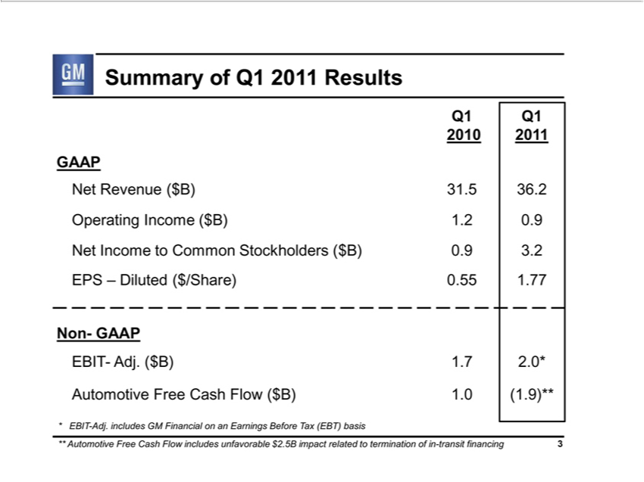

SummaryQ12010Q1of 2011Q12011 Results
NetGAAPRevenue ($B) 31.5 36.2
Operating Income ($B) 1.2 0.9
EPSNetIncome–Dilutedto Common($/Share) 0.55Stockholders1.77 ($B) 0.9 3.2
Non- GAAP
AutomotiveEBIT-Adj.(Free$B)1.7Cash2.0*Flow ($B) 1.0 (1.9)**
**EBITAutomotive-Adj.includesFreeCashGM FlowFinancialincludesonanunfavorableEarningsBefore$2.5BTaximpact(EBT)relatedbasisto termination of in-transit financing 3

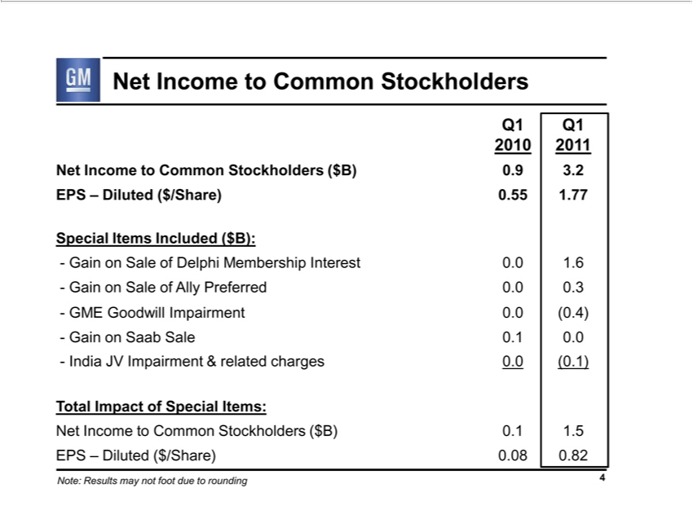

Q1Net 2010IncomeQ1to2011Common Stockholders
EPSNetIncome–Dilutedto Common($/Share) 0.55Stockholders1.77 ($B) 0.9 3.2
Special Items Included ($B):
^{ain on Sale of} Delphi Membership Interest 0.0 1.6
^{ME} ⁽⁰
^{Gain} Goodwill AllyImpairmentPreferred0.00. .4)0.3
⁻ on Saab Sale 0.1 0.0
TotalIndiaImpactJVImpairmentofSpecial&Items:related charges 0.0 (0.1)
EPSNetIncome–Dilutedto Common($/Share) 0.08Stockholders0.82 ($B) 0.1 1.5
4Note: Results may not foot due to rounding

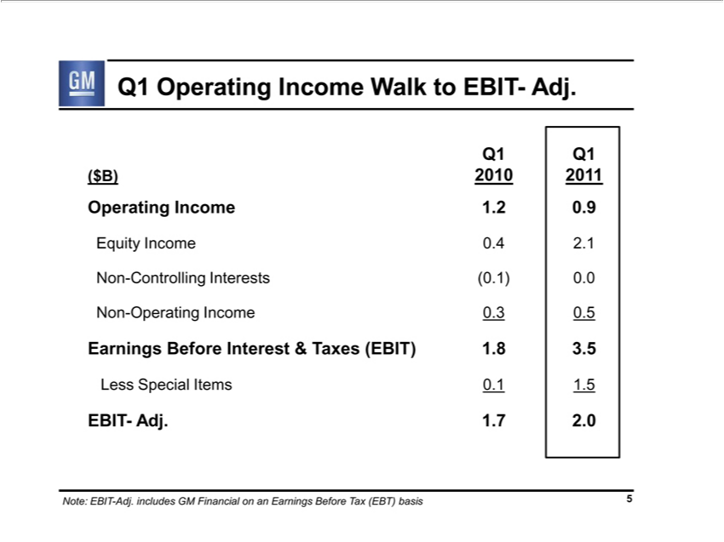

(Q1$B)OperatingQ12010 IncomeQ1₂₀₁1Walk to EBIT- Adj.
Operating Income . 0.9
Equity Income 0.4 .
^{Non-}Controlling Interests (0.1) 0.0
Operating Income 0.3 0.5
LessEarningsSpecialBeforeItemsInterest0.11.5& Taxes (EBIT) 1.8 3.5
EBIT- Adj. 1.7 2.0
5Note: EBIT-Adj. includes GM Financial on an Earnings Before Tax (EBT) basis

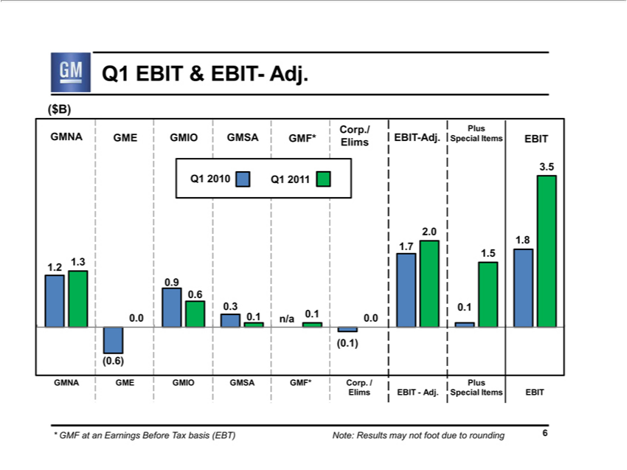

(Q1$B)EBIT & EBIT- Adj.
Q1GMNA₂₀₁₀GME^{Q1}201GMIO¹ GMSA GMF* Corp./Elims EBIT-Adj. Plus Special Items EBIT
.2 .3 .0 0.9 .6 0.3 0.1 n/a 0.1 0.0 1.7 2.0 0.1 1.5 1.8 3.5
0 6
GMNA GME GMIO GMSA GMF* Corp. / Elims EBIT - Adj. Plus Special Items EBIT
6* GMF at an Earnings Before Tax basis (EBT) Note: Results may not foot due to rounding

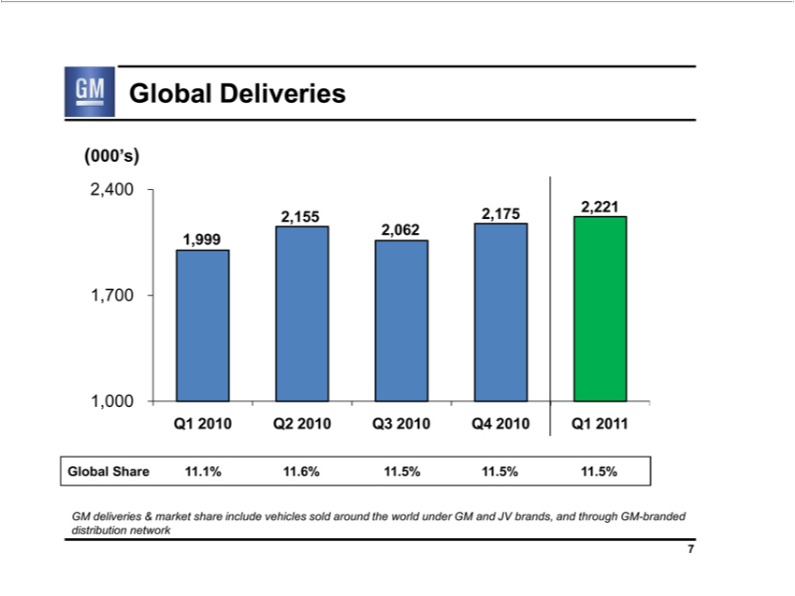

Global Deliveries
(000’s)
2 4 |  | 1,999 2,155 2,062 2,175 2,221
7
1,000 |  |  | Q3 2010 Q4 | Q1 | 1
Q1 | 2010 Q2 |  | Q3 2010 Q4 | Q1 | 1
2010 2010 201
GMlobaldeliveriesShare &.1%market11.6%share11.5%include1.5%vehicles.5%sold around the world under GM and JV brands, and through GM-branded distribution network 7

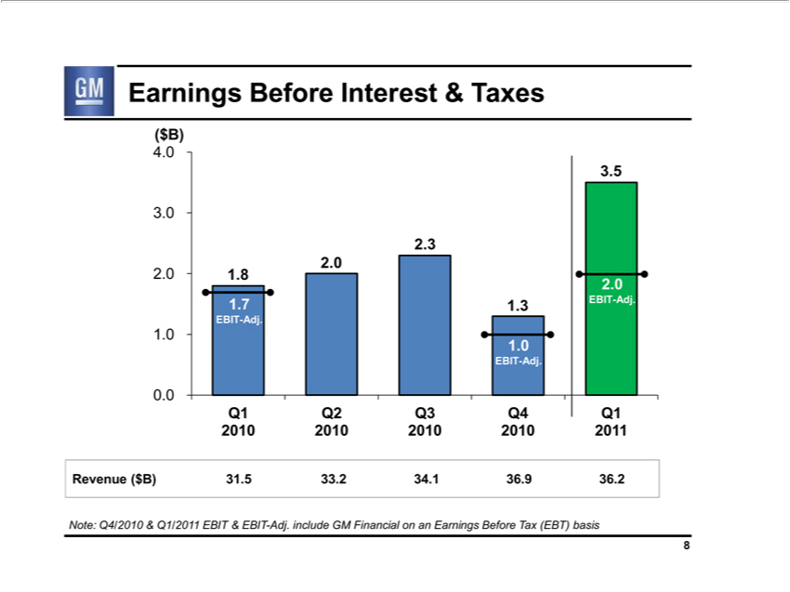

(Earnings$B) Before Interest & Taxes
4 0
3 ⁵
0
3
₂.₀ 1.8
EBIT171.3-Adj.EBIT-Adj.
1.0
EBIT-Adj.
0.0
Q1 Q2 Q3 Q4 Q1
2010 2010 2010 2010 ²⁰¹1
Revenue ($B) 31.5 33. 34.1 36.9 36.2

Note: Q4/2010 & Q1/2011 EBIT & EBIT-Adj. include GM Financial on an Earnings Before Tax (EBT) basis 8

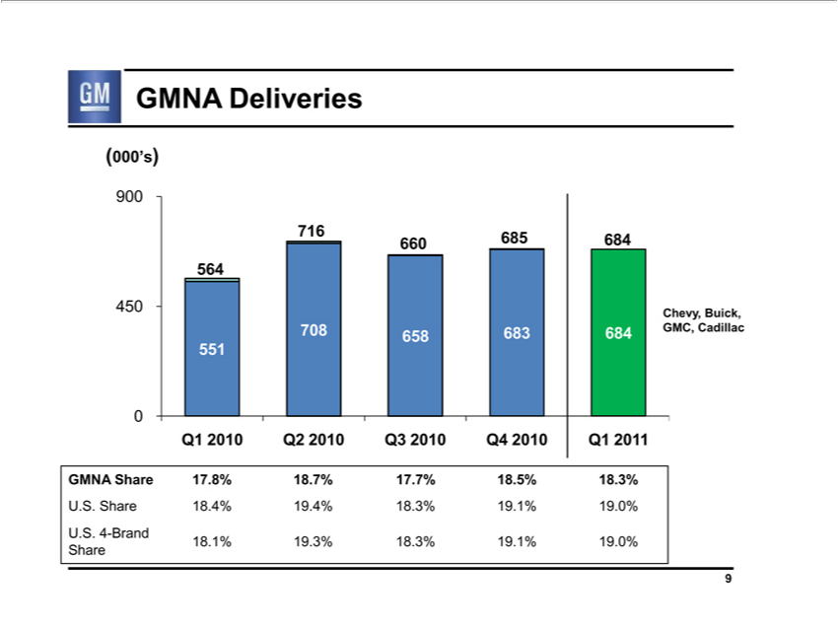

GMNA Deliveries
(000’s)
900 | 684⁵
7160 | 684⁵
564 | Chevy, Buick,
450
708 | 658 683 684 GMC, Cadillac
551
0
Q1 2010 Q2 2010 Q3 2010 Q4 2010 Q1 2011
GMNA |  | 17.8% 18.7% 17.7% 18.5% 18.3%
 | ShaShare18.4% 19.4% 18.3% 19.1% 19.0%
U.S. 4-Brand Share
18.1% 19.3% 18.3% 19.1% 19.0%
9

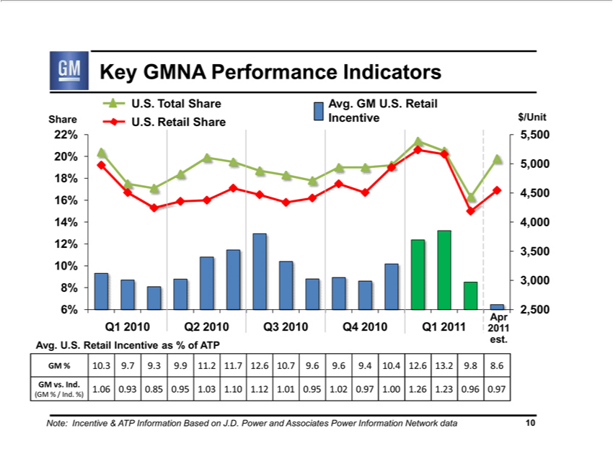

Key GMNA Performance Indicators
U_{Share}..TotalU.S. ShareRetailAvg.ShareGMIncentiveU.S.Retail$/Unit
_{20%}2% 5,500
5,000
18%
4,500
4%^{6%}
_{12%} 4,000
3,500
10%
3,000
^{8%}6%
Apr 2,500
est.Q1 2010 Q2 2010 Q3 2010 Q4 2010 Q1 2011 2011
Avg. U.S. Retail Incentive as % of ATP
^{GM} % 10.3 9.7 9.3 ⁹³.9 11.2 11.7 12.6 10.7 9.6 9.6 9.4 10.4 12.6 13.2 9.8 8²⁶.
(GMvs.% Ind./Ind.1.06%) 0. 0.85 0.95 1.03 1.10 1.12 1.01 0.95 1.02 0.97 1.00 1. 1.23 0.96 0.97

Note: Incentive & ATP Information Based on J.D. Power and Associates Power Information Network data 10

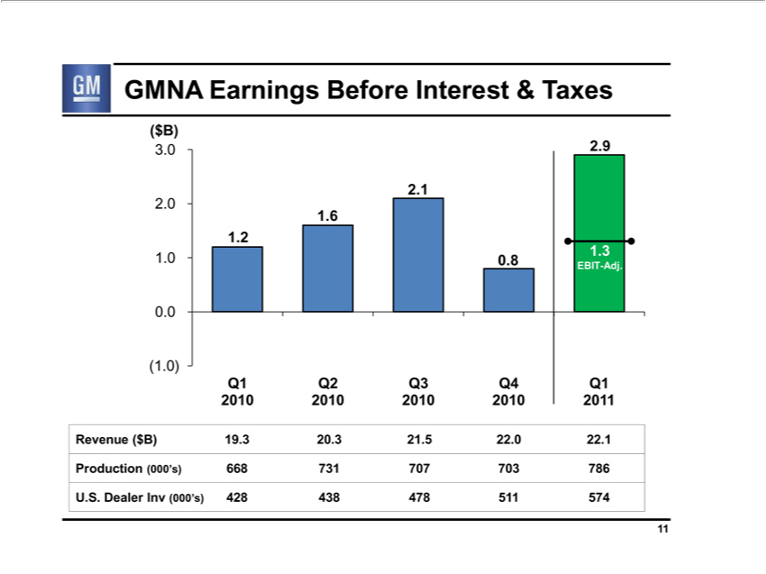

(GMNA$B) Earnings Before Interest & Taxes
3 0 2.9
2 ¹
0
6
1.²
EBIT00.8-Adj.1.3
0.0
(1.0)
Q1 Q2 Q3 Q4 Q1
2010 2010 2010 2010 2011

RevenueProduction($B)(000’s)19.3 66820.373121.570722.⁷⁰³22.1786

11U.S. Dealer Inv (000’s) 428 438 478 511 574

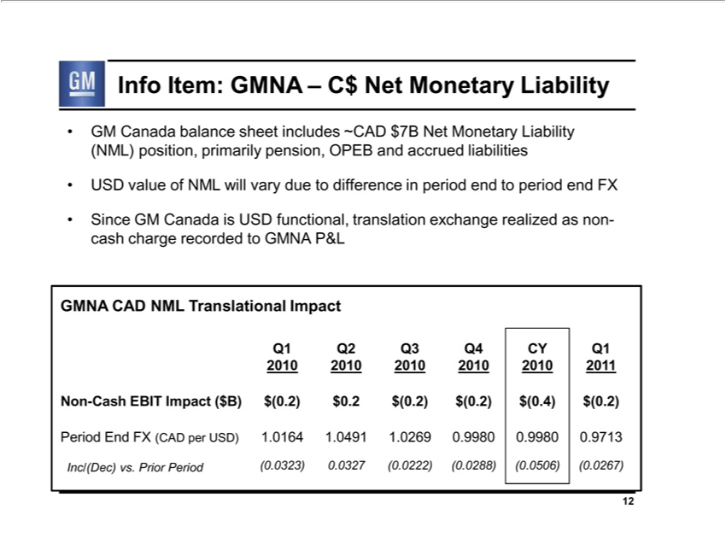

Info Item: GMNA – C$ Net Monetary Liability
GM Canada balance sheet includes ~CAD $7B Net Monetary Liability (NML) position, primarily pension, OPEB and accrued liabilities USD value of NML will vary due to difference in period end to period end FX

Since GM Canada is USD functional, translation exchange realized as non-cash charge recorded to GMNA P&L GMNA CAD NML Translational Impact
Q1 Q2 Q3 Q4 CY Q1
2010 2010 2010 2010 2010 2011
Non-Cash EBIT Impact ($B) $(0.2) $0.2 $(0.2) $(0.2) ^{$(0}.4) ^{$(0}.2)
Period End FX (CAD per USD) 1.⁰¹⁶⁴ 1.0491 1.0269 .9980 .9980 0.9713
12Inc/(Dec) vs. Prior Period (0.0323) .0327 (0.0222) (0.0288) .0506) (0.0267)

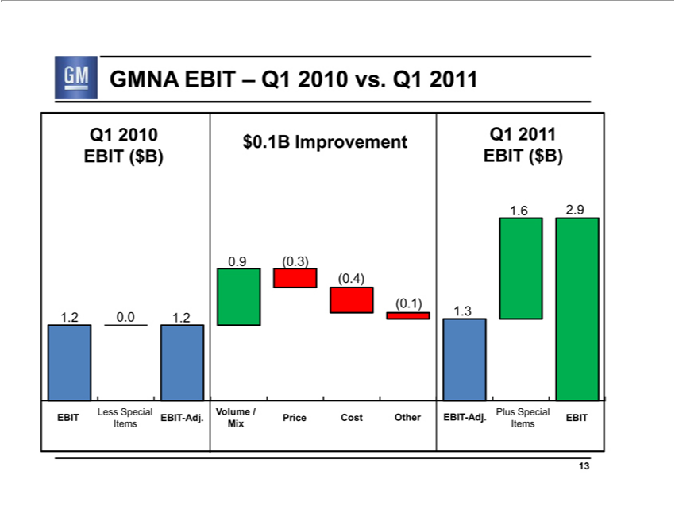

GMNA EBIT – Q1 2010 vs. Q1 2011
_{Q1}. _{2010.9} EBIT ($B) $0.1B Improvement Q1 2011 EBIT ($B)
₍₀9₆ (0.3)
.1)⁴⁾
1.2 0.0 1.2 1.3
Less Special Volume / Plus Special
ItemsEBIT MixEBITItems-Adj. Price Cost Other EBIT-Adj. EBIT

13

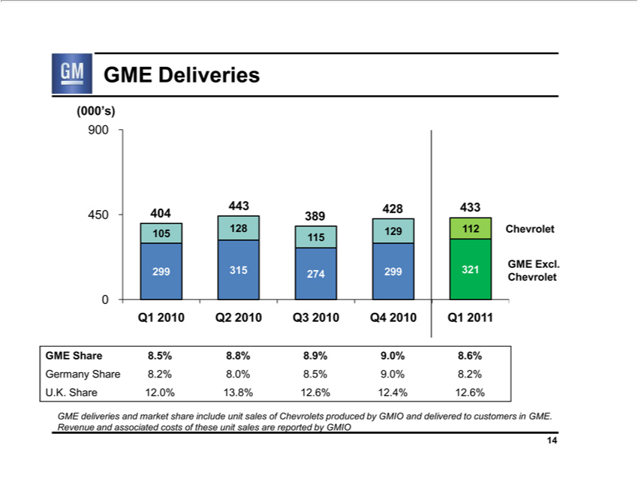

(000’s)GMEDeliveries
900
₄₅₀43 ₄₀₄28 433
¹05 128 129³⁸⁹ 112 Chevrolet
15
GME Excl.
299 315 274 299 321 Chevrolet
0
_{Germany}Q1ME2010ShareQ2 8.5%2010 8.Q3_{8%}20108.9%Q49.0%20108.6%Q12011
U.K. ShareShare12.0%8.2%13.8%.0%12.6%8.5%12.4%9.0% 8.2%12.6%

GME deliveries and market share include unit sales of Chevrolets produced by GMIO and delivered to customers in GME. Revenue and associated costs of these unit sales are reported by GMIO 14

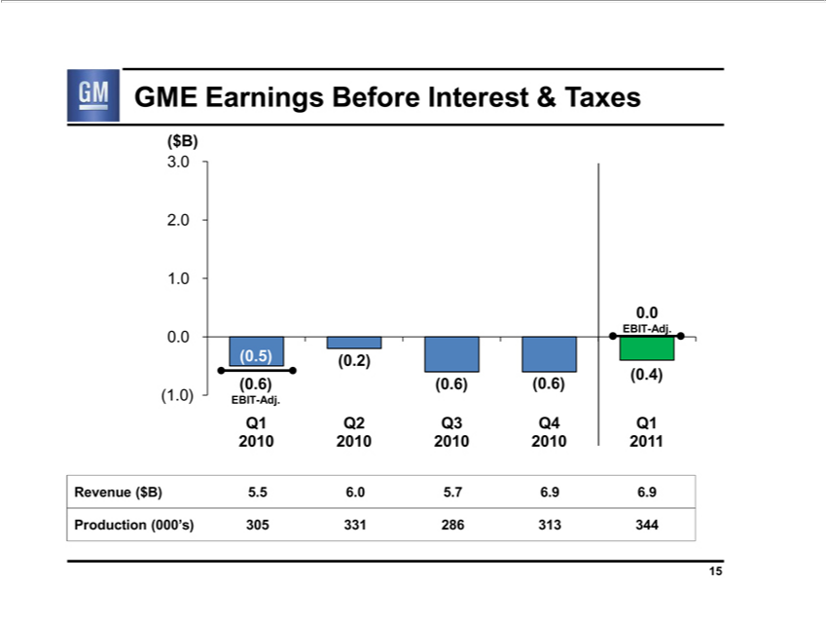

(GME$B) Earnings Before Interest & Taxes
3
2
¹.0
EBIT0-Adj.
0.0⁴⁾_{5) (0.2)}
0 6)
_{(1.0)} EBIT(0.6)-(0.6)Adj.
Q1 Q2 Q3 Q4 Q1
²⁰¹⁰
Revenue20102010($2010B)5.5 6. 5.720116.9²⁸⁶.9
15Production (000’s) 305 331 313 344

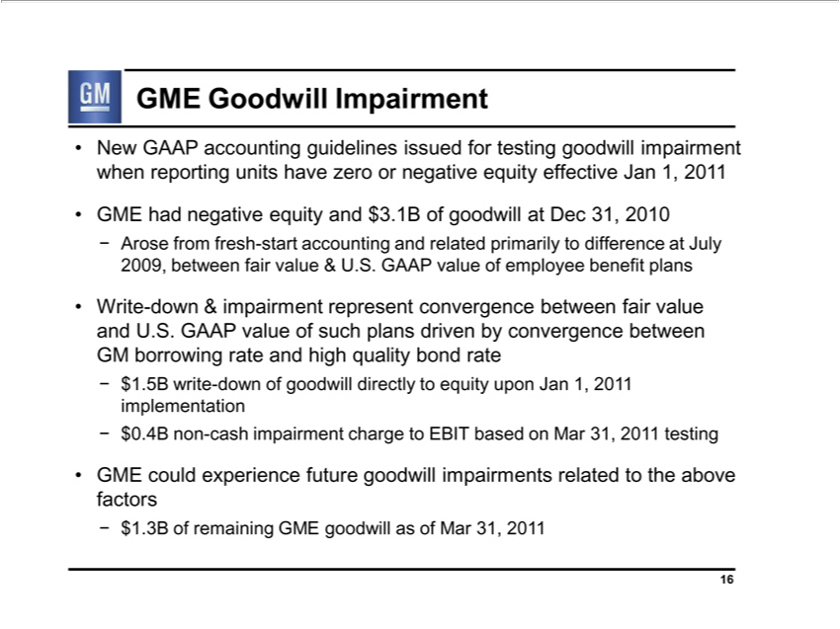

GME Goodwill Impairment
New GAAP accounting guidelines issued for testing goodwill impairment when reporting units have zero or negative equity effective Jan 1, 2011
–GMEArosehadfromnegativefresh-equitystartaccountingand$3.1Bandof goodwillrelatedprimarilyatDec31,to 2010difference at July 2009, between fair value & U.S. GAAP value of employee benefit plans
Write15B-downwrite&-downimpairmentofgoodwillrepresentdirectlyconvergencetoequity betweenJanfair1,201valueimplementationandU.S.GAAP value of such plans driven by convergence between GM borrowing rate and high quality bond rate
– $0.4B upon 201
GME couldnon-experiencecashimpairmentfuture chargegoodwillto impairmentsEBITbased relatedMar to31,the above1testingfactors
16–$1.3B of remaining GME goodwill as of Mar 31, 2011

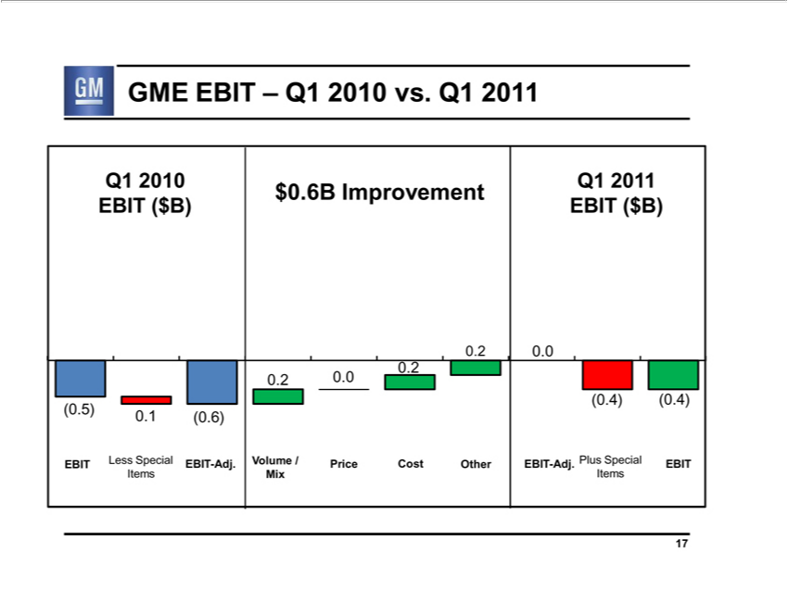

Q1GME₂₀₁₀EBITEBIT— (Q1$B)2010 vs. Q1 2011

(0.5) . (0.6)
$EBIT₀.6B Less_{Improvement}SpcialItems EBIT-Adj.
.2 0.0 0.2 0.2
Q1Volume2011/ EBITMixPrice($B) Cost Other
0.0 (0.4) (0.4)
17EBIT-Adj. Plus Special Items EBIT

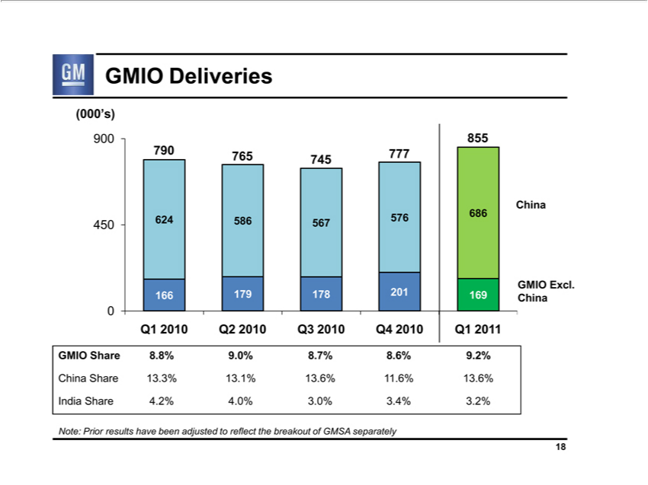

(000’s)GMIO Deliveries
₇₉₀900 ₇₆₅855
⁴⁵⁰ 745 ₅₆₇777
¹⁶⁶24 586 576 686 China
179 178 201 169 GMIO Excl. China
GMIOQ12010ShareQ2 20108.8%Q39.0%20108.7%Q4 8.6%2010 9.2%Q12011
IndiaChinaShareShare4.2%13.3%4.0%13.1%3.0%13.6%3.4%11.6%3.2% 13.6%
18Note: Prior results have been adjusted to reflect the breakout of GMSA separately

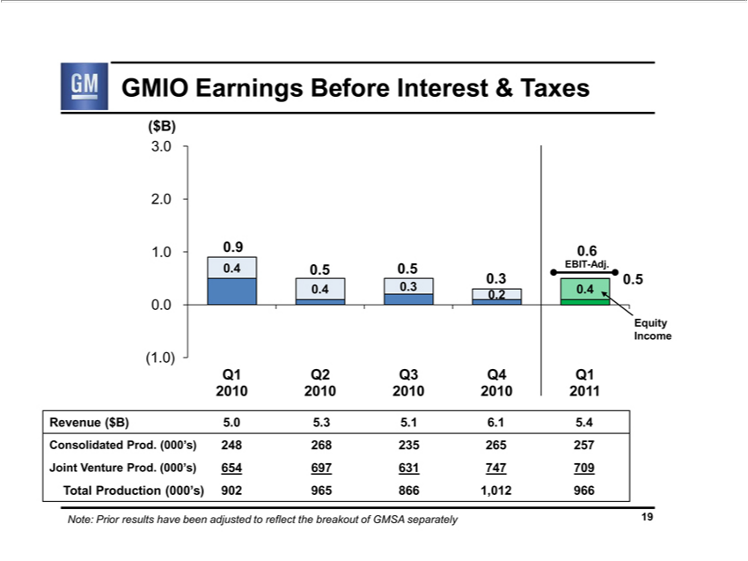

GMIO Earnings Before Interest & Taxes
($B)
3
2 | 0 | 9 | 6
1 | 0 | 9 | 6 | 3 0.5 EBIT-Adj.
 |  | 5 | 5
 | 4 0.3 |  | 0.2 | 0.4
0.0
Equity Income
(1.0)
Q1 Q2 Q3 Q4 Q1 |  |  |  |  | 1
2010 2010 |  |  |  | 2010 2010 | 1
Revenue ($B) 5.0 5.3 5.2016.1 5.4
Co solidated Prod. (000’s) 248 268 235 265 257
Joint |  | Venture Prod. (000’s) 654 697 631 747 709
Total Production (000’s) 902 965 866 1,012 966
Note: Prior results have been adjusted to reflect the breakout of GMSA separately 19

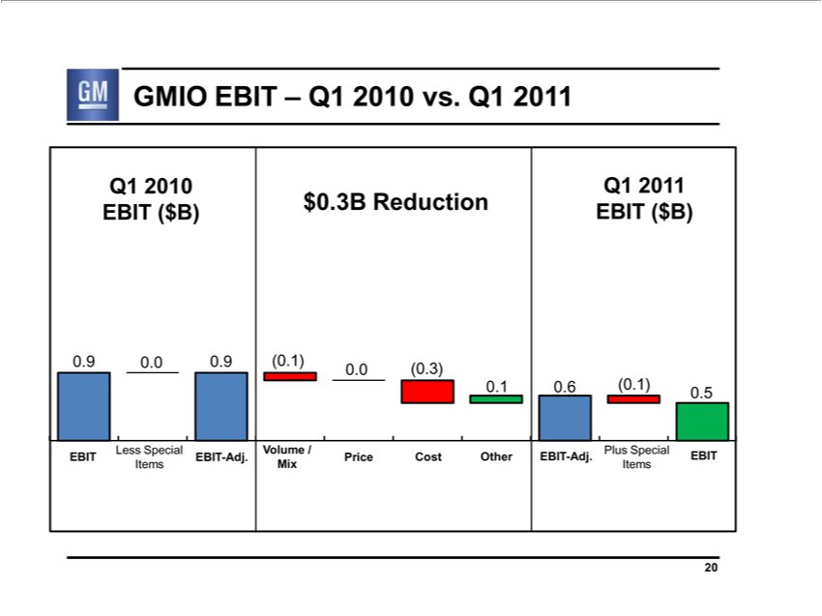

^{Q1}
Q1GMIO2010EBITQ1 201— 2010 vs. Q1 2011
EBIT($B) $0.3B Reduction EBIT ($B)
0.EBIT90.0Less0.9 (0.1)Special0.0Items(0.3) EBIT0.10.6-Adj.(0.1) 0.5
EBITVolume-Adj./MixPlusPriceSpecialCostItemsOtherEBIT
20

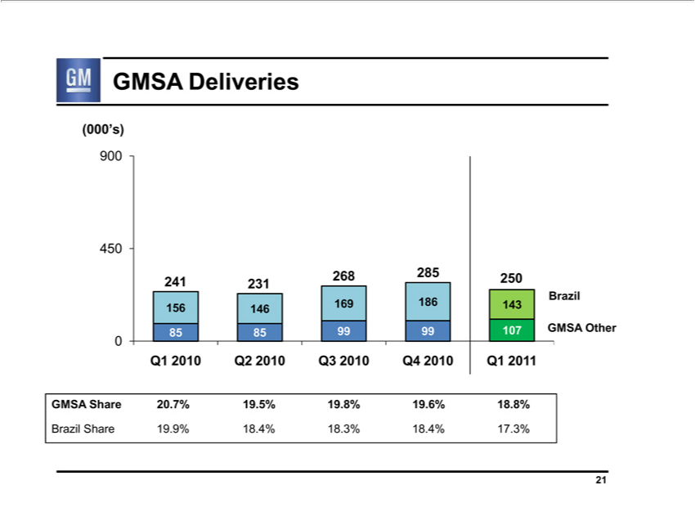

GMSA Deliveries
(000’s)
900
450 |  | 8 2 | 5 250 |  | Brazil
241 231 2 |  | 8 2 |  |  | Brazil
156 146 | 169 186 |  |  | 143
0
85 85 99 99 107 GMSA Other
Q1 2010 Q2 |  |  |  | Q3 2010 Q4 2010 Q1 2011
GMSA Share2010.7% 19.5% 19.8% 19.6% 18.8%

21Brazil Share 19.9% 18.4% 18.3% 18.4% 17.3%

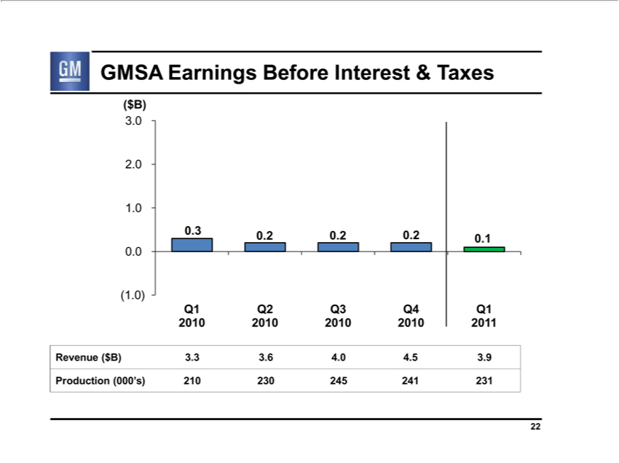

(GMSA$B) Earnings Before Interest & Taxes
3
2
¹.0
0
(1.0)
0.3 0.2 0.2 0.2 0.1
Q1 Q2 Q3 Q4 Q1
²⁰¹
Revenue20102010($2010B)3.320103.6 4. 4.51 3.9
22Production (000’s) 210 230 245 241 231

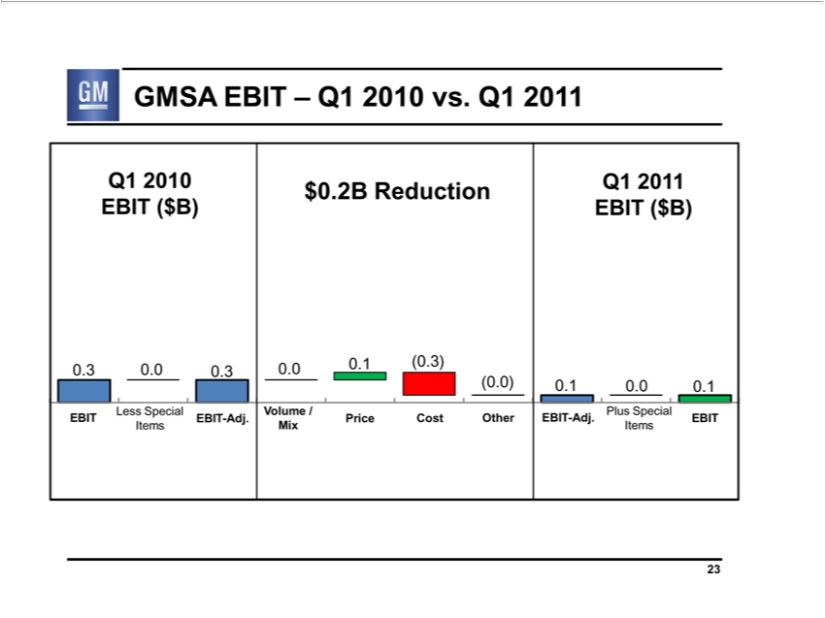

^{Q1}
Q1GMSA2010EBITQ1201– 2010 vs. Q1 2011
$0.2B Reduction
⁽⁰EBIT.30.0($0.3B) 0.0EBIT0.1($(0.3)B)
.0) 0.1 0.0 0.1
Less Special Volume / Plus Special
ItemsEBIT MixEBITItems-Adj. Price Cost Other EBIT-Adj. EBIT

23

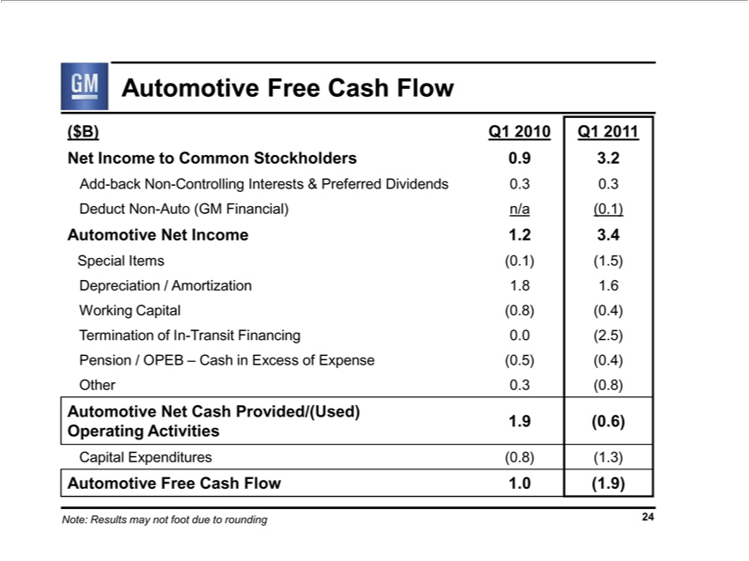

(Automotive$B)Q12010FreeQ1 Cash2011 Flow
Net Income to Common Stockholders 0.9 3.2
DeductAdd-backNonNon-Auto-Controlling(GMFinancial)Interestsn/a&(0.1)Preferred Dividends 0.3 0.3
Automotive Net Income 1.2 3.4
Special Items (0.1) (1.5)
Depreciation / Amortization 1.8 1.6
Working Capital (0.8) (0.4)
Termination of In-Transit Financing 0.0 (2.5)
OtherPension0.3/ OPEB(0.8) – Cash in Excess of Expense (0.5) (0.4)
Automotive Net Cash Provided/(Used)
1.9 (0.6)
Operating Activities
Au_{Note:}CapitalomotiveExpendituresFreeCash(0.8)Flow(1.3)1.0 (1.9)
Results may not foot due to rounding 24

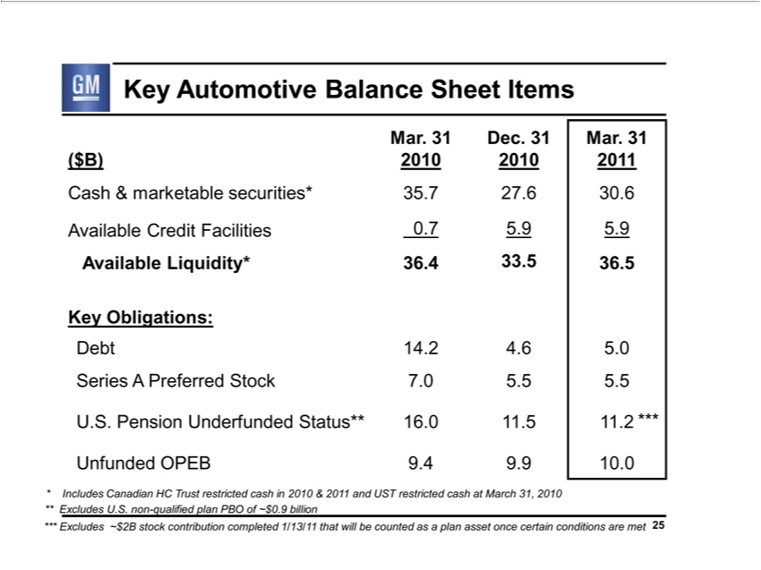

^{Mar}
Mar.Key Automotive31Dec.31 B lance.31 Sheet Items
($B) 2010 2010 2011
_{Available}Cash&marketableCreditFacilitiessecurities*0.75.935.75.927.6 30.6
K_{Debt}yObligations:Liquidity* 36.4 33.5 36.5
14.2 4.6 5.0
_{Series} A Preferred Stock 7.0 5.5 5.5
_{Unfunded}..Pension Underfunded Status** 16.0 11.5 11.2 ***
OPEB 9.4 9.9 10.0
Includes Canadian HC Trust restricted cash in 2010 & 2011 and UST restricted cash at March 31, 2010
***Excludes U.S. non-qualified plan PBO of ~$0.9 billion
Excludes ~$2B stock contribution completed 1/13/11 that will be counted as a plan asset once certain conditions are met 25

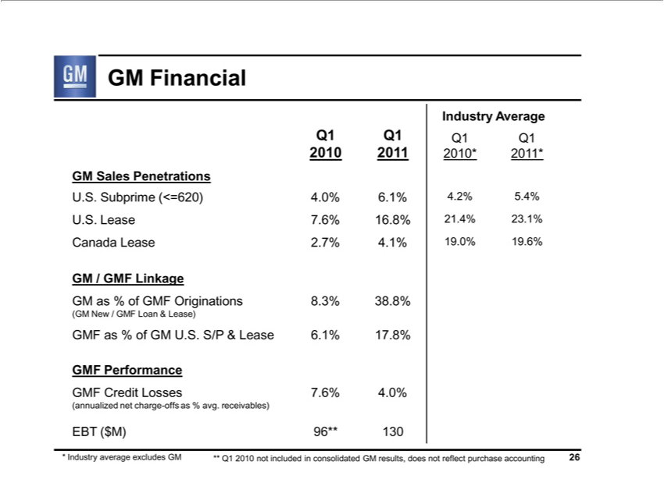

GM Financial
Industry Average
Q1 Q1 Q1 Q1
GM2010Sales2011 Penetrations2010*2011*
^{U.S.}
LeaseSubprime7.6%(<=620)16.8% 4.0%21.4%6.1%23.1%4.2% 5.4%
^{GM}Canada/GMFLeaseLinkage2.7% 4.1% 19.0% 19.6%
(GMasNew%of/GMFGMFLoanOriginations&Lease)8.3% 38.8%
^{GMF} Performanceas%ofGM U.S. S/P & Lease 6.1% 17.8%
Credit Losses 7.6% 4.0%
EBT(annualized($M)96**netcharge130-offs as % avg. receivables)

* Industry average excludes GM ** Q1 2010 not included in consolidated GM results, does not reflect purchase accounting 26

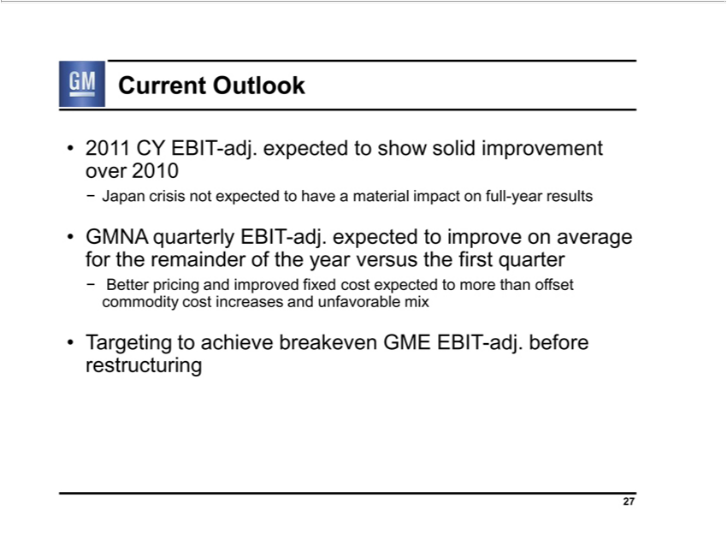

Current Outlook
2011 CY EBIT-adj. expected to show solid improvement over 2010
- Japan crisis not expected to have a material impact on full-year results
GMNA quarterly EBIT-adj. expected to improve on average for the remainder of the year versus the first quarter

- Better pricing and improved fixed cost expected to more than offset commodity cost increases and unfavorable mix Targeting to achieve breakeven GME EBIT-adj. before restructuring
27

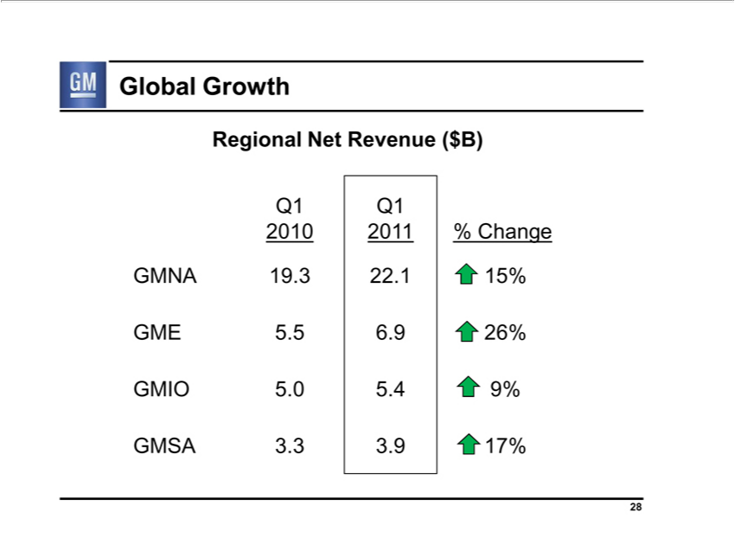

Global Growth
Q1RegionalQ1 Net Revenue ($B)
2010 201 % Change
IOENA5.5196.9.3 22.126%15%
5.0 5.4 9%

28GMSA 3.3 3.9 17%

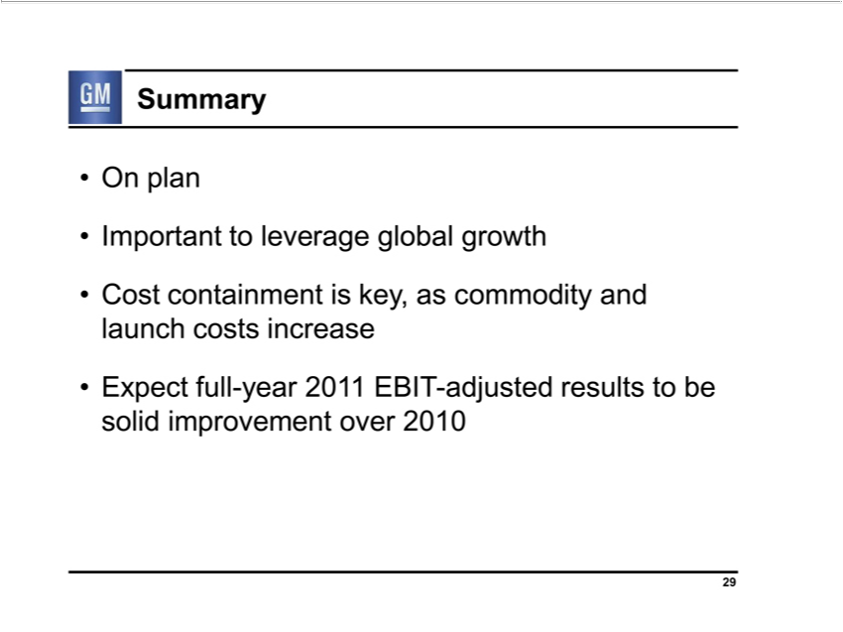

OnSummaryplan
Important to leverage global growth
Cost containment is key, as commodity and launch costs increase
29Expect full-year 2011 EBIT-adjusted results to be solid improvement over 2010

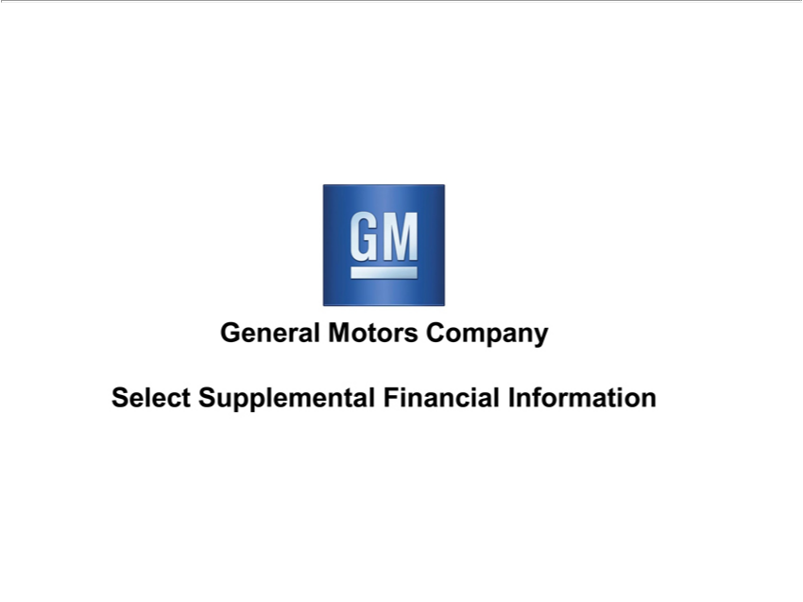

General Motors Company
Select Supplemental Financial Information

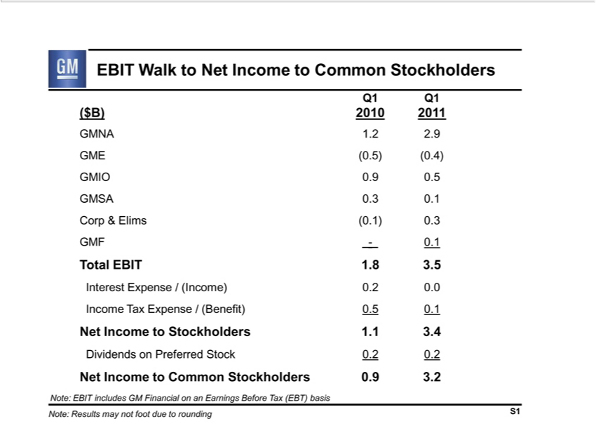

Q1EBITQ1Walk to Net Income to Common Stockholders
^{($B)}E2010 201¹
^{IO}NA(0.5).2 (0.4).9
_{GMSA} 0.90.3 0.50.1
GMFCorp &-0.1Elims (0.1) 0.3
Total EBIT 1.8 3.5
^{Income}
terest TaxExpenseExpense/(Income)/(Benefit)0.2 0.00.5 0.1
DividendsNetIncomeontoPreferredStockholdersStock1.10.23.40.2
et Income to Common Stockholders 0.9 3.2
^{Note:}
ResultsEBITincludesmaynotGMfootFinancialduetoroundingonanEarningsS1 Before Tax (EBT) basis

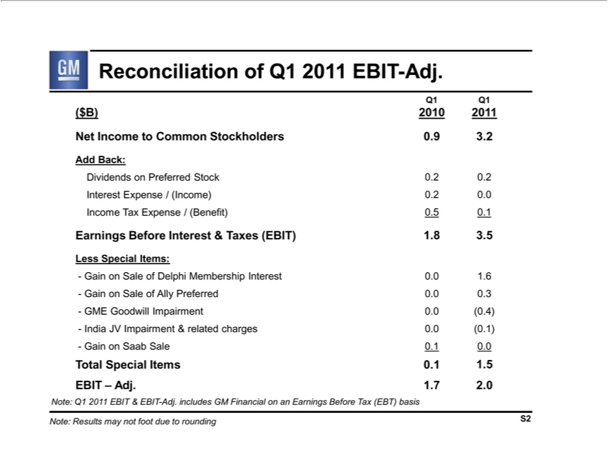

Reconciliation of Q1 2011 EBIT-Adj.
Q1 Q1
($B) 2010 2011
AddNetIncomeBack: to Common Stockholders 0.9 3.2
^{Income}DividendsterestExpenseonPreferred/(Income)Stock0.20.20.00.2
Tax Expense / (Benefit) 0.5 0.1
LessEarningsSpecialBeforeItems:Interest & Taxes (EBIT) 1.8 3.5
^{ain on Sale of} Delphi Membership Interest 0.0 1.6
^{GME} ⁽⁰
Goodwill AllyImpairmentPreferred0.00. .4)0.3
⁻
GainIndia onJV SaabImpairmentSale0.1&0.0related charges 0.0 (0.1)
^{EBIT}otal Special Items 0.1 1.5
– Adj. 1.7 2.0

_{Note:} Q1 2011 EBIT & EBIT-Adj. includes GM Financial on an Earnings Before Tax (EBT) basis Results may not foot due to rounding S2

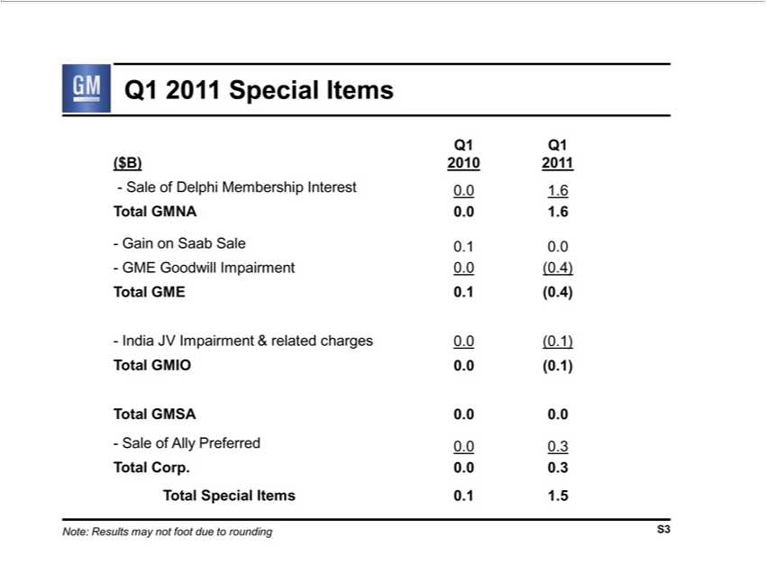

^{Q1} 2011 Special Items
Q1
($B) 2010 2011
Total-SaleGMNAofDelphi0.0Membership1.6 Interest 0.0 1.6
^{- GME}
ain onGoodwillSaabSaleImpairment0.10.0 0.0 (0.4)
Total GME 0.1 (0.4)
Total-IndiaGMSAJV^{IO}Impairment^{0.0}(0^{.1)} & related charges 0.0 (0.1)
0.0 .0
_{Total}-SaleCorp.ofAlly0.0Preferred0.3 0.0 0.3
Special Items 0.1 1.5

Note: Results may not foot due to rounding S3

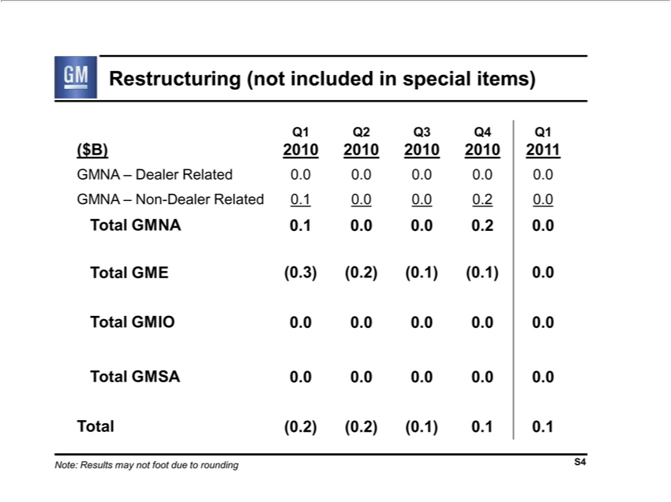

Restructuring (not included in special items)
Q1 Q2 Q3 Q4 Q1 |  |  | 1
($B) 2010 2010 2010 |  |  | 1
Dealer Related2010.0201.0 0.0 0.0 0.0
GMNA – Non-Dealer Related 0.1 0.0 0.0 0.2 0.0
NA 0.1 |  | .0 0. 0.2 | .0
E (0.3) |  | (0.2) (0.1) (0.1) 0.0
IO 0.0 0.0 0.0 0.0 0.0
GMSA 0.0 .0 0.0 0.0 0.0
Total (0.2) (0.2) | (0.1) 0.1 0.1
Note: Results may not foot due to rounding S4

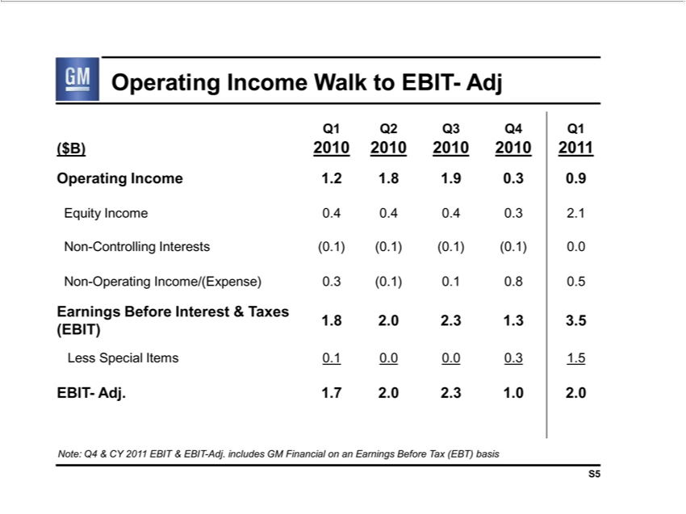

Operating Income Walk to EBIT- Adj
Q1 Q2 Q3 Q4 Q1
^{($B) 2010 2010} 201¹
EquityOperatingIncomeIncome0.4₂₀₁₀..4₂₀₁₀..84.9.3 2.1.3 0.9
^{Non-}Controlling Interests (0.1) (0.1) (0.1) (0.¹⁾ 0.0
Operating Income/(Expense) 0.3 (0.1) 0. 0.8 0.5
1.Earnings82.02.3Before1.33.5Interest & Taxes
(EBIT)
Less Special Items 0.1 0.0 0.0 0.3 1.5
EBIT- Adj. 1.7 2. 2.3 1.0 2.0
Note: Q4 & CY 2011 EBIT & EBIT-Adj. includes GM Financial on an Earnings Before Tax (EBT) basis S5

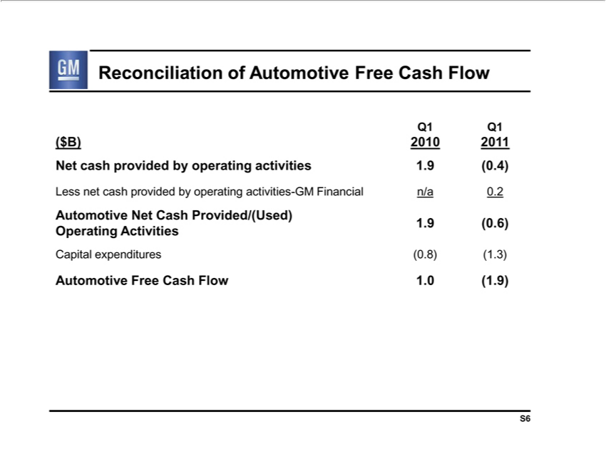

Q1ReconciliationQ1 of Automotive Free Cash Flow
($B) 2010 2011
Net cash provided by _{operating} activities 1.9 (0.4)
AutomotiveLessnetcashNetprovidedCash_{Provided/(Used)}byratingactivities-GM Financial n/a 0.2
1.9 (0.6)
Operating Activities
Capital expenditures (0.8) (1.3)
S6Automotive Free Cash Flow 1.0 (1.9)

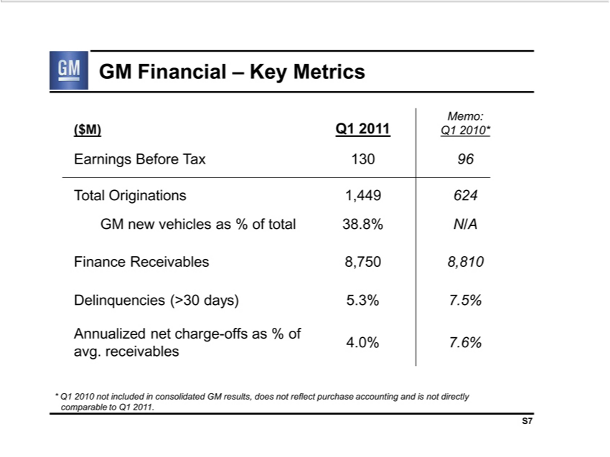

GM Financial – Key Metrics
($M) Q1 2011 Memo: Q1 2010*
Earnings Before Tax 130 96
Total Originations 1,449 624
GM new vehicles as % of total 38.8% N/A
DelinquenciesFinanceReceivables(>30days)8,7505.3%8,8107.5%
avg.Annualizedreceivablesnetcharge-offs as % of 4.0% 7.6%
S7*Q1 2010 not included in consolidated GM results, does not reflect purchase accounting and is not directly comparable to Q1 2011.

