UNITED STATES

SECURITIES AND EXCHANGE COMMISSION

Washington, D.C. 20549

SCHEDULE 14A

Proxy Statement Pursuant to Section 14(a) of the Securities

Exchange Act of 1934

☑ Filed by the Registrant ☐ Filed by a Party other than the Registrant
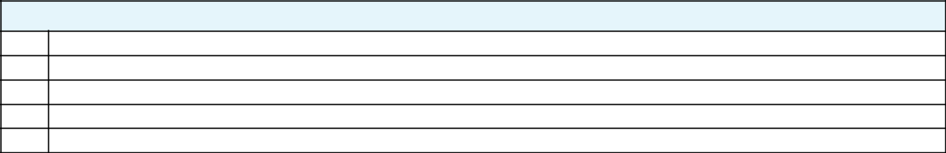

Check the appropriate box:

- Preliminary Proxy Statement

- CONFIDENTIAL, FOR USE OF THE COMMISSION ONLY (AS PERMITTED BY RULE 14a-6(e)(2))

- Definitive Proxy Statement

- Definitive Additional Materials

- Soliciting Material Pursuant to ss.240.14a-12

 |  | GENERAL MOTORS COMPANY
 |  | (Name of Registrant as Specified In Its Charter)
 |  | (Name of Person(s) Filing Proxy Statement, if other than the Registrant)
Payment of Filing Fee (Check the appropriate box):
☑ | No fee required.
☐ | Fee computed on table below per Exchange Act Rules 14a-6(i)(1) and 0-11.
 | (1) | Title of each class of securities to which transaction applies:
 | (2) | Aggregate number of securities to which transaction applies:
 | (3) | Per unit price or other underlying value of transaction computed pursuant to Exchange Act Rule 0-11 (set forth the amount on which the filing fee is calculated
 |  | and state how it was determined):
 | (4) | Proposed maximum aggregate value of transaction:
 | (5) | Total fee paid:
☐ | Fee paid previously with preliminary materials.
☐ | Check box if any part of the fee is offset as provided by Exchange Act Rule 0-11(a)(2) and identify the filing for which the offsetting fee was paid
 | previously. Identify the previous filing by registration statement number, or the Form or Schedule and the date of its filing.
 | (1) | Amount Previously Paid:
 | (2) | Form, Schedule or Registration Statement No.:
 | (3) | Filing Party:
 | (4) | Date Filed:


Your Vote Counts!

GENERAL MOTORS COMPANY

2021 Annual Meeting
Vote by June 13, 2021

11:59 PM ET

GENERAL MOTORS COMPANY

GENERAL MOTORS GLOBAL HEADQUARTERS MAIL CODE 482-C25-A36 300 RENAISSANCE CENTER

DETROIT, MI 48265

D50124-P53774

You invested in GENERAL MOTORS COMPANY and it’s time to vote!

You have the right to vote on proposals being presented at the Annual Meeting. This is an important notice regarding the availability of proxy material for the shareholder meeting to be held on June 14, 2021.

Get informed before you vote

View the Proxy Statement, Notice of 2021 Annual Meeting of Shareholders and 2020 Annual Report online OR you can receive a free paper or email copy of the material(s) by requesting prior to May 31, 2021. If you would like to request a copy of the material(s) for this and/or future shareholder meetings, you may (1) visit www.ProxyVote.com, (2) call 1-800-579-1639 or (3) send an email to sendmaterial@proxyvote.com. If sending an email, please include your control number (indicated below) in the subject line. Unless requested, you will not otherwise receive a paper or email copy.
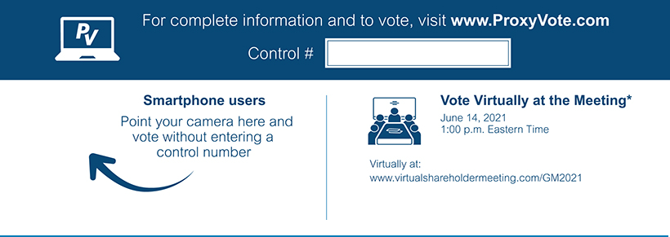

*Please check the meeting materials for any special requirements for meeting attendance.

V1

Vote at www.ProxyVote.com

THIS IS NOT A VOTABLE BALLOT

This is an overview of the proposals being presented at the
upcoming shareholder meeting. Please follow the instructions on

the reverse side to vote these important matters.

 |  | Board
Voting Items |  | Recommends
1. | Election of Directors
 | Nominees:
1a. | Mary T. Barra | For
1b. | Wesley G. Bush | For
1c. | Linda R. Gooden | For
1d. | Joseph Jimenez | For
1e. | Jane L. Mendillo | For
1f. | Judith A. Miscik | For
1g. | Patricia F. Russo | For
1h. | Thomas M. Schoewe | For
1i. | Carol M. Stephenson | For
1j. | Mark A. Tatum | For
1k. | Devin N. Wenig | For
1l. | Margaret C. Whitman | For
2. | Advisory Approval of Named Executive Officer Compensation | For
3. | Ratification of the Selection of Ernst & Young LLP as the Company’s Independent Registered Public Accounting | For
 | Firm for 2021 | For
4. | Shareholder Proposal Regarding Shareholder Written Consent | Against
5. | Shareholder Proposal Regarding a Report on Greenhouse Gas Emissions Targets as a Performance Element of | Against
 | Executive Compensation | Against

Prefer to receive an email instead? While voting on www.ProxyVote.com, be sure to click “Sign up for E-delivery”.

D50125-P53774

