Table of Contents

UNITED STATES

SECURITIES AND EXCHANGE COMMISSION

Washington, D.C. 20549

SCHEDULE 14A

Proxy Statement Pursuant to Section 14(a) of the Securities

Exchange Act of 1934

☑ Filed by the Registrant ☐ Filed by a Party other than the Registrant
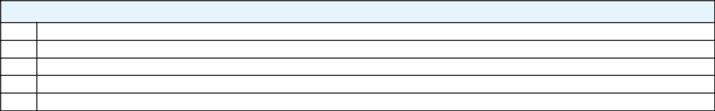

Check the appropriate box:

- Preliminary Proxy Statement

- CONFIDENTIAL, FOR USE OF THE COMMISSION ONLY (AS PERMITTED BY RULE 14a-6(e)(2))

- Definitive Proxy Statement

- Definitive Additional Materials

- Soliciting Material Pursuant to ss.240.14a-12

GENERAL MOTORS COMPANY

(Name of Registrant as Specified In Its Charter)

(Name of Person(s) Filing Proxy Statement, if other than the Registrant)
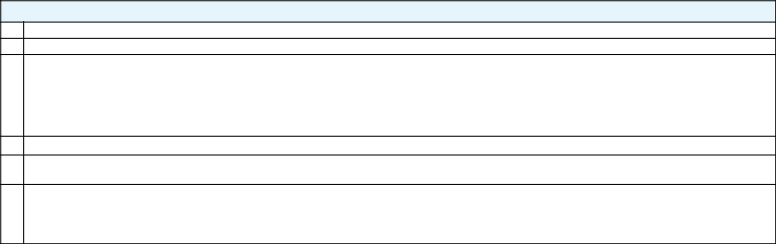

Payment of Filing Fee (Check the appropriate box):

- No fee required.

- Fee computed on table below per Exchange Act Rules 14a-6(i)(4) and 0-11.

  - Title of each class of securities to which transaction applies:

  - Aggregate number of securities to which transaction applies:

  - Per unit price or other underlying value of transaction computed pursuant to Exchange Act Rule 0-11 (set forth the amount on which the filing fee is calculated and state how it was determined):

  - Proposed maximum aggregate value of transaction:

  - Total fee paid:

- Fee paid previously with preliminary materials.

- Check box if any part of the fee is offset as provided by Exchange Act Rule 0-11(a)(2) and identify the filing for which the offsetting fee was paid previously. Identify the previous filing by registration statement number, or the Form or Schedule and the date of its filing.

  - Amount Previously Paid:

  - Form, Schedule or Registration Statement No.:

  - Filing Party:

  - Date Filed:

Table of Contents
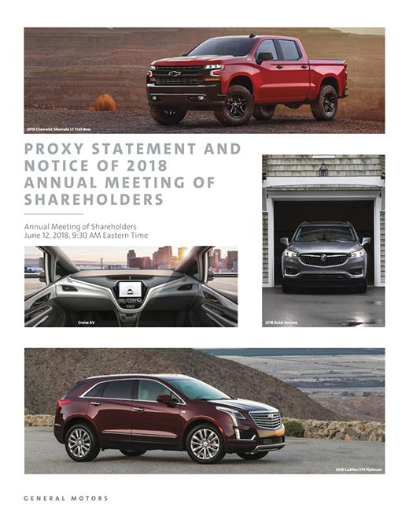

Table of Contents
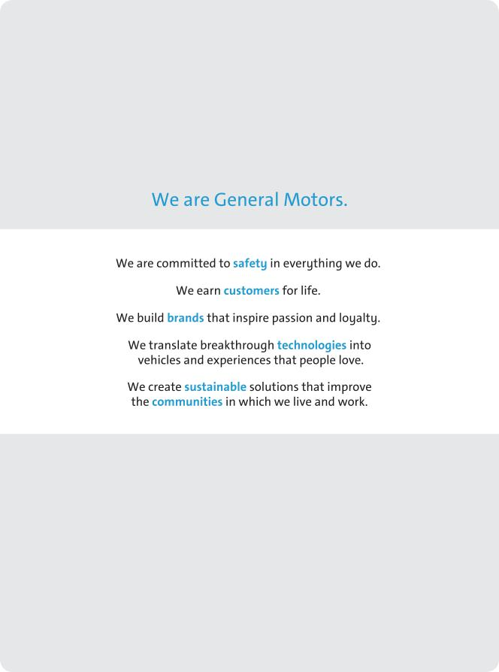

Table of Contents


The Long-Term View:

A Conversation with Mary Barra, Tim Solso, and Pat Russo

General Motors’ Chairman and CEO, Mary Barra, Independent Lead Director, Tim Solso, and Governance and Corporate Responsibility (“Governance”) Committee Chair, Pat Russo, discuss the Board’s approach to driving long-term shareholder value and the importance of meaningful shareholder engagement. They also explain why GM’s Board has the right mix of expertise, talent, and diversity to actively oversee the execution of GM’s strategy in this time of rapid industry change.

MARY T. BARRA THEODORE M. SOLSO

Chairman & CEO Independent Lead Director

PATRICIA F. RUSSO

Governance Committee Chair

How do you validate whether you are doing the right things for shareholders? Delivering value now and building for the future?

MARY: We have shared our strategy to transform GM, which is about driving excellence in our core business, while defining a future for mobility. We believe the best way to validate whether our approach is creating shareholder value is to deliver exceptional business results today while investing to lead in the future. By refocusing our finite resources during the past several years – including actions to either improve or exit underperforming businesses and to invest our capital in higher-return opportunities – we have achieved results that speak for themselves: three consecutive years of record financial performance. We have also made significant investments in technology and innovation that have positioned GM as a leader in the future of personal mobility. This view is shared by third parties like Navigant Research, which ranked GM as the leader in autonomous vehicle technology, ahead of 18 technology and automotive competitors.

What’s next? What steps are you taking to increase shareholder value?

MARY: We are a focused, more disciplined company. We will continue to transform our core business, invest in key technologies that are enabling us to lead in the future of personal mobility, and deploy capital to higher-return opportunities. In 2017, GM announced its vision for a world with zero crashes, zero emissions, and zero congestion. We are developing the technologies that will create this future, blending global insights with local market expertise as the automotive industry transforms from traditional manufacturing to transportation services.

The strong foundation and the increased flexibility we have created will enable us to take further actions – operational, financial, and technological – that we believe will deliver increased value for our shareholders.

The automobile industry is undergoing a period of profound change. How does the Board position GM to emerge as a leader?

TIM: The industry is changing quickly. Staying ahead means you have to be open to new ideas and invite input that challenges you with different thinking and perspectives. Our shareholder engagement process is an effective channel for the Board to hear these perspectives. Directors frequently meet with shareholders and can then bring shareholder views into the boardroom. During 2017, members of the Board met in person with shareholders representing approximately 25% of our outstanding common stock. We also invite large, long-term investors in GM and sell-side research analysts to meet with the full Board to share their unfiltered views on an annual basis.

Shareholder engagement is invaluable because it gives us a first-hand perspective on what is important to our shareholders as we make strategic, financial, and operational decisions. Using this approach, the Board has worked closely with management in recent years as it executed a number of key strategic actions to transform our core business and lead in the future of personal mobility. These included the decision to exit unprofitable markets, such as Europe and South and East Africa, in favor of higher-return opportunities that include growing the Cruise Automation team and acquiring LiDAR provider Strobe, Inc. to accelerate GM’s leadership in self-driving vehicle technology.

i

Table of Contents

How do you assure that the Board and management are aware of what’s on the horizon?

TIM: GM’s Board and leadership team are focused on new technologies and other emerging trends in the automotive industry. Management collaborates with internal and external experts across disciplines, from technology, cybersecurity, and design to regulatory and public policy, to assess opportunities and develop strategy. The Board is deeply engaged with management in these efforts. We also make it a priority to visit our global operations. Last April, we were in China, and this year, we visited our global propulsion headquarters and our research and development center and laboratories.

As you execute your plan, what are the elements that you believe are creating value?

MARY: We have been executing a plan that has accelerated GM’s transformation and driven accountability across our operations. Specifically, we have launched dozens of award-winning vehicles around the world; invested in key technologies to unlock our vision of zero crashes, zero emissions, and zero congestion; exited unprofitable markets; streamlined our operations with a relentless focus on cost; enhanced our capital structure; and strengthened our financing arm for competitive advantage.

Our record results over the last three years reflect the magnitude of change we have initiated and our dedication to meeting our financial commitments. And through dividends and stock repurchases, we have returned more than $25 billion to our shareholders from 2012 through the end of 2017. We also outperformed our peers in Total Shareholder Return in 2017.

Why do you believe the current Board is the right one to deliver increased value for GM shareholders?

PAT: We believe the current Board is composed of the right people to guide us through this important period of industry change and opportunity. Our strategic plan is multidisciplinary and so is your Board. Our directors are all outstanding leaders – most with experience managing large, highly complex, global organizations – who effectively oversee the performance of our core business as well as the execution of management’s strategy to lead in the future of personal mobility. We have members who understand evolving issues like technology, public policy, and international trade that are having a direct and increasingly important impact on our business. We also have directors with deep finance and capital markets expertise to provide guidance on optimal capital structure and effective capital allocation. With this expertise, your Board helps GM appropriately balance long-term investment with return of value to shareholders in the near term and navigate current and future risks.

ii

Can you provide insight for shareholders on what the Board looks for in a new director?

PAT: We find potential candidates from a variety of sources, including search firms and shareholders as well as recommendations from directors and management, and we take adding a new director to your Board seriously. Strategy-minded director recruitment and succession planning is critical to ensuring that your Board continues to protect shareholder value and be a strategic asset for the Company that is capable of addressing the evolving risks, trends, and opportunities that are around the corner at GM. We have a well-established process for director selection that is directly linked to the strategic needs of our business. The Governance Committee uses a carefully constructed skills matrix to review the experiences, qualifications, and attributes of current Board members and prospective candidates against the strategic needs of GM going forward to determine who can best help GM continue its momentum. Your Board also recognizes that refreshment brings both increased diversity and new perspectives, which are important components of a high-quality board. In fact, we added four new directors in the past three years as part of this comprehensive refreshment and recruitment process, including Devin N. Wenig, President and Chief Executive Officer of eBay Inc. (“eBay”), who brings considerable technology and consumer-facing experience to your Board.

Since 2016, Mary has been both the Chairman and CEO. With the two roles now combined, is the Board’s voice truly independent? Is the current Board leadership structure in the best interests of shareholders?

TIM: Your Board holds management accountable. Ten of the Board’s eleven directors are independent and together they have the right mix of expertise to oversee, guide, and challenge the leadership team. We are shaping and overseeing the Company’s strategy. Strategy is a part of every Board meeting agenda, and every year the Board holds a multiday session devoted exclusively to GM’s strategic plan. During these discussions, Board members engage in active debate and dialogue, challenge and validate management’s assumptions, and shape various aspects of management’s strategy and execution.

The Board does not believe there is a one-size-fits-all solution for board leadership structure or that combining or separating the Chairman and CEO roles is quite the black-and-white issue it is sometimes made out to be. Mary is the right person to lead your Board. GM’s performance under her leadership demonstrates that this structure is the most efficient way to execute our strategic plan and create value for shareholders. It is important for shareholders to realize that the Board retains the flexibility to separate the positions at any time if circumstances change. On an annual basis, the Board carefully considers the appropriate leadership structure for GM and its shareholders and determines whether to combine or split these roles. In the past, the Board has decided that separating the roles of Chairman and CEO would best serve shareholders, and in the future we may again, but we are confident that combining the roles is in the best interests of shareholders right now.

Table of Contents

Notice of 2018 Annual Meeting of Shareholders
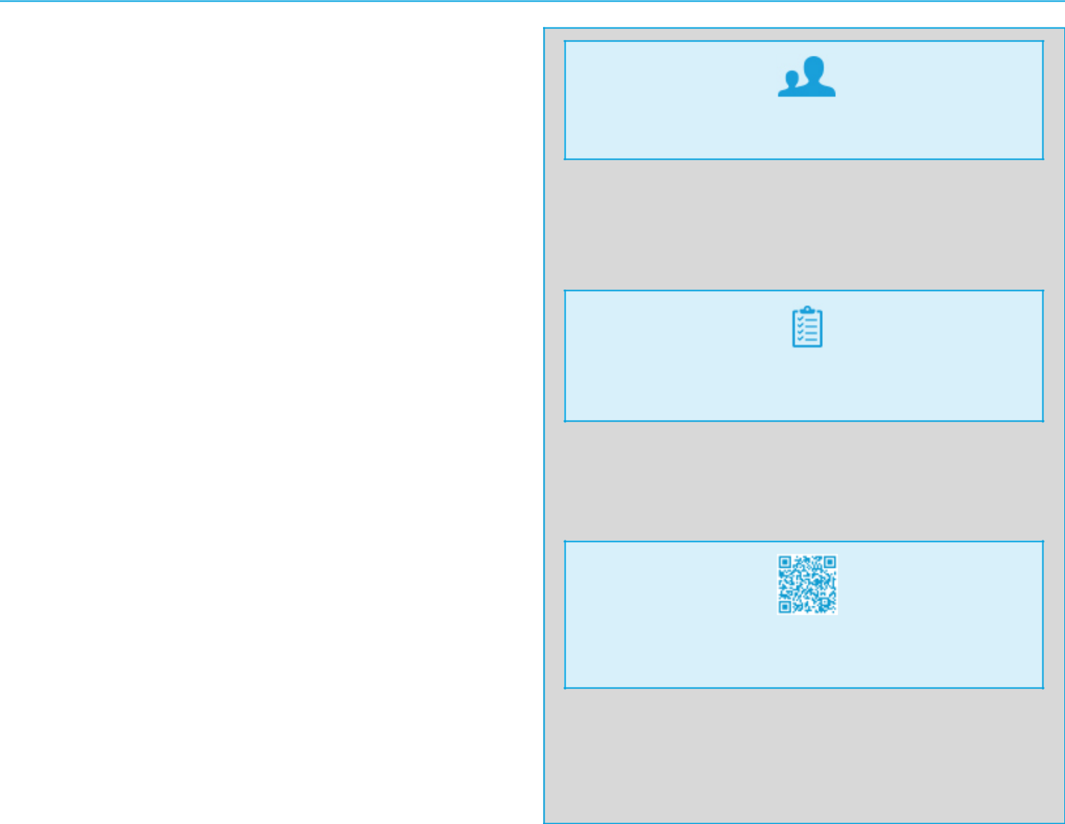

April 27, 2018

Dear Fellow Shareholder:

The Board of Directors of General Motors Company (“General Motors,” “GM,” the “Company,” “we,” and “our”) invites you to attend the 2018 Annual Meeting of Shareholders (the “Annual Meeting”) to be held on June 12, 2018, at the General Motors Global Headquarters, 300 Renaissance Center, Detroit, Michigan 48265. At the Annual Meeting, you will be asked to:

- Elect the 11 Board-recommended director nominees named in this Proxy Statement;

- Approve, on an advisory basis, Named Executive Officer (“NEO”) compensation;

- Ratify the selection of Ernst & Young LLP as the Company’s independent registered public accounting firm for 2018;

- Vote on three Rule 14a-8 shareholder proposals if properly presented at the meeting; and

- Transact any other business that is properly presented at the meeting.

Record Date

If you were a holder of record of GM common stock at the close of business on April 16, 2018, you are entitled to vote at the Annual Meeting. A list of registered shareholders will be available for examination for any purpose that is germane to the meeting at GM’s Global Headquarters in Detroit, Michigan, for 10 business days before the Annual Meeting between 9:00 a.m. and 5:00 p.m. Eastern time, and also during the Annual Meeting.

This Proxy Statement is provided in conjunction with GM’s solicitation of proxies to be used at the Annual Meeting. In addition to this Proxy Statement and proxy card or voting instruction form, the GM 2017 Annual Report on Form 10-K is provided in this package or is available on the Internet.

Thank you for your interest in General Motors Company.

By Order of the Board of Directors,

Rick E. Hansen

Assistant General Counsel and Corporate Secretary,

General Motors Company

Meeting Information:

Date: June 12, 2018

Time: 9:30 a.m. Eastern Time

Place: General Motors

Global Headquarters

300 Renaissance Center

Detroit, Michigan 48265

Your vote is important.

Please promptly submit your vote by Internet, by telephone, or by signing, dating, and returning the enclosed proxy card or voting instruction form in the postage-paid envelope provided so that your shares will be represented and voted at the meeting.

We are first mailing these proxy materials to our shareholders on or about April 27, 2018.

How You Can Access the
Proxy Materials Online:

Important Notice Regarding the Availability of Proxy Materials for the 2018 Annual Meeting of Shareholders, to be held on June 12, 2018.

Our Proxy Statement and 2017 Annual Report on Form 10-K are available at: gm.com/shareholderinformation. You may scan the QR code above with your smartphone or other mobile device to view our interactive Proxy Statement and to view the Annual Report on Form 10-K.

Table of Contents

Table of Contents

PROXY STATEMENT SUMMARY |  |  |  |  |  |  | 1
Agenda and Voting Recommendations |  |  |  |  |  |  | 1
Board Nominees |  |  |  |  |  |  | 1
Governance Highlights |  |  |  |  |  |  | 3
2017 Performance Snapshot |  |  |  |  |  |  | 4
Executive Compensation Highlights |  |  |  |  |  |  | 5
Environmental and Sustainability Performance |  |  |  |  |  |  | 6

ITEM NO. 1 – ELECTION OF DIRECTORS |  |  |  |  |  |  |  | 7
Overview of Your Board |  |  |  |  |  |  |  | 7
Board Membership Criteria, Refreshment, and Succession
 | Planning |  |  |  |  |  |  | 9
Your Board’s Nominees for Director |  |  |  |  |  |  |  | 10
Non-Employee Director Compensation |  |  |  |  |  |  |  | 17

CORPORATE GOVERNANCE |  |  |  |  |  |  |  |  |  |  |  |  |  |  |  |  |  |  |  |  |  | 20
Role of the Board of Directors |  |  |  |  |  |  |  |  |  |  |  |  |  |  |  |  |  |  |  |  |  | 20
Board Size |  |  |  |  |  |  |  |  |  |  |  |  |  |  |  |  |  |  |  |  |  | 20
Code of Business Conduct and Ethics: “Winning with
 | Integrity” |  |  |  |  |  |  |  |  |  |  |  |  |  |  |  |  |  |  |  |  | 20
Corporate Governance Guidelines |  |  |  |  |  |  |  |  |  |  |  |  |  |  |  |  |  |  |  |  |  | 20
Director Independence |  |  |  |  |  |  |  |  |  |  |  |  |  |  |  |  |  |  |  |  |  | 21
Board Leadership Structure |  |  |  |  |  |  |  |  |  |  |  |  |  |  |  |  |  |  |  |  |  | 21
Executive Sessions |  |  |  |  |  |  |  |  |  |  |  |  |  |  |  |  |  |  |  |  |  | 23
Board Committees |  |  |  |  |  |  |  |  |  |  |  |  |  |  |  |  |  |  |  |  |  | 23
Access to Outside Advisors |  |  |  |  |  |  |  |  |  |  |  |  |  |  |  |  |  |  |  |  |  | 27
Board and Committee Meetings and Attendance |  |  |  |  |  |  |  |  |  |  |  |  |  |  |  |  |  |  |  |  |  | 27
Board and Committee Oversight of Risk |  |  |  |  |  |  |  |  |  |  |  |  |  |  |  |  |  |  |  |  |  | 27
Succession Planning and Leadership Development |  |  |  |  |  |  |  |  |  |  |  |  |  |  |  |  |  |  |  |  |  | 28
Board and Committee Evaluations |  |  |  |  |  |  |  |  |  |  |  |  |  |  |  |  |  |  |  |  |  | 28
Annual Evaluation of CEO |  |  |  |  |  |  |  |  |  |  |  |  |  |  |  |  |  |  |  |  |  | 29
Director Orientation and Continuing Education |  |  |  |  |  |  |  |  |  |  |  |  |  |  |  |  |  |  |  |  |  | 29
Director Service on Other Public Company Boards |  |  |  |  |  |  |  |  |  |  |  |  |  |  |  |  |  |  |  |  |  | 29
Compensation Committee Interlocks and Insider
 | Participation |  |  |  |  |  |  |  |  |  |  |  |  |  |  |  |  |  |  |  |  | 29
Shareholder Engagement |  |  |  |  |  |  |  |  |  |  |  |  |  |  |  |  |  |  |  |  |  | 30
Shareholder Protections |  |  |  |  |  |  |  |  |  |  |  |  |  |  |  |  |  |  |  |  |  | 30
Certain Relationships and Related Party Transactions |  |  |  |  |  |  |  |  |  |  |  |  |  |  |  |  |  |  |  |  |  | 31

SECURITY OWNERSHIP INFORMATION |  |  |  |  |  | 32
Security Ownership of Directors, Named Executive Officers,
 | and Certain Other Beneficial Owners |  |  |  |  | 32
Section 16(a) Beneficial Ownership Reporting Compliance |  |  |  |  |  | 33

EXECUTIVE COMPENSATION |  |  |  |  |  |  |  |  |  |  |  |  |  |  |  |  |  |  |  |  |  |  |  |  |  |  |  |  |  |  |  |  |  |  |  |  |  |  | 35
Compensation Overview |  |  |  |  |  |  |  |  |  |  |  |  |  |  |  |  |  |  |  |  |  |  |  |  |  |  |  |  |  |  |  |  |  |  |  |  |  |  | 36
Compensation Principles |  |  |  |  |  |  |  |  |  |  |  |  |  |  |  |  |  |  |  |  |  |  |  |  |  |  |  |  |  |  |  |  |  |  |  |  |  |  | 43
Compensation Elements |  |  |  |  |  |  |  |  |  |  |  |  |  |  |  |  |  |  |  |  |  |  |  |  |  |  |  |  |  |  |  |  |  |  |  |  |  |  | 43
Performance Measures |  |  |  |  |  |  |  |  |  |  |  |  |  |  |  |  |  |  |  |  |  |  |  |  |  |  |  |  |  |  |  |  |  |  |  |  |  |  | 44
Performance Results and Compensation Decisions |  |  |  |  |  |  |  |  |  |  |  |  |  |  |  |  |  |  |  |  |  |  |  |  |  |  |  |  |  |  |  |  |  |  |  |  |  |  | 47
Compensation Policies and Governance Practices |  |  |  |  |  |  |  |  |  |  |  |  |  |  |  |  |  |  |  |  |  |  |  |  |  |  |  |  |  |  |  |  |  |  |  |  |  |  | 54
Compensation Committee Report |  |  |  |  |  |  |  |  |  |  |  |  |  |  |  |  |  |  |  |  |  |  |  |  |  |  |  |  |  |  |  |  |  |  |  |  |  |  | 56
Executive Compensation Tables |  |  |  |  |  |  |  |  |  |  |  |  |  |  |  |  |  |  |  |  |  |  |  |  |  |  |  |  |  |  |  |  |  |  |  |  |  |  | 57
Equity Compensation Plan Information |  |  |  |  |  |  |  |  |  |  |  |  |  |  |  |  |  |  |  |  |  |  |  |  |  |  |  |  |  |  |  |  |  |  |  |  |  |  | 67
ITEM NO. 2 – |  |  |  |  |  |  | Approval of, on an Advisory Basis,
 |  |  |  |  |  |  |  | Named Executive Officer |  |  |  |  |  |  |  |  |  |  |  |  |  |  |  |  |  |  |  |  |  |  |  |  |  |  |  |  |  |  | 68
 |  |  |  |  |  |  | Compensation |  |  |  |  |  |  |  |  |  |  |  |  |  |  |  |  |  |  |  |  |  |  |  |  |  |  |  |  |  |  |  | 68
ITEM NO. 3 – |  |  |  |  |  |  | Ratification of the Selection of
 |  |  |  |  |  |  |  | Ernst & Young LLP as the
 |  |  |  |  |  |  | Company’s Independent
 |  |  |  |  |  |  | Registered Public Accounting |  |  |  |  |  |  |  |  |  |  |  |  |  |  |  |  |  |  |  |  |  |  |  |  |  |  |  |  |  |  |  | 69
 |  |  |  |  |  |  | Firm for 2018 |  |  |  |  |  |  |  |  |  |  |  |  |  |  |  |  |  |  |  |  |  |  |  |  |  |  |  |  |  |  |  | 69
Audit Committee Report |  |  |  |  |  |  |  |  |  |  |  |  |  |  |  |  |  |  |  |  |  |  |  |  |  |  |  |  |  |  |  |  |  |  |  |  |  |  | 70
Fees Paid to Independent Registered Public Accounting
 | Firm |  |  |  |  |  |  |  |  |  |  |  |  |  |  |  |  |  |  |  |  |  |  |  |  |  |  |  |  |  |  |  |  |  |  |  |  |  | 71
ITEM NO. 4 – |  |  |  |  |  |  | Shareholder Proposal Regarding |  |  |  |  |  |  |  |  |  |  |  |  |  |  |  |  |  |  |  |  |  |  |  |  |  |  |  |  |  |  |  | 72
 |  |  |  |  |  |  |  | Independent Board Chairman |  |  |  |  |  |  |  |  |  |  |  |  |  |  |  |  |  |  |  |  |  |  |  |  |  |  |  |  |  |  | 72
ITEM NO. 5 – |  |  |  |  |  |  | Shareholder Proposal Regarding
 |  |  |  |  |  |  |  | Shareholder Right to Act by |  |  |  |  |  |  |  |  |  |  |  |  |  |  |  |  |  |  |  |  |  |  |  |  |  |  |  |  |  |  | 74
 |  |  |  |  |  |  | Written Consent |  |  |  |  |  |  |  |  |  |  |  |  |  |  |  |  |  |  |  |  |  |  |  |  |  |  |  |  |  |  |  | 74
ITEM NO. 6 – |  |  |  |  |  |  | Shareholder Proposal Regarding
 |  |  |  |  |  |  |  | Report on Greenhouse Gas |  |  |  |  |  |  |  |  |  |  |  |  |  |  |  |  |  |  |  |  |  |  |  |  |  |  |  |  |  |  | 76
 |  |  |  |  |  |  | Emissions and CAFE Standards |  |  |  |  |  |  |  |  |  |  |  |  |  |  |  |  |  |  |  |  |  |  |  |  |  |  |  |  |  |  |  | 76
GENERAL INFORMATION ABOUT |  |  |  |  |  |  |  |  |  |  |  |  |  |  |  |  |  |  |  |  |  |  |  |  |  |  |  |  |  |  |  |  |  |  |  |  |  |  | 78
THE ANNUAL MEETING |  |  |  |  |  |  |  |  |  |  |  |  |  |  |  |  |  |  |  |  |  |  |  |  |  |  |  |  |  |  |  |  |  |  |  |  |  |  | 78
APPENDIX A – |  |  |  |  |  |  | Reconciliation of GAAP and |  |  |  |  |  |  |  |  |  |  |  |  |  |  |  |  |  |  |  |  |  |  |  |  |  |  |  |  |  |  |  | A-1
 |  |  |  |  |  |  |  | Non-GAAP Financial Measures |  |  |  |  |  |  |  |  |  |  |  |  |  |  |  |  |  |  |  |  |  |  |  |  |  |  |  |  |  |  | A-1
APPENDIX B – |  |  |  |  |  |  | Additional Information Regarding
 |  |  |  |  |  |  |  | Change of Independent Registered |  |  |  |  |  |  |  |  |  |  |  |  |  |  |  |  |  |  |  |  |  |  |  |  |  |  |  |  |  |  | B-1
 |  |  |  |  |  |  | Public Accounting Firms |  |  |  |  |  |  |  |  |  |  |  |  |  |  |  |  |  |  |  |  |  |  |  |  |  |  |  |  |  |  |  | B-1

Table of Contents

PROXY STATEMENT SUMMARY

This summary highlights information contained elsewhere in this Proxy Statement. It does not contain all of the information that you should consider. Please read the entire Proxy Statement carefully before voting.

Agenda and Voting Recommendations

Proposal | Board Vote Recommendation | Page Reference
MANAGEMENT PROPOSALS:
Item No. 1 – Election of Directors | FOR | 7
Item No. 2 – Approval of, on an Advisory Basis, | FOR | 68
Named Executive Officer Compensation | FOR | 68
Item No. 3 – Ratification of the Selection of
Ernst & Young LLP as the Company’s Independent | FOR | 69
Registered Public Accounting Firm for 2018
SHAREHOLDER PROPOSALS:
Item No. 4 – Independent Board Chairman | AGAINST | 72
Item No. 5 – Shareholder Right to Act by Written Consent | AGAINST | 74
Item No. 6 – Report on Greenhouse Gas Emissions and CAFE Standards | AGAINST | 76

Board Nominees
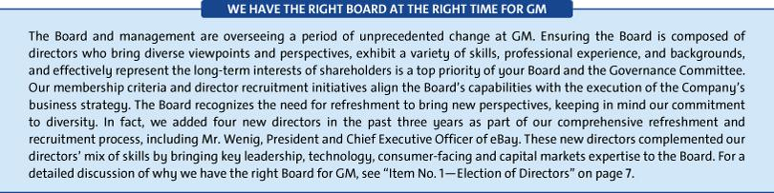

Composition of Board Nominees
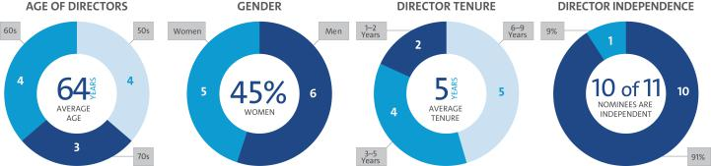

1

Table of Contents

PROXY STATEMENT SUMMARY

The following table provides summary information about each director nominee. For more detailed information about our directors, see “Item No. 1— Election of Directors—Your Board’s Nominees for Director” on page 10.

 |  | Director |  |  | Committee
Name | Age | Since | Principal Occupation | Independent | Memberships
Mary T. Barra |  |  | Chairman & |  | Executive – Chair
Mary T. Barra | 56 | 2014 | Chief Executive Officer, |  | Executive – Chair
 |  |  | General Motors Company
 |  |  | Independent Lead Director,
Theodore M. Solso | 71 | 2012 | General Motors Company, and |  | Executive
Theodore M. Solso | 71 | 2012 | Retired Chairman & Chief |  | Executive
 |  |  | Executive Officer, Cummins, Inc.
 |  |  | Retired Executive Vice President, |  | Audit
Linda R. Gooden | 65 | 2015 | Information Systems & Global |  | Cybersecurity – Chair
Linda R. Gooden | 65 | 2015 | Solutions, Lockheed Martin |  | Executive
 |  |  | Corporation |  | Risk
Joseph Jimenez | 58 | 2015 | Retired Chief Executive Officer, |  | Executive Compensation
Joseph Jimenez | 58 | 2015 | Novartis AG |  | Governance
Jane L. Mendillo |  |  | Retired President & |  | Finance
Jane L. Mendillo | 59 | 2016 | Chief Executive Officer, |  | Finance
 |  |  |  |  | Audit
 |  |  | Harvard Management Company |  | Audit
Admiral |  |  |  |  | Audit
Admiral | 71 | 2013 | Former Chairman, |  | Cybersecurity
Michael G. Mullen | 71 | 2013 | Joint Chiefs of Staff |  | Executive
 |  |  |  |  | Risk – Chair
 |  |  | Retired Chairman & |  | Executive
James J. Mulva |  |  | Retired Chairman & |  | Executive Compensation
James J. Mulva | 71 | 2012 | Chief Executive Officer, |  | Executive Compensation
 |  |  |  |  | Finance – Chair
 |  |  | ConocoPhillips |  | Finance – Chair
 |  |  | ConocoPhillips |  | Risk
 |  |  |  |  | Executive
Patricia F. Russo | 65 | 2009 | Chairman, Hewlett Packard |  | Executive Compensation
Patricia F. Russo | 65 | 2009 | Enterprise Company |  | Finance
 |  |  |  |  | Governance – Chair
 |  |  |  |  | Audit – Chair
Thomas M. |  |  | Retired Executive Vice President |  | Cybersecurity
Thomas M. | 65 | 2011 | & Chief Financial Officer, |  | Executive
Schoewe | 65 | 2011 | & Chief Financial Officer, |  | Executive
Schoewe |  |  | Wal-Mart Stores, Inc. |  | Finance
 |  |  |  |  | Risk
Carol M. |  |  | Retired Dean, Ivey Business |  | Executive
Carol M. | 67 | 2009 | School, The University of |  | Executive Compensation – Chair
Stephenson | 67 | 2009 | School, The University of |  | Executive Compensation – Chair
Stephenson |  |  | Western Ontario |  | Governance
 |  |  | President & |  | Committee memberships to be
Devin N. Wenig | 51 | 2018 | Chief Executive Officer, |  | determined at the Board’s June
 |  |  | eBay Inc. |  | 2018 meeting

2

Table of Contents

PROXY STATEMENT SUMMARY

Governance Highlights

We recognize that strong corporate governance contributes to long-term shareholder value. We are committed to sound governance practices, including those described below.
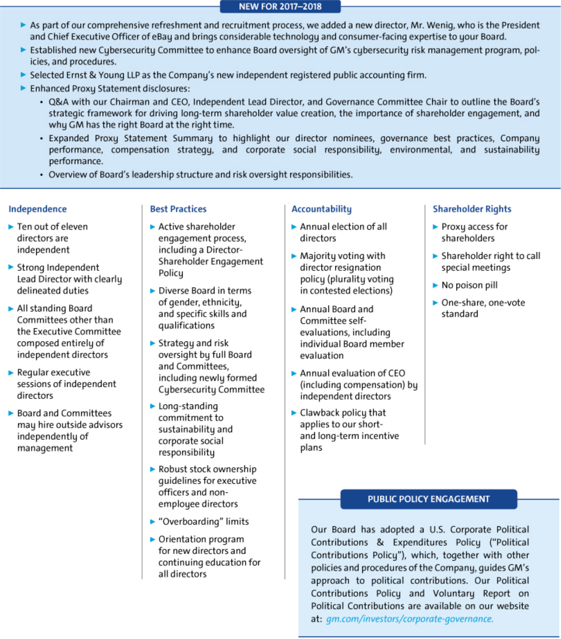

3

Table of Contents

PROXY STATEMENT SUMMARY

2017 Performance Snapshot
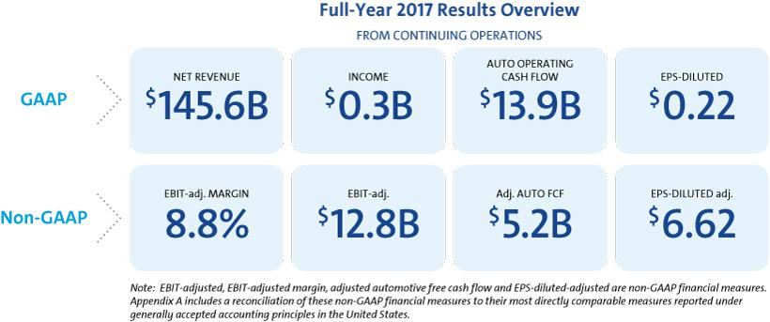

A Year of Transformation

Sweeping change accompanied record performance at General Motors in 2017. To continue focusing resources on its most profitable franchises, GM sold its Opel/Vauxhall and GM Financial European operations, and exited South and East Africa, and India. To advance its vision of a zero emissions world, GM laid out plans to introduce at least 20 new all-electric vehicles that will launch by 2023. The Company also recently filed a Safety Petition asking the U.S. Department of Transportation to allow GM to safely deploy its fourth-generation self-driving Cruise AV on public roads. This vehicle eliminates the steering wheel, pedals, and other unnecessary manual controls. GM expects to deploy self-driving vehicles at scale in a dense urban environment in 2019.

“The actions we took to further strengthen our core business and advance our vision for personal mobility made 2017 a transformative year. We will continue executing our plan and reshaping our company to position it for long-term success.”

– Mary Barra, Chairman & CEO

Shareholder Return

GM returned $6.7 billion to shareholders in 2017 through share buybacks of $4.5 billion and dividends of $2.2 billion. Since 2012, GM has returned more than $25 billion, which represents more than 90% of available free cash flow generated over that time.

COMPARISON OF CUMULATIVE TOTAL RETURN

Cumulative Value of $100 Investment Through December 31, 2017
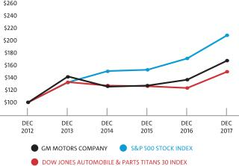

J.D. Power Awards

Chevrolet was J.D. Power’s most awarded brand in 2017, as six different Chevrolet cars, trucks, and SUVs won a total of nine awards in J.D. Power’s 2017 Vehicle Dependability, Initial Quality, and APEAL Studies. Chevrolet also earned high marks in the 2018 J.D. Power Customer Service Index (“CSI”) Study and the 2017 Sales Satisfaction Index (“SSI”) Survey. In addition, Buick and Chevrolet led the way as the two General Motors brands earning six awards and delivering more Top Three segment model rankings than any other company in the J.D. Power and Associates 2018 U.S. Vehicle Dependability Study.
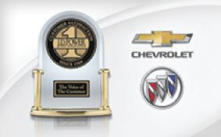

4

Table of Contents

PROXY STATEMENT SUMMARY

Executive Compensation Highlights

We provide highlights of our compensation program below. Please review our Compensation Discussion and Analysis and compensation-related tables beginning on page 35 of this Proxy Statement for a complete understanding of our compensation program.
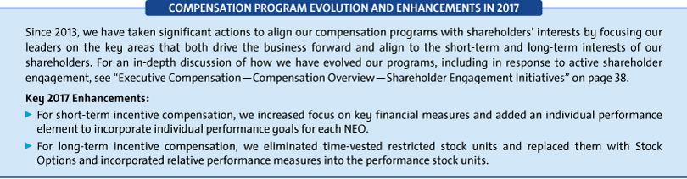

- Performance-Based Compensation Structure
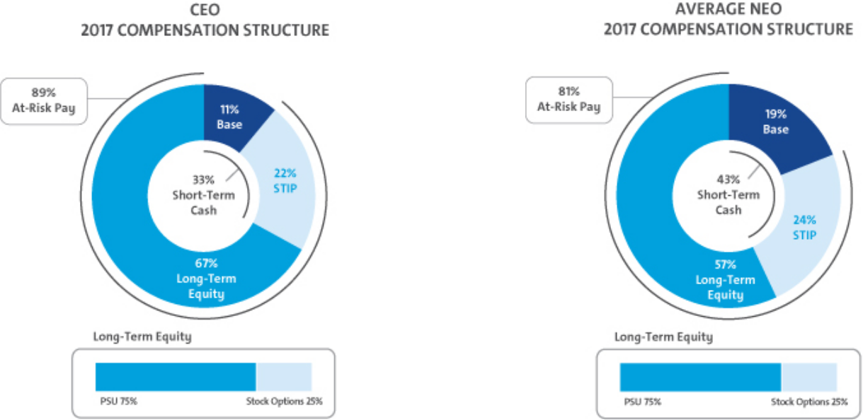

- 2017 Summary Compensation Snapshot

 |  |  |  |  |  | Change in
 |  |  |  |  |  | Pension
 |  |  |  |  |  | Value and
 |  |  |  |  | Nonequity | NQ Deferred
 |  |  | Stock | Option | Incentive Plan | Compensation | All Other
 | Salary | Bonus | Awards | Awards | Compensation | Earnings | Compensation | Total
Name | ($) | ($) | ($) | ($) | ($) | ($) | ($) | ($)
Mary T. Barra | 2,100,000 | — | 10,737,570 | 3,250,003 | 4,956,000 | 52,792 | 861,683 | 21,958,048
Charles K. Stevens, III | 1,100,000 | — | 3,076,744 | 931,251 | 1,622,500 | 54,114 | 316,430 | 7,101,039
Daniel Ammann | 1,450,000 | — | 4,078,222 | 1,234,378 | 2,138,800 | — | 356,918 | 9,258,318
Mark L. Reuss | 1,200,000 | — | 3,345,168 | 1,012,504 | 1,770,000 | 54,390 | 344,446 | 7,726,508
Alan S. Batey | 1,025,000 | — | 2,224,928 | 673,426 | 1,447,800 | 316,601 | 287,373 | 5,975,128
Karl-Thomas Neumann | 916,936 | 2,000,000 | 1,961,676 | 593,751 | 1,276,317 | 126,796 | 12,563 | 6,888,039

Note: For additional information on the table above, please see the Summary Compensation Table in “Executive Compensation” on page 57.

5

Table of Contents

PROXY STATEMENT SUMMARY

Environmental and Sustainability Performance

Our vision for the future can be summed up with three numbers: zero crashes, zero emissions, and zero congestion.

ZERO CRASHES

GM’s number one priority is safety. We are developing new technologies to help keep our customers safe.

u GM’s Cruise AV has the potential to provide a level of safety far beyond the capabilities of human drivers.

u We launched Super Cruise, the world’s first hands-free highway driving technology, on the Cadillac CT6.

u GM offers 53 global models with forward collision alert and lane departure warning and 40 models with side blind zone alert.

ZERO EMISSIONS

GM is committed to an all-electric, zero emissions future. We are working to make cars more efficient and embrace environmentally conscious options.

u GM will introduce 20 new all-electric vehicles by 2023.

u In 2018, GM will increase Bolt EV production at its Orion Assembly Plant north of Detroit.

u GM has committed to using 100% renewable energy in its operations by 2050.


ZERO CONGESTION

GM is building autonomous, connected, and shared personal mobility options that will help end the congestion that wastes our time and money.

u Maven Gig members have driven more than 6.5 million all-electric miles since February 2017, saving an estimated 250,000 gallons of gas.

u As of March 2018, more than 250 million Maven miles have been driven.

u In 2018, GM submitted a petition to the U.S. Department of Transportation seeking permission to begin operating fully autonomous vehicles, without steering wheels or pedals, at scale in a dense urban environment in 2019.


In 2017, GM documented existing practices by memorializing and publishing policies for shareholders, including:

u Conflict Minerals Policy

u Global Environmental Policy

u Human Rights Policy

u Global Integrity Policy, Gifts, Entertainment and Anti-Corruption

u Global Speak-Up! Non-Retaliation Policy u Supplier Code of Conduct

LEADERS IN ACTION



Dow Jones Sustainability World Index included GM for the first time and Dow Jones Sustainability North America Index included GM as the only automaker for the third consecutive year.

Other third parties regularly recognize our leadership. A few of those awards include:

u CDP (Carbon Disclosure Project) named GM to the Global Climate A List in 2016 for its performance and disclosure of its CO² and climate impacts and to the Water A List in 2017 for its effective water management practices.

u U.S. Energy Star Partner of the Year – Sustained Excellence Company.

Find more online.

For additional information, please read our Sustainability Report, available at: gmsustainability.com, which includes information about how our sustainability strategy integrates with corporate performance and other topics, such as:

u GM initiatives to service communities and youth in science, technology, engineering and math (STEM).

u Actions GM has taken to maintain and improve a responsible supply chain.

u Efforts GM has led to create a diverse and safe workplace of choice.

6

Table of Contents

ITEM NO. 1 – ELECTION OF DIRECTORS
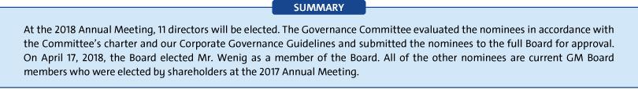

Overview of Your Board
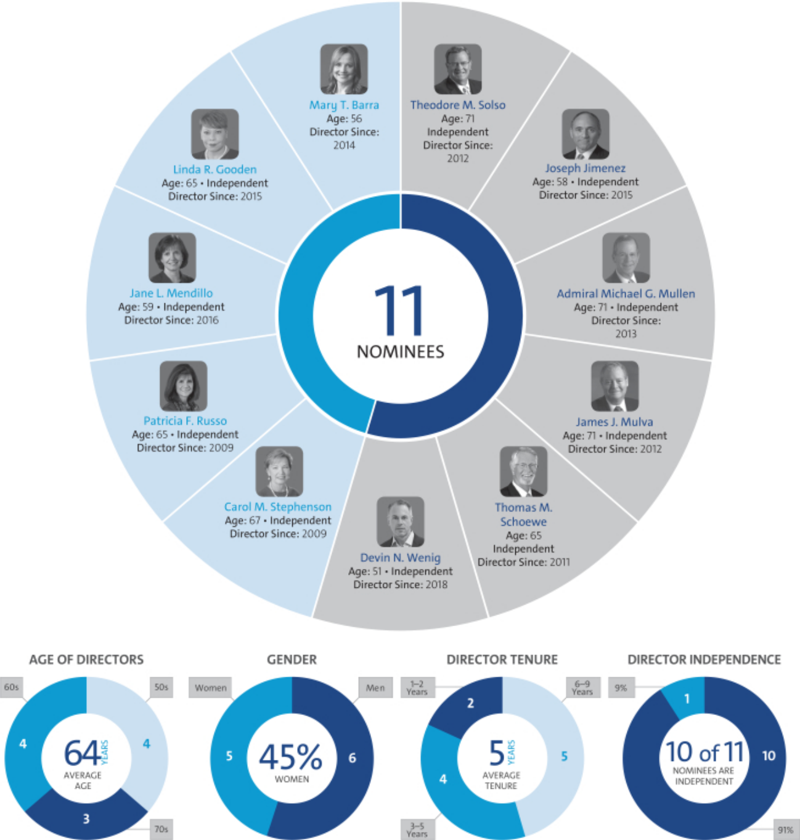

7

Table of Contents

ITEM NO. 1 – ELECTION OF DIRECTORS
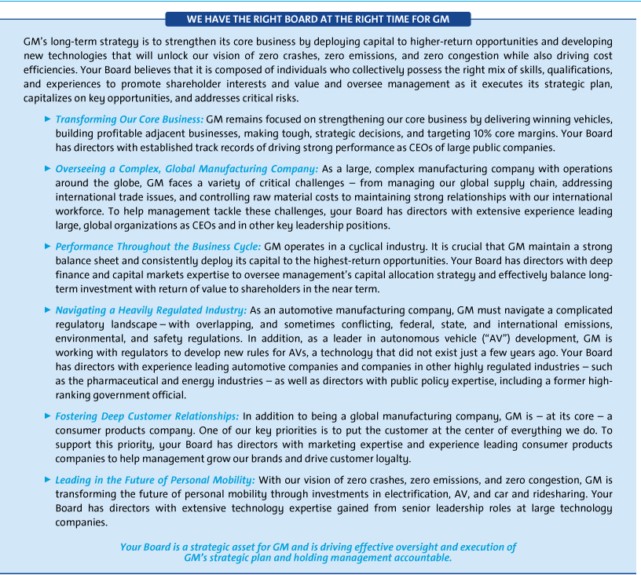

8

Table of Contents

ITEM NO. 1 – ELECTION OF DIRECTORS

- Diversity of Skills, Qualifications, and Experience

Your Board nominees offer a diverse range of skills and experience in relevant areas.

SKILL/
QUALIFICATION | BARRA | SOLSO | GOODEN | JIMENEZ | MENDILLO | MULLEN | MULVA | RUSSO | SCHOEWE | STEPHENSON | WENIG
 | ● | ● | ● | ● | ● | ● | ● | ● | ● | ● | ●
 | ● | ●
 | ● | ● | ● | ● |  |  | ● | ● | ●
 | ● | ● | ● |  |  | ● |  | ● | ● | ● | ●
 | ● | ● | ● | ● | ● | ● | ● | ● | ● | ● | ●
 | ● | ● | ● | ● | ● | ● | ● | ● | ● | ● | ●
 | ● | ● | ● | ● | ● |  | ● | ● | ● | ● | ●
 |  |  | ● |  |  | ● | ● |  |  | ●
 |  |  |  | ● |  |  |  | ● | ● | ● | ●
 | ● |  | ● | ● | ● |  |  | ● |  | ●



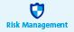






Board Membership Criteria, Refreshment, and Succession Planning

The selection of qualified directors is fundamental to the Board’s successful oversight of GM’s strategy and enterprise risks. As a result, ensuring your Board is composed of directors who bring diverse viewpoints and perspectives, exhibit a variety of skills, professional experiences, and backgrounds, and effectively represent the long-term interests of shareholders is critical to your Board and the Governance Committee. The priorities for recruiting new directors are continually evolving based on the Company’s strategic needs and the skills composition of your Board at any particular time. These dynamic priorities ensure the Board remains a strategic asset capable of addressing the risks, trends, and opportunities that GM will face in the future. In evaluating potential director candidates, the Governance Committee considers, among other factors, the criteria shown above in the skills and qualifications matrix for your current directors and any additional characteristics that it believes one or more directors should possess based on an assessment of the needs of the Board at that time. In every case, director candidates must be able to contribute significantly to your Board’s discussion and decision-making on the broad array of complex issues facing GM. The Governance Committee also engages a reputable, qualified search firm that uses our skills matrix to inform the search and help identify and evaluate potential candidates.

- Board Diversity

The Governance Committee considers individuals with a broad range of business experience and varied backgrounds. Although GM does not have a formal policy governing diversity among directors, your Board strives to identify candidates with diverse backgrounds. We recognize the value of overall diversity and consider members’ and candidates’ opinions, perspectives, personal and professional experiences, and backgrounds, including gender, race, ethnicity, and country of origin. We believe that the judgment and perspectives offered by a diverse board of directors improves the quality of decision making and enhances the Company’s business performance. We also believe such diversity can help the Board respond more effectively to the needs of customers, shareholders, employees, suppliers, and other stakeholders.

9

Table of Contents

ITEM NO. 1 – ELECTION OF DIRECTORS

- Candidate Recommendations

The Governance Committee will consider persons recommended by shareholders for election to the Board. The Governance Committee will review the qualifications and experience of each recommended candidate using the same criteria for candidates proposed by Board members and communicate its decision to the candidate or the person who made the recommendation.

- Director Recruitment Process
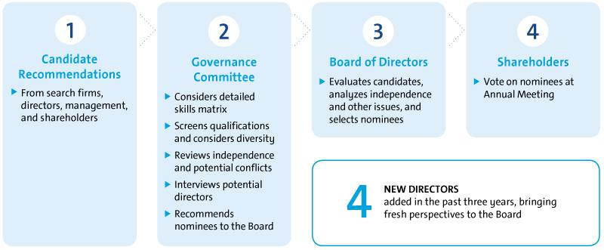

Your Board’s Nominees for Director

Set forth below is other information about our director nominees, including their name and age, recent employment or principal occupation, their period of service as a GM director, the names of other public companies for which they currently serve as a director or have served as a director in the past, and a summary of their specific experiences, qualifications, attributes, and skills. We believe each of your Board’s nominees is highly qualified with unique experiences that are particularly beneficial to GM. Collectively, we believe these director nominees represent the best mix of expertise, qualifications, and skills to advance GM’s business strategy and serve the interest of all of our shareholders by driving long-term shareholder value.

The Board of Directors recommends a vote FOR each of the nominees below.

10

Table of Contents

ITEM NO. 1 – ELECTION OF DIRECTORS


Mary T. Barra

Chairman & Chief Executive Officer,

General Motors Company

56 years old

Director since: 2014

Committees

Executive (Chair)

Current Public Company Directorships

The Walt Disney Company

Prior Public Company Directorships

General Dynamics Corporation (2011 to 2017)

Prior Experience

Ms. Barra has served as Chairman of GM’s Board of Directors since January 2016 and Chief Executive Officer of GM since January 2014. Prior to that time, she served as Executive Vice President, Global Product Development, Purchasing and Supply Chain from 2013 to 2014; Senior Vice President, Global Product Development from 2011 to 2013; Vice President, Global Human Resources from 2009 to 2011; and Vice President, Global Manufacturing Engineering from 2008 to 2009. Ms. Barra began her career at GM in 1980.

Reasons for Nomination

- Extensive senior leadership experience gained as the CEO of GM and in other key leadership positions at the Company, including experience in operational excellence, strategic planning, purchasing and supply chain, human resources, and manufacturing and engineering.
- In-depth knowledge of the global automotive industry.

- Deep understanding of GM’s strengths, weaknesses, opportunities, challenges, risks, and corporate culture.
- Ability to drive the efficient execution of GM’s strategic plan and vision for the future.
- Strong leadership and management skills coupled with extensive engineering and global product development experience.
- Valuable knowledge of key governance matters gained as a director of GM and other large global public companies.

Theodore M. Solso

Independent Lead Director, General Motors Company and Retired Chairman & Chief Executive Officer, Cummins, Inc.

71 years old

Director since: 2012

Committees

Executive

Current Public Company Directorships

Ball Corporation (Lead Director)

Prior Public Company Directorships

Ashland Inc. (1999 to 2012) (Lead director 2003 to 2010)

Prior Experience

Mr. Solso served as Non-Executive Chairman of the GM Board of Directors from 2014 to 2016. He was Chairman and Chief Executive Officer of Cummins, Inc. (“Cummins”) from 2000 until his retirement in 2011 and President and Chief Operating Officer of Cummins from 1995 to 2000.

Reasons for Nomination

- Extensive senior leadership experience gained as the CEO of Cummins, including automotive-related experience and experience in finance, accounting, and vehicle and workplace safety.

- Background leading a company through strong financial performance and shareholder returns, international growth, and business restructurings.

- Valuable knowledge of key governance matters, including environmental issues, corporate responsibility, diversity, and human rights issues, gained as the CEO of Cummins and the lead director of GM and other large global public companies.
- Extensive experience in automotive manufacturing and engineering, including with respect to emissions reduction technology, development of diesel engines, and compliance with challenging emissions laws and regulations.
- Valuable insight into advancing the business priorities of GM’s international operations gained as the U.S. Chairman of the U.S.-Brazil CEO Forum.

11

Table of Contents

ITEM NO. 1 – ELECTION OF DIRECTORS


Linda R. Gooden

Retired Executive Vice President, Information Systems &

Global Solutions, Lockheed Martin Corporation

65 years old

Director since: 2015

Committees

Audit, Cybersecurity (Chair), Executive, Risk

Current Public Company Directorships

Automatic Data Processing, Inc., The Home Depot, Inc., WGL Holdings, Inc., and Washington Gas & Light Company, a subsidiary of WGL Holdings, Inc.

Prior Experience

Ms. Gooden served as Executive Vice President, Information Systems & Global Solutions of Lockheed Martin Corporation (“Lockheed”) from 2007 to 2013. She was Deputy Executive Vice President, Information and Technology Services of Lockheed from October to December 2006; and President, Information Technology of Lockheed from 1997 to December 2006.

Reasons for Nomination

- Significant senior leadership experience gained through various leadership positions at Lockheed, including experience in technology, innovation, acquisitions, divestitures, business restructuring, finance, and risk management.
- Valuable insight into GM’s information technology (“IT”) function, technology systems and processes, and cybersecurity framework, including those related to mobility and autonomous vehicles, gained through various leadership roles at Lockheed.
- Extensive expertise in cybersecurity and IT as well as significant operational, strategic planning, and government relations experience.
- Valuable knowledge of key governance matters gained as a director of GM and other large global public companies.

12

Joseph Jimenez

Retired Chief Executive Officer, Novartis AG

58 years old

Director since: 2015

Committees

Executive Compensation, Governance and Corporate Responsibility

Current Public Company Directorships

The Procter & Gamble Co.

Prior Public Company Directorships

Colgate-Palmolive Company (2010 to 2015)

Prior Experience

Mr. Jimenez served as Chief Executive Officer of Novartis AG (“Novartis”) from 2010 until his retirement in 2017. He was Head of Novartis’ Pharmaceuticals Division from October 2007 to 2010 and Head of Novartis’ Consumer Health Division from April to October 2007. Prior to joining Novartis, Mr. Jimenez served as Advisor to the Blackstone Group L.P., a private equity firm, from 2006 to 2007. He was President and Chief Executive Officer of H.J. Heinz Company (“Heinz”) North America from 2002 to 2006 and Executive Vice President, President and Chief Executive Officer of Heinz Europe from 1999 to 2002. Prior to joining Heinz, Mr. Jimenez held various leadership positions at ConAgra Foods Inc. (“ConAgra”), including President and Senior Vice President of two operating divisions from 1993 to 1998.

Reasons for Nomination

- Extensive senior leadership experience gained as the CEO of Novartis and in other senior leadership positions in the consumer products industry, including experience in international operations, strategic planning, and finance.
- Valuable insight into GM’s strategy to enhance the customer experience and earn customers for life gained through various senior leadership positions at Heinz and ConAgra and as a director of Colgate-Palmolive Company.
- Experience executing business restructurings and significant business transformations at both Heinz and Novartis.
- Valuable knowledge of key governance matters gained as the CEO of Novartis and a director of GM and other large global public companies.

Table of Contents

ITEM NO. 1 – ELECTION OF DIRECTORS


Jane L. Mendillo

Retired President & Chief Executive Officer,

Harvard Management Company

59 years old

Director since: 2016

Committees

Audit, Finance

Current Public Company Directorships

Lazard Ltd

Prior Experience

Ms. Mendillo served as President and Chief Executive Officer of the Harvard Management Company (“HMC”) from 2008 to 2014, managing Harvard University’s approximately $37 billion global endowment and related assets. Prior to joining HMC, she was Chief Investment Officer of Wellesley College from 2002 to 2008; and prior to that, she spent 15 years at HMC in various other investment roles. She also served as Chair of the investment committee of the Partners Healthcare System; a member of the board of directors and investment committee of the Mellon Foundation; Senior Investment Advisor and Trustee to the Old Mountain Private Trust Company; and a member of the Board and Executive Committee of Berklee College of Music.

Reasons for Nomination

- Extensive senior leadership experience gained as the CEO of HMC, including experience in risk and crisis management.
- Deep capital markets expertise gained from her more than 30 years managing globally diverse endowments and investment portfolios.
- Valuable insight into GM’s disciplined capital allocation framework and its financial policies and strategies.
- Valuable knowledge of key governance matters gained as a director of GM and another large global public company.

Admiral Michael G. Mullen

Former Chairman, Joint Chiefs of Staff

71 years old

Director since: 2013

Committees

Audit, Cybersecurity, Executive, Risk (Chair)

Current Public Company Directorships

Sprint Corporation

Prior Experience

Admiral Mullen served as the 17th Chairman of the Joint Chiefs of Staff from 2007 until his retirement in 2011, one of his four different four-star assignments; the others included the 28th Chief of Naval Operations from 2005 to 2007; Commander, U.S. Naval Forces Europe/Allied Joint Force Command Naples from 2004 to 2005; and the 32nd Vice Chief Naval Officer from 2003 to 2004. Admiral Mullen has been President of MGM Consulting LLC since 2012, and he serves as a Charles and Marie Robertson Visiting Professor at the Woodrow Wilson School of Public and International Affairs at Princeton University.

Reasons for Nomination

- Extensive senior leadership experience gained over a 43-year career in the U.S. military, including four-star assignments in the U.S. Navy, which were equivalent to the Navy’s Chief Executive Officer, Chief Operating Officer, and Chief Financial Officer, and culminating in his appointment as Chairman of the Joint Chiefs of Staff.

- Valuable insight into GM’s IT function, technology systems and processes, and cybersecurity framework gained through overseeing the rapid development and deployment of innovative technologies for effective 21st-century military solutions.
- Deep experience leading change in complex organizations, strategic planning, budget policy, risk and crisis management, executive development and succession planning, diversity implementation, cybersecurity, and technical innovation.
- Experience in navigating geopolitical risks, succession planning, diversity, accountability, crisis management, public policy, and safety culture.

- Valuable knowledge of key governance matters gained as a long-tenured military leader and a director of GM and another large global public company.

13

Table of Contents

ITEM NO. 1 – ELECTION OF DIRECTORS


James J. Mulva

Retired Chairman & Chief Executive Officer, ConocoPhillips

71 years old

Director since: 2012

Committees

Executive, Executive Compensation, Finance (Chair), Risk

Current Public Company Directorships

General Electric Company and Baker Hughes, a GE company

Prior Public Company Directorships

Statoil ASA (2013 to 2015)

Prior Experience

Mr. Mulva served as Chairman and Chief Executive Officer of ConocoPhillips from 2004 until his retirement in 2012. He was Chairman, President, and Chief Executive Officer of ConocoPhillips from 2004 to 2008 and President and Chief Executive Officer of ConocoPhillips from 2002 to 2004.

Reasons for Nomination

- Extensive senior leadership experience gained as the CEO of ConocoPhillips, including experience in finance and international business.

- Significant strategic business experience, including with respect to mergers and acquisitions, business restructurings, joint ventures, and the successful navigation of the highly competitive energy industry.

- Valuable insight into GM’s manufacturing and safety strategies gained through experience in global manufacturing at ConocoPhillips with a focus on risk management.

- Valuable knowledge of key governance matters gained as the CEO of ConocoPhillips and a director of GM and other large global public companies.

14

Patricia F. Russo

Chairman, Hewlett Packard Enterprise Company

65 years old

Director since: 2009

Committees

Executive, Executive Compensation, Finance, Governance and Corporate Responsibility (Chair)

Current Public Company Directorships

Arconic Inc. (formerly Alcoa) (Interim-Chairman April 2017 to October 2017 and Lead Director May 2015 to April 2017), Hewlett Packard Enterprise Company (Chairman), KKR Management LLC (the managing partner of KKR & Co. L.P.), and Merck & Co. Inc.

Prior Public Company Directorships

Hewlett-Packard Company (2011 to 2015) (Lead Director 2014 to 2015)

Prior Experience

Ms. Russo served as Lead Director of the Hewlett-Packard Company Board of Directors from 2014 to 2015. She was Lead Director of the GM Board of Directors from March 2010 to January 2014. She also served as Chief Executive Officer of Alcatel-Lucent S.A. (“Alcatel-Lucent”) from 2006 to 2008; Chairman and Chief Executive Officer of Lucent Technologies, Inc. (“Lucent”) from 2003 to 2006; and President and Chief Executive Officer of Lucent from 2002 to 2006.

Reasons for Nomination

- Extensive senior leadership gained as the CEO of Alcatel-Lucent and Lucent, including experience in corporate strategy, finance, sales and marketing, technology, and leadership development.

- Significant strategic business experience gained through managing critical technology disruptions and successfully leading Lucent through a severe industry downturn.

- Valuable insight into GM’s evaluation and execution of strategic transactions gained through experience overseeing Hewlett-Packard Company’s split into two companies, the Alcoa-Arconic split, and managing the Alcatel-Lucent merger.
- Valuable knowledge of key governance matters, including executive compensation, gained as the CEO of Alcatel-Lucent and Lucent and a director of GM and other large global public companies.

Table of Contents

ITEM NO. 1 – ELECTION OF DIRECTORS


Thomas M. Schoewe

Retired Executive Vice President & Chief Financial Officer,

Wal-Mart Stores, Inc.

65 years old

Director since: 2011

Committees

Audit (Chair), Cybersecurity, Executive, Finance, Risk

Current Public Company Directorships

KKR Management LLC and Northrop Grumman Corporation

Prior Public Company Directorship

PulteGroup, Inc. (2009 to 2012)

Prior Experience

Mr. Schoewe served as Executive Vice President and Chief Financial Officer of Wal-Mart Stores, Inc. (“Wal-Mart”) from 2000 to 2011. Prior to joining Wal-Mart, he was Senior Vice President and Chief Financial Officer of Black & Decker Corporation (“Black & Decker”) from 1996 to 1999; Vice President and Chief Financial Officer of Black & Decker from 1993 to 1996; Vice President of Finance of Black & Decker from 1989 to 1993; and Vice President of Business Planning and Analysis of Black & Decker from 1986 to 1989.

Reasons for Nomination:

- Extensive financial expertise as the CFO of Wal-Mart and Black & Decker.
- Significant senior leadership experience gained in various leadership positions, including experience in financial reporting, accounting and controls, business planning and analysis, and risk management.

- Valuable insight into GM’s IT function, technology systems and processes, and cybersecurity framework gained through experience leading large-scale, transformational IT implementations at Wal-Mart and Black & Decker.
- Valuable knowledge of key governance matters gained as a director of GM and at other large global public companies.

Carol M. Stephenson, O.C.

Retired Dean, Ivey Business School,

The University of Western Ontario

67 years old

Director since: 2009

Committees

Executive, Executive Compensation (Chair), Governance and Corporate Responsibility

Current Public Company Directorships

Intact Financial Corporation (formerly ING Canada) and Maple Leaf Foods Inc.

Prior Public Company Directorships

Ballard Power Systems, Inc. (2012 to 2017) and Manitoba Telecom Services (2008 to 2016)

Prior Experience

Ms. Stephenson served as Dean of the Ivey Business School at the University of Western Ontario from 2003 until her retirement in 2013. Prior to joining the Ivey Business School, she was President and Chief Executive Officer of Lucent Technologies Canada from 1999 to 2003. She was also a member of the Advisory Board of General Motors of Canada, Limited, a GM subsidiary, from 2005 to 2009 and appointed an officer of the Order of Canada in 2009.

Reasons for Nomination

- Significant senior leadership experience gained as Dean of the Ivey Business School and in leadership positions in the telecommunications industry.

- Valuable insight into GM’s strategy to strengthen our core business and transform the future of personal mobility gained through expertise in marketing, operations, strategic planning, technology development, and financial management.
- Extensive expertise in North American trade issues and the Canadian business environment gained as a director at several leading Canadian companies.

- Valuable knowledge of key governance matters, including executive compensation, gained as a director of GM and at other large global public companies.

15

Table of Contents

ITEM NO. 1 – ELECTION OF DIRECTORS


Devin N. Wenig

President & Chief Executive Officer,

eBay Inc.

51 years old

Director since: 2018

Committees

Committee memberships to be determined at the Board’s June 2018

meeting.

Current Public Company Directorships

eBay Inc.

Prior Experience

In July 2015, Mr. Wenig was appointed as President and Chief Executive Officer of eBay. Prior to that time, he served as President of eBay’s Marketplaces business from 2011 to July 2015. Prior to joining eBay, Mr. Wenig was Chief Executive Officer of Thomson Reuters Corporation’s (“Thomson Reuters”) largest division, Thomson Reuters Markets, from 2008 to 2011; Chief Operating Officer of Reuters Group plc (“Reuters”) from 2006 to 2008; and President of Reuters Business divisions from 2003 to 2006.

Reasons for Nomination

- Extensive senior leadership experience gained as the CEO of eBay, including experience in technology, global operations, and strategic planning.

- Critical technology insight into GM’s strategies related to the future of mobility, autonomous vehicles, vehicle connectivity, and data monetization gained through various roles at eBay.

- Valuable insight into GM’s strategy to enhance the customer experience and earn customers for life gained through various consumer-facing leadership roles at eBay, Thomson Reuters, and Reuters.
- Valuable knowledge of key governance matters gained as the CEO of eBay and a director of other large global public companies.

16

Table of Contents

ITEM NO. 1 – ELECTION OF DIRECTORS

Non-Employee Director Compensation

Our non-employee directors receive cash compensation as well as equity compensation in the form of GM Deferred Share Units (“DSUs”) for their Board service. Compensation for our non-employee directors is set by the Board at the recommendation of the Governance Committee.

- Guiding Principles


- Fairly compensate directors for their responsibilities and time commitments.

- Attract and retain highly qualified directors by offering a compensation program consistent with those at companies of similar size, scope, and complexity.

- Align the interests of directors with our shareholders by providing a significant portion of compensation in equity and requiring directors to continue to own our common stock (or common stock equivalents).

- Provide compensation that is simple and transparent to shareholders.

- Annual Review Process

The Governance Committee, which consists solely of independent directors, annually assesses the form and amount of non-employee director compensation and recommends changes, if appropriate, to the Board based upon competitive market practices. GM’s Legal Staff also supports the Committee in determining director compensation and designing the related benefit programs. In addition, if the Governance Committee determines it is necessary, it has the authority to engage the services of outside consultants, experts, and others to assist in designing and setting director compensation. As part of its annual review, the Committee conducts extensive benchmarking by reviewing director compensation data for the executive compensation peer group described in “Executive Compensation—Compensation Overview—Peer Group for Compensation Comparisons” on page 41. Following its review of GM’s director compensation in December 2017, the Governance Committee recommended that the Board maintain the same structure and level of compensation and stock ownership requirements for 2018 as were in place in 2017.

- Director Stock Ownership and Holding Requirements


- Each non-employee director is required to own our common stock or DSUs with a market value of at least $500,000.

- Each director has up to five years from the date he or she is first elected to the Board to meet this ownership requirement.

- Non-employee directors are prohibited from selling any GM securities or derivatives of GM securities, such as DSUs, while they are members of the Board.

- Ownership guidelines are reviewed each year to confirm they continue to be effective in aligning the interests of the Board and our shareholders.

- All of our directors are in compliance with our stock retention requirements. Mr. Wenig is within his five-year compliance period and is expected to meet the ownership requirement by the end of such period. All other directors have met or exceeded the ownership requirement.

- Annual Compensation

During 2017, compensation for non-employee directors consisted of the elements described in the table below. We do not pay any other retainers or meeting fees. The Independent Lead Director and Committee Chairs receive additional compensation due to the increased workload and additional responsibilities associated with these positions. In particular, Mr. Solso’s compensation as Independent Lead Director reflects the additional time commitment for this role, which includes, among other responsibilities, attending all Board Committee meetings, meeting with the Company’s investors, and attending additional meetings with the Company’s senior management, including the CEO. For additional information about the roles and responsibilities of our Independent Lead Director, see “Corporate Governance—Board Leadership Structure” on page 21.

Compensation Element | 2017
Board Retainer | $ 285,000
Independent Lead Director Fee | $ 100,000
Audit Committee Chair Fee | $30,000
All Other Committee Chair Fees (excluding the Executive Committee) | $20,000

17

Table of Contents

ITEM NO. 1 – ELECTION OF DIRECTORS

Non-employee directors are required to defer 50% of their annual Board retainer ($142,500) into DSUs under the General Motors Company Deferred Compensation Plan for Non-Employee Directors (the “Director Compensation Plan”). Directors may elect to defer all or half of their remaining Board retainer or amounts payable (if any) for serving as Committee Chair or Independent Lead Director into additional DSUs. The fees for a director who joins or leaves the Board or assumes additional responsibilities during the year are prorated for his or her period of service.

- How Deferred Share Units Work

Each DSU is equal in value to a share of GM common stock and is fully vested upon grant, but does not have voting rights. DSUs will not be available for disposition until after the director leaves the Board. After leaving the Board, the director will receive a cash payment or payments based on the number of DSUs in the director’s account, valued at the average daily closing market price for the quarter immediately preceding payment. Directors will be paid in a lump sum or in annual installments for up to five years based on their deferral elections. All DSUs granted are rounded up to the nearest whole unit. Any portion of the retainer that is deferred into DSUs may also earn dividend equivalents, which are credited at the end of each calendar year to each director’s account in the form of additional DSUs. DSUs granted are determined as follows:
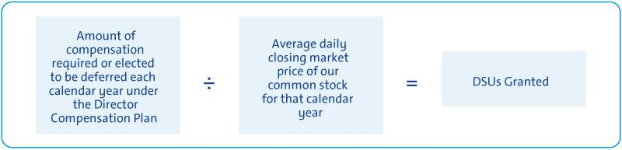

- Other Compensation

As outlined below, we provide certain additional benefits to non-employee directors.

Type |  | Purpose
u | Company Vehicles | We provide directors with the use of company vehicles to provide feedback on our products as well
 |  | as enhance the public image of our vehicles. Retired directors also receive the use of a company
 |  | vehicle for a period of time. Participants are charged with imputed income based on the lease value
 |  | of the vehicles and are responsible for associated taxes.
u | Personal Accident Insurance | We provide PAI coverage in the event of accidental death or dismemberment. Directors are
 | (“PAI”)⁽¹⁾ | responsible for associated taxes on the imputed income from the coverage.

- Ms. Barra, our sole employee director, does not receive additional compensation for her Board service other than the PAI benefit described above, the value of which is reported for Ms. Barra in the Summary Compensation Table on page 57.

Non-employee directors are not eligible to participate in any of the savings or retirement programs for our employees. Other than as described in this section, there are no separate benefit plans for directors.

18

Table of Contents

ITEM NO. 1 – ELECTION OF DIRECTORS

- 2017 Non-Employee Director Compensation Table

This table shows the compensation that each non-employee director received for his or her 2017 Board and Committee service.

 | Fees Earned or |  | Stock Awards | All Other |  | Total
 | Paid in Cash | (1) | Stock Awards | Compensation | (3) | Total
Director |  | (1) | (2) |  | (3)
Director | ($) |  | ($) | ($) |  | ($)
Joseph J. Ashton⁽⁴⁾ | 142,500 |  | 156,336 | 34,698 |  | 333,534
Linda R. Gooden⁽⁵⁾ | 145,833 |  | 155,311 | 22,448 |  | 323,592
Joseph Jimenez | 142,500 |  | 155,311 | 24,282 |  | 322,093
Jane L. Mendillo | 142,500 |  | 155,311 | 11,323 |  | 309,134
Michael G. Mullen | 162,500 |  | 155,311 | 23,428 |  | 341,239
James J. Mulva | 162,500 |  | 155,311 | 36,490 |  | 354,301
Patricia F. Russo | 162,500 |  | 155,311 | 19,886 |  | 337,697
Thomas M. Schoewe | 172,500 |  | 155,311 | 30,448 |  | 358,259
Theodore M. Solso | 242,500 |  | 155,311 | 15,490 |  | 413,301
Carol M. Stephenson | 162,500 |  | 155,311 | 12,782 |  | 330,593

- This column reflects director compensation eligible to be paid in cash, which consists of 50 percent of the annual Board retainer ($142,500) and any applicable Committee Chair or Independent Lead Director fees. Each of the following directors elected to receive DSUs in lieu of such amounts eligible to be paid in cash in the following amounts: Mr. Ashton — $71,250; Ms. Gooden — $3,333; Mr. Jimenez — $142,500; Ms. Mendillo — $142,500; Mr. Mullen — $20,000; Mr. Mulva — $162,500; Ms. Russo — $20,000; Mr. Solso — $242,500; and Ms. Stephenson — $81,250.

- Reflects aggregate grant date fair value of DSUs granted in 2017, which does not include any cash fees that directors voluntarily elected to receive as DSUs. Grant date fair value is calculated by multiplying the number of DSUs granted by the closing price of GM common stock on December 29, 2017, which was $40.99. The holders of DSUs also receive dividend equivalents, which are reinvested in additional DSUs based on the market price of the common stock on the date the dividends are paid.

- The following table provides more information on the type and amount of benefits included in the All Other Compensation column.

 | Company
 | Vehicle
 | Program | Other
Director | (a) | (b) | Total
Mr. Ashton | $34,458 | $240 | $34,698
Ms. Gooden | $22,208 | $240 | $22,448
Mr. Jimenez | $24,042 | $240 | $24,282
Ms. Mendillo | $11,083 | $240 | $11,323
Mr. Mullen | $23,188 | $240 | $23,428

 | Company
 | Vehicle
 | Program | Other
Director | (a) | (b) | Total
Mr. Mulva | $36,250 | $240 | $36,490
Ms. Russo | $19,646 | $240 | $19,886
Mr. Schoewe | $30,208 | $240 | $30,448
Mr. Solso | $15,250 | $240 | $15,490
Ms. Stephenson | $12,542 | $240 | $12,782

  - Company vehicle program includes the estimated annual lease value of the Company vehicles driven by directors. We include the annual lease value because it is more reflective of the value of the company vehicle perquisite than the Company’s incremental costs, which are generally significantly lower because the Company manufactures and ordinarily disposes of Company vehicles for a profit, resulting in minimal incremental costs, if any. Taxes related to imputed income are the responsibility of each director.

  - Reflects cost of premiums for providing personal accident insurance (annual premium cost of $240 is prorated, as applicable, for period of service). In addition, Mr. Solso received tickets to attend a special event; the tickets had no incremental cost to the Company.

- Mr. Ashton resigned from the Board effective December 8, 2017.

- Ms. Gooden was appointed Chair of the Cybersecurity Committee on November 20, 2017.

19

Table of Contents

CORPORATE GOVERNANCE

Role of the Board of Directors

GM is governed by a Board of Directors and Committees of the Board that meet throughout the year. The Board is elected by shareholders to oversee and provide guidance on the Company’s business and affairs. It is the ultimate decision-making body of the Company, except for those matters reserved for shareholders. The Board is actively engaged in the process of strategic development and oversight of ongoing execution of the Company’s strategic plan. It oversees management’s activities in connection with proper safeguarding of the assets

of the Company, maintenance of appropriate financial and other internal controls, compliance with applicable laws and regulations, and proper governance. The Board is committed to sound corporate governance policies and practices that are designed and routinely assessed to enable the Company to operate its business responsibly, with integrity, and to position GM to compete more effectively, sustain its success, and build long-term shareholder value.

Board Size

The Board of Directors sets the number of directors from time to time by resolution adopted by a majority of the Board. The Board is currently composed of 11 members. The Governance Committee reassesses the suitability of the Board’s size at least annually. The Board has the flexibility to increase or decrease the size of the Board, as circumstances warrant. If any nominee

is unable to serve as a director or if any director leaves the Board between Annual Meetings, the Board, by resolution, may reduce the number of directors or elect an individual to fill the resulting vacancy. If all of the Board’s nominees are elected, the Board will be composed of 11 members immediately following the Annual Meeting.

Code of Business Conduct and Ethics: “Winning with Integrity”

The Board is committed to the highest legal and ethical standards in fulfilling its responsibilities. We have adopted a code of business conduct and ethics, “Winning with Integrity,” that applies to our directors, officers, and employees. “Winning with Integrity” forms the foundation for compliance with corporate policies and procedures and creates a Company-wide focus on uncompromising integrity in every aspect of our operations. The code embodies our expectations for a number of topics, including workplace and vehicle safety, conflicts of

interest, protection of confidential information, insider trading, competition and fair dealing, human rights, community involvement and corporate citizenship, political activities and lobbying, preservation and use of Company assets, and compliance with all laws and regulations applicable to the conduct of our business. Employees are expected to report any conduct that they believe in good faith to be an actual or apparent violation of the code.

Corporate Governance Guidelines

Your Board oversees a governance structure that it believes promotes the best interests of our shareholders. Our Corporate Governance Guidelines form a transparent framework for the effective governance of the Company. The Corporate Governance Guidelines address matters such as the respective roles and responsibilities of the Board and management, the Board’s leadership structure, the responsibilities of the Independent Lead Director, director independence, the Board membership criteria, Board Committees, and Board and CEO evaluation. The Governance Committee regularly reviews the Corporate Governance Guidelines and periodically recommends to your Board the adoption of amendments in response to changing regulations, evolving best practices, and shareholder concerns. For a summary of our corporate governance best practices, see “Proxy Statement Summary— Governance Highlights” on page 3.

20

Find more online.


Our code of business conduct and ethics, “Winning with Integrity,” and Corporate Governance Guidelines and are available on our website at: gm.com/investors/corporate-governance.

Table of Contents

CORPORATE GOVERNANCE

Director Independence

GM’s Corporate Governance Guidelines define our standards for director independence and are based on applicable New York Stock Exchange (“NYSE”) and U.S. Securities and Exchange Commission (“SEC”) requirements. At least two-thirds of our directors are and must continue to be independent under these standards. The Governance Committee annually assesses the independence of each director and makes recommendations to the Board. For a director to be “independent,” the Board must affirmatively determine that the director has no material relationship with the Company other than his or her service as a director. In addition, members of the Audit and Compensation Committees must meet heightened independence standards under applicable NYSE and SEC rules.

Consistent with these standards, the Board has reviewed all relationships between the Company and each director and considered all relevant quantitative and qualitative criteria. The Board has affirmatively determined that all directors are independent, except Ms. Barra, who serves as CEO.

In recommending to the Board that it determine each director is independent, the Governance Committee considered whether there were any other facts or circumstances that might impair a director’s independence. In particular, the Governance Committee evaluated charitable contributions that GM has made to nonprofit organizations with which our directors are or have been associated. None of these transactions were material to either GM or the director. The Governance Committee also considered that GM, in the ordinary course of business, during the last three years, has sold fleet vehicles to and purchased products and services from companies at which some of our directors serve as non-employee directors or executives. The Board determined that these transactions were not material to GM or the other companies involved and that none of our directors had a material interest in transactions with these companies. In each case, these transactions were in the ordinary course of business for GM and the other companies involved and were on terms and conditions available to similarly situated customers and suppliers. Therefore, they did not impair such director’s independence.

Board Leadership Structure

Your Board has the flexibility to decide when the positions of Chairman and CEO should be combined or separated and whether an executive or an independent director should be Chairman. This approach is designed to allow the Board to choose the leadership structure that will best serve the interests of our shareholders at any particular time. In January 2016, the Board recombined the positions of Chairman and CEO under the leadership of Ms. Barra and designated Mr. Solso as Independent Lead Director. For 2018, our independent directors unanimously voted to appoint Mr. Solso as the Independent Lead Director for the third consecutive year. The Board’s key duties include oversight of strategy, risk management, and legal and regulatory compliance as well as CEO succession planning. In each of these areas, the Board determined that a combined role of Chairman and CEO, with the presence of a strong Independent Lead Director and governance best practices, is the optimal Board leadership structure for GM at this time. Mr. Solso’s perspective on your Board’s leadership structure is provided on the following page.
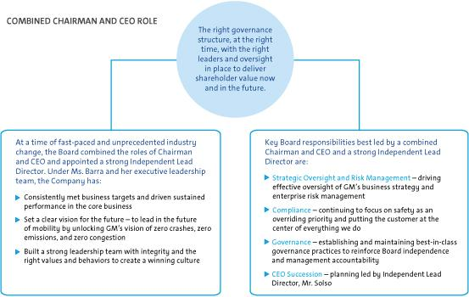

21

Table of Contents

CORPORATE GOVERNANCE


A Message from the Independent Lead Director on Your Board’s Leadership Structure

As the Independent Lead Director, I regularly engage with GM’s investors and other key stakeholders on a variety of issues, including GM’s corporate governance structure and practices and, importantly, your Board’s leadership structure. I want to share with you the same message I deliver during these engagements.

Mary Barra Is the Right Person to Lead Your Board

Your Board carefully considers the appropriate leadership structure for GM and its shareholders on an annual basis and determines whether to combine or split the roles of Chairman and CEO. Your Board believes that Ms. Barra’s service as both Chairman and CEO has provided, and continues to provide, a clear and unified strategic vision for GM during this time of unprecedented industry change. As the individual with primary responsibility for managing the Company, Ms. Barra’s in-depth knowledge of our business and understanding of GM’s day-to-day operations brings focused leadership to your Board. She has been a key leader as we have reset our culture of safety and relentlessly focused on putting the customer at the center of everything we do. As Chairman, she facilitates your Board’s continued strong oversight of compliance and enterprise risk management programs. For example, under her leadership, in 2017 the Board established a new Cybersecurity Committee to enhance the Board’s oversight of GM’s evolving cybersecurity risks.

Your Board Is Independent and Holds Management Accountable

With 10 of 11 directors being independent, your Board holds management accountable. We have the right mix of skills, qualifications, and experiences to oversee, guide, and challenge the leadership team. We are engaged in shaping and overseeing GM’s strategy. Strategy is a part of every Board meeting, and every year your Board holds a multiday session devoted exclusively to GM’s strategic plan. During these discussions, Board members engage in active debate and dialogue, challenge and validate management assumptions, and shape various aspects of management’s strategy and execution.

My Role as the Independent Lead Director

I strive to complement Ms. Barra’s role as Chairman by providing strong independent leadership in my role as the Independent Lead Director, with the following key duties and responsibilities:

u Presiding over all Board meetings when the Chairman is not present, including executive sessions of non-management directors, and advising the Chairman of any actions taken;

- Providing Board leadership if circumstances arise in which the role of the Chairman is potentially, or perceived to be, in conflict, or if potential conflicts of interest arise for any director;

- Calling executive sessions for independent directors, relaying feedback from these sessions to the Chairman, and implementing decisions made by the independent directors;

- Leading non-management directors in the annual evaluation of the CEO’s performance, communicating it to the CEO, and overseeing the process for CEO succession;

- Advising on the scope, quality, quantity, and timeliness of the flow of information between management and the Board and approving Board meeting agendas and materials recommended by the Chairman;

- Approving Board meeting schedules to ensure sufficient time for discussion of all agenda items;

- Serving as a liaison between independent directors and the Chairman when requested to do so by independent directors (although all non-management directors have direct and complete access to the Chairman at any time that they deem necessary or appropriate);

- Interviewing, along with the Chair of the Governance Committee, all Board candidates and making recommendations to the Governance Committee and the Board;

- Being available to advise the Chairs of the Committees of the Board in fulfilling their designated roles and responsibilities to the Board; and

- Being available, if requested by major shareholders, for consultation and communication in accordance with the Board’s Director-Shareholder Engagement Policy.

As always, I am proud to work closely with our Chairman and CEO and my fellow independent directors as we drive long-term shareholder value.

On behalf of the entire Board, thank you for your continued support.

Theodore M. Solso

Independent Lead Director

22

Table of Contents

CORPORATE GOVERNANCE

Executive Sessions

Independent directors have an opportunity to meet in executive session without management present as part of each regularly scheduled Board meeting.

Executive sessions are chaired by the Independent Lead Director, Mr. Solso.

During executive sessions, the independent directors may review CEO performance, compensation, and succession planning; strategy; risk; future Board agendas and flow of information to directors; corporate governance matters; and any other matters of importance to the Company raised during a meeting or otherwise presented by the independent directors.

The non-management directors of the Board met in executive session six times in 2017, including one time with only independent directors present.

Board Committees

Your Board of Directors has seven standing Committees: Audit, Cybersecurity, Executive Compensation, Finance, Governance, Risk, and Executive. The key responsibilities, recent activities, and focus areas of each Committee are set forth below, together with their current membership and the number of meetings held in 2017. Each Committee Chair meets regularly with management during the year to discuss Committee business, shape agendas, and facilitate efficient meetings. The Independent Lead Director, Mr. Solso, attends all Committee meetings to serve as a resource and identify topics requiring the full Board’s attention. The Board has determined that each member of the Audit, Compensation, Governance, Cybersecurity, Finance, and Risk Committees is independent according to NYSE listing standards and our Corporate Governance Guidelines.

In November 2017, the Board formed the Cybersecurity Committee, at which time the Risk Committee and Audit Committee charters were revised to reflect the transfer of cybersecurity oversight responsibilities. For additional information about our new Cybersecurity Committee, see “Corporate Governance—Board and Committee Oversight of Risk” on page 27.


Find more online.

Each Committee has a charter governing its activities.

Committee charters are available on our website at:

gm.com/investors/corporate-governance.

23

Table of Contents

CORPORATE GOVERNANCE

Members: Thomas M. Schoewe (Chair), Linda R. Gooden, Jane L. Mendillo, and Michael G. Mullen


Meetings held in 2017: 7

Thomas M. Schoewe,

Chair

Key Responsibilities

- Oversees the quality and integrity of our financial statements, related disclosures, and internal controls;
- Reviews and discusses with management and the independent auditors the Company’s earnings releases and quarterly and annual reports on Forms 10-Q and 10-K prior to filing with the SEC;

- Reviews the Company’s critical accounting policies, financial reporting and accounting standards and principles, and key accounting decisions and judgments affecting the Company’s financial statements;

- Reviews the scope and effectiveness of the Company’s compliance and ethics programs;
- Oversees the retention, qualifications, and performance of the independent auditor;
- Preapproves all audit and permitted non-audit services provided by the independent auditor;
- Regularly meets in private sessions with the General Counsel, Chief Compliance Officer, General Auditor and independent auditor;
- Reviews the scope, effectiveness, and independence of the Company’s internal audit function; and
- Oversees the Company’s compliance with legal, ethical, and regulatory requirements.

Members: Linda R. Gooden (Chair), Michael G. Mullen, and Thomas M. Schoewe


Meetings held in 2017: 2

Linda R. Gooden,

Chair

Key Responsibilities

- Oversees the effectiveness of the Company’s cybersecurity programs and its practices for identifying, assessing, and mitigating cybersecurity risks;

- Reviews the Company’s controls to prevent, detect, and respond to cyberattacks and breaches involving GM’s electronic information, intellectual property, sensitive data, connected products, and the connected ecosystem;
- Oversees management’s implementation of cybersecurity programs and risk policies and procedures and management’s actions to safeguard their effectiveness; and

- Evaluates the Company’s cyber crisis preparedness, incident response plans, and disaster recovery capabilities.
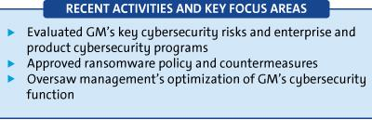

The Board has determined that all members of the Audit Committee meet

heightened independence and qualification criteria and are financially

literate in accordance with the NYSE listing standards and that

Ms. Gooden, Ms. Mendillo, and Mr. Schoewe are each qualified as an

“audit committee financial expert” as defined by the SEC.
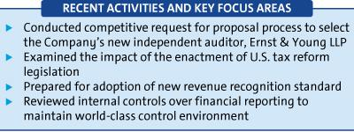

For additional information about the Audit Committee and its 2017

activities, see its report included in this Proxy Statement beginning on page

70.

24

Table of Contents

CORPORATE GOVERNANCE

Members: Carol M. Stephenson (Chair), Joseph Jimenez, James J. Mulva, and Patricia F. Russo


Meetings held in 2017: 6

Carol M. Stephenson,

Chair

Key Responsibilities

- Oversees the Company’s executive compensation policies, practices, and programs;
- Reviews and approves corporate goals and objectives, evaluates performance (along with the full Board), and determines compensation levels for the Chairman and CEO;

- Reviews and approves compensation of NEOs, executive officers, and other senior leaders under its purview;
- Oversees compensation policies and practices so that the plans do not encourage unnecessary or excessive risks; and
- Oversees the Company’s policies and practices that promote diversity and inclusion.

The Board has determined that all members of the Executive Compensation Committee meet heightened independence and qualification criteria in accordance with NYSE listing standards and SEC rules.
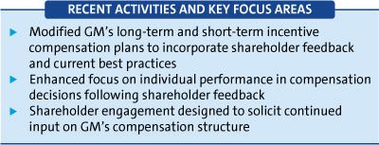

Members: James J. Mulva (Chair), Jane L. Mendillo, Patricia F. Russo, and Thomas M. Schoewe


Meetings held in 2017: 4

James J. Mulva,

Chair

Key Responsibilities

- Assists the Board in its oversight of financial policies, strategies, and capital structure;
- Reviews the Company’s cash management as well as proposed capital plans, capital expenditures, dividend actions, stock splits and repurchases, issuances of debt or equity securities, and credit facility and other borrowings;
- Reviews any significant financial exposures and contingent liabilities of the Company, including foreign exchange, interest rate, and commodities exposures, and the use of derivatives to hedge those exposures; and
- Reviews the regulatory compliance, administration, financing, investment performance, risk and liability profile, and funding of the Company’s U.S. pension obligations.
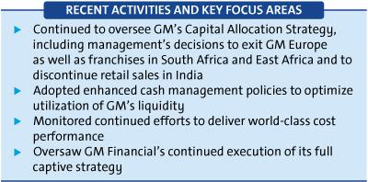

25

Table of Contents

CORPORATE GOVERNANCE

Members: Patricia F. Russo (Chair), Joseph Jimenez, and Carol M. Stephenson


Meetings held in 2017: 6

Patricia F. Russo,

Chair

Key Responsibilities

- Reviews the Company’s corporate governance framework, including all significant governance policies and procedures;
- Oversees Company policies and strategies related to corporate responsibility, sustainability, and political contributions;
- Reviews the appropriate composition of the Board and recommends director nominees;
- Oversees the self-evaluation process of the Board and Committees;

- Recommends compensation of non-employee directors to the Board; and
- Reviews and approves related party transactions and any potential Board conflicts of interest, as applicable.

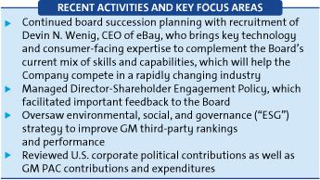

Members: Michael G. Mullen (Chair), Linda R. Gooden, James J. Mulva, and Thomas M. Schoewe


Meetings held in 2017: 4

Adm. Michael G. Mullen,

Chair

Key Responsibilities

- Assists the Board in its oversight of the Company’s risk management framework and practices;
- Reviews the Company’s risk culture, including open risk discussions and the integration of risk management into the Company’s behaviors, decision making, and processes;

- Reviews management’s evaluation of strategic and operating risks, including risk concentrations, mitigating measures and the types and levels of risk that are acceptable in the pursuit and protection of shareholder value;
- Reviews the impact of the Company’s programs and practices regarding vehicle and workplace safety; and
- Reviews risks related to the Company’s public policy positions in the United States and internationally.
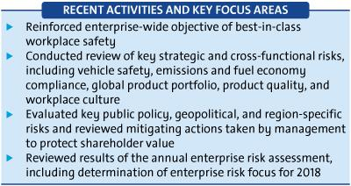

EXECUTIVE

26

Your Board has an Executive Committee composed of the Chairman and CEO, the Independent Lead Director, and the Chairs of our other standing Committees. The Executive Committee is chaired by Ms. Barra and empowered to act for the full Board in intervals between Board meetings, with the exception of certain matters that the Board has not delegated. The Executive Committee meets as necessary, and all actions by the Executive Committee are reported and ratified at the next succeeding Board meeting. The Executive Committee did not meet in 2017.

Table of Contents

CORPORATE GOVERNANCE

Access to Outside Advisors

The Board and each Board Committee can select and retain the services of outside advisors at the Company’s expense.

Board and Committee Meetings and Attendance

In 2017, your Board held a total of 10 meetings, and average director attendance at Board and Committee meetings was 97%. Each director standing for re-election attended at least 90% of the total meetings of the Board and Committees on which he or she served in 2017. Directors are expected to attend our Annual Meeting of shareholders, which is held in conjunction with a regularly scheduled Board meeting. All directors in office at such time attended the 2017 Annual Meeting.

Board and Committee Oversight of Risk
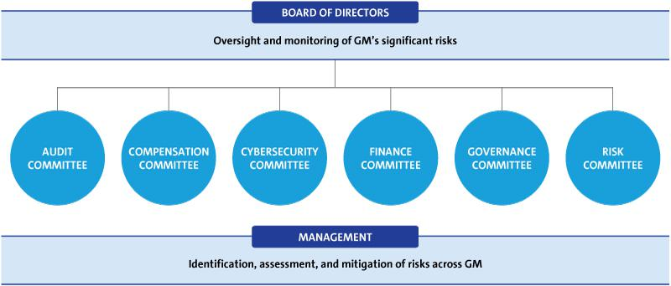

Your Board has the overall responsibility for risk oversight, with a focus on the most significant risks facing the Company. Effective risk management is the responsibility of the CEO and other members of management, specifically the Senior Leadership Team. As part of the risk management process, each of the Company’s business units and functions is responsible for identifying risks that could affect the achievement of business goals and strategies, assessing the likelihood and potential impact of significant risks, and prioritizing the risks and actions to be taken to mitigate such risks, as appropriate.

Your Board implements its risk oversight function both as a whole and through delegation to Board Committees, particularly the Risk Committee. The Board receives regular reports from management on particular risks within the Company, through review of the Company’s strategic plan and through regular communication with its Committees. Management provides comprehensive reports to the Risk Committee on the key strategic, operating, vehicle, and workplace safety, financial, and compliance risks facing the Company, including management’s response to managing and mitigating such risks, as appropriate. The Company’s Chief Compliance Officer also regularly reports to the Audit Committee.

The Chair of the Risk Committee coordinates with the Chairs of the other Board Committees in their review of the Company risks that have been delegated to these Committees to support them in coordinating the relationship between risk management policies and practices and their respective oversight accountabilities. Each of the other Board Committees, which meet regularly and report back to the Board, is responsible for oversight of risk management practices for categories of risks relevant to its functions.

Your Board believes that its structure for risk oversight provides for open communication between management and the Board and its Committees, which effectively supports management’s enterprise risk management programs. In addition, strong independent directors chair the Committees involved in risk oversight, and all directors are involved in the risk assessment and ongoing risk reviews.

27

Table of Contents

CORPORATE GOVERNANCE
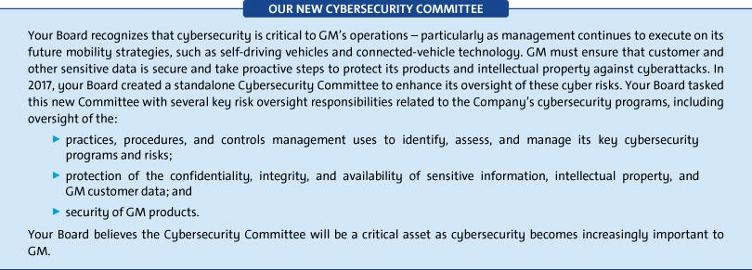

Succession Planning and Leadership Development

One of your Board’s primary responsibilities is to oversee the development of appropriate executive-level talent to successfully execute GM’s strategy. Management succession is regularly discussed by the directors with the CEO and during the Board’s executive sessions. The Board reviews candidates for all senior executive positions to confirm that qualified successor-candidates are available for all positions and that development plans are being utilized to strengthen the skills and qualifications of successor-candidates. Our Independent Lead Director oversees the process for CEO succession and leads, at

least annually, the Board’s discussion of CEO succession planning. Our CEO provides the Board with recommendations for and evaluations of potential CEO successors and reviews with the Board development plans for these successors. Directors engage with potential CEO and senior management talent at Board and Committee meetings and in less formal settings to enable directors to personally assess candidates. The Board reviews management succession in the ordinary course of business as well as contingency planning in the event of an emergency or unanticipated event.

Board and Committee Evaluations

The Board and each Committee conducts an annual self-evaluation to assess effectiveness and consider opportunities for improvement. As part of the evaluation process, each director completes a written questionnaire and is also interviewed by the Chairman and, if requested or needed, the Independent Lead Director. The results of the written questionnaires are compiled anonymously by the Corporate Secretary in the form of summaries for the full Board and each Committee. The feedback received from the questionnaires and interviews is reviewed and discussed by the Governance Committee (as it relates to both the Board and all Committees) and each other Committee (as it relates to such Committee). Following review and discussion by the Committees, the Chairman and the Chair of the Governance Committee summarize the results of the evaluations and report to the full Board for discussion and any action items. In addition, the Chairman and, if applicable, the Independent Lead Director, provide feedback from the individual director interviews to the full Board.

Matters considered in evaluations include the following:

u The effectiveness of the Board’s leadership and Committee | u The quality of Board and Committee agendas and the appropriate
structure; | Board and Committee priorities;
u Board and Committee skills, composition, and diversity and Board | u Dynamics between the Board and management, including the quality
succession planning; | of management presentations and information provided to the Board
u Board and Committee culture and dynamics, including the | and Committees; and
u Board and Committee culture and dynamics, including the | u The contributions and performance of individual directors, including
effectiveness of discussion and debate at Board and Committee
meetings; | the Chairman, Independent Lead Director, and Committee Chairs.

28

Table of Contents

CORPORATE GOVERNANCE

Annual Evaluation of CEO

The CEO reports annually to the Board regarding achievement of previously established goals and objectives. The non-management directors, meeting separately in executive session, annually conduct a formal evaluation of the CEO, which is communicated to the CEO by the Independent Lead Director. The evaluation is based on both objective and subjective criteria, including, but not limited to: the Company’s financial performance, accomplishment of ongoing initiatives in

furtherance of the Company’s long-term strategic objectives, and development of the Company’s top management team. The results of the evaluation are considered by the Compensation Committee in its deliberations when determining the compensation of the CEO, as further described in the “Executive Compensation” on page 35.

Director Orientation and Continuing Education

All new directors participate in the Company’s director orientation program, which generally commences promptly after the meeting at which a new director is elected. The Governance Committee oversees this orientation program to on-board new directors through a review of background material and meetings with senior management. The orientation also includes tours of GM plant(s), the Design Studio at the Warren Technical Center, dealer visits and/or auto show events. The orientation enables new directors to become familiar with the Company’s business and strategic plans; significant financial matters; core values, including ethics, compliance programs, and corporate governance practices; and other key policies and practices, including, but not limited to,

sustainability, vehicle and workplace safety, public policy and governance relations, risk management, and investor relations.

Continuing education opportunities are provided to keep directors updated with information about the Company and its strategy, operations, products, and other matters relevant to Board service. Board members are encouraged to visit GM facilities, dealers, auto shows, and other key corporate and industry events to enhance their understanding of the Company and its competitors in the auto industry. In addition, all directors are encouraged to attend, at our expense, director continuing education programs sponsored by governance organizations and other institutions.

Director Service on Other Public Company Boards

The Board recognizes that service on other public company boards provides valuable governance and leadership experience that benefits the Company. The Board also believes, however, that it is critical that directors dedicate sufficient time to their service on the Company’s Board. Directors are expected to advise the Chairman of the Board, Independent Lead Director, or Chair of the Governance Committee in advance of accepting an invitation to serve on another board of directors or any audit committee of another public company board. This provides an opportunity to assess the impact of joining another board, based on various factors relevant to the specific situation, including the nature and extent of a director’s other professional obligations and the time commitment attendant to the new position. Directors who are engaged in active, full-time employment, for example, would have less time to devote to Board service than a director whose principal occupation is serving on boards.

Our Corporate Governance Guidelines provide that without obtaining the approval of the Board:

- A director may not serve on the boards of more than four other public companies (excluding nonprofits and subsidiaries); and

- No member of the Audit Committee may serve on more than two other public company audit committees.

All directors are in compliance with this policy.

In general, senior members of management may not serve on the board of more than one other public company or for-profit entity and must obtain the approval of the Governance Committee prior to accepting an invitation to serve on an outside board.

Compensation Committee Interlocks and Insider Participation

During 2017, and as of the date of this Proxy Statement, none of the members of the Compensation Committee was or is an officer or employee of the Company, and no executive officer of the Company served or serves on the compensation committee or board of any company that employed or employs any member of the Company’s Compensation Committee or Board of Directors.

29

Table of Contents

CORPORATE GOVERNANCE

Shareholder Engagement

A priority for the Board is to meet with and hear from shareholders. This dialogue helps the Board and the senior management team gain feedback on a variety of topics, including strategic and financial performance, operations, products, executive compensation, Board composition, and leadership structure as well as important environmental and social issues. The constructive insights, experiences, and ideas exchanged during these engagements enable your Board to further evaluate and assess key initiatives from different perspectives and viewpoints.


DIRECTOR-

SHAREHOLDER

ENGAGEMENT POLICY

(adopted in 2016)

u Frequent and recurring proactive
and reactive engagement sessions with our largest shareholders

u Shareholders and analysts invited to Board meetings on an annual basis

During 2017, members of the Board, including our Independent Lead Director, met in-person with shareholders representing approximately 25% of shares outstanding.

During 2017, one or more members of management were involved in more than 75 in-person and telephonic meetings on these topics with investors representing more than 45% of shares outstanding. The common themes we heard in 2017 that led to boardroom discussion and action included the following:

Message | Actions
Received positive feedback regarding the quality and | See pages 7–9 for additional information on why we
diversity of the Board. | have the right Board at the right time for GM.
Encouraged to enhance our Audit Committee report in | See page 70 for the 2017 audit committee report.
the Proxy Statement.
Encouraged to enhance transparency about the | See pages 27–28 for insights on the Board’s new
Board’s role in overseeing cybersecurity. | Cybersecurity Committee.
Encouraged to include safety and ESG/ sustainability | See page 6 for insights into sustainability commitments
metrics in executive compensation decisions. | and performance and pages 48–51 for achievements
 | by our key executives.


Find more online.

Instructions on contacting our Board of Directors is available on our website at:

gm.com/investors/corporate-governance.

Shareholder Protections

Your Board is committed to governance structures and practices that increase shareholder value and protect important shareholder rights. Our Governance Committee regularly reviews these structures and practices, which include the following:

 | u Supermajority of independent directors serving on the Board, with all | u | Proxy access permitting a shareholder, or a group of up to 20
 | standing committees (except the Executive Committee) composed |  | shareholders owning at least 3% of the Company’s outstanding voting
 | entirely of independent directors; |  | shares continuously for at least three years, to nominate and include in
 | u Annual election of all directors; |  | the Company’s proxy materials director nominees (two individuals or
 | u Annual election of all directors; |  | 20% of the Board, whichever is greater);
 | u One-share, one-vote standard; | u | No poison pill;
 | u Majority voting standard for the election of directors in uncontested | u | Executive sessions without management present; and
 | elections (plurality voting standard in contested elections), coupled | u | Executive sessions without management present; and
 |  | u
 | with a director resignation policy; | u | Director-Shareholder Engagement Policy that contemplates proactive
 | u Shareholder right to call for a special meeting; |  | and productive engagement with shareholders.
30

Table of Contents

CORPORATE GOVERNANCE

Certain Relationships and Related Party Transactions

Our code of business conduct and ethics, “Winning with Integrity,” requires all of our employees and directors to avoid any activity that is in conflict with our business interests. In addition, your Board has adopted a written policy regarding the review and approval or ratification of “related party transactions.” Under the Related Party Transactions Policy, which is administered by our Governance Committee, directors and executive officers must report any potential related party transactions (including transactions involving immediate family members of directors and executive officers) to the General Counsel or Corporate Secretary to determine whether the transaction constitutes a related party transaction.

For purposes of our Related Party Transactions Policy, a related party transaction includes transactions in which our Company is a participant, the amount involved exceeds $120,000, and a “related party” has or will have a direct or an indirect material interest. Related parties of our Company consist of directors (including nominees for election as directors), executive officers, shareholders beneficially owning more than 5% of the Company’s voting securities, and the immediate family members of these individuals.

Once a related party transaction has been identified, the Governance Committee will review all of the relevant facts and circumstances and approve or disapprove entry into the transaction.


Find more online.

Our Related Party Transactions Policy is available on our

website at: gm.com/investors/corporate-governance.

- Factors Used in Assessing Related Party Transactions

u Whether the terms of the related party transaction are fair to the | u Whether the Company was notified about the related party transaction
Company and on the same basis as if the transaction had occurred | before its commencement, and if not, why preapproval was not sought
on an arms-length basis; | and whether subsequent ratification would be detrimental to the
u Whether there are any compelling business reasons for the Company | Company; and
 | u Whether the related party transaction would present an improper
to enter into the related party transaction and the nature of alternative
transactions, if any; | conflict of interest for any director or executive officer of the Company,
u Whether the related party transaction would impair the independence | taking into account the specific facts and circumstances of such
 | transaction.
of an otherwise independent director; | transaction.

Any member of the Governance Committee who has a potential interest in any related party transaction will recuse himself or herself and abstain from voting on the approval or ratification of the related party transaction, but may participate in all or a portion of the Governance Committee’s discussions of the related party transaction, if requested by the Chair of the Governance Committee. As required under SEC rules, we will disclose all related party transactions in our Proxy Statement.

The son of John Quattrone, our former Senior Vice President, Global Human Resources, is employed by the Company in a non-executive position and in 2017 received compensation of approximately $133,000 and customary Company benefits. His total compensation is similar to the total compensation provided to other employees of the same level with similar responsibilities. The terms of his employment with GM were approved by the Governance Committee pursuant to the Company’s Related Party Transactions Policy.

On March 2, 2018, we repurchased 2,518,257 shares of our common stock from the UAW Retiree Medical Benefits Trust (the “VEBA Trust”), a greater than 5% beneficial owner of GM’s common stock, at a cash price of $39.71 per share, for a total consideration of $100 million (the “Repurchase”). The price paid in the Repurchase represented a 1% discount over the closing price of our common stock on the day the Repurchase was announced. The Repurchase was made pursuant to our previously authorized stock repurchase program and was approved by the Board pursuant to the Company’s Related Party Transactions Policy.

31

Table of Contents

SECURITY OWNERSHIP INFORMATION

Security Ownership of Directors, Named Executive Officers, and Certain Other Beneficial Owners

The beneficial ownership as of April 1, 2018, of our common stock by each director, each NEO, and all directors and executive officers as a group is shown in the following tables, as well as ownership of DSUs and Deferred Salary Stock Units. Each of the individuals listed in the following tables owns less than 1% of the outstanding shares of our common stock; all directors and officers as a group own less than 1% of the outstanding shares. None of the shares shown in the following tables as beneficially owned by directors and executive officers is hedged or pledged as security for any obligation.

Non-Employee Directors

 | Shares of Common
Director(1) | Stock Beneficially | Deferred Share
Director(1) | Owned | Units
 |  | (2)
Linda R. Gooden | 1,000 | 11,994
Joseph Jimenez | 32,330 | 21,248
Jane L. Mendillo | 4,560 | 12,607
Michael G. Mullen | 750 | 19,855
James J. Mulva | 28,343 | 45,774
Patricia F. Russo | 12,300 | 29,362
Thomas M. Schoewe | 22,005 | 25,081
Theodore M. Solso | 5,000 | 61,312
Carol M. Stephenson | 800 | 51,093
Devin N. Wenig | — | —

- c/o General Motors Company, 300 Renaissance Center, Detroit, Michigan 48265.

- Represents the unit equivalents of our common stock under the Director Compensation Plan described on page 18.

Named Executive Officers and All Directors and Executive Officers as a Group

 | Beneficial Ownership
 | Shares of
 | Common Stock
 | Beneficially | Right to | Total Number
Name(1) | Owned | Acquire(2) | of Shares
Mary T. Barra | 696,981 | 1,779,360 | 2,476,341
Charles K. Stevens, III | 102,741 | 187,062 | 289,803
Daniel Ammann | 259,340 | 668,306 | 927,646
Mark L. Reuss | 203,934 | 67,771 | 271,705
Alan S. Batey | 138,067 | 162,212 | 300,279
Karl-Thomas Neumann | — | — | —
All Directors and Executive Officers as a Group | 1,856,101 | 3,600,787 | 5,456,888
(22 persons, including the foregoing)

- c/o General Motors Company, 300 Renaissance Center, Detroit, Michigan 48265.

- Includes shares that the named individual or group has the right to acquire through the exercise of vested Stock Options and shares that the named individual or group has the right to acquire through the vesting of restricted stock units and Stock Options within 60 days of April 1, 2018.

32

Table of Contents

SECURITY OWNERSHIP INFORMATION

Certain Beneficial Owners

The beneficial ownership as of April 1, 2018, of our common stock by each person or group of persons who is known to be the beneficial owner of more than 5% of our outstanding shares is shown in the following table.

 |  | Percent of
 | Number of | Outstanding
Name and Address of Beneficial Owner of Common Stock | Shares(1) | Shares
UAW Retiree Medical Benefits Trust, as advised by its fiduciary and investment | 100,150,000 | 7.1%
advisor Brock Fiduciary Services LLC
200 Walker Street
Detroit, MI 48207
The Vanguard Group | 87,437,866 | 6.2%
100 Vanguard Blvd.
Malvern, PA 19355
BlackRock, Inc. | 76,922,292 | 5.5%
55 East 52nd Street
New York, NY 10055

- Number of shares reported by each beneficial owner in filings with the SEC. The Company is permitted to rely on the information set forth in these filings and has no reason to believe that the information is incomplete or inaccurate or that the beneficial owner should have filed an amended report and did not. Each beneficial owner reported as follows:

 |  |  |  | Sole Dispositive | Shared Dispositive
Entity/ Filing |  | Sole Voting Power | Shared Voting Power | Power | Power
UAW Retiree Medical Benefits Trust | (a) | — | 100,150,000 | — | 100,150,000
(Form 4, filed Mar. 5, 2018) | (a)
The Vanguard Group |  | 1,806,486 | 293,363 | 85,419,593 | 2,018,273
(Sch. 13G, filed Feb. 9, 2018)
BlackRock, Inc. |  | 65,871,841 | — | 76,922,292 | —
(Sch. 13G, filed Feb. 8, 2018)

- Pursuant to the Stockholders Agreement dated October 15, 2009, between the Company and the VEBA Trust, the VEBA Trust will vote its shares of our common stock on each matter presented to the shareholders at the Annual Meeting in the same proportionate manner as the holders of our common stock other than our directors and executive officers. The VEBA Trust will be subject to the terms of the Stockholders Agreement until it beneficially owns less than 2% of the shares of our common stock then issued and outstanding.

Section 16(a) Beneficial Ownership Reporting Compliance

Federal securities laws require that our directors and executive officers and shareholders that own more than 10% of our common stock report to the SEC and the Company certain changes in ownership and ownership information within specified periods. Based solely on a review of the reports furnished to us or filed with the SEC and upon information furnished by these people, we believe that during 2017 all of our directors and officers timely filed all reports they were required to file under Section 16(a) of the Securities Exchange Act of 1934.

33

Table of Contents

This page intentionally left blank.

34

Table of Contents

EXECUTIVE COMPENSATION

Compensation Discussion and Analysis (CD&A) |  |  |  |  |  | Executive Compensation Tables
Compensation Overview |  |  |  |  | 36 | Summary Compensation Table |  |  |  |  |  |  |  | 57
Compensation Principles |  |  |  |  | 43 | Grants of Plan-Based Awards |  |  |  |  |  |  |  | 59
Compensation Elements |  |  |  |  | 43 | Outstanding Equity Awards at Fiscal Year-End |  |  |  |  |  |  |  | 60
Performance Measures |  |  |  |  | 44 | Option Exercises and Stock Vested |  |  |  |  |  |  |  | 61
Performance Results and Compensation Decisions |  |  |  |  | 47 | Pension Benefits |  |  |  |  |  |  |  | 61
Compensation Policies and Governance Practices |  |  |  |  | 54 | Nonqualified Deferred Compensation Plan |  |  |  |  |  |  |  | 63
Compensation Committee Report |  |  |  |  | 56 | Potential Payments Upon Termination |  |  |  |  |  |  |  | 64
 |  |  |  |  |  | Equity Compensation Plan Information |  |  |  |  |  |  |  | 67

Defined terms:

• AFCF – Automotive Free Cash Flow

• NEO – Named Executive Officer

• DB – Defined Benefit

• NQ – Non-Qualified

• DC – Defined Contribution

• OEM – Original Equipment Manufacturer

• DSV – Driving Stockholder Value

• PSU – Performance Share Unit

• EBIT – Earnings Before Interest and Taxes

• RSA – Restricted Stock Award

• EPS – Earnings Per Share

• ROIC – Return on Invested Capital

• ESG – Environmental, Social, and Governance

• RSU – Restricted Stock Unit

• LTIP – Long-Term Incentive Plan

• STIP – Short-Term Incentive Plan

• GAAP – Generally Accepted Accounting Principles

• TSR – Total Shareholder Return

35

Table of Contents
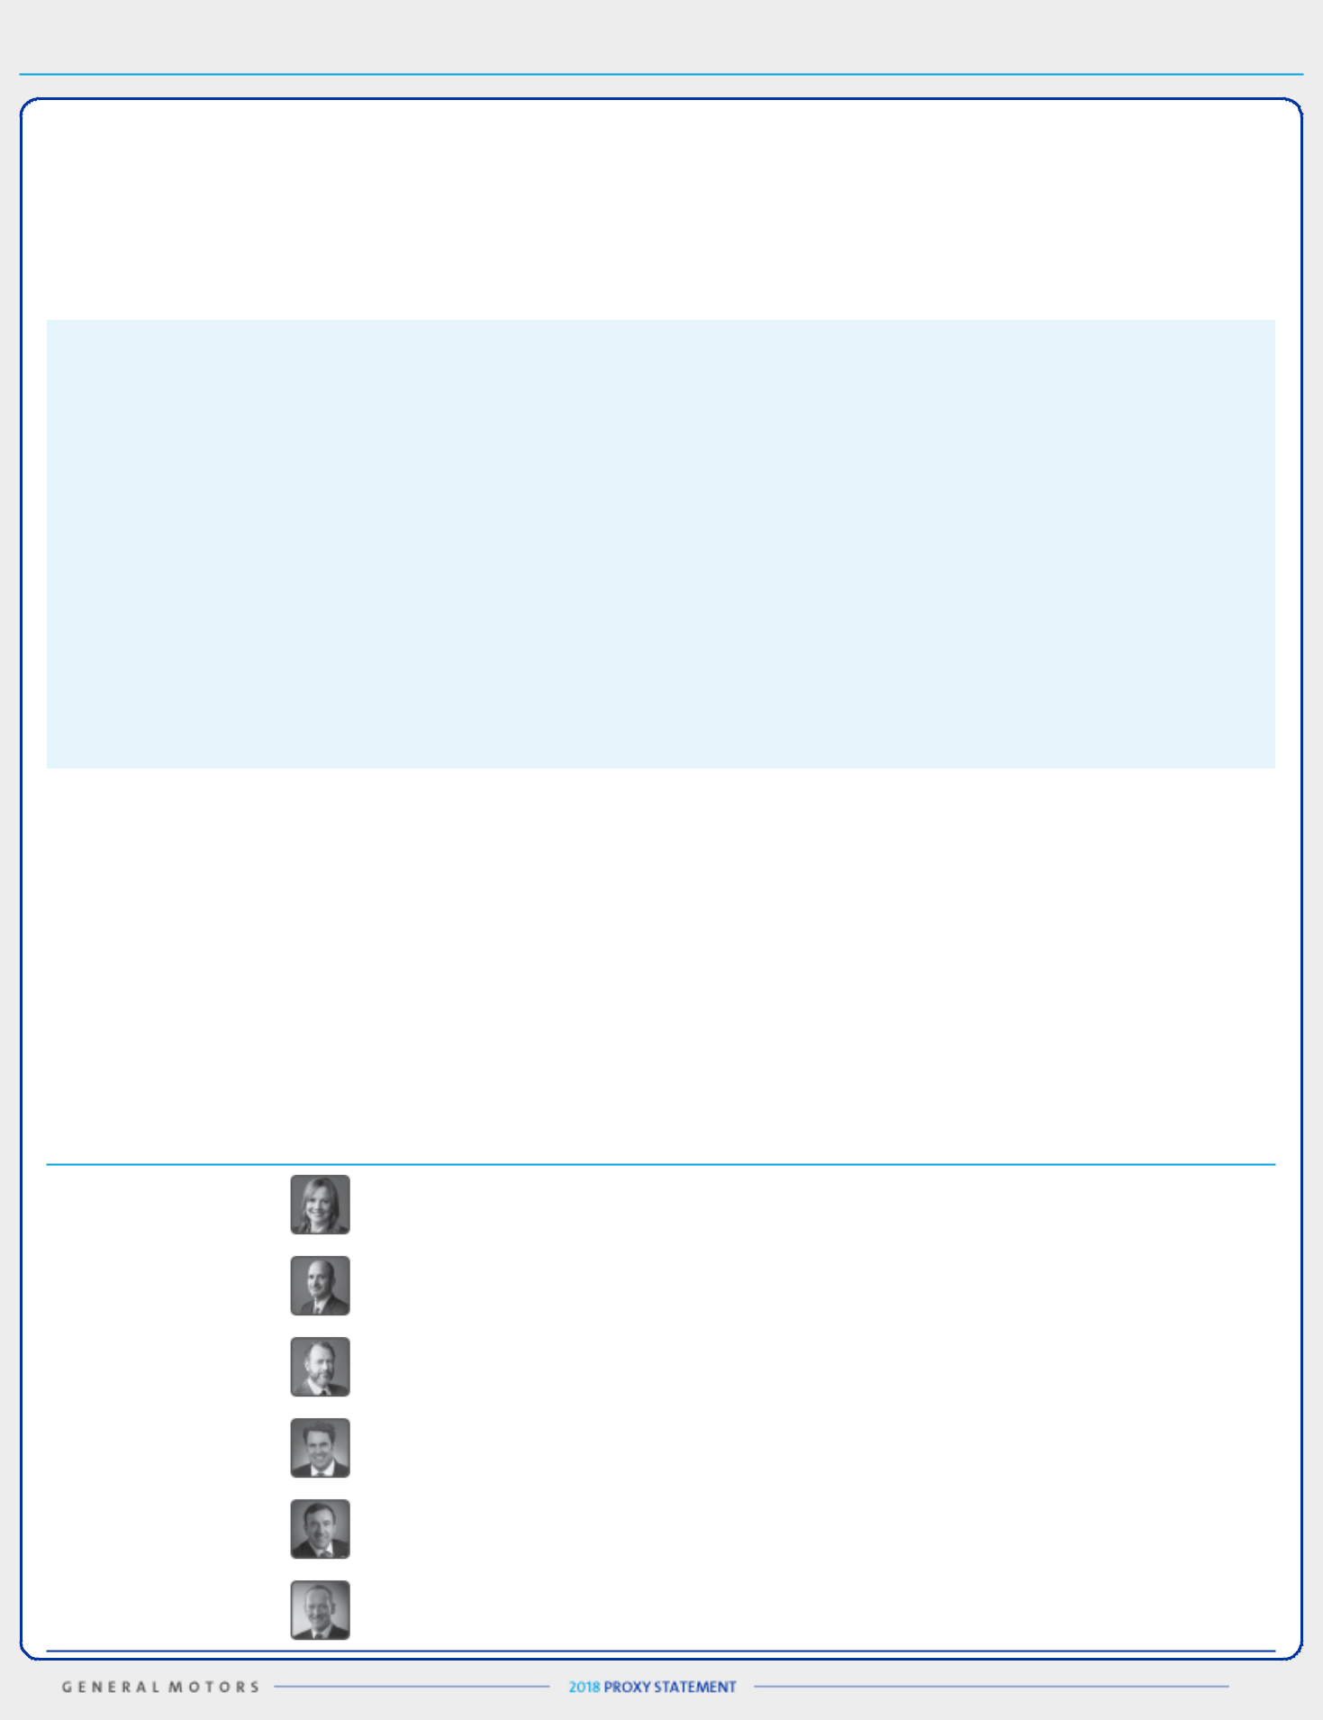

EXECUTIVE COMPENSATION

Compensation Overview

- Our Company Performance

In 2017, we continued progress toward our goal of making GM the most valued automotive company for our shareholders. The results below demonstrate how we are positioning GM as an industry leader both now and in the future:

- Completed the sale of Opel/Vauxhall and GM Financial European businesses to Peugot, S.A. (“PSA”);

- Exited franchises in South and East Africa and discontinued retail sales operations in India;

- For the fourth consecutive year, sold more pickup trucks in the United States than any other automaker – a record 948,909 units;

- Completed the refresh of GM’s crossover portfolio and became the fastest-growing crossover company in the United States, with retail market share up 1.6 percentage points to 13.1%, according to J.D. Power PIN estimates;

- Increased global Cadillac sales 15.5% in 2017 with significant sales increases in international markets, including a 50.8% increase in China;

- Improved EBIT-adjusted margin to 8.8% for continuing operations;

u Returned a total of $6.7 billion to shareholders through dividends and share repurchases;

- Increased EPS-diluted-adjusted to $6.62;

- Launched Super Cruise, the world’s first hands-free highway driving technology, on the Cadillac CT6;

- Shared the vision for zero crashes, zero emissions, and zero congestion and outlined an all-electric future with plans to launch at least 20 electric vehicle models by 2023;

- Announced plans to deploy self-driving vehicles in a dense urban environment in 2019;

- Acquired Strobe, Inc. to help develop next-generation LiDAR solutions for self-driving vehicles and reduce LiDAR costs by 99% over time; and

- Became the first company to use mass-production methods to build autonomous electric test vehicles.

Note: EBIT-adjusted margin and EPS-diluted-adjusted are non-GAAP financial measures. Refer to Appendix A for a reconciliation of these non-GAAP measures to their closest comparable GAAP measure.

- Our Vehicle Launches

We launched 25 vehicles across the globe in 2017, including some of the key vehicles below:

• | Buick Regal | • | Buick Enclave
• | Cadillac XTS | • | Chevrolet Equinox
• | Chevrolet Traverse | • | GMC Terrain

- Our Named Executive Officers

Mary T. Barra | Chairman and Chief Executive Officer
Charles K. Stevens, III | Executive Vice President and Chief Financial Officer
Daniel Ammann | President
Mark L. Reuss | Executive Vice President, Global Product Development, Purchasing and Supply Chain
Alan S. Batey | Executive Vice President and President, North America
Karl-Thomas Neumann | Former Executive Vice President and President, Europe

36

Table of Contents
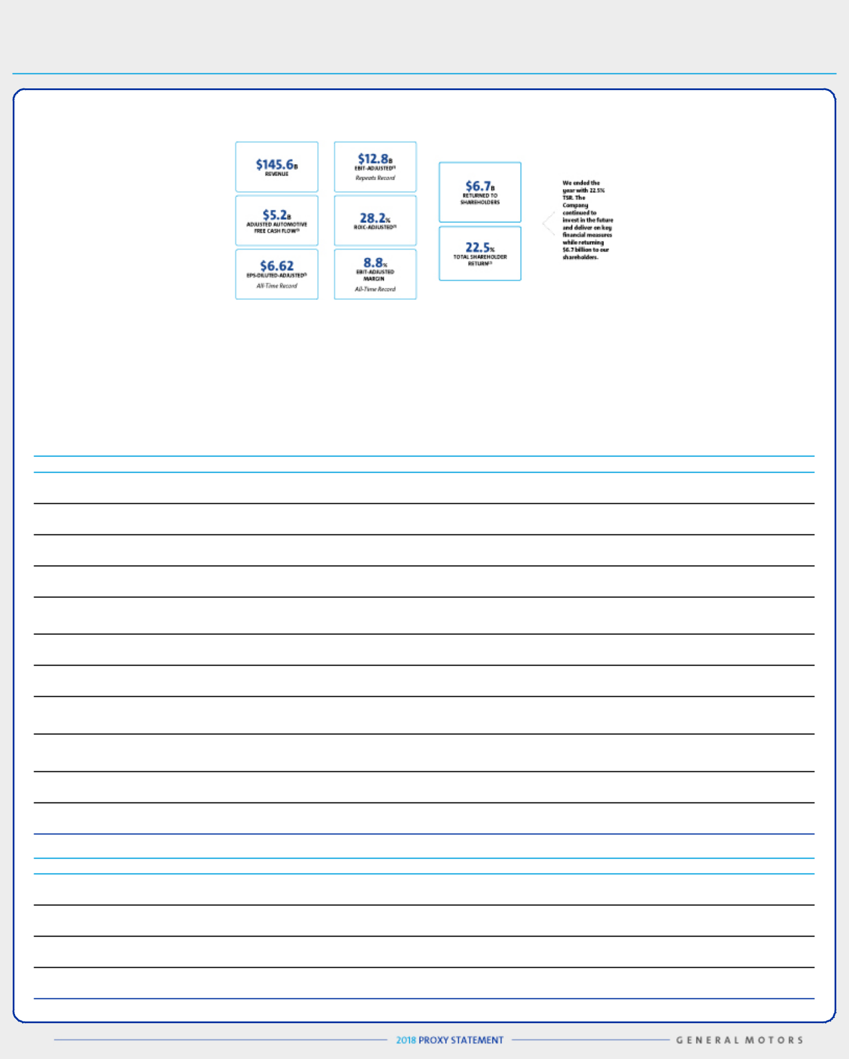

EXECUTIVE COMPENSATION

We ended 2017 with the following key financial results:

Note: The financial information above relates to our continuing operations.

- These are non-GAAP financial measures. Refer to Item 7, Management’s Discussion and Analysis of Financial Condition and Results of Operations in our Annual Report on Form 10-K for the fiscal year ended December 31, 2017 for a reconciliation of ROIC-adjusted to its closest comparable GAAP measure. Refer to Appendix A for a reconciliation of EBIT-adjusted, EBIT-adjusted margin, adjusted automotive free cash flow, and EPS-diluted-adjusted to their closest comparable GAAP measure.

- Assumes dividends are reinvested in common stock.

- Compensation Governance and Best Practices

WHAT WE DO

- Provide short-term and long-term incentive plans with performance targets aligned to business goals

- Conduct annual advisory vote for shareholders to approve executive compensation

- Maintain a Compensation Committee composed entirely of independent directors

- Require stock ownership for all senior leaders

Conduct rigorous shareholder engagement by management and directors, including our Executive Compensation Committee and our Lead
- Independent Director

- Include non-compete and non-solicitation terms in all grant agreements with senior leaders

- Retain an independent executive compensation consultant to the Compensation Committee

Maintain a Securities Trading Policy requiring directors, executive officers, and all other senior leaders to trade only during established
- window periods after contacting the GM Legal Staff prior to any sales or purchases of common stock

Require equity awards to have a double trigger (termination of employment and change in control) to initiate protection provisions of
- outstanding awards

- Complete incentive compensation risk reviews annually

- Maintain a clawback policy to apply to actions that damage GM’s reputation

WHAT WE DON’T DO

- Provide gross-up payments to cover personal income taxes or excise taxes pertaining to executive or severance benefits

- Allow directors or executives to engage in hedging or pledging of GM securities

- Reward executives for excessive, inappropriate, or unnecessary risk-taking

- Allow the repricing or backdating of equity awards

37

Table of Contents
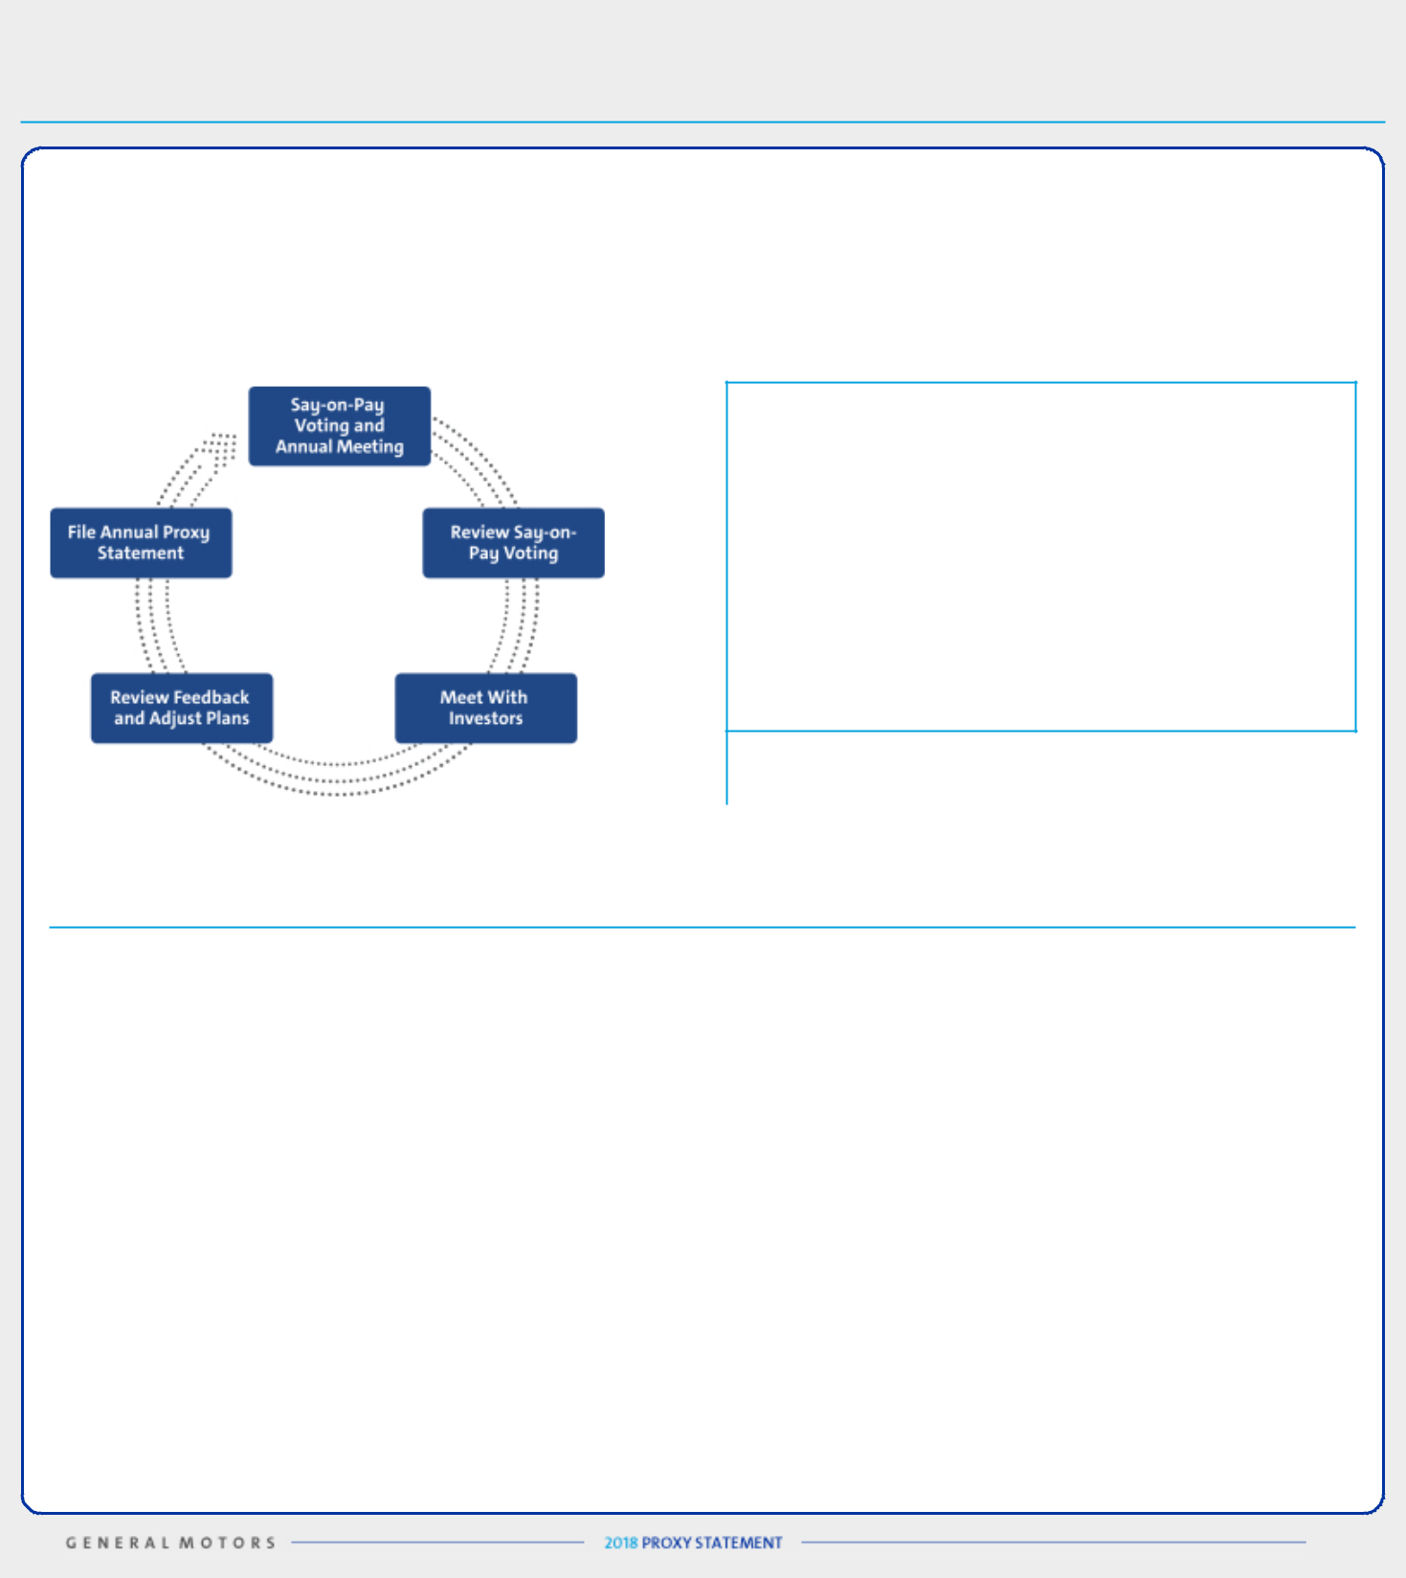

EXECUTIVE COMPENSATION

- Shareholder Engagement Initiatives

We view shareholder engagement as an important and continuous cycle. During 2017, members of the Board met in-person with shareholders representing approximately 25% of our outstanding common stock. In addition, during 2017, one or more members of management were involved in more than 75 in-person and telephonic meetings with investors representing more than 45% of shares outstanding. These discussions, say-on-pay voting results, and other factors are key drivers in assessing our compensation programs.

SHAREHOLDER SAY-ON-PAY

The Compensation Committee seeks to align the Company’s

executive compensation program with the interests of the

Company’s shareholders. The Compensation Committee

considers the results of the annual Say-On-Pay vote, input

from management, input from its independent compensation

consultant, and investor engagement initiatives when setting

compensation for our executives. In 2017, 96.3% of our

shareholders voted in favor of our compensation

programs. Discussions with investors and shareholder

Say-On-Pay voting are key drivers in our compensation

design to continue alignment between our compensation

programs and the interests of shareholders.

The Company values investor feedback and will continue to seek feedback through engagement initiatives to align our executive compensation programs with shareholder expectations. We made changes to our compensation plans that commenced at the start of 2017 to further align the interests of our senior leaders with those of our shareholders.

What We Heard | How We Responded
Maintain pay for performance | We continue to evolve our pay practices to support our pay-for-performance philosophy. For 2017, we added
 | an individual performance measure into our STIP while continuing Company focus on EBIT-adjusted and
 | Adjusted AFCF. In our LTIP we now measure both ROIC-adjusted and TSR performance relative to our OEM
 | peers while replacing RSUs with Stock Options to further align the interests of our most senior leaders with
 | those of our shareholders.
Continue to invest in the future | Our LTIP places a focus on investing in our future. By continuing to place a focus on ROIC and measuring
 | performance relative to OEM peers, we are incentivizing our most senior leaders to make investments in the
 | future of GM while delivering a return on investment that outperforms other OEMs.
Consider ESG performance when | The Company introduced our vision of a future with zero crashes, zero emissions, and zero congestion in
making pay decisions | 2017. Several key ESG results are discussed in the proxy statement summary on page 6 and in “Executive
 | Compensation—Compensation Overview—Our Company Performance” on page 36. In addition, we
 | introduced an individual performance component weighted at 25% for our STIP. Please see pages 48–53
 | where we discuss individual performance results, including results that had a positive impact on ESG
 | measures.
Look at performance relative to | Our PSUs measure both Relative ROIC-adjusted and Relative TSR against the Company’s OEM peers to
automotive industry peers | motivate our leaders to perform at the top of the industry regardless of business cycles.
Keep compensation plans simple | We simplified our compensation plans in 2017 to focus our most senior leaders on both key operational
 | performance measures and individual results in the STIP. This change added a complete line of sight into
 | compensation for each senior leader. We adjusted the LTIP to focus senior leaders on outperforming our
 | peers and increasing stock price to create value for our shareholders.

38

Table of Contents
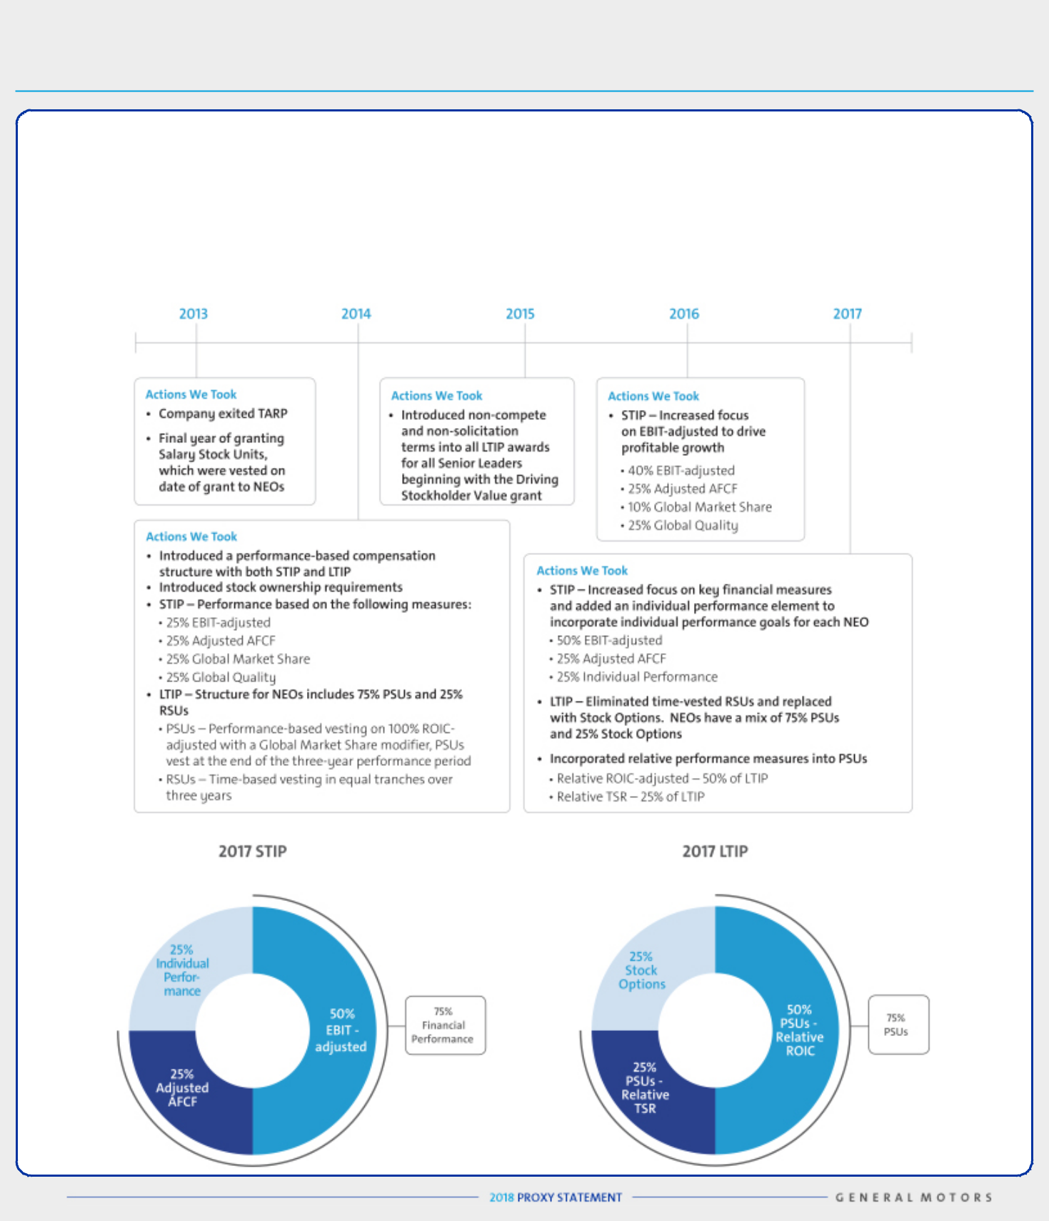

EXECUTIVE COMPENSATION

- Compensation Program Evolution

Our compensation programs have continued to focus our leaders on the key areas that both drive the business forward and align to the short-term and long-term interests of our shareholders. The Compensation Committee regularly reviews and discusses plan performance at each Compensation Committee meeting. The Compensation Committee considers many factors when electing to make plan changes for future incentive plans, including results, market trends, and investor feedback. The table below shows how the compensation program has continued to evolve to align with shareholders’ interests.

39

Table of Contents
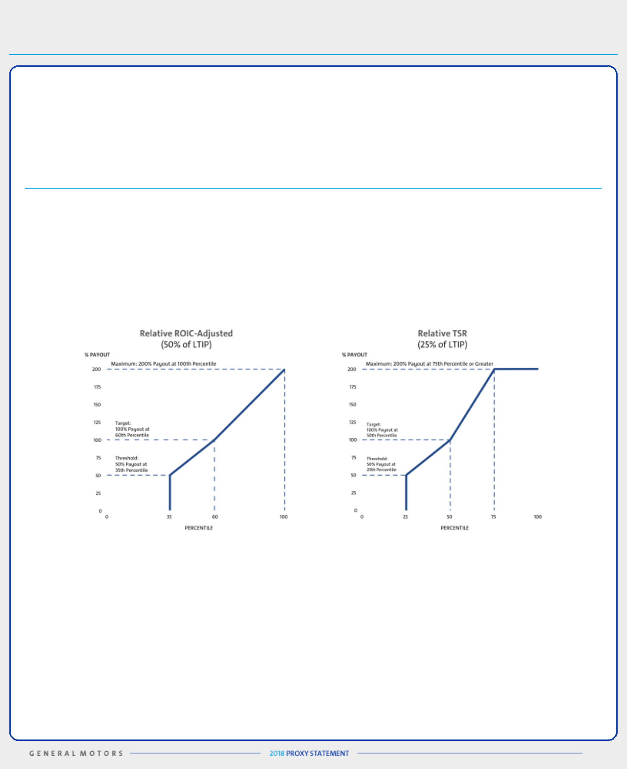

EXECUTIVE COMPENSATION

The Company held engagements with investors and received feedback on changes to both the STIP and LTIP. The 2017 STIP continued a focus on key financial measures (75% of STIP) and individual performance (25% of STIP). The total payout for the STIP will be 0% to 200% of target based on actual performance against pre-established goals. The Compensation Committee determined individual performance using a rigorous assessment process measuring performance against pre-established operational and other measures.

The 2017 LTIP replaced time-based RSUs with Stock Options to further align our most senior leaders with our shareholders’ interest in stock price appreciation. In addition, the Company changed PSU performance measures from ROIC-adjusted with a Global Market Share modifier to Relative ROIC-adjusted (50% of total LTIP) and Relative TSR (25% of total LTIP) against OEMs in the Dow Jones Automobiles and Parts Titans 30 Index, listed below.

Dow Jones Automobiles & Parts Titans 30 Index – OEM Peer Group

Toyota Motor Company | Volkswagen AG | Suzuki Motor Corp.
Daimler AG | Bayerische Motoren Werke AG | Fiat Chrysler Automobiles NV
Ford Motor Company | Nissan Motor Co. Ltd | Tesla, Inc.
Honda Motor Co. Ltd. | Renault SA | Mazda Motor Corp.
General Motors Co.⁽¹⁾ | Hyundai Motor Co. | Kia Motors Corp.

(1) GM’s performance will be determined on a continuous ranking for performance relative to OEM peers following the completion of the performance period.

The percentile rank required for each performance level relative to OEM peers and associated payouts for PSUs are displayed below.

Focusing performance on key financial measures and individual operational performance measures in the short term, combined with performance in both Relative ROIC-adjusted and Relative TSR compared with our other OEM peers in the long term, provides direct alignment of our executive compensation programs with the interests of our shareholders and continues to focus our senior leaders on making the investments that will provide for profitable long-term growth.

40

Table of Contents


EXECUTIVE COMPENSATION

- Peer Group for Compensation Comparisons

The Compensation Committee annually reviews the peer group for compensation comparisons and makes updates as needed to align with both the established criteria and Company strategy. We do not limit our peer group to our industry alone, because we believe compensation practices for NEOs at other large U.S.-based multinationals affect our ability to attract and retain diverse talent around the globe.

In determining 2017 compensation, we maintained the same compensation peer group from 2016. Based on the guidelines established by the Compensation Committee for our peer group selection, companies must satisfy each of the following criteria to be considered for the peer group:

- Revenue greater than $25 billion

- Significant international revenue

- Capital-intensive operations

In addition, the Compensation Committee considers the following factors when selecting our peer group:

- Comparable R&D expenditures as a percent of revenue

- Technology focused

- Durable goods manufacturer

- Business/production complexity

- Consumers who are the end user

- Strong brand reputation

Company | Industry |  | Company | Industry
3M Company |  | Industrial Conglomerates | Honeywell International Inc. |  | Aerospace and Defense
The Boeing Company |  | Aerospace and Defense | IBM Corporation |  | IT Consulting and Other
The Boeing Company |  | Aerospace and Defense | IBM Corporation |  | Services
Caterpillar Inc. |  | Construction Machinery and | Intel Corporation |  | Semiconductors
Caterpillar Inc. |  | Heavy Trucks | Intel Corporation |  | Semiconductors
Deere & Company |  | Agricultural and Farm Machinery | Johnson & Johnson |  | Pharmaceuticals
The Dow Chemical Company⁽¹⁾ | Diversified Chemicals |  | Johnson Controls Inc.⁽¹⁾⁽²⁾ | Auto Parts and Equipment
Du Pont⁽¹⁾ | Diversified Chemicals |  | PepsiCo, Inc. | Soft Drinks and Food
Ford Motor Company |  | Automobile Manufacturers | Pfizer Inc. |  | Pharmaceuticals
General Electric Company |  | Industrial Conglomerates | The Procter & Gamble Company |  | Household Products
HP, Inc. |  | Technology Hardware, | United Technologies Corp. |  | Aerospace and Defense
HP, Inc. |  | Storage, and Peripherals | United Technologies Corp. |  | Aerospace and Defense

- Companies were involved in significant mergers, acquisitions, or divestitures. The Committee will evaluate each peer company for inclusion in the peer group for 2018 and beyond.
- The Committee removed Johnson Controls Inc. from the peer group during their 2017 annual review.

- How We Use Comparator Data to Assess Compensation

We use executive compensation surveys composed of a broad array of industrial companies to benchmark relevant market data for executive positions. In addition, we benchmark pay practices and compensation levels against the proxy statement disclosures of our peer group and adjust this data to reflect GM’s size and market expected compensation trends. Further, we review the competitive market position of each of our executives compared with the market data.

We review each element of compensation compared with the market and generally target each element of our total direct compensation (base salary, STIP, and LTIP) for the executive group on average to be at or near the market median. However, an individual element or an individual’s total direct compensation may be positioned above or below the market median because of considerations such as his or her specific responsibilities, experience, and performance.

41

Table of Contents
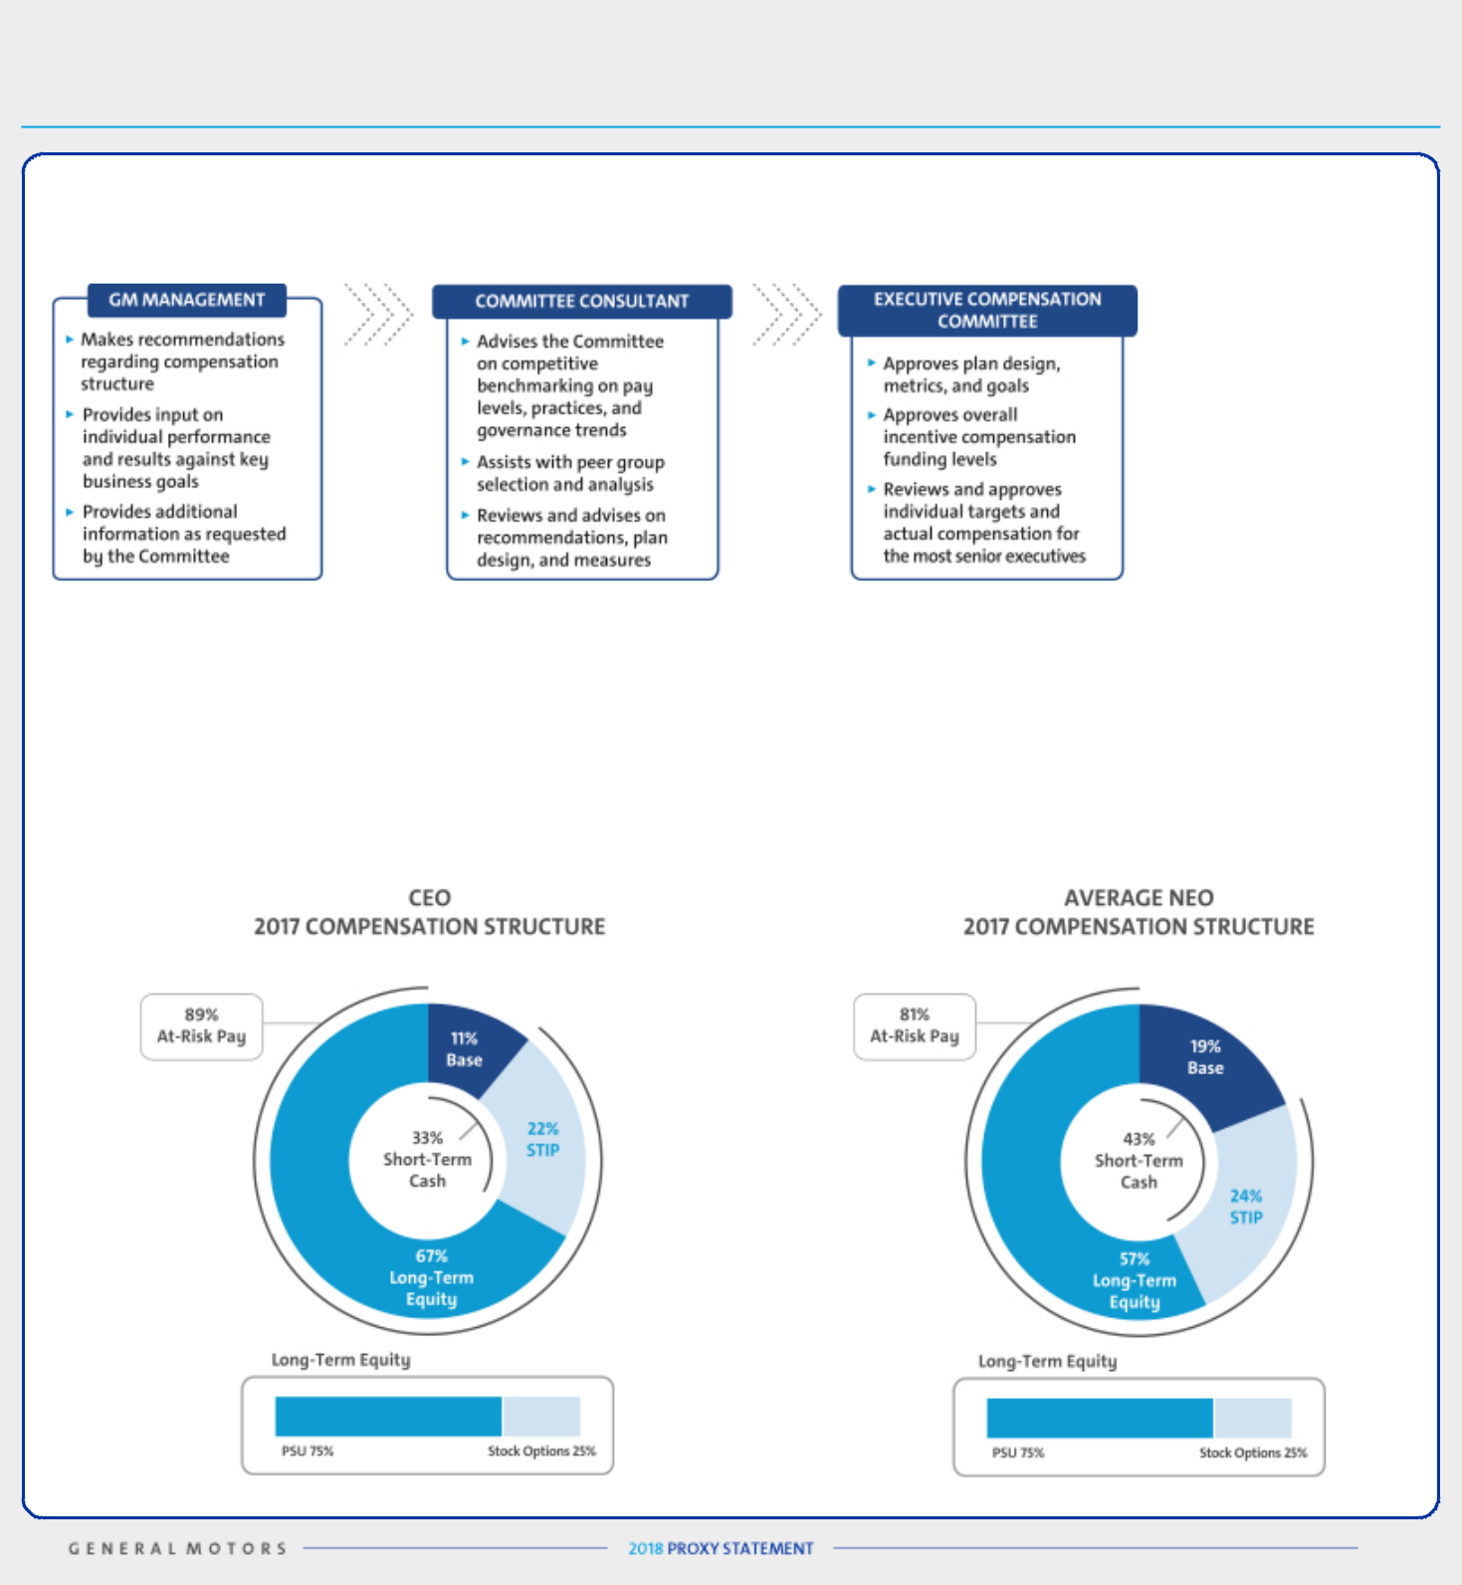

EXECUTIVE COMPENSATION

- How We Plan Compensation

- Performance-Based Compensation Structure

Our NEOs are incentivized to focus on optimizing long-term financial returns for our shareholders through increasing profitability, increasing margins, putting the customer at the center of everything we do, growing the business, and driving innovation.

The performance-based structure for 2017 incorporates both short-term and long-term incentives established from financial and operational metrics for fiscal year 2017 and beyond. In addition to base salary and an annual STIP award, this structure, shown graphically below, includes an LTIP award made up of both PSUs and Stock Options to focus our executives on long-term Company performance. The Compensation Committee believes a majority of compensation should be in the form of equity to align the interests of executives with those of shareholders.

42

Table of Contents

EXECUTIVE COMPENSATION

Compensation Principles

The compensation provided to our senior leaders continues to be guided by the following principles:

- Aligned with Shareholders – Compensation paid should align directly with the long-term interests of our shareholders, and our executives should share with them in the performance and value of our common stock;

- Performance-Based – Compensation paid should be based on a balance of financial and operational goals reflecting strong financial performance relative to our OEM competitors. The goals should be aggressive but achievable, within our executives’ control and should reward commitments met;

- Recognize Individual Performance – Compensation paid should motivate executives to perform at their best, reflecting their clear line of sight and contributions as well as their behaviors and demonstration of GM’s core values. Individual performance must be aligned with Company performance and desired behaviors;

- Simple Design – Our compensation plan should be easy to understand and communicate and minimize unintended consequences;

- Avoidance of Incentive to Take Excessive Risk – Compensation structure should avoid incentives to take unnecessary and excessive risk. Compensation should be paid over a period of time that takes into account the potential risk over the same time period;

- Appropriate Allocation of Compensation Components – The structure should appropriately allocate total compensation to fixed and variable pay elements resulting in an appropriate mix of short-term and long-term pay elements; and

- Comparable Target Compensation – Overall target compensation should be competitive (market median) with that paid to individuals at peer group companies so that it attracts, motivates, and retains talent.

Compensation Elements

- 2017 Compensation Structure

Each NEO’s 2017 compensation structure is market competitive with each pay element targeted at or near the market median. The compensation structure included the following pay elements:

- Base Salary – NEOs are paid a market-competitive base salary that reflects each NEO’s contribution, background, and performance as well as the knowledge and skills he or she brings to the role;

- STIP – The STIP is an annual cash incentive plan. The STIP rewards each NEO based on the achievement of annual Company financial goals and individual performance results. The potential payout ranges from 0% to 200% of target, based on actual Company performance and individual performance;

- PSUs – PSUs are equity awards designed to align each NEO’s interests with the long-term interests of the Company and its shareholders. PSUs can be earned at a level from 0% to 200% of target, based on the actual Company performance against Relative ROIC-adjusted and Relative TSR over the three-year performance period beginning January 1, 2017; and

- Stock Options – Stock options are time-based equity awards vesting ratably over a three-year period. Stock options align the interests of our most senior executives with our shareholders’ interest in stock price appreciation and allow our leaders to share in the gains with shareholders.

- Perquisites and Other Compensation

We provide perquisites and other compensation to our NEOs consistent with market practices. The following perquisites and other compensation were provided to NEOs in 2017:

- Personal Air Travel – Ms. Barra is prohibited by Company policy from commercial air travel due to security reasons identified by an independent third-party security consultant. As a result, the Company pays the costs associated with the use of private aircraft for both business and personal use. Ms. Barra is permitted to be accompanied by guests for personal travel and incurs imputed income for all passengers, including herself, at the U.S. Internal Revenue Service (the “IRS”) Standard Industry Fair Level rates. Other NEOs may travel on private aircraft in certain circumstances with prior approval from the CEO or the Senior Vice President, Global Human Resources, and also incur imputed income for any personal travel.

- Company Vehicle Programs – NEOs are eligible to participate in the Executive Company Vehicle Program and are allowed to use evaluation vehicles for the purpose of providing feedback on Company products. In addition, NEOs are eligible to use driver services provided by the Company and in accordance with Company policies.

43

Table of Contents

EXECUTIVE COMPENSATION

- Security – NEOs may receive security services, including home security systems and monitoring, for specific security-related reasons identified by independent third-party security consultants.

- Financial Counseling – NEOs are eligible to receive financial counseling, estate planning, and tax preparation services through an approved provider.

- Executive Physicals – NEOs are eligible to receive executive physicals with approved providers.

- 2017 Target Compensation

Our target total direct compensation for each NEO in 2017 was as follows:

 |  |  |  |  |  | LTIP
 |  | Annual Base | STIP | STIP | Target Total Cash | PSUs | Stock | Target Total
 |  | Salary | STIP | STIP | Compensation | PSUs | Options | Compensation
 |  |  |  |  |  | (2)
Name |  | ($) | (%) | ($) | ($) | ($) | ($) | ($)
Mary T. Barra |  | 2,100,000 | 200% | 4,200,000 | 6,300,000 | 9,750,000 | 3,250,000 | 19,300,000
Charles K. Stevens, III |  | 1,100,000 | 125% | 1,375,000 | 2,475,000 | 2,793,750 | 931,250 | 6,200,000
Daniel Ammann |  | 1,450,000 | 125% | 1,812,500 | 3,262,500 | 3,703,125 | 1,234,375 | 8,200,000
Mark L. Reuss |  | 1,200,000 | 125% | 1,500,000 | 2,700,000 | 3,037,500 | 1,012,500 | 6,750,000
Alan S. Batey |  | 1,025,000 | 125% | 1,281,300 | 2,306,300 | 2,020,275 | 673,425 | 5,000,000
Karl-Thomas Neumann | (1) | 1,050,000 | 125% | 1,312,500 | 2,362,500 | 1,781,250 | 593,750 | 4,737,500

- The targeted Total Direct Compensation for Dr. Neumann reflects the base salary and STIP in U.S. dollars. Dr. Neumann received a salary of €811,864 and an annual STIP target of €1,014,830.

- The number of PSUs awarded is determined by using the target PSU value divided by the closing price on the date of grant. PSUs with performance tied to relative TSR are valued using a Monte Carlo analysis, and Summary Compensation Table amounts may be higher or lower than target.

Performance Measures

- How We Set Performance Targets

Annually, the Compensation Committee approves the performance measures for the STIP and LTIP. The Compensation Committee reviews recommendations from management, receives input from the Compensation Committee consultant, evaluates the annual budget and mid term business plan, and reviews prior-year performance to approve value-creating goals tied to long-term shareholder value.

- 2017 STIP Performance Measures for NEOs

The STIP aligns with our plans to create the world’s most valued automotive company and to increase shareholder value. The STIP rewards NEOs for performance linked to the Company’s achievement of annual financial goals, operational performance goals, and individual performance results. The STIP is an annual cash incentive award intended to be deductible as performance-based compensation under U.S. Internal Revenue Code (“IRC”) Section 162(m) and is funded for each covered NEO once the Company achieves the threshold of positive EBIT-adjusted.

The Compensation Committee annually reviews and approves STIP goals to assess the difficulty in level of achievement and overall linkage to shareholders through the achievement of the business plan and strategic objectives. For the 2017 STIP, all targets were set at or above final 2016 performance. The Committee elected to adjust the weights to increase EBIT-adjusted to 50% and removed both global Market Share and Global Quality as overall measures. The Committee added individual performance with a weight of 25% as a measure to evaluate individual performance for each leader. Individual performance results and final individual compensation decisions are discussed beginning on page 48. Individual performance is assessed with an individual performance scorecard measuring results against pre-established goals that the Committee approves at the beginning of the year. Global market share and global quality are still focus items that the Committee considers when evaluating individual performance results.

44

Table of Contents

EXECUTIVE COMPENSATION

Actual STIP awards, if any, are determined following the completion of the plan year to reflect the achievement against the performance measures displayed below. The table below describes each STIP performance measure, its weighting, its target, and the behaviors each measure drives:

STIP Measure | Weight | Target |  | Leadership Behaviors
EBIT-adjusted | 50% | $ | 12.7 | Focus on operating profit and driving strong profitability
Adjusted AFCF (1) | 25% | $ | 6.3 | Focus on driving strong cash flow to invest in the business
Individual Performance | 25% | 25 pts. |  | Focus on individual performance goals that impact business results

- Adjusted AFCF for incentive purposes excludes payments related to certain recall-related expenses attributable to events occurring in 2014.

The potential payouts for each company performance measure range from 0% to 200% of target, based on actual Company performance with the threshold performance level being 50% of each STIP measure. The STIP calculation for the 2017 performance period determined the result for each NEO:
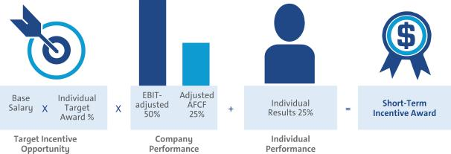

- 2017–2019 LTIP Performance Measures for NEOs

Grants under the LTIP are intended to link the financial interests of NEOs with the long-term interests of shareholders. The structure for NEOs included 75% PSUs and 25% Stock Options. PSUs cliff-vest following the three-year performance period, and Stock Options vest ratably over three years.
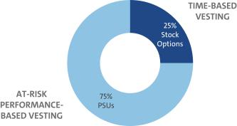

The 2017–2019 PSUs are awarded based on performance against the following measures relative to our OEM peers: Relative ROIC-adjusted and Relative TSR over the three-year performance period. The PSU performance measures were chosen to promote both efficient use of capital and long-term growth to create value for the shareholders and an increased focus on stock price appreciation. The following table shows the PSU performance measures and the leadership behaviors that each drives to make GM the world’s most valued automotive company:

LTIP Measure | Weight | Target | Leadership Behaviors
Relative ROIC-adjusted (1) | 67% | 60th Percentile | Focus on making sound investments that follow the disciplined capital approach of driving 20%
Relative ROIC-adjusted (1) | 67% | 60th Percentile | or higher returns in world-class vehicles and leading technology
Relative TSR (1) | 33% | 50th Percentile | Focus on delivering shareholder returns that outperform our OEM peers

- Relative performance is measured against the OEMs in the Dow Jones Automobiles and Parts Titans 30 Index on date of grant. OEMs for 2017–2019 PSUs are displayed on page 40.

45

Table of Contents

EXECUTIVE COMPENSATION

PSUs, if any, vest and are awarded and delivered following the completion of the three-year performance period, January 1, 2017 through December 31, 2019, and may be earned at a level between 0% and 200% of target based on actual Company results. When determining grant amounts, the Compensation Committee considers factors such as individual responsibilities, experience, and performance. In addition, the Compensation Committee will factor in relevant market compensation comparison data and seek the input from their independent compensation consultant. Final PSU awards are calculated as follows:
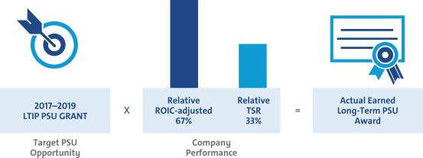

- Summary of Outstanding Performance Awards Granted in Prior Years
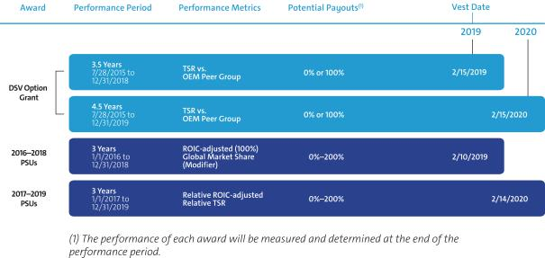

46

Table of Contents

EXECUTIVE COMPENSATION

Performance Results and Compensation Decisions

- 2017 Short-Term Incentive Plan

The Company portion of the 2017 STIP award was calculated based on the Company’s achievement of the following performance measures: EBIT-adjusted and Adjusted AFCF. In addition, each NEO has an individual performance portion of their STIP that measures performance against pre-established goals. Company performance including the individual results achieved the following results, as approved by the Compensation Committee. The results for EBIT-adjusted repeated GM’s 2016 record performance:

 |  |  |  |  |  |  |  | Performance |  | Performance
STIP Measure | Weight | Threshold |  |  | Target | Maximum |  |  | Results | Payout
EBIT-adjusted ($B) | 50% | $ | 6.8 | $ | 12.7 | $ | 14.0 | $ | 12.8 | 54%
Adjusted AFCF ($B) (1) | 25% | $ | 0.0 | $ | 6.3 | $ | 7.3 | $ | 5.6 | 24%
Individual Performance | 25% |  | 0 pts. |  | 25 pts. |  | 50 pts. |  | 25 – 40 pts. | 25%–40%
Result |  |  |  |  |  |  |  |  |  | 103%–118%

- Adjusted AFCF for incentive purposes excludes payments related to certain recall-related expenses attributable to events occurring in 2014.

- 2015–2017 Long-Term Incentive Plan

The 2015–2017 PSU awards vested on February 11, 2018, based on Company performance for the period January 1, 2015 through December 31, 2017 against pre-established performance targets for both ROIC-adjusted and the Global Market Share modifier. The following performance was approved by the Compensation Committee:

 |  |  |  |  | Performance |  | Performance
LTIP Measure | Weight | Threshold | Target | Maximum | Results |  | Payout
ROIC-adjusted | 100% | 16.0% | 20.0% | 24.0% | 28.1% | (1) | 200%
Result |  |  |  |  |  |  | (2)
Result |  |  |  |  |  |  | 200%

- Represents the average of ROIC-adjusted for 2015 to 2017. ROIC-adjusted for 2015 and 2016 was 27.2% and 28.9%, respectively. ROIC-adjusted for 2017 was 28.2%, as reported on a continuing operations basis.

- The modifier for Global Market Share reduces the payout 25 points if Global Market Share is below 11.3%. The payout is increased 25 points if Global Market Share is at or above 11.8% not to exceed plan maximum of 200%. The Company achieved 11.3% Global Market Share for the performance period, thus no modifier was applied. Global Market Share excludes the impact of the Company’s decision to exit markets during the performance period.

Focusing our leaders on ROIC-adjusted has resulted in significant performance improvements since calendar year 2012, when ROIC-adjusted was 16.0% at which time we set an enduring target of 20% based on commitment to shareholders. We ended calendar year 2017 with a ROIC-adjusted of

28.2%. The 2017–2019 PSUs focus leaders not only on delivering improved ROIC-adjusted results, but also on being the top automotive OEM for ROIC-adjusted results.

- One-time 2015–2020 DSV Option Grant

The DSV option grant was a one-time grant made on July 28, 2015 to senior leaders to secure non-compete and non-solicitation terms and to drive an increased focus on stock price appreciation. The DSV grant featured 40% time-based vesting and 60% performance-based vesting. The performance-based portion vests upon meeting or exceeding the median TSR relative to the OEM peer group in place on the date of grant. 20% of the DSV option grant vested based on relative TSR performance for the period July 28, 2015–December 31, 2017 and 40% of the overall award remains outstanding with performance periods ending on December 31, 2018, and December 31, 2019.

DSV Measure | Performance Period | Vesting Date | Weight |  | Target TSR |  | Result | Vesting
Relative TSR | July 28, 2015–December 31, 2017 | February 15, 2018 | 20% | 50 | th | Percentile | 87 Percentile | 100%
 |  |  |  |  | th |  | th

47

Table of Contents

EXECUTIVE COMPENSATION

- Compensation Decisions for Mary T. Barra

Mary T. Barra, Chairman and Chief Executive Officer


Ms. Barra’s performance for 2017 was directly aligned with the Company’s 2017 strategic objectives:

Core

u Continued to drive improvement in EBIT-adjusted margins and delivered record EBIT-adjusted margins, including the third straight year of 10% or higher margins in North America
u Increased EPS-diluted-adjusted to record $6.62

u Achieved 13 top 3 models in the J.D. Power APEAL survey measuring performance, execution, and layout

u Received the IHS Automotive Loyalty Award for the third straight year

u Chevrolet sold a record number of electric vehicles, including more than 43,600 Bolt EVs and Volts

u Completed the sales of Opel/Vauxhall and GM Financial European businesses to PSA u More than 150 facilities are operating landfill free
u Global Cadillac experienced record sales in 2017 with significant increases from GM China Transformation
u Introduced the vision of zero crashes, zero emissions, and zero congestion for the future of

GM

u Expanded both Maven and Book by Cadillac to increase carsharing capabilities

u Announced plans to deploy self-driving vehicles in a dense urban environment in 2019

u Launched Super Cruise, the world’s first hands-free highway driving technology, on the Cadillac CT6

u 180 Cruise autonomous vehicles built with approximately 100 testing in Arizona, California, and Michigan

u Acquired Strobe, Inc. to help develop next-generation LiDAR solutions for self-driving vehicles and reduce LiDAR costs by 99% over time

u Announced plans for at least 20 new electric vehicles by 2023

u Became the first company to use mass-production methods to build autonomous electric test vehicles

Effective January 1, 2017, the Compensation Committee increased Ms. Barra’s base salary from $2,000,000 to $2,100,000 based on her performance, leadership, and the competitive market analysis provided by the Compensation Committee’s independent compensation consultant. For 2017, the Compensation Committee awarded Ms. Barra an annual equity grant of $13 million consisting of 75% PSUs and 25% Stock Options. These changes placed Ms. Barra in line with the compensation peer group, as her targeted total direct compensation remained competitive at the market median.

The Compensation Committee awarded Ms. Barra 40 points based on her results, highlighted above, for the 2017 performance year. The total compensation for Ms. Barra in 2017, including salary, STIP and LTIP awards, is displayed below.

Pay Element | Majority of Pay Is At-Risk | Awarded Value
Base Salary | Only Fixed Pay Element | $ | 2,100,000
STIP | Performance to Metrics | $ | 4,956,000
PSUs(1) | Performance to Metrics and Stock Price | $ | 10,737,570
Stock Options(2) | Performance to Stock Price | $ | 3,250,003
TOTAL |  | $ | 21,043,573
- PSUs are subject to performance vesting; value reflects grant date fair value at target performance for Relative ROIC-adjusted awards and probable performance results from the Monte Carlo analysis to value Relative TSR awards.

- Stock Options are subject to time-based vesting.

Awarded value reflects the amount included in the Summary Compensation Table, excluding change in pension value and all other compensation. Realized compensation includes base salary, earned STIP, and all options exercised and stock vested during the year. 2017 realized compensation increased relative to the prior year reflecting 1) the vesting of the PSU award granted to Ms. Barra in 2014, the year she was promoted to her current role; and 2) an increase in stock price at the time of vesting versus the prior year.
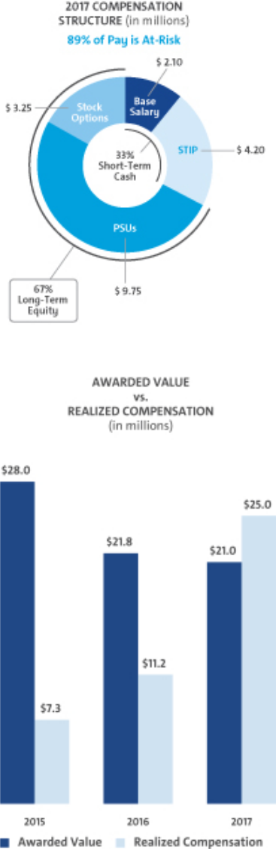

48

Table of Contents

EXECUTIVE COMPENSATION

- Compensation Decisions for Charles K. Stevens, III

Charles K. Stevens, III, Executive Vice President and Chief Financial Officer


2017 performance highlights for Mr. Stevens include:
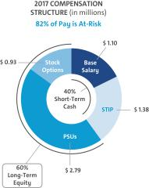

u Continued to drive improvement in EBIT-adjusted and delivered record EBIT-adjusted margins, including the third straight year of 10% or higher margins in North America

- Increased EPS-diluted-adjusted to record $6.62

- Repurchased more than $6.7 billion and returned $25 billion to shareholders through dividends and share repurchases since 2012, representing more than 90% of available free cash flow generated over that time

- Achieved ROIC-adjusted of 28.2%

- Delivered $5.5 billion in cost savings against $6.5 billion of targeted savings through the end of 2018
- Continued to make investments in future technology and innovation

The Compensation Committee kept Mr. Stevens’ base salary at $1,100,000 based on the competitive market analysis provided by the Compensation Committee’s independent compensation consultant. For 2017, the Compensation Committee awarded Mr. Stevens an annual equity grant of $3.725 million, consisting of 75% PSUs and 25% Stock Options.

The Compensation Committee awarded Mr. Stevens 40 points based on his results, highlighted above, for the 2017 performance year. The total compensation for Mr. Stevens in 2017, including salary, STIP and LTIP awards, is displayed below.
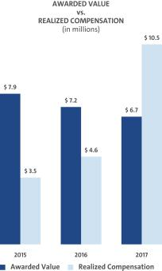

Pay Element | Majority of Pay Is At-Risk | Awarded Value
Base Salary | Only Fixed Pay Element | $ | 1,100,000
STIP | Performance to Metrics | $ | 1,622,500
PSUs(1) | Performance to Metrics and Stock Price | $ | 3,076,744
Stock Options(2) | Performance to Stock Price | $ | 931,251
TOTAL |  | $ | 6,730,495

- PSUs are subject to performance vesting; value reflects grant date fair value at target performance for Relative ROIC-adjusted awards and probable performance results from the Monte Carlo analysis to value Relative TSR awards.

- Stock Options are subject to time-based vesting.

Awarded value reflects the amount included in the

Summary Compensation Table, excluding change in

pension value and all other compensation. Realized

compensation includes base salary, earned STIP, and

all options exercised and stock vested during the year.

2017 realized compensation increased relative to the

prior year reflecting 1) the vesting of the PSU award

granted to Mr. Stevens in 2014, the year he was

promoted to his current role; and 2) an increase in

stock price at the time of vesting versus the prior year.

49

Table of Contents

EXECUTIVE COMPENSATION

- Compensation Decisions for Daniel Ammann

Daniel Ammann, President


2017 performance highlights for Mr. Ammann include:
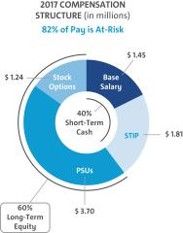

- Led the successful sale of Opel/Vauxhall and GM Financial European businesses to PSA

- Successfully completed various restructuring activities in GM International

- Defined strategy for commercialization of autonomous vehicles through Transportation as a Service
- Oversaw rapid autonomous vehicle technology development and successful scaling of the team at GM Cruise
- Significant global sales growth at Cadillac in 2017, with strong increases in China

- Continued reshaping and reprioritization of overall GM business and product portfolio

- Drove ongoing continuous performance improvement through extensive focus on Operational Excellence

The Compensation Committee kept Mr. Ammann’s base salary at $1,450,000 based on the competitive market analysis provided by the Compensation Committee’s independent compensation consultant. For 2017, the Compensation Committee awarded Mr. Ammann an annual equity grant of $4.94 million, consisting of 75% PSUs and 25% Stock Options.

The Compensation Committee awarded Mr. Ammann 40 points based on his results, highlighted above, for the 2017 performance year. The total compensation for Mr. Ammann in 2017, including salary, STIP and LTIP awards, is displayed below.
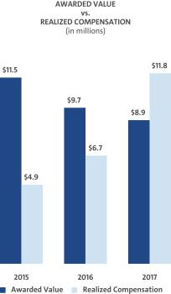

Pay Element | Majority of Pay Is At-Risk | Awarded Value
Base Salary | Only Fixed Pay Element | $1,450,000
STIP | Performance to Metrics | $2,138,800
PSUs(1) | Performance to Metrics and Stock Price | $4,078,222
Stock Options(2) | Performance to Stock Price | $1,234,378
TOTAL |  | $8,901,400

- PSUs are subject to performance vesting; value reflects grant date fair value at target performance for Relative ROIC-adjusted awards and probable performance results from the Monte Carlo analysis to value Relative TSR awards.

- Stock Options are subject to time-based vesting.

Awarded value reflects the amount included in the

Summary Compensation Table, excluding change in

pension value and all other compensation. Realized

compensation includes base salary, earned STIP, and

all options exercised and stock vested during the year.

2017 realized compensation increased relative to the

prior year reflecting 1) the vesting of the PSU award

granted to Mr. Ammann in 2014, the year he was

promoted to his current role; and 2) an increase in

stock price at the time of vesting versus the prior year.

50

Table of Contents

EXECUTIVE COMPENSATION

- Compensation Decisions for Mark L. Reuss

Mark L. Reuss, Executive Vice President, Global Product Development,

Purchasing and Supply Chain


2017 performance highlights for Mr. Reuss include:
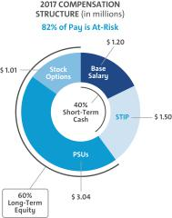

- Launched Super Cruise, the world’s first hands-free highway driving technology, on the Cadillac CT6
- Led development of all-new EME 1.0 battery architecture, providing flexible pack configurations at more than 30% lower cost
- Received the IHS Automotive Loyalty Award for the third straight year

- Developed a global electrification plan to lead the industry and announced that at least 20 new electric vehicles will be introduced by 2023
- Received nearly 40 independent awards for the Bolt EV, making it the most awarded electric vehicle of the year
- Developed the first fuel cell midsized truck for use by the U.S. military and delivered fuel cells for use in the first unmanned submarine powered by our fuel cells for validation for the U.S. military

- Awarded the Constructor Award for Chevrolet’s performance in motorsports winning manufacturers’ championships in Verizon IndyCar Series, NASCAR, NHRA Mello Yellow Series, IMSA, and Pirelli World Challenge

- Launched 25 vehicles globally

- Became the first company to use mass-production methods to build autonomous electric test vehicles
- Led development efforts to deliver a fully autonomous vehicle complete with no steering wheel, or gas or brake pedals
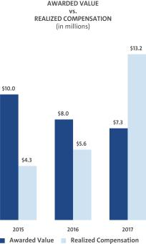

The Compensation Committee kept Mr. Reuss’ base salary at $1,200,000 based on the competitive market analysis provided by the Compensation Committee’s independent compensation consultant. For 2017, the Compensation Committee awarded Mr. Reuss an annual equity grant of $4.05 million, consisting of 75% PSUs and 25% Stock Options.

The Compensation Committee awarded Mr. Reuss 40 points based on his results, highlighted above, for the 2017 performance year. The total compensation for Mr. Reuss in 2017, including salary, STIP and LTIP awards, is displayed below.

Pay Element | Majority of Pay Is At-Risk | Awarded Value
Base Salary | Only Fixed Pay Element | $1,200,000
STIP | Performance to Metrics | $1,770,000
PSUs(1) | Performance to Metrics and Stock Price | $3,345,168
Stock Options(2) | Performance to Stock Price | $1,012,504
TOTAL |  | $7,327,672

- PSUs are subject to performance vesting; value reflects grant date fair value at target performance for Relative ROIC-adjusted awards and probable performance results from the Monte Carlo analysis to value Relative TSR awards.

- Stock Options are subject to time-based vesting.

Awarded value reflects the amount included in the

Summary Compensation Table, excluding change in

pension value and all other compensation. Realized

compensation includes base salary, earned STIP, and

all options exercised and stock vested during the year.

2017 realized compensation increased relative to the

prior year reflecting 1) the vesting of the PSU award

granted to Mr. Reuss in 2014, the year he was

promoted to his current role; and 2) an increase in

stock price at the time of vesting versus the prior year.

51

Table of Contents

EXECUTIVE COMPENSATION

- Compensation Decisions for Alan S. Batey

Alan S. Batey, Executive Vice President & President, North America


2017 performance highlights for Mr. Batey include:

- Achieved record margins in North America and delivered EBIT-adjusted margins of greater than 10% for the third straight year
- Increased GM crossover retail sales in the United States by 21% over 2016 resulting in the best year in history
- Increased average transaction prices in the United States to $35,600, exceeding the industry by $3,800
- Increased Denali sales in the United States where 29% of all GMC vehicles sold were Denali

- Awarded a third straight OEM IHS Customer Loyalty award for GM U.S.

- Delivered the best retail sales since 2008 in Canada with all four brands, Chevrolet +13.6%, Buick +15.1%, GMC +18.7%, and Cadillac +10.9%, experiencing double digit increases
- Earned the J.D. Power CSI and SSI awards for Buick in the United States for the second consecutive year
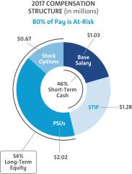

Effective January 1, 2017, Mr. Batey’s base salary was increased from $950,000 to $1,025,000. The increase was supported by the competitive market analysis provided by the Compensation Committee’s independent compensation consultant. For 2017, the Compensation Committee awarded Mr. Batey an annual equity grant of $2.69 million, consisting of 75% PSUs and 25% Stock Options.

The Compensation Committee awarded Mr. Batey 35 points based on his results, highlighted above, for the 2017 performance year. The total compensation for Mr. Batey in 2017, including salary, STIP and LTIP awards, is displayed below.
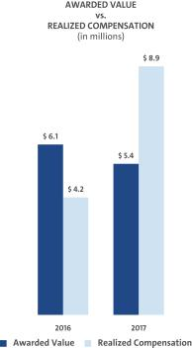

Pay Element | Majority of Pay Is At-Risk | Awarded Value
Base Salary | Only Fixed Pay Element | $ | 1,025,000
STIP | Performance to Metrics | $ | 1,447,800
PSUs(1) | Performance to Metrics and Stock Price | $ | 2,224,928
Stock Options(2) | Performance to Stock Price | $ | 673,426
TOTAL |  | $ | 5,371,154

- PSUs are subject to performance vesting; value reflects grant date fair value at target performance for Relative ROIC-adjusted awards and probable performance results from the Monte Carlo analysis to value Relative TSR awards.

- Stock Options are subject to time-based vesting.

Awarded value reflects the amount included in the

Summary Compensation Table, excluding change in

pension value and all other compensation. Realized

compensation includes base salary, earned STIP, and

all options exercised and stock vested during the

year. 2017 realized compensation increased relative

to the prior year reflecting 1) the vesting of the PSU

award granted to Mr. Batey in 2014, the year he was

promoted to his current role; and 2) an increase in

stock price at the time of vesting versus the prior

year.

52

Table of Contents

EXECUTIVE COMPENSATION

- Compensation Decisions for Karl-Thomas Neumann

Karl-Thomas Neumann, Former Executive Vice President & President, Europe


Dr. Neumann played a key role in leading the Opel/Vauxhall organizations through the sale to PSA while maximizing business results versus the plan and maintained the consistency of the workforce that transitioned to PSA. He continued to navigate the teams to achieve a successful closing and worked through issues with all stakeholders in a constructive manner.
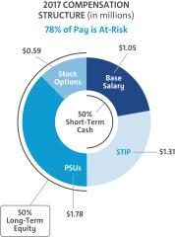

Effective January 1, 2017, Dr. Neumann’s base salary was €811,864 supported by the competitive market analysis provided by the Compensation Committee’s independent compensation consultant. For 2017, the Compensation Committee awarded Dr. Neumann an annual equity grant of $2.37 million, consisting of 75% PSUs and 25% Stock Options.

Based on performance to goals for 2017, the Compensation Committee awarded Dr. Neumann 25 points for his performance assessment under the STIP. In addition, the Committee awarded Dr. Neumann a one-time transaction success incentive (“TSI”) award for his efforts in leading the Opel/Vauxhall organization through the close of the sale to PSA. The total compensation for Dr. Neumann in 2017, including salary, bonus, STIP and LTIP awards, is displayed below.

Pay Element | Majority of Pay Is At-Risk | Awarded Value
(1) | Only Fixed Pay Element | $ | 916,936
Base Salary | Only Fixed Pay Element | $ | 916,936
STIP(2) | Performance to Metrics | $ | 1,276,317
PSUs(3) | Performance to Metrics and Stock Price | $ | 1,961,676
Stock Options(4) | Performance to Stock Price | $ | 593,751
Other(5) | Performance to Transaction | $ | 2,000,000
TOTAL |  | $ | 6,748,680
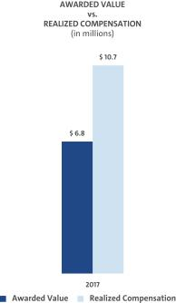

- The salary of €811,864 was paid in euros and converted to U.S. dollars, applying an average foreign exchange rate for the period from January 1, 2017 to December 31, 2017 during which compensation was earned €1 = $1.1294.

- The STIP award of €1,045,200, was paid in euros and converted using the exchange rate on date of payment. €1 = $1.221122

- PSUs are subject to performance vesting; value reflects grant date fair value at target performance for Relative ROIC-adjusted awards and probable performance results from the Monte Carlo analysis to value Relative TSR awards.

- Stock Options are subject to time-based vesting.

- The TSI was paid based on a successful close of the Opel/Vauxhall sale to PSA. The TSI award was based in U.S. dollars and paid in euros.

Awarded value reflects the amount included in the

Summary Compensation Table, excluding change in

pension value and all other compensation Realized

compensation includes base salary, earned STIP, TSI

award, and all options exercised and stock vested

during the year.

53

Table of Contents

EXECUTIVE COMPENSATION

Compensation Policies and Governance Practices

- Stock Ownership Requirements

The Company requires our senior leaders to own stock in the Company to more closely align the interests of senior leaders with those of our shareholders. The requirements:

- cover all senior leaders;

- set five years as the time frame to meet ownership requirements;

- establish a multiple of each executive’s base salary on the date they are first covered;

- make it possible to meet ownership requirements by owning either a multiple of base salary or a required number of shares; and

- call for senior leaders to hold shares in order to meet the ongoing ownership requirements.

The table below shows the stock ownership requirement by level in the Company as well as ownership requirements for each of our NEOs.

Position |  | Ownership Requirement
 |  | as a Multiple of Salary
• CEO |  | 6x
• | President | 4x
• | Executive Vice President | 4x
• | Senior Vice President | 3x
• | Senior Executive | 1x

As of December 31, 2017, all NEOs have met or are on track to meet stock ownership requirements by their respective dates.

- Policy on Recoupment of Incentive Compensation

We have a corporate policy to recover incentive compensation paid to executive officers in cases where financial statements are restated because of employee fraud, negligence, or intentional misconduct. Under this clawback policy, posted on our website at gm.com/investors/corporate-governance, if the Board or an appropriate Board Committee determines any bonus, retention award, or short or long-term incentive compensation has been paid to any executive officer based on materially inaccurate misstatement of earnings, revenues, gains, or other criteria, including reputational harm, the Board or Compensation Committee will take the action it deems necessary to recover the compensation paid, remedy the misconduct, and prevent its recurrence. For this purpose, a financial statement or performance metric will be treated as materially inaccurate when an employee knowingly engaged in providing inaccurate information or knowingly failed to timely correct information relating to those financial statements or performance metrics. We will continue to review our policy to ensure it is consistent with all legal requirements and in the best interests of the Company and its shareholders.

- Securities Trading Policy

Our securities trading policy prohibits our employees from buying or selling GM securities when in possession of material nonpublic information. Any sale or purchase of common stock by directors, executive officers, and all other senior leaders must be made during pre-established periods after receiving preclearance by a member of the GM Legal Staff or according to preapproved Rule 10b5-1 plan.

Trading in GM derivatives (i.e., puts or calls), engaging in short sales, and pledging of GM securities is also prohibited. All GM executive officers are in compliance with the policy of not pledging any shares of common stock. This policy is posted on our website at gm.com/investors/corporate-governance.

- Tax Considerations

IRC Section 162(m) generally disallows federal tax deductions for compensation in excess of $1 million paid to the CEO and the next three of our highest-paid officers (other than the CFO) whose compensation is required to be reported in the Summary Compensation Table in this Proxy Statement (‘‘Covered Executives’’). Certain performance-based compensation is not subject to this deduction limitation as applicable for fiscal year 2017. Generally, we strive to maximize the tax deductibility of compensation arrangements. The Compensation Committee, however, may award compensation that is not fully tax deductible if it deems it appropriate as compensation designed to attract and retain talented executives in the highly competitive market for talent.

STIP awards for performance during 2017 are paid based on the achievement of performance measures approved by shareholders in 2014 as part of the 2014 STIP. Because the STIP awards for performance during 2017 are intended to be deductible as performance-based compensation under 162(m), the Compensation Committee set the maximum award for each Covered Executive at $7.5 million. Incentive amounts equal to the maximum will be funded for each Covered Executive once a threshold level of positive EBIT-adjusted has been achieved. The Compensation Committee then exercises negative discretion, as needed, to determine actual incentive awards based on other business and individual performance, as described in “Executive Compensation—Performance Results and Compensation Decisions—2017 Short-Term Incentive Plan” on page 47.

54

Table of Contents

EXECUTIVE COMPENSATION

The Tax Cuts and Jobs Act, enacted on December 22, 2017, substantially modifies IRC Section 162(m) and, among other things, eliminates the performance-based compensation exception to the $1 million deduction limit effective as of January 1, 2018. As a result, beginning in 2018, compensation paid to Covered Executives in excess of $1 million will generally be nondeductible, whether or not it is performance-based. In addition, beginning in 2018, the Covered Executives will include any individual who served as the CEO or CFO at any time during the taxable year and the next three of our highest paid officers (other than the CEO and CFO) for the taxable year, and once an individual becomes a Covered Executive for any taxable year beginning after December 31, 2016, that individual will remain a Covered Executive for all future years, including following any termination of employment.

The Tax Cuts and Jobs Act includes a transition relief rule pursuant to which the changes to IRC Section 162(m) described above will not apply to compensation payable pursuant to a written binding contract that was in effect on November 2, 2017 and is not materially modified after that date. To the extent applicable to our existing arrangements, the Compensation Committee may avail itself of this transition relief rule. However, because of uncertainties as to the application and interpretation of the transition relief rule, no assurances can be given at this time that our existing arrangements, even if in place on November 2, 2017, will meet the requirements of the transition relief rule. Moreover, to maintain flexibility in attracting and retaining talented executives, the Compensation Committee does not limit its actions with respect to executive compensation to preserve deductibility under IRC Section 162(m) if the Compensation Committee determines that doing so is in the best interests of our shareholders.

- Compensation Committee and Consultant Independence

Our Compensation Committee is composed entirely of independent directors as determined by the Board under NYSE standards and as defined for various regulatory purposes. Farient Advisors assisted the Compensation Committee in 2017. Farient Advisors is an independent compensation consulting firm that takes direction from and is solely responsible to the Compensation Committee. The Compensation Committee is also aided in its deliberations by in-house legal counsel.

Under its charter, the Compensation Committee has the authority to hire outside consultants and advisors at the Company’s expense. The Compensation Committee retains the services of Farient Advisors for advice on issues related to the compensation of NEOs and other executive compensation-related matters. A representative of Farient Advisors attended all Compensation Committee meetings, either in person or via telephone, consulted with and advised the Compensation Committee members on executive compensation, including the structure and amounts of various pay elements, and developed executive benchmarking data for the Compensation Committee. Farient Advisors provided no services to the Company’s management.

The Compensation Committee annually reviews the performance of the compensation consultant and considers the following factors when assessing consultant independence in accordance with NYSE standards:

- Services provided to GM management outside of the services provided to the Compensation Committee;

- Fees paid as a percentage of Farient Advisors’ total revenue;

- Policies and procedures of Farient Advisors designed to prevent conflicts of interest;

- Any business or personal relationships between members of the Compensation Committee and Farient Advisors;

- Stock ownership by employees of Farient Advisors; and

- Any business or personal relationships between GM and Farient Advisors.

The Compensation Committee reviewed the performance and independence of Farient Advisors and determined that Farient Advisors was independent based on the standards above.

- Compensation Risk Assessment

During 2017, the Compensation Committee reviewed and discussed the impact of executive compensation programs on organizational risk. The Compensation Committee discussed plans and reviewed risk mitigation features in each of the plans to evaluate, with the assistance of our audit, legal and risk management organizations, the overall impact that compensation programs have on organizational risk. The Compensation Committee determined compensation programs have sufficient risk mitigation features and do not encourage or reward employees for taking excessive or unnecessary risk. The mix of our short-term and long-term compensation programs appropriately rewards employees while balancing risk through the delayed payment of long-term awards. As a result of the compensation risk review completed on December 12, 2017, the Compensation Committee determined the overall risk of compensation programs exposing the organization to unnecessary or excessive risks is low.

- Employment and Termination Agreements

The Company has no employment or termination agreements with any of our 2017 NEOs. All NEOs participate in the same Executive Severance Program available to other executive employees.

55

Table of Contents

EXECUTIVE COMPENSATION

Compensation Committee Report

The Compensation Committee has reviewed and discussed with management the CD&A and, based on that review and discussion, has recommended to the Board of Directors that the CD&A be included in this Proxy Statement and incorporated by reference in the GM 2017 Annual Report on Form 10-K.

Compensation Committee

Carol M. Stephenson (Chair)

Joseph Jimenez

James J. Mulva

Patricia F. Russo

56

Table of Contents

EXECUTIVE COMPENSATION

Executive Compensation Tables

- Summary Compensation Table

 |  |  |  |  |  |  |  | Change in
 |  |  |  |  |  |  |  | Pension
 |  |  |  |  |  |  |  | Value and
 |  |  |  |  |  |  | Nonequity | NQ Deferred
Name and |  |  |  |  | Stock | Option | Incentive Plan | Compensation |  | All Other
Principal |  | (2) | Bonus | (3) | (4) | (5) | (6) | Earnings | (7) | Compensation | (8) | Total
Principal |  | Salary | Bonus |  | Awards | Awards | Compensation | Earnings |  | Compensation |  | Total
(1) | Year | ($) | ($) |  | ($) | ($) | ($) | ($) |  | ($) |  | ($)
Position
Mary T. Barra | 2017 | 2,100,000 |  | — | 10,737,570 | 3,250,003 | 4,956,000 | 52,792 |  | 861,683 |  | 21,958,048
Chairman and Chief | 2017 | 2,100,000
Executive Officer | 2016 | 2,000,000 |  | — | 13,000,036 | — | 6,760,000 | 181,777 |  | 640,246 |  | 22,582,059
 | 2015 | 1,750,000 |  | — | 12,000,004 | 11,167,029 | 3,062,500 | 12,012 |  | 597,118 |  | 28,588,663
Charles K. Stevens, III | 2017 | 1,100,000 |  | — | 3,076,744 | 931,251 | 1,622,500 | 54,114 |  | 316,430 |  | 7,101,039
Executive Vice | 2017 | 1,100,000
President and Chief | 2016 | 1,100,000 |  | — | 3,450,007 | — | 2,673,800 | 135,146 |  | 244,132 |  | 7,603,085
Financial Officer
Financial Officer | 2015 | 1,000,000 |  | — | 2,875,049 | 2,675,437 | 1,375,000 |  | — | 176,738 |  | 8,102,224
Daniel Ammann | 2017 | 1,450,000 |  | — | 4,078,222 | 1,234,378 | 2,138,800 |  | — | 356,918 |  | 9,258,318
President | 2017 | 1,450,000 |  |  |  |  |  |  | — |  |  | 9,258,318
President | 2016 | 1,450,000 |  | — | 4,700,032 | — | 3,513,100 |  | — | 560,852 |  | 10,223,984
 | 2015 | 1,200,000 |  | — | 4,500,021 | 4,187,636 | 1,650,000 |  | — | 262,420 |  | 11,800,077
Mark L. Reuss | 2017 | 1,200,000 |  | — | 3,345,168 | 1,012,504 | 1,770,000 | 54,390 |  | 344,446 |  | 7,726,508
Executive Vice | 2017 | 1,200,000
President, Global | 2016 | 1,200,000 |  | — | 3,900,018 | — | 2,905,000 | 134,777 |  | 272,866 |  | 8,412,661
Product Development,
Product Development, | 2015 | 1,100,000 |  | — | 3,825,012 | 3,559,495 | 1,515,000 |  | — | 199,629 |  | 10,199,136
Purchasing | 2015 | 1,100,000 |  |  |  |  |  |  | — |  |  | 10,199,136
and Supply Chain
Alan S. Batey | 2017 | 1,025,000 |  | — | 2,224,928 | 673,426 | 1,447,800 | 316,601 |  | 287,373 |  | 5,975,128
Executive Vice President, & | 2017 | 1,025,000
President, North America | 2016 | 950,000 |  | — | 2,700,035 | — | 2,406,900 | 133,151 |  | 225,078 |  | 6,415,164
Karl-Thomas Neumann |  | 916,936 | 2,000,000 |  | 1,961,676 | 593,751 | 1,276,317 | 126,796 |  | 12,563 |  | 6,888,039

Former Executive | 2017
Vice President & President,
Europe

- Titles in the table reflect the NEOs position as of December 31, 2017. Mr. Batey first became a NEO in 2016. Dr. Neumann was not a NEO in 2015 or 2016.

- Dr. Neumann’s salary, which was paid in euros, has been converted to U.S. dollars, applying an average foreign exchange rate for the period from January 1, 2017 to December 31, 2017, during which compensation was earned €1 = $1.1294.

- Dr. Neumann received a Transaction Success Incentive award for his work on the successful sale of Opel/Vauxhall to PSA. The amount was based in U.S. dollars and paid in euros.

- Stock Awards displays the grant date fair value of PSUs issued under the LTIP, computed in accordance with Financial Accounting Standards Board (“FASB”) Accounting Standards Codification (“ASC”) Topic 718. PSUs will vest based on GM’s performance to both Relative ROIC-adjusted and Relative TSR. The maximum award for PSUs for the 2017–2019 performance periods is 200% of PSUs granted. The value at the time of grant was $37.24 per share for Relative ROIC-adjusted PSUs and $48.67 (131% of target) for Relative TSR PSUs based on the Monte Carlo analysis. The assumptions for the Monte Carlo analysis used implied volatility of 25.0%, risk-free interest rate of 1.56% and no dividend yield as dividends are assumed to be reinvested for the TSR calculation. The table below shows PSUs valued based on the closing price on date of grant of $37.24 per share and the maximum PSU grant value based on maximum performance.

 | Value of PSU Awards at Target and Maximum Performance
 |  | 2017
 | 2017 | Maximum
 | Target ($) | ($)
Mary T. Barra | 9,750,028 | 19,500,056
Charles K. Stevens, III | 2,793,782 | 5,587,564
Daniel Ammann | 3,703,146 | 7,406,291
Mark L. Reuss | 3,037,518 | 6,075,036
Alan S. Batey | 2,020,307 | 4,040,614
Karl-Thomas Neumann | 1,781,264 | 3,562,527

57

Table of Contents

EXECUTIVE COMPENSATION

- Option Awards displays the grant fair value of Stock Options issued under the LTIP, computed in accordance with FASB ASC Topic 718 using a Black-Scholes valuation. Assumptions used to calculate the grant date fair value was a dividend yield of 4.43%, expected volatility of 25.0%, a risk-free interest rate of 1.97%, and an expected option life of 5.84 years. The grant date fair value was $4.98 per option.

- Each NEO was eligible for a payment under the STIP for 2017 performance based on the Company’s achievement of annual performance goals and individual performance. Individual performance decisions for each NEO are determined by the Compensation Committee, and results are discussed beginning on page 48. The amount reported for Dr. Neumann was paid in euros and converted to U.S. dollars using the exchange rate on date of payment (February 28, 2018), which was €1 = $1.221122.

- These amounts represent the actuarial change in the present value of the executive’s accrued benefit for 2017 attributed to year-over-year variances in applicable discount rates, lump sum interest rates, mortality rates, and employer contributions to tax-qualified and non-tax-qualified plans as described in the section titled “Pension Benefits” on page 61. The Company does not credit interest at above-market rates to any deferred accounts, and no interest amounts are included in these totals. Mr. Ammann is not eligible for defined benefit pension plans.

- Totals for amounts included as “All Other Compensation” are described in the table below.

All Other Compensation

 | M.T. Barra | C.K. Stevens | D. Ammann | M.L. Reuss | A.S. Batey | K.T. Neumann
 | ($) | ($) | ($) | ($) | ($) | ($)
Perquisites and Other | 233,323 | 39,257 | 95,948 | 44,350 | 35,570 | 12,563
Personal Benefits
(1)
Employer Contributions
to Savings Plans(2) | 615,600 | 270,428 | 256,524 | 294,300 | 246,913 | —
Life and Other | 12,760 | 6,745 | 4,446 | 5,796 | 4,890 | —
Insurance Benefits
(3)
TOTAL | 861,683 | 316,430 | 356,918 | 344,446 | 287,373 | 12,563

- See Perquisites and Other Personal Benefits table below for additional information.

- Includes employer contributions to tax-qualified and non-tax-qualified savings and retirement plans during 2017.

- Includes premiums paid by the Company for Group Variable Universal Life insurance for executives. Executives are responsible for any ordinary income taxes resulting from the cost of the GM-paid premiums. For Ms. Barra, amounts also include the Company’s cost of premiums for providing personal accident insurance for members of the Board.

Perquisites and Other Personal Benefits

 | M.T. Barra | C.K. Stevens | D. Ammann | M.L. Reuss | A.S. Batey | K.T. Neumann
 | ($) | ($) | ($) | ($) | ($) | ($)
Personal Travel | 168,085 | — | 14,690 | — | — | —
(1)
Security | 12,597 | — | 37,511 | — | — | —
(2)
Company Vehicle Programs(3) | 37,031 | 23,647 | 33,387 | 28,990 | 25,210 | 12,563
Executive Physical(4) | 5,250 | 5,250 | — | 5,000 | — | —
Financial Counseling(5) | 10,360 | 10,360 | 10,360 | 10,360 | 10,360 | —
Other(6) | — | — | — | — | — | —
TOTAL | 233,323 | 39,257 | 95,948 | 44,350 | 35,570 | 12,563

- Personal travel pursuant to Company policy as discussed on page 43 includes both the full cost of chartered aircraft and the incremental cost when using Company-owned aircraft. Incremental costs include fuel, flight crew expenses, landing fees, ground transportation fees, and other miscellaneous variable expenses.

- Amounts include the actual costs of residential security system monitoring for Ms. Barra and Mr. Ammann as recommended by independent security consultants.

- Company vehicle programs includes the cost of providing cars and drivers and the estimated annual lease value of the Company vehicles, inclusive of fuel and insurance, driven by NEOs. We include the annual lease value because it is more reflective of the value of the company vehicle perquisite than the Company’s incremental costs, which are generally significantly lower because the Company manufactures and ordinarily disposes of Company vehicles for a profit, resulting in minimal incremental costs, if any. Taxes related to imputed income are the responsibility of each participant.

- Costs associated with executive physicals for each executive with approved providers.

- Costs associated with financial counseling and estate planning services with approved providers.

- Occasionally unused tickets from sponsorship agreements are made available for personal use. Tickets are included in sponsorship agreements and typically result in no incremental costs to the Company. The value represents the incremental costs associated with the personal use of tickets to GM-sponsored events. Occasionally, souvenirs such as jerseys may be included as part of a sponsorship agreements and no incremental costs are incurred by the Company.

58

Table of Contents

EXECUTIVE COMPENSATION

- Grants of Plan–Based Awards

STIP awards for the 2017 performance year were made under the terms of the 2014 STIP, PSU equity grants were made to each NEO under the terms of the 2014 LTIP, and Stock Options were granted under the terms of the 2017 LTIP. PSUs, which vest and deliver at the end of the performance period, will be earned

at a level between 0% and 200% of target. PSUs are based on the achievement of performance conditions relating to Relative ROIC-adjusted and Relative TSR over a three-year performance period from January 1, 2017 to December 31, 2019. The Stock Options will vest ratably over the three-year period.

 |  |  |  |  |  |  |  |  |  | All Other |  | All Other
 |  |  |  | Estimated Future Payouts |  |  | Estimated Future Payouts |  |  | Stock |  | Option |  | Exercise
 |  |  |  |  |  |  |  |  |  | Awards: |  | Awards: |  | or Base |  | Grant Date
 |  |  |  | Under Non-Equity Incentive |  |  | Under Equity Incentive |  |  | Number of |  | Number of |  | Price of |  | Fair Value
 |  |  |  |  | Plan Awards |  | Plan Awards |  |  | Shares of |  | Securities |  | Option |  | of Stock
 | Award | Grant | Approval | Threshold | Target | Maximum | Threshold | Target | Maximum | Stock or |  | Underlying |  | Awards |  | and Option
Name | Type | Date | Date | ($) | ($) | ($) | (#) | (#) | (#) | Units (#) |  | Options (#) |  | ($/share) |  | Awards($)(1)
Mary T. Barra | STIP | 1/1/2017 | 2/1/2017 | 525,000 | 4,200,000 | 8,400,000
 | Options | 6/7/2017 | 2/1/2017 |  |  |  |  |  |  |  |  | 652,611 |  | 34.34 |  | 3,250,003
 | PSU | 2/14/2017 | 2/1/2017 |  |  |  | 43,200 | 261,816 | 523,632 |  |  |  |  |  |  | 10,737,570
Charles K. Stevens, III | STIP | 1/1/2017 | 2/1/2017 | 171,875 | 1,375,000 | 2,750,000
 | Options | 6/7/2017 | 2/1/2017 |  |  |  |  |  |  |  |  | 186,998 |  | 34.34 |  | 931,251
 | PSU | 2/14/2017 | 2/1/2017 |  |  |  | 12,378 | 75,021 | 150,042 |  |  |  |  |  |  | 3,076,744
Daniel Ammann | STIP | 1/1/2017 | 2/1/2017 | 226,563 | 1,812,500 | 3,625,000
 | Options | 6/7/2017 | 2/1/2017 |  |  |  |  |  |  |  |  | 247,867 |  | 34.34 |  | 1,234,378
 | PSU | 2/14/2017 | 2/1/2017 |  |  |  | 16,408 | 99,440 | 198,880 |  |  |  |  |  |  | 4,078,222
Mark L. Reuss | STIP | 1/1/2017 | 2/1/2017 | 187,500 | 1,500,000 | 3,000,000
 | Options | 6/7/2017 | 2/1/2017 |  |  |  |  |  |  |  |  | 203,314 |  | 34.34 |  | 1,012,504
 | PSU | 2/14/2017 | 2/1/2017 |  |  |  | 13,458 | 81,566 | 163,132 |  |  |  |  |  |  | 3,345,168
Alan S. Batey | STIP | 1/1/2017 | 2/1/2017 | 160,163 | 1,281,300 | 2,562,600
 | Options | 6/7/2017 | 2/1/2017 |  |  |  |  |  |  |  |  | 135,226 |  | 34.34 |  | 673,426
 | PSU | 2/14/2017 | 2/1/2017 |  |  |  | 8,951 | 54,251 | 108,502 |  |  |  |  |  |  | 2,224,928
Karl-Thomas Neumann | STIP | 1/1/2017 | 2/1/2017 | 164,063 | 1,312,500 | 2,625,000
 | Options | 6/7/2017 | 2/1/2017 |  |  |  |  |  |  |  |  | 119,227 |  | 34.34 |  | 593,751
 | PSU | 2/14/2017 | 2/1/2017 |  |  |  | 7,892 | 47,832 | 95,664 |  |  |  |  |  |  | 1,961,676

- This column shows the aggregate grant date fair value of PSUs and Stock Options granted to the NEOs in 2017. The aggregate grant date fair value is the amount that the Company expects to expense in its financial statements over the award’s vesting schedule. All grant date fair values have been computed in accordance with FASB ASC Topic 718.

59

Table of Contents

EXECUTIVE COMPENSATION

- Outstanding Equity Awards at Fiscal Year-End

 |  |  |  | Option Awards |  |  |  |  |  | Stock Awards(1)
 |  |  |  |  |  |  |  |  |  |  |  | Equity
 |  |  |  |  |  |  |  |  |  |  | Equity | Incentive
 |  |  |  |  | Equity |  |  |  |  |  | Incentive | Plan Awards:
 |  |  |  |  | Incentive |  |  |  |  |  | Plan Awards: | Market or
 |  |  | Number of | Number of | Plan Awards: |  |  |  |  | Market | Number of | Payout Value
 |  |  | Securities | Securities | Number of |  |  |  | Number | Value of | Unearned | of Unearned
 |  |  | Underlying | Underlying | Securities |  |  |  | of Shares | Shares or | Shares, Units, | Shares, Units,
 |  |  | Unexercised | Unexercised | Underlying |  |  |  | of Units or | Units of | or Other | or Other
 |  |  | Options | Options | Unexercised | Option | Option | Stock That |  | Stock That | Rights That | Rights That
 |  | Grant | Exercisable | Unexercisable | Unearned | Exercise | Expiration |  | Have Not | Have Not | Have Not | Have Not
Name |  | Date | (#) | (#) | Options (#) | Price ($) | Date |  | Vested (#) | Vested ($) | Vested (#) | Vested ($)
Mary T. Barra | 6/7/2017 |  | — | 652,611(2) |  | 34.34 | 6/7/2027
 | 2/14/2017 |  |  |  |  |  |  |  |  |  | 261,816(7.8) | 10,731,838(8)
 | 2/10/2016 |  |  |  |  |  |  | 78,191(6) |  | 3,205,049 | 351,859(7,8) | 14,422,700(8)
 | 7/28/2015 |  | 1,041,215(3) | 520,608(4) | 1,041,214(5) | 31.32 | 7/28/2025
 | 2/11/2015 |  |  |  |  |  |  | 504,380(6,7) |  | 20,674,536
Charles K. Stevens, III | 6/7/2017 |  | — | 186,998(2) |  | 34.34 | 6/7/2027
 | 2/14/2017 |  |  |  |  |  |  |  |  |  | 75,021(7,8) | 3,075,111(8)
 | 2/10/2016 |  |  |  |  |  |  | 20,750(6) |  | 850,543 | 93,378(7,8) | 3,827,564(8)
 | 7/28/2015 |  | — | 124,729(4) | 249,458(5) | 31.32 | 7/28/2025
 | 2/11/2015 |  |  |  |  |  |  | 120,842(6,7) |  | 4,953,314
Daniel Ammann | 6/7/2017 |  | — | 247,867(2) |  | 34.34 | 6/7/2027
 | 2/14/2017 |  |  |  |  |  |  |  |  |  | 99,440(7,8) | 4,076,046(8)
 | 2/10/2016 |  |  |  |  |  |  | 28,269(6) |  | 1,158,746 | 127,211(7,8) | 5,214,379(8)
 | 7/28/2015 |  | 390,456(3) | 195,228(4) | 390,455(5) | 31.32 | 7/25/2025
 | 2/11/2015 |  |  |  |  |  |  | 189,143(6,7) |  | 7,752,972
Mark L. Reuss | 6/7/2017 |  | — | 203,314(2) |  | 34.34 | 6/7/2027
 | 2/14/2017 |  |  |  |  |  |  |  |  |  | 81,566(7,8) | 3,343,390(8)
 | 2/10/2016 |  |  |  |  |  |  | 23,457(6) |  | 961,502 | 105,558(7,8) | 4,326,822(8)
 | 7/28/2015 |  | — | 165,944(4) | 331,887(5) | 31.32 | 7/28/2025
 | 2/11/2015 |  |  |  |  |  |  | 160,771(6,7) |  | 6,590,003
Alan S. Batey | 6/7/2017 |  | — | 135,226(2) |  | 34.34 | 6/7/2027
 | 2/14/2017 |  |  |  |  |  |  |  |  |  | 54,251(7,8) | 2,223,748(8)
 | 2/10/2016 |  |  |  |  |  |  | 16,240(6) |  | 665,678 | 73,079(7,8) | 2,995,508(8)
 | 7/28/2015 |  | — | 117,137(4) | 234,273(5) | 31.32 | 7/28/2025
 | 2/11/2015 |  |  |  |  |  |  | 113,487(6,7) |  | 4,651,832
Karl-Thomas Neumann | 6/7/2017 |  | — | 119,227(2) |  | 34.34 | 6/7/2027
 | 2/14/2017 |  |  |  |  |  |  |  |  |  | 47,832(7,8) | 1,960,634(8)
 | 2/10/2016 |  |  |  |  |  |  | 14,285(6) |  | 585,542 | 64,282(7,8) | 2,634,919(8)
 | 7/28/2015 |  | — | 117,137(4) | 234,273(5) | 31.32 | 7/28/2025
 | 2/11/2015 |  |  |  |  |  |  | 99,826(6,7) |  | 4,091,868

- The awards are valued based on the closing price of common stock on the NYSE on December 29, 2017, which was $40.99.

- Options awards granted on June 7, 2017 and vest ratably each February 14 of 2018, 2019, and 2020.

- Option awards granted under the DSV Option Grant on July 28, 2015. This portion represents the 40% of the award that featured time-based vesting and vested on February 15, 2017.

- Option awards granted under the DSV Option Grant on July 28, 2015. This portion represents the 20% of the award that features performance-based vesting and vested on February 15, 2018 for the performance period ending December 31, 2017.

- Option awards granted under the DSV Option Grant on July 28, 2015. This portion represents the unearned 40% of the award that features performance-based vesting and vests ratably each February 15 of 2019 and 2020.

60

Table of Contents

EXECUTIVE COMPENSATION

- RSU awards granted on February 10, 2016, and vest ratably each February 10 of 2017, 2018, and 2019. RSU awards granted on February 11, 2015 and vest ratably each February 11 of 2016, 2017, and 2018.

- 2017 PSU awards granted on February 14, 2017, cliff-vest on February 14, 2020, upon completion of results for the performance period January 1, 2017–December 31, 2019. 2016 PSU awards granted on February 10, 2016 and cliff-vest on February 10, 2019, upon completion of results for the performance period January 1, 2016– December 31, 2018. 2015 PSU awards granted on February 11, 2015 and cliff-vested on February 11, 2018, upon completion of results for the performance period January 1, 2015–December 31, 2017. The final performance for the 2015–2017 PSU was 200% and is discussed on page 47.

- Assumes target-level payout of PSU awards. If maximum-level payout of PSU awards, the number of shares (and market value of such shares) with respect to unvested 2016–2018 PSUs and 2017–2020 PSUs, respectively, outstanding as of December 31, 2017 was for Ms. Barra: 703,718 shares ($28,845,401) and 523,632 shares ($21,463,676); for Mr. Stevens: 186,756 shares ($7,655,128) and 150,042 shares ($6,150,222); for Mr. Ammann: 254,422 shares ($10,428,758) and 198,880 shares ($8,152,091); for Mr. Reuss: 211,116 shares ($8,653,645) and 163,132 shares ($6,686,781); for Mr. Batey: 146,158 shares ($5,991,016) and 108,502 shares ($4,447,497); for Dr. Neumann: 128,564 shares ($5,269,838) and 95,664 shares ($3,921,267).

- Option Exercises and Stock Vested

 |  | Option Awards |  |  | Stock Awards
 |  |  | (1) |  |  | (2)
 |  | Number of Shares | Value Realized on |  | Number of Shares | Value Realized on
 |  | Acquired on | Exercise | Acquired on Vesting |  | Vesting
Name |  | Exercise (#) | ($) | (#) |  | ($)
Mary T. Barra |  | — | — | 506,118 |  | 17,952,336
Charles K. Stevens, III | 249,458 |  | 3,278,227 | 126,236 |  | 4,477,131
Daniel Ammann |  | — | — | 231,322 |  | 8,206,125
Mark L. Reuss | 331,888 |  | 1,222,211 | 254,800 |  | 9,032,512
Alan S. Batey | 234,274 |  | 1,573,702 | 135,982 |  | 4,824,134
Karl-Thomas Neumann | 234,274 |  | 808,339 | 158,341 |  | 5,665,176

- We computed the aggregate dollar value realized upon the exercise of Stock Options by multiplying the number of shares at exercise by the difference between the market price of our stock at exercise and the exercise price of the options.

- We computed the aggregate dollar value realized on vesting by multiplying the number of shares of stock vested by the closing price of common stock on the vesting date.

- Pension Benefits

GM Salaried Retirement Plan

Eligibility and Vesting: The GM Salaried Retirement Plan (“SRP”) is a funded, tax-qualified retirement program that covers eligible employees hired prior to January 1, 2007. Employees who commenced service on or after January 1, 2007, are eligible to participate only in defined contribution plans. Employees are vested in the SRP after five years of qualifying service. The plan permitted employee contributions, which vested immediately, until December 31, 2006. All Defined Benefit accruals were frozen on September 30, 2012, with service continuing toward eligibility to retire.

Benefit Formula:

Service prior to January 1, 2001: The plan provided benefits on both a contributory and noncontributory formula. The contributory formula factors the contributions of the executive and earnings for each fiscal year. The formulas were frozen effective December 31, 2006, and effective January 1, 2007, employees continued to participate in the SRP under a new formula that provided a pension accrual equal to 1.25% of the employee’s eligible earnings up to the IRS-prescribed limits for tax-qualified plans. The 1.25% accruals were frozen September 30, 2012.

Service from January 1, 2001 to December 31, 2006: The plan provided benefits under a cash balance formula with pay credits based on age through December 31, 2006, when the formula was frozen, with balances continuing to earn interest credits thereafter.

Time and Form of Payment: The accumulated benefit an employee earns over his or her career with the Company is payable starting after retirement. Normal retirement age is defined as age 65. Employees who commenced service prior to 1988 may elect early retirement after 30 years of credited service or 85 points, based on combined age and service, or age 60 and 10 or more years of service, with certain age-reduction factors applied. The plan also provides Social Security supplements for those hired prior to 1988. For employees hired on and after January 1, 1988, and prior to December 31, 2000, Social Security supplements are not payable, and age-reduction factors are greater for retirements prior to age 60. The plan provides both a spousal joint and survivor annuity and contingent annuitant optional form of payment. The employee may elect either a monthly annuity for life or a 100% lump sum of all benefits payable.

Tax Code Limitations on Benefits: Section 415 of the IRC limits the benefits payable under the GM SRP. For 2017, the maximum single life annuity a NEO could have received under these limits was $215,000 per year. This ceiling is actuarially adjusted in accordance with IRS rules to reflect employee contributions, actual forms of distribution, and actual retirement dates.

61

Table of Contents

EXECUTIVE COMPENSATION

GM Executive Retirement Plan

Eligibility and Vesting: The GM Executive Retirement Plan (“DB ERP”) is an unfunded and non-tax-qualified retirement program that covers eligible executives, including named executives, to provide retirement benefits above amounts available under our other pension programs.

Benefit Formula:

Service Prior to January 1, 2007: The supplemental pension will equal the greater of (a) 2% of the average monthly base salary multiplied by all years of contributory service less the sum of all benefits payable under the GM Salaried Retirement plus the maximum Social Security Benefit as of January 2007 multiplied by all years of noncontributory service or (b) 1.5% of the average monthly base salary plus annual incentive plan compensation multiplied by all years of contributory service, up to a maximum of 35 years less the sum of all benefits payable under the GM SRP plus 100% of the maximum Social Security benefit as of January 2007. In both cases, the base salary and annual incentive plan payments are determined using the highest 60 months out of the last 120 months prior to retirement.

Service from January 1, 2007 to December 31, 2007: The supplemental pension will equal 1.25% multiplied by their annual base salary and is applicable to amounts in excess of the IRS-prescribed limit applicable to tax-qualified plans.

Service from January 1, 2008 to September 30, 2012: The supplemental pension will equal 1.25% multiplied by their annual base salary plus short-term incentive payments and is applicable to amounts in excess of the IRS-prescribed limit applicable to tax-qualified plans.

Time and form of payment: Normal retirement age under the plan is age 65; however, employees who commenced service prior to January 1, 2007, including NEOs, may retire at age 60 with 10 or more years of service without any reduction in benefits. Employees may also retire at age 55 with 10 or more years of service with benefits reduced using the same factors as are utilized for early retirement under the GM SRP. The GM DB ERP is payable as a five-year certain annuity, with payments starting upon the retirement of the executive and continuing for 60 months.

VML Pension Plan

Eligibility and Vesting: The Vauxhall Motors (“VML”) Pension Plan is a funded defined benefit plan open to all GM United Kingdom employees prior to October 2012, when it closed to new entrants.

Benefit Formula:

Service Prior to May 31, 2009: The VML Pension Plan gave an annual pension equal to 1/55th times pensionable service times Final Pensionable Pay.

Pensionable Pay is defined as basic pay less the lower earnings limit.

Service from June 1, 2009: An annual pension equal to 1/60th times pensionable service times Final Pensionable Pay. Increases in pensionable pay is limited to the rate of RPI inflation annually other than for one off increases due to promotions.

Time and form of payment: Normal retirement age under the plan is age 65. Deferred members can take their pension from age 55 subject to a reduction, using the plans early retirement factors.

Adam Opel AG Pension Plan

Eligibility and Vesting: The Adam Opel AG (“Opel”) Pension Plan is a cash balance plan. Participants hired after 2006 accrue “pension elements” each year. The pension element equals a “pay credit” multiplied by an “age factor.” Full vesting is provided after five years of service and 25 years of age.

Benefit Formula:

Service from 2006: The pay credit is 1.75% times the annual income for the year, plus 10.5% times the portion of the annual income in excess of the social security threshold for the year. The age factor is designed to accumulate the pay credit with interest to age 60 and ranges from 4% for the youngest employees to 1% for the oldest. Between 60 and retirement, in addition to the pension elements continuing to accrue, the accumulated pension elements are increased at the minimum guaranteed rate of interest for German life insurance contracts.

Time and form of payment: Normal retirement age under the plan is age 63. Participants must wait until normal retirement benefit age before commencing benefits. The normal form of payment is 12 annual installments. Payments in six annual installments, a lump sum, or a lifelong annuity are available, but subject to Company consent.

62

Table of Contents

EXECUTIVE COMPENSATION

 |  | Number of Years
 |  | of Eligible Credited | Present Value
 |  | Service as of | of Accumulated | Payments During
 |  | December 31, | Benefits | Last Fiscal Year
Name | Plan Name | 2017 | (2) | ($)
Name | Plan Name | 2017 | ($) | ($)
 |  | (1)
Mary T. Barra | SRP | 35.3 | 1,095,092 | —
 | DB ERP | 35.3 | 964,422 | —
Charles K. Stevens, III | SRP | 38.5 | 1,179,679 | —
 | DB ERP | 38.5 | 436,059 | —
Daniel Ammann |  | — | — | —
(3)
Mark L. Reuss | SRP | 30.8 | 884,761 | —
 | DB ERP | 30.8 | 602,652 | —
Alan S. Batey | SRP | 38.3 | 52,949 | —
(4)
 | VML Pension Plan | 31.8 | 2,767,045 | —
Karl-Thomas Neumann | Opel | 4.8 | 490,007 | —

- Eligible service recognizes credited service under the frozen qualified SRP in addition to future service to determine retirement eligibility.

- The present value of the SRP benefit amount shown takes into consideration the ability to elect a joint and survivor annuity form of payment as well as the ability to elect to receive the annuity as a lump sum. For SRP and DB ERP benefits, the present value represents the value of the benefit payable at age 60 (or immediately if over age 60). Present values shown here are based on the mortality and discount rate assumptions used in the December 31, 2017, FASB ASC Section 718, “Compensation-Retirement Benefits” except where needed to meet proxy statement requirements. The discount rates used for calculations as of December 31, 2017 for the SRP are 3.69%; for the ERP are 3.32%; for the VML Pension Plan are 2.52%; and for the Opel Pension Plan are 1.54%.

- Mr. Ammann is eligible to participate only in defined contribution plans offered by the Company.

- Mr. Batey is a participant in the VML Pension Plan from his service in the United Kingdom.

- Nonqualified Deferred Compensation Plan

We maintain certain deferred compensation programs and arrangements for executives, including the NEOs.

DC ERP – Allows for the equalization of benefits for highly compensated salaried employees under the RSP when such employees’ contribution and benefit levels exceed the maximum limitations on contributions and benefits imposed by Section 2004 of ERISA, as amended, and Section 401(a)(17) and 415 of the IRC, as amended. The DC ERP is maintained as an unfunded plan, and we bear all expenses for administration of the plan and payment of amounts to participants.

Aggregate account balances disclosed below include both vested and unvested contributions by GM. Contributions made prior to 2007 were vested immediately. Contributions made between January 1, 2007, and September 30, 2012, vest when the participant attains age 55 with 10 years of service. Contributions made on October 1, 2012, and later vest when the participant attains three years of service, regardless of age.

The table below reflects December 31, 2017, balances for the nonqualified deferred compensation plan and any contributions, earnings, or withdrawals during the year.

 |  |  | Registrant | Aggregate | Aggregate | Aggregate
 |  | Executive | Contributions | Earnings | Withdrawals | Balance at 2017
 |  | Contributions | in the Last | in the Last | and | Fiscal
 |  | in the Last | Fiscal Year | Fiscal Year | Distributions | Year End
 |  |  | (1) | (2) |  | (3)
Name | Plan | Fiscal Year | ($) | ($) | ($) | ($)
Mary T. Barra | DC ERP | — | 602,664 | 222,246 | — | 1,743,016
Charles K. Stevens, III | DC ERP | — | 261,261 | 95,126 | — | 782,634
Daniel Ammann | DC ERP | — | 238,774 | 42,341 | — | 640,999
Mark L. Reuss | DC ERP | — | 271,200 | 104,822 | — | 795,468
Alan S. Batey | DC ERP | — | 224,626 | 83,770 | — | 664,358
Karl-Thomas Neumann | DC ERP | — | — | — | — | —

- The full amount shown under Registrant Contributions is included in the All Other Compensation column of the Summary Compensation Table.

- Earnings that may be included in the Aggregate Earnings in the Last Fiscal Year column are not reported in the Change in Pension Value and Non-qualified Deferred Compensation totals in the Summary Compensation Table, because we do not pay above-market earnings on deferred compensation.

- The following amounts have been included in the Summary Compensation Table in prior years: $797,224 (Ms. Barra), $386,918 (Mr. Stevens), $337,559 (Mr. Ammann), $382,466 (Mr. Reuss), and $150,466 (Mr. Batey).

63

Table of Contents

EXECUTIVE COMPENSATION

- Potential Payments Upon Termination

The Company does not maintain individual employment agreements with any NEO that provide guaranteed payments in the event of a termination of employment or change in control. In the event that an NEO’s position with the Company is eliminated, including the elimination of the NEO’s position as a result of a change in control, the NEO would be eligible for severance pay under the GM Executive Severance Program.

The table below shows the potential payments to each NEO assuming a termination of employment on December 31, 2017, due to each of the following: voluntary separation or termination for cause; qualifying termination under the Executive Severance Program; full career status retirement; disability; death; and change in control with termination of employment. Each of the separation events is described in more detail below. These provisions are generally applicable to participants in each of the applicable plans, and they are not reserved only for NEOs. The payments below are in addition to the present value of the accumulated benefits from each NEOs qualified and nonqualified pension plans shown in the Pension Benefits table on page 63, and the aggregate balance due to each NEO that is shown in the Nonqualified Deferred Compensation table above.

For purposes of the following table, the Company describes these terminations and potential payments:

- Voluntary Separation or Termination for Cause – A voluntary separation occurs when an executive voluntarily terminates employment with the Company. A termination for cause occurs when an executive is dismissed from employment by the Company for cause, which is considered to include, but is not limited to, the executive’s gross negligence, willful misconduct, or violation of state or federal securities laws. Under each of these scenarios, executives generally forfeit all outstanding equity awards and are not eligible for any award or payment under the STIP. Full career status retirements receive different treatment, as discussed below.

- Executive Severance Program – A separation occurs when an executive’s position is eliminated or the Company and an executive agree to mutually end the employment relationship. An executive will be eligible to receive severance pay from the Company calculated based on their position and reflected as a multiple of base salary, COBRA, as well as a STIP award at target. An executive will receive cash payments of the value of the equity awards that are scheduled to vest within the next year after separation at the time of vesting if the executive enters into a mutual separation agreement. All unvested Stock Options are usually forfeited. An executive is also eligible for outplacement assistance based on position.

- Full Career Status Retirement – A full career status retirement occurs when an executive reaches the age of 55 with 10 or more years of continuous service or age 62 or older and the executive voluntarily separates from the Company. If an executive enters into a separation or severance agreement, they cannot also elect full career status retirement.

In the event of full career status retirement, the executive is generally eligible for a prorated STIP award based on months of active service in the performance year as of their termination date and once final performance has been determined. RSUs granted within one year prior to the date of retirement are prorated based on months of active service prior to the date of retirement. RSUs granted more than one year prior to the date of retirement continue to vest in accordance with their vesting schedule. PSUs granted within one year prior to the date of retirement are prorated based on months of active service prior to the date of retirement and will be adjusted for final corporate performance against the performance measures contained in the awards; such awards will be payable following approval of such performance. PSUs granted more than one year prior to the date of retirement will remain outstanding until the end of the performance period, at which time they will be adjusted for final corporate performance and be settled following approval of such performance. Stock options granted within one year prior to the date of retirement are prorated based on months of active service prior to the date of retirement. Stock options granted more than one year prior to the date of retirement will continue to vest in accordance with their vesting schedule. As of December 31, 2017, only Ms. Barra and Mr. Stevens were eligible for full career status retirement.

- Disability – Disability occurs when an executive terminates employment by reason of their inability to engage in any gainful activity due to a medically determinable physical or mental impairment that can be expected to result in death or can be expected to last for a continuous period of not less than 12 months. Executives are eligible for a full-year STIP award related to the year in which termination occurs once final performance has been determined. Unvested RSUs continue to vest according to their vesting schedule. Unvested PSUs vest immediately upon such termination and will remain outstanding until the end of the performance period, at which time they will be adjusted for final corporate performance and be settled following approval of such performance. Stock options will continue to vest in accordance with their vesting schedule.

- Death – Following the death of an executive, the beneficiary of the executive will be eligible to receive the target STIP award subject to adjustment for final corporate and individual performance following determination of the final award. RSUs immediately vest in full and are settled within 90 days of death. PSUs vest immediately upon death and will remain outstanding until the end of the performance period, at which time they will be adjusted for final corporate performance and be settled following approval of such performance. Stock options vest immediately upon death.

- Change in Control (Double Trigger) – In the event of a termination of employment resulting from a change in control, an executive will be eligible for severance under the GM Executive Severance Program that provides a severance payment based on position and multiple of base salary and

64

Table of Contents

EXECUTIVE COMPENSATION

COBRA. Executives also receive a STIP award at target and the STIP award for the prior year, if such award has been determined, but not paid. If the STIP award for the prior year has not been determined, the award shall be determined at target and paid. All RSU awards will generally vest and become payable immediately prior to the change in control.

For PSUs, the performance period will end immediately prior to the change in control, and awards will be determined based on actual performance and converted to a time-based award. Stock options immediately vest and are exercisable upon termination as a result of a change in control.

Amounts shown in the following table are calculated by assuming that the relevant employment termination event occurred on December 31, 2017.

 |  |  | Voluntary
 |  |  | Separation or | Executive |  |  |  | Change in
 |  | Compensation | Termination | Severance |  |  |  | Control with
Name |  | Element(1)(2)(3) | for Cause | Program | Retirement(4) | Disability | Death | Termination
Mary T. Barra |  | Cash | — | 4,261,875 | — | — | — | 4,246,875
 |  | STIP | — | 4,200,000 | 4,326,000 | 4,326,000 | 4,326,000 | 4,200,000
 |  | LTIP | — | 22,277,081 | 57,633,624 | 68,476,813 | 68,476,813 | 68,476,813
 |  | TOTAL | — | 30,738,956 | 61,959,624 | 72,802,813 | 72,802,813 | 76,923,688
Charles K. Stevens, III |  | Cash | — | 1,700,156 | — | — | — | 1,685,156
 |  | STIP | — | 1,375,000 | 1,416,250 | 1,416,250 | 1,416,250 | 1,375,000
 |  | LTIP | — | 5,378,585 | 14,461,449 | 17,568,456 | 17,568,456 | 17,568,456
 |  | TOTAL | — | 8,453,741 | 15,877,699 | 18,984,706 | 18,984,706 | 20,628,612
Daniel Ammann |  | Cash | — | 2,206,187 | — | — | — | 2,191,187
 |  | STIP | — | 1,812,500 | — | 1,866,875 | 1,866,875 | 1,812,500
 |  | LTIP | — | 8,332,365 | — | 25,514,022 | 25,514,022 | 25,514,022
 |  | TOTAL | — | 12,351,052 | — | 27,380,897 | 27,380,897 | 29,517,709
Mark L. Reuss |  | Cash | — | 1,850,156 | — | — | — | 1,835,156
 |  | STIP | — | 1,500,000 | — | 1,545,000 | 1,545,000 | 1,500,000
 |  | LTIP | — | 7,070,775 | — | 21,387,781 | 21,387,781 | 21,387,781
 |  | TOTAL | — | 10,420,931 | — | 22,932,781 | 22,932,781 | 24,722,937
Alan S. Batey |  | Cash | — | 1,587,656 | — | — | — | 1,572,656
 |  | STIP | — | 1,281,250 | — | 1,319,688 | 1,319,688 | 1,281,250
 |  | LTIP | — | 4,984,671 | — | 14,834,154 | 14,834,154 | 14,834,154
 |  | TOTAL | — | 7,853,577 | — | 16,153,842 | 16,153,842 | 17,688,060
Karl-Thomas Neumann | (5) | Cash | — | — | — | — | — | —
 |  | STIP | — | — | — | — | — | —
 |  | LTIP | — | — | — | — | — | —
 |  | TOTAL | — | — | — | — | — | —

- Cash amounts shown for Executive Severance Program and Change in Control with Termination are based on the Executive Severance Program. Payments are 2X Base for the CEO and 1.5X Base for all other NEOs. Under the Executive Severance Program, the CEO is eligible for a cash payment equal to 24 months of COBRA premiums, and the other NEOs, 18 months of COBRA premiums. There are no cash payments due upon Full Career Status Retirement, Disability, or Death.

- STIP values shown for Full Career Status Retirement, Disability, and Death are based on the actual full-year performance at the overall corporate achievement. STIP amounts shown for Executive Severance Program and Change in Control with Termination reflect target-level performance. Executives forfeit STIP awards for Voluntary Separation or Termination for Cause.

- LTIP amounts reflect the value of unvested RSU awards, PSU awards, and Stock Options that may vest upon termination. The value of the awards is based on GM’s closing stock price on December 29, 2017, of $40.99. For the Executive Severance Program, RSU awards and PSU awards are delivered in cash once vested; the value displayed reflects the value of awards that would be subject to payment based on awards outstanding as of December 31, 2017.

- Only Ms. Barra and Mr. Stevens were eligible for retirement as of December 31, 2017.

- Dr. Neumann left the Company on March 1, 2018. Dr. Neumann’s termination constituted a Voluntary Separation, and no payments were made, as reflected in the table.

65

Table of Contents

EXECUTIVE COMPENSATION

- CEO Pay Ratio

Our CEO, who leads our global workforce of 180,000 (103,000 are located in the United States and 77,000 are non-U.S. employees) had $21,958,048 in Annual Total Compensation in 2017 as reported in the Summary Compensation Table.

To identify our median employee, we:

- Excluded all employees (7,519) in the following 26 countries under the SEC’s 5% de minimis exemption: Argentina (199), Belarus (2), Switzerland (26), Chile (215), China (802), Colombia (1,204), Germany (16), Ecuador (853), Egypt (837), Great Britain (57), Indonesia (52), Ireland (195), Israel (187), Italy (705), Japan (42), New Zealand (39), Peru (45), Philippines (277), Russia (117), Singapore (89), Taiwan (9), Uruguay (12), Uzbekistan (8), Venezuela (34), Vietnam (375), and South Africa (1,122)

- Calculated year-to-date payroll as of November 1, 2017 on all employees, excluding the CEO

- Identified the middle 51 employees using year-to-date payroll as a consistently applied compensation measure

- Calculated annual total compensation for the 51 middle employees based on the same SEC requirements that apply for determining total compensation of each NEO in the Summary Compensation Table

- Re-ranked all middle 51 employees and selected the median employee

Based on our calculation we can reasonably estimate that our median employee’s annual total compensation was $74,487 per year. The ratio of our CEO’s compensation to that of our median employee is estimated to be 295:1.

The SEC’s rules for identifying the median employee and calculating the pay ratio based on that employee’s annual total compensation allow companies to adopt a variety of methodologies to calculate the median employee, exclude up to 5% of the workforce, and make reasonable estimates and assumptions that may impact their employee populations. As a result, the pay ratio reported by other companies may not be comparable with the pay ratio reported above. Other companies have different employee populations and compensation practices and the ability to utilize different methodologies, exclusions, estimates, and assumptions in calculating their own pay ratios.

66

Table of Contents

EXECUTIVE COMPENSATION

Equity Compensation Plan Information

The following table provides information as of December 31, 2017, about the Company’s common stock that may be issued upon the exercise of options, warrants, and rights under all the Company’s existing equity compensation plans.

 |  |  |  | Number of Securities
 |  |  |  | Remaining Available for
 | Number of Securities to |  |  | Future Issuance Under
 | be Issued Upon Exercise |  | Weighted-Average Exercise | Equity Compensation Plan
 | of Outstanding Options, |  | Price of Outstanding Options, | (excluding securities
 | Warrants, and Rights |  | Warrants, and Rights | reflected in column (A))
Plan Category | (A) |  | (B) | (C)
Equity compensation plans approved by security holders | 43,700,545(1) |  | $32.04 | 43,807,105
Equity compensation plans not approved by security holders | 5,852,700 | (3) | — | 15,187
(2) |  | (3)
Total | 49,553,245(4) |  | $32.04 | 43,822,292

- The number includes the following:

  - 25,899,063 shares represent options.

  - 13,894,395 shares represent PSU awards assuming performance is achieved at target. For performance above target, awards may be settled in common stock, cash, or a combination of both.

  - 3,907,087 shares represent RSUs.

- 2016 Equity Incentive Plan, refer to Note 21 in our Annual Report on Form 10-K for the fiscal year ended December 31, 2016.

- Represents RSUs, restricted stock, and PSUs. PSUs may be issued upon achievement of performance conditions.

- Excludes 3,301,608 stock based units that are required to be settled in cash pursuant to award agreements.

The following table provides information on share usage for awards granted and performance awards vested/earned during fiscal year 2017 under the Company’s equity compensation plans.

 | Granted | Performance Awards
 | Granted | Vested/Earned
 | (1)
RSUs | 1,000,000 | —
RSAs | — | —
PSUs | 5,200,000 | 6,500,000
Time-Based Stock Options | 6,500,000 | —
Performance-Based Stock Options | — | —

- Excludes 4,000,000 stock based units that are required to be settled in cash pursuant to award agreements.

67

Table of Contents

ITEM NO. 2 – APPROVAL OF, ON AN ADVISORY BASIS, NAMED EXECUTIVE OFFICER COMPENSATION

Executive compensation is an important matter for our shareholders. The Dodd-Frank Wall Street Reform and Consumer Protection Act requires that we provide you with the opportunity to vote to approve, on a nonbinding advisory basis, the compensation of our named executive officers, as disclosed in this Proxy Statement in accordance with the compensation disclosure rules of the SEC (sometimes referred to as “Say-on-Pay”).

The Compensation Committee has approved the compensation arrangements for our named executive officers described in our Compensation Discussion and Analysis beginning on page 35 and accompanying compensation tables beginning on page 57 in this Proxy Statement. We urge you to read the Compensation Discussion and Analysis for a more complete understanding of our executive compensation plans, including our compensation philosophy and objectives and the 2017 compensation of named executive officers.

We are asking shareholders to vote in favor of the following resolution:

RESOLVED, that the compensation paid to the Company’s named executive officers, as disclosed pursuant to Item 402 of Regulation S-K, including the Compensation Discussion and Analysis, compensation tables, and the related narrative discussion, is hereby APPROVED.

As an advisory vote, this proposal is nonbinding. Although the vote is nonbinding, the Board of Directors and the Compensation Committee value the opinions of our shareholders and will consider the outcome of the vote when making future compensation decisions for named executive officers.

The next Say-on-Pay vote will occur at our 2019 Annual Meeting and the next Say-on-Frequency vote will occur at our 2020 Annual Meeting.

Vote Required

The affirmative vote of a majority of the shares of our common stock

present or represented by proxy and entitled to vote at the Annual

Meeting is required for approval of this proposal. If you own shares

through a broker, bank, or other nominee, you must instruct your broker,

bank, or other nominee on how to vote your shares to ensure that your

shares will be represented and voted on this proposal.

The Board of Directors recommends a vote FOR the advisory proposal to approve named executive officer compensation.

68

Table of Contents

ITEM NO. 3 – RATIFICATION OF THE SELECTION OF ERNST & YOUNG LLP AS THE COMPANY’S INDEPENDENT REGISTERED

PUBLIC ACCOUNTING FIRM FOR 2018
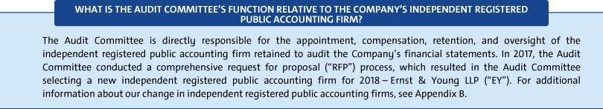

The Process and Scope of the RFP

The Committee conducted a competitive process to select the Company’s independent registered public accounting firm for the Company’s fiscal year ending December 31, 2018. The Committee invited several independent registered public accounting firms to participate in this process. The Committee evaluated the proposals of the independent registered public accounting firms and considered several factors, including audit quality; the benefits of tenure versus fresh perspective; cultural fit and business acumen; innovation and technology; potential transition risks; auditor independence; and the appropriateness of fees relative to both efficiency and audit quality.

The Outcome of the RFP

Following review of the RFP proposals, the Audit Committee selected EY as the Company’s independent registered public accounting firm for the Company’s fiscal year ending December 31, 2018. The Audit Committee believes that the engagement of EY as the Company’s independent registered public accounting firm for 2018 is in the best interest of the Company and its shareholders. The Board of Directors recommends that shareholders ratify the Audit Committee’s selection of EY as the Company’s independent registered public accounting firm for 2018. If the shareholders do not ratify the selection of EY as the independent registered public accounting firm for the Company for 2018, the Committee will reconsider whether to engage EY, but may ultimately determine to engage EY or another audit firm without resubmitting the matter to shareholders. Deloitte & Touche LLP (“Deloitte”) and its predecessor companies had been GM’s or General Motors Corporation’s auditors since 1918.

Even if the shareholders ratify the selection of EY, the Committee may, in its sole discretion, terminate the engagement of EY and direct the appointment of another independent registered public accounting firm at any time during the year, although it has no current intention to do so.

The Board of Directors recommends a vote FOR the proposal to ratify the selection of Ernst & Young LLP as the independent registered public accounting firm for GM and its subsidiaries for 2018.

69

Table of Contents

ITEM NO. 3 – RATIFICATION OF THE SELECTION OF ERNST & YOUNG LLP AS

THE COMPANY’S INDEPENDENT REGISTERED PUBLIC ACCOUNTING FIRM FOR 2018

Audit Committee Report

The Audit Committee (the “Committee”) of the General Motors Board of Directors is a standing committee composed of four directors: Thomas M.

Schoewe (Chair), Linda R. Gooden, Jane L. Mendillo, and Michael G. Mullen.
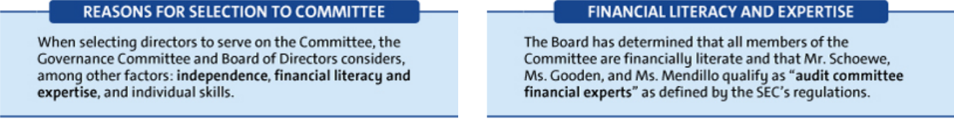

Purpose

The Committee’s core purposes are to assist the Board by providing oversight of:

- The quality and integrity of GM’s financial statements;

- GM’s compliance with legal and regulatory requirements; and

- The qualifications and independence of GM’s external auditors and the performance of GM’s internal audit staff and external auditors.

The Committee operates under a written charter adopted by the Committee and approved by the Board of Directors. The Committee’s charter is posted on our website at gm.com/investors/corporate-governance. The Committee’s charter is reviewed at least annually and updated as necessary

to address changes in regulatory requirements, authoritative guidance, evolving oversight practices, and shareholder feedback.

Management is responsible for the Company’s internal controls and the financial reporting process and has delivered its opinion on the effectiveness of the Company’s controls. The auditor is responsible for performing an independent audit of the Company’s consolidated financial statements and opining on the effectiveness of those controls in accordance with the standards of the Public Company Accounting Oversight Board (United States) (the “PCAOB”) and issuing its reports thereon. As provided in its charter, the Committee’s responsibilities include monitoring and overseeing these processes.

Required Disclosures

In 2017, the Committee met seven times and fulfilled all of its core charter obligations, spending a significant amount of time on completing a request for proposal process for independent audit services. The Committee conducted an extensive and competitive review involving a number of accounting firms and subsequently appointed EY as the Company’s independent registered public accounting firm for fiscal year 2018. EY will also provide non-audit services, including among others, cybersecurity and information technology assessment services and tax planning and advice and tax compliance, which are also areas of importance to the Committee. Deloitte was the Company’s independent registered public accounting firm for fiscal year 2017. The Committee has also reviewed and amended its charter and the Company’s Code of Conduct, “Winning with Integrity.”

Consistent with its charter responsibilities, the Committee met and held discussions with management and Deloitte regarding

the Company’s audited financial statements and internal controls for the year ended December 31, 2017. In this context, management represented to the Committee that the Company’s consolidated financial statements were prepared in accordance with accounting principles generally accepted in the United States. The Committee reviewed and discussed the consolidated financial statements with management and the auditor and further discussed with the auditor the matters required to be discussed by the standards of the PCAOB.

Deloitte also provided to the Committee the written disclosures and the letter required by the applicable requirements of the PCAOB concerning independence, and the Committee discussed with the auditor the auditor’s independence. The Committee also considered and determined that the provision of non-audit services to GM is compatible with maintaining the auditor’s independence. The Committee concluded that Deloitte was independent from the Company and management.

Recommendation

Based upon the Committee’s discussions with management and the auditor as described in this report and the Committee’s review of the representation of management and the reports of the auditors to the Committee, the Committee recommended to the Board of Directors, and the Board of Directors approved, the inclusion of the audited consolidated financial statements in the Company’s Annual Report on Form 10-K for the year ended December 31, 2017, as filed with the U.S. Securities and Exchange Commission on February 6, 2018.

Audit Committee

Thomas M. Schoewe (Chair)

Linda R. Gooden

Jane L. Mendillo

Michael G. Mullen

The preceding Audit Committee Report shall not be deemed incorporated by reference by any general statement incorporating by reference this Proxy Statement or any portion hereof into any filing under the Securities Act of 1933, as amended, or the Securities Exchange Act of 1934, as amended, and shall not otherwise be deemed filed thereunder.

70

Table of Contents

ITEM NO. 3 – RATIFICATION OF THE SELECTION OF ERNST & YOUNG LLP AS

THE COMPANY’S INDEPENDENT REGISTERED PUBLIC ACCOUNTING FIRM FOR 2018

Fees Paid to Independent Registered Public Accounting Firm

The Audit Committee retained Deloitte to audit the Company’s consolidated financial statements and the effectiveness of internal controls, as of and for the year ended December 31, 2017. The Company and its subsidiaries also retained Deloitte and certain of its affiliates, as well as other accounting and consulting firms, to provide various other services in 2017. Deloitte initially presented the proposed annual audit services and their related fees to the Audit Committee for approval on an audit-year basis.

The services performed by Deloitte in 2017 were preapproved in accordance with the preapproval policy and procedures established by the Committee. This policy requires that prior to the provision of services by the auditor, the Committee will be presented, for consideration, with a description of the types of Audit-Related, Tax, and All Other Services expected to be performed by the auditor during the fiscal year, with amounts budgeted for each category (Audit-Related, Tax, and All Other Services). Any requests for such services for $1 million or more not contemplated and approved by the Committee initially must thereafter be submitted to the Audit Committee (or the Chair of the Committee in an urgent case) for specific preapproval. Requests for services less than $1 million individually can be approved by management based on the amounts approved for each category. Management must report actual spending for each category to the full Audit Committee periodically during the year.

These services are actively monitored (both spending and work content) by the Committee to maintain the appropriate objectivity and independence in Deloitte’s core work, which is the audit of the Company’s consolidated financial statements and internal controls. The Committee determined that all services provided by Deloitte in 2017 were compatible with maintaining the independence of Deloitte.

The following table summarizes Deloitte fees billed or expected to be billed in connection with 2017 services. For comparison purposes, actual billings for 2016 services are also displayed.

 | 2017 | 2016
Type of Fees | ($ in millions) | ($ in millions)
Audit | 26 | 33
Audit-Related | 6 | 6
Tax | 5 | 5
Subtotal | 37 | 44
All Other Services | 6 | 6
TOTAL | 43 | 50

Audit Fees – Includes fees for the integrated audit of the Company’s annual consolidated financial statements and attestation of the effectiveness of the Company’s internal controls over financial reporting, including reviews of the interim financial statements contained in the Company’s Quarterly Reports on Form 10-Q and audits of statutory financial statements.

Audit-Related Fees – Includes fees for assurance and related services that are traditionally performed by the independent registered public accounting firm. More specifically, these services include employee benefit plan audits, comfort letters in connection with funding transactions, other attestation services, and consultation concerning financial accounting and reporting standards.

Tax Fees – Includes fees for tax compliance, tax planning, and tax advice. Tax compliance involves preparation of original and amended tax returns and claims for refund. Tax planning and tax advice encompass a diverse range of services, including assistance with tax audits and appeals, tax advice related to mergers and acquisitions and employee benefit plans, and requests for rulings or technical advice from taxing authorities.

All Other Fees – Includes fees for other advisory services related to risk management, contract compliance activities, and product-related data enhancement.

71

Table of Contents

ITEM NO. 4 – SHAREHOLDER PROPOSAL REGARDING

INDEPENDENT BOARD CHAIRMAN

James Dollinger, 6193 Stonegate Parkway, Flint, MI 48532, owner of approximately 50 shares of GM common stock, has given notice that he intends to present for action at the annual meeting the following shareholder proposal:

Shareholders request our Board of Directors to adopt as policy, and amend our governing documents as necessary, to require henceforth that the Chair of the Board of Directors, whenever possible, to be an independent member of the Board. The Board would have the discretion to phase in this policy for the next CEO transition, implemented so it does not violate any existing agreement.

If the Board determines that a Chairman who was independent when selected is no longer independent, the Board shall select a new Chair who satisfies the requirements of the policy within a reasonable amount of time. Compliance with this policy is waived if no independent director is available and willing to serve as Chairman. This proposal requests that all the necessary steps be taken to accomplish the above.

Caterpillar is an example of a company recently changing course and naming an independent board chairman. Caterpillar

had strongly opposed a shareholder proposal for an independent board chairman as recently as its 2016 annual meeting. Wells Fargo also changed course and named an independent board chairman in 2016.

It was reported that 53% of the Standard & Poors 1,500 firms separate these 2 positions (2015 report): Chairman and CEO. This proposal topic won 50%-plus support at 5 major U.S. companies in 2013 including 73%-support at Netflix.

Having a board chairman who is independent of management is a practice that will promote greater management accountability to shareholders and lead to a more objective evaluation of management. This is of the utmost importance since the automobile industry is undergoing the greatest change since 1900. GM cannot afford to get it wrong.

This proposal topic won impressive 41%-support at our 2017 annual meeting. This 41%-support would have been higher (perhaps 45%) if small shareholders had the same access to corporate governance information as large shareholders.

Please vote to enhance the oversight of our CEO: Independent Board Chairman – Proposal 4.

The Board of Directors recommends a vote AGAINST this proposal for the following reasons:

 |  |  |  | leadership | structure that |  |  | it | believes |  | serves | the best interests |  | of the
 |  | u The Board should have the flexibility and is in the best position
 |  |  |  | Company and its shareholders.
 |  | to decide who should serve as its Chairman.
 |  | to decide who should serve as its Chairman. |  | Your Board evaluates its leadership structure annually. This review will
 |  | u Ms. Barra’s service as Chairman provides a clear and unified |  | also occur in connection with any future CEO transition. Although your
 |  |  |  | Board has | in the past, |  | and may again in |  |  |  |  | the future, determine that
 |  | strategic vision for GM that fosters a nimble and responsive
 |  | strategic vision for GM that fosters a nimble and responsive |  | separating | the | roles | of |  | Chairman |  | and | CEO | would best | serve
 |  | Board.
 |  | Board. |  | shareholders, your Board presently believes that a combined role,
 |  | u GM’s strong Independent Lead Director and commitment to |  | coupled with a strong Independent Lead Director and other governance
 |  | u GM’s strong Independent Lead Director and commitment to |  | best practices, is in the best interests of shareholders at this time.
 |  | governance best practices already ensure management
 |  | governance best practices already ensure management |  | Your Board believes that Mary Barra’s service as Chairman and
 |  | accountability to shareholders by independent directors.
 |  |  |  | CEO has provided, and continues to provide, a clear and unified
 |  | Your Board should have the flexibility and is in the best position |  | strategic vision for GM during this time of unprecedented industry
 |  |  |  | change.
 |  | to determine who should serve as Chairman – whether that |  | change.
 |  | person is an independent director or CEO. |  | Your Board supports Ms. Barra’s service as both Chairman and CEO.
 |  | GM operates in a very competitive and fast-changing industry. Your |  | Her dual service provides the Company with a clear and unified strategic
 |  |  |  | vision, which |  | fosters | a | more |  | strategically focused Board |  |  |  | that is
 |  | Board and management must constantly assess industry change and
 |  |  |  | responsive | to | industry |  | trends |  | and | shareholder |  | demands. | During
 |  | disruption. Your Board is composed of directors with diverse
 |  |  |  | Ms. Barra’s tenure, GM has taken bold, strategic actions to grow long-
 |  | backgrounds, experience, perspectives, and in-depth knowledge about
 |  |  |  | term shareholder value, strengthened its core business and invested to
 |  | the Company. With this expertise, it is uniquely positioned to evaluate
 |  |  |  | lead in the future of mobility. More recently, with the Board’s full support,
 |  | the Company’s key challenges and needs, including the optimal Board
 |  |  |  | she has articulated GM’s vision for zero crashes, zero emissions, and
 |  | leadership structure.
 |  |  |  | zero congestion, outlined an all-electric future, and announced plans to
 |  | It is critical that your Board have the flexibility to choose the best
 |  |  |  | deploy self-driving vehicles in a dense urban environment in 2019.
 |  | person to serve as Chairman and not be arbitrarily constrained by a
 |  | one-size-fits-all policy that has been empirically shown to have little
 |  | relation to long-term shareholder value. The proposal would remove
 |  | the Board’s current flexibility to determine the
72


Table of Contents

ITEM NO. 4 – SHAREHOLDER PROPOSAL REGARDING INDEPENDENT BOARD CHAIRMAN


Ms. Barra’s Board leadership is complemented by a strong Independent Lead Director.

While Ms. Barra’s in-depth knowledge of our businesses and understanding of day-to-day operations brings focused leadership to your Board, the independent directors also recognize the importance of strong independent leadership. As the Independent Lead Director, Mr. Solso provides leadership and oversight for shareholders, including focus on strategic risk management, compliance, governance, and CEO succession planning. He regularly provides specific input on Board and Committee agendas and attends each Committee meeting. The specific duties of the Independent Lead Director are discussed on page 22 in this Proxy Statement. In addition, Mr. Solso maintains an office at our headquarters in Detroit, where he regularly provides mentorship and counsel to Ms. Barra and other members of senior management.

GM’s strong corporate governance practices reinforce Board independence and management accountability.

The Board has established and maintains numerous best-in-class governance practices to reinforce and facilitate management accountability and provide meaningful independent oversight, including:

- Annual election of directors;

- Annual evaluation of CEO performance and compensation by non-management directors;
- Executive sessions held at most Board and Committee meetings without management present;
- Six of our seven standing Committees, including the Executive Compensation Committee, are composed entirely of independent directors; and

- Directors have unrestricted access to management and independent, outside advisors.

Your Board routinely engages directly with shareholders, reinforcing management accountability.

Since implementing the Director-Shareholder Engagement Policy in 2016, directors have conducted over a dozen individual meetings with our largest shareholders, representing approximately 30% of our outstanding common stock. These

engagements help shape the Board’s perspective on many issues, such as Board leadership, succession planning, and refreshment; executive compensation, including the link between corporate strategy and executive compensation; and corporate responsibility, environmental, social, and other current and emerging issues so that your Board and management can understand and address the issues that are important to our shareholders. Examples of the Board incorporating feedback include proactively adopting proxy access (2016) and making significant changes to our compensation programs (2017). In addition, in connection with last year’s proxy contest with Greenlight Capital, your Board utilized engagement opportunities to discuss its director nominees and strategy for creating long-term shareholder value with investors, which led to an overwhelming victory for GM at the 2017 Annual

Meeting. Your Board’s engagement efforts demonstrate its commitment to ensuring that management and your Board are accountable to shareholders.

Your Board’s current leadership structure is consistent with the practices of the largest U.S. public companies.

According to Shearman & Sterling’s 2017 Corporate Governance & Executive Compensation Survey of the 100 largest

U.S. public companies, only 12 companies have a policy that requires separate individuals to serve as chairman and CEO, while the overwhelming majority of corporate policies provide boards with the flexibility to separate or combine the positions. Contrary to the proponent’s statements, your Board’s flexible approach to its leadership structure does not make it an outlier among its peers.

Therefore, your Board of Directors recommends a vote AGAINST this shareholder proposal.

73

Table of Contents

ITEM NO. 5 – SHAREHOLDER PROPOSAL REGARDING

SHAREHOLDER RIGHT TO ACT BY WRITTEN CONSENT

John Chevedden, 2215 Nelson Avenue, No. 205, Redondo Beach, CA 90278, owner of approximately 100 shares of GM common stock, has given notice that he intends to present for action at the annual meeting the following shareholder proposal:

Shareholders request that our board of directors undertake such steps as may be necessary to permit written consent by shareholders entitled to cast the minimum number of votes that would be necessary to authorize the action at a meeting at which all shareholders entitled to vote thereon were present and voting. This written consent is to be consistent with applicable law and consistent with giving shareholders the fullest power to act by written consent consistent with applicable law. This includes shareholder ability to initiate any topic for written consent consistent with applicable law.

This proposal topic won majority shareholder support at 13 major companies in a single year. This included 67%-support at both Allstate and Sprint. Hundreds of major companies enable shareholder action by written consent.

Taking action by written consent in lieu of a meeting is a means shareholders can use to raise important matters outside the normal annual meeting cycle. A shareholder right to act by

74

written consent and to call a special meeting are 2 complimentary ways to bring an important matter to the attention of both management and shareholders outside the annual meeting cycle. More than 100 Fortune 500 companies provide for shareholders to call special meetings and to act by written consent.

General Motors shareholders have no right to act by written consent. Shareholders of companies incorporated in Delaware, like General Motors, automatically have the right to act by written consent. However, the GM charter specifically takes away this important right. GM shareholders also do not have the full right to call a special meeting that is available under Delaware law.

This proposal could receive a substantial supporting vote at the 2018 GM annual meeting. It might get a still higher vote if small shareholders would have the advantage of the same access to independent corporate governance recommendations as large shareholders.

Please vote to improve director accountability to shareholders:

Shareholder Right to Act by Written Consent – Proposal 5.

Table of Contents

ITEM NO. 5 – SHAREHOLDER PROPOSAL REGARDING SHAREHOLDER RIGHT TO ACT BY WRITTEN CONSENT

The Board of Directors recommends a vote AGAINST this proposal for the following reasons:


u The proposal would significantly limit the right of ALL shareholders to consider and be heard on important matters.

u The right to call for a special meeting is a preferred, fair, and transparent mechanism for shareholders to consider
important matters.

A simple-majority written consent provision is NOT in the best interests of shareholders because it would significantly limit the right of ALL shareholders to consider and be heard on important matters.

Your Board believes that all shareholders – not just a simple majority – should have an opportunity to hear about and express their views on important shareholder proposals. Because there is no requirement that a written consent be distributed to all shareholders, actions permitted to be taken by the written consent of a simple majority of shareholders could deprive many shareholders of the critical opportunity to assess, discuss, deliberate, and vote on pending actions.

Further, a simple-majority written consent provision caters particularly to special and short-term interests. The proposal would permit these special and short-term interests to bypass our existing procedural protections and marginalize smaller shareholders. Multiple shareholder groups could solicit written consents simultaneously, some of which may be duplicative or contradictory. In addition, the Board would not have the opportunity to consider the merits of the proposed action and provide its recommendation for shareholder consideration.

The concerns are not merely theoretical. Just last year, GM shareholders overwhelmingly voted against a flawed, high-risk shareholder proposal to create a dual-class of common stock. However, had that proposal been more universally supported it

is not inconceivable that with a simple-majority written consent provision the proponent could have forced adoption of its proposal without resorting to the open proxy voting process.

GM’s shareholders already have a preferable, fair, and transparent mechanism to advance their concerns outside of the annual meeting process: special meetings.

Shareholders that are able to demonstrate a relatively modest level of support (25% of shares that would be entitled to vote) for their concerns can call for a special meeting of shareholders. Your Board believes that this mechanism is preferable to a simple-majority written consent provision because it is much more fair and transparent to ALL shareholders.

GM’s commitment to shareholder engagement and governance best practices enhances Board accountability and preserves a meaningful voice for shareholders.

The Board has also adopted a variety of other practices and policies that enhance Board accountability to shareholders, including:

- Annual election of directors;

- Proxy access rights;

- Active shareholder engagement process, including a Director-Shareholder Engagement Policy; and
- Direct line of communication from shareholders to the Board.

In addition, on an annual basis, the Governance Committee reviews GM’s governance program, discusses best practices, and considers shareholder feedback. For a detailed discussion of our governance best practices, see “Proxy Statement Summary—Governance Highlights” on page 3 and “Corporate Governance” on page 20.

Therefore, your Board of Directors recommends a vote AGAINST this shareholder proposal.

75

Table of Contents

ITEM NO. 6 – SHAREHOLDER PROPOSAL REGARDING REPORT ON GREENHOUSE GAS EMISSIONS AND CAFE STANDARDS

Whereas: Global action on climate change is accelerating. The Paris Agreement’s goal of keeping global temperature rise below 2 degrees Celsius is already shaping global, national, and local policy decisions.

Transportation accounts for more than 23 percent of global carbon dioxide emissions; this sector will need to deliver major emissions cuts for countries to achieve the Paris goal. (WEO 2017). In the U.S., a recent study found that greenhouse gas (GHG) reductions beyond those achievable from current vehicle emission reduction standards will be necessary by 2025 to meet global climate goals. ¹

Globally, governments are adopting transportation policies requiring significant fuel economy increases, and are beginning to promote low carbon vehicle technology standards. China will require 40 percent of cars sold by 2030 to be electric and intends to ban vehicles with internal combustion engines. Other countries and cities have announced, and California is considering, similar measures.

Many automakers have announced plans in line with this decarbonizing transportation market. Volvo committed that, by 2019, all new models will be electrified. BMW committed to sell 100,000 electrified vehicles in 2017 and that 20 to 25 percent of its sales will be plug-in hybrids or EVs by 2025. General Motors will need to undertake aggressive action to compete successfully in this transition to low carbon transportation.

In 2012, the U.S. issued light duty vehicle rules strengthening GHG emission reduction standards and improving corporate average fuel economy standards (collectively “CAFE standards”). These rules are being challenged by General Motors (GM) and other automakers. ²

The proposed weakening of CAFE standards will lead to additional greenhouse gas emissions, regulatory uncertainty,

and significant reputational risk for automakers. A public, grassroots campaign was recently launched demanding that automakers end their advocacy for rollback of CAFE standards.³

Although over 243,000 GM vehicles with electrification features have been sold as of 2016, this is a very small percentage of the company’s overall fleet sales. GM has announced a decision to accelerate and expand electrification of its global fleet, but has not specified sales targets, percentages of planned electric drive vehicles, or what percentage of its fleet will have electrification features. Coupled with lobbying to weaken CAFE standards, serious questions exist as to whether the company will retreat in reducing fleetwide GHG emissions, especially through 2025, a critical window of opportunity for the industry to meet climate goals. This uncertainty exposes the company to reputational harm, public controversy, and the potential to quickly lose global competitiveness.

General Motors’ actions have created investor concern about the alignment of its fleet emissions with an increasingly low carbon global vehicle market.

Resolved: Shareholders request that General Motors, with Board oversight, publish a report, at reasonable cost, describing whether our company’s fleet GHG emissions through 2025 will increase, given the industry’s proposed weakening of CAFE standards or, conversely, how GM plans to retain emissions consistent with current CAFE standards, to ensure its products are sustainable in a rapidly decarbonizing vehicle market.

- http://ns.umich.edu/new/releases/25157-beyond-epa-s-clean-power-decision-
climate-action-window-could-close-as-early-as-2023
- https://www.nytimes.com/2017/02/22/business/energy-
environment/automakers-pruitt-mileage-rules.html?_r=0

- https://www.sierraclub.org/press-releases/2017/10/go-forward-not-backward-environmental-and-consumer-groups-launch-campaign

76

Table of Contents

ITEM NO. 6 – SHAREHOLDER PROPOSAL REGARDING REPORT ON GREENHOUSE GAS EMISSIONS AND CAFE STANDARDS

The Board of Directors recommends a vote AGAINST this proposal for the following reasons:
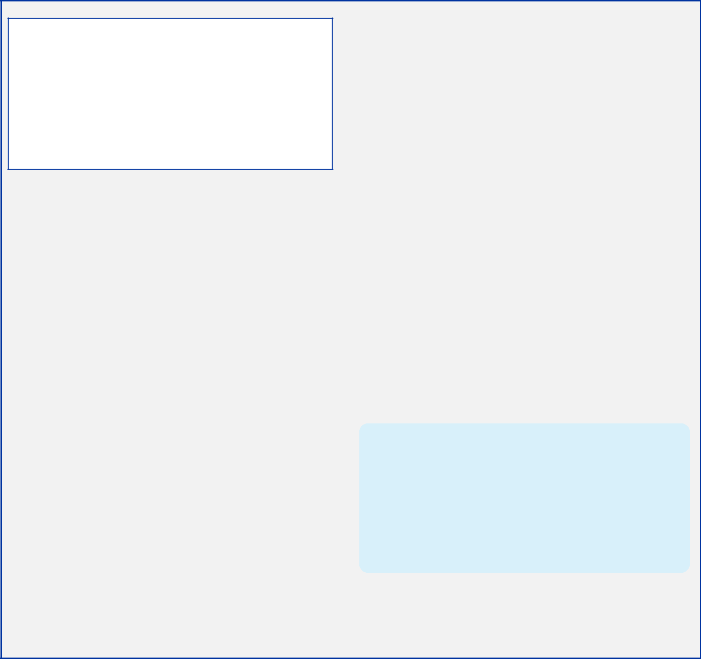

- GM believes climate change is real and advocates for climate action.

- GM is committed to zero emissions, and we are changing our business model to succeed in a carbon-constrained world.

- We are confident that GM’s fleet average GHG emissions will NOT increase through 2025.

- GM already provides transparent GHG emissions disclosure.

GM believes that climate change is real and advocates for climate action.

GM acknowledged long ago that climate change is real, and we have consistently advocated – in public forums – for climate action and awareness. GM is a founding member of the Climate Leadership Council, the only automaker to have signed the Ceres BICEP Climate Declaration and one of the first companies to sign the American Business Act on Climate Pledge. In addition, GM supported the goal of a decarbonized transportation sector through a World Economic Forum Auto Governors letter.

We agree with the proponent that aggressive action is required to complete the transition to low-carbon transportation. Effectively addressing a complex challenge like climate change requires collaboration among various stakeholders from both inside and outside the auto industry. To that end, we frequently engage stakeholders in a variety of ways, with the goal of creating a meaningful dialogue to develop effective ways to combat climate change. A critical part of our strategy is regular engagement with an external sustainability stakeholder advisory group – which we have invited the proponent to join – that is coordinated through Ceres, a nonprofit organization advocating for corporate sustainability leadership. This group, now in its eighth year, consists of nongovernmental organizations, socially conscious investors, academics, a peer company, a fleet customer, and a supplier, to help inform our sustainability strategy as well as provide feedback about opportunities and challenges.

GM is committed to zero crashes, zero emissions, and zero congestion, and we are changing our business to succeed in a carbon-constrained world.

We believe that the convergence of connectivity, electric and other alternative propulsion systems, autonomous vehicles and the sharing economy will truly enable us to stretch the boundaries of what is possible in addressing climate change and developing vehicles that are safer, smarter, cleaner, and more energy-efficient than ever before. To advance our vision of a zero emissions world, we will introduce 20 new all-electric vehicles by 2023. In addition, we are also pursuing a variety of strategies to

improve the fuel efficiency of our internal combustion engine vehicles, including light-weighting, improved aerodynamics, shifting to downsized turbo engines, and incorporating stop/start technology in more of our vehicles. Although a zero emissions future won’t arrive overnight, GM is already lowering GHG emissions from its products and facilities – GM has committed to using 100% renewable energy in its operations by 2050. These actions and others make us confident that GM’s fleet average GHG emissions will NOT increase through 2025.

Regardless of any changes to U.S. CAFE standards, GM’s commitment to zero emissions will not change.

We support one national set of standards that comprehends new technologies and shared and autonomous electric vehicles, and we remain committed to improving fuel economy, reducing emissions, and an all-electric future. Regardless of any proposals relative to CAFE standards for cars and light trucks for model years 2022–2025, our overall commitment to zero emissions and our strategy to achieve that commitment will not change. Nothing showcases this commitment more than our leadership in electric vehicles and the Chevrolet Bolt EV – the first EV for everyone with 238 miles of range on a single charge and a price of less than $30,000 after tax incentives.

GM already provides transparent GHG emissions disclosure.

GM’s annual Sustainability Report (available at gmsustainability.com) discloses GM’s progress on our products’ fuel efficiency and emissions goals as well as our approach to fuel economy regulations around the world. GM also annually discloses our GHG emissions performance in its CDP Climate Change Report (formerly known as the Carbon Disclosure Project), which is publicly available through our Sustainability Report.

We look forward to working with all parties, including the proponent, on modernized standards that achieve better fuel economy for our customers and a better environment for everyone.

“Our commitment on an all-electric, zero-emissions future is unwavering regardless of any modifications to future fuel economy standards, especially in the United States.”

– Mary Barra, Chairman & CEO, at the Bank of America Merrill Lynch 2018 New York Auto Summit on March 28, 2018

Therefore, your Board of Directors recommends a vote AGAINST this shareholder proposal.

77

Table of Contents

GENERAL INFORMATION ABOUT THE ANNUAL MEETING

- Voting and Meeting Information

Vote requirements and Board recommendations

 |  |  |  |  | Effect of
Agenda |  | Board |  | Effect of | Broker
Item | Description | Recommendation | Vote Requirement for Approval | Abstentions | Non-Vote
1 | Election of Directors(1) | FOR | Majority of votes cast | No effect | No effect
2 | Approval of, on an Advisory Basis, NEO | FOR |  | Counted as | No effect
2 | compensation | FOR |  | “AGAINST” | No effect
 | Ratification of the Selection of Ernst & Young LLP |  |  | Counted as | Discretionary
3 | as the Company’s Independent Registered Public | FOR |  | Counted as | Discretionary
3 | as the Company’s Independent Registered Public | FOR |  | “AGAINST” | Vote
 | Accounting Firm for 2018 |  | Majority of shares present | “AGAINST” | Vote
4 | Shareholder Proposal Regarding Independent | AGAINST | (in person or by proxy) | Counted as | No effect
4 | Board Chairman | AGAINST | and entitled to vote | “AGAINST” | No effect
5 | Shareholder Proposal Regarding Shareholder | AGAINST |  | Counted as | No effect
5 | Right to Act by Written Consent | AGAINST |  | “AGAINST” | No effect
6 | Shareholder Proposal Regarding Report on | AGAINST |  | Counted as | No effect
6 | Greenhouse Gas and CAFE Standards | AGAINST |  | “AGAINST” | No effect

- Each person elected as director will serve a one-year term and until his or her successor has been duly elected and qualified or until his or her earlier resignation or removal. If any nominee becomes unable to serve, proxies will be voted for the election of such other person as the Board may designate, unless the Board chooses to reduce the number of directors.

Other matters to be presented at the Annual Meeting

We do not know of any matters to be voted on by shareholders at the Annual Meeting other than those included in this Proxy Statement. If any other matter is properly presented at the meeting, your executed proxy gives the Proxies (as defined below) discretionary authority to vote your shares in accordance with its best judgment with respect to the matter.

Attending the Annual Meeting

Only shareholders and authorized guests of the Company may attend the Annual Meeting, and all attendees will be required to show a valid form of ID (such as a government-issued form of photo identification). If you hold your shares in street name (i.e., through a bank or broker), you must also provide proof of share ownership, such as a letter from your bank or broker or a recent brokerage statement.

Large bags, backpacks and packages, suitcases, briefcases, personal communication devices (e.g., cell phones, smartphones, and tablets), cameras, recording equipment, and other electronic devices will not be permitted in the meeting, and attendees will be subject to security inspections.

Quorum

The presence of the holders of a majority of the outstanding shares of our common stock, in person or by proxy, will constitute a quorum for transacting business at the Annual Meeting. Abstentions and broker non-votes are counted as present for purposes of establishing a quorum at the meeting.

Proxies

The Board appointed the following executive officers to act as proxies: Mary T. Barra, Daniel Ammann, and Charles K. Stevens, III (collectively, the “Proxies”). If you sign and return your proxy card or voting instruction form with voting instructions, one or more of the Proxies will vote your shares as you direct on the matters described in this Proxy Statement. If you sign and return your proxy card or voting instruction form without voting instructions, one or more of the Proxies will vote your shares as recommended by the Board.

Who can vote

Holders of record of our common stock as of the close of business on April 16, 2018, are entitled to vote at the Annual Meeting. On that date, the Company had 1,409,441,782 shares of common stock outstanding and entitled to vote. Each share of our common stock entitles the holder to one vote.

78

Table of Contents

GENERAL INFORMATION ABOUT THE ANNUAL MEETING

Voting without attending the Annual Meeting

When you timely submit your proxy or voting instructions in the proper form, your shares will be voted according to your instructions. You may give instructions to vote for or against or abstain from voting for the election of all the Board of Directors’ nominees or any individual nominee and to vote for or against or abstain from voting upon, each of the other matters submitted for voting. If you sign, date, and return the proxy card or voting instruction form without specifying how you wish to cast your vote, your shares will be voted by the Proxies according to the recommendations of the Board of Directors, as indicated above. Internet and telephone voting is available 24 hours a day, through 11:59 p.m. Eastern time on Monday, June 11, 2018.

Voting at the Annual Meeting

You may vote your shares at the Annual Meeting by completing a ballot at the meeting. If you are a registered holder (i.e., you hold shares in your name), you must present a valid form of ID (such as a government-issued form of photo identification) to vote at the meeting. If you are a beneficial shareholder and want to vote your shares in person at the Annual Meeting, you must bring a signed legal proxy form from your broker, bank, or other nominee giving you the right to vote the shares and submit that legal proxy with your ballot at the meeting. We encourage you to vote your shares in advance of the meeting, even if you plan to attend. Your vote at the meeting will supersede any prior vote by you.

Revoking your proxy

After you have submitted your proxy or voting instructions by Internet, telephone, or mail, you may revoke your proxy at any time until it is voted at the Annual Meeting. If you are a shareholder of record, you may do this by voting subsequently by Internet or telephone, submitting a new proxy card with a later date, sending a written notice of revocation to the Corporate Secretary at Mail Code 482-C24-A68, 300 Renaissance Center, Detroit, Michigan 48265, or by e-mail to shareholder.relations@gm.com.

If you are a beneficial shareholder, you may subsequently vote by Internet or telephone, or you may revoke your vote through your broker, bank, or other nominee in accordance with their instructions.

Annual Meeting voting results

Our independent inspector of elections, Broadridge Financial Services, will tabulate the vote at the Annual Meeting. We will provide voting results on our website and in a Current Report on Form 8-K filed with the SEC.

“Shareholder of record” and “Beneficial shareholder”

If your shares are owned directly in your name in an account with GM’s stock transfer agent, Computershare Trust Company, N.A. (“Computershare”), you are considered the “shareholder of record” of those shares in your account. If your shares are held in an account with a broker, bank, or other nominee as custodian on your behalf, you are considered a “beneficial” shareholder of those shares, which are held in “street name.” The broker, bank, or other nominee is considered the shareholder of record for those shares. As the beneficial owner, you have the right to instruct the broker, bank, or other nominee on how to vote the shares in your account. In order for your shares to be voted in the way you would like, you must provide voting instructions to your broker, bank, or other nominee by the deadline provided in the proxy materials you receive from your broker, bank, or other nominee. If you do not provide voting instructions to your broker, bank, or other nominee, whether your shares can be voted on your behalf depends on the type of item being considered for vote. Under NYSE rules, brokers are permitted to exercise discretionary voting authority only on “routine” matters. Therefore, your broker may vote on Item No. 3 (“Ratification of the Selection of Ernst & Young LLP as the Company’s Independent Registered Public Accounting Firm for 2018”) even if you do not provide voting instructions, because it is considered a routine matter. Your broker is not permitted to vote on the other Agenda Items if you do not provide voting instructions because those items involve matters that are considered non-routine.

Householding

SEC rules permit companies to send a single Proxy Statement and Annual Report on Form 10-K or Notice to two or more shareholders that share the same address, subject to certain conditions. Each shareholder will continue to receive a separate proxy card, voting instruction form, or Notice, and it will include the unique 16-digit control number that is needed to vote those shares and to access and vote during the Annual Meeting. This “householding” rule will benefit both the shareholders and GM by reducing the volume of duplicate information shareholders receive and reducing GM’s printing and mailing costs.

If one set of these documents was sent to your household for the use of all GM shareholders in your household and one or more of you would prefer to receive additional sets or if multiple copies of these documents were sent to your household and you want to receive one set, please contact Broadridge Financial Solutions, Inc., by calling toll-free at 866-540-7095 or by writing to Broadridge Financial Solutions, Inc., Householding Department, 51 Mercedes Way, Edgewood, New York 11717.

If a broker, bank, or other nominee holds your shares, please contact your broker, bank, or other nominee directly if you have questions about delivery of materials, require additional copies of the Proxy Statement or Annual Report on Form 10-K, or wish to receive multiple copies of proxy materials by stating that you do not consent to householding.

79

Table of Contents

GENERAL INFORMATION ABOUT THE ANNUAL MEETING

- Shareholder Proposals and Director Nominations

Type of Proposal | Rule 14a-8 Proposals by | Director Nominees for | Other Proposals or
 | Shareholders | Inclusion in Next Year’s | Nominees for
 | for Inclusion in Next Year’s Proxy | Proxy Statement | Representation at Next
 | Statement | (Proxy Access) | Year’s Annual Meeting
Rules/Provisions | SEC rules and our Bylaws permit | Our Bylaws permit a shareholder or | Our Bylaws require that any
 | shareholders to submit proposals for | group of shareholders (up to 20) who | shareholder proposal, including a
 | inclusion in our Proxy Statement if the | have owned a significant amount of | director nomination, that is not
 | shareholder and the proposal meet the | common stock (at least 3%) for a | submitted for inclusion in next year’s
 | requirements specified in SEC Rule 14a-8. | significant amount of time (at least | Proxy Statement (either under SEC
 |  | three years) to submit director | Rule 14a-8 or our proxy access
 |  | nominees (up to 20% of the Board or | bylaw), but is instead sought to be
 |  | two directors, whichever is greater) | presented directly at the next year’s
 |  | for inclusion in our Proxy Statement if | Annual Meeting must be received at
 |  | the shareholder(s) and the | our principal executive offices no
 |  | nominee(s) satisfy the requirements | earlier than 180 days and no later
 |  | specified in our Bylaws. | than 120 days before the first
 |  |  | anniversary of this year’s Annual
 |  |  | Meeting.
When to send these proposals | Must be received at our principal executive | No earlier than December 14, 2018, and no later than 11:59 p.m. Eastern
 | offices no later than 11:59 p.m. Eastern | time on February 12, 2019.
 | Time on December 28, 2018.
Where to send these proposals | Mail to our Corporate Secretary at Mail Code 482-C24-A68, 300 Renaissance Center, Detroit, Michigan 48265, or by
 | e-mail to shareholder.relations@gm.com.
What to include | Must conform to and include the | Must include information required by our Bylaws, which are available on our
 | information required by SEC Rule 14a-8. | website at
 |  | gm.com/investors/corporate-governance.

- Annual Report on Form 10-K and Other Investor Materials

You may download a copy of our 2017 Annual Report on Form 10-K by visiting the “Investors Contacts” section of our website at gm.com/investors. Other publications available for download at this website include our Proxy Statement, quarterly reports and our code of conduct, “Winning with Integrity.” Alternatively, you may request a printed copy of these publications by writing to Shareholder Relations at General Motors Company, Mail Code: 482-C23-A68, 300 Renaissance Center, Detroit, Michigan 48265 or by e-mail to shareholder.relations@gm.com.

- Cost of Proxy Solicitation

We will pay our cost for soliciting proxies for the Annual Meeting. The Company will distribute proxy materials and follow-up reminders, if any, by mail and electronic means. We have engaged Morrow Sodali, LLC (“Morrow”), a professional proxy solicitation firm, located at 470 West Avenue, Stamford, Connecticut 06902 to assist with the solicitation of proxies and to provide related advice and informational support for a service fee, plus customary disbursements. We expect to pay Morrow an aggregate fee, including reasonable out-of-pocket expenses, of up to $25,000, depending on the level of services actually provided. GM directors, officers, and employees may also solicit proxies by mail, telephone, or personal visits. They will not receive any additional compensation for their services.

General Motors will provide copies of these proxy materials to banks, brokerage houses, fiduciaries, and custodians holding in their names shares of our common stock beneficially owned by others so that they may forward these proxy materials to the beneficial owners. As usual, we will reimburse brokers, banks, and other nominees for their reasonable expenses in forwarding proxy materials to beneficial owners.

80

Table of Contents

APPENDIX A: RECONCILIATION OF GAAP AND NON-GAAP FINANCIAL MEASURES

Our Company reports its financial results in accordance with generally accepted accounting principles in the United States (“GAAP”). However, management believes that certain non-GAAP financial measures provide users with additional meaningful financial information.

Our non-GAAP measures presented in this Proxy Statement include earnings before interest and taxes (“EBIT”)-adjusted, presented net of noncontrolling interests, earnings per share (“EPS”)-diluted-adjusted and adjusted automotive free cash flow. These measures relate to our continuing operations and not our discontinued operations or our assets and liabilities held

for sale. Our calculation of these non-GAAP measures may not be comparable to similarly titled measures of other companies due to potential differences between companies in the method of calculation. As a result, the use of these non-GAAP measures has limitations and should not be considered superior to, in isolation from, or as a substitute for related GAAP measures. See our Annual Report on Form 10-K for the fiscal year ended December 31, 2017, and our subsequent filings with the SEC for additional information about the non-GAAP measures presented herein, including a description of the use of such measures. The numbers in the tables below may not sum due to rounding.

 |  | ($B, except Margin) | 2017
 |  | Net income attributable to stockholders | (3.9)
 |  | Income from discontinued operations, net of tax | 4.2
 |  | Subtract:
 |  | Automotive Interest Expense | (0.6)
 |  | Automotive Interest Income | 0.3
 |  | Income Tax (Expense) | (11.5)
 |  | Add Back Special Items1:
 |  | Ignition switch recall and related legal matters | 0.1
 |  | Venezuela related matters | 0.1
 |  | GMI restructuring | 0.5
 |  | Total Special items | 0.7
 |  | EBIT-adjusted | 12.8
 |  | Net Revenue | 146
 |  | EBIT-adjusted Margin | 8.8%
1 |  | Additional information on adjustments available in our Annual Report on Form 10-K for the year ended December 31, 2017.
 |  |  | 2017
 |  | Diluted earnings (loss) per common share | (2.60)
 |  | Diluted loss per common share – discontinued operations | 2.82
 |  | Adjustments(a) | 0.44
 |  | (b) | (0.14)
 |  | Tax effect of adjustments | (0.14)
 |  | Tax adjustments(c) | 6.10
 |  | EPS-diluted-adjusted | $ 6.62

- Refer to the reconciliation of EBIT-adjusted on a continuing operations basis above for adjustment details.

- The tax effect of each adjustment is determined based on the tax laws and valuation allowance status of the jurisdiction to which the adjustment relates.

- In the year ended December 31, 2017, these adjustments consist of the tax expense of $7.3 billion related to U.S. tax reform legislation and the establishment of a valuation allowance against deferred tax assets of $2.3 billion that will no longer be realizable as a result of the sale of the Opel/Vauxhall Business, partially offset by tax benefits related to tax settlements. These adjustments were excluded because impacts of tax legislation and valuation allowances are not considered part of our core operations.

A-1

Table of Contents

 | 2017
Net automotive cash provided by operating activities – continuing operations | 13.9
Less: capital expenditures – continuing operations | (8.4)
Adjustments
1
U.K. pension plan contribution | 0.2
GM Financial dividend | (0.6)
Total adjustments | (0.4)
Adjusted automotive free cash flow – continuing operations | 5.2
Net automotive cash used in operating activities – discontinued operations | —
Less: capital expenditures – discontinued operations | (0.7)
Adjusted automotive free cash flow | 4.5

- Additional information on adjustments available in our Annual Report on Form 10-K for the year ended December 31, 2017.

A-2

Table of Contents

APPENDIX B: ADDITIONAL INFORMATION

REGARDING CHANGE OF INDEPENDENT
REGISTERED PUBLIC ACCOUNTING FIRMS

As reported on the Company’s Current Report on Form 8-K, dated September 25, 2017, and amended on February 12, 2018, the Audit Committee approved the engagement of Ernst & Young LLP (“EY”) as the Company’s independent registered public accounting firm for the Company’s fiscal year ending December 31, 2018. Deloitte & Touche LLP (“Deloitte”) continued as the Company’s independent registered public accounting firm for the year ending December 31, 2017. On February 6, 2018, when the Company filed its Annual Report on Form 10-K for the fiscal year ended December 31, 2017, with the U.S. Securities and Exchange Commission, Deloitte completed its audit of the Company’s consolidated financial statements for such fiscal year, and the Company’s retention of Deloitte as our independent registered public accounting firm with respect to the audit of Company’s consolidated U.S. GAAP financial statements ended as of that date.

- Deloitte’s reports on our consolidated financial statements as of and for the fiscal years ended December 31, 2016 and 2017, did not contain any adverse opinion or disclaimer of opinion, nor were they qualified or modified as to uncertainty, audit scope, or accounting principles.

- During the fiscal years ended December 31, 2016 and 2017, and the subsequent interim period through February 6, 2018 (the effective date of Deloitte’s dismissal) there were: (i) no disagreements within the meaning of Item 304(a)(1)(iv) of Regulation S-K and the related instructions between the Company and Deloitte on any matters of accounting principles or practices, financial statement disclosure, or auditing scope or procedure which, if not resolved to Deloitte’s satisfaction, would have caused Deloitte to make reference thereto in their reports; and (ii) no “reportable events” within the meaning of Item 304(a)(1)(v) of Regulation S-K.

- During the fiscal years ended December 31, 2016 and 2017 and the subsequent interim period through February 6, 2018 (the effective date of Deloitte’s dismissal), neither the Company nor anyone on its behalf has consulted with EY regarding: (i) the application of accounting principles to a specific transaction, either completed or proposed, or the type of audit opinion that might be rendered on the Company’s financial statements, and neither a written report nor oral advice was provided to the Company that EY concluded was an important factor considered by the Company in reaching a decision as to any accounting, auditing, or financial reporting issue; (ii) any matter that was the subject of a disagreement within the meaning of Item 304(a)(1)(iv) of Regulation S-K and the related instructions; or (iii) any reportable event within the meaning of Item 304(a)(1)(v) of Regulation S-K.

- GM has been advised by each of EY and Deloitte that they will each have a representative present at the Annual Meeting and that such representatives will have the opportunity to make a statement if they desire to do so and are expected to be available to respond to appropriate questions.

B-1

Table of Contents


Table of Contents

G E N E R A L M O T O R S


GENERAL MOTORS COMPANY

GENERAL MOTORS GLOBAL HEADQUARTERS MAIL CODE 482-C24-A68 300 RENAISSANCE CENTER

DETROIT, MI 48265

TO VOTE, MARK BLOCKS BELOW IN BLUE OR BLACK INK AS FOLLOWS:

VOTE BY TELEPHONE OR INTERNET OR MAIL

24 Hours a Day, 7 Days a Week

VOTE BY INTERNET - www.proxyvote.com or scan the QR code above

Use the Internet to transmit your voting instructions up until 11:59 p.m. Eastern Time on Monday, June 11, 2018. Have this proxy card available when you access the website and follow the instructions to obtain your records and to create an electronic voting instruction form.

VOTE BY TELEPHONE - 1-800-690-6903

Use any touch-tone telephone to transmit your voting instructions up until 11:59 p.m. Eastern Time on Monday, June 11, 2018. Have this proxy card available when you call and then follow the instructions.

VOTE IN PERSON

If you are a registered shareholder (that is, you hold these shares in your name), you must present valid identification to vote at the meeting. If you are a beneficial shareholder (that is, these shares are held in the name of a broker, bank or other holder of record), you will also need to obtain a “legal proxy” from the holder of record to vote at the meeting.

If you vote by Internet or telephone or in person, do not mail this proxy card.

VOTE BY MAIL

Mark, sign, and date this proxy card and promptly return it in the enclosed postage-paid envelope or return it to: Vote Processing, c/o Broadridge, 51 Mercedes Way, Edgewood, NY 11717.

ELECTRONIC DELIVERY OF FUTURE SHAREHOLDER COMMUNICATIONS

To reduce our future postage and printing expenses, and the impact on the environment, you can consent to receiving all future proxy statements, proxy cards, and annual reports electronically via e-mail or the Internet. To enroll for electronic delivery, please follow the instructions above to vote using the Internet and, when prompted, indicate that you agree to receive or access shareholder communications electronically in the future.

E44393-P05180 KEEP THIS PORTION FOR YOUR RECORDS

— — — — — — — — — — — — — — — — — — — — — — — — — — — — — — — —
— — — — — — — — — — — — — — — — — — — — —
DETACH AND RETURN THIS PORTION ONLY

THIS PROXY CARD IS VALID ONLY WHEN SIGNED AND DATED.


GENERAL MOTORS COMPANY

If you wish to vote in accordance with the Board of Directors’ recommendations, you need only sign, date, and return this proxy card.
The Board of Directors recommends a vote FOR ALL

Board nominees listed in Item 1.

1. Election of Directors. |  | For | Against
Nominees: |  | For | Against
1a. | Mary T. Barra | ☐ | ☐
1b. | Linda R. Gooden | ☐ | ☐
1c. Joseph Jimenez |  | ☐ | ☐
1d. | Jane L. Mendillo | ☐ | ☐

Abstain

- The Board of Directors recommends a vote FOR Board Items 2
and 3.

☐

  - Approval of, on an Advisory Basis, Named Executive Officer
- Compensation

- 3. Ratification of the Selection of Ernst & Young LLP as GM’s Independent Registered Public Accounting Firm for 2018

For Against ☐ ☐

☐ ☐

Abstain

☐

☐

1e. | Michael G. Mullen | ☐ | ☐
1f. | James J. Mulva | ☐ | ☐
1g. | Patricia F. Russo | ☐ | ☐
1h. Thomas M. Schoewe |  | ☐ | ☐
1i. | Theodore M. Solso | ☐ | ☐
1j. | Carol M. Stephenson | ☐ | ☐
1k. Devin N. Wenig |  | ☐ | ☐

- The Board of Directors recommends a vote AGAINST shareholder For Against
☐ | Items 4 through 6. |  |  |  | ☐ | ☐
☐ | 4. Shareholder Proposal Regarding Independent Board Chairman |  |  |  | ☐ | ☐
☐ |  |  |  |  | ☐ | ☐
☐ |  |  |  |  | ☐ | ☐
☐ | 5. | Shareholder Proposal Regarding Shareholder Right to Act by Written |  |  | ☐ | ☐
☐ |  | Consent |  |  | ☐ | ☐
☐ |  |  |  |  | ☐ | ☐
☐ | 6. | Shareholder Proposal Regarding Report on Greenhouse Gas
☐ | 6.
☐ |  | Emissions and CAFE Standards

☐

Abstain

☐

☐

☐

NOTE: Please sign exactly as your name(s) appear(s) hereon. When shares are held jointly, each holder should sign. When signing as attorney, executor, administrator, guardian, trustee, custodian, or in any other representative capacity, give full title as such. Corporations should provide the full name of corporation and name and title of the authorized officer signing the proxy card.

Signature [PLEASE SIGN WITHIN BOX] Date Signature (Joint Owners) Date

Table of Contents

Important Notice Regarding the Availability of Proxy Materials for the Annual Meeting: The Proxy Statement, Notice of 2018 Annual Meeting of Shareholders and Annual Report are available at www.proxyvote.com.

PLEASE VOTE TODAY!

SEE REVERSE SIDE FOR THREE EASY WAYS TO VOTE

— — — — — — — — — — — — — — — — — — — — — — — — — — — — — — — —
— — — — — — — — — — — — — — — — — — — — —

E44394-P05180


G E N E R A L M O T O R S

THIS PROXY IS SOLICITED ON BEHALF OF THE BOARD OF DIRECTORS

The undersigned shareholder(s) of General Motors Company authorize(s) Mary T. Barra, Daniel Ammann, and Charles K. Stevens, III, and each of them as proxies with full power of substitution, to vote the common stock of the undersigned in the manner specified on this proxy card and in their discretion upon all other matters that may come before the 2018 Annual Meeting of Shareholders of General Motors Company, to be held at 9:30 a.m. Eastern Time on June 12, 2018 or any adjournment or postponement thereof. The undersigned hereby revokes all proxies previously given.

On matters for which you do not specify a choice, the shares will be voted in accordance with the recommendation of the Board of Directors; therefore, if no direction is made, this proxy will be voted FOR ALL of General Motors Company’s director nominees in Item 1; FOR Items 2 and 3; and AGAINST Items 4 through 6.

YOUR VOTE IS VERY IMPORTANT - PLEASE VOTE TODAY

Please see the reverse side for Internet, telephone and in person voting instructions.

(Continued and to be marked, signed, and dated on the reverse side)

