Table of Contents

UNITED STATES

SECURITIES AND EXCHANGE COMMISSION
Washington, DC 20549-1004

FORM 8-K

CURRENT REPORT

PURSUANT TO SECTION 13 OR 15(d) OF
THE SECURITIES EXCHANGE ACT OF 1934

Date of Report (Date of earliest event reported) May 17, 2010

GENERAL MOTORS COMPANY

(Exact Name of Registrant as Specified in its Charter)

000-53930

DELAWARE

27-0756180

(Commission

File Number)

(State or other jurisdiction

of incorporation)

(I.R.S. Employer

Identification No.)

300 Renaissance Center, Detroit, Michigan

48265-3000

(Address of Principal Executive Offices)

(Zip Code)

(313) 556-5000

(Registrant’s telephone number, including area code)

Not Applicable

(Former name or former address, if changed since last report)

Check the appropriate box below if the Form 8-K filing is intended to simultaneously satisfy the filing obligation of the registrant under any of the following provisions:

- Written communications pursuant to Rule 425 under the Securities Act (17 CFR 230.425)

- Soliciting material pursuant to Rule 14a-12 under the Exchange Act (17-CFR 240.14a-12)

- Pre-commencement communications pursuant to Rule 14d-2(b) under the Exchange Act (17 CFR 240.14d-2(b))

- Pre-commencement communications pursuant to Rule 13e-4(c) under the Exchange Act (17 CFR 240.13e-4(c))

Table of Contents

TABLE OF CONTENTS

ITEM 2.02 RESULTS OF OPERATIONS AND FINANCIAL CONDITIONS

ITEM 9.01 FINANCIAL STATEMENTS AND EXHIBITS

SIGNATURES

INDEX TO EXHIBITS

News Release Dated May 17, 2010 and Financial Statements

Charts Furnished to Securities Analysts

Table of Contents

ITEM 2.02 RESULTS OF OPERATIONS AND FINANCIAL CONDITION

On May 17, 2010, a news release was issued on the subject of first quarter 2010 consolidated earnings for General Motors Company (GM). The news release did not include certain financial statements, related footnotes and certain other financial information that were filed with the Securities and Exchange Commission as part of GM’s Quarterly Report on Form 10-Q. The news release and financial statements are incorporated as Exhibit 99.1.

Charts furnished to securities analysts in connection with GM’s first quarter 2010 earnings release are attached as Exhibit 99.2.

ITEM 9.01 FINANCIAL STATEMENTS AND EXHIBITS

EXHIBITS

Exhibits |  | Description | Attached | Method of Filing
Exhibit | 99.1 | News Release Dated May 17, 2010 and Financial Statements | Attached | as Exhibit
Exhibit 99.2 |  | Charts Furnished to Securities Analysts | Attached as Exhibit

Table of Contents

SIGNATURE

Pursuant to the requirements of the Securities Exchange Act of 1934, the Registrant has duly caused this report to be signed on its behalf by the undersigned hereunto duly authorized.

 | GENERAL MOTORS COMPANY
 | (Registrant)
Date: May 20, 2010 | By: /s/ Nick S. Cyprus
 |  | Nick S. Cyprus
 |  | Vice President, Controller and Chief Accounting Officer

Exhibit 99.1


GM Reports First Quarter 2010 Results

GM achieves net income of $0.9 billion and EPS of $1.66

DETROIT, Mich. – General Motors Company today announced its first quarter 2010 results, marked by revenue of $31.5 billion and operating income of $1.2 billion. Net income attributable to common stockholders was $0.9 billion, resulting in earnings per share on a diluted basis of $1.66.

GM’s first quarter adjusted earnings before interest and tax (EBIT) was $1.7 billion, after adjusting for the favorable impact of the sale of the Saab brand.

GM North America had EBIT in the first quarter 2010 of $1.2 billion, up from a loss of $3.4 billion in the fourth quarter 2009. GM Europe had a loss before interest and taxes of $0.5 billion; an improvement of $0.3 billion from the fourth quarter. GM International Operations posted EBIT of $1.2 billion, up $0.5 billion from the fourth quarter.

Cash flow from operating activities was $1.7 billion and after adjusting for capital expenditures of $0.7 billion, free cash flow was $1.0 billion. GM ended the first quarter with $35.7 billion in cash and marketable securities, including funds in escrow.

“We’re pleased with our first quarter performance, in particular achieving profitability,” said Chris Liddell, vice chairman and chief financial officer. “In North America we are adding production to keep up with strong demand for new products in our four brands. We’re also steadily growing in emerging markets, keeping our costs under control, generating positive cash flow and maintaining a strong balance sheet. These are all important steps as we lay the foundation for a successful GM.”

# # #

Forward-Looking Statements:

In this press release and in related comments by our management, our use of the words “expect,” “anticipate,” “possible,” “potential,” “target,” “believe,” “commit,” “intend,” “continue,” “may,” “would,” “could,” “should,” “project,” “projected,” “positioned” or similar expressions is intended to identify forward-looking statements that represent our current judgment about possible future events. We believe these judgments are reasonable, but these statements are not guarantees of any events or financial results, and our actual results may differ materially due to a variety of important factors. Among other items, such factors might include: our ability to realize production efficiencies and to achieve reductions in costs as a result of our restructuring initiatives and labor modifications; our ability to maintain quality control over our vehicles and avoid material vehicle recalls; our ability to maintain adequate liquidity and financing sources and an appropriate level of debt, including as required to fund our planning significant investment in new technology; our ability to realize successful vehicle applications of new technology; and our ability to comply with the continuing requirements related to U.S. and other government support.

GM’s most recent annual report on Form 10-K and quarterly report on Form 10-Q provides information about these and other factors, which we may revise or supplement in future reports to the SEC.

Exhibit 1

General Motors Company and Subsidiaries

Supplemental Material

(Unaudited)

The accompanying tables and charts for securities analysts include earnings (loss) before interest and taxes (EBIT), adjusted EBIT and free cash flow which are not prepared in accordance with Accounting Principles Generally Accepted in the United States of America (U.S. GAAP) and have not been audited or reviewed by GM’s independent auditors. EBIT, adjusted EBIT and free cash flow are considered non-GAAP financial measures.

Management believes these non-GAAP financial measures provide meaningful supplemental information regarding GM’s operating results because they exclude amounts that management does not consider part of operating results when assessing and measuring the operational and financial performance of the organization. Management believes these measures allow it to readily view operating trends, perform analytical comparisons, benchmark performance among geographic regions and assess whether GM’s plan to return to profitability is on target. Accordingly, GM believes these non-GAAP financial measures are useful in allowing for greater transparency of GM’s core operations and they are therefore used by management in its financial and operational decision-making.

While management believes that these non-GAAP financial measures provide useful information, they are not operating measures under U.S. GAAP and there are limitations associated with their use. GM’s calculation of these non-GAAP financial measures may not be completely comparable to similarly titled measures of other companies due to potential differences between companies in the method of calculation. As a result, the use of these non-GAAP financial measures has limitations and should not be considered in isolation from, or as a substitute for, other measures such as Net income (loss) or Net income (loss) attributable to common stockholders. Due to these limitations, these non-GAAP financial measures are used as a supplement to U.S. GAAP measures.

The following table summarizes the reconciliation of EBIT to its most comparable U.S. GAAP measure (dollars in millions):

 |  |  |  |  |  |  | Successor
 |  |  | Three Months |  |  |  | Three Months |  |  | July 10, 2009
 |  |  |  | Ended |  |  | Ended |  |  | Through
 |  |  | March 31, 2010 |  |  | December 31, 2009 |  |  | September 30, 2009
 | Operating segments
 | GMNA (a) |  | $ | 1,218 |  | $ | (3,443) |  | $ | (1,377)
 | GMIO (a) |  |  | 1,194 |  |  | 738 |  |  | 460
 | GME (a) |  |  | (506) |  |  | (814) |  |  | 9
 | Total operating segments |  |  | 1,906 |  |  | (3,519) |  |  | (908)
 | Corporate and eliminations |  |  | (82) |  |  | (527) |  |  | 167
 | EBIT |  |  | 1,824 |  |  | (4,046) |  |  | (741)
 | Interest income |  |  | 90 |  |  | 75 |  |  | 109
 | Interest expense |  |  | 337 |  |  | 329 |  |  | 365
 | Income tax expense (benefit) |  |  | 509 |  |  | (861) |  |  | (139)
 | Net income (loss) attributable to stockholders |  | $ | 1,068 |  | $ | (3,439) |  | $ | (858)

- Interest and income taxes are recorded centrally in Corporate; therefore, there are no reconciling items for GM’s operating segments between EBIT and Net income (loss) attributable to stockholders.

1

General Motors Company and Subsidiaries

Supplemental Material

(Unaudited)

The following tables summarize the reconciliation of adjusted EBIT to EBIT and free cash flow to Net cash provided by (used in) operating activities (dollars in millions):

 |  |  |  |  |  |  | Successor
 |  |  | Three Months |  |  |  | Three Months |  |  | July 10, 2009
 |  |  |  | Ended |  |  | Ended |  |  | Through
 |  |  | March 31, 2010 |  |  | December 31, 2009 |  |  | September 30, 2009
 | Adjusted EBIT |  | $ | 1,701 | $ |  | (954) |  | $ | (631)
 | Adjustments |  |  | 123 |  |  | (3,092) |  |  | (110)
 | EBIT |  | $ | 1,824 | $ |  | (4,046) |  | $ | (741)
Free Cash Flow
 |  |  | $ | 991 | $ |  | (2,919) |  | $ | 1,976
 | Capital expenditures |  |  | 755 |  |  | 1,033 |  |  | 881
Net cash provided by (used in) operating activities |  |  | $ | 1,746 |  | $ | (1,886) |  | $ | 2,857
 | In the three months ended March 31, 2010 Adjustments included the following:
 | • | Gain of $123 million as a result of the sale of Saab to Spyker Cars NV.

In the three months ended December 31, 2009 Adjustments included the following:

- Settlement loss of $2.6 billion related to the termination of GM’s UAW hourly retiree medical plan and Mitigation Plan, under which GM agreed that an independent VEBA would be formed to pay certain healthcare costs of UAW hourly retirees and their beneficiaries;

- Impairment charge of $270 million related to GM’s investment in GMAC common stock;

- Charges of $150 million related to the settlement of existing Delphi obligations upon consummation of the Delphi Master Disposition Agreement and GM’s agreement to fund the wind-down costs of certain Delphi facilities; and

- Loss on extinguishment of debt of $101 million related to the repayment of secured long-term debt of $400 million (in connection with the purchase of the remaining noncontrolling interest in CAMI Automotive, Inc.).

In the period July 10, 2009 through September 30, 2009 Adjustments included the following:

- Charges of $110 million to record reserves against advances to Delphi.

2

General Motors Company and Subsidiaries

Supplemental Material

(Unaudited)

 |  | Successor |  |  | Predecessor
 |  | Three Months |  |  | Three Months
 |  | Ended |  |  | Ended
 |  | March 31, |  |  | March 31,
 |  | 2010 |  | 2009
Worldwide Production Volume (units in thousands)(a)
GMNA – Cars |  | 244 |  | 116
GMNA – Trucks |  | 424 |  |  | 255
Total GMNA |  | 668 |  | 371
GME |  | 357 |  | 267
GMIO (b)(c) |  | 1,060 |  |  | 692
Total Worldwide |  | 2,085 |  | 1,330

- Production volume represents the number of vehicles manufactured by GM’s and Old GM’s assembly facilities and also includes vehicles produced by certain joint ventures.
- Includes Shanghai General Motors Co., Ltd. (SGM), SAIC-GM Wuling Automobile Co., Ltd. (SGMW), FAW-GM Light Duty Commercial Vehicle Co., Ltd. (FAW-GM) and SAIC GM Investment Ltd. (HKJV) joint venture production.
- Ownership of 34% in SGMW and 50% in FAW-GM, under the joint venture agreements, allows for significant rights as a member as well as the contractual right to report SGMW and FAW-GM production volume in China. These entities are not consolidated for financial reporting purposes. Income and losses related to these entities are recorded in Equity income, net of tax.

3

General Motors Company and Subsidiaries

Supplemental Material

(Unaudited)

 |  | Successor |  |  | Predecessor
 |  | Three Months |  |  | Three Months
 |  | Ended |  |  | Ended
 |  | March 31, 2010 |  |  | March 31, 2009
Vehicle Unit Deliveries (units in thousands) (a)(b)(c)
United States
Chevrolet – Cars |  | 156 |  | 93
Chevrolet – Trucks |  | 182 |  | 154
Cadillac |  | 29 |  | 24
Buick |  | 32 |  | 21
GMC |  | 69 |  | 54
Other |  | 8 |  |  | 67
Total United States |  | 477 |  | 413
Canada, Mexico and Other |  | 86 |  |  | 88
Total GMNA (d) |  | 563 |  | 501
GME
Opel/Vauxhall |  | 295 |  | 297
Chevrolet |  | 107 |  | 100
Other |  | 3 |  | 11
Total GME (e) |  | 405 |  |  | 407
GMIO
Chevrolet |  | 455 |  | 324
Buick |  | 122 |  | 82
GM Daewoo |  | 28 |  | 19
Holden |  | 36 |  | 29
Wuling |  | 334 |  | 231
FAW-GM |  | 27 |  |  | —
Cadillac |  | 4 |  | 2
Other |  | 23 |  | 22
Total GMIO (e)(f)(g) |  | 1,030 |  |  | 709
Total Worldwide |  | 1,998 |  | 1,617

- Includes HUMMER, Saturn and Pontiac vehicle sales data.

- Includes Saab vehicle sales data through February 2010.

- Vehicle sales data may include rounding differences.

- Vehicle sales represent sales to the ultimate customer.

- Vehicle sales primarily represent estimated sales to the ultimate customer.

- Includes SGM, SGMW, FAW-GM and HKJV joint venture sales.

- Ownership of 34% in SGMW and 50% in FAW-GM under the joint venture agreements allows for significant rights as a member as well as contractual rights to report SGMW and FAW-GM joint venture vehicle sales in China as a part of global market share. These entities are not consolidated for financial reporting purposes. Income and losses related to these entities are recorded in Equity income, net of tax.

4

General Motors Company and Subsidiaries

Supplemental Material

(Unaudited)

 |  | Successor |  |  | Predecessor
 |  | Three Months |  |  | Three Months
 |  | Ended |  |  | Ended
 |  | March 31, 2010 |  |  | March 31, 2009
 | Market Share (a)
 | United States – Cars | 14.8% |  |  | 15.3%
 | United States – Trucks | 22.0% |  |  | 21.3%
 | Total United States | 18.4% |  |  | 18.4%
 | Total GMNA (b) | 17.8% |  |  | 18.0%
 | Total GME (c) | 8.5% |  |  | 9.0%
 | Total GMIO (c)(d)(e) | 10.3% |  |  | 10.0%
 | Total Worldwide | 11.2% |  |  | 11.2%
 | U.S. Retail/Fleet Mix
 | % Fleet Sales – Cars | 40.6% |  |  | 19.9%
 | % Fleet Sales – Trucks | 24.5% |  |  | 15.2%
 | Total Vehicles | 30.9% |  |  | 17.1%
 | GMNA Capacity Utilization (f) | 84.8% |  |  | 37.7%

- Includes HUMMER, Saab, Saturn and Pontiac vehicle sales data.

- Vehicle sales represent sales to the ultimate customer.

- Vehicle sales primarily represent estimated sales to the ultimate customer.

- Includes SGM, SGMW, FAW-GM and HKJV joint venture sales.

- Ownership of 34% in SGMW and 50% in FAW-GM, under the joint venture agreements, allows for significant rights as a member as well as the contractual right to report SGMW and FAW-GM joint venture vehicle sales in China as part of global market share. These entities are not consolidated for financial reporting purposes. Income and losses related to these entities are recorded in Equity income, net of tax.
- Two shift rated, annualized.

 |  |  | Successor
 |  | March 31, 2010 |  | December 31, 2009
Worldwide Employment (thousands)
GMNA (a) |  | 103 | 103
GME (b)(c) |  | 45 | 50
GMIO (d) |  | 57 |  | 62
Total Worldwide |  | 205 |  | 215
United States – Salaried
 |  | 26 | 26
United States – Hourly |  | 52 | 51

- Beginning with the three months ended March 31, 2010 substantially all of the 1,200 Corporate employees are included in GMNA.

- Decrease in GME primarily reflects reduction of 3,200 employees due to the sale of Saab and reduction of 800 hourly employees in Germany.

- GME hourly inactive employees are no longer included in GME’s totals. GME hourly inactive employees excluded in the three months ended March 31, 2010 and 2009 were 2,300 and 2,500 employees.
- Decrease in GMIO reflects a reduction of 2,400 employees due to the sale of GM’s India Operations and the reclassification of 2,700 hourly employees to contract status.

 |  |  | Successor |  |  |  | Predecessor
 |  | Three Months |  |  |  | Three Months
 |  |  | Ended |  |  |  | Ended
 |  | March 31, 2010 |  |  |  | March 31, 2009
Worldwide Payroll (billions) |  | $ | 3.0 |  | $ |  | 2.9
 | 5

General Motors Company and Subsidiaries

Condensed Consolidated Statements of Operations

(In millions, except per share amounts)

(Unaudited)

 |  |  |  | Successor |  |  |  | Predecessor
 |  |  | Three Months |  |  |  | Three Months
 |  |  |  | Ended |  |  |  | Ended
 |  |  | March 31, 2010 |  |  |  | March 31, 2009
 | Net sales and revenue |  | $ | 31,476 |  | $ |  | 22,431
Costs and expenses
 | Cost of sales |  |  | 27,591 |  |  |  | 24,611
 | Selling, general and administrative expense |  |  | 2,684 |  |  |  | 2,497
 | Other expenses, net |  |  | 46 |  |  |  | 985
 | Total costs and expenses
 | Total costs and expenses |  |  | 30,321 |  |  |  | 28,093
 | Operating income (loss) |  |  | 1,155 |  |  |  | (5,662)
 | Equity in loss of GMAC |  |  | — |  |  |  | (500)
 | Interest expense |  |  | (337) |  |  |  | (1,230)
 | Interest income and other non-operating income, net |  |  | 485 |  |  |  | 425
 | Gain (loss) on extinguishment of debt |  |  | (1) |  |  |  | 906
Income (loss) before income taxes and equity income
 |  |  |  | 1,302 |  |  |  | (6,061)
 | Income tax expense (benefit) |  |  | 509 |  |  |  | (114)
 | Equity income, net of tax |  |  | 403 |  |  |  | 48
 | Net income (loss) |  |  | 1,196 |  |  |  | (5,899)
 | Less: Net income attributable to noncontrolling interests |  |  | 128 |  |  |  | 76
 | Net income (loss) attributable to stockholders |  |  | 1,068 |  |  |  | (5,975)
 | Less: Cumulative dividends on preferred stock |  |  | 203 |  |  |  | —
 | Net income (loss) attributable to common stockholders |  | $ | 865 |  | $ |  | (5,975)
Earnings (loss) per share
 | Basic
 | Net income (loss) attributable to common stockholders | $ |  | 1.73 |  | $ |  | (9.78)
 | Weighted-average common shares outstanding |  |  | 500 |  |  |  | 611
 | Diluted
 | Net income (loss) attributable to common stockholders | $ |  | 1.66 |  | $ |  | (9.78)
 | Weighted-average common shares outstanding |  |  | 522 |  |  |  | 611
 |  | 6

General Motors Company and Subsidiaries

Condensed Consolidated Balance Sheets

(In millions, except share amounts)

(Unaudited)

 |  |  |  |  | Successor
 |  | March 31, 2010 |  |  |  | December 31, 2009
 | ASSETS
 | Current Assets
 | Cash and cash equivalents | $ | 23,310 |  | $ |  | 22,679
 | Marketable securities |  | 153 |  |  |  | 134
 | Total cash, cash equivalents and marketable securities |  | 23,463 |  |  |  | 22,813
 | Restricted cash |  | 12,741 |  |  |  | 13,917
 | Accounts and notes receivable (net of allowance of $188 and $250) |  | 8,694 |  |  |  | 7,518
 | Inventories |  | 11,192 |  |  |  | 10,107
 | Assets held for sale |  | 60 |  |  |  | 388
 | Equipment on operating leases, net |  | 2,319 |  |  |  | 2,727
 | Other current assets and deferred income taxes |  | 1,888 |  |  |  | 1,777
 | Total current assets |  | 60,357 |  |  |  | 59,247
 | Non-Current Assets
 | Equity in net assets of nonconsolidated affiliates |  | 8,430 |  |  |  | 7,936
 | Assets held for sale |  | — |  |  |  | 530
 | Property, net |  | 18,432 |  |  |  | 18,687
 | Goodwill |  | 30,487 |  |  |  | 30,672
 | Intangible assets, net |  | 13,690 |  |  |  | 14,547
 | Other assets |  | 4,625 |  |  |  | 4,676
 | Total non-current assets |  | 75,664 |  |  |  | 77,048
 | Total Assets | $ | 136,021 |  | $ |  | 136,295
 | LIABILITIES AND EQUITY
 | Current Liabilities
 | Accounts payable (principally trade) | $ | 20,450 |  | $ |  | 18,725
 | Short-term debt and current portion of long-term debt (including debt at GM Daewoo of $1,308 at March 31, 2010) |  | 8,773 |  |  |  | 10,221
 | Liabilities held for sale |  | 60 |  |  |  | 355
 | Accrued expenses (including derivative liabilities at GM Daewoo of $339 at March 31, 2010) |  | 22,755 |  |  |  | 23,134
 | Total current liabilities |  | 52,038 |  |  |  | 52,435
 | Non-Current Liabilities
 | Long-term debt (including debt at GM Daewoo of $740 at March 31, 2010) |  | 5,401 |  |  |  | 5,562
 | Liabilities held for sale |  | — |  |  |  | 270
 | Postretirement benefits other than pensions |  | 8,794 |  |  |  | 8,708
 | Pensions |  | 26,492 |  |  |  | 27,086
 | Other liabilities and deferred income taxes |  | 13,245 |  |  |  | 13,279
 | Total non-current liabilities |  | 53,932 |  |  |  | 54,905
Total Liabilities |  |  | 105,970 |  |  |  | 107,340
 | Commitments and contingencies
 | Preferred stock, $0.01 par value (1,000,000,000 shares authorized, 360,000,000 shares issued and outstanding (each with a
 | $25.00 liquidation preference) at March 31, 2010 and December 31, 2009) |  | 6,998 |  |  |  | 6,998
 | Equity
 | Common stock, $0.01 par value (2,500,000,000 shares authorized, 500,000,000 shares issued and outstanding at
 | March 31, 2010 and December 31, 2009) |  | 5 |  |  |  | 5
 | Capital surplus (principally additional paid-in capital) |  | 24,050 |  |  |  | 24,050
 | Accumulated deficit |  | (3,529) |  |  |  | (4,394)
 | Accumulated other comprehensive income |  | 1,713 |  |  |  | 1,588
 | Total stockholders’ equity |  | 22,239 |  |  |  | 21,249
 | Noncontrolling interests |  | 814 |  |  |  | 708
 | Total equity |  | 23,053 |  |  |  | 21,957
Total Liabilities and Equity |  | $ | 136,021 |  | $ |  | 136,295
7

***************

***************

***************

***************

***************

***************

***************

***************

***************

***************

***************

***************

***************

***************

***************

***************

***************

***************

***************

***************

***************

*************

General Motors Company
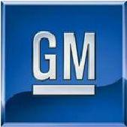

Q1 2010 Results

May 17, 2010

Exhibit 99.2

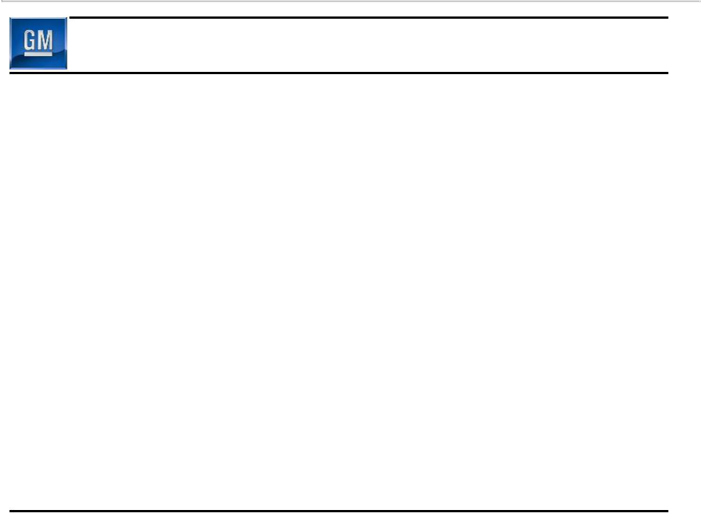
Forward Looking Statements

In this press release and in related comments by our management,our use of the words “expect,”“anticipate,” “possible,” “potential,” “target,” “believe,” “commit,” “intend,” “continue,” “may,” “would,” “could,” “should,” “project,” “projected,” “positioned” or similar expressions is intended to identify forward-looking statements that represent our current judgment about possible future events. We believe these judgments are reasonable, but these statements are not guarantees of any events or financial results, and our actual results may differ materially due to a variety of important factors. Among other items, such factors might include: our ability to realize production efficiencies and to achieve reductions in costs as a result of our restructuring initiatives and labor modifications; our ability to maintain quality control over our vehicles and avoid material vehicle recalls; our ability to maintain adequate liquidity and financing sources and an appropriate level of debt, including as required to fund our planning significant investment in new technology; our ability to realize successful vehicle applications of new technology; and our ability to comply with the continuing requirements related to U.S. and other government support.

GM's most recent annual report on Form 10-K and quarterly report on Form 10-Q provides information about these and other factors, which we may revise or supplement in future reports to the SEC.

1

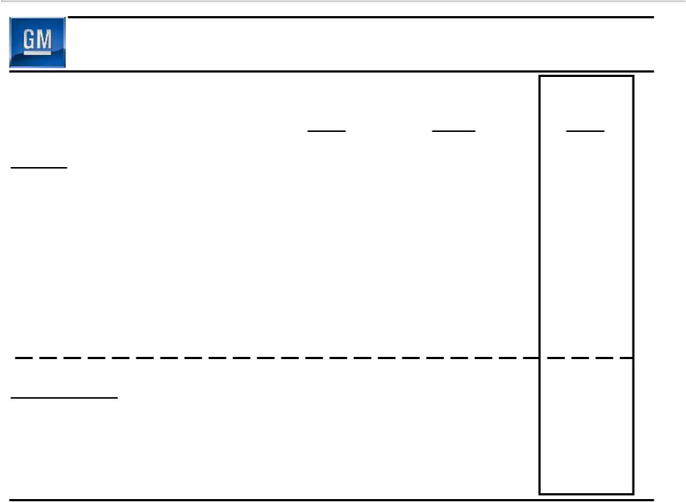
Summary of Q1 2010 Results

Jul 10 – Sep 30 | Q4 | Q1
2009 | 2009 | 2010

GAAP

Net Revenue ($B)

Operating Income ($B)

Net Income Attr. Common Stockholders ($B)

EPS – Diluted ($/Share)

Non- GAAP

EBIT - Adj. ($B)

Free Cash Flow ($B)

25.1 | 32.3 | 31.5
(1.0) | (3.9) | 1.2
(0.9) | (3.5) | 0.9
(2.20) | (8.53) | 1.66

(0.6) | (1.0) | 1.7
2.0 | (2.9) | 1.0

2

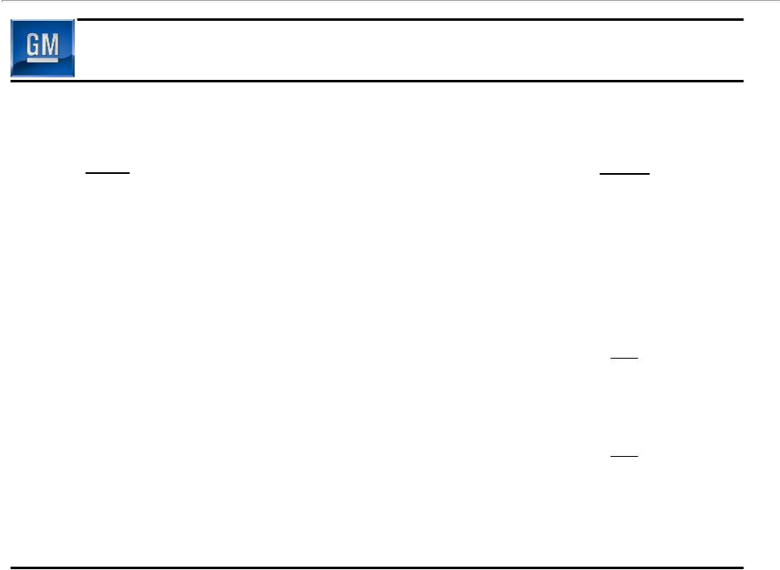
Q1 Operating Income Walk to EBIT- Adj.

 | Q1
($ B) | 2010
Operating Income | 1.2
Equity Income | 0.4
Non-Controlling Interests | (0.1)
Non-Operating Income | 0.3
Earnings Before Interest & Taxes (EBIT) | 1.8
Less Adjustments | 0.1
EBIT- Adj. | 1.7

3

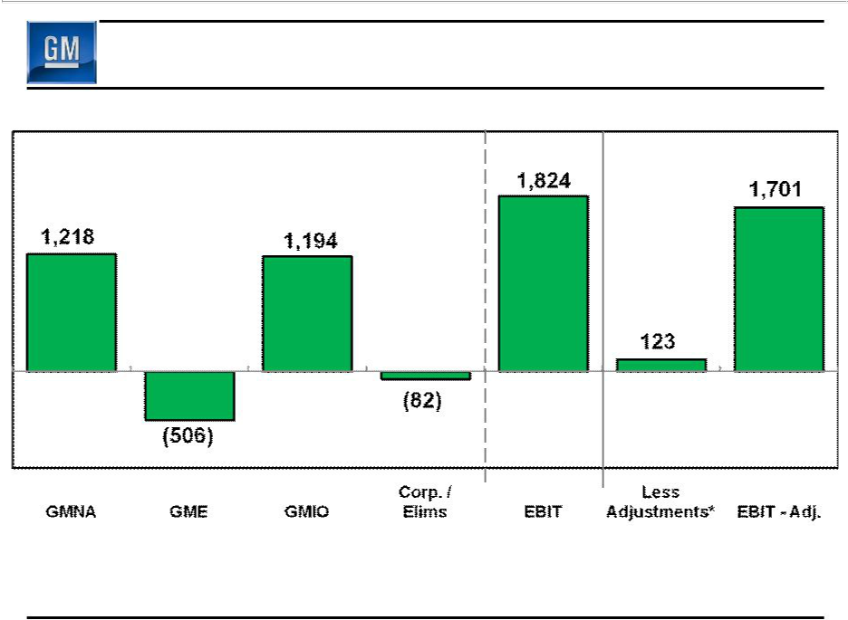
Q1 2010 EBIT & EBIT - Adj.

($M)

Gain on

Saab Sale

* Included in Earnings Before Interest and Taxes (EBIT)

4

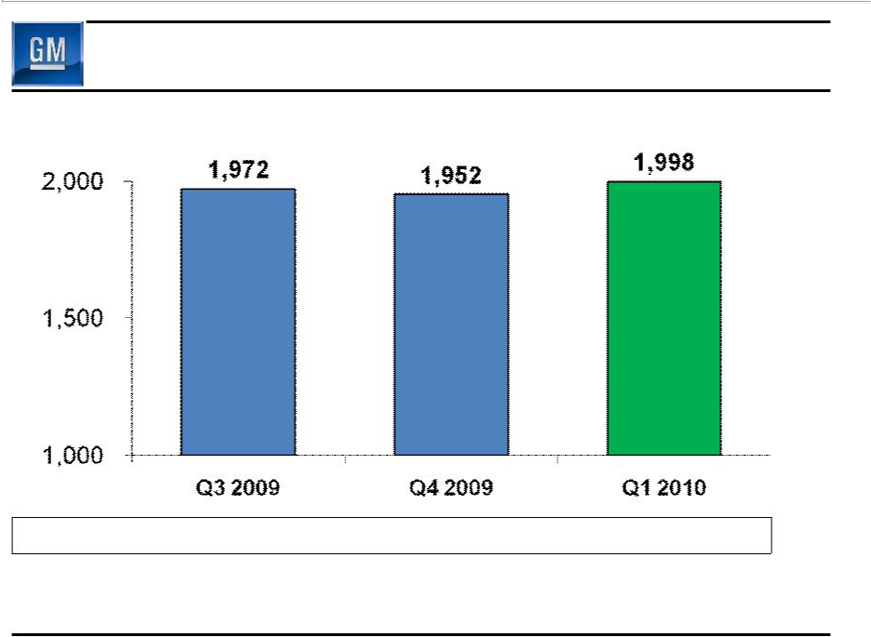
Q1 2010 Global Deliveries

(000’s)

Global Share | 11.8% | 11.5% | 11.2%

GM deliveries & market share includes vehicles sold around the world under GM and JV brands and through GM branded distribution network

5

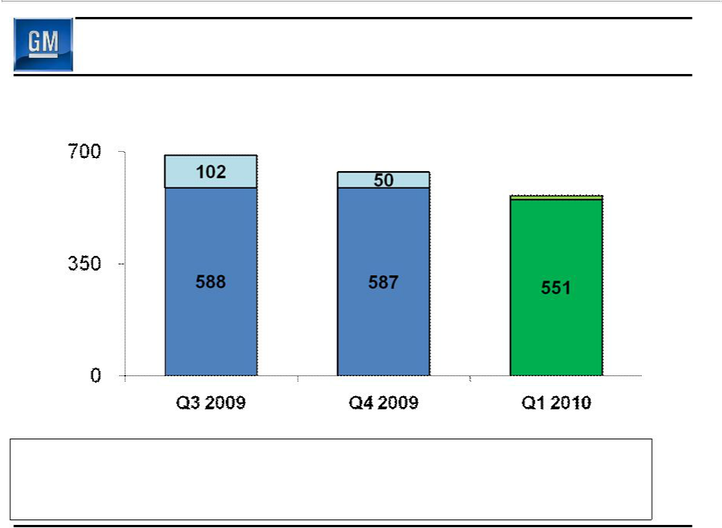
Q1 2010 GMNA Deliveries

(000’s)

690

637
563 Discontinued

Brands

Chevy, Buick,

GMC, Cadillac

GMNA Share | 18.7% | 19.3% | 17.8%
U.S. Share | 19.4% | 20.2% | 18.4%
U.S. 4 Brand Share | 16.7% | 18.6% | 18.1%

6

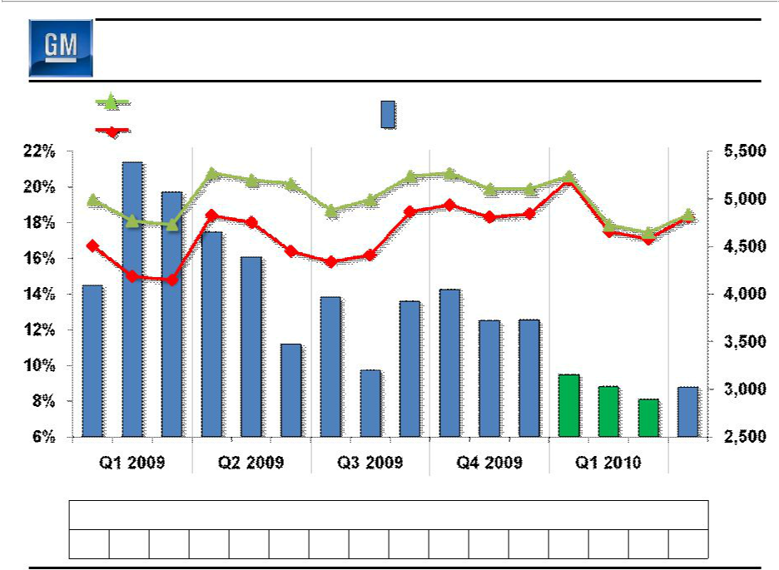
Key GMNA Performance Indicators

Share

U.S. Total Share | Avg. GM U.S. Retail | $/Unit
U.S. 4 Brand Share | Incentive – 4 Brands | $/Unit

Apr

2010

GM Average U.S. Retail Incentive (4 Brand) % of Industry Average

127 152 143 137 137 121 143 135 149 154 141 132 119 106 98 108

Note: Incentive Information Based on J.D. Power and Associates Power Information Network data | 7

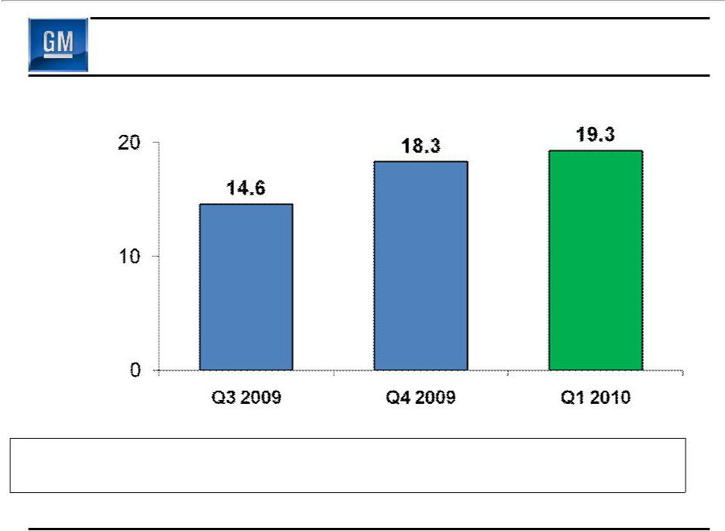
Q1 2010 GMNA Net Revenue

($B)

GMNA Production (000’s) | 531 | 616 | 668
U.S. Dealer Inv (000’s) | 424 | 385 | 428
Q3 2009 represents combined net revenue for GM and Old GM |  |  | 8

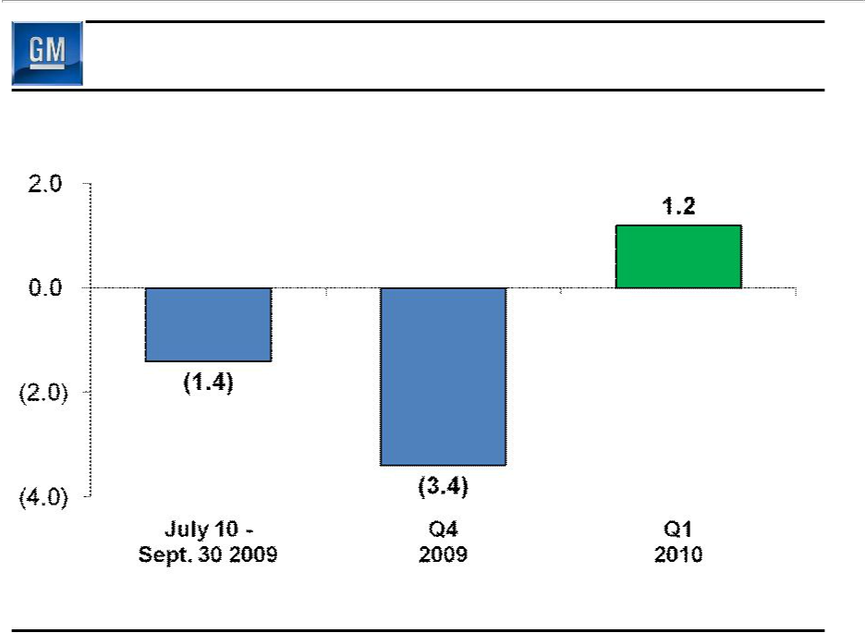
Q1 2010 GMNA Earnings Before Interest & Taxes

($B)

9

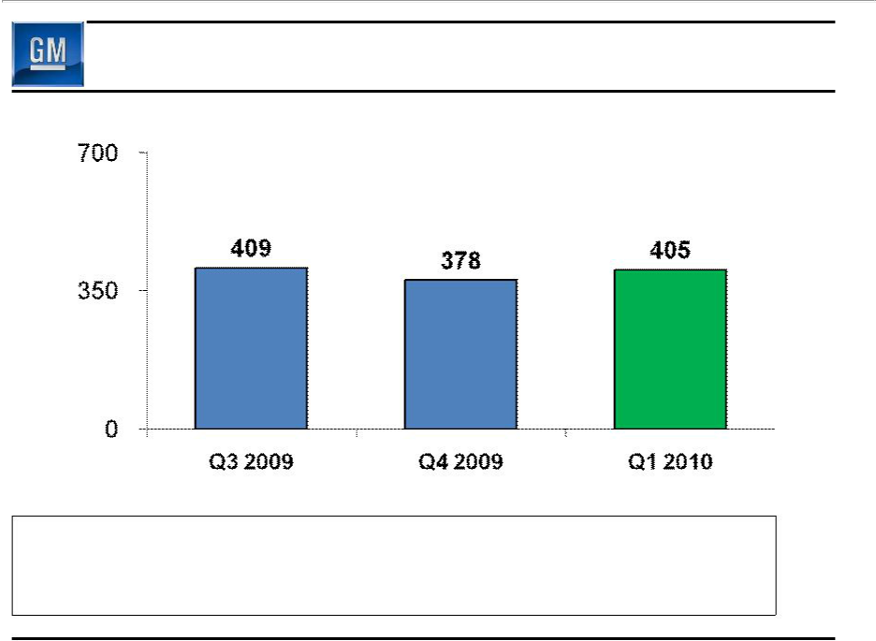
Q1 2010 GME Deliveries

(000’s)

GME Share | 8.9% | 8.2% | 8.5%
Germany Share | 9.4% | 8.8% | 8.2%
U.K. Share | 12.0% | 11.2% | 11.8%

10

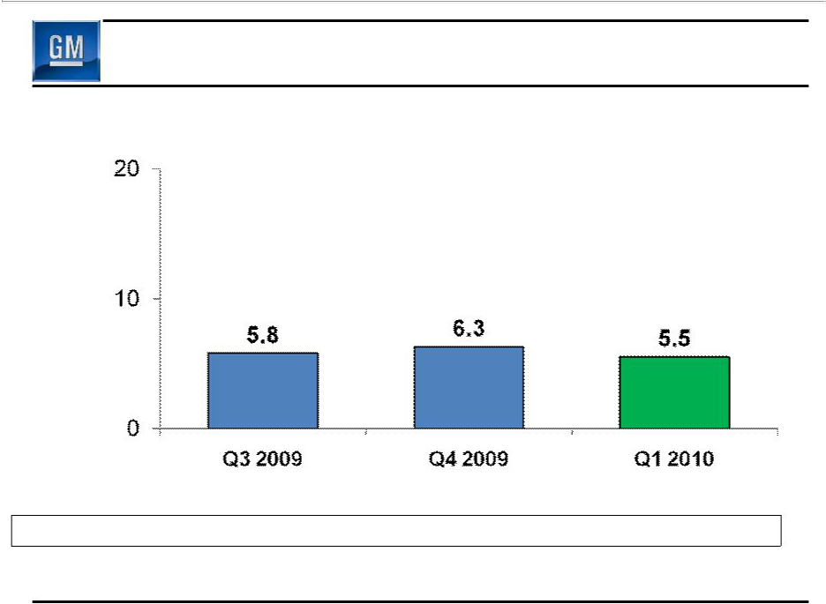
Q1 2010 GME Net Revenue

($B)

Total Production (000’s) | 277 | 266 | 357

Q3 2009 represents combined net revenue for GM and Old GM | 11

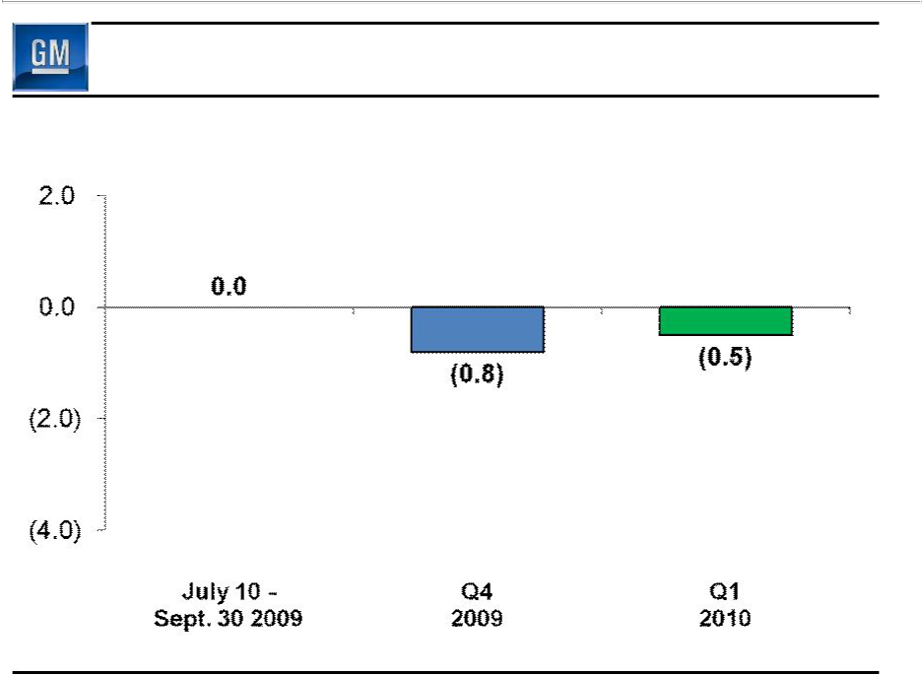
Q1 2010 GME Earnings Before Interest & Taxes

($B)

12

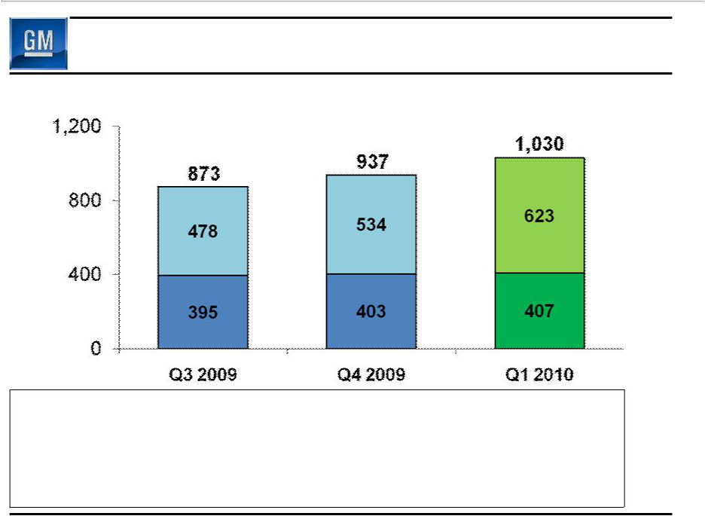
Q1 2010 GMIO Deliveries

(000’s)

China

GMIO Excl.

China

GMIO Share | 10.3% | 10.3% | 10.3%
China Share | 13.4% | 13.3% | 13.5%
Brazil Share | 19.8% | 18.7% | 19.9%
India Share | 3.1% | 3.7% | 4.2%

13

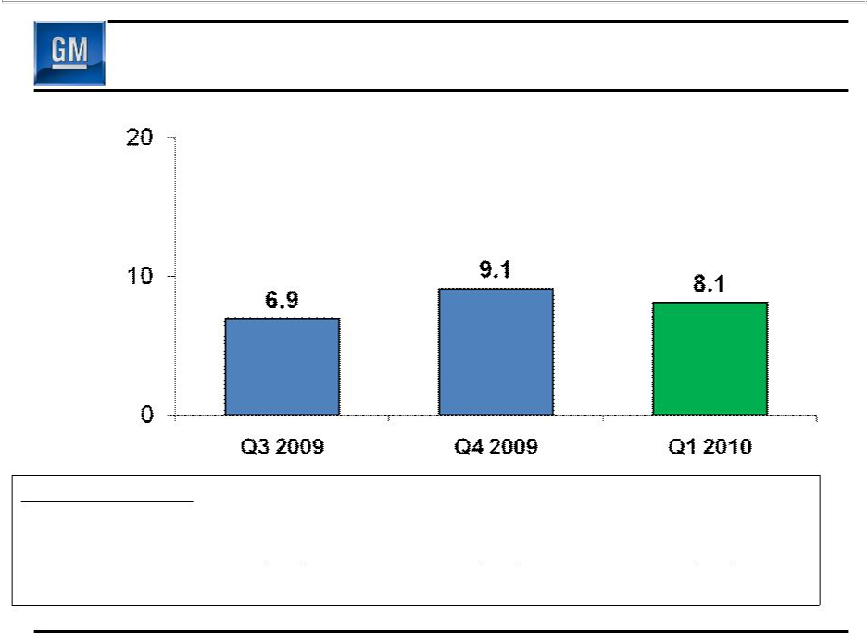
Q1 2010 GMIO Net Revenue

($B)

Production (000’s)
Fully Consolidated | 414 | 456 | 455
Joint Venture | 491 | 584 | 605
Total | 905 | 1,040 | 1,060
Q3 2009 represents combined net revenue for GM and Old GM |  |  | 14

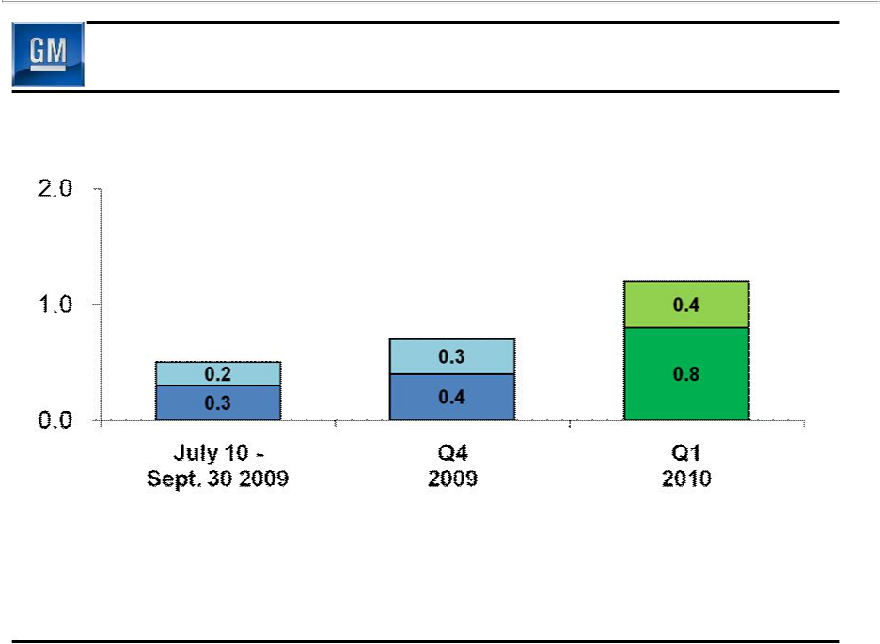
Q1 2010 GMIO Earnings Before Interest & Taxes

($B)

1.2

0.7

0.5

Equity

Income

Inc. Before Int/Tax/Equity

15

Cash Flow

($B)

Net Income /(Loss)

Depreciation / Amortization

Working Capital

Pension / OPEB & Other

Net cash provided/(used) operating activities

Capital Expenditures

July 10 – Sept 30 | Q4 | Q1
2009 | 2009 | 2010
(0.6) | (3.2) | 1.2
2.0 | 2.2 | 1.8
6.4 | (2.1) | (0.7)
(4.9) | 1.2 | (0.6)
2.9 | (1.9) | 1.7
(0.9) | (1.0) | (0.7)
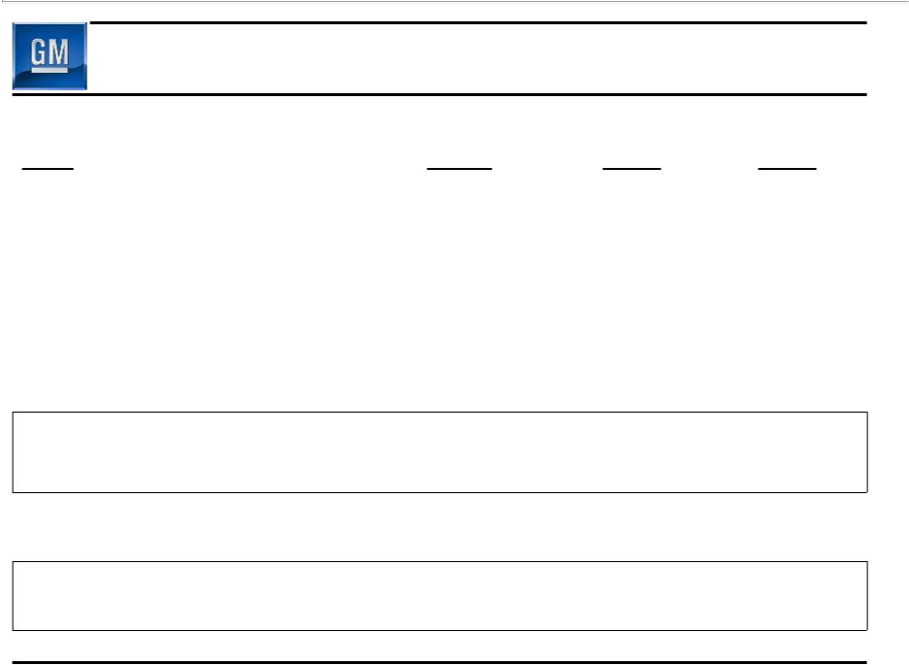

Free Cash Flow | 2.0 | (2.9) | 1.0

16

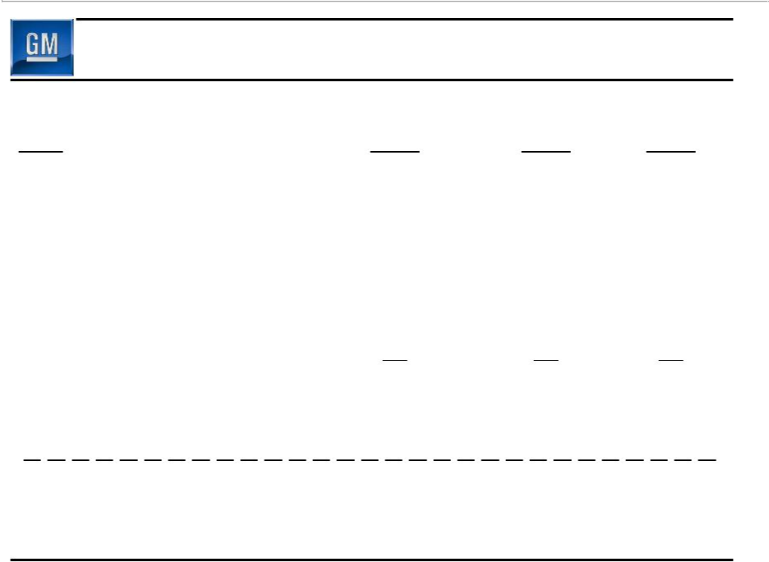
Depreciation / Amortization & Cap Ex

($M)

GMNA

GME

GMIO

Corp / Other

Total Depreciation & Amortization

July 10 – Sept 30 | Q4 | Q1
2009 | 2009 | 2010
1,348 | 1,384 | 1,174
401 | 551 | 384
170 | 277 | 194
66 | 44 | 51
1,985 | 2,256 | 1,803

Capital Expenditures | 881 | 1,033 | 755

17

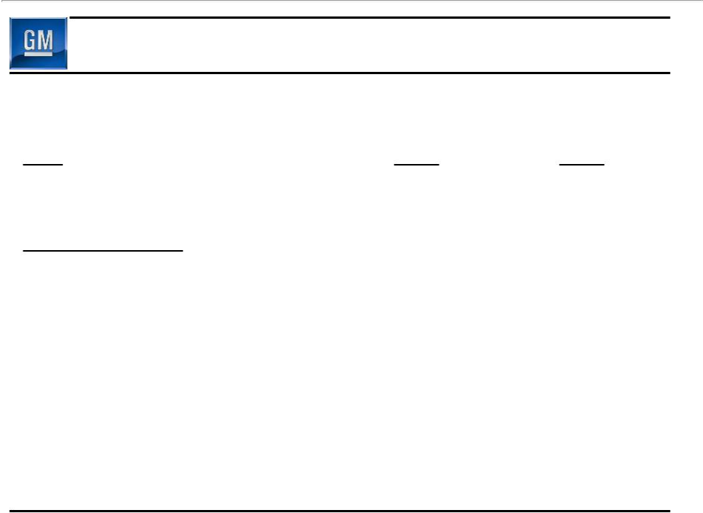
Key Balance Sheet Items

 | December 31 | March 31
($B) | 2009 | 2010
Cash & marketable securities* | 36.2 | 35.7
Key Obligations:
Debt | 15.8 | 14.2
Preferred Stock | 7.0 | 7.0
Underfunded Pensions | 27.5 | 26.9
Underfunded OPEB | 9.6 | 9.4

* Includes UST & Canadian HC Trust Restricted Cash | 18

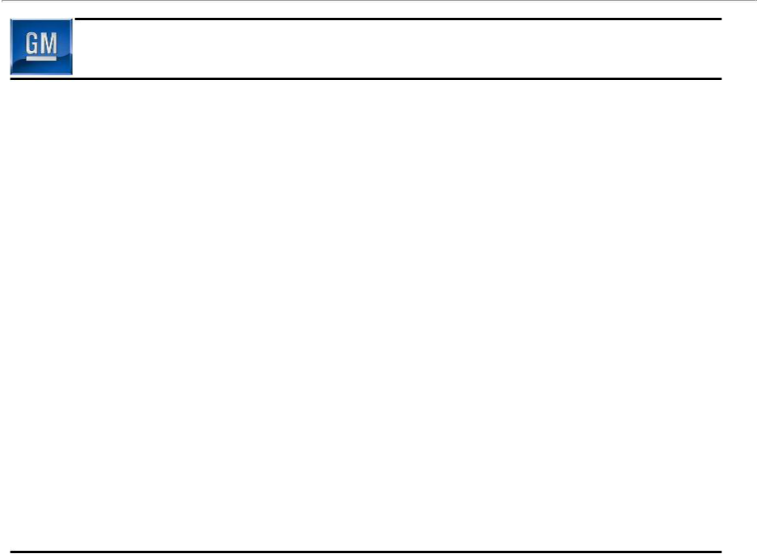
Summary

- Profitable, and positive cash flow

- U.S. y-o-y 4-brand share up & average retail incentive down, GMNA breakeven substantially lowered

- Well positioned to grow profitably in GMIO

- More work to do in GME

- Making progress on designing, building and selling the world's best vehicles

19

****** | *****************************
****** | *****************************
****** | *****************************
****** | *****************************
****** | *****************************
****** | *****************************
****** | *****************************
****** | *****************************
****** | *****************************
******
******
******
******
******
******
****** | General Motors Company
****** | General Motors Company
******
****** | Select Supplemental Financial Information
****** | Select Supplemental Financial Information
******
******
******
******
******
******
*

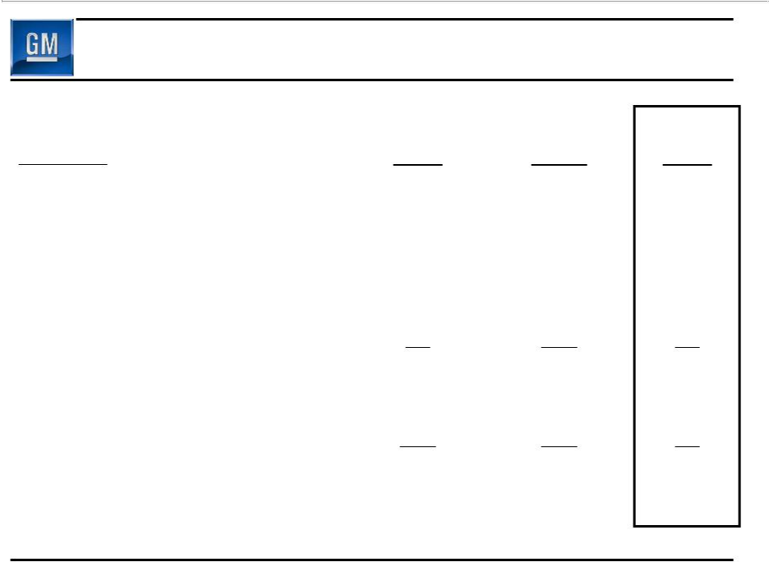
Operating Income Walk to EBIT- Adj

 | Jul 10 – Sep 30 | Q4 | Q1
($ Billions) | 2009 | 2009 | 2010
Operating Income | (1.0) | (3.9) | 1.2
Equity Income | 0.2 | 0.3 | 0.4
Non-Controlling Interests | (0.3) | (0.2) | (0.1)
Non-Operating Income/(Expense) | 0.4 | (0.2) | 0.3
Earnings Before Interest & Taxes | (0.7) | (4.0) | 1.8
Less Adjustments | (0.1) | (3.0) | 0.1
EBIT- Adj. | (0.6) | (1.0) | 1.7

S1

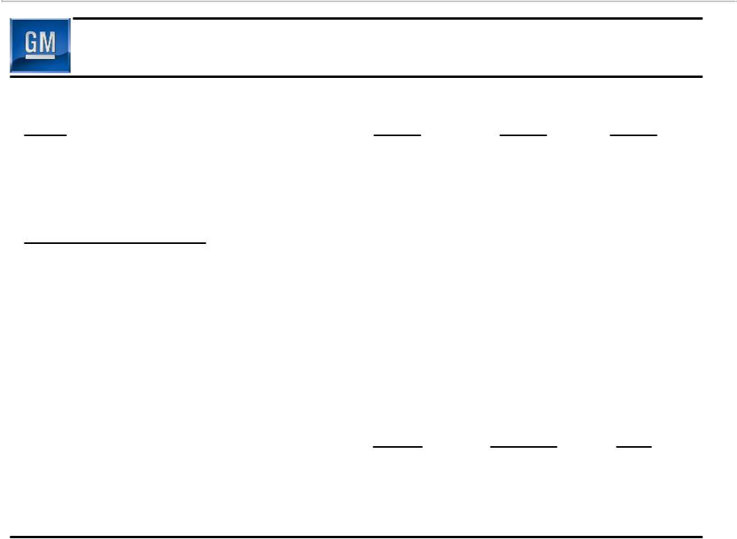
Detail of Adjustments

($M)

Earnings Before Interest

& Taxes (EBIT)

Less Adjustments

- Gain on Saab Sale

- VEBA Settlement

- GMAC Investment Impairment

- Delphi Related

- CAMI Debt Ext.

Total Adjustments

EBIT – Adj.

July 10 – Sept 30 | Q4 | Q1
2009 | 2009 | 2010
(741) | (4,046) | 1,824

- | - | 123
- | (2,571) | -
- | (270) | -
(110) | (150) | -
- | (101) | -
(110) | (3,092) | 123
(631) | (954) | 1,701

S2

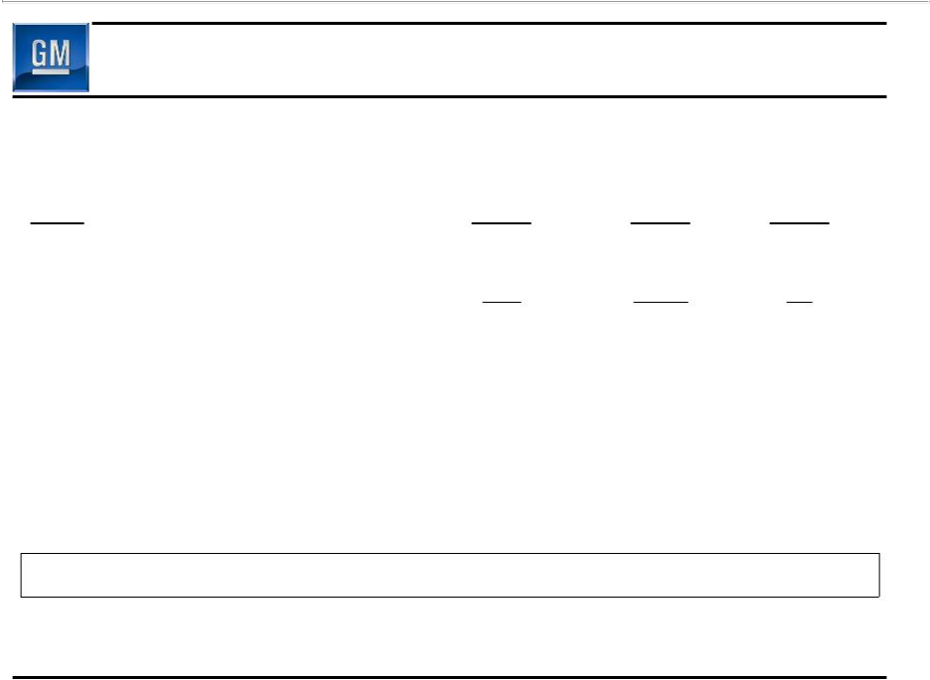
Restructuring Excluded From Adjustments

 | July 10 – Sept 30 | Q4 | Q1
($M) | 2009 | 2009 | 2010
GMNA – Dealer Related | (187) | (88) | (18)
GMNA – Non-Dealer Related | 134 | (208) | 97
Total GMNA | (53) | (296) | 79
Total GME | (9) | (28) | (273)
Total GMIO | (27) | (56) | -
Total | (89) | (380) | (194)

S3

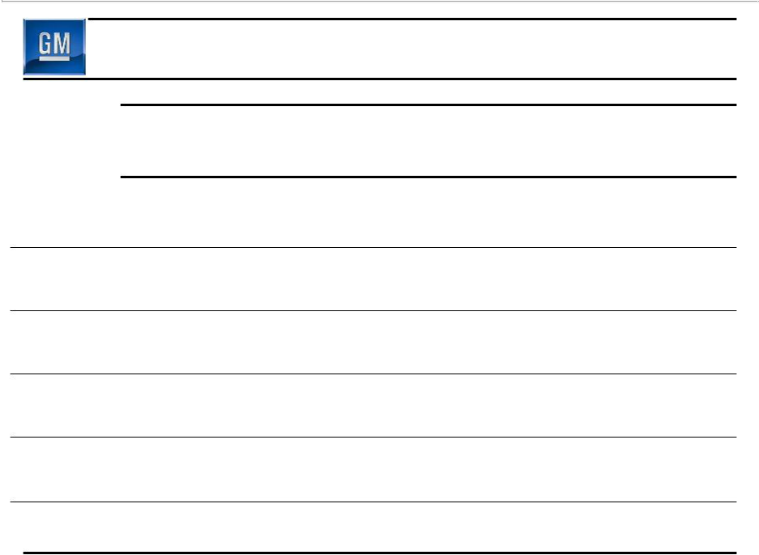
GMIO Joint Ventures

GM

Ownership

Deliveries

Market

Share

Revenue

Earnings

Shanghai - SAIC - GM
GM | Wuling | FAW - GM
49% | 34% | 50%
100% | 100% | 100%
100% | 100% | 100%
0% | 0% | 0%
49% | 34% | 50%
Equity Income | Equity Income | Equity Income

GM - Daewoo

70%

100%

100%

100%

70%
After adj. for Non-Controlling Interest

S4

