UNITED STATES

SECURITIES AND EXCHANGE COMMISSION

Washington, DC 20549-1004

___________________

FORM 8-K

___________________

CURRENT REPORT

PURSUANT TO SECTION 13 OR 15(d) OF

THE SECURITIES EXCHANGE ACT OF 1934

Date of Report (Date of earliest event reported) January 4, 2012

___________________

GENERAL MOTORS COMPANY

(Exact Name of Registrant as Specified in its Charter)

___________________

DELAWARE | 001-34960 | 27-0756180
(State or other jurisdiction of | 001-34960 | (I.R.S. Employer
incorporation) | (Commission File Number) | Identification No.)
300 Renaissance Center, Detroit, Michigan |  | 48265-3000
(Address of Principal Executive Offices) |  | (Zip Code)

(313) 556-5000

(Registrant's telephone number, including area code)

Not Applicable

(Former name or former address, if changed since last report)

___________________

Check the appropriate box below if the Form 8-K filing is intended to simultaneously satisfy the filing obligation of the registrant under any of the following provisions:

- Written communications pursuant to Rule 425 under the Securities Act (17 CFR 230.425)

- Soliciting material pursuant to Rule 14a-12 under the Exchange Act (17-CFR 240.14a-12)

- Pre-commencement communications pursuant to Rule 14d-2(b) under the Exchange Act (17 CFR 240.14d-2(b))

- Pre-commencement communications pursuant to Rule 13e-4(c) under the Exchange Act (17 CFR 240.13e-4(c))

TABLE OF CONTENTS

ITEM 8.01 Other Events

Signature

Index to Exhibits

Sales Release and Charts Dated January 4, 2012

ITEM 8.01 Other Events

On January 4, 2012, General Motors Company (GM) issued a news release announcing December 2011 sales. The release and charts are attached as Exhibit 99.1.

 |  |  |  | EXHIBIT
Exhibit |  | Description |  |  |  | Method of Filing
Exhibit 99.1 |  | Sales Release and Charts |  |  |  | Attached as Exhibit
 |  | Dated January 4, 2012

SIGNATURE

Pursuant to the requirements of the Securities Exchange Act of 1934, the Registrant has duly caused this report to be signed on its behalf by the undersigned hereunto duly authorized.

 |  | GENERAL MOTORS COMPANY
 |  | (Registrant)
By: |  | /s/ Nick S. Cyprus
 |  | Nick S. Cyprus
Date: January 12, 2012 |  | Vice President, Controller and Chief Accounting Officer

Exhibit 99.1


For Release: Wednesday, Jan. 4, 2012, 10 a.m. EST

GM's U.S. Sales Increase 5 Percent in December

Full-year sales increase 14 percent; market share grows

DETROIT - General Motors Co. (NYSE: GM) today reported total U.S. sales of 234,351 vehicles in December, up 5 percent compared with December 2010. Sales for the calendar year were up 14 percent year over year to more than 2.5 million units and the company gained market share.

“GM's balanced portfolio of fuel-efficient cars, trucks and crossovers helped us make the most of the U.S. economy's slow but steady recovery in 2011,” said Don Johnson, vice president, U.S. Sales Operations. “Importantly, we were able to grow all four of our brands and reestablish Chevrolet as a force to be reckoned with in the passenger car business. This gives us a very solid foundation to compete in a market that we expect to keep growing.”

In December, retail deliveries were up 2 percent compared with a very strong December 2010, and accounted for 81 percent of GM sales. Deliveries to fleets were up 17 percent.

GM's total passenger car sales for the month increased 12 percent. Crossover sales decreased 14 percent. Sales of trucks, which include full-size pickups, vans and SUVs increased 13 percent.

Highlights for the month include a 42 percent year-over-year increase in Chevrolet Sonic sales (compared with the Aveo), a 54 percent increase in Chevrolet Cruze sales, a 20 percent increase for the Chevrolet Camaro and a 13 percent increase for the Chevrolet Malibu. The Chevrolet Volt sold more than 1,500 units, making December its best month ever.

Other highlights include double-digit sales increases for the Cadillac SRX, Chevrolet Avalanche, Colorado, Silverado, Tahoe and Suburban, and the GMC Yukon XL. In addition, Chevrolet Equinox had its best sales month of the year in December.

Sales Highlights | Dec. 2011 Total | Total Sales Change | Dec. 2011 Retail | 2011 Total Sales | 2011 Total Sales | 2011 Retail Sales
Sales Highlights | Dec. 2011 Total | Total Sales Change | Sales Change vs. Dec. | 2011 Total Sales | 2011 Total Sales | 2011 Retail Sales
Sales Highlights | Sales (vehicles) | vs. Dec. 2010 | Sales Change vs. Dec. | (vehicles) | Change vs. 2010 | Change vs. 2010
 | Sales (vehicles) | vs. Dec. 2010 | 2010 | (vehicles) | Change vs. 2010 | Change vs. 2010
Chevrolet | 161,158 | 8.9 % | 5.3 % | 1,775,812 | 13.4% | 19.4%
GMC | 41,960 | (0.5)% | (4.1)% | 397,986 | 18.8% | 16%
Buick | 14,974 | (12.4)% | (8.4)% | 177,633 | 14.3% | 14.7%
Cadillac | 16,259 | (2.7)% | 4.9 % | 152,389 | 3.7% | 10.5%
Total GM | 234,351 | 4.7 % | 2.1 % | 2,503,820 | 13.7% | 17.6%

GM ended December with about 580,000 units in dealer stock, including approximately 180,000 full-size pickup trucks, as planned.

GM expects full-year 2012 light vehicle sales to be in a range of 13.5 million to 14.0 million units. In previous years, GM's forecasts were based on total vehicle sales, which included medium- and heavy-duty vehicles, or about 300,000 additional units.

“Over the course of the fourth quarter of 2011, clear signs emerged that U.S. consumers are more confident and that other underpinnings of our economy are either stable or slowly improving,” Johnson said. “When we add improving economic fundamentals to pent-up demand and an aging vehicle fleet, it's now clear that auto sales should continue to grow in 2012, barring a shock to the system.”

Inventory |  |  | Units @ |  |  | Days Supply (selling days |  |  |  | Units @ |  |  | Days Supply (selling days
 |  |  | Dec. 31, 2011 |  |  | adjusted) |  |  | Nov. 30, 2011 |  |  |  | adjusted)
All Vehicles |  |  | 583,407 |  |  | 67 |  |  |  | 623,666 |  |  | 86
Full-size Pickups |  |  | 181,070 |  |  | 73 |  |  |  | 202,720 |  |  | 105
 | Industry Sales |  |  | Dec. 2011 SAAR (est.) |  |  |  | 2011 (est.) |  |  |  | 2010
 | Total Vehicles |  |  |  | 13.9 million |  |  | 13.1 million |  |  |  | 11.8 million

General Motors Co. (NYSE:GM, TSX: GMM) and its partners produce vehicles in 30 countries, and the company has leadership positions in the world's largest and fastest-growing automotive markets. GM's brands include Chevrolet and Cadillac, as well as Baojun, Buick, GMC, Holden, Isuzu, Jiefang, Opel, Vauxhall and Wuling. More information on the company and its subsidiaries, including OnStar, a global leader in vehicle safety, security and information services, can be found at http://www.gm.com.

CONTACT:

Jim Cain

GM Communications

313-407-2843

james.cain@gm.com

Forward-Looking Statements

In this press release and in related comments by our management, our use of the words “expect,” “anticipate,” “possible,” “potential,” “target,” “believe,” “commit,” “intend,” “continue,” “may,” “would,” “could,” “should,” “project,” “projected,” “positioned” or similar expressions is intended to identify forward-looking statements that represent our current judgment about possible future events. We believe these judgments are reasonable, but these statements are not guarantees of any events or financial results, and our actual results may differ materially due to a variety of important factors. Among other items, such factors might include: our ability to realize production efficiencies and to achieve reductions in costs as a result of our restructuring initiatives and labor modifications; our ability to maintain quality control over our vehicles and avoid material vehicle recalls; our ability to maintain adequate liquidity and financing sources and an appropriate level of debt, including as required to fund our planned significant investment in new technology; the ability of our suppliers to timely deliver parts, components and systems; our ability to realize successful vehicle applications of new technology; and our ability to continue to attract new customers, particularly for our new products. GM's most recent annual report on Form 10-K and quarterly reports on Form 10-Q provides information about these and other factors, which we may revise or supplement in future reports to the SEC.

*S/D Curr: 27 |  | December |  |  | (Calendar Year-to-Date)
 |  |  |  |  | January - December
 |  |  | % Chg | %Chg per |  |  | %Chg
*S/D Prev: 27 | 2011 | 2010 | Volume | S/D | 2011 | 2010 | Volume
Vehicle Total | 234,351 | 224,185 | 4.5 | 4.5 | 2,503,820 | 2,215,227 | 13.0
Brand Total | 234,351 | 223,932 | 4.7 | 4.7 | 2,503,820 | 2,202,927 | 13.7
Other Brand Total | — | 253 | ***.* | ***.* | — | 12,300 | ***.*
GM Vehicle Deliveries by Marketing Division
 |  |  |  | %Chg per |  |  | %Chg
 | 2011 | 2010 | %Chg Volume | S/D | 2011 | 2010 | Volume
Buick Total | 14,974 | 17,095 | (12.4) | (12.4) | 177,633 | 155,389 | 14.3
Cadillac Total | 16,259 | 16,718 | (2.7) | (2.7) | 152,389 | 146,925 | 3.7
Chevrolet Total ** | 161,158 | 147,960 | 8.9 | 8.9 | 1,775,812 | 1,565,632 | 13.4
GMC Total ** | 41,960 | 42,159 | (0.5) | (0.5) | 397,986 | 334,981 | 18.8
Brand Total | 234,351 | 223,932 | 4.7 | 4.7 | 2,503,820 | 2,202,927 | 13.7
HUMMER Total | — | 38 | ***.* | ***.* | — | 3,812 | ***.*
Pontiac Total | — | 130 | ***.* | ***.* | — | 1,182 | ***.*
Saab Total | — | — | ***.* | ***.* | — | 608 | ***.*
Saturn Total | — | 85 | ***.* | ***.* | — | 6,698 | ***.*
Other Brand Total | — | 253 | ***.* | ***.* | — | 12,300 | ***.*
GM Vehicle Total | 234,351 | 224,185 | 4.5 | 4.5 | 2,503,820 | 2,215,227 | 13.0
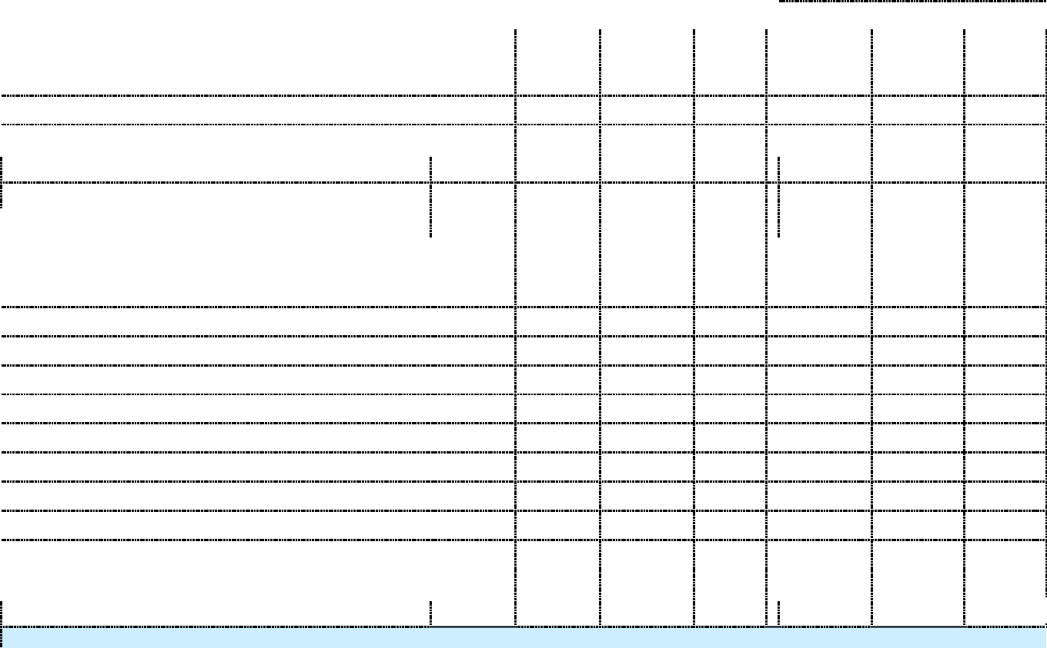

* Twenty-seven selling days for the December period this year and twenty-seven for last year.

** Calendar Year 2010 includes GMC & Chevrolet Dealer deliveries of commercial vehicles distributed by American Isuzu Motors, Inc.

 |  |  |  |  |  | (Calendar Year-to-Date)
 |  | December |  |  |  |  | January - December
 | 2011 | 2010 | % Chg Volume | % Chg per S/D |  | 2011 | 2010 | %Chg Volume
Selling Days (S/D) | 27 | 27
Enclave | 5,555 | 6,634 | (16.3) | (16.3) |  | 58,392 | 55,426 | 5.4
LaCrosse | 5,360 | 5,140 | 4.3 | 4.3 |  | 58,474 | 61,178 | (4.4)
Lucerne | 712 | 2,262 | (68.5) | (68.5) |  | 20,358 | 26,459 | (23.1)
Regal | 3,086 | 3,059 | 0.9 | 0.9 |  | 40,144 | 12,326 | 225.7
Verano | 261 | — | ***.* | ***.* |  | 265 | — | ***.*
Buick Total | 14,974 | 17,095 | (12.4) | (12.4) |  | 177,633 | 155,389 | 14.3
CTS | 5,420 | 5,171 | 4.8 | 4.8 |  | 55,042 | 45,656 | 20.6
DTS | 166 | 1,538 | (89.2) | (89.2) |  | 11,589 | 18,640 | (37.8)
Escalade | 1,890 | 2,286 | (17.3) | (17.3) |  | 15,079 | 16,118 | (6.4)
Escalade ESV | 1,119 | 1,262 | (11.3) | (11.3) |  | 8,388 | 8,674 | (3.3)
Escalade EXT | 262 | 266 | (1.5) | (1.5) |  | 2,036 | 2,082 | (2.2)
SRX | 7,324 | 5,865 | 24.9 | 24.9 |  | 56,905 | 51,094 | 11.4
STS | 78 | 329 | (76.3) | (76.3) |  | 3,338 | 4,473 | (25.4)
XLR | — | 1 | ***.* | ***.* |  | 12 | 188 | (93.6)
Cadillac Total | 16,259 | 16,718 | (2.7) | (2.7) |  | 152,389 | 146,925 | 3.7
Avalanche | 2,546 | 2,106 | 20.9 | 20.9 |  | 20,088 | 20,515 | (2.1)
Aveo | 24 | 4,037 | (99.4) | (99.4) |  | 28,601 | 48,623 | (41.2)
Camaro | 6,754 | 5,614 | 20.3 | 20.3 |  | 88,249 | 81,299 | 8.5
Caprice | 99 | — | ***.* | ***.* |  | 880 | — | ***.*
Captiva Sport | 1,983 | — | ***.* | ***.* |  | 7,038 | — | ***.*
Chevy C/T Series | — | — | ***.* | ***.* |  | — | 9 | ***.*
Chevy W Series | — | — | ***.* | ***.* |  | — | 286 | ***.*
Cobalt | 5 | 636 | (99.2) | (99.2) |  | 856 | 97,376 | (99.1)
Colorado | 2,970 | 2,387 | 24.4 | 24.4 |  | 31,026 | 24,642 | 25.9
Corvette | 1,038 | 979 | 6.0 | 6.0 |  | 13,164 | 12,624 | 4.3
Cruze | 16,675 | 10,865 | 53.5 | 53.5 |  | 231,732 | 24,495 | 846.0
Equinox | 18,195 | 22,764 | (20.1) | (20.1) |  | 193,274 | 149,979 | 28.9
Express | 8,461 | 6,474 | 30.7 | 30.7 |  | 71,943 | 59,753 | 20.4
HHR | 150 | 4,030 | (96.3) | (96.3) |  | 37,012 | 75,401 | (50.9)
Impala | 10,479 | 11,411 | (8.2) | (8.2) |  | 171,434 | 172,078 | (0.4)
Kodiak 4/5 Series | — | 16 | ***.* | ***.* |  | 10 | 1,205 | (99.2)
Kodiak 6/7/8 Series | — | 6 | ***.* | ***.* |  | — | 251 | ***.*
Malibu | 13,034 | 11,520 | 13.1 | 13.1 |  | 204,808 | 198,770 | 3.0
Silverado-C/K Pickup | 47,787 | 42,518 | 12.4 | 12.4 |  | 415,130 | 370,135 | 12.2
Sonic | 5,743 | — | ***.* | ***.* |  | 15,778 | — | ***.*
Suburban (Chevy) | 5,930 | 4,264 | 39.1 | 39.1 |  | 49,427 | 45,152 | 9.5
Tahoe | 8,430 | 7,482 | 12.7 | 12.7 |  | 80,527 | 75,675 | 6.4
TrailBlazer | — | 2 | ***.* | ***.* |  | 33 | 218 | (84.9)
Traverse | 9,326 | 10,523 | (11.4) | (11.4) |  | 107,131 | 106,744 | 0.4
Uplander | — | — | ***.* | ***.* |  | — | 76 | ***.*
Volt | 1,529 | 326 | 369.0 | 369.0 |  | 7,671 | 326 | ***.*
Chevrolet Total | 161,158 | 147,960 | 8.9 | 8.9 |  | 1,775,812 | 1,565,632 | 13.4
Acadia | 7,355 | 7,618 | (3.5) | (3.5) |  | 79,288 | 68,295 | 16.1
Canyon | 716 | 826 | (13.3) | (13.3) |  | 9,590 | 7,992 | 20.0
Envoy | — | 2 | ***.* | ***.* |  | 5 | 84 | (94.0)
GMC C/T Series | — | — | ***.* | ***.* |  | — | 54 | ***.*
GMC W Series | — | — | ***.* | ***.* |  | — | 382 | ***.*
Savana | 2,530 | 1,150 | 120.0 | 120.0 |  | 17,268 | 13,942 | 23.9
Sierra | 16,495 | 16,795 | (1.8) | (1.8) |  | 149,170 | 129,794 | 14.9
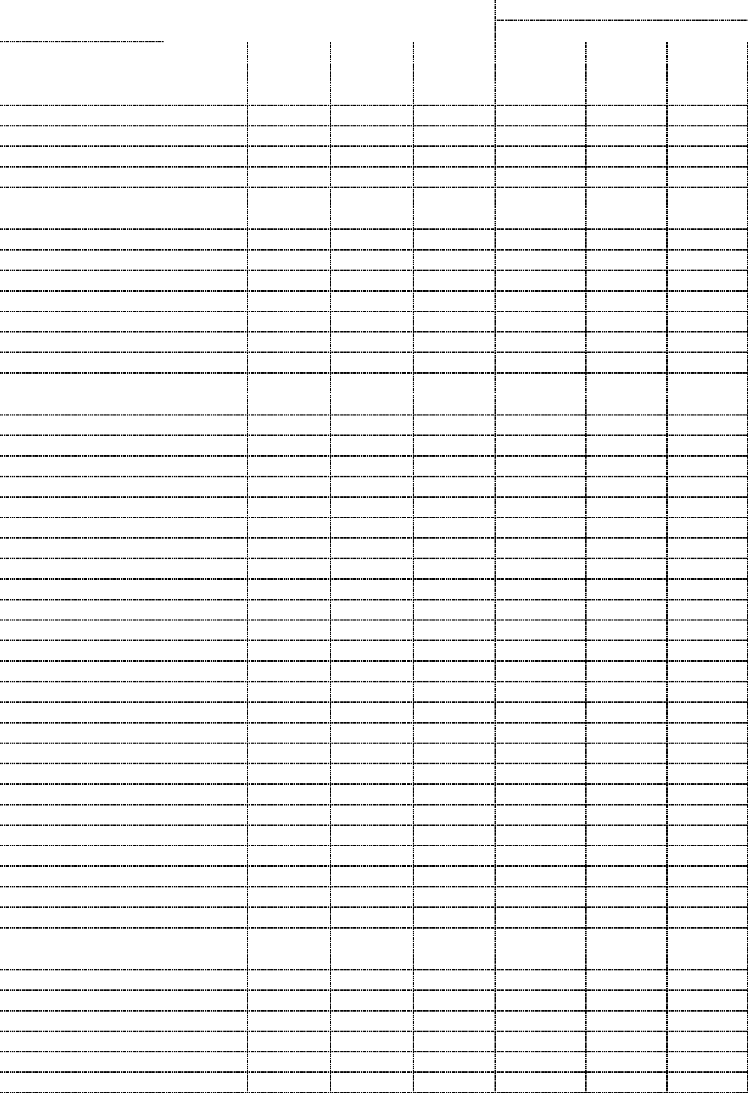

Terrain | 7,724 | 9,303 | (17.0) | (17.0) | 83,179 | 60,519 | 37.4
Topkick 4/5 Series | — | 8 | ***.* | ***.* | 5 | 915 | (99.5)
Topkick 6/7/8 Series | — | 8 | ***.* | ***.* | 8 | 426 | (98.1)
Yukon | 3,968 | 3,891 | 2.0 | 2.0 | 34,250 | 28,781 | 19.0
Yukon XL | 3,172 | 2,558 | 24.0 | 24.0 | 25,223 | 23,797 | 6.0
GMC Total | 41,960 | 42,159 | (0.5) | (0.5) | 397,986 | 334,981 | 18.8
Brand Total | 234,351 | 223,932 | 4.7 | 4.7 | 2,503,820 | 2,202,927 | 13.7
HUMMER Total | — | 38 | ***.* | ***.* | — | 3,812 | ***.*
Pontiac Total | — | 130 | ***.* | ***.* | — | 1,182 | ***.*
Saab Total | — | — | ***.* | ***.* | — | 608 | ***.*
Saturn Total | — | 85 | ***.* | ***.* | — | 6,698 | ***.*
Other Brand Total | — | 253 | ***.* | ***.* | — | 12,300 | ***.*
GM Vehicle Total | 234,351 | 224,185 | 4.5 | 4.5 | 2,503,820 | 2,215,227 | 13.0


