UNITED STATES

SECURITIES AND EXCHANGE COMMISSION

Washington, DC 20549-1004

___________________

FORM 8-K

___________________

CURRENT REPORT

Pursuant to Section 13 or 15(d) of

the Securities Exchange Act of 1934

Date of Report (Date of earliest event reported) July 25, 2017

___________________

GENERAL MOTORS COMPANY

(Exact name of registrant as specified in its charter)

___________________

DELAWARE | 001-34960 | 27-0756180
(State or other jurisdiction of | 001-34960 | (I.R.S. Employer
incorporation) | (Commission File Number) | Identification No.)
300 Renaissance Center, Detroit, Michigan |  | 48265-3000
(Address of principal executive offices) |  | (Zip Code)

(313) 556-5000

(Registrant's telephone number, including area code)

Not Applicable

(Former name or former address, if changed since last report)

___________________

Check the appropriate box below if the Form 8-K filing is intended to simultaneously satisfy the filing obligation of the registrant under any of the following provisions:

- Written communications pursuant to Rule 425 under the Securities Act (17 CFR 230.425)

- Soliciting material pursuant to Rule 14a-12 under the Exchange Act (17-CFR 240.14a-12)

- Pre-commencement communications pursuant to Rule 14d-2(b) under the Exchange Act (17 CFR 240.14d-2(b))

- Pre-commencement communications pursuant to Rule 13e-4(c) under the Exchange Act (17 CFR 240.13e-4(c))

ITEM 2.02 Results of Operations and Financial Condition

On July 25, 2017 General Motors Company (GM) issued a news release and supplemental materials on the subject of its 2017 second quarter earnings. The news release and supplemental materials are attached as Exhibit 99.1 and Exhibit 99.2.

Charts furnished to securities analysts in connection with GM's 2017 second quarter earnings release are available on GM's website at www.gm.com/investors/earnings-releases.html.

ITEM 9.01 Financial Statements and Exhibits

 |  |  |  | EXHIBIT
Exhibit |  | Description
Exhibit 99.1 |  | News Release Dated July 25, 2017
Exhibit 99.2 |  | Financial Highlights Dated July 25, 2017

SIGNATURE

Pursuant to the requirements of the Securities Exchange Act of 1934, the registrant has duly caused this report to be signed on its behalf by the undersigned hereunto duly authorized.

 |  | GENERAL MOTORS COMPANY (Registrant)
 |  | /s/ THOMAS S. TIMKO
Date: July 25, 2017 | By:
Date: July 25, 2017 | By: | Thomas S. Timko
 |  | Vice President, Controller, Chief Accounting Officer and Global
 |  | Business Services

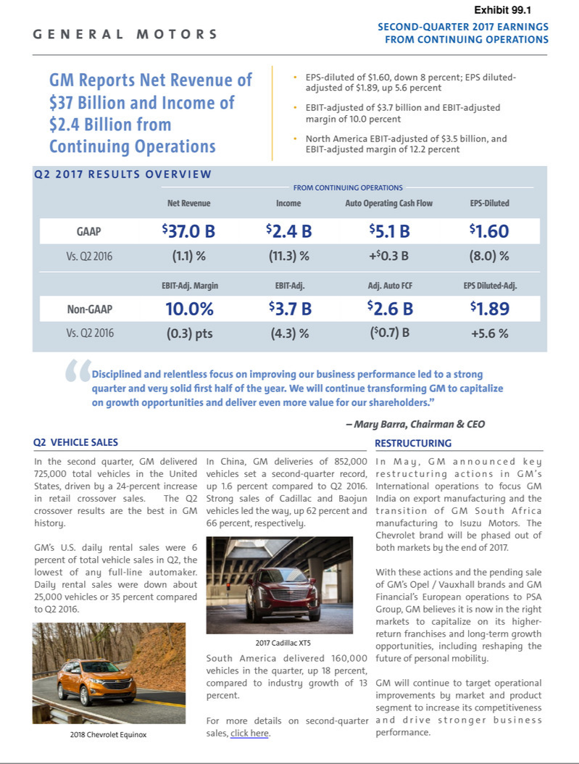

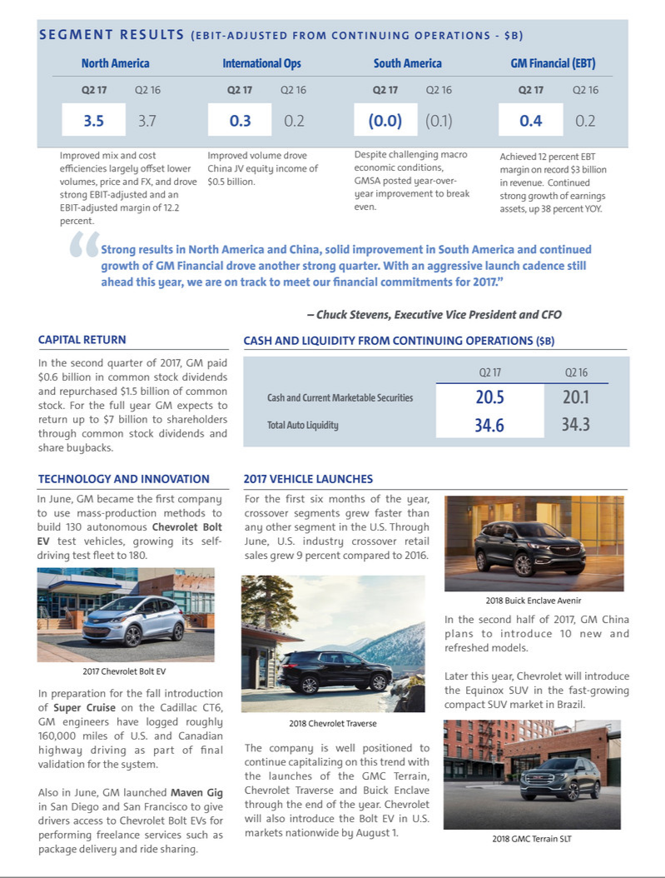

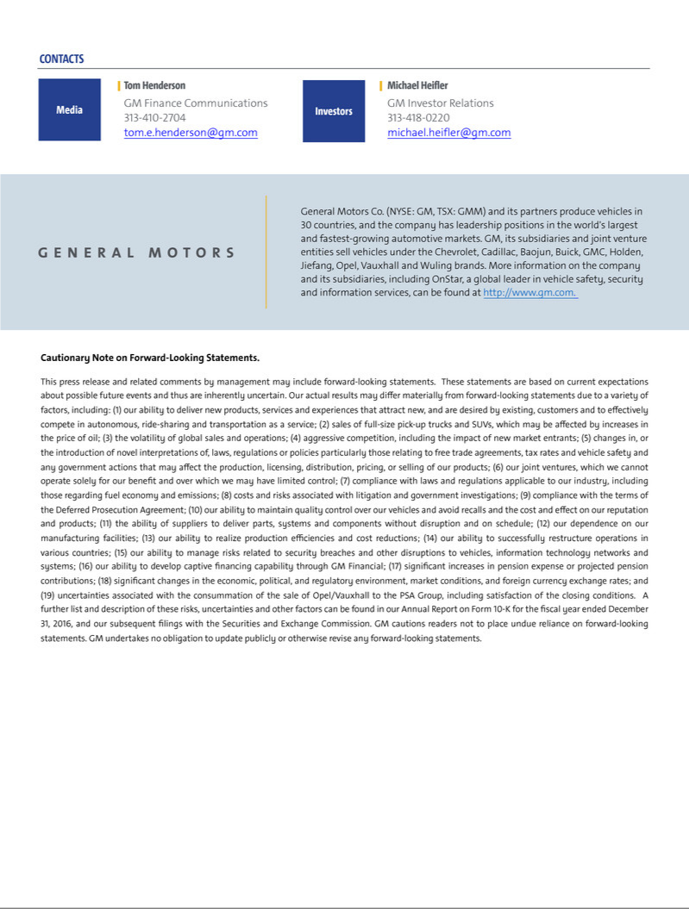

Exhibit 99.2

General Motors Company and Subsidiaries

Supplemental Material

(Unaudited)

Unless otherwise indicated, General Motors Company's (GM) non-GAAP measures are related to our continuing operations and not our discontinued operations nor assets and liabilities held for sale. GM's non-GAAP measures include earnings before interest and taxes (EBIT)-adjusted, presented net of noncontrolling interests, earnings per share (EPS)-diluted-adjusted, return on invested capital-adjusted (ROIC-adjusted) and adjusted automotive free cash flow. GM's calculation of these non-GAAP measures may not be comparable to similarly titled measures of other companies due to potential differences between companies in the method of calculation. As a result, the use of these non-GAAP measures has limitations and should not be considered superior to, in isolation from, or as a substitute for, related U.S. GAAP measures.

These non-GAAP measures allow management and investors to view operating trends, perform analytical comparisons and benchmark performance between periods and among geographic regions to understand operating performance without regard to items we do not consider a component of our core operating performance. Furthermore, these non-GAAP measures allow investors the opportunity to measure and monitor our performance against our externally communicated targets and evaluate the investment decisions being made by management to improve ROIC-adjusted. Management uses these measures in its financial, investment and operational decision-making processes, for internal reporting and as part of its forecasting and budgeting processes. Further, our Board of Directors uses these and other measures as key metrics to determine management performance under our performance-based compensation plans. For these reasons we believe these non-GAAP measures are useful for our investors.

EBIT-adjusted is used by management and can be used by investors to review our consolidated operating results because it excludes automotive interest income, automotive interest expense and income taxes as well as certain additional adjustments that are not considered part of our core operations. Examples of adjustments to EBIT include but are not limited to impairment charges related to goodwill; impairment charges on long-lived assets and other exit costs resulting from strategic shifts in our operations or discrete market and business conditions; costs arising from the ignition switch recall and related legal matters; and certain currency devaluations associated with hyperinflationary economies. For EBIT-adjusted and our other non-GAAP measures, once we have made an adjustment in the current period for an item, we will also adjust the related non-GAAP measure in any future periods in which there is an impact from the item.

EPS-diluted-adjusted is used by management and can be used by investors to review our consolidated diluted earnings per share results on a consistent basis. EPS-diluted-adjusted is calculated as net income attributable to common stockholders-diluted less income (loss) from discontinued operations on an after-tax basis, adjustments noted above for EBIT-adjusted, gains or losses on the extinguishment of debt obligations on an after-tax basis and certain income tax adjustments divided by weighted-average common shares outstanding-diluted. Examples of income tax adjustments include the establishment or reversal of significant deferred tax asset valuation allowances.

ROIC-adjusted is used by management and can be used by investors to review our investment and capital allocation decisions. We define ROIC-adjusted as EBIT-adjusted for the trailing four quarters divided by ROIC-adjusted average net assets, which is considered to be the average equity balances adjusted for average automotive debt and interest liabilities, exclusive of capital leases; average automotive net pension and OPEB liabilities; and average automotive net income tax assets during the same period. Adjustments to the average equity balances exclude assets and liabilities classified as either assets held for sale or liabilities held for sale.

Adjusted automotive free cash flow is used by management and can be used by investors to review the liquidity of our automotive operations and to measure and monitor our performance against our capital allocation program and evaluate our automotive liquidity against the substantial cash requirements of our automotive operations. We measure adjusted automotive free cash flow as automotive operating cash flow from continuing operations less capital expenditures adjusted for management actions, primarily related to strengthening our balance sheet, such as prepayments of debt and discretionary contributions to employee benefit plans.

1

General Motors Company and Subsidiaries

Supplemental Material

(Unaudited)

The following table reconciles segment profit (loss) to Net income attributable to common stockholders under U.S. GAAP (dollars in millions):

 |  | Three Months Ended |  |  |  |  |  | Six Months Ended
 |  | June 30, 2017 |  |  | June 30, 2016 |  |  | June 30, 2017 |  |  | June 30, 2016
Operating segments
GM North America (GMNA) | $ | 3,475 |  | $ | 3,745 |  | $ | 6,946 |  | $ | 6,129
GM International Operations (GMIO) |  | 340 |  |  | 190 |  |  | 637 |  |  | 624
GM South America (GMSA) |  | (23) |  |  | (118) |  |  | (142) |  |  | (182)
General Motors Financial Company, Inc. (GM Financial)(a) |  | 357 |  |  | 214 |  |  | 585 |  |  | 407
Total operating segments |  | 4,149 |  |  | 4,031 |  |  | 8,026 |  |  | 6,978
Corporate and eliminations(b) |  | (467) |  |  | (185) |  |  | (790) |  |  | (390)
EBIT-adjusted |  | 3,682 |  |  | 3,846 |  |  | 7,236 |  |  | 6,588
Special items
GMIO restructuring(c) |  | (460) |  |  | — |  |  | (460) |  |  | —
Venezuela deconsolidation(d) |  | (80) |  |  | — |  |  | (80) |  |  | —
Ignition switch recall and related legal matters(e) |  | (114) |  |  | (115) |  |  | (114) |  |  | (175)
Total special items |  | (654) |  |  | (115) |  |  | (654) |  |  | (175)
Automotive interest income |  | 68 |  |  | 50 |  |  | 125 |  |  | 94
Automotive interest expense |  | (132) |  |  | (144) |  |  | (279) |  |  | (268)
Income tax expense |  | (534) |  |  | (877) |  |  | (1,321) |  |  | (1,534)
Income from continuing operations(f) |  | 2,430 |  |  | 2,760 |  |  | 5,107 |  |  | 4,705
Income (loss) from discontinued operations, net of tax |  | (770) |  |  | 106 |  |  | (839) |  |  | 114
Net income attributable to common stockholders | $ | 1,660 |  | $ | 2,866 |  | $ | 4,268 |  | $ | 4,819
__________
- GM Financial amounts represent earnings before income taxes-adjusted.

- GM's automotive operations interest income and interest expense, Maven, corporate expenditures including autonomous vehicle-related engineering and other costs and certain nonsegment specific revenues and expenses are recorded centrally in Corporate.
- This adjustment was excluded because of a strategic decision to rationalize our core operations by exiting or significantly reducing our presence in various international markets to focus resources on opportunities expected to deliver higher returns. The adjustment primarily consists of asset impairments, sales incentives, inventory provisions, dealer restructuring, employee separations and other contract cancellation costs in India and South Africa.

- This adjustment was excluded because we ceased operations and terminated employment relationships in Venezuela due to causes beyond our control, which included adverse political and economic conditions, including the seizure of our manufacturing facility.
- These adjustments were excluded because of the unique events associated with the ignition switch recall. These events included the creation of the ignition switch recall compensation program, as well as various investigations, inquiries, and complaints from various constituents.
- Net of Net (income) loss attributable to noncontrolling interests.

2

General Motors Company and Subsidiaries

Supplemental Material

(Unaudited)

The following table reconciles Net income attributable to common stockholders under U.S. GAAP to EBIT-adjusted (dollars in millions):

 |  |  |  |  |  |  |  |  |  | Three Months Ended
 |  | June 30, |  |  |  |  |  | March 31, |  |  |  |  |  | December 31, |  |  |  |  |  | September 30,
 |  | 2017 |  |  | 2016 |  |  | 2017 |  |  | 2016 |  |  | 2016 |  |  | 2015 |  |  | 2016 |  |  | 2015
Net income attributable to common stockholders | $ | 1,660 |  | $ | 2,866 |  | $ | 2,608 |  | $ | 1,953 |  | $ | 1,835 |  | $ | 6,266 |  | $ | 2,773 |  | $ | 1,359
(Income) loss from discontinued operations, net of tax |  | 770 |  |  | (106) |  |  | 69 |  |  | (8) |  |  | 120 |  |  | 230 |  |  | (5) |  |  | (123)
Income tax expense (benefit) |  | 534 |  |  | 877 |  |  | 787 |  |  | 657 |  |  | 303 |  |  | (3,139) |  |  | 902 |  |  | 502
Gain on extinguishment of debt |  | — |  |  | — |  |  | — |  |  | — |  |  | — |  |  | (449) |  |  | — |  |  | —
Automotive interest expense |  | 132 |  |  | 144 |  |  | 147 |  |  | 124 |  |  | 150 |  |  | 109 |  |  | 145 |  |  | 107
Automotive interest income |  | (68) |  |  | (50) |  |  | (57) |  |  | (44) |  |  | (45) |  |  | (40) |  |  | (43) |  |  | (37)
Adjustments
GMIO restructuring(a) |  | 460 |  |  | — |  |  | — |  |  | — |  |  | — |  |  | — |  |  | — |  |  | —
Venezuela deconsolidation(a) |  | 80 |  |  | — |  |  | — |  |  | — |  |  | — |  |  | — |  |  | — |  |  | —
Ignition switch recall and related legal matters(a) |  | 114 |  |  | 115 |  |  | — |  |  | 60 |  |  | 235 |  |  | 60 |  |  | (110) |  |  | 1,500
Other |  | — |  |  | — |  |  | — |  |  | — |  |  | — |  |  | (18) |  |  | — |  |  | —
Total adjustments |  | 654 |  |  | 115 |  |  | — |  |  | 60 |  |  | 235 |  |  | 42 |  |  | (110) |  |  | 1,500
EBIT-adjusted | $ | 3,682 |  | $ | 3,846 |  | $ | 3,554 |  | $ | 2,742 |  | $ | 2,598 |  | $ | 3,019 |  | $ | 3,662 |  | $ | 3,308
________
- Refer to the reconciliation of segment profit (loss) to Net income attributable to common stockholders under U.S. GAAP within the previous section for the details of each individual adjustment.

3

General Motors Company and Subsidiaries

Supplemental Material

(Unaudited)

The following table reconciles diluted earnings per common share under U.S. GAAP to EPS-diluted-adjusted (dollars in millions):

 |  |  |  |  | Three Months Ended |  |  |  |  |  |  |  |  |  |  |  | Six Months Ended
 |  | June 30, 2017 |  |  |  |  |  | June 30, 2016 |  |  |  |  |  | June 30, 2017 |  |  |  |  |  | June 30, 2016
 |  | Amount |  |  | Per Share |  |  | Amount |  |  | Per Share |  |  | Amount |  |  | Per Share |  |  | Amount |  |  | Per Share
Diluted earnings per common share | $ | 1,660 |  | $ | 1.09 |  | $ | 2,865 |  | $ | 1.81 |  | $ | 4,268 |  | $ | 2.80 |  | $ | 4,817 |  | $ | 3.05
Diluted (earnings) loss per common share – discontinued
operations |  | 770 |  |  | 0.51 |  |  | (106) |  |  | (0.07) |  |  | 839 |  |  | 0.55 |  |  | (114) |  |  | (0.07)
Adjustments(a) |  | 654 |  |  | 0.43 |  |  | 115 |  |  | 0.08 |  |  | 654 |  |  | 0.43 |  |  | 175 |  |  | 0.11
Tax effect on adjustments(b) |  | (208) |  |  | (0.14) |  |  | (43) |  |  | (0.03) |  |  | (208) |  |  | (0.14) |  |  | (66) |  |  | (0.04)
EPS-diluted-adjusted | $ | 2,876 |  | $ | 1.89 |  | $ | 2,831 |  | $ | 1.79 |  | $ | 5,553 |  | $ | 3.64 |  | $ | 4,812 |  | $ | 3.05
________
- Refer to the reconciliation of segment profit (loss) to Net income attributable to common stockholders under U.S. GAAP within the previous section for the details of each individual adjustment.
- The tax effect of each adjustment is determined based on the tax laws and valuation allowance status of the jurisdiction in which the adjustment relates.

We define return on equity (ROE) as Net income attributable to common stockholders for the trailing four quarters divided by average equity for the same period. Management uses average equity to provide comparable amounts in the calculation of ROE. The following table summarizes the calculation of ROE (dollars in billions):

 |  | Four Quarters Ended
 |  | June 30, 2017 |  |  | June 30, 2016
Net income attributable to common stockholders | $ | 8.9 |  | $ | 12.4
Average equity | $ | 45.1 |  | $ | 40.2
ROE |  | 19.7% |  |  | 31.0%
The following table summarizes the calculation of ROIC-adjusted (dollars in billions):
 |  | Four Quarters Ended
 |  | June 30, 2017 |  |  | June 30, 2016
EBIT-adjusted(a) | $ | 13.5 |  | $ | 12.9
Average equity | $ | 45.1 |  | $ | 40.2
Add: Average automotive debt and interest liabilities (excluding capital leases) |  | 10.0 |  |  | 8.9
Add: Average automotive net pension & OPEB liability |  | 21.5 |  |  | 23.8
Less: Average automotive net income tax asset |  | (32.2) |  |  | (33.2)
ROIC-adjusted average net assets | $ | 44.4 |  | $ | 39.7
ROIC-adjusted |  | 30.4% |  |  | 32.5%
________
- Refer to the reconciliation of Net Income attributable to common stockholders under U.S. GAAP to EBIT-adjusted on the preceding page.

4

General Motors Company and Subsidiaries

Supplemental Material

(Unaudited)

The following table reconciles Net automotive cash provided by operating activities from continuing operations under U.S. GAAP to adjusted automotive free cash flow (dollars in millions):

 |  | Six Months Ended
 |  | June 30, 2017 |  |  | June 30, 2016
Net automotive cash provided by operating activities – continuing operations | $ | 6,162 |  | $ | 3,704
Less: capital expenditures |  | (4,139) |  |  | (3,994)
Adjustment – discretionary pension plan contributions |  | — |  |  | 1,982
Adjusted automotive free cash flow – continuing operations | $ | 2,023 |  | $ | 1,692
Net automotive cash provided by operating activities – discontinued operations |  | 131 |  |  | 622
Less: capital expenditures – discontinued operations |  | (516) |  |  | (569)
Adjusted automotive free cash flow | $ | 1,638 |  | $ | 1,745

5

General Motors Company and Subsidiaries

Supplemental Material

(Unaudited)

The following tables summarize key financial information by segment (dollars in millions):

 |  |  |  |  |  |  |  |  |  |  |  |  |  |  |  |  | Total |  |  | GM
 |  | GMNA |  |  | GMIO |  |  | GMSA |  |  | Corporate |  |  | Eliminations |  |  | Automotive |  |  | Financial |  |  | Eliminations |  |  | Total
Three Months Ended June 30, 2017
Net sales and revenue | $ | 28,437 |  | $ | 3,215 |  | $ | 2,297 |  | $ | 52 |  |  |  |  | $ | 34,001 |  | $ | 2,990 |  | $ | (7) |  | $ | 36,984
Expenditures for property | $ | 2,307 |  | $ | 46 |  | $ | 71 |  | $ | 6 |  | $ | (1) |  | $ | 2,429 |  | $ | 27 |  | $ | — |  | $ | 2,456
Depreciation and amortization | $ | 1,187 |  | $ | 108 |  | $ | 70 |  | $ | 10 |  | $ | — |  | $ | 1,375 |  | $ | 1,586 |  | $ | — |  | $ | 2,961
Impairment charges | $ | 34 |  | $ | 196 |  | $ | 3 |  | $ | — |  | $ | — |  | $ | 233 |  | $ | — |  | $ | — |  | $ | 233
Equity income(a) | $ | 1 |  | $ | 487 |  | $ | — |  | $ | — |  | $ | — |  | $ | 488 |  | $ | 42 |  | $ | — |  | $ | 530

 |  |  |  |  |  |  |  |  |  |  |  |  |  |  |  |  | Total |  |  | GM
 |  | GMNA |  |  | GMIO |  |  | GMSA |  |  | Corporate |  |  | Eliminations |  |  | Automotive |  |  | Financial |  |  | Eliminations |  |  | Total
Three Months Ended June 30, 2016
Net sales and revenue | $ | 30,222 |  | $ | 3,342 |  | $ | 1,639 |  | $ | 43 |  |  |  |  | $ | 35,246 |  | $ | 2,138 |  | $ | (1) |  | $ | 37,383
Expenditures for property | $ | 1,748 |  | $ | 141 |  | $ | 107 |  | $ | 2 |  | $ | (1) |  | $ | 1,997 |  | $ | 18 |  | $ | — |  | $ | 2,015
Depreciation and amortization | $ | 1,073 |  | $ | 106 |  | $ | 70 |  | $ | 5 |  | $ | — |  | $ | 1,254 |  | $ | 1,117 |  | $ | — |  | $ | 2,371
Impairment charges | $ | 30 |  | $ | 31 |  | $ | — |  | $ | — |  | $ | — |  | $ | 61 |  | $ | — |  | $ | — |  | $ | 61
Equity income(a) | $ | 153 |  | $ | 469 |  | $ | — |  | $ | — |  | $ | — |  | $ | 622 |  | $ | 38 |  | $ | — |  | $ | 660

 |  |  |  |  |  |  |  |  |  |  |  |  |  |  |  |  | Total |  |  | GM
 |  | GMNA |  |  | GMIO |  |  | GMSA |  |  | Corporate |  |  | Eliminations |  |  | Automotive |  |  | Financial |  |  | Eliminations |  |  | Total
Six Months Ended June 30, 2017
Net sales and revenue | $ | 57,775 |  | $ | 6,393 |  | $ | 4,257 |  | $ | 226 |  |  |  |  | $ | 68,651 |  | $ | 5,738 |  | $ | (139) |  | $ | 74,250
Expenditures for property | $ | 3,835 |  | $ | 143 |  | $ | 154 |  | $ | 8 | $ |  | (1) |  | $ | 4,139 |  | $ | 47 |  | $ | — |  | $ | 4,186
Depreciation and amortization | $ | 2,289 |  | $ | 226 |  | $ | 143 |  | $ | 12 | $ |  | (1) |  | $ | 2,669 |  | $ | 3,014 |  | $ | — |  | $ | 5,683
Impairment charges | $ | 49 |  | $ | 197 |  | $ | 3 |  | $ | 5 | $ |  | — |  | $ | 254 |  | $ | — |  | $ | — |  | $ | 254
Equity income(a) | $ | 6 |  | $ | 991 |  | $ | — |  | $ | — | $ |  | — |  | $ | 997 |  | $ | 88 |  | $ | — |  | $ | 1,085

 |  |  |  |  |  |  |  |  |  |  |  |  |  |  |  |  | Total |  |  | GM
 |  | GMNA |  |  | GMIO |  |  | GMSA |  |  | Corporate |  |  | Eliminations |  |  | Automotive |  |  | Financial |  |  | Eliminations |  |  | Total
Six Months Ended June 30, 2016
Net sales and revenue | $ | 56,730 |  | $ | 6,547 |  | $ | 2,982 |  | $ | 73 |  |  |  |  | $ | 66,332 |  | $ | 4,069 |  | $ | (2) |  | $ | 70,399
Expenditures for property | $ | 3,503 |  | $ | 294 |  | $ | 194 |  | $ | 5 | $ |  | (2) |  | $ | 3,994 |  | $ | 38 |  | $ | — |  | $ | 4,032
Depreciation and amortization | $ | 2,097 |  | $ | 214 |  | $ | 127 |  | $ | 10 | $ |  | (2) |  | $ | 2,446 |  | $ | 2,041 |  | $ | — |  | $ | 4,487
Impairment charges | $ | 41 |  | $ | 63 |  | $ | — |  | $ | — | $ |  | — |  | $ | 104 |  | $ | — |  | $ | — |  | $ | 104
Equity income(a) | $ | 159 |  | $ | 987 |  | $ | — |  | $ | — | $ |  | — |  | $ | 1,146 |  | $ | 74 |  | $ | — |  | $ | 1,220

________
- Includes Automotive China equity income of $509 million and $471 million in the three months ended June 30, 2017 and 2016 and $1.0 billion in the six months ended June 30, 2017 and 2016.

6

General Motors Company and Subsidiaries

Supplemental Material

(Unaudited)

Vehicle Sales

GM presents both wholesale and retail vehicle sales data to assist in the analysis of its revenue and market share. GM does not currently export vehicles to Cuba, Iran, North Korea, Sudan or Syria. Accordingly, these countries are excluded from industry sales data and corresponding calculations of GM's market share.

Wholesale vehicle sales data (vehicles in thousands), which represents sales directly to dealers and others, including sales to fleet customers, is the measure that correlates to GM's revenue from the sale of vehicles, which is the largest component of Automotive net sales and revenue. Wholesale vehicle sales exclude vehicles sold by joint ventures. We have agreed to purchase from and supply to PSA Group certain vehicles for a period of time following the close of the Master Agreement. As a result, in GMIO wholesale vehicle sales include 46 and 35 vehicles related to transactions with the European Business for the three months ended June 30, 2017 and 2016 and include 94 and 70 vehicles for the six months ended June 30, 2017 and 2016. Changes in wholesale vehicle sales in GMNA and GMSA were insignificant for the three and six months ended June 30, 2017 and 2016. In the six months ended June 30, 2017, 37.5% of our wholesale vehicle sales volume was generated outside the U.S. The following table summarizes total wholesale vehicle sales of new vehicles by automotive segment:

 | Three Months Ended |  |  |  | Six Months Ended
 | June 30, 2017 |  | June 30, 2016 |  | June 30, 2017 |  | June 30, 2016
GMNA | 894 |  | 1,004 |  | 1,834 |  | 1,878
GMIO | 155 |  | 175 |  | 316 |  | 340
GMSA | 164 |  | 133 |  | 302 |  | 247
Total | 1,213 |  | 1,312 |  | 2,452 |  | 2,465
Discontinued operations | 303 |  | 335 |  | 606 |  | 636

7

General Motors Company and Subsidiaries

Supplemental Material

(Unaudited)

Retail vehicle sales data, which represents sales to end customers based upon the good faith estimates of management, including sales to fleet customers, does not correlate directly to the revenue GM recognizes during the period. However retail vehicle sales data is indicative of the underlying demand for GM vehicles. Market share information is based primarily on retail vehicle sales volume. In countries where retail vehicle sales data is not readily available, other data sources such as wholesale or forecast volumes are used to estimate retail vehicle sales to end customers.

Retail vehicle sales data includes all sales by joint ventures on a total vehicle basis, not based on the percentage of ownership in the joint venture. Certain joint venture agreements in China allow for the contractual right to report vehicle sales of non-GM trademarked vehicles by those joint ventures. Retail vehicle sales data includes vehicles used by dealers under courtesy transportation programs and vehicles sold through the dealer registration channel primarily in Europe. This sales channel consists primarily of dealer demonstrator, loaner and self-registered vehicles which are not eligible to be sold as new vehicles after being registered by dealers. Certain fleet sales that are accounted for as operating leases are included in retail vehicle sales at the time of delivery to daily rental car companies. The following table summarizes total retail sales, or estimated sales where retail sales volume is not available, by geographic region (vehicles in thousands):

 | Three Months Ended |  |  |  | Six Months Ended
 | June 30, 2017 |  | June 30, 2016 |  | June 30, 2017 |  | June 30, 2016
United States
Chevrolet – Cars | 157 |  | 200 |  | 311 |  | 373
Chevrolet – Trucks | 217 |  | 227 |  | 419 |  | 424
Chevrolet – Crossovers | 123 |  | 107 |  | 238 |  | 210
Cadillac | 38 |  | 38 |  | 72 |  | 73
Buick | 60 |  | 50 |  | 110 |  | 104
GMC | 130 |  | 133 |  | 264 |  | 255
Total United States | 725 |  | 755 |  | 1,414 |  | 1,439
Canada, Mexico and Other | 154 |  | 155 |  | 281 |  | 270
Total North America(a) | 879 |  | 910 |  | 1,695 |  | 1,709
Asia/Pacific, Middle East and Africa
Chevrolet | 210 |  | 220 |  | 411 |  | 433
Wuling | 241 |  | 327 |  | 564 |  | 676
Buick | 275 |  | 276 |  | 525 |  | 561
Baojun | 188 |  | 113 |  | 391 |  | 329
Cadillac | 43 |  | 27 |  | 84 |  | 50
Other | 58 |  | 63 |  | 109 |  | 122
Total Asia/Pacific, Middle East and Africa(a)(b)(c) | 1,015 |  | 1,026 |  | 2,084 |  | 2,171
South America(a)(d) | 160 |  | 136 |  | 308 |  | 269
Total in GM markets | 2,054 |  | 2,072 |  | 4,087 |  | 4,149
Total Europe | 289 |  | 318 |  | 599 |  | 619
Total Worldwide | 2,343 |  | 2,390 |  | 4,686 |  | 4,768
_______
- Sales of Opel/Vauxhall outside of Europe were insignificant in the three and six months ended June 30, 2017 and 2016.

- In the three months ended March 31, 2017, we began using estimated vehicle registrations data as the basis for calculating industry volumes and market share in China. In the three and six months ended June 30, 2016, wholesale volumes were used for Industry, GM and Market Share.
- Includes Industry and GM sales in India and South Africa. We intend to phase out sales of Chevrolet in the Indian and South African markets by the end of 2017.

- Primarily Chevrolet.

8

General Motors Company and Subsidiaries

Supplemental Material

(Unaudited)

The vehicle sales at GM's China joint ventures presented in the following table are included in GM's retail vehicle sales on the preceding page (vehicles in thousands):

 |  | Three Months Ended |  |  |  |  |  |  | Six Months Ended
 |  | June 30, 2017 |  |  | June 30, 2016 |  |  |  | June 30, 2017 |  |  |  | June 30, 2016
SAIC General Motors Sales Co., Ltd.(a) |  | 424 |  |  | 398 |  |  |  | 810 |  |  |  | 810
SAIC GM Wuling Automobile Co., Ltd. and FAW-GM Light Duty Commercial
Vehicle Co., Ltd.(a) |  | 428 |  |  | 441 |  |  |  | 956 |  |  |  | 1,005
 |  | Three Months Ended |  |  |  |  |  |  | Six Months Ended
 |  | June 30, 2017 |  |  | June 30, 2016 |  |  |  | June 30, 2017 |  |  |  | June 30, 2016
Market Share
United States – Cars |  | 11.2% |  |  | 12.7% |  |  |  | 11.6% |  |  |  | 12.6%
United States – Trucks |  | 24.4% |  |  | 26.2% |  |  |  | 24.8% |  |  |  | 25.7%
United States – Crossovers |  | 14.5% |  |  | 12.6% |  |  |  | 14.8% |  |  |  | 13.2%
Total United States |  | 16.1% |  |  | 16.3% |  |  |  | 16.4% |  |  |  | 16.3%
Total North America |  | 15.7% |  |  | 16.0% |  |  |  | 16.0% |  |  |  | 15.9%
Total Asia/Pacific, Russia, Middle East and Africa(a) |  | 9.0% |  |  | 9.0% |  |  |  | 9.1% |  |  |  | 9.3%
Total South America |  | 15.9% |  |  | 15.2% |  |  |  | 15.8% |  |  |  | 15.4%
Total GM Market |  | 11.5% |  |  | 11.5% |  |  |  | 11.5% |  |  |  | 11.6%
Total Europe |  | 5.7% |  |  | 6.2% |  |  |  | 5.9% |  |  |  | 6.3%
Total Worldwide |  | 10.2% |  |  | 10.3% |  |  |  | 10.3% |  |  |  | 10.5%
United States fleet sales as a percentage of retail vehicle sales |  | 19.1% |  |  | 20.5% |  |  |  | 19.9% |  |  |  | 21.0%
North America Capacity Two Shift Utilization |  | 103.6% |  |  | 107.5% |  |  |  | 104.9% |  |  |  | 102.3%
_______
- In the three months ended March 31, 2017, we began using estimated vehicle registrations data as the basis for calculating industry volume and market share in China. In the three and six months ended June 30, 2016, wholesale volumes were used for Industry, GM and Market Share.

9

Net sales and revenue

Automotive

GM Financial

Total net sales and revenue

Costs and expenses

Automotive cost of sales

GM Financial interest, operating and other expenses

Automotive selling, general and administrative expense

Total costs and expenses

Operating income

Automotive interest expense

Interest income and other non-operating income (loss), net

Equity income

Income before income taxes

Income tax expense

Income from continuing operations

Income (loss) from discontinued operations, net of tax

Net income

Net (income) loss attributable to noncontrolling interests

Net income attributable to common stockholders

Net sales and revenue

Automotive

GM Financial

Total net sales and revenue

Costs and expenses

Automotive cost of sales

GM Financial interest, operating and other expenses

Automotive selling, general and administrative expense

Total costs and expenses

Operating income

Automotive interest expense

Interest income and other non-operating income, net

Equity income

Income before income taxes

Income tax expense

Income from continuing operations

Income (loss) from discontinued operations, net of tax

Net income

Net (income) loss attributable to noncontrolling interests

Net income attributable to common stockholders

General Motors Company and Subsidiaries

Combining Income Statement Information

(In millions) (Unaudited)

 |  |  |  | Three Months Ended June 30, 2017 |  |  |  |  |  |  |  |  |  |  |  | Three Months Ended June 30, 2016
 | Automotive |  |  | GM Financial |  |  | Eliminations |  |  | Combined |  |  | Automotive |  |  | GM Financial |  |  | Eliminations |  |  | Combined
$ | 34,001 |  | $ | — |  | $ | (3) |  | $ | 33,998 |  | $ | 35,246 |  | $ | — |  | $ | — |  | $ | 35,246
 | — |  |  | 2,990 |  |  | (4) |  |  | 2,986 |  |  | — |  |  | 2,138 |  |  | (1) |  |  | 2,137
 | 34,001 |  |  | 2,990 |  |  | (7) |  |  | 36,984 |  |  | 35,246 |  |  | 2,138 |  |  | (1) |  |  | 37,383
 | 29,216 |  |  | — |  |  | (4) |  |  | 29,212 |  |  | 29,942 |  |  | — |  |  | (1) |  |  | 29,941
 | — |  |  | 2,675 |  |  | — |  |  | 2,675 |  |  | — |  |  | 1,962 |  |  | — |  |  | 1,962
 | 2,479 |  |  | — |  |  | — |  |  | 2,479 |  |  | 2,508 |  |  | — |  |  | — |  |  | 2,508
 | 31,695 |  |  | 2,675 |  |  | (4) |  |  | 34,366 |  |  | 32,450 |  |  | 1,962 |  |  | (1) |  |  | 34,411
 | 2,306 |  |  | 315 |  |  | (3) |  |  | 2,618 |  |  | 2,796 |  |  | 176 |  |  | — |  |  | 2,972
 | 135 |  |  | — |  |  | (3) |  |  | 132 |  |  | 144 |  |  | — |  |  | — |  |  | 144
 | (49) |  |  | — |  |  | — |  |  | (49) |  |  | 133 |  |  | — |  |  | — |  |  | 133
 | 488 |  |  | 42 |  |  | — |  |  | 530 |  |  | 622 |  |  | 38 |  |  | — |  |  | 660
 | 2,610 |  |  | 357 |  |  | — |  |  | 2,967 |  |  | 3,407 |  |  | 214 |  |  | — |  |  | 3,621
 | 436 |  |  | 98 |  |  | — |  |  | 534 |  |  | 870 |  |  | 7 |  |  | — |  |  | 877
 | 2,174 |  |  | 259 |  |  | — |  |  | 2,433 |  |  | 2,537 |  |  | 207 |  |  | — |  |  | 2,744
 | (561) |  |  | (209) |  |  | — |  |  | (770) |  |  | 60 |  |  | 46 |  |  | — |  |  | 106
 | 1,613 |  |  | 50 |  |  | — |  |  | 1,663 |  |  | 2,597 |  |  | 253 |  |  | — |  |  | 2,850
 | (3) |  |  | — |  |  | — |  |  | (3) |  |  | 16 |  |  | — |  |  | — |  |  | 16
$ | 1,610 |  | $ | 50 |  | $ | — |  | $ | 1,660 |  | $ | 2,613 |  | $ | 253 |  | $ | — |  | $ | 2,866
 |  |  |  | Six Months Ended June 30, 2017 |  |  |  |  |  |  |  |  |  |  |  | Six Months Ended June 30, 2016
 | Automotive |  |  | GM Financial |  |  | Eliminations |  |  | Combined |  |  | Automotive |  |  | GM Financial |  |  | Eliminations |  |  | Combined
$ | 68,651 |  | $ | — |  | $ | (134) |  | $ | 68,517 |  | $ | 66,332 |  | $ | — |  | $ | — |  | $ | 66,332
 | — |  |  | 5,738 |  |  | (5) |  |  | 5,733 |  |  | — |  |  | 4,069 |  |  | (2) |  |  | 4,067
 | 68,651 |  |  | 5,738 |  |  | (139) |  |  | 74,250 |  |  | 66,332 |  |  | 4,069 |  |  | (2) |  |  | 70,399
 | 58,786 |  |  | — |  |  | (136) |  |  | 58,650 |  |  | 56,624 |  |  | — |  |  | (2) |  |  | 56,622
 |  |  |  | 5,241 |  |  | — |  |  | 5,241 |  |  | — |  |  | 3,736 |  |  | — |  |  | 3,736
 | 4,837 |  |  | — |  |  | — |  |  | 4,837 |  |  | 4,978 |  |  | — |  |  | — |  |  | 4,978
 | 63,623 |  |  | 5,241 |  |  | (136) |  |  | 68,728 |  |  | 61,602 |  |  | 3,736 |  |  | (2) |  |  | 65,336
 | 5,028 |  |  | 497 |  |  | (3) |  |  | 5,522 |  |  | 4,730 |  |  | 333 |  |  | — |  |  | 5,063
 | 282 |  |  | — |  |  | (3) |  |  | 279 |  |  | 268 |  |  | — |  |  | — |  |  | 268
 | 112 |  |  | — |  |  | — |  |  | 112 |  |  | 186 |  |  | — |  |  | — |  |  | 186
 | 997 |  |  | 88 |  |  | — |  |  | 1,085 |  |  | 1,146 |  |  | 74 |  |  | — |  |  | 1,220
 | 5,855 |  |  | 585 |  |  | — |  |  | 6,440 |  |  | 5,794 |  |  | 407 |  |  | — |  |  | 6,201
 | 1,176 |  |  | 145 |  |  | — |  |  | 1,321 |  |  | 1,473 |  |  | 61 |  |  | — |  |  | 1,534
 | 4,679 |  |  | 440 |  |  | — |  |  | 5,119 |  |  | 4,321 |  |  | 346 |  |  | — |  |  | 4,667
 | (654) |  |  | (185) |  |  |  |  |  | (839) |  |  | 41 |  |  | 73 |  |  | — |  |  | 114
 | 4,025 |  |  | 255 |  |  | — |  |  | 4,280 |  |  | 4,362 |  |  | 419 |  |  | — |  |  | 4,781
 | (12) |  |  | — |  |  | — |  |  | (12) |  |  | 38 |  |  | — |  |  | — |  |  | 38
$ | 4,013 |  | $ | 255 |  | $ | — |  | $ | 4,268 |  | $ | 4,400 |  | $ | 419 |  | $ | — |  | $ | 4,819

10

General Motors Company and Subsidiaries

Basic and Diluted Earnings per Share

(Unaudited)

The following table summarizes basic and diluted earnings per share (in millions, except per share amounts):

 |  | Three Months Ended |  |  |  |  |  | Six Months Ended
 |  | June 30, 2017 |  |  | June 30, 2016 |  |  | June 30, 2017 |  |  | June 30, 2016
Basic earnings per share
Income from continuing operations(a) | $ | 2,430 |  | $ | 2,760 |  | $ | 5,107 |  | $ | 4,705
Income (loss) from discontinued operations, net of tax |  | (770) |  |  | 106 |  |  | (839) |  |  | 114
Net income attributable to common stockholders | $ | 1,660 |  | $ | 2,866 |  | $ | 4,268 |  | $ | 4,819
Weighted-average common shares outstanding – basic |  | 1,497 |  |  | 1,548 |  |  | 1,501 |  |  | 1,547
Basic earnings per common share – continuing operations | $ | 1.62 |  | $ | 1.78 |  | $ | 3.40 |  | $ | 3.05
Basic earnings per common share – discontinued operations | $ | (0.51) |  | $ | 0.07 |  | $ | (0.56) |  | $ | 0.07
Basic earnings per common share | $ | 1.11 |  | $ | 1.85 |  | $ | 2.84 |  | $ | 3.12
Diluted earnings per share
Income from continuing operations – diluted(a) | $ | 2,430 |  | $ | 2,759 |  | $ | 5,107 |  | $ | 4,703
Income (loss) from discontinued operations, net of tax – diluted |  | (770) |  |  | 106 |  |  | (839) |  |  | 114
Net income attributable to common stockholders – diluted | $ | 1,660 |  | $ | 2,865 |  | $ | 4,268 |  | $ | 4,817
Weighted-average common shares outstanding – diluted |  | 1,519 |  |  | 1,581 |  |  | 1,525 |  |  | 1,580
Diluted earnings per common share – continuing operations | $ | 1.60 |  | $ | 1.74 |  | $ | 3.35 |  | $ | 2.98
DIluted earnings per common share – discontinued operations | $ | (0.51) |  | $ | 0.07 |  | $ | (0.55) |  | $ | 0.07
Diluted earnings per common share | $ | 1.09 |  | $ | 1.81 |  | $ | 2.80 |  | $ | 3.05
__________
(a) Net of Net (income) loss attributable to noncontrolling interests.

11

General Motors Company and Subsidiaries

Combining Balance Sheet Information

(In millions, except per share amounts) (Unaudited)

 |  |  |  |  | June 30, 2017 |  |  |  |  |  |  |  |  |  |  |  | December 31, 2016
 |  | Automotive |  |  | GM Financial |  |  | Eliminations |  |  | Combined |  |  | Automotive |  |  | GM Financial |  |  | Eliminations |  |  | Combined
ASSETS
Current Assets
Cash and cash equivalents | $ | 11,397 |  | $ | 5,201 |  | $ | — |  | $ | 16,598 |  | $ | 9,759 |  | $ | 2,815 |  | $ | — |  | $ | 12,574
Marketable securities |  | 9,133 |  |  | — |  |  | — |  |  | 9,133 |  |  | 11,841 |  |  | — |  |  | — |  |  | 11,841
Accounts and notes receivable, net(a) |  | 9,706 |  |  | 745 |  |  | (655) |  |  | 9,796 |  |  | 8,568 |  |  | 801 |  |  | (669) |  |  | 8,700
GM Financial receivables, net(b) |  | — |  |  | 19,665 |  |  | (369) |  |  | 19,296 |  |  | — |  |  | 16,474 |  |  | (347) |  |  | 16,127
Inventories |  | 11,289 |  |  | — |  |  | — |  |  | 11,289 |  |  | 11,040 |  |  | — |  |  | — |  |  | 11,040
Equipment on operating leases, net |  | 1,883 |  |  | — |  |  | — |  |  | 1,883 |  |  | 1,110 |  |  | — |  |  | — |  |  | 1,110
Other current assets |  | 1,647 |  |  | 2,668 |  |  | 9 |  |  | 4,324 |  |  | 1,658 |  |  | 1,975 |  |  | — |  |  | 3,633
Current assets held for sale(c) |  | 5,797 |  |  | 7,350 |  |  | (385) |  |  | 12,762 |  |  | 4,591 |  |  | 6,883 |  |  | (296) |  |  | 11,178
Total current assets |  | 50,852 |  |  | 35,629 |  |  | (1,400) |  |  | 85,081 |  |  | 48,567 |  |  | 28,948 |  |  | (1,312) |  |  | 76,203
Non-current Assets
GM Financial receivables, net(b) |  | — |  |  | 20,217 |  |  | (80) |  |  | 20,137 |  |  | — |  |  | 17,001 |  |  | — |  |  | 17,001
Equity in net assets of nonconsolidated affiliates |  | 7,192 |  |  | 1,056 |  |  | — |  |  | 8,248 |  |  | 8,052 |  |  | 944 |  |  | — |  |  | 8,996
Property, net |  | 34,060 |  |  | 241 |  |  | — |  |  | 34,301 |  |  | 32,389 |  |  | 214 |  |  | — |  |  | 32,603
Goodwill and intangible assets, net |  | 4,621 |  |  | 1,368 |  |  | — |  |  | 5,989 |  |  | 4,783 |  |  | 1,366 |  |  | — |  |  | 6,149
GM Financial equipment on operating leases, net |  | — |  |  | 39,725 |  |  | — |  |  | 39,725 |  |  | — |  |  | 34,342 |  |  | — |  |  | 34,342
Deferred income taxes |  | 32,277 |  |  | 148 |  |  | — |  |  | 32,425 |  |  | 32,931 |  |  | 241 |  |  | — |  |  | 33,172
Other assets |  | 3,143 |  |  | 853 |  |  | (2) |  |  | 3,994 |  |  | 3,038 |  |  | 811 |  |  | — |  |  | 3,849
Non-current assets held for sale |  | 6,049 |  |  | 4,351 |  |  | — |  |  | 10,400 |  |  | 5,295 |  |  | 4,080 |  |  | — |  |  | 9,375
Total non-current assets |  | 87,342 |  |  | 67,959 |  |  | (82) |  |  | 155,219 |  |  | 86,488 |  |  | 58,999 |  |  | — |  |  | 145,487
Total Assets | $ | 138,194 |  | $ | 103,588 |  | $ | (1,482) |  | $ | 240,300 |  | $ | 135,055 |  | $ | 87,947 |  | $ | (1,312) |  | $ | 221,690
LIABILITIES AND EQUITY
Current Liabilities
Accounts payable (principally trade)(a) | $ | 23,379 |  | $ | 681 |  | $ | (656) |  | $ | 23,404 |  | $ | 23,305 |  | $ | 696 |  | $ | (668) |  | $ | 23,333
Short-term debt and current portion of long-term debt
Automotive(b) |  | 1,415 |  |  | — |  |  | (349) |  |  | 1,066 |  |  | 1,407 |  |  | — |  |  | (347) |  |  | 1,060
GM Financial |  | — |  |  | 28,942 |  |  | — |  |  | 28,942 |  |  | — |  |  | 22,737 |  |  | — |  |  | 22,737
Accrued liabilities |  | 23,683 |  |  | 2,919 |  |  | (1) |  |  | 26,601 |  |  | 23,219 |  |  | 2,675 |  |  | (1) |  |  | 25,893
Current liabilities held for sale(c) |  | 8,839 |  |  | 5,838 |  |  | (384) |  |  | 14,293 |  |  | 7,092 |  |  | 5,362 |  |  | (296) |  |  | 12,158
Total current liabilities |  | 57,316 |  |  | 38,380 |  |  | (1,390) |  |  | 94,306 |  |  | 55,023 |  |  | 31,470 |  |  | (1,312) |  |  | 85,181
Non-current Liabilities
Long-term debt
Automotive(b) |  | 9,636 |  |  | — |  |  | (92) |  |  | 9,544 |  |  | 9,500 |  |  | — |  |  | — |  |  | 9,500
GM Financial |  | — |  |  | 49,537 |  |  | — |  |  | 49,537 |  |  | — |  |  | 41,826 |  |  | — |  |  | 41,826
Postretirement benefits other than pensions |  | 5,750 |  |  | — |  |  | — |  |  | 5,750 |  |  | 5,803 |  |  | — |  |  | — |  |  | 5,803
Pensions |  | 14,774 |  |  | 3 |  |  | — |  |  | 14,777 |  |  | 15,261 |  |  | 3 |  |  | — |  |  | 15,264
Other liabilities |  | 10,892 |  |  | 1,547 |  |  | (1) |  |  | 12,438 |  |  | 11,125 |  |  | 1,290 |  |  | — |  |  | 12,415
Non-current liabilities held for sale |  | 3,588 |  |  | 4,634 |  |  | 1 |  |  | 8,223 |  |  | 3,295 |  |  | 4,331 |  |  | — |  |  | 7,626
Total non-current liabilities |  | 44,640 |  |  | 55,721 |  |  | (92) |  |  | 100,269 |  |  | 44,984 |  |  | 47,450 |  |  | — |  |  | 92,434
Total Liabilities |  | 101,956 |  |  | 94,101 |  |  | (1,482) |  |  | 194,575 |  |  | 100,007 |  |  | 78,920 |  |  | (1,312) |  |  | 177,615
Commitments and contingencies
Equity
Common stock, $0.01 par value |  | 15 |  |  | — |  |  | — |  |  | 15 |  |  | 15 |  |  | — |  |  | — |  |  | 15
Additional paid-in capital |  | 26,327 |  |  | 1 |  |  | — |  |  | 26,328 |  |  | 26,982 |  |  | 1 |  |  | — |  |  | 26,983
Retained earnings |  | 18,015 |  |  | 10,532 |  |  | — |  |  | 28,547 |  |  | 15,903 |  |  | 10,265 |  |  | — |  |  | 26,168
Accumulated other comprehensive loss |  | (8,323) |  |  | (1,046) |  |  | — |  |  | (9,369) |  |  | (8,091) |  |  | (1,239) |  |  | — |  |  | (9,330)
Total stockholders’ equity |  | 36,034 |  |  | 9,487 |  |  | — |  |  | 45,521 |  |  | 34,809 |  |  | 9,027 |  |  | — |  |  | 43,836
Noncontrolling interests |  | 204 |  |  | — |  |  | — |  |  | 204 |  |  | 239 |  |  | — |  |  | — |  |  | 239
Total Equity |  | 36,238 |  |  | 9,487 |  |  | — |  |  | 45,725 |  |  | 35,048 |  |  | 9,027 |  |  | — |  |  | 44,075
Total Liabilities and Equity | $ | 138,194 |  | $ | 103,588 |  | $ | (1,482) |  | $ | 240,300 |  | $ | 135,055 |  | $ | 87,947 |  | $ | (1,312) |  | $ | 221,690
_________
- Eliminations primarily include Automotive accounts receivable of $273 million offset by GM Financial accounts payable, GM Financial accounts receivable of $383M offset by Automotive accounts payable at June 30, 2017 and Automotive accounts receivable of $322 million offset by GM Financial accounts payable, GM Financial accounts receivable of $347 million offset by Automotive accounts payable at December 31, 2016.
- Eliminations include GM Financial loan receivable of $449 million and $347 million offset by an Automotive loan payable at June 30, 2017 and December 31, 2016.
- Eliminations include Automotive assets held for sale of $247 million and $217 million primarily related to wholesale and commercial lending receivables offset by GM Financial liabilities held for sale at June 30, 2017 and December 31, 2016, GM Financial assets held for sale of $138 million and $79 million primarily trade receivables offset by Automotive liabilities held for sale at June 30, 2017 and December 31, 2016.

12

General Motors Company and Subsidiaries

Combining Cash Flow Information

(In millions) (Unaudited)

 |  |  |  |  | Six Months Ended June 30, 2017 |  |  |  |  |  |  |  |  |  |  |  | Six Months Ended June 30, 2016
 |  | Automotive |  | GM Financial |  |  | Reclassification/Eliminations |  |  |  | Combined |  |  | Automotive |  | GM Financial |  |  |  | Reclassification |  |  | Combined
Cash flows from operating activities
Net income
$ |  | 4,679 |  | $ | 440 |  | $ | — |  | $ | 5,119 |  | $ | 4,320 |  | $ | 347 |  | $ | — |  | $ | 4,667
Depreciation, amortization and impairment charges
 |  | 2,923 |  |  | 3,014 |  |  | — |  |  | 5,937 |  |  | 2,550 |  |  | 2,041 |  |  | — |  |  | 4,591
Foreign currency remeasurement and transaction losses
 |  | 95 |  |  | 10 |  |  | — |  |  | 105 |  |  | 143 |  |  | (1) |  |  | — |  |  | 142
Undistributed earnings of nonconsolidated affiliates, net
 |  | 575 |  |  | (88) |  |  | — |  |  | 487 |  |  | 837 |  |  | 56 |  |  | — |  |  | 893
Pension contributions and OPEB payments
 |  | (753) |  |  | — |  |  | — |  |  | (753) |  |  | (2,778) |  |  | — |  |  | — |  |  | (2,778)
Pension and OPEB (income), net
 |  | (405) |  |  | — |  |  | — |  |  | (405) |  |  | (406) |  |  | — |  |  | — |  |  | (406)
Provision for deferred taxes
 |  | 1,179 |  |  | 124 |  |  | — |  |  | 1,303 |  |  | 1,432 |  |  | 5 |  |  | — |  |  | 1,437
Change in other operating assets and liabilities(a)
 |  | (2,131) |  |  | (345) |  |  | (1,889) |  |  | (4,365) |  |  | (2,394) |  |  | (176) |  |  | (476) |  |  | (3,046)
Net cash provided by operating activities – continuing operations
 |  | 6,162 |  |  | 3,155 |  |  | (1,889) |  |  | 7,428 |  |  | 3,704 |  |  | 2,272 |  |  | (476) |  |  | 5,500
Net cash provided by operating activities – discontinued operations(a)
 |  | 131 |  |  | 176 |  |  | (176) |  |  | 131 |  |  | 622 |  |  | 346 |  |  | (449) |  |  | 519
Net cash provided by operating activities
 |  | 6,293 |  |  | 3,331 |  |  | (2,065) |  |  | 7,559 |  |  | 4,326 |  |  | 2,618 |  |  | (925) |  |  | 6,019
Cash flows from investing activities
Expenditures for property
 |  | (4,139) |  |  | (47) |  |  | — |  |  | (4,186) |  |  | (3,994) |  |  | (38) |  |  | — |  |  | (4,032)
Available-for-sale marketable securities, acquisitions
 |  | (2,149) |  |  | — |  |  | — |  |  | (2,149) |  |  | (2,278) |  |  | — |  |  | — |  |  | (2,278)
Trading marketable securities, acquisitions
 |  | — |  |  | — |  |  | — |  |  | — |  |  | (203) |  |  | — |  |  | — |  |  | (203)
Available-for-sale marketable securities, liquidations
 |  | 4,872 |  |  | — |  |  | — |  |  | 4,872 |  |  | 5,337 |  |  | — |  |  | — |  |  | 5,337
Trading marketable securities, liquidations
 |  | — |  |  | — |  |  | — |  |  | — |  |  | 813 |  |  | — |  |  | — |  |  | 813
Acquisition of companies/investments, net of cash acquired
 |  | (2) |  |  | — |  |  | — |  |  | (2) |  |  | (799) |  |  | — |  |  | — |  |  | (799)
Purchases of finance receivables, net(a)
 |  | — |  |  | (12,459) |  |  | 1,882 |  |  | (10,577) |  |  | — |  |  | (6,893) |  |  | 476 |  |  | (6,417)
Principal collections and recoveries on finance receivables
 |  | — |  |  | 6,020 |  |  | (17) |  |  | 6,003 |  |  | — |  |  | 4,938 |  |  | — |  |  | 4,938
Purchases of leased vehicles, net
 |  | — |  |  | (9,884) |  |  | — |  |  | (9,884) |  |  | — |  |  | (10,145) |  |  | — |  |  | (10,145)
Proceeds from termination of leased vehicles
 |  | — |  |  | 2,724 |  |  | — |  |  | 2,724 |  |  | — |  |  | 1,089 |  |  | — |  |  | 1,089
Other investing activities
 |  | 76 |  |  | (12) |  |  | — |  |  | 64 |  |  | 169 |  |  | 44 |  |  | — |  |  | 213
Net cash (used in) investing activities – continuing operations
 |  | (1,342) |  |  | (13,658) |  |  | 1,865 |  |  | (13,135) |  |  | (955) |  |  | (11,005) |  |  | 476 |  |  | (11,484)
Net cash (used in) investing activities – discontinued operations(a)
 |  | (511) |  |  | (364) |  |  | 87 |  |  | (788) |  |  | (553) |  |  | (751) |  |  | 449 |  |  | (855)
Net cash (used in) investing activities
 |  | (1,853) |  |  | (14,022) |  |  | 1,952 |  |  | (13,923) |  |  | (1,508) |  |  | (11,756) |  |  | 925 |  |  | (12,339)

Cash flows from financing activities

Net increase (decrease) in short-term debt

Proceeds from issuance of debt (original maturities greater than three months)

Payments on debt (original maturities greater than three months)

Payments to purchase common stock

Dividends paid

Other financing activities

Net cash provided by (used in) financing activities – continuing operations

Net cash (used in) financing activities – discontinued operations

Net cash provided by (used in) financing activities

Effect of exchange rate changes on cash, cash equivalents and restricted cash

Net transactions with Automotive/GM Financial(b)

Net increase (decrease) in cash, cash equivalents and restricted cash

Cash, cash equivalents and restricted cash at beginning of period
Cash, cash equivalents and restricted cash at end of period
 | $
Cash, cash equivalents and restricted cash – continuing operations at
end of period | $
Cash, cash equivalents and restricted cash – discontinued operations at
end of period | $
_________

(62) |  | (351) |  |  | — |  |  | (413) |  |  | 26 |  |  | (320) |  |  | — |  |  | (294)
428 |  | 26,703 |  |  | — |  |  | 27,131 |  |  | 2,048 |  |  | 19,452 |  |  | — |  |  | 21,500
(456) |  | (12,891) |  |  | 16 |  |  | (13,331) |  |  | (147) |  |  | (10,226) |  |  | — |  |  | (10,373)
(1,496) |  | — |  |  | — |  |  | (1,496) |  |  | (300) |  |  | — |  |  | — |  |  | (300)
(1,145) |  | — |  |  | — |  |  | (1,145) |  |  | (1,188) |  |  | — |  |  | — |  |  | (1,188)
(142) |  | (95) |  |  | — |  |  | (237) |  |  | (90) |  |  | (78) |  |  | — |  |  | (168)
(2,873) |  | 13,366 |  |  | 16 |  |  | 10,509 |  |  | 349 |  |  | 8,828 |  |  | — |  |  | 9,177
(131) |  | 65 |  |  | 97 |  |  | 31 |  |  | — |  |  | 850 |  |  | — |  |  | 850
(3,004) |  | 13,431 |  |  | 113 |  |  | 10,540 |  |  | 349 |  |  | 9,678 |  |  | — |  |  | 10,027
131 |  | 78 |  |  | — |  |  | 209 |  |  | 20 |  |  | 35 |  |  | — |  |  | 55
— |  | — |  |  | — |  |  | — |  |  | 419 |  |  | (419) |  |  | — |  |  | —
1,567 |  | 2,818 |  |  | — |  |  | 4,385 |  |  | 3,606 |  |  | 156 |  |  | — |  |  | 3,762
9,858 |  | 5,302 |  |  | — |  |  | 15,160 |  |  | 12,390 |  |  | 4,942 |  |  | — |  |  | 17,332
11,425 | $ | 8,120 |  | $ | — |  | $ | 19,545 |  | $ | 15,996 |  | $ | 5,098 |  | $ | — |  | $ | 21,094
11,423 | $ | 7,497 |  | $ | — |  | $ | 18,920 |  | $ | 15,994 |  | $ | 4,371 |  | $ | — |  | $ | 20,365
2 | $ | 623 |  | $ | — |  | $ | 625 |  | $ | 2 |  | $ | 727 |  | $ | — |  | $ | 729
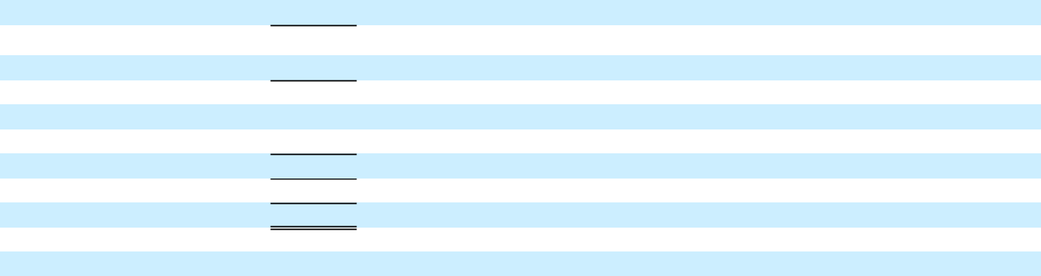

- Reclassifications of $1,685 million and $476 million in the six months ended June 30, 2017 and 2016 for purchases/collections of wholesale finance receivables resulting from vehicles sold by GM to dealers that have arranged their inventory floor plan financing through GM Financial.
- Amounts loaned from GM Financial to Automotive for commercial loans to dealers we consolidate.

13

