Table of Contents

UNITED STATES

SECURITIES AND EXCHANGE COMMISSION
Washington, D.C. 20549

SCHEDULE 14A

Proxy Statement Pursuant to Section 14(a) of the Securities

Exchange Act of 1934

☑ Filed by the Registrant ☐ Filed by a Party other than the Registrant

Check the appropriate box:
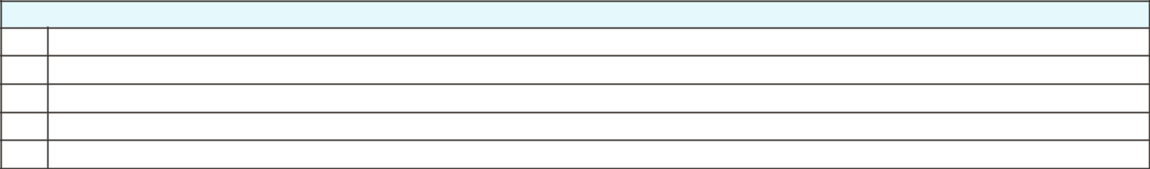

- Preliminary Proxy Statement

- CONFIDENTIAL, FOR USE OF THE COMMISSION ONLY (AS PERMITTED BY RULE 14a-6(e)(2))

- Definitive Proxy Statement

- Definitive Additional Materials

- Soliciting Material under ss.240.14a-12

GENERAL MOTORS COMPANY

300 Renaissance Center, Detroit, Michigan 48265

(Name of Registrant as Specified In Its Charter)

(Name of Person(s) Filing Proxy Statement, if other than the Registrant)

Payment of Filing Fee (Check all boxes that apply):
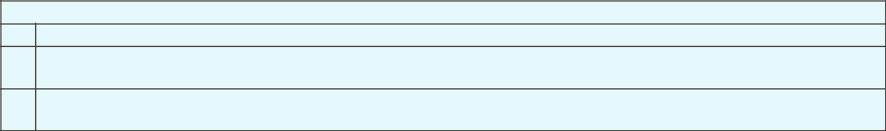

- No fee required

☐

Fee paid previously with preliminary materials

☐

Fee computed on table in exhibit required by Item 25(b) per Exchange Act Rules 14a-6(i)(1) and 0-11

Table of Contents
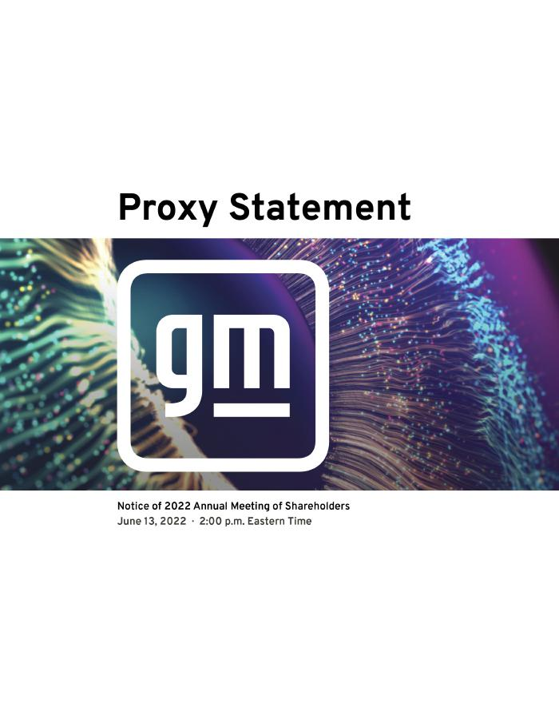

Table of Contents


Table of Contents

NOTICE OF 2022 ANNUAL MEETING OF SHAREHOLDERS

April 29, 2022

Dear Fellow Shareholders:

The Board of Directors of General Motors Company cordially invites you to attend the 2022 Annual Meeting of Shareholders.

At the Annual Meeting, you will be asked to:

- Elect the 12 Board-recommended director nominees named in this Proxy Statement;

- Approve, on an advisory basis, named executive officer compensation;

- Ratify the selection of Ernst & Young LLP as the Company’s independent registered public accounting firm for 2022;

- Vote on Rule 14a-8 shareholder proposals, if properly presented at the meeting; and

- Transact any other business that is properly presented at the meeting.

A list of registered shareholders will be available for examination for any purpose that is germane to the meeting for 10 business days before the Annual Meeting. Shareholders may request to review the list by emailing shareholder.relations@gm.com.

This Proxy Statement is provided in conjunction with GM’s solicitation of proxies to be used at the Annual Meeting. For additional information about how to attend our Annual Meeting, see “General Information About the Annual Meeting” starting on page 92 of this Proxy Statement.

Thank you for your interest in General Motors Company.

By Order of the Board of Directors,


Craig Glidden

Corporate Secretary
300 Renaissance Center

Detroit, Michigan 48265

Meeting Information


Date: June 13, 2022

Time: 2:00 p.m. Eastern Time

Place: Online via live webcast at virtualshareholdermeeting.com/GM2022

Record Date: April 19, 2022

Your Vote Is Important

Please promptly submit your vote by Internet, by telephone, or by signing, dating, and returning the enclosed proxy card or voting instruction form in the postage-paid envelope provided so that your shares will be represented and voted at the meeting.

We are first mailing these proxy materials to our shareholders on or about April 29, 2022.

How to Access the Proxy Materials Online

Important Notice Regarding the Availability of Proxy Materials for the 2022 Annual Meeting of Shareholders to be Held on June 13, 2022:

Our Proxy Statement and 2021 Annual Report are available at investor.gm.com/shareholder. You may also scan the QR code below with your smartphone or other mobile device to view our Proxy Statement and Annual Report.

i

Table of Contents

A MESSAGE FROM OUR CHAIR AND CEO

April 29, 2022

Dear Fellow Shareholders:

General Motors is executing an unprecedented transformation focused on an accelerated transition to electric and autonomous vehicles. As part of this transformation, we have rethought how and, in many cases, where we work. We are laser-focused on delivering the best and broadest portfolio, taking bold actions toward decarbonizing our business, deepening our social impact to create an equitable zero-emissions future, and becoming the most inclusive company in the world.

Powering Growth with Durable Returns

Despite a challenging and uncertain operating environment in 2021, we delivered record full-year financial results, including net income of $10.0 billion and EBIT-adjusted of $ 14.3 billion. Our record 2021 results were made possible by the resilience of the entire GM team, including GM Financial, our union partners, and our suppliers and dealers.

These record results are helping to fund our growth strategy, which is simple: With the customer at the center of everything we do, we are growing by playing to our strengths, staying focused on opportunities beyond the vehicle, and making our people and communities key enablers of our transformation.

Advancing toward our all-electric future is the most critical aspect of our growth strategy and the path to achieve our vision of a world with zero emissions. Last year, after investing billions to develop the Ultium Platform — a combined EV architecture and propulsion system that enables EVs at scale for every lifestyle and price point — we delivered our first Ultium-powered EVs to customers.

Now, backed by our consistently strong financial results and overwhelmingly positive customer response to our EVs, including the GMC HUMMER EV Pickup, the BrightDrop Zevo 600 and Zevo 400, the Wuling Hong Guang Mini EV (the best-selling EV in China), the Cadillac LYRIQ, and the recently revealed Chevrolet Silverado EV and Chevrolet Equinox EV, we are accelerating our plan. As evidence of this acceleration, we recently announced that by the end of 2025, we expect to have more than 2 million units of EV capacity globally — 1 million in North America and another 1 million in China. To meet these targets, we recently announced investments of nearly $7 billion for a significant expansion of battery cell and EV assembly capacity in the United States, expected to create 4,000 new jobs and retain 1,000 others because we believe in bringing everyone along in our transformation.

This investment is just part of our larger commitment to invest more than $35 billion in EVs and AVs from 2020 to 2025. Alongside Ultium, we are investing aggressively in other growth platforms and new businesses, including Cruise, BrightDrop, GM Defense, OnStar Insurance, Ultifi, and more, to drive innovation and create new markets that we believe will help us double our annual revenue by 2030 with expanded margins. Earlier this year, we named Kyle Vogt as the CEO of Cruise. Under his leadership, driverless Cruise test vehicles are rapidly accumulating miles and transporting members of the public throughout San Francisco, and Cruise is one permit away from being able to provide paid ride-hailing services there. We also recently increased our stake in Cruise, which gives us even more flexibility to create value for shareholders as we advance our integrated strategy to commercialize and unlock the full potential of AV technology.

Building a More Sustainable and Equitable Future

With leadership and oversight from our Board, we have also taken steps to ensure that environmental, social, and governance (“ESG”) issues are integrated throughout our business as we aspire to be a change

ii

Table of Contents

leader in our industry. Last year, we announced our plans to be carbon neutral in our global products and operations by 2040 and to eliminate tailpipe emissions from new light-duty vehicles globally by 2035. We also set SBTi-validated science-based emission reduction targets for scope 1, 2, and 3 emissions that align with the most ambitious goals of the Paris Agreement. We also announced our plan to source 100 percent renewable energy to power our U.S. facilities by 2025 — five years ahead of our previous target (and 25 years ahead of our initial target) — and globally by 2035.

Shaped in part by feedback we heard during our recent engagements with a wide variety of stakeholders, including director-led engagements with our institutional investors, we are also focused on how we execute our growth strategy and reach our environmental objectives. We continue to strengthen our progress and accountability on diversity, equity, and inclusion (“DE&I”) throughout our business. For example, last year we continued to bolster our Board’s expertise and diversity through the addition of Margaret (“Meg”) Whitman, Mark Tatum, and Aneel Bhusri. As a result, half of our Board nominees this year are women and one-third are racially or ethnically diverse.

But our progress goes beyond our Board. In 2021, we created a Work Appropriately policy to give most office-based employees flexibility in where they work, incorporated monthly DE&I learning modules for our global leaders, and launched an internal Inclusivity Index metric to measure our progress on inclusion. We also demonstrated improvement year-over-year in all diversity segments, including 29 percent and 26 percent growth in Asian and African American executives, respectively. In addition, our publicly released Consolidated EEO-1 Report established GM as the Detroit-area lead for OneTen (a consortium of companies that have committed to creating career opportunities for 1 million Black Americans over the next 10 years), and exceeded our OneTen hiring commitment by 100 percent. This year, we’ve also updated our executive compensation program to better link the long-term compensation of our executives to our EV strategy and enhanced our disclosure in this Proxy Statement to provide additional transparency about how we set and measure short-term incentive compensation, including with respect to ESG goals.

Lastly, Jane Mendillo has informed us that she has decided not to stand for re-election and will retire from our Board following the Annual Meeting. The Board is grateful for Jane’s invaluable service and significant contributions to GM over the past six years — particularly her insights that helped guide the development of our capital allocation strategy and accelerate the Company’s EV future.

We appreciate your continued commitment to GM, and we look forward to your attendance at our 2022 Annual Meeting of Shareholders on June 13, 2022, at 2:00 p.m. Eastern time.

Sincerely,


Mary T. Barra

Chair and Chief Executive Officer
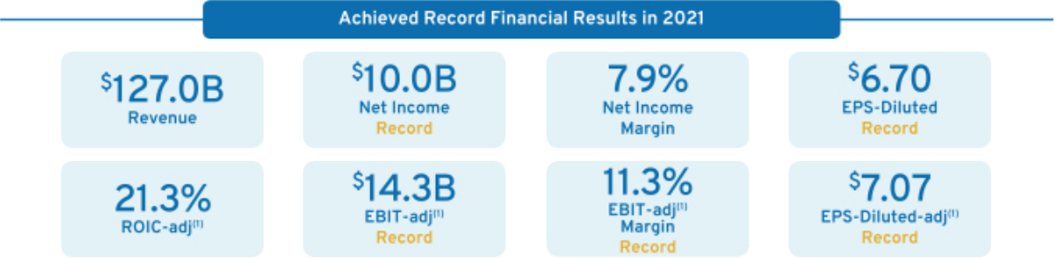

- These are non-GAAP financial measures. Refer to Appendix A for a reconciliation of ROIC-adjusted, EBIT-adjusted, EBIT-adjusted Margin, and EPS-Diluted-adjusted to their closest comparable GAAP measure.

iii

Table of Contents

HELPFUL RESOURCES

Annual Meeting: investor.gm.com/shareholder

2022 Proxy Statement

2021 Annual Report

Governance Documents: investor.gm.com/resources

Board Committee Charters

Bylaws and Certificate of Incorporation

Corporate Governance Guidelines

Compliance Documents: investor.gm.com/resources

Company Policy on Corporate Political Contributions GM’s Code of Conduct: “Winning with Integrity” Policy on Recoupment of Incentive Compensation Related Party Transactions Policy Insider Trading Policy

ESG Policies: investor.gm.com/resources

Anti-Harassment Policy

Conflict Minerals Policy

Environmental Policy

Human Rights Policy

Global Integrity Policy

Supplier Code of Conduct

Political Contributions & Lobbying Disclosures:

investor.gm.com/resources

Voluntary Report of 2021 Political Contributions

Public Policy Supplement to April 2021 Sustainability Report

U.S. Political Engagement Overview, Priorities, and Trade Association Disclosures

Sustainability Report: gmsustainability.com

Investor Relations: investor.gm.com

DEFINED TERMS AND COMMONLY USED ACRONYMS

AAFCF | Adjusted Automotive Free Cash Flow
Annual Meeting | GM’s Annual Meeting of Shareholders to be held
 | on June 13, 2022
AV | Autonomous Vehicle
Board | GM’s Board of Directors
CEO | Chief Executive Officer
CFO | Chief Financial Officer
Code of Conduct | GM’s Code of Conduct: “Winning with Integrity”
Committees | Audit Committee
 | Executive Committee
 | Executive Compensation Committee
 | Finance Committee
 | Governance and Corporate Responsibility
 | Committee
 | Risk and Cybersecurity Committee
Compensation | Executive Compensation Committee
Committee
DB | Defined Benefit
DC | Defined Contribution
DE&I | Diversity, Equity, and Inclusion
Director | General Motors Company Deferred Compensation
Compensation Plan Plan for Non-Employee Directors
DSU | Deferred Share Unit
EBIT | Earnings Before Interest and Taxes
EPS | Earnings Per Share
ESG | Environmental, Social, and Governance
EUV | Electric Utility Vehicle
EV | Electric Vehicle

EY | Ernst & Young LLP
GAAP | Generally Accepted Accounting Principals
GHG | Greenhouse Gas
GICS | Global Industry Classification Standard
GM or the Company General Motors Company
GMI | GM International
GMNA | General Motors North America
Governance | Governance and Corporate Responsibility
Committee | Committee
LTIP | Long-Term Incentive Plan
M&A | Mergers and Acquisitions
NEO | Named Executive Officer
NQ | Nonqualified
NYSE | New York Stock Exchange
OEM | Original Equipment Manufacturer
PSU | Performance Share Unit
ROIC | Return on Invested Capital
RSU | Restricted Stock Unit
SEC | U.S. Securities and Exchange Commission
SBTi | Science-Based Targets Initiative
Senior Leadership | Certain members of management who report
Team | directly to the CEO or the President
STIP | Short-Term Incentive Plan
TSR | Total Shareholder Return
WACC | Weighted Average Cost of Capital

Cautionary Note on Forward-Looking Statements: This Proxy Statement may include “forward-looking statements” within the meaning of the U.S. federal securities laws. Forward-looking statements are any statements other than statements of historical fact. Forward-looking statements represent our current judgement about possible future events. In making these statements, we rely upon assumptions and analysis based on our experience and perception of historical trends, current conditions, and expected future developments, as well as other factors we consider appropriate under the circumstances. We believe these judgements are reasonable, but these statements are not guarantees of any future events or financial results, and our actual results may differ materially due to a variety of factors, many of which are described in our most recent Annual Report on Form 10-K and our other filings with the U.S. Securities and Exchange Commission. We caution readers not to place undue reliance on forward-looking statements. Forward-looking statements speak only as of the date they are made, and we undertake no obligation to update publicly or otherwise revise any forward-looking statements, whether as a result of new information, future events, or other factors that affect the subject of these statements, except where we are expressly required to do so by law.

iv

Table of Contents

TABLE OF CONTENTS

PROXY VOTING ROADMAP |  |  |  |  |  |  |  |  |  |  |  |  |  |  |  |  |  |  |  |  |  |  |  |  |  |  |  |  |  |  |  |  |  |  |  |  |  |  |  |  |  |  |  |  |  | 1
ITEM NO. 1 – ANNUAL ELECTION OF DIRECTORS |  |  |  |  |  |  |  |  |  |  |  |  |  |  |  |  |  |  |  |  |  |  |  |  |  |  |  |  |  |  |  |  |  |  |  |  |  |  |  |  |  |  |  |  |  | 2
Snapshot of Our Board Nominees |  |  |  |  |  |  |  |  |  |  |  |  |  |  |  |  |  |  |  |  |  |  |  |  |  |  |  |  |  |  |  |  |  |  |  |  |  |  |  |  |  |  |  |  |  | 3
Board Experience and Expertise |  |  |  |  |  |  |  |  |  |  |  |  |  |  |  |  |  |  |  |  |  |  |  |  |  |  |  |  |  |  |  |  |  |  |  |  |  |  |  |  |  |  |  |  |  | 5
 | Skills Matrix |  |  |  |  |  |  |  |  |  |  |  |  |  |  |  |  |  |  |  |  |  |  |  |  |  |  |  |  |  |  |  |  |  |  |  |  |  |  |  |  |  |  |  |  | 5
 | Director Biographies |  |  |  |  |  |  |  |  |  |  |  |  |  |  |  |  |  |  |  |  |  |  |  |  |  |  |  |  |  |  |  |  |  |  |  |  |  |  |  |  |  |  |  |  | 7
 |  |  |  |  |  |  |  |  |  |  |  |  |  |  |  |  |  |  |  |  |  |  |  |  |  |  |  |  |  |  |  |  |  |  |  |  |  |  |  |  |  |  |  |  |  | 13
Board Membership Criteria, Refreshment, and Succession Planning |  |  |  |  |  |  |  |  |  |  |  |  |  |  |  |  |  |  |  |  |  |  |  |  |  |  |  |  |  |  |  |  |  |  |  |  |  |  |  |  |  |  |  |  |  | 13
Non-Employee Director Compensation |  |  |  |  |  |  |  |  |  |  |  |  |  |  |  |  |  |  |  |  |  |  |  |  |  |  |  |  |  |  |  |  |  |  |  |  |  |  |  |  |  |  |  |  |  | 14
CORPORATE GOVERNANCE |  |  |  |  |  |  |  |  |  |  |  |  |  |  |  |  |  |  |  |  |  |  |  |  |  |  |  |  |  |  |  |  |  |  |  |  |  |  |  |  |  |  |  |  |  | 19
The Board of Directors |  |  |  |  |  |  |  |  |  |  |  |  |  |  |  |  |  |  |  |  |  |  |  |  |  |  |  |  |  |  |  |  |  |  |  |  |  |  |  |  |  |  |  |  |  | 19
 |  |  |  |  |  |  |  |  |  |  |  |  |  |  |  |  |  |  |  |  |  |  |  |  |  |  |  |  |  |  |  |  |  |  |  |  |  |  |  |  |  |  |  |  |  | 20
Board Leadership Structure and Composition |  |  |  |  |  |  |  |  |  |  |  |  |  |  |  |  |  |  |  |  |  |  |  |  |  |  |  |  |  |  |  |  |  |  |  |  |  |  |  |  |  |  |  |  |  | 20
Board Committees |  |  |  |  |  |  |  |  |  |  |  |  |  |  |  |  |  |  |  |  |  |  |  |  |  |  |  |  |  |  |  |  |  |  |  |  |  |  |  |  |  |  |  |  |  | 21
 |  |  |  |  |  |  |  |  |  |  |  |  |  |  |  |  |  |  |  |  |  |  |  |  |  |  |  |  |  |  |  |  |  |  |  |  |  |  |  |  |  |  |  |  |  | 25
Board and Committee Oversight of Risk |  |  |  |  |  |  |  |  |  |  |  |  |  |  |  |  |  |  |  |  |  |  |  |  |  |  |  |  |  |  |  |  |  |  |  |  |  |  |  |  |  |  |  |  |  | 25
The Board’s Governance Policies and |  |  |  |  |  |  |  |  |  |  |  |  |  |  |  |  |  |  |  |  |  |  |  |  | Practices |  |  |  |  |  |  |  |  |  |  |  |  |  |  |  |  |  |  |  |  | 27
Shareholder Engagement |  |  |  |  |  |  |  |  |  |  |  |  |  |  |  |  |  |  |  |  |  |  |  |  |  |  |  |  |  |  |  |  |  |  |  |  |  |  |  |  |  |  |  |  |  | 30
Shareholder Protections |  |  |  |  |  |  |  |  |  |  |  |  | and Governance Best Practices |  |  |  |  |  |  |  |  |  |  |  |  |  |  |  |  |  |  |  |  |  |  |  |  |  |  |  |  |  |  |  |  | 32
Corporate Political Contributions and Lobbying Expenditures |  |  |  |  |  |  |  |  |  |  |  |  |  |  |  |  |  |  |  |  |  |  |  |  |  |  |  |  |  |  |  |  |  |  |  |  |  |  |  |  |  |  |  |  |  | 33
Certain Relationships and Related Party Transactions |  |  |  |  |  |  |  |  |  |  |  |  |  |  |  |  |  |  |  |  |  |  |  |  |  |  |  |  |  |  |  |  |  |  |  |  |  |  |  |  |  |  |  |  |  | 34
OUR PURPOSE, OUR VALUES, AND OUR BEHAVIORS |  |  |  |  |  |  |  |  |  |  |  |  |  |  |  |  |  |  |  |  |  |  |  |  |  |  |  |  |  |  |  |  |  |  |  |  |  |  |  |  |  |  |  |  |  | 36
SOCIAL AND ENVIRONMENTAL HIGHLIGHTS |  |  |  |  |  |  |  |  |  |  |  |  |  |  |  |  |  |  |  |  |  |  |  |  |  |  |  |  |  |  |  |  |  |  |  |  |  |  |  |  |  |  |  |  |  | 37
Our People |  |  |  |  |  |  |  |  |  |  |  |  |  |  |  |  |  |  |  |  |  |  |  |  |  |  |  |  |  |  |  |  |  |  |  |  |  |  |  |  |  |  |  |  |  | 37
 |  |  |  |  |  |  |  |  |  |  |  |  |  |  |  |  |  |  |  |  |  |  |  |  |  |  |  |  |  |  |  |  |  |  |  |  |  |  |  |  |  |  |  |  |  | 39
Our Communities |  |  |  |  |  |  |  |  |  |  |  |  |  |  |  |  |  |  |  |  |  |  |  |  |  |  |  |  |  |  |  |  |  |  |  |  |  |  |  |  |  |  |  |  |  | 39
Our Environment |  |  |  |  |  |  |  |  |  |  |  |  |  |  |  |  |  |  |  |  |  |  |  |  |  |  |  |  |  |  |  |  |  |  |  |  |  |  |  |  |  |  |  |  |  | 39
SECURITY OWNERSHIP INFORMATION |  |  |  |  |  |  |  |  |  |  |  |  |  |  |  |  |  |  |  |  |  |  |  |  |  |  |  |  |  |  |  |  |  |  |  |  |  |  |  |  |  |  |  |  |  | 41
AUDIT COMMITTEE REPORT |  |  |  |  |  |  |  |  |  |  |  |  |  |  |  |  |  |  |  |  |  |  |  |  |  |  |  |  |  |  |  |  |  |  |  |  |  |  |  |  |  |  |  |  |  | 43
Fees Paid to Independent Registered Public Accounting Firm |  |  |  |  |  |  |  |  |  |  |  |  |  |  |  |  |  |  |  |  |  |  |  |  |  |  |  |  |  |  |  |  |  |  |  |  |  |  |  |  |  |  |  |  |  | 45
EXECUTIVE COMPENSATION |  |  |  |  |  |  |  |  |  |  |  |  |  |  |  |  |  |  |  |  |  |  |  |  |  |  |  |  |  |  |  |  |  |  |  |  |  |  |  |  |  |  |  |  |  | 46
Our Company Performance |  |  |  |  |  |  |  |  |  |  |  |  |  |  |  |  |  |  |  |  |  |  |  |  |  |  |  |  |  |  |  |  |  |  |  |  |  |  |  |  |  |  |  |  |  | 47
Compensation Overview |  |  |  |  |  |  |  |  |  |  |  |  |  |  |  |  |  |  |  |  |  |  |  |  |  |  |  |  |  |  |  |  |  |  |  |  |  |  |  |  |  |  |  |  |  | 49
Compensation Principles |  |  |  |  |  |  |  |  |  |  |  |  |  |  |  |  |  |  |  |  |  |  |  |  |  |  |  |  |  |  |  |  |  |  |  |  |  |  |  |  |  |  |  |  |  | 55
Compensation Elements |  |  |  |  |  |  |  |  |  |  |  |  |  |  |  |  |  |  |  |  |  |  |  |  |  |  |  |  |  |  |  |  |  |  |  |  |  |  |  |  |  |  |  |  |  | 55
Performance Measures |  |  |  |  |  |  |  |  |  |  |  |  |  |  |  |  |  |  |  |  |  |  |  |  |  |  |  |  |  |  |  |  |  |  |  |  |  |  |  |  |  |  |  |  |  | 57
Performance Results and Compensation Decisions |  |  |  |  |  |  |  |  |  |  |  |  |  |  |  |  |  |  |  |  |  |  |  |  |  |  |  |  |  |  |  |  |  |  |  |  |  |  |  |  |  |  |  |  |  | 60
Compensation Policies and Governance Practices |  |  |  |  |  |  |  |  |  |  |  |  |  |  |  |  |  |  |  |  |  |  |  |  |  |  |  |  |  |  |  |  |  |  |  |  |  |  |  |  |  |  |  |  |  | 66
Compensation Committee Report |  |  |  |  |  |  |  |  |  |  |  |  |  |  |  |  |  |  |  |  |  |  |  |  |  |  |  |  |  |  |  |  |  |  |  |  |  |  |  |  |  |  |  |  |  | 69
Executive Compensation Tables |  |  |  |  |  |  |  |  |  |  |  |  |  |  |  |  |  |  |  |  |  |  |  |  |  |  |  |  |  |  |  |  |  |  |  |  |  |  |  |  |  |  |  |  |  | 70
CEO Pay Ratio |  |  |  |  |  |  |  |  |  |  |  |  |  |  |  |  |  |  |  |  |  |  |  |  |  |  |  |  |  |  |  |  |  |  |  |  |  |  |  |  |  |  |  |  |  | 81
Equity Compensation Plan Information |  |  |  |  |  |  |  |  |  |  |  |  |  |  |  |  |  |  |  |  |  |  |  |  |  |  |  |  |  |  |  |  |  |  |  |  |  |  |  |  |  |  |  |  |  | 82
ITEM NO. 2 – PROPOSAL TO APPROVE, ON AN ADVISORY BASIS, NAMED EXECUTIVE OFFICER COMPENSATION |  |  |  |  |  |  |  |  |  |  |  |  |  |  |  |  |  |  |  |  |  |  |  |  |  |  |  |  |  |  |  |  |  |  |  |  |  |  |  |  |  |  |  |  |  | 83
ITEM NO. 3 – PROPOSAL TO RATIFY THE SELECTION OF ERNST & YOUNG LLP AS THE COMPANY’S INDEPENDENT |  |  |  |  |  |  |  |  |  |  |  |  |  |  |  |  |  |  |  |  |  |  |  |  |  |  |  |  |  |  |  |  |  |  |  |  |  |  |  |  |  |  |  |  |  | 85
 |  |  | REGISTERED PUBLIC ACCOUNTING FIRM FOR 2022 |  |  |  |  |  |  |  |  |  |  |  |  |  |  |  |  |  |  |  |  |  |  |  |  |  |  |  |  |  |  |  |  |  |  |  |  |  |  |  |  |  |  | 85
ITEM NO. 4 – SHAREHOLDER PROPOSAL TO LOWER THE OWNERSHIP THRESHOLD TO CALL A SPECIAL MEETING |  |  |  |  |  |  |  |  |  |  |  |  |  |  |  |  |  |  |  |  |  |  |  |  |  |  |  |  |  |  |  |  |  |  |  |  |  |  |  |  |  |  |  |  |  | 86
ITEM NO. 5 – SHAREHOLDER PROPOSAL REGARDING SEPARATION OF CHAIR AND CEO ROLES |  |  |  |  |  |  |  |  |  |  |  |  |  |  |  |  |  |  |  |  |  |  |  |  |  |  |  |  |  |  |  |  |  |  |  |  |  |  |  |  |  |  |  |  |  | 88
ITEM NO. 6 – SHAREHOLDER PROPOSAL REQUESTING A REPORT ON THE USE OF CHILD LABOR IN CONNECTION |  |  |  |  |  |  |  |  |  |  |  |  |  |  |  |  |  |  |  |  |  |  |  |  |  |  |  |  |  |  |  |  |  |  |  |  |  |  |  |  |  |  |  |  |  | 90
 |  |  | WITH ELECTRIC VEHICLES |  |  |  |  |  |  |  |  |  |  |  |  |  |  |  |  |  |  |  |  |  |  |  |  |  |  |  |  |  |  |  |  |  |  |  |  |  |  |  |  |  |  | 90
GENERAL INFORMATION ABOUT THE ANNUAL MEETING |  |  |  |  |  |  |  |  |  |  |  |  |  |  |  |  |  |  |  |  |  |  |  |  |  |  |  |  |  |  |  |  |  |  |  |  |  |  |  |  |  |  |  |  |  | 92
APPENDIX A: NON-GAAP FINANCIAL MEASURES |  |  |  |  |  |  |  |  |  |  |  |  |  |  |  |  |  |  |  |  |  |  |  |  |  |  |  |  |  |  |  |  |  |  |  |  |  |  |  |  |  |  |  |  |  | A-1

v

Table of Contents

[THIS PAGE INTENTIONALLY LEFT BLANK]

Table of Contents

PROXY VOTING ROADMAP

Shareholders will be asked to vote on the following matters at the Annual Meeting of Shareholders:

 |  | BOARD VOTE | PAGE
 | VOTING MATTER | RECOMMENDATION | REFERENCE
Item 1: | Annual Election of Directors | FOR | 2
Item 1: | Annual Election of Directors | each director nominee | 2
Item 2: | Proposal to Approve, on an Advisory Basis, Named Executive | FOR | 83
 | Officer Compensation | FOR | 83
Item 3: | Proposal to Ratify the Selection of Ernst & Young LLP as the | FOR | 85
 | Company’s Independent Registered Public Accounting Firm for | FOR | 85
 | 2022
Item 4: | Shareholder Proposal to Lower the Ownership Threshold to Call | AGAINST | 86
 | a Special Meeting | AGAINST | 86
Item 5: | Shareholder Proposal Regarding Separation of Chair and CEO | AGAINST | 88
 | Roles | AGAINST | 88
Item 6: | Shareholder Proposal Requesting a Report on the Use of Child | AGAINST | 90
 | Labor in Connection with Electric Vehicles | AGAINST | 90
 |  |  | 1

Table of Contents

ITEM NO. 1: ANNUAL ELECTION OF DIRECTORS

At the Annual Meeting, 12 directors will be nominated for election to GM’s Board of Directors. The Governance Committee evaluated the nominees in accordance with the Committee’s charter and our Corporate Governance Guidelines and submitted the nominees to the full Board for approval. Other than Aneel Bhusri, who was elected to the Board in October 2021, all of the nominees were elected at the 2021 Annual Meeting.

If elected, the directors will serve on the Board until the next annual meeting of shareholders, or until their successors are duly elected and qualified, or until their earlier resignation or removal. If any nominee becomes unable to serve, proxies will be voted for the election of such other person as the Board may designate unless the Board chooses to reduce the number of directors standing for re-election. Each of the directors has consented to being named in this Proxy Statement and serving on the Board if elected.

The Board believes that GM has the right Board at the right time and that these director nominees collectively possess the right mix of skills, qualifications, and experience to make strategic decisions that strengthen our business today and position it for long-term success.

Further information on the Board’s composition, as well as each nominee’s qualifications and relevant experience, are provided on the following pages.

The Board recommends a vote FOR each of the nominees identified on
the following pages. | FOR

2

Table of Contents

Snapshot of Our Board Nominees

 | Director
Name & Principal Occupation | Age Since Independent Committee Memberships


Mary T. Barra

Chair & Chief Executive Officer | 60 | 2014 | Executive – Chair
General Motors Company


Aneel Bhusri
Chairman, Co-Founder & Co-Chief Executive Officer | 56 | 2021 | None
Workday, Inc.


Wesley G. Bush |  |  | Audit
Retired Chairman & Chief Executive Officer | 61 | 2019 | Compensation
Northrop Grumman Corporation |  |  | Finance
Linda R. Gooden |  |  | Audit
Retired Executive Vice President, |  |  | Audit
Retired Executive Vice President, | 69 | 2015 | Executive
Information Systems & Global Solutions | 69 | 2015 | Executive
Information Systems & Global Solutions |  |  | Risk and Cybersecurity – Chair
Lockheed Martin Corporation |  |  | Risk and Cybersecurity – Chair
Joseph Jimenez |  |  | Compensation
Joseph Jimenez | 62 | 2015 | Executive
Retired Chief Executive Officer | 62 | 2015 | Executive
Retired Chief Executive Officer | 62 | 2015 | Finance – Chair
Novartis AG |  |  | Finance – Chair
Novartis AG |  |  | Risk and Cybersecurity
Judith A. Miscik | 63 | 2018 | Finance
Chief Executive Officer & Vice Chairman | 63 | 2018 | Finance
Chief Executive Officer & Vice Chairman | 63 | 2018 | Risk and Cybersecurity
Kissinger Associates, Inc. |  |  | Risk and Cybersecurity
Patricia F. Russo |  |  | Compensation
Patricia F. Russo | 69 | 2009 | Executive
Chair | 69 | 2009 | Executive
Chair | 69 | 2009 | Finance
Hewlett Packard Enterprise Company |  |  | Finance
Hewlett Packard Enterprise Company |  |  | Governance – Chair
Thomas M. Schoewe |  |  | Audit – Chair
Retired Executive Vice President & | 69 | 2011 | Executive
Chief Financial Officer | 69 | 2011 | Finance
Wal-Mart Stores, Inc. |  |  | Risk and Cybersecurity
Carol M. Stephenson |  |  | Compensation – Chair
Retired Dean |  |  | Compensation – Chair
Retired Dean | 71 | 2009 | Executive
Ivey Business School, | 71 | 2009 | Executive
Ivey Business School, |  |  | Governance
The University of Western Ontario |  |  | Governance
Mark A. Tatum | 52 | 2021 | Audit
Deputy Commissioner & Chief Operating Officer | 52 | 2021 | Audit
Deputy Commissioner & Chief Operating Officer | 52 | 2021 | Governance
National Basketball Association |  |  | Governance
Devin N. Wenig | 55 | 2018 | Risk and Cybersecurity
Retired President & Chief Executive Officer | 55 | 2018 | Risk and Cybersecurity
eBay Inc.
Margaret C. Whitman | 65 | 2021 | Compensation
Retired President & Chief Executive Officer | 65 | 2021 | Compensation
Retired President & Chief Executive Officer | 65 | 2021 | Governance
Hewlett Packard Enterprise |  |  | Governance









3

Table of Contents

- 2022 Board Nominee Statistics
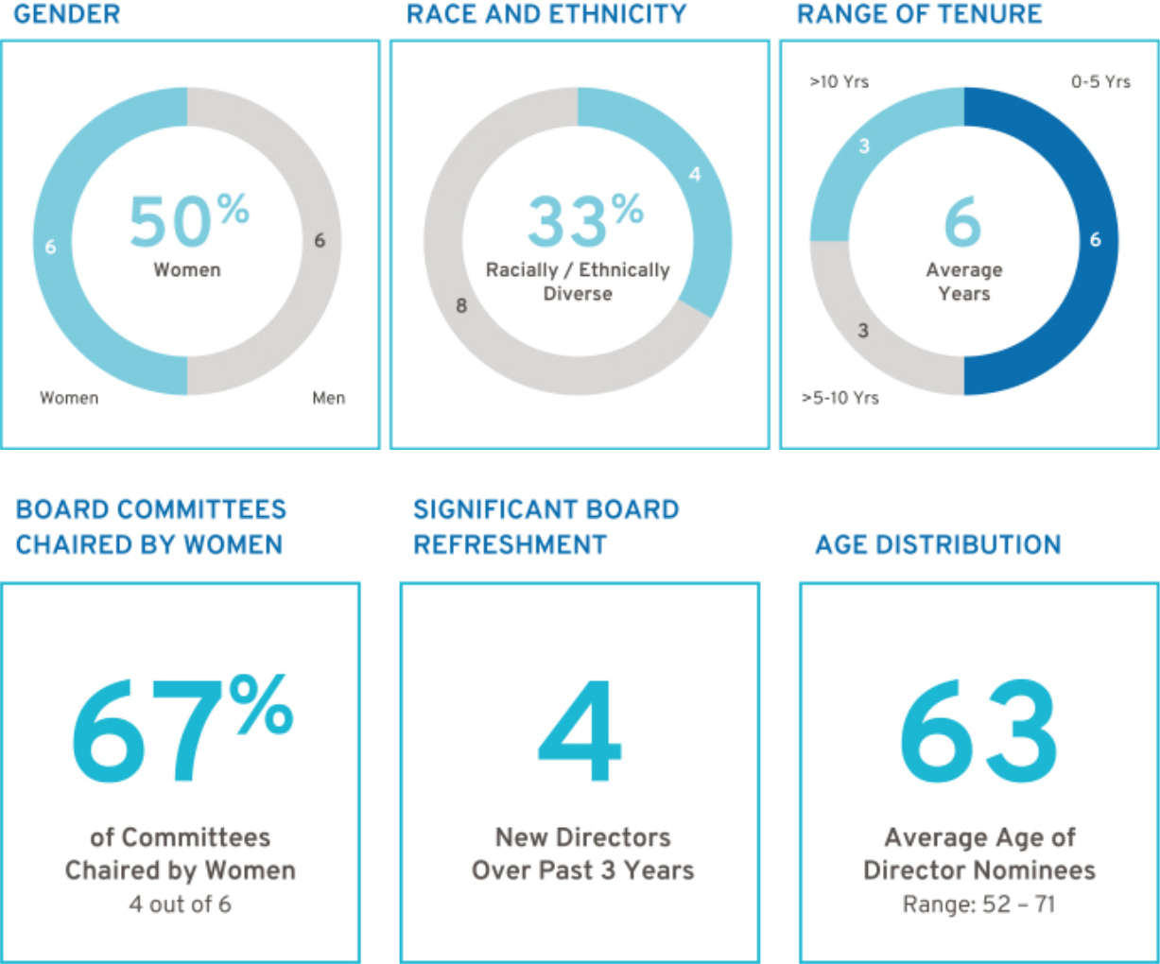

4

Table of Contents

Board Experience and Expertise

- Skills Matrix

Our director nominees collectively possess the expertise, leadership skills, and diversity of experiences and backgrounds to oversee management’s execution of its growth strategy and protect long-term shareholder value. The skills matrix below summarizes the qualifications of our director nominees and more detailed information can be found in the director biographies beginning on page 7.

 | Senior |  |  |  | Risk |  |  | ESG
Director | Leadership | Industry | Manufacturing | Technology | Management | Global | Finance | Government Marketing Cyber Expertise
M. Barra |  |  |  |  |  |  |  | SG

A. Bhusri
W. Bush
L. Gooden
J. Jimenez
J. Miscik
P. Russo
T. Schoewe
C. Stephenson
M. Tatum
D. Wenig
M. Whitman

SG

ESG

SG

EG

G

SG

G

SG

SG

G

ESG

5

Table of Contents

- 2021 Enhancement: ESG Self-Evaluation

Last year, the Board conducted a formal ESG self-evaluation. The evaluation was designed to ensure that the Board possesses the requisite skills and expertise to oversee the Company’s ESG opportunities, priorities, and risks. The Governance Committee, led by our Independent Lead Director, spearheaded this effort by asking directors to consider their expertise across the following key ESG subject matter areas:

- Environmental: Greenhouse gas emissions; raw material sources; the physical impacts of climate change; air quality; waste and hazardous materials management; product design and lifecycle management; water and wastewater management; energy efficiency management; and ecological impacts.

- Social: DE&I; data privacy; human rights; community relations; workplace health and safety; supply chain management; human capital management; consumer privacy; product quality and safety; and labor practices.

- Governance: Public company board governance; legal and regulatory matters; executive compensation; compliance and business ethics; anti-competitive practices; risk management; and ESG reporting principles and frameworks (e.g., Task Force on Climate-Related Financial Disclosures; Value Reporting Foundation).

Upon the conclusion of this evaluation, the Board determined that it has strong ESG expertise and possesses a broad range of skills, qualifications, and attributes that will support the Company’s ambitious EV transition, growth strategy, and sustainability and DE&I goals. The Board further determined it would not benefit at this time from adding a “special purpose” director exclusively on the basis of ESG criteria. The Board believes that it makes decisions as a group and has a collective responsibility to make informed decisions on a deliberative basis on all issues, including those related to ESG.

Results of the Board’s ESG self-evaluation are represented on the Board’s skill matrix above. Additional ESG insights are provided for each director nominee beginning on page 7 of this Proxy Statement under the heading “Director Biographies.” The Board intends to continue this practice going forward to ensure the Board remains an asset to the Company and its management team with respect to emerging ESG issues.

6

Table of Contents
u | Director Biographies
 |  | Director Since: 2014 | Director Since: 2009
 |  | Age: 60 | Age: 69
 |  | Independent: No | Independent: Yes
 |  | Gender: Female | Gender: Female
 |  | Race/Ethnicity: White | Race/Ethnicity: White



Mary T. Barra

Chair & CEO,

General Motors Company

Committees: Executive (Chair)

Other Public Company Directorships: The Walt Disney

Company

Prior Public Company Directorships: General

Dynamics Corporation

Prior Experience: Ms. Barra is Chair and CEO of General Motors. She has served as Chair of the Board of Directors since January 2016 and has served as CEO since January 2014. Prior to becoming CEO, Ms. Barra served as GM’s Executive Vice President, Global Product Development, Purchasing and Supply Chain from 2013 to 2014; Senior Vice President, Global Product Development from 2011 to 2013; Vice President, Global Human Resources from 2009 to 2011; and Vice President, Global Manufacturing Engineering from 2008 to 2009. Ms. Barra began her career with GM in 1980.

Reasons for Nomination: Ms. Barra has in-depth knowledge of the Company and the global automotive industry; extensive senior leadership, strategic planning, operational, and business experience; and a strong engineering background with experience in global product development.

Spotlight on ESG Expertise: Ms. Barra has developed social expertise – in particular, workplace health and safety – during her career at GM, which has included various executive roles in manufacturing and plant management. As Chair and CEO, she has initiated many workplace safety process improvements and holds herself and the leadership team accountable for the personal safety of GM employees. GM benefits from Ms. Barra’s experience in this area as it seeks to create a world with zero crashes.

Patricia F. Russo

Chair,

Hewlett Packard Enterprise Company

Committees: Compensation, Executive, Finance, Governance (Chair)

Other Public Company Directorships: Hewlett Packard Enterprise Company (Chair), KKR Management LLC, and Merck & Co. Inc.

Prior Public Company Directorships: Hewlett-Packard

Company and Arconic, Inc.

Prior Experience: Ms. Russo served as Lead Director of Hewlett-Packard Company’s board of directors from 2014 to 2015. She was GM’s Independent Lead Director from March 2010 to January 2014, and in 2021 she was re-appointed to that role. Ms. Russo served as CEO of Alcatel -Lucent S.A. from 2006 to 2008; Chairman and CEO of Lucent Technologies, Inc. (“Lucent”) from 2003 to 2006; and President and CEO of Lucent from 2002 to 2006.

Reasons for Nomination: Ms. Russo has extensive senior leadership experience in corporate strategy, finance, sales and marketing, technology, and leadership development, as well as experience managing business-critical technology disruptions.

Spotlight on ESG Expertise: Ms. Russo has developed governance expertise – in particular, board governance – during her tenure as chair of Hewlett Packard Enterprise Company and service on the JUST Capital board. In these capacities, among others, she advocates for enhanced ESG standards for directors and the inclusion of ESG metrics to drive strategic decisions. GM benefits from Ms. Russo’s experience as it works to continue to provide ESG disclosures that are meaningful to our investors and other stakeholders.

7

Table of Contents


Director Since: 2021
Age: 56
Independent: Yes
Gender: Male
Race/Ethnicity: Indian
American

Aneel Bhusri

Chairman, Co-Founder & Co-CEO,

Workday, Inc.

Committees: None

Other Public Company Directorships: Workday, Inc.

Prior Public Company Directorships: Okta, Inc., Cloudera, Inc., Pure Storage, Inc., and Intel Corporation

Prior Experience: Mr. Bhusri is a Co-Founder and Co-CEO of Workday, Inc. (“Workday”) and Chairman of its board. Before co-founding Workday in 2005, he held a number of leadership positions at PeopleSoft, Inc., including serving as Vice Chairman of the board and Senior Vice President responsible for product strategy, business development, and marketing. In addition to his role at Workday, Mr. Bhusri is an advisor at Greylock Partners, a leading venture capital firm.

Reasons for Nomination: Mr. Bhusri has extensive expertise in software, technology, and fostering growth companies from the start-up phase into mature, public companies. He also has strong leadership experience gained through his role as the CEO of a large, public technology company.

Spotlight on ESG Expertise: Mr. Bhusri has developed social expertise as the Co-Founder and Co-CEO of Workday. In that capacity, he advocates for human capital management solutions that focus, in part, on employee engagement. GM benefits from Mr. Bhusri’s experience in this area as it takes steps to be the most inclusive company in the world and seeks to minimize the impacts of the transition to EVs on employees.

8

Director Since: 2019

Age: 61
Independent: Yes
Gender: Male
Race/Ethnicity: White

Wesley G. Bush

Retired Chairman & CEO,

Northrop Grumman Corporation

Committees: Audit, Compensation, Finance

Other Public Company Directorships: Dow Inc. and Cisco

Systems Inc.

Prior Public Company Directorships: Norfolk Southern Corporation and Northrop Grumman Corporation (“Northrop Grumman”)

Prior Experience: Mr. Bush served as Chairman of Northrop Grumman’s board of directors from 2011 to 2019. He also served as the CEO of Northrop Grumman from 2010 to 2018. Prior to that, Mr. Bush served in numerous leadership roles at Northrop Grumman, including President and Chief Operating Officer, Chief Financial Officer, and President of the company’s Space Technology sector. He also served in a variety of leadership positions at TRW, Inc., before it was acquired by Northrop Grumman in 2002.

Reasons for Nomination: Mr. Bush has valuable experience in leading a manufacturing enterprise known for its advanced engineering and technology. He also has strong financial acumen gained through his finance leadership roles and has knowledge of key governance issues, including risk management.

Spotlight on ESG Expertise: Mr. Bush has developed environmental expertise as a member of the board of Conservation International. In that capacity, he leverages his scientific training to advocate for natural climate solutions. GM benefits from Mr. Bush’s experience in this area as it seeks to create a world with zero emissions.

Table of Contents


Director Since: 2015
Age: 69
Independent: Yes
Gender: Female
Race/Ethnicity: African
American

Linda R. Gooden

Retired Executive Vice President, Information Systems & Global Solutions, Lockheed Martin Corporation

Committees: Audit, Executive, Risk and Cybersecurity (Chair)

Other Public Company Directorships: The Home Depot Inc. and Bright Health Group, Inc.

Prior Public Company Directorships: WGL Holdings, Inc., Washington Gas & Light Company, a subsidiary of WGL Holdings, Inc., and Automatic Data Processing, Inc.

Prior Experience: Ms. Gooden served as Executive Vice President, Information Systems and Global Solutions of Lockheed Martin Corporation (“Lockheed Martin”) from 2007 to 2013. She also served as Lockheed Martin’s Deputy Executive Vice President, Information and Technology Services from October to December 2006, and as its President, Information Technology from 1997 to December 2006.

Reasons for Nomination: Ms. Gooden has strong leadership capabilities demonstrated through her various senior leadership positions at Lockheed Martin. She also has significant expertise in operations and strategic planning, as well as an extensive background in information technology and cybersecurity.

Spotlight on ESG Expertise: Ms. Gooden developed social expertise through her leadership in the cybersecurity industry. In that capacity, she leverages her technical training to advocate for stringent privacy and data protection controls. GM benefits from Ms. Gooden’s experience in this area as it develops innovative software and autonomous driving solutions.

Director Since: 2015

Age: 62
Independent: Yes
Gender: Male
Race/Ethnicity: Hispanic

Joseph Jimenez

Retired CEO,

Novartis AG

Committees: Compensation, Executive, Finance (Chair), Risk and Cybersecurity

Other Public Company Directorships: The Procter & Gamble Co., Century Therapeutics, Inc., and Graphite Bio Inc.

Prior Public Company Directorships: Colgate-Palmolive Company and AstraZeneca plc

Prior Experience: Since 2019, Mr. Jimenez served as Co-Founder and Managing Partner of Aditum Bio, a biotechnology-focused venture capital firm. Prior to that, he served as CEO of Novartis AG (“Novartis”) from 2010 until his retirement in 2018. Mr. Jimenez led Novartis’ Pharmaceuticals Division from October 2007 to 2010 and its Consumer Health Division in 2007. From 2006 to 2007, he served as Advisor to the Blackstone Group L.P. Mr. Jimenez was also Executive Vice President, President, and CEO of Heinz Europe from 2002 to 2006; and President and CEO of H.J. Heinz Company North America from 1999 to 2002.

Reasons for Nomination: Mr. Jimenez has served as the CEO of a global company with significant research and development and capital spending in a highly regulated environment. He also has significant experience in finance, strategic planning, and consumer branding and marketing.

Spotlight on ESG Expertise: Mr. Jimenez developed environmental expertise addressing reductions in greenhouse gases, waste, effluents, and consumption of natural resources for various manufacturing facilities during his career as a pharmaceutical executive. GM benefits from his experience in this area as it transitions its manufacturing capabilities for an EV future.

9

Table of Contents



Director Since: 2018 Director Since: 2011
Age: 63 Age: 69
Independent: Yes Independent: Yes
Gender: Female Gender: Male
Race/Ethnicity: White Race/Ethnicity: White

Judith A. Miscik

CEO & Vice Chairman,

Kissinger Associates, Inc.

Committees: Finance, Risk and Cybersecurity

Other Public Company Directorships: Morgan Stanley

and HP, Inc.

Prior Public Company Directorships: EMC Corporation

and Pivotal Software, Inc.

Prior Experience: In 2017, Ms. Miscik was appointed CEO and Vice Chairman of Kissinger Associates, Inc. (“Kissinger Associates”). Prior to that time, she served as Co-Chief Executive Officer and Vice Chairman of Kissinger Associates from 2015 to 2017 and as President and Vice Chairman of Kissinger Associates from 2009 to 2015. Prior to joining Kissinger Associates, Ms. Miscik was the Global Head of Sovereign Risk at Lehman Brothers from 2005 to 2008; and from 2002 to 2005, she served as Deputy Director for Intelligence at the U.S. Central Intelligence Agency, where she worked from 1983 to 2005.

Reasons for Nomination: Ms. Miscik has a unique and extensive background in intelligence, security, government affairs, and risk analysis, bringing valuable experience in assessing and mitigating geopolitical and macroeconomic risks in both the public and the private sectors.

Spotlight on ESG Expertise: Ms. Miscik has developed governance expertise – in particular, risk management – through years serving as a senior leader in the intelligence community, as CEO of Kissinger Associates, and as Vice Chairman of the Council on Foreign Relations. GM benefits from Ms. Miscik’s experience in this area as it seeks to navigate various geopolitical risks and advocates for climate solutions.

10

Thomas M. Schoewe

Retired Executive Vice President & CFO,

Wal-Mart Stores, Inc.

Committees: Audit (Chair), Executive, Finance, Risk and Cybersecurity

Other Public Company Directorships: KKR Management LLC and Northrop Grumman Corporation

Prior Public Company Directorships: PulteGroup, Inc.

Prior Experience: Mr. Schoewe served as Executive Vice President and CFO of Wal-Mart Stores, Inc. (“Wal-Mart”) from 2000 to 2011. Prior to joining Wal-Mart, he held several senior roles at the Black & Decker Corporation (“Black & Decker”), including CFO from 1993 to 1999. Before joining Black & Decker, Mr. Schoewe worked for Beatrice Companies where he was CFO and Controller of one of its subsidiaries, Beatrice Consumer Durables Inc.

Reasons for Nomination: Mr. Schoewe has extensive financial experience acquired through positions held as the CFO of large public companies, as well as expertise in internal controls and risk management. He also has significant international experience through his service as an executive of large public companies with substantial international operations and global enterprise information technology implementations.

Spotlight on ESG Expertise: Mr. Schoewe developed social expertise – in particular, supply chain management – during his tenure as CFO at Black & Decker and Wal-Mart and currently as a member of the Audit Committee Leadership Network. In his current capacity, he leverages his training to advocate for improved performance of audit committees and more rigorous controls of ESG disclosures. GM benefits from Mr. Schoewe’s experience as we continue our efforts to provide comprehensive and meaningful ESG disclosures.

Table of Contents


Director Since: 2009
Age: 71
Independent: Yes
Gender: Female
Race/Ethnicity: White

Carol M. Stephenson, O.C.

Retired Dean,
Ivey Business School,
University of Western Ontario

Committees: Compensation (Chair), Executive, Governance

Other Public Company Directorships: Maple Leaf Foods Inc. and Ritchie Bros. Auctioneers Incorporated

Prior Public Company Directorship: Ballard Power Systems, Inc., Manitoba Telecom Services, and Intact Financial Corporation

Prior Experience: Ms. Stephenson served as Dean of the Ivey Business School at the University of Western Ontario from 2003 until her retirement in 2013. Prior to joining the Ivey Business School, she was President and CEO of Lucent Technologies Canada from 1999 to 2003 and a member of the Advisory Board of General Motors of Canada, Limited, a GM subsidiary, from 2005 to 2009. Ms. Stephenson is an officer of the Order of Canada.

Reasons for Nomination: Ms. Stephenson has expertise in marketing, operations, strategic planning, technology development, financial management, executive compensation, and North American trade issues.

Spotlight on ESG Expertise: Ms. Stephenson developed governance expertise – in particular, executive compensation management – in part during her tenure as Dean of the Ivey Business School at the University of Western Ontario and as Chair of the Government of Canada’s Advisory Committee of Senior Level Retention and Compensation, and serving as chair of the executive compensation committees of other publicly traded companies. GM benefits from Ms. Stephenson’s experience in this area as it develops compensation plans that help motivate our workforce to execute our strategy for an all-electric future.

Director Since: 2021

Age: 52
Independent: Yes
Gender: Male
Race/Ethnicity: Black,
Asian

Mark A. Tatum

Deputy Commissioner & Chief Operating Officer,

National Basketball Association

Committees: Audit, Governance

Other Public Company Directorships: None

Prior Public Company Directorships: None

Prior Experience: Mr. Tatum joined the National Basketball Association (“NBA”) in 1999 and was appointed NBA Deputy Commissioner and Chief Operating Officer on February 1, 2014. Prior to that, he served in numerous leadership roles at the NBA, including Executive Vice President of Global Marketing Partnerships, Senior Vice President and Vice President of Business Development, Senior Director and Group Manager of Marketing Properties, and Director of Marketing Partnerships.

Reasons for Nomination: Mr. Tatum has extensive senior leadership experience in marketing and sales strategy, managing media relationships, and global business operations. He also has significant expertise driving customer engagement and operating in China through his leadership roles in the NBA.

Spotlight on ESG Expertise: Mr. Tatum has developed social expertise — in particular, in DE&I issues — as President of the NBA’s Social Justice Coalition as well as President of the NBA Foundation. In these roles, he advocates for social and racial justice and is working to drive economic opportunity and empowerment in the Black community. GM benefits from his experience in this area as it evolves its culture and seeks to become the most inclusive company in the world.

11

Table of Contents



Director Since: 2018 Director Since: 2021
Age: 55 Age: 65
Independent: Yes Independent: Yes
Gender: Male Gender: Female
Race/Ethnicity: White Race/Ethnicity: White

Devin N. Wenig

Retired President & CEO,

eBay Inc.

Committees: Risk and Cybersecurity

Other Public Company Directorships: None

Prior Public Company Directorships: eBay Inc. (“eBay”)

Prior Experience: Mr. Wenig served as President and CEO of eBay and as a member of its board of directors from July 2015 to August 2019. Prior to that time, he served as President of eBay’s Marketplaces business from 2011 to July 2015. Prior to joining eBay, Mr. Wenig was CEO of Thomson Reuters Corporation’s largest division, Thomson Reuters Markets, from 2008 to 2011; Chief Operating Officer of Reuters Group plc (“Reuters”) from 2006 to 2008; and President of Reuters’ business divisions from 2003 to 2006.

Reasons for Nomination: Mr. Wenig has extensive senior leadership experience in software and technology, global operations, and strategic planning. He also has significant expertise leading both high-growth companies from the start-up phase and large, complex organizations.

Spotlight on ESG Expertise: Mr. Wenig has developed social expertise as founder of the Wenig Family Charitable Trust. In that capacity, he helps facilitate technology and data-led solutions to issues of inequality and access in the United States. GM benefits from his experience in this area as it expands its philanthropic efforts, such as our commitment to climate justice through our Climate Equity Fund dedicated to help close equity gaps in the transition to EVs and other sustainable technology.

12

Margaret C. Whitman

Retired President & CEO,

Hewlett Packard Enterprise

Committees: Compensation, Governance

Other Public Company Directorships: The Procter & Gamble Co., Immortals, LLC, and Lead Edge Growth Opportunities

Prior Public Company Directorships: Dropbox, Inc., Hewlett Packard Enterprise (“HPE”), HP Inc., Survey Monkey, and DXC Technology

Prior Experience: From 2018 to 2021, Ms. Whitman served as the CEO of Quibi. From 2017 to 2018, she served as the CEO of HPE, and from 2015 to 2017 she served as President and CEO of HPE. From 2014 to 2015, Ms. Whitman served as President, CEO, and Chairman of Hewlett-Packard Company (now known as HP Inc.), the former parent of HPE, and as its President and CEO from 2011 to 2015. She also served as the President and CEO of eBay from 1998 to 2008 and held numerous other leadership roles at Hasbro, Inc., Florists Transworld Delivery, Stride Rite, and The Walt Disney Company.

Reasons for Nomination: Ms. Whitman has extensive senior leadership experience having served as president and CEO of three multinational, Fortune 500 companies where she gained expertise in technology, general management, strategic planning, manufacturing, supply chain, product development, sales, government relations, marketing, and global trade. As a veteran technology executive, she also has significant expertise in software and hardware.

Spotlight on ESG Expertise: Ms. Whitman has developed environmental expertise through years serving public interests and her involvement as a member of the board of trustees of the Nature Conservatory. GM benefits from Ms. Whitman’s experience in this area as it seeks to create a world with zero emissions and advocates for public policy initiatives that will drive EV adoption.

Table of Contents

Board Membership Criteria, Refreshment, and Succession Planning

The selection of qualified directors is fundamental to the Board’s successful oversight of GM’s strategy and enterprise risks. We seek directors who bring diverse viewpoints and perspectives, possess a variety of skills, professional experiences, and backgrounds, and effectively represent the long-term interests of shareholders. The priorities for recruiting new directors are continually evolving based on the Company’s strategic needs. It is important that the Board remains a strategic asset capable of overseeing and helping management address the risks, trends, and opportunities facing GM now and in the future.

In evaluating potential director candidates, the Governance Committee considers, among other factors, the criteria on page 5 of this Proxy Statement in the skills matrix for current directors and certain additional characteristics that it believes one or more directors should possess based on an assessment of the needs of the Board at that time. In every case, director candidates must be able to contribute significantly to the Board’s discussion and decision-making on the broad array of complex issues facing GM. The Governance Committee also engages a reputable, qualified search firm to help identify and evaluate potential candidates. In addition, GM’s Corporate Governance Guidelines include the general policy that non-employee directors will not stand for election after reaching age 72.

In 2020, the Governance Committee accelerated its Board succession plan by developing a five-year roadmap that will serve the Company and its shareholders in preparation for the departure of directors who are approaching the Company’s retirement age. The Governance Committee believes its succession plan will help it replace departing skills and identify the new skill sets required as the Company’s strategy evolves. As a result of this work, the Board elected three new directors in 2021: Ms. Whitman and Messrs. Tatum and Bhusri. The Governance Committee made these nominations by employing the process described below under the heading “Director Recruitment Process” and taking into account, among other factors, shareholders’ interest in board refreshment, enhancing the Board’s diversity, and adding directors with experience in technology, software, and customer experience. The Board believes the new directors will help ensure a smooth transition over the next several years and bolster its expertise as GM continues to execute its EV and growth strategy. Following these new additions to the Board, the Governance Committee continues to plan for the future as it considers the skills and experiences the Board will need upon anticipated director retirements and as GM’s business continues to evolve.

- Board Diversity

Although GM does not have a formal policy governing diversity among directors, our Board strives to identify candidates with diverse backgrounds. Our Board recognizes the value of overall diversity and considers members’ and candidates’ opinions, perspectives, personal and professional experiences, and backgrounds, including gender, race, ethnicity, and country of

origin. We believe the judgment and perspectives offered by a diverse board of directors improves the quality of decision-making and enhances the Company’s business performance. Such diversity can help the Board respond more effectively to the needs of customers, shareholders, employees, suppliers, and other stakeholders.

13

Table of Contents

- Candidate Recommendations

The Governance Committee will consider director candidates recommended by shareholders. The Governance Committee will review the qualifications and experience of each recommended candidate using the same criteria for candidates proposed by Board members and

communicate its decision to the candidate or the person who made the recommendation. Shareholder nominations must be submitted to the Company by the deadlines found on page 96 of this Proxy Statement.
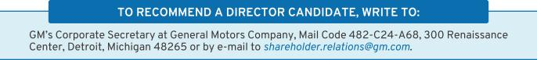

- Director Recruitment Process
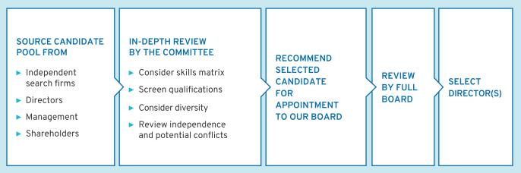

Non-Employee Director Compensation

Our non-employee directors receive cash compensation as well as equity compensation in the form of GM Deferred Share Units (“DSUs”) for

their Board service. Compensation for our non-employee directors is set by the Board at the recommendation of the Governance Committee.

- Guiding Principles


• Fairly compensate directors for their responsibilities and time commitments.

• Attract and retain highly qualified directors by offering a compensation program consistent with those at companies of similar size, scope, and complexity.
• Align the interests of directors with our shareholders by providing a significant portion of compensation in equity and

requiring directors to continue to own our common stock (or common stock equivalents) throughout their tenure on the Board.

• Provide compensation that is simple and transparent to shareholders.

14

Table of Contents

- Annual Review Process

The Governance Committee annually assesses the form and amount of non-employee director compensation and recommends changes, if appropriate, to the Board. As part of its annual review, the Governance Committee conducts extensive benchmarking by reviewing director compensation data for the executive

compensation peer group described in the “Peer Group for Compensation Benchmarking” section on page 53 of this Proxy Statement.

Non-employee director compensation for 2021 is set forth on pages 17 and 18 of this Proxy Statement.

Director Stock Ownership and Holding Requirements


• Each non-employee director is required to own our common stock or DSUs with a market value of at least $500,000.

• Each non-employee director has up to five years from the date he or she is first elected to the Board to meet this ownership requirement.

• Non-employee directors are prohibited from selling any GM securities or derivatives of GM securities, such as DSUs, while they are members of the Board.
• Ownership guidelines are reviewed each year to confirm they continue to be effective in aligning the interests of the Board and our shareholders.

All of our non-employee directors are in compliance with our stock retention requirements.

Annual Compensation

The 2021 and 2022 compensation for non-employee directors are described in the table below. We do not pay any other meeting fees. The Independent Lead Director and Committee Chairs receive additional compensation due to the increased workload and additional responsibilities associated with these positions. In particular, Ms. Russo’s compensation as Independent Lead Director reflects the additional time commitment for this role, which includes, among other responsibilities, attending all Committee meetings and attending additional meetings with the Company’s senior management, including the

CEO. For additional information about the roles and responsibilities of our Independent Lead Director, see “The Role of the Independent Lead Director” on page 20 of this Proxy Statement.

In December 2021, the Board approved a $5,000 increase in Committee Chair fees in recognition of the increased ESG oversight responsibilities for each Committee and in anticipation of Committee membership rotations in the coming years that are part of the Board’s ongoing director refreshment and succession planning efforts.

 |  | 2021 |  | 2022
Compensation Element |  | Structure |  | Structure
Board Retainer | $ | 305,000 | $ | 305,000
Independent Lead Director Fee | $ | 100,000 | $ | 100,000
Audit Committee Chair Fee | $ | 30,000 | $ | 35,000
All Other Committee Chair Fees (excluding the Executive Committee) | $ | 20,000 | $ | 25,000
 |  |  |  | 15

Table of Contents

Non-employee directors are required to defer at least 50 percent of their annual Board retainer into DSUs under the General Motors Company Deferred Compensation Plan for Non-Employee Directors (the “Director Compensation Plan”). Directors may elect to defer all or half of their remaining Board retainer or amounts payable (if

any) for serving as a Committee Chair or Independent Lead Director into additional DSUs. The fees for a director who joins or leaves the Board or assumes additional responsibilities during the year are prorated for the director’s period of service.

How Deferred Share Units Work

Each DSU is equal in value to one share of GM common stock and is fully vested upon grant but does not have voting rights. DSUs will not be available for disposition until after the director leaves the Board. After leaving the Board, the director will receive a cash payment or payments based on the number of DSUs in the director’s account valued at the average daily closing market price for the quarter immediately

preceding payment. Directors will be paid in a lump sum or in annual installments for up to five years, based on their deferral elections. All DSUs granted are rounded up to the nearest whole unit. Any portion of the retainer that is deferred into DSUs may also earn dividend equivalents, which are credited at the end of each calendar year to each director’s account in the form of additional DSUs. DSUs granted are determined as follows:
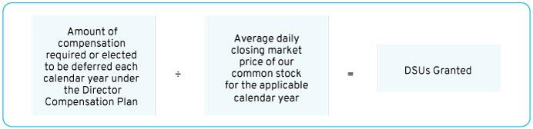

Other Compensation

We provide certain additional benefits to non-employee directors.

Type |  | Purpose
u | Company Vehicles | We provide directors with the use of Company vehicles to provide feedback on our products
 |  | as well as enhance the public image of our vehicles. Retired directors also receive the use of
 |  | a Company vehicle for a period of time. Participants are charged with imputed income based
 |  | on the lease value of the vehicles and are responsible for associated taxes.
u | Personal Accident | We provide personal accident insurance coverage in the event of accidental death or
 | Insurance(1) | dismemberment. Directors are responsible for associated taxes on the imputed income from
 |  | the coverage.

- Ms. Barra, our sole employee director, does not receive additional compensation for her Board service other than the personal accident insurance benefit described above, the value of which is reported for Ms. Barra in the Summary Compensation Table on page 70 of this Proxy Statement.

Non-employee directors are not eligible to participate in any of the savings or retirement programs available to our employees. Other than as described in this section, there are no separate benefit plans for directors.

16

Table of Contents

2021 Non-Employee Director Compensation Table

This table shows the compensation that each non-employee director received for his or her 2021 Board and Committee service.

 | Fees Earned or | Stock Awards(2) | All Other | Total
 | Paid in Cash(1) | Stock Awards(2) | Compensation(3) | Total
Director | ($) | ($) | ($) | ($)
Aneel Bhusri(4) | 35,990 | 35,999 | 40 | 72,029
Wesley G. Bush | 152,500 | 160,060 | 22,657 | 335,217
Linda R. Gooden | 172,500 | 160,060 | 17,490 | 350,050
Joseph Jimenez | 172,500 | 160,060 | 41,948 | 374,508
Jane L. Mendillo | 152,500 | 160,060 | 14,323 | 326,883
Judith A. Miscik | 152,500 | 160,060 | 28,740 | 341,300
Patricia F. Russo(5) | 227,300 | 160,060 | 24,803 | 412,163
Thomas M. Schoewe | 182,500 | 160,060 | 45,032 | 387,592
Theodore M. Solso(6) | 114,130 | 72,349 | 35,620 | 222,099
Carol M. Stephenson | 172,500 | 160,060 | 19,845 | 352,405
Mark A. Tatum(7) | 117,883 | 121,775 | 18,598 | 258,256
Devin N. Wenig | 182,500 | 160,060 | 16,490 | 359,050
Margaret C. Whitman(8) | 117,883 | 121,775 | 9,327 | 248,985

- As described above, a director may elect to defer all or a portion of his or her annual cash retainer into DSUs. This column reflects director compensation eligible to be paid in cash, which consists of 50 percent of the annual Board retainer and any applicable fees for Committee Chairs, the Independent Lead Director, and in the case of Mr. Wenig for service on the Cruise LLC board of directors. Each of the following directors elected to receive DSUs in lieu of such amounts eligible to be paid in cash in the following amounts: Mr. Bhusri — $35,990; Mr. Bush — $152,500; Mr. Jimenez — $172,500; Ms. Mendillo — $152,500; Ms. Russo — $227,300; Mr. Solso — $114,130; Ms. Stephenson — $86,250; Ms. Whitman — $117,833; and Mr. Wenig — $182,500.

- Reflects aggregate grant date fair value of DSUs granted in 2021, which does not include any cash fees that directors voluntarily elected to receive as DSUs. Grant date fair value is calculated by multiplying the number of DSUs granted by the closing price of GM common stock on December 31, 2021, which was $58.63. The holders of DSUs may also receive dividend equivalents, which are reinvested in additional DSUs based on the market price of the common stock on the date the dividends are paid.

17

Table of Contents

- The following table provides more information on the type and amount of benefits included in the All Other Compensation column.

 | Company
 | Vehicle |  | Other
 | Program
Director |  | (a) |  | (b) |  | Total
Mr. Bhusri | $ | 0 | $ | 40 | $ | 40
Mr. Bush | $ | 22,417 | $ | 240 | $ | 22,657
Ms. Gooden | $ | 17,250 | $ | 240 | $ | 17,490
Mr. Jimenez | $ | 41,708 | $ | 240 | $ | 41,948
Ms. Mendillo | $ | 14,083 | $ | 240 | $ | 14,323
Ms. Miscik | $ | 28,500 | $ | 240 | $ | 28,740
Ms. Russo | $ | 24,563 | $ | 240 | $ | 24,803
Mr. Schoewe | $ | 44,792 | $ | 240 | $ | 45,032
Mr. Solso | $ | 35,500 | $ | 120 | $ | 35,620
Ms. Stephenson | $ | 19,605 | $ | 240 | $ | 19,845
Mr. Tatum | $ | 18,438 | $ | 160 | $ | 18,598
Mr. Wenig | $ | 16,250 | $ | 240 | $ | 16,490
Ms. Whitman | $ | 9,167 | $ | 160 | $ | 9,327

  - The Company vehicle program includes the estimated annual lease value of the Company vehicles driven by directors. We include the annual lease value because it is more reflective of the value of the Company vehicle perquisite than the Company’s incremental costs, which are generally significantly lower because the Company manufactures and ordinarily disposes of Company vehicles for a profit, resulting in minimal incremental costs, if any. Taxes related to imputed income are the responsibility of each director.

  - Reflects the cost of premiums for providing personal accident insurance (annual premium cost of $240 per person is prorated, as applicable, for the period of service).

- Mr. Bhusri joined the Board on October 6, 2021.

- Ms. Russo was appointed Independent Lead Director on June 15, 2021.

- Mr. Solso retired from the Board on June 14, 2021.

- Mr. Tatum joined the Board on March 25, 2021.

- Ms. Whitman joined the Board on March 25, 2021.

18

Table of Contents

CORPORATE GOVERNANCE

The Board of Directors

GM is governed by a Board of Directors and Committees of the Board that meet throughout the year. The Board is elected by our shareholders to oversee and provide guidance on the Company’s business and affairs. It is the ultimate decision-making body of the Company, except for those matters reserved for shareholders by law or pursuant to the Company’s governance documents. Among other things, the Board oversees Company strategy and execution of the strategic plan. In addition, it oversees

management’s proper safeguarding of the assets of the Company, maintenance of appropriate financial and other internal controls, compliance with applicable laws and regulations, and proper governance. The Board is committed to sound corporate governance policies and practices that are designed and routinely assessed to enable the Company to operate its business responsibly, with integrity, and to position GM to compete more effectively, sustain its success, and build long-term shareholder value.

- Board Size

The Board sets the number of directors from time to time by a resolution adopted by a majority of the Board. The Governance Committee reassesses the suitability of the Board’s size at least annually. The Board has the flexibility to increase or decrease the size of the Board as circumstances warrant, although the Company’s Certificate of Incorporation limits the total number of directors to 17. There are currently 13 members of the

Board. If all of the Board’s nominees are elected, the Board will be composed of 12 members immediately following the Annual Meeting. If any nominee is unable to serve as a director, or if any director leaves the Board between annual meetings, the Board may reduce the number of directors or elect an individual to fill the resulting vacancy.

- Director Independence

GM’s Bylaws and Corporate Governance Guidelines define our standards for director independence and reflect applicable NYSE and SEC requirements. At least two-thirds of our directors must be independent under these standards. In addition, all members of the Audit Committee and the Compensation Committee must meet heightened independence standards under applicable NYSE and SEC rules. For a director to be “independent,” the Board must determine that the director has no material relationship with the Company other than his or her service as a director.

The Governance Committee annually assesses the independence of each director and makes recommendations to the Board. Consistent with the standards described above, the Board has reviewed all relationships between the Company and each director and considered all relevant quantitative and qualitative criteria. The Board has affirmatively determined that, other than Ms. Barra who serves as our CEO, all directors and

director nominees are currently independent and were independent throughout 2021.

In recommending to the Board that it determine each non-employee director is independent, the Governance Committee considered whether there were any other facts or circumstances that might impair a director’s independence. The Governance Committee also considered that GM, in the ordinary course of business during the last three years, has sold fleet vehicles to and purchased products and services from companies at which some of our directors serve as non-employee directors or executives. The Board determined that these transactions were not material to GM or the other companies involved and that none of our directors had a material interest in the transactions with these companies. In each case, these transactions were in the ordinary course of business for GM and the other companies involved and were on terms and conditions available to similarly situated customers and suppliers. Therefore, the Board determined they did not impair such directors’ independence.

19

Table of Contents

Board Leadership Structure and Composition

The Board has the flexibility to decide when the positions of Board Chair and CEO should be combined or whether an independent director should be Board Chair. This allows the Board to choose the leadership structure that it believes will best serve the interests of our shareholders at any particular time. In January 2016, the Board recombined the positions of Board Chair and CEO under the leadership of Ms. Barra and designated an Independent Lead Director.

Since then, each year the Board has voted to elect Ms. Barra as Board Chair. The Board believes that Ms. Barra’s in-depth knowledge of GM’s business and vision for the future bring focused leadership

to the Board and, therefore, combining the role of Board Chair and CEO while electing a strong Independent Lead Director results in the optimal Board leadership structure for GM at this time.

Ms. Russo is the Board’s Independent Lead Director, a role she has held since 2021. Ms. Russo joined our Board in 2009 and previously served as the Independent Lead Director from 2010 to 2014. Her extensive knowledge of GM’s business and experience collaborating with our management team uniquely qualifies her to provide strong, independent leadership and strategic direction to the Board at this time.

- The Role of the Independent Lead Director

The role of the Independent Lead Director is to provide strong, independent leadership to the Board and assist the other independent directors in overseeing and shaping the partnership between management and the Board. Below is a summary of the key duties and responsibilities of GM’s Independent Lead Director.

• Presiding over all Board meetings when the Board Chair


is not present, including executive sessions of non-management directors, and advising the Board Chair of any actions taken;

• Providing Board leadership if circumstances arise in

which the Board Chair actually has, potentially has, or is perceived to have, a conflict of interest;

• Calling executive sessions for non-management directors,

relaying feedback from these sessions to the Board Chair, and implementing decisions made by the non-management directors;

• Leading non-management directors in the annual

evaluation of the CEO’s performance, communicating the results of that evaluation to the CEO, and overseeing CEO succession planning;

• Approving Board meeting agendas to ensure sufficient time for discussion of all items;

• Advising on the scope, quality, quantity, and

timeliness of the flow of information between management and the Board;

• Serving as a liaison between non-management

directors and the Board Chair when requested to do so (although all non-management directors have direct and complete access to the Board Chair at any time they may deem necessary or appropriate);

• Interviewing, along with the Governance Committee

Chair, all director candidates and making recommendations to the Governance Committee and the Board;

• Being available to advise the Board Committee Chairs

in fulfilling their designated roles and responsibilities to the Board; and

• Engaging, when requested to do so, with shareholders.

20

Table of Contents

Board Committees

The Board of Directors has six standing Committees: Audit, Compensation, Executive, Finance, Governance, and Risk and Cybersecurity. The key responsibilities, recent activities, and focus areas of each Committee, together with their current membership and the number of meetings held in 2021, are set forth on pages 22 to 24 of this Proxy Statement. Each Committee Chair meets regularly with management during the year to discuss Committee business, shape agendas, and facilitate efficient meetings. The Board Chair, Ms. Barra, attends all Committee meetings to serve as a resource and to identify topics requiring the full Board’s attention. The Board has determined that each member of the Audit, Compensation, Finance, Governance, and Risk and Cybersecurity Committees is independent according to applicable SEC and NYSE requirements and our Corporate Governance Guidelines. Each Committee’s charter is available at investor.gm.com/resources.

- Board and Committee Meetings and Attendance

In 2021, the Board held 11 meetings and the average director attendance at Board and Committee meetings was 99 percent. Each director standing for re-election attended at least 95 percent of the total meetings of the Board and Committees on which he or she served in 2021. In addition, the Board conducted three special informational sessions throughout the year to receive in-depth briefings on critical topics, including a technical review of batteries and other key components of electric propulsion systems; an update on our EV supply chain with a focus on sourcing raw materials, rare earth elements, and semiconductors; and an in-depth review of our AV strategy.

Directors are encouraged to attend our annual meetings of shareholders. All directors that stood for re-election in 2021 attended the 2021 Annual Meeting.

- Executive Sessions

Independent directors have an opportunity to meet in executive session without management present as part of each regularly scheduled Board and Committee meeting. Executive sessions are chaired by our Independent Lead Director or the respective Committee Chair.

During executive sessions of the Board, the independent directors may review CEO performance, compensation, and succession planning; strategy; key enterprise risks; future Board agendas and the flow of information to directors; corporate governance matters; and any other matters of importance to the Company raised during a meeting or otherwise presented by the independent directors.

The non-management directors, all of whom are independent, met in executive session of the Board six times in 2021, in addition to numerous executive sessions of the Committees.

- Access to Outside Advisors

The Board and each Board Committee can select and retain the services of outside advisors at the Company’s expense.

21

Table of Contents


AUDIT


 | Members: Thomas M. Schoewe
 | (Chair), Wesley G. Bush, Linda
 | R. Gooden, Jane L. Mendillo, and
Thomas M. Schoewe | Mark A. Tatum
Chair | Meetings held in 2021: 8

Key Responsibilities

- Monitors the effectiveness of GM’s financial reporting processes and systems, as well as disclosure and internal controls;

- Selects and engages GM’s external auditors and

reviews and evaluates the audit process;

● Reviews and evaluates the scope and performance of the internal audit function;
● Facilitates ongoing communications about GM’s financial position and affairs between the Board and the external auditors, GM’s financial and senior management, and GM’s internal audit staff;

- Reviews GM’s policies and procedures regarding ethics and compliance;

- Reviews GM’s ESG reporting processes and control

procedures and annually approves GM’s Sustainability Report, starting in 2022; and
● Oversees the preparation of the Audit Committee Report and related disclosures for the annual proxy statement.
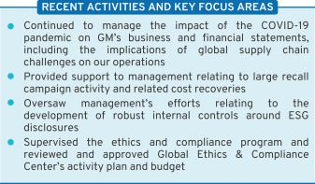

EXECUTIVE COMPENSATION


 | Members: Carol M. Stephenson
 | (Chair), Wesley G. Bush, Joseph
 | Jimenez, Patricia F. Russo, and
Carol M. Stephenson | Margaret C. Whitman
Chair | Meetings held in 2021: 4

Key Responsibilities

- Reviews the Company’s executive compensation policies, practices, and programs;
● Reviews and approves corporate goals and objectives for compensation, evaluates performance (along with the full Board), and determines compensation levels for the CEO;

- Reviews and approves compensation of NEOs, executive officers, and other senior leaders under its purview;
- Reviews compensation policies and practices so that the plans do not encourage unnecessary or excessive risk-taking; and
- Reviews the Company’s compensation policies and practices in an effort to promote diversity and inclusion.

The Board has determined that all members of the Compensation Committee meet heightened independence and qualification criteria in accordance with NYSE listing standards and SEC rules. The Compensation Committee’s charter permits the Committee to delegate its authority to members of management and also form and delegate authority to subcommittees consisting of one or more members when it deems it appropriate.
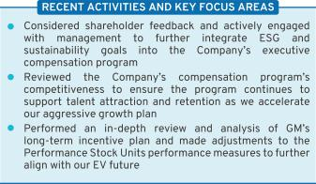

22

Table of Contents


FINANCE


 | Members: Joseph Jimenez (Chair),
 | Wesley G. Bush, Jane L. Mendillo,
 | Judith A. Miscik, Patricia F. Russo,
Joseph Jimenez | and Thomas M. Schoewe
Chair | Meetings held in 2021: 5

Key Responsibilities

- Reviews financial policies, strategies, and capital structure;
- Reviews the Company’s cash management policies and proposed capital plans, capital expenditures, dividend actions, stock repurchase programs, issuances of debt or equity securities, and credit facility and other borrowings;
- Reviews any significant financial exposures and risks, including foreign exchange, interest rate, and commodities exposures, and the use of derivatives to hedge those exposures; and

- Reviews the regulatory compliance, administration, financing, investment performance, risk and liability profile, and funding of the Company’s pension obligations.
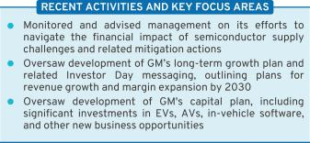

GOVERNANCE AND

CORPORATE RESPONSIBILITY

Members: Patricia F. Russo (Chair), Jane L. Mendillo, Carol M. Stephenson, Mark A. Tatum, and Margaret C. Whitman


Patricia F. Russo
^{Chair} Meetings held in 2021: 3

Key Responsibilities
- Reviews the Company’s corporate governance framework, including all significant governance policies and procedures;
- Monitors Company policies and strategies related to corporate responsibility, sustainability, and political contributions and lobbying activities;

- Reviews the appropriate composition of the Board and recommends director nominees;

- Monitors the self-evaluation process of the Board and Committees;

- Recommends compensation of non-employee directors to the Board;

- Oversees the Company’s development of ESG initiatives, strategies, policies, and practices related to sustainability and corporate responsibility;
- Reviews and approves, in consultation with the Audit Committee, the Company’s annual Sustainability Report;
and

● Reviews and approves related party transactions and any potential director conflicts of interest, as applicable.
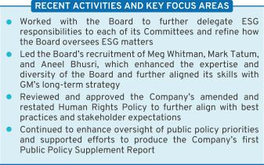

23

Table of Contents

RISK AND CYBERSECURITY

Members: Linda R. Gooden (Chair), Joseph Jimenez, Judith A. Miscik, Thomas M. Schoewe, and Devin N. Wenig

Linda R. Gooden
Chair | Meetings held in 2021: 3
Key Responsibilities
● Reviews | the Company’s key | strategic, enterprise,
and cybersecurity risks;
● Reviews | privacy risk, including | potential impact to
the Company’s employees, customers, and stakeholders; ● Reviews the Company’s risk management framework and management’s implementation of risk policies, procedures, and governance to assess their

effectiveness;

- Reviews management’s evaluation of strategic and operating risks, including risk concentrations, mitigating measures, and the types and levels of risk that are acceptable in the pursuit and protection of shareholder value; and

- Reviews the Company’s risk culture, including the integration of risk management into the Company’s behaviors, decision making, and processes.
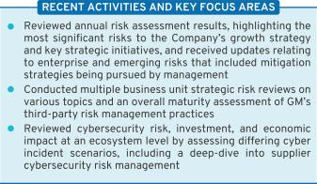

 | EXECUTIVE
 | Members: Mary T. Barra (Chair),
 | Linda R. Gooden, Joseph Jimenez,
 | Patricia F. Russo, Thomas M.
 | Schoewe, and Carol M. Stephenson
Mary T. Barra
Chair | Meetings held in 2021: 0


The Board has an Executive Committee composed of the Board Chair and CEO, the Independent Lead Director, and the Chairs of all other standing Committees. The Executive Committee is chaired by Ms. Barra, and it can act on certain limited matters for the full Board in intervals between meetings of the Board. The Executive Committee meets as necessary, and all actions by the Executive Committee are reported and ratified at the next succeeding Board meeting. Because the Board addressed all items throughout the year at Board meetings, no Executive Committee meetings were needed in 2021.

24

Table of Contents

Board and Committee Oversight of Risk

- Role of the Board of Directors

The Board has overall responsibility for risk oversight and focuses on the most significant risks facing the Company. The Board discharges its risk oversight responsibilities, in part, through delegation to its Committees. The Company’s risk governance is facilitated through a top-down and bottom-up communication structure, with the tone established at the top by Ms. Barra, our Board Chair and CEO, who is also our Chief Risk Officer, and other members of management, specifically the Senior Leadership Team. The Senior Leadership Team also utilizes our Risk Advisory Council, an executive-level body with delegates from each business unit, to discuss and monitor the most significant enterprise and emerging risks in a cross-functional setting. They are tasked with championing risk management practices and integrating them into their functional or regional business units.
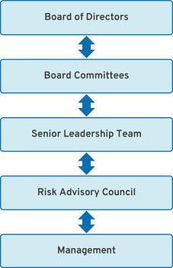

- Role of the Board Committees

Each of the Board’s Committees has a critical role to play in the overall execution of the Board’s risk oversight duties. The Board delegates oversight for certain risks to each Committee based on the risk categories relevant to the subject matter of the Committee. The Chair of the Risk and Cybersecurity Committee coordinates with the Chairs of the other Committees to support them in managing the relationship between risk management policies and practices and their respective oversight responsibilities. The Risk and Cybersecurity Committee also assists the Board by monitoring the overall effectiveness of the Company’s risk management framework and processes. For example, GM’s Strategic Risk Management team conducts an annual risk assessment, which the Risk and Cybersecurity Committee reviews and receives detailed management updates regularly throughout the year.

Below is a summary of the key risk oversight responsibilities that the Board has delegated to the Committees.

- Risk and Cybersecurity Committee: Oversees risks related to the Company’s key strategic, enterprise, and cybersecurity risks, including climate change, workplace and product safety, and privacy.

- Audit Committee: Oversees risks related to (i) financial reporting, internal disclosure controls (including with respect to ESG issues), and auditing matters; and (ii) legal, regulatory, and compliance programs.

- Finance Committee: Oversees risks related to (i) significant financial exposures and contingent liabilities of the Company; (ii) regulatory compliance of employee-defined benefit plans; and (iii) M&A activity and impacts from changes to the Company’s shareholder base.

- Governance and Corporate Responsibility Committee: Oversees risks related to (i) public policy and political activities;

  - director independence and related party transactions; (iii) the sustainability of our operations and products; and
  - ESG disclosures in consultation with the Audit Committee.

- Executive Compensation Committee: Oversees risks related to executive and employee compensation plans, including by designing compensation plans that promote prudent risk management and do not encourage excessive risk-taking.

25

Table of Contents
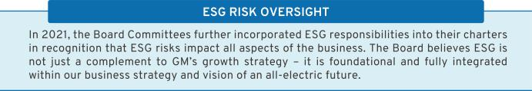

- Cybersecurity Risk Oversight

Each quarter, the Risk and Cybersecurity Committee reviews management’s Cybersecurity Maturity Scorecard, which leverages both the National Institute of Standards and Technology cybersecurity framework and the Federal Financial Institutions Examination Council maturity rating. Management discusses various topics, including information security, manufacturing cybersecurity, and product cybersecurity, and provides intelligence briefings on notable cyber events impacting the industry. The briefings summarize the vulnerabilities that led to the event, provide insight into what happened, and highlight learnings that GM can leverage in the future.

GM’s Global Cybersecurity organization aligns cybersecurity domains across GM, GM Financial (our automotive finance subsidiary), Cruise (our majority-owned subsidiary responsible for the development and commercialization of autonomous vehicle technology), and our growth businesses (such as BrightDrop and OnStar Insurance). It also enables GM to leverage both business and technical experts to accelerate the development and execution of security solutions. Our global team is charged with executing enterprise, product, and manufacturing cybersecurity programs with a focus on security architecture, penetration testing, cyber risk management, incident response, vulnerability management, intelligence, awareness and training,

- Privacy Risk Oversight

In recent years, GM’s Strategic Risk Management team determined that privacy risks were increasing in significance due to the enactment of new and more stringent U.S. and global regulations on the use and protection of personal information. Accordingly, the Risk and Cybersecurity Committee has taken steps to continue to enhance its oversight of GM’s data privacy policies and practices. Pursuant to the

26

and governance. GM applies a defense-in-depth cybersecurity strategy, making it more difficult for attackers to breach our defenses and allowing for quick detection, deflection, and counteraction of attempts at unauthorized access. Beyond the GM ecosystem, GM leverages a Third-Party Cybersecurity Program to minimize disruption to GM’s business and production operations, strengthen supply chain resilience in response to cyber-related events, and ensure the integrity of components and systems used in GM’s products.

GM also includes multi-domain cybersecurity training as part of its corporate required training program. In addition, training and awareness is integrated and continues throughout the year, utilizing various delivery methods such as phishing awareness campaigns, live training sessions, and informational articles. GM continues to invest heavily in cybersecurity, including through our nearly 500 dedicated employees. These employees have diverse skillsets and include pen-testers, cryptologists, analysts, architects, data analysts, security engineers, program managers, and “true hackers.” The Global Cybersecurity team uses a balanced approach in validating the efficacy of its risk management program, leveraging cybersecurity resources and GM’s internal audit services, as well as engaging with external, third-party expertise at least annually across the domains.

Committee’s charter, the Committee is responsible for overseeing GM’s privacy risks relating to the Company’s employees, customers, and other stakeholders. The Committee also devotes portions of its meetings to discuss critical privacy issues with management, including GM’s processes and policies designed to ensure compliance with emerging state, federal, and international laws and regulations.

Table of Contents

The Board’s Governance Policies and Practices

- Code of Conduct: “Winning with Integrity”

The Board is committed to the highest legal and ethical standards in fulfilling its responsibilities. We have adopted a code of business conduct and ethics, “Winning with Integrity,” that applies to everyone in our Company, at every level, including employees, executives, Board members and, as applicable, subsidiaries that GM controls. This Code of Conduct forms the foundation for compliance with corporate policies and procedures and creates a Company-wide focus on uncompromising integrity in every aspect of our operations. It embodies our expectations on a number of topics, including workplace and vehicle safety; DE&I; conflicts of interest; protection of confidential information; insider trading; competition and fair dealing; human rights; community involvement and corporate citizenship; political activities and
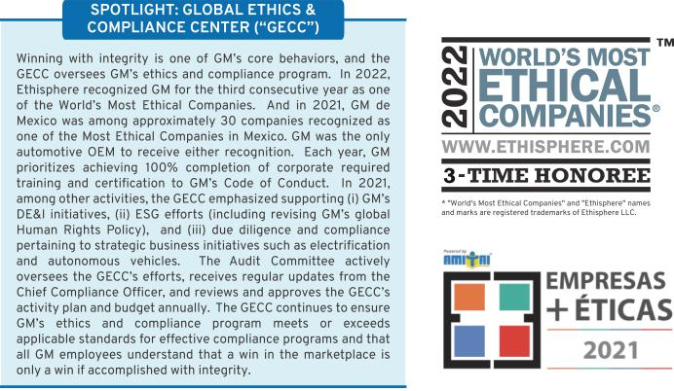

lobbying; preservation and use of Company assets; and compliance with laws and regulations. Employees are expected to report any conduct that they believe in good faith to be an actual or apparent violation of our Code of Conduct.

The Code of Conduct is available at investor.gm.com/resources.

In addition, GM’s Insider Trading Policy prohibits all GM directors and employees, including executive officers, from trading in GM securities while in possession of material, non-public information about the Company, and from trading any GM derivatives (e.g., put or call options), engaging in short sales or otherwise engaging in hedging activities, and pledging of GM securities. This policy is posted on our website at investor.gm.com/resources.

- Corporate Governance Guidelines

Our Corporate Governance Guidelines form a transparent framework for the effective governance of the Company. The Corporate Governance Guidelines address matters such as

the respective roles and responsibilities of the Board and management, the Board’s leadership structure, the responsibilities of the Independent Lead Director, director independence, Board

27

Table of Contents

membership criteria, Board Committees, and Board and CEO evaluations. The Governance Committee regularly reviews the Corporate Governance Guidelines and periodically recommends to the Board the adoption of amendments in response to changing regulations,

evolving best practices, and shareholder concerns. A summary of our corporate governance best practices is discussed in the “Shareholder Protections and Governance Best Practices” section on page 32 of this Proxy Statement.

- CEO Succession Planning

Our Independent Lead Director oversees the CEO succession planning process and leads, at least annually, the Board’s discussion of CEO succession planning. Our CEO provides the Board with recommendations for, and evaluations of, potential CEO successors and reviews with the Board developmental plans for these successors. Directors engage with CEO candidates and senior

management talent at Board and Committee meetings and other forums to enable directors to personally assess candidates. The Board reviews management succession planning in the ordinary course of business as well as contingency planning in the event of an emergency or unanticipated event.

- Board and Committee Evaluations

The Governance Committee periodically reviews the form and process for Board and Committee self-evaluations. The Board’s evaluation process is based on extensive benchmarking, engagement with shareholders, and internal discussion. Below is a summary of the self-evaluation process for the Board and its Committees:
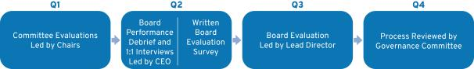

Throughout the process, directors have ample opportunity to provide feedback on Board, Committee, and individual director performance. The Board is committed to implementing feedback from its self-evaluations. Recent examples of changes to practices include evolving the composition of the Board (see page 13 of this Proxy Statement), conducting an extensive review of the Company’s e-commerce strategy, increasing the number of standing Audit Committee meetings, and increasing the frequency of off-cycle Board touchpoints and communications.

- Annual Evaluation of CEO

Each year, the Board reviews the CEO’s performance against her annual strategic goals. The non-management directors, meeting separately in executive session, annually conduct a formal evaluation of the CEO, which is communicated to the CEO by the Independent Lead Director. The evaluation is based on both objective and subjective criteria, including, but not limited to, the Company’s financial performance,

accomplishment of ongoing initiatives in furtherance of the Company’s long-term strategic objectives, and development of the Company’s senior management talent. The results of the evaluation are considered by the Compensation Committee in determining the compensation of the CEO as further described in the “Executive Compensation” section beginning on page 46 of this Proxy Statement.

28

Table of Contents

- Director Orientation and Continuing Education

All new directors participate in the Company’s director orientation program. The orientation enables new directors to become familiar with the Company’s business and strategic plans; significant financial matters; core values and behaviors, including ethics; compliance programs; corporate governance practices; and other key policies and practices.

Continuing education opportunities are provided to keep directors updated with information about

the Company and its strategy, operations, products, and other matters relevant to Board service. Board members are encouraged to visit GM facilities and dealers and attend auto shows and other key corporate and industry events to enhance their understanding of the Company and its competitors in the automotive industry. In addition, all directors are encouraged to attend, at our expense, director continuing education programs sponsored by governance organizations and other institutions.

- Director Service on Other Public Company Boards

The Board recognizes that service on other public company boards provides directors valuable experience that benefits the Company. The Board also believes, however, that it is critical that directors dedicate sufficient time to their service on the Company’s Board. Directors are expected to advise the Board Chair, Independent Lead Director, or Chair of the Governance Committee in advance of accepting an invitation to serve on another board of directors or any audit committee of another public company’s board. This allows the Governance Committee to assess the impact of the director joining another board based on various factors relevant to the specific situation, including the nature and extent of a director’s other professional obligations and the time commitment required by the new position. Directors who are engaged in active, full-time employment, for example, could have less time to

devote to board service than a director whose principal occupation is serving on boards. Our Corporate Governance Guidelines provide that without obtaining the approval of the Board:

- A director may not serve on the boards of more than four other public companies (excluding nonprofits and subsidiaries); and

- No member of the Audit Committee may serve on more than two other public company audit committees.

In general, senior members of management may not serve on the board of more than one other public company or for-profit entity, and executive officers must obtain the approval of the Governance Committee prior to accepting an invitation to serve on an outside board.

- Compensation Committee Interlocks and Insider Participation

Mses. Stephenson, Russo, and Whitman, and Messrs. Bush and Jimenez served on the Compensation Committee in 2021. As of the date of this Proxy Statement, no member of the Compensation Committee was or is a GM officer

or employee, and no executive officer of the Company served or serves on a compensation committee or board of any company that employed or employs any member of the Company’s Compensation Committee or Board.

29

Table of Contents

Shareholder Engagement

The Company has an extensive outreach program and routinely engages with institutional shareholders and other stakeholders to help the Board and management gain feedback on a variety of topics. The feedback received from these sessions is communicated to the Governance Committee and Compensation Committee on a regular basis throughout the year. Then, on an annual basis, the Governance Committee considers whether changes to our policies and practices are required in order to meet evolving expectations and best practices. Recent shareholder engagement highlights include:

- Since the last annual meeting, the Independent Lead Director, Ms. Russo, and the Chair and CEO, Ms. Barra, engaged with institutional shareholders owning over 18 percent of the Company’s outstanding common stock, including the lead investor from the Climate Action 100+ initiative.

“As the Independent Lead Director, I regularly engage with our investors and other key stakeholders, which include many of the leading voices in sustainable and ESG investing. Our engagements this year focused on the Board’s oversight of ESG risks and opportunities, GM’s DE&I initiatives, recent enhancements to our executive compensation plans, critical public policy issues, and our ongoing efforts to build a more sustainable and resilient global supply chain. I shared the insights we received from these recent engagements with my colleagues on our Board. We take this investor feedback very seriously, and we’ll consider the messages we heard as we continue to accelerate the Company’s EV transformation and execute our growth strategy.”
Patricia F. Russo

Independent Lead Director

- Since the last annual meeting, Ms. Barra has participated in a number of investor conferences, including a key institutional investor conference where she discussed various issues related to ESG.

“Earlier this year, I spoke at the Council of Institutional Investors on issues ranging from GM’s efforts to become more inclusive, our all-electric future, climate change issues, and our AV strategy at Cruise. Conversations like these give me confidence that our shareholders and other stakeholders are aligned with our long-term strategic objectives and the Company’s vision of zero crashes, zero emissions, and zero congestion.”

Mary T. Barra

Chair and CEO

- Every year since 2017, the Board has invited at least one institutional shareholder to a Board meeting to provide its perspective on the Company’s strategic direction. The constructive insights, experiences, and ideas exchanged during these engagements have helped the Board evaluate and assess key initiatives during the Company’s ongoing transition to an all-electric future.

- Members of senior management annually engage with retail and institutional shareholders on various topics, including executive compensation; Board composition and leadership structure; important ESG issues like DE&I, human rights, and responsible sourcing; and regulatory issues related to environmental matters. See page 50 of this Proxy Statement for shareholder feedback and actions taken related to GM’s executive compensation program, including actions to further integrate ESG into our compensation framework.

30

Table of Contents

The table below provides a summary of common themes we have heard that led to boardroom discussion and action.

 |  | Message |  |  |  | Actions
Requested | to |  | communicate |  | more | For a discussion of the actions taken to further assess the Board’s ESG skill set,
disclosure around the ESG skills on the |  |  |  |  |  | see page 6 of this Proxy Statement. In addition, beginning last year, the Board
Board and priorities for future director |  |  |  |  |  | made available elements of its five-year roadmap, which the Governance
recruitment. |  |  |  |  |  | Committee is using as it prepares for the departure of up to five directors who
 |  |  |  |  |  | are approaching the Company’s retirement age in the coming years and Meg
 |  |  |  |  |  | Whitman, who will need to resign from the Board upon her confirmation as the
 |  |  |  |  |  | U.S. Ambassador to Kenya.
Encouraged to continue the process of |  |  |  |  |  | The prospect of continued strong earnings and free cash flow even as we
communicating |  | the | Company’s |  | capital | accelerate investments in growth initiatives naturally raises questions about
allocation | strategy |  | to | shareholders, |  | resuming a common stock dividend. Following significant input from the Board,
especially with regard to potential dividend |  |  |  |  |  | we have taken opportunities – including on earnings calls and in other forums –
reinstatement. |  |  |  |  |  | to disclose that we will continue to consider all opportunities to return excess
 |  |  |  |  |  | capital to shareholders, but we do not plan to reinstate a dividend at this time.
 |  |  |  |  |  | Our clear priority is to accelerate our EV plan and drive growth, and we want to
 |  |  |  |  |  | maintain maximum financial flexibility to invest as opportunities arise.
Encouraged | to | increase |  | transparency |  | We worked with the Climate Action 100+ to publish the Company’s first Public
regarding the Company’s public policy |  |  |  |  |  | Policy Supplement report that disclosed how GM’s lobbying activities aligns with
priorities and lobbying activity. |  |  |  |  |  | the Paris Agreement’s goal of limiting average global warming to below 2°
 |  |  |  |  |  | Celsius. We plan to update the report on an annual basis moving forward.

Requested to enhance the governance of Last year the GM PAC board voted to improve its governance and establish new the Company’s Political Action Committee contributions criteria and processes to manage the candidate selection process
(“GM PAC”). and fully assess reputational risks. For a discussion of the actions taken, see

page 34 of this Proxy Statement.

Encouraged to enhance the Company’s In 2021, we conducted purposeful engagement among GM senior leaders, human rights reporting and take action to investors, and other stakeholders with expertise in human rights and supply prevent the acquisition of supplies chain governance. These engagements helped inform key updates to our originating from forced labor in the Xinjiang Human Rights Policy, which the Governance Committee approved in August
Province in China. 2021. The updated policy can be viewed on our website at investor.gm.com/resources.

With regard to forced labor in the Xinjiang Province in China, the Board works to actively monitor and take appropriate steps to ensure that all of our supply chain partners in China and throughout the world meet our high ethical and human rights standards. Further, the Company is building a sustainable and resilient North America-focused supply chain for EVs covering the entire ecosystem from raw materials to battery cell manufacturing and recycling.

31

Table of Contents

Message Actions

Requested that we continue progress on making the workforce more diverse and transitioning it to be ready for an all-electric future.

The Board worked with management to create a “Work Appropriately” policy that allows employees flexibility in where they work and launched an internal Inclusivity Index to measure our progress on diversity and inclusion and provide survey data to inform future action.

Management also continues to work with the leaders of our represented workforce, including the International Union, United Automobile, Aerospace and Agricultural Implement Workers of America (“UAW”), to constructively address our business challenges in a way that positions our employees and our Company for success.
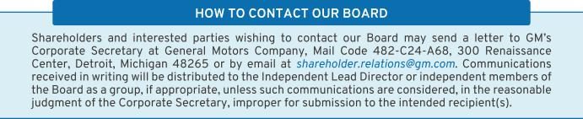

Shareholder Protections and Governance Best Practices

The Board is committed to governance structures and practices that protect shareholder value and important shareholder rights. The Governance Committee regularly reviews these structures and practices, which include the following:
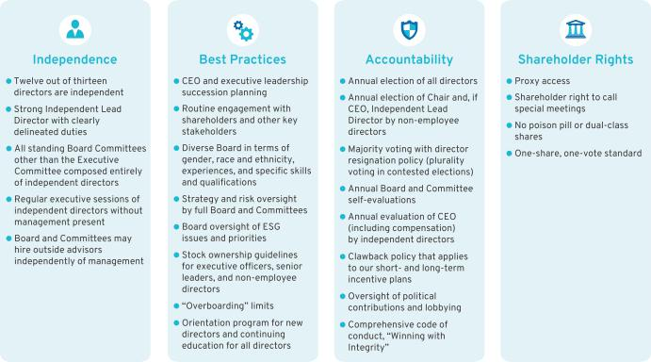

32

Table of Contents

Corporate Political Contributions and Lobbying Expenditures

- Board Oversight

We participate in the legislative, regulatory, and political processes to help inform decision makers and shape public policy that impacts GM, our industry, our shareholders, and other stakeholders. GM has supported and will continue to support legislation and associations that drive the achievement of our long-term, sustainable growth and our vision for the future of mobility. To guide our activities and ensure compliance with applicable laws and regulations, the Board has adopted a U.S. Corporate Political Contributions and Expenditures Policy (“Political Contributions Policy”).

The Governance Committee oversees the Political Contributions Policy and annually reviews the Company’s engagement in the public policy process. The Governance Committee also annually reviews all corporate political contributions, GM PAC contributions and expenditures, and the process by which such contributions and expenditures are made. GM PAC expenditures are funded entirely by voluntary director and employee contributions and are guided by a board of directors and a steering committee using defined criteria set forth in the Political Contributions Policy. In 2021, the criteria expanded to also include review of any enforcement actions into the character of a candidate.

Management provides updates twice per year to the Governance Committee regarding the Company’s lobbying expenditures. In addition, the full Board receives a monthly report from management regarding significant global policy issues facing the Company. The Board uses this report to continuously assess which issues are most important to the Company’s long-term interests and which organizations the Company is working with to advance those interests.

- Transparency and Disclosure

To promote political transparency and accountability, GM publishes an annual voluntary report of political contributions. In addition, GM files publicly available federal Lobbying Disclosure Act Reports each quarter, which disclose GM’s lobbying expenditures, describe the legislative issues on which we have lobbied, and identify the individuals who lobbied on behalf of GM. GM also files similar periodic reports with state agencies. In 2021, for the fourth consecutive year, the Center for Political Accountability’s Zicklin Index of Corporate Political Disclosure and Accountability, which benchmarks the political disclosure and accountability policies and practices of leading U.S. public companies, recognized the quality of our disclosures and ranked GM among the First Tier of S&P 500 companies. To further enhance transparency, in 2021 GM published a Public Policy Supplement to our April 2021 Sustainability Report, which can be viewed on our website at investor.gm.com/resources. In addition to other pertinent disclosures, this supplement describes how GM’s lobbying activities aligns with society’s broader climate goals, including the Paris Agreement’s goal of limiting average global warming to below 2° Celsius, and supports our vision for zero crashes, zero emissions, and zero congestion.

33

Table of Contents
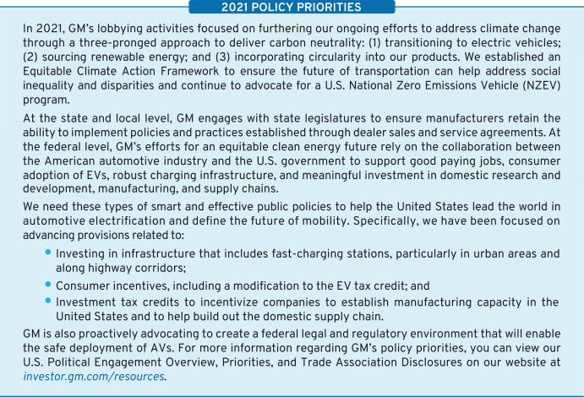

Certain Relationships and Related Party Transactions

Our Code of Conduct requires all of our employees and directors to avoid any activity that is in conflict with our business interests. In addition, the Board has adopted a Related Party Transaction Policy regarding the review and approval of related party transactions, which was updated in December 2021.

Under the Related Party Transactions Policy, which is administered by our Governance Committee, directors and executive officers must report any potential related party transactions (including transactions involving immediate family members) to the General Counsel to determine whether the transaction constitutes a related party transaction. If any member of the Governance Committee has a potential interest in any related party transaction, such member will recuse themself and abstain from voting on the approval of the related party transaction.

For purposes of our Related Party Transactions Policy, a related party transaction includes transactions in which our Company (or a subsidiary) is a participant, the amount involved exceeds $120,000, and the related party has or will have a direct or indirect material interest. Related parties of our Company consist of directors (including nominees for election as directors), executive officers, shareholders beneficially owning more than 5 percent of the Company’s voting securities, and the immediate family members of these individuals. Once a potential related party transaction has been identified, the Governance Committee will review all of the relevant facts and circumstances and approve or disapprove entry into the transaction. As required under SEC rules, we disclose all related party transactions annually in our proxy statement.

34

Table of Contents

- Factors Used in Assessing Related Party Transactions


• Whether the terms of the related party transaction are fair

to the Company and on the same basis as if the transaction had occurred on an arm’s-length basis;

• Whether there are any compelling business reasons for

the Company to enter into the related party transaction and the nature of alternative transactions, if any;

• Whether the related party transaction would impair the independence of an otherwise independent director; and


• Whether the related party transaction would present an

improper conflict of interest for any director or executive officer of the Company, taking into account the specific facts and circumstances of such transaction.

- 2021 Related Party Transactions

In 2021, GM entered into an agreement for consulting services with Kissinger Associates for approximately $500,000. Our director, Ms. Miscik, is the Chief Executive Officer and Vice Chairman of Kissinger Associates.

In 2021, two holders of 5 percent or more of the Company’s common stock – BlackRock and Vanguard – provided investment management services to Company-sponsored pension plans.

The SEC has identified employment of immediate family members of directors and executive officers as per-se related party transactions and subject to disclosure if the $120,000 threshold is met. In 2021, the following immediate family members of executive officers were employed by General Motors or its subsidiaries and had 2021 total compensation in excess of $120,000: the daughter of Mark L. Reuss, our President, is employed by GM in the Brand organization; the wife of Julian Blissett, our Executive Vice President and President, GM China, is employed by GM in the Global Manufacturing organization; and the son of Craig B. Glidden, our Executive Vice President, Global Public Policy, General Counsel, and Corporate Secretary, is employed by Cruise as a Manager, Reliability and Lifecycle Planning.

NEOs may be eligible to reimburse personal travel expenses pursuant to time-sharing agreements that the Company may enter into from time to time, subject to Federal Aviation Administration regulations. In 2021, pursuant to such an agreement, Mr. Reuss reimbursed the Company $ 140,000 for his personal use of corporate aircraft, including certain taxes. For additional information about NEO’s personal use of corporate aircraft, see page 56 of this Proxy Statement under “Perquisites and Other Compensation.”

35

Table of Contents

OUR PURPOSE, OUR VALUES, AND OUR BEHAVIORS

Our Purpose

After extensive work by the Board, our senior leadership team, and a diverse, cross-functional global team of colleagues, we introduced our Purpose statement in 2021. It’s a simple but powerful statement that honors our heritage of innovation, captures who we are when we’re at our best, and looks ahead to the future: We pioneer the innovations that move

and connect people to what matters.

Our Values

Customers

We put the customer at the center of everything we do. We listen intently to our customers’ needs. Each interaction matters. Safety and quality are foundational commitments, never compromised.

Excellence

We act with integrity. We are driven by ingenuity and innovation. We have the courage to do and say what’s difficult. Each of us takes accountability for results, drives for continued efficiencies, and has the tenacity to win.

Relationships

Our success depends on our relationships inside and outside the Company. We encourage diverse thinking and collaboration from all over the world to create great customer experiences.

Our Behaviors

Seek Truth

We pursue facts, respectfully challenge assumptions, and clearly define objectives. When we disagree, we provide additional context and consider multiple perspectives.
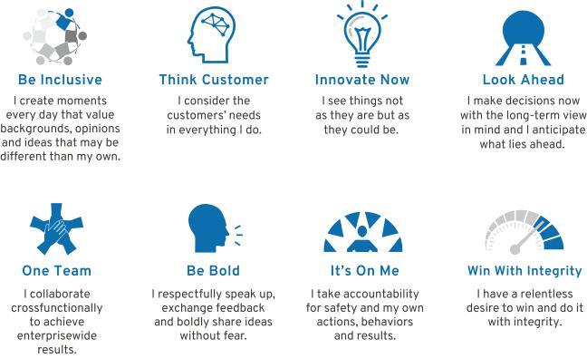

36

Table of Contents

SOCIAL AND ENVIRONMENTAL HIGHLIGHTS

Our People

We are building a diverse, equitable, and inclusive team that is inspired to make people’s lives safer, more convenient, and more sustainable. In pursuit of our ambition to become the most inclusive company in the world, we are also committed to bringing our workforce along as we transform our business and execute GM’s long-term EV and growth strategy. Our focus is on providing a safe and inclusive workplace with ample opportunity for talent development and career advancement.

By applying our GM behaviors, we strive to inspire our team across various key dimensions, including teamwork, fairness, trust, growth, commitment, and recognition, to make a lasting impact. A key development with respect to our workforce in 2021 was our adoption of a Work Appropriately policy, a new approach to the future of work that allows most office-based employees to work where they can have the greatest impact on achieving their goals.

- Key Workforce Priorities

- Workplace Safety: Returning people home safely – every person, every site, every day.

- Talent Engagement: Creating a positive work environment and a place where employees feel inspired to do their best work, valued for doing it, and connected to our Purpose, Vision, and Values.

- Talent Development: Providing a broad range of development opportunities to employees, including training current employees for new types of work as our business evolves, education reimbursement, and stretch assignments.

- Talent Acquisition: Attracting a diverse candidate pool, creating an inclusive hiring process, hiring top talent, and investing in their success.

- Wellness and Benefits: Market competitive pay; quality health care plans; retirement and savings plans with Company contributions and matching programs; paid time off for vacations, illness, family care needs, and military leave; physical and mental health and well-being programs; and support for flexible and alternative work arrangements.

- Labor Relations: Respecting our employees’ right to freedom of association in all countries, complying with all local labor laws and regulations, and engaging our workforce in our collective future.

- Diversity, Equity, and Inclusion

In 2020, GM set an aspirational goal to become the world’s most inclusive company. We are committed to DE&I in our interactions with all people, including employees, customers, and communities. We are proud of our efforts to create positive, sustainable, and inclusive social change, exemplified through the following:

- GM has long been a global leader in advocating for women’s equity in the workplace, with women in 31.9 percent of our top management positions within two levels of the CEO. As a part of GM’s commitment to the Equal Pay Pledge, GM reviews pay equity annually in the United States with respect to gender, race, and ethnicity.

- GM’s policies and practices support the LGBTQ+ community. We have a strong anti-discrimination

policy, which protects all employees at GM. We extended same-sex domestic partner benefits early on and continue to provide full benefits to married LGBTQ+ couples.

- GM joined the Business Roundtable’s Multiple Pathways Initiative to hire employees based on the value of skills rather than just degrees, and to improve equity and diversity in the workplace. GM also joined and became the Detroit-area lead for OneTen, a consortium of companies who have committed to creating career opportunities for 1 million Black Americans over the next 10 years. In 2021, we exceeded our OneTen hiring commitment by 100 percent.

- GM has strengthened transparency and accountability on DE&I by publicly releasing our

37

Table of Contents

EEO-1 Consolidated Report and adopting corporate key performance indicators (“KPIs”) for diversity across several metrics. We also launched an Inclusivity Index as part of our global Workplace of Choice survey, which asks eight inclusion-related questions, and which revealed a three-point increase in our inclusion score among salaried employees from our baseline established in 2020.

- GM signed the Gender and Diversity KPI Alliance (“KPI Alliance”) in 2021. The KPI Alliance supports the adoption and use of a set of KPIs to measure gender and diversity. By signing on to the KPI Alliance, GM pledges to use three KPIs – percentage of representation on the GM board, percentage of representation by employee category, and pay equality – as part of our efforts to measure and improve diversity in the organization.

- GM supports diversity across our business, including among our suppliers and dealers. GM

was the first automotive OEM to establish a formal supplier diversity program. Over the past five years, we have spent more than $17 billion with diverse suppliers and contributed to many community initiatives in collaboration with diverse suppliers. Today, our commitment to supplier diversity continues with engagement, technical assistance programs, and supplier diversity KPIs. GM also has a Minority Dealer Development Program and Women’s Retail Network as part of our commitment to a diverse dealer network.

- GM has 11 Employee Resource Groups (“ERGs”) which are voluntary, employee-led groups that serve as a resource for their members and a catalyst for promoting a diverse, inclusive workplace that aligns with the Vision and core Values of the Company. Importantly, ERGs are fully open to anyone interested in joining, and we are proud that all GM ERGs experienced growth in members and allies in 2021.
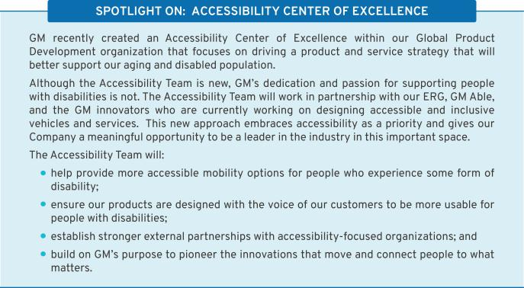

38

Table of Contents

Our Communities

An important part of our aspiration to be the world’s most inclusive company is doing our part to help create a clean, safe, and equitable world for all. We create jobs and technological innovations that support customers and local economies. We also give back to promote progress in the communities where we live and work.

GM’s philanthropic investments focus on inclusive and sustainable solutions for our communities. This work puts people at the center and is structured under three focus areas aligned with the United Nations Sustainable Development Goals: expand access to science, technology, engineering, and math (“STEM”) educational opportunities, vehicle and road safety, and community development. We also prioritize programs that create equitable opportunities and advance DE&I goals.

Recognizing that climate change does not impact every community equally, in 2021 we launched a

Climate Equity Fund to help lead positive change and implement inclusive solutions by providing funding to organizations focused on clean energy jobs, sustainable transportation, and community-level action that helps residents adapt to the effects of climate change. In early 2022, we doubled our financial commitment to the fund from $25 million to $50 million.

In 2020, GM launched a Justice and Inclusion Fund, and in 2021, we committed $22 million to organizations doing critical racial justice work, such as the Martin Luther King Jr. Memorial Foundation, the Asian Pacific American Institute for Congressional Studies, and the Smithsonian Latino Center.
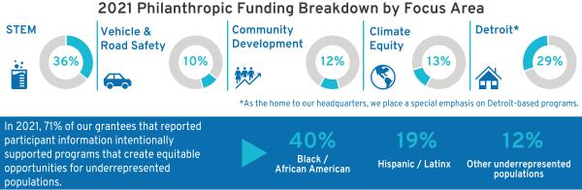

Our Environment

GM remains committed to an all-electric future with zero emissions. Climate change is a problem that urgently needs to be addressed, and we want to be part of the solution.

In 2021, we made the following commitments to advance our vision of a world with zero emissions:

- We plan to become carbon neutral in our global products and operations by 2040 and eliminate tailpipe emissions from new light-duty vehicles by 2035.

- We will source 100 percent renewable energy to power our U.S. facilities by 2025 (five years ahead of our previous target and 25 years ahead of our initial target) and by 2035 globally.

- We signed the Business Ambition Pledge of 1.5° Celsius, and set SBTi-validated, science-based targets that align with the most ambitious goals of the Paris Agreement.

Advancing toward our all-electric future is the most critical aspect of our path to achieve our vision of a zero-emissions world. The use of our products accounts for the vast majority of the emissions that we may be able to impact. To that end, earlier this year we announced that by the end of 2025, we will launch more than 30 new EVs globally and expect to have more than 2 million units of EV capacity globally – 1 million in North America and another 1 million in China. To meet these targets, we recently announced a

39

Table of Contents

commitment of nearly $ 7 billion for a significant expansion of battery cell and EV assembly capacity in the United States, which is just part of our larger commitment to invest more than $35 billion in EVs and AVs from 2020 to 2025.

As we transform our business to support production of EVs, we are also rethinking how our vehicles are made and designing them with a mindset focused on reducing environmental impacts throughout our operations and the vehicle life cycle. In addition to using sustainable inputs in our operations and our vehicles, there are other ways we work to reduce the volume of waste we generate.

Here is just some of the progress we made toward our environmental goals in 2021:

- Achieved 86.4 percent waste diversion from landfills and incineration globally compared to a three-year average (2017-2019) baseline;

40

- Implemented the U.S. Department of Energy 50001 Ready Program at 27 U.S. manufacturing facilities (93 percent of our U.S. manufacturing footprint), more than any other participating company;

- Sourced 25 percent of our global electricity use from renewable sources;

- Used more than 17 million pounds of recycled plastic in GM vehicles; and

- Packaged approximately 8,000 parts for GM Customer Care & Aftersales in consumer-facing packaging.

You can learn more about our sustainability goals and accomplishments in our Sustainability Report, available at gmsustainability.com.

Table of Contents

SECURITY OWNERSHIP INFORMATION

Security Ownership of Directors, Named Executive Officers, and Certain Other Beneficial Owners

The following table and accompanying footnotes show information regarding the beneficial ownership of GM’s issued and outstanding common stock by (i) each of our directors and NEOs, and all directors and executive officers as a group, each as of April 1, 2022, and (ii) each person known by us to beneficially own more than 5 percent of our issued and outstanding common stock as of the dates indicated in the footnotes. All directors and executive officers have sole voting and dispositive power over their shares. The Percentage of Outstanding Shares is based on 1,458,240,927 shares issued and outstanding as of April 1, 2022.

 | Shares of Common | Percentage of
 | Stock Beneficially | Outstanding
Name | Owned | Shares
Non-Employee Directors(1)
Aneel Bhusri | 47,646(2) | *
Wesley G. Bush | 10,000(2),(10) | *
Linda R. Gooden | 1,000(2) | *
Joseph Jimenez | 32,330(2),(11) | *
Jane L. Mendillo | 4,560(2) | *
Judith A. Miscik | 0(2) | *
Patricia F. Russo | 31,000(2) | *
Thomas M. Schoewe | 22,005(2) | *
Carol M. Stephenson | 800(2) | *
Mark A. Tatum | 0(2) | *
Devin N. Wenig | 0(2) | *
Margaret C. Whitman | 0(2) | *
Named Executive Officers(1)
Mary T. Barra | 3,510,333(3) | *
Paul A. Jacobson | 121,934(3) | *
Mark L. Reuss | 696,614(3) | *
Douglas L. Parks | 194,161(3) | *
Stephen K. Carlisle | 167,377(3) | *
All Directors and Executive Officers as a Group (21 persons),
including the foregoing | 5,664,798(4) | *
Certain Other Beneficial Owners(5)
BlackRock, Inc.(6) | 117,709,151 | 8.1%
The Vanguard Group(7) | 102,724,091 | 7.0%
Capital Research Global Investors(8) | 95,124,907 | 6.5%
Capital World Investors(9) | 79,839,592 | 5.5%

- Less than 1 percent.

- c/o General Motors Company, 300 Renaissance Center, Detroit, Michigan 48265.

41

Table of Contents

- These amounts represent common stock only and do not include DSUs, which are unit equivalents of our common stock. For more information about how DSUs work, see page 16 of this Proxy Statement. Directors hold the following number of DSUs: 1,228 DSUs for Mr. Bhusri; 21,717 DSUs for Mr. Bush; 29,056 DSUs for Ms. Gooden; 55,679 DSUs for Mr. Jimenez; 44,821 DSUs for Ms. Mendillo; 12,424 DSUs for Ms. Miscik; 57,961 DSUs for Ms. Russo; 42,976 DSUs for Mr. Schoewe; 80,869 DSUs for Ms. Stephenson; 2,077 DSUs for Mr. Tatum; 30,456 DSUs for Mr. Wenig; and 4,085 DSUs for Ms. Whitman.

- These amounts include shares that may be acquired upon exercise of stock options that are currently exercisable or will become exercisable within 60 days of April 1, 2022, as follows: 2,097,180 shares for Ms. Barra; 46,934 shares for Mr. Jacobson; 506,540 shares for Mr. Reuss; 158,468 shares for Mr. Parks; and 77,562 shares for Mr. Carlisle.

- These include shares that individuals in the group may acquire upon exercise of stock options that are currently exercisable or will become exercisable within 60 days of April 1, 2022.

- The Company is permitted to rely on the information reported by each beneficial owner in filings with the SEC and has no reason to believe that the information is incomplete or inaccurate or that the beneficial owner should have filed an amended report and did not.

- Based solely on information set forth in a Schedule 13G/A filed with the SEC on February 8, 2022, BlackRock, Inc., reported that it and its subsidiaries listed on Exhibit A to Schedule 13G/A were the beneficial owners of 117,709,151 shares of GM’s outstanding common stock as of December 31, 2021. BlackRock reported having sole voting power over 106,199,079 shares and sole dispositive power over 117,709,151 shares. No shared voting or dispositive powers were reported. The address for BlackRock, Inc., is 55 East 52nd Street, New York, New York 10055.

- Based solely on information set forth in a Schedule 13G/A filed with the SEC on February 10, 2022, The Vanguard Group reported that it was the beneficial owner of 102,724,091 shares of GM’s outstanding common stock as of December 31, 2021. The Vanguard Group reported having shared voting power over 2,144,675 shares, sole dispositive power over 97,213,704 shares, and shared dispositive power over 5,510,387 shares. No sole voting power was reported. The address for The Vanguard Group is 100 Vanguard Boulevard, Malvern, Pennsylvania 19355.

- Based solely on information set forth in a Schedule 13G/A filed with the SEC on February 11, 2022, Capital Research Global Investors reported that it is the beneficial owner of 95,124,907 shares of GM’s outstanding common stock as of December 31, 2021. Capital Research Global Investors reported having sole voting power over 95,121,786 shares and sole dispositive power over 95,124,907 shares. No shared voting or dispositive powers were reported. The address for Capital Research Global Investors is 333 South Hope Street, 55th Floor, Los Angeles, California 90071.

- Based solely on information set forth in a Schedule 13G/A filed with the SEC on February 11, 2022, Capital World Investors reported that it is the beneficial owner of 79,839,592 shares of GM’s outstanding common stock as of December 31, 2021. Capital World Investors reported having sole voting power over 79,694,526 shares and sole dispositive power over 79,839,592 shares. No shared voting or dispositive powers were reported. The address for Capital World Investors is 333 South Hope Street, 55th Floor, Los Angeles, California 90071.

- These shares are held indirectly in the Wesley G. Bush Revocable Trust.

- This amount includes 330 shares of common stock that Mr. Jimenez holds indirectly through a limited liability company owned but not managed by him.

42

Table of Contents

AUDIT COMMITTEE REPORT

The Audit Committee of the Board of Directors of General Motors Company is a standing committee composed of five independent directors: Thomas M. Schoewe (Chair), Wesley G. Bush, Linda R. Gooden, Jane L. Mendillo, and Mark A. Tatum.
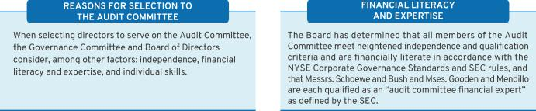

Purpose

The Audit Committee’s core purpose is to assist the Board by providing oversight of:

•

•

•

•

•

The quality and integrity of GM’s financial statements;

The effectiveness of GM’s financial reporting process and systems of disclosure controls and internal controls;

The qualifications, performance, and independence of GM’s external auditors;

The scope and performance of GM’s internal audit function; and

GM’s policies and procedures regarding ethics and compliance.

The Audit Committee operates under a written charter adopted by the Audit Committee and approved by the Board of Directors. The Audit Committee’s charter is posted on our website at investor.gm.com/resources. The Audit Committee’s charter is reviewed at least annually and is updated as necessary to address changes in regulatory requirements, authoritative guidance, evolving oversight practices, and shareholder feedback. In 2021, the Audit Committee charter was amended to formalize the Audit Committee’s responsibilities with respect to ESG matters.

Management is responsible for the Company’s internal controls and the financial reporting process and has delivered its opinion on the effectiveness of the Company’s controls. EY is responsible for performing an independent audit of the Company’s consolidated financial statements and opining on the effectiveness of internal controls over financial reporting in accordance with the standards of the Public Company Accounting Oversight Board (United States) (the “PCAOB”) and issuing its reports thereon. As provided in its charter, the Audit Committee’s responsibilities include monitoring and overseeing these processes.

Required Disclosures

In 2021, the Audit Committee met eight times and fulfilled all of its core charter obligations. Consistent with its charter responsibilities, the Audit Committee met and held discussions with management and EY regarding the Company’s audited financial statements and internal controls for the year ended December 31, 2021. In this context, management represented to the Audit Committee that the Company’s consolidated financial statements were prepared in accordance with accounting principles generally accepted in the United States. The Audit Committee reviewed and discussed the consolidated financial statements with management and EY and further discussed with EY the matters required to be discussed by the requirements of the PCAOB and the SEC. This review included a discussion with management and EY of the quality, not merely the acceptability, of GM’s accounting principles, the reasonableness of significant estimates and judgments, and the clarity of disclosure in GM’s financial statements, including

43

Table of Contents

the disclosures related to critical accounting estimates and critical audit matters. EY also provided to the Audit Committee the written disclosures and letter required by the applicable requirements of the PCAOB concerning independence, and the Audit Committee discussed with EY the auditor’s independence. The Audit Committee also considered and determined that the provision of non-audit services to GM is compatible with maintaining EY’s independence. The Audit Committee concluded that EY was independent from the Company and management.

For additional information about GM’s policies and procedures related to the approval of EY’s audit and non-audit services, see “Policy for Approval of Audit and Permitted Non-Audit Services” on page 45 of this Proxy Statement.

Recommendation

Based upon the Audit Committee’s discussions with management and EY as described in this report and the Audit Committee’s review of the representation of management and the reports of EY to the Audit Committee, the Audit Committee recommended to the Board of Directors, and the Board of Directors approved, the inclusion of the audited consolidated financial statements in the Company’s Annual Report on Form 10-K for the year ended December 31, 2021, as filed with the SEC on February 2, 2022.

Audit Committee
Thomas M. Schoewe (Chair)
Wesley G. Bush
Linda R. Gooden
Jane L. Mendillo
Mark A. Tatum

The preceding Audit Committee Report shall not be deemed incorporated by reference by any general statement incorporating by reference this Proxy Statement or any portion hereof into any filing under the Securities Act of 1933, as amended, or the Securities Exchange Act of 1934, as amended, and shall not otherwise be deemed filed thereunder.

44

Table of Contents

Fees Paid to Independent Registered Public Accounting Firm

The following table summarizes the fees for professional services provided by EY for the audit of GM’s annual financial statements and internal controls over financial reporting for the years ended December 31, 2021 and 2020, together with the fees billed for other services rendered by EY during these periods. The numbers in the table below may not sum due to rounding.

 | 2021 | 2020
Type of Fees | ($ in millions) | ($ in millions)
Audit | 21 | 21
Audit-Related | 8 | 4
Tax | 3 | 2
Subtotal | 31 | 27
All Other Services | 1 | —
TOTAL | 32 | 27

Audit Fees – Includes fees for the integrated audit of the Company’s annual consolidated financial statements and attestation of the effectiveness of the Company’s internal controls over financial reporting, including reviews of the interim financial statements contained in the Company’s Quarterly Reports on Form 10-Q and audits of statutory financial statements.

Audit-Related Fees – Includes fees for assurance and related services that are traditionally performed by the independent registered public accounting firm. More specifically, these services include employee benefit plan audits, comfort letters in connection with funding transactions, financial due diligence, other attestation services, and consultations concerning financial accounting and reporting standards.

Tax Fees – Includes fees for tax compliance, tax planning, and tax advice. Tax compliance involves preparation of original and amended tax returns and claims for refunds. Tax planning and tax advice encompass a diverse range of services, including assistance with tax audits and appeals, tax advice related to mergers and acquisitions and employee benefit plans, and requests for rulings or technical advice from taxing authorities.

All Other Fees – Includes fees for services that are not contained in the above categories and consists of permissible advisory services.

Policy for Approval of Audit and Permitted Non-Audit Services

The services performed by EY in 2021 were preapproved in accordance with the preapproval policy and procedures established by the Audit Committee. This policy requires that, prior to the provision of services by the auditor, the Audit Committee will be presented, for consideration, with a description of the types of Audit-Related, Tax, and All Other Services expected to be performed by the auditor during the fiscal year, with amounts budgeted for each category. Any requests for such services for $1 million or more not contemplated and approved by the Audit Committee initially must thereafter be submitted to the Audit Committee Chair for specific preapproval and must be reported to the full Audit Committee at the next regularly scheduled

meeting of the Committee. Requests for services less than $1 million individually can be approved by management based on the amounts approved for each category. Management must report actual spending for each category to the full Audit Committee periodically throughout the year.

These services are actively monitored (both spending and work content) by the Audit Committee to maintain the appropriate objectivity and independence in EY’s core work, which is the audit of the Company’s annual consolidated financial statements and internal controls. The Audit Committee determined that all services provided by EY in 2021 were compatible with maintaining the independence of EY.

45

Table of Contents

EXECUTIVE COMPENSATION

Compensation Discussion and Analysis |  |  |  |  |  |  |  |  | Executive Compensation Tables
Our Company Performance |  |  |  |  |  |  |  | 47 | Summary Compensation Table |  |  |  |  |  |  |  |  | 70
Compensation Overview |  |  |  |  |  |  |  | 49 | Grants of Plan-Based Awards |  |  |  |  |  |  |  |  | 73
Compensation Principles |  |  |  |  |  |  |  | 55 | Outstanding Equity Awards at Fiscal Year-End |  |  |  |  |  |  |  |  | 74
Compensation Elements |  |  |  |  |  |  |  | 55 | Option Exercises and Stock Vested |  |  |  |  |  |  |  |  | 75
Performance Measures |  |  |  |  |  |  |  | 57 | Pension Benefits |  |  |  |  |  |  |  |  | 75
Performance Results and Compensation Decisions |  |  |  |  |  |  |  | 60 | Nonqualified Deferred Compensation Plan |  |  |  |  |  |  |  |  | 77
Compensation Policies and Governance Practices |  |  |  |  |  |  |  | 66 | Potential Payments Upon Termination |  |  |  |  |  |  |  |  | 78
Compensation Committee Report |  |  |  |  |  |  |  | 69 | CEO Pay Ratio |  |  |  |  |  |  |  |  | 81
 |  |  |  |  |  |  |  |  | Equity Compensation Plan Information |  |  |  |  |  |  |  |  | 82

AAFCF | — Adjusted Automotive Free Cash Flow |  | GMNA | — General Motors North America
AV | — | Autonomous Vehicle | LTIP | — | Long-Term Incentive Plan
DB | — | Defined Benefit | NEO | — | Named Executive Officer
DC | — | Defined Contribution | NQ | — | Nonqualified
EBIT | — Earnings Before Interest and Taxes |  | OEM | — | Original Equipment Manufacturer
EPS | — | Earnings Per Share | PSU | — | Performance Share Unit
ESG | — Environmental, Social, and Governance |  | ROIC | — Return on Invested Capital
EUV | — | Electric Utility Vehicle | RSU | — | Restricted Stock Unit
EV | — | Electric Vehicle | STIP | — | Short-Term Incentive Plan
GHG | — | Greenhouse Gas | TSR | — | Total Shareholder Return
GICS | — | Global Industry Classification Standard | WACC | — | Weighted Average Cost of Capital

Mary T. Barra | Chair and Chief Executive Officer
Paul A. Jacobson | Executive Vice President and Chief Financial Officer
Mark L. Reuss | President
Douglas L. Parks | Executive Vice President, Global Product Development, Purchasing and Supply Chain
Stephen K. Carlisle | Executive Vice President and President, North America





Positions as of December 31, 2021.

46

Table of Contents

Our Company Performance

“General Motors is leading the way toward an all EV and AV future, and we’re bringing everybody along. We are laser-focused on delivering the best and broadest portfolio enabled by our competitive advantage in our Ultium battery system, software, manufacturing capabilities, and customer experience.”


- Mary T. Barra
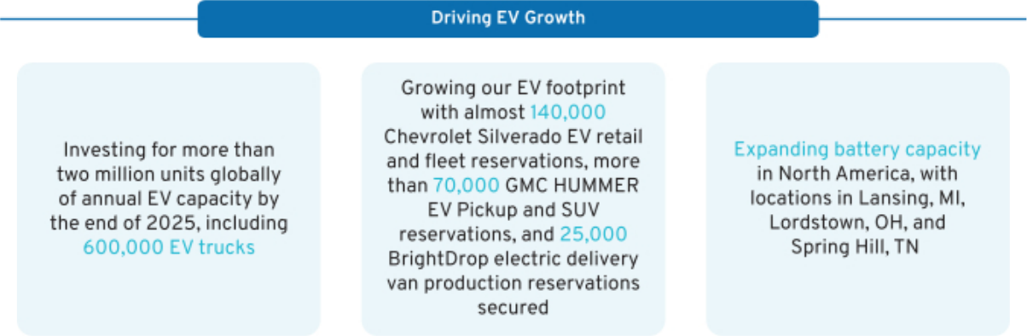
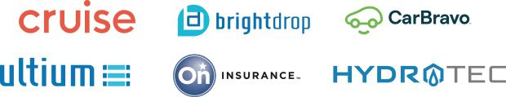

- These are non-GAAP financial measures. Refer to Appendix A for a reconciliation of ROIC-adjusted, EBIT-adjusted, EBIT-adjusted Margin, and EPS-diluted adjusted to their closest comparable GAAP measure.

47

Table of Contents

Showed strength and resiliency of the business by responding to the challenges of the semiconductor shortage while delivering a record $10.0 billion in net income and a record $14.3 billion in EBIT-adjusted

GM Financial generated record-breaking EBT-adjusted of $5.0 billion and paid $3.5 billion in dividends to GM

Increased investment in EV and AV technology to $35 billion from 2020 to 2025 to achieve our commitment of EV leadership in North America by mid-decade and safely commercialize self-driving technology

Announced SBTi-validated, science-based emission reduction targets that align with the Paris Agreement, plans to be carbon neutral in our global products and operations by 2040, and eliminate tailpipe emissions from new light-duty vehicles globally by 2035

Introduced Ultium Charge 360, a holistic charging approach integrating charging networks, GM vehicle mobile apps, and other products and services, to simplify and improve GM EV owners’ overall charging experience

Launched BrightDrop, an all-new business offering commercial customers, including Walmart, all-electric delivery and logistics solutions. BrightDrop started production of the Zevo 600 electric delivery van, and delivered the first units to FedEx Express and Merchants Fleet

Became the first company to receive permission from the California Department of Motor Vehicles to provide a driverless AV passenger service to the public

Delivered 2.2 million vehicles, with Chevrolet and GMC cementing the Company’s eighth consecutive year of combined full-size and midsize pickup sales leadership, second consecutive year as the full-size pickup sales leader, and its 21st consecutive year as the market leader in full-size SUVs

Announced Chevrolet will expand its EV lineup in 2023 to include the Equinox EV, an affordable, functional compact SUV, which will be launched with both fleet and retail versions

Introduced the 2024 Chevrolet Silverado EV, a reimagined full-size, fully electric pickup, developed from the ground up, leveraging the power of GM’s Ultium Platform

Increased U.S. sales of Buick’s new crossover lineup by 12.3 percent, led by Encore GX (up 59 percent) and Envision (up 33 percent)

Began production and customer deliveries of the GMC HUMMER EV Pickup, the world’s first all-electric supertruck

Filled in minutes, reservations for the debut edition of the all-electric Cadillac LYRIQ, the brand’s first electric luxury SUV, built on the Ultium Platform

Launched OnStar Insurance, a new digital insurance experience that aims to be secure, fair, personalized and easy to use, which became one of the fastest nationwide rollouts of an auto insurance product in the U.S.

Joined the Gender and Diversity KPI Alliance, pledging to use three key performance indicators to improve diversity:
representation on the GM Board, representation by employee category, and pay equality

48

Table of Contents

Compensation Overview

- Compensation Governance and Best Practices

WHAT WE DO

- Provide short-term and long-term incentive plans with performance targets aligned to business goals

- Maintain a Compensation Committee composed entirely of independent directors who are advised by an independent compensation consultant

- Require stock ownership for all senior leaders

- Engage with shareholders and other stakeholders on various topics with members of management and directors, including our Compensation Committee and our Independent Lead Director

- Include non-compete and non-solicitation terms in all grant agreements with senior leaders

- Maintain an Insider Trading Policy requiring directors, executive officers, and all other senior leaders to trade only during pre-established periods after receiving preclearance from the GM legal staff

- Require equity awards to have double trigger (change in control and termination of employment) vesting provisions

- Complete an annual risk review evaluating incentive compensation plans

- Require short-term cash and long-term equity awards for all executive officers to be subject to clawback and cancellation provisions

- Conduct an annual audit of senior executive expenses and perquisites that is reviewed by the Audit Committee

WHAT WE DON’T DO

- Provide gross-up payments to cover personal income taxes or excise taxes pertaining to executive severance benefits

- Pay above-market interest on deferred compensation in retirement plans

- Allow any director or employee to engage in hedging or pledging of GM securities

- Reward executives for excessive, imprudent, inappropriate, or unnecessary risk-taking

- Allow the repricing, spring-loading, or backdating of equity awards

49

Table of Contents

- Shareholder Engagement

The Company views shareholder engagement as a continuous process and annually seeks feedback directly from our shareholders. Through these engagements, we received positive feedback in support of our executive compensation program and, in particular, the Compensation Committee’s decision to further drive accountability and reinforce our EV and growth strategy, safety culture, and ESG priorities. The ongoing dialog with shareholders this past year provided critical feedback that was used in the development of our 2022 LTIP design, which further aligns the interest of our executives to those of our shareholders.
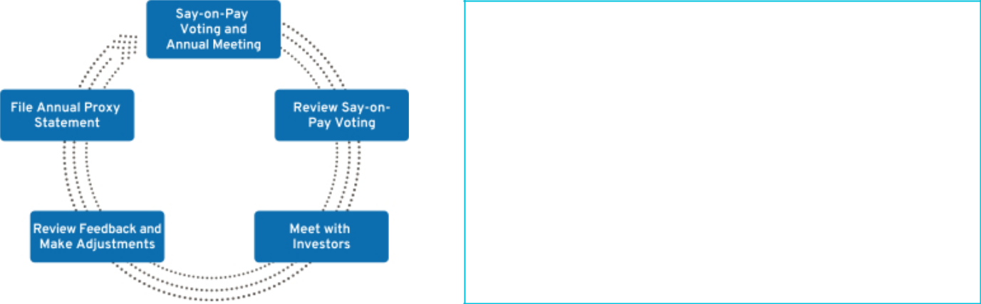

SHAREHOLDER SAY-ON-PAY

The Compensation Committee seeks to align the Company’s executive compensation program with the interests of the Company’s shareholders. The Compensation Committee considers the results of the annual Say-on-Pay vote, the long-term vision and strategic goals of the Company, input from management, input from its independent compensation consultant, and investor engagement feedback when setting and developing compensation plans for our executives. In 2021, 95.3 percent of our shareholders voted in favor of our executive compensation program.

Investor Alignment Topics 2021 Activities

Review Incentive Plan Metrics to Align to EV Strategy and Reduce Overall GHG Emissions

We considered shareholder feedback in making changes to our LTIP design. For the 2022 LTIP design, we replaced Relative ROIC-Adjusted with absolute EBIT-Adjusted Margin, maintained Relative TSR, and added Electric Vehicle performance measures that reward performance for GMNA EV Volume, GMNA EV Launch Timing, and GMNA EV Launch Quality. These changes further link the long-term compensation of our executives to the long-term EV strategy of the Company.

Provide Additional Disclosure on the Impact of ESG Results into Compensation Decisions

ESG performance continues to be a focus for the Company and our shareholders. The Compensation Committee factors ESG performance into strategic goals for each NEO. We enhanced our disclosure to demonstrate our continued work towards ESG performance and provided greater detail into the goal setting process for our strategic goals portion of the STIP. We identify ESG results with a green leaf in the “Our Company Performance” section beginning on page 47 of this Proxy Statement and the “Performance Results and Compensation Decisions” section for our NEOs beginning on page 61 of this Proxy Statement.

Continued Assessment of | The Compensation Committee reviews recommendations from its independent
Appropriate Peer Group | compensation consultant annually to determine if any additions or deletions to the peer
Selection | group is appropriate. We ensure our peer group composition remains competitive and
 | appropriate as the Company continues to expand into new businesses. A full disclosure of
 | our consistent approach and framework can be found in the “Peer Group for
 | Compensation Benchmarking” section on page 53 of this Proxy Statement.

50

Table of Contents

- Compensation Program Evolution

Our executive compensation program focuses leadership on key areas that drive the business forward and align to the short-term and long-term interests of our shareholders. The Compensation Committee regularly reviews and discusses plan performance at each meeting. The Compensation Committee considers many factors when electing to make plan changes for future incentive plans, including results, market trends, and feedback from its independent compensation consultant and shareholders. The timeline below shows the actions we have taken to develop executive compensation plans that align the interests of our senior leaders with those of our shareholders.
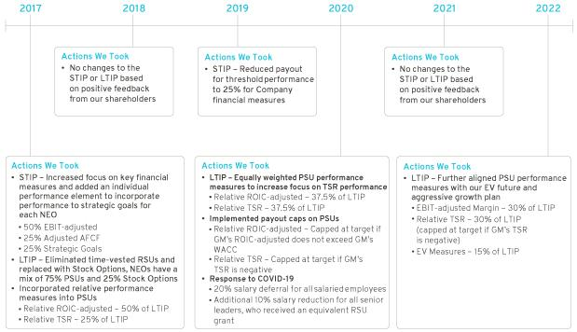

- 2022 LTIP Design Changes

The 2022 LTIP design will continue to have a mix of PSUs and Stock Options, and PSUs will now include the following performance measures:
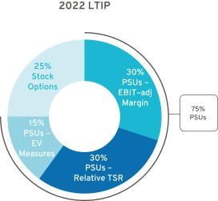

PSUs – 75%

EBIT-adjustedMargin – 30%

Relative TSR – 30%

EV Measures – 15%

• GMNA EV Volume

• GMNA EV Launch Timing
• GMNA EV Launch Quality (modifier)

Stock Options – 25%

These changes further align our executive compensation program with our all-electric future and directs additional focus on Company growth and ESG performance, which will better support our path to EV leadership and expansion into new markets and technologies.

- 2021 STIP and 2021 LTIP Overview

The 2021 STIP focuses leadership on key financial measures (75% of STIP) and strategic goals (25% of STIP). The total payout for the STIP ranges from 0 to 200 percent based on performance against

51

Table of Contents

pre-established targets. The Compensation Committee determines performance to strategic goals using a rigorous assessment process that evaluates final results against pre-established operational goals, safety results, and other measures, including ESG outcomes. Payout for strategic goals performance occurs only if threshold performance of at least one financial measure is met.

The 2021 LTIP has the same design as in 2020 and features Stock Options (25% of total LTIP) to align our most senior leaders with shareholders’ interest in stock price appreciation and PSUs (75% of total LTIP) with relative performance measures that drive long-term results. PSUs are equally weighted for Relative ROIC-adjusted (37.5% of total LTIP) and Relative TSR (37.5% of total LTIP), and performance payouts are capped, as described below.

Relative ROIC-adjusted – Capped at target if GM’s ROIC-adjusted does not exceed GM’s WACC Relative TSR – Capped at target if GM’s TSR is negative over the performance period

Focusing performance on EBIT-adjusted, AAFCF, and strategic goals in the short term, combined with measuring Relative ROIC-adjusted and Relative TSR compared to our OEM peer group in the long term, provided direct alignment of our executive compensation program with the interests of our shareholders and focused senior leaders on making the investments that will provide profitable long-term growth.
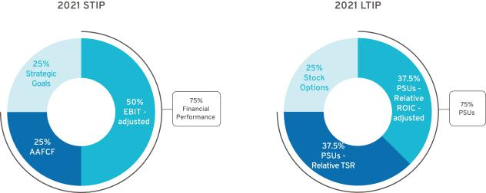

- Peer Group for 2021–2023 LTIP Performance

We use the following OEMs in the Dow Jones Automobiles & Parts Titans 30 Index to measure relative performance for Relative ROIC-adjusted and Relative TSR measures for the 2021–2023 PSU awards. The Compensation Committee uses this index for performance comparisons because these companies represent our global competition and are subject to similar macroeconomic forces.

Dow Jones Automobiles & Parts Titans 30 Index – OEM Peer Group(1)

Bayerische Motoren Werke AG | Mercedes-Benz Group AG(2) | Suzuki Motor Corporation
Ford Motor Company | Nissan Motor Co., Ltd. | Tesla Inc.
Honda Motor Co., Ltd. | Renault SA | Toyota Motor Corporation
Hyundai Motor Company | Stellantis NV(3) | Volkswagen AG
Kia Corporation | Subaru Corporation

- GM is a member of the Dow Jones Automobiles & Parts Titans 30 Index. Our performance is determined on a continuous ranking for performance relative to the OEM peer group following the completion of the performance period.

- Daimler AG changed its name to Mercedes-Benz Group AG on February 1, 2022.

- Fiat Chrysler Automobiles NV and Peugeot SA merged on January 15, 2021, forming Stellantis NV.

52

Table of Contents

- Peer Group for Compensation Benchmarking

The Compensation Committee annually reviews the peer group for compensation benchmarking comparisons and makes updates as needed to align with the established criteria and Company strategy. We do not limit the peer group to our industry alone because we believe compensation practices for NEOs at other large U.S.-based multinational companies affect our ability to attract and retain diverse talent around the globe.

The Compensation Committee considered the following factors when selecting the peer group used to inform 2021 target compensation levels for our NEOs:
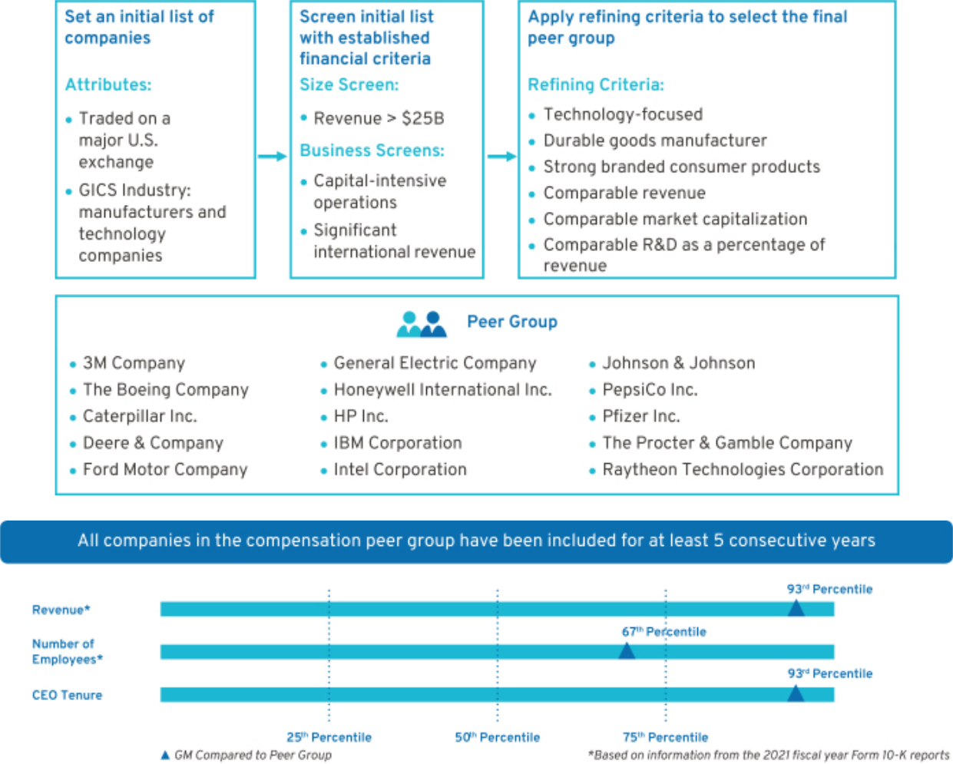

- How We Use Benchmarking Data to Assess Compensation

We benchmark pay practices and compensation levels against the proxy statement disclosures of our peer group. In addition, we use executive compensation surveys to benchmark relevant market data for executive positions and adjust this data to reflect GM’s size and market-expected compensation trends. Furthermore, the Compensation Committee reviews an analysis completed by its independent compensation consultant of the competitive position of each of our executives relative to its benchmark data.

53

Table of Contents

We review each element of compensation compared with the market and generally target each element of our total direct compensation (base salary, STIP, and LTIP) for the executive group to be, on average, at or near the market median. An individual element or an individual’s total direct compensation may be positioned above or below the market median due to a variety of considerations, such as specific responsibilities, experience, and performance.

- How We Plan Compensation
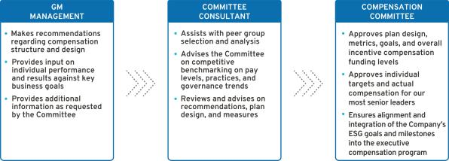

- Performance-Based Compensation Structure

Our incentive plans are designed to optimize long-term financial returns for our shareholders and reward our NEOs for delivering on the Company’s strategy and vision of zero crashes, zero emissions, and zero congestion. The 2021 performance-based structure incorporated short-term and long-term incentives tied to financial and operational measures to drive Company performance for fiscal year 2021 and beyond. The Compensation Committee believes a majority of the compensation opportunity should be in the form of equity to align the interests of executives with those of shareholders.
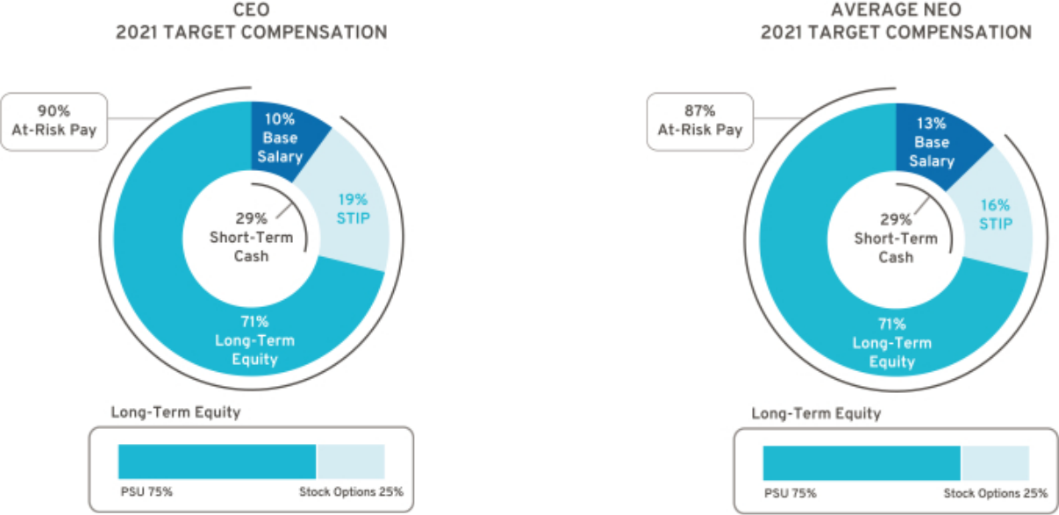

54

Table of Contents

Compensation Principles

The compensation provided to our senior leaders is guided by pay-for-performance and the following principles:

Align with Shareholders – Compensation paid should align directly with the long-term interests of our shareholders, and our executives should share with them in the performance and value of our common stock.

Enable Company Strategy – Compensation should be based on challenging Company performance and strategic goals, which are within our executives’ control, and reward performance aligned with GM’s strategy, values, and expected behaviors.

Market Competitive – Target compensation should have an appropriate mix of short-term and long-term pay elements and should be competitive (market median) with that paid to individuals at peer group companies so that it attracts, motivates, and retains talent.

Avoid Excessive Risk Taking – Compensation structure should avoid incentivizing unnecessary and excessive risk taking.

Simple Design – Compensation plans should be easy to understand and communicate, and minimize unintended consequences.

Compensation Elements

- Compensation Structure

The 2021 compensation structure is market competitive with each pay element targeted at or near the market median and includes the following pay elements:
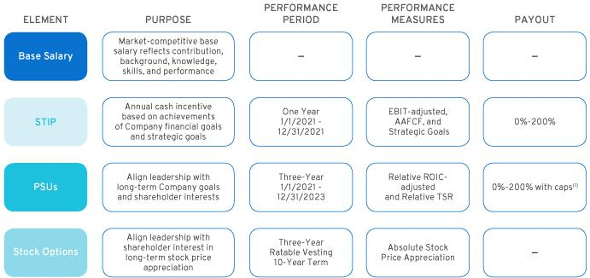

- Relative ROIC-adjusted is capped at target if GM’s ROIC-adjusted does not exceed GM’s WACC, and Relative TSR is capped at target if GM’s TSR is negative over the performance period.

55

Table of Contents

- Perquisites and Other Compensation

We provide perquisites and other compensation to our NEOs consistent with market practices. The following perquisites and other compensation were provided in 2021:

Personal Air Travel – Due to security reasons identified by an independent third-party security consultant, Company policy prohibits Ms. Barra from using commercial air travel for business and personal use. As a result, the Company pays the costs associated with both business and personal use of aircraft. Other NEOs may travel on company aircraft in certain circumstances with prior approval from the CEO or the Senior Vice President, Global Human Resources. All NEOs, including our CEO, incur imputed income when aircraft is used for personal travel and do not receive any tax gross-ups. Aircraft travel by NEOs for an annual executive physical through the Executive Physical Program is included under Personal Travel. NEOs may be eligible to reimburse personal travel pursuant to time-sharing agreements that the Company may enter into from time-to-time, subject to Federal Aviation Administration regulations.

Company Vehicle Programs – NEOs are eligible to participate in the Executive Company Vehicle Program and may use evaluation vehicles for the purpose of providing feedback on Company products. In addition, NEOs are eligible to use driver services provided by the Company in accordance with Company policies.

Security – NEOs may receive security services, including home security systems and monitoring, for specific security-related reasons identified by independent third-party security consultants. We maintain security staff to provide all employees with a safe and secure environment, which aligns to and reinforces our safety culture.

Financial Counseling – NEOs are eligible to receive financial counseling, estate planning, and tax preparation services through an approved provider. These services allow our NEOs to focus on Company business and ensure accurate personal tax reporting.

Executive Physicals – The health and wellness of our workforce is a priority, and all of our employees are encouraged to complete an annual physical. NEOs are eligible to receive a comprehensive wellness examination with an approved provider. The cost of meals, lodging, and ground transportation for NEOs who traveled for an annual executive physical through the Executive Physical Program are included under Executive Physicals. These wellness visits promote employee well-being and enable employees to take appropriate steps in the event of illness or a medical condition that may impact his or her ability to perform his or her duties.

- 2021 Target Compensation

Our target total direct compensation for each NEO in 2021 was as follows:

 |  |  |  |  | LTIP
 |  |  |  |  |  |  | Target Total
 | Base Salary | STIP | STIP | Target Total Cash | PSUs | Stock | Direct
 | Base Salary | STIP | STIP | Compensation | PSUs | Options | Compensation
 |  |  |  |  | (1)
Name | ($) | (%) | ($) | ($) | ($) | ($) | ($)
Mary T. Barra | 2,100,000 | 200% | 4,200,000 | 6,300,000 | 11,812,500 | 3,937,500 | 22,050,000
Paul A. Jacobson | 1,000,000 | 125% | 1,250,000 | 2,250,000 | 3,937,500 | 1,312,500 | 7,500,000
Mark L. Reuss | 1,300,000 | 125% | 1,625,000 | 2,925,000 | 5,006,250 | 1,668,750 | 9,600,000
Douglas L. Parks | 850,000 | 125% | 1,062,500 | 1,912,500 | 3,740,625 | 1,246,875 | 6,900,000
Stephen K. Carlisle | 850,000 | 125% | 1,062,500 | 1,912,500 | 3,740,625 | 1,246,875 | 6,900,000

- The number of PSUs awarded is determined by using the target PSU value divided by the closing stock price on the date of grant. A portion of the PSU award with performance tied to Relative TSR is valued in the Summary Compensation Table using a Monte Carlo analysis resulting in amounts that may be higher or lower than target.

56

Table of Contents

Performance Measures

- How We Set Performance Targets

The Compensation Committee approves the performance measures for the STIP and LTIP annually. The Compensation Committee reviews recommendations from management, receives input from its independent compensation consultant, evaluates the annual budget and mid-term business plan, and reviews prior year performance to approve value-creating goals tied to long-term shareholder value.

- 2021 STIP Performance Measures

STIP performance measures are linked to the Company’s annual financial goals and strategic goals that drive our long-term strategy. The Compensation Committee annually reviews and approves STIP performance measures that align with shareholders’ interests.

The Compensation Committee approves strategic goals that align to delivering on our long-term Company strategy and objectives. Strategic goals cover the following five areas:

Our People – Attracting, retaining, and engaging our people by providing the best employee experience that supports and invests in diversity, equity, and inclusion, while living values and behaviors that return people home safely every day.

Products, Software, and Services – Creating leading technologies and innovations that deliver customer value and executing launch excellence with best-in-class product quality.

Citizenship – Prioritizing actions that are inclusive for the communities in which we live and work, including implementation of our plan to be carbon neutral in our global products and operations by 2040 and to eliminate tailpipe emissions from new light-duty vehicles globally by 2035.

Enterprise – Maximizing our EV opportunity through scale and cost optimization by expanding manufacturing capabilities and operational excellence, while exceeding our financial and structural cost objectives.

Customer Experience – Reimagining the customer experience, while in pursuit of EV leadership and enhancing human experiences across the GM ecosystem.

Following the performance period, the Committee uses a scorecard to assess individual performance results to the strategic goals above and makes final compensation decisions as discussed beginning on page 61 of this Proxy Statement.

STIP awards, if any, are determined based on final Company financial performance and the Compensation Committee’s assessment of performance to strategic goals for each NEO. 2021 STIP targets were aligned to the business plan and to the guidance provided in connection with our earnings release for the year ended December 31, 2020. The target for EBIT-adjusted was set above the prior year result and the target for AAFCF was set below the prior year result primarily due to expected increases in capital expenditures and a reduction in expected wholesale volumes because of the semiconductor shortage. The table below describes each STIP performance measure – its weighting, its target, and the leadership behavior each measure drives.

STIP Performance | Weight | Target | Leadership Behaviors
Measure | Weight | Target | Leadership Behaviors
EBIT-adjusted ($B)(1) | 50% | $11.0 | Focus on operating profit and driving strong profitability
AAFCF ($B)(2) | 25% | $1.3 | Focus on driving strong cash flow to invest in the business
Strategic Goals | 25% | 25 pts. | Focus on performance that aligns to the Company vision and drives
 |  |  | business results

- Measure adjusted for incentive purposes and excludes the impact of Cruise. For a description of how EBIT-adjusted is calculated, see Appendix A of this Proxy Statement.

- Measure adjusted for incentive purposes and excludes payments related to certain recall-related expenses attributable to events occurring in 2014. For a description of how AAFCF is calculated, see Appendix A of this Proxy Statement.

57

Table of Contents

The potential payouts for each Company performance measure ranges from 0 to 200 percent of target based on actual Company performance. The payout for threshold performance is 25 percent for both EBIT-adjusted and AAFCF; performance below threshold results in a 0 percent payout. Final STIP awards are calculated as follows:
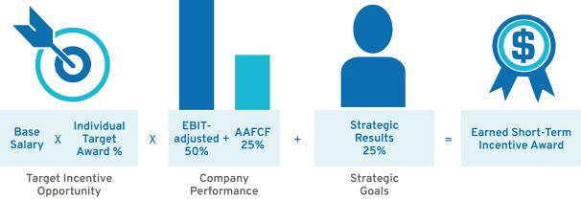

- 2021–2023 LTIP Performance Measures

Grants made under the LTIP are intended to link the financial interests of NEOs with the long-term interests of shareholders. When determining grant amounts, the Compensation Committee considers factors such as individual responsibilities, experience, and performance. In addition, the Compensation Committee factors relevant market compensation comparison data and input provided by its independent compensation consultant. The structure includes 75 percent PSUs and 25 percent Stock Options. PSUs cliff-vest following a three-year performance period, and Stock Options vest ratably over three years.

PSUs are based on Relative ROIC-adjusted and Relative TSR performance against our OEM peer group shown on page 52 of this Proxy Statement. Continuing for 2021, PSUs are equally weighted for Relative ROIC-adjusted and Relative TSR, and both measures are subject to performance caps. The PSU performance measures promote the efficient use of capital for long-term growth in shareholder value with an increased focus on stock price appreciation. The table below describes each PSU performance measure — its weighting, the leadership behavior each measure drives, and its payout.
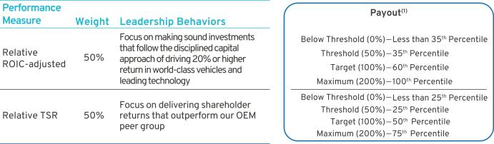

- Relative ROIC-adjusted is capped at target if GM’s ROIC-adjusted does not exceed GM’s WACC, and Relative TSR is capped at target if GM’s TSR is negative over the performance period.

58

Table of Contents

The 2021–2023 PSUs vest and are awarded and delivered following the completion of the three-year performance period beginning January 1, 2021, and may be earned at a level between 0 and 200 percent of target based on actual Company results relative to the OEM peer group. Final PSU awards are calculated as follows:
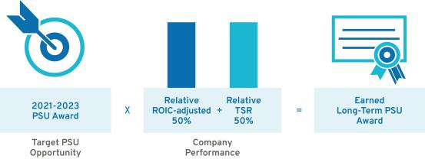

- Summary of Outstanding Performance Awards

Each PSU award features a three-year performance period resulting in overlapping awards that, in aggregate, cover a five-year period. The potential payout for each PSU award ranges from 0 to 200 percent. The table below illustrates the performance period for the three outstanding PSU awards as of the filing date of this Proxy Statement, and the corresponding performance measures and weights.
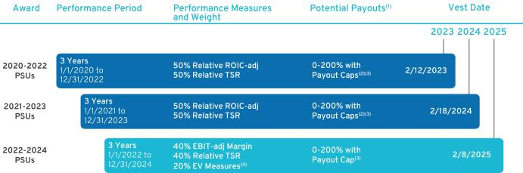

- The performance of each PSU award will be measured and determined at the end of the performance period.

- Relative ROIC-adjusted is capped at target if GM’s ROIC-adjusted does not exceed GM’s WACC.

- Relative TSR is capped at target if GM’s TSR is negative over the performance period.

- EV Measures are comprised of GMNA EV Volume, GMNA EV Launch Timing, and GMNA EV Launch Quality (modifier).

59

Table of Contents

Performance Results and Compensation Decisions

- 2021 STIP Results

The Company financial performance portion of the 2021 STIP award was calculated based on the Company’s achievement of EBIT-adjusted and AAFCF performance measures. Target goals were set in consideration of the significant business disruption caused by the global semiconductor shortage and continued effects of the global pandemic, which adversely affected numerous elements of the supply chain and our business operations. Despite these challenges, the Company achieved record EBIT-adjusted through extensive work in the areas of purchasing, engineering, sales, and manufacturing, where we prioritized production of our highest demand products. The Company also delivered other strong 2021 financial results and key business highlights as detailed in the “Our Company Performance” section on page 47 of this Proxy Statement. In addition to Company financial measures, a portion of each NEO’s STIP evaluates his or her performance against pre-established strategic goals.

Final STIP performance approved by the Compensation Committee is displayed below.

 |  |  |  |  | Performance
STIP Measure | Weight | Threshold | Target | Maximum | Result
EBIT-adjusted ($B)(1) | 50% | $5.1 | $11.0 | $12.0 | $15.5
AAFCF ($B)(2) | 25% | $(4.6) | $1.3 | $2.3 | $2.8
Strategic Goals(3) | 25% | 0 pts. | 25 pts. | 50 pts. | 30-37 pts.
Performance Payout |  |  |  | 180%—187% of Target

- Measure adjusted for incentive purposes and excludes the impact of Cruise. For a description of how EBIT-adjusted is calculated, see Appendix A of this Proxy Statement.

- Measure adjusted for incentive purposes and excludes payments related to certain recall-related expenses attributable to events occurring in 2014. For a description of how AAFCF is calculated, see Appendix A of this Proxy Statement.

- Performance results to strategic goals are discussed beginning on page 61 of this Proxy Statement.

- 2019–2021 LTIP Results

The 2019-2021 PSUs vested on February 13, 2022, based on Company performance for the three-year performance period beginning January 1, 2019, against pre-established performance targets for Relative ROIC-adjusted and Relative TSR. Final LTIP performance approved by the Compensation Committee is displayed below.

 |  |  | Percentile
 |  |  |  |  | Performance
LTIP Measure | Weight | Threshold | Target | Maximum | Performance
 |  |  |  |  | Result
Relative ROIC-adjusted | 67% | 35th | 60th | 100th | 100th Percentile
Relative TSR | 33% | 25th | 50th | 75th | 64th Percentile
Performance Payout |  |  |  |  | 186% of Target

The Company continues to focus on ROIC and delivering best results among the OEMs, while driving TSR performance with a focus on the long-term interest of our shareholders. We continue to prioritize and focus on investing in new and existing businesses, including opportunities in EV, AV, and connected services to achieve strong, profitable growth with solid return on investment.

60

Table of Contents

- Compensation Decisions for Mary T. Barra

Chair and Chief Executive Officer

The Compensation Committee made the following pay decisions based on performance, competitive market data, and feedback from its independent compensation consultant:

Base Salary – Held base salary at $2,100,000.

Short-Term Incentive – In addition to the Company’s record EBIT-adjusted and strong AAFCF performance (discussed on page 60 of this Proxy Statement), Ms. Barra was awarded 32 points out of a 25-point target and 50-point maximum for the strategic goals portion for the 2021 STIP performance year. In determining the number of points earned, the Committee considered these results for Ms. Barra:

- Accelerated our EV investments and portfolio including delivering, in record time, our first GMC HUMMER EVs and BrightDrop Zevo 600 electric delivery vans;
- Generated a record $10 billion in net income and $14.3 billion in EBIT-adjusted by mitigating the effects of the semiconductor shortage; and

- Demonstrated strong leadership in the transition to EVs by prioritizing infrastructure and climate equity through creation of a $25 million Climate Equity Fund and pledging an additional $25 million, for a total of $50 million, as well as other highlights below.

Our People

• Continued to prioritize our safety culture through multiple initiatives
• Introduced Work Appropriately, a new approach to the future of work that allows employees to work where they can have the greatest impact on achieving our goals
• Exceeded by 100 percent our hiring commitment to OneTen, a coalition aiming to upskill, hire, and advance 1 million Black Americans over the next decade into family-sustaining jobs with opportunities for advancement

Products, Software, and Services

• Announced Ultra Cruise, an all-new, advanced driver-assistance technology designed to enable hands-free driving in 95 percent of all driving scenarios
• Accelerated our EV investments to grow an all-electric portfolio that is unmatched in depth and range, including: BrightDrop electric delivery vans, Chevrolet Silverado EV, Equinox EV, Blazer EV, Bolt EV and EUV, along with GMC Sierra EV, HUMMER EVs, and Cadillac LYRIQ and CELESTIQ

Citizenship

• Set SBTi-validated, science-based targets to achieve carbon neutrality and committed to become carbon neutral in global products and operations by 2040, 10 years ahead of the goals set forth in the Paris Agreement on climate change

• Named as one of America’s Most Responsible Companies for 2022 by Newsweek

• Received 2021 ENERGY STAR Partner of the Year – Sustained Excellence Award from U.S. EPA and U.S. Department of Energy for the 10th year for GM’s commitment to fighting climate change and protecting public health

Enterprise

• Achieved record GM Financial EBT-adjusted of $5.0 billion and $3.5 billion in dividends paid back to
GM

• Elected as the first woman to serve as the Chair of the Business Roundtable

Customer Experience

• Introduced Ultium Charge 360, a holistic charging approach integrating charging networks, GM vehicle mobile apps, and other products and services, to simplify and improve GM EV owners’ overall charging experience
• Announced Ultifi, an end-to-end software platform designed to unlock new vehicle experiences and connect customers’ digital lives
• Launched OnStar Insurance, one of the fastest nationwide rollouts of an auto insurance product in the U.S.


Long-Term Incentive – In February 2021, awarded an annual LTIP grant of $15.75 million, consisting of 75 percent PSUs and 25 percent Stock Options.

Total awarded compensation for 2021, including salary, STIP, and LTIP, is displayed below.

Pay Element | Majority of Pay Is At-Risk | Awarded Value
Base Salary | Only Fixed Pay Element | $2,100,000
STIP | Performance to Metrics | $7,644,000
PSUs⁽¹⁾ | Performance to Metrics and Stock Price | $14,582,198
Stock Options | Performance to Stock Price | $3,937,507
TOTAL |  | $28,263,705

- Value reflects grant date fair value at target performance for Relative ROIC-adjusted awards and reflects the accounting value based on the results from the Monte Carlo analysis for Relative TSR awards.

Awarded Value reflects the amount included in the Summary Compensation Table, excluding change in pension value and all other compensation.
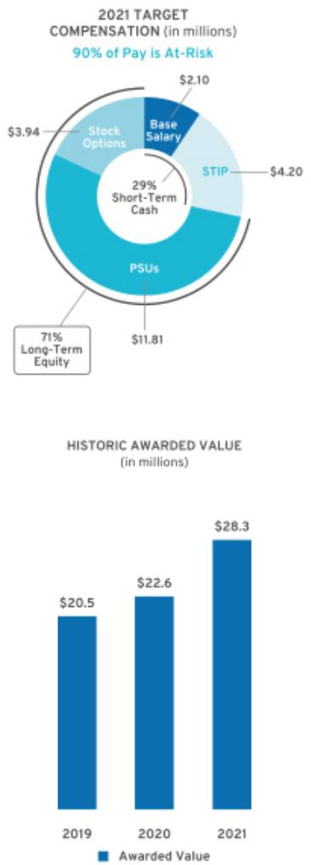

Represents ESG Results

61

Table of Contents

- Compensation Decisions for Paul A. Jacobson

Executive Vice President and Chief Financial Officer

The Compensation Committee made the following pay decisions based on performance, competitive market data, and feedback from its independent compensation consultant and management:

Base Salary – Held base salary at $1,000,000.

Short-Term Incentive – In addition to the Company’s record EBIT-adjusted and strong AAFCF performance (discussed on page 60 of this Proxy Statement), Mr. Jacobson was awarded 30 points out of a 25-point target and 50-point maximum for the strategic goals portion for the 2021 STIP performance year. In determining the number of points earned, the Committee considered these results for Mr. Jacobson:

- Accelerated our EV and AV investments by $8 billion;

- Achieved record GM Financial EBT-adjusted of $5.0 billion and $3.5 billion in dividends paid back to GM; and
- Increased_{below.} the diversity of the finance leadership team, as well as other highlights


Our People

• Continued to prioritize our safety culture through multiple initiatives

Products, Software, and Services

• Accelerated our EV investments to grow an all-electric portfolio that is unmatched in depth and range

Citizenship

• Increased EV and AV investments from 2020 through 2025 to $35 billion to become the EV leader in North America, the global battery and fuel cell technology leader, and the first to safely commercialize self-driving technology

• Joined 20 major corporations, as well as institutional investors, as a founding member of TPG Rise Climate in a first-of-its-kind coalition focused on climate-related investments in clean energy, enabling solutions, decarbonized transport, greening industrials, and agriculture and natural solutions

• Recognized in the S&P’s Sustainability Yearbook under a Gold Class Distinction Enterprise
• Outlined growth strategy of how GM plans to double its annual revenue and expand margins to a range of 12 to 14 percent by 2030

• Generated a record $10 billion in net income, $14.3 billion in EBIT-adjusted, EPS-diluted of $6.70, and EPS-diluted-adjusted of $7.07

• Leveraged the strength of our balance sheet to increase equity investment in Cruise, acquiring SoftBank’s $2.1 billion ownership stake and making an additional $1.35 billion investment to advance our integrated AV strategy

Customer Experience

• Partnered with cross-functional teams to develop new tools for dealers and customers to make vehicle ordering more efficient and expanded e-commerce opportunities in the used vehicle market with the launch of Car Bravo

• Co-championed a project that identified $1.4B in direct material cost reduction opportunities, through the use of advanced data analytics

Long-Term Incentive – In February 2021, awarded an annual LTIP grant of $5.25 million, consisting of 75 percent PSUs and 25 percent Stock Options.

Total awarded compensation for 2021, including salary, STIP, and LTIP, is displayed below.

Pay Element | Majority of Pay Is At-Risk | Awarded Value
Base Salary | Only Fixed Pay Element | $1,000,000
STIP | Performance to Metrics | $2,250,000
PSUs⁽¹⁾ | Performance to Metrics and Stock Price | $4,860,724
Stock Options | Performance to Stock Price | $1,312,502
TOTAL |  | $9,423,226

- Value reflects grant date fair value at target performance for Relative ROIC-adjusted awards and reflects the accounting value based on the results from the Monte Carlo analysis for Relative TSR awards.

62

Awarded Value reflects the amount included in the Summary Compensation Table, excluding change in pension value and all other compensation.
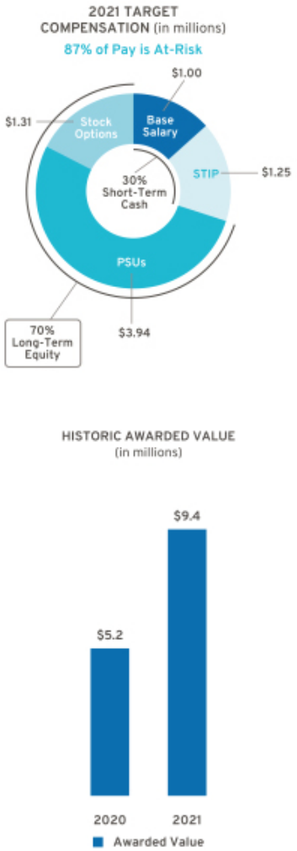

Represents ESG Results

Table of Contents

- Compensation Decisions for Mark L. Reuss

President

The Compensation Committee made the following pay decisions based on performance, competitive market data, and feedback from its independent compensation consultant and management:

Base Salary – Held base salary at $1,300,000.

Short-Term Incentive – In addition to the Company’s record EBIT-adjusted and strong AAFCF performance (discussed on page 60 of this Proxy Statement), Mr. Reuss was awarded 37 points out of a 25-point target and 50-point maximum for the strategic goals portion for the 2021 STIP performance year. In determining the number of points earned, the Committee considered these results for Mr. Reuss:

- Opened Factory ZERO in Detroit-Hamtramck, our first plant dedicated to Ultium products, including the GMC HUMMER EV Pickup;
- Launched and refreshed 15 vehicles globally, including the BrightDrop Zevo 600, amid a challenging environment; and

- Improved key drivers of customer experiences, as well as other highlights below.

Our People

• Continued to prioritize our safety culture through multiple initiatives
• Introduced Work Appropriately, a new approach to the future of work that allows employees to work where they can have the greatest impact on achieving our goals

Products, Software, and Services

• Announced Ultifi, an end-to-end software platform designed to unlock new vehicle experiences and connect customers’ digital lives
• Built momentum for the Cadillac brand through the reveal and launch of the LYRIQ EV nine months ahead of schedule, and bolstered the brand’s reputation for performance with CT4 and CT5 V-Series Blackwing

Citizenship

• Committed to become carbon neutral in global products and operations by 2040 and set SBTi-validated, science-based targets to achieve carbon neutrality
• Developed a new community charging program, in collaboration with the dealer network, to install up to 40,000 Level 2 EV chargers across the U.S. and Canada
• Key contributor to the Michigan Climate Advisory Board and supported GM’s public policy initiatives in Washington

Enterprise

• Transitioned the Spring Hill Complex in Tennessee to become GM’s third plant to produce electric vehicles, including the Cadillac LYRIQ
• Opened GM Defense’s new production facility in North Carolina, which manufactures the Infantry Squad Vehicle for the U.S. Army
• Announced the Wallace Battery Cell Innovation Center, an all-new facility that will significantly expand the Company’s battery technology operations and accelerate development and commercialization of longer range, more affordable electric vehicle batteries

Customer Experience

• Focused on increasing net promoter scores across all regions aligning with our aspiration to become a leading customer experience company
• Expanded access to OnStar Guardian, OnStar’s safety and security app, to all customers in North America with a compatible Apple or Android mobile device, and announced plans to introduce the OnStar Guardian skill for Amazon Alexa, offering a voice-enabled connection to Emergency-Certified OnStar Advisors at home


Awarded Value reflects the amount included in the Summary Compensation Table, excluding change in pension value and all other compensation.
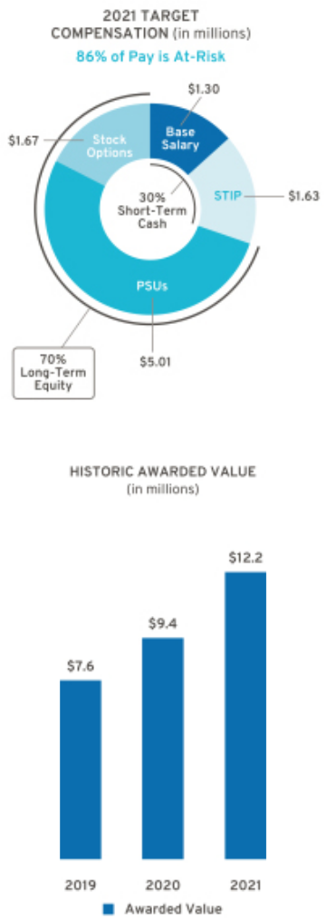

Long-Term Incentive – In February 2021, awarded an annual LTIP grant of $6.68 million, consisting of 75 percent PSUs and 25 percent Stock Options.

Total awarded compensation for 2021, including salary, STIP, and LTIP, is displayed below.

Pay Element | Majority of Pay Is At-Risk | Awarded Value
Base Salary | Only Fixed Pay Element | $1,300,000
STIP | Performance to Metrics | $3,038,800
PSUs⁽¹⁾ | Performance to Metrics and Stock Price | $6,180,076
Stock Options | Performance to Stock Price | $1,668,752
TOTAL |  | $12,187,628

- Value reflects grant date fair value at target performance for Relative ROIC-adjusted awards and reflects the accounting value based on the results from the Monte Carlo analysis for Relative TSR awards.

Represents ESG Results

63

Table of Contents

- Compensation Decisions for Douglas L. Parks

Executive Vice President, Global Product Development, Purchasing and Supply Chain

The Compensation Committee made the following pay decisions based on performance, competitive market data, and feedback from its independent compensation consultant and management:

Base Salary – Held base salary at $850,000

Short-Term Incentive – In addition to the Company’s record EBIT-adjusted and strong AAFCF performance (discussed on page 60 of this Proxy Statement), Mr. Parks was awarded 32 points out of a 25-point target and 50-point maximum for the strategic goals portion for the 2021 STIP performance year. In determining the number of points earned, the Committee considered these results for Mr. Parks:

- Managed supply chain challenges and delivered full-size pickup and full-size SUV sales leadership in the U.S. and the best-selling EV in China;
- Developed the Ultifi software architecture, an end-to-end software platform designed to unlock new vehicle experiences and quickly connect customers’ digital lives; and

- Established strategic plan for C02 reduction glidepaths across key material commodities, as well as other highlights below.

Our People

• Continued to prioritize our safety culture through multiple initiatives
• Received strong engagement and Inclusivity Index scores, while developing leadership initiatives to further engage our people in order to become the most inclusive company in the world

Products, Software, and Services

• Executed successful strategy in the midst of the global supply chain shortage by prioritizing the highest-demand products in order to satisfy as many customers as possible and drive strong results in key market segments
• Announced Ultra Cruise, an all-new, advanced driver-assistance technology designed to enable hands-free driving in 95 percent of all driving scenarios

Citizenship

• Progressed towards achieving GHG compliance in all global markets
• Joined the Initiative for Responsible Mining Assurance, adding another element to company programs that support the sustainability and human rights of the EV supply chain
• Announced collaboration with Wabtec Corporation to develop and commercialize Ultium battery technology and HYDROTEC hydrogen fuel cell systems for Wabtec locomotives

Enterprise

• Executed an aggressive EV portfolio rollout across all brands and segments
• Began customer deliveries of the first 2022 GMC HUMMER EV Pickup, which is produced at the Factory ZERO EV assembly plant that opened in 2021

Customer Experience

• Launched Periscope, a new brand representing a holistic approach to customer and vehicle safety consisting of three focus areas: vehicle technology, research, and advocacy
• Launched plan to extend the HYDROTEC fuel cell power cubes to provide portable fast-charging capability for EVs


Long-Term Incentive – In February 2021, awarded an annual LTIP grant of $4.99 million, consisting of 75 percent PSUs and 25 percent Stock Options.

Total awarded compensation for 2021, including salary, STIP, and LTIP, is displayed below.

Pay Element | Majority of Pay Is At-Risk | Awarded Value
Base Salary | Only Fixed Pay Element | $850,000
STIP | Performance to Metrics | $1,933,800
PSUs⁽¹⁾ | Performance to Metrics and Stock Price | $4,617,717
Stock Options | Performance to Stock Price | $1,246,876
TOTAL |  | $8,648,393

- Value reflects grant date fair value at target performance for Relative ROIC-adjusted awards and reflects the accounting value based on the results from the Monte Carlo analysis for Relative TSR awards.

64

Awarded Value reflects the amount included in the Summary Compensation Table, excluding change in pension value and all other compensation.
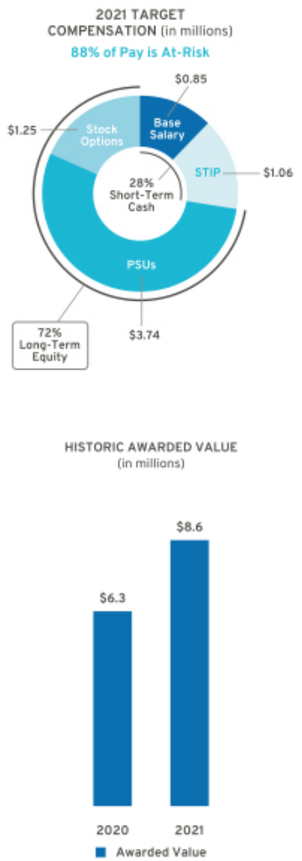

Represents ESG Results

Table of Contents

- Compensation Decisions for Stephen K. Carlisle

Executive Vice President and President, North America

The Compensation Committee made the following pay decisions based on performance, competitive market data, and feedback from its independent compensation consultant and management:

Base Salary – Effective January 1, 2021, increased base salary from $800,000 to $850,000.

Short-Term Incentive – In addition to the Company’s record EBIT-adjusted and strong AAFCF performance (discussed on page 60 of this Proxy Statement), Mr. Carlisle was awarded 32 points out of a 25-point target and 50-point maximum for the strategic goals portion for the 2021 STIP performance year. In determining the number of points earned, the Committee considered these results for Mr. Carlisle:
- Increased EV manufacturing capacity in North America;

- Achieved 10 percent EBIT-adjusted margin in North America in a challenging semiconductor and supply chain environment; and

- Maintained leadership in full-size pickups in the U.S. market for the 2nd consecutive year and leadership in full-size SUVs for the 21st consecutive year, as well as other highlights below.
Our People

• Continued to prioritize our safety culture through multiple initiatives
• Received strong engagement and Inclusivity Index scores, while developing leadership initiatives to further engage our people in order to become the most inclusive company in the world

Products, Software, and Services

• Received Top Overall Manufacturer Loyalty award by IHS Markit for the 6th consecutive year

• Achieved top three ranks in J.D. Powers Sales Satisfaction Index Study’s mass market category for GMC, Buick, and Chevrolet

Citizenship

• Announced plan to source 100 percent renewable energy to power our U.S. sites by 2025 – five years earlier than previously announced, and 25 years ahead of its initial target
• Progressed towards GHG compliance in North America

• Committed a $50 million investment, in collaboration with the City of Detroit, into Detroit-based nonprofit programs that expand access to education and employment opportunities and strengthen city neighborhoods

Enterprise

• Announced investments totaling more than $14 billion in 10 North American sites to increase EV manufacturing capacity to more than 1 million annually by the end of 2025
• Launched the Oshawa Assembly Plant in less than one year, one of the fastest retooling plant launches in GM history

Customer Experience

• Achieved strong dealer return on sales in the U.S. despite supply chain headwinds
• Developed the all-new My GM Rewards loyalty program for Chevrolet, Buick, GMC, and Cadillac customers, enhancing the ownership experience
• Focused on increasing net promoter scores across all regions aligning with our aspiration to become a leading customer experience company


Long-Term Incentive – In February 2021, awarded an annual LTIP grant of $4.99 million, consisting of 75 percent PSUs and 25 percent Stock Options.

Total awarded compensation for 2021, including salary, STIP, and LTIP, is displayed below.

Pay Element | Majority of Pay Is At-Risk | Awarded Value
Base Salary | Only Fixed Pay Element | $850,000
STIP | Performance to Metrics | $1,933,800
PSUs⁽¹⁾ | Performance to Metrics and Stock Price | $4,617,717
Stock Options | Performance to Stock Price | $1,246,876
TOTAL |  | $8,648,393

- Value reflects grant date fair value at target performance for Relative ROIC-adjusted awards and reflects the accounting value based on the results from the Monte Carlo analysis for Relative TSR awards.

Awarded Value reflects the amount included in the Summary Compensation Table, excluding change in pension value and all other compensation.
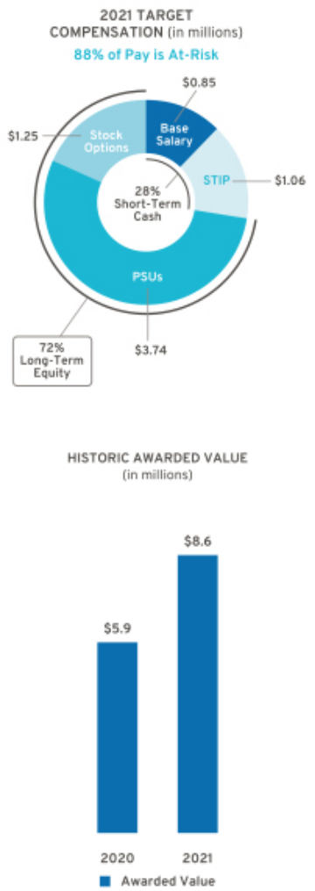

Represents ESG Results

65

Table of Contents

Compensation Policies and Governance Practices

- Stock Ownership Requirements

The Company requires our senior leaders to own GM stock to align their interests with those of our shareholders. Our stock ownership requirements:

- Cover all senior leaders

- Set a five-year time frame to meet ownership requirements

- Require senior leaders to continually hold owned shares to maintain ownership requirements

- Establish a multiple of each executive’s base salary on the date first covered

- Allow the opportunity to own either a required number of shares or the total dollar value of shares to meet ownership requirements

- Count only actual share holdings and unvested RSUs (i.e., excludes stock options and unvested PSUs)

The table below shows the stock ownership requirement by level in the Company. As of December 31, 2021, all NEOs have met or are on track to meet stock ownership requirements by their respective dates.
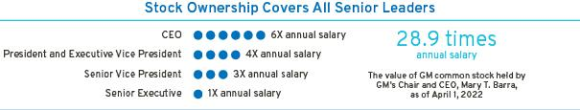

- Compensation Risk Assessment

The Compensation Committee annually reviews the potential impact of our compensation programs on organizational risk. The Compensation Committee discusses the compensation programs and risk mitigation features when evaluating whether the programs encourage or reward employees for engaging in excessive, imprudent, inappropriate, or unnecessary risk-taking. The Committee also confirms the alignment of the compensation programs to the Company’s sustainability risks and opportunities.

The annual risk review, completed on October 22, 2021, with assistance from our human resources, audit, and legal organizations, involved analyzing our current compensation programs in relation to risk. Our analysis concluded that our compensation programs include the following risk mitigation features:

Mix of Pay Elements – Base salary, STIP, PSUs, and Stock Options are included in the executive compensation program.

Short-Term and Long-Term Plans – The mix of our short-term and long-term compensation plans appropriately reward employees while balancing risk through the delayed payment of long-term awards.

Adjustments to Compensation – Maximum payout caps are in place for incentive compensation, and the Compensation Committee has the ability to apply negative discretion.

Compensation Committee Oversight – Our Compensation Committee reviews plan performance and approves all executive compensation plans and payouts.

Multiple Performance Measures – Multiple performance measures work together to balance risk in our incentive compensation plans.

Stock Ownership Requirements – All senior leaders are subject to stock ownership requirements of at least one times their salary, as described above.

66

Table of Contents

Clawback and Cancellation Provisions – All awards are subject to our Policy on Recoupment of Incentive Compensation, as described below. In addition, cancellation provisions apply to all outstanding STIP and LTIP awards.

In 2021, the Compensation Committee determined that our compensation programs have sufficient risk mitigation features and do not encourage or reward employees for engaging in excessive, imprudent, inappropriate, or unnecessary risk-taking. Based on the Compensation Committee’s review, the Committee determined our compensation programs to be low risk.

- Policy on Recoupment of Incentive Compensation

Under our Policy on Recoupment of Incentive Compensation (available on our website at investor.gm.com/resources), the Compensation Committee is empowered to recoup (“clawback”) compensation paid to executive officers and other executives under its purview. In the event of employee misconduct that causes specified financial or reputational damage, a materially inaccurate performance calculation, or an accounting restatement, the Committee may seek to clawback paid incentive compensation. The Committee may also cancel outstanding equity-based awards granted to any covered employee if that employee engages in conduct detrimental to the Company. This policy was expanded in 2020 to cover additional executives and scenarios of misconduct beyond only an accounting restatement.

 |  | Cancellation and | Cancellation of
 | Clawback Policy | Clawback Due to Violation | Unvested
 | Clawback Policy | of Non-Compete and | and Outstanding
 |  | Non-Solicitation Terms | Awards
 | Executive officers and other | Approximately 250 | All employees that
Covered Population executives under the purview of |  | Approximately 250 | receive awards through
 |  | senior leaders | receive awards through
 | the Committee | senior leaders | STIP or LTIP
 | Following employee misconduct
 | that causes specified financial or | Employee violates
Event Applicable | reputational damage, a | Employee violates | Employee engages in conduct
Event Applicable | materially inaccurate | non-compete or | deemed detrimental to the
 | performance calculation, or an | non-solicitation terms | Company
 | accounting restatement, as
 | defined by the policy
Awards Subject to | STIP, PSUs, RSUs, | PSUs, RSUs, and | STIP, PSUs, RSUs,
Cancellation, | STIP, PSUs, RSUs, | PSUs, RSUs, and | STIP, PSUs, RSUs,
Forfeiture, and/or | and Stock Options | Stock Options | and Stock Options
Recoupment

- Trading GM Securities

Our Insider Trading Policy, which applies to (i) directors, executive officers, and employees of GM, (ii) such persons’ family members, and (iii) GM contractors and consultants who have access to material nonpublic information concerning GM (collectively, “Insiders”), prohibits Insiders from buying or selling GM securities when in possession of material nonpublic information and during other closed periods. Any sale or purchase of common stock by directors, executive officers, and all other senior leaders must be made during pre-established periods after receiving preclearance by a member of the GM legal staff or pursuant to a pre-approved and pre-established Rule 10b5-1 plan.

67

Table of Contents

Trading in GM derivatives (i.e., puts or calls), engaging in short sales or otherwise engaging in hedging activities, and pledging of GM securities is prohibited for all Insiders. All Insiders are expected to be in compliance with the Insider Trading Policy and to not hedge nor pledge any shares of GM common stock. This policy is posted on our website at investor.gm.com/resources.

- Tax Considerations

The Tax Cuts and Jobs Act enacted on December 22, 2017, modified Internal Revenue Code (“IRC”) Section 162(m) and, among other things, limits the federal tax deduction for annual individual compensation paid up to $1 million for NEOs beginning with the 2018 tax year. Previously, compensation paid in excess of $ 1 million could be deducted if it was performance-based. The Tax Cuts and Jobs Act includes a transition relief rule in which these changes do not apply to compensation payable pursuant to a written binding contract in effect on November 2, 2017, and is not materially modified after that date. To the extent it is applicable to our existing arrangements, the Compensation Committee may avail itself of this rule. The Committee continues to closely align executive pay with performance, regardless of the performance-based exception being removed under IRC Section 162(m).

- Compensation Committee and Consultant Independence

Our Compensation Committee is composed entirely of independent directors as determined by the Board under NYSE guidelines and as defined for various regulatory purposes. Under its charter, the Compensation Committee has the authority to hire outside consultants and advisors at the Company’s expense.

For 2021, the Compensation Committee retained the services of Frederic W. Cook & Co., Inc. (“FW Cook”), an independent consultant, for advice on issues related to the compensation of NEOs and other executive compensation-related matters. FW Cook takes direction from, and is solely responsible to, the Compensation Committee, and does not provide services to the Company’s management. A representative from FW Cook attended all Compensation Committee meetings, either in person or virtually, consulted with and advised the Compensation Committee members on executive compensation, including the structure and amounts of various pay elements, and developed executive benchmarking data. The Compensation Committee is also aided in its deliberations by in-house legal counsel.

The Compensation Committee annually reviews the performance of its compensation consultant and considers the following factors when assessing the independence of FW Cook in accordance with NYSE standards:

- Services provided to GM management outside the services provided to the Compensation Committee

- Fees paid as a percentage of FW Cook’s total revenue

- Policies and procedures designed to prevent conflicts of interest

- Any business or personal relationships between members of the Compensation Committee and FW Cook

- GM stock ownership by employees of FW Cook

- Any business or personal relationships between GM and FW Cook

After reviewing the performance and independence of its consultant, the Compensation Committee determined FW Cook was independent based on the standards above.

- Employment and Termination Agreements

The Company has no employment or pre-defined termination agreements with any of our 2021 NEOs. All NEOs participate in the General Motors LLC U.S. Executive Severance Program filed as an exhibit to the Company’s Annual Report on Form 10-K for the year ended December 31, 2021 (the “2021 Form 10-K”).

68

Table of Contents

Compensation Committee Report

The Compensation Committee has reviewed and discussed with management the Compensation Discussion and Analysis and, based on that review and discussion, has recommended to the Board of Directors that the Compensation Discussion and Analysis be included in this Proxy Statement and incorporated by reference into the Company’s Annual Report on Form 10-K for the year ended December 31, 2021, as filed with the U.S. Securities and Exchange Commission on February 2, 2022.

Compensation Committee

Carol M. Stephenson (Chair)
Wesley G. Bush
Joseph Jimenez
Patricia F. Russo
Margaret C. Whitman

69

Table of Contents

Executive Compensation Tables

- Summary Compensation Table

 |  |  |  |  |  |  |  | Change in
 |  |  |  |  |  |  |  | Pension
 |  |  |  |  |  | Nonequity |  | Value and
Name and |  |  |  | Stock | Option |  |  | NQ Deferred | All Other
Name and |  | Salary | Bonus | Stock | Option | Incentive Plan |  | Compensation |  |  | Total
Principal |  | Salary | Bonus | Awards | Awards | Compensation | (4) | Earnings | Compensation | (6) | Total
 |  |  |  | (2) | (3) |  | (4) | (5) |  | (6)
Position(1) | Year | ($) | ($) | ($) | ($) | ($) |  | ($) | ($) |  | ($)
Mary T. Barra | 2021 | 2,100,000 | — | 14,582,198 | 3,937,507 | 7,644,000 |  | — | 873,075 |  | 29,136,780
Chair and Chief | 2020 | 1,995,000 | — | 13,093,722 | 3,750,002 | 3,780,000 |  | 423,608 | 615,655 |  | 23,657,987
Executive Officer
Executive Officer | 2019 | 2,100,000 | — | 12,141,801 | 3,525,000 | 2,730,000 |  | 302,986 | 831,080 |  | 21,630,867
Paul A. Jacobson | 2021 | 1,000,000 | — | 4,860,724 | 1,312,502 | 2,250,000 |  | — | 155,422 |  | 9,578,648
Executive Vice | 2020 | 83,333 | — | 4,475,128 | 525,001 | 88,600 |  | — | 7,610 |  | 5,179,672
President and Chief
Financial Officer
Mark L. Reuss | 2021 | 1,300,000 | — | 6,180,076 | 1,668,752 | 3,038,800 |  | — | 348,119 |  | 12,535,747
President | 2020 | 1,235,000 | — | 5,217,207 | 1,487,501 | 1,462,500 |  | 333,492 | 227,702 |  | 9,963,402
 | 2019 | 1,200,000 | — | 4,133,385 | 1,200,000 | 1,050,000 |  | 250,488 | 348,374 |  | 8,182,247
Douglas L. Parks | 2021 | 850,000 | — | 4,617,717 | 1,246,876 | 1,933,800 |  | — | 187,084 |  | 8,835,477
Executive Vice | 2020 | 767,500 | — | 3,543,682 | 1,021,888 | 977,500 |  | 260,113 | 163,025 |  | 6,733,708
President, Global
Product Development,
Purchasing and Supply
Chain
Stephen K. Carlisle | 2021 | 850,000 | — | 4,617,717 | 1,246,876 | 1,933,800 |  | — | 331,811 |  | 8,980,204
Executive Vice | 2020 | 711,136 | — | 3,390,773 | 875,009 | 920,000 |  | 232,390 | 160,155 |  | 6,289,463
President and
President, North
America

- Titles reflect position as of December 31, 2021. Messrs. Jacobson, Parks, and Carlisle were not NEOs in 2019.

- Stock Awards displays the grant date fair value of PSUs issued under the LTIP, computed in accordance with Financial Accounting Standards Board (“FASB”) Accounting Standards Codification (“ASC”) Topic 718. PSUs will vest based on GM’s performance against Relative ROIC-adjusted and Relative TSR. The maximum award for PSUs for the 2021–2023 performance period is 200% of PSUs granted. The assumptions used for the Monte Carlo valuation of the Relative TSR portion of the PSUs are summarized below:

 |  |  | Risk-Free |  | Valuation Price as a
Grant Date | Stock Price | Implied Volatility | Interest Rate | Valuation Price | Percent of Target
2/18/2021 | $52.16 | 48% | 0.21% | $76.62 | 146.9%

There is no dividend yield, as dividends are assumed to be reinvested for the TSR calculation. The table below shows the PSUs valued based on the closing stock price on the date of grant and the maximum grant value based on maximum performance.

 | Value of PSU Awards at Target and Maximum Performance
 | 2021 Target | 2021 Maximum
 | ($) | ($)
Mary T. Barra | 11,812,519 | 23,625,038
Paul A. Jacobson | 3,937,506 | 7,875,012
Mark L. Reuss | 5,006,265 | 10,012,530
Douglas L. Parks | 3,740,654 | 7,481,308
Stephen K. Carlisle | 3,740,654 | 7,481,308

70

Table of Contents

- Option Awards displays the grant date fair value of Stock Options issued under the LTIP, computed in accordance with FASB ASC Topic 718 using a Black-Scholes valuation. The assumptions used for the Black-Scholes valuation of the Stock Options are summarized below:

Grant Date | Dividend Yield | Implied Volatility | Risk-Free Interest Rate | Expected Option Life | Grant Date Fair Value
2/18/2021 | 1.67% | 48% | 0.76% | 6.00 years | $20.23

- All NEOs were eligible for a payment under the STIP for 2021 performance based on the Company’s achievement of annual performance goals and individual performance. Individual performance decisions for each NEO are determined by the Compensation Committee; results are discussed beginning on page 61 of this Proxy Statement.

- These amounts represent the actuarial change in the present value of the NEO’s accrued benefit for 2021 attributed to year-over-year variances in applicable discount rates, lump sum interest rates, mortality rates, and employer contributions to tax-qualified and non-tax-qualified plans, as described in “Pension Benefits” on page 75 of this Proxy Statement. The Company does not credit interest at above-market rates to any deferred retirement accounts, and no interest amounts are included in these totals. In 2021, the actuarial present value decreased in the amount of $6,319 (Ms. Barra), $60,098 (Mr. Reuss), $34,340 (Mr. Parks), and $35,446 (Mr. Carlisle). Mr. Jacobson is not eligible to participate in DB pension plans based on his date of service.

- The amounts included as All Other Compensation are described in the table below.

All Other Compensation

 | M.T. Barra | P.A. Jacobson | M.L. Reuss | D.L. Parks | S.K. Carlisle
 | ($) | ($) | ($) | ($) | ($)
Perquisites and Other Personal Benefits⁽¹⁾ | 413,368 | 69,067 | 122,452 | 34,259 | 34,615
Employer Contributions to Savings Plans⁽²⁾ | 436,800 | 83,544 | 217,750 | 143,650 | 140,200
Life and Other Insurance Benefits⁽³⁾ | 22,907 | 2,811 | 7,917 | 9,175 | 5,075
Other⁽⁴⁾ | — | — | — | — | 151,921
TOTAL | 873,075 | 155,422 | 348,119 | 187,084 | 331,811

- The amounts included as Perquisites and Other Personal Benefits are described in the table below.

- Includes employer contributions to tax-qualified and non-tax-qualified savings and retirement plans during 2021.

- Includes premiums paid by the Company for Group Variable Universal Life insurance for executives. For Ms. Barra, the amount also includes premiums paid by the Company for providing personal accident insurance for members of the Board. NEOs are responsible for any ordinary income taxes resulting from the cost of Company-paid premiums.

- Reflects tax equalization payments in connection with Mr. Carlisle’s international assignment in Canada, which ended in May 2018. These tax equalization payments are made under a policy that applies to all employees on international assignment at the request of the Company to ensure an employee does not receive any undue tax burden or benefit had the employee remained in his or her home country. For Mr. Carlisle, the trailing tax payments made after the end of his assignment are to address any foreign tax obligations relating to equity awards earned while on international assignment.

71

Table of Contents

Perquisites and Other Personal Benefits

 | M.T. Barra | P.A. Jacobson | M.L. Reuss | D.L. Parks | S.K. Carlisle
 | ($) | ($) | ($) | ($) | ($)
Personal Travel⁽¹⁾ | 264,761 | 20,440 | 79,043 | — | —
Security⁽²⁾ | 111,966 | — | 1,484 | — | —
Company Vehicle Programs⁽³⁾ | 16,620 | 21,012 | 25,311 | 19,249 | 19,605
Executive Physical⁽⁴⁾ | 9,661 | 6,720 | 6,254 | 4,650 | 4,650
Financial Counseling⁽⁵⁾ | 10,360 | — | 10,360 | 10,360 | 10,360
Other(6)(7) | — | 20,895 | — | — | —
TOTAL | 413,368 | 69,067 | 122,452 | 34,259 | 34,615

- Personal travel, pursuant to Company policy as discussed on page 56 of this Proxy Statement, includes incremental costs (fuel, flight crew expenses, landing fees, ground transportation fees, and other miscellaneous variable expenses) associated with aircraft use. Ms. Barra serves on outside boards, which we view as directly and integrally related to her role as Chair and CEO, and her professional development. The cost of travel to outside boards for 2021 was $90,985 and is excluded from the amount above.

- Includes the incremental cost of providing security services and residential security system monitoring for Ms. Barra and Mr. Reuss as recommended by an independent third-party security consultant. For security personnel employed by the Company, the cost is the actual incremental cost of expenses incurred by the security personnel. Total salary, wages, and benefits are not allocated, as the Company already incurs these costs for business purposes.

- Includes the cost of providing cars, drivers, and the estimated annual lease value of Company vehicles, inclusive of fuel and insurance, driven by NEOs. The annual lease value is included because it is more reflective of the value of the Company vehicle perquisite than of the Company’s incremental costs, which are generally significantly lower because the Company manufactures and ordinarily disposes of Company vehicles for a profit, resulting in minimal incremental costs, if any. Taxes related to imputed income are the responsibility of each participant.

- Reflects costs associated with executive physicals with an approved provider as discussed on page 56 of this Proxy Statement.

- Reflects costs associated with financial counseling and estate planning services with an approved provider.

- The total amount disclosed for Mr. Jacobson is related to his position location change to Detroit, Michigan, which includes $3,123 of relocation tax benefits. Relocation assistance and associated relocation tax benefits are consistent with our standard relocation program and available to all employees.

- Occasionally, unused tickets from sponsorship agreements are made available for personal use. Tickets are included in sponsorship agreements and typically result in no incremental costs to the Company. In 2021, there were no incremental costs associated with the personal use of tickets to GM-sponsored events. Occasionally, limited souvenirs may be included as part of a sponsorship agreement and no incremental costs are incurred by the Company.

72

Table of Contents

- Grants of Plan-Based Awards

STIP awards for the 2021 performance year were made under the terms of the 2017 STIP. Equity awards granted to each NEO were made under the terms of the 2020 LTIP. PSUs vest and deliver at the end of the performance period and will be earned at a level between 0 and 200 percent of target. PSUs are based on the achievement of performance conditions relating to Relative ROIC-adjusted and Relative TSR over a three-year performance period from January 1, 2021, to December 31, 2023. Stock Options vest ratably over a three-year period.

 |  |  |  |  |  |  |  |  |  | All Other | All Other
 |  |  |  | Estimated Future Payouts |  |  | Estimated Future Payouts |  |  | Stock | Option | Exercise | Grant Date
 |  |  |  | Under Non-Equity Incentive |  |  | Under Equity Incentive |  |  | Awards: | Awards: | or Base | Grant Date
 |  |  |  |  | Plan Awards |  | Plan Awards |  |  | Number of | Number of | Price of | Fair Value
 |  |  |  |  |  |  |  |  |  | Shares of | Securities | Option | of Stock
 | Award | Grant | Approval | Threshold | Target | Maximum | Threshold | Target | Maximum
 |  |  |  |  |  |  |  |  |  | Stock or | Underlying | Awards | and Option
Name | Type | Date | Date | ($) | ($) | ($) | (#) | (#) | (#) | Units (#) | Options (#) | ($/share) | Awards($)(1)
Mary T. Barra | STIP | 1/1/2021 | 12/7/2020 | 262,500 | 4,200,000 | 8,400,000
 | Options | 2/18/2021 | 12/7/2020 |  |  |  |  |  |  |  | 194,637 | 52.16 | 3,937,507
 | PSU | 2/18/2021 | 12/7/2020 |  |  |  | 56,617 | 226,467 | 452,934 |  |  |  | 14,582,198
Paul A. Jacobson | STIP | 1/1/2021 | 12/7/2020 | 78,125 | 1,250,000 | 2,500,000
 | Options | 2/18/2021 | 12/7/2020 |  |  |  |  |  |  |  | 64,879 | 52.16 | 1,312,502
 | PSU | 2/18/2021 | 12/7/2020 |  |  |  | 18,872 | 75,489 | 150,978 |  |  |  | 4,860,724
Mark L. Reuss | STIP | 1/1/2021 | 12/7/2020 | 101,563 | 1,625,000 | 3,250,000
 | Options | 2/18/2021 | 12/7/2020 |  |  |  |  |  |  |  | 82,489 | 52.16 | 1,668,752
 | PSU | 2/18/2021 | 12/7/2020 |  |  |  | 23,995 | 95,979 | 191,958 |  |  |  | 6,180,076
Douglas L. Parks | STIP | 1/1/2021 | 12/7/2020 | 66,406 | 1,062,500 | 2,125,000
 | Options | 2/18/2021 | 12/7/2020 |  |  |  |  |  |  |  | 61,635 | 52.16 | 1,246,876
 | PSU | 2/18/2021 | 12/7/2020 |  |  |  | 17,929 | 71,715 | 143,430 |  |  |  | 4,617,717
Stephen K. Carlisle | STIP | 1/1/2021 | 12/7/2020 | 66,406 | 1,062,500 | 2,125,000
 | Options | 2/18/2021 | 12/7/2020 |  |  |  |  |  |  |  | 61,635 | 52.16 | 1,246,876
 | PSU | 2/18/2021 | 12/7/2020 |  |  |  | 17,929 | 71,715 | 143,430 |  |  |  | 4,617,717

- This column shows the aggregate grant date fair value of equity awards granted to the NEOs in 2021. The aggregate grant date fair value is the amount that the Company expects to expense in its financial statements over the vesting schedule. All grant date fair values have been computed in accordance with FASB ASC Topic 718.

73

Table of Contents

- Outstanding Equity Awards at Fiscal Year-End

 |  |  |  | Option Awards |  |  |  |  | Stock Awards(1)
 |  |  |  |  |  |  |  |  |  | Equity | Equity
 |  |  |  |  |  |  |  |  |  | Equity | Incentive
 |  |  |  |  |  |  |  |  |  | Incentive | Plan Awards:
 |  |  | Number of | Number of |  |  |  |  | Market | Plan Awards: | Market or
 |  |  | Number of | Number of |  |  |  | Number | Market | Number of | Payout Value
 |  |  | Securities | Securities |  |  |  | Number | Value of | Unearned | of Unearned
 |  |  | Underlying | Underlying |  |  |  | of Shares | Shares or | Shares, Units, | Shares, Units,
 |  |  | Unexercised | Unexercised | Option | Option |  | or Units of | Units of | or Other | or Other
 |  | Grant | Options | Options | Option |  |  | Stock That | Stock That | Rights That | Rights That
 |  | Grant | Exercisable | Unexercisable | Exercise | Expiration |  | Have Not | Have Not | Have Not | Have Not
Name |  | Date | (#) | (#) | Price ($) | Date |  | Vested (#) | Vested ($) | Vested (#) | Vested ($)
Mary T. Barra | 2/18/2021 |  | — | 194,637(2) | 52.16 | 2/18/2031 |  |  |  | 226,467(7)(8) | 13,277,760(8)
 | 2/12/2020 |  | 248,016 | 496,032(3) | 35.49 | 2/12/2030 |  |  |  | 316,991(7)(8) | 18,585,182(8)
 | 2/13/2019 |  | 313,334 | 156,666(4) | 39.00 | 2/13/2029 |  | 504,347(5) | 29,569,865
Paul A. Jacobson | 2/18/2021 |  | — | 64,879(2) | 52.16 | 2/18/2031 |  |  |  | 75,489(7)(8) | 4,425,920(8)
 | 12/1/2020 |  | 12,654 | 25,307(3) | 44.68 | 2/12/2030 |  | 55,954(6) | 3,280,583 | 35,251(7)(8) | 2,066,766(8)
Mark L. Reuss | 2/18/2021 |  | — | 82,489(2) | 52.16 | 2/18/2031 |  |  |  | 95,979(7)(8) | 5,627,249(8)
 | 2/12/2020 |  | 98,380 | 196,759(3) | 35.49 | 2/12/2030 |  |  |  | 125,740(7)(8) | 7,372,136(8)
 | 2/13/2019 |  | 106,667 | 53,333(4) | 39.00 | 2/13/2029 |  | 171,693(5) | 10,066,361
Douglas L. Parks | 2/18/2021 |  | — | 61,635(2) | 52.16 | 2/18/2031 |  |  |  | 71,715(7)(8) | 4,204,650(8)
 | 10/1/2020 |  | 11,139 | 22,278(3) | 30.38 | 2/12/2030 |  |  |  | 32,867(7)(8) | 1,926,992(8)
 | 2/12/2020 |  | 45,573 | 91,144(3) | 35.49 | 2/12/2030 |  |  |  | 58,246(7)(8) | 3,414,963(8)
 | 2/13/2019 |  | 16,334 | 8,166(4) | 39.00 | 2/13/2029 |  | 26,292(5) | 1,541,500
Stephen K. Carlisle | 2/18/2021 |  | — | 61,635(2) | 52.16 | 2/18/2031 |  |  |  | 71,715(7)(8) | 4,204,650(8)
 | 12/1/2020 |  |  |  |  |  |  |  |  | 6,715(7)(8) | 393,700(8)
 | 10/1/2020 |  | — | 33,049(3) | 30.38 | 2/12/2030 |  |  |  | 48,758(7)(8) | 2,858,682(8)
 | 2/12/2020 |  | — | 50,430(3) | 35.49 | 2/12/2030 |  |  |  | 32,228(7)(8) | 1,889,528(8)
 | 2/13/2019 |  | — | 15,278(4) | 39.00 | 2/13/2029 |  | 49,184(5) | 2,883,658

- The awards are valued based on the closing price of GM common stock on the NYSE on December 31, 2021, which was $58.63.

- Stock Options granted on February 18, 2021, vest ratably each February 18 of 2022, 2023, and 2024.

- Stock Options granted on February 12, 2020, October 1, 2020, and December 1, 2020, vest ratably each February 12 of 2021, 2022, and 2023.

- Stock Options granted on February 13, 2019, vest ratably each February 13 of 2020, 2021, and 2022.

- 2019-2021 PSU awards granted on February 13, 2019, cliff-vested on February 13, 2022, upon determination of results for the performance period January 1, 2019–December 31, 2021. The final performance of the 2019–2021 PSU award was 186% and is discussed on page 60 of this Proxy Statement.

- RSU awards granted to Mr. Jacobson on December 1, 2020, vest ratably each December 1 of 2022 and 2023.

- 2021-2023 PSU awards granted on February 18, 2021, cliff-vest on February 18, 2024, upon determination of results for the performance period January 1, 2021–December 31, 2023. 2020-2022 PSU awards granted on February 12, 2020, October 1, 2020, and December 1, 2020, cliff-vest on February 12, 2023, upon determination of results for the performance period January 1, 2020– December 31, 2022.

- Assumes target-level payout of PSU awards. The number of shares (and market value of such shares) for maximum-level payout with respect to unvested 2021–2023 PSUs granted on February 18, 2021, outstanding as of December 31, 2021, for Ms. Barra is 452,934 ($26,555,520); for Mr. Jacobson is 150,978 ($8,851,840); Mr. Reuss is 191,958 ($11,254,498); for Mr. Parks is 143,430 ($8,409,301); and for Mr. Carlisle is 143,430 ($8,409,301). The number of shares (and market value of such shares) for maximum-level payout with respect to unvested 2020–2022 PSUs granted on February 12, 2020, outstanding as of December 31, 2021, for Ms. Barra is 633,982 ($37,170,365); for Mr. Reuss is 251,480 ($14,744,272); for Mr. Parks is 116,492 ($6,829,926); and for Mr. Carlisle is 64,456 ($3,779,055). The number of shares (and market value of such shares) for maximum-level payout with respect to unvested 2020–2022 PSUs granted on October 1, 2020, outstanding as of December 31, 2021, for Mr. Parks is 65,734 ($3,853,984) and for Mr. Carlisle is 97,516 ($5,717,363). The number of shares (and market value of such shares) for maximum-level payout with respect to unvested 2020–2022 PSUs granted on December 1, 2020, outstanding as of December 31, 2021, for Mr. Jacobson is 70,502 ($4,133,532) and for Mr. Carlisle is 13,430 ($787,401).

74

Table of Contents

- Option Exercises and Stock Vested

 | Option Awards(1) |  |  | Stock Awards(2)
 | Number of Shares | Value Realized on |  | Number of Shares | Value Realized on
 | Acquired on | Exercise |  | Acquired on Vesting | Vesting
Name | Exercise (#) | ($) |  | (#) | ($)
Mary T. Barra | 1,003,027 | 26,496,723 |  | 468,794 | 25,147,014
Paul A. Jacobson | — | — |  | — | —
Mark L. Reuss | 203,314 | 6,103,717 |  | 140,099 | 7,521,474
Douglas L. Parks | 57,268 | 1,322,332 |  | 26,628 | 1,434,514
Stephen K. Carlisle | 297,206 | 5,149,657 |  | 47,476 | 2,551,266

- The aggregate dollar value realized upon exercise is computed by multiplying the number of shares at exercise by the difference between the market price of GM common stock and the exercise price of the options.

- The aggregate dollar value realized upon vesting is computed by multiplying the number of shares vested by the closing price of GM common stock on the vesting date.

- Pension Benefits

GM Salaried Retirement Plan

Eligibility and Vesting: The GM Salaried Retirement Plan (“SRP”) is a funded, tax-qualified retirement plan that covers eligible employees hired prior to January 1, 2007. Employees who commenced service on or after January 1, 2007, are eligible to participate only in DC plans. Employees are vested in the SRP after five years of qualifying service. The plan permitted employee contributions, which vested immediately, until December 31, 2006. All DB accruals were frozen on September 30, 2012, with service continuing towards eligibility to retire.

Benefit Formula:

Service Prior to January 1, 2001: The plan provided benefits on both a contributory and noncontributory formula. The contributory formula factors the contributions of the employee and earnings for each fiscal year. The formulas were frozen effective December 31, 2006, and effective January 1, 2007, employees continued to participate in the SRP under a new formula that provided a pension accrual equal to 1.25 percent of the employee’s eligible earnings up to the IRS-prescribed limits for tax-qualified plans. The 1.25 percent accruals were frozen September 30, 2012.

Service from January 1, 2001, to December 31, 2006: The plan provided benefits under a cash balance formula with pay credits based on age through December 31, 2006, when the formula was frozen, with balances continuing to earn interest credits thereafter.

Time and Form of Payment: For employees hired prior to January 1, 2001, the accumulated benefit an employee earns over his or her career with the Company is payable starting after retirement. Normal retirement age is defined as age 65. Employees who commenced service prior to 1988 may elect early retirement after 30 years of credited service or 85 points, based on combined age and service, or age 60 and 10 or more years of service, with certain age-reduction factors applied. As of December 31, 2021, Ms. Barra and Messrs. Reuss, Parks, and Carlisle were eligible for early retirement. The plan also provides Social Security supplements for those hired prior to 1988. For employees hired on or after January 1, 1988, and prior to December 31, 2000, Social Security supplements are not payable and age-reduction factors are greater for retirements prior to age 62. The plan provides a single-life annuity, a spousal joint and survivor annuity, a contingent annuitant optional form of payment, or a 100 percent lump sum option. For employees hired from January 1, 2001, to December 31, 2006, the plan provides a single-life annuity, a contingent annuitant optional form of payment, or a 100 percent lump sum option.

75

Table of Contents

Tax Code Limitations on Benefits: Section 415(b)(1)(A) of the IRC limits the benefits payable under the SRP. For 2021, the maximum single life annuity an NEO could have received under these limits was $230,000 per year. This ceiling is actuarially adjusted in accordance with IRS rules to reflect employee contributions, actual forms of distribution, and actual retirement dates.

GM Executive Retirement Plan

Eligibility and Vesting: The GM Executive Retirement Plan (“DB ERP”) is an unfunded, non-tax-qualified retirement plan that covers eligible executives to provide retirement benefits above amounts available under our other pension programs.

Benefit Formula:

Service Prior to January 1, 2007: The supplemental pension equals the greater of (a) 2 percent of the average monthly base salary multiplied by all years of contributory service less the sum of all benefits payable under the SRP plus the maximum Social Security benefit as of January 2007 multiplied by all years of contributory service or (b) 1.5 percent of the average monthly base salary plus annual incentive plan compensation multiplied by all years of contributory service, up to a maximum of 35 years, less the sum of all benefits payable under the SRP plus 100 percent of the maximum Social Security benefit as of January 2007. In both cases, the base salary and annual incentive plan payments are determined using the highest 60 months out of the last 120 months as of December 31, 2006. These DB accruals were frozen on December 31, 2006, with service continuing towards eligibility to retire.

Service from January 1, 2007, to September 30, 2012: For employees hired prior to January 1, 2001, the supplemental pension equals 1.25 percent of annual base salary plus short-term incentive payments and is applicable to amounts in excess of the IRS-prescribed limit applicable to tax-qualified plans. These DB accruals were frozen on September 30, 2012, with service continuing towards eligibility to retire.

Time and Form of Payment: Normal retirement age under the plan is age 65; however, employees who commenced service prior to January 1, 2007, may retire at age 60 with 10 or more years of service without any reduction in benefits. Employees may also retire at age 55 with 10 or more years of service with benefits reduced using the same factors as are utilized for early retirement under the SRP. As of December 31, 2021, Ms. Barra and Messrs. Reuss, Parks, and Carlisle were eligible for early retirement. The DB ERP is payable as a five-year certain annuity, with payments starting upon the retirement of the executive and continuing for 60 months.

GM Canadian Retirement Program for Salaried Employees

Eligibility and Vesting: The GM Canadian Retirement Program for Salaried Employees (“GM Canada Salaried Plan”) is a funded DB plan open to all GM Canada employees hired prior to January 1, 2007, when it closed to new entrants. The plan permitted employee contributions, which vested immediately, until December 31, 2012. All DB accruals were frozen on December 31, 2012, with service continuing towards eligibility to retire.

Benefit Formula:

Service Prior to January 1, 2007: 1.0 percent of final 3-year average pay plus 0.75 percent of final 3-year average pay in excess of 3-year average Yearly Maximum Pensionable Earnings (“YMPE”) per year of contributory service (the 1.0 percent formula is subject to a Minimum Basic Benefit of $ 67 per month per year of contributory service prior to January 1, 2007, if retiring on or after October 1, 2006). Average pay and average YMPE were frozen as of December 31, 2006, for all those active as of December 31, 2006, except for Quebec active members, whose future earnings and YMPE growth are reflected.

76

Table of Contents

Time and Form of Payment: Normal retirement age is defined as age 65. Employees who commenced service prior to 1988 may elect early retirement after 30 years of credited service, 85 points, based on combined age and service, or age 60 and 10 or more years of service, with certain age-reduction factors applied. As of December 31, 2021, Mr. Carlisle was eligible for early retirement. The plan also provides bridging supplements. The plan provides a single-life annuity, a spousal joint and survivor annuity, a contingent annuitant optional form of payment, or a 100 percent lump sum option.

Tax Code Limitations on Benefits: The Income Tax Act limits the benefits payable from a registered pension plan.

The table below reflects pension benefits as of December 31, 2021, provided by the respective plans.

 |  | Number of Years | Present Value of | Payments During
 |  | of Eligible Credited | Accumulated | Payments During
 |  | Service as of | Benefits(2) | Last Fiscal Year
Name | Plan Name | December 31, 2021(1) | ($) | ($)
Mary T. Barra | SRP | 39.3 | 1,433,790 | —
 | DB ERP | 39.3 | 1,291,346 | —
Paul A. Jacobson(3) | — | — | — | —
Mark L. Reuss | SRP | 34.8 | 1,175,528 | —
 | DB ERP | 34.8 | 776,940 | —
Douglas L. Parks | SRP | 36.7 | 1,259,261 | —
 | DB ERP | 36.7 | 491,556 | —
Stephen K. Carlisle(4) | SRP | 37.6 | 952,013 | —
 | DB ERP | 37.6 | 423,897 | —
 | GM Canada Salaried Plan | 37.6 | 234,723 | —

- Eligible service recognizes credited service under the frozen qualified SRP in addition to future service to determine retirement eligibility.

- The present value of the SRP benefit amount shown takes into consideration the ability to elect a joint and survivor annuity form of payment as well as the ability to elect to receive the annuity as a lump sum. For SRP and DB ERP benefits, the present value represents the value of the benefit payable at age 60 (or immediately if over age 60). Present values shown here are based on the mortality and discount rate assumptions used in the December 31, 2021, FASB ASC Topic 715, “Compensation-Retirement Benefits,” except where needed to meet proxy statement requirements. The discount rates used for calculations as of December 31, 2021, for the SRP is 3.01%; for the DB ERP is 2.52%; and for the GM Canada Salaried Plan is 3.04%.

- Mr. Jacobson is only eligible to participate in DC plans offered by the Company based on his date of service.

- Mr. Carlisle is a participant in the GM Canada Salaried Plan due to his service with GM Canada.

- Nonqualified Deferred Compensation Plan

We maintain certain deferred compensation programs and arrangements for executives.

The DC ERP allows for the equalization of benefits for highly compensated salaried employees under the Retirement Savings Plan when such employees’ contribution and benefit levels exceed the maximum limitations on contributions and benefits imposed by Section 2004 of Employment Retirement Income Security Act of 1974, commonly known as ERISA, as amended, and Sections 401(a)(17) and 415(c)(1)(A) of

77

Table of Contents

the IRC, as amended. The DC ERP is maintained as an unfunded plan, and we bear all expenses for administration of the plan and payment of amounts to participants.

Aggregate account balances disclosed below include both vested and unvested contributions made by the Company. Contributions made prior to 2007 vested immediately. Contributions made between January 1, 2007, and September 30, 2012, vest when the participant attains age 55 with 10 years of service, and the benefit is payable as a five-year certain annuity with payments starting upon the retirement of the executive and continuing for 60 months. Contributions made on or after October 1, 2012, vest when the participant attains three years of service, regardless of age, and the benefit is payable as a 100 percent lump sum upon the retirement of the executive.

The table below reflects December 31, 2021, balances for the nonqualified deferred compensation plan and any contributions, earnings, or withdrawals during the year.

 |  | Executive | Registrant | Aggregate | Aggregate | Aggregate
 |  | Contributions | Contributions | Earnings | Withdrawals | Balance at
 |  | in the Last | in the Last | in the Last | and | 2021 Fiscal
 |  | Fiscal Year | Fiscal Year(1) | Fiscal Year(2) | Distributions | Year End(3)
Name | Plan | ($) | ($) | ($) | ($) | ($)
Mary T. Barra | DC ERP | — | 420,663 | 518,127 | — | 4,844,404
Paul A. Jacobson | DC ERP | — | 63,888 | 2,138 | — | 66,026
Mark L. Reuss | DC ERP | — | 206,917 | 225,741 | — | 2,259,099
Douglas L. Parks | DC ERP | — | 120,583 | 98,608 | — | 1,049,091
Stephen K. Carlisle | DC ERP | — | 130,200 | 12,987 | — | 846,255

- The amounts shown are included in All Other Compensation in the Summary Compensation Table.

- The amounts shown are not reported in Change in Pension Value and Nonqualified Deferred Compensation Earnings in the Summary Compensation Table because we do not pay above-market earnings on deferred compensation in retirement plans.

- The following amounts have been included in the Summary Compensation Table in prior years: $2,700,521 (Ms. Barra), $1,250,933 (Mr. Reuss), $107,433 (Mr. Parks), and $125,239 (Mr. Carlisle).

- Potential Payments Upon Termination

The Company does not maintain individual employment agreements with any NEO that provide guaranteed payments in the event of a termination of employment or change in control. In the event that a NEO’s position with the Company is eliminated, including the elimination of the NEO’s position as a result of a change in control, the NEO would be eligible for a severance payment under the Executive Severance Program.

The table below shows the potential payments to each NEO assuming a termination of employment on December 31, 2021, due to the following events: voluntary separation or termination for cause, qualifying termination under the Executive Severance Program, full career status retirement, disability, death, or change in control with termination of employment. Each of the separation events is described in more detail below. These provisions are generally applicable to participants in each of the respective plans and are not reserved only for NEOs. The payments below are in addition to the present value of the accumulated benefits from each NEO’s qualified and nonqualified pension plans shown in the Pension Benefits table on page 77 of this Proxy Statement and the aggregate balance due to each NEO that is shown in the Nonqualified Deferred Compensation Plan table above.

78

Table of Contents

For purposes of the following table, the Company describes these terminations and potential payments:

Voluntary Separation or Termination for Cause — A voluntary separation occurs when an executive voluntarily terminates employment with the Company. A full career status retirement receives different treatment, as discussed below. A termination for cause occurs when an executive is dismissed from employment by the Company for cause, which is considered to include, but is not limited to, the executive’s gross negligence, willful misconduct, or violation of state or federal securities laws. Under each of these scenarios, the executive generally forfeits all outstanding equity awards and is not eligible for any award or payment under the STIP.

Executive Severance Program — A separation occurs when an executive’s position is eliminated, or the Company and an executive agree to mutually end the employment relationship. An executive will be eligible to receive a severance payment from the Company calculated based on his or her position and reflected as a multiple of base salary, COBRA, and a STIP award at target. An executive may receive cash payments of the value of the equity awards that are scheduled to vest within the next year after separation at the time of vesting. Unvested Stock Options are usually forfeited. An executive is also eligible for outplacement assistance based on position. All potential payments are contingent upon the executive entering into a mutual separation agreement.

Full Career Status Retirement — A full career status retirement occurs when an executive reaches the age of 55 with 10 or more years of continuous service with the Company, or reaches the age of 62 or older, at which time the executive voluntarily separates from the Company. An executive who enters into a separation or severance agreement cannot also elect full career status retirement.

In the event of a full career status retirement, the executive is generally eligible for a prorated STIP award based on his or her retirement date in the performance year and once final performance has been determined. RSUs granted in the year of the retirement date, are prorated based on the retirement date. RSUs granted prior to the year of the retirement date, continue to vest in accordance with the vesting schedule. PSUs granted in the year of the retirement date, are prorated based on the retirement date and will be adjusted for final company performance against the performance measures contained in the awards; such awards will be payable following approval of such performance. PSUs granted prior to the year of the retirement date will remain outstanding until the end of the performance period, at which time they will be adjusted for final Company performance and be settled following approval of such performance. Stock Options granted in the year of the retirement date, are prorated based on the retirement date. Stock Options granted prior to the year of the retirement date, will continue to vest in accordance with the vesting schedule.

Disability — Disability occurs when an executive terminates employment by reason of his or her inability to engage in any gainful activity due to a medically determinable physical or mental impairment that can be expected to result in death or can be expected to last for a continuous period of not less than 12 months. The executive is eligible for a full-year STIP award related to the year in which termination occurs once final Company performance has been determined. RSUs continue to vest according to the vesting schedule. PSUs vest immediately upon such termination and will remain outstanding until the end of the performance period, at which time they will be adjusted for final Company performance and be settled following approval of such performance. Stock Options will continue to vest in accordance with the vesting schedule.

Death — Following the death of an executive, the beneficiary of the executive will be eligible to receive the full-year STIP award subject to adjustment for final Company performance. RSUs immediately vest in full and are settled within 90 days of death. PSUs vest immediately upon death and will remain outstanding until the end of the performance period, at which time they will be adjusted for final Company performance and be settled following approval of such performance. Stock Options vest immediately upon death.

79

Table of Contents

Change in Control (Double Trigger) — In the event of a termination of employment resulting from a change in control, an executive will be eligible for severance under the Executive Severance Program that provides a severance payment based on position and a multiple of base salary and COBRA. An executive will also receive a STIP award at target and the STIP award for the prior year if such award has been determined but not paid. If the STIP award for the prior year has not been determined, the award shall be determined at target and paid. All RSU awards will generally vest and become payable immediately prior to the change in control. For PSUs, the performance period will end immediately prior to the change in control and awards will be determined based on actual performance and converted to a time-based award. Stock Options immediately vest and are exercisable upon termination as a result of a change in control.

Amounts shown below are calculated by assuming that the relevant employment termination event occurred on December 31, 2021.

 |  | Voluntary
 |  | Separation or | Executive |  |  |  | Change in
 | Compensation | Termination | Severance |  |  |  | Control with
Name | _{Element}(1)(2)(3) | for Cause | Program | Retirement⁽⁴⁾ | Disability | Death | Termination
Mary T. Barra | Cash | — | 4,269,622 | — | — | — | 4,227,622
 | STIP | — | 4,200,000 | 7,350,000 | 7,350,000 | 7,350,000 | 4,200,000
 | LTIP | — | 38,804,076 | 77,245,642 | 77,245,642 | 77,245,642 | 77,245,642
 | TOTAL | — | 47,273,698 | 84,595,642 | 84,595,642 | 84,595,642 | 85,673,264
Paul A. Jacobson | Cash | — | 1,555,324 | — | — | — | 1,513,324
 | STIP | — | 1,250,000 | — | 2,187,500 | 2,187,500 | 1,250,000
 | LTIP | — | 139,927 | — | 10,546,069 | 10,546,069 | 10,546,069
 | TOTAL | — | 2,945,251 | — | 12,733,569 | 12,733,569 | 13,309,393
Mark L. Reuss | Cash | — | 2,012,717 | — | — | — | 1,970,717
 | STIP | — | 1,625,000 | 2,843,800 | 2,843,800 | 2,843,800 | 1,625,000
 | LTIP | — | 13,567,707 | 29,199,380 | 29,199,380 | 29,199,380 | 29,199,380
 | TOTAL | — | 17,205,424 | 32,043,180 | 32,043,180 | 32,043,180 | 32,795,097
Douglas L. Parks | Cash | — | 1,337,717 | — | — | — | 1,295,717
 | STIP | — | 1,062,500 | 1,859,400 | 1,859,400 | 1,859,400 | 1,062,500
 | LTIP | — | 3,203,938 | 14,385,608 | 14,385,608 | 14,385,608 | 14,385,608
 | TOTAL | — | 5,604,155 | 16,245,008 | 16,245,008 | 16,245,008 | 16,743,825
Stephen K. Carlisle | Cash | — | 1,334,654 | — | — | — | 1,292,654
 | STIP | — | 1,062,500 | 1,859,400 | 1,859,400 | 1,859,400 | 1,062,500
 | LTIP | — | 4,366,769 | 15,029,487 | 15,029,487 | 15,029,487 | 15,029,487
 | TOTAL | — | 6,763,923 | 16,888,887 | 16,888,887 | 16,888,887 | 17,384,641

- Cash amounts shown for Executive Severance Program and Change in Control with Termination are based on the Executive Severance Program. Payments are 2X base salary for the CEO and 1.5X base salary for all other NEOs. Under the Executive Severance Program, the CEO is eligible for a cash payment equal to 24 months of COBRA premiums and the other NEOs are eligible for a cash payment equal to 18 months of COBRA premiums. There are no cash payments due upon Voluntary Separation or Termination for Cause, Retirement, Disability, or Death.

- STIP amounts shown under Retirement, Disability, and Death are based on final company performance. STIP amounts shown for Executive Severance Program and Change in Control with Termination reflect target-level performance. Executives forfeit STIP awards for Voluntary Separation or Termination for Cause.

- LTIP amounts shown reflect the value of any unvested RSU awards, PSU awards, and Stock Options that may vest upon termination. The value of the awards is based on the closing price of GM common stock on December 31, 2021, of $58.63. Under the Executive Severance Program, structure equity awards are delivered in cash once vested; the value displayed reflects the value of awards that would be subject to payment based on awards outstanding as of December 31, 2021.

- Ms. Barra and Messrs. Reuss, Parks, and Carlisle were eligible for full career status retirement as of December 31, 2021.

80

Table of Contents

CEO Pay Ratio

Our CEO, who leads our global workforce of 157,000 employees (98,000 located in the United States and 59,000 non-U.S.

employees) earned $29,136,780 in total compensation in 2021 as reported in the Summary Compensation Table.

To identify our new median employee for 2021, we:

- Excluded all employees (7,005) in the following 27 countries under the SEC’s 5 percent de minimis exception: Argentina (1,501), Australia (195), Chile (215), China (735), Colombia (980), Ecuador (401), Egypt (748), Germany (87), India (309), Indonesia (10), Ireland (401), Israel (535), Italy (1), Japan (35), New Zealand (14), Peru (33), Philippines (461), Russia (65), Singapore (4), South Africa (8), Switzerland (14), Taiwan (9), Thailand (49), United Arab Emirates (171), United Kingdom (9), Uruguay (9), and Uzbekistan (6);

- Calculated year-to-date payroll as of November 1, 2021, for all employees excluding the CEO;

- Identified the middle 51 employees using year-to-date payroll converted to U.S. dollars as a consistently applied compensation measure;

- Calculated annual total compensation for the 51 middle employees based on the same SEC requirements that apply to determine total compensation in the Summary Compensation Table; and

- Re-ranked all middle 51 employees and selected the median employee.

At GM, we believe that fair and equitable pay is an essential element of any successful organization, and we invest in our employees with market competitive pay and benefits. We compensate our employees to create alignment with the short-term and long-term goals tied to the success of the Company and with our vision of zero crashes, zero emissions, and zero congestion.

Based on our calculation, we can reasonably estimate that our median employee earned $69,433 in 2021. The ratio of our CEO’s compensation to that of our median employee is estimated to be 420:1.

The rules outlined by the SEC for identifying the median employee and calculating the pay ratio based on that employee’s annual total compensation allow companies to adopt a variety of methodologies to calculate the median employee, excluding up to 5 percent of the workforce, and make reasonable estimates and assumptions that may impact their employee populations. As a result, the pay ratio reported by other companies may not be comparable to the pay ratio reported above. Other companies have different employee populations, compensation practices, and the ability to utilize different methodologies, exclusions, estimates, and assumptions in calculating their own pay ratios.

81

Table of Contents

Equity Compensation Plan Information

The following table provides information as of December 31, 2021, about the Company’s common stock that may be issued upon the exercise of options, warrants, and rights under all the Company’s existing equity compensation plans.

 |  |  | Number of Securities
 |  |  | Remaining Available for
 | Number of Securities to |  | Future Issuance Under
 | be Issued Upon Exercise | Weighted-Average Exercise | Equity Compensation Plan
 | of Outstanding Options, | Price of Outstanding Options, | (excluding securities
 | Warrants, and Rights | Warrants, and Rights | reflected in column (A))
Plan Category | (A) | (B) | (C)
Equity
compensation
plans approved by
security holders | 29,897,777(1) | $37.54 | 52,828,421
Equity
compensation
plans not approved
by security
holders(2) | 103,841(3) | — | 15,187
Total | 30,001,618(4) | $37.54 | 52,843,608

- The number includes the following:

  - 16,052,729 shares represent options.

  - 11,592,672 shares represent PSU awards assuming performance is achieved at target. For performance above target, awards may be settled in common stock, cash, or a combination of both.

  - 2,252,376 shares represent RSUs.

- 2016 Equity Incentive Plan — refer to Note 21 in our 2016 Form 10-K.

- Represents PSUs which may be issued upon achievement of performance conditions.

- Excludes 150,177 stock-based units that are required to be settled in cash pursuant to award agreements.

The following table provides information on share usage for awards granted and performance awards vested/earned during fiscal year 2021 under the Company’s equity compensation plans.

 |  | Performance Awards
 | Granted | Vested/Earned
RSUs | 800,000 | —
PSUs | 3,600,000 | 6,700,000
Time-Based Stock Options | 1,700,000 | —
Performance-Based Stock Options | — | —

82

Table of Contents

ITEM NO. 2: PROPOSAL TO APPROVE, ON AN ADVISORY BASIS, NAMED EXECUTIVE OFFICER COMPENSATION

Executive compensation is an important matter for our shareholders. The Dodd-Frank Wall Street Reform and Consumer Protection Act requires that we provide you with the opportunity to vote to approve, on a non-binding advisory basis, the compensation of our NEOs, as disclosed in this Proxy Statement in accordance with the compensation disclosure rules of the SEC (sometimes referred to as “Say-on-Pay”). The Board has adopted a policy providing for an annual Say-on-Pay advisory vote.

The Compensation Committee has approved the compensation arrangements for our NEOs described in the Executive Compensation section beginning on page 46 and the accompanying compensation tables beginning on page 70 of this Proxy Statement. We urge you to read the Compensation Discussion and Analysis for a more complete understanding of our executive compensation plans, including our compensation principles, our objectives, and the 2021 compensation of our NEOs.

We are asking shareholders to vote in favor of the following resolution:

RESOLVED, that the compensation paid to the Company’s named executive officers, as disclosed pursuant to Item 402 of Regulation S-K, including the Compensation Discussion and Analysis, compensation tables, and the related narrative discussion, is hereby APPROVED.

Although the vote on this item is non-binding, the Board of Directors and the Compensation Committee value the opinions of our shareholders and will consider the outcome of the vote when making future compensation decisions for NEOs.

The next Say-on-Pay vote will occur at our 2023 Annual Meeting and the next Say-on-Frequency vote will occur at our 2026 Annual Meeting.

The Board recommends a vote FOR the advisory proposal to approve
named executive officer compensation. | FOR

83

Table of Contents

[THIS PAGE INTENTIONALLY LEFT BLANK]

Table of Contents

ITEM NO. 3: PROPOSAL TO RATIFY THE SELECTION OF ERNST & YOUNG LLP AS THE COMPANY’S INDEPENDENT REGISTERED PUBLIC ACCOUNTING FIRM FOR 2022

The Audit Committee is directly responsible for the appointment, compensation, retention, and oversight of the Company’s independent registered public accounting firm retained to audit the Company’s financial statements. The Audit Committee evaluates the selection of the Company’s independent auditors each year and determines whether to reengage the current independent auditors or consider other firms. Following this process, the Audit Committee made the determination to re-engage Ernst & Young LLP as the Company’s independent auditors for the fiscal year ending December 31, 2022.

Criteria for Re-Engaging EY. EY has served as the Company’s independent registered public accounting firm since 2017 when the Audit Committee selected the firm as part of a competitive and comprehensive request for proposal (“RFP”) process. Through this RFP process, the Audit Committee evaluated firms based on several key factors, including audit quality; the benefits of tenure versus fresh perspective; cultural fit and business acumen; innovation and technology; auditor independence; and the appropriateness of fees relative to both efficiency and audit quality. These critical factors continue to drive the Audit Committee’s priorities with respect to the selection and retention of the Company’s independent auditors. Based on its annual review, the Audit Committee believes that the continued retention of EY as our independent auditors is in the best interests of our shareholders.

Shareholder Ratification of Our Selection of EY. As a matter of good corporate governance, the Board submits the selection of the independent auditors to our shareholders for ratification. If shareholders do not ratify the selection of EY, the Audit Committee will reconsider whether to engage EY, but may ultimately determine to engage EY or another audit firm without resubmitting the matter to shareholders. Even if the shareholders ratify the selection of EY, the Audit Committee may, in its sole discretion, terminate the engagement of EY and direct the appointment of another independent registered public accounting firm at any time during the year, although it has no current intention to do so.

We Expect EY to Attend Our Annual Meeting. We expect that representatives of EY will be present at the Annual Meeting. They will have an opportunity to make a statement if they so desire and are expected to be available to respond to appropriate questions from shareholders.

For additional information concerning the Audit Committee and its activities with EY, see the “Audit Committee Report” beginning on page 43 of this Proxy Statement.

The Board recommends a vote FOR the proposal to ratify the selection of
Ernst & Young LLP as the independent registered public accounting firm |  |  | FOR
for 2022. |  |  | FOR

85

Table of Contents

ITEM NO. 4: SHAREHOLDER PROPOSAL TO LOWER THE OWNERSHIP THRESHOLD TO CALL A SPECIAL MEETING

John Chevedden, 2215 Nelson Avenue, No. 205, Redondo Beach, California 90278, owner of 100 shares of GM common stock, has given notice that he intends to present for action at the Annual Meeting the following shareholder proposal. The shareholder proponent is responsible for the content of the proposal for which we and our Board accept no responsibility.

Proposal 4 – Special Shareholder Meeting Improvement


Shareholders ask our board to take the steps necessary to amend the appropriate company governing documents to give the owners of a combined 10% of our outstanding common stock the power to call a special shareholder meeting.

Currently there is a face value of 25% of shares that can call a special shareholder meeting and it then goes downhill. 25% of shares equal 32% of shares that vote at the annual meeting. It would be hopeless to think that the shares that do not have the time to vote at the annual meeting would have the time to take the special procedural steps to call for a special shareholder meeting.

A realistic 32% stock ownership threshold to call a special shareholder meeting is not much for management to brag about especially when we have no right to act by written consent.

GM shareholders gave 49.5% support for a shareholder right to act by written consent. This 49.5% vote most likely represented close to a 60% vote from the shares that have access to independent proxy voting advice.

We need a more useful right to call a special shareholder meeting due to the recent onslaught of online annual meetings which give management more control. The vast majority of 2021 online shareholder meetings dictated that no shareholders could speak.

A reasonable shareholder right to call for a special shareholder meeting can elect a new director. Ms. Patricia Russo, GM Lead Director, was the director who received the most negative votes at the 2021 GM annual meeting.

A reasonable shareholder right to call for a special shareholder meeting can help make shareholder engagement meaningful. If management tends to lack good faith in its shareholder engagement, a right for shareholders to call for a special meeting in our bylaws can make management think twice. We have no protection in our bylaws that any sort of shareholder engagement will take place.

To help make up for our lack of a right to act by written consent we need the right of 10% of shares to call for a special shareholder meeting.

Please vote yes: Special Shareholder Meeting Improvement — Proposal 4

86

Table of Contents

The Board of Directors recommends a vote AGAINST this proposal for the following reasons:

Our shareholders already have a meaningful right to call a special meeting.

Our Board recognizes the importance of giving shareholders a meaningful right to call special meetings in appropriate circumstances. GM’s Bylaws currently provide that any group of shareholders who own an aggregate of at least 25 percent of GM’s outstanding common stock (not the 32 percent the proponent asserts) may call a special meeting.

Conducting a special shareholder meeting is a significant undertaking that requires substantial Company expense and Board and management time and resources. The Company must pay to prepare, print, and distribute disclosure documents to shareholders, solicit proxies, hold the meeting, and tabulate votes. Such time and expense are only in the best interest of shareholders if a reasonable percentage of our shareholders support holding a special meeting. This is why the Board believes our current 25 percent threshold, which is common among public companies, strikes the appropriate balance between avoiding an imprudent use of Company resources and shareholder attention to address the special interests of a select group of shareholders, while at the same time ensuring that shareholders holding a meaningful percentage of our outstanding shares have a mechanism to call a special meeting. The Board believes the threshold advocated by the proponent could allow shareholders with narrow, short-term, or special interests to pursue matters that are not widely viewed as requiring immediate attention or that are being pursued for reasons that may not be in the best interest of the Company or all of our shareholders.

Our governance policies and practices promote transparency and accountability to our shareholders.

The Board believes a lower threshold is not necessary because the Company already provides shareholders with the ability to voice their opinions and ensure Board accountability and responsiveness to shareholders. The Company has numerous corporate governance policies and practices that reinforce such accountability and responsiveness, including a proxy access bylaw that allows the Company’s shareholders to include their own director nominees in the Company’s proxy materials along with the candidates nominated by the Board. In addition, the Company maintains the following governance best practices to enhance Board and management accountability to shareholders: annual director elections;

majority voting in uncontested director elections; no supermajority voting provisions; annual say-on-pay vote; no shareholder rights plan (“poison pill”); significant board refreshment; a strong Independent Lead Director with delineated leadership duties; and in addition to proxy access, a policy of considering director candidates recommended by shareholders. Additionally, GM’s shareholders have always been allowed to voice their concerns and ask questions live, over the phone or via an online portal, during our Annual Meetings. A more complete review of our governance policies and practices can be found beginning on page 27 of this Proxy Statement.

We have a robust shareholder engagement program and an established track record of responding to shareholder concerns.

Active shareholder engagement and responsiveness to shareholder feedback are important to both our Board and management. Members of management, including the CEO, and members of the Board, including our Independent Lead Director, regularly engage with shareholders and other stakeholders throughout the year to gain feedback on a variety of topics. The Company’s engagement efforts are critical to ensuring accountability to our shareholders. To date, no shareholder has expressed a concern about our 25 percent special meeting threshold during these engagements. A few of the actions the Board took in 2021 in response to feedback include:

- Providing enhanced disclosures regarding GM’s public policy priorities and political lobbying expenditures, including a report describing how they are aligned with the Paris Agreement’s goals regarding climate change (see our Public Policy Supplement to April 2021 Sustainability Report at investor.gm.com/resources);

- Posting our annual Consolidated EEO-1 Report (see the

report at gmsustainability.com/downloads-and-archives.html); and

- Enhancing our Human Rights Policy to align more strongly with international human rights frameworks (see the enhanced policy at investor.gm.com/resources).

For a more detailed review of our engagement efforts and how you can contact the Board, see pages 30 to 32 of this Proxy Statement.

Therefore, the Board of Directors recommends a vote AGAINST this shareholder proposal.

87

Table of Contents

ITEM NO. 5: SHAREHOLDER PROPOSAL REGARDING SEPARATION OF CHAIR AND CEO ROLES

John Lauve, 200 N. Saginaw Drive, Holly, Michigan 48442, owner of 63 shares of GM common stock, has given notice that he intends to present for action at the Annual Meeting the following shareholder proposal. The shareholder proponent is responsible for the content of the proposal for which we and our Board accept no responsibility.

Proposal 5 – Separate CEO and Board Chairman

Reform: Mandate the separation of Board Chairman and Chief Executive Officer (CEO)

The Chairman shall not be a former CEO of GM. If the Directors are too busy to select from their ranks then find another new person.

THE RECORD

Ford, in 2020, had more revenue than GM

GM, in 2019, canceled the Cruze, the Chevy entry car

John Lauve, (200 N Saginaw, Holly MI 48442) interviewed dealers all stated the loss hurt their business.

GM, in 2019, canceled the Volt electric car and stopped production
GM, in 2021, recalled every electric Bolt 140,000
In 2021 Cadillac names its electric car Lyriq and forced dealers to close down.
In 2021 Buick Envision is imported from China
Tesla sold more cars than GM sold at Buick & Cadillac the 3rd quarter of 2021
Foreign car companies are taking over the US car market 45% hail from overseas

GM is 17%

Toyota is 14%

THE PROBLEM

The management, Mary Berra [sic], is clearly overloaded

It is wrong to have one person working 3 jobs.

- Board Chairman

- Executive Manager (CEO)
- Director at Disneyland [sic]

Boeing stockholders voted to separate the positions after they had 2 737 Max crashes.

Approval of this proposal is a better alternative to no or abstain votes on the Director elections.

The one man show has flaws.

VOTE YES Make GM Better.

88

Table of Contents

The Board of Directors recommends a vote AGAINST this proposal for the following reasons:

The Board is in the best position to determine who should serve as Chair and should have the flexibility to make that determination.

The Board carefully considers the appropriate leadership structure for GM and its shareholders on an annual basis and determines whether to combine or separate the roles of Chair and CEO. This allows the Board to choose the optimal leadership structure for the Company at any point in time. The proposal would remove the Board’s current flexibility, which is critical in our very competitive and fast-changing industry. The current directors have diverse backgrounds, experiences, and perspectives. It is this expertise that uniquely positions our Board to assess GM’s key challenges and needs, including the most appropriate board leadership structure. Although the Board has determined in the past, and may again determine in the future, that separating the roles of Chair and CEO would best serve shareholders, the Board believes that a combined role is in the best interests of shareholders at this time.

The Board believes that Mary Barra’s service as Chair and CEO provides a clear and unified strategic vision for GM.

During Ms. Barra’s tenure, GM has taken bold, strategic actions to transform the Company by strengthening its core business and investing in technologies that will help realize our vision of zero crashes, zero emissions, and zero congestion. Ms. Barra is driving GM leadership in EVs and AVs and accelerating GM’s growth platforms that we believe will fundamentally change the margin profile of the business and double annual revenues by 2030. Key to that strategy is GM’s significant, long-term investments in EVs and AVs — over $35 billion dollars committed from 2020 to 2025. Consistently strong financial results, including record earnings in 2021, have been a key enabler to this transformation. In the last year alone, GM has made significant progress towards executing against its ambitious growth strategy. Significant milestones include additional investments to expand EV manufacturing capacity, launching the Ultium-powered GMC HUMMER EV and the Cadillac LYRIQ, and BrightDrop (our new business that is building an ecosystem of all-electric and connected first-to-last mile products and services) beginning deliveries of its EV600 to FedEx Express and Merchants Fleet.

The Board believes that Ms. Barra’s in-depth knowledge of GM’s business and vision for the

future bring focused leadership to the Board during this inflection point in our collective transition from automaker to platform innovator.

The Board is committed to independent oversight of management.

The Board recognizes the importance of strong, independent oversight. All members of the Board, other than Ms. Barra, are independent. In addition, other than the Executive Committee, all standing committees of the Board consist entirely of independent directors. These standing committees include the Audit, Compensation, Governance, Finance, and Risk and Cybersecurity Committees, each of which is key to oversight of management.

We have a strong Independent Lead Director.

GM’s Bylaws require that if the Chair is not independent, the independent members of the Board shall designate an Independent Lead Director. Our Independent Lead Director provides an additional layer of leadership and oversight on behalf of shareholders, including a focus on strategic risk management, compliance, governance, and CEO succession planning. The specific duties of the Independent Lead Director, discussed further on page 20 of this Proxy Statement, include providing leadership whenever the Chair may have a conflict of interest, holding executive sessions of non-management directors, and leading non-management directors in the annual evaluation of the CEO’s performance and compensation, among others.

GM’s other strong corporate governance practices reinforce Board independence and management accountability.

The Board maintains numerous governance best practices that reinforce management accountability and provide meaningful independent oversight, including the annual election of directors; annual self-assessment to determine whether the Board has the proper mix of experience, leadership, and skills; executive sessions without management at most Board and Committee meetings; and unrestricted access by directors to management and independent, outside advisors. A more complete review of our governance policies and practices can be found beginning on page 27 of this Proxy Statement.

Therefore, the Board of Directors recommends a vote AGAINST this shareholder proposal.

89

Table of Contents

ITEM NO. 6: SHAREHOLDER PROPOSAL REQUESTING A REPORT ON THE USE OF CHILD LABOR IN CONNECTION WITH ELECTRIC VEHICLES

The National Legal and Policy Center, 107 Park Washington Court, Falls Church, Virginia 22046, owner of 100 shares of GM common stock, has given notice that it intends to present for action at the Annual Meeting the following shareholder proposal. The shareholder proponent is responsible for the content of the proposal for which we and our Board accept no responsibility.

Request for Disclosure of Child Labor and Human Rights

RESOLVED:

Shareholders request that, beginning in 2022, General Motors Company report to shareholders on the extent to which its business plans with respect to electric vehicles may involve, rely, or depend on child labor outside the United States.

Supporting Statement:

General Motors Company’s business plans involve the promotion of electric vehicles. General Motors hopes to profit from the sales of such vehicles.

But according to Amnesty International and media reports:

– Cobalt is an expensive metal used in electric car batteries;

– 59% of the global cobalt supply comes from the Democratic Republic of the Congo;
– Cobalt mining in the Congo is often done by children — as many as 40,000 — working in brutal and unsafe conditions. A euphemism for these children is “informal” workers;
– Many of these children are injured and killed in these conditions;
– Such child labor is a gross violation of human rights.

More information on these human rights violations may be found at https://bitly/31pxaCq [sic].

Shareholders have the right to know the extent to which, if any and intentionally or not, General Motors Company’s business plans rely on or involve the direct or indirect exploitation of child labor and/or the violation of the human rights of child workers outside the United States.

90

Table of Contents

The Board of Directors recommends a vote AGAINST this proposal for the following reasons:

GM’s policies already reflect our strong focus on building a sustainable and ethical EV supply chain, and we have a zero-tolerance policy towards child labor.

As part of our vision to create a future with zero crashes, zero emissions, and zero congestion, GM plans to put drivers in electric vehicles on a scale previously unseen and eliminate tailpipe emissions from new light-duty vehicles by 2035. While driving towards this future, GM is focused on utilizing this moment of transformation to enhance the sustainability and safety of our entire supply chain, from raw materials to electric drive motors. GM does not permit child labor in our supply chain.

GM is deeply committed to protecting human rights and has a zero-tolerance policy towards child labor, both of which are underscored across our corporate policies, including our Supplier Code of Conduct, Human Rights Policy, and Conflict Minerals Policy (all of which are available at
investor.gm.com/resources), our Anti-Slavery and Human Trafficking Statement (available at gm.com/content/dam/company/archive/docs/legal/General_ Motors_Company_Anti_Slavery_ And_Human_Trafficking_ Statement.pdf), and our Terms and Conditions. In particular, our Human Rights Policy, which the Board updated and enhanced in 2021 with input from investors and other stakeholders, emphasizes our expectation that our suppliers are committed to protecting the rights of children and other vulnerable groups. The Board has requested management return on an annual basis for updates on how the Human Rights Policy is being implemented and to review any remedial actions.

In addition, we expect our Tier 1 suppliers to abide by the expectations outlined in our Supplier Code of Conduct and cascade those expectations, including the prohibition of child labor, throughout their own supply chains. Our contractual relationships with suppliers are premised on our Terms and Conditions, which require suppliers to represent that no child labor or any other form of forced or involuntary labor is involved in the supplying of goods and services to GM, including through any of their subcontractors, vendors, agents, or other associated third parties.

Code of Conduct and Terms and Conditions, up to and including the termination of business relationships. GM also requires employees who are frequently at supplier facilities to undertake annual training about identifying child and forced labor and provides external training to improve supplier operations and practices.

Understanding the importance of human rights and sustainability across global supply chains, GM has taken steps to enhance our understanding of, and improve accountability and transparency in, the global supply of certain key minerals (including cobalt) through work with third-party organizations. For example, in November 2021, GM announced that it had joined the Initiative for Responsible Mining Assurance. GM also has established contractual relationships with mines and suppliers closer to the origination point of certain minerals to increase supply chain visibility.

The requested report is unnecessary because GM already follows robust and transparent reporting practices.

GM’s approach to supply chain governance, human rights, and compliance are addressed in our annual Sustainability Report, which is available at gmsustainability.com. Specifically, GM makes disclosures aligned with relevant Global Reporting Initiatives and Sustainability Accounting Standards Board standards. Furthermore, GM engages regularly with shareholders and other stakeholders on these and other critical ESG issues. GM will continue to provide robust public disclosure on its actions and engagement on human rights matters, including our expanding engagement with providers of raw materials throughout our supply chain.

Therefore, the Board of Directors recommends a vote AGAINST this shareholder proposal.

GM’s practices advance GM’s commitment to a

sustainable and ethical EV supply chain.

We survey all active suppliers within GM’s SupplyPower
portal annually and ask them to confirm that they comply
with and cascade GM’s Supplier Code of Conduct or an
equivalent code of conduct throughout their own supply
chains. GM is committed to responding swiftly and
appropriately to violations or alleged violations of our

Supplier

91

Table of Contents

GENERAL INFORMATION ABOUT THE ANNUAL MEETING

Voting and Meeting Information

- Board Recommendations and Vote Requirements*

 |  |  |  |  | Effect of
Agenda |  | Board | Vote Requirement for | Effect of | Broker
Item | Description | Recommendation | Approval | Abstentions | Non-Votes
 |  | FOR
1 | Annual Election of Directors | each director | Majority of votes cast | No effect | No effect
 |  | nominee
 | Proposal to Approve, on an Advisory |  |  | Counted as
2 | Basis, Named Executive Officer | FOR |  | Counted as | No effect
2 | Basis, Named Executive Officer | FOR |  | “AGAINST” | No effect
 | Compensation |  |  | “AGAINST”
 | Proposal to Ratify the Selection of |  |  | Counted as | Discretionary
3 | Ernst & Young LLP as the Company’s | FOR |  | Counted as | Discretionary
3 | Independent Registered Public | FOR |  | “AGAINST” | vote
 | Accounting Firm for 2022 |  | Majority of shares present
4 | Shareholder Proposal to Lower the | AGAINST | (in person or by proxy) | Counted as | No effect
4 | Ownership Threshold to Call a Special | AGAINST | and entitled to vote | Counted as | No effect
 |  |  |  | “AGAINST” | No effect
 | Meeting |  |  | “AGAINST”
5 | Shareholder Proposal Regarding | AGAINST |  | Counted as | No effect
5 | Separation of Chair and CEO Roles | AGAINST |  | “AGAINST” | No effect
6 | Shareholder Proposal Requesting a | AGAINST |  | Counted as | No effect
6 | Report on the Use of Child Labor in | AGAINST |  | Counted as | No effect
6 | Report on the Use of Child Labor in | AGAINST |  | “AGAINST” | No effect
 | Connection with Electric Vehicles |  |  | “AGAINST”

- See sections 1.7 and 2.2(c) of the General Motors Company Amended and Restated Bylaws as of August 17, 2021 (the “Bylaws”) for a description of the vote requirements and the impact of abstentions and broker non-votes on the meeting agenda items listed above.

- Other Matters to Be Presented at the Annual Meeting

We do not know of any matters to be voted on by shareholders at the Annual Meeting other than those included in this Proxy Statement. If any matter other than the election of the directors or items 2 through 6 in this Proxy Statement is properly presented at the meeting, your executed proxy gives the Proxies (as defined below) discretionary authority to vote your shares in accordance with their best judgment with respect to the matter presented.

92

Table of Contents

- Attending the Virtual Annual Meeting

The Annual Meeting will be held virtually again this year. If circumstances warrant, the Board of Directors and certain members of management may dial in to the webinar from remote locations and will not be present in person.

How to Participate in | 1. Visit virtualshareholdermeeting.com/GM2022; and
the Annual Meeting | 2. Enter the 16-digit control number included on your Notice Regarding the Availability of
Online | Proxy Materials (“Notice”), on your proxy card (if you received a printed copy of the proxy
 | materials), or on the instructions that accompanied your proxy materials.
 | You may begin to log into the meeting platform beginning at 1:45 p.m. Eastern Time on
 | June 13, 2022. The meeting will begin promptly at 2:00 p.m. Eastern Time.
How to Participate in | Call (877) 328-2502 (toll free) or (412) 317-5419 (international) to listen to the meeting
the Annual Meeting | proceedings. If you join via phone, you will not be able to vote your shares during the
Without Internet | meeting.
Access
How to Participate in | Visit virtualshareholdermeeting.com/GM2022 and register as a guest. If you join as a guest,
the Annual Meeting | you will not be able to vote your shares or ask questions during the meeting.
Without a 16-digit
Control Number
For Help with | Call (800) 586-1548 (U.S.) or (303) 562-9288 (international) for assistance.
Technical Difficulties
Additional Questions | Email GM Shareholder Relations at shareholder.relations@gm.com or call (313) 667-1432.

- Submitting Questions for Our Online Meeting


1. Log in to proxyvote.com;
Submitting Questions 2. Enter your 16-digit control number; and
Before the Meeting 3. Once past the login screen, click on “Questions for Management,” type in your question, and click “Submit.”

1. Log in to the online meeting platform at virtualshareholdermeeting.com/GM2022, type your
Submitting Questions question in the “Ask a Question” field, and click “Submit”; or
During the Meeting 2. Call (877) 328-2502 (toll free) or (412) 317-5419 (international) and press *1 when we announce the question and answer session has opened.

Only shareholders with a valid control number will be allowed to ask questions.

Questions pertinent to meeting matters will be answered during the meeting, subject to time constraints. If there are questions pertinent to meeting matters that cannot be answered during the meeting due to time constraints, management will post answers to a representative set of such questions at investor.gm.com/shareholder. The questions and answers will be available as soon as practicable after the meeting and will remain available until GM’s 2023 Proxy Statement is filed.

93

Table of Contents

- Voting at the Annual Meeting

Shareholders of record and beneficial owners who join the Annual Meeting online will be able to vote their shares electronically during the meeting. However, even if you plan to participate in the Annual Meeting online, we recommend that you also vote by proxy so that your votes will be counted if you later decide not to participate in the Annual Meeting.

- Quorum

The presence of the holders of a majority of the outstanding shares of our common stock, in person or by proxy, will constitute a quorum for transacting business at the Annual Meeting. Abstentions and broker non-votes are counted as present for purposes of establishing a quorum at the meeting.

- Proxies

The Board appointed the following officers to act as proxies: Mary T. Barra, Craig B. Glidden, and John S. Kim (collectively, the “Proxies”). If you sign and return your proxy card or voting instruction form with voting instructions, one or more of the Proxies will vote your shares as you direct on the matters described in this Proxy Statement. If you sign and return your proxy card or voting instruction form without voting instructions, one or more of the Proxies will vote your shares as recommended by the Board.

- Who Can Vote

If you are a holder of the Company’s common stock as of the close of business on April 19, 2022, or you hold a valid proxy, you are entitled to vote at the Annual Meeting. On that date, the Company had 1,458,240,927 shares of common stock outstanding and entitled to vote. Each share of our common stock entitles the holder to one vote.

- Voting Without Attending the Annual Meeting

To vote your shares without attending the Annual Meeting, please follow the instructions for voting provided on the Notice, on your proxy card, or on the voting instructions form. When you timely submit your proxy or voting instructions in the proper form, your shares will be voted according to your instructions. If you sign, date, and return the proxy card or voting instructions form without specifying how you wish to cast your vote, your shares will be voted by the Proxies according to the recommendations of the Board of Directors, as indicated above. Internet and telephone voting are available 24 hours a day through 11:59 p.m. Eastern Time on Sunday, June 12, 2022.

- Revoking Your Proxy

After you have submitted your proxy or voting instructions by Internet, telephone, or mail, you may revoke it at any time until it is voted at the Annual Meeting. Your attendance at the Annual Meeting will not cause your previously granted proxy to be revoked unless you specifically make that request or vote your shares electronically during the meeting.

94

Table of Contents

To revoke your proxy, follow the instructions below.

 | Shareholders of Record |  |  | Street Name Shareholders
• Grant a new proxy bearing a later date (which |  |  |  | • Notify your broker, bank, or nominee in accordance with
automatically revokes the earlier proxy); |  |  |  | that entity’s procedures for revoking your voting
• Send a written notice of revocation to the General |  |  |  | instructions; or
 |  |  |  | • Participate in the Annual Meeting and vote your shares
Motors Company Corporate Secretary at Mail Code |  |  |  | • Participate in the Annual Meeting and vote your shares
482-C24-A68, 300 Renaissance Center, Detroit, |  |  |  | electronically during the meeting.
Michigan 48265;
• E-mail the | General Motors Company | Corporate
Secretary at shareholder.relations@gm.com; or
• Participate | in the Annual Meeting and | vote your
shares electronically during the meeting.

- Annual Meeting Voting Results

Our independent inspector of elections, Broadridge Financial Services, Inc., will tabulate the vote at the Annual Meeting. We will provide voting results on our website and in a Current Report on Form 8-K filed with the SEC.

- “Shareholder of Record” and “Beneficial Shareholder”

If your shares are owned directly in your name in an account with GM’s stock transfer agent, Computershare Trust Company, N.A., you are considered the “shareholder of record” of those shares in your account. If your shares are held in an account with a broker, bank, or other nominee as custodian on your behalf, you are considered a “beneficial shareholder” of those shares, which are held in street name. The broker, bank, or other nominee is considered the shareholder of record for those shares. As the beneficial owner, you have the right to instruct the broker, bank, or other nominee on how to vote the shares in your account. In order for your shares to be voted in the way you would like, you must provide voting instructions to your broker, bank, or other nominee by the deadline provided in the proxy materials you receive from your broker, bank, or other nominee. If you do not provide voting instructions to your broker, bank, or other nominee, whether your shares can be voted on your behalf depends on the type of item being considered for vote. Under NYSE rules, brokers are permitted to exercise discretionary voting authority only on “routine” matters. Therefore, your broker may vote on Item No. 3 (“Proposal to Ratify the Selection of Ernst & Young LLP as the Company’s Independent Registered Public Accounting Firm for 2022”) even if you do not provide voting instructions because it is considered a routine matter. Your broker is not permitted to vote on the other agenda items if you do not provide voting instructions because those items involve matters that are considered nonroutine.

- Householding

SEC rules permit companies to send a single Proxy Statement and Annual Report or Notice to two or more shareholders that share the same address, subject to certain conditions. Each shareholder will continue to receive a separate proxy card or voting instruction form, and it will include the unique 16-digit control number that is needed to vote those shares and to access and vote during the Annual Meeting. This “householding” rule will benefit both the shareholders and GM by reducing the volume of duplicate information shareholders receive and reducing GM’s printing and mailing costs.

If one set of these documents was sent to your household for the use of all GM shareholders in your household and one or more of you would prefer to receive additional sets or if multiple copies of these documents were sent to your household and you want to receive one set, please contact Broadridge

95

Table of Contents

Financial Solutions, Inc., by calling toll-free at (866) 540-7095 or by writing to Broadridge Financial Solutions, Inc., Householding Department, 51 Mercedes Way, Edgewood, New York 11717.

If a broker, bank, or other nominee holds your shares, please contact your broker, bank, or other nominee directly if you have questions about delivery of materials, require additional copies of the Proxy Statement or Annual Report, or wish to receive multiple copies of proxy materials, which would require you to state that you do not consent to householding.

- Shareholder Proposals and Director Nominations for the 2023 Annual Meeting

Type of Proposal |  | Director Nominees for | Other Proposals or
 | Rule 14a-8 Proposals by | Inclusion in Next Year’s | Nominees for Presentation
 | Shareholders for Inclusion in | Proxy Statement (Proxy | at Next Year’s Annual
 | Next Year’s Proxy Statement | Access) | Meeting
Rules/Provisions | SEC rules and our Bylaws | Our Bylaws permit a | Our Bylaws require that any
 | permit shareholders to submit | shareholder or group of | shareholder proposal,
 | proposals for inclusion in our | shareholders (up to 20) who | including a director
 | Proxy Statement if the | have owned a significant | nomination, that is not
 | shareholder and the proposal | amount of common stock (at | submitted for inclusion in
 | meet the requirements | least 3%) for a significant | next year’s Proxy
 | specified in SEC Rule 14a-8. | amount of time (at least three | Statement (either under
 |  | years) to submit director | SEC Rule 14a-8 or our
 |  | nominees (up to 20% of the | proxy access bylaw), but is
 |  | Board or two directors, | instead sought to be
 |  | whichever is greater) for | presented directly at next
 |  | inclusion in our Proxy | year’s annual meeting must
 |  | Statement if the | be received at our principal
 |  | shareholder(s) and the | executive offices no earlier
 |  | nominee(s) satisfy the | than 180 days and no later
 |  | requirements specified in our | than 120 days before the
 |  | Bylaws. | first anniversary of this
 |  |  | year’s Annual Meeting.
Deadline for Submitting | Proposals must be received at | Proposals must be received at our principal executive offices
These Proposals | our principal executive offices | no earlier than December 15, 2022, and no later than 11:59
 | no later than 11:59 p.m. | p.m. Eastern Time on February 13, 2023.
 | Eastern Time on
 | December 30, 2022.
Where to Send These | Mail proposals to our Corporate Secretary at Mail Code 482-C24-A68, 300 Renaissance
Proposals | Center, Detroit, Michigan 48265 or send proposals by e-mail to shareholder.relations@gm.com.
What to Include | Proposals must conform to | Proposals must include information required by our Bylaws,
 | and include the information | which are available on our website at
 | required by SEC Rule 14a-8. | investor.gm.com/resources.

96

Table of Contents

- Annual Report and Other Investor Materials

You may download a copy of our 2021 Annual Report and 2022 Proxy Statement at investor.gm.com/shareholder. Our other SEC filings are available at investor.gm.com/sec-filings. Alternatively, you may request a printed copy of these publications by writing to Shareholder Relations at General Motors Company, Mail Code 482-C24-A68, 300 Renaissance Center, Detroit, Michigan 48265 or by e-mail to shareholder.relations@gm.com.

- Cost of Proxy Solicitation

We will pay our cost for soliciting proxies for the Annual Meeting. The Company will distribute proxy materials and follow-up reminders, if any, by mail and electronic means. We have engaged Innisfree M&A Incorporated (“Innisfree”), a professional proxy solicitation firm located at 501 Madison Avenue, 20th Floor, New York, New York 10022, to assist with the solicitation of proxies and to provide related advice and informational support for a service fee, plus customary disbursements. We expect to pay Innisfree a base fee of $20,000, plus expenses, and up to approximately $2 million, depending on level of services actually provided.” GM directors, officers, and employees may also solicit proxies by mail, telephone, or personal visits. They will not receive any additional compensation for their services.

GM will provide copies of these proxy materials to banks, brokerage houses, fiduciaries, and custodians holding in their names shares of our common stock beneficially owned by others so that they may forward these proxy materials to the beneficial owners. As usual, we will reimburse brokers, banks, and other nominees for their reasonable expenses in forwarding proxy materials to beneficial owners.

97

Table of Contents

[THIS PAGE INTENTIONALLY LEFT BLANK]

Table of Contents

APPENDIX A: NON-GAAP FINANCIAL MEASURES

Non-GAAP Reconciliations

Our Company reports its financial results in accordance with GAAP. However, management believes that certain non-GAAP financial measures provide users with additional meaningful financial information.

Our non-GAAP measures presented in this Proxy Statement include: (i) EBIT-adjusted, presented net of noncontrolling interests, (ii) EPS-diluted-adjusted, and (iii) ROIC-adjusted. Our calculation of these non-GAAP measures may not be comparable with similarly titled measures of other companies due to

potential differences between companies in the method of calculation. As a result, the use of these non-GAAP measures has limitations and should not be considered superior to, in isolation from, or as a substitute for related GAAP measures. See our 2021 Form 10-K and our subsequent filings with the SEC for additional information about the non-GAAP measures presented herein, including a description of the use of such measures. The numbers in the tables below may not sum due to rounding.

The following table reconciles Net Income Attributable to Stockholders under GAAP to EBIT-adjusted:

($B) | 2021
Net Income Attributable to Stockholders | $10.0
Income Tax Expense | 2.8
Automotive Interest Expense | 1.0
Automotive Interest Income | (0.1)
Adjustments:
Patent royalty matters⁽¹⁾ | 0.3
GM Brazil indirect tax matters⁽²⁾ | 0.2
Cadillac dealer strategy⁽³⁾ | 0.2
GM Korea wage litigation⁽⁴⁾ | 0.1
Total Special items | 0.7
EBIT-adjusted | $14.3

- This adjustment was excluded because it relates to potential royalties accrued with respect to past-year sales.

- This adjustment was excluded because it relates to a potential settlement with certain third parties relating to retrospective recoveries of indirect taxes in Brazil.

- This adjustment was excluded because it relates to strategic activities to transition certain Cadillac dealers from the network as part of Cadillac’s electric vehicle strategy.

- This adjustment was excluded because of the unique events associated with recent Supreme Court of the Republic of Korea decisions related to our salaried workers.

A-1

Table of Contents

The following table reconciles Diluted Earnings per Common Share under GAAP to EPS-diluted-adjusted:

$ per Share | 2021
Diluted Earnings per Common Share | $ 6.70
Adjustments⁽¹⁾ | 0.47
Tax effect of adjustments⁽²⁾ | (0.07)
Tax adjustments⁽³⁾ | (0.03)
EPS-diluted-adjusted | $ 7.07

- Refer to the reconciliation of Net Income Attributable to Stockholders under GAAP to EBIT-adjusted above for adjustment details.

- The tax effect of each adjustment is determined based on the tax laws and valuation allowance status of the jurisdiction to which the adjustment relates.

- This adjustment consists of tax benefits related to a deduction for an investment in a subsidiary and resolution of uncertainty relating to an indirect tax refund claim in Brazil, partially offset by tax expense related to the establishment of a valuation allowance against Cruise deferred tax assets. This adjustment was excluded because of the unique nature of these events and significant impacts of valuation allowances are not considered part of our core operations.

The following table summarizes the calculation of ROIC-adjusted:

($B) | 2021
EBIT-adjusted⁽¹⁾ | $ 14.3
Average equity⁽²⁾ | 56.5
Add: Average automotive debt and interest liabilities (excluding finance leases) | 17.1
Add: Average automotive net pension and other post-retirement benefits liabilities | 15.8
Less: Average automotive net income tax asset | (22.2)
ROIC-adjusted average net assets | 67.2
ROIC-adjusted | 21.3%

- Refer to the reconciliation of Net Income Attributable to Stockholders under GAAP to EBIT-adjusted above.

- Includes equity of noncontrolling interests where the corresponding earnings are included in EBIT-adjusted.

A-2

Table of Contents

Adjusted Automotive Free Cash Flow

In the section titled “Executive Compensation,” we present one of our incentive compensation measures, adjusted automotive free cash flow, which is not prepared in accordance with GAAP. Below is a reconciliation of adjusted automotive

free cash flow (as calculated for incentive compensation purposes) to Net Automotive Cash Provided by Operating Activities, its nearest GAAP measure. The numbers in the table below may not sum due to rounding.

($B) | 2021
Net Automotive Cash Provided by Operating Activities | $ 9.7
Less: Capital expenditures | (7.4)
Adjustments:
Add: Cadillac dealer strategy | 0.1
Add: GM Korea Wage Litigation | 0.1
Add: GMI restructuring | —
Add: Incentive compensation adjustments⁽¹⁾ | 0.2
Total adjustments | 0.4
Adjusted Automotive Free Cash Flow (for incentive compensation purposes) | $ 2.8

- Reflects certain recall-related expenses attributable to events occurring in 2014.

A-3

Table of Contents

[THIS PAGE INTENTIONALLY LEFT BLANK]

Table of Contents


Table of Contents


Table of Contents
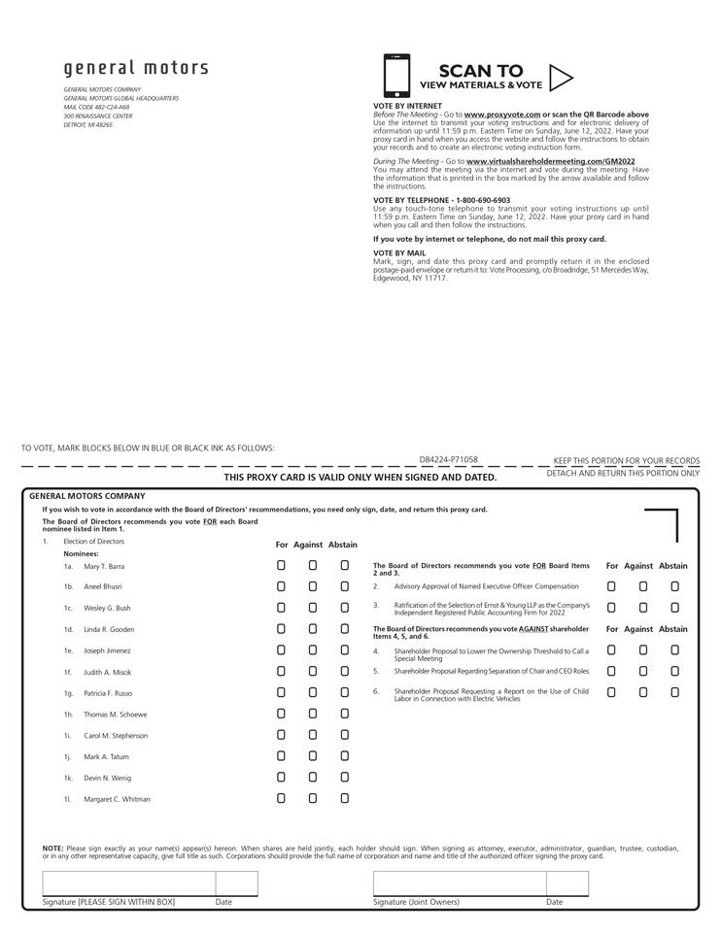

Table of Contents


