SEC Form 4

FORM 4

Check this box if no longer subject to Section 16. Form 4 or Form 5 obligations may continue. See Instruction 1(b).

UNITED STATES SECURITIES AND EXCHANGE COMMISSION
Washington, D.C. 20549
Washington, D.C. 20549 |  | OMB APPROVAL
STATEMENT OF CHANGES IN BENEFICIAL OWNERSHIP
STATEMENT OF CHANGES IN BENEFICIAL OWNERSHIP |  | OMB Number: | 3235-0287
 |  | Estimated average burden
Filed pursuant to Section 16(a) of the Securities Exchange Act of 1934 |  | hours per response: | 0.5
or Section 30(h) of the Investment Company Act of 1940
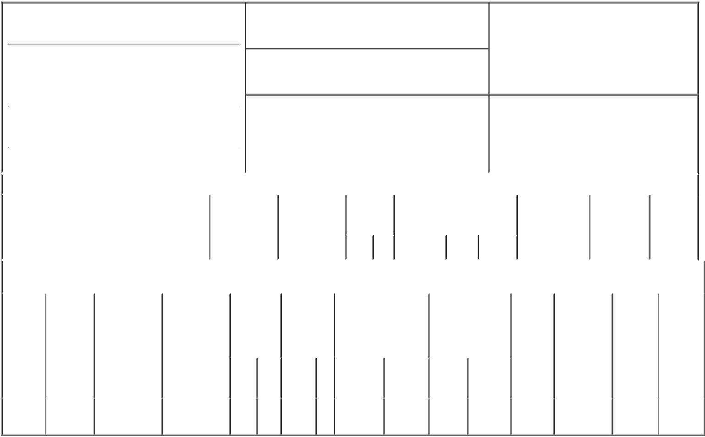

1. Name and Address of Reporting Person*
Timko Thomas S

(Last) (First) (Middle)

300 RENAISSANCE CENTER M/C: 482-C25-A36

2. Issuer Name and Ticker or Trading Symbol

General Motors Co [ GM ]

3. Date of Earliest Transaction (Month/Day/Year)

07/28/2015

- Relationship of Reporting Person(s) to Issuer (Check all applicable)

 | Director | 10% Owner
X | Officer (give title | Other (specify
X | below) | below)

Vice President & Controller

 |  |  |  |  |  |  |  | 4. If Amendment, Date of Original Filed (Month/Day/Year) |  |  |  |  |  |  | 6. Individual or Joint/Group Filing (Check Applicable
 | (Street) |  |  |  |  |  |  |  |  |  |  |  |  |  | Line)
 |  |  |  |  |  |  |  |  |  |  |  |  |  |  | X Form filed by One Reporting Person
 |  | DETROIT |  | MI |  | 48265-3000
 |  |  |  |  |  | 48265-3000 |  |  |  |  |  |  |  |  |  |  |  | Form filed by More than One Reporting
 |  |  |  |  |  |  |  |  |  |  |  |  |  |  |  |  |  | Person
 |  | (City) |  | (State) |  | (Zip) |  |  |  |  |  |  |  |  |  |  |  | Person
 |  |  |  |  | Table I - Non-Derivative Securities Acquired, Disposed of, or Beneficially Owned
 | 1. Title of Security (Instr. 3) |  |  |  |  | 2. Transaction |  |  | 2A. Deemed |  | 3. |  | 4. Securities Acquired (A) or |  |  |  |  | 5. Amount of |  | 6. Ownership |  | 7. Nature of
 |  |  |  |  |  | Date |  |  | Execution Date, |  |  | Transaction Disposed Of (D) (Instr. 3, 4 and 5) |  |  |  |  |  | Securities |  | Form: Direct |  | Indirect
 |  |  |  |  |  | (Month/Day/Year) |  |  | if any |  |  | Code (Instr. |  |  |  |  |  | Beneficially |  | (D) or Indirect |  | Beneficial
 |  |  |  |  |  |  |  |  | (Month/Day/Year) 8) |  |  |  |  |  |  |  |  | Owned Following |  | (I) (Instr. 4) |  | Ownership
 |  |  |  |  |  |  |  |  |  |  |  |  |  |  |  |  |  | Reported |  |  |  | (Instr. 4)
 |  |  |  |  |  |  |  |  |  |  |  | Code V | Amount | (A) or | Price |  |  | Transaction(s)
 |  |  |  |  |  |  |  |  |  |  |  | Code V | Amount | (D) |  |  |  | (Instr. 3 and 4)
 |  |  |  |  |  | Table II - Derivative Securities Acquired, Disposed of, or Beneficially Owned
 |  |  |  |  |  | (e.g., puts, calls, warrants, options, convertible securities)
 | 1. Title of |  | 2. |  | 3. Transaction | 3A. Deemed | 4. |  | 5. Number of |  | 6. Date Exercisable and |  |  | 7. Title and Amount |  |  | 8. Price of |  | 9. Number of |  | 10. | 11. Nature
 | Derivative |  | Conversion |  | Date | Execution Date, | Transaction |  | Derivative |  | Expiration Date |  |  | of Securities |  |  | Derivative |  | derivative |  | Ownership of Indirect
 | Security |  | or Exercise |  | (Month/Day/Year) | if any | Code (Instr. |  | Securities |  | (Month/Day/Year) |  |  | Underlying |  |  | Security |  | Securities |  | Form: | Beneficial
 | (Instr. 3) |  | Price of |  |  | (Month/Day/Year) | 8) |  | Acquired (A) |  |  |  |  | Derivative Security |  |  | (Instr. 5) |  | Beneficially |  | Direct (D) | Ownership
 |  |  | Derivative |  |  |  |  |  | or Disposed |  |  |  |  | (Instr. 3 and 4) |  |  |  |  | Owned |  | or Indirect | (Instr. 4)
 |  |  | Security |  |  |  |  |  | of (D) (Instr. |  |  |  |  |  |  |  |  |  | Following |  | (I) (Instr. 4)
 |  |  |  |  |  |  |  |  | 3, 4 and 5) |  |  |  |  |  |  |  |  |  | Reported
 |  |  |  |  |  |  |  |  |  |  |  |  |  |  |  |  |  |  | Transaction(s)
 |  |  |  |  |  |  |  |  |  |  |  |  |  |  | Amount |  |  |  | (Instr. 4)
 |  |  |  |  |  |  |  |  |  |  |  |  |  |  | or
 |  |  |  |  |  |  |  |  |  |  | Date |  | Expiration |  | Number
 |  |  |  |  |  |  | Code V |  | (A) | (D) | Exercisable |  | Date | Title | of Shares
 | Employee |  |  |  |  |  |  |  |  |  |  |  |  | Common | 151,844
 | Stock |  | $31.32 |  | 07/28/2015 |  |  | A | 151,844 |  | (1) |  | 07/28/2025 | Common | 151,844 |  | $0 |  | 151,844 |  | D
 | Option⁽¹⁾ |  |  |  |  |  |  |  |  |  |  |  |  | Stock

Explanation of Responses:

- The stock options were granted under the 2014 General Motors Long-Term Incentive Plan and vest as follows: 40% on February 15, 2017; 20% on February 15, 2018 upon meeting or exceeding the median Total Shareholder Return ("TSR") of the original equipment manufacturers, other than GM, as of the grant date in the Dow Jones Automobiles and Parts Titan 30 Index ("OEM Peer Group") for the period July 28, 2015 through December 31, 2017; 20% on February 15, 2019 upon meeting or exceeding the median TSR of the OEM Peer Group for the period July 28, 2015 through December 31, 2018; and 20% on February 15, 2020 upon meeting or exceeding the median TSR of the OEM Peer Group for the period July 28, 2015 through December 31, 2019.

Remarks:

/s/ Robert C. Shrosbree, |  |  |  | 07/30/2015
Attorney-In-Fact for Mr.Timko |  |  |  | 07/30/2015
** Signature of Reporting Person |  |  | Date

Reminder: Report on a separate line for each class of securities beneficially owned directly or indirectly.

* If the form is filed by more than one reporting person, see Instruction 4 (b)(v).

- Intentional misstatements or omissions of facts constitute Federal Criminal Violations See 18 U.S.C. 1001 and 15 U.S.C. 78ff(a). Note: File three copies of this Form, one of which must be manually signed. If space is insufficient, see Instruction 6 for procedure.

Persons who respond to the collection of information contained in this form are not required to respond unless the form displays a currently valid OMB Number.



