UNITED STATES

SECURITIES AND EXCHANGE COMMISSION

Washington, DC 20549-1004

___________________

FORM 8-K

___________________

CURRENT REPORT

PURSUANT TO SECTION 13 OR 15(d) OF

THE SECURITIES EXCHANGE ACT OF 1934

Date of Report (Date of earliest event reported) February 1, 2012

___________________

GENERAL MOTORS COMPANY

(Exact Name of Registrant as Specified in its Charter)

___________________

DELAWARE | 001-34960 | 27-0756180
(State or other jurisdiction of | 001-34960 | (I.R.S. Employer
incorporation) | (Commission File Number) | Identification No.)
300 Renaissance Center, Detroit, Michigan |  | 48265-3000
(Address of Principal Executive Offices) |  | (Zip Code)

(313) 556-5000

(Registrant's telephone number, including area code)

Not Applicable

(Former name or former address, if changed since last report)

___________________

Check the appropriate box below if the Form 8-K filing is intended to simultaneously satisfy the filing obligation of the registrant under any of the following provisions:

- Written communications pursuant to Rule 425 under the Securities Act (17 CFR 230.425)

- Soliciting material pursuant to Rule 14a-12 under the Exchange Act (17-CFR 240.14a-12)

- Pre-commencement communications pursuant to Rule 14d-2(b) under the Exchange Act (17 CFR 240.14d-2(b))

- Pre-commencement communications pursuant to Rule 13e-4(c) under the Exchange Act (17 CFR 240.13e-4(c))

TABLE OF CONTENTS

ITEM 8.01 Other Events

Signature

Index to Exhibits

Sales Release and Charts Dated February 1, 2012

ITEM 8.01 Other Events

On February 1, 2012, General Motors Company (GM) issued a news release announcing January sales. The release and charts are attached as Exhibit 99.1.

 |  |  |  | EXHIBIT
Exhibit |  | Description |  |  |  | Method of Filing
Exhibit 99.1 |  | Sales Release and Charts |  |  |  | Attached as Exhibit
 |  | Dated February 1, 2012

SIGNATURE

Pursuant to the requirements of the Securities Exchange Act of 1934, the Registrant has duly caused this report to be signed on its behalf by the undersigned hereunto duly authorized.

 |  |  | GENERAL MOTORS COMPANY
 |  |  | (Registrant)
 |  |  | /s/ Nick S. Cyprus
Date: February 7, 2012 | By:
Date: February 7, 2012 | By: |  | Nick S. Cyprus
 |  |  | Vice President, Controller and Chief Accounting Officer

Exhibit 99.1


1

For Release: Wednesday, Feb. 1, 2012, 10 a.m. EST

GM's U.S. Sales Down 6 percent in January

Chevrolet car sales up 13 percent on Strength of Cruze, Sonic

DETROIT - General Motors Co. (NYSE: GM) today reported total sales of 167,962 vehicles in the United States in January, down 6 percent compared with a very strong January 2011.

“Chevrolet drove our performance once again and sales of our fuel-efficient new cars were especially good,” and Don Johnson, vice president, U.S. Sales Operations. “The strength that the economy and the auto industry showed in the fourth quarter carried into January, so we believe the year is off to a good start.”

Chevrolet passenger car sales increased 13 percent. GM's total passenger car sales increased 3 percent in January, led by a 30 percent increase in sales of fuel -efficient small and compact cars, which include the new Chevrolet Sonic, the consistently strong-selling Chevrolet Cruze and the new Buick Verano.

In addition, the Buick LaCrosse, which now offers the 36-mpg highway eAssist powertrain as standard equipment, posted a 6 percent year-over-year increase, and the Chevrolet Camaro was up 20 percent.

GM's crossover sales decreased 18 percent and sales of trucks, which include full-size pickups, vans and SUVs, decreased 6 percent.

Retail deliveries declined 15 percent compared with the same month a year ago and accounted for 70 percent of GM sales.

Highlights | Jan. 2012 Total | Total Change vs. | Jan. 2012 Retail Sales | Jan. 2012 Retail Sales
Highlights | Sales | Jan. 2011 | vs. Jan. 2011 | Change vs. Jan. 2011
Chevrolet | 123,864 | (1.2%) | 78,189 | (14.7%)
GMC | 24,966 | (9.7%) | 21,649 | (13.7%)
Buick | 10,208 | (23.1%) | 9,521 | (18.5%)
Cadillac | 8,924 | (29.1%) | 8,373 | (22.0%)
Total GM | 167,962 | (6.1%) | 117,732 | (15.4%)

“In 2012, we will strengthen our position with more new products, an even better dealership experience

and reinforce the disciplined 'go to market' strategy that helped us grow profitably in the United States in 2011,” said Johnson.

GM has an aggressive new product plan for 2012: Production of the new 2013 Buick Verano is ramping up. In January, the company began production of the 37-mpg 2013 Chevrolet Malibu Eco, with four-cylinder and turbo powertrains launching in the summer, about the same time the new 2013 Chevrolet Spark arrives in showrooms.

In late spring, Cadillac will launch its new XTS large sedan and in late summer, its new ATS luxury sports sedan. Late in 2012, Buick will launch the new Encore crossover, which made its debut at the North American International Auto Show.

At the Chicago Auto Show, GMC will introduce a new Acadia, which will go into production in late 2012. Other new products will be announced at major U.S. auto shows and other events throughout the year.

 | Inventory |  | Units @ |  |  | Days Supply (selling |  |  |  |  | Units @ |  | Days Supply (selling days
 | Inventory |  | Dec. 31, 2011 |  |  |  | days adjusted) |  |  | Jan. 31, 2012 |  |  | adjusted)
 | All Vehicles |  | 583,407 |  |  |  | 67 |  |  |  | 619,455 |  | 89
Full-size Pickups |  |  | 181,070 |  |  |  | 73 |  |  |  | 188,568 |  | 119
 | Industry Sales |  |  | Dec. 2011 SAAR |  |  |  | Jan. 2012 SAAR (est.) |  |  | Full Year 2012
 |  |  |  |  |  |  |  |  |  |  |  | (est.)
 | Light Vehicles |  |  | 13.5 million |  |  |  | 13.5 million |  |  | 13.5 million - 14.0 million

General Motors Co. (NYSE:GM, TSX: GMM) and its partners produce vehicles in 30 countries, and the company has leadership positions in the world's largest and fastest-growing automotive markets. GM's brands include Chevrolet and Cadillac, as well as Baojun, Buick, GMC, Holden, Isuzu, Jiefang, Opel, Vauxhall and Wuling. More information on the company and its subsidiaries, including OnStar, a global leader in vehicle safety, security and information services, can be found at http://www.gm.com.

CONTACT:

Jim Cain

313-407-2843

james.cain@gm.com

Forward-Looking Statements

In this press release and in related comments by our management, our use of the words “expect,” “anticipate,” “possible,” “potential,” “target,” “believe,” “commit,” “intend,” “continue,” “may,” “would,” “could,” “should,” “project,” “projected,” “positioned” or similar expressions is intended to identify forward-looking statements that represent our current judgment about possible future events. We believe these judgments are reasonable, but these statements are not guarantees of any events or financial results, and our actual results may differ materially due to a variety of important factors. Among other items, such factors might include: our ability to realize production efficiencies and to achieve reductions in costs as a result of our restructuring initiatives and labor modifications; our ability to maintain quality control over our vehicles and avoid material vehicle recalls; our ability to maintain adequate liquidity and financing sources and an appropriate level of debt, including as required to fund our planned significant investment in new technology; the ability of our suppliers to timely deliver parts, components and systems; our ability to realize successful vehicle applications of new technology; and our ability to continue to attract new customers, particularly for our new products. GM's most recent annual report on Form 10-K and quarterly reports on Form 10-Q provides information about these and other factors, which we may revise or supplement in future reports to the SEC.

 |  | January |  | (Calendar Year-to-Date)
 |  |  |  | January - | January
 |  |  | %Change |  |  | %Change
 | 2012 | 2011 | Volume | 2012 | 2011 | Volume
Enclave | 3,124 | 4,347 | (28.1) | 3,124 | 4,347 | (28.1)
LaCrosse | 4,013 | 3,771 | 6.4 | 4,013 | 3,771 | 6.4
Lucerne | 421 | 2,816 | (85.0) | 421 | 2,816 | (85.0)
Regal | 1,855 | 2,335 | (20.6) | 1,855 | 2,335 | (20.6)
Verano | 795 | — | ***.* | 795 | — | ***.*
Buick Total | 10,208 | 13,269 | (23.1) | 10,208 | 13,269 | (23.1)
CTS | 3,019 | 4,362 | (30.8) | 3,019 | 4,362 | (30.8)
DTS | 89 | 1,365 | (93.5) | 89 | 1,365 | (93.5)
Escalade | 985 | 1,514 | (34.9) | 985 | 1,514 | (34.9)
Escalade ESV | 531 | 592 | (10.3) | 531 | 592 | (10.3)
Escalade EXT | 108 | 153 | (29.4) | 108 | 153 | (29.4)
SRX | 4,166 | 4,236 | (1.7) | 4,166 | 4,236 | (1.7)
STS | 26 | 359 | (92.8) | 26 | 359 | (92.8)
XLR | — | (1) | ***.* | — | (1) | ***.*
Cadillac Total | 8,924 | 12,580 | (29.1) | 8,924 | 12,580 | (29.1)
Avalanche | 1,617 | 1,397 | 15.7 | 1,617 | 1,397 | 15.7
Aveo | 16 | 2,739 | (99.4) | 16 | 2,739 | (99.4)
Camaro | 5,709 | 4,763 | 19.9 | 5,709 | 4,763 | 19.9
Caprice | 92 | — | ***.* | 92 | — | ***.*
Captiva Sport | 2,261 | — | ***.* | 2,261 | — | ***.*
Cobalt | 1 | 406 | (99.8) | 1 | 406 | (99.8)
Colorado | 2,872 | 2,204 | 30.3 | 2,872 | 2,204 | 30.3
Corvette | 629 | 721 | (12.8) | 629 | 721 | (12.8)
Cruze | 15,049 | 13,631 | 10.4 | 15,049 | 13,631 | 10.4
Equinox | 13,662 | 12,847 | 6.3 | 13,662 | 12,847 | 6.3
Express | 4,532 | 5,273 | (14.1) | 4,532 | 5,273 | (14.1)
HHR | 4 | 7,387 | ***.* | 4 | 7,387 | ***.*
Impala | 16,009 | 15,188 | 5.4 | 16,009 | 15,188 | 5.4
Kodiak 4/5 Series | ***.* | ***.* | ***.* | ***.* | ***.* | ***.*
Malibu | 14,676 | 14,102 | 4.1 | 14,676 | 14,102 | 4.1
Silverado-C/K Pickup | 26,850 | 28,172 | (4.7) | 26,850 | 28,172 | (4.7)
Sonic | 5,712 | — | ***.* | 5,712 | — | ***.*
Suburban (Chevy) | 2,935 | 2,343 | 25.3 | 2,935 | 2,343 | 25.3
Tahoe | 3,995 | 5,281 | (24.4) | 3,995 | 5,281 | (24.4)
TrailBlazer | — | 9 | ***.* | — | 9 | ***.*
Traverse | 6,640 | 8,605 | (22.8) | 6,640 | 8,605 | (22.8)
Volt | 603 | 321 | 87.9 | 603 | 321 | 87.9
Chevrolet Total | 123,864 | 125,389 | (1.2) | 123,864 | 125,389 | (1.2)
Acadia | 4,870 | 5,723 | (14.9) | 4,870 | 5,723 | (14.9)
Canyon | 1,059 | 694 | 52.6 | 1,059 | 694 | 52.6
Envoy | — | 1 | ***.* | — | 1 | ***.*
Savana | 838 | 718 | 16.7 | 838 | 718 | 16.7
Sierra | 9,517 | 10,627 | (10.4) | 9,517 | 10,627 | (10.4)
Terrain | 5,649 | 6,369 | (11.3) | 5,649 | 6,369 | (11.3)
Topkick 4/5 Series | ***.* | ***.* | ***.* | ***.* | ***.* | ***.*
Topkick 6/7/8 Series | ***.* | ***.* | ***.* | ***.* | ***.* | ***.*
Yukon | 2,022 | 2,076 | (2.6) | 2,022 | 2,076 | (2.6)
Yukon XL | 1,011 | 1,450 | (30.3) | 1,011 | 1,450 | (30.3)
GMC Total | 24,966 | 27,658 | (9.7) | 24,966 | 27,658 | (9.7)
GM Vehicle Total | 167,962 | 178,896 | (6.1) | 167,962 | 178,896 | (6.1)
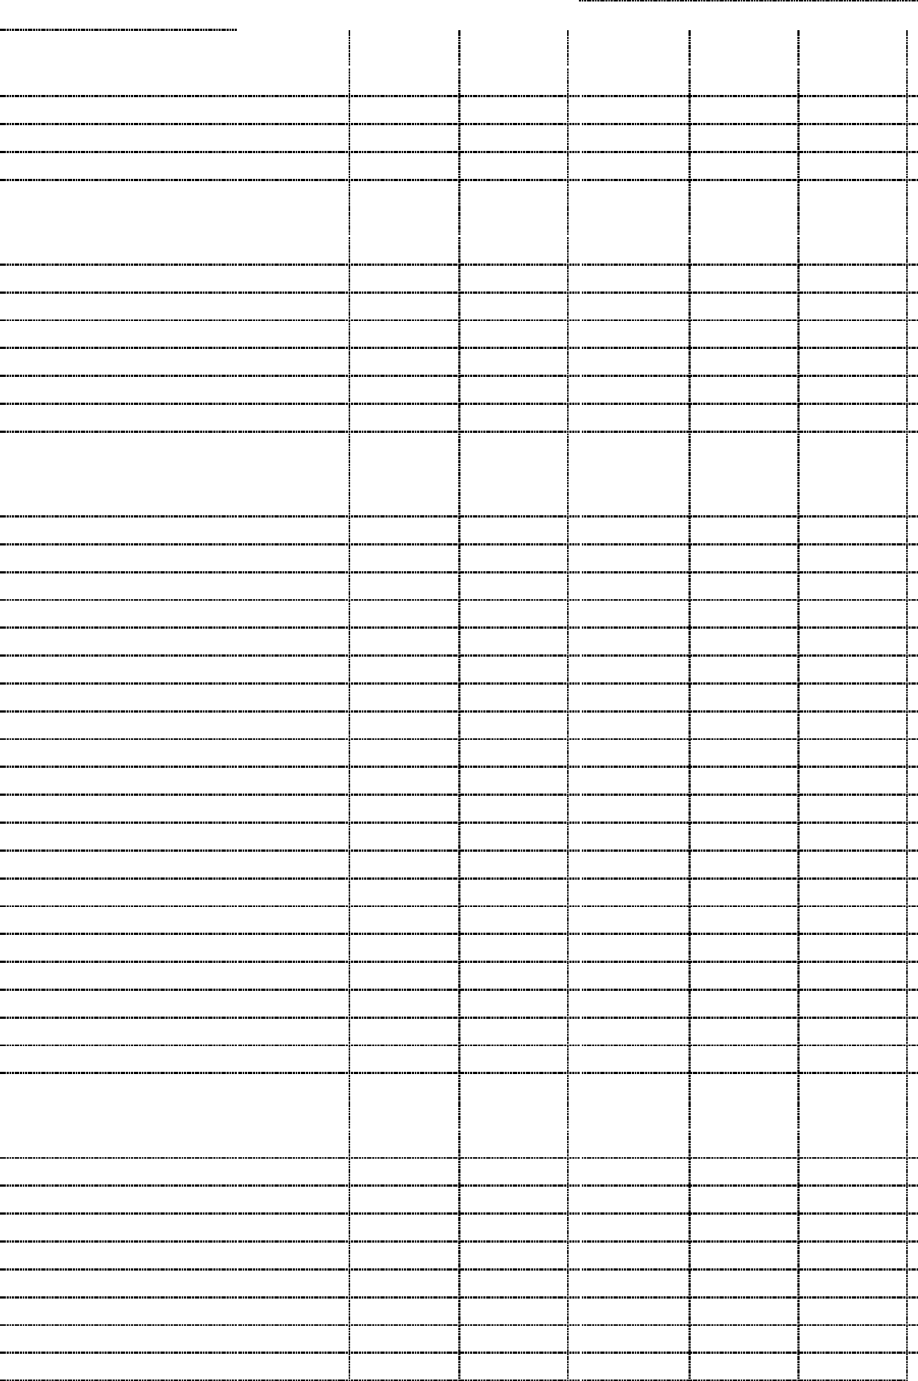
* 24 selling days for the January period this year and 24 for last year.

