SCHEDULE 14A

Proxy Statement Pursuant to Section 14(a)
of the Securities Exchange Act of 1934

Filed by the Registrant o

Filed by a Party other than the Registrant ☑

Check the appropriate box:

- Preliminary Proxy Statement

- Confidential, for Use of the Commission Only (as permitted by Rule 14a-6(e)(2))
- Definitive Proxy Statement
- Definitive Additional Materials

- Soliciting Material Under Rule 14a-12

General Motors Company

(Name of Registrant as Specified In Its Charter)

Greenlight Capital, Inc.

Greenlight Capital, L.P.
DME Advisors, LP
DME Advisors GP, LLC
DME Capital Management, LP
Greenlight Capital Qualified, LP
Greenlight Capital (Gold), LP
Greenlight Capital Offshore Partners
Greenlight Capital Offshore Master (Gold), Ltd.
Greenlight Masters, LLC
Greenlight Masters Partners
David Einhorn
Leo Hindery, Jr.
Vinit Sethi

William N. Thorndike, Jr.

(Name of Person(s) Filing Proxy Statement, if other than the Registrant)

Payment of Filing Fee (check the appropriate box):

- No fee required.

- Fee computed on table below per Exchange Act Rule 14a-6(i)(4) and 0-11.

  - Title of each class of securities to which transaction applies:

  - Aggregate number of securities to which transaction applies:

  - Per unit price or other underlying value of transaction computed pursuant to Exchange Act Rule 0-11 (set forth the amount on which the filing fee is calculated and state how it was determined):

  - Proposed maximum aggregate value of transaction:

  - Total fee paid:

- Fee paid previously with preliminary materials.

- Check box if any part of the fee is offset as provided by Exchange Act Rule 0-11(a)(2) and identify the filing for which the offsetting fee was paid previously. Identify the previous filing by registration statement number, or the Form or Schedule and the date of its filing.

  - Amount Previously Paid:

  - Form, Schedule or Registration Statement No.:

  - Filing Party:

  - Date Filed:

On May 4, 2017, Greenlight Capital, Inc. (“Greenlight”) issued a press release (the “Press Release”), which included the full text of a letter that Greenlight sent to shareholders of General Motors Company (the “Company”). A copy of the Press Release is filed herewith as Exhibit 1.

Also on May 4, 2017, Greenlight posted various soliciting materials to www.UnlockGMValue.com (the “Website”). Copies of the materials posted to the Website are filed herewith as Exhibit 2. On the Website, Greenlight also posted (1) the original term sheet regarding the "Dividend Shares" that Greenlight shared with GM (the "Greenlight Term Sheet"), (2) the term sheet that GM purportedly presented to the credit rating agencies (the "GM Term Sheet"), and (3) an annotated comparison of the Greenlight Term Sheet and the GM Term Sheet, copies of which are filed herewith as Exhibit 3.

Also on May 4, 2017, Greenlight issued a second press regarding the Company, which is filed herewith as Exhibit 4.

Green Proxy Card

GENERAL MOTORS COMPANY

Proxy Card for 2017 Annual Meeting of Shareholders
Scheduled for June 6, 2017 (the “Annual Meeting”):

THIS PROXY SOLICITATION IS BEING MADE BY GREENLIGHT CAPITAL, INC. AND CERTAIN OF ITS AFFILIATES (COLLECTIVELY, “GREENLIGHT,” “WE” OR “US”) AND THE INDIVIDUALS NAMED IN PROPOSAL 1 (THE “NOMINEES”)

THE BOARD OF DIRECTORS OF GENERAL MOTORS COMPANY IS NOT SOLICITING THIS PROXY

The undersigned appoints Daniel Roitman, Richard H. Grubaugh, and Eleazer Klein, and each of them, attorneys and agents with full power of substitution to vote all shares of common stock of General Motors Company, a Delaware corporation (the “Company”), that the undersigned would be entitled to vote at the Annual Meeting of shareholders of the Company scheduled to be held on Tuesday, June 6, 2017 at 9:30 A.M. Eastern Time at General Motors Global Headquarters, located at 300 Renaissance Center, Detroit, Michigan, 48265, including at any adjournments or postponements thereof, with all powers that the undersigned would possess if personally present, upon and in respect of the instructions indicated herein, with discretionary authority as to any and all other matters that may properly come before the meeting or any adjournment, postponement, or substitution thereof that are unknown to us a reasonable time before this solicitation.

The undersigned hereby revokes any other proxy or proxies heretofore given to vote or act with respect to said shares, and hereby ratifies and confirms all action the herein named attorneys and proxies, their substitutes, or any of them may lawfully take by virtue hereof. This proxy will be valid until the sooner of one year from the date indicated on the reverse side and the completion of the Annual Meeting (including any adjournments or postponements thereof).

If this proxy is signed and returned, it will be voted in accordance with your instructions. If you do not specify how the proxy should be voted, this proxy will be voted “FOR ALL” of the nominees listed in Proposal 1 and the Company’s candidates other than Jane L. Mendillo, Michael G. Mullen and Carol M. Stephenson, “FOR” Proposal 2, “FOR” Proposal 3, “FOR” Proposal 4, “FOR” Proposal 5, “AGAINST” Proposal 6 and “FOR” Proposal 7. None of the matters currently intended to be acted upon pursuant to this proxy are conditioned on the approval of other matters.

– – – – – – – – – – – – – – – – – – – – – – – – – – – – – – – – – – – – – – – – – – – – – – – – – – – – – – – – INSTRUCTIONS: FILL IN VOTING BOXES “©” IN BLACK OR BLUE INK

We recommend that you vote “FOR ALL” of the Nominees below:

Proposal 1 – Election at the Annual Meeting of the Nominees listed below and the Company’s candidates other than Jane L.

Mendillo, Michael G. Mullen and Carol M. Stephenson to serve as directors.

Nominees:

FOR ALL

WITHHOLD ALL

FOR ALL EXCEPT

Leo Hindery, Jr.

□

□

□

Vinit Sethi

William N. Thorndike, Jr.

(INSTRUCTIONS: To withhold authority to vote for any individual nominee, mark the “For All Except” box above and write the name of the nominee(s) or Company nominees other than Jane L. Mendillo, Michael G. Mullen and Carol M. Stephenson from which you wish to withhold the authority to vote in the space provided below.)

We recommend that you vote “FOR” Proposal 2: |  |  |  | FOR | AGAINST | ABSTAIN
Proposal 2 – To vote on the Company’s advisory resolution on the |  |  |  | FOR | AGAINST | ABSTAIN
 |  |  |  | □ | □ | □
compensation of its named executive officers.
We recommend that you vote “FOR” Proposal 3: |  |  |  | FOR | AGAINST | ABSTAIN
Proposal 3 – To approve the Company’s 2017 Short-Term Incentive Plan. |  |  |  | FOR | AGAINST | ABSTAIN
 |  |  |  | □ | □ | □
We recommend that you vote “FOR” Proposal 4: |  |  |  | FOR | AGAINST | ABSTAIN
Proposal 4 – To approve the Company’s 2017 Long-Term Incentive Plan. |  |  |  | FOR | AGAINST | ABSTAIN
 |  |  |  | □ | □ | □
We recommend that you vote “FOR” Proposal 5: |  |  |  | FOR | AGAINST | ABSTAIN
Proposal 5 – To ratify the appointment of Deloitte & Touche LLP as the |  |  |  | FOR | AGAINST | ABSTAIN
 |  |  |  | □ | □ | □
Company’s independent registered public accounting firm for the fiscal year
ending December 31, 2017.
We recommend that you vote “AGAINST” Proposal 6: |  |  |  | FOR | AGAINST | ABSTAIN
Proposal 6 – To vote on an advisory shareholder proposal requesting that the |  |  |  | FOR | AGAINST | ABSTAIN
 |  |  |  | □ | □ | □
Board take the necessary steps to establish an independent Chairman.
We recommend that you vote “FOR” Proposal 7: |  |  |  | FOR | AGAINST | ABSTAIN
Proposal 7 – To request that the Board create a second class of common |  |  |  | FOR | AGAINST | ABSTAIN
 |  |  |  | □ | □ | □
stock of the Company (the “Dividend Shares”) that would trade separately from
the existing common stock and continue to pay quarterly dividends at an
annual rate of $1.52, and to authorize a distribution of the Dividend Shares to
the Company’s existing shareholders at no cost to them.

IN ORDER FOR YOUR PROXY TO BE VALID, IT MUST BE DATED.
 | Signature (Capacity) |  | Date
 | Signature (Joint Owner) (Capacity/Title) |  | Date

NOTE: Please sign exactly as your name(s) appear(s) on stock certificates or on the label affixed hereto. When signing as attorney, executor, administrator or other fiduciary, please give full title as such. Joint owners must each sign personally. ALL HOLDERS MUST SIGN. If a corporation or partnership, please sign in full corporate or partnership name by an authorized officer and give full title as such.

PLEASE SIGN, DATE AND PROMPTLY RETURN THIS PROXY IN THE ENCLOSED RETURN ENVELOPE THAT IS POSTAGE PREPAID IF MAILED IN THE UNITED STATES.

GREENLIGHT CAPITAL SENDS LETTER TO GENERAL MOTORS’ SHAREHOLDERS

Highlights GM’s Significant Valuation Problem, Poor Stock Performance and

the Board’s Failure to Address These Persistent Issues

Greenlight’s Plan to Split GM Common Stock into Two Classes Could Unlock

$14 to $40 Billion of Shareholder Value

Urges Shareholders to Vote the GREEN Proxy Card
FOR Greenlight’s Three Highly Qualified Director Nominees and
FOR Greenlight’s Proposal

NEW YORK – May 4, 2017 – Greenlight Capital, Inc. (“Greenlight”), which owns 3.6% of the common stock of General Motors Company (NYSE: “GM”) (the “Company”) making it the fifth largest public shareholder, today announced that it is mailing a letter to GM shareholders urging them to vote the GREEN proxy card in favor of its three highly qualified Director nominees, Leo Hindery, Jr., Vinit Sethi, and William N. Thorndike, Jr., and in support of Greenlight’s plan to split GM’s common stock into two classes of common equity, potentially unlocking billions of dollars in shareholder value, at General Motors’ Annual Meeting of Shareholders, scheduled to take place on June 6, 2017.

Greenlight has launched a website, www.UnlockGMValue.com, where shareholders can access all the materials related to its proxy solicitation.

The full text of the letter is below and available at www.UnlockGMValue.com.

May 3, 2017

To Our Fellow General Motors Company Shareholders:

I write on behalf of Greenlight Capital, Inc. and its affiliates (“Greenlight”), which are the owners of 3.6% of the common stock of General Motors Company (“GM” or the “Company”). We are long-term holders of GM common stock and GM’s fifth largest public shareholder.

I am asking you to return the enclosed GREEN proxy card to vote for three exceptional candidates who we are nominating for election to GM’s Board of Directors (the “Board”) at this year’s annual meeting of GM shareholders and to support our plan to split GM’s common stock into two classes of common equity (the “Two Classes of Common Stock Plan” or the “Plan”).

OUR PLAN TO HELP ALL SHAREHOLDERS

Our Plan is simple. GM should split its common stock into two classes of common equity. The two classes, which would trade separately, would have the following characteristics:

- The Dividend Shares: GM would continue to pay quarterly dividends at the current annual rate of $1.52 per share, but the dividends would now be paid on the “Dividend Shares.” The Dividend Shares would be distributed to GM’s existing shareholders at no cost. The Dividend Shares would appeal to yield-focused investors.

- The Capital Appreciation Shares: GM would grant its existing common stock the majority of the voting rights and participation in the rest of the Company’s earnings, cash flows, share buybacks and future growth. The Capital Appreciation Shares would appeal to and be valued appropriately by investors focused on GM’s growth prospects.

Every GM owner would initially own both securities. After the distribution you will have the exact same position that you have now.

The only difference is that you will own two securities instead of one.

We believe that splitting GM’s stock would lead to a 27% to 79% appreciation in the share price.

GM HAS A PROBLEM

Since its late 2010 IPO, the Company has generated a meager 15% total return for shareholders or barely 2% per year. Over that same period, BMW, Daimler and Toyota have approximately doubled shareholders’ investment – nearly in line with the 132% S&P 500 total return – and Fiat Chrysler has grown shareholders’ investment 115% since its late 2014 IPO. Meanwhile, GM has one of the lowest price-to-earnings ratio of any global automobile manufacturer and the lowest of any company in the S&P 500, regardless of industry.
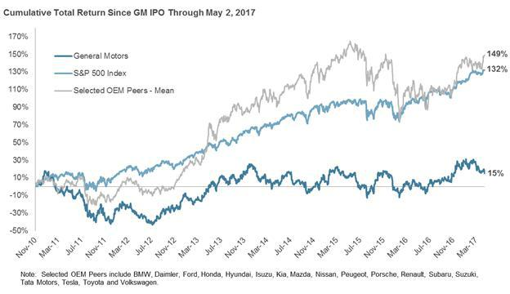

The problem is not the business, but an inefficient capital structure. GM needs access to low cost capital to fund its operations and growth, and our Two Classes of Common Stock Plan will deliver just that.

For example, in 2016 the Company bought Cruise Automation to obtain important technology for self-driving cars. Half of the purchase price was paid in stock. A better valued stock would give GM needed flexibility and a stronger currency to make other important strategic investments, which are vital to the Company’s future.

While a higher stock price will not cause GM to sell more cars today, it may be essential to GM’s ability to compete in the future.

That GM does not understand this fundamental element of corporate finance is deeply distressing.

A better valued stock will also reward all shareholders for being patient GM investors.

Unfortunately, GM’s management and Board are not interested in taking the steps we believe are necessary to address the discounted stock price and unlock significant value for all GM shareholders. GM’s position is that nothing can be done about the undervalued share price for several more years, because investors need to witness the Company’s performance in the next down-cycle before they can adopt a more favorable attitude toward the stock.

Even long-term shareholders shouldn’t have to be this patient.

We believe we have a solution to this problem and that our Plan will unlock the latent value immediately. Our Plan to split GM’s common stock into two classes of common equity will reverse the current valuation gap. As described below, by implementing our Plan, we think the total value for each GM share will be between $42 and $60, compared to today’s stock price of $33.

Unfortunately, GM has thus far rejected our Plan. Rather than giving our Plan a fair hearing, GM subverted our idea by modifying the Plan before giving it to the credit rating agencies to review. This has led the credit rating agencies to express undue concern about the impact of the Plan on creditors. In essence, GM’s management and Board are hiding behind a flawed credit rating agency process to avoid addressing the Company’s problem.

Therefore, we have nominated a minority slate of three new directors – Leo Hindery, Jr., Vinit Sethi and William N. Thorndike, Jr. – who understand the capital markets, are not afraid to address the inefficient capital structure and will seek to enhance shareholder value.

We urge you to vote for these three new directors and in support of our Plan to unlock significant shareholder value.

GM’s BOARD NEEDS TO BE ENHANCED TO ENSURE IT HAS CRITICAL CAPITAL MARKETS EXPERTISE

AND A WILLINGNESS TO MAXIMIZE SHAREHOLDER VALUE

We have engaged with GM management and the Board over the last seven months regarding the Plan. GM’s management has refused to work collaboratively with us. We have been disappointed by what we believe is management’s inaccurate and shallow analysis of the Plan, as well as their use of the informal credit rating agency process to subvert our Plan.

Even worse, the Board has failed to recognize these deficiencies and is seemingly unable to independently analyze the Plan. Therefore, we believe the Board must be enhanced to include additional capital markets experts and business leaders with proven track records of capital structure management and shareholder value creation.

The current Board believes that shareholders should reject the Plan (which could increase shareholder value by tens of billions of dollars) because it might complicate the directors’ jobs. The directors complain that the Board would need to serve as fiduciaries for both the owners of the Dividend Shares and of the Capital Appreciation Shares. This argument says more about the directors than about the Plan. It is a standard function of Boards to balance the competing interests of different stakeholders. GM shareholders deserve better directors.

Notably, GM’s 10 non-employee directors collectively own only 0.02% of the Company’s shares. Perhaps this explains why this Board has presided over a six-year long failure to create shareholder value.

Our director nominees – Leo Hindery, Jr., Vinit Sethi and William N. Thorndike, Jr. – will seek to enhance shareholder value, even if it means their responsibilities to shareholders could be more complicated.

Not only are our director nominees supportive of the Plan, they are outstanding, accomplished professionals who will serve all shareholders on every issue that comes before the Board:

- Leo Hindery, Jr. is the former CEO of TCI, Liberty Media, and AT&T Broadband (companies that have been multi-billion dollar value-creating engines) and is a corporate leader willing to break new ground to create value for shareholders;

- Vinit Sethi is a Partner and the Director of Research at Greenlight, and he has fiduciary responsibilities to Greenlight’s investors that collectively own nearly $2 billion of GM stock; and

- William N. Thorndike, Jr. is the Founder of Housatonic Partners, a private equity firm, and Chairman of CONSOL Energy, in addition to being the author of a critically acclaimed book about CEOs who generated superior returns for shareholders, entitled “The Outsiders: Eight Unconventional CEOs and Their Radically Rational Blueprint for Success.”

We encourage you to read our director nominees’ complete biographies in the enclosed proxy statement and to consider whether it is time for fresh perspectives and a new formula at GM to lift the stock out of the lowest valuation metrics among all global automobile manufacturers and S&P 500 companies. Surely, continuing with the same team and the same approach – with a clear unwillingness to address GM’s problem or be burdened with additional fiduciary responsibility – should not be tolerated by shareholders who have long suffered by owning GM stock.

SPLITTING GM’s COMMON STOCK INTO TWO SHARE CLASSES WOULD

UNLOCK BILLIONS OF DOLLARS IN SHAREHOLDER VALUE

We believe implementing the Plan will allow the market to respect (and correspondingly capitalize) the existing dividend stream.

We also believe that the Plan would attract significant new investment into the stock. The Dividend Shares would attract new yield-oriented investors and the Capital Appreciation Shares would attract both new growth and value investors excited by the future prospects of GM.

GM’s dividend is equal to only about 25% of its earnings and GM has cash equal to nine years of dividends sitting on its balance sheet. The dividend is stable and GM’s stated financial policy is to continue paying the dividend even in a downturn. Our substantial work on likely pricing and comparable securities, undertaken with a leading financial advisor, suggests that the Dividend Shares alone would trade for between $17 and $22, representing a yield of between 7% and 9%, which is very attractive in today’s low interest rate environment.

This year GM expects to spend $5 billion on buybacks. Under the Company’s existing capital structure, this would amount to approximately 10% of the Company’s equity value. GM says that it does not believe our Plan will unlock value. For a moment, let’s pretend GM is correct: assuming the Dividend Shares trade at $19, then the Capital Appreciation Shares would only be worth about $14 each or $22 billion in the aggregate, which means that the same $5 billion in buybacks would repurchase about 23% of those shares in a single year.

At that rate, it would only take a few years for GM to repurchase its entire public float of the Capital Appreciation Shares. Since that isn’t possible, the alternative must be a much higher share price. Our Plan would enable GM’s existing share repurchase plan to have a much greater impact, which would

show up in a faster share count reduction and, therefore, faster EPS growth. This faster growth should lead to a higher price-to-earnings ratio.

But even if the Capital Appreciation Shares only trade at the current price-to-earnings ratio, they would be worth about $25 per share. With modest multiple expansion, the Capital Appreciation Shares could trade to $38 per share.

Adding the pieces of our Plan together, we think the total value delivered to GM shareholders will be between $42 and $60 per existing share, compared to today’s stock price of $33: a 27% to 79% appreciation in the share price.

As this analysis illustrates, splitting today’s common stock in this way will unlock significant value for all shareholders.

THE TWO CLASSES OF COMMON STOCK PLAN CREATES ENORMOUS BENEFITS

In addition to the opportunity to create between $14 billion and $40 billion of incremental shareholder value for GM’s shareholders, our Plan should:

Lower GM’s cost of capital and enhance its strategic flexibility, permitting the Company to make additional long-range investments at an improved expected net return. We believe this should lead to a brighter, more profitable future for GM and its shareholders.

Offer attractive current income. Investors own thousands of securities primarily for their yield, including real estate investment trusts, master limited partnerships, preferred stocks and long-maturity corporate debt. We suspect many GM shareholders would be pleased to buy more Dividend Shares and earn a 7% or 9% yield from an issuer they know well.

Retain and enhance GM’s financial flexibility. Whatever the Board would do today with the Company’s capital – paying or ceasing to pay dividends, buying back stock, investing in R&D, making acquisitions and so forth – it can do after splitting the stock into two classes. Our Plan is specifically designed to leave intact GM’s business strategy, capital allocation priorities and financial policy.

GM’s DEALINGS WITH THE CREDIT RATING AGENCIES ARE CAUSE FOR CONCERN

The Board’s speculation about a credit rating downgrade is just that – speculation. Each of the major credit rating agencies has a formalized process for evaluating potential changes to an issuer’s capital structure or financial policies that are suggested by a shareholder; each requires that the rated company provide permission for the credit rating agency to engage in such a dialogue with a shareholder. GM has repeatedly refused to allow us – even at our own expense – to discuss our Plan and receive a formal opinion from the credit rating agencies.

Even worse, GM’s management has refused to work with us to modify or enhance the Plan in ways management believes would make it more attractive to the credit rating agencies. Instead, the Company presented the credit rating agencies with an altered version of our proposed term sheet for the Plan and held conversations with the credit rating agencies without our involvement.

The altering of our term sheet in a manner calculated to cause the rating agencies to view the Plan negatively is disgraceful.

Shareholders should be equally outraged that GM has called into question its credit rating in order to undermine a Plan to unlock significant value for shareholders.

We believe that if the credit rating agencies were to formally evaluate an accurate version of the Plan and understand it for what it is – merely splitting the existing stock into two classes of common equity, with no change in the commitment to the dividend or buybacks (and certainly no material “departure from current financial policy”) – they would conclude, as they have done in many other situations involving companies that have issued a new class of common stock, that there is no negative credit impact.

As a very large shareholder of the Company, we do not want to put GM in harm’s way. We are asking you to send the Board a clear message to focus on shareholder value. The purpose of our Plan is to lower – not to raise – the cost of capital. If GM advocated for our Plan to the credit rating agencies, presented the Plan as credit neutral or positive, and still learned that it would cause a credit downgrade (which we do not believe would actually happen), we would suggest GM work iteratively with us and the credit rating agencies to modify the Plan so as to preserve the investment grade rating while unlocking as much value as possible.

You have nothing to lose and much to gain from voting for our Plan and our Director Nominees!

RETURN THE GREEN PROXY CARD TODAY OR VOTE BY INTERNET OR PHONE FOR LEO HINDERY, JR., VINIT SETHI AND WILLIAM N. THORNDIKE, JR.

We encourage you to read our proxy statement and vote “FOR” Proposal 7 and “FOR ALL” on Proposal 1 on the enclosed GREEN proxy card to advise the Board that you believe the Two Classes of Common Stock Plan should be seriously considered and implemented and to cast your vote in favor of our highly qualified nominees.

You can learn more about our Two Classes of Common Stock Plan by going to www.UnlockGMValue.com.

If you have any questions about how to vote, please contact our proxy solicitor, D.F. King at 1- (800) 252-8173 or email to gm@dfking.com.

Sincerely,
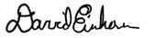

David Einhorn

If you have already submitted a white proxy card to GM, it is not too late to change your vote. To revoke your prior proxy, simply submit a GREEN proxy card or vote by phone or internet. Follow the instructions on the voting instruction card.

About Greenlight Capital

Greenlight Capital, Inc. (“Greenlight”), founded in 1996, is a value-oriented investment advisor that primarily invests and trades in long and short publicly listed equity securities, as well as distressed debt when cyclically attractive. Greenlight seeks to achieve capital appreciation by buying securities with trading values materially lower than their intrinsic values and by selling short securities with trading values materially higher than their intrinsic values. Greenlight aims to achieve high absolute rates of return while minimizing the risk of capital loss.

Contacts

Jonathan Gasthalter/Nathaniel Garnick
Gasthalter & Co.
(212) 257-4170

About the Proxy Solicitation

Greenlight Capital, Inc., Greenlight Capital, L.P., DME Advisors, LP, DME Capital Management, LP, DME Advisors GP, LLC, Greenlight Capital Qualified, LP, Greenlight Capital (Gold), LP, Greenlight Capital Offshore Partners, Greenlight Capital Offshore Master (Gold), Ltd., Greenlight Masters Partners, Greenlight Masters, LLC, David Einhorn, Leo Hindery, Jr., Vinit Sethi, and William N. Thorndike, Jr. (collectively, the “Participants”) have filed with the Securities and Exchange Commission (the “SEC”) a definitive proxy statement and accompanying form of proxy to be used in connection with the solicitation of proxies from the shareholders of General Motors Company (the “Company”). All shareholders of the Company are advised to read the definitive proxy statement and other documents related to the solicitation of proxies by the Participants, as they contain important information, including additional information related to the Participants. The definitive proxy statement and an accompanying proxy card will be furnished to some or all of the Company’s shareholders and is, along with other relevant documents, available at no charge on the SEC website at http://www.sec.gov/ and at http://www.UnlockGMValue.com/.

Information about the Participants and a description of their direct or indirect interests by security holdings is contained in the definitive proxy statement on Schedule 14A filed by the Participants with the SEC on April 28, 2017. This document is available free of charge from the sources indicated above.

Warning Regarding Forward Looking Statements

THIS PRESS RELEASE CONTAINS FORWARD LOOKING STATEMENTS. FORWARD LOOKING STATEMENTS CAN BE IDENTIFIED BY USE OF WORDS SUCH AS “OUTLOOK”, “BELIEVE”, “INTEND”, “EXPECT”, “POTENTIAL”, “WILL”, “MAY”,

“SHOULD”, “ESTIMATE”, “ANTICIPATE”, AND DERIVATIVES OR NEGATIVES OF SUCH WORDS OR SIMILAR WORDS. FORWARD LOOKING STATEMENTS IN THIS PRESS RELEASE ARE BASED UPON PRESENT BELIEFS OR EXPECTATIONS. HOWEVER, FORWARD LOOKING STATEMENTS AND THEIR IMPLICATIONS ARE NOT GUARANTEED TO OCCUR AND MAY NOT OCCUR AS A RESULT OF VARIOUS RISKS, REASONS AND UNCERTAINTIES. EXCEPT AS REQUIRED BY LAW, GREENLIGHT CAPITAL, INC. AND ITS AFFILIATES AND RELATED PERSONS UNDERTAKE NO OBLIGATION TO UPDATE ANY FORWARD LOOKING STATEMENT, WHETHER AS A RESULT OF NEW INFORMATION, FUTURE DEVELOPMENTS OR OTHERWISE.

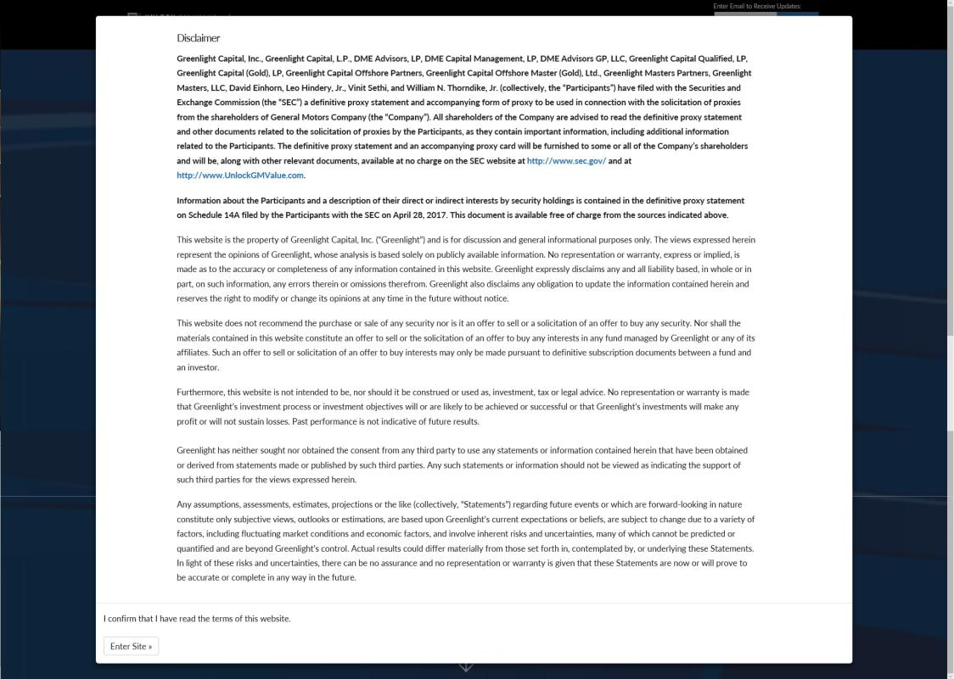

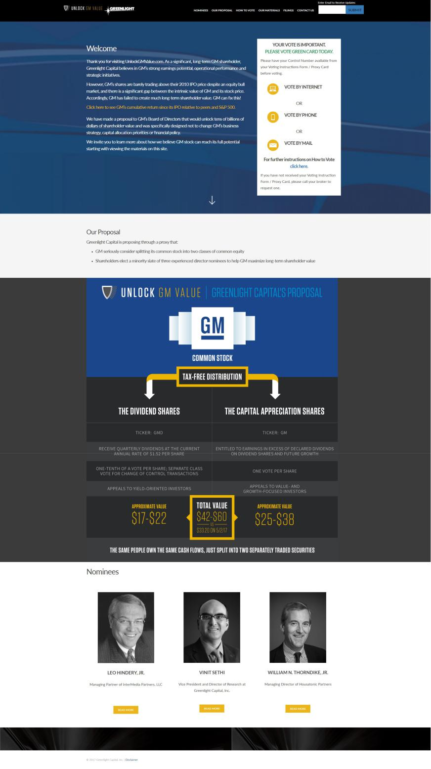

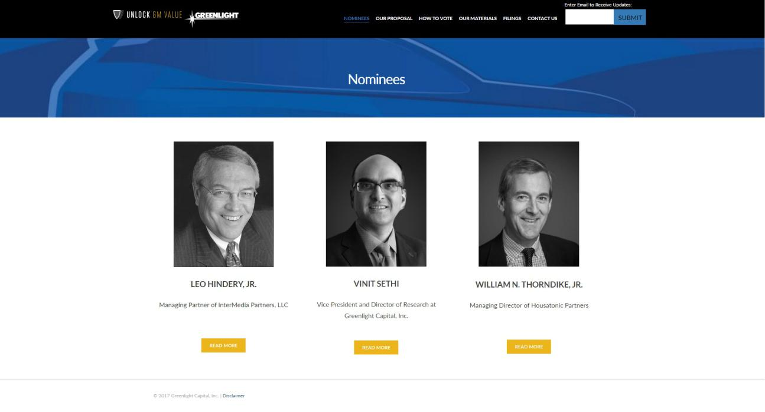

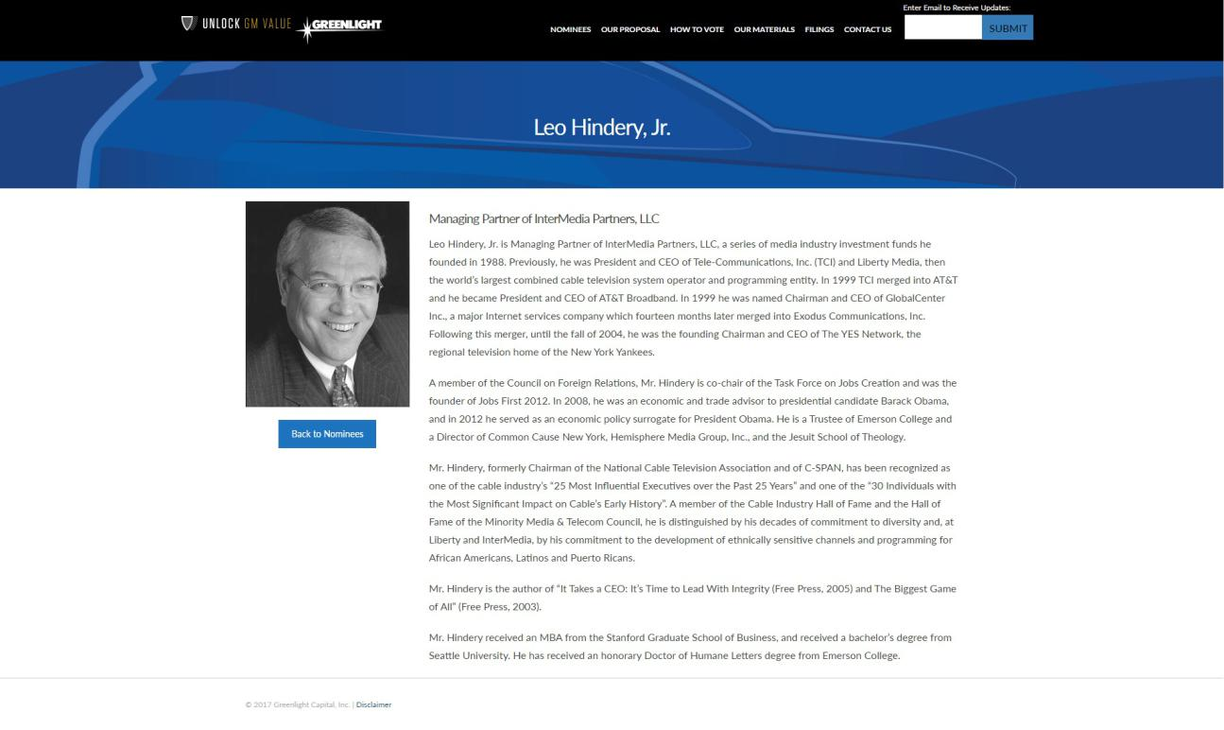

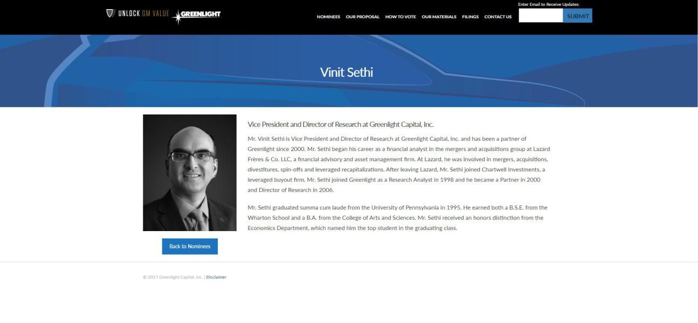

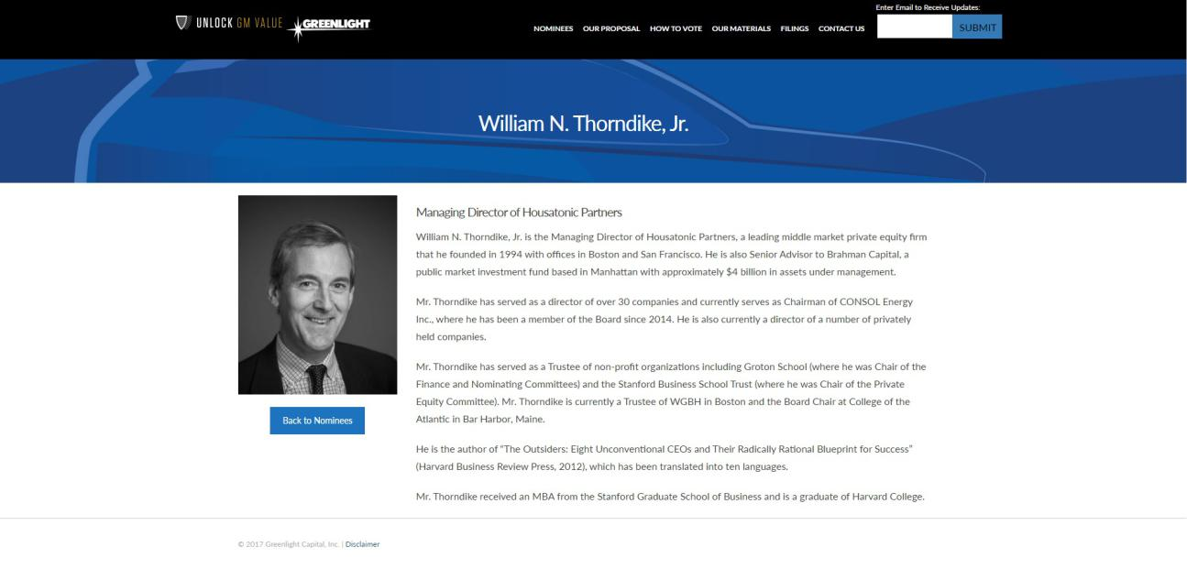

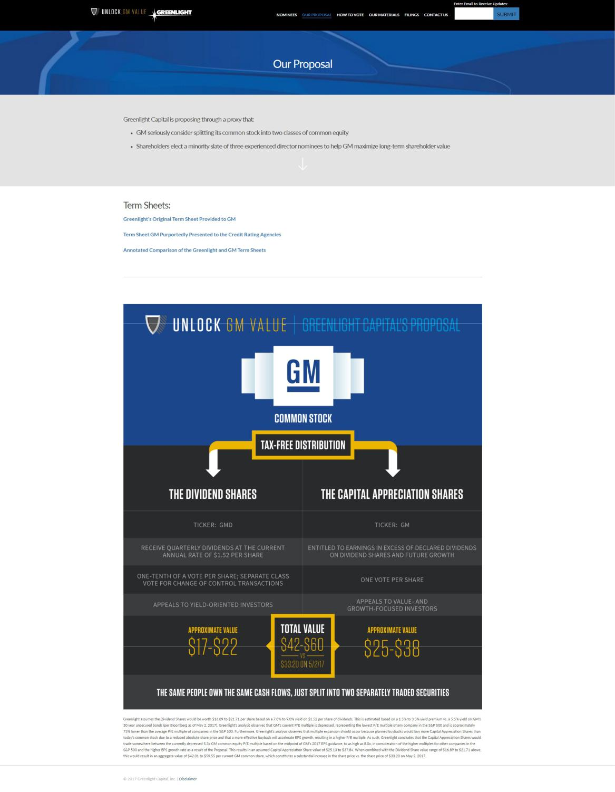

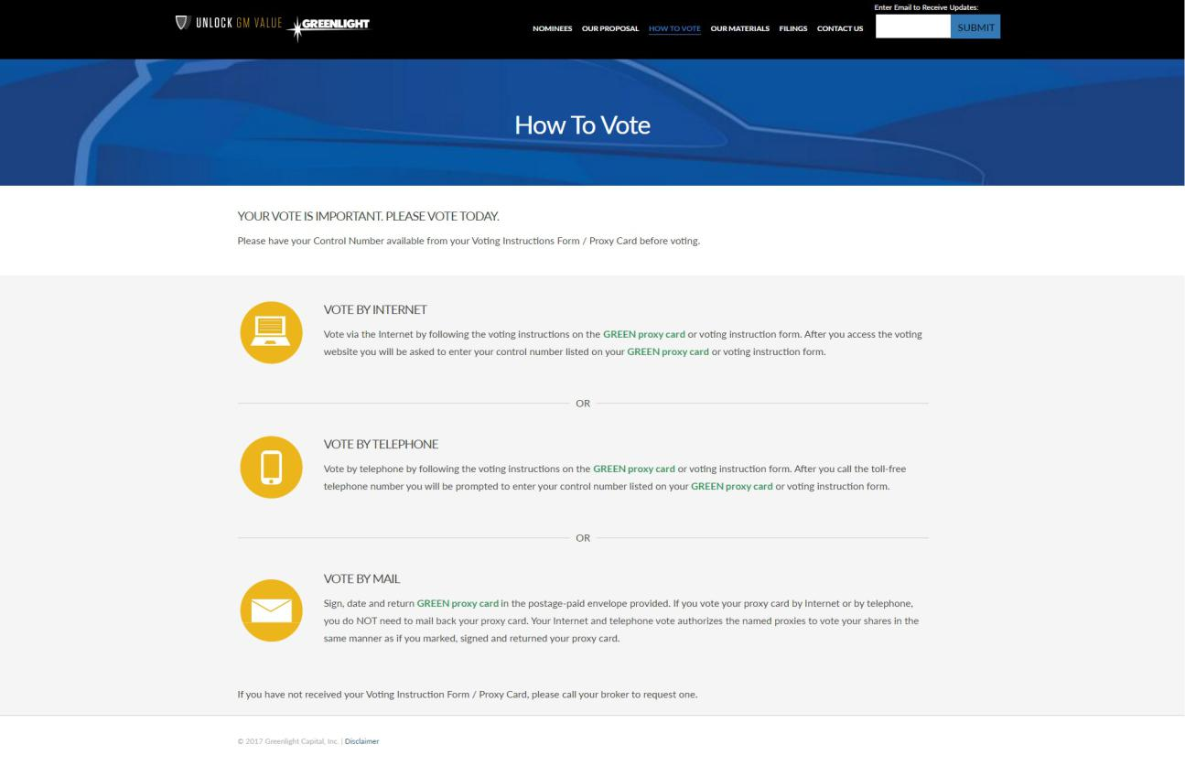

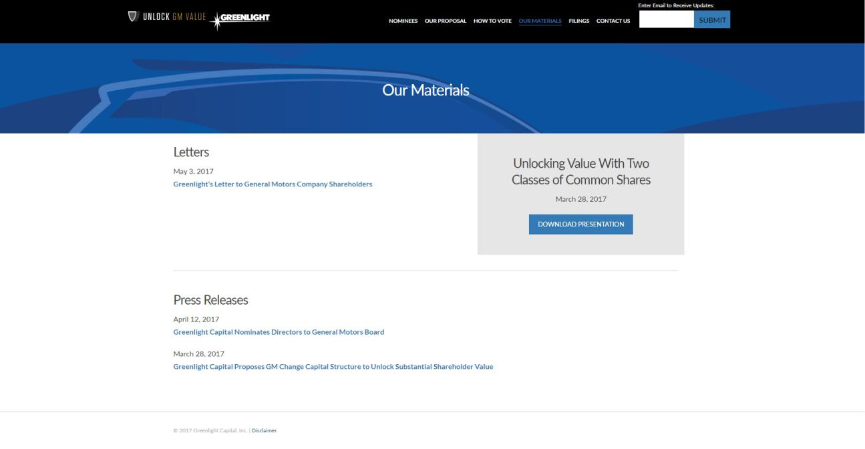

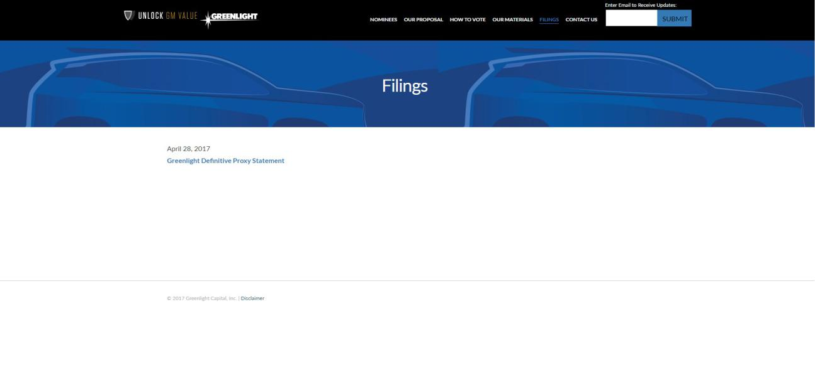

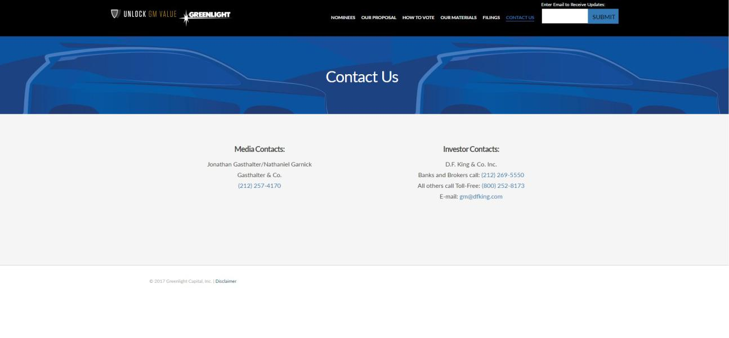

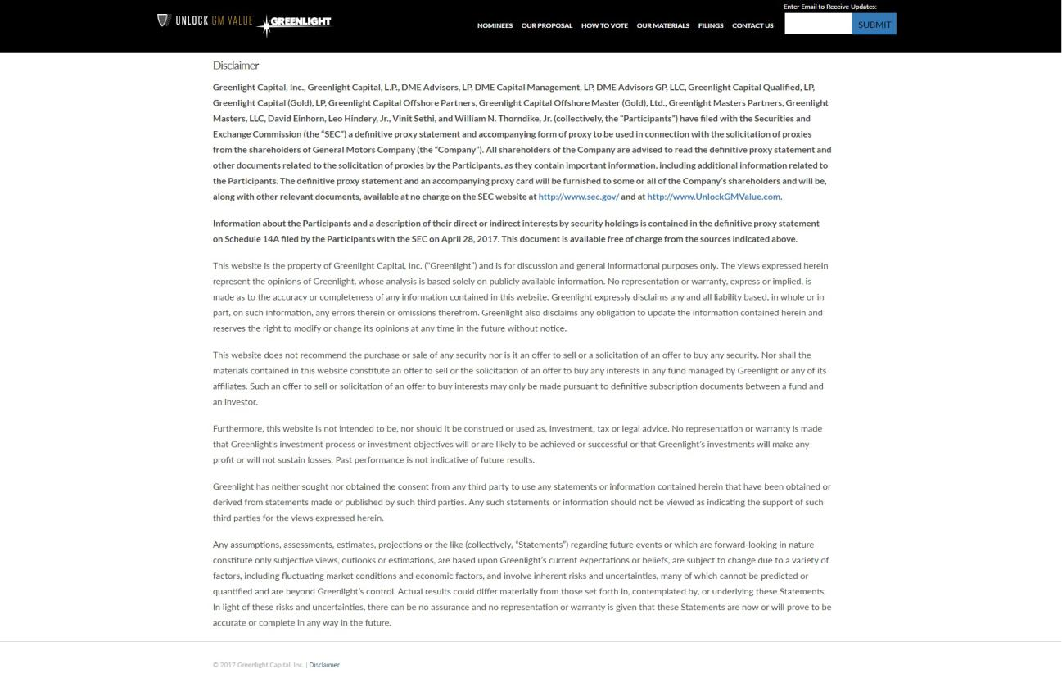

Exhibit 3

GREENLIGHT'S ORIGINAL TERM SHEET PROVIDED TO GM:

SUMMARY OF TERMS FOR

DIVIDEND SHARES OF
GENERAL MOTORS COMPANY

The following is a summary of terms and conditions for the issuance of shares of the Dividend Shares.

Issuer:

General Motors Company (NYSE:GM) (the “Issuer”).

Issue:

Dividend Share Common Stock (the “Dividend Shares”).

Issuance:

One Dividend Share to be issued via dividend for each share of existing Common Stock (the “Capital Appreciation Shares”). The Capital Appreciation Shares will have the same rights and privileges as the currently outstanding shares of Common Stock and may pay dividends as described below.

Dividend Shares are common stock (not preferred), and the board of directors of the Issuer (the “Board”) will owe its fiduciary duties to holders of both the Capital Appreciation Shares and the Dividend Shares.

Voting:

Except to the extent required by Delaware law or as set forth below, the Capital Appreciation Shares and Dividend Shares will vote together as a single class on all matters submitted to stockholders. When voting together with the Capital Appreciation Shares, each Dividend Share will possess 1/10 of a vote per share, and each Capital Appreciation Share will continue to have one vote per share.

Dividends:

The Dividend Shares shall be entitled to a quarterly dividend, payable in cash, when and if declared by the Board, in an amount equal to $0.38 (the “Dividend Share Dividend”). While an aggregate amount equal to at least the Dividend Share Dividend for each quarter since the issuance of the Dividend Shares has not been paid in respect of each Dividend Share, no dividends or distributions may be paid in respect of Capital Appreciation Shares, and the Issuer may not conduct any discretionary repurchase of Capital Appreciation Shares (other than as required pursuant to the terms of any bona fide employee benefit plan). If dividends on the Dividend Shares are current, the Board may declare and pay dividends or make optional repurchases in respect of Capital Appreciation Shares. In addition, in the exercise of its fiduciary duties, the Board may make optional repurchases of Dividend Shares.

Change of Control: In connection with a Change of Control, the Dividend Shares will vote as a separate class to approve such Change of Control and the consideration offered to the Dividend Shares in connection therewith.

“Change of Control” means an occurrence where the Issuer (or any of its subsidiaries) sell, convey, license, lease or otherwise dispose of all or substantially all of the assets or business of the Issuer and its subsidiaries (taken as a whole) or merge with or into or consolidate with any other corporation, limited liability company or other entity (other than a wholly-owned subsidiary of the Issuer), or there is any transaction or series of related transactions in which in excess of 50% of the Issuer’s outstanding voting securities are transferred to one person or group of persons, in each case, to the extent that such occurrence or transaction is submitted to stockholders.

Liquidation: Upon a liquidation (other than a Change of Control) of the Issuer, payment will be made equally (on a per share basis) to the Capital Appreciation Shares and the Dividend Shares. To account for these payments being made on a per share basis, the Dividend Shares will be subject to adjustment as determined by the Board in the exercise of its fiduciary duties for stock splits, combinations, share dividends and other similar transactions.

Listing: The Capital Appreciation Shares will continue to be listed on the NYSE and TSX, and the Dividend Shares will be listed on the NYSE.

Registration: While the Dividend Shares will be issued pursuant to an exemption from registration under the Securities Act of 1933, they will be registered pursuant to the Securities Exchange Act of 1934.

Non-Binding: Except with respect to this provision, this Term Sheet is intended solely as an outline of general terms and as the basis for further discussion. It is not intended to be, and does not constitute, a legally binding obligation or commitment on behalf of any person. This Term Sheet does not create and is not intended to create a duty to negotiate, in good faith or otherwise, towards a binding contract and may not be relied upon as the basis for a contract by estoppel or otherwise. This Term Sheet may be withdrawn at any time for any reason or no reason. No legally binding obligation or commitment will be created, implied or inferred hereby. This Term Sheet does not constitute an offer to sell or a solicitation of an offer to buy securities.

TERM SHEET GM PURPORTEDLY PRESENTED TO THE CREDIT RATING AGENCIES:

STRICTLY CONFIDENTIAL

SUMMARY OF PROPOSED TERMS AND CONDITIONS FOR A POTENTIAL DISTRIBUTION OF DIVIDEND SHARE COMMON STOCK

Issuer | General Motors Company (NYSE: GM) (the “Issuer”).
Issue | Dividend Share Common Stock (the “Dividend Shares”).
Issuance | One Dividend Share to be issued via dividend for each share of existing Common Stock (the “Capital
 | Appreciation Shares”).
 | The Capital Appreciation Shares will have the same rights and privileges as the currently outstanding
 | shares of Common Stock, but upon issuance of the Dividend Shares, the Company would cease paying
 | dividends on the Capital Appreciation Shares for the foreseeable future.
 | Dividend Shares are common stock, and the board of directors of the Issuer (the “Board”) will be elected
 | by and will owe its fiduciary duties to holders of both the Capital Appreciation Shares and the Dividend
 | Shares.
Voting | Except to the extent required by Delaware law or as set forth below, the Capital Appreciation Shares and
 | Dividend Shares will vote together as a single class on all matters submitted to stockholders.
 | When voting together with the Capital Appreciation Shares, each Dividend Share will possess 1/10 of
 | a vote per share, and each Capital Appreciation Share will continue to have one vote per share.
Dividends | The Dividend Shares shall be entitled to a quarterly dividend, payable in cash, when and if declared by the
 | Board, in an amount equal to $0.38 per share (the “Dividend Share Dividend”).
 | While an aggregate amount equal to at least the Dividend Share Dividend for each quarter since the
 | issuance of the Dividend Shares has not been paid in respect of each Dividend Share, no dividends or
 | distributions may be paid in respect of Capital Appreciation Shares, and the Issuer may not conduct any
 | discretionary repurchase of Capital Appreciation Shares (other than as required pursuant to the terms of
 | any bona fide employee benefit plan).
 | If dividends on the Dividend Shares are current, the Board may declare and pay dividends or make
 | optional repurchases in respect of Capital Appreciation Shares.
 | In addition, in the exercise of its fiduciary duties, the Board may make optional repurchases of Dividend
 | Shares.

Change of | In connection with a Change of Control, the Dividend Shares will vote as a separate class to approve such
Control | Change of Control and the consideration offered to the Dividend Shares in connection therewith.
 | “Change of Control” means an occurrence where the Issuer (or any of its subsidiaries) sell, convey,
 | license, lease or otherwise dispose of all or substantially all of the assets or business of the Issuer and its
 | subsidiaries (taken as a whole) or merge with or into or consolidate with any other corporation, limited
 | liability company or other entity (other than a wholly-owned subsidiary of the Issuer), or there is any
 | transaction or series of related transactions in which in excess of 50% of the Issuer’s outstanding voting
 | securities are transferred to one person or group of persons, in each case, to the extent that such occurrence
 | or transaction is submitted to stockholders.
Liquidation1 | Upon a liquidation (other than a Change of Control) of the Issuer, payment will be made equally (on a per
 | share basis) to the Capital Appreciation Shares and the Dividend Shares, with holders of the Dividend
 | Shares receiving dividends in arrears (i.e., accrued but unpaid dividends on the Dividend Shares) in
 | preference to the holders of Capital Appreciation Shares. To account for these payments being made on a
 | per share basis, the Dividend Shares will be subject to adjustment as determined by the Board in the
 | exercise of its fiduciary duties for stock splits, combinations, share dividends and other similar
 | transactions.
Ranking1 | The Dividend Shares will rank equally amongst themselves in all respects and rank senior to the Capital
 | Appreciation Shares with respect to dividend rights and rank pari passu with any class or series of stock or
 | other equity securities that is not expressly made senior or subordinated to the Dividend Shares as to the
 | payment of distributions. The Dividend Shares will rank junior to the Issuer’s existing and future
 | indebtedness (and junior to any class or series of stock or equity securities, including preferred shares,
 | expressly made senior to the Dividend Shares).
Restrictions | None
on Issuances of
Other Share
Classes
Conversion | None
Rights
Redemption | No special redemption rights.
Rights
Preemptive | No special preemptive rights would attach to the Dividend Shares.
Rights

1 Following clarifying call with Schulte Roth on Feb 13, 2017, confirmed in subsequent discussions with RAs that payment of dividends in arrears to Dividend Shares in liquidation, or lack thereof, would not change credit rating judgment.

Financial or | None
Other Covenants
Listing | The Capital Appreciation Shares will continue to be listed on the NYSE and such other exchanges as they
 | may currently be listed, and the Dividend Shares will be listed on the NYSE.
Registration | While the Dividend Shares will be issued pursuant to an exemption from registration under the Securities
 | Act of 1933, they will be registered pursuant to the Securities Exchange Act of 1934.

ANNOTATED COMPARISON OF THE GREENLIGHT AND GM TERM SHEETS:
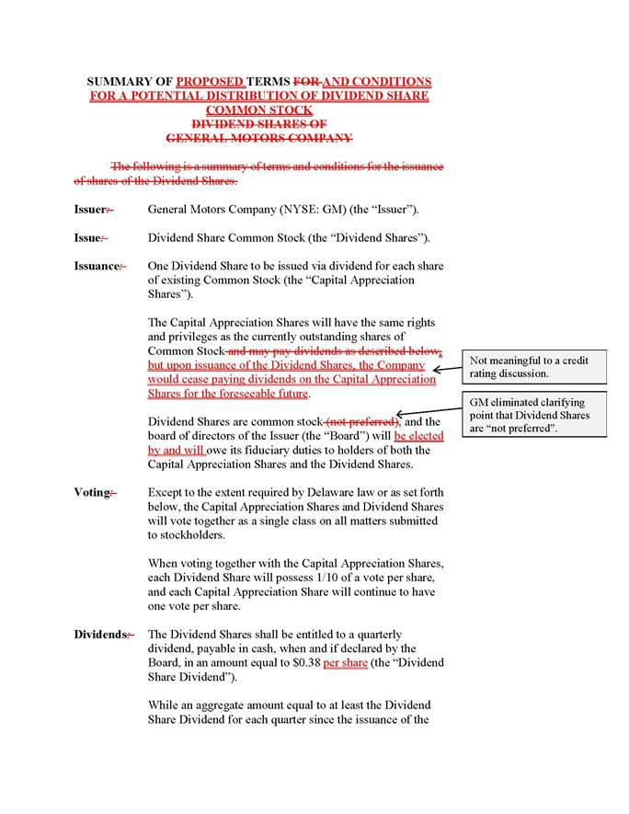

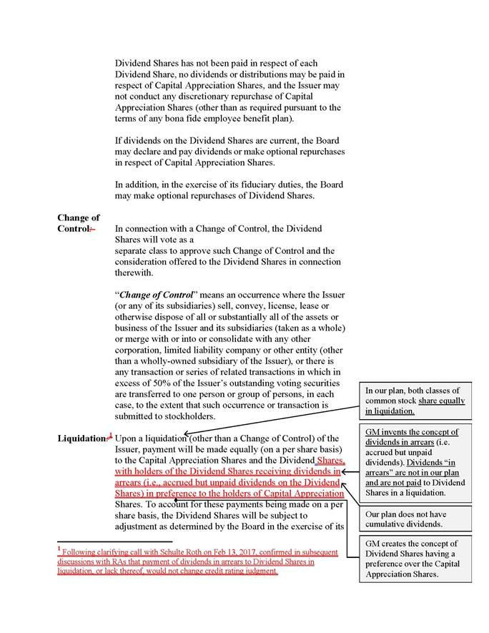

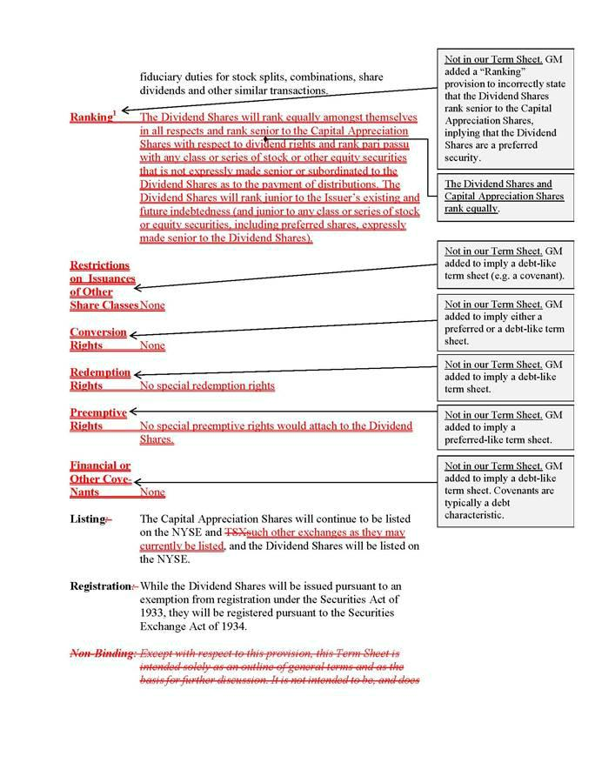



Exhibit 4

GREENLIGHT RESPONDS TO GM’S MISLEADING PRESS RELEASE

NEW YORK – May 4, 2017 – Greenlight Capital, Inc. (“Greenlight”), which owns 3.6% of the common stock of General Motors Company (NYSE: “GM”) (the “Company”) making it the fifth largest public shareholder, today issued the following statement regarding GM’s press release from earlier today.

Contrary to GM’s press release:

- GM has not “returned significant value to [its] shareholders.” That GM believes it has done so is a big part of the reason why change is needed at GM.

- GM provides no evidence or analysis to support its conclusion that Greenlight’s plan would not unock value for shareholders. Greenlight has repeatedly asked GM to provide its analysis, together with the supporting math, used to arrive at this conclusion and, tellingly, GM has not provided any.

- GM misstates what the rating agencies publicly said about Greenlight’s plan. None of the rating agencies’ statements support GM’s assertion that the plan “would result in a downgrade of GM’s credit rating.” In fact, in public statements on March 28, 2017, Moody’s explicitly relied on several assumptions and draws conditional conclusions. S&P explicitly stated, “As there is considerable uncertainty regarding the eventual outcome of the proposal at this point, we cannot predict the specific implications that it will have on our ratings on GM.” Finally, Fitch stated, “More information needed to determine impact of Greenlight Proposal.”

- GM did not present Greenlight’s plan to the rating agencies accurately and responsibly. Greenlight stands by its assertion that GM manipulated our term sheet before providing it to the rating agencies in what we believe was an effort to undermine the merits of our plan to create two classes of GM common equity, which would unlock billions of dollars of shareholder value.

- Shareholders can see GM’s duplicity for themselves by reviewing the term sheet Greenlight provided to GM and the term sheet GM purportedly provided to the rating agencies at https://www.unlockgmvalue.com/content/uploads/2017/02/Annotated-Comparison-of-Greenlights-GMs-Term-Sheets-1.pdf, which is available at www.UnlockGMValue.com/our-proposal.

About Greenlight Capital

Greenlight Capital, Inc. (“Greenlight”), founded in 1996, is a value-oriented investment advisor that primarily invests and trades in long and short publicly listed equity securities, as well as distressed debt when cyclically attractive. Greenlight seeks to achieve capital appreciation by buying securities with trading values materially lower than their intrinsic values and by selling short securities with trading values materially higher than their intrinsic values. Greenlight aims to achieve high absolute rates of return while minimizing the risk of capital loss.

Contacts

Jonathan Gasthalter/Nathaniel Garnick

Gasthalter & Co.
(212) 257-4170

About the Proxy Solicitation

Greenlight Capital, Inc., Greenlight Capital, L.P., DME Advisors, LP, DME Capital Management, LP, DME Advisors GP, LLC, Greenlight Capital Qualified, LP, Greenlight Capital (Gold), LP, Greenlight Capital Offshore Partners, Greenlight Capital Offshore Master (Gold), Ltd., Greenlight Masters Partners, Greenlight Masters, LLC, David Einhorn, Leo Hindery, Jr., Vinit Sethi, and William N. Thorndike, Jr. (collectively, the “Participants”) have filed with the Securities and Exchange Commission (the “SEC”) a definitive proxy statement and accompanying form of proxy to be used in connection with the solicitation of proxies from the shareholders of General Motors Company (the “Company”). All shareholders of the Company are advised to read the definitive proxy statement and other documents related to the solicitation of proxies by the Participants, as they contain important information, including additional information related to the Participants. The definitive proxy statement and an accompanying proxy card will be furnished to some or all of the Company’s shareholders and is, along with other relevant documents, available at no charge on the SEC website at http://www.sec.gov/ and at http://www.UnlockGMValue.com/.

Information about the Participants and a description of their direct or indirect interests by security holdings is contained in the definitive proxy statement on Schedule 14A filed by the Participants with the SEC on April 28, 2017. This document is available free of charge from the sources indicated above.

Warning Regarding Forward Looking Statements

THIS PRESS RELEASE CONTAINS FORWARD LOOKING STATEMENTS. FORWARD LOOKING STATEMENTS CAN BE IDENTIFIED BY USE OF WORDS SUCH AS “OUTLOOK”, “BELIEVE”, “INTEND”, “EXPECT”, “POTENTIAL”, “WILL”,

“MAY”, “SHOULD”, “ESTIMATE”, “ANTICIPATE”, AND DERIVATIVES OR NEGATIVES OF SUCH WORDS OR SIMILAR WORDS. FORWARD LOOKING STATEMENTS IN THIS PRESS RELEASE ARE BASED UPON PRESENT BELIEFS OR EXPECTATIONS. HOWEVER, FORWARD LOOKING STATEMENTS AND THEIR IMPLICATIONS ARE NOT GUARANTEED TO OCCUR AND MAY NOT OCCUR AS A RESULT OF VARIOUS RISKS, REASONS AND UNCERTAINTIES. EXCEPT AS REQUIRED BY LAW, GREENLIGHT CAPITAL, INC. AND ITS AFFILIATES AND RELATED PERSONS UNDERTAKE NO OBLIGATION TO UPDATE ANY FORWARD LOOKING STATEMENT, WHETHER AS A RESULT OF NEW INFORMATION, FUTURE DEVELOPMENTS OR OTHERWISE.

