UNITED STATES

SECURITIES AND EXCHANGE COMMISSION

Washington, DC 20549-1004

___________________

FORM 8-K

___________________

CURRENT REPORT

PURSUANT TO SECTION 13 OR 15(d) OF

THE SECURITIES EXCHANGE ACT OF 1934

Date of Report (Date of earliest event reported) March 1, 2012

___________________

GENERAL MOTORS COMPANY

(Exact Name of Registrant as Specified in its Charter)

___________________

DELAWARE | 001-34960 | 27-0756180
(State or other jurisdiction of | 001-34960 | (I.R.S. Employer
incorporation) | (Commission File Number) | Identification No.)
300 Renaissance Center, Detroit, Michigan |  | 48265-3000
(Address of Principal Executive Offices) |  | (Zip Code)

(313) 556-5000

(Registrant's telephone number, including area code)

Not Applicable

(Former name or former address, if changed since last report)

___________________

Check the appropriate box below if the Form 8-K filing is intended to simultaneously satisfy the filing obligation of the registrant under any of the following provisions:

- Written communications pursuant to Rule 425 under the Securities Act (17 CFR 230.425)

- Soliciting material pursuant to Rule 14a-12 under the Exchange Act (17-CFR 240.14a-12)

- Pre-commencement communications pursuant to Rule 14d-2(b) under the Exchange Act (17 CFR 240.14d-2(b))

- Pre-commencement communications pursuant to Rule 13e-4(c) under the Exchange Act (17 CFR 240.13e-4(c))

TABLE OF CONTENTS

ITEM 8.01 Other Events

Signature

Index to Exhibits

Sales Release and Charts Dated March 1, 2012

ITEM 8.01 Other Events

On March 1, 2012, General Motors Company (GM) issued a news release announcing February sales. The release and charts are attached as Exhibit 99.1.

 |  |  |  | EXHIBIT
Exhibit |  | Description |  |  |  | Method of Filing
Exhibit 99.1 |  | Sales Release and Charts |  |  |  | Attached as Exhibit
 |  | Dated February 1, 2012

SIGNATURE

Pursuant to the requirements of the Securities Exchange Act of 1934, the Registrant has duly caused this report to be signed on its behalf by the undersigned hereunto duly authorized.

 |  |  | GENERAL MOTORS COMPANY
 |  |  | (Registrant)
 |  |  | /s/ Nick S. Cyprus
Date: March 2, 2012 | By:
Date: March 2, 2012 | By: |  | Nick S. Cyprus
 |  |  | Vice President, Controller and Chief Accounting Officer

Exhibit 99.1

1


For Release: Thursday, March 1, 2012, 10 a.m. EST

GM February Sales Beat Expectations

Small and Compact Car Sales up 43 percent

DETROIT - General Motors Co. (NYSE: GM) today reported total sales of 209,306 vehicles in February, up 1.1 percent compared with the company's very strong February 2011 results.

“Chevrolet's 6 percent sales increase, which was driven by new models, as well as a stronger economy, helped GM exceed last February's remarkably strong result,” said Don Johnson, vice president, U.S. Sales Operations. “It's an affirmation of our progress. We are continuing to execute the same disciplined sales strategy that was the key to our success in 2011.”

Industry wide, February light vehicle sales will top 1.1 million units, thanks to stronger employment and credit availability, an improving housing market and the recovery in consumer sentiment, he added.

“Commercial sales are a good barometer for the economy,” Johnson said. “GM's commercial deliveries increased 35 percent in February, driven by strong sales of heavy-duty pickups.”

Year over year sales of the Chevrolet Silverado HD and GMC Sierra HD were up 28 percent and 20 percent, respectively. Other sales highlights for February include double-digit sales increases for the Buick LaCrosse, which features the 36-mpg eAssist powertrain as standard equipment, the Chevrolet Equinox and Camaro, and the GMC Terrain.

Chevrolet passenger car sales were up 13 percent. The all-new Chevrolet Sonic had its best month ever, with sales of 7,900 units. Chevrolet Cruze exceeded 20,000 units for the sixth time, marking its sixth-consecutive month of year-over-year sales gains. GM's small and compact car portfolio, which now includes the Chevrolet Sonic, Cruze and Volt, and the new Buick Verano, were up a combined 43 percent versus February 2011.

GM's year-over-year incentive spending, expressed as a percentage of average transaction prices, was down 3.5 percentage points to 9.5 percent in February, according to J.D. Power PIN estimates. Incentive spending was down about one-half point from January.

Highlights | Feb. 2012 Total Sales | Total Change vs. Feb. | Feb. 2012 Retail Sales | CYTD Total Sales | CYTD Total Sales | CYTD Retail Sales
Highlights | Feb. 2012 Total Sales | 2011 | Change vs. Feb. 2011 | CYTD Total Sales | Change vs. 2011 | Change vs. 2011
Chevrolet | 151,197 | 5.8% | (1.3%) | 275,061 | 2.5% | (7.5%)
GMC | 32,581 | 0.1% | (5.7%) | 57,547 | (4.4%) | (9.4%)
Buick | 14,023 | (11.3%) | (3.6%) | 24,231 | (16.7%) | (10.4%)
Cadillac | 11,505 | (27.0%) | (20.2%) | 20,429 | (27.9%) | (21.0%)
Total GM | 209,306 | 1.1% | (3.9%) | 377,268 | (2.2%) | (9.2%)

Inventory | Units @ | Days Supply (selling days | Units @ | Days Supply (selling days
Inventory | Feb. 29, 2012 | adjusted) | Jan. 31, 2012 | adjusted)
All Vehicles | 667,096 | 80 | 619,455 | 89
Full-size Pickups | 210,463 | 116 | 188,568 | 119
Industry Sales | Full Year 2012 | Jan. 2012 SAAR | Feb. 2012 SAAR (est.) | Feb. 2011 SAAR
Industry Sales | (est.) | Jan. 2012 SAAR | Feb. 2012 SAAR (est.) | Feb. 2011 SAAR
Total Light Vehicles | 13.5 million - 14.0 | 14.1 million | 14.5 million - 14.9 | 13.3 million
Total Light Vehicles | million | 14.1 million | million | 13.3 million

General Motors Co. (NYSE:GM, TSX: GMM) and its partners produce vehicles in 30 countries, and the company has leadership positions in the world's largest and fastest-growing automotive markets. GM's brands include Chevrolet and Cadillac, as well as Baojun, Buick, GMC, Holden, Isuzu, Jiefang, Opel, Vauxhall and Wuling. More information on the company and its subsidiaries, including OnStar, a global leader in vehicle safety, security and information services, can be found at http://www.gm.com.

CONTACT:

Jim Cain

GM Communications

313-407-2843

james.cain@gm.com

Forward-Looking Statements

In this press release and in related comments by our management, our use of the words “expect,” “anticipate,” “possible,” “potential,” “target,” “believe,” “commit,” “intend,” “continue,” “may,” “would,” “could,” “should,” “project,” “projected,” “positioned” or similar expressions is intended to identify forward-looking statements that represent our current judgment about possible future events. We believe these judgments are reasonable, but these statements are not guarantees of any events or financial results, and our actual results may differ materially due to a variety of important factors. Among other items, such factors might include: our ability to realize production efficiencies and to achieve reductions in costs as a result of our restructuring initiatives and labor modifications; our ability to maintain quality control over our vehicles and avoid material vehicle recalls; our ability to maintain adequate liquidity and financing sources and an appropriate level of debt, including as required to fund our planned significant investment in new technology; the ability of our suppliers to timely deliver parts, components and systems; our ability to realize successful vehicle applications of new technology; and our ability to continue to attract new customers, particularly for our new products. GM's most recent annual report on Form 10-K and quarterly reports on Form 10-Q provides information about these and other factors, which we may revise or supplement in future reports to the SEC.

 |  | February |  | (Calendar Year-to-Date)
 |  |  |  | January - | February
 |  |  | %Change |  |  | %Change
 | 2012 | 2011 | Volume | 2012 | 2011 | Volume
Enclave | 4,167 | 5,199 | (19.8) | 7,291 | 9,546 | (23.6)
LaCrosse | 5,228 | 4,329 | 20.8 | 9,241 | 8,100 | 14.1
Lucerne | 304 | 2,574 | (88.2) | 725 | 5,390 | (86.5)
Regal | 2,636 | 3,705 | (28.9) | 4,491 | 6,040 | (25.6)
Verano | 1,688 | — | ***.* | 2,483 | — | ***.*
Buick Total | 14,023 | 15,807 | (11.3) | 24,231 | 29,076 | (16.7)
CTS | 4,570 | 6,033 | (24.2) | 7,589 | 10,395 | (27.0)
DTS | 68 | 1,512 | (95.5) | 157 | 2,877 | (94.5)
Escalade | 1,011 | 1,279 | (21.0) | 1,996 | 2,793 | (28.5)
Escalade ESV | 690 | 756 | (8.7) | 1,221 | 1,348 | (9.4)
Escalade EXT | 150 | 167 | (10.2) | 258 | 320 | (19.4)
SRX | 4,983 | 5,502 | (9.4) | 9,149 | 9,738 | (6.0)
STS | 33 | 519 | (93.6) | 59 | 878 | (93.3)
XLR | — | — | ***.* | — | (1) | ***.*
Cadillac Total | 11,505 | 15,768 | (27.0) | 20,429 | 28,348 | (27.9)
Avalanche | 1,794 | 1,414 | 26.9 | 3,411 | 2,811 | 21.3
Aveo | 17 | 2,760 | (99.4) | 33 | 5,499 | (99.4)
Camaro | 6,923 | 6,245 | 10.9 | 12,632 | 11,008 | 14.8
Caprice | 155 | — | ***.* | 247 | — | ***.*
Captiva Sport | 2,289 | — | ***.* | 4,550 | — | ***.*
Cobalt | 2 | 153 | (98.7) | 3 | 559 | (99.5)
Colorado | 3,532 | 2,606 | 35.5 | 6,404 | 4,810 | 33.1
Corvette | 927 | 955 | (2.9) | 1,556 | 1,676 | (7.2)
Cruze | 20,427 | 18,556 | 10.1 | 35,476 | 32,187 | 10.2
Equinox | 17,851 | 15,434 | 15.7 | 31,513 | 28,281 | 11.4
Express | 5,257 | 4,021 | 30.7 | 9,789 | 9,294 | 5.3
HHR | 1 | 6,398 | ***.* | 5 | 13,785 | ***.*
Impala | 15,333 | 16,290 | (5.9) | 31,342 | 31,478 | (0.4)
Kodiak 4/5 Series | ***.* | ***.* | ***.* | ***.* | ***.* | ***.*
Malibu | 19,987 | 19,092 | 4.7 | 34,663 | 33,194 | 4.4
Silverado-C/K Pickup | 32,297 | 31,728 | 1.8 | 59,147 | 59,900 | (1.3)
Sonic | 7,900 | — | ***.* | 13,612 | — | ***.*
Suburban (Chevy) | 3,304 | 2,383 | 38.6 | 6,239 | 4,726 | 32.0
Tahoe | 4,212 | 5,068 | (16.9) | 8,207 | 10,349 | (20.7)
TrailBlazer | — | 2 | ***.* | — | 11 | ***.*
Traverse | 7,966 | 9,533 | (16.4) | 14,606 | 18,138 | (19.5)
Volt | 1,023 | 281 | 264.1 | 1,626 | 602 | 170.1
Chevrolet Total | 151,197 | 142,919 | 5.8 | 275,061 | 268,308 | 2.5
Acadia | 6,630 | 7,547 | (12.2) | 11,500 | 13,270 | (13.3)
Canyon | 1,064 | 765 | 39.1 | 2,123 | 1,459 | 45.5
Envoy | — | — | ***.* | — | 1 | ***.*
Savana | 2,126 | 673 | 215.9 | 2,964 | 1,391 | 113.1
Sierra | 11,306 | 11,696 | (3.3) | 20,823 | 22,323 | (6.7)
Terrain | 8,086 | 7,190 | 12.5 | 13,735 | 13,559 | 1.3
Topkick 4/5 Series | ***.* | ***.* | ***.* | ***.* | ***.* | ***.*
Topkick 6/7/8 Series | ***.* | ***.* | ***.* | ***.* | ***.* | ***.*
Yukon | 2,125 | 2,817 | (24.6) | 4,147 | 4,893 | (15.2)
Yukon XL | 1,244 | 1,846 | (32.6) | 2,255 | 3,296 | (31.6)
GMC Total | 32,581 | 32,534 | 0.1 | 57,547 | 60,192 | (4.4)
GM Vehicle Total | 209,306 | 207,028 | 1.1 | 377,268 | 385,924 | (2.2)
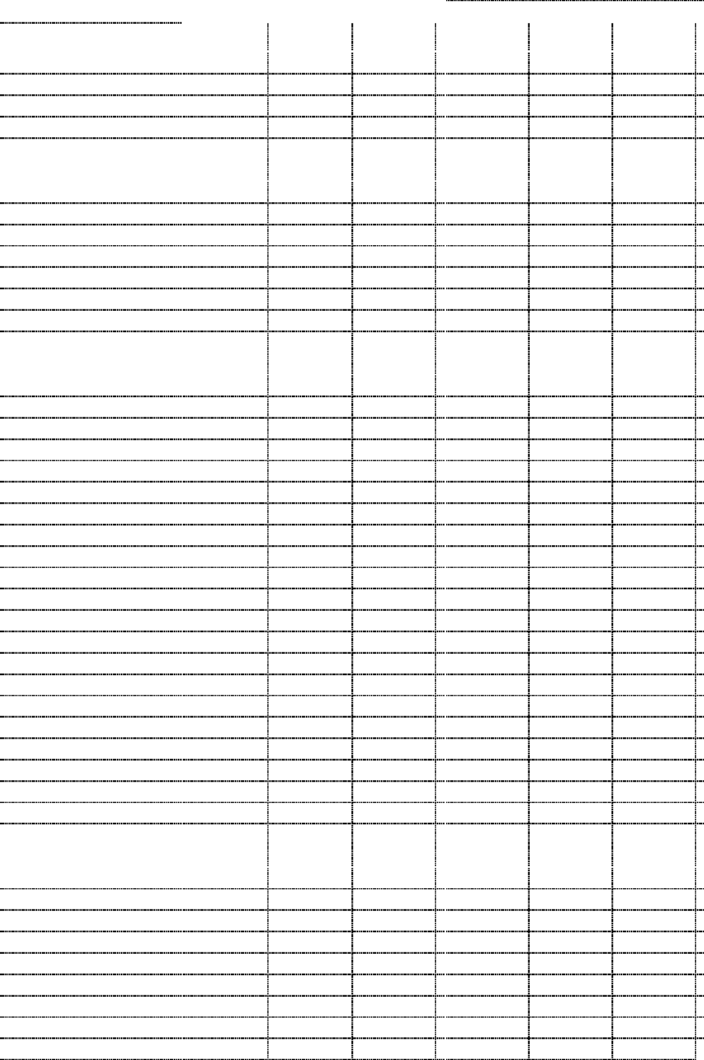

* 25 selling days for the February period this year and 24 for last year.

