

2024 Annual Report

[THIS PAGE INTENTIONALLY LEFT BLANK]

UNITED STATES

SECURITIES AND EXCHANGE COMMISSION

Washington, D.C. 20549

Form 10-K

- ANNUAL REPORT PURSUANT TO SECTION 13 OR 15(d) OF THE SECURITIES EXCHANGE ACT OF 1934

For the fiscal year ended December 31, 2024

OR

- TRANSITION REPORT PURSUANT TO SECTION 13 OR 15(d) OF THE SECURITIES EXCHANGE ACT OF 1934

For the transition period from to

Commission file number 001-34960


GENERAL MOTORS COMPANY

(Exact name of registrant as specified in its charter)

Delaware | 27-0756180
(State or other jurisdiction of | (I.R.S. Employer
incorporation or organization) | Identification No.)
300 Renaissance Center, Detroit, Michigan | 48265 -3000
(Address of principal executive offices) | (Zip Code)
(313) 667-1500
(Registrant’s telephone number, including area code)

Securities registered pursuant to Section 12(b) of the Act:

 | Title of each class |  | Trading Symbol(s) |  | Name of each exchange on which registered
Common Stock, $0.01 par value |  |  | GM |  | New York Stock Exchange

Securities registered pursuant to Section 12 (g) of the Act: None

Indicate by check mark if the registrant is a well-known seasoned issuer, as defined in Rule 405 of the Securities Act. Yes ☑ No ☐ Indicate by check mark if the registrant is not required to file reports pursuant to Section 13 or Section 15(d) of the Act. Yes ☐ No ☑

Indicate by check mark whether the registrant (1) has filed all reports required to be filed by Section 13 or 15(d) of the Securities Exchange Act of 1934 during the preceding 12 months (or for such shorter period that the registrant was required to file such reports), and (2) has been subject to such filing requirements for the past 90 days. Yes ☑ No ☐

Indicate by check mark whether the registrant has submitted electronically every Interactive Data File required to be submitted pursuant to Rule 405 of Regulation S-T (§ 232.405 of this chapter) during the preceding 12 months (or for such shorter period that the registrant was required to submit such files). Yes ☑ No ☐

Indicate by check mark whether the registrant is a large accelerated filer, an accelerated filer, a non-accelerated filer, a smaller reporting company or an emerging growth company. See the definitions of “large accelerated filer,” “accelerated filer,” “smaller reporting company” and "emerging growth company" in Rule 12b-2 of the Exchange Act.

Large accelerated filer ☑ Accelerated filer ☐ Non-accelerated filer ☐ Smaller reporting company ☐ Emerging growth company ☐

If an emerging growth company, indicate by check mark if the registrant has elected not to use the extended transition period for complying with any new or revised financial accounting standards provided pursuant to Section 13(a) of the Exchange Act. ☐

Indicate by check mark whether the registrant has filed a report on and attestation to its management's assessment of the effectiveness of its internal control over financial reporting under Section 404(b) of the Sarbanes-Oxley Act (15 U.S.C.7262(b)) by the registered public accounting firm that prepared or issued its audit report. ☑

If securities are registered pursuant to Section 12(b) of the Act, indicate by check mark whether the financial statements of the registrant included in the filing reflect the correction of an error to previously issued financial statements. ☐

Indicate by check mark whether any of those error corrections are restatements that required a recovery analysis of incentive-based compensation received by any of the registrant's executive officers during the relevant recovery period pursuant to §240.10D-1(b). ☐

Indicate by check mark whether the registrant is a shell company (as defined in Rule 12b-2 of the Act). Yes ☐ No ☑

The aggregate market value of the voting stock held by non-affiliates of the registrant (assuming only for purposes of this computation that directors and executive officers may be affiliates) was approximately $52.2 billion as of June 30, 2024.

As of January 16, 2025 there were 995,001,891 shares of common stock outstanding.

DOCUMENTS INCORPORATED BY REFERENCE

Portions of the registrant's definitive Proxy Statement related to the Annual Stockholders Meeting to be filed subsequently are incorporated by reference into Part III of this Form 10-K.

 |  | TABLE OF CONTENTS
 |  |  | Page
 |  | PART I
Item 1. | Business |  | 1
Item 1A. | Risk Factors
Item 1A. | Risk Factors |  | 11
Item 1B. Unresolved Staff Comments
 |  |  | 22
Item 1C. | Cybersecurity
Item 1C. |  |  | 22
Item 2. | Properties
Item 2. | Properties |  | 23
Item 3. | Legal Proceedings
Item 3. |  |  | 24
Item 4. | Mine Safety Disclosures
Item 4. |  |  | 24
 |  | PART II
Item 5. | Market for Registrant’s Common Equity, Related Stockholder Matters and Issuer Purchases of Equity
 | Securities |  | 24
Item 6. | [Reserved]
Item 6. | [Reserved] |  | 26
Item 7. | Management’s Discussion and Analysis of Financial Condition and Results of Operations
Item 7. |  |  | 26
Item 7A. | Quantitative and Qualitative Disclosures About Market Risk
Item 7A. |  |  | 47
Item 8. | Financial Statements and Supplementary Data
Item 8. |  |  | 54
 | Consolidated Income Statements
 |  |  | 54
 | Consolidated Statements of Comprehensive Income
 |  |  | 54
 | Consolidated Balance Sheets
 |  |  | 55
 | Consolidated Statements of Cash Flows
 |  |  | 56
 | Consolidated Statements of Equity
 |  |  | 57
 | Notes to Consolidated Financial Statements
 |  |  | 58
 | Note 1.
 | Note 1. | Nature of Operations and Basis of Presentation | 58
 | Note 2.
 | Note 2. | Significant Accounting Policies | 58
 | Note 3.
 | Note 3. | Revenue | 65
 | Note 4.
 | Note 4. | Marketable and Other Securities | 67
 | Note 5.
 | Note 5. | GM Financial Receivables and Transactions | 68
 | Note 6.
 | Note 6. | Inventories | 71
 | Note 7.
 | Note 7. | Operating Leases | 71
 | Note 8.
 | Note 8. | Equity in Net Assets of Nonconsolidated Affiliates | 72
 | Note 9.
 | Note 9. | Property | 75
 | Note 10.
 | Note 10. | Goodwill and Intangible Assets | 75
 | Note 11.
 | Note 11. | Variable Interest Entities | 76
 | Note 12.
 | Note 12. | Accrued and Other Liabilities | 77
 | Note 13.
 | Note 13. | Debt | 78
 | Note 14.
 | Note 14. | Derivative Financial Instruments | 80
 | Note 15.
 | Note 15. | Pensions and Other Postretirement Benefits | 81
 | Note 16.
 | Note 16. | Commitments and Contingencies | 87
 | Note 17.
 | Note 17. | Income Taxes | 92
 | Note 18.
 | Note 18. | Restructuring and Other Initiatives | 94
 | Note 19.
 | Note 19. | Interest Income and Other Non-Operating Income | 95
 | Note 20.
 | Note 20. | Stockholders’ Equity and Noncontrolling Interests | 95
 | Note 21.
 | Note 21. | Earnings Per Share | 98
 | Note 22.
 | Note 22. | Stock Incentive Plans | 98
 | Note 23.
 | Note 23. | Segment Reporting | 100
 | Note 24.
 | Note 24. | Supplemental Information for the Consolidated Statements of Cash Flows | 104


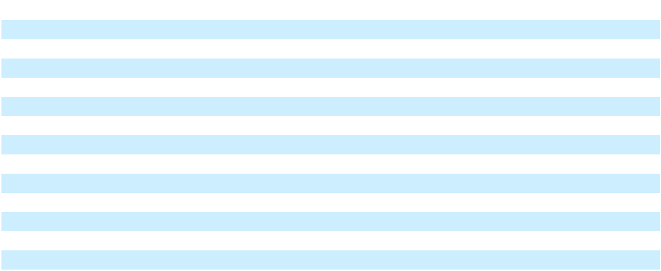
Item 9. Changes in and Disagreements with Accountants on Accounting and Financial Disclosure

Item 9A. Controls and Procedures

Item 9B. Other Information

Item 9C. Disclosure Regarding Foreign Jurisdictions that Prevent Inspections

PART III

Item 10. Directors, Executive Officers and Corporate Governance Item 11. Executive Compensation
Item 12. Security Ownership of Certain Beneficial Owners and Management and Related Stockholder Matters Item 13. Certain Relationships and Related Transactions, and Director Independence Item 14. Principal Accountant Fees and Services

PART IV

Item 15. Exhibit and Financial Statement Schedules

Item 16. Form 10-K Summary

Signatures

Page

105

105

106

106

106

106

106

106

106

107

110

111

Table of Contents

GENERAL MOTORS COMPANY AND SUBSIDIARIES

PART I

Item 1. Business

General Motors Company (sometimes referred to as we, our, us, ourselves, the Company, General Motors or GM) was incorporated as a Delaware corporation in 2009. We design, build and sell trucks, crossovers, cars and automobile parts and provide software-enabled services and subscriptions worldwide. Our automotive operations meet the demands of our customers through our automotive segments: GM North America (GMNA) and GM International (GMI) with vehicles developed, manufactured and/or marketed under the Buick, Cadillac, Chevrolet and GMC brands. We also have equity ownership stakes in entities that meet the demands of customers in other countries, primarily in China, with vehicles developed, manufactured and/ or marketed under the Baojun, Buick, Cadillac, Chevrolet and Wuling brands. Cruise is our global segment responsible for the development of autonomous vehicle (AV) technology. We provide automotive financing services through our General Motors Financial Company, Inc. (GM Financial) segment. Refer to Part II, Item 7. Management's Discussion and Analysis of Financial Condition and Results of Operations (MD&A) and Note 23 to our consolidated financial statements for financial information about our segments. Except for per share amounts or as otherwise specified, amounts presented within tables are stated in millions. Certain columns and rows may not add due to rounding. Forward-looking statements in this Business section are not guarantees of future performance and may involve risks and uncertainties that could cause actual results to differ materially from those projected. Refer to Item 1A. Risk Factors and the "Forward-Looking Statements" section of Part II, Item 7. MD&A for a discussion of these risks and uncertainties.

Our vision for the future is a world with zero crashes, zero emissions and zero congestion, which guides our growth-focused strategy to invest in electric vehicles (EVs) and AVs, software-enabled services and subscriptions and new business opportunities, while strengthening our market position in profitable internal combustion engine (ICE) vehicles, such as trucks and sport utility vehicles (SUVs).

Electric Vehicles We are offering customers choice with our diverse EV lineup. A key element in our EV strategy is our dedicated EV propulsion architecture. Our current-generation, flexible EV platform is being deployed across multiple brands and vehicle sizes, styles and drive configurations, leveraging our technology to expand our EV portfolio over a wide and growing variety of segments and price points. With our next-generation battery technology, we intend to expand to multiple chemistries, multiple form factors and multiple cell suppliers as we continue to deliver even more EV choices for our customers.

To support our expanding portfolio of EVs, we have made significant investments in our plants across North America. GM’s Factory ZERO Detroit-Hamtramck Assembly Center is a fully dedicated EV facility which produces a variety of vehicles, including the GMC HUMMER EV Pickup and SUV, the Chevrolet Silverado EV and the recently launched Cadillac ESCALADE IQ, with globally sourced parts. GM's CAMI Assembly is Canada's first full-scale EV manufacturing facility. We plan to convert Orion Assembly in Orion Township, Michigan to build electric pickups, with the plant slated to begin production in 2026. GM is also investing in our propulsion, stamping and components plants to support EV production. We are mass-producing battery cells for these and other future EVs through Ultium Cells Holdings LLC (an equally owned joint venture with LG Energy Solution) in plants in Warren, Ohio and Spring Hill, Tennessee, with plans to expand our battery cell manufacturing footprint, including in Indiana through a joint venture with Samsung SDI.

GM's all-electric future is guided by customer choice and focused on delivering a world-class portfolio of EVs and an ecosystem to support them, while maintaining a compelling lineup of gas-powered vehicles. GM EV drivers have access to more than 231,000 chargers across North America. This includes access to more than 20,000 Tesla Superchargers with the use of a GM-approved North American Charging Standard adapter. In 2024, GM also announced that it will enhance its collaboration with EVgo to build 2,850 DC fast charging stalls, including 400 fast chargers at flagship destinations in major metropolitan areas across the U.S. GM is also a founding member of IONNA, a joint venture with seven other automakers aiming to create a high-powered charging network with a targeted installation of at least 30,000 chargers in urban and highway locations throughout North America. The joint venture broke ground on its first charging station in October 2024.

Software-Enabled Services and Subscriptions Our vehicles are equipped with a suite of software-enabled services, including OnStar services, Super Cruise and others. With nearly three decades of experience, OnStar is a global leader in enabling automotive services. OnStar is currently available in 20 markets globally and growing. As GM introduces more software-defined vehicles, OnStar is playing a key role as an enabler of active safety, infotainment, connectivity and driver assistance features. OnStar provides one ecosystem for retail and fleet customers to use, engage and shop through a broader set of service offerings available at and after vehicle purchase. Our end-to-end software platform provides customers with

1

Table of Contents

GENERAL MOTORS COMPANY AND SUBSIDIARIES

software-defined features, apps and services over-the-air and will empower customers to update their ownership experiences with desirable features, software services, vehicle performance and Super Cruise. Super Cruise enables drivers of properly equipped vehicles to travel hands-free on more than 530,000 miles of compatible roads, and soon to be approximately 750,000 miles, in the U.S. and Canada. Additional software-enabled features are expected to be available in the near future including security features, climate and comfort options, personal themes and EV ownership experience elements. Many of GM's latest electric and internal combustion vehicles are employing this software platform as it rolls out across most products in the coming years.

Cruise GM Cruise Holdings LLC (Cruise Holdings), our majority-owned subsidiary, has been pursuing the development and commercialization of AV technology for deployment in a robotaxi application. In December 2024, we announced plans to refocus our autonomous driving strategy on personal vehicles and that we would no longer fund Cruise's robotaxi development work. We are pursuing the acquisition of the noncontrolling interests in Cruise, and as of December 31, 2024, we owned approximately 97% of Cruise. Following the acquisition of the noncontrolling interests and subject to approval of the Cruise Board of Directors, we expect to work with the Cruise leadership team to restructure Cruise's operations and combine the GM and Cruise technical efforts to build on the success of Super Cruise and prioritize the development of advanced driver-assistance systems (ADAS) on a path to fully autonomous personal vehicles. Refer to Item 1A. Risk Factors for a further discussion of the risks associated with our AV strategy.

Over the last year, we have engaged and actively cooperated with certain federal and state agencies who opened investigations or made inquiries to us and Cruise in connection with an accident involving a Cruise robotaxi in October 2023. We and Cruise have resolved the investigations and inquiries by the National Highway Traffic Safety Administration (NHTSA), the U.S. Department of Justice and the California Public Utilities Commission (CPUC). Specifically, in July 2024, Cruise entered into a settlement agreement with the CPUC that imposed a $112,500 fine on Cruise and various reporting obligations. In September 2024, Cruise and NHTSA executed a Consent Order, which imposed a $1.5 million fine on Cruise and requires enhanced reporting and engagement with NHTSA for two years (with an optional third year at NHTSA's discretion). In November 2024, Cruise entered into a Deferred Prosecution Agreement (DPA) with the U.S. Attorney's Office for the Northern District of California relating to the October 2023 accident. Under the terms of the DPA, Cruise admitted to one count of submitting a false report to a federal agency and paid a $500,000 monetary penalty. The government will not pursue an indictment or prosecution so long as Cruise complies with the terms of the DPA over the next three years by undertaking certain remedial measures, maintaining a safety compliance program and submitting reports to the government no less than annually. GM is neither a party nor a signatory to these agreements.

Competitive Position and Vehicle Sales The principal factors that determine consumer vehicle preferences in the markets in which we operate include overall vehicle design, price, quality, available options, safety, reliability, fuel economy or range and functionality. Market leadership in individual countries in which we compete varies widely.

We present both wholesale and total vehicle sales data to assist in the analysis of our revenue and market share. Wholesale vehicle sales data consists of sales to GM's dealers and distributors, as well as sales to the U.S. government, and excludes vehicles sold by our joint ventures. Wholesale vehicle sales data correlates to our revenue recognized from the sale of vehicles, which is the largest component of Automotive net sales and revenue. In the year ended December 31, 2024, 27.9% of our wholesale vehicle sales volume was generated outside the U.S. The following table summarizes wholesale vehicle sales by automotive segment (vehicles in thousands):

 |  |  | Years Ended December 31,
 | 2024 |  |  |  | 2023 |  |  |  |  | 2022
GMNA | 3,464 | 86.4 % |  | 3,147 |  | 83.5 % |  |  |  | 2,926 | 81.8 %
GMI | 547 |  | 13.6 % |  | 621 |  | 16.5 % |  |  | 653 |  | 18.2 %
Total | 4,010 | 100.0 % |  | 3,768 |  | 100.0 % |  |  |  | 3,579 | 100.0 %

Total vehicle sales data represents: (1) retail sales (i.e., sales to consumers who purchase new vehicles from dealers or distributors); (2) fleet sales (i.e., sales to large and small businesses, governments and daily rental car companies); and (3) sales of courtesy transportation vehicles (i.e., vehicles previously used by dealers that were sold to the end consumer). Total vehicle sales data includes all sales by joint ventures on a total vehicle basis, not based on our percentage ownership interest in the joint venture. Certain joint venture agreements in China allow for the contractual right to report vehicle sales of non-GM trademarked vehicles by those joint ventures, which are included in the total vehicle sales we report for China. While total vehicle sales data does not correlate directly to the revenue we recognize during a particular period, we believe it is indicative

2

Table of Contents

GENERAL MOTORS COMPANY AND SUBSIDIARIES

of the underlying demand for our vehicles. Total vehicle sales data represents management's good faith estimate based on sales reported by our dealers, distributors and joint ventures; commercially available data sources such as registration and insurance data; and internal estimates and forecasts when other data is not available.

The following table summarizes industry and GM total vehicle sales and our related competitive position by geographic region (vehicles in thousands):

 |  |  |  |  |  |  | Years Ended December 31,
 |  | 2024 |  |  |  |  |  | 2023 |  |  |  |  |  | 2022
 | Industry |  | GM |  | Market |  | Industry |  | GM |  | Market |  | Industry |  | GM |  | Market
 | Industry |  | GM |  | Share |  | Industry |  | GM |  | Share |  | Industry |  | GM |  | Share
North America
United States | 16,385 | 2,705 |  | 16.5 % |  | 16,022 |  | 2,595 |  | 16.2 % |  | 14,242 |  | 2,274 |  | 16.0 %
Other | 3,909 |  | 510 | 13.1 % |  |  | 3,590 |  | 460 | 12.8 % |  |  | 3,066 |  | 406 | 13.2 %
Total North America | 20,294 | 3,215 |  | 15.8 % |  | 19,612 |  | 3,055 |  | 15.6 % |  | 17,308 |  | 2,680 |  | 15.5 %
Asia/Pacific, Middle East and
Africa
China(a) | 26,567 | 1,839 |  | 6.9 % |  | 24,967 |  | 2,099 |  | 8.4 % |  | 23,489 |  | 2,303 |  | 9.8 %
Other | 21,727 |  | 520 | 2.4 % |  |  | 22,058 |  | 577 | 2.6 % |  |  | 20,259 |  | 505 | 2.5 %
Total Asia/Pacific, Middle East and | 48,293 | 2,359 |  | 4.9 % |  | 47,025 |  | 2,676 |  | 5.7 % |  | 43,748 |  | 2,808 |  | 6.4 %
Africa
South America
Brazil | 2,634 | 315 |  | 12.0 % |  | 2,307 |  | 328 |  | 14.2 % |  | 2,103 |  | 291 |  | 13.8 %
Other | 1,347 |  | 109 | 8.1 % |  |  | 1,419 |  | 128 | 9.0 % |  |  | 1,563 |  | 160 | 10.3 %
Total South America | 3,980 |  | 424 | 10.7 % |  |  | 3,726 |  | 456 | 12.2 % |  |  | 3,666 |  | 451 | 12.3 %
Total in GM markets | 72,568 | 5,998 |  | 8.3 % |  | 70,362 |  | 6,187 |  | 8.8 % |  | 64,722 |  | 5,939 |  | 9.2 %
Total Europe | 16,816 |  | 2 |  | — % |  | 16,596 |  | 2 |  | — % |  | 14,236 |  | 2 |  | — %
Total Worldwide(b)(c) | 89,383 | 6,001 |  | 6.7 % |  | 86,958 |  | 6,189 |  | 7.1 % |  | 78,958 |  | 5,941 |  | 7.5 %
United States
Cars | 2,939 | 178 |  | 6.0 % |  | 3,070 |  | 224 |  | 7.3 % |  | 2,815 |  | 214 |  | 7.6 %
Trucks | 4,345 | 1,383 |  | 31.8 % |  | 4,249 |  | 1,303 |  | 30.7 % |  | 3,974 |  | 1,246 |  | 31.4 %
Crossovers | 9,101 |  | 1,144 | 12.6 % |  |  | 8,702 |  | 1,068 | 12.3 % |  |  | 7,454 |  | 814 | 10.9 %
Total United States | 16,385 | 2,705 |  | 16.5 % |  | 16,022 |  | 2,595 |  | 16.2 % |  | 14,242 |  | 2,274 |  | 16.0 %
China(a)
SGMS |  | 524 |  |  |  |  |  | 870 |  |  |  |  |  | 1,037
SGMW |  |  | 1,315 |  |  |  |  |  | 1,229 |  |  |  |  |  | 1,266
Total China | 26,567 | 1,839 |  | 6.9 % |  | 24,967 |  | 2,099 |  | 8.4 % |  | 23,489 |  | 2,303 |  | 9.8 %
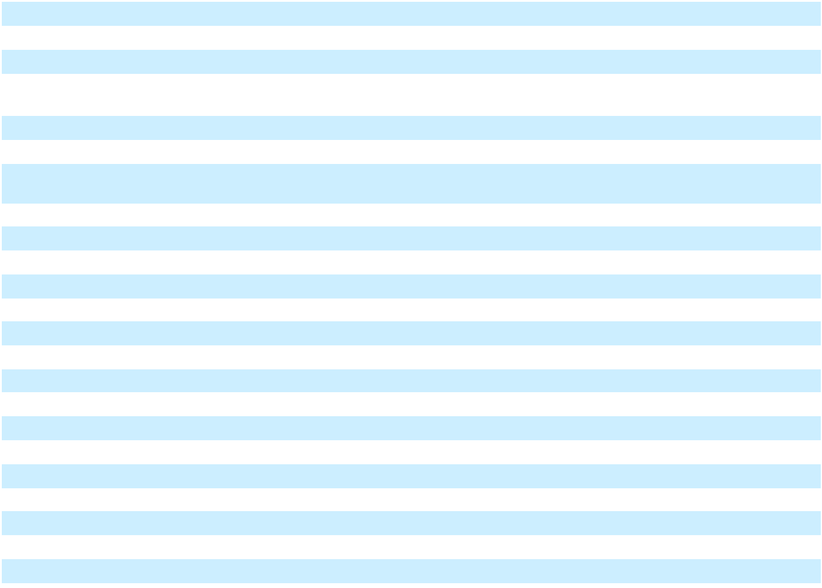
__________

- Includes sales by the Automotive China Joint Ventures (Automotive China JVs): SAIC General Motors Sales Co., Ltd. (SGMS) and SAIC GM Wuling Automobile Co., Ltd. (SGMW).
- Cuba, Iran, North Korea, Sudan and Syria are subject to broad economic sanctions. Accordingly, these countries are excluded from industry sales data and corresponding calculation of market share.
- As of March 2022, GM is no longer importing vehicles or parts to Russia, Belarus and other sanctioned provinces in Ukraine.

3

Table of Contents

GENERAL MOTORS COMPANY AND SUBSIDIARIES

As discussed above, total vehicle sales and market share data provided in the table above includes fleet vehicles. We sell vehicles directly or through our dealer network to fleet customers, including daily rental car companies, commercial fleet customers, leasing companies and governments. Certain fleet transactions, particularly sales to daily rental car companies, are generally less profitable than retail sales to end customers. The following table summarizes estimated fleet sales and those sales as a percentage of total vehicle sales (vehicles in thousands):

 |  | Years Ended December 31,
 | 2024 |  |  | 2023 |  |  |  | 2022
GMNA | 615 |  | 679 |  |  |  |  | 564
GMI | 401 |  |  | 506 |  |  |  | 426
Total fleet sales | 1,016 |  |  | 1,185 |  |  |  | 990
Fleet sales as a percentage of total vehicle sales | 16.9 | % | 19.2 |  | % |  |  | 16.7 | %
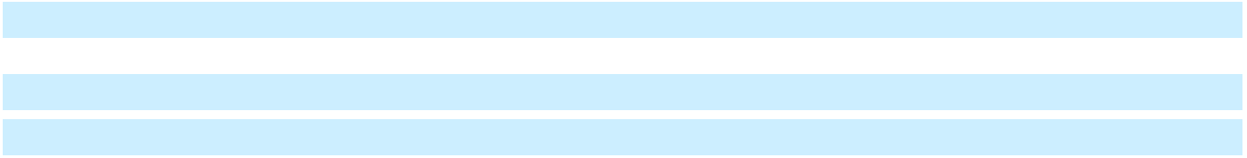

Product Pricing Several methods are used to promote our products, including the use of dealer, retail and fleet incentives, such as customer rebates and finance rate support. The level of incentives is dependent upon the level of competition in the markets in which we operate and the level of demand for our products.

Cyclical and Seasonal Nature of Business The market for vehicles is cyclical and depends in part on general economic conditions, credit availability and consumer spending. Vehicle markets are also seasonal. Production varies from month to month. Vehicle model changeovers occur throughout the year as a result of new market entries.

Relationship with Dealers We market vehicles and automotive parts primarily through a network of independent authorized retail dealers. These outlets include distributors, dealers and authorized sales, service and parts outlets. Our customers can obtain a wide range of after-sale vehicle services and products through our dealer network, such as maintenance, light repairs, collision repairs, vehicle accessories and extended service warranties. The number of authorized dealerships and other agents performing similar functions were 4,588 in GMNA and 6,594 in GMI at December 31, 2024.

We, and our joint ventures, enter into a contract with each authorized dealer agreeing to sell to the dealer one or more specified product lines at wholesale prices and granting the dealer the right to sell those products to customers from an approved location. Our dealers often offer more than one GM brand at a single dealership in a number of our markets. Authorized dealers offer parts, accessories, service and repairs for GM vehicles in the product lines that they sell using GM parts and accessories. Our dealers are authorized to service GM vehicles under our limited warranty, and those repairs are made almost exclusively with GM parts. Our dealers generally provide their customers with access to credit or lease financing, vehicle insurance and extended service contracts, which may be provided by GM Financial and other financial institutions.

The quality of GM dealerships and our relationship with our dealers are critical to our success now, and as we transition to our all-electric future, given that they maintain the primary sales and service interface with the end consumer of our products. In addition to the terms of our contracts with our dealers, we are regulated by various country and state franchise laws and regulations that may supersede those contractual terms and impose specific regulatory requirements and standards for initiating dealer network changes, pursuing terminations for cause and other contractual matters.

Research, Product Development and Intellectual Property Costs for research, manufacturing engineering, software engineering, product engineering and design and development activities primarily relate to developing new products or services or improving existing products or services, including activities related to vehicle and greenhouse gas (GHG) emissions control, improved fuel economy, EVs, AVs and the safety of drivers and passengers. Research and development expenses were $9.2 billion, $9.9 billion and $9.8 billion in the years ended December 31, 2024, 2023 and 2022.

Product Development The Global Product Development organization is responsible for designing, developing, validating and integrating all global products, services and their components while aiming to maximize part sharing across multiple vehicle segments. Our global vehicle architecture development is headquartered at our Global Technical Center in Warren, Michigan, where our global teams in Design, Program Management & Execution, Hardware, Systems & Integration, Product Safety, Systems & Certification, Electrification & Battery Systems, Technology Acceleration & Commercialization and Purchasing & Supply Chain collaborate to meet customer requirements and maximize global economies of scale.

We continue to invest in key ICE segments, which are critical to fund our all-electric future. Cross-segment part sharing is an essential enabler to optimize our vehicle portfolio profitability, with more than 75% of our global internal combustion vehicle

4

Table of Contents

GENERAL MOTORS COMPANY AND SUBSIDIARIES

sales volume expected to come from five internal combustion vehicle architectures through this decade. We will continue to leverage our ICE portfolio to accommodate our customers around the world while achieving our financial goals.

Software and Services The Software & Services organization, with a presence in Mountain View, California and globally, is bringing together all of GM's software capabilities and assets under one team for the first time at GM. The team is developing and implementing an integrated strategy, working closely with the Global Product Development organization and others across the enterprise to deliver an end-to-end integrated software and services strategy that will make the driver experience even more compelling and seamless.

Intellectual Property We are constantly innovating and hold a significant number of patents, copyrights, trade secrets and other intellectual property that protect those innovations in numerous countries. While no single piece of intellectual property is individually material to our business as a whole, our intellectual property is important to our operations and continued technological development. Additionally, we hold a number of trademarks and service marks that are very important to our identity and recognition in the marketplace.

Raw Materials, Services and Supplies We purchase a wide variety of raw materials, systems, components, parts, supplies, energy, freight, transportation and other services from numerous suppliers to manufacture our products. The raw materials primarily include steel, aluminum, resins, copper, lead, precious metals and raw materials used in EVs. We do not normally carry substantial inventories of these raw materials in excess of levels reasonably required to meet our production requirements, and while we have not experienced any significant shortages of raw materials, supply disruptions may occur as a result of geopolitical and/or policy actions. Processing and extraction of certain EV battery raw materials is currently concentrated in China and may be subject to import or export restrictions, or tariffs. In addition, our transition to EVs will require developing a more resilient, scalable and sustainable North America-focused EV supply chain, which includes advancing our strategic sourcing initiatives to secure supply through investments in raw materials suppliers and the execution of strategic, multi-year supply agreements with suppliers throughout the value chain. This includes securing supply through offtake agreements for EV raw materials and derivatives thereof, such as lithium, cathode active material, manganese, synthetic and natural graphite, nickel, cobalt, rare earth elements and permanent motor magnets. These EV-related agreements may require us to hold higher than normal levels of EV raw materials inventory and to make long-term commitments to purchase raw materials. Expected demand for these raw materials currently exceeds the North American capacity of the existing supply chain and our raw material sourcing strategy aims to secure raw material supply to support our EV transition.

Commodity costs are reflecting greater variability due to the macroeconomic environment and the continuing existence of government policies. Furthermore, an increased demand for EV critical minerals is increasing scrutiny of the sustainability and human rights implications of these supply chains.

In some instances, we purchase systems, components, parts and supplies from a single source, which may increase risk to supply disruptions. The inability or unwillingness of these sources to provide us with parts and supplies could have a material adverse effect on our production. Combined purchases from our two largest suppliers were approximately 11% of our total purchases in each of the years ended December 31, 2024, 2023 and 2022. Refer to Item 1A. Risk Factors for further discussion of these risks.

Automotive Financing - GM Financial GM Financial is our global captive automotive finance company and our global provider of automobile finance solutions. GM Financial conducts its business in North America, South America and through joint ventures in China.

GM Financial provides retail loan and lease lending across the credit spectrum to support vehicle sales. Additionally, GM Financial offers commercial lending products to dealers including floorplan financing, which is lending to finance new and used vehicle inventory; and dealer loans, which are loans to finance improvements to dealership facilities, to provide working capital, or to purchase and/or finance dealership real estate. GM Financial provides lending products to commercial vehicle upfitters and advances to certain GM subsidiaries.

In North America, GM Financial offers a sub-prime lending program. The program is primarily offered to consumers with a FICO score or its equivalent of less than 620 who have limited access to automobile financing through banks and credit unions and is expected to sustain a higher level of credit losses than prime lending.

5

Table of Contents

GENERAL MOTORS COMPANY AND SUBSIDIARIES

GM Financial generally seeks to fund its operations in each country through local sources of funding to minimize currency and country risk. GM Financial primarily finances its loan, lease and commercial origination volume through the use of secured and unsecured credit facilities, securitization transactions and the issuance of unsecured debt in the capital markets.

Human Capital The foundation of GM’s business is our Purpose: We pioneer the innovations that move and connect people to what matters. It is why we exist. Our Purpose, growth strategy and culture all help us on our path towards achieving our vision of a world with zero crashes, zero emissions and zero congestion. Our people are our most valuable asset, and we must continue to attract and retain the best talent in the world in order to achieve this vision. As a result, we strive to create a Workplace of Choice to attract, retain, motivate and develop top talent by adhering to a responsible employer philosophy, which includes, among other things, commitments to create job opportunities, pay workers fairly, ensure safety and well-being and foster an inclusive work environment in which all employees can perform at their best. Fundamental to these commitments are our company values.
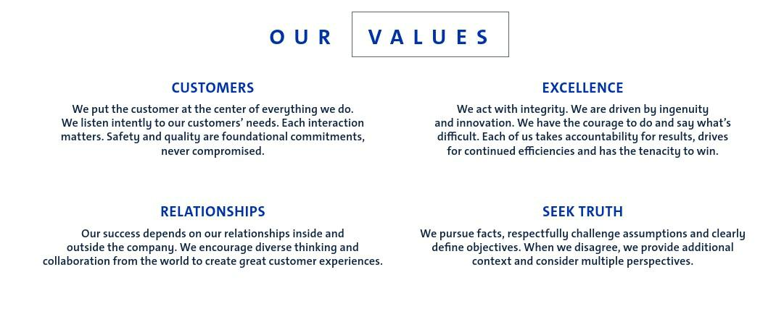

Building a Stronger Future Together Attracting and retaining talent to build great vehicles is critical to thriving in an increasingly competitive landscape. Our company initiatives for inclusivity are created to further our main business objective – to build and sell the best vehicles on the market to everyone, everywhere. Our current Board of Directors includes six women and seven men of different backgrounds who contribute their own unique perspective, industry insights, experiences and expertise. We bring together best-in-class talent to innovate in an inclusive work environment, and our guiding principle is performance. We have a talent management system that underscores our commitment to high standards. We extend outside of GM to reduce barriers and improve access to our products and services by aligning to GM's focus on STEAM education and road safety. This includes our investments in communities through many partnerships and volunteerism.

Develop and Retain Talented People Today, we compete for talent not only against other automotive companies, but with businesses in sectors such as technology. To win and retain that talent, we must encourage employee behaviors that align with our values, fulfill employees' long-term aspirations and provide experiences that make them feel valued, included and engaged. We have introduced various tools to outline expectations of our employees at each stage of our career ladder in terms of role scope, skills and behaviors. Along with providing mentoring and networking opportunities, we offer a vast array of career development resources to employees to make the most of their careers at GM. We have established curricula for each of our functional areas aimed at ensuring that our employees have the skills they need to perform their jobs. We also offer continuing education programs from leading colleges and universities. For example, the Technical Education Program provides employees an opportunity to complete corporate strategically aligned degrees and certificate programs. Employees in some of our technical roles can participate in the GM Technical Learning University — a training and upskilling program designed to expand and update the technical abilities of our workforce.

GM recognizes that leadership effectiveness is a critical business need. We continue to expand our leadership development programs, which are designed to deliver skills and behaviors for each level of leadership to effectively lead their teams. Focus areas range from delivering constructive feedback to effectively leading large scale change initiatives.

Safety and Well-Being The safety and well-being of our employees is also a critical component of our ability to transform the future of personal mobility. At GM, we pride ourselves on our commitment to live values that return people home safely —

6

Table of Contents

GENERAL MOTORS COMPANY AND SUBSIDIARIES

Every Person, Every Site, Every Day. Our unwavering commitment to safety is manifested through empowering employees to “Speak Up for Safety” and the Employee Safety Concern Process. These resources make it easier for salaried, hourly or represented and contract employees to report potential vehicle or workplace safety issues, or to suggest safety related improvements without fear of retaliation. The well-being of our employees is equally as important to entice and stimulate creativity and innovation.

Our award-winning Total Rewards package includes support for physical, emotional and financial wellness. We provide a comprehensive, competitive offering that includes compensation, a 401(k) company contribution and matching program, paid time off for holidays and vacations, a high-quality health care plan, and GM Family First savings on GM vehicles, parts and services. We are committed to creating safe spaces where people can perform and thrive at work. GM encourages and supports healthy behaviors, attitudes and actions in our workplaces to improve health outcomes for team members and their families and to contribute to the success of our business.

Employees At December 31, 2024, we employed approximately 90,000 (55%) hourly employees and approximately 72,000 (45%) salaried employees. At December 31, 2024, substantially all of our hourly U.S. employees (approximately 47,000) were represented by unions, a majority of which were represented by the International Union, United Automobile, Aerospace and Agricultural Implement Workers of America (UAW). The following table summarizes worldwide employment (in thousands):

 | December 31, 2024
GMNA(a) | 123
GMI | 30
GM Financial | 9
Total Worldwide | 162
U.S. - Salaried | 50
U.S. - Hourly | 47
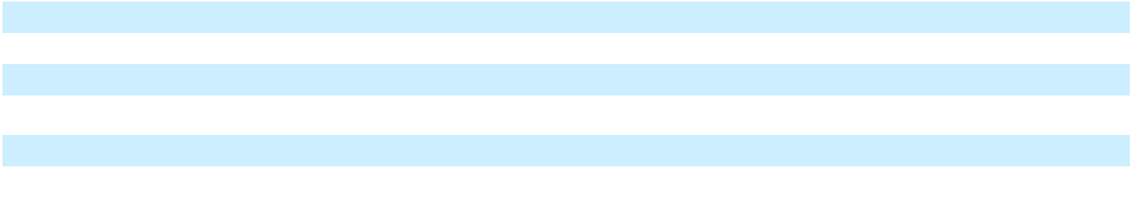

__________

(a) Includes Cruise.

Information About our Executive Officers As of January 28, 2025, the names and ages of our executive officers, their positions with GM and their business experiences during the past five years are as follows:

Name (Age) |  | Present GM Position (Effective Date) |  | Positions Held During the Past Five Years (Effective Date)
Mary T. Barra (63) |  | Chair and Chief Executive Officer
 | (2016)
Grant Dixton (51) |  | Executive Vice President, Chief |  | Activision Blizzard, Chief Legal Officer (2021)
 |  | Legal, Public Policy Officer and |  | Boeing, Senior Vice President, General Counsel and Corporate
 |  | Corporate Secretary (2024) |  | Secretary (2020)
Rory V. Harvey (57) |  | Executive Vice President and |  | Executive Vice President and President, North America (2023)
 |  | President, Global Markets (2024) |  | Vice President, Global Cadillac (2020)
 |  |  |  | Vice President, Cadillac North America Sales, Service and
 |  |  |  | Marketing (2018)
Christopher T. Hatto (54) |  | Vice President, Global Business |  | Vice President, Controller and Chief Accounting Officer (2018)
 |  | Solutions and Chief Accounting
 |  | Officer (2020)
Paul A. Jacobson (53) |  | Executive Vice President and |  | Delta Air Lines, Executive Vice President and Chief Financial
 |  | Chief Financial Officer (2020) |  | Officer (2013)
Mark L. Reuss (61) |  | President (2019)
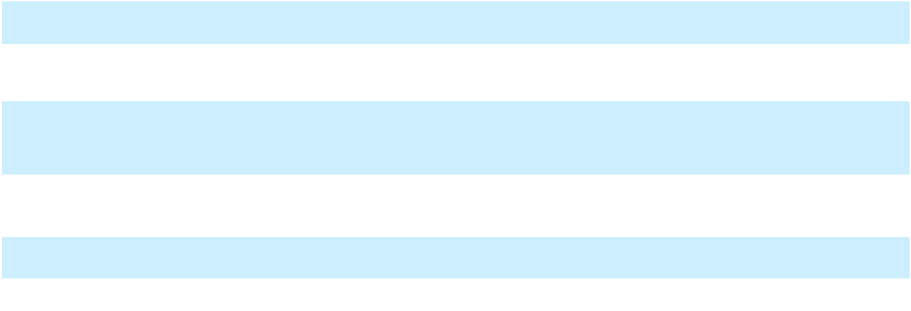

There are no family relationships between any of the officers named above and there is no arrangement or understanding between any of the officers named above and any other person pursuant to which he or she was selected as an officer. Each of the officers named above was elected by the Board of Directors to hold office until his or her successor is elected and qualified or until his or her earlier resignation or removal.

7

Table of Contents

GENERAL MOTORS COMPANY AND SUBSIDIARIES

Environmental and Regulatory Matters

Automotive Criteria Emissions Control Our products are subject to laws and regulations globally that require us to control certain non-GHG automotive emissions, including vehicle and engine exhaust emission standards, vehicle evaporative emission standards and onboard diagnostic (OBD) system requirements. Emission requirements have become more stringent as a result of stricter standards and new diagnostic requirements that have come into force in many markets around the world, often with very little harmonization. Regulatory authorities may conduct ongoing evaluations of products from all manufacturers. Refer to Item 1A. Risk Factors for additional information.

The U.S. federal government, through the Environmental Protection Agency (EPA), imposes stringent exhaust and evaporative emission control requirements on vehicles sold in the U.S. The California Air Resources Board (CARB) likewise imposes stringent exhaust and evaporative emission standards. The Clean Air Act permits states that have areas with air quality compliance issues to adopt California emission standards in lieu of federal requirements. Various other states have adopted California emission standards, and there is a possibility that additional U.S. jurisdictions could adopt California emission standards in the future. The EPA has finalized its Tier 4 Multipollutant Rule that will begin with the 2027 model year. The historically stringent proposal calls for ever-increasing volumes of zero emission vehicles (ZEVs) in order to maintain compliance.

For each model year, we must obtain certification that our vehicles and engines will meet emission requirements of the EPA before we can sell vehicles in the U.S. and Canada, and of CARB before we can sell vehicles in California and the states that have adopted California emission standards.

The Canadian federal government's current vehicle pollutant emission requirements are generally aligned with U.S. federal requirements.

In 2019, certain areas within China began implementation of the China 6 emission standard (China 6) requirements. China 6 combines elements of both European Union (EU) and U.S. standards and increases the time and mileage periods over which manufacturers are responsible for a vehicle's emission performance. Nationwide implementation of China 6a for new registrations occurred in January 2021, and the more stringent China 6b was implemented in July 2023. In 2022, China began studies regarding the next generation of vehicle emission standards (China 7), with the final standard expected in 2026. While largely based on Euro 7, some divergence and unique requirements are expected.

Brazil has approved a set of national emission standards referred to as L7, implemented in 2022, and L8, to be implemented from 2025 onward. L7 standards cover vehicle exhaust emissions, durability for emissions, evaporative emissions and noise limits, and include additional OBD requirements and a phase-in for onboard refueling vapor recovery systems. L8 standards include corporate average vehicle emissions targets, which increase in stringency every two years until 2031. Some of the requirements are aligned with those of the EPA.

As a result of the sale of the Opel and Vauxhall businesses and certain other assets in Europe (the Opel/Vauxhall Business), GM’s vehicle presence in Europe is smaller, but GM may still be affected by actions taken by regulators related both to Opel/ Vauxhall vehicles sold before the sale of the Opel/Vauxhall Business as well as to other vehicles GM continues to sell in Europe. In Europe, increased scrutiny of emission standards compliance may result in changes to these standards, as well as stricter interpretations or redefinition of these standards and more rigorous enforcement. Beyond this, as part of the EU's desire to accelerate the shift to sustainable mobility, the EU has recently rolled out new regulations which will impose more stringent emissions standards on ICE vehicles (Euro 7), before phasing them out in 2035. New regulations that are already in place and for which technical requirements are currently being shaped will also impact EV battery design, use and recyclability/recycling. For additional information, refer to Note 16 to our consolidated financial statements.

Automotive Fuel Economy and GHG Emissions In the U.S., NHTSA promulgates and enforces Corporate Average Fuel Economy (CAFE) standards for three separate fleets: domestic cars, import cars and light-duty trucks. Manufacturers may use one or a combination of the following to resolve CAFE fleet deficits: credits from the five prior model years, expected credits for the next three model years, credits obtained from other manufacturers or payment of civil penalties. Manufacturers that do not resolve deficits for a model year may be subject to substantial CAFE civil penalties to bring their fleets into compliance. In addition to federal CAFE standards, the EPA promulgates and enforces GHG emission standards. Manufacturers may use one or a combination of the following to resolve EPA GHG fleet deficits: credits from the five prior model years, expected credits for the next three model years and credits obtained from other manufacturers. NHTSA and the EPA have previously finalized separate standards with differing stringency levels and affected model years, with the CAFE standards addressing the 2024–

8

Table of Contents

GENERAL MOTORS COMPANY AND SUBSIDIARIES

2026 model years and the GHG standards addressing the 2023–2026 model years and both standards have been challenged through litigation. In 2024, NHTSA finalized CAFE standards for the 2027–2031 model years and the EPA finalized GHG standards for the 2027–2032 model years. NHTSA and the EPA have also finalized on-going fuel efficiency and GHG emissions requirements for medium- and heavy-duty vehicles. These requirements also increase in stringency over time.

In addition, CARB has promulgated and enforces its own light-duty vehicle GHG standards with increasing stringency through model year 2025, and other states have adopted CARB's GHG standards under the Federal Clean Air Act. GM is required to meet state GHG standards in California and the states that have adopted California’s GHG standards. CARB has not proposed increases to its GHG standards for the 2026 or later model years, but may do so in the future.

CARB has also imposed requirements to sell increasing percentages of ZEVs in California, ending with a 100% sales target in the 2035 model year. This includes CARB's Advanced Clean Cars II (ACC II) program, which requires the sale of increasing percentages of light-duty ZEVs for the 2026–2035 model years, and has been adopted by numerous states. CARB received a waiver from the EPA for it and the other adopting states to implement and enforce the ACC II program and that waiver action has been challenged through litigation. Additional U.S. jurisdictions could adopt CARB’s ACC II requirements in the future. CARB has also imposed a ZEV requirement for medium- and heavy-duty vehicles in its Advanced Clean Trucks (ACT) program, requiring increasing percentages of ZEVs for the 2024–2026 model years, ending with a 100% ZEV sales requirement in the 2036 model year. CARB has a waiver from the EPA to enforce ACT.

In Canada, federal light- and heavy-duty GHG regulations contain emission standards that are modeled on existing U.S. EPA light- and heavy-duty GHG emission standards for the 2023–2026 model years. In December 2023, the Canadian federal government announced the ZEV Availability Standard as a new requirement within the existing light-duty GHG emission standard, which requires a specified percentage of manufacturer's new light-duty vehicles offered for sale in Canada to be ZEV, beginning with model year 2026 and increasing each year to 100% by model year 2035, and potential enforcement actions for non-compliance in accordance with the existing GHG standards. At the provincial level, Quebec and British Columbia have enacted ZEV sales requirements, which include potential monetary penalties for non-compliance. In 2023, Quebec amended its light-duty ZEV regulations applicable to 2025–2035 model years, requiring ZEVs to comprise 100% of all new light-duty vehicle sales by model year 2035. In December 2024, the Quebec government adopted regulations that prohibit the sale or lease of certain internal combustion engines by December 31, 2035. In October 2024, the British Columbia government announced amendments to British Columbia's existing ZEV sales requirements, which would require ZEVs to comprise 100% of new light-duty sales in British Columbia by model year 2035.

China has two fuel consumption requirements for passenger vehicles enforced by the Ministry of Industry and Information Technology: an individual vehicle pass-fail type approval requirement and a corporate average fuel consumption (CAFC) requirement. Specific to the CAFC requirement, China introduced Phase 5 in 2021 with full compliance required by 2025. In addition, China has established a mandate that requires passenger car manufacturers to produce a certain volume of plug-in hybrid, battery electric and fuel cell vehicles, which are referred to as New Energy Vehicles (NEVs), from 2019 and beyond. The number of NEV credits per car is based on the electric range, energy efficiency and battery energy density with the goal of increasing NEV volume penetrations and improving technological sophistication over time. Uncommitted NEV credits may be used to assist compliance with the CAFC requirement. China previously issued NEV credit targets between 2019 and 2023 and has set new NEV credit targets aimed at further increasing NEV volumes for 2024 and 2025. In 2022, China began to study the CAFC requirement and NEV credit mandates for 2026–2030 (referred to as Phase 6) with the final standard expected in 2025. These standards are anticipated to be more stringent, aligned with the trend observed in other key global markets.

In Brazil, the Secretary of Industry and Development promulgates and enforces CAFE standards and has enforced a CAFE program for the period October 2020–September 2026 for light-duty and mid-size trucks and SUVs, including diesel vehicles. The second phase of the program was finalized in May 2024 and introduces more stringent requirements from 2027 through 2031.

We have several options to comply with existing and potential new regulations that we have utilized and may continue to utilize, including increasing production and sale of certain vehicles, such as EVs, and curtailing production of others, which could include profitable ICE vehicles; technology changes, including fuel consumption efficiency and engine upgrades; payment of penalties; and/or the purchase of credits from third parties. We regularly evaluate our current and future product plans and strategies for compliance with fuel economy and GHG regulations. In the years ended December 31, 2024, 2023 and 2022, we paid $2.0 billion, $0.5 billion and $1.0 billion to purchase credits to facilitate our compliance with regulations. Compliance-related costs of $1.0 billion, $0.7 billion and $0.5 billion were recorded in Automotive and other cost of sales in the years ended December 31, 2024, 2023 and 2022. Refer to Item 1A. Risk Factors for additional information.

9

Table of Contents

GENERAL MOTORS COMPANY AND SUBSIDIARIES

Industrial Environmental Control Our operations are subject to a wide range of environmental protection laws including those regulating air emissions, water discharge, waste management and environmental cleanup. Certain environmental statutes require that responsible parties fund remediation actions regardless of fault, legality of original disposal or ownership of a disposal site. Under certain circumstances, these laws impose joint and several liability as well as liability for related damages to natural resources.

Chemical Regulations We continually monitor the implementation of chemical regulations to maintain compliance and evaluate their effect on our business, suppliers and the automotive industry.

Globally, governments continue to introduce new legislation and regulations related to the selection and use of chemicals by mandating broad prohibitions or restrictions and implementing vehicle interior air quality, green chemistry, life cycle analysis and product stewardship initiatives. These initiatives give broad regulatory authority to ban or restrict the use of certain chemical substances and potentially affect automobile manufacturers' responsibilities for vehicle components at the end of a vehicle's life, as well as chemical selection for product development and manufacturing. Global treaties and initiatives such as the Basel, Rotterdam and Stockholm Conventions on Chemicals and Waste, the Minamata Convention on Mercury and EU Registration, Evaluation, Authorization and Restriction of Chemicals, are driving chemical regulations across signatory countries. Increases in the use of circuit boards and other electronics may require additional assessment under the Restriction of Hazardous Substances and Waste from Electrical and Electronic Equipment directives. New European requirements require suppliers of parts and vehicles to the European market to disclose substances of concern in parts.

Chemical regulations are increasing in North America. In the U.S., the EPA is moving forward with risk analysis and management of high priority chemicals under the authority of the 2016 Lautenberg Chemical Safety for the 21st Century Act. The EPA has also issued a per- and polyfluoroalkyl substances (PFAS) reporting rule that requires PFAS use reporting by manufacturers between 2011 and 2022. In addition, several U.S. states have chemical management regulations that can affect vehicle design and manufacturing such as chemical restriction and use requirements. For example, Minnesota has adopted PFAS reporting and elimination requirements beginning as early as 2026, except for unavoidable uses. Chemical restrictions and export controls in Canada continue to steadily progress under the Environment and Climate Change Canada's Chemical Management Plan to assess existing substances and implement risk management controls on any chemical deemed toxic.

These emerging laws and regulations will potentially lead to increases in costs and supply chain complexity. Manufacturers, including joint venture partners and suppliers, that do not comply with global and specific country regulations could be subject to civil penalties, production disruptions or limitations on the sale of affected products. We believe we are materially in compliance with substantially all these requirements or expect to be materially in compliance by the required dates.

Vehicle Safety

U.S. Requirements The National Traffic and Motor Vehicle Safety Act of 1966 (the Safety Act) regulates the vehicles and items of motor vehicle equipment that we manufacture and sell. The Safety Act prohibits the sale in the U.S. of any new vehicle or equipment that does not conform to applicable federal motor vehicle safety standards established by NHTSA. Meeting or exceeding the many safety standards is costly as global compliance and non-governmental assessment requirements continue to evolve and grow more complex, and lack harmonization globally. The Safety Act further requires that if we or NHTSA determine a vehicle or an item of vehicle equipment does not comply with a safety standard, or that vehicle or equipment contains a defect that poses an unreasonable safety risk, we must conduct a safety recall to remedy that condition in the affected vehicles. Should we or NHTSA determine a safety defect or noncompliance issue exists with respect to any of our vehicles, the cost of such recall campaigns could be substantial.

Other National Requirements Outside of the U.S., many countries have established vehicle safety standards and regulations and are likely to adopt additional, more stringent requirements in the future. The European General Safety Regulation has introduced United Nations Economic Commission for Europe (UNECE) regulations, which are required for the European Type Approval process. Globally, governments generally have been adopting UNECE based regulations with some variations to address local concerns. Any difference between North American and UNECE based regulations can add complexity and costs to vehicle development, and we continue to support efforts to harmonize regulations to reduce complexity. Safety and recall requirements in various countries around the world, including in China, Brazil and Gulf Cooperation Council countries, also may add substantial costs and complexity to our safety and field action activities globally. In Canada, vehicle regulatory requirements are generally aligned with U.S. regulations; however, under the Canadian Motor Vehicle Safety Act, recall thresholds are different and the Minister of Transport has broad powers to order manufacturers to submit a notice of defect or non-compliance when the Minister considers it to be in the interest of safety. Global regulations continue to increase in scope

10

Table of Contents

GENERAL MOTORS COMPANY AND SUBSIDIARIES

with new technologies, some of which can be market-specific, that can add complexity and increase our cost of compliance globally.

Crash Test Ratings and New Car Assessment Programs Organizations in various regions around the world, including in the U.S., rate and compare motor vehicles through various New Car Assessment Programs (NCAPs) to provide consumers and businesses with additional information about the safety of new vehicles. NCAPs use crash tests and other evaluations that are different than what is required by applicable regulations, and use stars or other grading systems, depending on the region, to rate vehicle safety. Achieving high NCAP ratings, which can vary by country and region, can add complexity and cost to vehicles.

Website Access to Our Reports Our internet website address is https://www.gm.com. In addition to the information about us and our subsidiaries contained in this 2024 Form 10-K, information about us can be found on our website including information on our corporate governance principles and practices. Our Investor Relations website at https://investor.gm.com, which contains a link to our Sustainability Report, and our News website at https://news.gm.com contain a significant amount of information about us, including financial and other information for investors. We encourage investors to visit both websites, as we frequently update and post new information about our company on these websites and it is possible that this information could be deemed to be material information. Our Investor Relations website and News website and information included in or linked to these websites are not part of this 2024 Form 10-K.

Our annual reports on Form 10-K, quarterly reports on Form 10-Q, current reports on Form 8-K and amendments to those reports filed or furnished pursuant to Section 13(a) or 15(d) of the Securities Exchange Act of 1934, as amended (Exchange Act), are available free of charge through our website as soon as reasonably practicable after they are electronically filed with or furnished to the U.S. Securities and Exchange Commission (SEC). The SEC maintains a website that contains reports, proxy and information statements, and other information regarding our filings at https://www.sec.gov.

* * * * * * *

Item 1A. Risk Factors

We have listed below the most material risk factors applicable to us. These risk factors are not necessarily in the order of importance or probability of occurrence:

Risks related to our competition and strategy

If we do not deliver new products, services, technologies and customer experiences in response to increased competition and changing consumer needs and preferences, our business could suffer. We believe that the automotive industry will continue to experience significant change in the coming years, particularly as traditional automotive original equipment manufacturers (OEMs) continue to shift resources to the development of EVs. In addition to our traditional competitors, we must also be responsive to the entrance of start-ups and other non-traditional competitors in the automotive industry, such as software and ridesharing services supported by large technology companies. These new competitors, as well as established industry participants, are disrupting the historic business model of our industry through the introduction of new technologies, products, services, direct-to-consumer sales channels, methods of transportation and vehicle ownership. To successfully execute our long-term strategy, we must continue to develop and commercialize new products and services, including products and services that are outside of our historically core ICE business, such as EVs and AVs, software-enabled connected services, future features and services based on artificial intelligence and other new businesses.

There can be no assurance that advances in technology will occur in a timely or feasible way, if at all, that others will not acquire similar or superior technologies sooner than we do, or that we will acquire technologies on an exclusive basis or at a significant price advantage. The process of designing and developing new technology, products and services is costly and uncertain and requires extensive capital investment. If our access to capital were to become significantly constrained, if costs of capital increased significantly, or if our ability to raise capital is challenged relative to our peers, our ability to execute on our strategic plans could be adversely affected. Further, if we are unable to prevent or effectively remedy errors, bugs, vulnerabilities or defects in our software and hardware, or fail to deploy updates to our software properly, or if we do not adequately prepare for and respond to new kinds of technological innovations, market developments and changing customer needs and preferences, our sales, profitability and long-term competitiveness may be materially harmed.

11

Table of Contents

GENERAL MOTORS COMPANY AND SUBSIDIARIES

Our ability to attract and retain talented and highly skilled employees is critical to our success and competitiveness.

Attracting and retaining employees who are highly skilled in their areas is critical to thriving in an increasingly competitive landscape. In particular, our vehicles and connected services increasingly rely on software and hardware that is highly technical and complex and our success in this area is dependent upon our ability to retain and recruit the best talent. The market for highly skilled workers and leaders in our industry is extremely competitive. In addition to compensation considerations, current and potential employees are increasingly placing a premium on culture and other various intangibles, such as working for companies with a clear purpose and strong brand reputation, flexible work arrangements, and other considerations, such as embracing sustainability and inclusion initiatives. Failure to attract, hire, develop, motivate and retain highly qualified employees could disrupt our operations and adversely affect our strategic plans.

Our ability to maintain profitability is dependent upon our ability to timely fund and introduce new and improved vehicle models, including EVs, that are able to attract a sufficient number of consumers. We operate in a very competitive industry with market participants routinely introducing new and improved vehicle models and features, at decreasing price points, designed to meet rapidly evolving consumer expectations. Producing new and improved vehicle models, including EVs, that preserve our reputation for designing, building and selling safe, high-quality cars, crossovers, trucks and SUVs is critical to our long-term profitability. Successful launches of our new vehicles are critical to our short-term profitability. The new vehicle development process can take two years or more, and a number of factors may lengthen that time period. Because of this product development cycle and the various elements that may contribute to consumers’ acceptance of new vehicle designs, including competitors’ product introductions, technological innovations, fuel prices, general economic conditions, regulatory developments, including tax credits or other government policies in various countries, transportation infrastructure and changes in quality, safety, reliability and styling demands and preferences, an initial product concept or design may not result in a saleable vehicle or a vehicle that generates sales in sufficient quantities and at high enough prices to be profitable. Our high proportion of fixed costs, both due to our significant investment in property, plant and equipment as well as other requirements of our collective bargaining agreements, which limit our flexibility to adjust personnel costs to changes in demands for our products, may further exacerbate the risks associated with incorrectly assessing demand for our vehicles.

Our long-term strategy is dependent upon our ability to profitably deliver a strategic portfolio of EVs. The production and profitable sale of EVs has become increasingly important to our long-term business as we continue our transition to an all-electric future. Our EV strategy is dependent on our ability to (i) deliver a strategic portfolio of high-quality EVs that are competitive and meet consumer demands; (ii) scale our EV manufacturing capabilities; (iii) reduce the costs associated with the manufacture of EVs, particularly with respect to battery cells and packs; (iv) increase vehicle range and the rate of charge and energy density of our batteries; (v) efficiently source sufficient materials for the manufacture of battery cells; (vi) license and monetize our proprietary platforms and related innovations; (vii) successfully invest in new technologies relative to our peers;

- develop new software and services; and (ix) leverage our scale, manufacturing capabilities and synergies with existing ICE vehicles. Our progress towards these objectives has impacted, and may continue to impact, the need to record losses on our EV-related inventory, including battery cells. If we are unable to successfully deliver on our EV strategy, it could materially and adversely affect our results of operations, financial condition and growth prospects, and could negatively impact our brand and reputation.

The success of our long-term strategy is dependent on consumer adoption of EVs. Consumer adoption of EVs has been slower than anticipated, and has been and in the future could be impacted by numerous factors, including the breadth of the portfolio of EVs available; perceptions about EV features, quality, safety, performance and cost relative to ICE vehicles; the range over which EVs may be driven on a given battery charge; the proliferation and speed of charging infrastructure, in particular with respect to public EV charging stations, and the success of the Company's charging infrastructure programs and strategic joint ventures and other relationships; cost and availability of high fuel-economy ICE vehicles; volatility in energy prices due to increased demand and investments to support electrification efforts; volatility, or a sustained decrease, in the cost of petroleum-based fuel; failure by governments and other third parties to make the investments necessary to make infrastructure improvements, such as greater availability of EV charging stations, and to provide meaningful and fully utilizable economic incentives promoting the adoption of EVs, including production and consumer credits contemplated by the Inflation Reduction Act (IRA); and negative feedback from stakeholders impacting investor and consumer confidence in our company or industry. If industry-wide adoption rates continue to be lower than anticipated, we may take portfolio actions to better match the pace of EV adoption, such as not fully utilizing or reducing the capacity of our existing or future plants or reducing production hours or shifts, and we may become subject to claims by suppliers as a result of such actions. We may be unable to successfully deliver on our EV strategy, which could materially and adversely affect our results of operations, financial condition and growth prospects, and could negatively impact our brand and reputation.

12

Table of Contents

GENERAL MOTORS COMPANY AND SUBSIDIARIES

In addition, the production and sale of EVs at increasingly larger volumes is also part of our long-term strategy to comply with global emissions and fuel economy regulations. If we are not able to successfully execute our EV strategy or if future compliance requirements do not change, we may need to take various actions, including purchasing additional regulatory credits from third parties, paying penalties to various government regulators, or taking portfolio actions such as reducing the production of profitable ICE vehicles, the impact of which could be material to our results of operations and financial condition. See "Our operations and products are subject to extensive laws, regulations and policies, including those related to vehicle emissions and fuel economy standards, which can significantly increase our costs and affect how we do business."

Our near-term profitability is dependent upon the success of our current line of ICE vehicles, particularly our full-size ICE SUVs and full-size ICE pickup trucks. While we offer a broad portfolio of cars, crossovers, SUVs and trucks, and we have announced significant plans to design, build and sell a strategic portfolio of EVs, we currently recognize the highest profit margins on our full-size ICE SUVs and full-size ICE pickup trucks. As a result, our near-term success is dependent upon our ability to sell higher margin vehicles in sufficient volumes. We are also using the cash generated by our ICE vehicles to fund our growth strategy, including with respect to EVs and AVs. Any near-term shift in consumer preferences toward smaller, more fuel-efficient vehicles, whether as a result of increases in the price of oil or any sustained shortage of oil, including as a result of global political instability (such as related to the ongoing conflicts in Eastern Europe and the Middle East), concerns about fuel consumption or GHG emissions, or other reasons, could weaken the demand for our higher margin vehicles. More stringent fuel economy regulations could also impact our ability to sell these vehicles or could result in additional costs associated with these vehicles, which could be material. See “Our operations and products are subject to extensive laws, regulations and policies, including those related to vehicle emissions and fuel economy standards, which can significantly increase our costs and affect how we do business.”

We operate in a highly competitive industry that has historically had excess manufacturing capacity, and attempts by our competitors to sell more vehicles could have a significant negative effect on our vehicle pricing, market share and operating results. The global automotive industry is highly competitive in terms of the quality, innovation, new technologies, pricing, fuel economy, reliability, safety, customer service and financial services offered. Additionally, despite the fact that OEMs have experienced supply constraints in recent years due to the COVID-19 pandemic and certain supply chain and logistics challenges, overall manufacturing capacity in the automotive industry has historically far exceeded demand. Supply chain and logistics challenges may occur as a result of geopolitical and/or policy actions. In addition, we have made, and plan to continue to make, significant investments in EV manufacturing capacity based on our expectations for long-term EV demand, which is subject to various risks and uncertainties as described above. Our transition to EVs will also require developing a more resilient, scalable and sustainable North American-focused EV supply chain, which includes advancing our strategic sourcing initiatives to secure supply through investments in raw materials suppliers and the execution of strategic, multi-year supply agreements with suppliers throughout the value chain. These EV-related agreements may require us to hold higher than normal levels of EV raw materials inventory and to make long-term commitments to purchase raw materials. Expected demand for these raw materials currently exceeds the North American capacity of the existing supply chain. If we are not successful in developing our North America supply chain, our operating results and profitability could be negatively impacted.

Many manufacturers, including GM, have relatively high fixed labor costs as well as limitations on their ability to efficiently close facilities and reduce fixed costs, including as a result of collective bargaining agreements. In light of any excess capacity and high fixed costs, many industry participants have attempted to sell more vehicles by providing subsidized financing or leasing programs, offering marketing incentives or reducing vehicle prices. As a result, we have had, and may in the future need, to offer similar incentives, which may result in vehicle prices that do not offset our costs, including any cost increases or the impact of adverse currency fluctuations, which could affect our profitability. Our competitors may also seek to benefit from economies of scale by consolidating or entering into other strategic agreements such as alliances or joint ventures intended to enhance their competitiveness.

Manufacturers in countries that have lower production costs, such as China and India, have become competitors in key emerging markets and have begun offering their products in established markets, as well as a low-cost alternative to established entry-level automobiles. These actions have had, and are expected to continue to have, a significant negative effect on our vehicle pricing, market share and operating results in these markets. In addition, foreign governments may decide to implement tax and other policies that favor their domestic manufacturers at the expense of international manufacturers, including GM and its joint venture partners. Similarly, the potential imposition of tariffs may lead to further challenges for GM and its joint venture partners.

We recently announced plans to refocus our AV strategy on personal vehicles and the execution of this strategy is dependent upon our ability to successfully mitigate unique technological, operational and regulatory risks. Cruise Holdings,

13

Table of Contents

GENERAL MOTORS COMPANY AND SUBSIDIARIES

our majority-owned subsidiary, has been pursuing the development and commercialization of AV technology for deployment in a robotaxi application. In December 2024, we announced plans to refocus our autonomous driving strategy on personal vehicles and that we would no longer fund Cruise's robotaxi development work. We are pursuing the acquisition of the noncontrolling interests in Cruise, and as of December 31, 2024, we owned about 97% of Cruise. Following the acquisition of the noncontrolling interests and subject to approval of the Cruise Board of Directors, we expect to work with the Cruise leadership team to restructure Cruise's operations and combine the GM and Cruise technical efforts to build on the success of Super Cruise, our ADAS technology, and prioritize the development of ADAS on a path to fully autonomous personal vehicles. While we expect our refocused AV strategy to be less capital intensive than the Cruise robotaxi plan, we expect that our AV and ADAS development activities will continue to require significant capital investments and remain subject to a variety of risks inherent with the development of new technologies, including our ability to continue to develop self-driving software and hardware; attract and retain key software talent with expertise in artificial intelligence and machine learning; access to sufficient capital; and significant competition from both established automotive companies and technology companies, some of which may have more resources and capital to devote to AV technologies than we do. In addition, we face risks related to the commercial deployment of AVs, including consumer acceptance, reputation of our brand, achievement of adequate safety and other performance standards and compliance with uncertain, evolving and potentially conflicting federal, state, provincial or local regulations. Advanced technologies such as AVs present novel issues with which domestic and foreign regulators have only limited experience, and will be subject to evolving regulatory frameworks. Any current or future regulations in these areas, and our relationships with regulators, could impede the successful commercialization of these technologies and impact whether and how these technologies are designed and integrated into our products, and may ultimately subject us to increased costs and uncertainty. To the extent accidents, cybersecurity breaches or other adverse events associated with our autonomous driving systems occur, we could be subject to liability, reputational harm, government scrutiny and further regulation, and it could deter consumer adoption of AV and ADAS technology. Any of the foregoing could materially and adversely affect our results of operations, financial condition and growth prospects.

We are subject to risks associated with climate change, including increased regulation of GHG emissions, changing consumer preferences and other risks related to our transition to EVs and the potential increased impacts of severe weather events on our operations and infrastructure. Increasing attention to climate change, rising societal expectations on companies to address climate change, requirements for increased disclosure and changes in consumer and investor preferences may result in increased costs, reduced demand for our products, reduced profits, risks associated with new regulatory requirements, risks to our reputation and the potential for increased litigation and governmental investigations. Regulations at the federal, state or local level or in international jurisdictions could require us to further limit emissions associated with customer use of products we sell, change our manufacturing processes or product portfolio or undertake other activities that may require us to incur additional expense, including the purchase of emissions credits or the payment of penalties, which may be material. These requirements may increase the cost of, and/or diminish demand for, our ICE vehicles. See “Our operations and products are subject to extensive laws, regulations and policies, including those related to vehicle emissions and fuel economy standards, which can significantly increase our costs and affect how we do business.” In addition, at the state and federal level in the U.S. and abroad there are an increasing number of sustainability-related rules and regulations that have been adopted or proposed. Such regulations are expected to subject us to new disclosure requirements, new supply chain requirements, new trade restrictions and increased risk of litigation or regulatory action, which are expected to result in increased costs (in our operations and supply chain), as well as risks to our reputation or consumer demand for our products if we do not meet increasingly demanding stakeholder expectations and standards. Furthermore, our practices may be judged against sustainability standards that are continually evolving and not always clear. Prevailing sustainability standards, expectations and regulations may also reflect contrasting or conflicting values or agendas.

Part of our strategy to address these risks includes the continued scaling of EVs, which presents additional risks, including reduced demand for, and therefore profits from, our ICE vehicles, which we are currently using to fund our growth strategy and transition to EVs; higher costs or reduced availability of materials related to EV technologies, whether as a result of increased competition or more stringent regulatory requirements, impacting profitability, particularly with respect to batteries and battery raw material; risks related to the success of our EV strategy, particularly with respect to advancement of battery cell technology, charging infrastructure and competition; and uncertainty over treatment of EVs in vehicle emission standards. See “Our long-term strategy is dependent upon our ability to profitably deliver a strategic portfolio of EVs” and “Our near-term profitability is dependent upon the success of our current line of full-size ICE SUVs and full-size ICE pickup trucks.”

Finally, increased intensity, frequency or duration of storms, droughts, wildfires or other severe weather events as a result of climate change may disrupt our production and the production, logistics, cost and procurement of products from our suppliers, timely delivery of vehicles to customers and operations of our dealers, and could negatively impact working conditions at our plants and those of our suppliers and dealers. Such weather events may also adversely impact the financial condition of our

14

Table of Contents

GENERAL MOTORS COMPANY AND SUBSIDIARIES

customers, and thereby reduce demand for our products and services. Any of the foregoing could have a material adverse effect on our financial condition and results of operations.

Risks related to our operations

Our business is highly dependent upon global automobile market sales volume, which can be volatile. Because we have a high proportion of relatively fixed structural costs, small changes in sales volume can have a disproportionately large effect on our profitability. A number of economic and market conditions drive changes in new vehicle sales, including disruptions in the new vehicle supply chain, the availability and prices of used vehicles, levels of unemployment and inflation, availability of affordable financing, elevated interest rates, fluctuations in the cost of fuel, consumer confidence and demand for vehicles, political unrest or uncertainty, the occurrence of a public health crisis, barriers to trade and other global economic conditions. For a discussion of economic and market trends, see the "Overview" section in Part II, Item 7. MD&A. If our operating environment deteriorates for these or other reasons, including a moderate to severe recession in any of the markets in which we operate, it could lead to a significant decrease in new vehicle sales, which could materially and adversely affect our results of operations and financial condition.

Inflationary pressures and persistently high prices and uncertain availability of commodities, raw materials or other inputs used by us and our suppliers, or instability in logistics and related costs, could negatively impact our profitability.
Increases in prices, including as a result of inflation and rising interest rates, for commodities, raw materials, energy or other inputs that we and our suppliers use in manufacturing products, systems, components and parts, such as steel, precious metals, non-ferrous metals, critical minerals or other similar raw materials, or increases in logistics and related costs, have led and may continue to lead to higher production costs for parts, components and vehicles. In addition, elevated cost, or reduced availability, of critical materials for our EV propulsion systems, including lithium, nickel, cobalt and certain rare earth metals, could lead to higher production costs for our EVs and could impede our ability to successfully deliver on our EV strategy. Further, increasing global demand for, and uncertain supply of, such materials could disrupt our or our suppliers’ ability to obtain such materials in a timely manner and/or could lead to increased costs. Geopolitical risk, fluctuations in supply and demand, fluctuations in interest rates, any weakening of the U.S. dollar and other economic, regulatory and political factors have created and may continue to create pricing pressure for commodities, raw materials, energy and other inputs. These inflationary pressures could, in turn, negatively impact our profitability because we may not be able to pass all of those costs on to our customers or require our suppliers to absorb such costs.

Our business in China subjects us to unique operational, competitive and regulatory risks. Our business in China is subject to aggressive competition from many of the largest global manufacturers and numerous domestic manufacturers, which have experienced significant growth in customer acceptance, as well as non-traditional market participants, such as domestic technology companies. Over the last several years, this intense competition and an increasingly challenging operating environment negatively impacted the profitability of our operations in China, our China JVs' ability to grow vehicle sales in China and our ability to generate sustainable equity income from our China JVs. As a result, in December 2024, our Board of Directors determined there to be a material loss in value of our investments in certain of the China JVs. Updated business forecasts and recent restructuring actions to address continuing market challenges and competitive conditions have indicated that the loss in value is other-than-temporary for our equity interests in SAIC General Motors Corporation Limited (SGM), certain SGM subsidiaries and SAIC-GMAC Automotive Finance Company Limited (SAIC-GMAC). As a result, we recorded an other-than-temporary impairment of our equity interests of $2.4 billion in the year ended December 31, 2024. We also recorded additional equity losses of $2.0 billion resulting from the implementation of these restructuring actions, which includes plant closures and portfolio optimization, in the year ended December 31, 2024. These charges are non-cash in nature. We expect SGM will likely incur additional restructuring charges in 2025. We cannot guarantee that the restructuring actions will be successful in our China JVs achieving long-term profitability or that additional, material restructuring actions will not be required.

In addition, our success in China depends upon our ability to adequately address unique market and consumer preferences driven by advancements related to EVs, infotainment, software-enabled connected services and other new technologies while achieving affordability. Our ability to fully deploy our technologies in China may be impacted by evolving laws and regulations in the U.S. and China and the unique regulatory landscape in China. Increased competition, continued U.S.-China trade tensions, weakening economic conditions in China or China's level of integration with key components in our global supply chain, among other factors, may result in cost increases, price reductions, reduced sales, profitability and margins, and challenges to gaining or holding market share.

15

Table of Contents

GENERAL MOTORS COMPANY AND SUBSIDIARIES

Certain risks and uncertainties of doing business in China are solely within the control of the Chinese government, and Chinese law regulates the scope of our investments and business conducted within China. The Chinese government may adopt new regulations that may impact entities operating in China or the ability of non-Chinese entities to obtain critical materials from China, potentially with little advance notice. In order to maintain access to the Chinese market, we may be required to comply with significant technical and other regulatory requirements, including under such regulatory actions, that are unique to the Chinese market, at times with short notice. These actions may increase the cost of doing business in China or limit how we may do business in China, which could materially and adversely affect the profitability and financial condition of our China business.

We benefit from many ongoing strategic business relationships, particularly with respect to facilitating access to raw materials necessary for the production of EVs, and a significant amount of our operations are conducted by joint ventures, which we cannot operate solely for our benefit. We are engaged in many strategic business relationships, and we expect that such arrangements will continue to be an important factor in the growth and success of our business, particularly in light of industry consolidation. However, there are no assurances that we will be able to identify or secure suitable business relationships in the future or that our competitors will not capitalize on such opportunities before we do, or that any strategic business relationships that we enter into will be successful. If we are unable to successfully source and execute on strategic business relationships in the future, our overall growth could be impaired, and our business, prospects and results of operations could be materially adversely affected. In particular, to secure critical materials for the production of EVs, we have entered, and plan to continue to enter, into offtake agreements with raw material suppliers and make investments in certain raw material suppliers. The terms of these offtake agreements may obligate us to purchase defined quantities of output over a specified period of time, subject to certain conditions. If we are unable to utilize or otherwise monetize the raw materials we are obligated to purchase under these offtake agreements, whether as a result of lower than expected EV production volumes, lower than expected rates of consumer adoption, changes in battery technology that reduce the need for certain raw materials or other reasons, it could materially adversely affect our cash flows and increase our inventory. Further, our investments in raw materials suppliers could expose us to distinct risks not traditionally associated with the automotive sector, and if the raw materials suppliers in which we have invested are unsuccessful, our investments could lose their value.

In addition, many of our operations, primarily in China and Korea as well as certain of our battery manufacturing and raw material sourcing operations in the U.S. and Canada, are carried out by joint ventures. Our primary joint venture agreement for our China JVs expires in 2027, and we expect to shortly begin negotiations with our partner for a new agreement. In joint ventures, we share ownership and management of a company with one or more parties who may not have the same goals, strategies, priorities, business incentives or resources as we do and may compete with us outside the joint venture. Joint ventures are intended to be operated for the benefit of all co-owners, rather than for our exclusive benefit. Operating a business as a joint venture often requires additional organizational formalities as well as time-consuming procedures for sharing information and making decisions that must further take into consideration our partners' interests. In joint ventures, we are required to foster our relationships with our co-owners as well as promote the overall success of the joint venture, and if a co-owner changes, relationships deteriorate or strategic objectives diverge, our success in the joint venture may be materially adversely affected. Further, because most of the benefits from a successful joint venture are shared among the co-owners, we do not receive all the benefits from our successful joint ventures.

In addition, because we share ownership and management with one or more parties, we may have limited control over the actions of a joint venture, particularly when we own a minority interest. As a result, we may be unable to prevent violations of applicable laws or other misconduct by a joint venture, adverse human rights or other impacts or the failure to satisfy contractual obligations by one or more parties. Moreover, a joint venture may not be subject to the same financial reporting, corporate governance or compliance approaches that we follow. To the extent another party makes decisions that negatively impact the joint venture or internal control issues arise within the joint venture, we may have to take responsive actions, or we may be subject to penalties, fines or other punitive actions or suffer reputational harm for these activities.

The international scale and footprint of our operations expose us to additional risks. We manufacture, sell and service products globally and rely upon an integrated global supply chain to deliver the raw materials, components, systems and parts that we need to manufacture our products. Our global operations subject us to extensive domestic and foreign legal and regulatory requirements, and a variety of other political, economic and regulatory risks, which may have a material adverse effect on our financial condition or results of operations, including: (1) changes in government leadership; (2) changes in trade compliance, labor, employment, tax, privacy, environmental and other laws, regulations or government policies impacting our overall business model or practices or restricting our ability to manufacture, purchase or sell products consistent with market demand and our business objectives; (3) political pressures to change any aspect of our business model or practices or that impair our ability to source raw materials, services, components, systems and parts, or manufacture products on competitive

16

Table of Contents

GENERAL MOTORS COMPANY AND SUBSIDIARIES

terms in a manner consistent with our business objectives (including with respect to full utilization of the incentives contemplated by the IRA); (4) political uncertainty, instability, civil unrest, government controls over certain sectors or human rights concerns; (5) political and economic tensions between governments and changes in international economic policies, including restrictions on the repatriation of dividends or in the export of technology, especially between China and the U.S.; (6) changes to customs requirements or procedures (e.g., inspections) or new or higher tariffs, for example, on products imported into or exported from the U.S., including under U.S. or other trade laws or measures, or other key markets; (7) new or evolving non-tariff barriers or domestic preference procurement requirements, or enforcement of, changes to, withdrawals from or impediments to implementing free trade agreements, or preferences of foreign nationals for domestically manufactured products; (8) changes in foreign currency exchange rates and interest rates; (9) economic downturns or significant changes in macroeconomic conditions in the countries in which we operate; (10) differing local product preferences and product requirements, including government certification requirements related to, among other things, fuel economy, vehicle emissions, EVs and AVs, connected services and safety; (11) impact of changes to and compliance with U.S. and foreign countries’ export controls, economic sanctions, import controls, foreign investment and other similar measures; (12) impacts on our operations or liabilities resulting from U.S. and foreign laws and regulations, including, but not limited to, those related to the Foreign Corrupt Practices Act and certain other anti-corruption laws; (13) differing labor regulations, agreements, requirements and union relationships; (14) differing dealer and franchise regulations and relationships; (15) difficulties in obtaining financing in foreign countries for local operations; and (16) natural disasters, public health crises and other catastrophic events.

Any significant disruption at one of our manufacturing facilities could disrupt our production schedule. We assemble vehicles at various facilities around the world. Our facilities are typically designed to produce particular models for particular geographic markets. No single facility is designed to manufacture our full range of vehicles. In some cases, certain facilities produce products, systems, components and parts that disproportionately contribute a greater degree to our profitability than others and create significant interdependencies among manufacturing facilities around the world. When these or other facilities become unavailable, either temporarily or permanently and for any number of reasons, including labor disruptions or shortages, supply chain disruptions, the occurrence of a public health crisis or catastrophic weather events, whether or not as a result of climate change, the inability to manufacture at the affected facility has resulted, and may in the future result, in harm to our reputation, increased costs, lower revenues and the loss of customers. We may not be able to easily shift production to other facilities or to make up for lost production. Any new facility needed to replace an inoperable manufacturing facility would need to comply with the necessary regulatory requirements and applicable labor agreements, need to satisfy our specialized manufacturing requirements and require specialized equipment.

In addition, substantially all of our hourly employees are represented by unions and covered by collective bargaining agreements that must be negotiated from time-to-time, including at the local facility level. As a result, we may be subject to an increased risk of strikes, work stoppages or other types of conflicts with labor unions and employees.

Disruption in our suppliers’ operations have disrupted, and could in the future disrupt, our production schedule. Our automotive operations are dependent upon the continued ability of our suppliers to deliver the systems, components, raw materials and parts that we need to manufacture our products. Other than with respect to certain of our offtake agreements with battery raw material suppliers, our use of “just-in-time” manufacturing processes typically allows us to maintain minimal inventory. As a result, our ability to maintain production is dependent upon our suppliers delivering sufficient quantities of systems, components, raw materials and parts on time to meet our production schedules and specifications. In some instances, we purchase systems, components, raw materials and parts that are ultimately derived from a single source and may be at an increased risk for supply disruptions. Any number of factors, including labor disruptions, catastrophic weather events, the occurrence of a public health crisis, contractual or other disputes, unfavorable economic or industry conditions, restrictions on transactions involving certain territories, entities or individuals, delivery delays or other performance problems or financial difficulties or solvency problems, could disrupt our suppliers’ operations and lead to uncertainty in our supply chain or cause supply disruptions for us, which could, in turn, disrupt our operations, including the production of certain higher margin vehicles. When we experience supply disruptions, we may not be able to develop alternate sourcing quickly. Any disruption of our production schedule caused by an unexpected shortage of systems, components, raw materials or parts even for a relatively short period of time could cause us to alter production schedules, increase work-in-process inventory or suspend production entirely, which could cause a loss of revenues or an increase in working capital, which would adversely affect our profitability and financial condition.

Pandemics, epidemics, disease outbreaks and other public health crises have disrupted our business and operations, and future public health crises could materially adversely impact our business, financial condition, liquidity and results of operations. Pandemics, epidemics or disease outbreaks in the U.S. or globally, such as the COVID-19 pandemic, have previously disrupted, and may in the future disrupt, our business, which could materially affect our results of operations,

17

Table of Contents

GENERAL MOTORS COMPANY AND SUBSIDIARIES

financial condition, liquidity and future expectations. Any such events may adversely impact our global supply chain and global manufacturing operations and cause us to suspend our operations in the affected markets. In particular, we could experience, among other things: (1) continued or additional global supply disruptions; (2) labor disruptions or shortages; (3) an inability to manufacture; (4) an inability to sell to our customers; (5) a decline in showroom traffic and customer demand; (6) customer defaults on automobile loans and leases; (7) lower than expected pricing on vehicles sold at auction; and (8) an impaired ability to access credit and the capital markets. Any new public health crisis could have a material impact on our business, financial condition and results of operations going forward.

Risks related to our intellectual property, cybersecurity, information technology and data management practices

Competitors may independently develop products and services similar to ours, and there are no guarantees that GM’s intellectual property rights would prevent competitors from independently developing or selling those products and services.
There may be instances where, notwithstanding our intellectual property position, competitive products or services may impact the value of our brands and other intangible assets, and our business may be adversely affected. Moreover, although GM takes reasonable steps to maintain the confidentiality of GM proprietary information, there can be no assurance that such efforts will completely deter or prevent misappropriation or improper use of our intellectual property. We sometimes face attempts to gain unauthorized access to our information technology networks and systems for the purpose of improperly acquiring our trade secrets or confidential business information. The theft or unauthorized use or publication of our trade secrets and other confidential business information as a result of such an incident could adversely affect our competitive position. In addition, we have been, and in the future may be, the target of patent enforcement actions by third parties, including aggressive and opportunistic enforcement claims by non-practicing entities. Regardless of the merit of such claims, responding to infringement claims can be expensive and time-consuming. Although we have taken steps to mitigate such risks, if we are found to have infringed any third-party intellectual property rights, we could be required to pay substantial damages, or we could be enjoined from offering some of our products and services. In addition, to prevent unauthorized use of our intellectual property, it may be necessary to prosecute actions for infringement, misappropriation or other violations of our intellectual property against third parties. Any such action could result in significant costs and diversion of our resources and management’s attention, and there can be no assurance that we will be successful in any such action.

Security breaches, cyberattacks and other disruptions to information technology systems and networked products, including connected vehicles, owned or maintained by us, GM Financial, service providers, such as data processors, or third parties, such as vendors or suppliers, could interfere with our operations and could compromise the confidentiality of private customer data or our proprietary information. We rely upon information technology systems and manufacture networked and connected products, some of which are managed by third parties, to collect, process, transmit, use, protect and store electronic information and to manage or support a variety of our business processes, activities and products. Additionally, we and GM Financial collect, process, transmit, use, protect and store confidential data, including intellectual property and proprietary business information (including that of our dealers and suppliers), as well as personally identifiable information of our customers and employees, in data centers and on information technology networks (including networks that may be controlled or maintained by third parties). The secure operation of these systems and products, and the processing and maintenance of the information processed by these systems and products, is critical to our business operations and strategy. Further, customers using our systems rely on the security of our infrastructure, including hardware and other elements provided by third parties, to ensure the reliability of our products and the protection of their data. We also face the risk of operational disruption, failure, termination or capacity constraints of any of the service providers or third parties that facilitate our business activities, including vendors, suppliers, customers, counterparties, exchanges, clearing agents, clearinghouses or other financial intermediaries. Such parties and other third parties who provide us services or with whom we communicate could also be the source of a cyberattack on, or breach of, our operational systems, network, data or infrastructure.

Despite our security measures and business continuity plans, our information technology systems and networked and connected products may be vulnerable to intrusions, damage, disruptions or shutdowns caused by attacks by hackers, computer viruses or worms, malware (including “ransomware”), phishing attacks, spyware, denial of service attacks and/or breaches due to errors, negligence or malfeasance by employees, contractors, vendors and others who have access to these systems and products. In addition, cybersecurity threat actors are increasingly sophisticated and are targeting employees, contractors, service providers and third parties through various techniques that involve social engineering and/or misrepresentation. Techniques used in cyberattacks to obtain unauthorized access to, disable or sabotage information technology systems are increasingly diverse and sophisticated, including as a result of emerging technologies, such as artificial intelligence and machine learning. Data breaches and other cybersecurity events have become increasingly commonplace, including as a result of the intensification of state-sponsored cyberattacks during periods of geopolitical conflict. The occurrence of any of these events could compromise the confidentiality, operational integrity and accessibility of these systems and products and the data that

18

Table of Contents

GENERAL MOTORS COMPANY AND SUBSIDIARIES

resides within them. Similarly, such an occurrence could result in the compromise, acquisition or loss of the information processed by these systems and products. Such events could result in, among other things, the loss of proprietary data, interruptions or delays in our business operations and damage to our reputation. In addition, such events could increase the risk of claims alleging that we are non-compliant with applicable laws or regulations, subjecting us to potential liability from private litigation or regulatory penalties and related costs under laws protecting the privacy of personal information or unfair or deceptive practices relating to consumer information; disrupt our operations; or reduce the competitive advantage we hope to derive from our investment in advanced technologies. Various events described above have occurred in the past and may occur in the future. Although impacts of past events have been immaterial, the impacts of such events in the future may be material.

Security breaches and other disruptions of our in-vehicle systems could impact the safety of our customers and reduce confidence in GM and our products. Our vehicles contain complex information technology systems. These systems control various vehicle functions including engine, transmission, safety, steering, navigation, acceleration, braking, window, door lock functions and battery and electric motors. We have designed, implemented and tested security measures intended to prevent unauthorized access to these systems. However, hackers and other malicious actors have reportedly attempted, and may attempt in the future, to gain unauthorized access to modify, alter and use networks, vehicle software or their systems to gain control of, or to change, our vehicles’ functionality, user interface and performance characteristics, or to gain access to data stored in or generated by the vehicle. Any unauthorized access to, or control of, our vehicles or their systems or any unauthorized access to, acquisition of or loss of data could adversely impact the safety of our customers or result in failure of our systems, any of which could result in interruptions to our business, legal claims or proceedings, liability or regulatory penalties. Laws that would permit third-party access to vehicle data and related systems, including "right to repair" laws, could expose our vehicles and vehicle systems to third-party access without appropriate security measures in place, leading to new safety and security risks for our customers and reducing customer trust and confidence in our products. In addition, regardless of their veracity, reports of unauthorized access to our vehicles or their systems or data, as well as other factors that may result in the perception that our vehicles or their systems or data are capable of being "hacked" and lack appropriate safety controls, could negatively affect our brand and harm our reputation, which could adversely impact our business and operating results.

Our enterprise data practices, including the collection, use, sharing and security of the personal or other information of our customers, employees and suppliers, are subject to increasingly complex and restrictive regulations in all key market regions. Data privacy and protection and unfair and deceptive practice laws and similar regulations in many jurisdictions where we do business require that we take significant steps to safeguard such personal information, and these laws and regulations continue to evolve. Under these regulations, which include, but are not limited to, the California Consumer Privacy Act of 2018, as amended by the California Privacy Rights Act, the EU's General Data Protection Regulation 2016/679, the U.K. Data Protection Act of 2018, and other international data protection, privacy, data security, data localization and similar national, state, provincial, and local laws, the failure to maintain compliant data practices could result in consumer complaints, private litigation and regulatory inquiry resulting in civil or criminal penalties, as well as have a negative impact on our brand or result in other harm to our business. In addition, increased consumer sensitivity to real or perceived failures in establishing, implementing and maintaining acceptable data practices could damage our reputation and deter current and potential users or customers from using our products and services. The cost of compliance with these laws and regulations will be high and is likely to increase in the future. The growing patchwork of state and country regulations imposes burdensome obligations on companies to quickly respond to consumer requests, such as requests to delete, disclose and stop selling personal information, with significant fines for noncompliance. Complying with these new laws has significantly increased, and may continue to increase, our operating costs and is driving increased complexity in our operations.

Risks related to government regulations and litigation

Our operations and products are subject to extensive laws, regulations and policies, including those related to vehicle emissions and fuel economy standards, which can significantly increase our costs and affect how we do business. We are significantly affected by governmental regulations on a global basis that can increase costs related to the production of our vehicles and affect our product portfolio, particularly regulations relating to fuel economy standards and GHG emissions. Meeting the requirements of these regulations is costly, often technologically challenging and may require phase-out of ICE vehicles in certain major jurisdictions, and these standards are often not harmonized across jurisdictions. We anticipate that the number and extent of these and other regulations, laws and policies, and the related costs and changes to our product portfolio, may increase significantly in the future, primarily motivated by efforts to reduce GHG emissions. Specifically, fuel economy and GHG emission regulations at the federal, state or local level or in international jurisdictions could require us to further limit the sale of certain profitable ICE products in current and future years, subsidize the sale of less profitable ones, change our manufacturing processes, pay increased penalties, purchase additional credits from our competitors or undertake other activities that may require us to incur additional expense, which may be material. These requirements may increase the cost of, and/or

19

Table of Contents

GENERAL MOTORS COMPANY AND SUBSIDIARIES

diminish demand for, our vehicles. These regulatory requirements, among others, could significantly affect our plans for global product development and, given the uncertainty surrounding enforcement and regulatory definitions and interpretations, may result in substantial costs, including civil or criminal penalties. In addition, an evolving but un-harmonized emissions and fuel economy regulatory framework that could include specific sales mandates may limit or dictate the types of vehicles we sell and where we sell them, which can affect our revenues and profitability. Refer to the “Environmental and Regulatory Matters” section of Item 1. Business for further information on regulatory and environmental requirements.

We expect that to comply with fuel economy and GHG emission standards and mandates to sell specific volumes of ZEVs in certain jurisdictions, we will be required to sell a significant volume of EVs, and potentially develop and implement new technologies for conventional internal combustion engines, all of which will require substantial investment and expense. There are limits on our ability to achieve fuel economy improvements over a given time frame, primarily relating to the cost and effectiveness of available technologies, lack of sufficient consumer acceptance of new technologies and of changes in vehicle mix, lack of willingness of consumers to absorb the additional costs of new technologies, the appropriateness (or lack thereof) of certain technologies for use in particular vehicles, the widespread availability (or lack thereof) of supporting infrastructure for new technologies, especially with respect to EVs, the availability (or lack thereof) of the raw materials and component supply to make batteries and other elements of EVs, and the human, engineering and financial resources necessary to deploy new technologies across a wide range of products and powertrains in a short time. There is no assurance that we will be able to produce and sell vehicles that use such new technologies on a profitable basis or that our customers will purchase such vehicles in the quantities necessary for us to comply with current or future regulatory requirements.

In the current uncertain regulatory framework, compliance costs under existing and potential new regulations for which we may be responsible and that are not reasonably estimable could be substantial. Alleged violations of fuel economy or vehicle emission standards could result in legal proceedings, the recall of one or more of our products, negotiated remedial actions, fines and penalties, restricted product offerings or a combination of any of those items. Any of these actions could have a material adverse effect on our profitability, financial condition and operations, including facility idling, reduced employment, increased costs and loss of revenue.

In addition, many of our advanced technologies, including AVs, present novel issues with which domestic and foreign regulators have only limited experience, and will be subject to evolving regulatory frameworks. Current or any future regulations in these areas could impede the successful commercialization of these technologies and impact whether and how these technologies are designed and integrated into our products, and may ultimately subject us to increased costs and uncertainty.

We could be materially adversely affected by unusual or significant litigation, governmental investigations or other proceedings. We are subject to legal proceedings in the U.S. and elsewhere involving various issues, including product liability lawsuits, warranty litigation, class action litigations alleging product defects, emissions litigation, privacy matters, stockholder litigation, labor and employment litigation and claims and actions arising from restructurings and divestitures of operations and assets. In addition, we are subject to various governmental proceedings and investigations. A negative outcome in one or more of these proceedings could result in the imposition of damages, including punitive damages, fines, reputational harm, civil lawsuits and criminal penalties, interruptions of business, modification of business practices, equitable remedies and other sanctions against us or our personnel as well as legal and other costs, all of which may be significant. For a further discussion of certain of these matters, refer to Note 16 to our consolidated financial statements.

The costs and effect on our reputation of product safety recalls and alleged defects in products and services could materially adversely affect our business. Government safety standards require manufacturers to remedy certain product safety defects through recall campaigns and vehicle repurchases. Under these standards, we could be subject to civil or criminal penalties or may incur various costs, including significant costs for repairs made at no cost to the consumer. The costs we incur in connection with these recalls typically include the cost of the part being replaced and labor to remove and replace the defective part. The costs to complete a recall could be exacerbated to the extent that such action relates to a global platform. Concerns about the safety of our products, including advanced technologies like AVs, whether raised internally or by regulators or consumer advocates, and whether or not based on scientific evidence or supported by data, can result in product delays, recalls, field actions, lost sales, governmental investigations, regulatory action, private claims, lawsuits and settlements and reputational damage. These circumstances can also result in damage to brand image, brand equity and consumer trust in our products and ability to lead the industry with respect to new technologies, such as EVs and AVs.

We currently source a variety of systems, components, raw materials and parts from third parties. From time to time, these items may have performance or quality issues that could harm our reputation and cause us to incur significant costs, particularly

20

Table of Contents

GENERAL MOTORS COMPANY AND SUBSIDIARIES

if the affected items relate to global platforms or involve defects that are identified years after production. Our ability to recover costs associated with recalls or other campaigns caused by parts or components purchased from suppliers may be limited by the suppliers’ financial condition or a number of other reasons or defenses.

We may incur additional tax expense or become subject to additional tax exposure. We are subject to the tax laws and regulations of the U.S. and numerous other jurisdictions in which we do business. Many judgments are required in determining our worldwide provision for income taxes and other tax liabilities, and we are regularly under audit by the U.S. Internal Revenue Service and other tax authorities, which may not agree with our tax positions. In addition, our tax liabilities are subject to other significant risks and uncertainties, including those arising from potential changes in laws and regulations in the U.S. and other countries in which we do business (for example, the IRA and the Organisation for Economic Co-Operation and Development proposals, including the introduction of global minimum tax standards), the possibility of tax controversy related to adverse determinations with respect to the application of existing laws (for example, with respect to full realization of the incentives contemplated by the IRA), changes in our business or structure and changes in the valuation of our deferred tax assets and liabilities. Any unfavorable resolution of these and other uncertainties may have a significant adverse impact on our tax rate and results of operations. If our tax expense were to increase, or if the ultimate determination of our taxes owed is for an amount in excess of amounts previously accrued, our operating results, cash flows and financial condition could be adversely affected.

Risks related to Automotive Financing - GM Financial

We rely on GM Financial to provide financial services to our customers and dealers. GM Financial faces a number of business, economic and financial risks that could impair its access to capital and negatively affect its business and operations, which in turn could impede its ability to provide leasing and financing to customers and commercial lending to our dealers. Any reduction in GM Financial’s ability to provide such financial services would negatively affect our efforts to support additional sales of our vehicles and expand our market penetration among customers and dealers.

The primary factors that could adversely affect GM Financial’s business and operations and reduce its ability to provide financing services at competitive rates include the sufficiency, availability and cost of sources of funding, including credit facilities, securitization programs and secured and unsecured debt issuances; the performance of loans and leases in its portfolio, which could be materially affected by charge-offs, delinquencies and prepayments; wholesale auction values of used vehicles; vehicle return rates and the residual value performance on vehicles GM Financial leases to customers; fluctuations in interest rates and currency exchange rates; competition for customers from commercial banks, credit unions and other financing and leasing companies; and changes to regulation, supervision, enforcement and licensing across various jurisdictions.

In addition, GM Financial has certain floating-rate obligations, hedging transactions and floating-rate commercial loans that determine their applicable interest rate or payment amount by reference to a benchmark rate, generally the Secured Overnight Financing Rate (SOFR), which is a broad measure of the cost of borrowing cash overnight collateralized by Treasury securities. Any uncertainties associated with these benchmark rates may impact GM Financial's ability to manage interest rate risk effectively.

Further, as an entity operating in the financial services sector, GM Financial is required to comply with a wide variety of laws and regulations that may be costly to adhere to and may affect our consolidated operating results. Compliance with these laws and regulations requires that GM Financial maintain forms, processes, procedures, controls and the infrastructure to support these requirements. Laws in the financial services industry are designed primarily for the protection of consumers. The failure to comply with these laws could result in significant statutory civil and criminal penalties, monetary damages, attorneys’ fees and costs, revocation of licenses and damage to reputation, brand and valued customer relationships.

Risks related to defined benefit pension plans

Our pension funding requirements could increase significantly due to a reduction in funded status as a result of a variety of factors, including weak performance of financial markets, declining interest rates, changes in the level of benefits provided for by the plans, changes in laws or regulations, or changes in assumptions or investments that do not achieve adequate returns. Our employee benefit plans currently hold a significant amount of equity and fixed income securities. A detailed description of the investment funds and strategies and our potential funding requirements are disclosed in Note 15 to our consolidated financial statements, which also describes significant concentrations of risk to the plan investments.

21

Table of Contents

GENERAL MOTORS COMPANY AND SUBSIDIARIES

Our future funding requirements for our defined benefit pension plans depend upon the future performance of assets placed in trusts for these plans, the level of interest rates used to determine funding levels, the level of benefits provided for by the plans and any changes in laws and regulations. Future funding requirements generally increase if the discount rate decreases or if actual asset returns are lower than expected asset returns, assuming other factors are held constant. We estimate future contributions to these plans using assumptions with respect to these and other items. Changes to those assumptions could have a significant effect on future contributions.

There are additional risks due to the complexity and magnitude of our investments. Examples include implementation of significant changes in investment policy, insufficient market liquidity in particular asset classes and the inability to quickly rebalance illiquid and long-term investments.

Factors that affect future funding requirements for our U.S. defined benefit plans generally affect the required funding for non-U.S. plans. Certain plans outside the U.S. do not have assets and therefore the obligation is funded as benefits are paid. If local legal authorities increase the minimum funding requirements for our non-U.S. plans, we could be required to contribute more funds, which could negatively affect our liquidity and financial condition.

* * * * * * *

Item 1B. Unresolved Staff Comments

None.

* * * * * * *

Item 1C. Cybersecurity

Risk Management and Strategy

We recognize the importance of assessing, identifying and managing material risks associated with cybersecurity threats. We have implemented cybersecurity policies, procedures, technologies and controls to aid in our efforts to access, identify and manage such risks. Material risks from cybersecurity threats are managed across GM, GM Financial, Cruise, service providers such as data processors, third-party suppliers, dealers and vendors, and monitoring such risks and threats are integrated into the Company's overall risk management program.

GM has a Cybersecurity Management Board that brings together representatives from senior management across the Company's Software & Services, Product Development, Information Technology, Manufacturing, Finance, Communications, Human Resources, Legal and Public Policy organizations to provide guidance and monitor overall company cybersecurity risk. The Company's cybersecurity maturity scorecard, cybersecurity threats and incident information are reviewed by the Company's Chief Information Security Officer (CISO), the Risk and Cybersecurity Committee of the Company's Board of Directors and the Cybersecurity Management Board during standing meetings as well as in impromptu sessions, when appropriate. During the reviews, various topics are discussed, which may include:

- implementation and maturity of the Company's cybersecurity program, risk management framework, including cybersecurity risk policies, procedures and governance;

- cybersecurity and privacy risk, including potential impact to the Company's employees, customers, supply chain, joint ventures and other stakeholders;
- intelligence briefings on notable cyber events impacting the industry; and

- cybersecurity budget and resource allocation, including industry benchmarking and economic modeling of various potential cybersecurity events.

The Company maintains administrative, physical, technical and organizational safeguards, including employee training, incident response capability reviews and exercises, cybersecurity insurance and business continuity mechanisms for the protection of the Company's assets. From time to time, the Company's processes are audited and validated by internal and external experts. The Company leverages a third-party cybersecurity program with the goal of minimizing disruption to the Company's business and production operations, strengthening supply chain resilience in response to cyber-related events and supporting the integrity of components and systems used in its products and services.

22

Table of Contents

GENERAL MOTORS COMPANY AND SUBSIDIARIES

When cybersecurity incidents occur, the GM Cybersecurity team's focus is on responding to and containing the threat and minimizing impact. When we become aware of a cybersecurity incident, we have defined policies and procedures to respond to and recover from such incident as quickly as possible. In the event of a cybersecurity incident, the Cybersecurity team also assesses, among other factors, safety impact, supply chain and manufacturing disruption, data and personal information loss, business operations disruption, projected cost and potential for reputational harm, with support from external technical, legal and law enforcement, as appropriate. Our policies and procedures are reviewed periodically for alignment with regulatory requirements and the threat landscape.

In the last three fiscal years, the Company has not experienced any material cybersecurity incidents and expenses incurred from cybersecurity incidents were immaterial (including penalties and settlements, of which there were none). For a discussion of whether and how any risks from cybersecurity threats, including as a result of any previous cybersecurity incidents, have materially affected or, if realized, are reasonably likely to materially affect the Company, including its business strategy, results of operations or financial condition, see Item 1A. Risk Factors – "Risks related to our intellectual property, cybersecurity, information technology and data management practices", which are incorporated by reference into this Item 1C.

Governance

The GM Board of Directors is responsible for overseeing the Company's enterprise risk, and has established its Risk and Cybersecurity Committee with specific responsibility for overseeing our cybersecurity program, among other things. The Company's cybersecurity organization is led by the CISO, who is responsible for assessing and managing material risks from cybersecurity threats and reports to the Risk and Cybersecurity Committee. The CISO has served in this role since December 2024 and has more than 20 years of experience in various information technology, cybersecurity and software engineering roles. The CISO's experience includes building and leading cybersecurity functions at large enterprises, startups, and research and development centers, as well as leading software engineering teams responsible for building and operating large-scale software services. The CISO also has expertise in building and designing secure software, scalable and resilient systems, incident response practices, privacy programs and other critical security disciplines and practice areas. The CISO holds a master's degree in information security policy and management, has taught information security courses at the graduate level, is an inventor on cybersecurity-related patents and has been a speaker at leading cybersecurity conferences.

The CISO and the Cybersecurity Management Board monitor the prevention, mitigation, detection and remediation of cybersecurity incidents through their management of, and participation in, the cybersecurity risk management and strategy processes described above, including through the operation of the Company's incident response plans, which include escalation to the Risk and Cybersecurity Committee, as appropriate, and simulated exercises.

* * * * * * *

Item 2. Properties

At December 31, 2024, we had over 100 locations in the U.S. (excluding our automotive financing operations and dealerships), which are primarily for manufacturing, assembly, distribution, warehousing, engineering and testing. We, our subsidiaries or associated companies in which we own an equity interest, own most of these properties and/or lease a portion of these properties. Leased properties are primarily composed of warehouses and administration, engineering and sales offices.

We have manufacturing, assembly, distribution, office or warehousing operations in 33 countries, including equity interests in associated companies, which perform manufacturing, assembly or distribution operations. The major facilities outside the U.S., which are principally vehicle manufacturing and assembly operations, are located in Brazil, Canada, China, Mexico and South Korea.

These facilities are used to support our automotive segments and are suitable and adequate for the conduct of our business.

GM Financial owns or leases facilities for administration and regional credit centers. GM Financial has 34 facilities, of which 21 are located in the U.S. The major facilities outside the U.S. are located in Brazil, Canada, China and Mexico.

* * * * * * *

23

Table of Contents

GENERAL MOTORS COMPANY AND SUBSIDIARIES

Item 3. Legal Proceedings

SEC regulations require us to disclose certain information about environmental proceedings if a governmental authority is a party to such proceedings and such proceedings involve potential monetary sanctions that we reasonably believe will exceed a stated threshold. Pursuant to the SEC regulations, the Company will use a threshold of $1 million for purposes of determining whether disclosure of any such proceedings is required.

In GM's 2023 Annual Report on Form 10-K, GM reported that in February 2023 it had self-disclosed to the EPA potential violations of the Toxic Substances Control Act's (TSCA) requirements applicable to the import of new chemical substances at our Ultium Cells LLC joint venture. In November 2023, these potential violations were settled via consent agreement with the EPA, the terms of which include, among other items, payment of civil penalties based upon import activity prior to receipt of a TSCA 5(e) order. As of December 31, 2024, GM has incurred an estimated $14.6 million in civil penalties. These penalties, which will continue to grow until the EPA issues a TSCA 5(e) order, are assessed jointly and severally to GM and Ultium Cells LLC.

The discussion under Note 16 to our consolidated financial statements is incorporated by reference into this Part I, Item 3.

* * * * * * *

Item 4. Mine Safety Disclosures

Not applicable.

* * * * * * *

PART II

Item 5. Market for Registrant’s Common Equity, Related Stockholder Matters and Issuer Purchases of Equity Securities

Market Information Shares of our common stock are publicly traded on the New York Stock Exchange under the symbol "GM".

Holders At January 16, 2025, we had 1.0 billion issued and outstanding shares of common stock held by 444 holders of record.

Dividends In September 2022, our Board of Directors reinstated a quarterly dividend of $0.09 per share of our common stock and in December 2023, increased the quarterly dividend to $0.12 per share of our common stock beginning in 2024. We anticipate that we will continue to declare and pay dividends on our common stock quarterly. However, the declaration of any dividend on our common stock is a matter to be acted upon by our Board of Directors in its sole discretion and will depend on various factors, including our financial condition, operating results, available cash, and current and anticipated cash needs, as described further in the "Liquidity and Capital Resources" section of the MD&A.

24

Table of Contents

GENERAL MOTORS COMPANY AND SUBSIDIARIES

Stock Performance Graph The following graph compares the performance of our common stock to the Standard & Poor's (S&P) 500 Stock Index and the Dow Jones Automobile & Parts Titans 30 Index for the last five years. It assumes $100 was invested on December 31, 2019, with dividends being reinvested.

Stock Performance Graph

$250

$225

$200
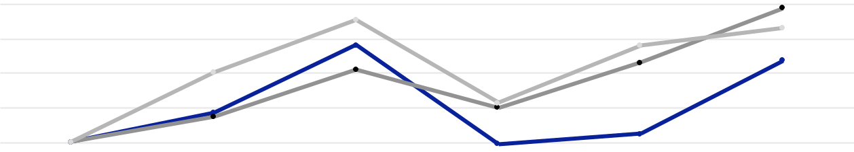

$175

$150

$125

$100

$75

$50

$25

$0

2019 | 2020 |  | 2021 | 2022 |  | 2023 | 2024
General Motors Company |  |  | S&P 500 Stock Index |  | Dow Jones Automobile & Parts Titans 30 Index

The following table summarizes stock performance graph data points in dollars:

 |  |  |  |  |  |  | Years Ended December 31,
 |  | 2019 |  |  | 2020 |  |  | 2021 |  |  | 2022 |  |  | 2023 |  |  | 2024
General Motors Company | $ | 100 | $ |  | 121 | $ |  | 170 | $ |  | 98 | $ |  | 106 | $ |  | 159
S&P 500 Stock Index | $ | 100 | $ |  | 118 | $ |  | 152 | $ |  | 125 | $ |  | 158 | $ |  | 197
Dow Jones Automobile & Parts Titans 30 Index | $ | 100 | $ |  | 151 | $ |  | 188 | $ |  | 128 | $ |  | 170 | $ |  | 183

25

Table of Contents

GENERAL MOTORS COMPANY AND SUBSIDIARIES

Purchases of Equity Securities The following table summarizes our purchases of common stock in the three months ended

December 31, 2024:

 |  |  | Weighted- |  |  | Total Number of |  | Approximate Dollar
 | Total Number of |  |  | Average |  | Total Number of |  | Value of Shares That
 | Total Number of |  | Price Paid |  |  | Shares Purchased |  | May Yet be Purchased
 | Shares |  |  | per |  | Under Announced |  | Under Announced
 | Purchased(a)(b) |  | Share(b)(c) |  |  | Programs(b)(d) |  | Programs(b)(d)
October 1, 2024 through October 31, 2024
Final settlement of ASR(b) | 19,078,910 |  |  |  | 19,078,910
Other shares purchased | 8,946,822 | $ |  | 48.77 | 8,789,744 |  |  | $4.6 billion
November 1, 2024 through November 30, 2024
Final settlement of ASR(b) | 6,213,168 |  |  |  | 6,213,168
Other shares purchased | 44,026,509 | $ |  | 55.88 | 44,026,379 |  |  | $2.1 billion
December 1, 2024 through December 31, 2024 | 33,860,946 | $ |  | 52.51 |  | 33,860,946 |  | $0.3 billion
Total | 112,126,355 | $ |  | 53.83 | 111,969,147
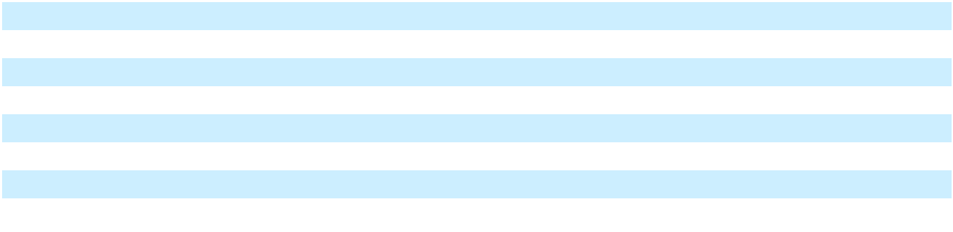
__________

- Shares purchased include shares delivered by employees or directors to us for the payment of taxes resulting from issuance of common stock upon the vesting of Restricted Stock Units (RSUs) and Performance Stock Units (PSUs) relating to compensation plans. In June 2020, our shareholders approved the 2020 Long-Term Incentive Plan (LTIP), which authorizes awards of stock options, stock appreciation rights, RSUs, PSUs or other stock-based awards to selected employees, consultants, advisors and non-employee Directors of the Company. Refer to Note 22 to our consolidated financial statements for additional details on employee stock incentive plans.

- During the three months ended December 31, 2023, we entered into the accelerated share repurchase (ASR) agreements (collectively, the ASR Agreements) to repurchase an aggregate $10.0 billion of common stock, and we received and immediately retired approximately 215 million shares of our common stock (68% of the $10.0 billion aggregate purchase price calculated on the basis of a price of $31.60 per share, the closing share price of our common stock on November 29, 2023). In March 2024, upon the first settlement of the transactions contemplated under the ASR Agreements, we received approximately 4 million additional shares of our common stock, which were immediately retired. There were no settlements under the ASR Agreements in the three months ended June 30, 2024 or September 30, 2024. In the three months ended December 31, 2024, upon the final settlement of the transactions contemplated under the ASR Agreements, we received approximately 25 million additional shares, which were immediately retired. The final number of shares received was based on the average of the daily volume-weighted average prices of our common stock during the term of the ASR Agreements, less a discount pursuant to the terms and conditions of the ASR Agreements.

- The weighted-average price paid per share excludes broker commissions.

- In November 2023, our Board of Directors increased the capacity under the share repurchase program by $10.0 billion to an aggregate of $11.4 billion and approved the $10.0 billion ASR program. In June 2024, our Board of Directors approved a new share repurchase authorization to repurchase up to an additional $6.0 billion of our outstanding common stock. At December 31, 2024, we had $0.3 billion in capacity remaining under the share repurchase program, with no expiration date.

* * * * * * *

Item 6. [Reserved]

* * * * * * *

Item 7. Management’s Discussion and Analysis of Financial Condition and Results of Operations

This MD&A should be read in conjunction with the accompanying audited consolidated financial statements and notes. Forward-looking statements in this MD&A are not guarantees of future performance and may involve risks and uncertainties that could cause actual results to differ materially from those projected. Refer to the "Forward-Looking Statements" section of this MD&A and Part I, Item 1A. Risk Factors for a discussion of these risks and uncertainties. The discussion of our financial condition and results of operations for the year ended December 31, 2022 included in Item 7. Management's Discussion and Analysis of Financial Condition and Results of Operations in our Annual Report on Form 10-K for the year ended December 31, 2023 is incorporated by reference into this MD&A.

Overview Our vision for the future is a world with zero crashes, zero emissions and zero congestion. We will adapt to customer preferences while executing our growth-focused strategy to invest in EVs, hybrids, personal AV technology, software-enabled services and other new business opportunities. To support strong margins and cash flow during this transition, we are strengthening our market position in profitable ICE vehicles, such as trucks and SUVs. We plan to execute our strategy

26

Table of Contents

GENERAL MOTORS COMPANY AND SUBSIDIARIES

with a steadfast commitment to good corporate citizenship through more sustainable operations and a leading health and safety culture.

Our financial performance in 2024 was driven by the strength of our vehicle portfolio including high margin full-size pickup trucks and SUVs, strong consumer demand for our products and the execution of our core business strategy. We remain focused on maintaining an efficient cost structure and pricing discipline. We are monitoring industry pricing pressures, changing interest rates, inflation, warranty claims, consumer demand trends and potential changes in the regulatory environment. We continue to prioritize driving down costs and building scale in our EV portfolio to improve profitability.

As we continue to assess our performance and the needs of our evolving business, additional restructuring and rationalization actions could be required. These actions could give rise to future asset impairments or other charges, which may have a material impact on our operating results. Refer to the "Consolidated Results" and regional sections of this MD&A for additional information.

We face continuing market, operating and regulatory challenges in several countries across the globe due to, among other factors, competitive pressures, our product portfolio offerings, heightened emission standards, labor disruptions, foreign exchange volatility, evolving trade policy and political uncertainty. Refer to Part I, Item 1A. Risk Factors for a discussion of these challenges.

For the year ending December 31, 2025, we expect earnings per share (EPS)-diluted and EPS-diluted-adjusted of between $11.00 and $12.00, Net income attributable to stockholders of between $11.2 billion and $12.5 billion and earnings before interest and taxes (EBIT)-adjusted of between $13.7 billion and $15.7 billion. These expected financial results do not include the potential impact of future adjustments related to special items. Refer to the "Non-GAAP Measures" section of this MD&A for additional information.

The following table reconciles expected Net income attributable to stockholders under U.S. generally accepted accounting principles (GAAP) to expected EBIT-adjusted (dollars in billions):

 | Year Ending December 31, 2025
Net income attributable to stockholders | $ 11.2-12.5
Income tax expense | 2.5-3.2
Automotive interest income, net | (0.0)
EBIT-adjusted(a) | $ 13.7-15.7
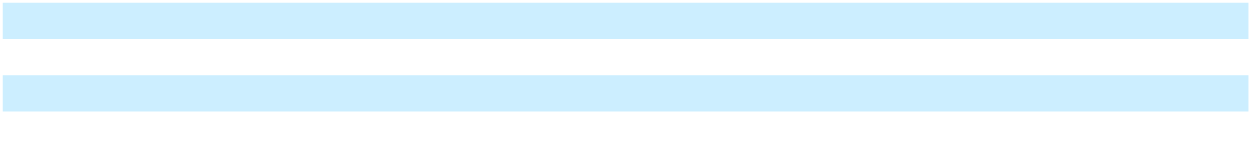
__________

(a) We do not consider the potential future impact of adjustments on our expected financial results.

GMNA Industry sales in North America were 20.3 million units in the year ended December 31, 2024, representing an increase of 3.5% compared to the corresponding period in 2023. U.S. industry sales were 16.4 million units in the year ended December 31, 2024, representing an increase of 2.3% compared to the corresponding period in 2023.

Our total vehicle sales in the U.S., our largest market in North America, were 2.7 million units for a market share of 16.5% in the year ended December 31, 2024, representing an increase of 0.3 percentage points compared to the corresponding period in 2023.

We expect to sustain relatively strong EBIT-adjusted margins in 2025 on the continuing strength of our product portfolio, improving EV margins and continuing cost discipline, partially offset by pricing moderation with increased incentives and higher depreciation expense. While we expect EV margins to improve in 2025, we may continue to recognize losses to adjust inventory to net realizable value. Our outlook is dependent on continued supply chain availability, EV-related cost reduction and the resiliency of the U.S. economy and overall economic conditions, including the potential imposition of tariffs or other trade restrictions by the U.S. or its trading partners.

GMI Industry sales in China were 26.6 million units in the year ended December 31, 2024, representing an increase of 6.4% compared to the corresponding period in 2023. Our total vehicle sales in China were 1.8 million units resulting in a market share of 6.9% in the year ended December 31, 2024, representing a decrease of 1.5 percentage points compared to the corresponding period in 2023. Intense price competition with significant excess capacity from both new market entrants and established competitors offering vehicles at lower prices and an increasingly challenging regulatory environment related to emissions, fuel consumption and NEVs continue to negatively impact the profitability of our operations in China. Additionally,

27

Table of Contents

GENERAL MOTORS COMPANY AND SUBSIDIARIES

we believe independent, Chinese automakers are expanding market share and prioritizing production volumes over profitability, with the ability to produce vehicles at costs well below foreign automakers, including our Automotive China JVs. These factors are impacting our China JVs’ ability to grow vehicle sales in China and our ability to generate sustainable equity income from our China JVs. We are in the late stages of finalizing details with our JV partners on an agreement regarding certain restructuring actions, which include plant closures and portfolio optimization to address continuing market challenges and competitive conditions, and updated business forecasts.

Based on the updated forecast, we determined that the material loss in value of our equity interests in SAIC General Motors Corporation Limited (SGM), SAIC GM (Shenyang) Norsom Motors Co., Ltd. (SGM Norsom), SAIC GM Dong Yue Motors Co., Ltd. (SGM DY) and SAIC GM Dong Yue Powertrain Co., Ltd. (SGM DYPT) was other than temporary. As a result, we recorded an other-than-temporary impairment of our equity interests of $2.1 billion in the year ended December 31, 2024 which is included in equity income (loss). Our Automotive China JVs' equity losses also includes non-cash charges of $2.0 billion resulting from the implementation of the restructuring plan. We expect additional restructuring charges are likely to be incurred in 2025. Going forward, we will continue to assess our strategy in the Chinese market to maintain presence while prioritizing profitability. In addition, GM Financial also concluded that a $0.3 billion other-than-temporary impairment of its equity interest in SAIC-GMAC Automotive Finance Company Limited (SAIC-GMAC) existed. Refer to the "Automotive Financing – GM Financial Summary and Outlook” section of this MD&A for discussion of GM Financial’s other-than-temporary impairment of its equity interest in SAIC-GMAC.

Outside of China, industry sales were 25.7 million units in the year ended December 31, 2024, representing a decrease of 0.3% compared to the corresponding period in 2023. Our total vehicle sales outside of China were 0.9 million units for a market share of 3.7% in the year ended December 31, 2024, representing a decrease of 0.3 percentage points compared to the corresponding period in 2023.

Cruise Cruise Holdings, our majority-owned subsidiary, has been pursuing the development and commercialization of AV technology for deployment in a robotaxi application. In June 2024, Cruise indefinitely delayed development work on the Cruise Origin and recorded restructuring charges of $0.6 billion primarily related to non-cash write-offs of Origin assets. In December 2024, we announced plans to refocus our autonomous driving strategy on personal vehicles and that we would no longer fund Cruise's robotaxi development work. Refer to Part I, Item 1. Business for a further discussion on Cruise. In conjunction with our announcement to no longer fund Cruise’s robotaxi development work and our plans to combine the Cruise and GM technical efforts to advance autonomous and assisted driving, Cruise recorded net charges of $0.5 billion. These charges primarily relate to anticipated headcount reductions and impairments of real estate lease assets and certain intangible assets.

Automotive Financing - GM Financial Summary and Outlook We believe that offering a comprehensive suite of financing products will generate incremental sales of our vehicles, drive incremental GM Financial earnings and help support our sales throughout various economic cycles. GM Financial's penetration of our retail sales in the U.S. was 39% in the year ended December 31, 2024 and 42% in the corresponding period in 2023. Penetration levels vary depending on incentive financing programs available and competing third-party financing products in the market. GM Financial's prime loan originations as a percentage of total loan originations in North America was 81% in the year ended December 31, 2024 and 82% in the corresponding period in 2023. In the year ended December 31, 2024, GM Financial's revenue consisted of leased vehicle income of 46%, retail finance charge income of 40% and commercial finance charge income of 8%.

GM Financial's leasing program is exposed to residual values, which are heavily dependent on used vehicle prices. Gains on terminations of leased vehicles of $0.8 billion and $0.9 billion were included in GM Financial interest, operating and other expenses in the years ended December 31, 2024 and 2023. The decrease in gains is primarily due to fewer terminated leases in 2024 compared to 2023. The following table summarizes the estimated residual value based on GM Financial's most recent

28

Table of Contents

GENERAL MOTORS COMPANY AND SUBSIDIARIES

estimates and the number of units included in GM Financial Equipment on operating leases, net by vehicle type (units in thousands):

 |  |  | December 31, 2024 |  |  |  |  |  |  |  | December 31, 2023
 | Residual Value |  |  | Units |  |  | Percentage |  | Residual Value |  |  | Units |  |  | Percentage
Crossovers | $ | 13,184 | 635 |  |  |  | 67.3 % | $ |  | 12,830 | 648 |  |  |  | 67.5 %
Trucks |  | 7,458 | 224 |  |  |  | 23.7 % |  |  | 6,793 | 210 |  |  |  | 21.9 %
SUVs |  | 2,260 | 53 |  |  |  | 5.6 % |  |  | 2,304 | 58 |  |  |  | 6.0 %
Cars |  | 590 |  | 31 |  |  | 3.3 % |  |  | 734 |  | 44 |  |  | 4.6 %
Total | $ | 23,492 | 943 |  |  |  | 100.0 % | $ |  | 22,661 | 960 |  |  |  | 100.0 %
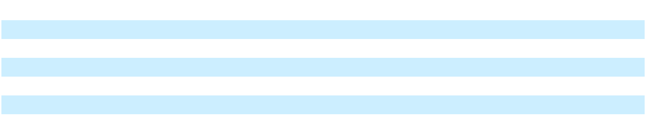

As a result of the market challenges and competitive conditions in China, GM Financial recorded a $0.3 billion other-than-temporary impairment charge to write down its SAIC-GMAC investment to its fair value. Refer to the "Overview – GMI" section of this MD&A for discussion of the China market and associated restructuring actions being taken.

Consolidated Results We review changes in our results of operations under five categories: Volume, Mix, Price, Cost and Other. Volume measures the impact of changes in wholesale vehicle volumes driven by industry volume, market share and changes in dealer stock levels. Mix measures the impact of changes to the regional portfolio due to product, model, trim, country and option penetration in current year wholesale vehicle volumes. Price measures the impact of changes related to Manufacturer’s Suggested Retail Price and various sales allowances. Cost primarily includes: (1) material and freight; (2) manufacturing, engineering, advertising, administrative and selling and warranty expense; and (3) non-vehicle related activity. Other primarily includes foreign exchange and non-vehicle related automotive revenues as well as equity income or loss from our nonconsolidated affiliates. Refer to the regional sections of this MD&A for additional information.

Total Net Sales and Revenue

 | Years Ended December 31, |  |  |  |  |  |  | Favorable/ |  |  |  |  |  |  |  |  | Variance Due To
 |  | 2024 |  |  | 2023 |  |  | Favorable/ |  | % |  |  | Volume |  |  |  | Mix |  |  | Price |  |  | Other
 |  | 2024 |  |  | 2023 |  | (Unfavorable) |  |  | % |  |  |  |  |  |  | Mix |  |  | Price |  |  | Other
 |  |  |  |  |  |  |  |  |  |  |  |  |  |  |  | (Dollars |  | in billions)
GMNA | $ | 157,509 | $ |  | 141,445 | $ |  | 16,064 | 11.4 % |  |  | $ |  | 12.8 | $ |  | 2.5 | $ |  | 0.7 | $ |  | —
GMI |  | 13,890 |  |  | 15,949 |  |  | (2,059) | (12.9)% |  |  | $ |  | (1.6) | $ |  | 0.4 | $ |  | 0.2 | $ |  | (1.1)
Corporate |  | 206 |  |  | 273 |  |  | (67) | (24.5)% |  |  |  |  |  | $ |  | — |  |  |  | $ |  | (0.1)
Automotive |  | 171,605 |  |  | 157,667 |  |  | 13,938 | 8.8 % |  |  | $ |  | 11.2 | $ |  | 2.9 | $ |  | 0.9 | $ |  | (1.1)
Cruise |  | 257 |  |  | 102 |  |  | 155 |  | n.m. |  |  |  |  | $ |  | — |  |  |  | $ |  | 0.2
GM Financial |  | 15,875 |  |  | 14,225 |  |  | 1,650 | 11.6 % |  |  |  |  |  |  |  |  |  |  |  | $ |  | 1.7
Eliminations/reclassifications |  | (296) |  |  | (151) |  |  | (145) | (96.0)% |  |  |  |  |  | $ |  | — |  |  |  | $ |  | (0.1)
Total net sales and revenue | $ | 187,442 |  | $ | 171,842 |  | $ | 15,598 | 9.1 % |  |  | $ |  | 11.2 | $ |  | 2.9 | $ |  | 0.9 | $ |  | 0.6
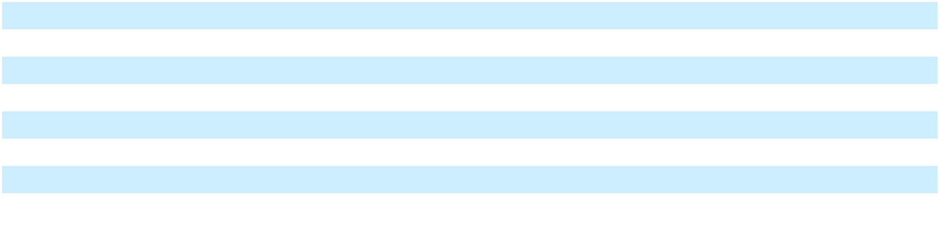
__________

n.m. = not meaningful

Refer to the regional sections of this MD&A for additional information on Volume, Mix, Price and Other.

29

Table of Contents

GENERAL MOTORS COMPANY AND SUBSIDIARIES

Automotive and Other Cost of Sales

 | Years Ended December 31, |  |  |  |  |  |  | Favorable/ |  |  |  |  |  |  |  |  | Variance Due To
 |  | 2024 |  |  | 2023 |  |  | Favorable/ |  | % |  |  | Volume |  |  |  | Mix |  |  | Cost |  |  | Other
 |  | 2024 |  |  | 2023 |  | (Unfavorable) |  |  | % |  |  |  |  |  |  | Mix |  |  | Cost |  |  | Other
 |  |  |  |  |  |  |  |  |  |  |  |  |  |  |  | (Dollars |  | in billions)
GMNA | $ | 135,818 | $ |  | 123,577 | $ |  | (12,241) | (9.9)% |  |  | $ |  | (8.9) | $ |  | (5.5) | $ |  | 2.2 | $ |  | 0.1
GMI |  | 12,552 |  |  | 14,164 |  |  | 1,612 | 11.4 % |  |  | $ |  | 1.2 | $ |  | (0.3) | $ |  | (0.2) | $ |  | 0.8
Corporate |  | 132 |  |  | 513 |  |  | 381 | 74.3 % |  |  |  |  |  | $ |  | — | $ |  | 0.4 | $ |  | —
Cruise |  | 2,566 |  |  | 3,088 |  |  | 522 | 16.9 % |  |  |  |  |  | $ |  | — | $ |  | 0.5
Eliminations |  | (3) |  |  | (12) |  |  | (9) | (75.0)% |  |  |  |  |  | $ |  | — | $ |  | —
Total automotive and other cost | $ | 151,065 |  | $ | 141,330 |  | $ | (9,735) | (6.9)% |  |  | $ |  | (7.7) | $ |  | (5.8) | $ |  | 2.9 | $ |  | 0.9
of sales
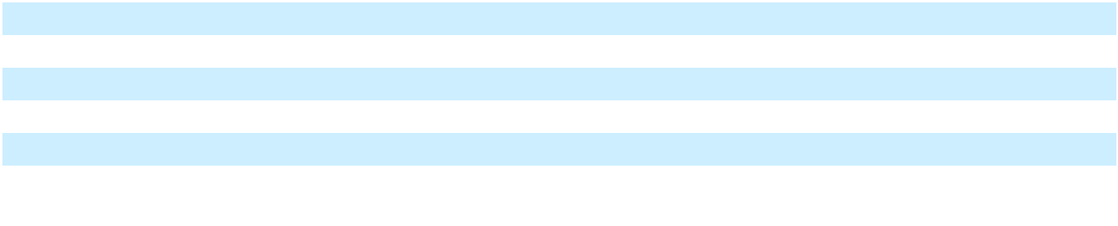

The most significant element of our Automotive and other cost of sales is material cost, which makes up approximately two-thirds of the total amount. The remaining portion includes labor costs, depreciation and amortization, engineering, freight and product warranty and recall campaigns.

Factors that most significantly influence a region's profitability are industry volume, market share and the relative mix of vehicles (trucks, crossovers, cars) sold. Variable profit is a key indicator of product profitability. Variable profit is defined as revenue less material cost, freight, the variable component of manufacturing expense and warranty and recall-related costs. Vehicles with higher selling prices generally have higher variable profit. Refer to the regional sections of this MD&A for additional information on Volume and Mix.

In the year ended December 31, 2024, decreased Cost was primarily due to: (1) decreased inventory adjustments of $2.2 billion, primarily EV-related, to reflect the net realizable value at period end; (2) the absence of charges related to the voluntary separation program (VSP) of $0.7 billion; (3) decreased engineering costs of $0.7 billion, driven primarily by lower AV engineering costs; (4) increased equity earnings related to Ultium Cells Holdings LLC of $0.7 billion; (5) decreased material and freight costs of $0.3 billion; partially offset by (6) increased other employee-related costs of $0.6 billion; (7) increased charges of $0.5 billion related to restructuring costs resulting from the plan to realign Cruise with our existing GM technical teams to develop personal AV technology; (8) increased warranty-related costs of $0.4 billion; and (9) increased information technology costs of $0.3 billion. In the year ended December 31, 2024, favorable Other was primarily due to net foreign currency changes in the Brazilian real and the Korean won.

Automotive and Other Selling, General and Administrative Expense

 | Years Ended December 31, |  |  |  |  |  |  |  |  | Year Ended
 |  |  |  |  |  |  |  |  |  | 2024 vs. 2023 Change
 | 2024 |  |  | 2023 |  |  | 2022 |  |  | Favorable/ |  |  | %
 | 2024 |  |  | 2023 |  |  | 2022 |  | (Unfavorable) |  |  |  | %
Automotive and other selling, general and administrative | $ 10,621 | $ |  | 9,840 | $ |  | 10,667 | $ |  | (781) |  |  | (7.9)%
expense |  |  |  |  |  |  |  |  |  |  |  |  | (7.9)%

In the year ended December 31, 2024, Automotive and other selling, general and administrative expense increased primarily due to: (1) increased charges of $0.4 billion related to strategic activities to transition certain Buick dealerships; and (2) increased advertising, selling and administrative costs of $0.3 billion.

30

Table of Contents

GENERAL MOTORS COMPANY AND SUBSIDIARIES

Interest Income and Other Non-operating Income, net

 |  | Years Ended December 31, |  |  |  |  |  |  |  |  | Year Ended
 |  |  |  |  |  |  |  |  |  |  | 2024 vs. 2023 Change
 |  | 2024 |  |  | 2023 |  |  | 2022 |  |  | Favorable/ |  | %
 |  | 2024 |  |  | 2023 |  |  | 2022 |  | (Unfavorable) |  |  | %
Interest income and other non-operating income, net | $ | 1,257 | $ |  | 1,537 | $ |  | 1,432 | $ |  | (280) | (18.2)%

In the year ended December 31, 2024, Interest income and other non-operating income, net decreased primarily due to several insignificant items.

Income Tax Expense

 |  | Years Ended December 31, |  |  |  |  |  |  |  |  | Year Ended
 |  |  |  |  |  |  |  |  |  |  | 2024 vs. 2023 Change
 |  | 2024 |  |  | 2023 |  |  | 2022 |  |  | Favorable/ |  |  | %
 |  | 2024 |  |  | 2023 |  |  | 2022 |  | (Unfavorable) |  |  |  | %
Income tax expense | $ | 2,556 | $ |  | 563 | $ |  | 1,888 | $ |  | (1,993) |  |  | n.m.

__________

n.m. = not meaningful

In the year ended December 31, 2024, Income tax expense increased primarily due to jurisdictional mix of earnings and valuation allowance adjustments that occurred in the year ended December 31, 2023.

For the year ended December 31, 2024, our effective tax rate-adjusted (ETR-adjusted) was 20.1%. We expect our adjusted effective tax rate to be between 18% and 20% for the year ending December 31, 2025.

Refer to Note 17 to our consolidated financial statements for additional information related to Income tax expense.

GM North America

 | Years Ended December 31, |  |  |  |  | Favorable/ |  |  |  |  |  |  |  |  | Variance Due To
 | 2024 |  | 2023 |  |  | Favorable/ |  | % |  |  | Volume |  |  |  | Mix |  | Price |  |  | Cost |  |  | Other
 | 2024 |  | 2023 |  | (Unfavorable) |  |  | % |  |  |  |  |  |  | Mix
 |  |  |  |  |  |  |  |  |  |  |  |  |  |  | (Dollars in billions)
Total net sales and revenue | $157,509 | $141,445 |  | $ |  | 16,064 | 11.4 % |  |  | $ |  | 12.8 | $ |  | 2.5 | $ |  | 0.7 |  |  |  | $ |  | —
EBIT-adjusted | $ 14,528 | $ 12,306 |  | $ |  | 2,222 | 18.1 % |  |  | $ |  | 3.9 | $ |  | (3.1) | $ |  | 0.7 | $ |  | 1.3 | $ |  | (0.6)
EBIT-adjusted margin | 9.2 % | 8.7 % |  |  |  | 0.5 %
 | (Vehicles in thousands)
Wholesale vehicle sales | 3,464 | 3,147 |  |  |  | 317 | 10.1 %
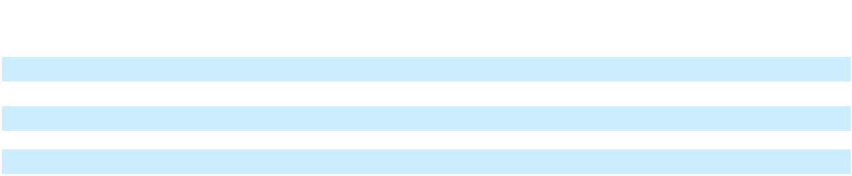

GMNA Total Net Sales and Revenue In the year ended December 31, 2024, Total net sales and revenue increased primarily due to: (1) increased net wholesale volumes primarily due to increased sales of full-size pickup trucks, mid-size pickup trucks and other vehicles; (2) favorable Mix associated with increased sales of full-size pickup trucks and full-size SUVs, partially offset by increased sales of crossover vehicles; and (3) favorable Price as a result of stable dealer inventory levels and strong demand for our products.

GMNA EBIT-Adjusted The most significant factors that influence profitability are industry volume and market share. While not as significant as industry volume and market share, another factor affecting profitability is the relative mix of vehicles sold. Trucks, crossovers and cars sold currently have a variable profit of approximately 160%, 40% and 50% of our GMNA portfolio on a weighted-average basis.

In the year ended December 31, 2024, EBIT-adjusted increased primarily due to: (1) increased net wholesale volumes primarily due to increased sales of full-size pickup trucks, mid-size pickup trucks and crossover vehicles; (2) favorable Cost primarily due to decreased inventory adjustments of $2.1 billion, primarily EV-related, to reflect the net realizable value at period end, increased equity earnings related to Ultium Cells Holdings LLC of $0.7 billion and decreased material and freight costs of $0.6 billion, partially offset by increased other employee-related costs of $0.7 billion, increased engineering costs of $0.5 billion, primarily due to a decrease in cost sharing arrangements with our Automotive China JVs, increased warranty-

31

Table of Contents

GENERAL MOTORS COMPANY AND SUBSIDIARIES

related costs of $0.4 billion, increased information technology costs of $0.3 billion and increased other cost of sales of $0.3 billion; and (3) favorable Price; partially offset by (4) unfavorable Mix associated with increased sales of crossover vehicles and EVs; and (5) unfavorable Other due to net foreign currency changes primarily in the Mexican peso.

GM International

 | Years Ended December 31, |  |  |  |  |  |  | Favorable/ |  |  |  |  |  |  |  |  | Variance Due To
 |  | 2024 |  |  | 2023 |  |  | Favorable/ |  | % |  |  | Volume |  |  |  | Mix |  | Price |  |  | Cost |  | Other
 |  | 2024 |  |  | 2023 |  | (Unfavorable) |  |  | % |  |  |  |  |  |  | Mix |  |  |  |  | Cost
 |  |  |  |  |  |  |  |  |  |  |  |  |  |  |  |  | (Dollars in billions)
Total net sales and revenue | $ | 13,890 | $ |  | 15,949 | $ |  | (2,059) | (12.9)% |  |  | $ |  | (1.6) | $ |  | 0.4 | $ |  | 0.2 |  |  | $ |  | (1.1)
EBIT-adjusted | $ | 303 | $ |  | 1,210 | $ |  | (907) | (75.0)% |  |  | $ |  | (0.4) | $ |  | 0.1 | $ |  | 0.2 | $ (0.2) |  | $ |  | (0.7)
EBIT-adjusted margin |  | 2.2 % |  |  | 7.6 % |  |  | (5.4)%
Equity income (loss) — | $ | (4,407) | $ |  | 446 | $ |  | (4,853) |  | n.m.
Automotive China
EBIT-adjusted — excluding | $ | 633 | $ |  | 764 | $ |  | (131) | (17.1)%
Equity income (loss)(a)
 |  | (Vehicles in thousands)
Wholesale vehicle sales |  | 547 |  |  | 621 |  |  | (74) | (11.9)%
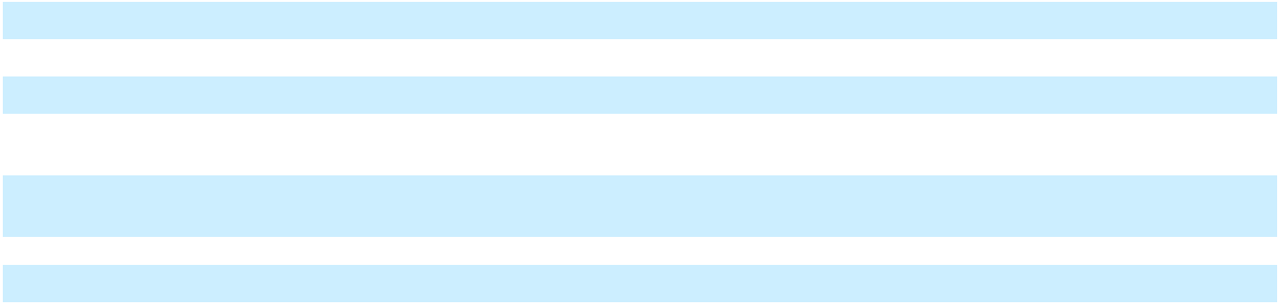

__________

n.m. = not meaningful

- Excludes adjustments related to Automotive China JVs restructuring recorded in GMI. Refer to the "Overview – GMI" section of this MD&A for discussion of these adjustments.

The vehicle sales of our Automotive China JVs are not recorded in Total net sales and revenue. The results of our joint ventures are recorded in Equity income (loss), which is included in EBIT-adjusted above.

GMI Total Net Sales and Revenue In the year ended December 31, 2024, Total net sales and revenue decreased primarily due to: (1) decreased net wholesale volumes in South America, in Asia/Pacific and in the Middle East primarily due to decreased sales of passenger cars and crossover vehicles, partially offset by higher sales of trucks; and (2) unfavorable Other primarily due to the foreign currency effect resulting from the weakening of the Brazilian real and Egyptian pound against the U.S. dollar and decreased components sales; partially offset by (3) favorable Mix primarily in Brazil and in the Middle East; and (4) favorable pricing across multiple vehicle lines in the Middle East and in Brazil.

GMI EBIT-Adjusted In the year ended December 31, 2024, EBIT-adjusted decreased primarily due to: (1) unfavorable Other primarily due to decreased Automotive China JVs equity income (loss); (2) decreased net wholesale volumes; and (3) unfavorable Cost primarily due to increased material costs and unfavorable impact due to nonrecurring asset sale in Korea, partially offset by favorable fixed cost; partially offset by (4) favorable Price; and (5) favorable Mix in South America.

Our Automotive China JVs’ ability to grow vehicle sales in China and generate sustainable equity income continues to be a challenge due to intense competition from our domestic competitors in the Chinese market. In the year ended December 31, 2024, we recognized equity losses of $4.4 billion driven primarily by impairment and restructuring charges of $4.1 billion for certain of our Automotive China JVs. Refer to Note 8 to our consolidated financial statements for additional information. The following table summarizes certain key operational and financial data for the Automotive China JVs (vehicles in thousands):

 |  |  | Years Ended December 31,
 |  | 2024 |  |  |  | 2023 |  |  |  |  | 2022
Wholesale vehicle sales including vehicles exported to markets outside of China |  | 1,843 |  |  |  | 2,334 |  |  |  |  | 2,639
Total net sales and revenue | $ | 21,740 |  | $ |  | 31,435 |  |  | $ |  | 35,857
Net income (loss) | $ | (4,466) |  | $ |  | 1,122 |  |  | $ |  | 1,407
 |  |  | December 31, 2024 |  |  |  |  | December 31, 2023
Cash and cash equivalents |  | $ |  |  |  | 6,389 |  | $ |  |  | 6,875
Debt |  | $ |  |  |  | 104 |  | $ |  |  | 202

32

Table of Contents

GENERAL MOTORS COMPANY AND SUBSIDIARIES

Cruise

 |  | Years Ended December 31, |  |  |  |  |  |  |  |  | 2024 vs. 2023 Change
 |  | 2024 |  |  | 2023 |  |  | 2022 |  |  | Favorable/ |  | %
 |  | 2024 |  |  | 2023 |  |  | 2022 |  | (Unfavorable) |  |  | %
Total net sales and revenue(a) | $ | 257 | $ |  | 102 | $ |  | 102 | $ |  | 155 |  | n.m.
EBIT (loss)-adjusted | $ | (1,701) | $ |  | (2,695) | $ |  | (1,890) | $ |  | 994 | 36.9 %

__________

n.m. = not meaningful

- Primarily reclassified to Interest income and other non-operating income, net in our consolidated income statements in each of the years ended December 31, 2024, 2023 and 2022.

Cruise EBIT (Loss)-Adjusted In the year ended December 31, 2024, EBIT (loss)-adjusted decreased primarily due to the restructuring actions taken in the year ended December 31, 2023 that resulted in a decrease in the development costs associated with Cruise's refocused operating strategy. Following the acquisition of the noncontrolling interests and subject to the approval of the Cruise Board of Directors, we expect that the plans to combine the Cruise and GM technical efforts to advance autonomous and assisted driving will reduce Cruise's costs going forward.

GM Financial

 |  | Years Ended December 31, |  |  |  |  |  |  |  |  |  |  |  | 2024 vs. 2023 Change
 |  | 2024 |  |  |  | 2023 |  |  |  | 2022 |  |  |  | Amount |  |  | %
Total revenue | $ | 15,875 |  | $ |  | 14,225 |  | $ |  | 12,766 |  | $ |  | 1,650 | 11.6 %
Provision for loan losses | $ | 1,029 |  | $ |  | 826 |  | $ |  | 654 |  | $ |  | 203 | 24.6 %
EBT-adjusted | $ | 2,965 |  | $ |  | 2,985 |  | $ |  | 4,076 |  | $ |  | (20) | (0.7)%
Average debt outstanding (dollars in billions) | $ | 109.0 |  | $ |  | 100.4 |  | $ |  | 93.8 |  | $ |  | 8.6 | 8.6 %
Effective rate of interest paid |  | 5.5 | % |  |  | 4.7 | % |  |  | 3.1 | % |  |  | 0.8 | %
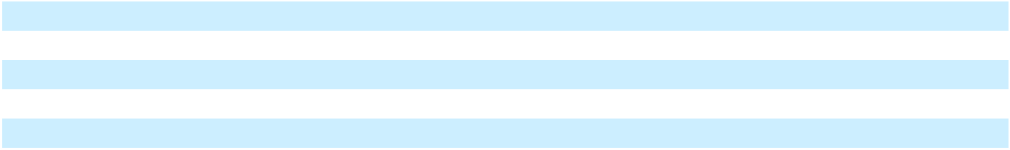

GM Financial Revenue In the year ended December 31, 2024, total revenue increased primarily due to: (1) increased finance charge income of $1.5 billion primarily due to an increase in the effective yield resulting from higher average interest rates on new loans and growth in the size of the portfolio; and (2) increased other income of $0.2 billion primarily due to higher investment income resulting from an increase in the average investment balance and growth in vehicle protection contracts.

GM Financial EBT-Adjusted In the year ended December 31, 2024, earnings before income taxes-adjusted (EBT-adjusted) decreased primarily due to: (1) increased interest expense of $1.3 billion primarily due to an increased effective rate of interest on debt, resulting from higher benchmark interest rates on new issuances relative to maturing debt, as well as an increase in average debt outstanding; (2) increased provision for loan losses of $0.2 billion primarily due to increased loan origination volume and moderating credit performance and recovery rates; and (3) decreased equity income of $0.1 billion primarily due to lower earning asset levels at its joint ventures in China; partially offset by (4) increased finance charge income of $1.5 billion primarily due to an increase in the effective yield resulting from higher average interest rates on new loans and growth in the size of the portfolio; and (5) increased other income of $0.2 billion primarily due to higher investment income resulting from an increase in the average investment balance and growth in vehicle protection contracts.

Liquidity and Capital Resources We believe our current levels of cash, cash equivalents, marketable debt securities, available borrowing capacity under our credit facilities and other liquidity actions currently available to us are sufficient to meet our liquidity requirements in the short- and long-term. We also maintain access to the capital markets and may issue debt or equity securities, which may provide an additional source of liquidity. We have substantial cash requirements going forward, which we plan to fund through our total available liquidity, cash flows from operating activities and additional liquidity measures, if determined to be necessary.

Our known current material uses of cash include, among other possible demands: (1) capital spending and our investments in our battery cell manufacturing joint ventures of approximately $10.0 billion to $11.0 billion in 2025; (2) payments for engineering and product development activities, including the development of AV technology and software-enabled services;

- payments associated with previously announced vehicle recalls and any other recall-related contingencies; (4) payments to service debt and other long-term obligations, including discretionary and mandatory contributions to our pension plans; (5) dividend payments on our common stock that are declared by our Board of Directors; (6) payments to purchase shares of our

33

Table of Contents

GENERAL MOTORS COMPANY AND SUBSIDIARIES

common stock authorized by our Board of Directors; and (7) payments of emissions-related regulatory compliance costs. Refer to Note 7, Note 13 and Note 15 to our consolidated financial statements for additional funding requirements for our operating leases, debt and pension plans. Our material future uses of cash, which may vary from time to time based on market conditions and other factors, are focused on the three objectives of our capital allocation program: (1) grow our business at an average target return on invested capital-adjusted (ROIC-adjusted) rate of 20% or greater; (2) maintain a strong investment-grade balance sheet, including a target average automotive cash balance of $18.0 billion; and (3) after the first two objectives are met, return available cash to shareholders. Our senior management evaluates our capital allocation program on an ongoing basis and recommends any modifications to the program to our Board of Directors not less than once annually.

We continue to monitor and evaluate opportunities to strengthen our competitive position over the long term while maintaining a strong investment-grade balance sheet. These actions may include opportunistic payments to reduce our long-term obligations, as well as the possibility of acquisitions, dispositions and investments with joint venture partners, as well as strategic alliances that we believe would generate significant advantages and substantially strengthen our business. To support our transition to EVs, we anticipate making investments in suppliers or providing funding towards the execution of strategic, multi-year supply agreements to secure critical materials. In addition, we have entered, and plan to continue to enter, into offtake agreements that generally obligate us to purchase defined quantities of output. These arrangements could have a short-term adverse impact on our cash and increase our inventory.

Our liquidity plans are subject to a number of risks and uncertainties, including those described in the "Forward-Looking Statements" section of this MD&A and Part I, Item 1A. Risk Factors, some of which are outside of our control.

In November 2023, our Board of Directors increased the capacity under our previously announced share repurchase program by $10.0 billion to an aggregate of $11.4 billion and approved a $10.0 billion ASR program. In December 2023, pursuant to the agreements entered into in connection with the ASR, we advanced $10.0 billion and received approximately 215 million shares of common stock with a value of $6.8 billion, which were immediately retired. In the year ended December 31, 2024, we received and retired approximately 29 million additional shares upon settlement of the transactions contemplated under the ASR Agreements. The final number of shares received was based on the average of the daily volume-weighted average prices of our common stock during the term of the ASR Agreements, less a discount pursuant to the terms and conditions of the ASR Agreements.

In June 2024, our Board of Directors approved a new share repurchase authorization to repurchase up to an additional $6.0 billion of our outstanding common stock.

In the year ended December 31, 2024, in addition to shares received under the ASR program, we purchased approximately 140 million shares of our outstanding common stock for $7.1 billion. We have $0.3 billion in capacity remaining under our share repurchase program as of December 31, 2024, with no expiration date.

During the year ended December 31, 2024, we paid dividends of $0.5 billion to holders of our common stock. We anticipate that we will continue to declare and pay dividends on our common stock quarterly.

Cash flows that occur amongst our Automotive, Cruise and GM Financial operations are eliminated when we consolidate our cash flows. Such eliminations include, among other things, collections by Automotive on wholesale accounts receivables financed by dealers through GM Financial, payments between Automotive and GM Financial for accounts receivables transferred by Automotive to GM Financial, loans to Automotive and Cruise from GM Financial, dividends issued by GM Financial to Automotive, tax payments by GM Financial to Automotive and Automotive cash injections in Cruise. The presentation of Automotive liquidity, Cruise liquidity and GM Financial liquidity presented below includes the impact of cash transactions amongst the sectors that are ultimately eliminated in consolidation.

Automotive Liquidity Total available liquidity includes cash, cash equivalents, marketable debt securities and funds available under credit facilities. The amount of available liquidity is subject to seasonal fluctuations and includes balances held by various business units and subsidiaries worldwide that are needed to fund their operations.

We manage our liquidity primarily at our treasury centers as well as at certain of our significant consolidated overseas subsidiaries. Over 83% of our cash and marketable debt securities were managed within North America and at our regional treasury centers at December 31, 2024. We have used, and will continue to use, other methods including intercompany loans to utilize these funds across our global operations as needed.

34

Table of Contents

GENERAL MOTORS COMPANY AND SUBSIDIARIES

Our cash equivalents and marketable debt securities balances are primarily denominated in U.S. dollars and include investments in U.S. government and agency obligations, foreign government securities, time deposits, corporate debt securities and mortgage and asset-backed securities. Our investment guidelines, which we may change from time to time, prescribe certain minimum credit worthiness thresholds and limit our exposures to any particular sector, asset class, issuance or security type. The majority of our current investments in debt securities are with A/A2 or better rated issuers.

In March 2024, we renewed our 364-day, $2.0 billion revolving credit facility allocated for the exclusive use of GM Financial, which now matures March 27, 2025. Interest rates on obligations under the renewed credit facility are based on Term SOFR.

In March 2024, we terminated our unsecured 364-day delayed draw term loan credit agreement that permitted the Company to borrow up to $3.0 billion executed in November 2023, resulting in an insignificant loss.

We use credit facilities as a mechanism to provide additional flexibility in managing our global liquidity. Our Automotive borrowing capacity under credit facilities totaled $14.3 billion at December 31, 2024, which consisted primarily of two credit facilities, and $17.1 billion at December 31, 2023, which consisted primarily of three credit facilities. Total Automotive borrowing capacity under our credit facilities does not include our 364-day, $2.0 billion facility allocated for exclusive use of GM Financial. We did not have any borrowings against our primary facilities, but had letters of credit outstanding under our sub-facility of $0.5 billion and $0.7 billion at December 31, 2024 and 2023.

If available capacity permits, GM Financial continues to have access to our automotive credit facilities. GM Financial did not have borrowings outstanding against any of these facilities at December 31, 2024 and 2023. We had intercompany loans from GM Financial of $0.3 billion and $0.2 billion at December 31, 2024 and 2023, which primarily consisted of commercial loans to dealers we consolidate. We did not have intercompany loans to GM Financial at December 31, 2024 and 2023. Refer to Note 5 to our consolidated financial statements for additional information.

Several of our loan facilities, including our credit facilities, require compliance with certain financial and operational covenants as well as regular reporting to lenders. We have reviewed our covenants in effect as of December 31, 2024 and determined we are in compliance and expect to remain in compliance in the future.

In December 2024, we exercised the make-whole provision on a portion of our $2.0 billion senior unsecured notes with a maturity date of October 2025, redeeming $750 million in aggregate principal amount. Upon settlement in December 2024, we recorded an insignificant early extinguishment of debt loss.

GM Financial's Board of Directors declared and paid dividends on its common stock of $1.8 billion in the years ended December 31, 2024 and 2023 and $1.7 billion in the year ended December 31, 2022. Future dividends from GM Financial will depend on several factors including business and economic conditions, its financial condition, earnings, liquidity requirements and leverage ratio.

The following table summarizes our Automotive available liquidity (dollars in billions):

 | December 31, 2024 |  |  | December 31, 2023
Automotive cash and cash equivalents | $ | 14.5 | $ |  | 12.2
Marketable debt securities |  | 7.3 |  |  | 7.6
Automotive cash, cash equivalents and marketable debt securities |  | 21.7 |  |  | 19.8
Available under credit facilities(a) |  | 13.8 |  |  | 16.4
Total Automotive available liquidity | $ | 35.5 | $ |  | 36.3
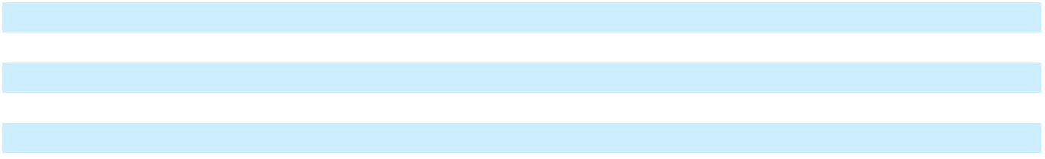

__________

(a) We had letters of credit outstanding under our sub-facility of $0.5 billion and $0.7 billion at December 31, 2024 and 2023.

35

Table of Contents

GENERAL MOTORS COMPANY AND SUBSIDIARIES
The following table summarizes the changes in our Automotive available liquidity (dollars in billions):
 |  |  |  |  | Year Ended
 |  |  |  |  | December 31, 2024
Operating cash flow |  |  | $ |  | 23.9
Capital expenditures |  |  |  |  | (10.7)
Dividends paid and payments to purchase common stock |  |  |  |  | (7.6)
GM investment in Cruise |  |  |  |  | (1.3)
Payment of senior unsecured note |  |  |  |  | (0.8)
Investment in Ultium Cells Holdings LLC |  |  |  |  | (0.7)
Investment in Lithium Americas |  |  |  |  | (0.3)
Other non-operating |  |  |  |  | (0.7)
Decrease in available credit facilities |  |  |  |  | (2.7)
Total change in automotive available liquidity |  |  | $ |  | (0.8)
Automotive Cash Flow (Dollars in billions)
 |  | Years Ended December 31, |  |  |  | 2024 vs. 2023
2024 |  | 2023 | 2022 |  |  | 2024 vs. 2023
 |  | 2023 |  |  |  | Change
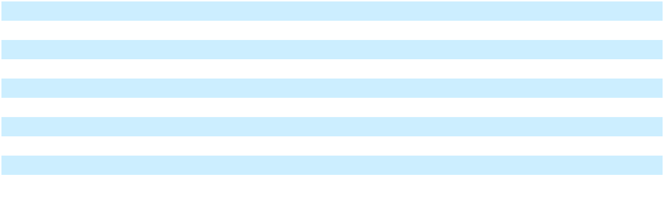
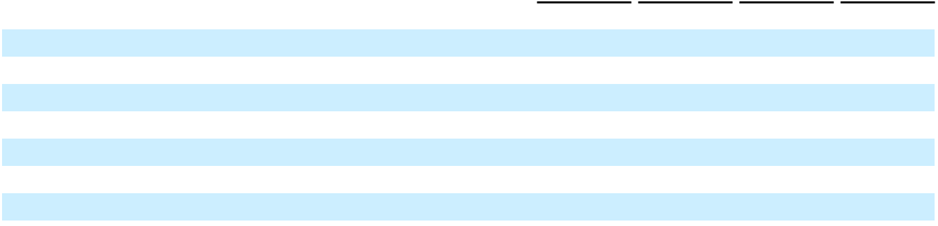

Operating Activities

Net income

Depreciation, amortization and impairment charges

Pension and OPEB activities

Working capital

Accrued and other liabilities and income taxes Other(a)
Net automotive cash provided by (used in) operating activities(b)

__________

$ | 6.6 | $ |  | 10.1 | $ |  | 8.5 | $ |  | (3.5)
 | 6.5 |  |  | 6.8 |  |  | 6.3 |  |  | (0.3)
 | (1.4) |  |  | (1.0) |  |  | (2.0) |  |  | (0.4)
 | 1.5 |  |  | (0.4) |  |  | 0.5 |  |  | 1.9
 | 6.3 |  |  | 4.1 |  |  | 3.1 |  |  | 2.2
 | 4.4 |  |  | 1.2 |  |  | 2.7 |  |  | 3.2
$ | 23.9 | $ |  | 20.8 | $ |  | 19.1 | $ |  | 3.1

- Includes $4.1 billion for the Automotive China JVs impairment and restructuring-related equity losses in the year ended December 31, 2024; $1.8 billion in dividends received from GM Financial in the years ended December 31, 2024 and 2023 and $1.7 billion in dividends received from GM Financial in the year ended December 31, 2022; partially offset by non-cash changes in other assets and liabilities.

- Includes $8.2 billion, $4.8 billion and $6.7 billion in the years ended December 31, 2024, 2023 and 2022 which are eliminated within the consolidated statements of cash flows. Amounts eliminated primarily relate to purchases of, and collections on, wholesale finance receivables provided by GM Financial to our dealers and dividends issued by GM Financial to us.

36

Table of Contents

GENERAL MOTORS COMPANY AND SUBSIDIARIES

 |  | Years Ended December 31, |  |  |  |  |  |  |  | 2024 vs. 2023
 |  | 2024 |  |  | 2023 |  |  | 2022
 |  | 2024 |  |  | 2023 |  |  | 2022 |  |  | Change
Investing Activities
Capital expenditures | $ | (10.7) | $ |  | (10.7) | $ |  | (9.0) | $ |  | —
Acquisitions and liquidations of marketable securities, net |  | 0.3 |  |  | 3.5 |  |  | (3.9) |  |  | (3.2)
Other(a) |  | (2.4) |  |  | (1.5) |  |  | (4.5) |  |  | (0.9)
Net automotive cash provided by (used in) investing activities(b) | $ | (12.8) | $ |  | (8.7) | $ |  | (17.5) | $ |  | (4.1)
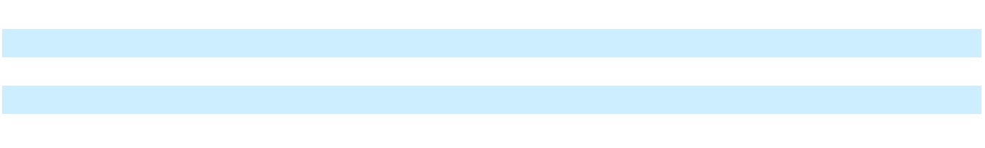

__________

- Includes $1.3 billion, $0.5 billion and $2.4 billion of GM's investment in Cruise in the years ended December 31, 2024, 2023 and 2022, which is inclusive of a $0.9 billion convertible note issued by Cruise to us in the year ended December 31, 2024; $0.7 billion of GM's investment in Ultium Cells Holdings LLC in the years ended December 31, 2024 and 2023 and $0.8 billion of GM's investment in Ultium Cells Holdings LLC in the year ended December 31, 2022; $0.3 billion of GM's investment in Lithium Americas in the years ended December 31, 2024 and 2023; $0.1 billion and $2.1 billion for the purchase of Cruise common and preferred shares from noncontrolling shareholders in the years ended December 31, 2024 and 2022; and $0.9 billion related to the sale of Stellantis N.V. (Stellantis) common shares, excluding dividends received and tax withholding, in the year ended December 31, 2022.
- The investments in Cruise are eliminated within the consolidated statements of cash flows. The redemption of Cruise common and preferred shares from noncontrolling shareholders in 2024 and 2022 are reclassified to financing activities within the consolidated statements of cash flows.

 |  | Years Ended December 31, |  |  |  |  |  |  |  | 2024 vs. 2023
 |  | 2024 |  |  | 2023 |  |  | 2022
 |  | 2024 |  |  | 2023 |  |  | 2022 |  |  | Change
Financing Activities
Net proceeds (payments) from short-term debt | $ | (0.7) | $ |  | (1.5) | $ |  | (1.4) | $ |  | 0.8
Issuance of senior notes |  | — |  |  | — |  |  | 2.3 |  |  | —
Other(a) |  | (7.8) |  |  | (12.1) |  |  | (3.3) |  |  | 4.3
Net automotive cash provided by (used in) financing activities | $ | (8.5) | $ |  | (13.6) | $ |  | (2.5) | $ |  | 5.1
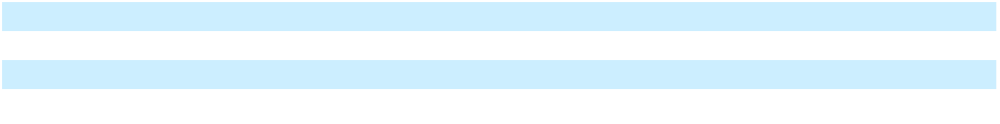
__________

- Includes $7.1 billion, $1.1 billion and $2.5 billion for payments to purchase common stock in the years ended December 31, 2024, 2023 and 2022; $0.5 billion for dividends paid in the years ended December 31, 2024 and 2023; $0.3 billion for dividends paid in the year ended December 31, 2022; and $10.0 billion in connection with the ASR in the year ended December 31, 2023.

Adjusted Automotive Free Cash Flow We measure adjusted automotive free cash flow as automotive operating cash flow from operations less capital expenditures adjusted for management actions. For the year ended December 31, 2024, net automotive cash provided by operating activities under U.S. GAAP was $23.9 billion, capital expenditures were $10.7 billion and adjustments for management actions were $0.8 billion. For the year ended December 31, 2023, net automotive cash provided by operating activities under U.S. GAAP was $20.8 billion, capital expenditures were $10.7 billion and adjustments for management actions were $1.5 billion. Refer to the "Non-GAAP Measures" section of this MD&A for additional information.

Status of Credit Ratings We receive ratings from four independent credit rating agencies: DBRS Limited (DBRS), Fitch Ratings (Fitch), Moody's Investor Service (Moody's) and S&P. All four credit rating agencies currently rate our corporate credit at investment grade. The following table summarizes our credit ratings at January 16, 2025:

 | Corporate |  | Revolving Credit |  | Senior Unsecured |  | Outlook
 | Corporate |  | Facilities |  | Senior Unsecured |  | Outlook
DBRS | BBB (high) |  | BBB (high) |  | N/A |  | Stable
Fitch | BBB |  | BBB |  | BBB |  | Positive
Moody's | Investment Grade |  | Baa2 |  | Baa2 |  | Stable
S&P | BBB |  | BBB |  | BBB |  | Stable
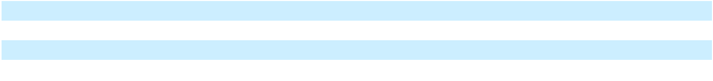

Fitch: Revised their outlook to Positive from Stable in October 2024.

Cruise Liquidity Cruise available liquidity of $0.3 billion and $1.3 billion at December 31, 2024 and 2023 consists primarily of cash and cash equivalents. In June 2024, Cruise issued to us a convertible note in the amount of $0.9 billion. This note is convertible into certain Cruise equity interests. At December 31, 2024, Cruise had total borrowings of $0.4 billion with GM

37

Table of Contents

GENERAL MOTORS COMPANY AND SUBSIDIARIES

Financial under a multi-year credit agreement to fund the purchase of AVs from GM. Cruise available liquidity also excludes a multi-year framework agreement with us whereby Cruise can defer payments until June 2028 on up to $0.8 billion of invoices, which are related to engineering and capital spending incurred by us on behalf of Cruise, and an agreement with us whereby Cruise can defer reimbursing us for amounts we paid related to its restructuring actions that commenced in October 2023. At December 31, 2024, Cruise deferred $1.3 billion under these agreements. In December 2024, GM announced it will no longer fund Cruise's robotaxi development work given the considerable time and resources that would be needed to scale the business, along with an increasingly competitive robotaxi market. Refer to Note 18 to our consolidated financial statements for additional information related to Cruise's restructuring actions.

The following table summarizes the changes in Cruise's available liquidity (dollars in billions):

 |  |  |  |  |  |  |  |  | Year Ended
 |  |  |  |  |  |  |  |  | December 31, 2024
Operating cash flow(a) |  |  |  |  |  |  |  | $ |  |  |  | (2.2)
GM investment in Cruise |  |  |  |  |  |  |  |  |  |  |  | 1.3
Other non-operating |  |  |  |  |  |  |  |  |  |  |  | (0.1)
Total change in Cruise available liquidity |  |  |  |  |  |  |  | $ |  |  |  | (1.0)
__________
(a) Includes $0.1 billion cash outflows related to tendered Cruise Class B Common Shares classified as liabilities.
Cruise Cash Flow (Dollars in billions)
 |  | Years Ended December 31, |  |  |  |  |  |  |  |  | 2024 vs. 2023
 |  | 2024 |  |  | 2023 |  |  | 2022
 |  | 2024 |  |  | 2023 |  |  |  |  |  |  | Change
Net cash provided by (used in) operating activities | $ | (2.2) | $ |  | (1.9) | $ |  | (1.8) |  | $ |  | (0.3)
Net cash provided by (used in) investing activities(a) | $ | — | $ |  | 1.3 | $ |  |  | — | $ |  | (1.4)
Net cash provided by (used in) financing activities(b) | $ | 1.2 | $ |  | 0.4 | $ |  | 1.8 |  | $ |  | 0.8
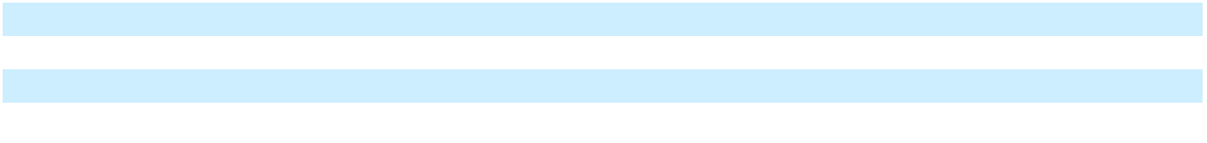

__________

- Includes $1.4 billion of net proceeds from the liquidation of marketable securities in the year ended December 31, 2023.

- Includes $1.3 billion, $0.5 billion and $2.4 billion in the years ended December 31, 2024, 2023 and 2022 related to investments from GM which are eliminated within the consolidated statements of cash flows.

Following the acquisition of the noncontrolling interests and subject to the approval of the Cruise Board of Directors, we expect that the plans to combine the Cruise and GM technical efforts to advance autonomous and assisted driving will significantly reduce Cruise's liquidity needs going forward.

Automotive Financing – GM Financial Liquidity GM Financial's primary sources of cash are finance charge income, leasing income and proceeds from the sale of terminated leased vehicles, net distributions from credit facilities, securitizations, secured and unsecured borrowings and collections and recoveries on finance receivables. GM Financial's primary uses of cash are purchases and funding of finance receivables and leased vehicles, repayment or repurchases of secured and unsecured debt, funding credit enhancement requirements in connection with securitizations and secured credit facilities, interest costs, operating expenses, income taxes and dividend payments. GM Financial continues to monitor and evaluate opportunities to optimize its liquidity position and the mix of its debt between secured and unsecured debt. The following table summarizes GM Financial's available liquidity (dollars in billions):

 | December 31, 2024 |  |  | December 31, 2023
Cash and cash equivalents | $ | 5.1 | $ |  | 5.3
Borrowing capacity on unpledged eligible assets |  | 21.5 |  |  | 21.9
Borrowing capacity on committed unsecured lines of credit |  | 0.7 |  |  | 0.7
Borrowing capacity on revolving credit facility, exclusive to GM Financial |  | 2.0 |  |  | 2.0
Total GM Financial available liquidity | $ | 29.3 | $ |  | 29.9
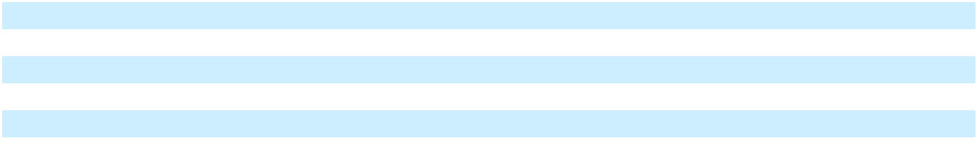

GM Financial structures liquidity to support at least six months of GM Financial's expected net cash flows, including new originations, without access to new debt financing transactions or other capital markets activity. At December 31, 2024, available liquidity exceeded GM Financial's liquidity targets.

38

Table of Contents

GENERAL MOTORS COMPANY AND SUBSIDIARIES

GM Financial did not have any borrowings outstanding against our credit facility designated for their exclusive use or the remainder of our revolving credit facilities at December 31, 2024 and 2023. Refer to the "Automotive Liquidity" section of this MD&A for additional details.

Credit Facilities In the normal course of business, in addition to using its available cash, GM Financial utilizes borrowings under its credit facilities, which may be secured or unsecured, and GM Financial repays these borrowings as appropriate under its cash management strategy. At December 31, 2024, secured, committed unsecured and uncommitted unsecured credit facilities totaled $27.1 billion, $0.7 billion and $2.1 billion with advances outstanding of $5.4 billion, an insignificant amount and $2.1 billion.

GM Financial Cash Flow (Dollars in billions)

 |  | Years Ended December 31, |  |  |  |  |  |  |  | 2024 vs. 2023
 |  | 2024 |  |  | 2023 |  |  | 2022
 |  | 2024 |  |  | 2023 |  |  | 2022 |  |  | Change
Net cash provided by (used in) operating activities | $ | 6.4 | $ |  | 6.7 | $ |  | 5.5 | $ |  | (0.3)
Net cash provided by (used in) investing activities(a) | $ | (15.4) | $ |  | (10.9) | $ |  | (10.0) | $ |  | (4.5)
Net cash provided by (used in) financing activities(b) | $ | 8.9 | $ |  | 5.7 | $ |  | 4.0 | $ |  | 3.2

__________

- Includes $6.4 billion, $3.0 billion and $5.0 billion in the years ended December 31, 2024, 2023 and 2022 for purchases of, and collections on, wholesale finance receivables from GM which are eliminated within the consolidated statements of cash flows.
- Includes $1.8 billion in the years ended December 31, 2024 and 2023 and $1.7 billion in the year ended December 31, 2022 for dividends to GM which are eliminated within the consolidated statements of cash flows.

In the year ended December 31, 2024, net cash provided by operating activities decreased primarily due to an increase in interest paid, a net decrease in cash provided by counterparty derivative collateral posting activities and an increase in acquisition costs related to vehicle protection contracts, partially offset by an increase in finance charge income.

Critical Accounting Estimates The consolidated financial statements are prepared in conformity with U.S. GAAP, which requires the use of estimates, judgments and assumptions that affect the reported amounts of assets and liabilities, the disclosure of contingent assets and liabilities at the date of the financial statements and the reported amounts of revenues and expenses in the periods presented. We believe the accounting estimates employed are appropriate and the resulting balances are reasonable; however, due to the inherent uncertainties in developing estimates, actual results could differ from the original estimates, requiring adjustments to these balances in future periods. Refer to Note 2 to our consolidated financial statements for our significant accounting policies related to our critical accounting estimates.

Product Warranty and Recall Campaigns The estimates related to product warranties are established using historical information on the nature, frequency and average cost of claims of each vehicle line or each model year of the vehicle line and assumptions about future activity and events. When little or no claims experience exists for a model year or a vehicle line, the estimate is based on comparable models.

We accrue the costs related to product warranty at the time of vehicle sale and we accrue the estimated cost of recall campaigns when they are probable and estimable.

The estimates related to recall campaigns accrued at the time of vehicle sale are established by applying a paid loss approach that considers the number of historical recall campaigns and the estimated cost for each recall campaign. These estimates consider the nature, frequency and magnitude of historical recall campaigns, and use key assumptions including the number of historical periods and the weighting of historical data in the reserve studies. Costs associated with recall campaigns not accrued at the time of vehicle sale are estimated based on the estimated cost of repairs and the estimated vehicles to be repaired. Depending on part availability and time to complete repairs we may, from time to time, offer courtesy transportation at no cost to our customers. These estimates are re-evaluated on an ongoing basis and based on the best available information. Revisions are made when necessary based on changes in these factors.

The estimated amount accrued for recall campaigns at the time of vehicle sale is most sensitive to the estimated number of recall events, the number of vehicles per recall event, the assumed number of vehicles that will be brought in by customers for repair (take rate) and the cost per vehicle for each recall event. The estimated cost of a recall campaign that is accrued on an individual basis is most sensitive to our estimated assumed take rate that is primarily developed based on our historical take rate

39

Table of Contents

GENERAL MOTORS COMPANY AND SUBSIDIARIES

experience. A 10% increase in the estimated take rate for all recall campaigns would increase the estimated cost by approximately $0.4 billion.

Actual experience could differ from the amounts estimated requiring adjustments to these liabilities in future periods. Due to the uncertainty and potential volatility of the factors contributing to developing estimates, changes in our assumptions could materially affect our results of operations.

Sales Incentives The estimated effect of sales incentives offered to dealers and end customers is recorded as a reduction of Automotive net sales and revenue at the time of sale. There may be numerous types of incentives available at any particular time. Incentive programs are generally specific to brand, model or sales region and are for specified time periods, which may be extended. Significant factors used in estimating the cost of incentives include type of program, forecasted sales volume, product mix, and the rate of customer acceptance of incentive programs, all of which are estimated based on historical experience and assumptions concerning future customer behavior and market conditions. A change in any of these factors affecting the estimate could have a significant effect on recorded sales incentives. A 10% increase in the cost of incentives would increase the sales incentive liability by approximately $0.4 billion. Subsequent adjustments to incentive estimates are possible as facts and circumstances change over time, which could affect the revenue previously recognized in Automotive net sales and revenue.

GM Financial Allowance for Loan Losses The GM Financial retail finance receivables portfolio consists of smaller-balance, homogeneous loans that are carried at amortized cost, net of allowance for loan losses. The allowance for loan losses on retail finance receivables reflects net credit losses expected to be incurred over the remaining life of the retail finance receivables, which have a weighted-average remaining life of approximately two years. GM Financial forecasts net credit losses based on relevant information about past events, current conditions and forecast economic performance. GM Financial believes that the allowance is adequate to cover expected credit losses on the retail finance receivables; however, because the allowance for loan losses is based on estimates, there can be no assurance that the ultimate charge-off amount will not exceed such estimates or that our credit loss assumptions will not increase.

GM Financial incorporates its outlook on forecast recovery rates and overall economic performance in its allowance estimate. Each 5% relative decrease/increase in the forecast recovery rates would increase/decrease the allowance for loan losses by $0.1 billion.

At December 31, 2024, the weightings applied to the economic forecast scenarios considered resulted in an allowance for loan losses on the U.S. retail finance receivables portfolio of $2.1 billion. If the forecast economic conditions were based entirely on the weakest scenario considered, the allowance for loan losses would increase by $0.2 billion. Actual economic data and recovery rates that are lower than those forecasted by GM Financial could result in an increase to the allowance for loan losses.

The GM Financial commercial finance receivables portfolio consists of financing products for dealers and other businesses. GM Financial provides commercial lending products to its dealer customers that include floorplan financing, also known as wholesale or inventory financing, which is lending to finance vehicle inventory. GM Financial also provides dealer loans, which are loans to finance improvements to dealership facilities, to provide working capital, or to purchase and/or finance dealership real estate. Additionally, GM Financial provides lending products to commercial vehicle upfitters and advances to certain of our subsidiaries. The allowance for loan losses on commercial finance receivables is based on historical loss experience for the consolidated portfolio, in addition to forecasted industry conditions. There can be no assurance that the ultimate charge-off amount will not exceed such estimates or that GM Financial's credit loss assumptions will not increase.

Valuation of GM Financial Equipment on Operating Lease Assets and Residuals GM Financial has investments in leased vehicles recorded as operating leases. Each leased asset in the portfolio represents a vehicle that GM Financial owns and has leased to a customer. At the inception of a lease, an estimate is made of the expected residual value for the vehicle at the end of the lease term, which typically ranges from one to five years. GM Financial estimates the expected residual value based on third-party data that considers various data points and assumptions, including, but not limited to, recent auction values, the expected future volume of returning leased vehicles, significant liquidation of rental or fleet inventory, used vehicle prices, manufacturer incentive programs and fuel prices.

During the term of a lease, GM Financial periodically evaluates the estimated residual value and may adjust the value downward, which increases the prospective depreciation, or upward (limited to the contractual residual value), which decreases the prospective depreciation.

40

Table of Contents

GENERAL MOTORS COMPANY AND SUBSIDIARIES

The customer is obligated to make payments during the lease term for the difference between the purchase price and the contract residual value plus a money factor. However, since the customer is not obligated to purchase the vehicle at the end of the contract, GM Financial is exposed to a risk of loss to the extent the customer returns the vehicle prior to or at the end of the lease term and the proceeds GM Financial receives on the disposition of the vehicle are lower than the residual value estimated at the inception of the lease. Realization of the residual values is dependent on GM Financial's future ability to market the vehicles under prevailing market conditions.

At December 31, 2024, the estimated residual value of GM Financial's leased vehicles was $23.5 billion. Depreciation reduces the carrying value of each leased asset in GM Financial's operating lease portfolio over time from its original acquisition value to its expected residual value at the end of the lease term. If used vehicle prices weaken compared to estimates, GM Financial would increase depreciation expense and/or record an impairment charge on the lease portfolio. If an impairment exists, GM Financial would determine any shortfall in recoverability of the leased vehicle asset groups by year, make and model. Recoverability is calculated as the excess of: (1) the sum of remaining lease payments plus estimated residual value; over (2) leased vehicles, net less deferred revenue. Alternatively, if used vehicle prices outperform GM Financial's latest estimates, it may record gains on sales of off-lease vehicles and/or decreased depreciation expense.

The following table illustrates the effect of a 1% relative change in the estimated residual values at December 31, 2024, which could increase or decrease depreciation expense over the remaining term of the leased vehicle portfolio, holding all other assumptions constant (dollars in millions):

 |  | Impact to
 | Depreciation Expense
2025 | $ | 158
2026 |  | 60
2027 |  | 16
2028 and thereafter |  | 1
Total | $ | 235

Changes to residual values are rarely simultaneous across all maturities and segments, and also may impact return rates. If a decrease in residual values is concentrated among specific asset groups, the decrease could result in an immediate impairment charge. GM Financial reviewed the leased vehicle portfolio for indicators of impairment and determined that no material impairment indicators were present at December 31, 2024 or 2023.

Pension and OPEB Plans Our defined benefit pension plans are accounted for on an actuarial basis, which requires the selection of various assumptions, including an expected long-term rate of return on plan assets, a discount rate, mortality rates of participants and expectation of mortality improvement. Our pension obligations include Korean statutory pension payments that are valued on a walk away basis. The expected long-term rate of return on U.S. plan assets that is utilized in determining pension expense is derived from periodic studies, which include a review of asset allocation strategies, anticipated future long-term performance of individual asset classes, risks using standard deviations and correlations of returns among the asset classes that comprise the plans' asset mix. While the studies give appropriate consideration to recent plan performance and historical returns, the assumptions are primarily long-term, prospective rates of return.

In December 2024, an investment policy study was completed for the U.S. pension plans. As a result, the weighted-average long-term rate of Return on Assets (ROA) increased to 6.5% at December 31, 2024 from 6.3% at December 31, 2023. The expected long-term rate of return on plan assets used in determining pension expense for non-U.S. plans is determined in a similar manner to the U.S. plans.

Another key assumption in determining net pension and other postretirement benefits (OPEB) expense is the assumed discount rate used to discount plan obligations. We estimate the assumed discount rate for U.S. plans using a cash flow matching approach, which uses projected cash flows matched to spot rates along a high quality corporate bond yield curve to determine the weighted-average discount rate for the calculation of the present value of cash flows. We apply the individual annual yield curve rates instead of the assumed discount rate to determine the service cost and interest cost, which more specifically links the cash flows related to service cost and interest cost to bonds maturing in their year of payment.

Significant differences in actual experience or significant changes in assumptions may materially affect the pension obligations. The effects of actual results differing from assumptions and the changing of assumptions are included in

41

Table of Contents

GENERAL MOTORS COMPANY AND SUBSIDIARIES

unamortized net actuarial gains and losses that are subject to amortization to pension expense over future periods. The unamortized pre-tax actuarial loss on our pension plans was $6.2 billion and $5.9 billion at December 31, 2024 and 2023. The year-over-year change is primarily due to lower than expected asset returns partially offset by an increase in discount rates.

The funded status of the U.S. pension plans improved in the year ended December 31, 2024 to $1.8 billion underfunded status from $2.2 billion underfunded status primarily due to: (1) favorable effect of an increase in discount rates of $1.4 billion;

- contributions of $0.5 billion; and (3) favorable effect of actual return on plan assets of $0.5 billion; partially offset by (4) service and interest costs of $2.2 billion.

The following table illustrates the sensitivity to a change in certain assumptions for the pension plans, holding all other assumptions constant:

 | U.S. Plans(a) |  |  |  | Non-U.S. Plans(a)
 | Effect on 2025 |  | Effect on |  | Effect on 2025 |  | Effect on
 | Pension |  | December 31, |  | Pension |  | December 31,
 | Expense |  | 2024 PBO |  | Expense |  | 2024 PBO
25 basis point decrease in discount rate | -$50 | +$767 |  | -$4 |  | +$256
25 basis point increase in discount rate | +$47 | -$741 |  | +$7 |  | -$245
25 basis point decrease in expected rate of ROA | +$99 |  | N/A | +$23 |  |  | N/A
25 basis point increase in expected rate of ROA | -$99 |  | N/A | -$23 |  |  | N/A
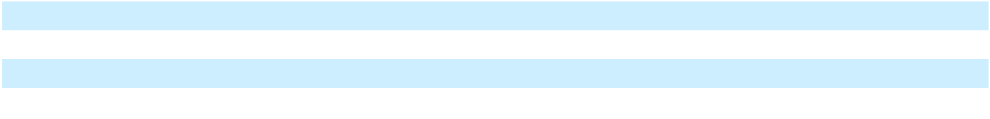

__________

- The sensitivity does not include the effects of the individual annual yield curve rates applied for the calculation of the service and interest cost.

Refer to Note 15 to our consolidated financial statements for additional information on pension contributions, investment strategies, assumptions, the change in benefit obligations and related plan assets, pension funding requirements and future net benefit payments. Refer to Note 2 to our consolidated financial statements for a discussion of the inputs used to determine fair value for each significant asset class or category.

Valuation of Deferred Tax Assets The ability to realize deferred tax assets depends on the ability to generate sufficient taxable income within the carryback or carryforward periods provided for in the tax law for each applicable tax jurisdiction. The assessment regarding whether a valuation allowance is required or should be adjusted is based on an evaluation of possible sources of taxable income and also considers all available positive and negative evidence factors. Our accounting for the valuation of deferred tax assets represents our best estimate of future events. Changes in our current estimates, due to unanticipated market conditions, governmental legislative actions or events, could have a material effect on our ability to utilize deferred tax assets.

At December 31, 2024, valuation allowances against deferred tax assets were $6.5 billion. Refer to Note 17 to our consolidated financial statements for additional information on the composition of these valuation allowances.

Non-GAAP Measures We use both GAAP and non-GAAP financial measures for operational and financial decision making, and to assess Company and segment business performance. Our non-GAAP measures include: EBIT-adjusted, presented net of noncontrolling interests; EBT-adjusted for our GM Financial segment; EPS-diluted-adjusted; ETR-adjusted; ROIC-adjusted and adjusted automotive free cash flow. Our calculation of these non-GAAP measures may not be comparable to similarly titled measures of other companies due to potential differences between companies in the method of calculation. As a result, the use of these non-GAAP measures has limitations and should not be considered superior to, in isolation from, or as a substitute for, related U.S. GAAP measures.

These non-GAAP measures allow management and investors to view operating trends, perform analytical comparisons and benchmark performance between periods and among geographic regions to understand operating performance without regard to items we do not consider a component of our core operating performance. Furthermore, these non-GAAP measures allow investors the opportunity to measure and monitor our performance against our externally communicated targets and evaluate the investment decisions being made by management to improve ROIC-adjusted. Management uses these measures in its financial, investment and operational decision-making processes, for internal reporting and as part of its forecasting and budgeting processes. Further, our Board of Directors uses certain of these and other measures as key metrics to determine management performance under our performance-based compensation plans. For these reasons, we believe these non-GAAP measures are useful for our investors.

42

Table of Contents

GENERAL MOTORS COMPANY AND SUBSIDIARIES

EBIT-adjusted (Most comparable GAAP measure: Net income attributable to stockholders) EBIT-adjusted is presented net of noncontrolling interests and is used by management and can be used by investors to review our consolidated operating results because it excludes automotive interest income, automotive interest expense and income taxes as well as certain additional adjustments that are not considered part of our core operations. Examples of adjustments to EBIT include, but are not limited to, impairment charges on long-lived assets and other exit costs resulting from strategic shifts in our operations or discrete market and business conditions, and certain costs arising from legal matters. For EBIT-adjusted and our other non-GAAP measures, once we have made an adjustment in the current period for an item, we will also adjust the related non-GAAP measure in any future periods in which there is an impact from the item. Our corresponding measure for our GM Financial segment is EBT-adjusted because interest income and interest expense are part of operating results when assessing and measuring the operational and financial performance of the segment.

EPS-diluted-adjusted (Most comparable GAAP measure: Diluted earnings per common share) EPS-diluted-adjusted is used by management and can be used by investors to review our consolidated diluted EPS results on a consistent basis. EPS-diluted-adjusted is calculated as net income attributable to common stockholders-diluted less adjustments noted above for EBIT-adjusted and certain income tax adjustments divided by weighted-average common shares outstanding-diluted. Examples of income tax adjustments include the establishment or release of significant deferred tax asset valuation allowances.

ETR-adjusted (Most comparable GAAP measure: Effective tax rate) ETR-adjusted is used by management and can be used by investors to review the consolidated effective tax rate for our core operations on a consistent basis. ETR-adjusted is calculated as Income tax expense less the income tax related to the adjustments noted above for EBIT-adjusted and the income tax adjustments noted above for EPS-diluted-adjusted divided by Income before income taxes less adjustments. When we provide an expected adjusted effective tax rate, we do not provide an expected effective tax rate because the U.S. GAAP measure may include significant adjustments that are difficult to predict.

ROIC-adjusted (Most comparable GAAP measure: Return on equity) ROIC-adjusted is used by management and can be used by investors to review our investment and capital allocation decisions. We define ROIC-adjusted as EBIT-adjusted for the trailing four quarters divided by ROIC-adjusted average net assets, which is considered to be the average equity balances adjusted for average automotive debt and interest liabilities, exclusive of finance leases; average automotive net pension and OPEB liabilities; and average automotive net income tax assets during the same period.

Adjusted automotive free cash flow (Most comparable GAAP measure: Net automotive cash provided by operating activities) Adjusted automotive free cash flow is used by management and can be used by investors to review the liquidity of our automotive operations and to measure and monitor our performance against our capital allocation program and evaluate our automotive liquidity against the substantial cash requirements of our automotive operations. We measure adjusted automotive free cash flow as automotive operating cash flow from operations less capital expenditures adjusted for management actions. Management actions can include voluntary events such as discretionary contributions to employee benefit plans or nonrecurring specific events such as a closure of a facility that are considered special for EBIT-adjusted purposes. Refer to the “Liquidity and Capital Resources” section of this MD&A for additional information.

43

Table of Contents

GENERAL MOTORS COMPANY AND SUBSIDIARIES

The following table reconciles Net income attributable to stockholders under U.S. GAAP to EBIT-adjusted:

 |  | Years Ended December 31,
 |  | 2024 |  |  | 2023 |  |  | 2022
Net income attributable to stockholders | $ | 6,008 | $ |  | 10,127 | $ |  | 9,934
Income tax expense |  | 2,556 |  |  | 563 |  |  | 1,888
Automotive interest expense |  | 846 |  |  | 911 |  |  | 987
Automotive interest income |  | (967) |  |  | (1,109) |  |  | (460)
Adjustments
China JV restructuring actions(a) |  | 4,010 |  |  | — |  |  | —
Cruise restructuring(b) |  | 1,103 |  |  | 478 |  |  | —
Buick dealer strategy(c) |  | 964 |  |  | 569 |  |  | 511
Restructuring actions(d) |  | 200 |  |  | — |  |  | —
GMI plant wind down(e) |  | 150 |  |  | — |  |  | —
Headquarters relocation(f) |  | 64 |  |  | — |  |  | —
Voluntary separation program(g) |  | — |  |  | 1,035 |  |  | —
GM Korea wage litigation(h) |  | — |  |  | (106) |  |  | —
India asset sales(i) |  | — |  |  | (111) |  |  | —
Cruise compensation modifications(j) |  | — |  |  | — |  |  | 1,057
Russia exit(k) |  | — |  |  | — |  |  | 657
Patent royalty matters(l) |  | — |  |  | — |  |  | (100)
Total adjustments |  | 6,491 |  |  | 1,865 |  |  | 2,125
EBIT-adjusted | $ | 14,934 | $ |  | 12,357 | $ |  | 14,474
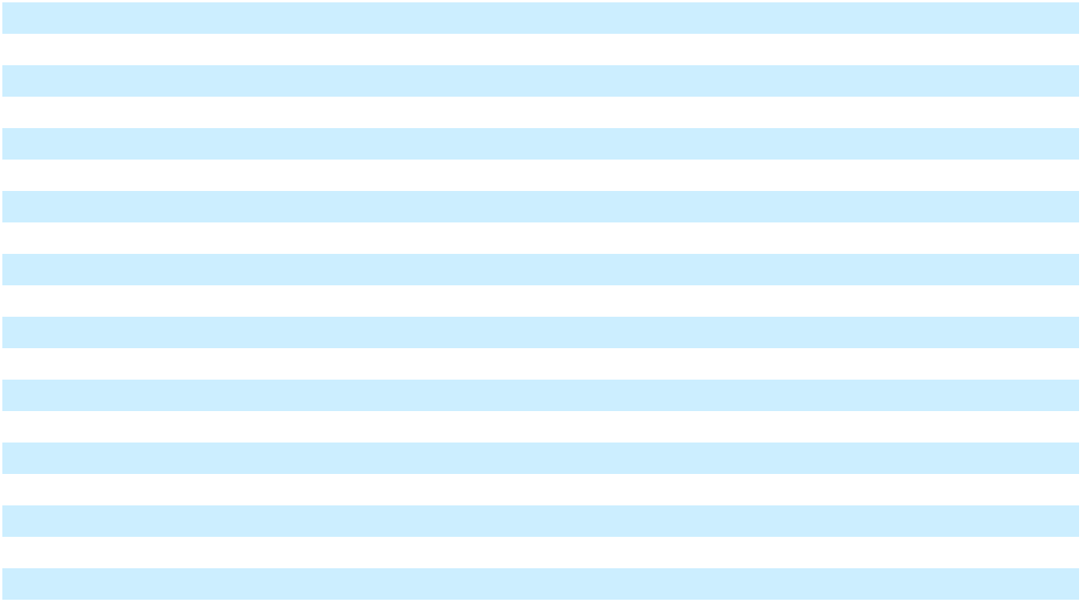
__________

- These adjustments were excluded because they relate to the other-than-temporary impairment and our portion of restructuring charges recorded in equity earnings associated with our restructuring actions of Automotive China JVs.
- These adjustments were excluded because they relate to restructuring charges resulting from the plan to combine the Cruise and GM technical efforts to advance autonomous and assisted driving, the indefinite delay of the Cruise Origin and the voluntarily pausing in 2023 of Cruise's driverless, supervised and manual AV operations in the U.S. The adjustments primarily consist of non-cash restructuring charges, supplier-related charges and employee separation costs.

- These adjustments were excluded because they relate to strategic activities to transition certain Buick dealers out of our dealer network as part of Buick’s EV strategy.
- These adjustments were excluded because they relate to employee separation charges primarily in North America.

- These adjustments were excluded because they relate to the wind down of our manufacturing operations in Colombia and Ecuador.

- These adjustments were excluded because they relate to the GM headquarters relocation, primarily consisting of accelerated depreciation.
- These adjustments were excluded because they relate to the acceleration of attrition as part of the cost reduction program announced in January 2023, primarily in the U.S.
- These adjustments were excluded because they relate to the partial resolution of subcontractor matters in Korea.

- These adjustments were excluded because they relate to an asset sale resulting from our strategic decision in 2020 to exit India.

- This adjustment was excluded because it relates to the one-time modification of Cruise stock incentive awards.

- This adjustment was excluded because it relates to the shutdown of our Russia business including the write off of our net investment and release of accumulated translation losses into earnings.
- These adjustments were excluded because they relate to certain royalties accrued with respect to past-year vehicle sales in 2021 and the resolution of substantially all of these matters in 2022.

44

Table of Contents

GENERAL MOTORS COMPANY AND SUBSIDIARIES

The following table reconciles diluted earnings per common share under U.S. GAAP to EPS-diluted-adjusted:

 |  |  |  |  |  |  | Years Ended December 31,
 |  | 2024 |  |  |  |  |  | 2023 |  |  |  |  |  | 2022
 |  | Amount |  | Per Share |  |  |  | Amount |  | Per Share |  |  |  | Amount |  | Per Share
Diluted earnings per common share | $ | 7,189 | $ |  | 6.37 | $ |  | 10,022 | $ |  | 7.32 | $ |  | 8,915 | $ |  | 6.13
Adjustments(a) |  | 6,491 |  |  | 5.75 |  |  | 1,865 |  |  | 1.36 |  |  | 2,125 |  |  | 1.46
Tax effect on adjustments(b) |  | (477) |  |  | (0.42) |  |  | (504) |  |  | (0.37) |  |  | (423) |  |  | (0.29)
Tax adjustments(c) |  | — |  |  | — |  |  | (870) |  |  | (0.64) |  |  | (482) |  |  | (0.33)
Return to (return from) preferred shareholders(d) |  | (1,239) |  |  | (1.10) |  |  | — |  |  | — |  |  | 909 |  |  | 0.63
EPS-diluted-adjusted | $ | 11,963 | $ |  | 10.60 | $ |  | 10,513 | $ |  | 7.68 | $ |  | 11,044 | $ |  | 7.59
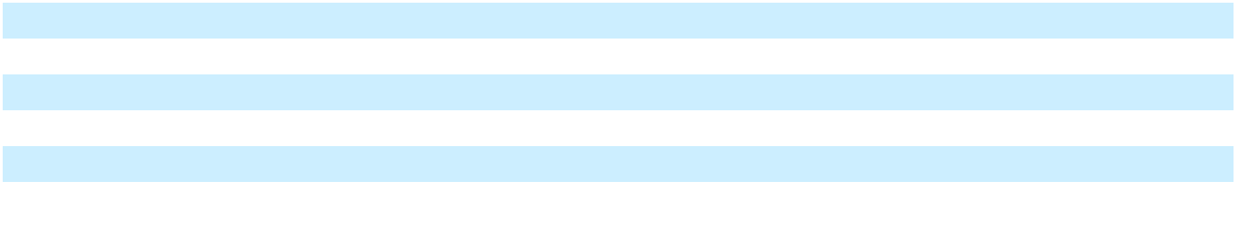
__________

- Refer to the reconciliation of Net income attributable to stockholders under U.S. GAAP to EBIT-adjusted within this section of the MD&A for adjustment details.
- The tax effect of each adjustment is determined based on the tax laws and valuation allowance status of the jurisdiction to which the adjustment relates.
- In the year ended December 31, 2023, the adjustment consists of tax benefit related to the release of a valuation allowance against deferred tax assets considered realizable in Korea. In the year ended December 31, 2022, the adjustment consists of tax benefit related to the release of a valuation allowance against deferred tax assets considered realizable as a result of Cruise tax reconsolidation. These adjustments were excluded because significant impacts of valuation allowances are not considered part of our core operations.

- This adjustment consists of a return to (return from) the preferred shareholders related to the redemption of Cruise preferred shares from noncontrolling interest holders in the years ended December 31, 2024 and 2022.

The following table reconciles our effective tax rate under U.S. GAAP to ETR-adjusted:

 |  |  |  |  |  |  |  |  |  | Years Ended December 31,
 |  |  |  |  | 2024 |  |  |  |  |  |  |  | 2023 |  |  |  |  |  |  |  | 2022
 |  | Income |  | Income tax |  |  | Effective |  |  | Income |  | Income tax |  |  | Effective |  |  | Income |  | Income tax |  |  | Effective
 |  | before |  |  |  |  | Effective |  |  | before |  |  |  |  | Effective |  |  | before |  |  |  |  | Effective
Effective tax rate | income taxes |  |  |  | expense |  | tax rate |  | income taxes |  |  |  | expense |  | tax rate |  | income taxes |  |  |  | expense |  | tax rate
Effective tax rate | $ | 8,519 |  | $ | 2,556 |  | 30.0 % |  | $ | 10,403 |  | $ | 563 |  | 5.4 % |  | $ | 11,597 |  | $ | 1,888 |  | 16.3 %
Adjustments(a) |  | 6,564 |  |  | 477 |  |  |  |  | 1,916 |  |  | 504 |  |  |  |  | 2,221 |  |  | 423
Tax adjustments(b) |  |  |  |  | — |  |  |  |  |  |  |  | 870 |  |  |  |  |  |  |  | 482
ETR-adjusted | $ | 15,083 | $ |  | 3,033 | 20.1 % |  | $ |  | 12,319 | $ |  | 1,937 | 15.7 % |  | $ |  | 13,818 | $ |  | 2,793 | 20.2 %
__________
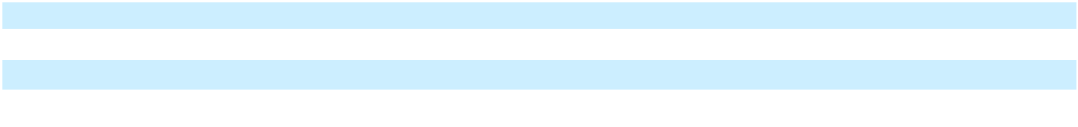
- Refer to the reconciliation of Net income attributable to stockholders under U.S. GAAP to EBIT-adjusted within this section of the MD&A for adjustment details. Net income attributable to noncontrolling interests for these adjustments is included in the years ended December 31, 2024, 2023 and 2022. The tax effect of each adjustment is determined based on the tax laws and valuation allowance status of the jurisdiction to which the adjustment relates.

- Refer to the reconciliation of diluted earnings per common share under U.S. GAAP to EPS-diluted-adjusted within this section of the MD&A for adjustment details.

We define return on equity (ROE) as Net income attributable to stockholders for the trailing four quarters divided by average equity for the same period. Management uses average equity to provide comparable amounts in the calculation of ROE. The following table summarizes the calculation of ROE (dollars in billions):

 |  |  | Years Ended December 31,
 |  | 2024 |  |  |  | 2023 |  |  | 2022
Net income attributable to stockholders | $ | 6.0 | $ |  |  | 10.1 | $ |  | 9.9
Average equity(a) | $ | 68.9 | $ |  |  | 72.0 | $ |  | 66.6
ROE |  | 8.7 % |  |  |  | 14.1 % |  |  | 14.9 %

__________

- Includes equity of noncontrolling interests where the corresponding earnings (loss) are included in Net income attributable to stockholders.

45

Table of Contents

GENERAL MOTORS COMPANY AND SUBSIDIARIES

The following table summarizes the calculation of ROIC-adjusted (dollars in billions):

 |  | Years Ended December 31,
 |  | 2024 |  |  | 2023 |  |  | 2022
EBIT-adjusted(a) | $ | 14.9 | $ |  | 12.4 | $ |  | 14.5
Average equity(b) | $ | 68.9 | $ |  | 72.0 | $ |  | 66.6
Add: Average automotive debt and interest liabilities (excluding finance |  | 16.1 |  |  | 16.2 |  |  | 17.6
leases) |  | 16.1 |  |  | 16.2 |  |  | 17.6
Add: Average automotive net pension and OPEB liability |  | 9.4 |  |  | 8.1 |  |  | 9.4
Less: Average automotive net income tax asset |  | (22.7) |  |  | (21.1) |  |  | (21.2)
ROIC-adjusted average net assets | $ | 71.8 | $ |  | 75.2 | $ |  | 72.3
ROIC-adjusted
ROIC-adjusted |  | 20.8 % |  |  | 16.4 % |  |  | 20.0 %
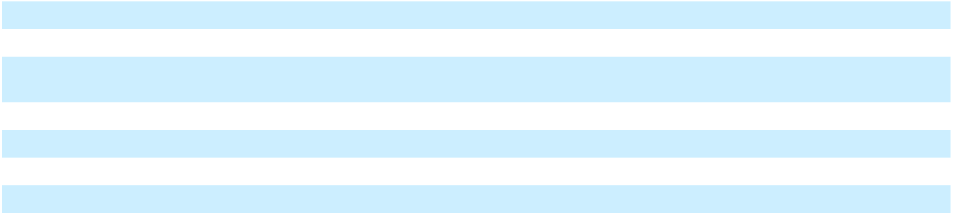

__________

- Refer to the reconciliation of Net income attributable to stockholders under U.S. GAAP to EBIT-adjusted within this section of the MD&A.
- Includes equity of noncontrolling interests where the corresponding earnings (loss) are included in EBIT-adjusted.

Forward-Looking Statements This report and the other reports filed by us with the SEC from time to time, as well as statements incorporated by reference herein and related comments by our management, may include "forward-looking statements" within the meaning of the U.S. federal securities laws. Forward-looking statements are any statements other than statements of historical fact. Forward-looking statements represent our current judgment about possible future events and are often identified by words like “aim,” “anticipate,” “appears,” “approximately,” “believe,” “continue,” “could,” “designed,” “effect,” “estimate,” “evaluate,” “expect,” “forecast,” “goal,” “initiative,” “intend,” “may,” “objective,” “outlook,” “plan,” “potential,” “priorities,” “project,” “pursue,” “seek,” “should,” “target,” “when,” “will,” “would,” or the negative of any of those words or similar expressions. In making these statements, we rely on assumptions and analysis based on our experience and perception of historical trends, current conditions and expected future developments as well as other factors we consider appropriate under the circumstances. We believe these judgments are reasonable, but these statements are not guarantees of any future events or financial results, and our actual results may differ materially due to a variety of important factors, many of which are beyond our control. These factors, which may be revised or supplemented in subsequent reports we file with the SEC, include, among others, the following: (1) our ability to deliver new products, services, technologies and customer experiences in response to increased competition and changing consumer needs and preferences; (2) our ability to attract and retain talented and highly skilled employees; (3) our ability to timely fund and introduce new and improved vehicle models, including EVs, that are able to attract a sufficient number of consumers; (4) our ability to profitably deliver a strategic portfolio of EVs; (5) our long-term strategy is dependent on consumer adoptions of EVs; (6) the success of our current line of ICE vehicles, particularly our full-size SUVs and full-size pickup trucks; (7) our highly competitive industry, which has been historically characterized by excess manufacturing capacity and the use of incentives, and the introduction of new and improved vehicle models by our competitors; (8) the unique technological, operational, regulatory and competitive risks related to our recently announced plans to refocus our AV strategy on personal vehicles; (9) risks associated with climate change, including increased regulation of GHG emissions, our transition to EVs and the potential increased impacts of severe weather events; (10) global automobile market sales volume, which can be volatile; (11) inflationary pressures and persistently high prices and uncertain availability of raw materials and commodities used by us and our suppliers, and instability in logistics and related costs; (12) our business in China, which is subject to unique operational, competitive, regulatory and economic risks; (13) the success of our ongoing strategic business relationships, particularly with respect to facilitating access to raw materials necessary for the production of EVs, and of our joint ventures, which we cannot operate solely for our benefit and over which we may have limited control; (14) the international scale and footprint of our operations, which expose us to a variety of unique political, economic, competitive and regulatory risks, including the risk of changes in government leadership and laws (including labor, trade, tax and other laws), political uncertainty or instability and economic tensions between governments and changes in international trade policies, new barriers to entry and changes to or withdrawals from free trade agreements, changes in foreign exchange rates and interest rates, economic downturns in the countries in which we operate, differing local product preferences and product requirements, changes to and compliance with U.S. and foreign countries' export controls and economic sanctions, differing labor regulations, requirements and union relationships, differing dealer and franchise regulations and relationships, difficulties in obtaining financing in foreign countries, and public health crises, including the occurrence of a contagious disease or illness; (15) any significant disruption, including any work stoppages, at any of our manufacturing facilities; (16) the ability of our suppliers to deliver parts, systems and components without disruption and at such times to allow us to meet production schedules; (17) pandemics, epidemics, disease outbreaks and other public health crises; (18) the possibility that competitors may independently develop products and services similar to ours, or that our intellectual property

46

Table of Contents

GENERAL MOTORS COMPANY AND SUBSIDIARIES

rights are not sufficient to prevent competitors from developing or selling those products or services; (19) our ability to manage risks related to security breaches, cyberattacks and other disruptions to our information technology systems and networked products, including connected vehicles; (20) our ability to manage security breaches and other disruptions to our in-vehicle systems; (21) our ability to comply with increasingly complex, restrictive and punitive regulations relating to our enterprise data practices, including the collection, use, sharing and security of the personal information of our customers, employees or suppliers; (22) our ability to comply with extensive laws, regulations and policies applicable to our operations and products, including those relating to fuel economy, emissions and AVs; (23) costs and risks associated with litigation and government investigations; (24) the costs and effect on our reputation of product safety recalls and alleged defects in products and services;

- any additional tax expense or exposure or failure to fully realize available tax incentives; (26) our continued ability to develop captive financing capability through GM Financial; and (27) any significant increase in our pension funding requirements. For a further discussion of these and other risks and uncertainties, refer to Part I, Item 1A. Risk Factors.

We caution readers not to place undue reliance on forward-looking statements. Forward-looking statements speak only as of the date they are made, and we undertake no obligation to update publicly or otherwise revise any forward-looking statements, whether as a result of new information, future events or other factors, except where we are expressly required to do so by law.

* * * * * * *

Item 7A. Quantitative and Qualitative Disclosures About Market Risk

The overall financial risk management program is under the responsibility of the Chief Financial Officer with support from the Financial Risk Council, which reviews and, where appropriate, approves strategies to be pursued to mitigate these risks. The Financial Risk Council comprises members of our management and functions under the oversight of the Audit Committee and Finance Committee of the Board of Directors. The Audit Committee and Finance Committee assist and guide the Board of Directors in its oversight of our financial and risk management strategies. A risk management control framework is utilized to monitor the strategies, risks and related hedge positions in accordance with the policies and procedures approved by the Financial Risk Council. Our financial risk management policy is designed to protect against risk arising from large adverse market movements on our key exposures.

Automotive The following analyses provide quantitative information regarding exposure to foreign currency exchange rate risk, interest rate risk and commodity risk. Sensitivity analysis is used to measure the potential loss in the fair value of financial instruments with exposure to market risk. The models used assume instantaneous, parallel shifts in exchange rates, interest rate yield curves and commodity prices. For options and other instruments with nonlinear returns, models appropriate to these types of instruments are utilized to determine the effect of market shifts. There are certain shortcomings inherent in the sensitivity analyses presented, primarily due to the assumption that interest rates change in a parallel fashion and that spot exchange rates and commodity prices change instantaneously. In addition, the analyses are unable to reflect the complex market reactions that normally would arise from the market shifts modeled and do not contemplate the effects of correlations between foreign currency exposures and offsetting long-short positions in currency or other exposures, such as interest rates and commodity prices, which may significantly reduce the potential loss in value.

Foreign Currency Exchange Rate Risk We have foreign currency exposures related to buying, selling and financing in currencies other than the functional currencies of our operations. At December 31, 2024, our most significant foreign currency exposures were between the U.S. dollar and the Canadian dollar, Chinese yuan, Korean won, Mexican peso and Brazilian real. Derivative instruments such as foreign currency forwards, swaps and options are primarily used to hedge exposures with respect to forecasted revenues, costs and commitments denominated in foreign currencies. Such contracts had remaining maturities of up to 12 months at December 31, 2024.

The net fair value liability of financial instruments with exposure to foreign currency risk was $0.2 billion and $0.4 billion at December 31, 2024 and 2023. These amounts are calculated utilizing a population of foreign currency exchange derivatives and foreign currency denominated debt and exclude the offsetting effect of foreign currency cash, cash equivalents and other assets. The potential loss in fair value for such financial instruments from a 10% adverse change in all quoted foreign currency exchange rates would have been $0.3 billion and insignificant at December 31, 2024 and 2023.

We are exposed to foreign currency risk due to the translation and remeasurement of the results of certain international operations into U.S. dollars as part of the consolidation process. Fluctuations in foreign currency exchange rates can therefore create volatility in the results of operations and may adversely affect our financial condition.

47

Table of Contents

GENERAL MOTORS COMPANY AND SUBSIDIARIES

The following table summarizes the amounts of automotive foreign currency translation, transaction and remeasurement (gains) losses:

 |  | Years Ended December 31,
 |  | 2024 |  |  | 2023
Translation (gains) losses recorded in Accumulated other comprehensive loss | $ | 765 | $ |  | (169)
Transaction and remeasurement (gains) losses recorded in earnings | $ | (314) | $ |  | 344

Interest Rate Risk We are subject to market risk from exposure to changes in interest rates related to certain financial instruments, primarily debt, finance lease obligations and certain marketable debt securities. At December 31, 2024, interest rate swap positions were used to manage interest rate exposures in our automotive operations and were insignificant. The fair value of debt and finance leases was $15.2 billion and $16.5 billion at December 31, 2024 and 2023. The potential increase in fair value resulting from a 10% decrease in quoted interest rates would have been $0.7 billion at December 31, 2024 and 2023.

We had marketable debt securities of $7.3 billion and $7.6 billion classified as available-for-sale at December 31, 2024 and 2023. The potential decrease in fair value from a 50 basis point increase in interest rates would have been insignificant at December 31, 2024 and 2023.

Commodity Risk We have commodity price risk which could have an impact of our financial results as result of fluctuations in the prices of commodities used in vehicle production. At December 31, 2024 we used derivative instruments such as commodity forwards, swaps and options to hedge a portion of our exposures with respect to forecasted commodity purchases of steel, copper, aluminum, palladium, lithium and nickel.

The net fair value liability of financial instruments with exposure to commodity price movements was insignificant at December 31, 2024 and 2023. The potential change in fair value for such financial instruments from a 10% adverse change in the underlying commodity prices would have been $0.2 billion and insignificant at December 31, 2024 and 2023.

Automotive Financing - GM Financial

Interest Rate Risk Fluctuations in market interest rates can affect GM Financial's gross interest rate spread, which is the difference between interest earned on finance receivables and interest paid on debt. GM Financial is exposed to interest rate risks as financial assets and liabilities have different characteristics that may impact financial performance. These differences may include tenor, yield, repricing timing and prepayment expectations. Typically, retail finance receivables and leases purchased by GM Financial earn fixed interest and commercial finance receivables originated by GM Financial earn variable interest. GM Financial funds its business with variable or fixed rate debt. The variable rate debt is subject to adjustments to reflect prevailing market interest rates. To help mitigate interest rate risk or mismatched funding, GM Financial may employ hedging.

Quantitative Disclosure GM Financial measures the sensitivity of its net interest income to changes in interest rates by using interest rate scenarios that assume a hypothetical, instantaneous parallel shift of one hundred basis points in all interest rates across all maturities, as well as a base case that assumes that rates perform at the current market forward curve. However, interest rate changes are rarely instantaneous or parallel and rates could move more or less than the one percentage point assumed in GM Financial's analysis. Therefore, the actual impact to net interest income could be higher or lower than the results detailed in the table below. These interest rate scenarios are purely hypothetical and do not represent GM Financial's view of future interest rate movements.

48

Table of Contents

GENERAL MOTORS COMPANY AND SUBSIDIARIES

At December 31, 2024, GM Financial moved to an asset-sensitive profile from a liability-sensitive profile in 2023, meaning that more assets than liabilities were expected to reprice within the next 12 months. During a period of rising interest rates, the interest earned on assets would increase more than the interest paid on liabilities, which would initially increase net interest income. During a period of falling interest rates, net interest income would be expected to initially decrease.

The following table presents GM Financial's net interest income sensitivity to interest rate movement:

 |  | Years Ended December 31,
 |  | 2024 |  |  | 2023
One hundred basis points instantaneous increase in interest rates | $ | 5.6 | $ |  | (7.7)
One hundred basis points instantaneous decrease in interest rates(a) | $ | (5.6) | $ |  | 7.7

__________

- Net interest income sensitivity given a one hundred basis point decrease in interest rates requires an assumption of negative interest rates in markets where existing interest rates are below one percent.

Additional Model Assumptions The sensitivity analysis presented is GM Financial's best estimate of the effect of the hypothetical interest rate scenarios; however, actual results could differ. The estimates are also based on assumptions including the amortization and prepayment of the finance receivable portfolio, originations of finance receivables and leases, refinancing of maturing debt, replacement of maturing derivatives and exercise of options embedded in debt and derivatives. The prepayment projections are based on historical experience. If interest rates or other factors change, actual prepayment experience could be different than projected.

Foreign Currency Exchange Rate Risk GM Financial is exposed to foreign currency risk due to the translation and remeasurement of the results of certain international operations into U.S. dollars as part of the consolidation process. Fluctuations in foreign currency exchange rates can therefore create volatility in the results of operations and may adversely affect GM Financial's financial condition.

GM Financial primarily finances its receivables and leased assets with debt in the same currency. When a different currency is used, GM Financial may use foreign currency swaps to convert substantially all of its foreign currency debt obligations to the local currency of the receivables and leased assets to minimize any impact to earnings. As a result, GM Financial believes its market risk exposure relating to changes in currency exchange rates at December 31, 2024 was insignificant.

GM Financial had foreign currency swaps with notional amounts of $8.4 billion and $8.0 billion at December 31, 2024 and 2023. The net fair value of these derivative financial instruments was a liability of $0.4 billion and $0.2 billion at December 31, 2024 and 2023.

The following table summarizes GM Financial's foreign currency translation, transaction and remeasurement (gains) losses:

 |  | Years Ended December 31,
 |  | 2024 |  |  | 2023
Translation (gains) losses recorded in Accumulated other comprehensive loss | $ | 403 | $ |  | (147)
Transaction and remeasurement (gains) losses recorded in earnings | $ | (7) | $ |  | 5

* * * * * * *

49

Table of Contents

REPORT OF INDEPENDENT REGISTERED PUBLIC ACCOUNTING FIRM

To the Shareholders and the Board of Directors of General Motors Company

Opinion on the Financial Statements

We have audited the accompanying consolidated balance sheets of General Motors Company and subsidiaries (the Company) as of December 31, 2024 and 2023, the related consolidated income statements and consolidated statements of comprehensive income, cash flows and equity for each of the three years in the period ended December 31, 2024, and the related notes (collectively referred to as the “financial statements”). In our opinion, the financial statements present fairly, in all material respects, the financial position of the Company at December 31, 2024 and 2023, and the results of its operations and its cash flows for each of the three years in the period ended December 31, 2024, in conformity with U.S. generally accepted accounting principles.

We also have audited, in accordance with the standards of the Public Company Accounting Oversight Board (United States) (PCAOB), the Company's internal control over financial reporting as of December 31, 2024, based on criteria established in Internal Control-Integrated Framework issued by the Committee of Sponsoring Organizations of the Treadway Commission (2013 framework) and our report dated January 28, 2025 expressed an unqualified opinion thereon.

Basis for Opinion

These financial statements are the responsibility of the Company's management. Our responsibility is to express an opinion on the Company’s financial statements based on our audits. We are a public accounting firm registered with the PCAOB and are required to be independent with respect to the Company in accordance with the U.S. federal securities laws and the applicable rules and regulations of the Securities and Exchange Commission and the PCAOB.

We conducted our audits in accordance with the standards of the PCAOB. Those standards require that we plan and perform the audit to obtain reasonable assurance about whether the financial statements are free of material misstatement, whether due to error or fraud. Our audits included performing procedures to assess the risks of material misstatement of the financial statements, whether due to error or fraud, and performing procedures that respond to those risks. Such procedures included examining, on a test basis, evidence regarding the amounts and disclosures in the financial statements. Our audits also included evaluating the accounting principles used and significant estimates made by management, as well as evaluating the overall presentation of the financial statements. We believe that our audits provide a reasonable basis for our opinion.

Critical Audit Matters

The critical audit matters communicated below are matters arising from the current period audit of the financial statements that were communicated or required to be communicated to the audit committee and that: (1) relate to accounts or disclosures that are material to the financial statements and (2) involved our especially challenging, subjective or complex judgments. The communication of critical audit matters does not alter in any way our opinion on the financial statements, taken as a whole, and we are not, by communicating the critical audit matters below, providing separate opinions on the critical audit matters or on the accounts or disclosures to which they relate.

Product warranty and recall campaigns

Description of the matter As discussed in Note 12 to the financial statements, the liabilities for product warranty and recall campaigns amount to $10.6 billion at December 31, 2024. The Company accrues for costs related to product warranty at the time of vehicle sale and accrues the estimated cost of recall campaigns when they are probable and estimable.

Auditing these liabilities involved a high degree of subjectivity in evaluating management’s estimates due to the size, uncertainties, and potential volatility related to the estimated liabilities. Management’s estimates consider historical claims experience, including the nature, frequency, and average cost of claims of each vehicle line or each model year of the vehicle line, and the key assumptions of historical data being predictive of future activity and events, specifically the number of historical periods used and the weighting of historical data in the reserve studies.

50

Table of Contents

How we addressed the matter in our audit

Description of the matter

How we addressed the matter in our audit

Description of the matter

We evaluated the design and tested the operating effectiveness of internal controls over the Company’s product warranty and recall campaign processes. We tested internal controls over management’s review of the valuation models and significant assumptions for product warranty and recall, including the warranty claims forecasted based on the frequency and average cost per warranty claim for product warranty, and the cost estimates related to recall campaigns. Our audit also included the evaluation of controls that address the completeness and accuracy of the data utilized in the valuation models.

Our audit procedures related to product warranty and recall campaigns also included, among others, evaluating the Company’s estimation methodology, the related significant assumptions and underlying data, and performing analytical procedures to corroborate cost per vehicle based on historical claims data. Furthermore, we performed sensitivity analyses to evaluate the significant judgments made by management, including cost estimates to evaluate the impact on reserves from changes in assumptions. We performed analysis over the vehicle lines and model years that had little or no claims experience to ensure the vehicle and model substitutions are comparable. We also involved actuarial specialists to evaluate the methodologies and assumptions, and to test the actuarial calculations used by the Company.

Sales incentives

As discussed in Note 2 to the financial statements, Automotive net sales and revenue represents the amount of consideration to which the Company expects to be entitled in exchange for transferring goods or providing services, which is net of estimated dealer and customer sales incentives the Company reasonably expects to pay. Provisions for dealer and customer sales incentives are recorded as a reduction to Automotive net sales and revenue at the time of vehicle sale. The liabilities for dealer and customer allowances, claims and discounts amount to $7.3 billion at December 31, 2024.

Auditing the estimate of sales incentives involved a high degree of judgment. Significant factors used by the Company in estimating its liability for sales incentives include type of program, forecasted sales volume, product mix, and the rate of customer acceptance of incentive programs, all of which are estimated based on historical experience and assumptions concerning future customer behavior and market conditions. The Company’s estimation model reflects the best estimate of the total incentive amount that the Company reasonably expects to pay at the time of sale. The estimated cost of incentives is forward-looking, and could be materially affected by future economic and market conditions.

We evaluated the design and tested the operating effectiveness of internal controls over the Company’s sales incentive process, including management’s review of the estimation model, the significant assumptions (e.g., incentive cost per unit, customer take rate, and market conditions), and the data inputs used in the model.

Our audit procedures included, among others, the performance of analytical procedures to develop an independent range of the liability for sales incentives as of the balance sheet date. Our independent range was developed for comparison to the Company’s recorded liability, and is based on historical claims, forecasted spend, and the specific vehicle mix of current dealer stock. In addition, we performed sensitivity analyses over the cost per unit assumption developed by management to evaluate the impact on the liability resulting from a change in the assumption. Lastly, we assessed management’s forecasting process by performing quarterly hindsight analyses to assess the adequacy of prior forecasts.

Valuation of GM Financial equipment on operating leases

GM Financial has recorded investments in vehicles leased to retail customers under operating leases. As discussed in Note 2 to the financial statements, at the beginning of the lease, management establishes an expected residual value for each vehicle at the end of the lease term. During the term of a lease, management periodically evaluates the estimated residual value and may adjust the value downward or upward. The Company’s estimated residual value of leased vehicles at the end of lease term was $23.5 billion as of December 31, 2024.

51

Table of Contents

How we addressed the matter in our audit

Auditing management’s estimate of the residual value of leased vehicles involved a high degree of judgment. Management’s estimate is based, in part, on third-party data which considers inputs including recent auction values and assumptions regarding the expected future volume of leased vehicles that will be returned to the Company, used car prices, manufacturer incentive programs and fuel prices. Realization of the residual values is dependent on the future ability to market the vehicles under future prevailing market conditions.

We evaluated the design and tested the operating effectiveness of the Company’s controls over the lease residual estimation process, including controls over management’s review of residual value estimates obtained from the Company’s third-party provider and other significant assumptions.

Our procedures also included, among others, independently recalculating depreciation related to equipment on operating leases and performing sensitivity analyses related to significant assumptions. We also performed hindsight analyses to assess the propriety of management’s estimate of residual values, as well as tested the completeness and accuracy of data from underlying systems and data warehouses that are used in the estimation models.

/s/ Ernst & Young LLP

We have served as the Company's auditor since 2017.

Detroit, Michigan

January 28, 2025

52

Table of Contents

REPORT OF INDEPENDENT REGISTERED PUBLIC ACCOUNTING FIRM

To the Shareholders and the Board of Directors of General Motors Company

Opinion on Internal Control Over Financial Reporting

We have audited General Motors Company and subsidiaries’ internal control over financial reporting as of December 31, 2024, based on criteria established in Internal Control-Integrated Framework issued by the Committee of Sponsoring Organizations of the Treadway Commission (2013 framework) (the COSO criteria). In our opinion, General Motors Company and subsidiaries (the Company) maintained, in all material respects, effective internal control over financial reporting as of December 31, 2024, based on the COSO criteria.

We also have audited, in accordance with the standards of the Public Company Accounting Oversight Board (United States) (PCAOB), the consolidated balance sheets of the Company as of December 31, 2024 and 2023, the related consolidated income statements and consolidated statements of comprehensive income, cash flows and equity for each of the three years in the period ended December 31, 2024, and the related notes and our report dated January 28, 2025 expressed an unqualified opinion thereon.

Basis for Opinion

The Company’s management is responsible for maintaining effective internal control over financial reporting and for its assessment of the effectiveness of internal control over financial reporting included in the accompanying Management’s Report on Internal Control over Financial Reporting. Our responsibility is to express an opinion on the Company’s internal control over financial reporting based on our audit. We are a public accounting firm registered with the PCAOB and are required to be independent with respect to the Company in accordance with the U.S. federal securities laws and the applicable rules and regulations of the Securities and Exchange Commission and the PCAOB.

We conducted our audit in accordance with the standards of the PCAOB. Those standards require that we plan and perform the audit to obtain reasonable assurance about whether effective internal control over financial reporting was maintained in all material respects.

Our audit included obtaining an understanding of internal control over financial reporting, assessing the risk that a material weakness exists, testing and evaluating the design and operating effectiveness of internal control based on the assessed risk, and performing such other procedures as we considered necessary in the circumstances. We believe that our audit provides a reasonable basis for our opinion.

Definition and Limitations of Internal Control Over Financial Reporting

A company’s internal control over financial reporting is a process designed to provide reasonable assurance regarding the reliability of financial reporting and the preparation of financial statements for external purposes in accordance with generally accepted accounting principles. A company’s internal control over financial reporting includes those policies and procedures that (1) pertain to the maintenance of records that, in reasonable detail, accurately and fairly reflect the transactions and dispositions of the assets of the company; (2) provide reasonable assurance that transactions are recorded as necessary to permit preparation of financial statements in accordance with generally accepted accounting principles, and that receipts and expenditures of the company are being made only in accordance with authorizations of management and directors of the company; and (3) provide reasonable assurance regarding prevention or timely detection of unauthorized acquisition, use, or disposition of the company’s assets that could have a material effect on the financial statements.

Because of its inherent limitations, internal control over financial reporting may not prevent or detect misstatements. Also, projections of any evaluation of effectiveness to future periods are subject to the risk that controls may become inadequate because of changes in conditions, or that the degree of compliance with the policies or procedures may deteriorate.

/s/ Ernst & Young LLP

Detroit, Michigan

January 28, 2025

53

Table of Contents

GENERAL MOTORS COMPANY AND SUBSIDIARIES

Item 8. Financial Statements and Supplementary Data

CONSOLIDATED INCOME STATEMENTS

(In millions, except per share amounts)

 |  | Years Ended December 31,
 |  | 2024 |  |  | 2023 |  |  | 2022
Net sales and revenue | $ | 171,606 | $ |  | 157,658 | $ |  | 143,975
Automotive
GM Financial |  | 15,836 |  |  | 14,184 |  |  | 12,760
Total net sales and revenue (Note 3) |  | 187,442 |  |  | 171,842 |  |  | 156,735
Costs and expenses |  | 151,065 |  |  | 141,330 |  |  | 126,892
Automotive and other cost of sales |  | 151,065 |  |  | 141,330 |  |  | 126,892
GM Financial interest, operating and other expenses |  | 12,972 |  |  | 11,374 |  |  | 8,862
Automotive and other selling, general and administrative expense |  | 10,621 |  |  | 9,840 |  |  | 10,667
Total costs and expenses |  | 174,658 |  |  | 162,544 |  |  | 146,421
Operating income (loss) |  | 12,784 |  |  | 9,298 |  |  | 10,315
Automotive interest expense |  | 846 |  |  | 911 |  |  | 987
Interest income and other non-operating income, net (Note 19) |  | 1,257 |  |  | 1,537 |  |  | 1,432
Equity income (loss) (Note 8) |  | (4,675) |  |  | 480 |  |  | 837
Income (loss) before income taxes |  | 8,519 |  |  | 10,403 |  |  | 11,597
Income tax expense (benefit) (Note 17) |  | 2,556 |  |  | 563 |  |  | 1,888
Net income (loss) |  | 5,963 |  |  | 9,840 |  |  | 9,708
Net loss (income) attributable to noncontrolling interests |  | 45 |  |  | 287 |  |  | 226
Net income (loss) attributable to stockholders | $ | 6,008 |  | $ | 10,127 |  | $ | 9,934
Net income (loss) attributable to common stockholders
Net income (loss) attributable to common stockholders | $ | 7,189 | $ |  | 10,022 | $ |  | 8,915
Earnings per share (Note 21)
Basic earnings per common share | $ | 6.45 | $ |  | 7.35 | $ |  | 6.17
Weighted-average common shares outstanding – basic |  | 1,115 |  |  | 1,364 |  |  | 1,445
Diluted earnings per common share | $ | 6.37 | $ |  | 7.32 | $ |  | 6.13
Weighted-average common shares outstanding – diluted |  | 1,129 |  |  | 1,369 |  |  | 1,454
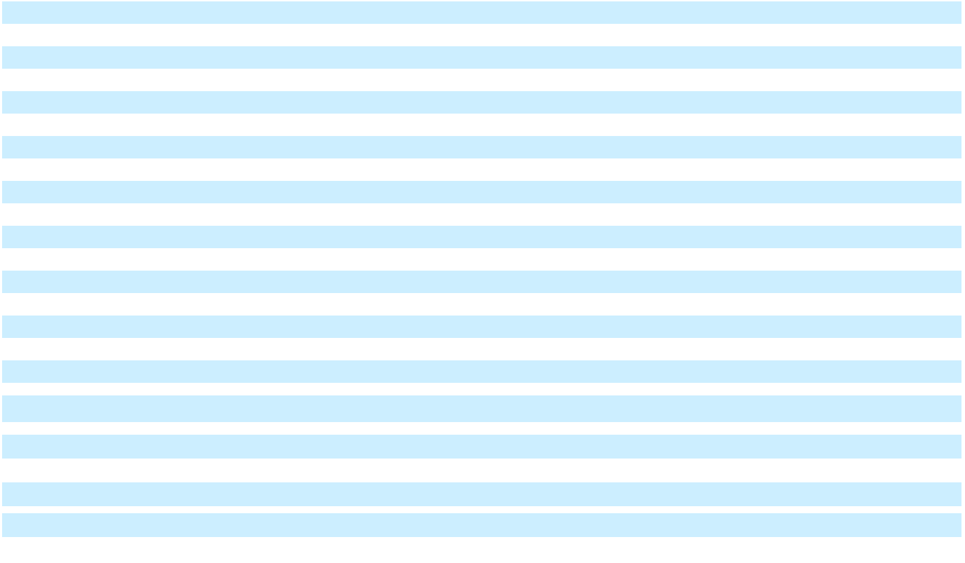

CONSOLIDATED STATEMENTS OF COMPREHENSIVE INCOME

(In millions)

 |  | Years Ended December 31,
 |  | 2024 |  |  | 2023 |  |  | 2022
Net income (loss) | $ | 5,963 | $ |  | 9,840 | $ |  | 9,708
Other comprehensive income (loss), net of tax (Note 20)
Foreign currency translation adjustments and other |  | (1,133) |  |  | 458 |  |  | (340)
Defined benefit plans |  | (4) |  |  | (2,814) |  |  | 1,677
Other comprehensive income (loss), net of tax |  | (1,137) |  |  | (2,355) |  |  | 1,337
Comprehensive income (loss) |  | 4,826 |  |  | 7,485 |  |  | 11,045
Comprehensive loss (income) attributable to noncontrolling interests |  | 176 |  |  | 297 |  |  | 257
Comprehensive income attributable to stockholders (loss) | $ | 5,002 | $ |  | 7,781 | $ |  | 11,303
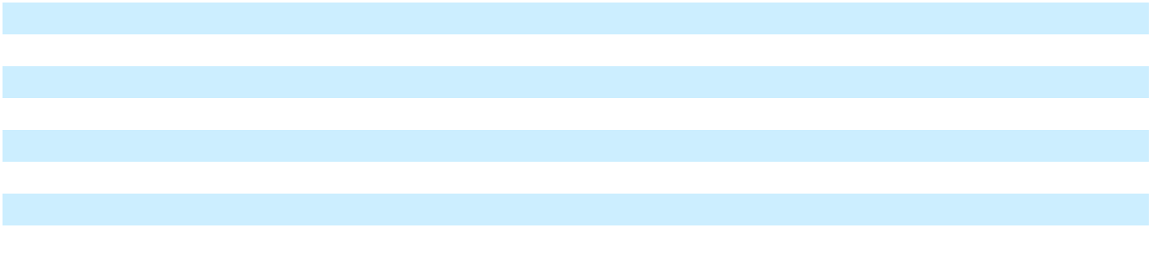

Reference should be made to the notes to consolidated financial statements.

Amounts may not add due to rounding.

54

Table of Contents

GENERAL MOTORS COMPANY AND SUBSIDIARIES

CONSOLIDATED BALANCE SHEETS

(In millions, except per share amounts)

 | December 31, 2024 |  |  | December 31, 2023
ASSETS
Current Assets | $ | 19,872 | $ |  | 18,853
Cash and cash equivalents (Note 4)
Marketable debt securities (Note 4) |  | 7,265 |  |  | 7,613
Accounts and notes receivable, net of allowance of $313 and $298 |  | 12,827 |  |  | 12,378
GM Financial receivables, net of allowance of $991 and $906 (Note 5; Note 11) |  | 46,362 |  |  | 39,076
Inventories (Note 6) |  | 14,564 |  |  | 16,461
Other current assets (Note 4; Note 11) |  | 7,655 |  |  | 7,238
Total current assets |  | 108,545 |  |  | 101,618
Non-current Assets |  | 46,474
GM Financial receivables, net of allowance of $1,467 and $1,438 (Note 5; Note 11) |  | 46,474 |  |  | 45,043
Equity in net assets of nonconsolidated affiliates (Note 8) |  | 7,102 |  |  | 10,613
Property, net (Note 9) |  | 51,904 |  |  | 50,321
Goodwill and intangible assets, net (Note 10) |  | 4,551 |  |  | 4,862
Equipment on operating leases, net (Note 7; Note 11) |  | 31,586 |  |  | 30,582
Deferred income taxes (Note 17) |  | 21,254 |  |  | 22,339
Other assets (Note 4; Note 11) |  | 8,346 |  |  | 7,686
Total non-current assets |  | 171,216 |  |  | 171,446
Total Assets | $ | 279,761 |  | $ | 273,064
LIABILITIES AND EQUITY
Current Liabilities | $ | 25,680 | $ |  | 28,114
Accounts payable (principally trade)
Short-term debt and current portion of long-term debt (Note 13) |  | 2,141 |  |  | 428
Automotive |  | 2,141 |  |  | 428
GM Financial (Note 11) |  | 37,291 |  |  | 38,540
Accrued liabilities (Note 12) |  | 31,154 |  |  | 27,364
Total current liabilities |  | 96,265 |  |  | 94,445
Non-current Liabilities
Long-term debt (Note 13) |  | 13,327 |  |  | 15,985
Automotive |  | 13,327 |  |  | 15,985
GM Financial (Note 11) |  | 76,973 |  |  | 66,788
Postretirement benefits other than pensions (Note 15) |  | 3,990 |  |  | 4,345
Pensions (Note 15) |  | 5,779 |  |  | 6,680
Other liabilities (Note 12) |  | 17,836 |  |  | 16,515
Total non-current liabilities |  | 117,906 |  |  | 110,312
Total Liabilities |  | 214,171 |  |  | 204,757
Commitments and contingencies (Note 16)
Noncontrolling interest - Cruise stock incentive awards (Note 20) |  | — |  |  | 118


Equity (Note 20)

Common stock, $0.01 par value

Additional paid-in capital

Retained earnings

Accumulated other comprehensive loss

Total stockholders’ equity

Noncontrolling interests

Total Equity

Total Liabilities and Equity

 | 10 |  |  | 12
 | 20,843 |  |  | 19,130
 | 53,472 |  |  | 55,391
 | (11,253) |  |  | (10,247)
 | 63,072 |  |  | 64,286
 | 2,518 |  |  | 3,903
 | 65,590 |  |  | 68,189
$ | 279,761 |  | $ | 273,064

Reference should be made to the notes to consolidated financial statements.

Amounts may not add due to rounding.

55

Table of Contents

GENERAL MOTORS COMPANY AND SUBSIDIARIES

CONSOLIDATED STATEMENTS OF CASH FLOWS

(In millions)

 |  | Years Ended December 31,
 |  | 2024 |  |  | 2023 |  |  | 2022
Cash flows from operating activities | $ | 5,963 | $ |  | 9,840 | $ |  | 9,708
Net income (loss)
Depreciation and impairment of Equipment on operating leases, net |  | 4,844 |  |  | 4,904 |  |  | 4,839
Depreciation, amortization and impairment charges on Property, net |  | 7,545 |  |  | 6,984 |  |  | 6,451
Foreign currency remeasurement and transaction (gains) losses |  | (321) |  |  | 349 |  |  | 172
Undistributed earnings and impairment of nonconsolidated affiliates, net |  | 4,118 |  |  | 245 |  |  | 193
Pension contributions and OPEB payments |  | (1,518) |  |  | (1,100) |  |  | (790)
Pension and OPEB income, net |  | 89 |  |  | 90 |  |  | (1,189)
Provision (benefit) for deferred taxes |  | 1,368 |  |  | (1,041) |  |  | 425
Change in other operating assets and liabilities (Note 24) |  | (1,529) |  |  | 1,822 |  |  | (2,977)
Other operating activities |  | (433) |  |  | (1,163) |  |  | (790)
Net cash provided by (used in) operating activities |  | 20,129 |  |  | 20,930 |  |  | 16,043
Cash flows from investing activities |  | (10,830) |  |  | (10,970) |  |  | (9,238)
Expenditures for property |  | (10,830) |  |  | (10,970) |  |  | (9,238)
Available-for-sale marketable securities, acquisitions |  | (3,986) |  |  | (4,429) |  |  | (11,837)
Available-for-sale marketable securities, liquidations |  | 4,331 |  |  | 9,345 |  |  | 8,057
Purchases of finance receivables |  | (36,348) |  |  | (35,379) |  |  | (33,974)
Principal collections and recoveries on finance receivables |  | 31,784 |  |  | 28,346 |  |  | 26,887
Purchases of leased vehicles |  | (15,279) |  |  | (13,640) |  |  | (11,949)
Proceeds from termination of leased vehicles |  | 10,892 |  |  | 13,033 |  |  | 14,234
Other investing activities |  | (1,081) |  |  | (969) |  |  | (62)
Net cash provided by (used in) investing activities |  | (20,517) |  |  | (14,663) |  |  | (17,882)
Cash flows from financing activities |  | 128 |  |  | (156) |  |  | 373
Net increase (decrease) in short-term debt |  | 128 |  |  | (156) |  |  | 373
Proceeds from issuance of debt (original maturities greater than three months) |  | 53,435 |  |  | 50,963 |  |  | 45,813
Payments on debt (original maturities greater than three months) |  | (43,399) |  |  | (44,675) |  |  | (39,606)
Payments to purchase common stock (Note 20) |  | (7,064) |  |  | (11,115) |  |  | (2,500)
Issuance (redemption) of subsidiary stock (Note 20) |  | (101) |  |  | — |  |  | (2,121)
Dividends paid |  | (653) |  |  | (597) |  |  | (397)
Other financing activities |  | (407) |  |  | (774) |  |  | (1,178)
Net cash provided by (used in) financing activities |  | 1,938 |  |  | (6,353) |  |  | 383
Effect of exchange rate changes on cash, cash equivalents and restricted cash |  | (503) |  |  | 54 |  |  | (138)
Net increase (decrease) in cash, cash equivalents and restricted cash |  | 1,047 |  |  | (31) |  |  | (1,594)
Cash, cash equivalents and restricted cash at beginning of period |  | 21,917 |  |  | 21,948 |  |  | 23,542
Cash, cash equivalents and restricted cash at end of period | $ | 22,964 |  | $ | 21,917 |  | $ | 21,948
Significant Non-cash Investing and Financing Activity
Significant Non-cash Investing and Financing Activity | $ | 3,864 | $ |  | 6,013 | $ |  | 5,376
Non-cash property additions


Reference should be made to the notes to consolidated financial statements.

Amounts may not add due to rounding.

56

Table of Contents

GENERAL MOTORS COMPANY AND SUBSIDIARIES

CONSOLIDATED STATEMENTS OF EQUITY

(In millions)
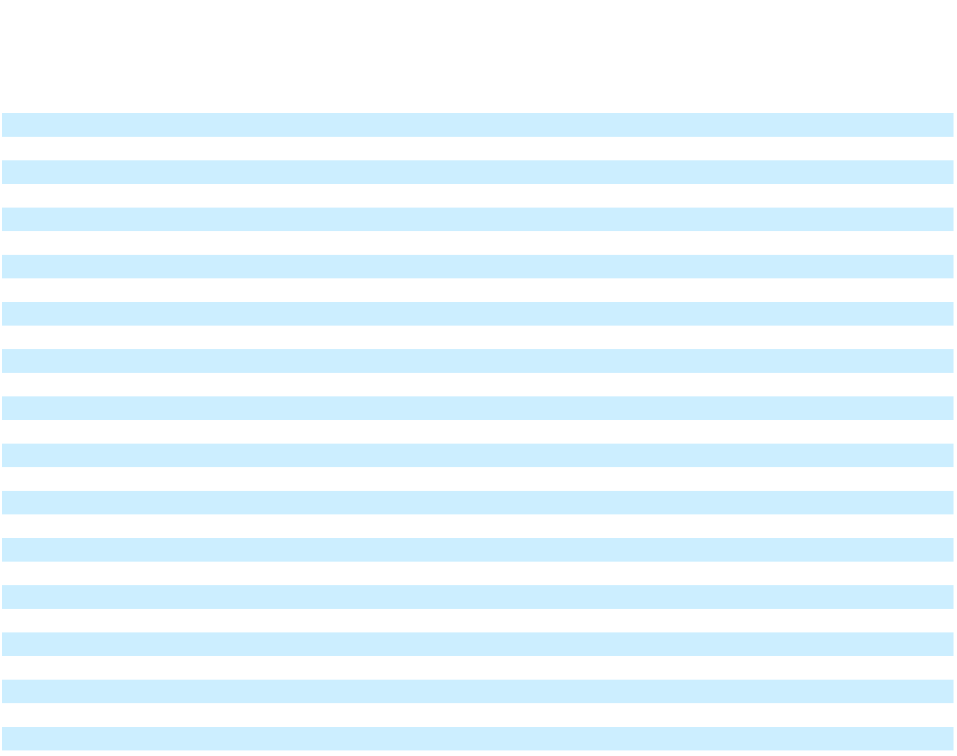

 |  |  |  |  |  |  |  |  |  |  |  |  |  |  |  |  | Noncontrolling
 |  |  |  | Common Stockholders’ |  |  |  |  |  |  |  |  |  |  |  |  |  | Interest
 |  |  |  |  |  |  |  |  |  |  |  |  |  |  |  |  | Cruise Stock
 |  |  |  |  |  |  |  | Accumulated
 |  |  |  | Additional |  |  |  |  |  |  |  |  |  |  |  |  |  | Incentive
 | Common |  |  | Additional |  | Retained |  |  | Other |  | Noncontrolling |  |  |  | Total |  |  | Awards
 |  |  |  | Paid-in |  | Retained |  | Comprehensive |  |  |  |  |  |  | Total |  |  | (Temporary
 |  | Stock |  | Capital |  | Earnings |  |  | Loss |  |  | Interests |  |  | Equity |  |  | Equity)
Balance at January 1, 2022 | $ | 15 |  | $ 27,061 |  | $41,937 |  | $ | (9,269) |  | $ | 6,071 |  | $ | 65,815 |  | $ | —
Net income (loss) |  | — |  | — | 9,934 |  |  |  | — |  |  | (226) |  |  | 9,708 |  |  | —
Other comprehensive income (loss) |  | — |  | — |  | — |  |  | 1,368 |  |  | (31) |  |  | 1,337 |  |  | —
Issuance (redemption) of subsidiary stock (Note 20) |  | — |  | — | (909) |  |  |  | — |  |  | (1,212) |  |  | (2,121) |  |  | —
Purchase of common stock (Note 20) |  | (1) | (1,153) |  | (1,347) |  |  |  | — |  |  | — |  |  | (2,500) |  |  | —
Stock based compensation |  | — | 299 |  | (5) |  |  |  | — |  |  | — |  |  | 294 |  |  | 299
Cash dividends paid on common stock |  | — |  | — | (257) |  |  |  | — |  |  | — |  |  | (257) |  |  | —
Dividends to noncontrolling interests |  | — |  | — | (12) |  |  |  | — |  |  | (127) |  |  | (140) |  |  | —
Other |  | — | 221 |  | (90) |  |  |  | — |  |  | (340) |  |  | (208) |  |  | 59
Balance at December 31, 2022 |  | 14 |  | 26,428 |  | 49,251 |  |  | (7,901) |  |  | 4,135 |  |  | 71,927 |  |  | 357
Net income (loss) |  | — |  | — | 10,127 |  |  |  | — |  |  | (287) |  |  | 9,840 |  |  | —
Other comprehensive income (loss) |  | — |  | — |  | — |  |  | (2,346) |  |  | (9) |  |  | (2,355) |  |  | —
Purchase of common stock (Note 20) |  | (2) | (7,686) |  | (3,426) |  |  |  | — |  |  | — |  |  | (11,115) |  |  | —
Stock based compensation |  | — | 259 |  | (6) |  |  |  | — |  |  | — |  |  | 253 |  |  | 24
Cash dividends paid on common stock |  | — |  | — | (477) |  |  |  | — |  |  | — |  |  | (477) |  |  | —
Dividends to noncontrolling interests |  | — |  | — |  | — |  |  | — |  |  | (120) |  |  | (120) |  |  | —
Other |  | — | 129 |  | (77) |  |  |  | — |  |  | 185 |  |  | 237 |  |  | (263)
Balance at December 31, 2023 |  | 12 |  | 19,130 |  | 55,391 |  |  | (10,247) |  |  | 3,903 |  |  | 68,189 |  |  | 118
Net income (loss) |  | — |  | — | 6,008 |  |  |  | — |  |  | (45) |  |  | 5,963 |  |  | —
Other comprehensive income (loss) |  | — |  | — |  | — |  |  | (1,006) |  |  | (131) |  |  | (1,137) |  |  | —
Issuance (redemption) of subsidiary stock (Note 20) |  | — | 973 |  |  | — |  |  | — |  |  | (1,074) |  |  | (101) |  |  | —
Purchase of common stock (Note 20) |  | (2) | 245 |  | (7,307) |  |  |  | — |  |  | — |  |  | (7,064) |  |  | —
Stock based compensation |  | — | 552 |  | (9) |  |  |  | — |  |  | — |  |  | 543 |  |  | —
Cash dividends paid on common stock |  | — |  | — | (530) |  |  |  | — |  |  | — |  |  | (530) |  |  | —
Dividends to noncontrolling interests |  | — |  | — |  | — |  |  | — |  |  | (123) |  |  | (123) |  |  | —
Other |  | — | (57) |  | (80) |  |  |  | — |  |  | (13) |  |  | (150) |  |  | (118)
Balance at December 31, 2024 | $ | 10 |  | $ 20,843 |  | $53,472 |  | $ | (11,253) |  | $ | 2,518 |  | $ | 65,590 |  | $ | —

Reference should be made to the notes to consolidated financial statements.

Amounts may not add due to rounding.

57

Table of Contents

GENERAL MOTORS COMPANY AND SUBSIDIARIES

NOTES TO CONSOLIDATED FINANCIAL STATEMENTS Note 1. Nature of Operations and Basis of Presentation

General Motors Company was incorporated as a Delaware corporation in 2009. We design, build and sell trucks, crossovers, cars and automobile parts and provide software-enabled services and subscriptions worldwide. We also provide automotive financing services through GM Financial. We analyze the results of our operations through the following segments: GMNA, GMI, Cruise and GM Financial. Cruise is our global segment responsible for the development of AV technology. Corporate includes certain centrally recorded income and costs such as interest, income taxes, corporate expenditures and certain revenues and expenses that are not part of a reportable segment. The consolidated financial statements are prepared in conformity with U.S. GAAP. Except for per share amounts or as otherwise specified, amounts presented within tables are stated in millions. Certain columns and rows may not add due to rounding.

Throughout this report, we refer to General Motors Company and its consolidated subsidiaries in a simplified manner and on a collective basis, using words like "we", "our", "us" and "the Company." This drafting style is suggested by the SEC and is not meant to indicate that General Motors Company, the publicly traded parent company, or any particular subsidiary of the parent company, owns or operates any particular asset, business or property. The operations and businesses described in this report are owned and operated by distinct subsidiaries of General Motors Company.

Principles of Consolidation We consolidate entities that we control due to ownership of a majority voting interest and we consolidate variable interest entities (VIEs) when we are the primary beneficiary. All intercompany balances and transactions are eliminated in consolidation. Our share of earnings or losses of nonconsolidated affiliates is included in our consolidated operating results using the equity method of accounting when we are able to exercise significant influence over the operating and financial decisions of the affiliate.

Use of Estimates in the Preparation of the Financial Statements Accounting estimates are an integral part of the consolidated financial statements. These estimates require the use of judgments and assumptions that affect the reported amounts of assets and liabilities, the disclosure of contingent assets and liabilities at the date of the financial statements and the reported amounts of revenues and expenses in the periods presented. We believe that the accounting estimates employed are appropriate and the resulting balances are reasonable; however, due to the inherent uncertainties in making estimates, actual results could differ from the original estimates, requiring adjustments to these balances in future periods.

GM Financial The amounts presented for GM Financial are adjusted to reflect the impact on GM Financial's deferred tax positions and provision for income taxes resulting from the inclusion of GM Financial in our consolidated tax return and to eliminate the effect of transactions between GM Financial and the other members of the consolidated group. Accordingly, the amounts presented will differ from those presented by GM Financial on a stand-alone basis.

Note 2. Significant Accounting Policies

The accounting policies that follow are utilized by our automotive, automotive financing and Cruise operations, unless otherwise indicated.

Revenue Recognition

Automotive Automotive net sales and revenue represents the amount of consideration to which we expect to be entitled in exchange for vehicle, parts and accessories and services and other sales. The consideration recognized represents the amount received, typically shortly after the sale to a customer, net of estimated dealer and customer sales incentives we reasonably expect to pay. Significant factors in determining our estimates of incentives include forecasted sales volume, product mix and the rate of customer acceptance of incentive programs, all of which are estimated based on historical experience and assumptions concerning future customer behavior and market conditions. Subsequent adjustments to incentive estimates are possible as facts and circumstances change over time. A portion of the consideration received is deferred for separate performance obligations, such as maintenance, services and vehicle connectivity, that will be provided to our customers at a future date. Taxes assessed by various government entities, such as sales, use and value-added taxes, collected at the time of the vehicle sale are excluded from Automotive net sales and revenue. Costs for shipping and handling activities that occur after control of the vehicle transfers to the dealer are recognized at the time of sale and presented in Automotive and other cost of sales.

58

Table of Contents

GENERAL MOTORS COMPANY AND SUBSIDIARIES

NOTES TO CONSOLIDATED FINANCIAL STATEMENTS – (Continued)

Vehicle, Parts and Accessories For the majority of vehicle and accessories sales, our customers obtain control and we recognize revenue when the vehicle transfers to the dealer, which typically occurs either when the vehicle is released to the carrier responsible for transporting it to a dealer or upon delivery to a dealer. Revenue, net of estimated returns, is recognized on the sale of parts upon delivery to the customer. When our customers have a right to return eligible parts and accessories, we consider the returns in our estimation of the transaction price.

Typically, transfers to daily rental companies are accounted for as sales, with revenue recognized at the time of transfer. We defer revenue for remarketing obligations, record a residual value guarantee and reflect a liability for amounts expected to be paid once the remarketing services are complete at the time of sale and recognize deferred revenue in earnings upon completion of the remarketing service.

Used Vehicles Proceeds from the auction of vehicles utilized by our employees are recognized in Automotive net sales and revenue upon transfer of control of the vehicle to the customer and the related vehicle carrying value is recognized in Automotive and other cost of sales.

Services and Other Services and other revenue primarily consists of revenue from vehicle-related service arrangements and after-sale services such as maintenance, OnStar, Super Cruise, vehicle connectivity and extended service warranties. For those service arrangements that are bundled with a vehicle sale, a portion of the revenue from the sale is allocated to the service component and recognized as deferred revenue within Accrued liabilities or Other liabilities. We recognize revenue for bundled services and services sold separately as services are performed, typically over a period of up to eight years.

Automotive Financing - GM Financial Finance charge income earned on finance receivables is recognized using the effective interest method. Fees and commissions received (including manufacturer subvention) and direct costs of originating loans are deferred and amortized over the term of the related finance receivables using the effective interest method and are removed from the consolidated balance sheets when the related finance receivables are fully charged off or paid in full. Accrual of finance charge income on retail finance receivables is generally suspended on accounts that are more than 60 days delinquent, accounts in bankruptcy and accounts in repossession. Payments received on nonaccrual loans are first applied to any fees due, then to any interest due and then any remaining amounts are applied to principal. Interest accrual generally resumes once an account has received payments bringing the delinquency to less than 60 days past due. Accrual of finance charge income on commercial finance receivables is generally suspended on accounts that are more than 90 days delinquent, upon receipt of a bankruptcy notice from a borrower, or where reasonable doubt exists about the full collectability of contractually agreed upon principal and interest. Payments received on nonaccrual loans are first applied to principal. Interest accrual resumes once an account has received payments bringing the account fully current and collection of contractual principal and interest is reasonably assured (including amounts previously charged off).

Income from operating lease assets, which includes lease origination fees, net of lease origination costs, is recorded as operating lease revenue on a straight-line basis over the term of the lease agreement. Gains or losses realized upon disposition of off-lease assets including any payments received from lessees upon lease termination, are included in GM Financial interest, operating and other expenses.

Advertising and Promotion Expenditures Advertising and promotion expenditures, which are expensed as incurred in Automotive and other selling, general and administrative expense, were $3.3 billion, $3.6 billion and $4.0 billion in the years ended December 31, 2024, 2023 and 2022.

Research and Development Expenditures Research and development expenditures, which are expensed as incurred in Automotive and other cost of sales, were $9.2 billion, $9.9 billion and $9.8 billion in the years ended December 31, 2024, 2023 and 2022. These expenditures include cost sharing payments and fees we receive when we enter into cost sharing arrangements with third parties or nonconsolidated affiliates for product-related research, engineering, design and development activities and use of intellectual property.

Cash Equivalents and Restricted Cash Cash equivalents are defined as short-term, highly-liquid investments with original maturities of 90 days or less. Certain operating agreements require us to post cash as collateral. Cash and cash equivalents subject to contractual restrictions and not readily available are classified as restricted cash. Restricted cash is invested in accordance with the terms of the underlying agreements and include amounts related to various deposits, escrows and other cash collateral. Restricted cash is included in Other current assets and Other assets in the consolidated balance sheets.

59

Table of Contents

GENERAL MOTORS COMPANY AND SUBSIDIARIES

NOTES TO CONSOLIDATED FINANCIAL STATEMENTS – (Continued)

Fair Value Measurements A three-level valuation hierarchy, based upon observable and unobservable inputs, is used for fair value measurements. Observable inputs reflect market data obtained from independent sources, while unobservable inputs reflect market assumptions based on the best evidence available. These two types of inputs create the following fair value hierarchy: Level 1 – Quoted prices for identical instruments in active markets; Level 2 – Quoted prices for similar instruments in active markets, quoted prices for identical or similar instruments in markets that are not active and model-derived valuations whose significant inputs are observable; and Level 3 – Instruments whose significant inputs are unobservable.

Marketable Debt Securities We generally classify marketable debt securities as available-for-sale. Various factors, including turnover of holdings and investment guidelines, are considered in determining the classification of securities. Available-for-sale debt securities are recorded at fair value with non-credit related unrealized gains and losses recorded in Accumulated other comprehensive loss until realized. Credit losses are recorded in Interest income and other non-operating income, net. An evaluation is made quarterly to determine if any portion of unrealized losses recorded in Accumulated other comprehensive loss needs to be reclassified. Non-credit related unrealized losses are reclassified to Interest income and other non-operating income, net if we intend to sell the security or it is more likely than not that we will be required to sell the security before the recovery of the unrealized loss.

We determine realized gains and losses for all debt securities using the specific identification method and measure the fair value of our marketable debt securities using a market approach where identical or comparable prices are available and an income approach in other cases. If quoted market prices are not available, fair values of securities are determined using prices from a pricing service, pricing models, quoted prices of securities with similar characteristics or discounted cash flow models. These prices represent non-binding quotes. Our pricing service utilizes industry-standard pricing models that consider various inputs. We review our pricing service quarterly and believe the prices received from our pricing service are a reliable representation of exit prices.

Accounts and Notes Receivable Accounts and notes receivable primarily consists of amounts that are due and payable from our customers for the sale of vehicles, parts and accessories. We evaluate the collectability of receivables each reporting period and record an allowance for doubtful accounts to present the net amount expected to be collected on our receivables. Additions to the allowance are charged to bad debt expense reported in Automotive and other selling, general and administrative expense and were insignificant in the years ended December 31, 2024, 2023 and 2022.

GM Financial Receivables Finance receivables are carried at amortized cost, net of allowance for loan losses. Provisions for loan losses are charged to operations in amounts sufficient to maintain the allowance for loan losses at levels considered adequate to cover expected credit losses on the finance receivables. For retail finance receivables, GM Financial uses static pool modeling techniques to determine the allowance for loan losses expected over the remaining life of the receivables, which is supplemented by management judgment. The modeling techniques incorporate reasonable and supportable forecasts of economic conditions over the expected remaining life of the finance receivables. The economic forecasts incorporate factors which vary by region that GM Financial believes will have the largest impact on expected losses, including unemployment rates, interest rate spreads, disposable personal income and growth rates in gross domestic product.

Commercial finance receivables are carried at amortized cost, net of allowance for loan losses and amounts held under a cash management program. GM Financial establishes the allowance for loan losses based on historical loss experience, as well as forecasted auto industry conditions, which is the economic indicator believed to have the largest impact on expected losses.

Inventories Inventories are stated at the lower of cost or net realizable value. Cost is determined on a first-in, first-out (FIFO) basis. Net realizable value is the estimated selling price in the ordinary course of business less cost to sell, and considers general market and economic conditions, periodic reviews of current profitability of vehicles, product warranty costs and the effect of estimated sales incentives. Net realizable value for off-lease and other vehicles is current auction sales proceeds less disposal and warranty costs. Inventories are reviewed to determine if inventory quantities are in excess of forecasted usage or if they have become obsolete, with a primary focus on productive material, supplies, work in process and parts and accessories.

Equipment on Operating Leases Equipment on operating leases, net consists of vehicle leases to retail customers with lease terms of typically two to five years. We are exposed to changes in the residual values of these assets. The residual values represent estimates of the values of the leased vehicles at the end of the lease agreements and are determined based on forecasted auction proceeds when there is a reliable basis to make such a determination. Realization of the residual values is dependent on the future ability to market the vehicles under prevailing market conditions. The estimate of the residual value is evaluated over the life of the arrangement and adjustments may be made to the extent the expected value of the vehicle changes.

60

Table of Contents

GENERAL MOTORS COMPANY AND SUBSIDIARIES

NOTES TO CONSOLIDATED FINANCIAL STATEMENTS – (Continued)

Adjustments may be in the form of revisions to the depreciation rate or recognition of an impairment charge. A lease vehicle asset group is determined to be impaired if an impairment indicator exists and the expected future cash flows, which include estimated residual values, are lower than the carrying amount of the vehicle asset group. If the carrying amount is considered impaired, an impairment charge is recorded for the amount by which the carrying amount exceeds fair value of the vehicle asset group. Fair value is determined primarily using the anticipated cash flows, including estimated residual values. In our automotive finance operations, when a leased vehicle is returned or repossessed, the asset is recorded in Other assets at the lower of amortized cost or net realizable value. Upon disposition a gain or loss is recorded in GM Financial interest, operating and other expenses for any difference between the net book value of the leased asset and the proceeds from the disposition of the asset.

Equity Investments When events and circumstances warrant, equity investments accounted for under the equity method of accounting are evaluated for impairment. An impairment charge is recorded whenever a decline in value of an equity investment below its carrying amount is determined to be other-than-temporary. Impairment charges related to equity method investments are recorded in Equity income. Equity investments that are not accounted for under the equity method of accounting are measured at fair value or in certain cases adjusted to fair value upon an observable price change, with changes in fair value recorded in Interest income and other non-operating income, net.

Property, net Property, plant and equipment, including internal use software, is recorded at cost. The gross amount of assets under finance leases is included in property, plant and equipment. Major improvements that extend the useful life or add functionality are capitalized. Expenditures for repairs and maintenance are charged to expense as incurred. We depreciate depreciable property using the straight-line method. Leasehold improvements are amortized over the period of lease or the life of the asset, whichever is shorter. The amortization of the assets under finance leases is included in depreciation expense. Upon retirement or disposition of property, plant and equipment, the cost and related accumulated depreciation are eliminated and any resulting gain or loss is recorded in earnings. Impairment charges related to property are recorded in Automotive and other cost of sales, Automotive and other selling, general and administrative expense or GM Financial interest, operating and other expenses.

Special Tools Special tools represent product-specific propulsion and non-propulsion related tools, dies, molds and other items used in the vehicle manufacturing process. Expenditures for special tools are recorded at cost and are capitalized. We amortize special tools over their estimated useful lives using the straight-line method or an accelerated amortization method based on their historical and estimated production volume. Impairment charges related to special tools are recorded in Automotive and other cost of sales.

Goodwill Goodwill is not amortized but rather tested for impairment annually on October 1 and when events warrant such a review. The impairment test entails an assessment of qualitative factors to determine whether it is more likely than not that an impairment exists. If it is more likely than not that an impairment exists, then a quantitative impairment test is performed. Impairment exists when the carrying amount of a reporting unit exceeds its fair value.

Intangible Assets, net Intangible assets, excluding goodwill, primarily include brand names, technology and intellectual property, customer relationships and dealer networks. Intangible assets are amortized on a straight-line or an accelerated method of amortization over their estimated useful lives. Amortization of developed technology and intellectual property is recorded in Automotive and other cost of sales. Amortization of brand names, customer relationships and our dealer networks is recorded in Automotive and other selling, general and administrative expense or GM Financial interest, operating and other expenses. Impairment charges, if any, related to intangible assets are recorded in Automotive and other selling, general and administrative expense or Automotive and other cost of sales.

Valuation of Long-Lived Assets The carrying amount of long-lived assets and finite-lived intangible assets to be held and used in the business is evaluated for impairment when events and circumstances warrant. If the carrying amount of a long-lived asset group is considered impaired, a loss is recorded based on the amount by which the carrying amount exceeds fair value. Product-specific long-lived asset groups and non-product specific long-lived assets are separately tested for impairment on an asset group basis. Fair value is determined using either the market or sales comparison approach, cost approach or anticipated cash flows discounted at a rate commensurate with the risk involved. Long-lived assets to be disposed of other than by sale are considered held for use until disposition.

Government Incentives and Grants We receive incentives from federal, state and local governments in different regions of the world that encourage us to establish, maintain, or increase investment, employment or production in the region. We are also

61

Table of Contents

GENERAL MOTORS COMPANY AND SUBSIDIARIES

NOTES TO CONSOLIDATED FINANCIAL STATEMENTS – (Continued)

entitled to certain advanced manufacturing production credits under the IRA. We account for government incentives as a reduction of expense, a reduction of the cost of the capital investment or other income based on the substance of the incentive received. The benefit from advanced manufacturing production credits are not accounted for or classified as an income tax credit. Benefits are generally recorded when there is reasonable assurance of receipt or, as it relates to advanced manufacturing production credits, upon the generation of the credit. Amounts are recorded in earnings as the expenses in which the incentive is meant to offset are incurred, as we meet the conditions of the grant or as the capital investment is depreciated or, as it relates to advanced manufacturing production credits, upon generation of the credit. At December 31, 2024, cash incentives receivable in Accounts and notes receivable, net of allowance was $343 million, cash incentives credited to Property, net were $480 million, cash incentives receivable in Other assets was $292 million and deferred incentive income in Other liabilities was $212 million. In the year ended December 31, 2024, we recognized $524 million in Automotive and other cost of sales associated with incentives. Current agreements expire at various dates through 2032 and we consider the risk that any amounts recognized will be returned to be remote.

Emissions Credits We periodically enter into agreements to purchase credits to facilitate our compliance with emission and fuel economy regulations. Purchased credits are recorded at cost in Other current assets and Other assets and are recognized in expense over the periods in which the acquired credits facilitate our compliance with emission and fuel economy regulations. In the years ended December 31, 2024, 2023 and 2022, we paid $2.0 billion, $0.5 billion and $1.0 billion to purchase credits to facilitate our compliance with regulations. At December 31, 2024 and 2023, the carrying amount of acquired credits were $2.1 billion and $1.0 billion. Compliance-related costs of $1.0 billion, $0.7 billion and $0.5 billion were recorded in Automotive and other costs of sales in the years ended December 31, 2024, 2023 and 2022.

Pension and OPEB Plans

Attribution, Methods and Assumptions The cost of benefits provided by defined benefit pension plans is recorded in the period employees provide service. The cost of pension plan amendments that provide for benefits already earned by plan participants is amortized over the expected period of benefit which may be the duration of the applicable collective bargaining agreement specific to the plan, the expected future working lifetime or the life expectancy of the plan participants.

The cost of medical, dental, legal service and life insurance benefits provided through postretirement benefit plans is recorded in the period employees provide service. The cost of postretirement plan amendments that provide for benefits already earned by plan participants is amortized over the expected period of benefit which may be the average period to full eligibility or the average life expectancy of the plan participants.

An expected return on plan asset methodology is utilized to calculate future pension expense for certain significant funded benefit plans. A market-related value of plan assets methodology is also utilized that averages gains and losses on the plan assets over a period of years to determine future pension expense. The methodology recognizes 60% of the difference between the fair value of assets and the expected calculated value in the first year and 10% of that difference over each of the next four years.

The discount rate assumption is established for each of the retirement-related benefit plans at their respective measurement dates. In the U.S., we use a cash flow matching approach that uses projected cash flows matched to spot rates along a high-quality corporate bond yield curve to determine the present value of cash flows to calculate a single equivalent discount rate. We apply individual annual yield curve rates to determine the service cost and interest cost for our pension and OPEB plans to more specifically link the cash flows related to service cost and interest cost to bonds maturing in their year of payment.

The benefit obligation for pension plans in Canada, the United Kingdom (UK) and Germany represents 89% of the non-U.S. pension benefit obligation at December 31, 2024. The discount rates for plans in Canada, the UK and Germany are determined using a cash flow matching approach like the U.S.

Plan Asset Valuation Due to the lack of timely available market information for certain investments in the asset classes described below as well as the inherent uncertainty of valuation, reported fair values may differ from fair values that would have been used had timely available market information been available.

Cash Equivalents and Other Short-Term Investments Cash equivalents, including reverse repurchase agreements, trade deposits and other short-term investments, are valued based on pricing received from independent pricing services, dealers who

62

Table of Contents

GENERAL MOTORS COMPANY AND SUBSIDIARIES

NOTES TO CONSOLIDATED FINANCIAL STATEMENTS – (Continued)

make markets in such securities or held at amortized cost. Cash equivalent pricing utilizes observable inputs and are classified in Level 2.

Common and Preferred Stock Common and preferred stock for which market prices are readily available at the measurement date are valued at the last reported sale price or official closing price on the primary market or exchange on which they are actively traded and are classified in Level 1. Such equity securities for which the market is not considered to be active are valued via the use of observable inputs, which may include the use of adjusted market prices last available, bids or last available sales prices and/or other observable inputs and are classified in Level 2. Common and preferred stock classified in Level 3 are privately issued securities or other issues that are valued via the use of valuation models using significant unobservable inputs that generally consider aged (stale) pricing, earnings multiples, discounted cash flows and/or other qualitative and quantitative factors.

Debt Securities Valuations for debt securities are based on quotations received from independent pricing services or from dealers who make markets in such securities. Debt securities priced via pricing services that utilize matrix pricing which considers readily observable inputs such as the yield or price of bonds of comparable quality, coupon, maturity and type as well as dealer supplied prices, are classified in Level 2. Debt securities that are typically priced by dealers and pricing services via the use of proprietary pricing models which incorporate significant unobservable inputs are classified in Level 3. These inputs primarily consist of yield and credit spread assumptions, discount rates, prepayment curves, default assumptions and recovery rates.

Investment Funds, Private Equity and Debt Investments and Real Estate Investments Investment funds, private equity and debt investments and real estate investments are valued based on the Net Asset Value (NAV) per Share (or its equivalent) as a practical expedient to estimate fair value due to the absence of readily available market prices.

NAVs are provided by the respective investment sponsors or investment advisers and are subsequently reviewed and approved by management. In the event management concludes a reported NAV does not reflect fair value or is not determined as of the financial reporting measurement date, we will consider whether and when deemed necessary to make an adjustment at the balance sheet date. In determining whether an adjustment to the external valuation is required, we will review material factors that could affect the valuation, such as changes in the composition or performance of the underlying investments or comparable investments, overall market conditions, expected sale prices for private investments which are probable of being sold in the short-term and other economic factors that may possibly have a favorable or unfavorable effect on the reported external valuation.

Stock Incentive Plans Our stock incentive plans include RSUs, PSUs, stock options and awards that may be settled in our stock, the stock of our subsidiaries or in cash. We measure and record compensation expense based on the fair value of GM or Cruise's common stock on the date of grant for RSUs and PSUs and the grant date fair value, determined utilizing the Black-Scholes formula or a lattice model, for stock options and PSUs. We record compensation cost for service-based RSUs, PSUs and service-based stock options on a straight-line basis over the entire vesting period, or for retirement eligible employees over the requisite service period. Compensation cost for awards that do not have an established accounting grant date, but for which the service inception date has been established or are settled in cash is based on the fair value of GM or Cruise's common stock at the end of each reporting period.

In March 2022, all outstanding RSUs that settle in Cruise's common stock were modified to remove the liquidity vesting condition. Prospectively, RSUs that will settle in Cruise's common stock will vest solely upon satisfaction of a service condition. In April 2024, substantially all remaining outstanding unvested Cruise RSUs were exchanged by participants for unvested cash payment rights. The remaining outstanding Cruise RSUs are insignificant and are presented in permanent equity. Prior to the April 2024 modification, compensation cost was recorded on stock issued to settle awards based on the fair value of Cruise's common stock until such time that the stock had been issued for more than six months.

Product Warranty and Recall Campaigns The estimated costs related to product warranties are accrued at the time products are sold and are charged to Automotive and other cost of sales. These estimates are established using historical information on the nature, frequency and average cost of claims of each vehicle line or each model year of the vehicle line and assumptions about future activity and events. Revisions are made when necessary and are based on changes in these factors.

The estimated costs related to recall campaigns are accrued when probable and estimable. In GMNA, we estimate the costs related to recall campaigns by applying a paid loss approach that considers the number of historical recall campaigns and the

63

Table of Contents

GENERAL MOTORS COMPANY AND SUBSIDIARIES

NOTES TO CONSOLIDATED FINANCIAL STATEMENTS – (Continued)

estimated cost for each recall campaign. The estimated costs associated with recall campaigns in other geographical regions are determined using the estimated costs of repairs and the estimated number of vehicles to be repaired. Costs associated with recall campaigns are charged to Automotive and other cost of sales. Revisions are made when necessary based on changes in these factors.

Income Taxes The liability method is used in accounting for income taxes. Deferred tax assets and liabilities are recorded for temporary differences between the tax basis of assets and liabilities and their reported amounts in the consolidated financial statements using the statutory tax rates in effect for the year in which the differences are expected to reverse. The effect on deferred tax assets and liabilities of a change in tax laws or rates is recorded in the results of operations in the period that includes the enactment date under the law. We record Global Intangible Low Tax Income as a current period expense when incurred. Income tax effects are released from Accumulated other comprehensive loss using the specific-identification method.

We establish valuation allowances for deferred tax assets based on a more likely than not standard. Deferred income tax assets are evaluated quarterly to determine if valuation allowances are required or should be adjusted. The ability to realize deferred tax assets depends on the ability to generate sufficient taxable income within the carryback or carryforward periods provided for in the tax law for each applicable tax jurisdiction. The assessment regarding whether a valuation allowance is required or should be adjusted also considers all available positive and negative evidence factors. It is difficult to conclude a valuation allowance is not required when there is significant objective and verifiable negative evidence, such as cumulative losses in recent years. We utilize a rolling three years of actual and current year results as the primary measure of cumulative losses in recent years.

We record uncertain tax positions on the basis of a two-step process whereby we determine whether it is more likely than not that the tax positions will be sustained based on the technical merits of the position, and for those tax positions that meet the more likely than not criteria, we recognize the largest amount of tax benefit that is greater than 50% likely to be realized upon ultimate settlement with the related tax authority. We record interest and penalties on uncertain tax positions in Income tax expense.

Foreign Currency Transactions and Translation The assets and liabilities of foreign subsidiaries that use the local currency as their functional currency are translated to U.S. dollars based on the current exchange rate prevailing at each balance sheet date and any resulting translation adjustments are included in Accumulated other comprehensive loss. The assets and liabilities of foreign subsidiaries whose local currency is not their functional currency are remeasured from their local currency to their functional currency and then translated to U.S. dollars. Revenues and expenses are translated into U.S. dollars using the average exchange rates prevailing for each period presented. The financial statements of any foreign subsidiary that has been identified as having a highly inflationary economy are remeasured as if the functional currency were the U.S. dollar.

Gains and losses arising from foreign currency transactions and the effects of remeasurements discussed in the preceding paragraph are recorded in Automotive and other cost of sales and GM Financial interest, operating and other expenses unless related to Automotive debt, which are recorded in Interest income and other non-operating income, net. Foreign currency transactions and remeasurements in the years ended December 31, 2024, 2023 and 2022 were gains of $321 million, losses of $349 million and losses of $172 million.

Derivative Financial Instruments Derivative financial instruments are recognized as either assets or liabilities at fair value. The accounting for changes in the fair value of each derivative financial instrument depends on whether it has been designated and qualifies as an accounting hedge, as well as the type of hedging relationship identified. Cash flows for all derivative financial instruments are typically classified in cash flows from operating activities. Derivative instruments are not used for trading or speculative purposes.

Automotive We utilize options, swaps and forward contracts to manage foreign currency, commodity price and interest rate risks. The change in the fair value of option, swap and forward contracts not designated as an accounting hedge is recorded in Interest income and other non-operating income, net.

Certain foreign currency and commodity forward contracts have been designated and qualify as cash flow hedges. The risks being hedged are foreign currency and commodity price risks related to forecasted transactions that are generally expected to occur in the next 12 months. The change in the fair value of these forward contracts is recorded in Accumulated other comprehensive loss and will be recognized in Automotive net sales and revenue or Automotive and other cost of sales when the

64

Table of Contents

GENERAL MOTORS COMPANY AND SUBSIDIARIES

NOTES TO CONSOLIDATED FINANCIAL STATEMENTS – (Continued)

hedged transaction impacts earnings. Forward contracts designated as cash flow hedges are evaluated for effectiveness using regression analysis at inception and throughout the hedge period.

Certain receive-fixed, pay-float interest rate swap agreements have been designated and qualify as fair value hedges of our fixed-rate debt. The risk being hedged is the risk of changes in the fair value of the hedged debt attributable to changes in the benchmark interest rate. The changes in both the fair value of the hedged debt and the hedging instrument are recorded in Automotive interest expense. When a fair value hedge is de-designated, or when the derivative is terminated prior to maturity, the fair value adjustment to the hedged debt continues to be reported as part of the carrying value of the debt and is recognized in Automotive interest expense over its remaining life.

Automotive Financing - GM Financial GM Financial utilizes interest rate derivative instruments to manage interest rate risk and foreign currency derivative instruments to manage foreign currency risk. The change in fair value of the derivative instruments not designated as an accounting hedge is recorded in GM Financial interest, operating and other expenses.

Certain interest rate and foreign currency swap agreements have been designated as fair value hedges. The risk being hedged is the risk of changes in the fair value of the hedged debt attributable to changes in the benchmark interest rate or the risk of changes in fair value attributable to changes in foreign currency exchange rates. If the swap has been designated as a fair value hedge, the changes in the fair value of the hedged item are recorded in GM Financial interest, operating and other expenses. The change in fair value of the related hedge is also recorded in GM Financial interest, operating and other expenses.

Certain interest rate swap and foreign currency swap agreements have been designated as cash flow hedges. The risk being hedged is the interest rate and foreign currency risk related to forecasted transactions. If the contract has been designated as a cash flow hedge, the change in the fair value of the cash flow hedge is deferred in Accumulated other comprehensive loss and is recognized in GM Financial interest, operating and other expenses along with the earnings effect of the hedged item when the hedged item affects earnings. Changes in the fair value of amounts excluded from the assessment of effectiveness are recorded currently in earnings and are presented in the same income statement line as the earnings effect of the hedged item.

Note 3. Revenue

The following table disaggregates our revenue by major source:

 |  |  |  |  |  |  |  | Year Ended December 31, 2024
 | GMNA |  | GMI |  | Corporate |  |  |  | Total |  | Cruise |  |  |  | GM |  |  | Eliminations/ |  | Total
 | GMNA |  | GMI |  |  |  |  | Automotive |  |  |  |  |  | Financial |  |  | Reclassifications |  |  | Total
Vehicle, parts and accessories | $152,306 |  | $12,775 |  | $ | 90 |  | $ | 165,171 |  | $ | — |  | $ | — |  | $ | (1) |  | $165,170
Used vehicles | 1,259 | 31 |  |  |  | — |  |  | 1,290 |  |  | — |  |  | — |  |  | — | 1,290
Services and other | 3,944 | 1,084 |  |  |  | 116 |  |  | 5,145 |  |  | 257 |  |  | — |  |  | (255) | 5,147
Automotive net sales and revenue | 157,509 |  | 13,890 |  |  | 206 |  |  | 171,605 |  |  | 257 |  |  | — |  |  | (256) |  | 171,606
Leased vehicle income | — |  | — |  |  | — |  |  | — |  |  | — |  |  | 7,297 |  |  | — | 7,297
Finance charge income | — |  | — |  |  | — |  |  | — |  |  | — |  |  | 7,669 |  |  | (33) | 7,636
Other income | — |  | — |  |  | — |  |  | — |  |  | — |  |  | 910 |  |  | (7) | 903
GM Financial net sales and revenue | — |  | — |  |  | — |  |  | — |  |  | — |  |  | 15,875 |  |  | (40) |  | 15,836
Net sales and revenue | $157,509 |  | $13,890 |  | $ | 206 |  | $ | 171,605 |  | $ | 257 |  | $ 15,875 |  |  | $ | (296) |  | $187,442
 |  |  |  |  |  |  |  | Year Ended December 31, 2023
 | GMNA |  | GMI |  | Corporate |  |  |  | Total |  | Cruise |  |  |  | GM |  |  | Eliminations/ |  | Total
 | GMNA |  | GMI |  |  |  |  | Automotive |  |  |  |  |  | Financial |  |  | Reclassifications |  |  | Total
Vehicle, parts and accessories | $136,983 |  | $14,424 |  | $ | 113 |  | $ | 151,520 |  | $ | — |  | $ | — |  | $ | (10) |  | $151,510
Used vehicles | 954 | 37 |  |  |  | — |  |  | 991 |  |  | — |  |  | — |  |  | — | 991
Services and other | 3,508 | 1,487 |  |  |  | 160 |  |  | 5,155 |  |  | 102 |  |  | — |  |  | (100) | 5,157
Automotive net sales and revenue | 141,445 |  | 15,949 |  |  | 273 |  |  | 157,667 |  |  | 102 |  |  | — |  |  | (110) |  | 157,658
Leased vehicle income | — |  | — |  |  | — |  |  | — |  |  | — |  |  | 7,266 |  |  | — | 7,266
Finance charge income | — |  | — |  |  | — |  |  | — |  |  | — |  |  | 6,204 |  |  | (18) | 6,187
Other income | — |  | — |  |  | — |  |  | — |  |  | — |  |  | 754 |  |  | (23) | 732
GM Financial net sales and revenue | — |  | — |  |  | — |  |  | — |  |  | — |  |  | 14,225 |  |  | (41) |  | 14,184
Net sales and revenue | $141,445 |  | $15,949 |  | $ | 273 |  | $ | 157,667 |  | $ | 102 |  | $ 14,225 |  |  | $ | (151) |  | $171,842
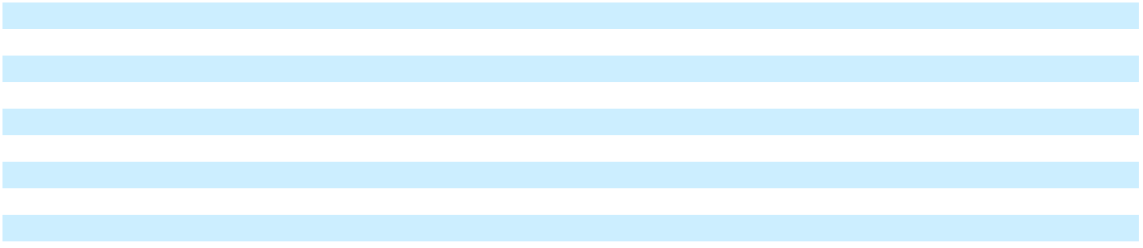

65

Table of Contents

GENERAL MOTORS COMPANY AND SUBSIDIARIES

NOTES TO CONSOLIDATED FINANCIAL STATEMENTS – (Continued)

 |  |  |  |  |  |  |  | Year Ended December 31, 2022
 | GMNA |  | GMI |  | Corporate |  |  |  | Total |  | Cruise |  |  |  | GM |  |  | Eliminations/ |  | Total
 | GMNA |  | GMI |  |  |  |  | Automotive |  |  |  |  |  | Financial |  |  | Reclassifications |  |  | Total
Vehicle, parts and accessories | $124,657 |  | $13,993 |  | $ | 42 |  | $ | 138,692 |  | $ | — |  | $ | — |  | $ | — |  | $138,692
Used vehicles | 483 | 33 |  |  |  | — |  |  | 516 |  |  | — |  |  | — |  |  | — | 516
Services and other | 3,238 | 1,393 |  |  |  | 134 |  |  | 4,765 |  |  | 102 |  |  | — |  |  | (101) | 4,766
Automotive net sales and revenue | 128,378 |  | 15,420 |  |  | 177 |  |  | 143,974 |  |  | 102 |  |  | — |  |  | (101) |  | 143,975
Leased vehicle income | — |  | — |  |  | — |  |  | — |  |  | — |  |  | 7,811 |  |  | — | 7,811
Finance charge income | — |  | — |  |  | — |  |  | — |  |  | — |  |  | 4,521 |  |  | (2) | 4,519
Other income | — |  | — |  |  | — |  |  | — |  |  | — |  |  | 435 |  |  | (4) | 431
GM Financial net sales and revenue | — |  | — |  |  | — |  |  | — |  |  | — |  |  | 12,766 |  |  | (6) |  | 12,760
Net sales and revenue | $128,378 |  | $15,420 |  | $ | 177 |  | $ | 143,974 |  | $ | 102 |  | $ | 12,766 |  | $ | (107) |  | $156,735

Revenue is measured as the amount of consideration we expect to receive in exchange for transferring goods or providing services. Adjustments to sales incentives for previously recognized sales were insignificant during the years ended December 31, 2024, 2023 and 2022.

Contract liabilities in our Automotive segments primarily consist of vehicle connectivity, customer rewards programs, maintenance, extended warranty and other contracts of $6.6 billion and $5.0 billion at December 31, 2024 and 2023, which are included in Accrued liabilities and Other liabilities. We recognized revenue of $2.0 billion and $1.4 billion related to contract liabilities during the years ended December 31, 2024 and 2023. We expect to recognize revenue of $2.2 billion, $1.4 billion and $3.0 billion in the years ending December 31, 2025, 2026 and thereafter related to contract liabilities at December 31, 2024.

66

Table of Contents

GENERAL MOTORS COMPANY AND SUBSIDIARIES

NOTES TO CONSOLIDATED FINANCIAL STATEMENTS – (Continued) Note 4. Marketable and Other Securities

The following table summarizes the fair value of cash equivalents and marketable debt securities, which approximates cost:

 | Fair Value |  | December 31, 2024 |  |  | December 31, 2023
 | Level
Cash and cash equivalents
Cash and time deposits |  | $ |  | 12,471 | $ |  | 8,977
Available-for-sale debt securities
U.S. government and agencies | 2 |  |  | 26 |  |  | 211
Corporate debt | 2 |  |  | 1,541 |  |  | 1,439
Sovereign debt | 2 |  |  | 785 |  |  | 734
Total available-for-sale debt securities – cash equivalents |  |  |  | 2,351 |  |  | 2,384
Money market funds | 1 |  |  | 5,050 |  |  | 7,491
Total cash and cash equivalents |  | $ |  | 19,872 | $ |  | 18,853
Marketable debt securities
U.S. government and agencies | 2 | $ |  | 3,082 | $ |  | 3,495
Corporate debt and other | 2 |  |  | 3,592 |  |  | 3,529
Mortgage and asset-backed | 2 |  |  | 591 |  |  | 589
Total available-for-sale debt securities – marketable securities |  | $ |  | 7,265 | $ |  | 7,613
Restricted cash
Cash and cash equivalents |  | $ |  | 294 | $ |  | 277
Money market funds | 1 |  |  | 2,798 |  |  | 2,787
Total restricted cash |  | $ |  | 3,092 | $ |  | 3,064
Available-for-sale debt securities included above with contractual
maturities(a)
Due in one year or less |  | $ |  | 3,590
Due between one and five years |  |  |  | 5,386
Total available-for-sale debt securities with contractual maturities |  | $ |  | 8,976
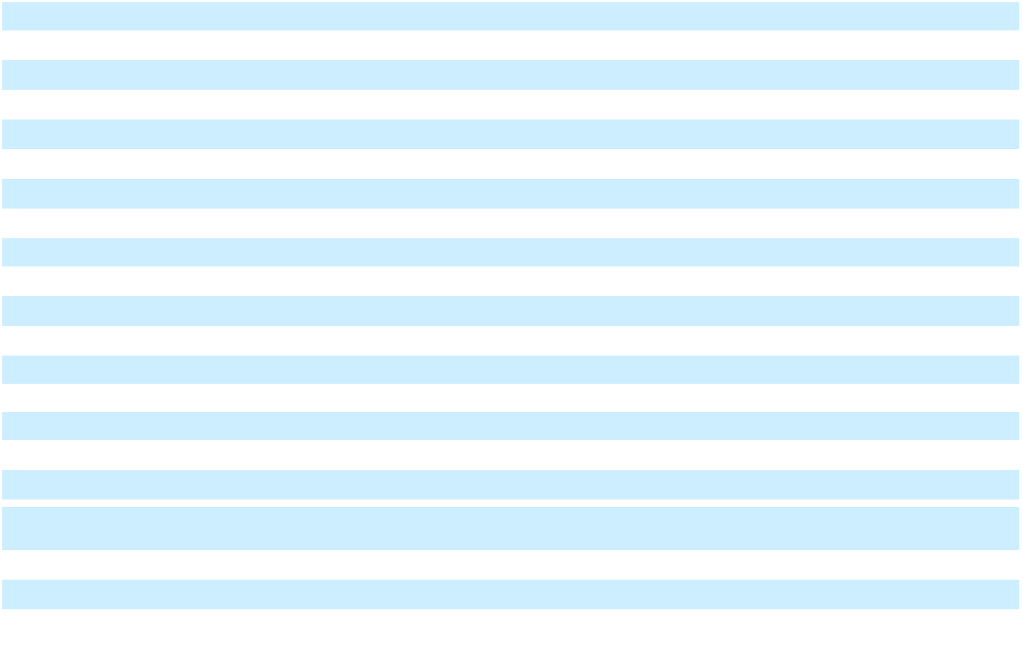
__________

- Excludes mortgage and asset-backed securities of $591 million at December 31, 2024 as these securities are not due at a single maturity date.

Proceeds from the sale of available-for-sale debt securities sold prior to maturity were $2.5 billion, $2.1 billion and $1.8 billion in the years ended December 31, 2024, 2023 and 2022. Available-for-sale debt securities had net unrealized gains of $86 million and $196 million in the years ended December 31, 2024 and 2023 and net unrealized losses of $319 million in the year ended December 31, 2022. Cumulative unrealized losses on available-for-sale debt securities were $74 million and $160 million at December 31, 2024 and 2023.

The following table provides a reconciliation of cash, cash equivalents and restricted cash reported within the consolidated balance sheets that sum to the total of the same amounts shown in the consolidated statements of cash flows:

 | December 31, 2024 |  |  | December 31, 2023
Cash and cash equivalents | $ | 19,872 | $ |  | 18,853
Restricted cash included in Other current assets |  | 2,608 |  |  | 2,604
Restricted cash included in Other assets |  | 484 |  |  | 460
Total | $ | 22,964 | $ |  | 21,917

67

Table of Contents

GENERAL MOTORS COMPANY AND SUBSIDIARIES

NOTES TO CONSOLIDATED FINANCIAL STATEMENTS – (Continued) Note 5. GM Financial Receivables and Transactions

 |  | December 31, 2024 |  |  |  |  |  |  |  | December 31, 2023
 |  | Retail |  | Commercial(a) |  |  | Total |  |  | Retail |  | Commercial(a) |  |  | Total
GM Financial receivables | $ | 76,066 | $ |  | 19,228 |  | $ 95,294 | $ |  | 72,729 | $ |  | 13,734 |  | $ 86,463
Less: allowance for loan losses |  | (2,400) |  |  | (58) |  | (2,458) |  |  | (2,308) |  |  | (36) |  | (2,344)
GM Financial receivables, net | $ | 73,667 | $ |  | 19,169 |  | $ 92,836 | $ |  | 70,421 | $ |  | 13,698 |  | $ 84,119
Fair value of GM Financial receivables utilizing
Fair value of GM Financial receivables utilizing |  |  |  |  |  |  | $ 19,169 |  |  |  |  |  |  |  | $ 13,698
Level 2 inputs |  |  |  |  |  |  | $ 19,169 |  |  |  |  |  |  |  | $ 13,698
Fair value of GM Financial receivables utilizing |  |  |  |  |  |  | $ 74,729 |  |  |  |  |  |  |  | $ 70,911
Level 3 inputs |  |  |  |  |  |  | $ 74,729 |  |  |  |  |  |  |  | $ 70,911
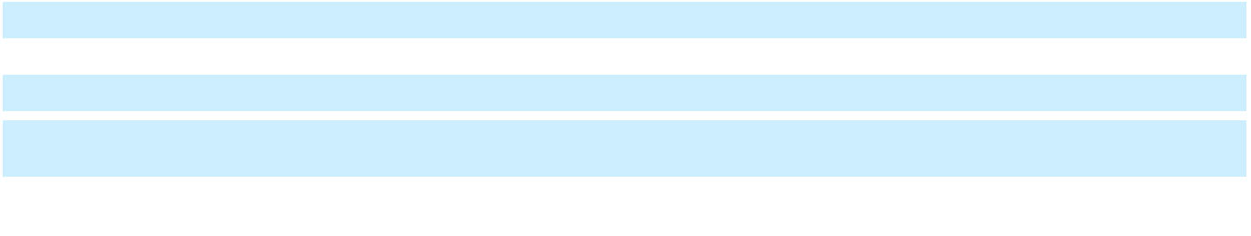

__________

- Commercial finance receivables include dealer financing of $18.6 billion and $13.3 billion, and other financing of $604 million and $476 million at December 31, 2024 and 2023. Commercial finance receivables are presented net of dealer cash management balances of $3.4 billion and $2.6 billion at December 31, 2024 and 2023. Under the cash management program, subject to certain conditions, a dealer may choose to reduce the amount of interest on its floorplan line by making principal payments to GM Financial in advance.

 |  | Years Ended December 31,
 |  | 2024 |  |  | 2023 |  |  | 2022
Allowance for loan losses at beginning of period | $ | 2,344 | $ |  | 2,096 | $ |  | 1,886
Provision for loan losses |  | 1,029 |  |  | 826 |  |  | 654
Charge-offs |  | (1,756) |  |  | (1,423) |  |  | (1,138)
Recoveries |  | 903 |  |  | 768 |  |  | 686
Effect of foreign currency and other |  | (61) |  |  | 76 |  |  | 9
Allowance for loan losses at end of period | $ | 2,458 | $ |  | 2,344 | $ |  | 2,096
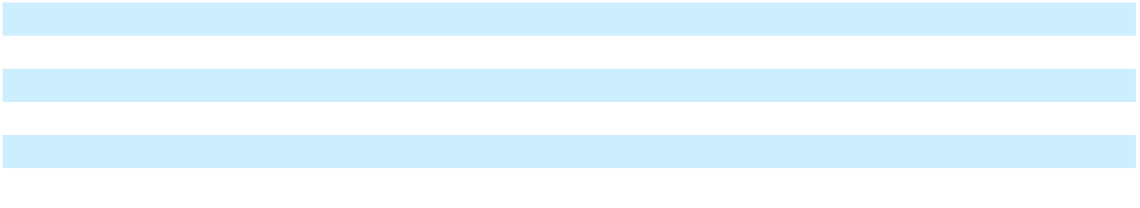

The allowance for loan losses as a percentage of finance receivables was 2.6% and 2.7% at December 31, 2024 and 2023.

Retail Finance Receivables GM Financial's retail finance receivable portfolio includes loans made to consumers and businesses to finance the purchase of vehicles for personal and commercial use. The following tables are consolidated summaries of the retail finance receivables by FICO score or its equivalent, determined at origination, for each vintage of the retail finance receivables portfolio at December 31, 2024 and 2023:

 |  |  |  |  | Year of Origination |  |  |  |  |  |  |  |  | December 31, 2024
 | 2024 |  | 2023 |  | 2022 |  | 2021 |  | 2020 |  |  | Prior |  | Total |  | Percent
Prime – FICO score 680 and greater | $24,155 | $15,814 |  | $ 9,749 |  | $ 5,424 |  | $ 2,559 |  | $ |  | 366 | $58,067 |  | 76.3 %
Near-prime – FICO score 620 to 679 | 3,547 | 2,227 |  | 1,507 |  | 1,077 |  | 473 |  |  |  | 159 | 8,990 |  | 11.8 %
Sub-prime – FICO score less than 620 | 3,399 |  | 2,059 |  | 1,546 |  | 1,141 |  | 543 |  |  | 322 |  | 9,008 |  | 11.8 %
Retail finance receivables | $31,101 | $20,100 |  | $12,802 |  | $ 7,642 |  | $ 3,575 |  | $ |  | 847 | $76,066 |  | 100.0 %

68

Table of Contents

GENERAL MOTORS COMPANY AND SUBSIDIARIES

NOTES TO CONSOLIDATED FINANCIAL STATEMENTS – (Continued)

 |  |  |  |  | Year of Origination |  |  |  |  |  |  |  |  | December 31, 2023
 | 2023 |  | 2022 |  | 2021 |  | 2020 |  | 2019 |  |  | Prior |  | Total |  | Percent
Prime – FICO score 680 and greater | $23,940 | $15,581 |  | $ 9,039 |  | $ 4,926 |  | $ 1,076 |  | $ |  | 320 | $54,882 |  | 75.5 %
Near-prime – FICO score 620 to 679 | 3,234 | 2,281 |  | 1,746 |  | 906 |  | 350 |  |  |  | 129 | 8,647 |  | 11.9 %
Sub-prime – FICO score less than 620 | 3,079 |  | 2,397 |  | 1,884 |  | 1,010 |  | 573 |  |  | 257 |  | 9,200 |  | 12.6 %
Retail finance receivables | $30,253 | $20,259 |  | $12,670 |  | $ 6,842 |  | $ 2,000 |  | $ |  | 707 | $72,729 |  | 100.0 %

GM Financial reviews the ongoing credit quality of retail finance receivables based on customer payment activity. A retail account is considered delinquent if a substantial portion of a scheduled payment has not been received by the date the payment was contractually due. Retail finance receivables are collateralized by vehicle titles and, subject to local laws, GM Financial generally has the right to repossess the vehicle in the event the customer defaults on the payment terms of the contract. The accrual of finance charge income had been suspended on delinquent retail finance receivables with contractual amounts due of $958 million and $809 million at December 31, 2024 and 2023. The following tables are consolidated summaries of the delinquency status of the outstanding amortized cost of retail finance receivables for each vintage of the portfolio at December 31, 2024 and 2023:

 |  |  |  |  |  |  |  | Year of Origination |  |  |  |  |  |  |  |  |  |  |  | December 31, 2024
 |  | 2024 |  |  | 2023 |  |  | 2022 |  |  | 2021 |  |  | 2020 |  |  | Prior |  |  | Total |  | Percent
0-to-30 days | $ | 30,581 | $ |  | 19,411 | $ |  | 12,207 | $ |  | 7,178 | $ |  | 3,350 | $ |  | 710 | $ |  | 73,438 | 96.5 %
31-to-60 days |  | 374 |  |  | 481 |  |  | 425 |  |  | 340 |  |  | 166 |  |  | 99 |  |  | 1,885 | 2.5 %
Greater-than-60 days |  | 128 |  |  | 188 |  |  | 155 |  |  | 115 |  |  | 55 |  |  | 36 |  |  | 677 | 0.9 %
Finance receivables more
than 30 days |  | 502 |  |  | 669 |  |  | 580 |  |  | 455 |  |  | 221 |  |  | 135 |  |  | 2,562 | 3.4 %
delinquent |  | 502 |  |  | 669 |  |  | 580 |  |  | 455 |  |  | 221 |  |  | 135 |  |  | 2,562
In repossession |  | 17 |  |  | 19 |  |  | 14 |  |  | 10 |  |  | 3 |  |  | 2 |  |  | 66 | 0.1 %
Finance receivables more
than 30 days
delinquent or in |  | 519 |  |  | 689 |  |  | 595 |  |  | 464 |  |  | 225 |  |  | 136 |  |  | 2,628 |  | 3.5 %
repossession |  | 519 |  |  | 689 |  |  | 595 |  |  | 464 |  |  | 225 |  |  | 136 |  |  | 2,628 |  | 3.5 %
Retail finance receivables | $ | 31,101 |  | $ | 20,100 |  | $ | 12,802 |  | $ | 7,642 |  | $ | 3,575 |  | $ | 847 |  | $ | 76,066 |  | 100.0 %
 |  |  |  |  |  |  |  | Year of Origination |  |  |  |  |  |  |  |  |  |  |  | December 31, 2023
 |  | 2023 |  |  | 2022 |  |  | 2021 |  |  | 2020 |  |  | 2019 |  |  | Prior |  |  | Total |  | Percent
0-to-30 days | $ | 29,816 | $ |  | 19,602 | $ |  | 12,098 | $ |  | 6,533 | $ |  | 1,825 | $ |  | 599 | $ |  | 70,472 | 96.9 %
31-to-60 days |  | 318 |  |  | 470 |  |  | 415 |  |  | 227 |  |  | 130 |  |  | 78 |  |  | 1,637 | 2.3 %
Greater-than-60 days |  | 102 |  |  | 168 |  |  | 142 |  |  | 76 |  |  | 42 |  |  | 29 |  |  | 559 | 0.8 %
Finance receivables more
than 30 days |  | 421 |  |  | 637 |  |  | 557 |  |  | 302 |  |  | 172 |  |  | 107 |  |  | 2,196 | 3.0 %
delinquent |  | 421 |  |  | 637 |  |  | 557 |  |  | 302 |  |  | 172 |  |  | 107 |  |  | 2,196
In repossession |  | 17 |  |  | 20 |  |  | 14 |  |  | 6 |  |  | 3 |  |  | 1 |  |  | 61 | 0.1 %
Finance receivables more
than 30 days
delinquent or in |  | 437 |  |  | 657 |  |  | 572 |  |  | 308 |  |  | 175 |  |  | 108 |  |  | 2,257 |  | 3.1 %
repossession |  | 437 |  |  | 657 |  |  | 572 |  |  | 308 |  |  | 175 |  |  | 108 |  |  | 2,257 |  | 3.1 %
Retail finance receivables | $ | 30,253 | $ |  | 20,259 | $ |  | 12,670 | $ |  | 6,842 | $ |  | 2,000 | $ |  | 707 | $ |  | 72,729 | 100.0 %
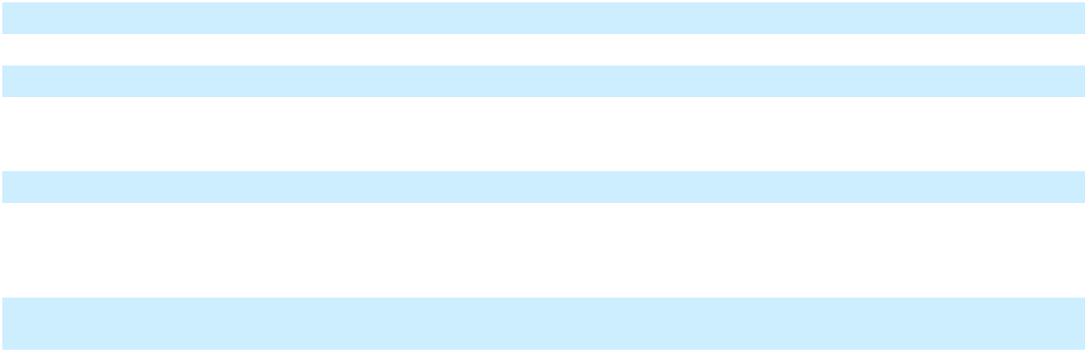
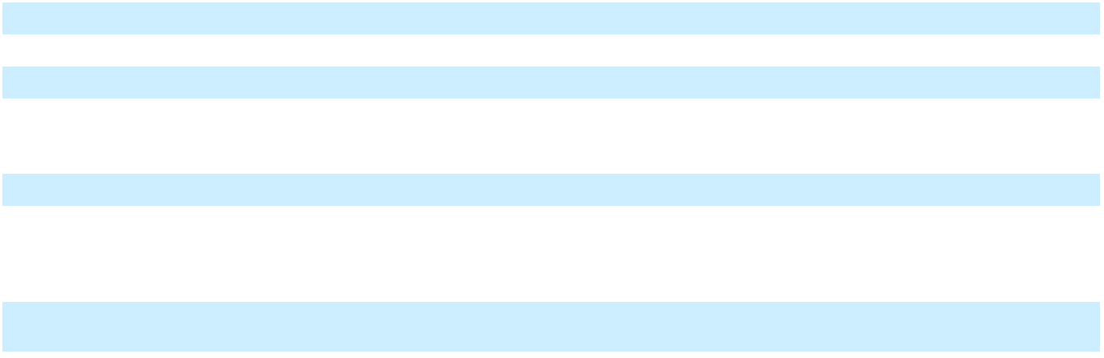

69

Table of Contents

GENERAL MOTORS COMPANY AND SUBSIDIARIES

NOTES TO CONSOLIDATED FINANCIAL STATEMENTS – (Continued)

Commercial Finance Receivables GM Financial's commercial finance receivables consist of dealer financing, primarily for dealer inventory purchases, and other financing, which includes loans to commercial vehicle upfitters. For dealer financing, proprietary models are used to assign a risk rating to each dealer. GM Financial performs periodic credit reviews of each dealership and adjusts the dealership's risk rating, if necessary. The credit risk associated with other financing is limited due to the structure of the business relationships.

GM Financial's dealer risk model and risk rating categories are as follows:

Rating I

II

III

IV

Description
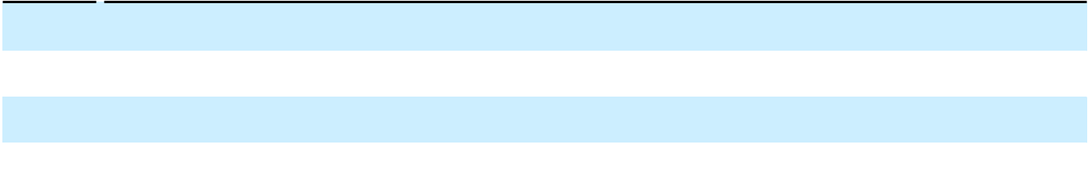

Performing accounts with strong to acceptable financial metrics with at least satisfactory capacity to meet financial commitments.

Performing accounts experiencing potential weakness in financial metrics and repayment prospects resulting in increased monitoring.

Non-Performing accounts with inadequate paying capacity for current obligations and have the distinct possibility of creating a loss if deficiencies are not corrected.

Non-Performing accounts with inadequate paying capacity for current obligations and inherent weaknesses that make collection of liquidation in full highly questionable or improbable.

Dealers with III and IV risk ratings are subject to additional monitoring and restrictions on funding, including suspension of lines of credit and liquidation of assets. The following tables summarize the dealer credit risk profile by dealer risk rating at December 31, 2024 and 2023:

 |  |  |  |  |  |  | Year of Origination(a) |  |  |  |  |  |  |  |  |  |  |  |  |  |  | December 31, 2024
Dealer Risk Rating |  | Revolving |  |  | 2024 |  |  | 2023 |  |  | 2022 |  |  | 2021 |  |  | 2020 |  | Prior |  |  | Total |  | Percent
I | $ | 16,190 | $ |  | 321 | $ |  | 209 | $ |  | 360 | $ |  | 237 | $ |  | 267 | $ |  | 22 | $17,606 |  | 94.5 %
II |  | 621 |  |  | — |  |  | 10 |  |  | 26 |  |  | 3 |  |  | 2 |  |  | — | 663 |  | 3.6 %
III |  | 305 |  |  | 10 |  |  | 4 |  |  | — |  |  | 22 |  |  | — |  |  | 12 | 354 |  | 1.9 %
IV |  | 1 |  |  | — |  |  | — |  |  | — |  |  | — |  |  | — |  |  | — |  | 1 |  | — %
Balance at end of period | $ | 17,117 | $ |  | 331 | $ |  | 223 | $ |  | 385 | $ |  | 263 | $ |  | 269 | $ |  | 35 | $18,623 |  | 100.0 %
__________
(a) Floorplan advances comprise 99.5% of the total revolving balance. Dealer term loans are presented by year of origination.
 |  |  |  |  |  |  | Year of Origination(a) |  |  |  |  |  |  |  |  |  |  |  |  |  |  | December 31, 2023
Dealer Risk Rating |  | Revolving |  |  | 2023 |  |  | 2022 |  |  | 2021 |  |  | 2020 |  |  | 2019 |  | Prior |  |  | Total |  | Percent
I | $ | 11,513 | $ |  | 279 | $ |  | 403 | $ |  | 297 | $ |  | 301 | $ |  | 75 | $ |  | 11 | $12,879 |  | 97.1 %
II |  | 182 |  |  | — |  |  | 2 |  |  | 2 |  |  | — |  |  | — |  |  | — | 187 |  | 1.4 %
III |  | 152 |  |  | 1 |  |  | 15 |  |  | 12 |  |  | — |  |  | 11 |  |  | — | 192 |  | 1.4 %
IV |  | ——————— |  |  |  |  |  |  |  |  |  |  |  |  |  |  |  |  |  |  |  | — |  | — %
Balance at end of period | $ | 11,846 |  | $ | 281 |  | $ | 421 |  | $ | 311 |  | $ | 301 |  | $ | 86 |  | $ | 11 |  | $13,257 |  | 100.0 %

__________

(a) Floorplan advances comprise 99.7% of the total revolving balance. Dealer term loans are presented by year of origination.

There were no commercial finance receivables on nonaccrual status at December 31, 2024 and 2023.

70

Table of Contents

GENERAL MOTORS COMPANY AND SUBSIDIARIES

NOTES TO CONSOLIDATED FINANCIAL STATEMENTS – (Continued)

Transactions with GM Financial The following tables show transactions between our Automotive segments, Cruise and GM Financial. These amounts are presented in GM Financial's consolidated balance sheets and statements of income.

 | December 31, 2024 |  |  | December 31, 2023
Consolidated Balance Sheets(a)
Commercial finance receivables due from GM consolidated dealers | $ | 279 | $ |  | 164
Commercial finance receivables due from Cruise | $ | 395 | $ |  | 353
Subvention receivable from GM(b) | $ | 360 | $ |  | 508
Commercial loan funding payable to GM | $ | 100 | $ |  | 55
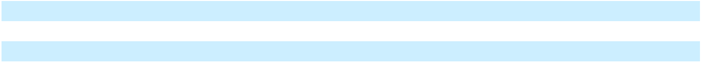

 |  | Years Ended December 31,
 |  | 2024 |  |  | 2023 |  |  | 2022
Consolidated Statements of Income
Interest subvention earned on finance receivables | $ | 1,385 | $ |  | 1,234 | $ |  | 984
Leased vehicle subvention earned | $ | 1,511 | $ |  | 1,537 | $ |  | 1,916

__________

- All balance sheet amounts are eliminated upon consolidation.

- Our Automotive segments made cash payments to GM Financial for subvention of $3.8 billion, $3.5 billion and $2.4 billion in the years ended December 31, 2024, 2023 and 2022.

GM Financial's Board of Directors declared and paid dividends on its common stock of $1.8 billion in the years ended December 31, 2024 and 2023 and $1.7 billion in the year ended December 31, 2022.

Note 6. Inventories

 | December 31, 2024 |  |  | December 31, 2023
Total productive material, supplies and work in process | $ | 6,444 | $ |  | 7,422
Finished product, including service parts |  | 8,120 |  |  | 9,039
Total inventories | $ | 14,564 | $ |  | 16,461

Inventories are reflected net of allowances totaling $2.0 billion and $2.2 billion, of which $1.4 billion and $1.9 billion are EV-related, to remeasure inventory on-hand to net realizable value at December 31, 2024 and 2023.

Note 7. Operating Leases

Operating Leases Our portfolio of leases primarily consists of real estate office space, manufacturing and warehousing facilities, land and equipment. Certain leases contain escalation clauses and renewal or purchase options, and generally our leases have no residual value guarantees or material covenants. We exclude leases with a term of one year or less from our balance sheet, and do not separate non-lease components from our real estate leases.

Rent expense under operating leases was $369 million, $346 million and $317 million in the years ended December 31, 2024, 2023 and 2022. Variable lease costs were insignificant in the years ended December 31, 2024, 2023 and 2022. At December 31, 2024 and 2023, operating lease right of use assets in Other assets were $919 million and $979 million, operating lease liabilities in Accrued liabilities were $254 million and $264 million and non-current operating lease liabilities in Other liabilities were $961 million and $907 million. Operating lease right of use assets obtained in exchange for lease obligations were $368 million and $225 million in the years ended December 31, 2024 and 2023. Our undiscounted future lease obligations related to operating leases having initial terms in excess of one year are $290 million, $255 million, $209 million, $183 million, $156 million and $296 million for the years 2025, 2026, 2027, 2028, 2029 and thereafter, with imputed interest of $174 million as of December 31, 2024. The weighted-average discount rate was 4.6% and 4.3% and the weighted-average remaining lease term was 5.9 years and 6.0 years at December 31, 2024 and 2023. Payments for operating leases included in Net cash provided by (used in) operating activities were $416 million, $359 million and $314 million in the years ended December 31, 2024, 2023 and 2022. Lease agreements that have not yet commenced were $746 million at December 31, 2024.

71

Table of Contents

GENERAL MOTORS COMPANY AND SUBSIDIARIES

NOTES TO CONSOLIDATED FINANCIAL STATEMENTS – (Continued)

Equipment on Operating Leases Equipment on operating leases primarily consists of leases to retail customers of GM Financial.

 | December 31, 2024 |  |  | December 31, 2023
Equipment on operating leases | $ | 38,187 | $ |  | 37,921
Less: accumulated depreciation |  | (6,601) |  |  | (7,338)
Equipment on operating leases, net | $ | 31,586 | $ |  | 30,582

At December 31, 2024, the estimated residual value of our leased assets at the end of the lease term was $23.5 billion.

Depreciation expense related to Equipment on operating leases, net was $4.8 billion, $4.9 billion and $4.8 billion in the years ended December 31, 2024, 2023 and 2022.

The following table summarizes lease payments due to GM Financial on leases to retail customers:

 |  |  | Years Ending December 31,
 | 2025 |  | 2026 |  | 2027 |  |  | 2028 |  |  |  | 2029 |  | Total
Lease receipts under operating leases | $ 5,195 | $ 3,371 |  | $ 1,257 |  | $ |  | 135 |  |  | $ | 1 | $ 9,959

Note 8. Equity in Net Assets of Nonconsolidated Affiliates

Nonconsolidated affiliates are entities in which we maintain an equity ownership interest and for which we use the equity method of accounting due to our ability to exert significant influence over decisions relating to their operating and financial affairs. Revenue and expenses of our joint ventures are not consolidated into our financial statements; rather, our proportionate share of the earnings of each joint venture is reflected as Equity income (loss) or Automotive and other cost of sales.

 |  | Years Ended December 31,
 |  | 2024 |  |  | 2023 |  |  | 2022
Automotive China JVs equity income (loss) | $ | (4,407) | $ |  | 446 | $ |  | 677
Ultium Cells Holdings LLC equity income (loss)(a) |  | 975 |  |  | 293 |  |  | 8
Other joint ventures equity income (loss) |  | (268) |  |  | 34 |  |  | 151
Total Equity income (loss) | $ | (3,701) | $ |  | 773 | $ |  | 837
__________

- Equity earnings related to Ultium Cells Holdings LLC are presented in Automotive and other cost of sales as this entity is integral to the operations of our business by providing battery cells for our EVs.

Investments in Nonconsolidated Affiliates

 | December 31, 2024 |  |  | December 31, 2023
Automotive China JVs carrying amount | $ | 1,474 | $ |  | 6,373
Ultium Cells Holdings LLC carrying amount |  | 3,749 |  |  | 2,268
Other investments carrying amount |  | 1,879 |  |  | 1,972
Total equity in net assets of nonconsolidated affiliates | $ | 7,102 | $ |  | 10,613

The carrying amount of our investments in certain joint ventures exceeded our share of the underlying net assets by $1.9 billion and $4.2 billion at December 31, 2024 and 2023 primarily due to goodwill from the application of fresh-start reporting and the purchase of additional interests in nonconsolidated affiliates.

72

Table of Contents

GENERAL MOTORS COMPANY AND SUBSIDIARIES

NOTES TO CONSOLIDATED FINANCIAL STATEMENTS – (Continued)

The following table summarizes our direct ownership interests in our China JVs:

 | December 31, 2024 |  | December 31, 2023
Automotive China JVs
SAIC General Motors Corp., Ltd. (SGM) | 50 % | 50 %
Pan Asia Technical Automotive Center Co., Ltd. | 50 % | 50 %
SAIC General Motors Sales Co., Ltd. (SGMS) | 49 % | 49 %
SAIC GM Wuling Automobile Co., Ltd. (SGMW) | 44 % | 44 %
Shanghai OnStar Telematics Co., Ltd. (Shanghai OnStar) | 40 % | 40 %
SAIC GM (Shenyang) Norsom Motors Co., Ltd. (SGM Norsom) | 25 % | 25 %
SAIC GM Dong Yue Motors Co., Ltd. (SGM DY) | 25 % | 25 %
SAIC GM Dong Yue Powertrain Co., Ltd. (SGM DYPT) | 25 % | 25 %
Other joint ventures
SAIC-GMAC Automotive Finance Company Limited (SAIC-GMAC) | 35 % | 35 %
SAIC-GMF Leasing Co., Ltd. | 35 % | 35 %
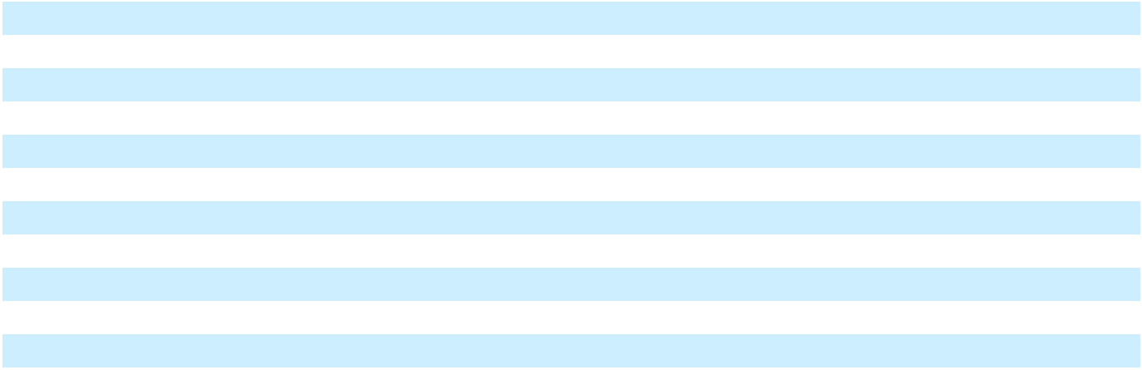

SGM is a joint venture we established with Shanghai Automotive Industry Corporation (SAIC) (50%). SGM has interests in three other joint ventures in China: SGM Norsom, SGM DY and SGM DYPT. These three joint ventures are jointly held by SGM (50%), SAIC (25%) and ourselves. These four joint ventures are engaged in the production, import and sale of a range of products under the Buick, Chevrolet and Cadillac brands. SGM also has interests in Shanghai OnStar (20%), SAIC-GMAC (20%) and SAIC-GMF Leasing Co., Ltd. (20%). Shanghai Automotive Group Finance Company Ltd., a subsidiary of SAIC, owns 45% of SAIC-GMAC. SAIC Financial Holdings Company, a subsidiary of SAIC, owns 45% of SAIC-GMF Leasing Co., Ltd.

Impairment Charges Our Automotive China JVs generated an equity loss of $4.4 billion in the year ended December 31, 2024, which includes $2.0 billion of impairments and restructuring-related charges recorded by certain of the China JVs and a $2.1 billion other-than-temporary impairment charge to write down certain of our automotive investments to their fair values. In response to intense competition in a market with significant excess capacity and an increasingly challenging regulatory environment related to emissions, fuel consumption and NEVs, we and our JV partners are restructuring our operations in China. The charges recorded by the China JVs were primarily related to asset impairments associated with plant closures and portfolio optimization actions and the recognition of a valuation allowance on deferred tax assets. As a result of the market challenges and competitive conditions, GM Financial also recorded a $0.3 billion other-than-temporary impairment charge to write down its SAIC-GMAC investment to its fair value.

Fair Value Measurements In performing our impairment testing, we utilize a third-party valuation specialist to assist in determining the fair values of our investments based on valuation techniques using the best available information. The fair values of the investments in the China JVs are estimated based on their discounted cash flows (income approach). We make significant assumptions and estimates about the extent and timing of future cash flows, growth rates, market share and discount rates that represent unobservable, Level 3, inputs into our valuation methodologies. Where available and as appropriate, comparative market multiples are used to corroborate the results of the discounted cash flow method.

The investment balance for SGM, SGM Norsom, SGM DY and SGM DYPT that was tested for impairment was $2.4 billion and the estimated key assumptions utilized in our impairment testing were: 16.5% discount rate; 0.5% long-term growth rate; passenger vehicle industry volumes of 23.3-24.0 million and a market share of 2.0-2.2% in 2024 through 2028. The investment balance for SAIC-GMAC that was tested for impairment was $1.5 billion and the estimated key assumptions utilized in our impairment testing were: 13.0% discount rate; 3.5% long-term growth rate; and alignment with the Automotive China JVs on vehicle volumes and market share.

The discount rate considered various factors including bond yields, cost of equity, risk premiums and tax rates; the terminal values were determined using a growth model that applied an investee's long-term growth rate to its projected cash flows beyond the forecast period; and industry volumes and market share included annual estimates through the forecast period. In addition, minimum operating cash needs that incorporate specific business, economic and regulatory factors giving rise to varying cash needs were estimated. Our fair value estimates assume the achievement of the future financial results

73

Table of Contents

GENERAL MOTORS COMPANY AND SUBSIDIARIES

NOTES TO CONSOLIDATED FINANCIAL STATEMENTS – (Continued)

contemplated in our forecasted cash flows which is subject to significant uncertainties. There is no assurance that anticipated financial results will be achieved.

Summarized Financial Data of Nonconsolidated Affiliates

 |  |  |  | December 31, 2024 |  |  |  |  |  |  |  |  |  |  |  |  |  |  | December 31, 2023
 |  | Automotive |  |  |  |  | Others |  |  |  | Total |  |  |  | Automotive |  |  |  |  |  |  | Others |  |  |  |  |  | Total
 |  |  | China JVs |  |  |  |  |  |  |  |  |  |  |  |  | China JVs |  |  |  |  |  |  |  |  |  |  |  | Total
Summarized Balance Sheet Data
Current assets |  | $ | 11,203 | $ |  |  | 10,862 |  |  | $ | 22,065 |  | $ |  |  | 15,963 |  |  | $ |  |  | 17,435 |  |  | $ |  |  | 33,398
Non-current assets |  |  | 6,518 |  |  |  | 11,434 |  |  |  | 17,952 |  |  |  |  | 11,585 |  |  |  |  |  | 11,535 |  |  |  |  |  | 23,120
Total assets |  | $ | 17,721 |  |  | $ | 22,296 |  |  | $ | 40,017 |  |  |  | $ | 27,548 |  |  |  |  | $ | 28,970 |  |  |  |  | $ | 56,518
Current liabilities |  | $ | 17,076 | $ |  |  | 7,722 |  |  | $ | 24,798 |  | $ |  |  | 22,104 |  |  | $ |  |  | 15,308 |  |  | $ |  |  | 37,412
Non-current liabilities |  |  | 887 |  |  |  | 2,562 |  |  |  | 3,449 |  |  |  |  | 1,070 |  |  |  |  |  | 4,174 |  |  |  |  |  | 5,244
Total liabilities |  | $ | 17,963 |  |  | $ | 10,284 |  |  | $ | 28,247 |  |  |  | $ | 23,174 |  |  |  |  | $ | 19,482 |  |  |  |  | $ | 42,656
Noncontrolling interests |  | $ | 279 | $ |  |  | — |  |  | $ | 279 |  | $ |  |  |  | 868 |  | $ |  |  | — |  |  | $ |  |  | 868
 |  |  |  |  |  |  |  |  |  |  |  |  |  |  |  | Years Ended December 31,
 |  |  |  |  |  |  |  |  |  |  |  |  | 2024 |  |  |  |  |  | 2023 |  |  |  |  |  |  |  |  | 2022
Summarized Operating Data
Automotive China JVs' net sales |  |  |  |  |  |  |  |  |  |  | $ |  | 21,740 |  |  |  | $ |  |  |  |  | 31,435 |  |  | $ |  |  | 35,857
Others' net sales |  |  |  |  |  |  |  |  |  |  |  |  | 5,545 |  |  |  |  |  |  |  |  | 4,311 |  |  |  |  |  | 2,029
Total net sales |  |  |  |  |  |  |  |  |  |  |  | $ | 27,285 |  |  |  |  | $ |  |  |  | 35,746 |  |  | $ |  |  | 37,886
Automotive China JVs' net income (loss) |  |  |  |  |  |  |  |  |  |  | $ |  | (4,466) |  |  |  | $ |  |  |  |  | 1,122 |  |  | $ |  |  | 1,407
Others' net income |  |  |  |  |  |  |  |  |  |  |  |  | 1,315 |  |  |  |  |  |  |  |  | 771 |  |  |  |  |  | 426
Total net income (loss) |  |  |  |  |  |  |  |  |  |  | $ |  | (3,151) |  |  |  | $ |  |  |  |  | 1,893 |  |  | $ |  |  | 1,833
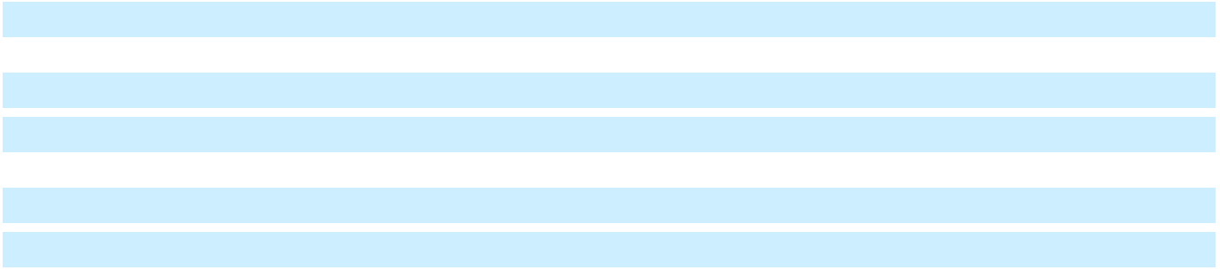
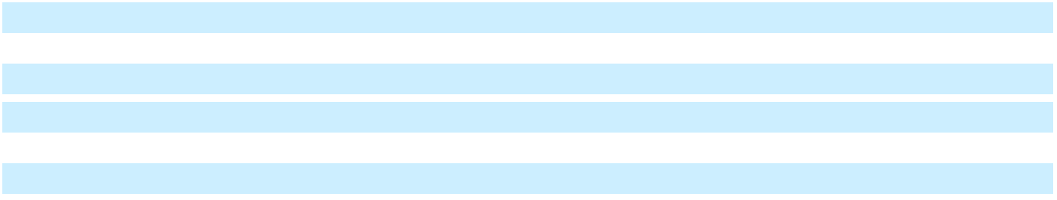

Transactions with Nonconsolidated Affiliates Our nonconsolidated affiliates are involved in various aspects of the development, production and marketing of trucks, crossovers, cars and automobile parts. We enter into transactions with certain nonconsolidated affiliates to purchase and sell component parts and vehicles. The following tables summarize transactions with and balances related to our nonconsolidated affiliates:

 |  |  | Years Ended December 31,
 |  | 2024 |  |  |  | 2023 |  |  |  |  |  | 2022
Automotive sales and revenue | $ | 90 |  | $ |  | 209 |  |  |  |  | $ | 218
Automotive purchases, net | $ | 4,875 |  | $ |  | 2,766 |  |  |  |  | $ | 2,637
Dividends received | $ | 418 |  | $ |  | 1,018 |  |  |  |  | $ | 1,030
Operating cash flows | $ | (4,422) |  | $ |  | (941) |  |  |  |  | $ | (1,133)
 |  |  | December 31, 2024 |  |  |  |  |  | December 31, 2023
Accounts and notes receivable, net |  | $ |  |  |  | 1,056 |  |  | $ |  |  | 589
Accounts payable |  | $ |  |  |  | 892 |  |  | $ |  |  | 806
Undistributed earnings |  | $ |  |  |  | 6 |  |  | $ |  |  | 1,719

74

Table of Contents

GENERAL MOTORS COMPANY AND SUBSIDIARIES

NOTES TO CONSOLIDATED FINANCIAL STATEMENTS – (Continued)

Note 9. Property

 | Estimated
 | Useful Lives in |  | December 31, 2024 |  |  | December 31, 2023
 | Years
Land |  | $ |  | 1,253 | $ |  | 1,293
Buildings and improvements | 5-40 |  |  | 14,915 |  |  | 13,256
Machinery and equipment | 3-27 |  |  | 39,575 |  |  | 37,074
Special tools | 1-16 |  |  | 25,813 |  |  | 26,086
Construction in progress |  |  |  | 7,176 |  |  | 8,135
Total property |  |  |  | 88,732 |  |  | 85,845
Less: accumulated depreciation |  |  |  | (36,828) |  |  | (35,524)
Total property, net |  | $ |  | 51,904 | $ |  | 50,321
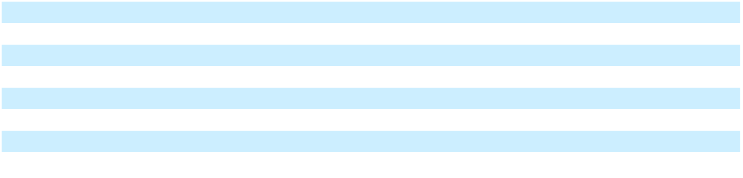

The amount of capitalized software included in Property, net was $2.3 billion and $2.2 billion at December 31, 2024 and 2023. The amount of interest capitalized and excluded from Automotive interest expense was $215 million in the year ended December 31, 2024 and insignificant in the years ended December 31, 2023 and 2022.

 |  | Years Ended December 31,
 |  | 2024 |  |  | 2023 |  |  | 2022
Depreciation and amortization expense | $ | 6,466 | $ |  | 6,719 | $ |  | 6,297
Impairment charges(a) | $ | 635 | $ |  | 115 | $ |  | 12
Capitalized software amortization expense(b) | $ | 798 | $ |  | 705 | $ |  | 614

__________

- In the year ended December 31, 2024, we recognized impairment charges primarily related to the indefinite delay of the Cruise Origin.

- Included in Depreciation and amortization expense.

Note 10. Goodwill and Intangible Assets

Goodwill of $1.9 billion consisted of $1.3 billion in GM Financial at December 31, 2024 and 2023, and $569 million and $573 million in Cruise at December 31, 2024 and 2023. In the three months ended December 31, 2024, we performed a goodwill impairment test for Cruise and determined that the goodwill was not impaired.

 |  | December 31, 2024 |  |  |  |  |  |  |  |  | December 31, 2023
 |  | Gross |  | Accumulated |  |  |  | Net |  |  | Gross |  | Accumulated |  |  |  | Net
 |  | Carrying |  |  |  |  | Carrying |  |  |  | Carrying |  |  |  |  | Carrying
 |  | Amount |  | Amortization |  |  | Amount |  |  |  | Amount |  | Amortization |  |  | Amount
Technology and intellectual property | $ | 554 | $ |  | 483 |  | $ | 71 | $ |  | 749 | $ |  | 517 |  | $ | 231
Brands |  | 4,288 |  |  | 1,873 |  |  | 2,415 |  |  | 4,293 |  |  | 1,768 |  |  | 2,526
Dealer network, customer relationships and other |  | 957 |  |  | 793 |  |  | 164 |  |  | 968 |  |  | 784 |  |  | 184
Total intangible assets | $ | 5,799 | $ |  | 3,149 |  | $ | 2,649 | $ |  | 6,010 | $ |  | 3,069 |  | $ | 2,941
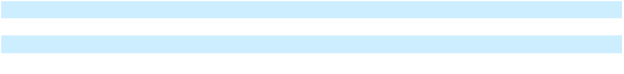

Our amortization expense related to intangible assets was $146 million, $114 million and $139 million in the years ended December 31, 2024, 2023 and 2022. In the year ended December 31, 2024, we recorded $142 million of impairment charges related to the write-off of technology and intellectual property associated with Cruise.

Amortization expense related to intangible assets is estimated to be approximately $141 million in each of the next five years.

75

Table of Contents

GENERAL MOTORS COMPANY AND SUBSIDIARIES

NOTES TO CONSOLIDATED FINANCIAL STATEMENTS – (Continued) Note 11. Variable Interest Entities

Consolidated VIEs

Automotive Financing - GM Financial

GM Financial uses special purpose entities (SPEs) that are considered VIEs to issue variable funding notes to third party, bank-sponsored warehouse facilities or asset-backed securities to investors in securitization transactions. The debt issued by these VIEs is backed by finance receivables and leasing-related assets transferred to the VIEs (Securitized Assets). GM Financial determined that it is the primary beneficiary of the SPEs because the servicing responsibilities for the Securitized Assets give GM Financial the power to direct the activities that most significantly impact the performance of the VIEs and the variable interests in the VIEs give GM Financial the obligation to absorb losses and the right to receive residual returns that could potentially be significant. The assets of the VIEs serve as the sole source of repayment for the debt issued by these entities. Investors in the notes issued by the VIEs do not have recourse to GM Financial or its other assets, with the exception of customary representation and warranty repurchase provisions and indemnities that GM Financial provides as the servicer. GM Financial is not required to provide additional financial support to these SPEs. While these subsidiaries are included in GM Financial's consolidated financial statements, they are separate legal entities and their assets are legally owned by them and are not available to GM Financial's creditors or creditors of GM Financial's other subsidiaries.

The following table summarizes the assets and liabilities related to GM Financial's consolidated VIEs:

Restricted cash – current | December 31, 2024 |  |  | December 31, 2023
Restricted cash – current | $ | 2,410 | $ |  | 2,398
Restricted cash – non-current | $ | 350 | $ |  | 367
GM Financial receivables – current | $ | 27,631 | $ |  | 22,990
GM Financial receivables – non-current | $ | 27,619 | $ |  | 23,535
GM Financial equipment on operating leases, net | $ | 14,252 | $ |  | 15,794
GM Financial short-term debt and current portion of long-term debt | $ | 18,008 | $ |  | 22,088
GM Financial long-term debt | $ | 31,638 | $ |  | 23,210
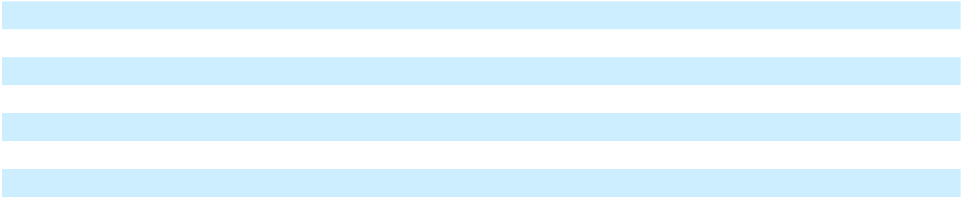

GM Financial recognizes finance charge, leased vehicle and fee income on the Securitized Assets and interest expense on the secured debt issued in a securitization transaction and records a provision for loan losses to recognize loan losses expected over the remaining life of the finance receivables.

Nonconsolidated VIEs

Automotive

Nonconsolidated VIEs primarily include our battery cell manufacturing joint ventures to which we provided financial support to ensure that our supply needs for production are met or are not disrupted. Our variable interests in these nonconsolidated VIEs include equity investments, accounts and loans receivable, committed financial support and other off-balance sheet arrangements. The carrying amounts of assets were approximately $4.3 billion and $2.4 billion and liabilities were insignificant related to our nonconsolidated VIEs at December 31, 2024 and 2023. Our maximum exposure to loss as a result of our involvement with these VIEs was $7.0 billion and $3.5 billion, inclusive of $2.3 billion and $0.8 billion in committed capital contributions to our battery cell manufacturing joint ventures, at December 31, 2024 and 2023. Our maximum exposure to loss, and required capital contributions, could vary depending on our battery cell joint ventures' requirements and access to capital. We currently lack the power through voting or similar rights to direct the activities of these entities that most significantly affect their economic performance.

76

Table of Contents

GENERAL MOTORS COMPANY AND SUBSIDIARIES

NOTES TO CONSOLIDATED FINANCIAL STATEMENTS – (Continued) Note 12. Accrued and Other Liabilities

 | December 31, 2024 |  |  | December 31, 2023
Accrued liabilities
Dealer and customer allowances, claims and discounts | $ | 7,270 | $ |  | 6,065
Deferred revenue |  | 3,371 |  |  | 2,802
Product warranty and related liabilities |  | 4,555 |  |  | 3,285
Payrolls and employee benefits excluding postemployment benefits |  | 3,221 |  |  | 3,099
Other(a) |  | 12,737 |  |  | 12,113
Total accrued liabilities | $ | 31,154 | $ |  | 27,364
Other liabilities
Deferred revenue | $ | 5,940 | $ |  | 5,019
Product warranty and related liabilities |  | 6,016 |  |  | 6,011
Operating lease liabilities |  | 961 |  |  | 907
Employee benefits excluding postemployment benefits |  | 501 |  |  | 518
Postemployment benefits including facility idling reserves |  | 154 |  |  | 151
Other(a) |  | 4,265 |  |  | 3,909
Total other liabilities | $ | 17,836 | $ |  | 16,515
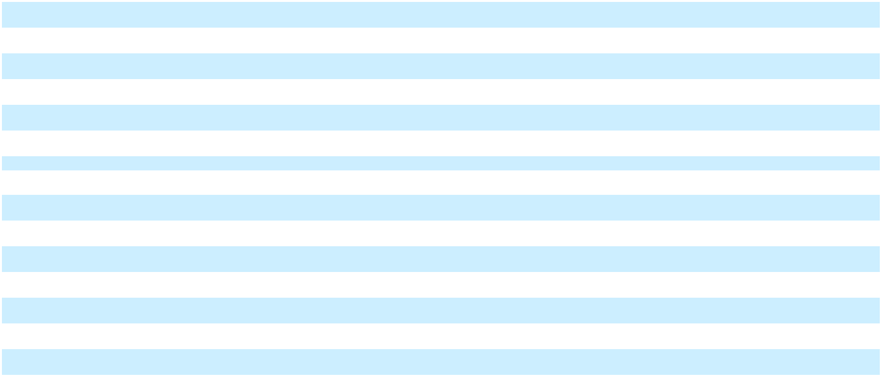
__________

- Includes amounts related to product liability, breach of warranty and other legal and environmental-related accruals of $3.4 billion and $2.9 billion at December 31, 2024 and 2023.

 |  | Years Ended December 31,
Product Warranty and Related Liabilities |  | 2024 |  |  | 2023 |  |  | 2022
Warranty balance at beginning of period | $ | 9,295 | $ |  | 8,530 | $ |  | 9,774
Warranties issued and assumed in period – recall campaigns |  | 997 |  |  | 864 |  |  | 651
Warranties issued and assumed in period – product warranty |  | 3,621 |  |  | 2,418 |  |  | 1,943
Payments |  | (4,474) |  |  | (4,009) |  |  | (4,097)
Adjustments to pre-existing warranties |  | 1,237 |  |  | 1,462 |  |  | 297
Effect of foreign currency and other |  | (106) |  |  | 31 |  |  | (37)
Warranty balance at end of period |  | 10,571 |  |  | 9,295 |  |  | 8,530
Less: Supplier recoveries balance at end of period(a) |  | 438 |  |  | 646 |  |  | 1,184
Warranty balance, net of supplier recoveries at end of period | $ | 10,133 | $ |  | 8,649 | $ |  | 7,345
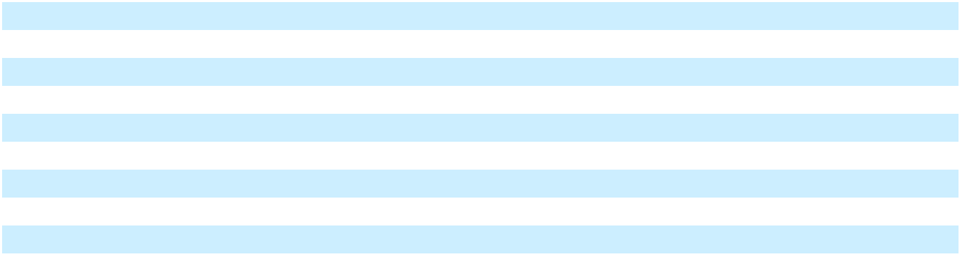
__________

- The current portion of supplier recoveries is recorded in Accounts and notes receivable, net of allowance and the non-current portion is recorded in Other assets.

 |  | Years Ended December 31,
 |  | 2024 |  |  | 2023 |  |  | 2022
Product warranty expense, net of recoveries
Warranties issued and assumed in period | $ | 4,618 | $ |  | 3,282 | $ |  | 2,593
Supplier recoveries accrued in period |  | (297) |  |  | 3 |  |  | (261)
Adjustments and other |  | 1,131 |  |  | 1,493 |  |  | 260
Warranty expense, net of supplier recoveries | $ | 5,452 | $ |  | 4,778 | $ |  | 2,592

For estimates related to reasonably possible losses in excess of amounts accrued for recall campaigns, refer to Note 16 for additional information.

77

Table of Contents

GENERAL MOTORS COMPANY AND SUBSIDIARIES

NOTES TO CONSOLIDATED FINANCIAL STATEMENTS – (Continued)

Note 13. Debt

Automotive The following table presents debt in our automotive operations:

 |  | December 31, 2024 |  |  |  |  |  |  | December 31, 2023
 | Carrying Amount |  |  |  | Fair Value |  |  | Carrying Amount |  |  |  | Fair Value
Secured debt | $ | 105 | $ |  | 105 |  | $ |  | 134 | $ |  | 132
Unsecured debt(a) |  | 14,980 |  |  | 14,709 |  |  |  | 15,842 |  |  | 15,911
Finance lease liabilities |  | 383 |  |  | 391 |  |  |  | 437 |  |  | 447
Total automotive debt(b) | $ | 15,467 | $ |  | 15,204 |  | $ |  | 16,413 | $ |  | 16,490
Fair value utilizing Level 1 inputs |  |  | $ |  | 14,366 |  |  |  |  | $ |  | 15,457
Fair value utilizing Level 2 inputs |  |  | $ |  | 838 |  |  |  |  | $ |  | 1,033
Available under credit facility agreements(c) |  |  | $ |  | 13,793 |  |  |  |  | $ |  | 16,446
Weighted-average interest rate on outstanding short-term debt(d) |  |  |  |  | 7.3 | % |  |  |  |  |  | 16.2 | %
Weighted-average interest rate on outstanding long-term debt(d) |  |  |  |  | 5.8 | % |  |  |  |  |  | 5.8 | %
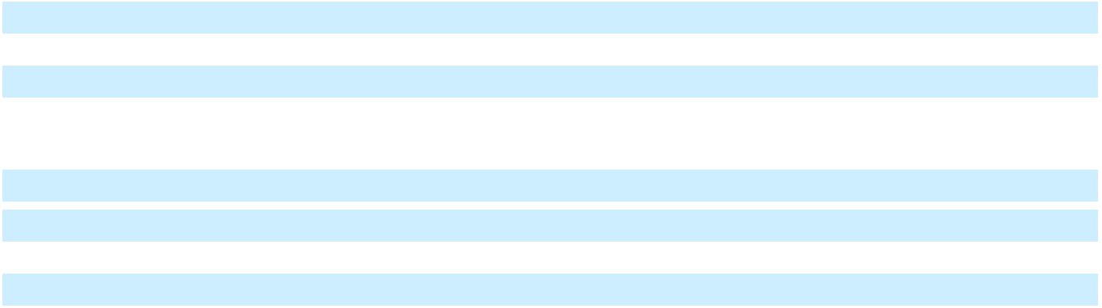

__________

- Primarily consist of senior notes.

- Includes net discount and debt issuance costs of $439 million and $527 million at December 31, 2024 and 2023.

- Excludes our 364-day, $2.0 billion facility designated for exclusive use by GM Financial.

- Includes coupon rates on debt denominated in various foreign currencies and interest free loans.

In March 2024, we renewed our 364-day, $2.0 billion revolving credit facility allocated for the exclusive use of GM Financial, which now matures March 27, 2025. Interest rates on obligations under the renewed credit facility are based on Term SOFR.

In March 2024, we terminated our unsecured 364-day delayed draw term loan credit agreement that permitted the Company to borrow up to $3.0 billion executed in November 2023, resulting in an insignificant loss.

In December 2024, we exercised the make-whole provision on a portion of our $2.0 billion senior unsecured notes with a maturity date of October 2025, redeeming $750 million in aggregate principal amount. Upon settlement in December 2024, we recorded an insignificant early extinguishment of debt loss.

GM Financial The following table presents debt of GM Financial:

 |  | December 31, 2024 |  |  |  |  |  | December 31, 2023
 | Carrying Amount |  |  |  | Fair Value |  | Carrying Amount |  |  |  | Fair Value
Secured debt | $ | 49,573 | $ |  | 49,753 | $ |  | 45,243 | $ |  | 44,971
Unsecured debt |  | 64,691 |  |  | 65,258 |  |  | 60,084 |  |  | 59,651
Total GM Financial debt | $ | 114,264 |  | $ | 115,010 |  | $ | 105,327 |  | $ | 104,622
Fair value utilizing Level 2 inputs |  |  | $ |  | 112,941 |  |  |  | $ |  | 102,262
Fair value utilizing Level 3 inputs |  |  | $ |  | 2,070 |  |  |  | $ |  | 2,360
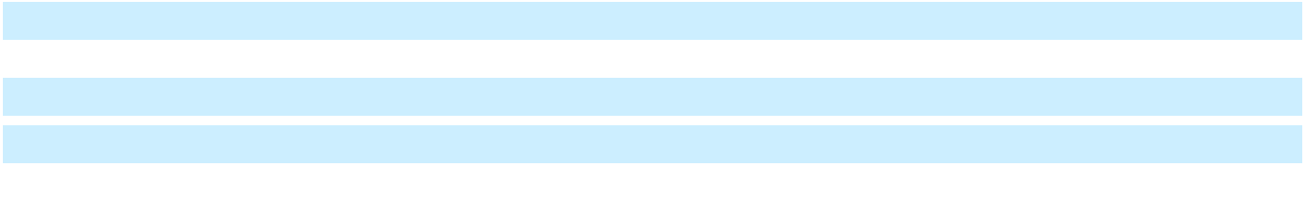

Secured debt consists of revolving credit facilities and securitization notes payable. Most of the secured debt was issued by VIEs and is repayable only from proceeds related to the underlying pledged assets. Refer to Note 11 for additional information on GM Financial's involvement with VIEs. GM Financial is required to hold certain funds in restricted cash accounts to provide additional collateral for borrowings under certain secured credit facilities. The weighted-average interest rate on secured debt was 5.17% at December 31, 2024. The revolving credit facilities have maturity dates ranging from 2025 to 2028 and securitization notes payable have maturity dates ranging from 2025 to 2037. At the end of the revolving period, if not renewed, the debt of revolving credit facilities will amortize over a defined period. In the year ended December 31, 2024, GM Financial renewed revolving credit facilities with total borrowing capacity of $27.4 billion and issued $24.8 billion in aggregate principal

78

Table of Contents

GENERAL MOTORS COMPANY AND SUBSIDIARIES

NOTES TO CONSOLIDATED FINANCIAL STATEMENTS – (Continued)

amount of securitization notes payable with an initial weighted-average interest rate of 5.30% and maturity dates ranging from 2024 to 2037.

Unsecured debt consists of senior notes, credit facilities and other unsecured debt. Senior notes outstanding at December 31, 2024 have maturity dates ranging from 2025 to 2034 and have a weighted-average interest rate of 4.20%. In the year ended December 31, 2024, GM Financial issued $12.5 billion in aggregate principal amount of senior notes with an initial weighted-average interest rate of 5.39% and maturity dates ranging from 2027 to 2034.

Unsecured credit facilities and other unsecured debt have original maturities of up to five years. The weighted-average interest rate on these credit facilities and other unsecured debt was 7.15% at December 31, 2024.

 |  | Years Ended December 31,
 |  | 2024 |  |  | 2023 |  |  | 2022
Automotive interest expense | $ | 846 | $ |  | 911 | $ |  | 987
Automotive Financing - GM Financial interest expense |  | 6,030 |  |  | 4,685 |  |  | 2,881
Total interest expense | $ | 6,876 | $ |  | 5,596 | $ |  | 3,868

The following table summarizes contractual maturities including finance leases at December 31, 2024:

 |  |  |  |  | Automotive
 |  | Automotive |  |  | Financing |  |  | Total
2025 | $ | 2,143 | $ |  | 37,388 | $ |  | 39,531
2026 |  | 99 |  |  | 24,129 |  |  | 24,228
2027 |  | 1,830 |  |  | 19,330 |  |  | 21,160
2028 |  | 833 |  |  | 11,567 |  |  | 12,400
2029 |  | 1,051 |  |  | 10,140 |  |  | 11,191
Thereafter |  | 9,998 |  |  | 13,249 |  |  | 23,247
 | $ | 15,955 | $ |  | 115,804 | $ |  | 131,758
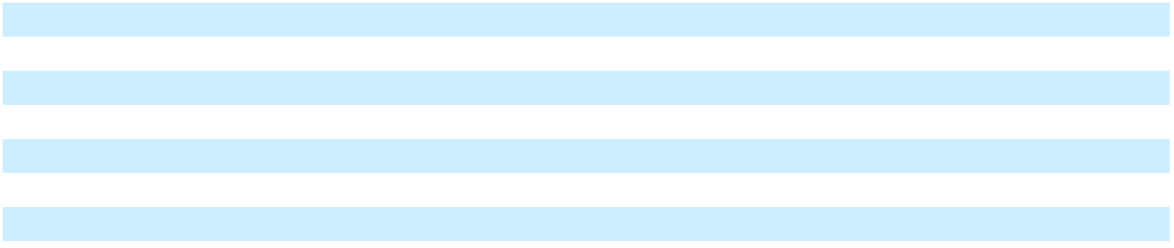

Compliance with Debt Covenants Several of our loan facilities, including our revolving credit facilities, require compliance with certain financial and operational covenants as well as regular reporting to lenders, including providing certain subsidiary financial statements. Certain of GM Financial’s secured debt agreements also contain various covenants, including maintaining portfolio performance ratios as well as limits on deferment levels. GM Financial’s unsecured debt obligations contain covenants including limitations on GM Financial's ability to incur certain liens. Failure to meet certain of these requirements may result in a covenant violation or an event of default depending on the terms of the agreement. An event of default may allow lenders to declare amounts outstanding under these agreements immediately due and payable, to enforce their interests against collateral pledged under these agreements or restrict our ability or GM Financial's ability to obtain additional borrowings. No technical defaults or covenant violations existed at December 31, 2024.

79

Table of Contents

GENERAL MOTORS COMPANY AND SUBSIDIARIES

NOTES TO CONSOLIDATED FINANCIAL STATEMENTS – (Continued) Note 14. Derivative Financial Instruments

Automotive The following table presents the gross fair value amounts of derivative financial instruments and the associated notional amounts in our automotive operations:

 | Fair Value |  |  | December 31, 2024 |  |  |  |  |  |  |  |  | December 31, 2023
 | Level
 |  |  |  | Notional |  | Fair Value |  |  | Fair Value |  |  |  | Notional |  | Fair Value |  |  | Fair Value
 |  |  |  | Notional |  | of Assets |  |  | of Liabilities |  |  |  | Notional |  | of Assets |  |  | of Liabilities
Derivatives designated as hedges(a)
Fair value hedges
Interest rate swaps(b) | 2 | $ |  | 4,405 | $ |  | 13 | $ |  | 61 | $ |  | 670 | $ |  | 38 | $ |  | 4
Cash flow hedges(c)
Foreign exchange contracts | 2 |  |  | 6,555 |  |  | 190 |  |  | 124 |  |  | 809 |  |  | 6 |  |  | 12
Commodity contracts | 2 |  |  | 2,323 |  |  | 24 |  |  | 103 |  |  | 528 |  |  | 17 |  |  | 17
Total derivative financial instruments |  | $ |  | 13,283 | $ |  | 227 | $ |  | 288 | $ |  | 2,007 | $ |  | 60 | $ |  | 32
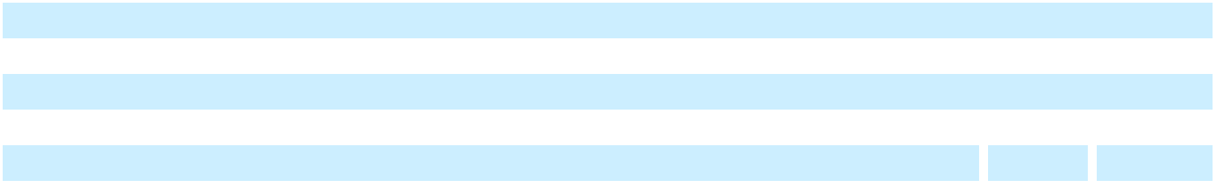
__________

- The gains/losses included in our consolidated income statements and consolidated statements of comprehensive income for the years ended December 31, 2024, 2023 and 2022 were insignificant.
- Amounts accrued for interest payments in a net receivable position are included in Other assets. Amounts accrued for interest payments in a net payable position are included in Other liabilities.
- The effect of cash flow hedges recognized in the consolidated statements of comprehensive income were insignificant for the years ended December 31, 2024, 2023 and 2022. The effect of cash flow hedges reclassified from Accumulated other comprehensive loss to the consolidated income statements were insignificant for the years ended December 31, 2024, 2023 and 2022. We expect to recognize insignificant revenues and costs of goods sold over the next 12 months related to amounts included in Accumulated other comprehensive loss.

The fair value for Level 2 instruments was derived using the market approach based on observable market inputs including quoted prices of similar instruments and foreign exchange and interest rate forward curves.

The following amounts were recorded in the consolidated balance sheets related to items designated and qualifying as hedged items in fair value hedging relationships:

 |  | December 31, 2024 |  |  |  |  |  | December 31, 2023
 |  | Carrying Amount of |  |  | Cumulative Amount of Fair |  |  | Carrying Amount of |  |  | Cumulative Amount of Fair
 |  | Hedged Items |  |  | Value Hedging Adjustments |  |  | Hedged Items |  |  | Value Hedging Adjustments
Short-term unsecured debt | $ | — | $ |  | — | $ |  | — | $ |  | —
Long-term unsecured debt |  | 4,405 |  |  | 48 |  |  | 670 |  |  | (34)
Automotive unsecured debt | $ | 4,405 | $ |  | 48 | $ |  | 670 | $ |  | (34)

80

Table of Contents

GENERAL MOTORS COMPANY AND SUBSIDIARIES

NOTES TO CONSOLIDATED FINANCIAL STATEMENTS – (Continued)

GM Financial The following table presents the gross fair value amounts of GM Financial's derivative financial instruments and the associated notional amounts:

 | Fair Value |  |  | December 31, 2024 |  |  |  |  |  |  |  |  | December 31, 2023
 | Level
 |  |  |  | Notional |  | Fair Value |  |  | Fair Value of |  |  |  | Notional |  | Fair Value |  |  | Fair Value of
 |  |  |  | Notional |  | of Assets |  |  |  | Liabilities |  |  | Notional |  | of Assets |  |  |  | Liabilities
Derivatives designated as hedges(a)
Fair value hedges
Interest rate swaps(b) | 2 | $ |  | 36,145 | $ |  | 32 | $ |  | 621 | $ |  | 18,379 | $ |  | 75 | $ |  | 238
Cash flow hedges
Interest rate swaps | 2 |  |  | 1,873 |  |  | 35 |  |  | 4 |  |  | 2,381 |  |  | 17 |  |  | 16
Foreign currency swaps(c) | 2 |  |  | 8,363 |  |  | 80 |  |  | 508 |  |  | 8,003 |  |  | 144 |  |  | 311
Derivatives not designated as hedges(a)
Interest rate contracts | 2 |  |  | 123,346 |  |  | 833 |  |  | 1,294 |  |  | 134,683 |  |  | 1,573 |  |  | 1,997
Total derivative financial instruments(d) |  | $ |  | 169,727 | $ |  | 981 | $ |  | 2,427 | $ |  | 163,446 | $ |  | 1,809 | $ |  | 2,563
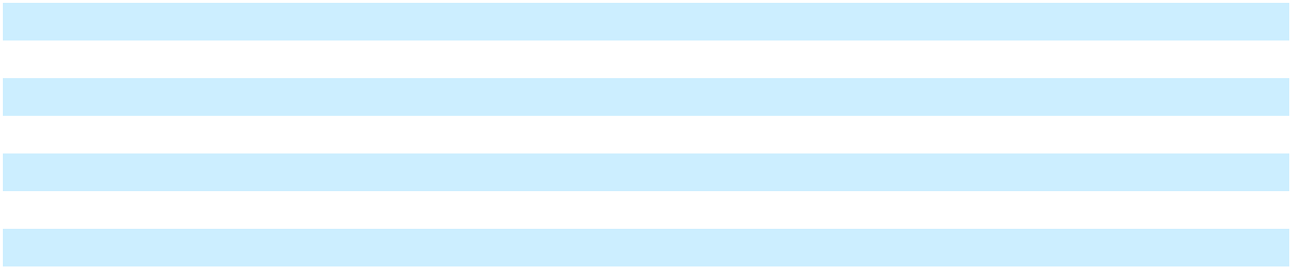
__________

- The gains/losses included in our consolidated income statements and statements of comprehensive income for the years ended December 31, 2024, 2023 and 2022 were insignificant, unless otherwise noted. Amounts accrued for interest payments in a net receivable position are included in Other assets. Amounts accrued for interest payments in a net payable position are included in Other liabilities.

- The effect of fair value hedges in the consolidated income statements include losses of $200 million, an insignificant loss and an insignificant gain for the years ended December 31, 2024, 2023 and 2022.
- The effect of foreign currency cash flow hedges in the consolidated statements of comprehensive income include losses of $375 million, gains of $139 million and losses of $529 million recognized in Accumulated other comprehensive loss and losses of $422 million, gains of $92 million and losses of $578 million reclassified from Accumulated other comprehensive loss into income for the years ended December 31, 2024, 2023 and 2022.

- GM Financial held $190 million and $457 million of collateral from counterparties available for netting against GM Financial's asset positions, and posted $1.2 billion of collateral to counterparties available for netting against GM Financial's liability positions at December 31, 2024 and 2023.

The fair value for Level 2 instruments was derived using the market approach based on observable market inputs including quoted prices of similar instruments and foreign exchange and interest rate forward curves.

The following amounts were recorded in the consolidated balance sheets related to items designated and qualifying as hedged items in fair value hedging relationships:

 |  | December 31, 2024 |  |  |  |  |  | December 31, 2023
 |  | Carrying Amount of |  |  | Cumulative Amount of Fair |  |  | Carrying Amount of |  |  | Cumulative Amount of Fair
 |  | Hedged Items |  | Value Hedging Adjustments(a) |  |  |  | Hedged Items |  | Value Hedging Adjustments(a)
Short-term unsecured debt | $ | 6,406 | $ |  | (6) | $ |  | 3,508 | $ |  | (8)
Long-term unsecured debt |  | 30,258 |  |  | 1,287 |  |  | 30,043 |  |  | 1,037
GM Financial unsecured debt | $ | 36,664 | $ |  | 1,281 | $ |  | 33,551 | $ |  | 1,029
__________

- Includes $719 million and $872 million of unamortized losses remaining on hedged items for which hedge accounting has been discontinued at December 31, 2024 and 2023.

Note 15. Pensions and Other Postretirement Benefits

Employee Pension and Other Postretirement Benefit Plans

Defined Benefit Pension Plans Defined benefit pension plans covering eligible U.S. hourly employees (hired prior to October 2007) and Canadian hourly employees (hired prior to October 2016) generally provide benefits of negotiated, stated amounts for each year of service and supplemental benefits for employees who retire with 30 years of service before normal retirement age. The benefits provided by the defined benefit pension plans covering eligible U.S. (hired prior to January 1, 2001) and Canadian salaried employees and employees in certain other non-U.S. locations are generally based on years of

81

Table of Contents

GENERAL MOTORS COMPANY AND SUBSIDIARIES

NOTES TO CONSOLIDATED FINANCIAL STATEMENTS – (Continued)

service and compensation history. Accrual of defined pension benefits ceased in 2012 for U.S. and Canadian salaried employees. There is also an unfunded nonqualified pension plan primarily covering U.S. executives for service prior to January 1, 2007 and it is based on an “excess plan” for service after that date.

The funding policy for qualified defined benefit pension plans is to contribute annually not less than the minimum required by applicable laws and regulations or to directly pay benefit payments where appropriate. In the year ended December 31, 2024, all legal funding requirements were met. The following table summarizes contributions made to the defined benefit pension plans:

 |  | Years Ended December 31,
 |  | 2024 |  |  | 2023 |  |  | 2022
U.S. hourly and salaried | $ | 526 | $ |  | 357 | $ |  | 71
Non-U.S. |  | 653 |  |  | 395 |  |  | 332
Total | $ | 1,179 | $ |  | 753 | $ |  | 403

We expect to make insignificant contributions to our U.S. pension plans and up to $120 million in contributions to our non-U.S. pension plans in 2025.

Other Postretirement Benefit Plans Certain hourly and salaried defined benefit plans provide postretirement medical, dental, legal service and life insurance to eligible U.S. and Canadian retirees and their eligible dependents. Certain other non-U.S. subsidiaries have postretirement benefit plans, although most non-U.S. employees are covered by government sponsored or administered programs. We made contributions to the U.S. OPEB plans of $285 million, $295 million and $335 million in the years ended December 31, 2024, 2023 and 2022. Plan participants' contributions were insignificant in the years ended December 31, 2024, 2023 and 2022.

Defined Contribution Plans We have defined contribution plans for eligible U.S. salaried and hourly employees that provide discretionary matching contributions. Contributions are also made to certain non-U.S. defined contribution plans. We made contributions to our defined contribution plans of $908 million, $742 million and $724 million in the years ended December 31, 2024, 2023 and 2022.

Significant Plan Amendments, Benefit Modifications and Related Events

Other Remeasurements As part of our collective bargaining agreement with the UAW in 2023 we amended the U.S. Hourly Pension Plan to increase the monthly basic benefit by $5.00 a month for active plan members and to provide an annual contribution of $500 to eligible retirees and surviving spouses for the duration of the contract. These changes increased our pension obligation by $791 million for the year ended December 31, 2023.

In the three months ended December 31, 2024, we completed a $699 million annuity purchase for salaried retirees in the U.S.

This resulted in an insignificant non-operating pension settlement.

82

Table of Contents

GENERAL MOTORS COMPANY AND SUBSIDIARIES

NOTES TO CONSOLIDATED FINANCIAL STATEMENTS – (Continued) Pension and OPEB Obligations and Plan Assets

 |  | Year Ended December 31, 2024 |  |  |  |  |  |  |  |  | Year Ended December 31, 2023
 |  | Pension Benefits |  |  |  |  |  | Global |  |  | Pension Benefits |  |  |  |  |  | Global
 |  |  |  |  |  |  |  | OPEB |  |  |  |  |  |  |  |  | OPEB
 |  | U.S. |  | Non-U.S. |  |  |  | OPEB |  |  | U.S. |  | Non-U.S. |  |  |  | OPEB
 |  | U.S. |  |  |  |  |  | Plans |  |  | U.S. |  |  |  |  |  | Plans
Change in benefit obligations
Beginning benefit obligation | $ | 44,481 | $ |  | 13,140 | $ |  | 4,701 | $ |  | 44,817 | $ |  | 12,582 | $ |  | 4,543
Service cost |  | 113 |  |  | 156 |  |  | 10 |  |  | 103 |  |  | 161 |  |  | 9
Interest cost |  | 2,132 |  |  | 505 |  |  | 226 |  |  | 2,273 |  |  | 551 |  |  | 236
Amendments |  | 15 |  |  | 51 |  |  | — |  |  | 795 |  |  | 17 |  |  | —
Actuarial (gains) losses |  | (1,600) |  |  | (350) |  |  | (179) |  |  | 1,185 |  |  | 453 |  |  | 204
Benefits paid |  | (4,140) |  |  | (931) |  |  | (363) |  |  | (4,186) |  |  | (1,001) |  |  | (371)
Foreign currency translation adjustments |  | — |  |  | (882) |  |  | (95) |  |  | — |  |  | 453 |  |  | 32
Curtailments, settlements and other |  | (859) |  |  | (85) |  |  | 37 |  |  | (506) |  |  | (76) |  |  | 48
Ending benefit obligation |  | 40,142 |  |  | 11,604 |  |  | 4,337 |  |  | 44,481 |  |  | 13,140 |  |  | 4,701
Change in plan assets
Beginning fair value of plan assets |  | 42,287 |  |  | 9,819 |  |  | — |  |  | 44,901 |  |  | 9,530 |  |  | —
Actual return on plan assets |  | 487 |  |  | 288 |  |  | — |  |  | 1,829 |  |  | 640 |  |  | —
Employer contributions |  | 526 |  |  | 653 |  |  | 338 |  |  | 357 |  |  | 395 |  |  | 348
Benefits paid |  | (4,140) |  |  | (931) |  |  | (363) |  |  | (4,186) |  |  | (1,001) |  |  | (371)
Foreign currency translation adjustments |  | — |  |  | (610) |  |  | — |  |  | — |  |  | 354 |  |  | —
Settlements and other |  | (862) |  |  | (98) |  |  | 25 |  |  | (614) |  |  | (99) |  |  | 23
Ending fair value of plan assets |  | 38,298 |  |  | 9,121 |  |  | — |  |  | 42,287 |  |  | 9,819 |  |  | —
Ending funded status | $ | (1,844) | $ |  | (2,483) | $ |  | (4,337) | $ |  | (2,194) | $ |  | (3,321) | $ |  | (4,701)
Amounts recorded in the consolidated balance sheets
Non-current assets | $ | — | $ |  | 1,575 | $ |  | — | $ |  | — | $ |  | 1,557 | $ |  | —
Current liabilities |  | (68) |  |  | (54) |  |  | (347) |  |  | (62) |  |  | (330) |  |  | (356)
Non-current liabilities |  | (1,776) |  |  | (4,004) |  |  | (3,990) |  |  | (2,132) |  |  | (4,548) |  |  | (4,345)
Net amount recorded | $ | (1,844) | $ |  | (2,483) | $ |  | (4,337) | $ |  | (2,194) | $ |  | (3,321) | $ |  | (4,701)
Amounts recorded in Accumulated other
comprehensive loss
Net actuarial loss | $ | (3,953) | $ |  | (2,242) | $ |  | (152) | $ |  | (3,372) | $ |  | (2,560) | $ |  | (332)
Net prior service (cost) credit |  | (747) |  |  | (117) |  |  | (5) |  |  | (793) |  |  | (74) |  |  | 8
Total recorded in Accumulated other comprehensive loss | $ | (4,700) | $ |  | (2,359) | $ |  | (157) | $ |  | (4,165) | $ |  | (2,634) | $ |  | (324)
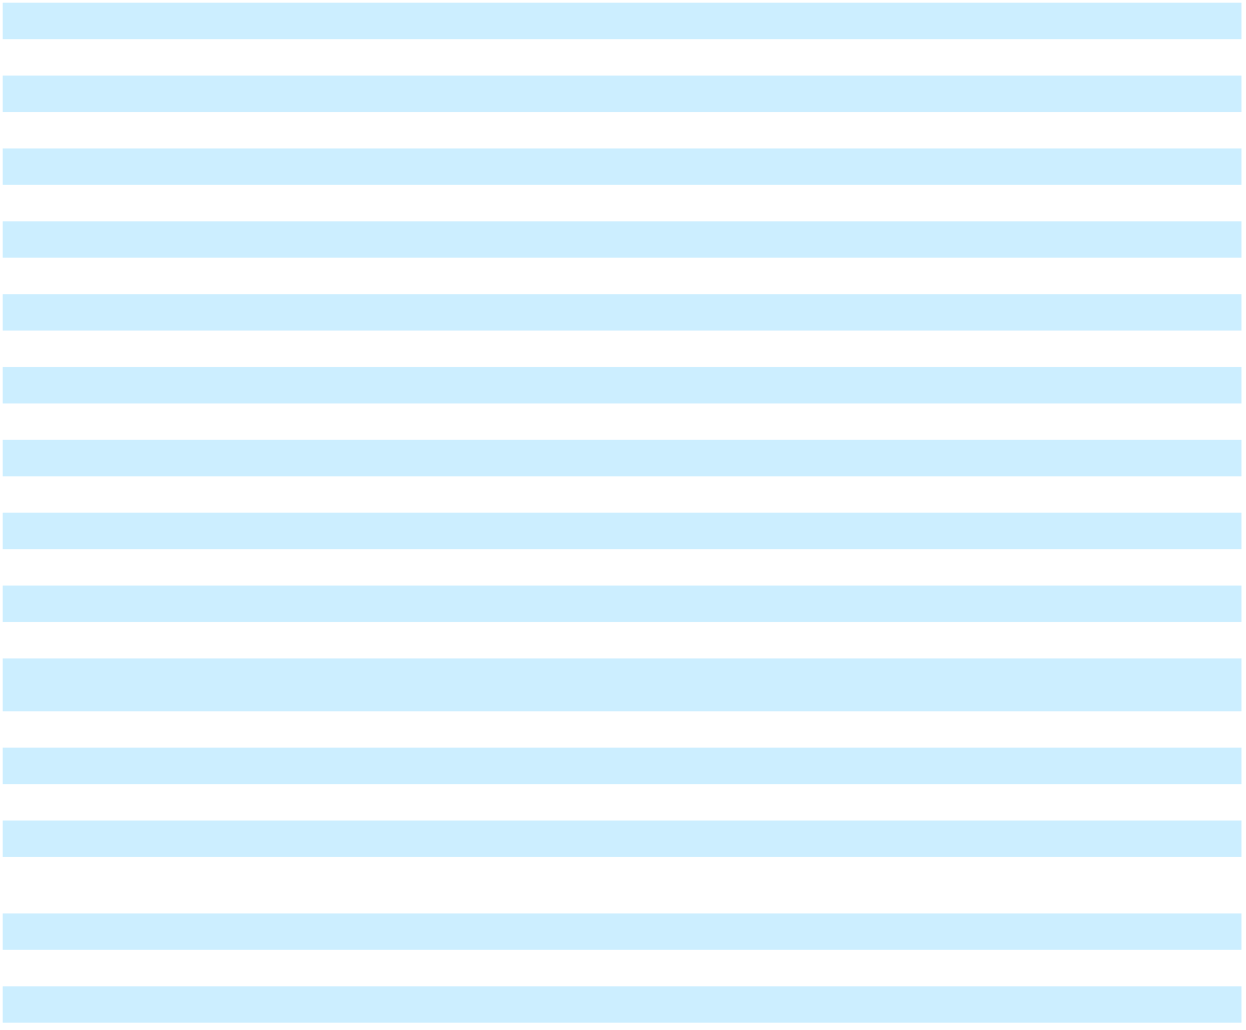

In the year ended December 31, 2024, the actuarial gain included in the benefit obligations was primarily due to an increase in discount rates.

In the year ended December 31, 2023, the actuarial loss included in the benefit obligations was primarily due to a decrease in discount rates.

83

Table of Contents

GENERAL MOTORS COMPANY AND SUBSIDIARIES

NOTES TO CONSOLIDATED FINANCIAL STATEMENTS – (Continued)

The following table summarizes the total accumulated benefit obligations (ABO), the ABO and fair value of plan assets for defined benefit pension plans with ABO in excess of plan assets, and the projected benefit obligation (PBO) and fair value of plan assets for defined benefit pension plans with PBO in excess of plan assets:

 |  | December 31, 2024 |  |  |  |  |  | December 31, 2023
 |  | U.S. |  |  | Non-U.S. |  |  | U.S. |  |  | Non-U.S.
ABO | $ | 40,126 | $ |  | 11,516 | $ |  | 44,464 | $ |  | 13,050
Plans with ABO in excess of plan assets
ABO | $ | 40,126 | $ |  | 4,267 | $ |  | 44,464 | $ |  | 4,863
Fair value of plan assets | $ | 38,298 | $ |  | 298 | $ |  | 42,287 | $ |  | 74
Plans with PBO in excess of plan assets
PBO | $ | 40,141 | $ |  | 4,396 | $ |  | 44,481 | $ |  | 4,953
Fair value of plan assets | $ | 38,298 | $ |  | 338 | $ |  | 42,287 | $ |  | 74
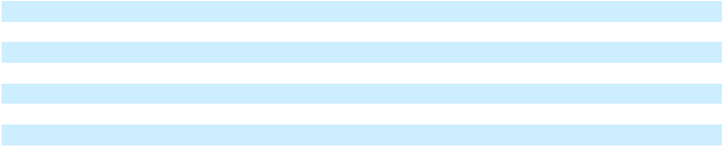

The following table summarizes the components of net periodic pension and OPEB expense along with the assumptions used to determine benefit obligations:

 | Year Ended December 31, 2024 |  |  |  |  |  |  |  | Year Ended December 31, 2023 |  |  |  |  |  |  |  | Year Ended December 31, 2022
 | Pension Benefits |  |  |  |  | Global |  |  | Pension Benefits |  |  |  |  | Global |  |  | Pension Benefits |  |  |  |  | Global
 |  |  |  |  |  | OPEB |  |  |  |  |  |  |  | OPEB |  |  |  |  |  |  |  | OPEB
 | U.S. |  | Non-U.S. |  |  |  |  |  | U.S. |  | Non-U.S. |  |  |  |  |  | U.S. |  | Non-U.S.
Components of expense | U.S. |  |  |  |  |  | Plans |  | U.S. |  |  |  |  | Plans |  |  | U.S. |  |  |  |  |  | Plans
Service cost | $ 185 | $ |  | 165 | $ |  | 10 | $ 173 |  | $ |  | 173 | $ |  | 9 | $ 233 |  | $ |  | 157 | $ |  | 16
Interest cost | 2,132 |  |  | 505 |  |  | 226 | 2,273 |  |  |  | 551 |  |  | 236 | 1,292 |  |  |  | 293 |  |  | 148
Expected return on plan assets | (2,740) |  |  | (521) |  |  | — | (2,922) |  |  |  | (573) |  |  | — | (3,000) |  |  |  | (534) |  |  | —
Amortization of net actuarial (gains) losses | 8 |  |  | 46 |  |  | 1 |  | — |  |  | 32 |  |  | (23) | 18 |  |  |  | 133 |  |  | 67
Curtailments, settlements and other | 56 |  |  | 18 |  |  | (1) | 126 |  |  |  | 33 |  |  | 2 | (17) |  |  |  | 10 |  |  | (5)
Net periodic pension and OPEB (income)
expense | $ (359) | $ |  | 213 | $ |  | 236 | $ (350) |  | $ |  | 216 | $ |  | 224 | $(1,474) |  | $ |  | 59 | $ |  | 226
Weighted-average assumptions used to
determine benefit obligations(a)
Discount rate | 5.56 % |  |  | 4.68 % | 5.51 % |  |  | 5.12 % |  | 4.41 % |  |  | 5.13 % |  |  | 5.47 % |  | 4.85 % |  |  | 5.51 %
Weighted-average assumptions used to
determine net expense(a)
Discount rate | 5.08 % |  |  | 5.10 % | 5.13 % |  |  | 5.37 % |  | 5.33 % |  |  | 5.48 % |  |  | 2.34 % |  | 2.98 % |  |  | 2.84 %
Expected rate of return on plan assets | 6.27 % |  |  | 5.25 % |  |  | N/A | 6.30 % |  | 5.65 % |  |  |  |  | N/A | 5.38 % |  | 4.39 % |  |  |  |  | N/A
__________
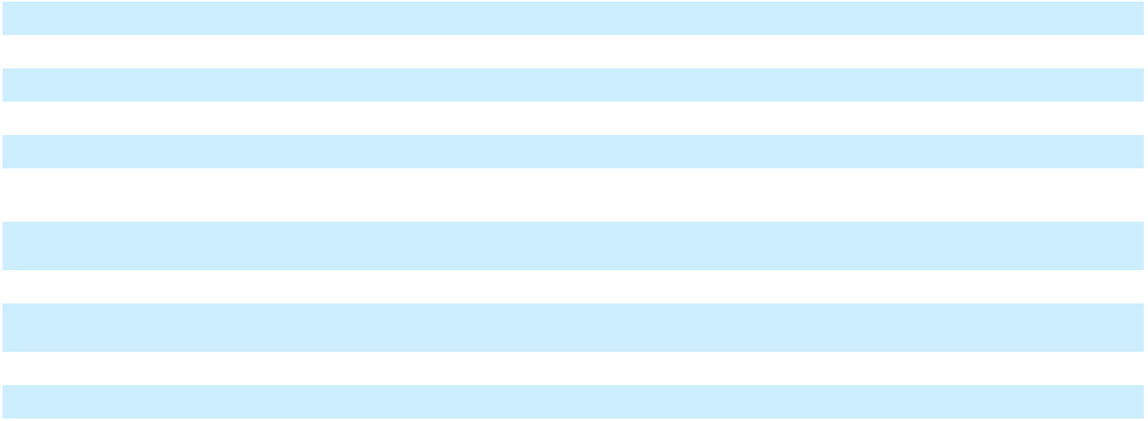
- The rate of compensation increase and the cash balance interest crediting rates do not have a significant effect on our U.S. pension and OPEB plans.

The non-service cost components of the net periodic pension and OPEB income are presented in Interest income and other non-operating income, net. Refer to Note 19 for additional information.

U.S. pension plan service cost, which includes administrative expenses and Pension Benefit Guarantee Corporation premiums, were insignificant for the years ended December 31, 2024, 2023 and 2022. Weighted-average assumptions used to determine net expense are determined at the beginning of the period and updated for remeasurements. Non-U.S. pension plan administrative expenses included in service cost were insignificant in the years ended December 31, 2024, 2023 and 2022.

84

Table of Contents

GENERAL MOTORS COMPANY AND SUBSIDIARIES

NOTES TO CONSOLIDATED FINANCIAL STATEMENTS – (Continued)

Assumptions

Investment Strategies and Long-Term Rate of Return Detailed periodic studies are conducted by our internal asset management group as well as outside actuaries and are used to determine the long-term strategic mix among asset classes, risk mitigation strategies and the expected long-term ROA assumptions for the U.S. pension plans. The U.S. study includes a review of alternative asset allocation and risk mitigation strategies, anticipated future long-term performance and risk of the individual asset classes that comprise the plans' asset mix. Similar studies are performed for the significant non-U.S. pension plans with the assistance of outside actuaries and asset managers. While the studies incorporate data from recent plan performance and historical returns, the expected rate of return on plan assets represents our estimate of long-term prospective rates of return.

We continue to pursue various options to fund and to manage risk in our pension plans, including continued changes to the pension asset portfolio mix to manage funded status volatility. The strategic asset mix and risk mitigation strategies for the plans are tailored specifically for each plan. Individual plans have distinct liabilities, liquidity needs and regulatory requirements. Consequently, there are different investment policies set by individual plan fiduciaries. Although investment policies and risk mitigation strategies may differ among plans, each investment strategy is considered to be appropriate in the context of the specific factors affecting each plan.

In setting new strategic asset mixes, consideration is given to the likelihood that the selected asset mixes will effectively fund the projected pension plan liabilities, while aligning with the risk tolerance of the plans' fiduciaries. The strategic asset mixes for U.S. defined benefit pension plans are increasingly designed to satisfy the competing objectives of improving funded positions (market value of assets equal to or greater than the present value of the liabilities) and mitigating the possibility of a deterioration in funded status.

Derivatives may be used to provide cost effective solutions for rebalancing investment portfolios, increasing or decreasing exposure to various asset classes and for mitigating risks, primarily interest rate, equity and currency risks. Equity and fixed income managers are permitted to utilize derivatives as efficient substitutes for traditional securities. Interest rate derivatives may be used to adjust portfolio duration to align with a plan's targeted investment policy and equity derivatives may be used to protect equity positions from downside market losses. Alternative investment managers are permitted to employ leverage, including through the use of derivatives, which may alter economic exposure.

In December 2024, an investment policy study was completed for the U.S. pension plans. As a result, the weighted-average long-term rate of ROA increased from 6.3% at December 31, 2023 to 6.5% at December 31, 2024. The expected long-term rate of return on plan assets used in determining pension expense for non-U.S. plans is determined in a similar manner to the U.S. plans.

Target Allocation Percentages The following table summarizes the target allocations by asset category for U.S. and non-

U.S. defined benefit pension plans:

 | December 31, 2024 |  |  |  | December 31, 2023
 | U.S. |  | Non-U.S. |  | U.S. |  | Non-U.S.
Equity | 11 % | 9 % |  | 11 % |  | 10 %
Debt | 60 % | 74 % |  | 60 % |  | 75 %
Other(a) | 29 % |  | 17 % |  | 29 % |  | 15 %
Total | 100 % | 100 % |  | 100 % |  | 100 %
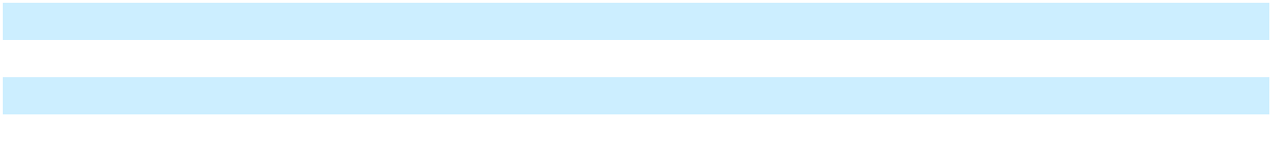
__________

(a) Primarily includes private equity, real estate and absolute return strategies, which mainly consist of hedge funds.

85

Table of Contents

GENERAL MOTORS COMPANY AND SUBSIDIARIES

NOTES TO CONSOLIDATED FINANCIAL STATEMENTS – (Continued)

Assets and Fair Value Measurements The following tables summarize the fair value of U.S. and non-U.S. defined benefit pension plan assets by asset class:

 |  |  |  | December 31, 2024 |  |  |  |  |  |  |  |  |  |  |  | December 31, 2023
 | Level 1 |  |  | Level 2 |  |  | Level 3 |  |  |  | Total |  | Level 1 |  |  | Level 2 |  |  | Level 3 |  |  |  | Total
U.S. Pension Plan Assets
Common and preferred stocks | $ | 15 | $ |  | — | $ |  | — | $ |  | 15 | $ |  | 850 | $ |  | — | $ |  | — | $ |  | 850
Government and agency debt securities(a) |  | — | 11,728 |  |  |  |  | — | 11,728 |  |  |  |  | — |  |  | 9,822 |  |  | — |  |  | 9,822
Corporate and other debt securities |  | — | 15,155 |  |  |  |  | — | 15,155 |  |  |  |  | — | 20,957 |  |  |  |  | 3 | 20,960
Other investments, net(b)(c) |  | (75) |  | (3,662) |  |  |  | 389 |  | (3,348) |  |  |  | 545 |  |  | (269) |  |  | 328 |  |  | 604
Net plan assets subject to leveling | $ | (60) | $23,221 |  |  | $ |  | 389 | 23,550 |  |  | $ 1,395 |  |  | $30,510 |  |  | $ |  | 331 | 32,236
Plan assets measured at net asset value
Investment funds |  |  |  |  |  |  |  |  | 10,025 |  |  |  |  |  |  |  |  |  |  |  |  |  | 5,322
Private equity and debt investments |  |  |  |  |  |  |  |  |  |  | 2,961 |  |  |  |  |  |  |  |  |  |  |  | 2,864
Real estate investments |  |  |  |  |  |  |  |  |  |  | 2,655 |  |  |  |  |  |  |  |  |  |  |  | 2,976
Total plan assets measured at net asset value |  |  |  |  |  |  |  |  | 15,641 |  |  |  |  |  |  |  |  |  |  |  | 11,162
Other plan assets (liabilities), net(d) |  |  |  |  |  |  |  |  |  |  | (893) |  |  |  |  |  |  |  |  |  |  | (1,111)
Net plan assets |  |  |  |  |  |  |  |  | $38,298 |  |  |  |  |  |  |  |  |  |  |  | $42,287
 |  |  |  | December 31, 2024 |  |  |  |  |  |  |  |  |  |  |  | December 31, 2023
 | Level 1 |  |  | Level 2 |  |  | Level 3 |  |  |  | Total |  | Level 1 |  |  | Level 2 |  |  | Level 3 |  |  |  | Total
Non-U.S. Pension Plan Assets
Common and preferred stocks | $ | 98 | $ |  | — | $ |  | — | $ |  | 98 | $ |  | 160 | $ |  | — | $ |  | — | $ |  | 160
Government and agency debt securities(a) |  | — |  |  | 2,262 |  |  | 5 |  |  | 2,267 |  |  | — |  |  | 2,310 |  |  | — |  |  | 2,310
Corporate and other debt securities |  | — |  |  | 2,336 |  |  | 8 |  |  | 2,344 |  |  | — |  |  | 2,738 |  |  | 7 |  |  | 2,745
Other investments, net(b)(c) |  | 8 |  |  | (151) |  |  | 35 |  |  | (108) |  |  | (4) |  |  | (55) |  |  | 43 |  |  | (16)
Net plan assets subject to leveling | $ | 106 | $ 4,447 |  |  | $ |  | 48 |  |  | 4,601 | $ |  | 156 | $ 4,993 |  |  | $ |  | 50 |  |  | 5,199
Plan assets measured at net asset value
Investment funds |  |  |  |  |  |  |  |  |  |  | 3,303 |  |  |  |  |  |  |  |  |  |  |  | 3,265
Private equity and debt investments |  |  |  |  |  |  |  |  |  |  | 406 |  |  |  |  |  |  |  |  |  |  |  | 431
Real estate investments |  |  |  |  |  |  |  |  |  |  | 689 |  |  |  |  |  |  |  |  |  |  |  | 781
Total plan assets measured at net asset value |  |  |  |  |  |  |  |  |  |  | 4,398 |  |  |  |  |  |  |  |  |  |  |  | 4,477
Other plan assets (liabilities), net(d) |  |  |  |  |  |  |  |  |  |  | 122 |  |  |  |  |  |  |  |  |  |  |  | 143
Net plan assets |  |  |  |  |  |  |  |  | $ 9,121 |  |  |  |  |  |  |  |  |  |  |  | $ 9,819
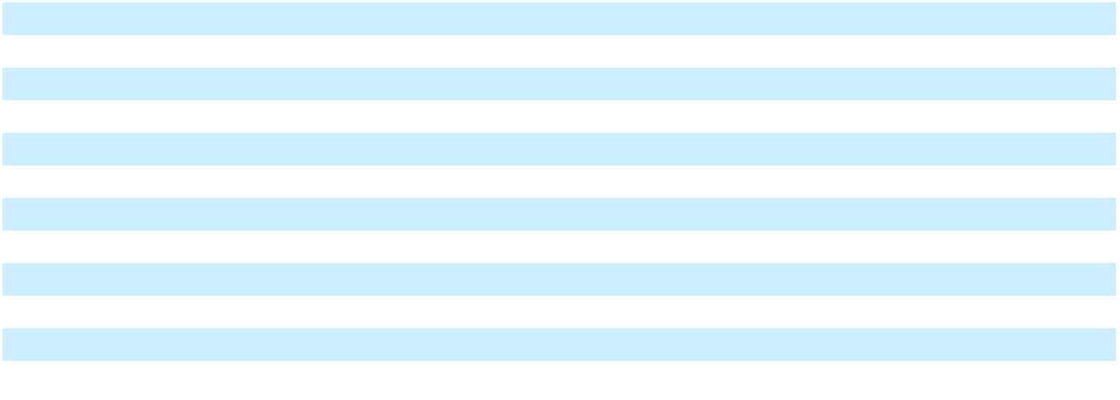
__________

- Includes U.S. and sovereign government and agency issues.

- Includes net derivative assets (liabilities).

- Level 2 Other investments, net includes approximately $3.6 billion of U.S. reverse repurchase agreements at December 31, 2024, and approximately $185 million and $137 million of Canadian reverse repurchase agreements at December 31, 2024 and 2023.
- Cash held by the plans, net of amounts receivable/payable for unsettled security transactions and payables for investment manager fees, custody fees and other expenses.

The activity attributable to U.S. and non-U.S. Level 3 defined benefit pension plan investments was insignificant in the years ended December 31, 2024 and 2023.

Investment Fund Strategies Investment funds include hedge funds, funds of hedge funds, equity funds and fixed income funds. Hedge funds and funds of hedge funds managers typically seek to achieve their objectives by allocating capital across a broad array of funds and/or investment managers. Equity funds invest in U.S. common and preferred stocks as well as similar equity securities issued by companies incorporated, listed or domiciled in developed and/or emerging market countries. Fixed income funds include investments in high quality funds and, to a lesser extent, high yield funds. High quality fixed income

86

Table of Contents

GENERAL MOTORS COMPANY AND SUBSIDIARIES

NOTES TO CONSOLIDATED FINANCIAL STATEMENTS – (Continued)

funds invest in government securities, investment-grade corporate bonds and mortgage and asset-backed securities. High yield fixed income funds invest in high yield fixed income securities issued by corporations, which are rated below investment grade. Other investment funds also included in this category primarily represent multi-strategy funds that invest in broadly diversified portfolios of equity, fixed income and derivative instruments.

Private equity and debt investments primarily consist of investments in private equity and debt funds. These investments provide exposure to and benefit from long-term equity investments in private companies, including leveraged buy-outs, venture capital and distressed debt strategies.

Real estate investments include funds that invest in entities that are primarily engaged in the ownership, acquisition, development, financing, sale and/or management of income-producing real estate properties, both commercial and residential. These funds typically seek long-term growth of capital and current income that is above average relative to public equity funds.

Significant Concentrations of Risk The assets of the pension plans include certain investment funds, private equity and debt investments and real estate investments. Investment managers may be unable to quickly sell or redeem some or all of these investments at an amount close or equal to fair value in order to meet a plan's liquidity requirements or to respond to specific events such as deterioration in the creditworthiness of any particular issuer or counterparty.

Illiquid investments held by the plans are generally long-term investments that complement the long-term nature of pension obligations and are not used to fund benefit payments when currently due. Plan management monitors liquidity risk on an ongoing basis and has procedures in place that are designed to maintain flexibility in addressing plan-specific, broader industry and market liquidity events.

The pension plans may invest in financial instruments denominated in foreign currencies and may be exposed to risks that the foreign currency exchange rates might change in a manner that has an adverse effect on the value of the foreign currency denominated assets or liabilities. Forward currency contracts may be used to manage and mitigate foreign currency risk.

The pension plans may invest in debt securities for which any change in the relevant interest rates for particular securities might result in an investment manager being unable to secure similar returns upon the maturity or the sale of securities. In addition, changes to prevailing interest rates or changes in expectations of future interest rates might result in an increase or decrease in the fair value of the securities held. Interest rate swaps and other financial derivative instruments may be used to manage interest rate risk.

Benefit Payments Benefits for most U.S. pension plans and certain non-U.S. pension plans are paid out of plan assets rather than our Cash and cash equivalents. The following table summarizes net benefit payments expected to be paid in the future, which include assumptions related to estimated future employee service:

 |  | Pension Benefits |  |  |  |  |  | Global OPEB
 |  | U.S. Plans |  | Non-U.S. Plans |  |  |  | Global OPEB
 |  | U.S. Plans |  |  |  |  |  | Plans
2025 | $ | 4,282 | $ |  | 973 | $ |  | 354
2026 | $ | 4,036 | $ |  | 870 | $ |  | 350
2027 | $ | 3,919 | $ |  | 855 | $ |  | 347
2028 | $ | 3,771 | $ |  | 840 | $ |  | 343
2029 | $ | 3,580 | $ |  | 824 | $ |  | 341
2030–2034 | $ | 15,900 | $ |  | 3,909 | $ |  | 1,644
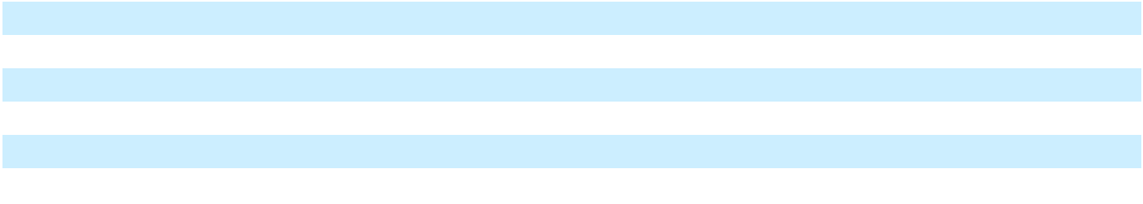

Note 16. Commitments and Contingencies

Litigation-Related Liability and Tax Administrative Matters In the normal course of our business, we are named from time to time as a defendant in various legal actions, including arbitrations, class actions and other litigation. We identify below the material individual proceedings and investigations where we believe a material loss is reasonably possible or probable. We accrue for matters when we believe that losses are probable and can be reasonably estimated. At December 31, 2024 and 2023, we had accruals of $1.1 billion and $1.2 billion for such legal actions in Accrued liabilities and Other liabilities. In many matters, it is inherently difficult to determine whether a loss is probable or reasonably possible or to estimate the size or range

87

Table of Contents

GENERAL MOTORS COMPANY AND SUBSIDIARIES

NOTES TO CONSOLIDATED FINANCIAL STATEMENTS – (Continued)

of the potential loss. Some matters may involve compensatory, punitive or other treble damage claims, environmental remediation programs or sanctions that, if granted, could require us to pay damages or make other expenditures in amounts that cannot be reasonably estimated. Accordingly, while we believe that appropriate accruals have been established for losses that are probable and can be reasonably estimated, it is possible that adverse outcomes from such proceedings could exceed the amounts accrued by an amount that could be material to our results of operations or cash flows in any particular reporting period.

GM Korea Subcontract Workers Litigation GM Korea Company (GM Korea) is party to litigation with current and former subcontract workers over allegations that they are entitled to the same wages and benefits provided to full-time employees, and to be hired as full-time employees. In May 2018 and September 2020, the Korean labor authorities issued adverse administrative orders finding that GM Korea must hire certain current subcontract workers as full-time employees. GM Korea appealed the May 2018 and September 2020 orders. Since June 2020, the Seoul High Court (an intermediate-level appellate court) ruled against GM Korea in eight subcontract worker claims. While GM Korea's appeals were pending in the Supreme Court of the Republic of Korea (Korea Supreme Court), GM Korea hired certain of its subcontract workers as full-time employees. During the third quarter of 2024, the Korea Supreme Court issued its decisions with respect to the appeal. While the Korea Supreme Court ruled against GM Korea on most of the appeals, the Korea Supreme Court ruled in favor of GM Korea with regard to certain subcontract workers. At December 31, 2024, our accrual covering certain asserted claims and claims that we believe are probable of assertion and for which liability is probable was insignificant. We estimate the reasonably possible loss in excess of amounts accrued for other current subcontract workers who may assert similar claims to be insignificant at December 31, 2024.

Other Litigation-Related Liability and Tax Administrative Matters Various other legal actions, including class actions, governmental investigations, claims and proceedings are pending against us or our related companies or joint ventures, including, but not limited to, matters arising out of alleged product defects; employment-related matters; product and workplace safety, vehicle emissions and fuel economy regulations; product warranties; financial services; dealer, supplier and other contractual relationships; competition issues; tax-related matters not subject to the provision of Accounting Standards Codification 740, "Income Taxes" (indirect tax-related matters); product design, manufacture and performance; consumer protection laws; and environmental protection laws, including laws regulating air emissions, water discharges, waste management and environmental remediation from stationary sources. We also from time to time receive subpoenas and other inquiries or requests for information from agencies or other representatives of U.S. federal, state and foreign governments on a variety of issues.

There are several putative class actions pending against GM in the U.S. and Canada alleging that various vehicles sold, including model year 2011–2016 Duramax Diesel Chevrolet Silverado and GMC Sierra vehicles, violate federal and state laws because they release more emissions than a reasonable customer would expect. In July 2023, the two putative class actions pending in the U.S. were dismissed with prejudice and judgment entered in favor of GM, and plaintiffs appealed the dismissal. In August 2024, the Sixth Circuit reversed the dismissal in one of the cases. In October 2024, a panel of the Sixth Circuit vacated the judgment in favor of GM in one of the class actions, but a different panel has yet to rule in the other class action. We are currently unable to estimate any reasonably possible material loss or range of loss that may result from these actions. GM has also faced a series of additional lawsuits in the U.S. based on these allegations, including a shareholder demand lawsuit that remains pending.

There are several putative class actions and two certified class actions pending against GM in the U.S. alleging that various 2011–2014 model year vehicles are defective because they excessively consume oil. While many of these proceedings have been dismissed or have been settled for insignificant amounts, several remain outstanding. In October 2022, we received an adverse jury verdict in a certified class action proceeding involving three states. We have reached an agreement in principle to resolve these matters and have accrued an immaterial amount related to these proceedings.

There is one putative class action and one certified class action pending against GM in the U.S. alleging that various 2015– 2022 model year vehicles are defective because they are equipped with faulty 8-speed transmissions. In March 2023, the judge overseeing the class action concerning 2015–2019 model year vehicles certified 26 state subclasses. In October 2024, a panel of the Sixth Circuit affirmed certification of these state subclasses; in December 2024, the Sixth Circuit granted our petition for rehearing en banc. The putative class action concerning 2020–2022 model year vehicles is pending in front of a different judge that has not yet addressed class certification. We have similar cases pending in Canada concerning these vehicles. We are

88

Table of Contents

GENERAL MOTORS COMPANY AND SUBSIDIARIES

NOTES TO CONSOLIDATED FINANCIAL STATEMENTS – (Continued)

currently unable to estimate any reasonably possible or probable material loss or range of loss that may result from these proceedings in excess of amounts accrued.

There is a class action pending against GM in the U.S., and a putative class action in Canada, alleging that 2011–2016 model year Duramax Diesel Chevrolet Silverado and GMC Sierra vehicles are equipped with defective fuel pumps that are prone to failure. In March 2023, the U.S. court certified seven state subclasses. We reached an agreement to settle this matter on terms consistent with our accrual and the settlement agreement is pending final court approval.

Beyond the class action litigations disclosed, we have several other class action litigations pending at any given time. Historically, relatively few classes have been certified in these types of cases. Therefore, we will generally only disclose specific class actions if a class is certified and we believe there is a reasonably possible material exposure to the Company.

Indirect tax-related matters are being evaluated globally pertaining to value added taxes, customs, duties, sales tax, property taxes and other non-income tax exposures. Certain administrative proceedings are indirect tax-related and may require that we deposit funds in escrow or provide an alternative form of security. For indirect tax-related matters, we estimate our reasonably possible loss in excess of amounts accrued to be up to approximately $5.6 billion at December 31, 2024.

Takata Matters In November 2020, NHTSA directed that we replace the Takata Corporation (Takata) airbag inflators in our GMT900 vehicles, which are full-size pickup trucks and SUVs, and we decided not to contest NHTSA's decision. While we have already begun the process of executing the recall, given the number of vehicles in this population, the recall will take several years to be completed. Accordingly, in the year ended December 31, 2020, we recorded a warranty accrual of $1.1 billion for the expected costs of complying with the recall remedy. At December 31, 2024, our remaining accrual for these matters was $555 million, and we believe the currently accrued amount remains reasonable.

GM has recalled certain vehicles sold outside of the U.S. to replace Takata inflators in those vehicles. There are significant differences in vehicle and inflator design between the relevant vehicles sold internationally and those sold in the U.S. We continue to gather and analyze evidence about these inflators and to share our findings with regulators. Any additional recalls relating to these inflators could be material to our results of operations and cash flows.

There are several putative class actions that have been filed against GM, including in the U.S. and Canada, arising out of allegations that airbag inflators manufactured by Takata are defective. In March 2023, a U.S. court overseeing one of the putative class actions issued a final judgment in favor of GM on all claims in eight states at issue in that proceeding. In August 2023, the U.S. court granted class certification as to a Louisiana claim, but denied certification as to seven other states. At this stage of these proceedings, we are unable to provide an estimate of the amounts or range of reasonably possible material loss.

ARC Matters In May 2023, we initiated a voluntary recall covering nearly one million 2014–2017 model year Buick Enclave, Chevrolet Traverse and GMC Acadia SUVs equipped with driver front airbag inflators manufactured by ARC Automotive, Inc. (ARC), and accrued an insignificant amount for the expected costs of the recall. As part of its ongoing investigation into ARC airbag inflators, on September 5, 2023, NHTSA issued an Initial Decision that approximately 52 million frontal driver and passenger airbag inflators manufactured by ARC and Delphi Automotive Systems LLC over a roughly 20-year period contain a safety-related defect and must be recalled. On July 31, 2024, NHTSA issued a Supplemental Initial Decision reaffirming its September 2023 Initial Decision and reopening the administrative record to additional public comments. The Initial Decision and the Supplemental Initial Decision are primarily based on the occurrence of seven field ruptures involving ARC-manufactured frontal airbag inflators. We are continuing to investigate the cause of the ruptures in GM vehicles in connection with our existing recalls. On December 13, 2024, NHTSA issued a memorandum indicating that, based on the public comments it had received to date, the agency would be "conducting additional investigation of the issues related to the Supplemental Initial Decision." As indicated in GM's filed comments in the record, we do not believe that further GM vehicle recalls are necessary or appropriate at this time. However, depending on the outcome of the dispute between NHTSA and ARC, and the possibility of additional recalls, the cost of which may not be fully recoverable, it is reasonably possible that the costs associated with these matters in excess of amounts accrued could be material, but we are unable to provide an estimate of the amounts or range of reasonably possible material loss at this time.

There are several putative class actions that have been filed against GM, including in the U.S., Canada and Israel, arising out of allegations that airbag inflators manufactured by ARC are defective. At this stage of these proceedings, we are unable to provide an estimate of the amounts or range of reasonably possible material loss.

89

Table of Contents

GENERAL MOTORS COMPANY AND SUBSIDIARIES

NOTES TO CONSOLIDATED FINANCIAL STATEMENTS – (Continued)

Chevrolet Bolt Recall In July 2021, we initiated a voluntary recall for certain 2017–2019 model year Chevrolet Bolt EVs due to the risk that two manufacturing defects present in the same battery cell could cause a high voltage battery fire in certain of these vehicles. After further investigation into the manufacturing processes at our battery supplier, LG Energy Solution (LGES), and disassembling battery packs, we determined that the risk of battery cell defects was not confined to the initial recall population. As a result, in August 2021, we expanded the recall to include all 2017–2022 model year Chevrolet Bolt EV and Chevrolet Bolt Electric Utility Vehicles (EUVs). LG Electronics, Inc. (LGE) and LGES (collectively, LG), have agreed to reimburse GM for certain costs and expenses associated with the recall. The commercial negotiations with LG also resolved other commercial matters associated with our Ultium Cells Holdings LLC joint venture with LGES. Accordingly, as of December 31, 2024, we had accrued a total of $2.6 billion and recognized receivables totaling $1.6 billion in connection with these matters. At December 31, 2024, our remaining accrual for these matters was $0.3 billion. These charges reflect our current best estimate for the cost of the recall remedy, which includes non-traditional recall remedies provided by GM to enhance customer satisfaction. The actual costs of the recall could be materially higher or lower.

In addition, putative class actions have been filed against GM in the U.S. and Canada alleging that the batteries contained in the Bolt EVs and EUVs included in the recall population are defective. GM has agreed to settle the U.S. class actions for an immaterial amount and the settlement agreement is pending final court approval.

Opel/Vauxhall Sale In 2017, we sold the Opel/Vauxhall Business to PSA Group (now Stellantis) under a Master Agreement (the Agreement). We also sold the European financing subsidiaries and branches to Banque PSA Finance S.A. and BNP Paribas Personal Finance S.A. Although the sale reduced our new vehicle presence in Europe, we may still be impacted by actions taken by regulators related to vehicles sold before the sale. General Motors Holdings LLC agreed, on behalf of our wholly owned subsidiary (the Seller), to indemnify Stellantis for certain losses resulting from any inaccuracy of the representations and warranties or breaches of our covenants included in the Agreement and for certain other liabilities, including costs related to certain emissions claims, product liabilities and recalls. We are unable to estimate any reasonably possible material loss or range of loss that may result from these actions either directly or through an indemnification claim from Stellantis. Certain of these indemnification obligations are subject to time limitations, thresholds and/or caps as to the amount of required payments.

Currently, various consumer lawsuits have been filed against the Seller and Stellantis in Germany, the UK, Austria and the Netherlands alleging that Opel and Vauxhall vehicles sold by the Seller violated applicable emissions standards. In addition, we indemnified Stellantis for an immaterial amount for certain recalls that Stellantis has conducted or will conduct, including recalls in certain geographic locations that Stellantis intends to conduct related to Takata inflators in legacy Opel vehicles. We may in the future be required to further indemnify Stellantis relating to its Takata recalls, but we believe such further indemnification to be remote at this time.

European Commission and UK Competition and Markets Authority Matter In March 2022, the European Commission and UK Competition and Markets Authority (CMA) conducted inspections at the premises of, and sent out formal requests for information to, several companies and associations active in the automotive sector. The investigations concern conduct related to coordination regarding the collection, treatment and recovery of end-of-life cars and vans, which are considered waste. GM was not the subject of the inspections but has since received requests for information related to activities conducted by Opel, a former subsidiary business we sold to Stellantis in 2017. GM has replied to the European Commission's and CMA's requests for information. The inspections and requests for information are preliminary investigatory steps and do not prejudge the outcome of the investigations, and as of December 31, 2024, we had accrued an immaterial amount related to this matter. If an infringement is established as to Opel's conduct, there are a range of possible outcomes, including fines, which could be material.

Privacy and Consumer Protection Matters There are putative class actions pending against GM in federal courts in the U.S. alleging violations of state and federal privacy and consumer protection laws related to the collection and use of certain consumer data obtained through our former OnStar Smart Driver product. In June 2024, those class actions were consolidated into a multi-district litigation proceeding in the Northern District of Georgia. In addition, a number of federal and state agencies and attorneys general have opened investigations or made inquiries of us relating to these alleged consumer protection and privacy issues. The Company is fully cooperating with these agencies and attorneys general. At this stage, we are not able to estimate any reasonably possible or probable material loss or range of loss that may result from these actions.

Product Liability and Breach of Warranty We record liabilities related to product liability claims in Accrued liabilities and Other liabilities for the expected cost of all known product liability claims, plus an estimate of the expected cost for product liability claims that have already been incurred and are expected to be filed in the future for which we are self-insured. It is

90

Table of Contents

GENERAL MOTORS COMPANY AND SUBSIDIARIES

NOTES TO CONSOLIDATED FINANCIAL STATEMENTS – (Continued)

reasonably possible that our accruals for product liability claims may increase in future periods in material amounts, although we cannot estimate a reasonable range of incremental loss based on currently available information. We believe that any judgment against us involving our products for actual damages will be adequately covered by our recorded accruals and, where applicable, excess liability insurance coverage.

We are also subject to breach of warranty claims resulting from state and federal consumer protection laws which allow consumers to hold manufacturers legally responsible for "breaches" of implied or express warranties. Claims can include but are not limited to a refund, a replacement vehicle, a recovery of legal and administrative fees or other monetary damages. Losses that we believe to be probable and estimable based on evaluation of historical transactions are included in Accrued liabilities and Other liabilities and are reviewed regularly for adequacy. We believe that any judgment against us involving our warranties for actual damages will be adequately covered by our recorded accruals.

Guarantees We enter into indemnification agreements for liability claims involving products manufactured primarily by certain joint ventures. These guarantees terminate in years ranging from 2025 to 2029, or upon the occurrence of specific events or are ongoing. We believe that the related potential costs incurred are adequately covered by our recorded accruals, which are insignificant. The maximum future undiscounted payments mainly based on royalties received associated with vehicles sold to date were $3.7 billion and $3.5 billion for these guarantees at December 31, 2024 and 2023, the majority of which relates to the indemnification agreements.

We provide payment guarantees on commercial loans outstanding with third parties such as dealers. In some instances, certain assets of the party or our payables to the party whose debt or performance we have guaranteed may offset, to some degree, the amount of any potential future payments. We are also exposed to residual value guarantees associated with certain sales to rental car companies.

We periodically enter into agreements that incorporate indemnification provisions in the normal course of business. It is not possible to estimate our maximum exposure under these indemnifications or guarantees due to the conditional nature of these obligations. Insignificant amounts have been recorded for such obligations as the majority of them are not probable or estimable at this time and the fair value of the guarantees at issuance was insignificant. Refer to the Opel/Vauxhall Sale section of this note for additional information on our indemnification obligations to Stellantis under the Agreement.

Credit Cards Credit card programs offer rebates that can be applied primarily against the purchase or lease of our vehicles. At December 31, 2024 and 2023, our redemption liability was insignificant, our deferred revenue was $425 million and $384 million, and qualified cardholders had rebates available, net of deferred program revenue, of $1.1 billion and $1.2 billion. Our redemption liability and deferred revenue are recorded in Accrued liabilities and Other liabilities.

Supplier Finance Programs Third-party finance providers offer certain suppliers the option for payment in advance of their invoice due date through financing programs that we established. We retain our obligation to the participating suppliers, and we make payments directly to the third-party finance providers on the original invoice due date pursuant to the original invoice terms. There are no assets pledged as security or other forms of guarantees provided for committed payments. Our outstanding eligible balances under our supplier finance programs were $0.9 billion and $1.3 billion at December 31, 2024 and 2023, which are recorded in Accounts payable (principally trade).

The following table represents the change in the supplier finance program obligation (dollars in billions):

 |  | Year Ended December 31, 2024
Confirmed obligations outstanding at the beginning of the year | $ | 1.3
Invoices confirmed during the year |  | 11.8
Confirmed paid during the year |  | (12.2)
Confirmed obligations outstanding at the end of the year | $ | 0.9
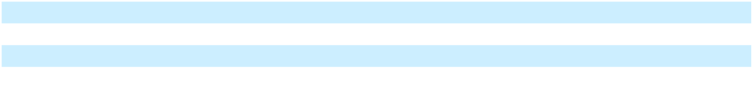

91

Table of Contents

GENERAL MOTORS COMPANY AND SUBSIDIARIES

NOTES TO CONSOLIDATED FINANCIAL STATEMENTS – (Continued) Note 17. Income Taxes

 |  | Years Ended December 31,
 |  | 2024 |  |  | 2023 |  |  | 2022
U.S. income (loss) | $ | 9,729 | $ |  | 6,388 | $ |  | 9,454
Non-U.S. income (loss) |  | 3,465 |  |  | 3,535 |  |  | 1,306
Income (loss) before income taxes and equity income (loss) | $ | 13,194 |  | $ | 9,924 |  | $ | 10,760
 |  | Years Ended December 31,
 |  | 2024 |  |  | 2023 |  |  | 2022
Current income tax expense (benefit)
U.S. federal | $ | 202 | $ |  | 240 | $ |  | 389
U.S. state and local |  | 309 |  |  | 490 |  |  | 368
Non-U.S. |  | 676 |  |  | 874 |  |  | 707
Total current income tax expense (benefit) |  | 1,188 |  |  | 1,605 |  |  | 1,464
Deferred income tax expense (benefit)
U.S. federal |  | 891 |  |  | (120) |  |  | 263
U.S. state and local |  | 101 |  |  | (43) |  |  | 109
Non-U.S. |  | 376 |  |  | (878) |  |  | 53
Total deferred income tax expense (benefit) |  | 1,368 |  |  | (1,041) |  |  | 425
Total income tax expense (benefit) | $ | 2,556 | $ |  | 563 | $ |  | 1,888
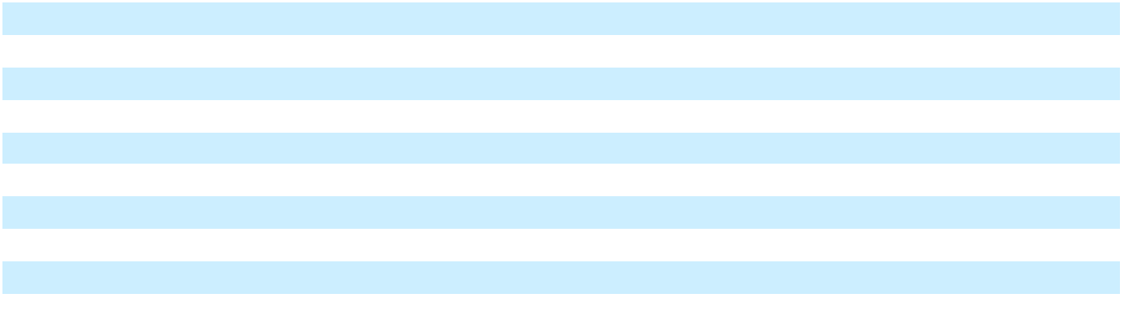

The Non-U.S. deferred income tax benefit in the year ended December 31, 2023 relates primarily to the release of a valuation allowance in Korea.

Provisions are made for estimated U.S. and non-U.S. income taxes which may be incurred on the reversal of our basis differences in investments in foreign subsidiaries and corporate joint ventures not deemed to be indefinitely reinvested. Taxes have not been provided on basis differences in investments primarily as a result of earnings in foreign subsidiaries which are deemed indefinitely reinvested of $6.1 billion and $4.3 billion at December 31, 2024 and 2023. We have indefinitely reinvested basis differences related to investments in non-consolidated China JVs of $1.4 billion and $3.4 billion at December 31, 2024 and 2023 as a result of fresh-start reporting. Quantification of the deferred tax liability, if any, associated with indefinitely reinvested basis differences is not practicable. Refer to Note 8 for additional information regarding the decrease in our basis differences related to investments in nonconsolidated affiliates from fresh-start reporting.

 |  | Years Ended December 31,
 |  | 2024 |  |  | 2023 |  |  | 2022
Income tax expense at U.S. federal statutory income tax rate | $ | 2,771 | $ |  | 2,084 | $ |  | 2,260
State and local tax expense (benefit) |  | 323 |  |  | 348 |  |  | 388
Non-U.S. income taxed at other than the U.S. federal statutory tax rate |  | 130 |  |  | 203 |  |  | 32
U.S. tax impact on Non-U.S. income and activities |  | (49) |  |  | (62) |  |  | 5
Change in valuation allowances |  | 46 |  |  | (1,061) |  |  | (392)
Change in tax laws |  | 9 |  |  | 25 |  |  | 78
General business credits and manufacturing incentives |  | (906) |  |  | (966) |  |  | (829)
Settlements of prior year tax matters |  | — |  |  | 23 |  |  | —
Realization of basis differences in affiliates |  | (45) |  |  | — |  |  | 209
Foreign currency remeasurement |  | 73 |  |  | (62) |  |  | 36
Other adjustments |  | 204 |  |  | 31 |  |  | 102
Total income tax expense (benefit) | $ | 2,556 | $ |  | 563 | $ |  | 1,888
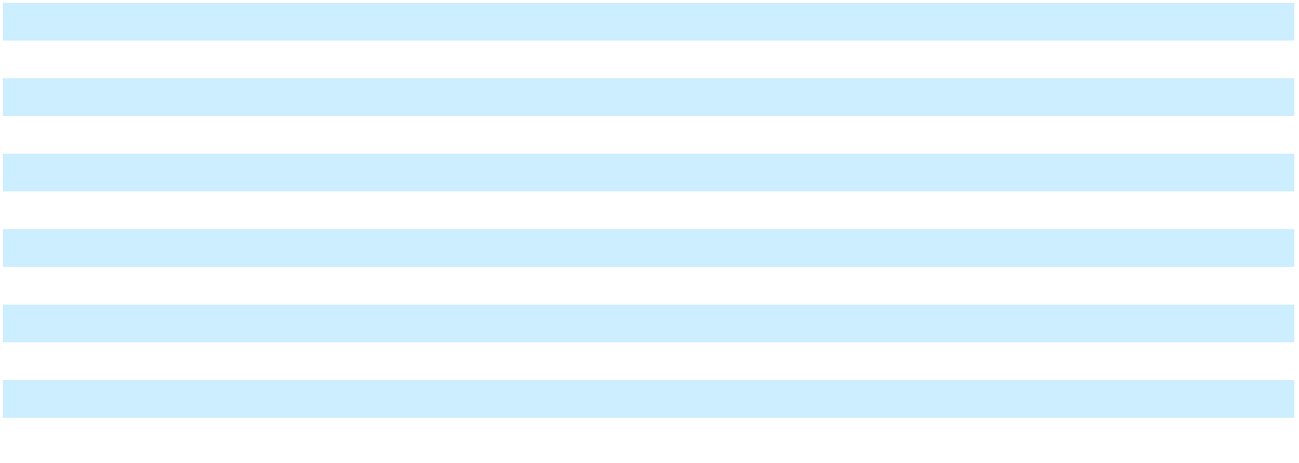

92

Table of Contents

GENERAL MOTORS COMPANY AND SUBSIDIARIES

NOTES TO CONSOLIDATED FINANCIAL STATEMENTS – (Continued)

Deferred Income Tax Assets and Liabilities Deferred income tax assets and liabilities at December 31, 2024 and 2023 reflect the effect of temporary differences between amounts of assets, liabilities and equity for financial reporting purposes and the bases of such assets, liabilities and equity as measured based on tax laws, as well as tax loss and tax credit carryforwards. The following table summarizes the components of temporary differences and carryforwards that give rise to deferred tax assets and liabilities:

 | December 31, 2024 |  |  | December 31, 2023
Deferred tax assets
Postretirement benefits other than pensions | $ | 1,024 | $ |  | 1,119
Pension and other employee benefit plans |  | 1,421 |  |  | 1,522
Warranties, dealer and customer allowances, claims and discounts |  | 4,215 |  |  | 3,684
U.S. capitalized research expenditures |  | 10,111 |  |  | 9,879
U.S. operating loss and tax credit carryforwards(a) |  | 6,582 |  |  | 6,033
Non-U.S. operating loss and tax credit carryforwards(b) |  | 5,239 |  |  | 6,204
Miscellaneous |  | 4,302 |  |  | 5,121
Total deferred tax assets before valuation allowances |  | 32,894 |  |  | 33,562
Less: valuation allowances |  | (6,529) |  |  | (6,979)
Total deferred tax assets |  | 26,365 |  |  | 26,583
Deferred tax liabilities
Property, plant and equipment |  | 5,111 |  |  | 4,233
Intangible assets |  | 635 |  |  | 699
Total deferred tax liabilities |  | 5,746 |  |  | 4,932
Net deferred tax assets | $ | 20,619 | $ |  | 21,651
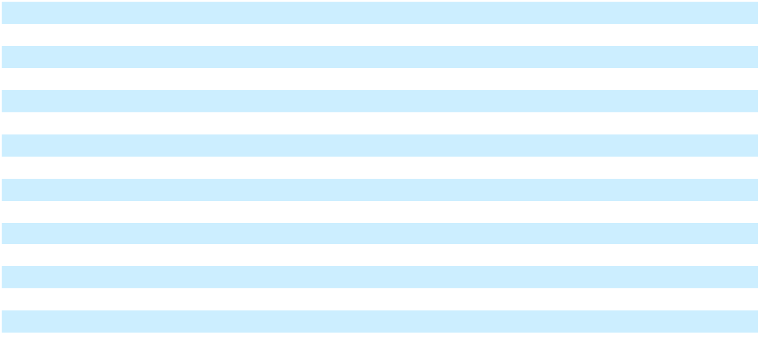
__________

- At December 31, 2024, U.S. operating loss deferred tax assets were $411 million, where $129 million can be carried forward indefinitely and $282 million will expire by 2042, if not utilized. At December 31, 2024, U.S. tax credit carryforwards were $6.2 billion, where $462 million can be carried forward indefinitely and $5.7 billion will expire by 2044, if not utilized.

- At December 31, 2024, Non-U.S. operating loss deferred tax assets were $5.2 billion, where $4.8 billion can be carried forward indefinitely and $342 million will expire by 2044, if not utilized. At December 31, 2024, Non-U.S. tax credit carryforwards were $68 million, where $45 million can be carried forward indefinitely and $23 million will expire by 2043, if not utilized.

Valuation Allowances As a result of improving profitability in the Korean operating business evidenced by cumulative earnings in recent years and the completion of our near-and long-term business plans in the three months ended December 31, 2023 that forecasted continuing profitability, we determined that it was more likely than not that future earnings would be sufficient to realize the deferred tax assets in Korea. Accordingly, we released Korea's $870 million valuation allowance during 2023 resulting in an income tax benefit.

During the years ended December 31, 2024 and 2023, valuation allowances against deferred tax assets of $6.5 billion and $7.0 billion were comprised of cumulative losses, credits and other timing differences, primarily in Germany, Spain, the U.S. and Brazil.

93

Table of Contents

GENERAL MOTORS COMPANY AND SUBSIDIARIES

NOTES TO CONSOLIDATED FINANCIAL STATEMENTS – (Continued)

Uncertain Tax Positions The following table summarizes activity of the total amounts of unrecognized tax benefits:

 |  | Years Ended December 31,
 | 2024 |  |  |  | 2023 |  |  | 2022
Balance at beginning of period | $ | 585 | $ |  | 520 | $ |  | 634
Additions to current year tax positions |  | 108 |  |  | 45 |  |  | 12
Additions to prior years' tax positions |  | 28 |  |  | 72 |  |  | 14
Reductions to prior years' tax positions |  | (109) |  |  | (15) |  |  | (98)
Reductions in tax positions due to lapse of statutory limitations |  | (7) |  |  | (19) |  |  | (20)
Settlements |  | (8) |  |  | (18) |  |  | (10)
Other |  | (11) |  |  | — |  |  | (12)
Balance at end of period | $ | 586 | $ |  | 585 | $ |  | 520
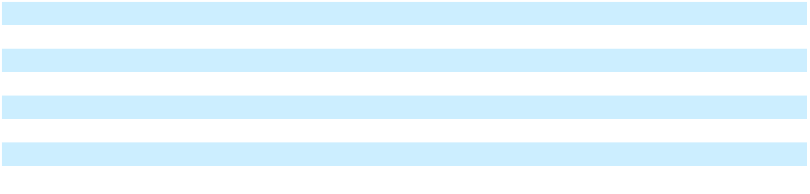

At December 31, 2024 and 2023, there were $415 million and $386 million of unrecognized tax benefits that if recognized would favorably affect our effective tax rate in the future. In the years ended December 31, 2024, 2023 and 2022, income tax-related interest and penalties were insignificant. At December 31, 2024 and 2023, liabilities for income tax-related interest and penalties were insignificant.

At December 31, 2024, it is not possible to reasonably estimate the expected change to the total amount of unrecognized tax benefits in the next twelve months.

Other Matters Income tax returns are filed in multiple jurisdictions and are subject to examination by taxing authorities throughout the world. We have open tax years from 2011 to 2024 with various significant tax jurisdictions. Tax authorities may have the ability to review and adjust net operating loss or tax credit carryforwards that were generated prior to these periods if utilized in an open tax year. These open years contain matters that could be subject to differing interpretations of applicable tax laws and regulations as they relate to the amount, character, timing or inclusion of revenue and expenses or the sustainability of income tax credits for a given audit cycle.

Note 18. Restructuring and Other Initiatives

We have executed various restructuring and other initiatives and we may execute additional initiatives in the future, if necessary, to streamline manufacturing capacity and reduce other costs to improve the utilization of remaining facilities. To the extent these programs involve voluntary separations, a liability is generally recorded at the time offers to employees are accepted. To the extent these programs provide separation benefits in accordance with pre-existing agreements, a liability is recorded once the amount is probable and reasonably estimable. If employees are involuntarily terminated, a liability is generally recorded at the communication date. Related charges are recorded in Automotive and other cost of sales and Automotive and other selling, general and administrative expense.

The following table summarizes the reserves and charges related to restructuring and other initiatives, including postemployment benefit reserves and charges:

 |  | Years Ended December 31,
 |  | 2024 |  |  | 2023 |  |  | 2022
Balance at beginning of period | $ | 779 | $ |  | 520 | $ |  | 285
Additions, interest accretion and other |  | 1,790 |  |  | 1,831 |  |  | 522
Payments |  | (1,303) |  |  | (1,597) |  |  | (275)
Revisions to estimates and effect of foreign currency |  | (22) |  |  | 25 |  |  | (12)
Balance at end of period | $ | 1,243 | $ |  | 779 | $ |  | 520

In the years ended December 31, 2024, 2023 and 2022, restructuring and other initiatives included strategic activities in GMNA related to Buick dealerships. We recorded charges of $964 million in the year ended December 31, 2024, which are included in the table above, and incurred $530 million in net cash outflows resulting from these dealer restructurings, in

94

Table of Contents

GENERAL MOTORS COMPANY AND SUBSIDIARIES

NOTES TO CONSOLIDATED FINANCIAL STATEMENTS – (Continued)

addition to the charges of $569 million and $511 million and net cash outflows of $674 million and $120 million in the years ended December 31, 2023 and 2022. We expect remaining cash outflows related to these activities of $719 million to be substantially completed by the end of 2025.

In April 2024, we announced restructuring actions in GMI related to the closure of manufacturing operations in Colombia and Ecuador. In the year ended December 31, 2024, we recorded $170 million before noncontrolling interest primarily related to employee separations and supplier-related charges of $88 million, which are included in the table above, and non-cash restructuring charges of $79 million primarily related to accelerated depreciation and amortization, which are not reflected in the table above. As of December 31, 2024, we have incurred $48 million of cash outflows resulting from these restructuring activities. We expect the remaining cash outflows related to these activities to be substantially completed by the end of 2025.

In the year ended December 31, 2024, we recorded restructuring charges of $200 million, primarily in GMNA, related to employee separations. As of December 31, 2024, we have incurred $163 million of cash outflows resulting from these restructuring actions. We expect the remaining cash outflows related to these activities to be substantially completed by the end of 2025.

In March 2023, we announced a VSP to accelerate attrition related to the cost reduction program announced in January 2023. We recorded charges in GMNA of $1.0 billion in the year ended December 31, 2023, primarily related to employee separation charges of $905 million, which are reflected in the table above, and non-cash pension curtailment and settlement charges of approximately $130 million, not reflected in the table above. We incurred cash outflows of $58 million and $820 million in the years ended December 31, 2024 and 2023. This program is complete as of December 31, 2024.

In October 2023, Cruise voluntarily paused all of its driverless, supervised and manual AV operations in the U.S. while it examined its processes, systems and tools. In conjunction with these actions, Cruise recorded charges before noncontrolling interest of $529 million in the year ended December 31, 2023, which included non-cash restructuring charges of $250 million. In June 2024, Cruise indefinitely delayed the Cruise Origin and recognized primarily non-cash charges before noncontrolling interest of $631 million. In December 2024, in conjunction with GM’s announcement of its decision to no longer fund Cruise’s robotaxi development work and its plans, subject to approval by the Cruise Board of Directors, to combine the Cruise and GM technical efforts to advance autonomous and assisted driving, Cruise recorded net charges before noncontrolling interest of $522 million, which included net non-cash restructuring charges of $173 million. The non-cash restructuring charges are not reflected in the table above. Cumulatively, we have incurred $287 million of cash outflows resulting from these restructuring activities. We expect the remaining cash outflows related to these activities of approximately $389 million to be completed by the end of 2025.

Note 19. Interest Income and Other Non-Operating Income

 |  | Years Ended December 31,
 |  | 2024 |  |  | 2023 |  |  | 2022
Non-service pension and OPEB income (loss) | $ | 191 | $ |  | 184 | $ |  | 1,512
Interest income |  | 967 |  |  | 1,109 |  |  | 460
Licensing agreements income |  | 211 |  |  | 172 |  |  | 238
Revaluation of investments |  | (225) |  |  | (77) |  |  | (236)
Other |  | 112 |  |  | 149 |  |  | (542)
Total interest income and other non-operating income, net | $ | 1,257 | $ |  | 1,537 | $ |  | 1,432
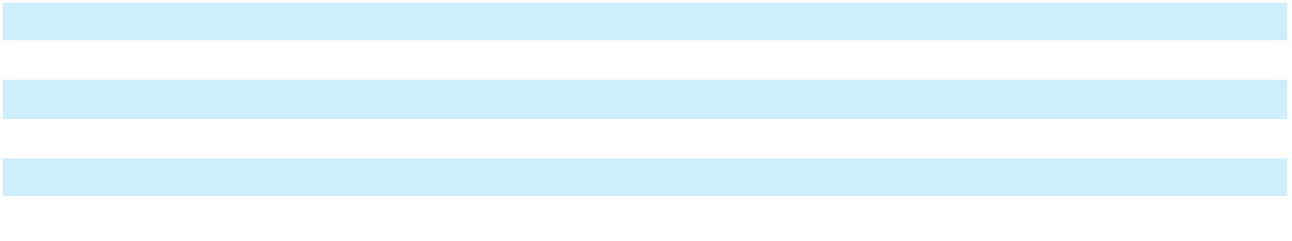

In the year ended December 31, 2022, we shut down our Russia business and recorded a $657 million charge, included in Other in the table above, to write off our net investment and release accumulated translation losses into earnings.

Note 20. Stockholders’ Equity and Noncontrolling Interests

We have 2.0 billion shares of preferred stock and 5.0 billion shares of common stock authorized for issuance. We had no shares of preferred stock issued and outstanding at December 31, 2024 and 2023. We had 1.0 billion and 1.2 billion shares of common stock issued and outstanding at December 31, 2024 and 2023.

95

Table of Contents

GENERAL MOTORS COMPANY AND SUBSIDIARIES

NOTES TO CONSOLIDATED FINANCIAL STATEMENTS – (Continued)

Common Stock Holders of our common stock are entitled to dividends at the sole discretion of our Board of Directors. Our dividends declared per common share were $0.48, $0.36 and $0.18 and our total dividends paid on common stock were $530 million, $477 million and $257 million for the years ended December 31, 2024, 2023 and 2022. Holders of common stock are entitled to one vote per share on all matters submitted to our stockholders for a vote. The liquidation rights of holders of our common stock are secondary to the payment or provision for payment of all our debts and liabilities and to holders of our preferred stock, if any such shares are then outstanding.

In November 2023, our Board of Directors increased the capacity under our share repurchase program by $10.0 billion to an aggregate of $11.4 billion and we entered into the ASR Agreements to repurchase an aggregate amount of $10.0 billion of our common stock under the authorized share repurchase program. In December 2023, we advanced the $10.0 billion and received approximately 215 million shares of our common stock with a value of $6.8 billion, which were immediately retired. In the year ended December 31, 2024, we received and retired approximately 29 million additional shares upon settlement of the transactions contemplated under the ASR Agreements. The final number of shares received was based on the average of the daily volume-weighted average prices of our common stock during the term of the ASR Agreements, less a discount pursuant to the terms and conditions of the ASR Agreements. Because of our ability to settle in shares, the $3.2 billion prepaid forward contract was classified as a reduction to Additional paid-in capital within the consolidated statement of equity at December 31, 2023. Upon settlement, the amount over par was allocated on a pro-rata basis, between Additional paid-in capital and Retained earnings.

In June 2024, our Board of Directors approved a new share repurchase authorization to repurchase up to an additional $6.0 billion of our outstanding common stock.

In the years ended December 31, 2024 and 2023, in addition to shares received under the ASR program, we purchased approximately 140 million and 30 million shares of our outstanding common stock for $7.1 billion and $1.1 billion. In the year ended December 31, 2022, we purchased approximately 64 million shares of our outstanding common stock for $2.5 billion. Shares are immediately retired upon purchase and the amount of the purchase price over par is allocated on a pro-rata basis, subject to the availability of paid-in capital calculated on a per-share basis, between Additional paid-in capital and Retained earnings.

Cruise Preferred Shares In March 2022, we acquired SoftBank Vision Fund (AIV M2) L.P.’s (SoftBank) Cruise Class A-1, Class F and Class G Preferred Shares for $2.1 billion and made an additional $1.35 billion investment in Cruise in place of SoftBank. In December 2024, we acquired Class F and Class G Preferred Shares from noncontrolling shareholders for an insignificant amount.

Cruise Common Shares During the years ended December 31, 2024, 2023 and 2022, Cruise Holdings issued an insignificant amount, $0.4 billion and $0.8 billion of Class B Common Shares to net settle vested awards under Cruise's 2018 Employee Incentive Plan and issued an insignificant amount, $0.2 billion and $0.5 billion of Class B Common Shares, primarily to us, to fund the payment of statutory tax withholding obligations resulting from the settlement or exercise of vested awards. GM conducted quarterly tender offers and paid approximately $0.2 billion, $0.3 billion and $0.6 billion in cash to purchase tendered Cruise Class B Common Shares during the years ended December 31, 2024, 2023 and 2022. The Class B Common Shares are classified as noncontrolling interests in our consolidated financial statements except for certain shares that are liability classified that have a recorded value of approximately $42 million at December 31, 2023. Refer to Note 22 for additional information on Cruise stock incentive awards. In December 2024, we acquired Class E Common Shares from a noncontrolling shareholder for an insignificant amount.

During the year ended December 31, 2024, the effect on the equity attributable to us for changes in our ownership interest in Cruise was a decrease in Additional paid-in capital of $0.9 billion and during the years ended December 31, 2023 and 2022 was insignificant. For the year ended December 31, 2024, net income attributable to shareholders and transfers to the noncontrolling interest in Cruise and other subsidiaries were $7.0 billion, which included a $1.0 billion increase in equity attributable to us, mainly due to the redemption of Cruise preferred shares. For the year ended December 31, 2023, net income attributable to shareholders and transfers to the noncontrolling interest in Cruise and other subsidiaries were $10.3 billion. For the year ended December 31, 2022, net income attributable to shareholders and transfers to the noncontrolling interest in Cruise and other subsidiaries were $9.2 billion, which included a $0.7 billion decrease in equity attributable to us, mainly due to the redemption of Cruise preferred shares.

96

Table of Contents

GENERAL MOTORS COMPANY AND SUBSIDIARIES

NOTES TO CONSOLIDATED FINANCIAL STATEMENTS – (Continued)

The following table summarizes the significant components of Accumulated other comprehensive loss:

 |  | Years Ended December 31,
 |  | 2024 |  |  | 2023 |  |  | 2022
Foreign Currency Translation Adjustments
Balance at beginning of period | $ | (2,457) | $ |  | (2,776) | $ |  | (2,654)
Other comprehensive income (loss) and noncontrolling interests, net of |  | (1,173) |  |  | 319 |  |  | (123)
reclassification adjustment and tax(a)(b)(c) |  | (1,173) |  |  | 319 |  |  | (123)
Balance at end of period | $ | (3,630) | $ |  | (2,457) | $ |  | (2,776)
Defined Benefit Plans
Balance at beginning of period | $ | (7,665) | $ |  | (4,851) | $ |  | (6,528)
Other comprehensive income (loss) and noncontrolling interests before |  | (207) |  |  | (3,706) |  |  | 1,487
reclassification adjustment(a) |  | (207) |  |  | (3,706) |  |  | 1,487
Tax benefit (expense) |  | (91) |  |  | 838 |  |  | 2
Other comprehensive income (loss) and noncontrolling interests before |  | (298) |  |  | (2,868) |  |  | 1,488
reclassification adjustment, net of tax(a) |  | (298) |  |  | (2,868) |  |  | 1,488
Reclassification adjustment, net of tax(c) |  | 294 |  |  | 54 |  |  | 188
Other comprehensive income (loss), net of tax |  | (4) |  |  | (2,814) |  |  | 1,677
Balance at end of period(d) | $ | (7,669) | $ |  | (7,665) | $ |  | (4,851)
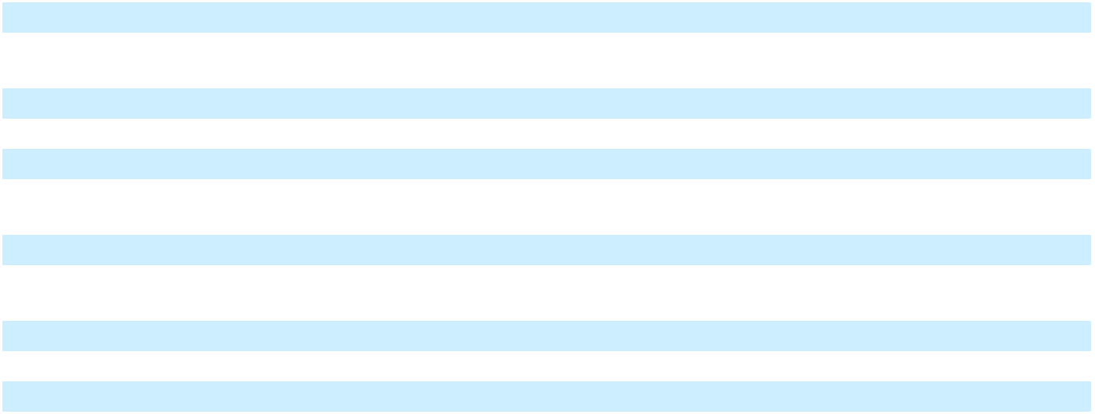
__________

- The noncontrolling interests were insignificant in the years ended December 31, 2024, 2023 and 2022.

- The reclassification adjustment was insignificant in the years ended December 31, 2024, 2023 and 2022.

- The income tax effect was insignificant in the years ended December 31, 2024, 2023 and 2022.

- Primarily consists of unamortized actuarial loss on our defined benefit plans.

97

Table of Contents

GENERAL MOTORS COMPANY AND SUBSIDIARIES

NOTES TO CONSOLIDATED FINANCIAL STATEMENTS – (Continued) Note 21. Earnings Per Share

Basic and diluted earnings per share are computed by dividing Net income attributable to common stockholders by the weighted-average common shares outstanding in the period. Diluted earnings per share is computed by giving effect to all potentially dilutive securities that are outstanding using the treasury stock method for awards under stock incentive plans.

 |  | Years Ended December 31,
 |  | 2024 |  |  | 2023 |  |  | 2022
Basic earnings per share
Net income (loss) attributable to stockholders | $ | 6,008 | $ |  | 10,127 | $ |  | 9,934
Adjustments(a) |  | 1,181 |  |  | (106) |  |  | (1,019)
Net income (loss) attributable to common stockholders | $ | 7,189 | $ |  | 10,022 | $ |  | 8,915
Weighted-average common shares outstanding |  | 1,115 |  |  | 1,364 |  |  | 1,445
Basic earnings per common share | $ | 6.45 | $ |  | 7.35 | $ |  | 6.17
Diluted earnings per share
Net income (loss) attributable to common stockholders – diluted | $ | 7,189 | $ |  | 10,022 | $ |  | 8,915
Weighted-average common shares outstanding – basic |  | 1,115 |  |  | 1,364 |  |  | 1,445
Dilutive effect of awards under stock incentive plans |  | 13 |  |  | 6 |  |  | 10
Weighted-average common shares outstanding – diluted |  | 1,129 |  |  | 1,369 |  |  | 1,454
Diluted earnings per common share | $ | 6.37 | $ |  | 7.32 | $ |  | 6.13
Potentially dilutive securities(b) |  | — |  |  | 23 |  |  | 10
__________
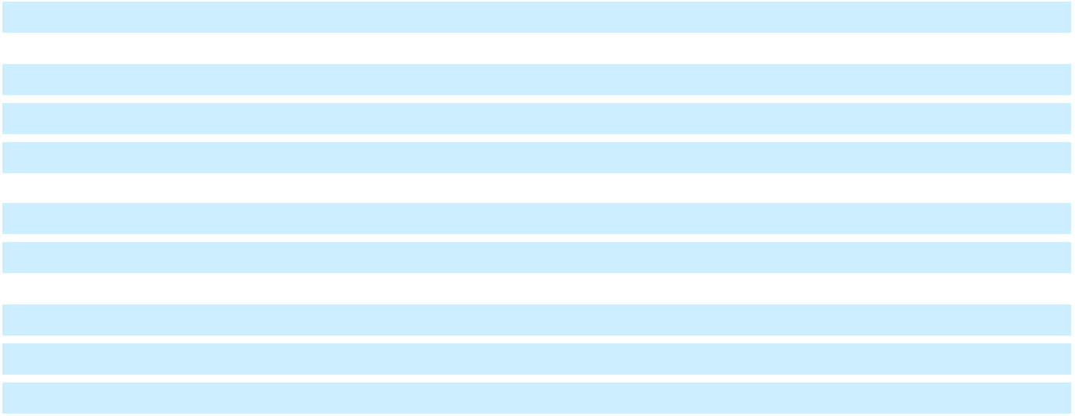
- Includes a $1.2 billion and $(909) million return from (return to) the preferred shareholders related to the redemption of Cruise preferred shares from noncontrolling interest holders and an insignificant amount in participating securities income from a subsidiary for the years ended December 31, 2024 and 2022.

- Potentially dilutive securities attributable to outstanding stock options and RSUs at December 31, 2023 and 2022, were excluded from the computation of diluted EPS because the securities would have had an antidilutive effect.

Note 22. Stock Incentive Plans

GM Stock Incentive Awards We grant to certain employees RSUs, PSUs and stock options (collectively, stock incentive awards) under our 2020 LTIP and prior to the 2020 LTIP, under our 2017 and 2014 LTIP. The 2020 LTIP was approved by stockholders in June 2020. Any new awards granted after the approval of the 2020 LTIP in June 2020 will be issued under the 2020 LTIP. To the extent any shares remain available for issuance under the 2017 LTIP and/or the 2014 LTIP, such shares will only be used to settle outstanding awards that were previously granted under such plans prior to June 2020. The awards under the plans are subject to forfeiture if the participant leaves the company for reasons other than those permitted under the plans such as retirement, death or disability.

RSU awards granted either cliff vest or ratably vest generally over a three-year service period, as defined in the terms of each award. PSU awards vest at the end of a three-year performance period, based on performance criteria determined by the Executive Compensation Committee of the Board of Directors at the time of award. The number of shares earned, or units paid in cash, may equal, exceed or be less than the targeted number depending on whether the performance criteria are met, surpassed or not met. Our service-based stock options vest ratably over three years. Stock options expire 10 years from the grant date.

98

Table of Contents

GENERAL MOTORS COMPANY AND SUBSIDIARIES

NOTES TO CONSOLIDATED FINANCIAL STATEMENTS – (Continued)

Equity-Classified Awards

 |  |  | Weighted-Average |  |  | Weighted-Average
 |  |  |  |  |  | Remaining
 | Shares (in millions) |  | Grant Date Fair |  |  | Contractual Term
 | Shares (in millions) |  | Value |  |  | in Years
Units outstanding at January 1, 2024 | 39.9 | $ |  | 27.53 | 0.9
Granted | 10.0 | $ |  | 41.76
Settled | (11.6) | $ |  | 22.65
Forfeited or expired | (3.4) | $ |  | 45.26
Units outstanding at December 31, 2024(a) | 34.9 | $ |  | 31.52 | 3.0
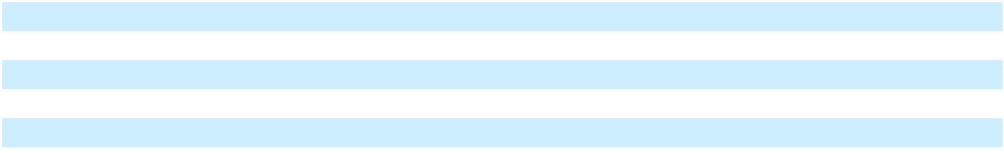
__________

(a) Includes the target amount of PSUs.

There were no stock options issued during the year ended December 31, 2024. Our weighted-average assumptions used to value our stock options are a dividend yield of 1.90% and 1.60%, expected volatility of 34.0% and 41.0%, a risk-free interest rate of 3.70% and 1.88%, and an expected option life of 6.00 years for options issued during the years ended December 31, 2023 and 2022. The expected volatility is based on the average of the implied volatility of publicly traded options for our common stock.

Total compensation expense related to the above awards was $332 million, $340 million and $419 million in the years ended December 31, 2024, 2023 and 2022.

At December 31, 2024, the total unrecognized compensation expense for nonvested equity awards granted was $273 million. This expense is expected to be recorded over a weighted-average period of 1.6 years. The total fair value of stock incentive awards vested was $257 million, $425 million and $307 million in the years ended December 31, 2024, 2023 and 2022.

Liability-Classified Awards We grant certain employees stock incentive awards that are payable in cash. The total compensation expense and cash paid to settle these awards was insignificant in the years ended December 31, 2024, 2023 and 2022.

Cruise Stock Incentive Awards Cruise granted RSUs that will settle in common shares of Cruise Holdings in the years ended December 31, 2024, 2023 and 2022. Stock options were granted in common shares of Cruise Holdings in the year ended December 31, 2022. These awards were granted under Cruise's 2018 Employee Incentive Plan approved by Cruise Holdings' Board of Directors in August 2018. Shares awarded under the plan are subject to forfeiture if the participant leaves the company for reasons other than those permitted under the plan. In March 2022, Cruise modified its RSUs that settle in Cruise Class B Common Shares to remove the liquidity vesting condition such that all granted RSU awards vest solely upon satisfaction of a service condition. The service condition for the majority of these awards is satisfied over four years. Upon modification, 31 million RSUs whose service condition was previously met became immediately vested, thereby resulting in the immediate recognition of compensation expense. Subsequent to the modification, holders of Cruise Class B Common Shares issued to settle vested awards could tender their shares generally at the fair value of Cruise’s common stock. The ability to tender the Class B Common Shares results in certain awards to be classified as liabilities and other awards to be presented in temporary equity. A final tender offer was completed in April 2024, after which substantially all remaining outstanding unvested Cruise RSUs were exchanged by participants for unvested cash payment rights. The remaining outstanding Cruise RSUs are insignificant and are now presented in permanent equity.

Total compensation expense related to Cruise Holdings' share-based awards was insignificant, $0.4 billion and $1.6 billion for the years ended December 31, 2024, 2023 and 2022. GM conducted quarterly tender offers for the years ended December 31, 2023 and 2022 and paid approximately $0.2 billion, $0.3 billion and $0.6 billion in cash to settle tendered Cruise Class B Common Shares during the years ended December 31, 2024, 2023 and 2022.

99

Table of Contents

GENERAL MOTORS COMPANY AND SUBSIDIARIES

NOTES TO CONSOLIDATED FINANCIAL STATEMENTS – (Continued) Note 23. Segment Reporting

Our chief operating decision-maker, who is our Chair and Chief Executive Officer, analyzes the results of our business through the following reportable segments: GMNA, GMI, Cruise and GM Financial. Our chief operating decision-maker evaluates the operating results and performance of our automotive segments and Cruise through EBIT-adjusted, which is presented net of noncontrolling interests. Our chief operating decision-maker evaluates GM Financial through EBT-adjusted because interest income and interest expense are an integral part of its operational and financial performance. These financial metrics are used to view operating trends, perform analytical comparisons and benchmark performance between periods and among geographic regions and to monitor budget-to-actual variances on a monthly basis. To manage operations and make decisions regarding resource allocations, our chief operating decision-maker is regularly provided and reviews expense information at a consolidated, functional level for our global purchasing and supply chain, manufacturing and engineering functions. Warranty and quality metrics are also viewed on a consolidated basis. Currently, a focus is being placed on driving an efficient, consolidated fixed cost structure and managing overall global headcount. Vehicle-level profitability metrics are also reviewed during the planning stage and throughout a program's life cycle on a forecasted basis, and not on an actual basis. Each segment has a manager responsible for executing our strategic initiatives.

Substantially all of the trucks, crossovers, cars and automobile parts produced are marketed through retail dealers in North America and through distributors and dealers outside of North America, the substantial majority of which are independently owned. In addition to the products sold to dealers for consumer retail sales, trucks, crossovers and cars are also sold to fleet customers, including daily rental car companies, commercial fleet customers, leasing companies and governments. Fleet sales are completed through the dealer network and in some cases directly with fleet customers. Retail and fleet customers can obtain a wide range of after-sale vehicle services and products through the dealer network, such as maintenance, light repairs, collision repairs, vehicle accessories and extended service warranties.

GMNA meets the demands of customers in North America and GMI primarily meets the demands of customers outside North America, with vehicles developed, manufactured and/or marketed under the Buick, Cadillac, Chevrolet and GMC brands. We also have equity ownership stakes in entities that meet the demands of customers in other countries, primarily China, with vehicles developed, manufactured and/or marketed under the Baojun, Buick, Cadillac, Chevrolet and Wuling brands. Cruise is our global segment responsible for the development of AV technology, and includes AV-related engineering and other costs. We provide automotive financing services through our GM Financial segment.

Our automotive interest income and interest expense, legacy costs from the Opel/Vauxhall Business (primarily pension costs), corporate expenditures and certain revenues and expenses that are not part of a reportable segment are recorded centrally in Corporate. Corporate assets primarily consist of cash and cash equivalents, marketable debt securities and intersegment balances. All intersegment balances and transactions have been eliminated in consolidation.

100

Table of Contents

GENERAL MOTORS COMPANY AND SUBSIDIARIES

NOTES TO CONSOLIDATED FINANCIAL STATEMENTS – (Continued)

The following tables summarize key financial information by segment:

 |  |  |  |  |  |  |  |  |  |  | At and For the Year Ended December 31, 2024
 |  | GMNA |  |  | GMI |  | Corporate |  |  | Eliminations |  |  |  | Total |  |  | Cruise |  |  | GM |  |  | Eliminations/ |  |  | Total
 |  | GMNA |  |  | GMI |  |  |  |  |  |  |  | Automotive |  |  |  | Cruise |  | Financial |  |  | Reclassifications |  |  |  | Total
Net sales and revenue | $ | 157,509 | $ |  | 13,890 | $ |  | 206 | $ |  | — | $ |  | 171,605 | $ |  | 257 | $ |  | 15,875 | $ |  | (296) | $ |  | 187,442
Segment expenses and other items(a) |  | (143,719) |  |  | (17,849) |  |  | (1,398) |  |  | — |  |  | (162,966) |  |  | (3,065) |  |  | (13,231) |  |  | 263 |  |  | (178,999)
Adjustments(b) |  | 738 |  |  | 4,262 |  |  | 64 |  |  | — |  |  | 5,064 |  |  | 1,107 |  |  | 320 |  |  | — |  |  | 6,491
Earnings (loss) before interest and | $ | 14,528 | $ |  | 303 | $ |  | (1,129) | $ |  | — | $ |  | 13,703 | $ |  | (1,701) | $ |  | 2,965 | $ |  | (33) | $ |  | 14,934
taxes-adjusted
Adjustments(b) |  |  |  |  |  |  |  |  |  |  |  |  |  |  |  |  |  |  |  |  |  |  |  |  |  | (6,491)
Automotive interest income |  |  |  |  |  |  |  |  |  |  |  |  |  |  |  |  |  |  |  |  |  |  |  |  |  | 967
Automotive interest expense |  |  |  |  |  |  |  |  |  |  |  |  |  |  |  |  |  |  |  |  |  |  |  |  |  | (846)
Net income (loss) attributable to |  |  |  |  |  |  |  |  |  |  |  |  |  |  |  |  |  |  |  |  |  |  |  |  |  | (45)
noncontrolling interests |  |  |  |  |  |  |  |  |  |  |  |  |  |  |  |  |  |  |  |  |  |  |  |  |  | (45)
Income (loss) before income taxes |  |  |  |  |  |  |  |  |  |  |  |  |  |  |  |  |  |  |  |  |  |  |  |  |  | 8,519
Income tax benefit (expense) |  |  |  |  |  |  |  |  |  |  |  |  |  |  |  |  |  |  |  |  |  |  |  |  |  | (2,556)
Net income (loss) |  |  |  |  |  |  |  |  |  |  |  |  |  |  |  |  |  |  |  |  |  |  |  |  |  | 5,963
Net loss (income) attributable to |  |  |  |  |  |  |  |  |  |  |  |  |  |  |  |  |  |  |  |  |  |  |  |  |  | 45
noncontrolling interests |  |  |  |  |  |  |  |  |  |  |  |  |  |  |  |  |  |  |  |  |  |  |  |  |  | 45
Net income (loss) attributable to |  |  |  |  |  |  |  |  |  |  |  |  |  |  |  |  |  |  |  |  |  |  |  | $ |  | 6,008
stockholders |  |  |  |  |  |  |  |  |  |  |  |  |  |  |  |  |  |  |  |  |  |  |  |  |  | 6,008
Equity in net assets of
Equity in net assets of | $ | 4,447 | $ |  | 1,449 | $ |  | — | $ |  | — | $ |  | 5,896 | $ |  | — | $ |  | 1,206 | $ |  | — | $ |  | 7,102
nonconsolidated affiliates
Goodwill and intangibles | $ | 1,966 | $ |  | 676 | $ |  | — | $ |  | — | $ |  | 2,642 | $ |  | 570 | $ |  | 1,339 | $ |  | — | $ |  | 4,551
Total assets | $ | 165,905 | $ |  | 21,769 | $ |  | 38,817 | $ |  | (85,117) | $ |  | 141,374 | $ |  | 2,948 | $ |  | 139,156 | $ |  | (3,717) | $ |  | 279,761
Expenditures for property | $ | 10,266 | $ |  | 415 | $ |  | 30 | $ |  | — | $ |  | 10,711 | $ |  | 7 | $ |  | 24 | $ |  | 88 | $ |  | 10,830
Depreciation and amortization | $ | 5,963 | $ |  | 506 | $ |  | 80 | $ |  | — | $ |  | 6,548 | $ |  | 25 | $ |  | 4,883 | $ |  | — | $ |  | 11,456
Impairment charges | $ | — | $ |  | — | $ |  | — | $ |  | — | $ |  | — | $ |  | 933 | $ |  | — | $ |  | — | $ |  | 934
Equity income (loss)(c) | $ | 955 | $ |  | (4,400) | $ |  | — | $ |  | — | $ |  | (3,445) | $ |  | — | $ |  | (256) | $ |  | — | $ |  | (3,701)
__________
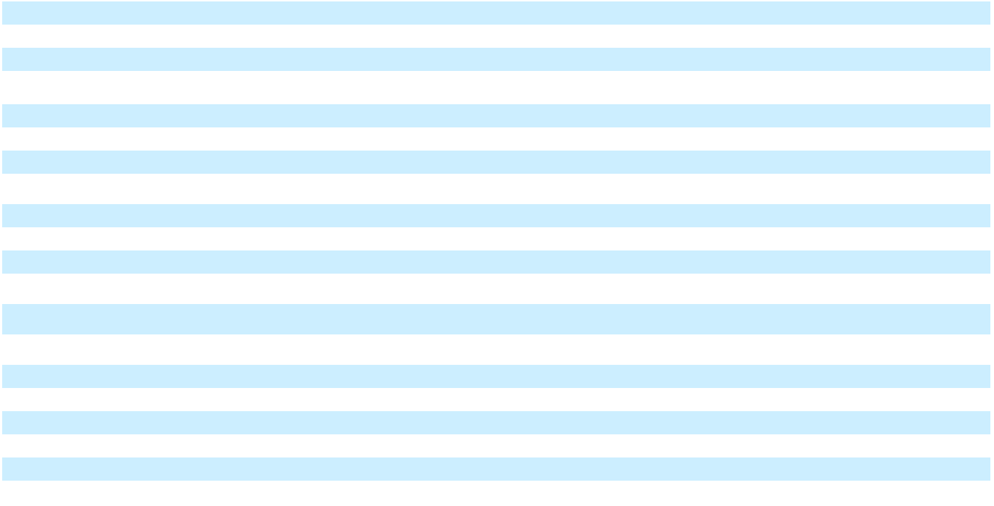
- Segment expenses and other items for Automotive segments primarily include material and logistics; manufacturing; equity income; selling, general and administrative people-related costs; advertising; information technology; engineering; professional services; and policy, campaign, and warranty. GM Financial items consist primarily of GM Financial interest expense; leased vehicle depreciation; people-related costs; provision for loan losses and gains and losses on termination of leased vehicles. Cruise items primarily consist of people-related costs.

- Consists of charges related to the Buick dealerships and restructuring actions in GMNA; charges related to manufacturing operations wind down in GMI; China restructuring actions in GMI, GMNA and GM Financial; headquarters relocation in Corporate; and charges related to Cruise restructuring and Cruise realignment.
- Equity loss associated with our Automotive China JVs include impacts of the other-than-temporary impairment and our portion of restructuring charges. Equity earnings related to Ultium Cells Holdings LLC are presented in Automotive and other cost of sales as this entity is integral to the operations of our business by providing battery cells for our EVs. Refer to Note 8 for additional information.

101

Table of Contents

GENERAL MOTORS COMPANY AND SUBSIDIARIES

NOTES TO CONSOLIDATED FINANCIAL STATEMENTS – (Continued)

 |  |  |  |  |  |  |  |  |  |  | At and For the Year Ended December 31, 2023
 |  | GMNA |  |  | GMI |  | Corporate |  |  | Eliminations |  |  |  | Total |  |  | Cruise |  |  | GM |  |  | Eliminations/ |  |  | Total
 |  | GMNA |  |  | GMI |  |  |  |  |  |  |  | Automotive |  |  |  | Cruise |  | Financial |  |  | Reclassifications |  |  |  | Total
Net sales and revenue | $ | 141,445 | $ |  | 15,949 | $ |  | 273 | $ |  | — | $ |  | 157,667 | $ |  | 102 | $ |  | 14,225 | $ |  | (151) | $ |  | 171,842
Segment expenses and other items(a) |  | (130,743) |  |  | (14,522) |  |  | (1,686) |  |  | — |  |  | (146,951) |  |  | (3,275) |  |  | (11,239) |  |  | 116 |  |  | (161,350)
Adjustments(b) |  | 1,604 |  |  | (217) |  |  | — |  |  | — |  |  | 1,387 |  |  | 478 |  |  | — |  |  | — |  |  | 1,865
Earnings (loss) before interest and | $ | 12,306 | $ |  | 1,210 | $ |  | (1,413) | $ |  | — | $ |  | 12,103 | $ |  | (2,695) | $ |  | 2,985 | $ |  | (35) | $ |  | 12,357
taxes-adjusted
Adjustments(b) |  |  |  |  |  |  |  |  |  |  |  |  |  |  |  |  |  |  |  |  |  |  |  |  |  | (1,865)
Automotive interest income |  |  |  |  |  |  |  |  |  |  |  |  |  |  |  |  |  |  |  |  |  |  |  |  |  | 1,109
Automotive interest expense |  |  |  |  |  |  |  |  |  |  |  |  |  |  |  |  |  |  |  |  |  |  |  |  |  | (911)
Net income (loss) attributable to |  |  |  |  |  |  |  |  |  |  |  |  |  |  |  |  |  |  |  |  |  |  |  |  |  | (287)
noncontrolling interests |  |  |  |  |  |  |  |  |  |  |  |  |  |  |  |  |  |  |  |  |  |  |  |  |  | (287)
Income (loss) before income taxes |  |  |  |  |  |  |  |  |  |  |  |  |  |  |  |  |  |  |  |  |  |  |  |  |  | 10,403
Income tax benefit (expense) |  |  |  |  |  |  |  |  |  |  |  |  |  |  |  |  |  |  |  |  |  |  |  |  |  | (563)
Net income (loss) |  |  |  |  |  |  |  |  |  |  |  |  |  |  |  |  |  |  |  |  |  |  |  |  |  | 9,840
Net loss (income) attributable to |  |  |  |  |  |  |  |  |  |  |  |  |  |  |  |  |  |  |  |  |  |  |  |  |  | 287
noncontrolling interests |  |  |  |  |  |  |  |  |  |  |  |  |  |  |  |  |  |  |  |  |  |  |  |  |  | 287
Net income (loss) attributable to |  |  |  |  |  |  |  |  |  |  |  |  |  |  |  |  |  |  |  |  |  |  |  | $ |  | 10,127
stockholders |  |  |  |  |  |  |  |  |  |  |  |  |  |  |  |  |  |  |  |  |  |  |  |  |  | 10,127
Equity in net assets of
Equity in net assets of | $ | 2,595 | $ |  | 6,348 | $ |  | — | $ |  | — | $ |  | 8,943 | $ |  | — | $ |  | 1,670 | $ |  | — | $ |  | 10,613
nonconsolidated affiliates
Goodwill and intangibles | $ | 2,083 | $ |  | 710 | $ |  | — | $ |  | — | $ |  | 2,793 | $ |  | 715 | $ |  | 1,354 | $ |  | — | $ |  | 4,862
Total assets | $ | 155,908 | $ |  | 26,225 | $ |  | 41,271 | $ |  | (82,858) | $ |  | 140,546 | $ |  | 4,555 | $ |  | 130,780 | $ |  | (2,817) | $ |  | 273,064
Expenditures for property | $ | 10,147 | $ |  | 522 | $ |  | 15 | $ |  | — | $ |  | 10,684 | $ |  | 63 | $ |  | 24 | $ |  | 198 | $ |  | 10,970
Depreciation and amortization | $ | 6,146 | $ |  | 589 | $ |  | 21 | $ |  | — | $ |  | 6,755 | $ |  | 38 | $ |  | 4,944 | $ |  | — | $ |  | 11,737
Impairment charges | $ | — | $ |  | — | $ |  | — | $ |  | — | $ |  | — | $ |  | 209 | $ |  | — | $ |  | — | $ |  | 209
Equity income (loss)(c) | $ | 196 | $ |  | 440 | $ |  | — | $ |  | — | $ |  | 635 | $ |  | — | $ |  | 138 | $ |  | — | $ |  | 773
__________
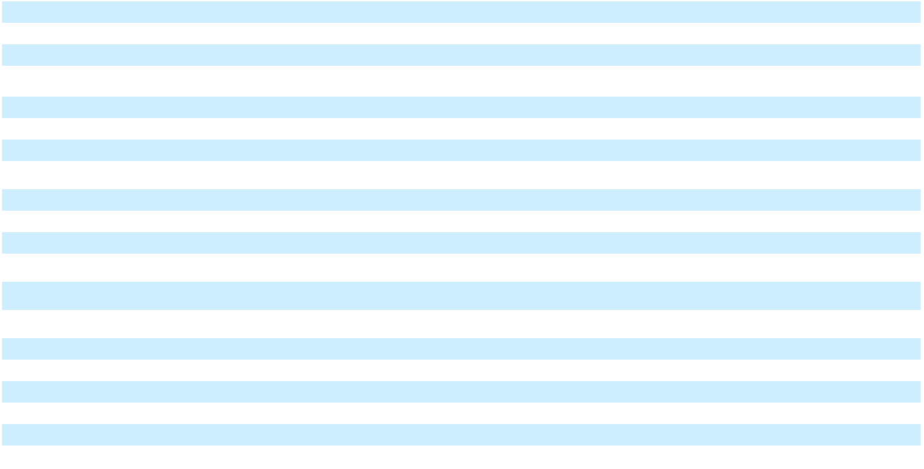
- Segment expenses and other items for Automotive segments primarily include material and logistics; manufacturing; equity income; selling, general and administrative people-related costs; advertising; information technology; engineering; professional services; and policy, campaign, and warranty. GM Financial items consist primarily of GM Financial interest expense; leased vehicle depreciation; people-related costs; provision for loan losses and gains and losses on termination of leased vehicles. Cruise items primarily consist of people-related costs.

- Consists of charges related to the VSP and strategic activities related to Buick dealerships in GMNA; the gain associated with India asset sales and the partial resolution of Korean subcontractor matters in GMI; and charges related to Cruise restructuring.
- Equity earnings related to Ultium Cells Holdings LLC are presented in Automotive and other cost of sales as this entity is integral to the operations of our business by providing battery cells for our EVs. Refer to Note 8 for additional information.

102

Table of Contents

GENERAL MOTORS COMPANY AND SUBSIDIARIES

NOTES TO CONSOLIDATED FINANCIAL STATEMENTS – (Continued)

 |  |  |  |  |  |  |  |  |  |  | At and For the Year Ended December 31, 2022
 |  | GMNA |  |  | GMI |  | Corporate |  |  | Eliminations |  |  |  | Total |  |  | Cruise |  |  | GM |  |  | Eliminations/ |  |  | Total
 |  | GMNA |  |  | GMI |  |  |  |  |  |  |  | Automotive |  |  |  | Cruise |  | Financial |  |  | Reclassifications |  |  |  | Total
Net sales and revenue | $ | 128,378 | $ |  | 15,420 | $ |  | 177 | $ |  | — | $ |  | 143,974 | $ |  | 102 | $ |  | 12,766 | $ |  | (107) | $ |  | 156,735
Segment expenses and other items(a) |  | (115,801) |  |  | (14,934) |  |  | (2,023) |  |  | — |  |  | (132,756) |  |  | (3,049) |  |  | (8,690) |  |  | 109 |  |  | (144,386)
Adjustments(b) |  | 411 |  |  | 657 |  |  | — |  |  | — |  |  | 1,068 |  |  | 1,057 |  |  | — |  |  | — |  |  | 2,125
Earnings (loss) before interest and | $ | 12,988 | $ |  | 1,143 | $ |  | (1,846) | $ |  | — | $ |  | 12,286 | $ |  | (1,890) | $ |  | 4,076 | $ |  | 2 | $ |  | 14,474
taxes-adjusted
Adjustments(b) |  |  |  |  |  |  |  |  |  |  |  |  |  |  |  |  |  |  |  |  |  |  |  |  |  | (2,125)
Automotive interest income |  |  |  |  |  |  |  |  |  |  |  |  |  |  |  |  |  |  |  |  |  |  |  |  |  | 460
Automotive interest expense |  |  |  |  |  |  |  |  |  |  |  |  |  |  |  |  |  |  |  |  |  |  |  |  |  | (987)
Net income (loss) attributable to |  |  |  |  |  |  |  |  |  |  |  |  |  |  |  |  |  |  |  |  |  |  |  |  |  | (226)
noncontrolling interests |  |  |  |  |  |  |  |  |  |  |  |  |  |  |  |  |  |  |  |  |  |  |  |  |  | (226)
Income (loss) before income taxes |  |  |  |  |  |  |  |  |  |  |  |  |  |  |  |  |  |  |  |  |  |  |  |  |  | 11,597
Income tax benefit (expense) |  |  |  |  |  |  |  |  |  |  |  |  |  |  |  |  |  |  |  |  |  |  |  |  |  | (1,888)
Net income (loss) |  |  |  |  |  |  |  |  |  |  |  |  |  |  |  |  |  |  |  |  |  |  |  |  |  | 9,708
Net loss (income) attributable to |  |  |  |  |  |  |  |  |  |  |  |  |  |  |  |  |  |  |  |  |  |  |  |  |  | 226
noncontrolling interests |  |  |  |  |  |  |  |  |  |  |  |  |  |  |  |  |  |  |  |  |  |  |  |  |  | 226
Net income (loss) attributable to |  |  |  |  |  |  |  |  |  |  |  |  |  |  |  |  |  |  |  |  |  |  |  | $ |  | 9,934
stockholders |  |  |  |  |  |  |  |  |  |  |  |  |  |  |  |  |  |  |  |  |  |  |  |  |  | 9,934
Equity in net assets of
Equity in net assets of | $ | 1,820 | $ |  | 6,691 | $ |  | — | $ |  | — | $ |  | 8,511 | $ |  | — | $ |  | 1,665 | $ |  | — | $ |  | 10,176
nonconsolidated affiliates
Goodwill and intangibles | $ | 2,134 | $ |  | 740 | $ |  | 4 | $ |  | — | $ |  | 2,877 | $ |  | 727 | $ |  | 1,341 | $ |  | — | $ |  | 4,945
Total assets | $ | 157,250 | $ |  | 24,808 | $ |  | 60,518 | $ |  | (104,157) | $ |  | 138,419 | $ |  | 5,510 | $ |  | 121,544 | $ |  | (1,436) | $ |  | 264,037
Expenditures for property | $ | 8,280 | $ |  | 706 | $ |  | 20 | $ |  | — | $ |  | 9,007 | $ |  | 197 | $ |  | 44 | $ |  | (10) | $ |  | 9,238
Depreciation and amortization | $ | 5,800 | $ |  | 513 | $ |  | 21 | $ |  | — | $ |  | 6,335 | $ |  | 53 | $ |  | 4,888 | $ |  | — | $ |  | 11,276
Impairment charges | $ | 11 | $ |  | 1 | $ |  | — | $ |  | — | $ |  | 12 | $ |  | — | $ |  | — | $ |  | — | $ |  | 12
Equity income (loss) | $ | (9) | $ |  | 672 | $ |  | — | $ |  | — | $ |  | 663 | $ |  | — | $ |  | 173 | $ |  | — | $ |  | 837
__________
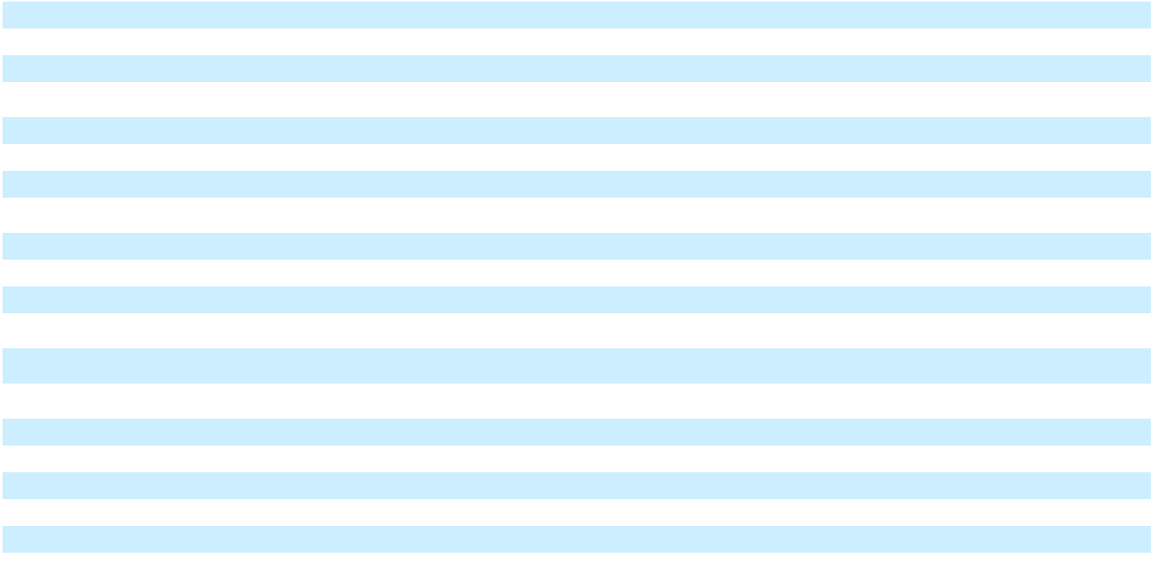
- Segment expenses and other items for Automotive segments primarily include material and logistics; manufacturing; equity income; selling, general and administrative people-related costs; advertising; information technology; engineering; professional services; and policy, campaign, and warranty. GM Financial items consist primarily of GM Financial interest expense; leased vehicle depreciation; people-related costs; provision for loan losses and gains and losses on termination of leased vehicles. Cruise items primarily consist of people-related costs.

- Consists of charges for strategic activities related to Buick dealerships and the resolution of substantially all royalty matters accrued with respect to past-year vehicle sales in GMNA; charges related to the shutdown of our Russia business in GMI; and charges related to the one-time modification of Cruise stock incentive awards.

Automotive revenue is attributed to geographic areas based on the country of sale. GM Financial revenue is attributed to the geographic area where the financing is originated. The following table summarizes information concerning principal geographic areas:

 |  |  |  |  | At and For the Years Ended December 31,
 |  | 2024 |  |  |  |  |  | 2023 |  |  |  |  |  | 2022
 | Net Sales and |  |  | Long-Lived |  |  | Net Sales and |  |  | Long-Lived |  |  | Net Sales and |  |  |  | Long-Lived
 |  | Revenue |  |  | Assets |  |  | Revenue |  |  | Assets |  |  | Revenue |  |  | Assets
Automotive
U.S. | $ | 140,536 | $ |  | 35,986 | $ |  | 127,472 | $ |  | 34,142 | $ |  | 116,798 | $ |  | 30,201
Non-U.S. |  | 31,070 |  |  | 15,811 |  |  | 30,186 |  |  | 16,054 |  |  | 27,177 |  |  | 14,907
GM Financial
U.S. |  | 13,575 |  |  | 28,129 |  |  | 12,133 |  |  | 27,397 |  |  | 11,035 |  |  | 29,411
Non-U.S. |  | 2,261 |  |  | 3,563 |  |  | 2,051 |  |  | 3,309 |  |  | 1,725 |  |  | 3,431
Total consolidated | $ | 187,442 | $ |  | 83,490 | $ |  | 171,842 | $ |  | 80,903 | $ |  | 156,735 | $ |  | 77,950
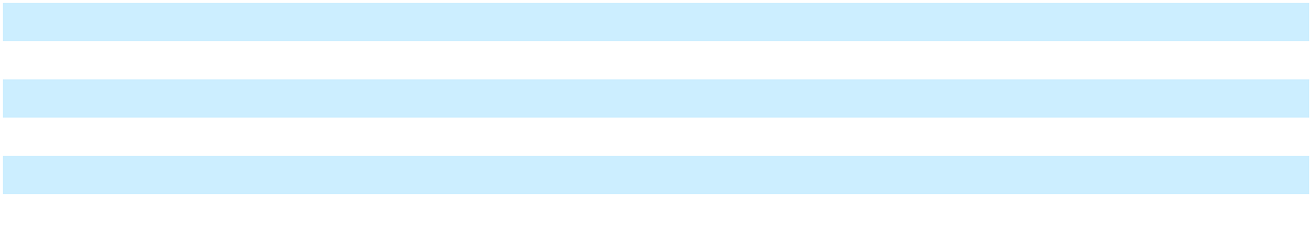

No individual country other than the U.S. represented more than 10% of our total net sales and revenue or long-lived assets, other than Mexico, whose long-lived assets were approximately 12%, 12% and 11% of our total long-lived assets at December 31, 2024, 2023 and 2022.

103

Table of Contents

GENERAL MOTORS COMPANY AND SUBSIDIARIES

NOTES TO CONSOLIDATED FINANCIAL STATEMENTS – (Continued) Note 24. Supplemental Information for the Consolidated Statements of Cash Flows

The following table summarizes the sources (uses) of cash provided by Change in other operating assets and liabilities and

Cash paid for income taxes and interest:

Change in other operating assets and liabilities |  | Years Ended December 31,
Change in other operating assets and liabilities |  | 2024 |  |  | 2023 |  |  | 2022
Accounts receivable | $ | (846) | $ |  | 1,183 | $ |  | (4,483)
Wholesale receivables funded by GM Financial, net |  | (6,341) |  |  | (2,982) |  |  | (5,000)
Inventories |  | 666 |  |  | (757) |  |  | (2,581)
Change in other assets |  | (2,022) |  |  | (685) |  |  | (248)
Accounts payable |  | 1,284 |  |  | (398) |  |  | 6,144
Income taxes payable |  | (288) |  |  | (121) |  |  | 273
Accrued and other liabilities |  | 6,018 |  |  | 5,582 |  |  | 2,918
Total | $ | (1,529) | $ |  | 1,822 | $ |  | (2,977)
Cash paid for income taxes and interest
Cash paid for income taxes, net | $ | 1,475 | $ |  | 1,726 | $ |  | 1,191
Cash paid for interest (net of amounts capitalized) – Automotive | $ | 777 | $ |  | 863 | $ |  | 933
Cash paid for interest (net of amounts capitalized) – GM Financial |  | 5,406 |  |  | 4,652 |  |  | 2,673
Total cash paid for interest (net of amounts capitalized) | $ | 6,183 | $ |  | 5,515 | $ |  | 3,606
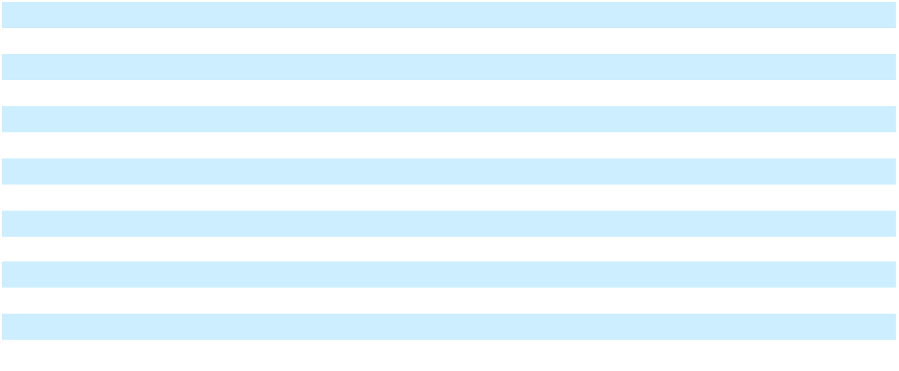

104

Table of Contents

GENERAL MOTORS COMPANY AND SUBSIDIARIES

Item 9. Changes in and Disagreements with Accountants on Accounting and Financial Disclosure

None.

* * * * * * *

Item 9A. Controls and Procedures

Disclosure Controls and Procedures We maintain disclosure controls and procedures designed to provide reasonable assurance that information required to be disclosed in reports filed under the Exchange Act is recorded, processed, summarized and reported within the specified time periods and accumulated and communicated to our management, including our principal executive officer and principal financial officer, as appropriate, to allow timely decisions regarding required disclosures.

Our management, with the participation of our CEO and CFO, evaluated the effectiveness of our disclosure controls and procedures (as defined in Rules 13a-15(e) or 15d-15(e) promulgated under the Exchange Act) as of December 31, 2024 as required by paragraph (b) of Rules 13a-15 or 15d-15. Based on this evaluation, our CEO and CFO concluded that our disclosure controls and procedures were effective as of December 31, 2024.

Management's Report on Internal Control over Financial Reporting Our management is responsible for establishing and maintaining effective internal control over financial reporting as defined in Rules 13a-15(f) and 15d-15(f) under the Exchange Act. This system is designed to provide reasonable assurance regarding the reliability of financial reporting and the preparation of consolidated financial statements for external purposes in accordance with U.S. GAAP. Because of the inherent limitations of internal control over financial reporting, including the possibility of collusion or improper management override of controls, misstatements due to error or fraud may not be prevented or detected on a timely basis.

Our management performed an assessment of the effectiveness of our internal control over financial reporting at December 31, 2024, utilizing the criteria discussed in the “Internal Control – Integrated Framework (2013)” issued by the Committee of Sponsoring Organizations of the Treadway Commission. The objective of this assessment was to determine whether our internal control over financial reporting was effective as of December 31, 2024. Based on management's assessment, we have concluded that our internal control over financial reporting was effective as of December 31, 2024.

The effectiveness of our internal control over financial reporting has been audited by Ernst & Young LLP (PCAOB ID: 42), an independent registered public accounting firm, as stated in its report included herein.

Changes in Internal Control over Financial Reporting There have not been any changes in our internal control over financial reporting during the three months ended December 31, 2024 that have materially affected, or are reasonably likely to materially affect, our internal control over financial reporting.

* * * * * * *

105

Table of Contents

GENERAL MOTORS COMPANY AND SUBSIDIARIES

Item 9B. Other Information

None.

* * * * * * *

Item 9C. Disclosure Regarding Foreign Jurisdictions that Prevent Inspections

Not applicable.

* * * * * * *

PART III

Items 10, 11, 12, 13 and 14

Information required by Items 10, 11, 12, 13 and 14 of this Form 10-K is incorporated by reference from our definitive Proxy Statement for our 2025 Annual Meeting of Stockholders, which will be filed with the SEC, pursuant to Regulation 14A, not later than 120 days after the end of the 2024 fiscal year, all of which information is hereby incorporated by reference in, and made part of, this Form 10-K, except disclosure of our executive officers, which is included in Part I, Item 1 of this report.

* * * * * * *

106

Table of Contents

GENERAL MOTORS COMPANY AND SUBSIDIARIES

PART IV

Item 15. Exhibit and Financial Statement Schedules

- 1. All Financial Statements and Supplemental Information

  - Financial Statement Schedules

All financial statement schedules are omitted as the required information is inapplicable or the information is presented in the consolidated financial statements and notes thereto in Item 8.
  - Exhibits

- Exhibits

Exhibit |  |  |  |  |  |  |  |  |  |  |  | Exhibit Name
Number
2.1 |  |  | Master Agreement, dated as of March 5, 2017, between General Motors Holdings LLC and Peugeot S.A., |  |  |  |  |  |  |  |  |  |  |  |  |  |  |  |  |  |  |  | Incorporated by
 |  |  | incorporated by reference to Exhibit 2.1 to the Quarterly Report on Form 10-Q of General Motors |  |  |  |  |  |  |  |  |  |  |  |  |  |  |  |  |  |  |  | Reference
 |  |  | Company filed April 28, 2017
3.1 |  |  | Restated Certificate of Incorporation of General Motors Company dated December 9, 2010, incorporated |  |  |  |  |  |  |  |  |  |  |  |  |  |  |  |  |  |  |  | Incorporated by
 |  |  | by reference to Exhibit 3.2 to the Current Report on Form 8-K of General Motors Company filed December |  |  |  |  |  |  |  |  |  |  |  |  |  |  |  |  |  |  |  | Reference
 |  |  | 13, 2010
3.2 |  |  | General Motors Company Amended and Restated Bylaws, as amended October 4, 2024, incorporated by |  |  |  |  |  |  |  |  |  |  |  |  |  |  |  |  |  |  |  | Incorporated by
 |  |  | reference to Exhibit 3.1 to the Current Report on Form 8-K of General Motors Company filed October 9, |  |  |  |  |  |  |  |  |  |  |  |  |  |  |  |  |  |  |  | Reference
 |  |  | 2024
4.1 |  |  | Description of Securities |  |  |  |  |  |  |  |  |  |  |  |  |  |  |  |  |  |  |  | Filed Herewith
4.2 |  |  | Indenture, dated as of September 27, 2013, between General Motors Company and the Bank of New York |  |  |  |  |  |  |  |  |  |  |  |  |  |  |  |  |  |  |  | Incorporated by
 |  |  | Mellon, as Trustee, incorporated by reference to Exhibit 4.2 to the Registration Statement on Form S-3 of |  |  |  |  |  |  |  |  |  |  |  |  |  |  |  |  |  |  |  | Reference
 |  |  | General Motors Company filed April 30, 2014
4.3 |  |  | First Supplemental Indenture, dated as of September 27, 2013 to the Indenture dated as of September 27, |  |  |  |  |  |  |  |  |  |  |  |  |  |  |  |  |  |  |  | Incorporated by
 |  |  | 2013 between General Motors Company and the Bank of New York Mellon, as Trustee, incorporated by |  |  |  |  |  |  |  |  |  |  |  |  |  |  |  |  |  |  |  | Reference
 |  |  | reference to Exhibit 4.3 to the Registration Statement on Form S-4 of General Motors Company filed May
 |  |  | 22, 2014
4.4 |  |  | Second Supplemental Indenture, dated as of November 12, 2014 to the Indenture dated as of September 27, |  |  |  |  |  |  |  |  |  |  |  |  |  |  |  |  |  |  |  | Incorporated by
 |  |  | 2013 between General Motors Company and the Bank of New York Mellon, as Trustee, incorporated by |  |  |  |  |  |  |  |  |  |  |  |  |  |  |  |  |  |  |  | Reference
 |  |  | reference to Exhibit 4.4 to the Current Report on Form 8-K of General Motors Company filed November
 |  |  | 12, 2014
4.5 |  |  | Third Supplemental Indenture, dated as of February 23, 2016, to the Indenture, dated as of September 27, |  |  |  |  |  |  |  |  |  |  |  |  |  |  |  |  |  |  |  | Incorporated by
 |  |  | 2013, between General Motors Company, as issuer, and The Bank of New York Mellon, as Trustee, |  |  |  |  |  |  |  |  |  |  |  |  |  |  |  |  |  |  |  | Reference
 |  |  | incorporated by reference to Exhibit 4.1 to the Current Report on Form 8-K of General Motors Company
 |  |  | filed February 23, 2016
4.6 |  |  | Fourth Supplemental Indenture, dated as of August 7, 2017, to the Indenture, dated as of September 27, |  |  |  |  |  |  |  |  |  |  |  |  |  |  |  |  |  |  |  | Incorporated by
 |  |  | 2013, between General Motors Company, as issuer, and The Bank of New York Mellon, as Trustee, |  |  |  |  |  |  |  |  |  |  |  |  |  |  |  |  |  |  |  | Reference
 |  |  | incorporated by reference to Exhibit 4.1 to the Current Report on Form 8-K of General Motors Company
 |  |  | filed August 8, 2017
4.7 |  |  | Fifth Supplemental Indenture, dated as of September 10, 2018, to the Indenture, dated as of September 27, |  |  |  |  |  |  |  |  |  |  |  |  |  |  |  |  |  |  |  | Incorporated by
 |  |  | 2013, between General Motors Company, as issuer, and The Bank of New York Mellon, as Trustee, |  |  |  |  |  |  |  |  |  |  |  |  |  |  |  |  |  |  |  | Reference
 |  |  | incorporated by reference to Exhibit 4.2 to the Current Report on Form 8-K of General Motors Company
 |  |  | filed September 10, 2018
4.8 |  |  | Sixth Supplemental Indenture, dated as of May 12, 2020, to the Indenture. dated as of September 27, 2013, |  |  |  |  |  |  |  |  |  |  |  |  |  |  |  |  |  |  |  | Incorporated by
 |  |  | between General Motors Company, as issuer, and The Bank of New York Mellon, as Trustee, incorporated |  |  |  |  |  |  |  |  |  |  |  |  |  |  |  |  |  |  |  | Reference
 |  |  | by reference to Exhibit 4.2 to the Current Report on Form 8-K of General Motors Company filed May 12,
 |  |  | 2020
4.9 |  |  | Seventh Supplemental Indenture, dated as of August 2, 2022, to the Indenture. dated as of September 27, |  |  |  |  |  |  |  |  |  |  |  |  |  |  |  |  |  |  |  | Incorporated by
 |  |  | 2013, between General Motors Company, as issuer, and The Bank of New York Mellon, as Trustee, |  |  |  |  |  |  |  |  |  |  |  |  |  |  |  |  |  |  |  | Reference
 |  |  | incorporated by reference to Exhibit 4.2 to the Current Report on Form 8-K of General Motors Company
 |  |  | filed August 2, 2022
4.10 |  |  | Calculation Agency Agreement, dated as of September 10, 2018 between General Motors Company and |  |  |  |  |  |  |  |  |  |  |  |  |  |  |  |  |  |  |  | Incorporated by
 |  |  | the Bank of New York Mellon, as calculation agent, incorporated by reference to Exhibit 4.3 to the Current |  |  |  |  |  |  |  |  |  |  |  |  |  |  |  |  |  |  |  | Reference
 |  |  | Report on Form 8-K of General Motors Company filed September 10, 2018
10.1* |  |  | Form of Compensation Statement, incorporated by reference to Exhibit 10.14 to the Annual Report on |  |  |  |  |  |  |  |  |  |  |  |  |  |  |  |  |  |  |  | Incorporated by
 |  |  | Form 10-K of General Motors Company filed April 7, 2010 |  |  |  |  |  |  |  |  |  |  |  |  |  |  |  |  |  |  |  | Reference
10.2* |  |  | General Motors Company Executive Retirement Plan, with modifications through October 10, 2012, |  |  |  |  |  |  |  |  |  |  |  |  |  |  |  |  |  |  |  | Incorporated by
 |  |  | incorporated by reference to Exhibit 10.12 to the Annual Report on Form 10-K of General Motors |  |  |  |  |  |  |  |  |  |  |  |  |  |  |  |  |  |  |  | Reference
 |  |  | Company filed February 15, 2013
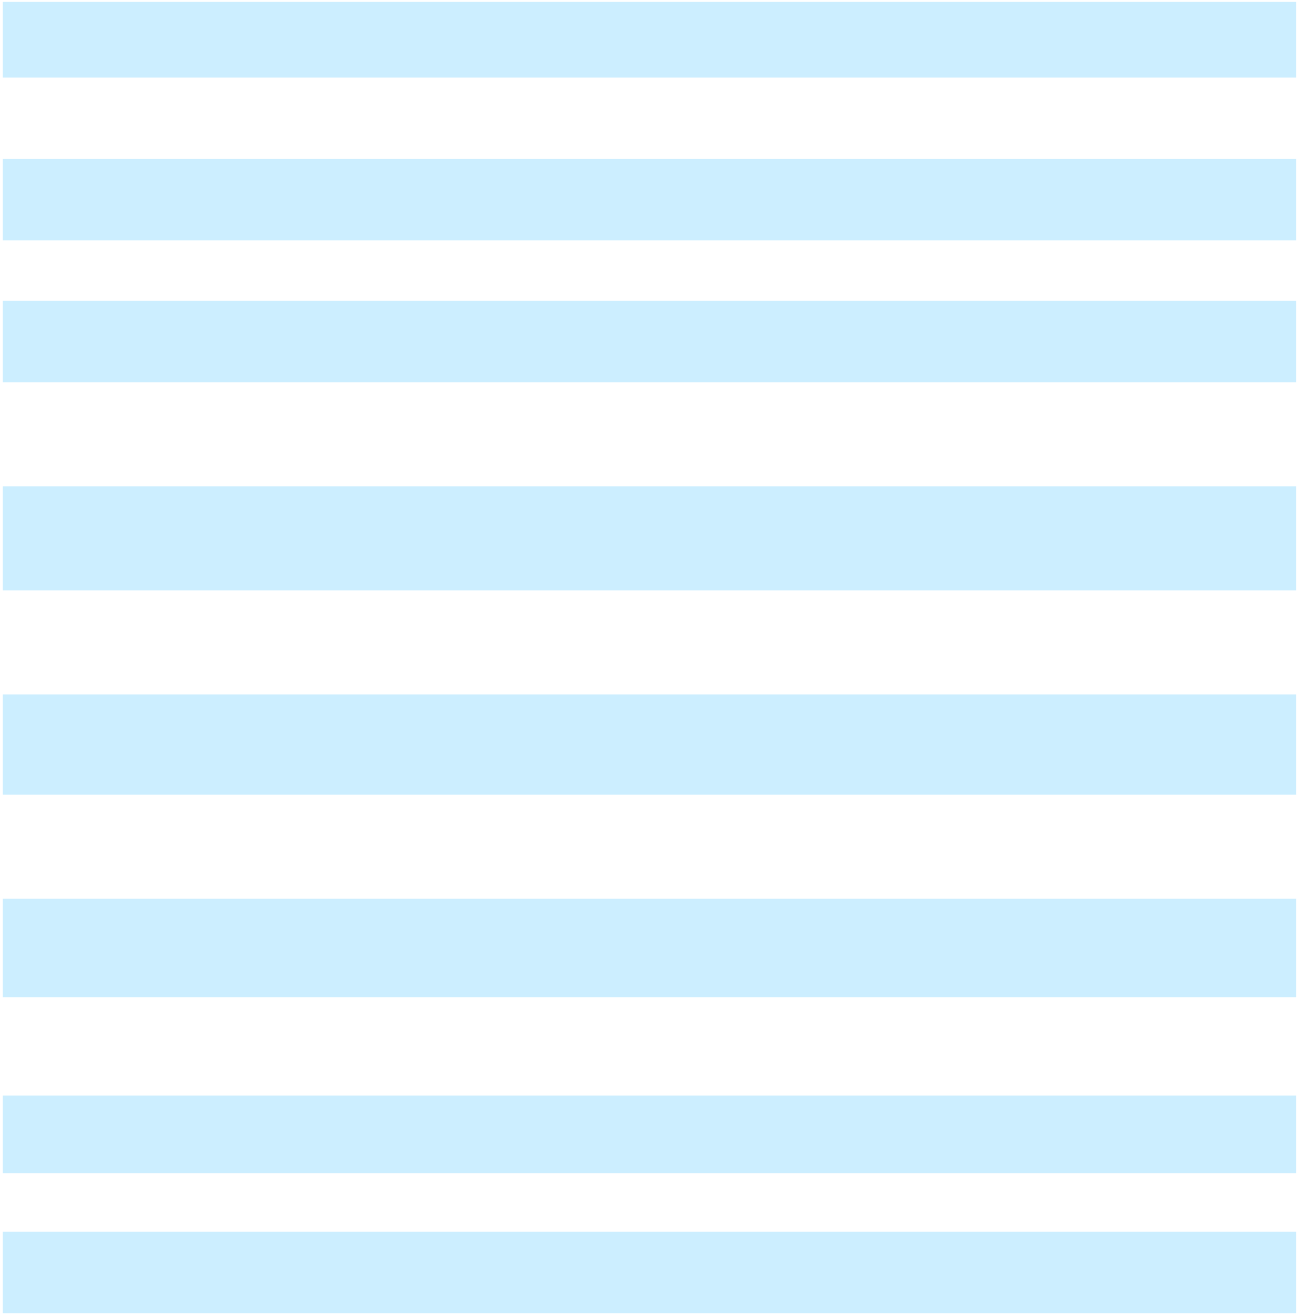

107

Table of Contents

GENERAL MOTORS COMPANY AND SUBSIDIARIES

Exhibit
Number

10.3*

10.4*

10.5*

10.6*

10.7*

10.8*

10.9*

10.10*

10.11*

10.12*

10.13*

10.14*

10.15*

10.16*

10.17*

10.18*

10.19*

10.20*

10.21*

10.22*

10.23*

10.24*

Exhibit Name

Amendment No. 1 to General Motors Company Executive Retirement Plan, with modifications through October 10, 2012, incorporated by reference to Exhibit 10.2 to the Current Report on Form 8-K of General Motors Company filed February 3, 2016
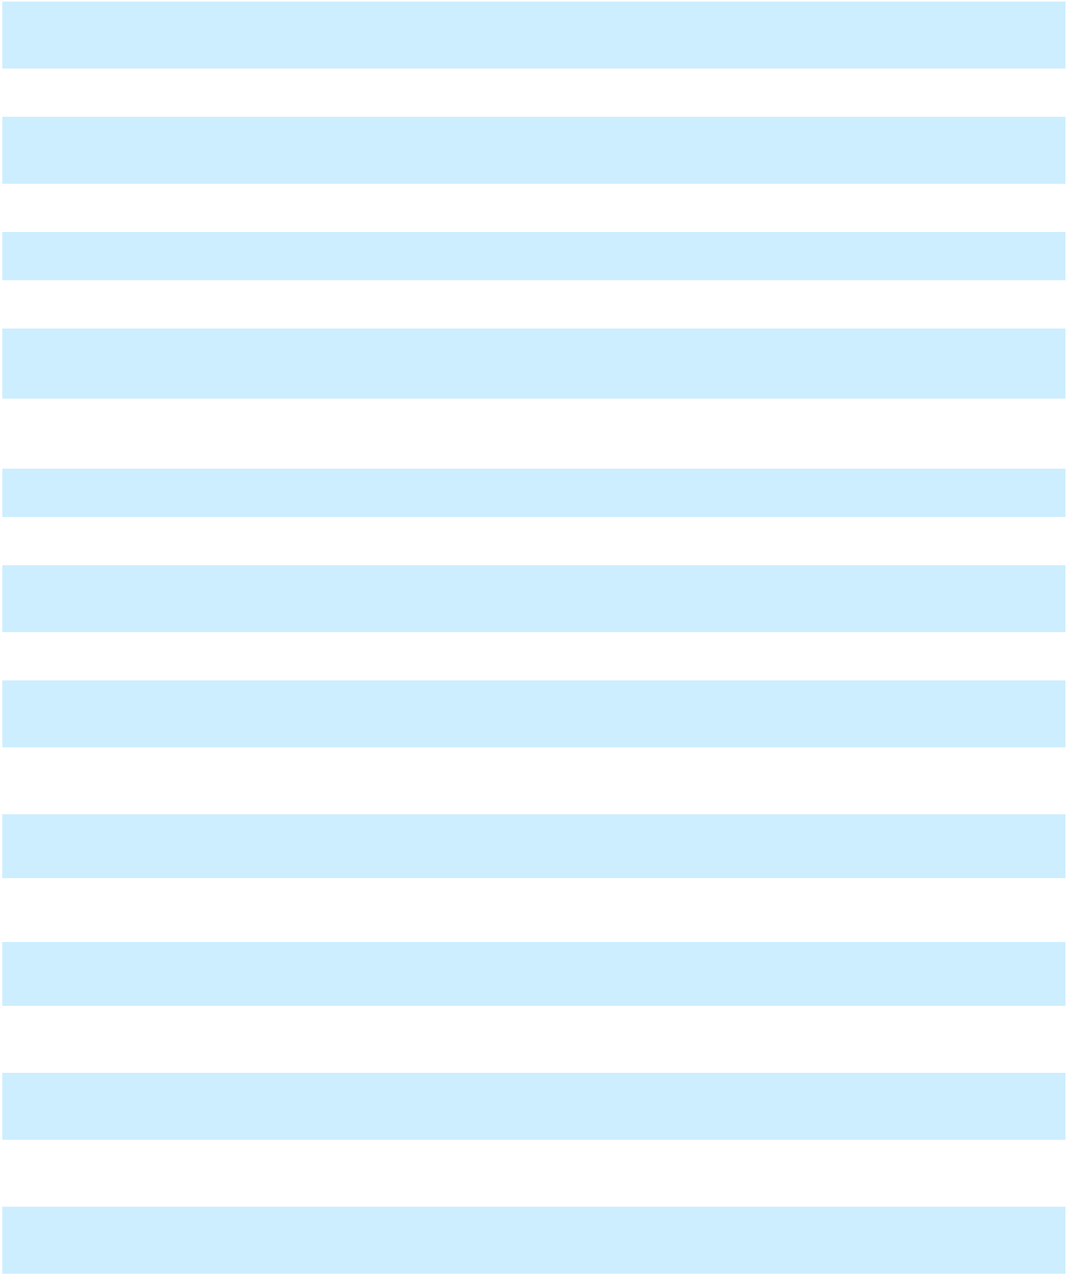

General Motors Company Vehicle Operations - Senior Management Vehicle Program (SMVP) Supplement, revised December 15, 2005, incorporated by reference to Exhibit 10(g) to the Annual Report on Form 10-K of Motors Liquidation Company filed March 28, 2006

General Motors Company 2014 Long-Term Incentive Plan, incorporated by reference to Exhibit 10.1 to the Current Report on Form 8-K of General Motors Company filed June 12, 2014

Form of Non-Qualified Stock Option Agreement under the 2014 Long-Term Incentive Plan, incorporated by reference to Exhibit 10.1 to the Current Report on Form 8-K of General Motors Company filed July 30, 2015

Form of Director and Officer Indemnification Agreement, incorporated by reference to Exhibit 10.6 to the Quarterly Report on Form 10-Q of General Motors Company filed April 21, 2016

General Motors Company 2017 Short-Term Incentive Plan, incorporated by reference to Exhibit 10.25 to the Annual Report on Form 10-K of General Motors Company filed February 6, 2018

General Motors Company 2017 Long-Term Incentive Plan, incorporated by reference to Exhibit 4.1 to the Registration Statement on Form S-8 of General Motors Company filed June 16, 2017

Form of Non-Qualified Stock Option Award Agreement No. 1 under the General Motors Company 2017 Long-Term Incentive Plan, incorporated by reference to Exhibit 10.2 to the Quarterly Report on Form 10-Q of General Motors Company filed April 26, 2018

Form of Non-Qualified Stock Option Award Agreement No. 2 under the General Motors Company 2017 Long-Term Incentive Plan, incorporated by reference to Exhibit 10.2 to the Quarterly Report on Form 10-Q of General Motors Company filed May 6, 2020

Amended and Restated General Motors LLC U.S. Executive Severance Program, incorporated by reference to Exhibit 10.23 to the Annual Report on Form 10-K of General Motors Company filed February 6, 2019

Form of Time Sharing Agreement, incorporated by reference to Exhibit 10.2 to the Quarterly Report on Form 10-Q of General Motors Company filed October 29, 2019

The General Motors Company Deferred Compensation Plan for Non-Employee Directors, incorporated by reference to Exhibit 10.19 to the Annual Report on Form 10-K of General Motors Company filed February 5, 2020

General Motors Company 2020 Long-Term Incentive Plan, incorporated by reference to Exhibit 4.1 to the Registration Statement on Form S-8 of General Motors Company filed June 25, 2020

Amendment No. 1 to the General Motors Company 2020 Long-Term Incentive Plan, incorporated by reference to Appendix B of the Definitive Proxy Statement of General Motors Company filed April 28, 2023

Form of Performance Share Unit Award Agreement No.1 under the General Motors Company 2020 Long-Term Incentive Plan, incorporated by reference to Exhibit 10.1 to the Quarterly Report on Form 10-Q of General Motors Company filed May 5, 2021

Form of Performance Share Unit Award Agreement No.3 under the General Motors Company 2020 Long-Term Incentive Plan, incorporated by reference to Exhibit 10.1 to the Quarterly Report on Form 10-Q of General Motors Company, filed April 27, 2022

Form of Non-Qualified Stock Option Award Agreement No. 1 under the General Motors Company 2020
Long- Term Incentive Plan, incorporated by reference to Exhibit 10.2 to the Quarterly Report on Form 10-

Q of General Motors Company filed May 5, 2021

Form of Non-Qualified Stock Option Award Agreement No.2 under the General Motors Company 2020 Long-Term Incentive Plan incorporated by reference to Exhibit 10.2 to the Quarterly Report on Form 10-Q of General Motors Company, filed April 27, 2022

Form of Restricted Stock Unit Award Agreement No. 2 under the General Motors Company 2020 Long-Term Incentive Plan, incorporated by reference to Exhibit 10.1 to the Quarterly Report on Form 10-Q of General Motors Company, filed October 24, 2023

Form of Restricted Stock Unit Award Agreement No. 3 under the General Motors Company 2020 Long-Term Incentive Plan, incorporated by reference to Exhibit 10.24 to the Annual Report on Form 10-K of General Motors Company, filed January 30, 2024

Form of Restricted Stock Unit Award Agreement No. 4 under the General Motors Company 2020 Long-Term Incentive Plan, incorporated by reference to Exhibit 10.1 to the Quarterly Report on Form 10-Q of General Motors Company, filed April 23, 2024

Form of Performance Stock Unit Award Agreement No. 4 under the General Motors Company 2020 Long-Term Incentive Plan, incorporated by reference to Exhibit 10.2 to the Quarterly Report on Form 10-Q of General Motors Company, filed April 23, 2024

Incorporated by Reference

Incorporated by Reference

Incorporated by Reference

Incorporated by Reference

Incorporated by Reference

Incorporated by Reference

Incorporated by Reference

Incorporated by Reference

Incorporated by Reference

Incorporated by Reference

Incorporated by Reference

Incorporated by Reference

Incorporated by Reference

Incorporated by Reference

Incorporated by Reference

Incorporated by Reference

Incorporated by Reference

Incorporated by Reference

Incorporated by Reference

Incorporated by Reference

Incorporated by Reference

Incorporated by Reference

108

Table of Contents

GENERAL MOTORS COMPANY AND SUBSIDIARIES

Exhibit |  |  |  |  |  |  | Exhibit Name
Number
10.25* |  |  | Senior Advisor Consulting Agreement between General Motors LLC and Michael Abbott, incorporated by
 |  |  | reference to Exhibit 10.1 to the Quarterly Report on Form 10-Q of General Motors Company, filed July 23,
 |  |  | 2024
10.26* |  |  | Amended Senior Advisor Consulting Agreement between General Motors LLC and Michael Abbott,
 |  |  | incorporated by reference to Exhibit 10.1 to the Quarterly Report on Form 10-Q of General Motors
 |  |  | Company, filed October 22, 2024
10.27† |  |  | Fourth Amended and Restated 5-Year Revolving Credit Agreement among General Motors Company,
 |  |  | General Motors Financial Company, Inc., the subsidiary borrowers from time to time parties thereto, the
 |  |  | several lenders from time to time parties thereto, JPMorgan Chase Bank, N.A., as administrative agent, and
 |  |  | Citibank, N.A., as syndication agent, incorporated by reference to Exhibit 10.1 to the Current Report on
 |  |  | Form 8-K of General Motors Company filed March 31, 2023
10.28† |  |  | Fifth Amended and Restated 3-Year Revolving Credit Agreement among General Motors Company,
 |  |  | General Motors Financial Company, Inc., the subsidiary borrowers from time to time parties thereto, the
 |  |  | several lenders from time to time parties thereto, JPMorgan Chase Bank, N.A., as administrative agent, and
 |  |  | Citibank, N.A., as syndication agent, incorporated by reference to Exhibit 10.2 to the Current Report on
 |  |  | Form 8-K of General Motors Company filed March 31, 2023
10.29† |  |  | Fifth Amended and Restated 364-Day Revolving Credit Agreement among General Motors Company,
 |  |  | General Motors Financial Company, Inc., the subsidiary borrowers from time to time parties thereto, the
 |  |  | several lenders from time to time parties thereto, JPMorgan Chase Bank, N.A., as administrative agent, and
 |  |  | Citibank, N.A., as syndication agent, incorporated by reference to Exhibit 10.3 to the Current Report on
 |  |  | Form 8-K of General Motors Company filed March 31, 2023
10.30† |  |  | Sixth Amended and Restated 364-Day Revolving Credit Agreement among General Motors Company,
 |  |  | General Motors Financial Company, Inc., the subsidiary borrowers from time to time parties thereto, the
 |  |  | several lenders from time to time parties thereto, JPMorgan Chase Bank, N.A., as administrative agent,
 |  |  | Citibank, N.A., as syndication agent, and Bank of America, N.A., as co-syndication agent, incorporated by
 |  |  | reference to Exhibit 10.1 to the Current Report on Form 8-K of General Motors Company filed March 28,
 |  |  | 2024
10.31 |  |  | Eighth Amended and Restated Limited Liability Company Agreement of GM Cruise Holdings LLC, dated
 |  |  | March 18, 2022, incorporated by reference to Exhibit 10.2 to the Quarterly Report on Form 10-Q of
 |  |  | General Motors Company filed July 26, 2022
10.32 |  |  | Form of Master Confirmation - Uncollared Accelerated Share Repurchase, dated November 29, 2023,
 |  |  | incorporated by reference to Exhibit 10.1 to the Current Report on Form 8-K of General Motors Company
 |  |  | filed November 29, 2023
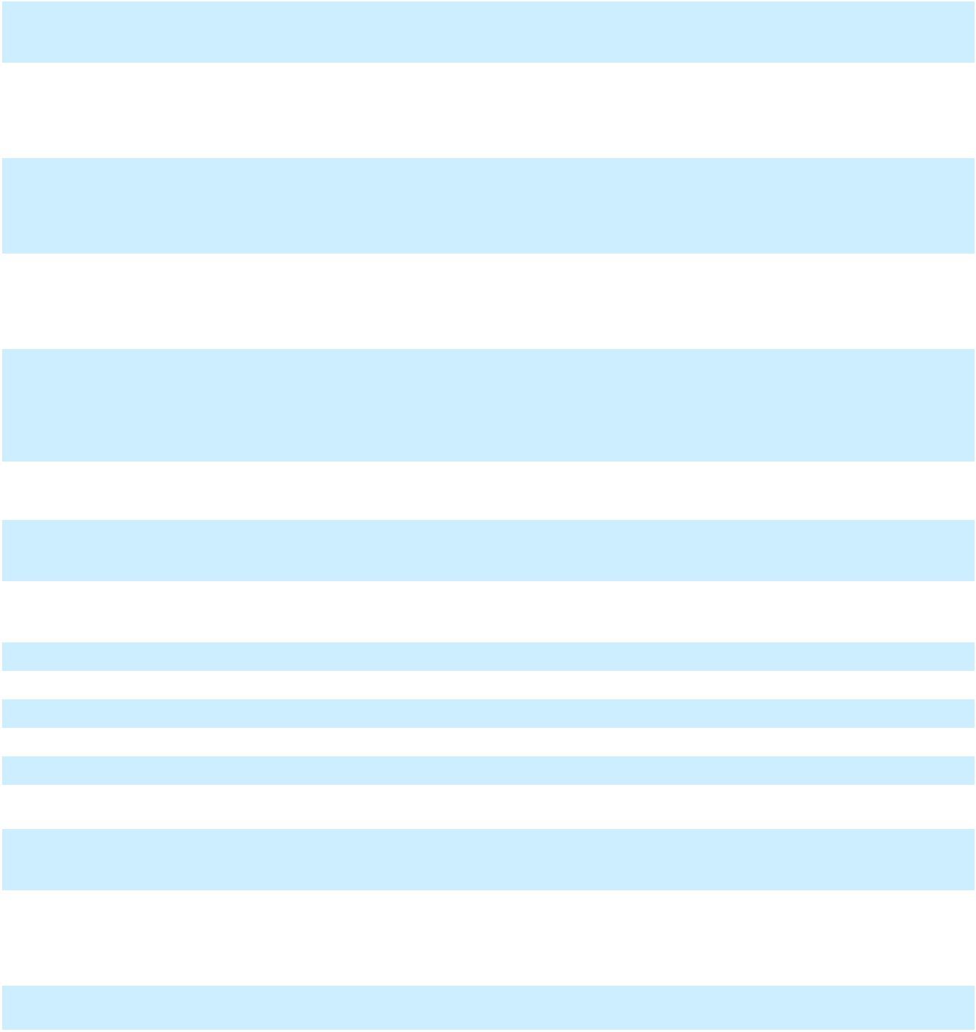

- General Motors Company Amended and Restated Insider Trading Policy, dated March 9, 2023, incorporated by reference to Exhibit 19 to the Annual Report on Form 10-K of General Motors Company, filed January 30, 2024

- Subsidiaries and Joint Ventures of the Registrant as of December 31, 2024

- Consent of Ernst & Young LLP

- Power of Attorney for Directors of General Motors Company

31.1 | Section 302 | Certification of the Chief Executive Officer
31.2 | Section 302 | Certification of the Chief Financial Officer

- Certification Pursuant to 18 U.S.C. Section 1350, As Adopted Pursuant to Section 906 of the Sarbanes-Oxley Act of 2002

- General Motors Company Amended and Restated Policy on Recoupment of Incentive Compensation, dated August 14, 2023, incorporated by reference to Exhibit 97 to the Annual Report on Form 10-K of General Motors Company filed January 30, 2024

- The following financial information from the Company’s Annual Report on Form 10-K for the year ended December 31, 2024 formatted in Inline Extensible Business Reporting Language (iXBRL) includes: (i) the Consolidated Income Statements, (ii) the Consolidated Statements of Comprehensive Income, (iii) the Consolidated Balance Sheets, (iv) the Consolidated Statements of Cash Flows, (v) the Consolidated Statements of Equity and (vi) Notes to the Consolidated Financial Statements

- The cover page from the Company's Annual Report on Form 10-K for the year ended December 31, 2024, formatted as Inline XBRL and contained in Exhibit 101

Incorporated by Reference

Incorporated by Reference

Incorporated by Reference

Incorporated by Reference

Incorporated by Reference

Incorporated by Reference

Incorporated by Reference

Incorporated by Reference

Incorporated by Reference

Filed Herewith Filed Herewith Filed Herewith Filed Herewith Filed Herewith

Furnished with this Report

Incorporated by Reference

Filed Herewith

Filed Herewith

__________

- Portions of this exhibit have been omitted pursuant to Rule 601(b)(10) of Regulation S-K. The omitted information is not material and would likely cause competitive harm to the registrant if publicly disclosed.

- Management contracts and compensatory plans and arrangements required to be filed as exhibits pursuant to Item 15(b) of this Report.

* * * * * * *

109

Table of Contents

GENERAL MOTORS COMPANY AND SUBSIDIARIES

Item 16. Form 10-K Summary

None.

* * * * * * *

110

Table of Contents

GENERAL MOTORS COMPANY AND SUBSIDIARIES

SIGNATURES

Pursuant to the requirements of Section 13 or 15(d) of the Securities Exchange Act of 1934, the registrant has duly caused this report to be signed on its behalf by the undersigned, thereunto duly authorized.

GENERAL MOTORS COMPANY

(Registrant)

By: /s/ MARY T. BARRA

Mary T. Barra
Chair and Chief Executive Officer

Date: January 28, 2025

111

Table of Contents

GENERAL MOTORS COMPANY AND SUBSIDIARIES

Pursuant to the requirements of the Securities Exchange Act of 1934, this report has been signed below on this 28th day of January 2025 by the following persons on behalf of the registrant and in the capacities indicated, including a majority of the directors.

Signature

/s/ MARY T. BARRA

Mary T. Barra

Title

Chair and Chief Executive Officer

/s/ PAUL A. JACOBSON |  | Executive Vice President and Chief Financial Officer
Paul A. Jacobson
/s/ CHRISTOPHER T. HATTO |  | Vice President, Global Business Solutions and Chief
Christopher T. Hatto |  | Accounting Officer
/s/ PATRICIA F. RUSSO* |  | Independent Lead Director
Patricia F. Russo
/s/ WESLEY G. BUSH* |  | Director
Wesley G. Bush
/s/ JOANNE C. CREVOISERAT* |  | Director
Joanne C. Crevoiserat
/s/ LINDA R. GOODEN* |  | Director
Linda R. Gooden
/s/ JOSEPH JIMENEZ* |  | Director
Joseph Jimenez
/s/ ALFRED F. KELLY JR.* |  | Director
Alfred F. Kelly Jr.
/s/ JONATHAN MCNEILL* |  | Director
Jonathan McNeill
/s/ JUDITH A. MISCIK* |  | Director
Judith A. Miscik
/s/ THOMAS M. SCHOEWE* |  | Director
Thomas M. Schoewe
/s/ MARK A. TATUM* |  | Director
Mark A. Tatum
/s/ JAN E. TIGHE* |  | Director
Jan E. Tighe
/s/ DEVIN N. WENIG* |  | Director
Devin N. Wenig
 | *By: /s/ GRANT DIXTON
 |  | Grant Dixton
 |  | Attorney-in-Fact

112

[THIS PAGE INTENTIONALLY LEFT BLANK]

