UNITED STATES SECURITIES AND EXCHANGE COMMISSION

Washington, DC 20549

___________________

FORM 8-K

___________________

CURRENT REPORT

Pursuant to Section 13 or 15(d) of

the Securities Exchange Act of 1934

Date of Report (Date of earliest event reported): February 1, 2022

___________________

GENERAL MOTORS COMPANY

(Exact name of registrant as specified in its charter)

__________________

Delaware

001-34960

27-0756180

(State or other jurisdiction of incorporation)

(Commission File Number)

(I.R.S. Employer Identification No.)

300 Renaissance Center, Detroit, Michigan

(Address of principal executive offices)

48265 -3000

(Zip Code)

(313) 667-1500

(Registrant's telephone number, including area code)

Not Applicable

(Former name or former address, if changed since last report)

__________________

Check the appropriate box below if the Form 8-K filing is intended to simultaneously satisfy the filing obligation of the registrant under any of the following provisions:

- Written communications pursuant to Rule 425 under the Securities Act (17 CFR 230.425)

- Soliciting material pursuant to Rule 14a-12 under the Exchange Act (17 CFR 240.14a-12)

- Pre-commencement communications pursuant to Rule 14d-2(b) under the Exchange Act (17 CFR 240.14d-2(b))

- Pre-commencement communications pursuant to Rule 13e-4(c) under the Exchange Act (17 CFR 240.13e-4(c))

 |  |  | Securities registered pursuant to Section 12(b) of the Act:
 | Title of each class |  |  | Trading Symbol(s) |  | Name of each exchange on which registered
Common Stock, $0.01 par value |  |  |  | GM |  |  | New York Stock Exchange

Indicate by check mark whether the registrant is an emerging growth company as defined in Rule 405 of the Securities Act of 1933 (§230.405 of this chapter) or Rule 12b-2 of the Securities Exchange Act of 1934 (§240.12b-2 of this chapter). Emerging growth company ☐

If an emerging growth company, indicate by check mark if the registrant has elected not to use the extended transition period for complying with any new or revised financial accounting standards provided pursuant to Section 13(a) of the Exchange Act. ☐

ITEM 2.02 Results of Operations and Financial Condition

On February 1, 2022 General Motors Company (GM) issued a news release and supplemental materials on the subject of its 2021 fourth quarter and full year consolidated earnings. The news release and supplemental materials are attached as Exhibit 99.1 and Exhibit 99.2.

Charts furnished to securities analysts in connection with GM's 2021 fourth quarter and full year consolidated earnings release are available on GM's website at www.gm.com/investors/earnings-releases.html.

ITEM 9.01 Financial Statements and Exhibits

 |  |  |  |  |  | EXHIBIT
 | Exhibit |  | Description
 | Exhibit 99.1 |  | News Release Dated February 1, 2022
 | Exhibit 99.2 |  | Financial Highlights Dated February 1, 2022
 | Exhibit 104 |  | Cover Page Interactive Data File (embedded within the Inline XBRL document)

SIGNATURE

Pursuant to the requirements of the Securities Exchange Act of 1934, the registrant has duly caused this report to be signed on its behalf by the undersigned hereunto duly authorized.

 | GENERAL MOTORS COMPANY (Registrant)
By: | /s/ CHRISTOPHER T. HATTO
Date: February 1, 2022 | Christopher T. Hatto, Vice President, Global Business Solutions and Chief Accounting
 | Officer

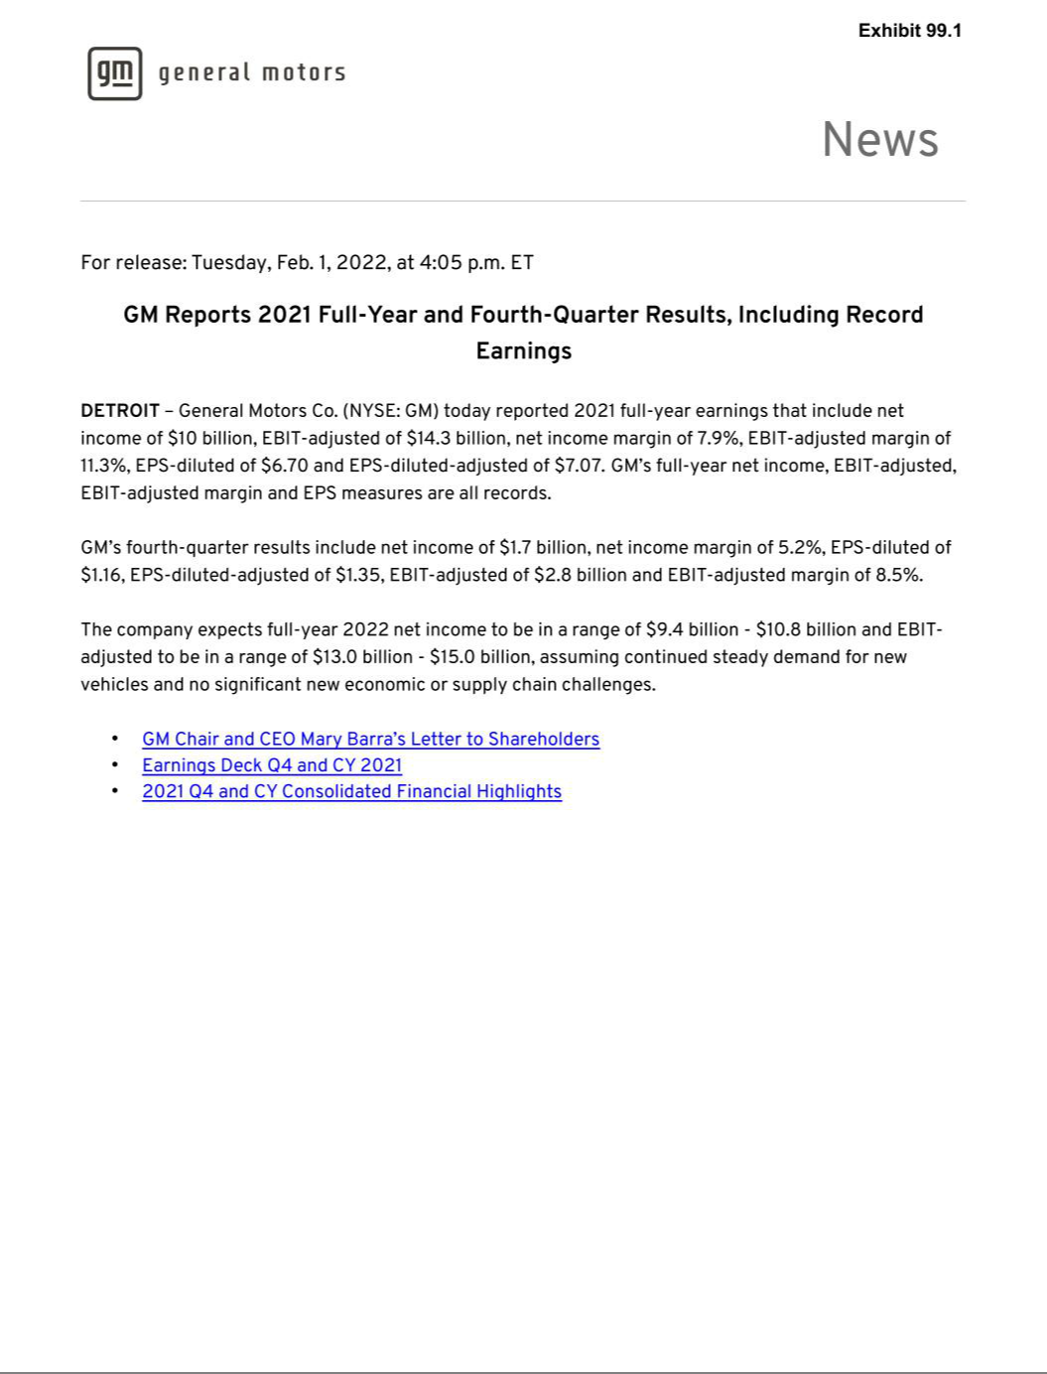

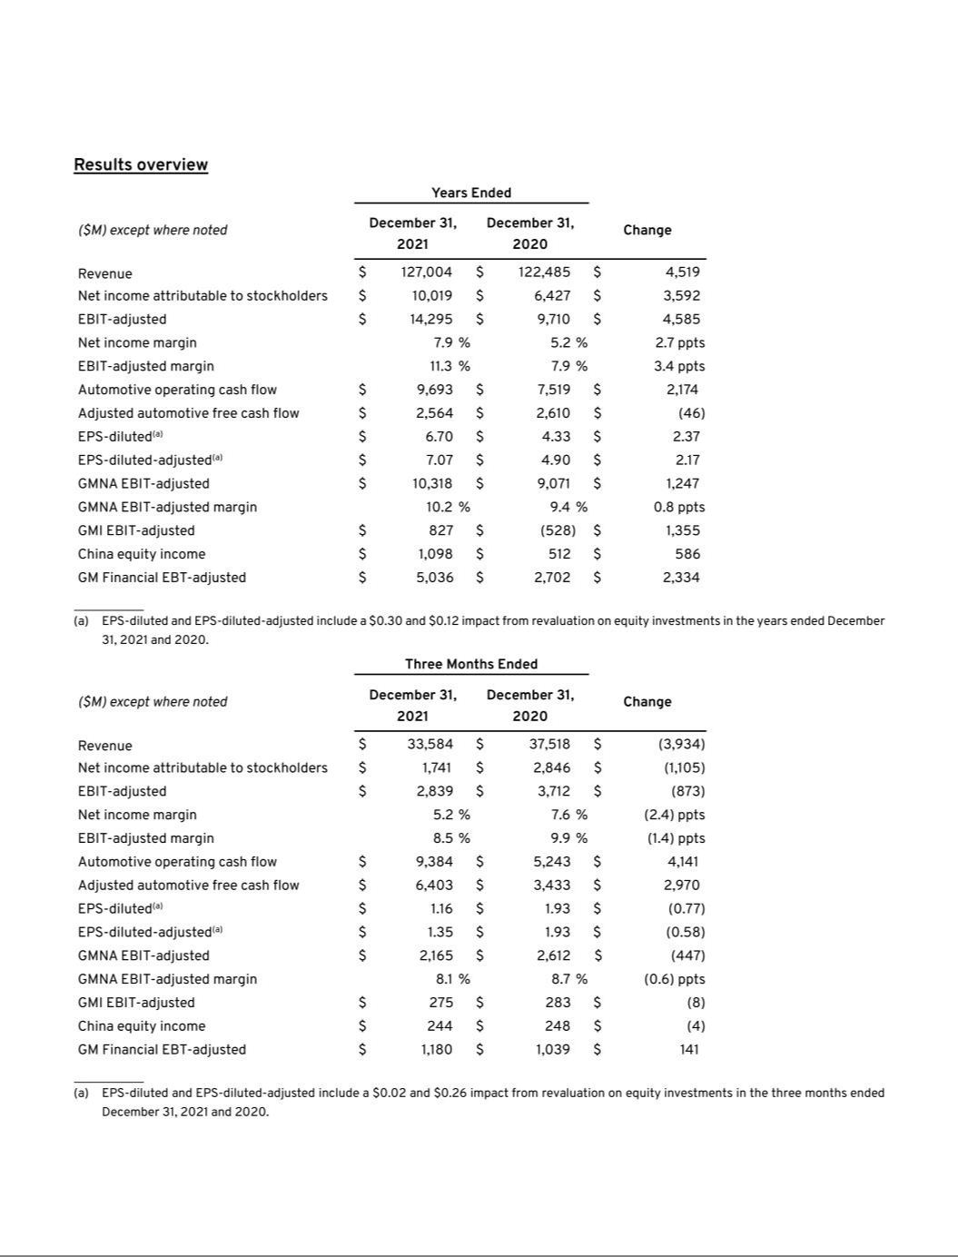

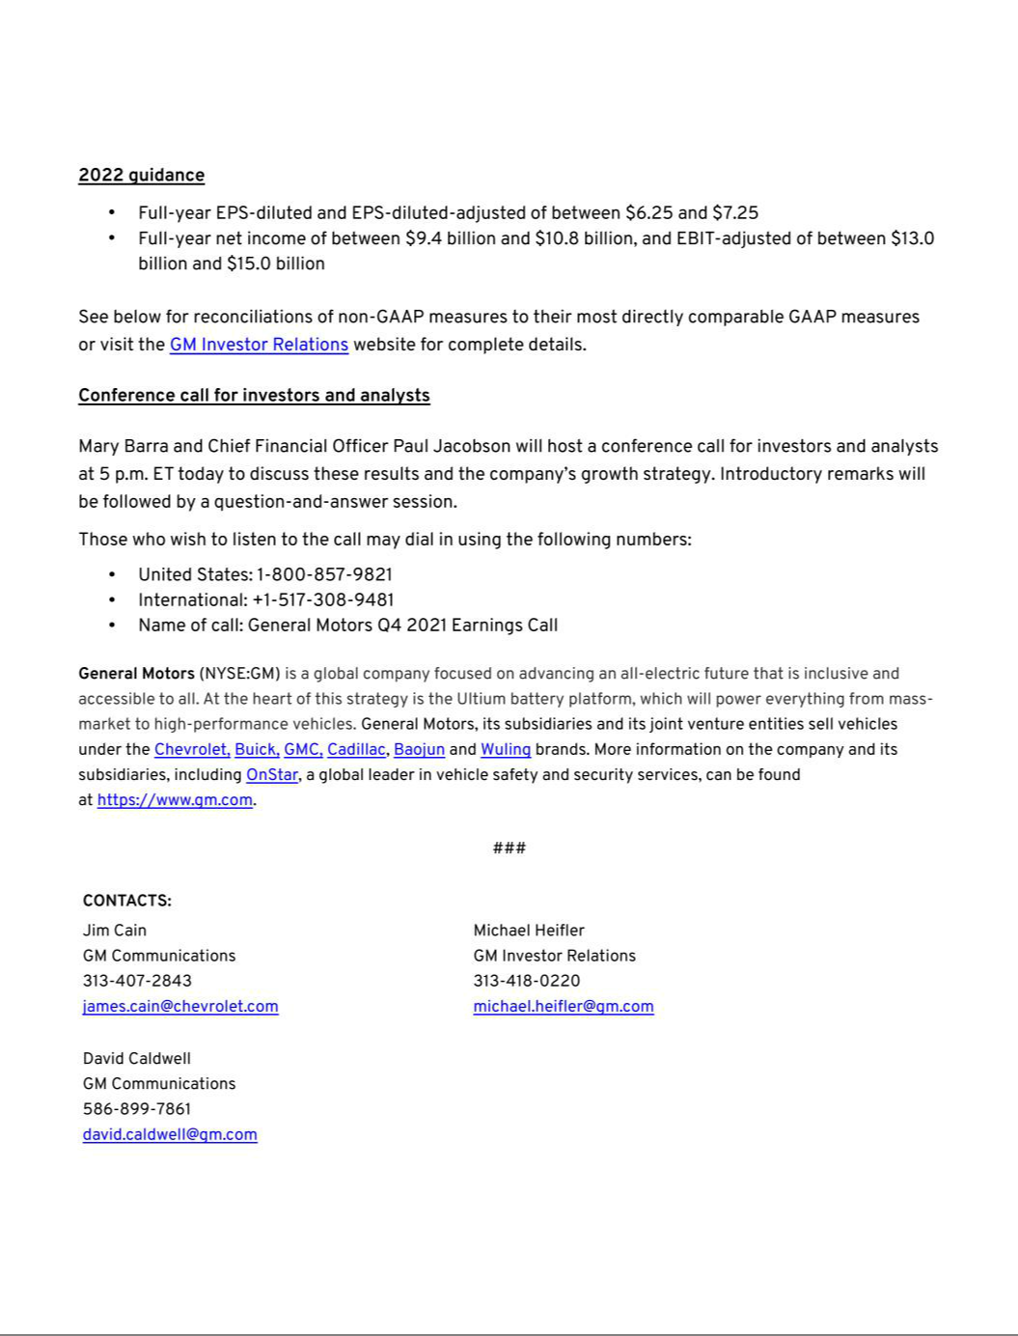

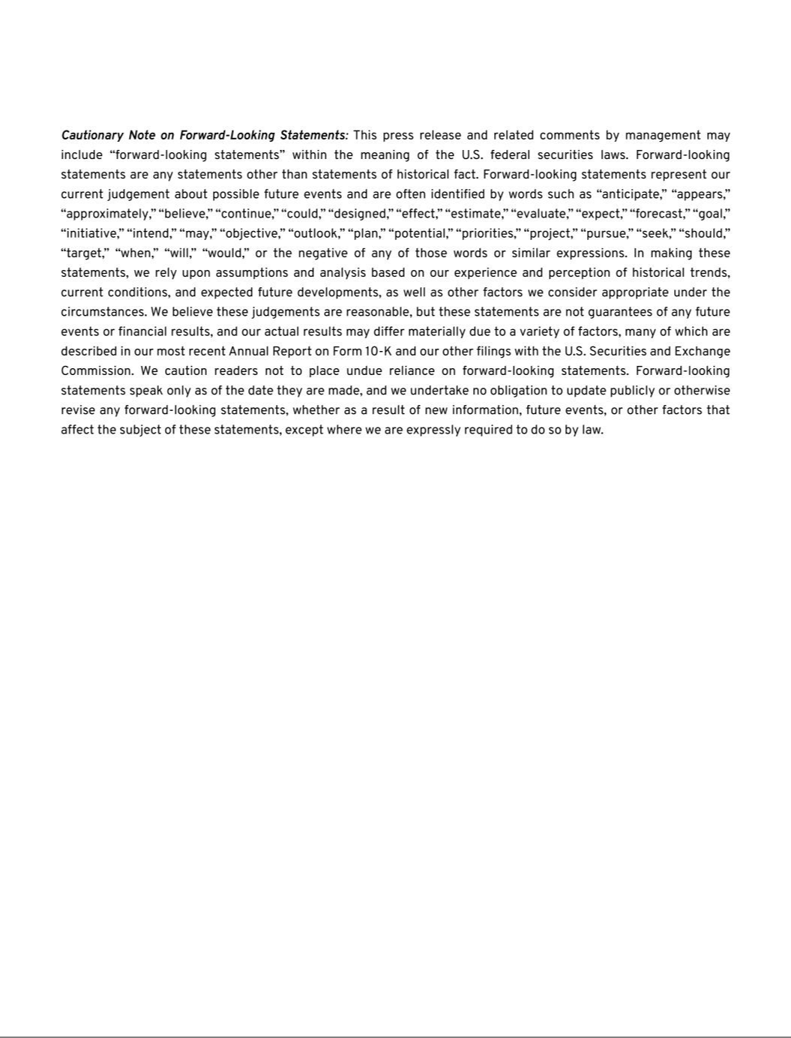

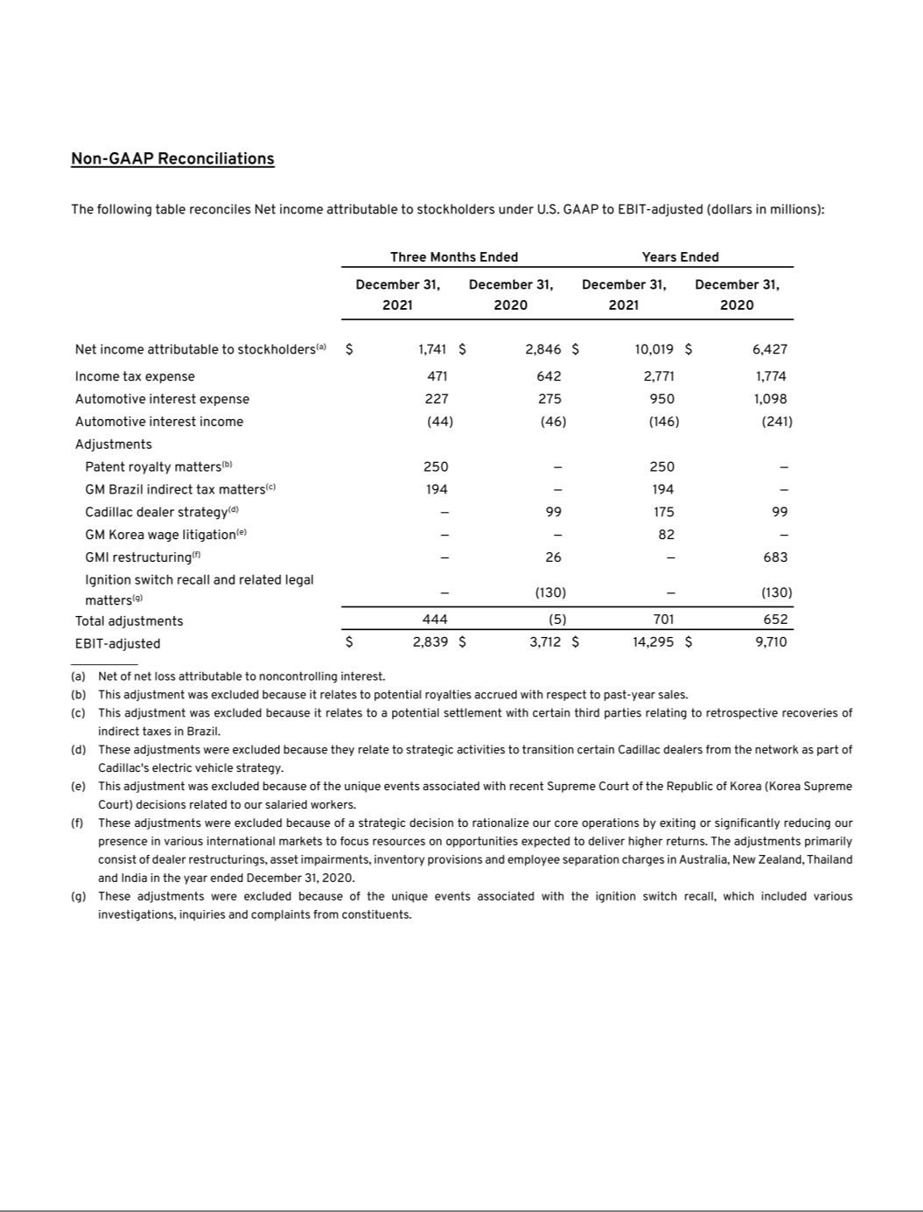

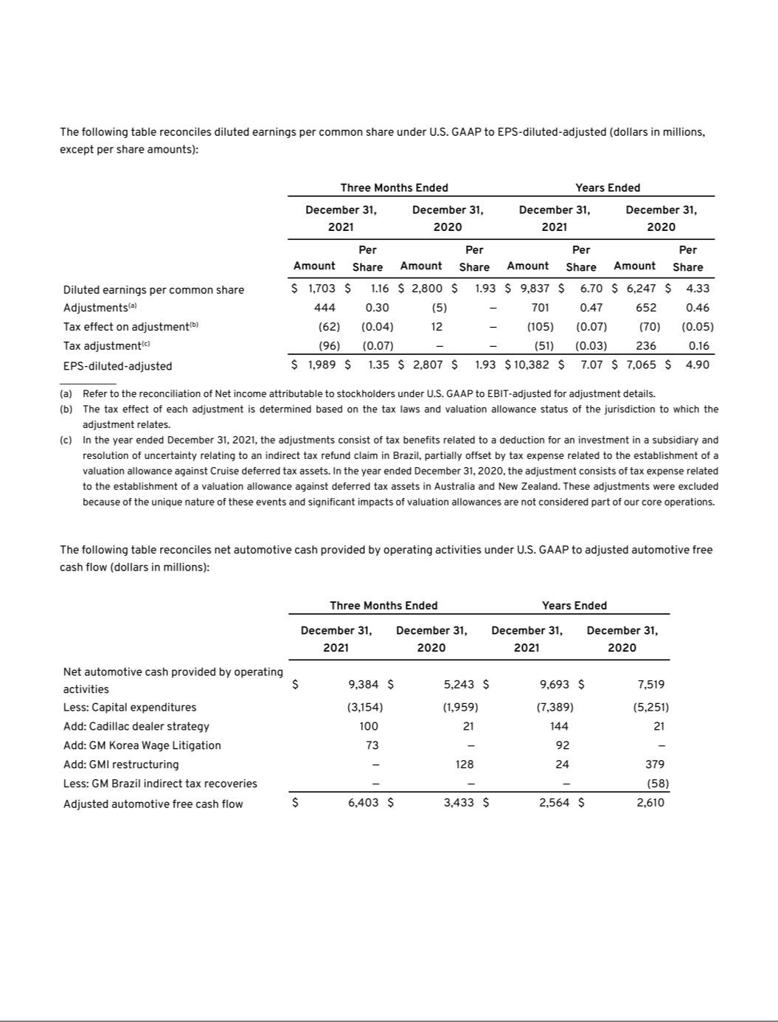

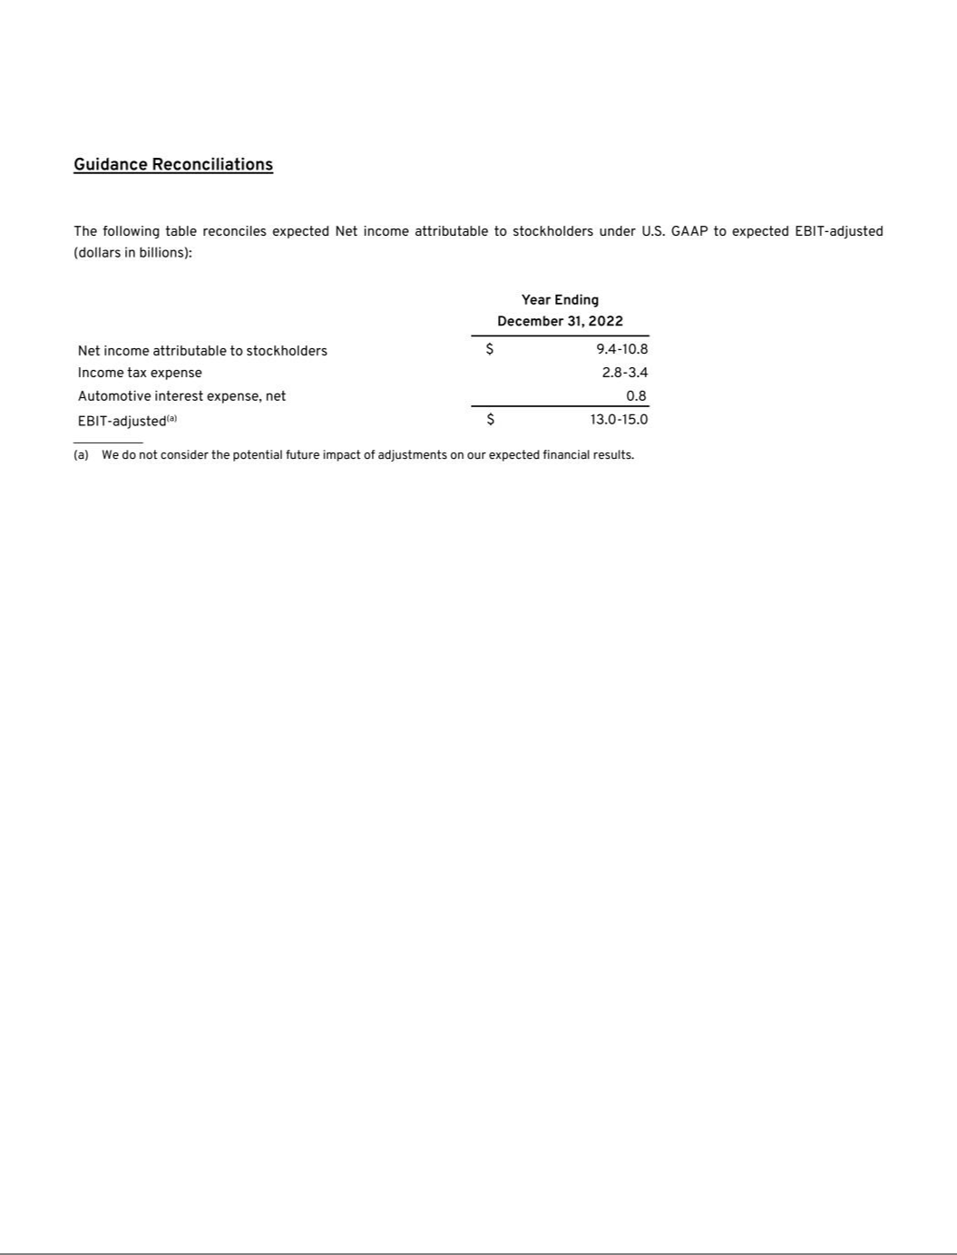

Exhibit 99.2

General Motors Company and Subsidiaries

Supplemental Material
(Unaudited)

General Motors Company's (GM) non-GAAP measures include: earnings before interest and taxes (EBIT)-adjusted, presented net of noncontrolling interests; earnings before income taxes (EBT)-adjusted for our General Motors Financial Company, Inc. (GM Financial) segment; earnings per share (EPS)-diluted-adjusted; effective tax rate-adjusted (ETR-adjusted); return on invested capital-adjusted (ROIC-adjusted) and adjusted automotive free cash flow. GM's calculation of these non-GAAP measures may not be comparable to similarly titled measures of other companies due to potential differences between companies in the method of calculation. As a result, the use of these non-GAAP measures has limitations and should not be considered superior to, in isolation from, or as a substitute for, related U.S. GAAP measures.

These non-GAAP measures allow management and investors to view operating trends, perform analytical comparisons and benchmark performance between periods and among geographic regions to understand operating performance without regard to items we do not consider a component of our core operating performance. Furthermore, these non-GAAP measures allow investors the opportunity to measure and monitor our performance against our externally communicated targets and evaluate the investment decisions being made by management to improve ROIC-adjusted. Management uses these measures in its financial, investment and operational decision-making processes, for internal reporting and as part of its forecasting and budgeting processes. Further, our Board of Directors uses certain of these and other measures as key metrics to determine management performance under our performance-based compensation plans. For these reasons, we believe these non-GAAP measures are useful for our investors.

EBIT-adjusted EBIT-adjusted is presented net of noncontrolling interests and is used by management and can be used by investors to review our consolidated operating results because it excludes automotive interest income, automotive interest expense and income taxes as well as certain additional adjustments that are not considered part of our core operations. Examples of adjustments to EBIT include, but are not limited to, impairment charges on long-lived assets and other exit costs resulting from strategic shifts in our operations or discrete market and business conditions; costs arising from the ignition switch recall and related legal matters; and certain currency devaluations associated with hyperinflationary economies. For EBIT-adjusted and our other non-GAAP measures, once we have made an adjustment in the current period for an item, we will also adjust the related non-GAAP measure in any future periods in which there is an impact from the item. Our corresponding measure for our GM Financial segment is EBT-adjusted because interest income and interest expense are part of operating results when assessing and measuring the operational and financial performance of the segment.

EPS-diluted-adjusted EPS-diluted-adjusted is used by management and can be used by investors to review our consolidated diluted EPS results on a consistent basis. EPS-diluted-adjusted is calculated as net income attributable to common stockholders-diluted less adjustments noted above for EBIT-adjusted and certain income tax adjustments divided by weighted-average common shares outstanding-diluted. Examples of income tax adjustments include the establishment or reversal of significant deferred tax asset valuation allowances.

ETR-adjusted ETR-adjusted is used by management and can be used by investors to review the consolidated effective tax rate for our core operations on a consistent basis. ETR-adjusted is calculated as Income tax expense less the income tax related to the adjustments noted above for EBIT-adjusted and the income tax adjustments noted above for EPS-diluted-adjusted divided by Income before income taxes less adjustments. When we provide an expected adjusted effective tax rate, we do not provide an expected effective tax rate because the U.S. GAAP measure may include significant adjustments that are difficult to predict.

ROIC-adjusted ROIC-adjusted is used by management and can be used by investors to review our investment and capital allocation decisions. We define ROIC-adjusted as EBIT-adjusted for the trailing four quarters divided by ROIC-adjusted average net assets, which is considered to be the average equity balances adjusted for average automotive debt and interest liabilities, exclusive of finance leases; average automotive net pension and other postretirement benefits (OPEB) liabilities; and average automotive net income tax assets during the same period.

Adjusted automotive free cash flow Adjusted automotive free cash flow is used by management and can be used by investors to review the liquidity of our automotive operations and to measure and monitor our performance against our capital allocation program and evaluate our automotive liquidity against the substantial cash requirements of our automotive operations. We measure adjusted automotive free cash flow as automotive operating cash flow from operations less capital expenditures adjusted for management actions. Management actions can include voluntary events such as discretionary contributions to employee benefit plans or nonrecurring specific events such as a closure of a facility that are considered special for EBIT-adjusted purposes.

1

General Motors Company and Subsidiaries

Supplemental Material
(Unaudited)

The following table reconciles Net income attributable to stockholders under U.S. GAAP to segment profit (loss) (dollars in millions):

 |  | Three Months Ended |  |  |  |  |  | Years Ended
 |  | December 31, 2021 |  |  | December 31, 2020 |  |  | December 31, 2021 |  |  | December 31, 2020
Net income attributable to stockholders(a) | $ | 1,741 |  | $ | 2,846 |  | $ | 10,019 |  | $ | 6,427
Income tax expense |  | 471 |  |  | 642 |  |  | 2,771 |  |  | 1,774
Automotive interest expense |  | 227 |  |  | 275 |  |  | 950 |  |  | 1,098
Automotive interest income |  | (44) |  |  | (46) |  |  | (146) |  |  | (241)
Adjustments
Patent royalty matters(b) |  | 250 |  |  | — |  |  | 250 |  |  | —
GM Brazil indirect tax matters(c) |  | 194 |  |  | — |  |  | 194 |  |  | —
Cadillac dealer strategy(d) |  | — |  |  | 99 |  |  | 175 |  |  | 99
GM Korea wage litigation(e) |  | — |  |  | — |  |  | 82 |  |  | —
GMI restructuring(f) |  | — |  |  | 26 |  |  | — |  |  | 683
Ignition switch recall and related legal matters(g) |  | — |  |  | (130) |  |  | — |  |  | (130)
Total adjustments |  | 444 |  |  | (5) |  |  | 701 |  |  | 652
EBIT-adjusted |  | 2,839 |  |  | 3,712 |  |  | 14,295 |  |  | 9,710
Operating segments
GM North America (GMNA) |  | 2,165 |  |  | 2,612 |  |  | 10,318 |  |  | 9,071
GM International (GMI) |  | 275 |  |  | 283 |  |  | 827 |  |  | (528)
Cruise |  | (349) |  |  | (260) |  |  | (1,196) |  |  | (887)
GM Financial(h) |  | 1,180 |  |  | 1,039 |  |  | 5,036 |  |  | 2,702
Total operating segments |  | 3,271 |  |  | 3,674 |  |  | 14,985 |  |  | 10,358
Corporate and eliminations(i) |  | (432) |  |  | 38 |  |  | (690) |  |  | (648)
EBIT-adjusted | $ | 2,839 |  | $ | 3,712 |  | $ | 14,295 |  | $ | 9,710

__________

- Net of net loss attributable to noncontrolling interests.
- This adjustment was excluded because it relates to potential royalties accrued with respect to past-year sales.
- This adjustment was excluded because it relates to a potential settlement with certain third parties relating to retrospective recoveries of indirect taxes in Brazil.
- These adjustments were excluded because they relate to strategic activities to transition certain Cadillac dealers from the network as part of Cadillac's electric vehicle strategy.
- This adjustment was excluded because of the unique events associated with recent Supreme Court of the Republic of Korea (Korea Supreme Court) decisions related to our salaried workers.
- These adjustments were excluded because of a strategic decision to rationalize our core operations by exiting or significantly reducing our presence in various international markets to focus resources on opportunities expected to deliver higher returns. The adjustments primarily consist of dealer restructurings, asset impairments, inventory provisions and employee separation charges in Australia, New Zealand, Thailand and India in the year ended December 31, 2020.
- These adjustments were excluded because of the unique events associated with the ignition switch recall, which included various investigations, inquiries and complaints from constituents.
- GM Financial amounts represent EBT-adjusted.
- GM's automotive interest income and interest expense, legacy costs from the Opel and Vauxhall businesses and certain other assets in Europe, which are primarily pension costs, corporate expenditures and certain nonsegment-specific revenues and expenses are recorded centrally in Corporate.

2

General Motors Company and Subsidiaries

Supplemental Material
(Unaudited)

The following table reconciles Net income attributable to stockholders under U.S. GAAP to EBIT-adjusted (dollars in millions):

 |  |  |  |  | Years Ended December 31,
 | 2021 |  |  |  | 2020 |  |  | 2019
Net income attributable to stockholders | $ | 10,019 |  | $ | 6,427 |  | $ | 6,732
Income tax expense |  | 2,771 |  |  | 1,774 |  |  | 769
Automotive interest expense |  | 950 |  |  | 1,098 |  |  | 782
Automotive interest income |  | (146) |  |  | (241) |  |  | (429)
Adjustments
Patent royalty matters(a) |  | 250 |  |  | — |  |  | —
GM Brazil indirect tax matters(b) |  | 194 |  |  | — |  |  | (1,360)
Cadillac dealer strategy(c) |  | 175 |  |  | 99 |  |  | —
GM Korea wage litigation(d) |  | 82 |  |  | — |  |  | —
GMI restructuring(e) |  | — |  |  | 683 |  |  | —
Ignition switch recall and related legal matters(f) |  | — |  |  | (130) |  |  | —
Transformation activities(g) |  | — |  |  | — |  |  | 1,735
FAW-GM divestiture(h) |  | — |  |  | — |  |  | 164
Total adjustments |  | 701 |  |  | 652 |  |  | 539
EBIT-adjusted | $ | 14,295 |  | $ | 9,710 |  | $ | 8,393

__________

- This adjustment was excluded because it relates to potential royalties accrued with respect to past-year sales.
- These adjustments were excluded because of the unique events associated with decisions rendered by the Superior Judicial Court of Brazil resulting in retrospective recoveries of indirect taxes in the year ended December 31, 2019, and a potential settlement with certain third parties relating to these recoveries in the year ended December 31, 2021.
- These adjustments were excluded because they relate to strategic activities to transition certain Cadillac dealers from the network as part of Cadillac's electric vehicle strategy.
- This adjustment was excluded because of the unique events associated with recent Korea Supreme Court decisions related to our salaried workers.
- These adjustments were excluded because of a strategic decision to rationalize our core operations by exiting or significantly reducing our presence in various international markets to focus resources on opportunities expected to deliver higher returns. The adjustments primarily consist of dealer restructurings, asset impairments, inventory provisions and employee separation charges in Australia, New Zealand, Thailand and India in the year ended December 31, 2020.
- These adjustments were excluded because of the unique events associated with the ignition switch recall, which included various investigations, inquiries and complaints from constituents.
- These adjustments were excluded because of a strategic decision to accelerate our transformation for the future to strengthen our core business, capitalize on the future of personal mobility, and drive significant cost efficiencies. The adjustments primarily consist of accelerated depreciation, supplier-related charges, pension and other curtailment charges and employee-related separation charges in the year ended December 31, 2019.

- This adjustment was excluded because we divested our joint venture FAW-GM Light Duty Commercial Vehicle Co., Ltd. (FAW-GM), as a result of a strategic decision by both shareholders, allowing us to focus our resources on opportunities expected to deliver higher returns.

3

General Motors Company and Subsidiaries

Supplemental Material
(Unaudited)

The following table reconciles diluted earnings per common share under U.S. GAAP to EPS-diluted-adjusted (dollars in millions, except per share amounts):

 |  |  |  |  | Three Months Ended |  |  |  |  |  |  |  |  |  |  |  | Years Ended
 |  | December 31, 2021 |  |  |  |  |  | December 31, 2020 |  |  |  |  |  | December 31, 2021 |  |  |  |  |  | December 31, 2020
 |  | Amount |  |  | Per Share |  |  | Amount |  |  | Per Share |  |  | Amount |  |  | Per Share |  |  | Amount |  |  | Per Share
Diluted earnings per common share | $ | 1,703 |  | $ | 1.16 |  | $ | 2,800 |  | $ | 1.93 |  | $ | 9,837 |  | $ | 6.70 |  | $ | 6,247 |  | $ | 4.33
Adjustments(a) |  | 444 |  |  | 0.30 |  |  | (5) |  |  | — |  |  | 701 |  |  | 0.47 |  |  | 652 |  |  | 0.46
Tax effect on adjustments(b) |  | (62) |  |  | (0.04) |  |  | 12 |  |  | — |  |  | (105) |  |  | (0.07) |  |  | (70) |  |  | (0.05)
Tax adjustments(c) |  | (96) |  |  | (0.07) |  |  | — |  |  | — |  |  | (51) |  |  | (0.03) |  |  | 236 |  |  | 0.16
EPS-diluted-adjusted | $ | 1,989 |  | $ | 1.35 |  | $ | 2,807 |  | $ | 1.93 |  | $ | 10,382 |  | $ | 7.07 |  | $ | 7,065 |  | $ | 4.90

________

- Refer to the reconciliation of Net income attributable to stockholders under U.S. GAAP to segment profit (loss) for adjustment details.
- The tax effect of each adjustment is determined based on the tax laws and valuation allowance status of the jurisdiction to which the adjustment relates.

- In the year ended December 31, 2021, the adjustments consist of tax benefits related to a deduction for an investment in a subsidiary and resolution of uncertainty relating to an indirect tax refund claim in Brazil, partially offset by tax expense related to the establishment of a valuation allowance against Cruise deferred tax assets. In the year ended December 31, 2020, the adjustment consists of tax expense related to the establishment of a valuation allowance against deferred tax assets in Australia and New Zealand. These adjustments were excluded because of the unique nature of these events and significant impacts of valuation allowances are not considered part of our core operations.

The following table reconciles our effective tax rate under U.S. GAAP to ETR-adjusted (dollars in millions):

 |  |  |  |  |  |  | Years Ended December 31,
 |  |  |  |  | 2021 |  |  |  |  |  |  |  | 2020
 | Income before income |  |  |  | Income tax |  | Effective tax rate |  | Income before income |  |  |  | Income tax |  | Effective tax rate
 |  | taxes |  |  | expense |  | Effective tax rate |  | taxes |  |  |  | expense |  | Effective tax rate
Effective tax rate | $ | 12,716 |  | $ | 2,771 | 21.8 % |  |  | $ | 8,095 |  | $ | 1,774 | 21.9 %
Adjustments(a) |  | 726 |  |  | 105 |  |  |  |  | 652 |  |  | 70
Tax adjustments(b) |  |  |  |  | 51 |  |  |  |  |  |  |  | (236)
ETR-adjusted | $ | 13,442 |  | $ | 2,927 | 21.8 % |  |  | $ | 8,747 |  | $ | 1,608 | 18.4 %

________

- Refer to the reconciliation of Net income attributable to stockholders under U.S. GAAP to segment profit (loss) for adjustment details. Net income attributable to noncontrolling interests for these adjustments is included in the years ended December 31, 2021. The tax effect of each adjustment is determined based on the tax laws and valuation allowance status of the jurisdiction to which the adjustment relates.
- Refer to the reconciliation of diluted earnings (loss) per common share under U.S. GAAP to EPS-diluted-adjusted within the previous section for adjustment details.

We define return on equity (ROE) as Net income (loss) attributable to stockholders for the trailing four quarters divided by average equity for the same period. Management uses average equity to provide comparable amounts in the calculation of ROE. The following table summarizes the calculation of ROE (dollars in billions):

 | Years Ended December 31,
 | 2021 |  |  | 2020
Net income (loss) attributable to stockholders | $ | 10.0 |  | $ | 6.4
Average equity(a) | $ | 56.5 |  | $ | 43.3
ROE |  | 17.7 % |  |  | 14.9 %

________

- Includes equity of noncontrolling interests where the corresponding earnings (loss) are included in Net income (loss) attributable to stockholders.

4

General Motors Company and Subsidiaries

Supplemental Material
(Unaudited)

The following table summarizes the calculation of ROIC-adjusted (dollars in billions):

 | Years Ended December 31,
 | 2021 |  |  | 2020
EBIT-adjusted(a) | $ | 14.3 |  | $ | 9.7
Average equity(b) | $ | 56.5 |  | $ | 43.3
Add: Average automotive debt and interest liabilities (excluding finance leases) |  | 17.1 |  |  | 27.8
Add: Average automotive net pension & OPEB liability |  | 15.8 |  |  | 17.6
Less: Average automotive net income tax asset |  | (22.2) |  |  | (24.0)
ROIC-adjusted average net assets | $ | 67.2 |  | $ | 64.7
ROIC-adjusted |  | 21.3 % |  |  | 15.0 %

________

- Refer to the reconciliation of Net income attributable to stockholders under U.S. GAAP to segment profit (loss) for adjustment details.
- Includes equity of noncontrolling interests where the corresponding earnings (loss) are included in EBIT-adjusted.

5

General Motors Company and Subsidiaries

Supplemental Material
(Unaudited)

The following table reconciles Net automotive cash provided by operating activities under U.S. GAAP to adjusted automotive free cash flow (dollars in millions):

 |  |  | Three Months Ended |  |  |  |  |  | Years Ended
 |  |  | December 31, 2021 |  |  | December 31, 2020 |  |  | December 31, 2021 |  |  | December 31, 2020
Net automotive cash provided by operating activities | $ |  | 9,384 |  | $ | 5,243 |  | $ | 9,693 |  | $ | 7,519
Less: Capital expenditures |  |  | (3,154) |  |  | (1,959) |  |  | (7,389) |  |  | (5,251)
Add: Cadillac dealer strategy |  |  | 100 |  |  | 21 |  |  | 144 |  |  | 21
Add: GM Korea Wage Litigation |  |  | 73 |  |  | — |  |  | 92 |  |  | —
Add: GMI restructuring |  |  | — |  |  | 128 |  |  | 24 |  |  | 379
Less: GM Brazil indirect tax recoveries |  |  | — |  |  | — |  |  | — |  |  | (58)
Adjusted automotive free cash flow | $ |  | 6,403 |  | $ | 3,433 |  | $ | 2,564 |  | $ | 2,610
 | 6

General Motors Company and Subsidiaries

Supplemental Material
(Unaudited)

The following tables summarize key financial information by segment (dollars in millions):

 |  | GMNA |  |  | GMI |  |  | Corporate |  |  | Eliminations |  |  | Total |  |  | Cruise |  |  | GM |  | Reclassifications/Eliminations |  |  |  | Total
 |  |  |  |  |  |  |  |  |  |  |  |  |  | Automotive |  |  |  |  |  | Financial |  |  |  |  |  | Total
Three Months Ended December 31, 2021
Net sales and revenue | $ | 26,865 |  | $ | 3,451 |  | $ | 37 |  |  |  |  | $ | 30,353 |  | $ | 25 |  | $ | 3,232 |  | $ | (26) |  | $ | 33,584
Expenditures for property | $ | 2,716 |  | $ | 421 |  | $ | 17 |  | $ | — |  | $ | 3,154 |  | $ | 34 |  | $ | 6 |  | $ | 5 |  | $ | 3,199
Depreciation and amortization | $ | 1,449 |  | $ | 135 |  | $ | 5 |  | $ | — |  | $ | 1,589 |  | $ | 15 |  | $ | 1,333 |  | $ | — |  | $ | 2,937
Impairment charges | $ | — |  | $ | — |  | $ | — |  | $ | — |  | $ | — |  | $ | — |  | $ | — |  | $ | — |  | $ | —
Equity income(a) | $ | — |  | $ | 242 |  | $ | — |  | $ | — |  | $ | 242 |  | $ | — |  | $ | 44 |  | $ | — |  | $ | 286
 |  | GMNA |  |  | GMI |  |  | Corporate |  |  | Eliminations |  |  | Total |  |  | Cruise |  |  | GM |  | Reclassifications/Eliminations |  |  |  | Total
 |  |  |  |  |  |  |  |  |  |  |  |  |  | Automotive |  |  |  |  |  | Financial |  |  |  |  |  | Total
Three Months Ended December 31, 2020
Net sales and revenue | $ | 30,170 |  | $ | 3,894 |  | $ | 29 |  |  |  |  | $ | 34,093 |  | $ | 24 |  | $ | 3,426 |  | $ | (25) |  | $ | 37,518
Expenditures for property | $ | 1,798 |  | $ | 155 |  | $ | 6 |  | $ | — |  | $ | 1,959 |  | $ | 5 |  | $ | 8 |  | $ | — |  | $ | 1,972
Depreciation and amortization | $ | 1,203 |  | $ | 163 |  | $ | 5 |  | $ | — |  | $ | 1,371 |  | $ | 13 |  | $ | 1,678 |  | $ | — |  | $ | 3,062
Impairment charges | $ | — |  | $ | (2) |  | $ | — |  | $ | — |  | $ | (2) |  | $ | 20 |  | $ | — |  | $ | — |  | $ | 18
Equity income(a) | $ | 2 |  | $ | 249 |  | $ | — |  | $ | — |  | $ | 251 |  | $ | — |  | $ | 34 |  | $ | — |  | $ | 285
 |  | GMNA |  |  | GMI |  |  | Corporate |  |  | Eliminations |  |  | Total |  |  | Cruise |  |  | GM |  | Reclassifications/Eliminations |  |  |  | Total
 |  |  |  |  |  |  |  |  |  |  |  |  |  | Automotive |  |  |  |  |  | Financial |  |  |  |  |  | Total
Year Ended December 31, 2021
Net sales and revenue | $ | 101,308 |  | $ | 12,172 |  | $ | 104 |  |  |  |  | $ | 113,584 |  | $ | 106 |  | $ | 13,419 |  | $ | (105) |  | $ | 127,004
Expenditures for property | $ | 6,576 |  | $ | 783 |  | $ | 30 |  | $ | — |  | $ | 7,389 |  | $ | 89 |  | $ | 26 |  | $ | 5 |  | $ | 7,509
Depreciation and amortization | $ | 5,298 |  | $ | 542 |  | $ | 21 |  | $ | — |  | $ | 5,861 |  | $ | 52 |  | $ | 6,134 |  | $ | — |  | $ | 12,047
Impairment charges | $ | — |  | $ | — |  | $ | — |  | $ | — |  | $ | — |  | $ | 4 |  | $ | — |  | $ | — |  | $ | 4
Equity income(a) | $ | 8 |  | $ | 1,092 |  | $ | — |  | $ | — |  | $ | 1,100 |  | $ | — |  | $ | 201 |  | $ | — |  | $ | 1,301
 |  | GMNA |  |  | GMI |  |  | Corporate |  |  | Eliminations |  |  | Total |  |  | Cruise |  |  | GM |  | Reclassifications/Eliminations |  |  |  | Total
 |  |  |  |  |  |  |  |  |  |  |  |  |  | Automotive |  |  |  |  |  | Financial |  |  |  |  |  | Total
Year Ended December 31, 2020
Net sales and revenue | $ | 96,733 |  | $ | 11,586 |  | $ | 350 |  |  |  |  | $ | 108,669 |  | $ | 103 |  | $ | 13,831 |  | $ | (118) |  | $ | 122,485
Expenditures for property | $ | 4,501 |  | $ | 729 |  | $ | 21 |  | $ | — |  | $ | 5,251 |  | $ | 15 |  | $ | 34 |  | $ | — |  | $ | 5,300
Depreciation and amortization | $ | 4,739 |  | $ | 624 |  | $ | 25 |  | $ | — |  | $ | 5,388 |  | $ | 43 |  | $ | 7,245 |  | $ | — |  | $ | 12,676
Impairment charges | $ | 20 |  | $ | 99 |  | $ | — |  | $ | — |  | $ | 119 |  | $ | 20 |  | $ | — |  | $ | — |  | $ | 139
Equity income(a) | $ | 17 |  | $ | 510 |  | $ | — |  | $ | — |  | $ | 527 |  | $ | — |  | $ | 147 |  | $ | — |  | $ | 674

________
- Includes Automotive China equity income of $244 million and $248 million in the three months ended December 31, 2021 and 2020 and $1,098 million and $512 million in the years ended December 31, 2021 and 2020.

7

General Motors Company and Subsidiaries

Supplemental Material
(Unaudited)

Vehicle Sales

GM presents both wholesale and total vehicle sales data to assist in the analysis of our revenue and our market share. Cuba, Iran, North Korea, Sudan and Syria are subject to broad economic sanctions. Accordingly, these countries are excluded from industry sales data and the corresponding calculation of GM's market share.

Wholesale vehicle sales data consists of sales to GM's dealers and distributors as well as sales to the U.S. Government and excludes vehicles sold by our joint ventures. Wholesale vehicle sales data correlates to GM's revenue recognized from the sale of vehicles, which is the largest component of Automotive net sales and revenue. In the year ended December 31, 2021, 30% of our wholesale vehicle sales volume was generated outside the U.S. The following table summarizes wholesale vehicle sales by automotive segment (vehicles in thousands):

 | Three Months Ended |  |  |  |  | Years Ended
 | December 31, 2021 |  |  | December 31, 2020 |  | December 31, 2021 |  |  | December 31, 2020
GMNA |  | 579 |  | 802 |  | 2,308 |  |  | 2,707
GMI |  | 163 |  | 216 |  | 551 |  |  | 663
Total |  | 742 |  | 1,018 |  | 2,859 |  |  | 3,370

8

General Motors Company and Subsidiaries

Supplemental Material
(Unaudited)

Total vehicle sales data represents: (1) retail sales (i.e., sales to consumers who purchase new vehicles from dealers or distributors); (2) fleet sales, such as sales to large and small businesses, governments, and daily rental car companies; and (3) vehicles used by dealers in their businesses, including courtesy transportation vehicles. Total vehicle sales data includes all sales by joint ventures on a total vehicle basis, not based on our percentage ownership interest in the joint venture. Certain joint venture agreements in China allow for the contractual right to report vehicle sales of non-GM trademarked vehicles by those joint ventures, which are included in the total vehicle sales we report for China. While total vehicle sales data does not correlate directly to the revenue GM recognizes during a particular period, we believe it is indicative of the underlying demand for GM vehicles. Total vehicle sales data represents management's good faith estimate based on sales reported by GM's dealers, distributors, and joint ventures, commercially available data sources such as registration and insurance data, and internal estimates and forecasts when other data is not available.

The following table summarizes total vehicle sales by geographic region (vehicles in thousands):

 | Three Months Ended |  |  |  | Years Ended
 | December 31, 2021 |  | December 31, 2020 |  | December 31, 2021 |  |  | December 31, 2020
United States
Chevrolet – Cars | 24 |  | 60 |  | 121 |  |  | 211
Chevrolet – Trucks | 191 |  | 269 |  | 807 |  |  | 876
Chevrolet – Crossovers | 74 |  | 194 |  | 509 |  |  | 652
Cadillac | 22 |  | 43 |  | 118 |  |  | 129
Buick | 29 |  | 44 |  | 180 |  |  | 163
GMC | 101 |  | 161 |  | 483 |  |  | 516
Total United States | 441 |  | 771 |  | 2,218 |  |  | 2,547
Canada, Mexico and Other | 70 |  | 104 |  | 356 |  |  | 377
Total North America | 511 |  | 875 |  | 2,574 |  |  | 2,924
Asia/Pacific, Middle East and Africa
Chevrolet | 151 |  | 200 |  | 609 |  |  | 764
Wuling | 406 |  | 377 |  | 1,426 |  |  | 1,099
Buick | 200 |  | 290 |  | 816 |  |  | 885
Baojun | 33 |  | 126 |  | 211 |  |  | 402
Cadillac | 53 |  | 82 |  | 240 |  |  | 237
Other | 5 |  | 8 |  | 21 |  |  | 44
Total Asia/Pacific, Middle East and Africa | 848 |  | 1,083 |  | 3,323 |  |  | 3,431
South America(a) | 118 |  | 159 |  | 393 |  |  | 470
Total in GM markets | 1,477 |  | 2,117 |  | 6,290 |  |  | 6,825
Total Europe | — |  | — |  | 1 |  |  | 1
Total Worldwide | 1,477 |  | 2,117 |  | 6,291 |  |  | 6,826

_______

- Primarily Chevrolet.

The vehicle sales at GM's China joint ventures presented in the following table are included in the preceding vehicle sales table (vehicles in thousands):

 | Three Months Ended |  |  |  |  |  | Years Ended
 | December 31, 2021 |  |  | December 31, 2020 |  |  | December 31, 2021 |  |  | December 31, 2020
SAIC General Motors Sales Co., Ltd. |  | 303 |  |  | 455 |  | 1,277 |  |  | 1,407
SAIC GM Wuling Automobile Co., Ltd. |  | 434 |  |  | 499 |  | 1,615 |  |  | 1,494
 |  | 9

General Motors Company and Subsidiaries

Supplemental Material
(Unaudited)

 | Three Months Ended |  |  |  | Years Ended
 | December 31, 2021 |  | December 31, 2020 |  | December 31, 2021 |  |  | December 31, 2020
Market Share
United States – Cars | 4.3 % |  | 7.5 % |  | 4.2 % |  |  | 7.1 %
United States – Trucks | 29.2 % |  | 33.2 % |  | 29.6 % |  |  | 31.0 %
United States – Crossovers | 7.0 % |  | 14.1 % |  | 10.7 % |  |  | 14.0 %
Total United States | 13.1 % |  | 18.0 % |  | 14.4 % |  |  | 17.1 %
Total North America | 12.6 % |  | 17.3 % |  | 13.9 % |  |  | 16.5 %
Total Asia/Pacific, Middle East and Africa | 7.3 % |  | 8.2 % |  | 7.3 % |  |  | 8.0 %
Total South America | 12.7 % |  | 15.2 % |  | 10.9 % |  |  | 14.9 %
Total GM Market | 8.9 % |  | 10.9 % |  | 9.3 % |  |  | 10.7 %
Total Worldwide | 7.4 % |  | 8.9 % |  | 7.6 % |  |  | 8.7 %
United States fleet sales as a percentage of retail vehicle sales | 15.9 % |  | 14.5 % |  | 15.2 % |  |  | 16.6 %
North America capacity two shift utilization | 69.9 % |  | 107.0 % |  | 78.4 % |  |  | 90.6 %

10

General Motors Company and Subsidiaries

Combining Income Statement Information

(In millions) (Unaudited)

 |  |  |  |  |  |  |  |  | Year Ended December 31, 2021 |  |  |  |  |  |  |  |  |  |  |  |  |  |  | Year Ended December 31, 2020
 |  |  | Automotive |  |  | Cruise |  |  |  | GM Financial Reclassifications/Eliminations |  |  |  |  | Combined |  |  | Automotive |  |  | Cruise |  |  |  | GM Financial Reclassifications/Eliminations |  |  |  |  | Combined
Net sales and revenue
 | Automotive | $ | 113,584 | $ |  | 106 | $ |  |  | — $ |  |  | (100)$ |  | 113,590 | $ |  | 108,669 | $ |  | 103 | $ |  |  | — $ |  |  | (99)$ |  | 108,673
GM Financial |  |  | — |  |  | — |  |  | 13,419 |  |  |  | (5) |  | 13,414 |  |  | — |  |  | — |  |  | 13,831 |  |  |  | (19) |  | 13,812
 | Total net sales and revenue |  | 113,584 |  |  | 106 |  |  |  | 13,419 |  |  | (105) |  | 127,004 |  |  | 108,669 |  |  | 103 |  |  |  | 13,831 |  |  | (118) |  | 122,485
Costs and expenses
 | Automotive and other cost of sales |  | 99,421 |  |  | 1,124 |  |  |  | — |  |  | (1) |  | 100,544 |  |  | 96,711 |  |  | 829 |  |  |  | — |  |  | (1) |  | 97,539
 | GM Financial interest, operating and other
 | expenses |  | — |  |  | — |  |  | 8,584 |  |  |  | (2) |  | 8,582 |  |  | — |  |  | — |  |  | 11,276 |  |  |  | (2) |  | 11,274
 | Automotive and other selling, general and
 | administrative expense |  | 8,257 |  |  | 297 |  |  |  | — |  |  | — |  | 8,554 |  |  | 6,799 |  |  | 239 |  |  |  | — |  |  | — |  | 7,038
 | Total costs and expenses |  | 107,678 |  |  | 1,421 |  |  |  | 8,584 |  |  | (3) |  | 117,680 |  |  | 103,510 |  |  | 1,068 |  |  |  | 11,276 |  |  | (3) |  | 115,851
 | Operating income (loss) |  | 5,906 |  |  | (1,315) |  |  | 4,835 |  |  |  | (102) |  | 9,324 |  |  | 5,159 |  |  | (965) |  |  | 2,555 |  |  |  | (115) |  | 6,634
Automotive interest expense |  |  | 952 |  |  | — |  |  |  | — |  |  | (2) |  | 950 |  |  | 1,113 |  |  | — |  |  |  | — |  |  | (15) |  | 1,098
 | Interest income and other non-operating income,
 | net |  | 2,934 |  |  | 16 |  |  |  | — |  |  | 91 |  | 3,041 |  |  | 1,766 |  |  | 18 |  |  |  | — |  |  | 101 |  | 1,885
 | Equity income |  | 1,100 |  |  | — |  |  |  | 201 |  |  | — |  | 1,301 |  |  | 527 |  |  | — |  |  |  | 147 |  |  | — |  | 674
 | Income (loss) before income taxes |  | 8,988 |  |  | (1,299) |  |  | 5,036 |  |  |  | (9) |  | 12,716 |  |  | 6,339 |  |  | (947) |  |  | 2,702 |  |  |  | 1 |  | 8,095
 | Income tax expense |  |  |  |  |  |  |  |  |  |  |  |  |  | 2,771 |  |  |  |  |  |  |  |  |  |  |  |  |  |  | 1,774
Net income |  |  |  |  |  |  |  |  |  |  |  |  |  |  | 9,945 |  |  |  |  |  |  |  |  |  |  |  |  |  |  | 6,321
 | Net loss attributable to noncontrolling interests |  |  |  |  |  |  |  |  |  |  |  |  |  | 74 |  |  |  |  |  |  |  |  |  |  |  |  |  |  | 106
 | Net income attributable to stockholders |  |  |  |  |  |  |  |  |  |  |  | $ |  | 10,019 |  |  |  |  |  |  |  |  |  |  |  |  | $ |  | 6,427
 | Net income attributable to common
 | stockholders |  |  |  |  |  |  |  |  |  |  |  | $ |  | 9,837 |  |  |  |  |  |  |  |  |  |  |  |  | $ |  | 6,247

11

General Motors Company and Subsidiaries

Basic and Diluted Earnings per Share

(Unaudited)

The following table summarizes basic and diluted earnings per share (in millions, except per share amounts):

 |  | Three Months Ended |  |  |  |  |  | Years Ended
 |  | December 31, 2021 |  |  | December 31, 2020 |  |  | December 31, 2021 |  |  | December 31, 2020
Basic earnings per share
Net income attributable to stockholders | $ | 1,741 |  | $ | 2,846 |  | $ | 10,019 |  | $ | 6,427
Less: cumulative dividends on subsidiary preferred stock(a) |  | (38) |  |  | (46) |  |  | (182) |  |  | (180)
Net income attributable to common stockholders | $ | 1,703 |  | $ | 2,800 |  | $ | 9,837 |  | $ | 6,247
Weighted-average common shares outstanding |  | 1,453 |  |  | 1,436 |  |  | 1,451 |  |  | 1,433
Basic earnings per common share | $ | 1.17 |  | $ | 1.95 |  | $ | 6.78 |  | $ | 4.36
Diluted earnings per share
Net income attributable to common stockholders – diluted | $ | 1,703 |  | $ | 2,800 |  | $ | 9,837 |  | $ | 6,247
Weighted-average common shares outstanding – diluted |  | 1,472 |  |  | 1,451 |  |  | 1,468 |  |  | 1,442
Diluted earnings per common share | $ | 1.16 |  | $ | 1.93 |  | $ | 6.70 |  | $ | 4.33
Potentially dilutive securities(b) |  | 2 |  |  | 7 |  |  | 2 |  |  | 7

__________

- Cumulative dividends on subsidiary preferred stock includes an insignificant amount in participating securities income from a subsidiary in the three months ended December 31, 2021.
- Potentially dilutive securities attributable to outstanding stock options at December 31, 2021, and 2020 and restricted stock units (RSUs) at December 31, 2020, were excluded from the computation of diluted EPS because the securities would have had an antidilutive effect.

12

General Motors Company and Subsidiaries

Combining Balance Sheet Information

(In millions, except per share amounts) (Unaudited)(a)

 |  |  |  |  |  |  |  | December 31, 2021 |  |  |  |  |  |  |  |  |  |  |  |  |  |  | December 31, 2020
 |  | Automotive |  |  | Cruise |  |  | GM Financial |  | Reclassifications/Eliminations |  |  |  | Combined |  |  | Automotive |  |  | Cruise |  |  | GM Financial |  | Reclassifications/Eliminations |  |  |  | Combined
ASSETS
Current Assets
Cash and cash equivalents | $ | 14,541 |  | $ | 1,578 |  | $ | 3,948 |  | $ | — |  | $ | 20,067 |  | $ | 14,168 |  | $ | 761 |  | $ | 5,063 |  | $ | — |  | $ | 19,992
Marketable debt securities |  | 7,076 |  |  | 1,551 |  |  | — |  |  | (19) |  |  | 8,609 |  |  | 8,103 |  |  | 972 |  |  | — |  |  | (29) |  |  | 9,046
Accounts and notes receivable, net(b) |  | 7,553 |  |  | 1 |  |  | 532 |  |  | (691) |  |  | 7,394 |  |  | 7,951 |  |  | 3 |  |  | 1,035 |  |  | (954) |  |  | 8,035
GM Financial receivables, net(c) |  | — |  |  | — |  |  | 26,812 |  |  | (163) |  |  | 26,649 |  |  | — |  |  | — |  |  | 26,607 |  |  | (398) |  |  | 26,209
Inventories |  | 12,990 |  |  | — |  |  | — |  |  | (2) |  |  | 12,988 |  |  | 10,236 |  |  | 1 |  |  | — |  |  | (2) |  |  | 10,235
Other current assets |  | 2,167 |  |  | 179 |  |  | 4,301 |  |  | (250) |  |  | 6,396 |  |  | 1,884 |  |  | 32 |  |  | 5,524 |  |  | (32) |  |  | 7,407
Total current assets |  | 44,326 |  |  | 3,309 |  |  | 35,592 |  |  | (1,124) |  |  | 82,103 |  |  | 42,342 |  |  | 1,769 |  |  | 38,228 |  |  | (1,414) |  |  | 80,924
Non-current Assets
GM Financial receivables, net |  | — |  |  | — |  |  | 36,167 |  |  | — |  |  | 36,167 |  |  | — |  |  | — |  |  | 31,783 |  |  | — |  |  | 31,783
Equity in net assets of nonconsolidated affiliates |  | 7,960 |  |  | — |  |  | 1,717 |  |  | — |  |  | 9,677 |  |  | 6,825 |  |  | — |  |  | 1,581 |  |  | — |  |  | 8,406
Property, net |  | 40,858 |  |  | 105 |  |  | 152 |  |  | — |  |  | 41,115 |  |  | 37,325 |  |  | 123 |  |  | 184 |  |  | — |  |  | 37,632
Goodwill and intangible assets, net |  | 3,012 |  |  | 736 |  |  | 1,339 |  |  | — |  |  | 5,087 |  |  | 3,152 |  |  | 735 |  |  | 1,343 |  |  | — |  |  | 5,230
Equipment on operating leases, net |  | — |  |  | — |  |  | 37,929 |  |  | — |  |  | 37,929 |  |  | — |  |  | — |  |  | 39,819 |  |  | — |  |  | 39,819
Deferred income taxes |  | 21,653 |  |  | — |  |  | (501) |  |  | — |  |  | 21,152 |  |  | 23,853 |  |  | 617 |  |  | (334) |  |  | — |  |  | 24,136
Other assets |  | 10,358 |  |  | 339 |  |  | 812 |  |  | (21) |  |  | 11,488 |  |  | 6,129 |  |  | 382 |  |  | 805 |  |  | (53) |  |  | 7,264
Total non-current assets |  | 83,842 |  |  | 1,180 |  |  | 77,615 |  |  | (21) |  |  | 162,615 |  |  | 77,284 |  |  | 1,856 |  |  | 75,182 |  |  | (53) |  |  | 154,270
Total Assets | $ | 128,167 |  | $ | 4,489 |  | $ | 113,207 |  | $ | (1,145) |  | $ | 244,718 |  | $ | 119,625 |  | $ | 3,625 |  | $ | 113,410 |  | $ | (1,466) |  | $ | 235,194
LIABILITIES AND EQUITY
Current Liabilities
Accounts payable (principally trade)(b) | $ | 20,065 |  | $ | 140 |  | $ | 855 |  | $ | (669) |  | $ | 20,391 |  | $ | 19,928 |  | $ | 93 |  | $ | 867 |  | $ | (959) |  | $ | 19,928
Short-term debt and current portion of long-term debt
Automotive(c) |  | 624 |  |  | 27 |  |  | — |  |  | (188) |  |  | 463 |  |  | 1,674 |  |  | — |  |  | — |  |  | (398) |  |  | 1,276
GM Financial |  | — |  |  | — |  |  | 33,257 |  |  | — |  |  | 33,257 |  |  | — |  |  | — |  |  | 35,637 |  |  | — |  |  | 35,637
Accrued liabilities |  | 16,879 |  |  | 230 |  |  | 3,439 |  |  | (251) |  |  | 20,297 |  |  | 18,751 |  |  | 133 |  |  | 4,218 |  |  | (34) |  |  | 23,069
Total current liabilities |  | 37,568 |  |  | 397 |  |  | 37,550 |  |  | (1,108) |  |  | 74,408 |  |  | 40,353 |  |  | 226 |  |  | 40,722 |  |  | (1,391) |  |  | 79,910
Non-current Liabilities
Long-term debt
Automotive |  | 16,348 |  |  | 7 |  |  | — |  |  | — |  |  | 16,355 |  |  | 16,193 |  |  | — |  |  | — |  |  | — |  |  | 16,193
GM Financial |  | — |  |  | — |  |  | 59,304 |  |  | — |  |  | 59,304 |  |  | — |  |  | — |  |  | 56,788 |  |  | — |  |  | 56,788
Postretirement benefits other than pensions |  | 5,743 |  |  | — |  |  | — |  |  | — |  |  | 5,743 |  |  | 6,277 |  |  | — |  |  | — |  |  | — |  |  | 6,277
Pensions |  | 8,002 |  |  | — |  |  | 5 |  |  | — |  |  | 8,008 |  |  | 12,897 |  |  | — |  |  | 5 |  |  | — |  |  | 12,902
Other liabilities |  | 12,560 |  |  | 488 |  |  | 2,058 |  |  | (21) |  |  | 15,085 |  |  | 11,151 |  |  | 539 |  |  | 1,810 |  |  | (53) |  |  | 13,447
Total non-current liabilities |  | 42,654 |  |  | 495 |  |  | 61,368 |  |  | (21) |  |  | 104,495 |  |  | 46,519 |  |  | 539 |  |  | 58,602 |  |  | (53) |  |  | 105,607
Total Liabilities |  | 80,222 |  |  | 892 |  |  | 98,918 |  |  | (1,129) |  |  | 178,903 |  |  | 86,872 |  |  | 764 |  |  | 99,325 |  |  | (1,444) |  |  | 185,517
Commitments and contingencies
Equity
Common stock, $0.01 par value |  | 15 |  |  | — |  |  | — |  |  | — |  |  | 15 |  |  | 14 |  |  | — |  |  | — |  |  | — |  |  | 14
Additional paid-in capital(d) |  | 27,065 |  |  | 55 |  |  | 1,551 |  |  | (1,611) |  |  | 27,061 |  |  | 26,551 |  |  | 76 |  |  | 1,730 |  |  | (1,816) |  |  | 26,542
Retained earnings |  | 27,920 |  |  | 42 |  |  | 13,985 |  |  | (9) |  |  | 41,937 |  |  | 17,444 |  |  | 891 |  |  | 13,640 |  |  | (13) |  |  | 31,962
Accumulated other comprehensive loss |  | (8,025) |  |  | 4 |  |  | (1,248) |  |  | — |  |  | (9,269) |  |  | (12,213) |  |  | 10 |  |  | (1,284) |  |  | — |  |  | (13,488)
Total stockholders’ equity |  | 46,974 |  |  | 100 |  |  | 14,288 |  |  | (1,620) |  |  | 59,744 |  |  | 31,796 |  |  | 976 |  |  | 14,085 |  |  | (1,829) |  |  | 45,030
Noncontrolling interests(d) |  | 971 |  |  | 3,496 |  |  | — |  |  | 1,603 |  |  | 6,071 |  |  | 959 |  |  | 1,884 |  |  | — |  |  | 1,804 |  |  | 4,647
Total Equity |  | 47,945 |  |  | 3,597 |  |  | 14,289 |  |  | (16) |  |  | 65,815 |  |  | 32,754 |  |  | 2,861 |  |  | 14,085 |  |  | (23) |  |  | 49,677
Total Liabilities and Equity | $ | 128,167 |  | $ | 4,489 |  | $ | 113,207 |  | $ | (1,145) |  | $ | 244,718 |  | $ | 119,625 |  | $ | 3,625 |  | $ | 113,410 |  | $ | (1,466) |  | $ | 235,194

_________

- Amounts may not sum due to rounding.

- Eliminations primarily include GM Financial accounts and notes receivable of $301 million offset by Automotive accounts payable and Automotive accounts receivable of $313 million offset by GM Financial accounts payable at December 31, 2021; and GM Financial accounts receivable of $643 million offset by Automotive accounts payable and Automotive accounts receivable of $268 million offset by GM Financial accounts payable at December 31, 2020.
- Eliminations include GM Financial loan receivable of $163 million and $398 million offset by an Automotive loan payable at December 31, 2021 and 2020.

- Primarily reclassification of GM Financial Cumulative Perpetual Preferred Stock, Series A, B and C. The preferred stock is classified as noncontrolling interests in our condensed consolidated balance sheets.

13

General Motors Company and Subsidiaries

Combining Cash Flow Information

(In millions) (Unaudited)(a)

 |  |  |  |  |  | Year Ended December 31, 2021 |  |  |  |  |  |  |  |  |  |  |  |  |  |  |  | Year Ended December 31, 2020
 |  | Automotive |  |  | Cruise |  |  | GM Financial |  | Reclassifications/Eliminations |  |  |  | Combined |  |  | Automotive |  |  | Cruise |  |  | GM Financial |  | Reclassifications/Eliminations |  |  |  | Combined
Cash flows from operating activities
Net income (loss) | $ | 7,774 |  | $ | (1,616) | $ |  | 3,796 |  | $ | (9) |  | $ | 9,945 |  | $ | 4,975 |  | $ | (675) |  | $ | 2,020 |  | $ | 1 |  | $ | 6,321
Depreciation and impairment of Equipment on operating leases, net |  | — |  |  | — |  |  | 6,076 |  |  | — |  |  | 6,076 |  |  | 3 |  |  | — |  |  | 7,175 |  |  | — |  |  | 7,178
Depreciation, amortization and impairment charges on Property, net |  | 5,861 |  |  | 56 |  |  | 58 |  |  | — |  |  | 5,975 |  |  | 5,504 |  |  | 63 |  |  | 70 |  |  | — |  |  | 5,637
Foreign currency remeasurement and transaction (gains) losses |  | (15) |  |  | 2 |  |  | (3) |  |  | — |  |  | (17) |  |  | 209 |  |  | — |  |  | (6) |  |  | — |  |  | 203
Undistributed earnings of nonconsolidated affiliates, net |  | (390) |  |  | — |  |  | (127) |  |  | — |  |  | (517) |  |  | 578 |  |  | — |  |  | (54) |  |  | — |  |  | 524
Pension contributions and OPEB payments |  | (837) |  |  | — |  |  | — |  |  | — |  |  | (838) |  |  | (851) |  |  | — |  |  | — |  |  | — |  |  | (851)
Pension and OPEB income, net |  | (1,606) |  |  | — |  |  | 1 |  |  | — |  |  | (1,605) |  |  | (766) |  |  | — |  |  | 1 |  |  | — |  |  | (765)
Provision (benefit) for deferred taxes |  | 1,697 |  |  | 317 |  |  | 201 |  |  | — |  |  | 2,214 |  |  | 863 |  |  | (272) |  |  | 334 |  |  | — |  |  | 925
Change in other operating assets and liabilities(b) |  | (6,224) |  |  | 74 |  |  | (3) |  |  | 2,787 |  |  | (3,366) |  |  | (3,908) |  |  | 24 |  |  | 668 |  |  | 2,816 |  |  | (399)
Other operating activities(c) |  | 3,435 |  |  | — |  |  | (2,702) |  |  | (3,412) |  |  | (2,679) |  |  | 912 |  |  | 11 |  |  | (2,229) |  |  | (796) |  |  | (2,103)
Net cash provided by (used in) operating activities |  | 9,693 |  |  | (1,167) |  |  | 7,297 |  |  | (634) |  |  | 15,188 |  |  | 7,519 |  |  | (849) |  |  | 7,979 |  |  | 2,021 |  |  | 16,670
Cash flows from investing activities
Expenditures for property |  | (7,389) |  |  | (89) |  |  | (26) |  |  | (5) |  |  | (7,509) |  |  | (5,251) |  |  | (15) |  |  | (34) |  |  | — |  |  | (5,300)
Available-for-sale marketable securities, acquisitions |  | (5,150) |  |  | (3,811) |  |  | — |  |  | — |  |  | (8,962) |  |  | (13,190) |  |  | (3,014) |  |  | — |  |  | — |  |  | (16,204)
Available-for-sale marketable securities, liquidations |  | 6,123 |  |  | 3,245 |  |  | — |  |  | (20) |  |  | 9,347 |  |  | 9,598 |  |  | 2,368 |  |  | — |  |  | (25) |  |  | 11,941
Purchases of finance receivables, net |  | — |  |  | — |  |  | (33,013) |  |  | 4 |  |  | (33,009) |  |  | — |  |  | — |  |  | (30,215) |  |  | 125 |  |  | (30,090)
Principal collections and recoveries on finance receivables(b) |  | — |  |  | — |  |  | 27,720 |  |  | (3,097) |  |  | 24,622 |  |  | — |  |  | — |  |  | 22,785 |  |  | (3,059) |  |  | 19,726
Purchases of leased vehicles, net |  | — |  |  | — |  |  | (14,602) |  |  | — |  |  | (14,602) |  |  | — |  |  | — |  |  | (15,233) |  |  | — |  |  | (15,233)
Proceeds from termination of leased vehicles |  | — |  |  | — |  |  | 14,393 |  |  | — |  |  | 14,393 |  |  | — |  |  | — |  |  | 13,399 |  |  | — |  |  | 13,399
Other investing activities(d) |  | (1,758) |  |  | (5) |  |  | (14) |  |  | 1,142 |  |  | (635) |  |  | 66 |  |  | (71) |  |  | 18 |  |  | (77) |  |  | (65)
Net cash used in investing activities |  | (8,174) |  |  | (661) |  |  | (5,543) |  |  | (1,978) |  |  | (16,355) |  |  | (8,778) |  |  | (733) |  |  | (9,280) |  |  | (3,036) |  |  | (21,826)
Cash flows from financing activities
Net increase (decrease) in short-term debt |  | 1 |  |  | — |  |  | 2,911 |  |  | — |  |  | 2,912 |  |  | 1 |  |  | — |  |  | 273 |  |  | 3 |  |  | 277
Proceeds from issuance of debt (original maturities greater than
three months) |  | 367 |  |  | 26 |  |  | 44,933 |  |  | (26) |  |  | 45,300 |  |  | 21,362 |  |  | — |  |  | 57,165 |  |  | — |  |  | 78,527
Payments on debt (original maturities greater than three months) |  | (1,203) |  |  | (18) |  |  | (46,708) |  |  | 123 |  |  | (47,806) |  |  | (18,364) |  |  | — |  |  | (54,470) |  |  | 171 |  |  | (72,663)
Proceeds from issuance of subsidiary preferred and common
stock(d) |  | — |  |  | 2,736 |  |  | — |  |  | (1,000) |  |  | 1,736 |  |  | — |  |  | — |  |  | 492 |  |  | — |  |  | 492
Dividends paid(c) |  | (1) |  |  | (65) |  |  | (3,620) |  |  | 3,500 |  |  | (186) |  |  | (547) |  |  | (33) |  |  | (890) |  |  | 800 |  |  | (669)
Other financing activities |  | (37) |  |  | (32) |  |  | (158) |  |  | 15 |  |  | (212) |  |  | (316) |  |  | 26 |  |  | (162) |  |  | 40 |  |  | (412)
Net cash provided by (used in) financing activities |  | (873) |  |  | 2,647 |  |  | (2,641) |  |  | 2,612 |  |  | 1,744 |  |  | 2,135 |  |  | (7) |  |  | 2,408 |  |  | 1,015 |  |  | 5,552
Effect of exchange rate changes on cash, cash equivalents and
restricted cash |  | (97) |  |  | — |  |  | (56) |  |  | — |  |  | (152) |  |  | (139) |  |  | — |  |  | (83) |  |  | — |  |  | (222)
Net increase (decrease) in cash, cash equivalents and restricted
cash |  | 549 |  |  | 818 |  |  | (943) |  |  | — |  |  | 425 |  |  | 738 |  |  | (1,588) |  |  | 1,024 |  |  | — |  |  | 174
Cash, cash equivalents and restricted cash at beginning of period |  | 14,225 |  |  | 766 |  |  | 8,126 |  |  | — |  |  | 23,117 |  |  | 13,487 |  |  | 2,355 |  |  | 7,102 |  |  | — |  |  | 22,943
Cash, cash equivalents and restricted cash at end of period | $ | 14,774 |  | $ | 1,584 | $ |  | 7,183 |  | $ | — |  | $ | 23,542 |  | $ | 14,225 |  | $ | 766 |  | $ | 8,126 |  | $ | — |  | $ | 23,117

_________

- Amounts may not sum due to rounding.

- Includes reclassifications of $2.9 billion and $2.7 billion in the years ended December 31, 2021 and 2020 for purchases/collections of wholesale finance receivables resulting from vehicles sold by GM to dealers that have arranged their inventory floor plan financing through GM Financial.

- Eliminations include dividends issued by GM Financial to Automotive.

- Eliminations include $1.0 billion in the year ended December 31, 2021 for Automotive investments in Cruise Preferred Shares.

.

14

