Table of Contents

UNITED STATES

SECURITIES AND EXCHANGE COMMISSION

Washington, DC 20549-1004

FORM 8-K

CURRENT REPORT

PURSUANT TO SECTION 13 OR 15(d) OF THE

SECURITIES EXCHANGE ACT OF 1934

Date of Report (Date of earliest event reported) November 10, 2010

GENERAL MOTORS COMPANY

(Exact Name of Registrant as Specified in its Charter)

000-53930

DELAWARE

27-0756180

(Commission

File Number)

(State or other jurisdiction

of incorporation)

(I.R.S. Employer

Identification No.)

300 Renaissance Center, Detroit, Michigan

48265-3000

(Address of Principal Executive Offices)

(Zip Code)

(313) 556-5000

(Registrant’s telephone number, including area code)

Not Applicable

(Former name or former address, if changed since last report)

Check the appropriate box below if the Form 8-K filing is intended to simultaneously satisfy the filing obligation of the registrant under any of the following provisions:

- Written communications pursuant to Rule 425 under the Securities Act (17 CFR 230.425)

- Soliciting material pursuant to Rule 14a-12 under the Exchange Act (17-CFR 240.14a-12)

- Pre-commencement communications pursuant to Rule 14d-2(b) under the Exchange Act (17 CFR 240.14d-2(b))

- Pre-commencement communications pursuant to Rule 13e-4(c) under the Exchange Act (17 CFR 240.13e-4(c))

Table of Contents

TABLE OF CONTENTS

ITEM 2.02 RESULTS OF OPERATIONS AND FINANCIAL CONDITIONS

ITEM 9.01 FINANCIAL STATEMENTS AND EXHIBITS

SIGNATURES

INDEX TO EXHIBITS

Charts Furnished to Securities Analysts

Table of Contents

ITEM 2.02 RESULTS OF OPERATIONS AND FINANCIAL CONDITION

On November 10, 2010, charts were furnished to securities analysts in connection with GM’s third quarter 2010 earnings release. The charts are attached as Exhibit 99.1.

ITEM 9.01 |  | FINANCIAL STATEMENTS AND EXHIBITS
 |  | EXHIBITS
Exhibits |  |  | Description |  |  | Method of Filing
Exhibit 99.1 |  | Charts Furnished to Securities Analysts |  |  | Attached as Exhibit

Table of Contents

SIGNATURE

Pursuant to the requirements of the Securities Exchange Act of 1934, the Registrant has duly caused this report to be signed on its behalf by the undersigned hereunto duly authorized.

GENERAL MOTORS COMPANY

(Registrant)

Date: November 12, 2010 By: /s/ NICK S. CYPRUS

Nick S. Cyprus

Vice President, Controller and Chief Accounting Officer

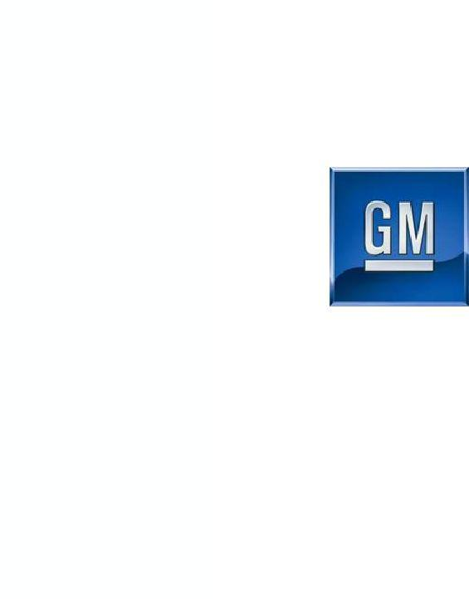
Exhibit 99.1

General Motors Company

Q3 2010 Results

November 10, 2010

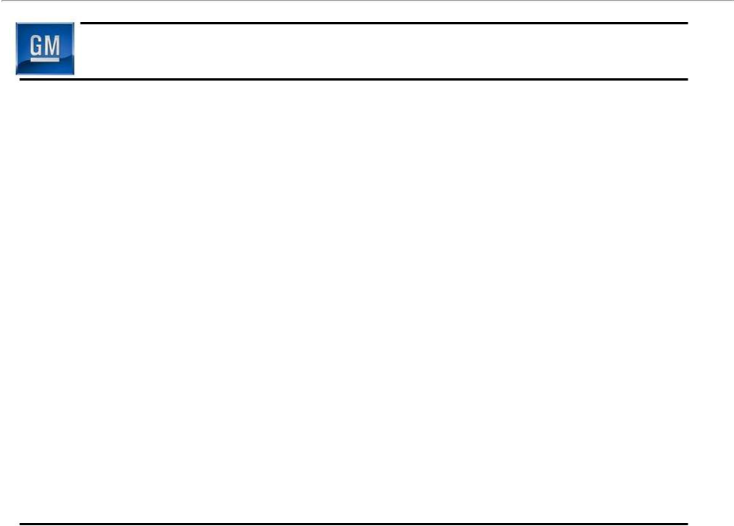
Forward Looking Statements

In this presentation and in related comments by our management, our use of the words “expect,” “anticipate,” “possible,” “potential,” “target,” “believe,” “commit,” “intend,” “continue,” “may,” “would,” “could,” “should,” “project,” “projected,” “positioned” or similar expressions is intended to identify forward looking statements that represent our current judgment about possible future events. We believe these judgments are reasonable, but these statements are not guarantees of any events or financial results, and our actual results may differ materially due to a variety of important factors. Among other items, such factors might include: our ability to realize production efficiencies and to achieve reductions in costs as a result of our restructuring initiatives and labor modifications; our ability to maintain quality control over our vehicles and avoid material vehicle recalls; our ability to maintain adequate liquidity and financing sources and an appropriate level of debt, including as required to fund our planning significant investment in new technology; our ability to realize successful vehicle applications of new technology; and our ability to continue to attract new customers, particularly for our new products

GM's most recent annual report on Form 10-K and quarterly report on Form 10-Q provides information about these and other factors, which we may revise or supplement in future reports to the SEC.

1

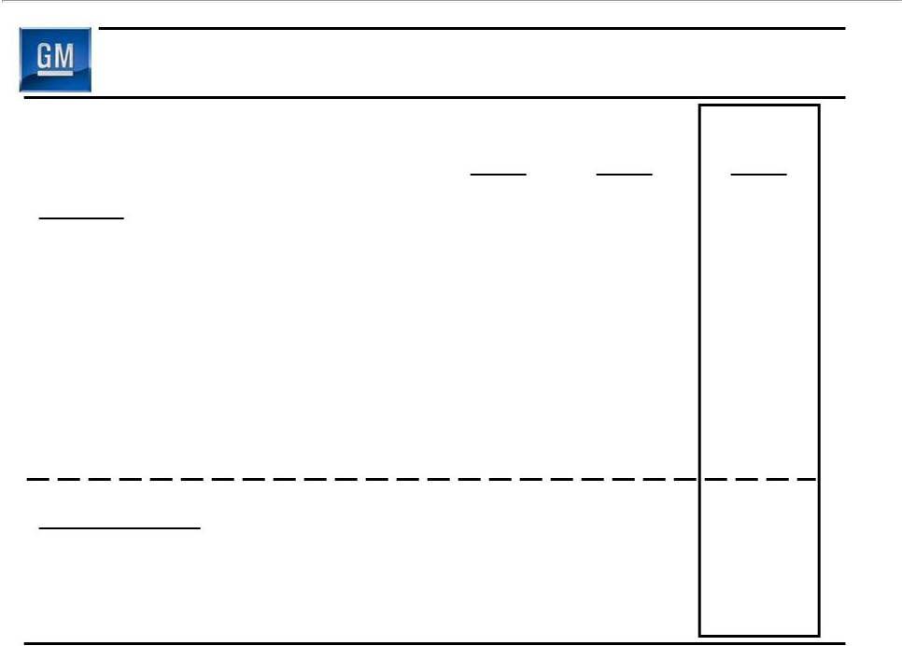
Summary of Q3 2010 Results

GAAP

Net Revenue ($B)

Operating Income ($B)

Net Income Attr. Common

Stockholders ($B)

EPS – Diluted ($/Share)

Non- GAAP

EBIT - Adj. ($B)

Free Cash Flow ($B)

Q1 | Q2 | Q3
2010 | 2010 | 2010

31.5 | 33.2 | 34.1
1.2 | 1.8 | 1.9
0.9 | 1.3 | 2.0
0.55 | 0.85 | 1.20

1.7 | 2.0 | 2.3
1.0 | 2.8 | 1.4

2

Q3 Operating Income Walk to EBIT - Adj.

 | Q3
($ B) | 2010
Operating Income | 1.9
Equity Income | 0.4
Non-Controlling Interests | (0.1)
Non-Operating Income | 0.1
Earnings Before Interest & Taxes (EBIT) | 2.3
Less Adjustments | 0.0
EBIT- Adj. | 2.3

3

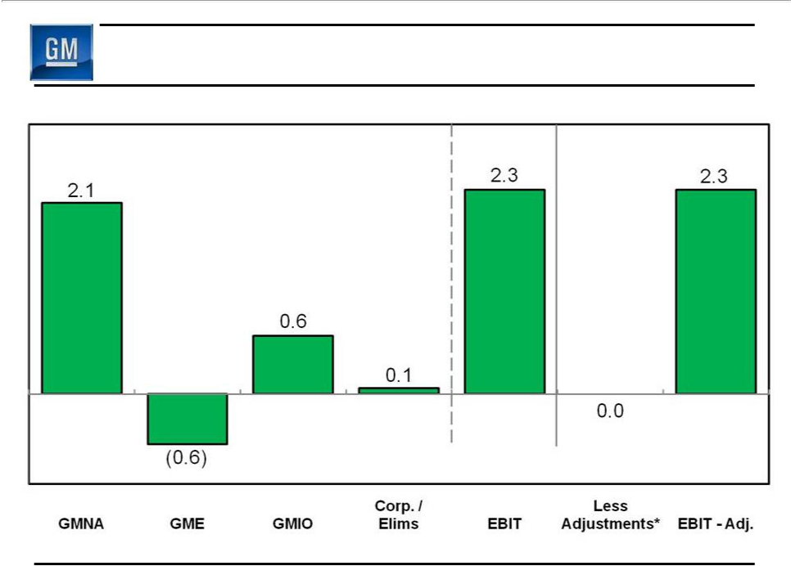
Q3 2010 EBIT & EBIT - Adj.

($B)

* Included in Earnings Before Interest and Taxes (EBIT)
Note: Results may not foot due to rounding | 4

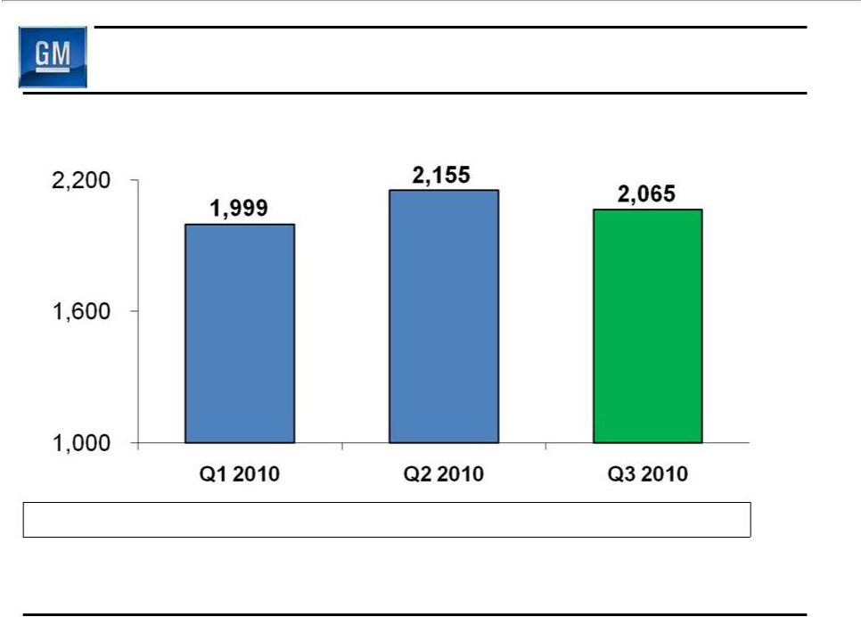
Q3 2010 Global Deliveries

(000’s)

Global Share | 11.0% | 11.6% | 11.5%

GM deliveries & market share include vehicles sold around the world under GM and JV brands, and through GM branded distribution network

5

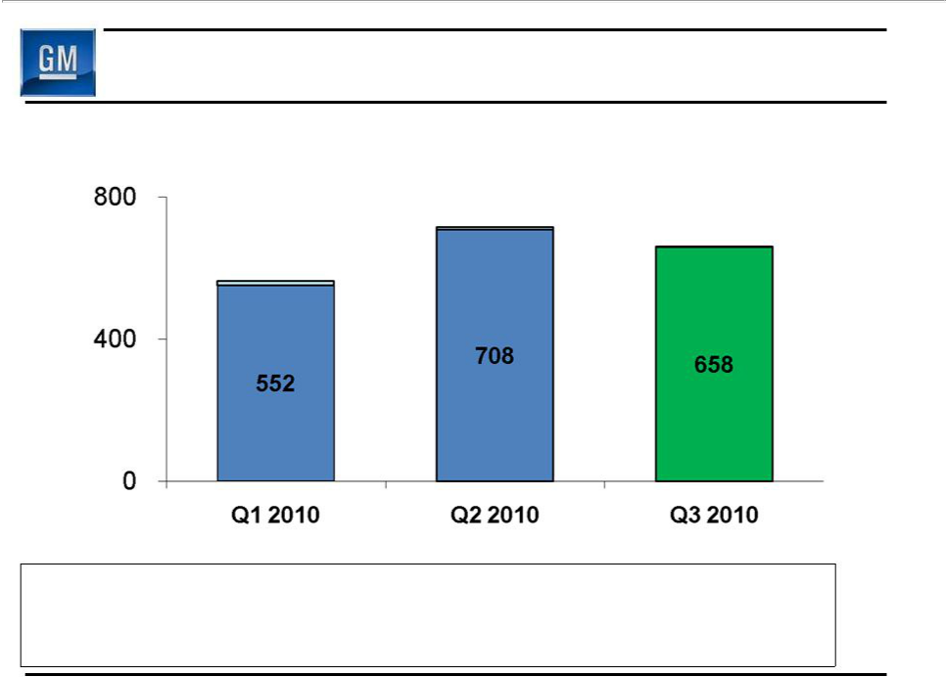
Q3 2010 GMNA Deliveries

(000’s)

 | 716 | 661
564 |  | 661 | Discontinued
564 |  |  | Brands

Chevy, Buick,

GMC, Cadillac

GMNA Share | 17.8% | 18.7% | 17.7%
U.S. Share | 18.4% | 19.4% | 18.3%
U.S. 4 Brand Share | 18.1% | 19.3% | 18.3%

6

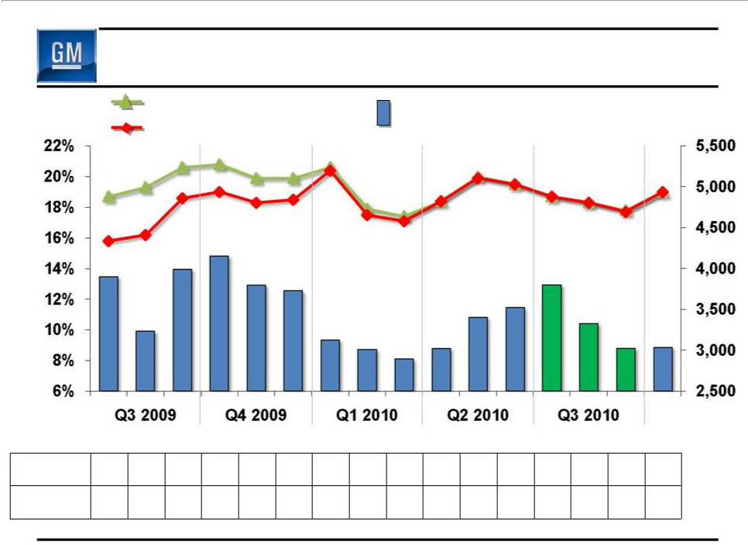
Key GMNA Performance Indicators

 | U.S. Total Share | Avg. GM U.S. Retail | $/Unit
Share | U.S. 4-Brand Share | Incentive (4-Brands) | $/Unit

 |  |  |  |  |  |  |  |  |  |  |  |  |  | Oct
 |  |  |  |  |  |  |  |  |  |  |  |  |  | 2010*
Avg. U.S. Retail Incentive, as % of ATP
GM | 14.0 | 12.2 | 12.5 | 13.3 | 12.2 | 12.0 | 10.3 9.7 | 9.3 | 9.9 11.2 | 11.7 | 12.6 | 10.7 | 9.6 | 9.5
(4-Brand) %
GM vs. Ind. | 1.23 | 1.23 | 1.31 | 1.40 | 1.29 | 1.20 | 1.06 0.93 | 0.85 | 0.95 1.03 | 1.10 | 1.12 | 1.01 | 0.95 | 1.01
(GM % / Ind. %)
* October incentives as of the October 24th.

Note: Incentive & ATP Information Based on J.D. Power and Associates Power Information Network data | 7

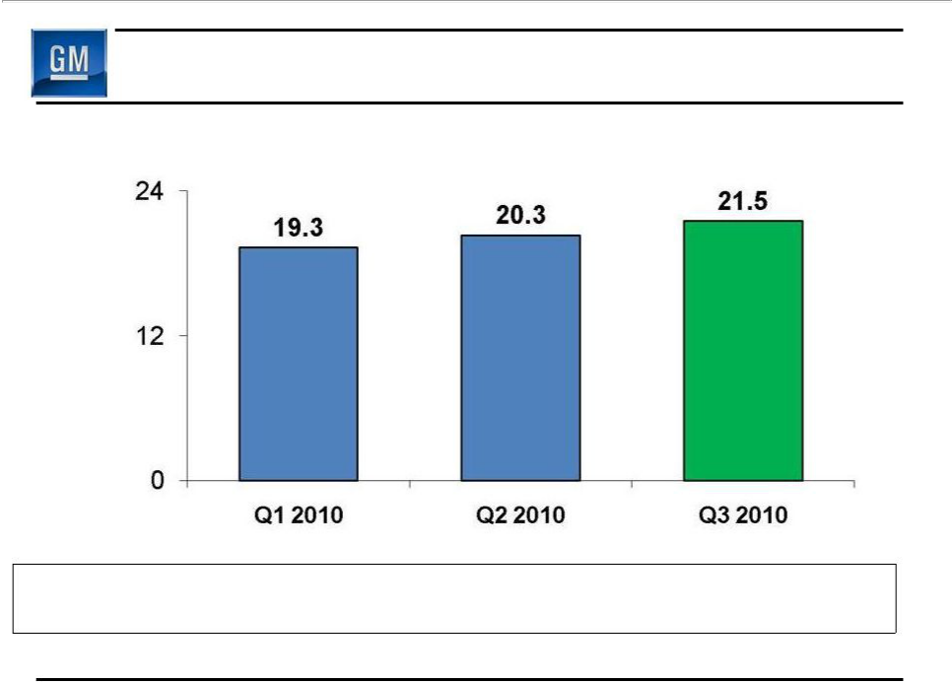
Q3 2010 GMNA Net Revenue

($B)

GMNA Production (000’s) | 668 | 731 | 707
U.S. Dealer Inv (000’s) | 428 | 438 | 478

8

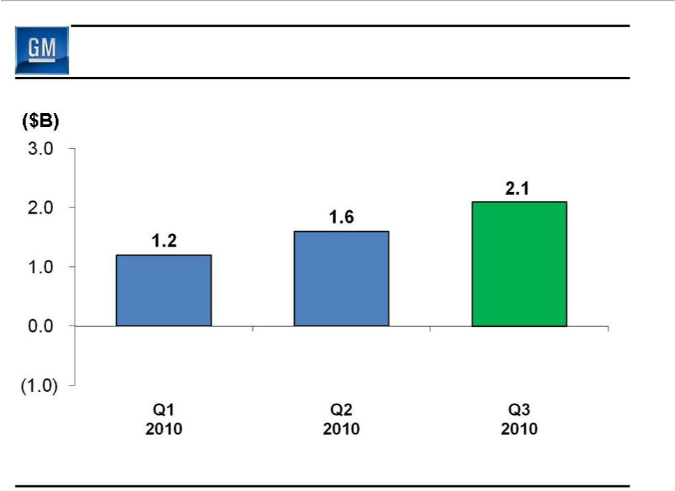
Q3 2010 GMNA Earnings Before Interest & Taxes

($B)

9

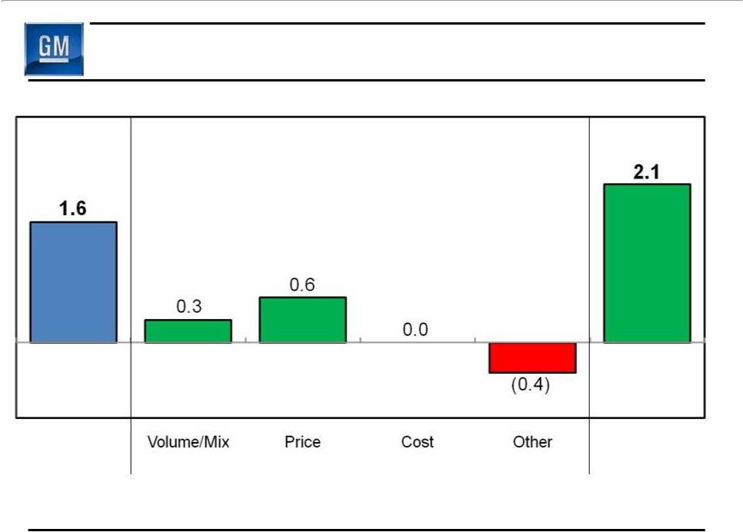
GMNA EBIT – Q2 2010 vs. Q3 2010

($B)

$0.5B Improvement

Q2 2010

Q3 2010

EBIT

EBIT

10

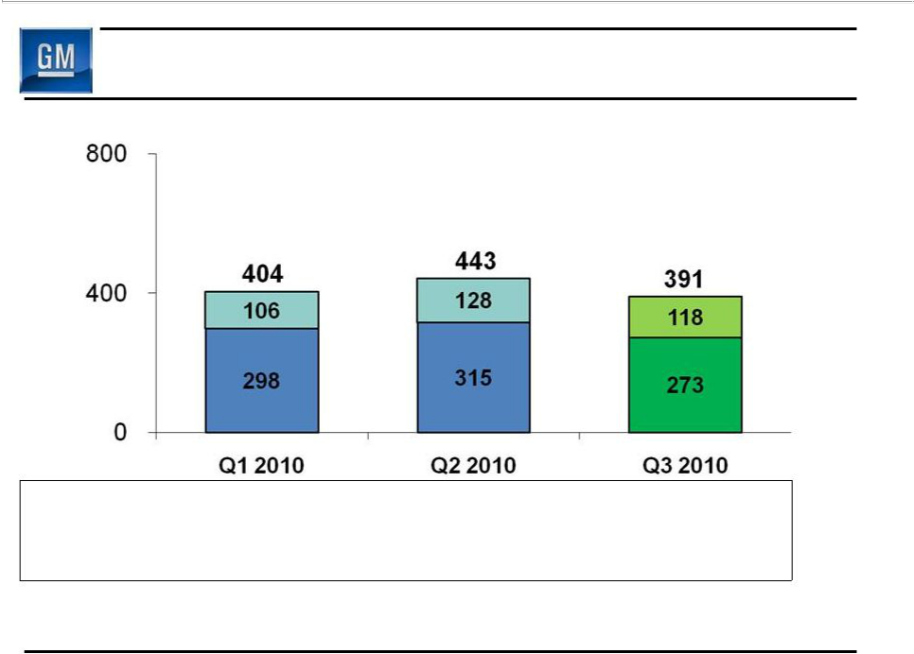
Q3 2010 GME Deliveries

(000’s)

Chevrolet

GME Excl.

Chevrolet

GME Share | 8.5% | 8.8% | 8.9%
Germany Share | 8.2% | 8.0% | 8.5%
U.K. Share | 12.0% | 13.8% | 12.6%

GME deliveries and market share include unit sales of Chevrolets produced by GMIO. Revenue and associated costs of these unit sales are reported by GMIO

11

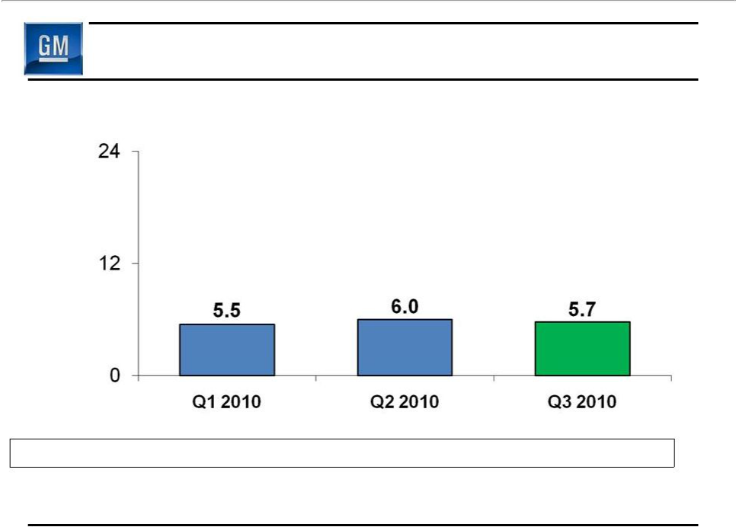
Q3 2010 GME Net Revenue

($B)

Production (000’s) | 305 | 331 | 286

12

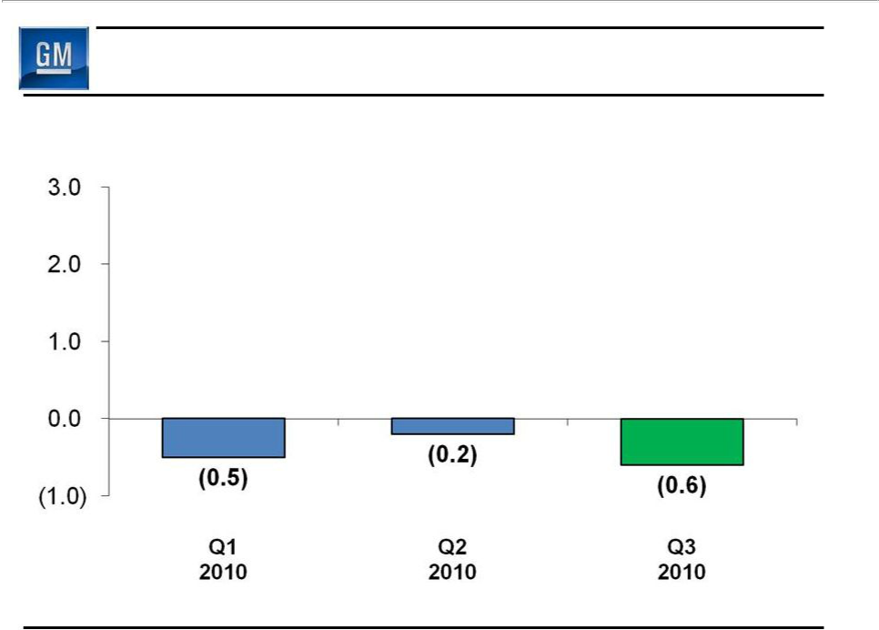
Q3 2010 GME Earnings Before Interest & Taxes

($B)

13

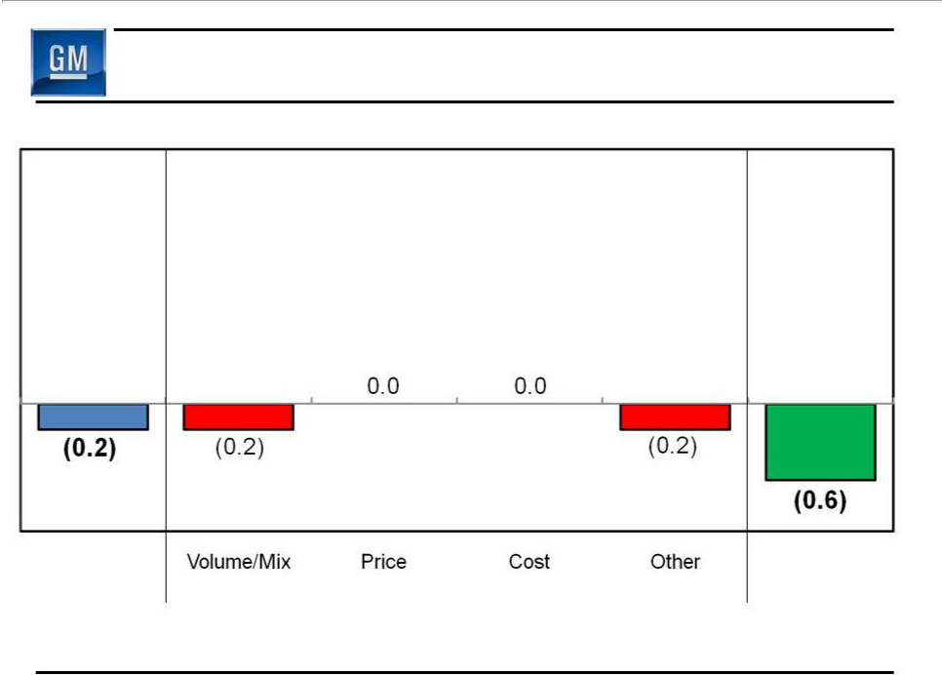
GME EBIT – Q2 2010 vs. Q3 2010

($B)

$0.4B Reduction

Q2 2010

Q3 2010

EBIT

EBIT

14

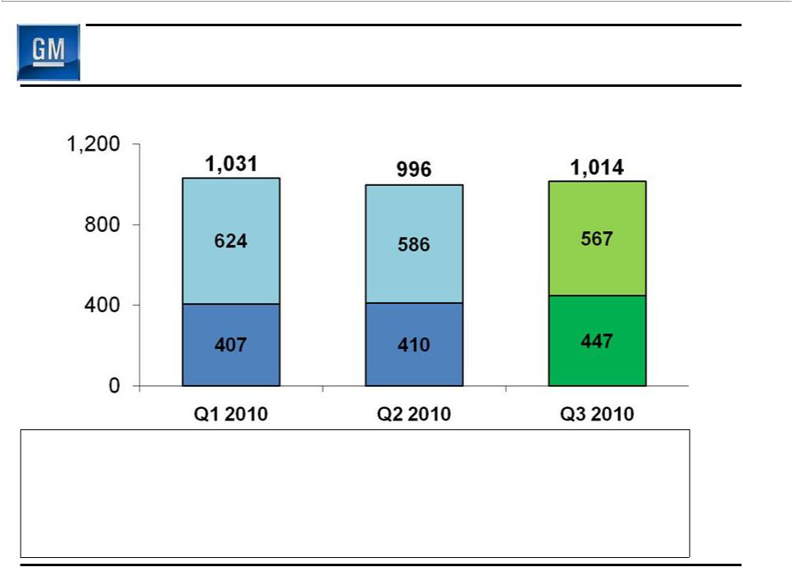
Q3 2010 GMIO Deliveries

(000’s)

China

GMIO Excl.

China

GMIO Share | 10.2% | 10.3% | 10.3%
China Share | 13.3% | 13.1% | 13.6%
Brazil Share | 19.9% | 18.4% | 18.3%
India Share | 4.2% | 4.0% | 3.0%

15

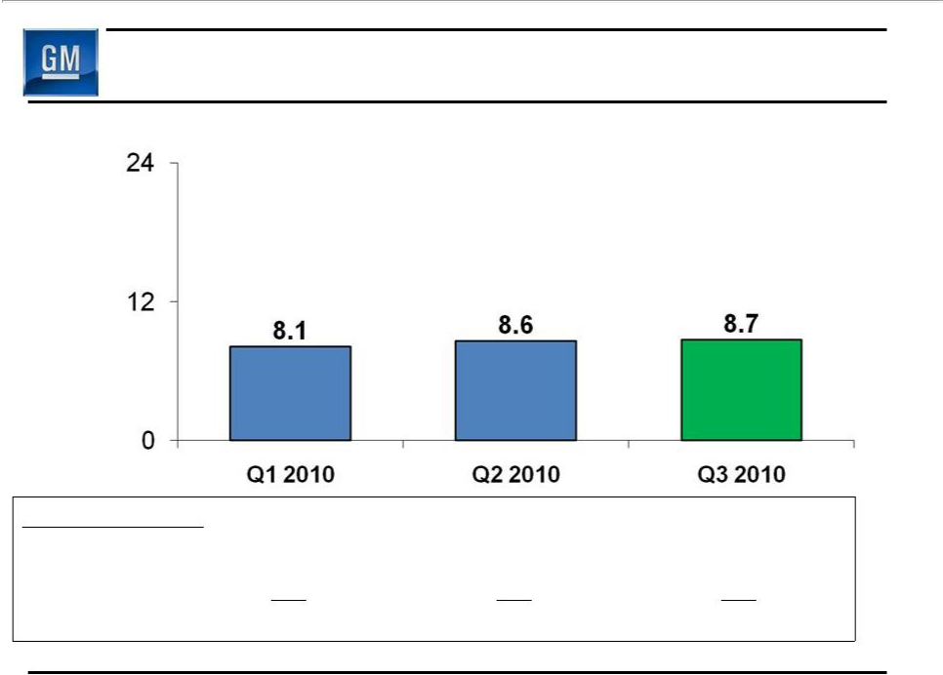
Q3 2010 GMIO Net Revenue

($B)

Production (000’s)
Fully Consolidated | 458 | 498 | 480
Joint Venture | 654 | 697 | 631
Total | 1,112 | 1,195 | 1,111

16

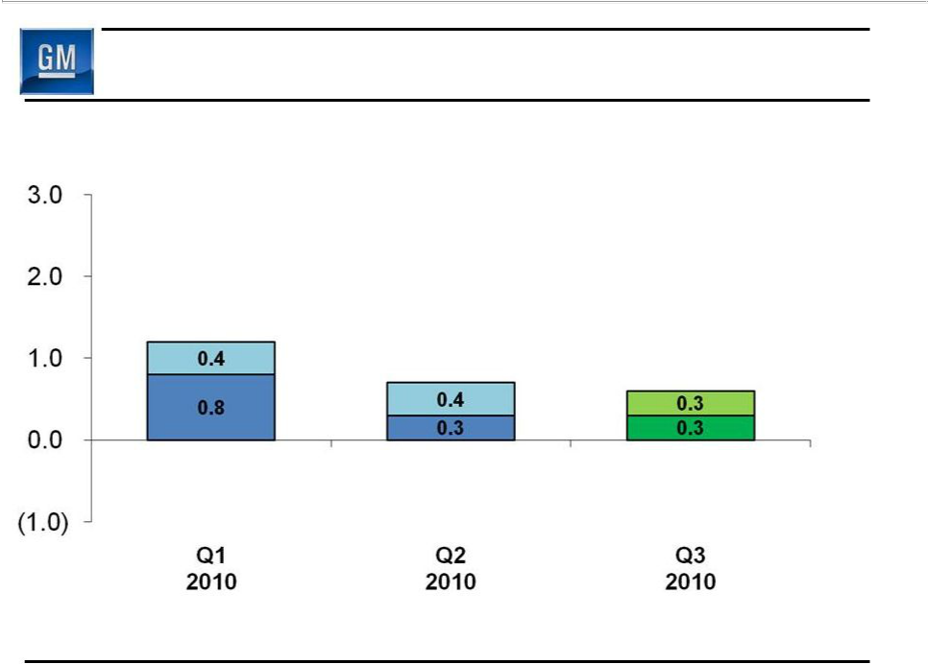
Q3 2010 GMIO Earnings Before Interest & Taxes

($B)

1.2

0.7 | 0.6 | Equity Income

Inc. Before

Int/Tax/Equity

17

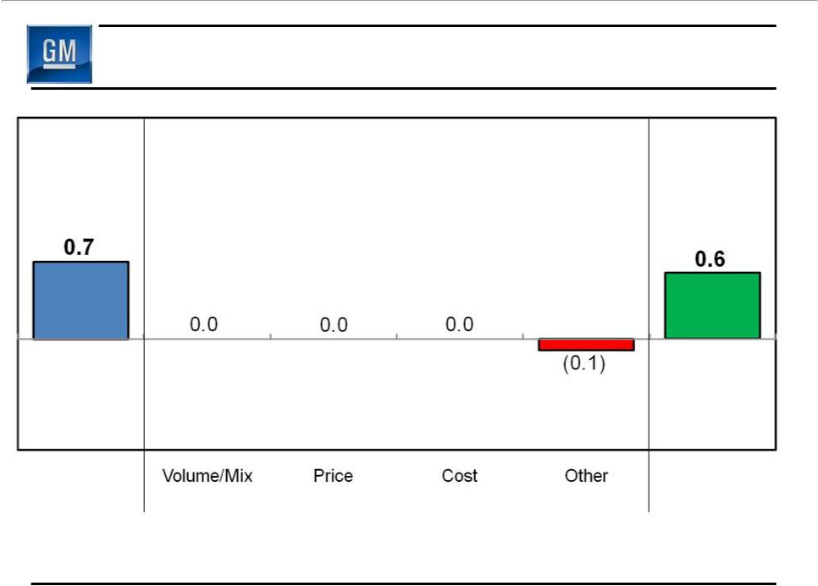
GMIO EBIT - Q2 2010 vs. Q3 2010

($B)

$0.1B Reduction

Q2 2010

Q3 2010

EBIT

EBIT

18

Cash Flow

($B)

Net Income Attr. Common Stockholders

Add-back Non-Controlling Interests & Preferred Dividends

Net Income

Depreciation / Amortization Working Capital Pension / OPEB & Other

Net cash provided/(used)

operating activities

Capital Expenditures

Free Cash Flow

Q2 2010 Q3 2010
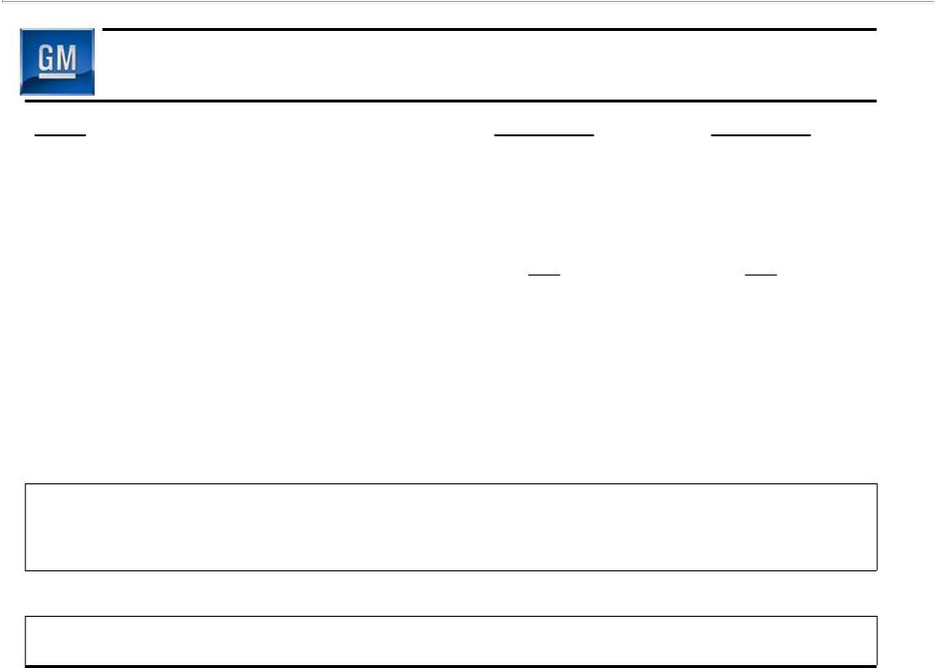

1.3 2.0

0.3 0.2

1.6 2.2

1.7 1.7

0.1 (0.5)

0.5 (0.8)

3.9 2.6

(1.1) (1.2)

2.8 1.4

19

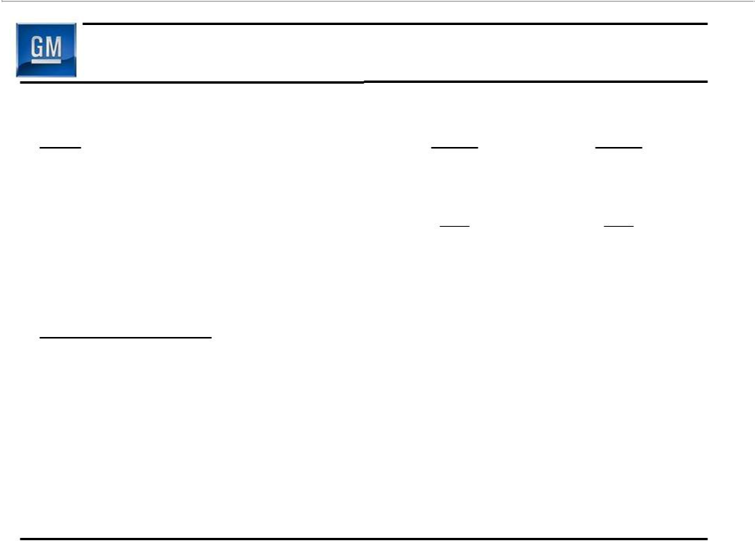
Key Balance Sheet Items

 | June 30 | Sept. 30
($B) | 2010 | 2010
Cash & marketable securities * | 32.5 | 34.5
Available Credit Facilities | 1.1 | 1.3
Available Liquidity * | 33.6 | 35.8
Key Obligations:
Debt | 8.2 | 8.6
Preferred Stock | 7.0 | 7.0
Underfunded Pensions | 26.4 | 29.4
Underfunded OPEB | 9.3 | 9.4

- Includes Canadian HC Trust Restricted Cash

20

Q4 Outlook

- Expect Q4 EBIT to remain positive, but at a significantly lower run-rate than each of first three quarters

– Different production mix

– New vehicle launch costs

– Increased engineering expense in support of future products

- $0.7B non-cash charge associated with purchase of Series A Preferred Stock held by United States Department of Treasury

21

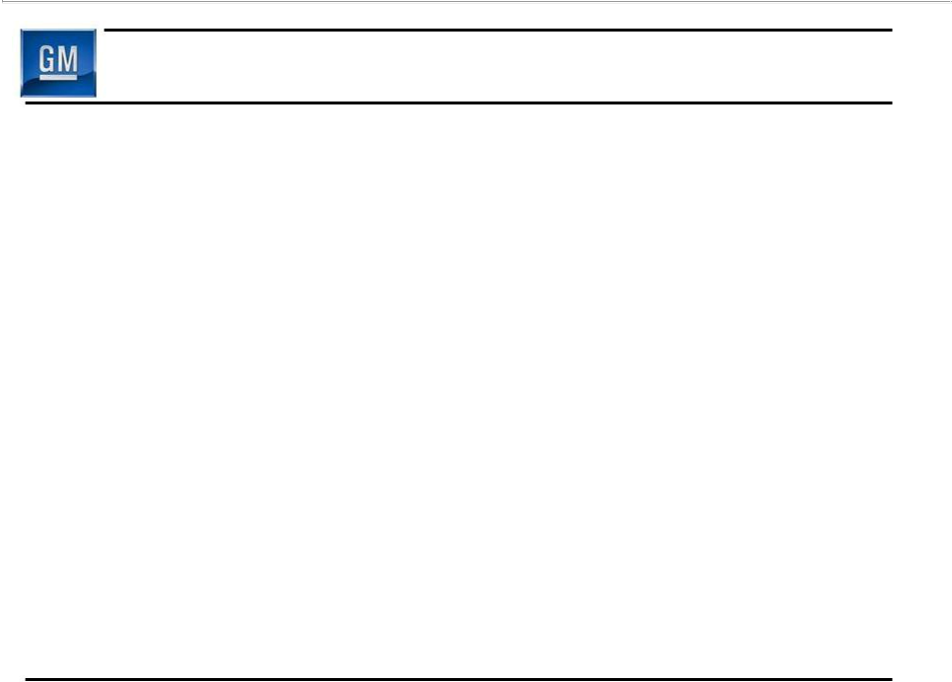
Q3 Key Messages

- Three straight quarters of profitability and positive cash flow

- Expect to post solidly profitable results for CY 2010

- Company continues to deliver on major business objectives

– Product launches

– Cost discipline

– European restructuring

– Strengthening balance sheet

22

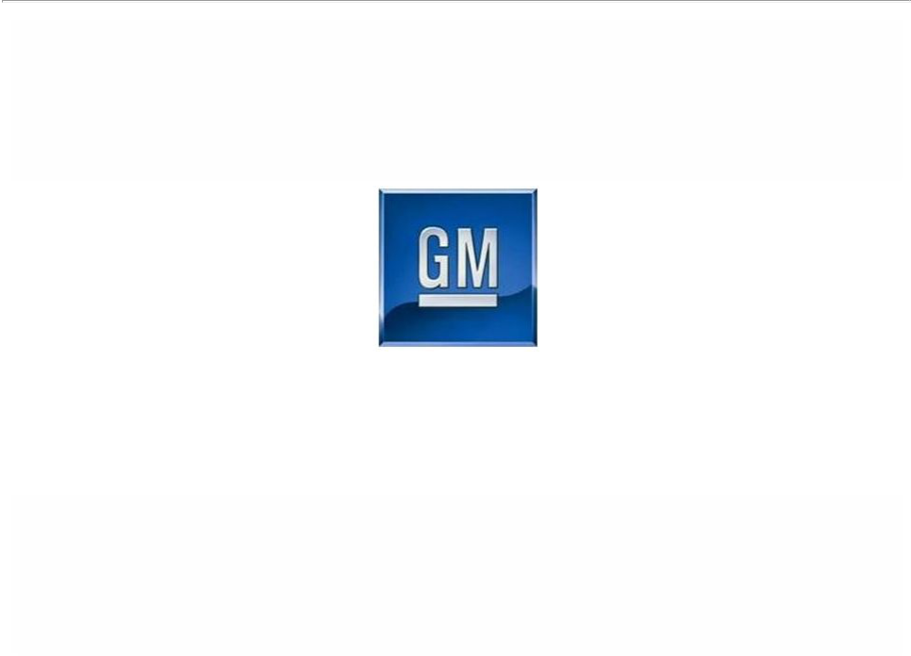

General Motors Company

Select Supplemental Financial Information

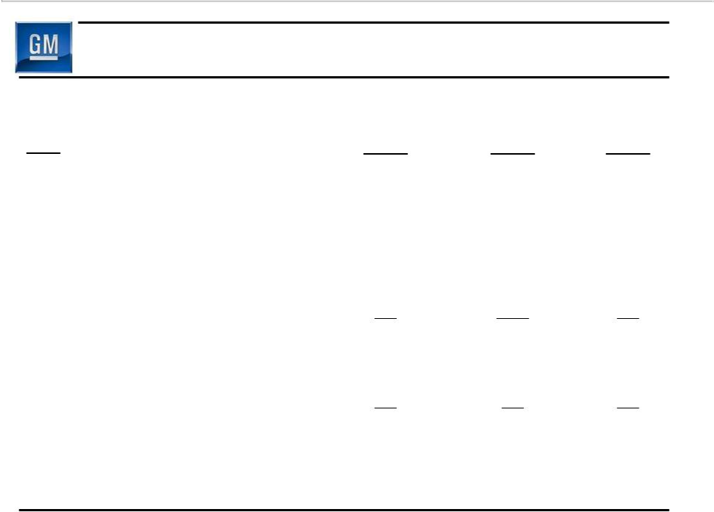
Operating Income Walk to EBIT- Adj

 | Q1 | Q2 | Q3
($B) | 2010 | 2010 | 2010
Operating Income | 1.2 | 1.8 | 1.9
Equity Income | 0.4 | 0.4 | 0.4
Non-Controlling Interests | (0.1) | (0.1) | (0.1)
Non-Operating Income/(Expense) | 0.3 | (0.1) | 0.1
Earnings Before Interest & Taxes | 1.8 | 2.0 | 2.3
Less Adjustments | 0.1 | 0.0 | 0.0
EBIT- Adj. | 1.7 | 2.0 | 2.3

S1

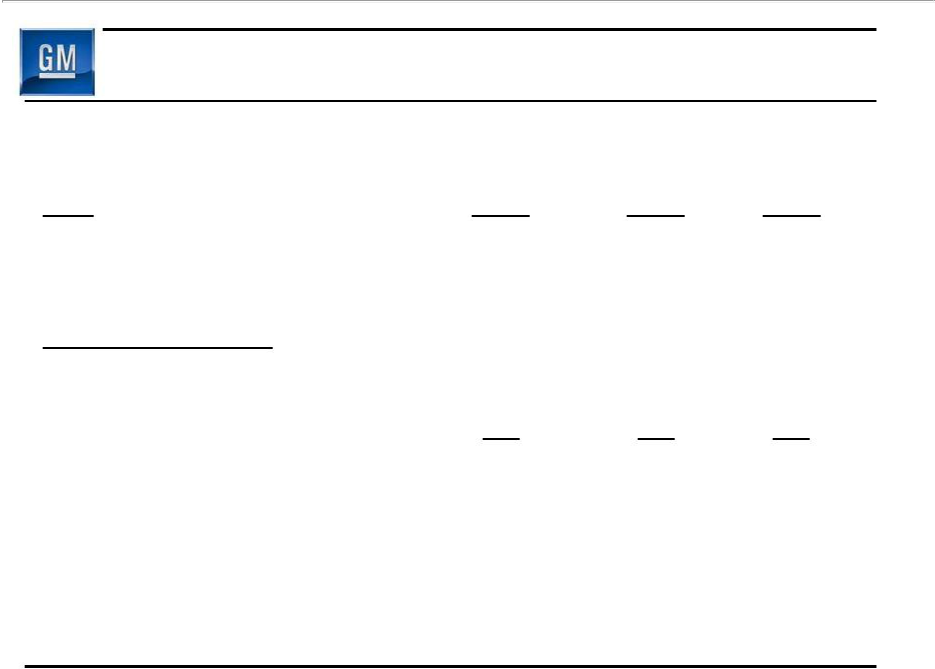
Detail of Adjustments

($B)

Earnings Before Interest

& Taxes (EBIT)

Less Adjustments

- Gain on Saab Sale

Total Adjustments

EBIT – Adj.

Q1 | Q2 | Q3
2010 | 2010 | 2010
1.8 | 2.0 | 2.3

0.1
0.1 | 0.0 | 0.0
1.7 | 2.0 | 2.3

S2

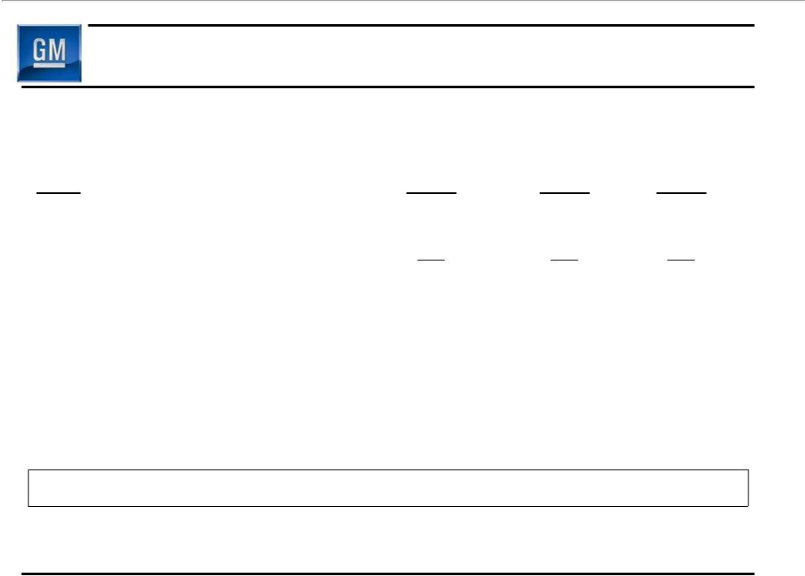
Restructuring Excluded From Adjustments

 | Q1 | Q2 | Q3
($B) | 2010 | 2010 | 2010
GMNA – Dealer Related | 0.0 | 0.0 | 0.0
GMNA – Non-Dealer Related | 0.1 | 0.0 | 0.0
Total GMNA | 0.1 | 0.0 | 0.0
Total GME | (0.3) | (0.2) | (0.1)
Total GMIO | 0.0 | 0.0 | 0.0
Total | (0.2) | (0.2) | (0.1)

S3

