SEC Form 3

FORM 3 UNITED STATES SECURITIES AND EXCHANGE COMMISSION

Washington, D.C. 20549

INITIAL STATEMENT OF BENEFICIAL OWNERSHIP OF SECURITIES

Filed pursuant to Section 16(a) of the Securities Exchange Act of 1934

or Section 30(h) of the Investment Company Act of 1940
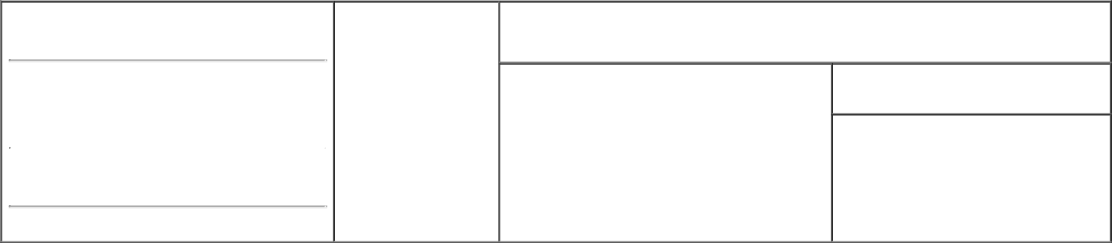

OMB APPROVAL
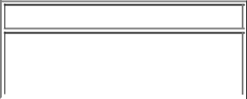

 | OMB Number: | 3235-0104
 | Estimated average burden
 | hours per response: | 0.5

1. Name and Address of Reporting Person * | 2. Date of Event Requiring
Blissett Julian G. | Statement (Month/Day/Year)
Blissett Julian G. | 04/27/2020

3. Issuer Name and Ticker or Trading Symbol

General Motors Co [ GM ]

 | (Last) | (First) | (Middle)
 | 300 RENAISSANCE CENTER
 | M/C: 482-C24-A68
(Street)
 | DETROIT | MI | 48265

- Relationship of Reporting Person(s) to Issuer (Check all applicable)
Director 10% Owner
_{X} Officer (give title Other (specify

below) below)

Executive Vice President

- If Amendment, Date of Original Filed (Month/Day/Year)

- Individual or Joint/Group Filing (Check Applicable Line)
- Form filed by One Reporting Person

Form filed by More than One Reporting Person

(City) (State) (Zip)

Table I - Non-Derivative Securities Beneficially Owned

1. Title of Security (Instr. 4) |  |  | 2. Amount of Securities Beneficially |  | 3. Ownership Form: 4. Nature of Indirect Beneficial Ownership (Instr. 5)
 |  |  | Owned (Instr. 4) |  | Direct (D) or
 |  |  |  |  | Indirect (I) (Instr. 5)
Common Stock |  |  |  | 12,830 | D
 |  | Table II - Derivative Securities Beneficially Owned
 | (e.g., puts, calls, warrants, options, convertible securities)
1. Title of Derivative Security (Instr. 4) |  | 2. Date Exercisable and |  | 3. Title and Amount of Securities Underlying |  | 4. | 5. Ownership | 6. Nature of Indirect
 |  | Expiration Date |  | Derivative Security (Instr. 4) |  | Conversion | Form: Direct | Beneficial Ownership
 |  | (Month/Day/Year) |  |  |  | or Exercise | (D) or Indirect | (Instr. 5)
 |  |  |  |  |  | Price of | (I) (Instr. 5)
 |  |  |  |  | Amount | Price of | (I) (Instr. 5)
 |  |  |  |  | Amount | Derivative
 |  | Date | Expiration |  | or | Security
 |  | Date | Expiration | Title | Number
 |  | Exercisable | Date | Title | of Shares
Employee Stock Option (Right to Buy) ⁽¹⁾ | 02/15/2020 |  | 07/28/2025 | Common Stock | 30,976 | 31.32 | D
Employee Stock Option (Right to Buy) ⁽²⁾ | 02/14/2020 |  | 06/07/2027 | Common Stock | 15,533 | 34.34 | D
Employee Stock Option (Right to Buy) ⁽³⁾ | (3) |  | 02/11/2028 | Common Stock | 14,013 | 41.4 | D
Employee Stock Option (Right to Buy) ⁽⁴⁾ | (4) |  | 02/13/2029 | Common Stock | 14,875 | 39 | D
Employee Stock Option (Right to Buy) ⁽⁵⁾ | (5) |  | 02/13/2029 | Common Stock | 15,940 | 37.76 | D
Employee Stock Option (Right to Buy) ⁽⁶⁾ | (6) |  | 02/12/2030 | Common Stock | 37,823 | 35.49 | D
Employee Stock Option (Right to Buy) ⁽⁷⁾ | (7) |  | 02/12/2030 | Common Stock | 31,754 | 19.26 | D
Explanation of Responses:

- These Stock Options were granted on July 28, 2015, under the Company's 2014 Long-Term Incentive Plan and are fully vested.

- These Stock Options were granted on June 7, 2017, under the Company's 2017 Long-Term Incentive Plan (the "2017 LTIP") and are fully vested.

- These Stock Options were granted on February 13, 2018, under the Company's 2017 LTIP. Two-thirds have vested, and one-third will vest on February 13, 2021.

- These Stock Options were granted on February 13, 2019, under the Company's 2017 LTIP. One-third has vested; one-third will vest on February 13, 2021; and one-third will vest on February 13, 2022.

- These Stock Options were granted on April 1, 2019, under the Company's 2017 LTIP. One-third has vested; one-third will vest on February 13, 2021; and one-third will vest on February 13, 2022.

- These Stock Options were granted on February 12, 2020, under the Company's 2017 LTIP. One-third will vest on February 12, 2021; one-third will vest on February 12, 2022; and one-third will vest on February 12, 2023.

- These Stock Options were granted on April 1, 2020, under the Company's 2017 LTIP. One-third will vest on February 12, 2021; one-third will vest on February 12, 2022; and one-third will vest on February 12, 2023.

Remarks:

/s/ Tia Y. Turk, Attorney-in-Fact for

Mr. Blissett

** Signature of Reporting Person

04/29/2020

Date

Reminder: Report on a separate line for each class of securities beneficially owned directly or indirectly.

* If the form is filed by more than one reporting person, see Instruction 5 (b)(v).

- Intentional misstatements or omissions of facts constitute Federal Criminal Violations See 18 U.S.C. 1001 and 15 U.S.C. 78ff(a). Note: File three copies of this Form, one of which must be manually signed. If space is insufficient, see Instruction 6 for procedure.
Persons who respond to the collection of information contained in this form are not required to respond unless the form displays a currently valid OMB Number.



