SCHEDULE 14A

Proxy Statement Pursuant to Section 14(a)
of the Securities Exchange Act of 1934

Filed by the Registrant ☐

Filed by a Party other than the Registrant ☑

Check the appropriate box:

- Preliminary Proxy Statement

- Confidential, for Use of the Commission Only (as permitted by Rule 14a-6(e)(2))

- Definitive Proxy Statement

- Definitive Additional Materials

- Soliciting Material Under Rule 14a-12

General Motors Company

(Name of Registrant as Specified In Its Charter)

Greenlight Capital, Inc.

Greenlight Capital, L.P.
DME Advisors, LP,
DME Advisors GP, LLC
DME Capital Management, LP
Greenlight Capital Qualified, LP
Greenlight Capital (Gold), LP
Greenlight Capital Offshore Partners
Greenlight Capital Offshore Master (Gold), Ltd.
Greenlight Masters, LLC
Greenlight Masters Partners
David Einhorn
Leo Hindery, Jr.
Vinit Sethi

William N. Thorndike, Jr.

(Name of Person(s) Filing Proxy Statement, if other than the Registrant)

Payment of Filing Fee (check the appropriate box):

- No fee required.

- Fee computed on table below per Exchange Act Rule 14a-6(i)(4) and 0-11.

  - Title of each class of securities to which transaction applies:

  - Aggregate number of securities to which transaction applies:

  - Per unit price or other underlying value of transaction computed pursuant to Exchange Act Rule 0-11 (set forth the amount on which the filing fee is calculated and state how it was determined):

  - Proposed maximum aggregate value of transaction:

  - Total fee paid:

- Fee paid previously with preliminary materials.

Check box if any part of the fee is offset as provided by Exchange Act Rule 0-11(a)(2) and identify the filing for which

- the offsetting fee was paid previously. Identify the previous filing by registration statement number, or the Form or Schedule and the date of its filing.

  - Amount Previously Paid:

  - Form, Schedule or Registration Statement No.:

  - Filing Party:

  - Date Filed:

On May 11, 2017, Greenlight Capital, Inc. (“Greenlight”) issued a press release (the “Press Release”), which included a description of a presentation released to shareholders (the “Presentation”) on the same day. A copy of the Press Release is filed herewith as Exhibit 1. A copy of the Presentation is filed herewith as Exhibit 2.

Also on May 11, 2017, Greenlight posted a video to www.UnlockGMValue.com that included audio commentary from David Einhorn regarding certain slides of the Presentation. A transcript of that audio is filed herewith as Exhibit 3.

Exhibit 1

GREENLIGHT RELEASES INVESTOR PRESENTATION TO GM SHAREHOLDERS

NEW YORK – May 11, 2017 – Greenlight Capital, Inc. (“Greenlight”), which owns 3.6% of the common stock of General Motors Company (NYSE: GM) making it GM’s fifth largest public shareholder, today released a detailed presentation to GM’s shareholders in connection with its nomination of three directors for election to the Board of Directors at GM’s Annual Meeting of Shareholders, scheduled to take place on June 6, 2017.

The presentation explains how GM can unlock substantial value by adopting Greenlight’s proposal to split GM’s common stock into two classes: one that would receive the current dividends and one that would participate in the remaining earnings and cash flows and future growth of the Company. The presentation also details the qualifications of Greenlight’s director nominees and the rationale for bringing a fresh perspective and new ideas to GM’s Board.

In the presentation, Greenlight highlights and further discusses several key points, including:

- GM is substantially undervalued and has the lowest price-to-earnings ratio of any company in the S&P 500 index

- Greenlight believes implementing the proposal would result in a 26% to 76% increase in in GM’s share price

- The proposal would not impact GM’s existing financial policy or operational strategy

- The credit rating red herring, in which GM is attempting to manipulate both the rating agencies and its own shareholders to protect the status quo

- Greenlight’s nominees would bring substantially more capital markets understanding, financial sophistication and shareholder value-creation experience to the Board than the three incumbent directors they would replace

- After years of barely generating any return for shareholders, GM needs directors with demonstrable track records of driving significant shareholder returns

The presentation – and related audio commentary by Greenlight President David Einhorn – is available at:

www.UnlockGMValue.com.

About Greenlight Capital

Greenlight Capital, Inc. (“Greenlight”), founded in 1996, is a value-oriented investment advisor that primarily invests and trades in long and short publicly listed equity securities, as well as distressed debt when cyclically attractive. Greenlight seeks to achieve capital appreciation by buying securities with trading values materially lower than their intrinsic values and by selling short securities with trading values materially higher than their intrinsic values. Greenlight aims to achieve high absolute rates of return while minimizing the risk of capital loss.

Contacts

Jonathan Gasthalter/Nathaniel Garnick

Gasthalter & Co.
(212) 257-4170

About the Proxy Solicitation

Greenlight Capital, Inc., Greenlight Capital, L.P., DME Advisors, LP, DME Capital Management, LP, DME Advisors GP, LLC, Greenlight Capital Qualified, LP, Greenlight Capital (Gold), LP, Greenlight Capital Offshore Partners, Greenlight Capital Offshore Master (Gold), Ltd., Greenlight Masters Partners, Greenlight Masters, LLC, David Einhorn, Leo Hindery, Jr., Vinit Sethi, and William N. Thorndike, Jr. (collectively, the “Participants”) have filed with the Securities and Exchange Commission (the “SEC”) a definitive proxy statement and accompanying form of proxy to be used in connection with the solicitation of proxies from the shareholders of General Motors Company (the “Company”). All shareholders of the Company are advised to read the definitive proxy statement and other documents related to the solicitation of proxies by the Participants, as they contain important information, including additional information related to the Participants. The definitive proxy statement and an accompanying proxy card will be furnished to some or all of the Company’s shareholders and, along with other relevant documents, are available at no charge on the SEC website at http://www.sec.gov/ and at http://www.UnlockGMValue.com/.

Information about the Participants and a description of their direct or indirect interests by security holdings is contained in the definitive proxy statement on Schedule 14A filed by the Participants with the SEC on April 28, 2017. This document is available free of charge from the sources indicated above.

Warning Regarding Forward Looking Statements

THIS PRESS RELEASE CONTAINS FORWARD LOOKING STATEMENTS. FORWARD LOOKING STATEMENTS CAN BE IDENTIFIED BY USE OF WORDS SUCH AS “OUTLOOK”, “BELIEVE”, “INTEND”, “EXPECT”, “POTENTIAL”, “WILL”,

“MAY”, “CAN”, “SHOULD”, “ESTIMATE”, “ANTICIPATE”, AND DERIVATIVES OR NEGATIVES OF SUCH WORDS OR SIMILAR WORDS. FORWARD LOOKING STATEMENTS IN THIS PRESS RELEASE ARE BASED UPON PRESENT BELIEFS OR EXPECTATIONS. HOWEVER, FORWARD LOOKING STATEMENTS AND THEIR IMPLICATIONS ARE NOT GUARANTEED TO OCCUR AND MAY NOT OCCUR AS A RESULT OF VARIOUS RISKS, REASONS AND UNCERTAINTIES. EXCEPT AS REQUIRED BY LAW, GREENLIGHT CAPITAL, INC. AND ITS AFFILIATES AND RELATED PERSONS UNDERTAKE NO OBLIGATION TO UPDATE ANY FORWARD LOOKING STATEMENT, WHETHER AS A RESULT OF NEW INFORMATION, FUTURE DEVELOPMENTS OR OTHERWISE.

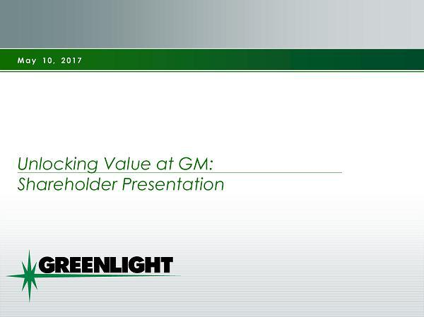

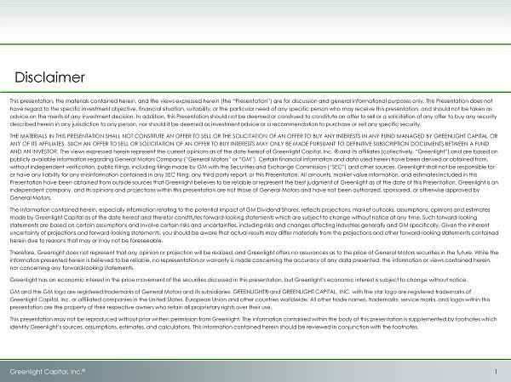

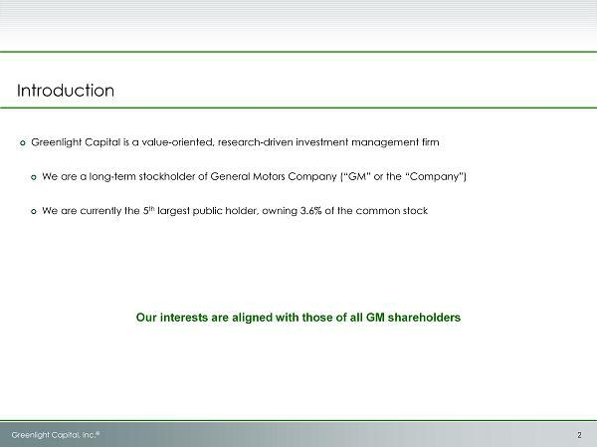

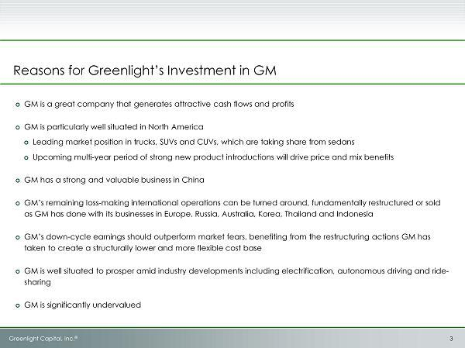

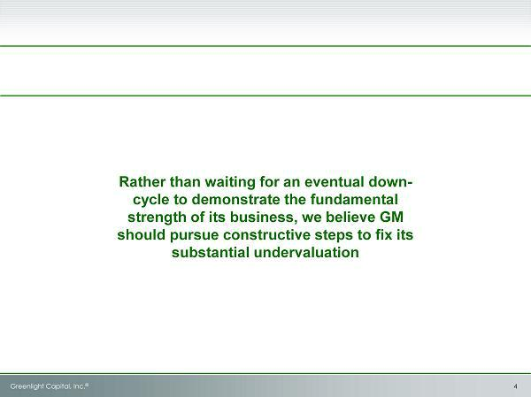

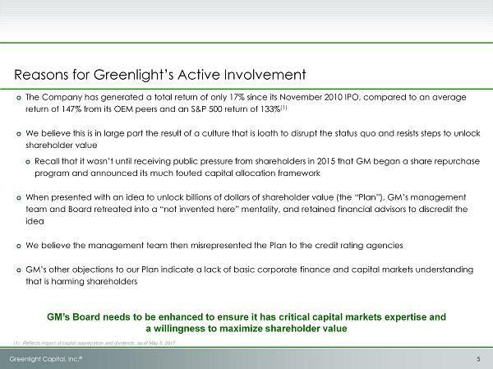

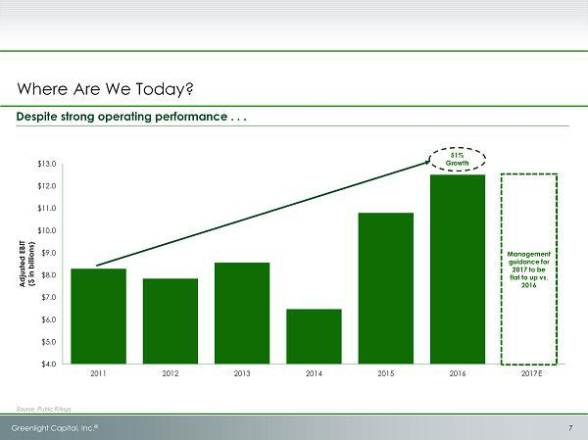

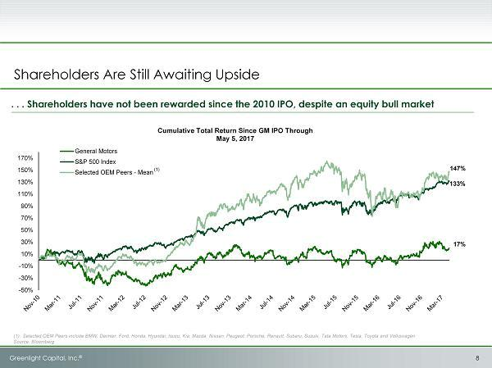

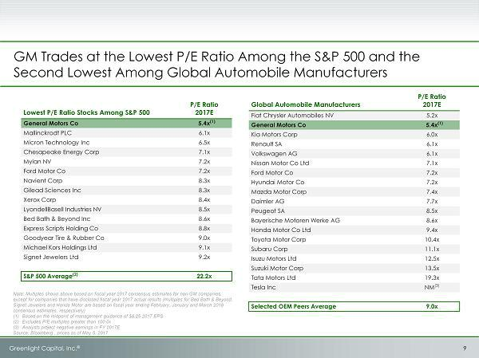

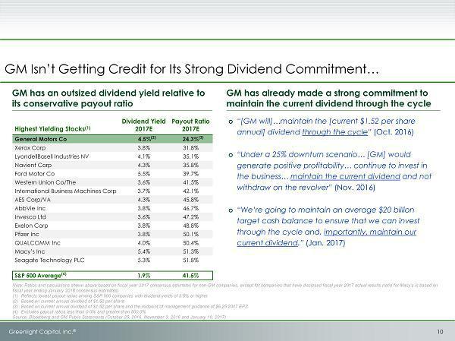

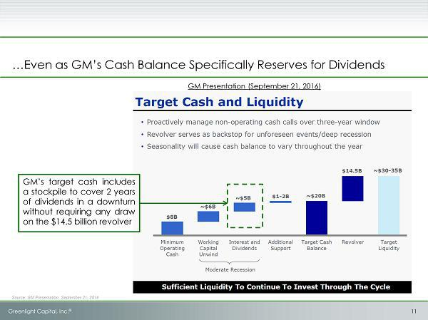

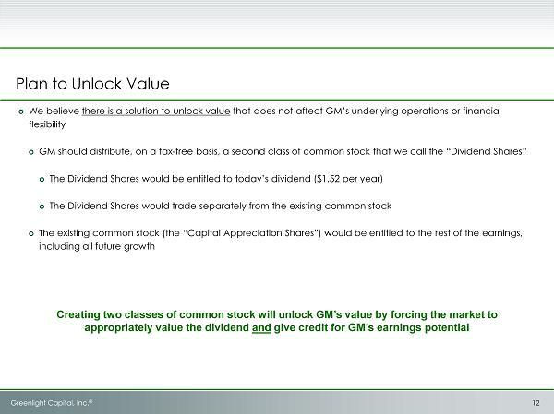

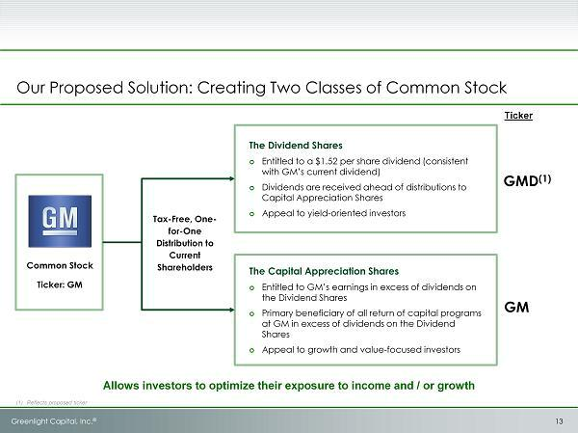

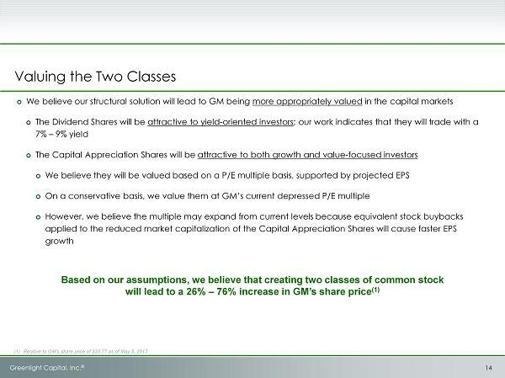

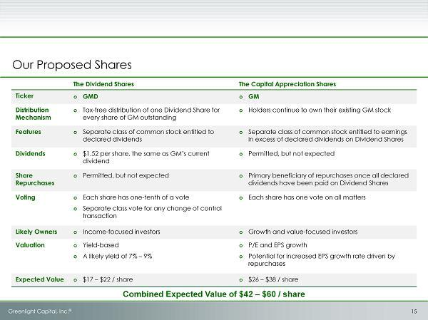

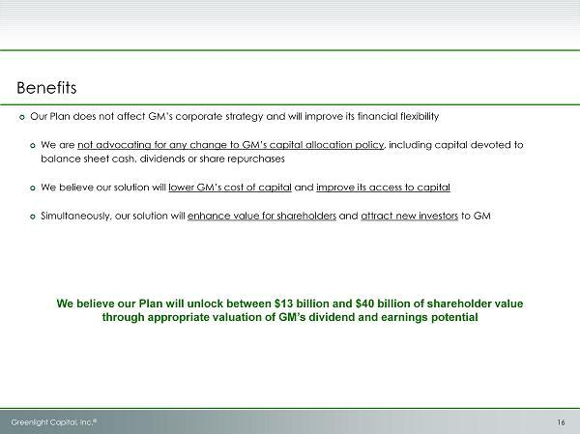

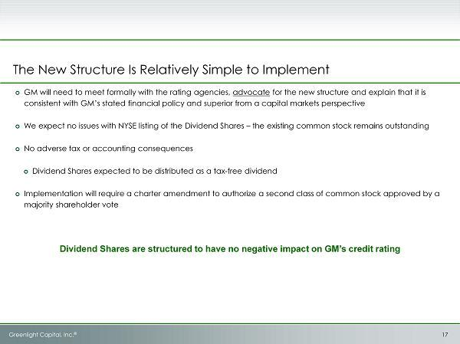

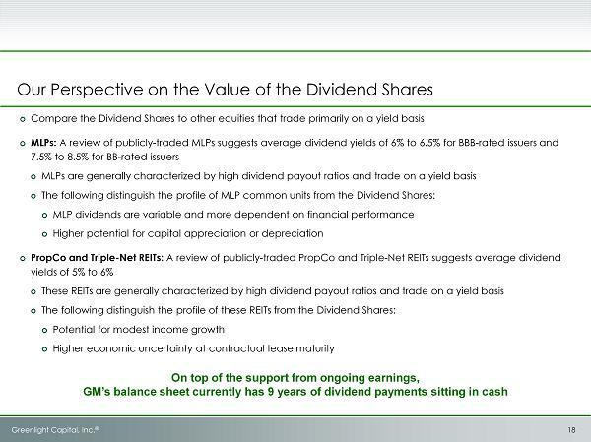

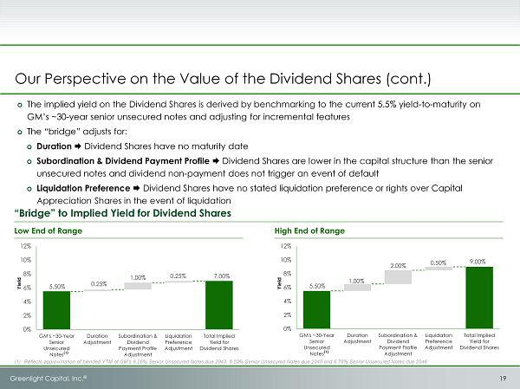

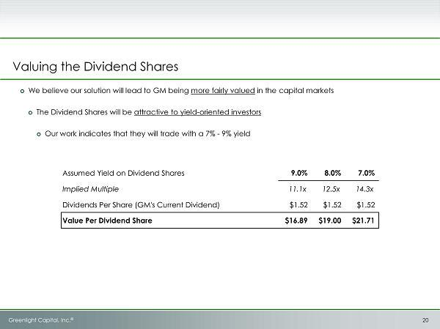

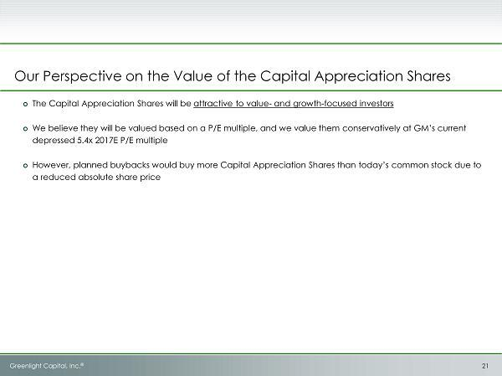

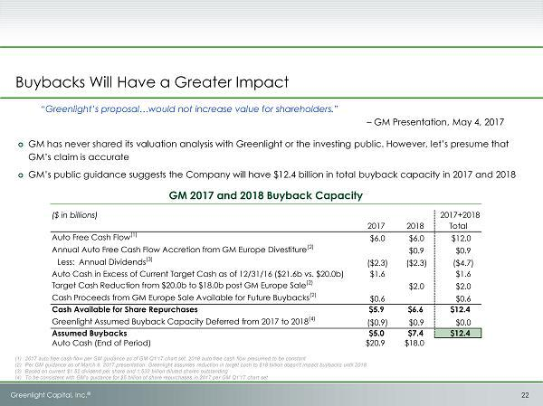

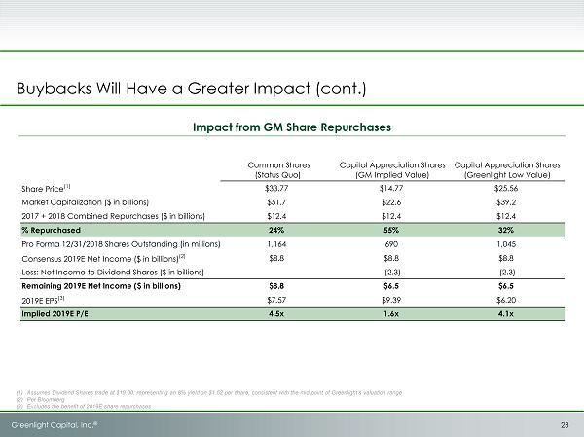

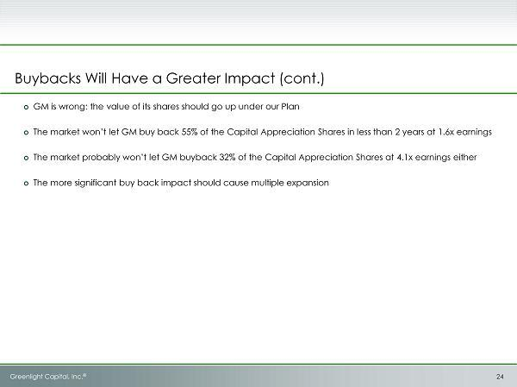

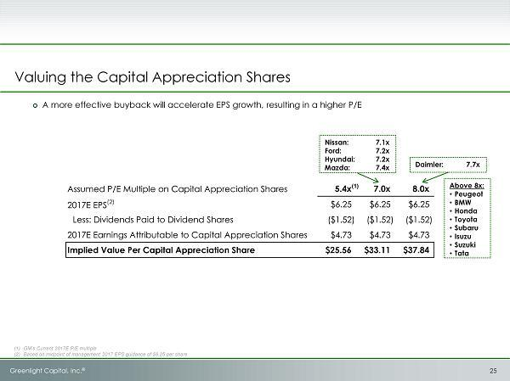

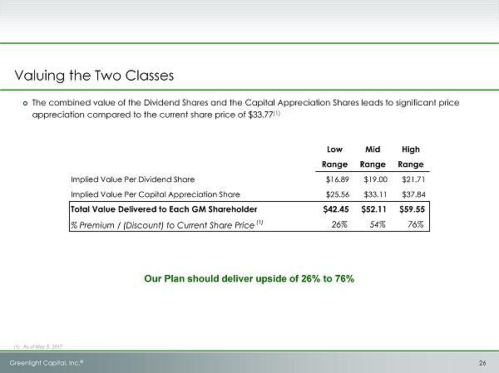

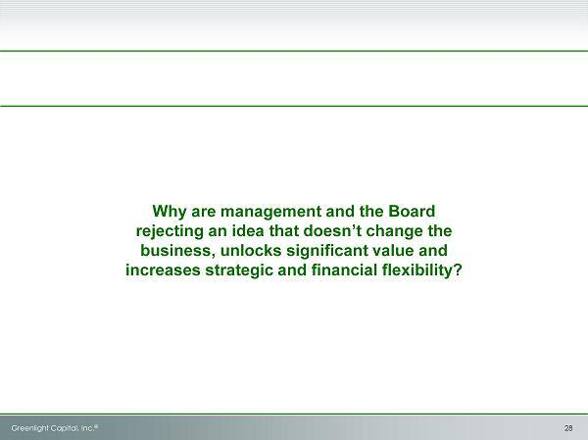

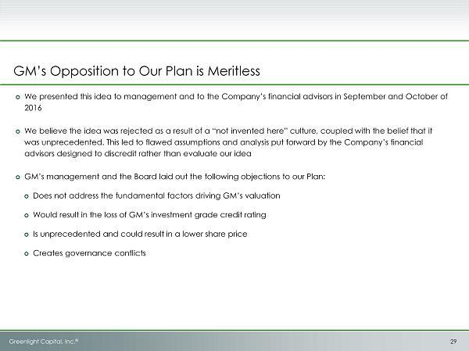

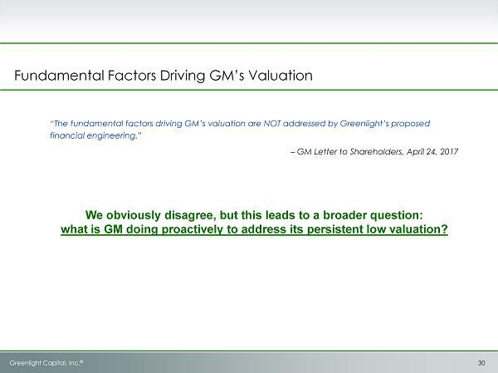

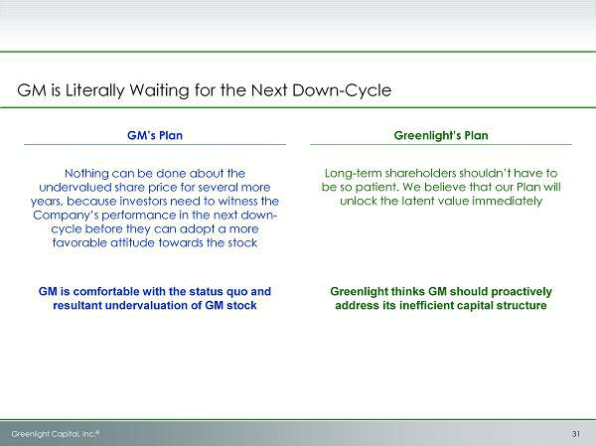

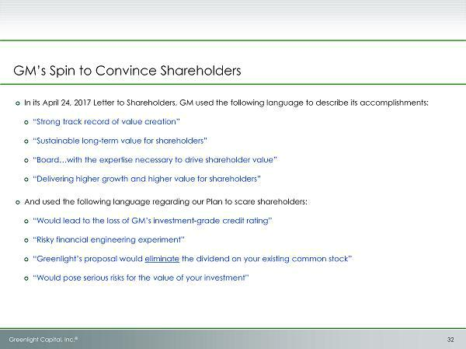

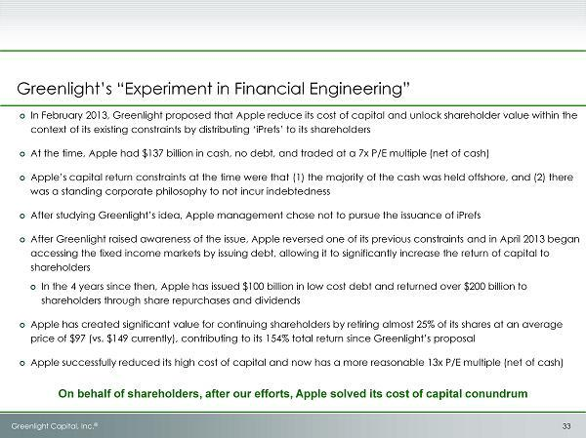

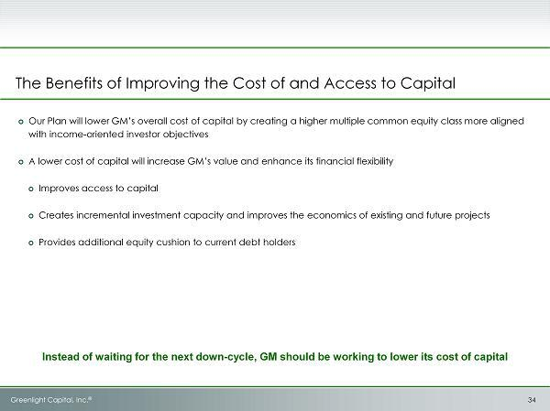

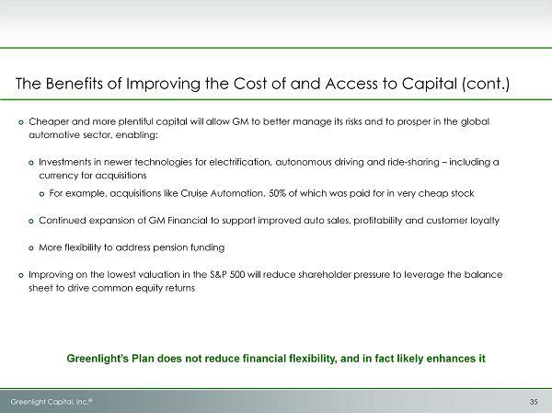

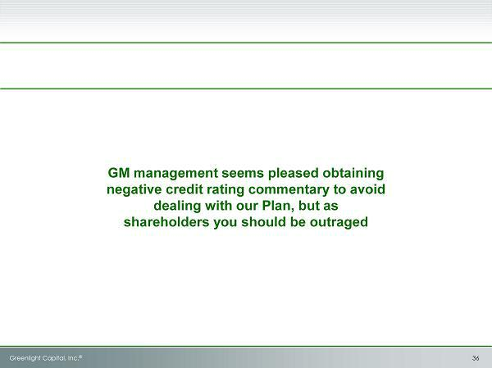

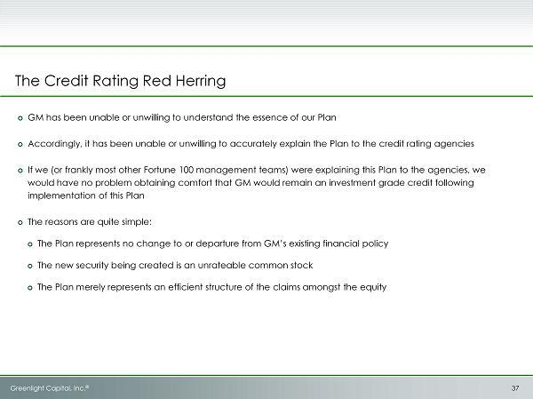

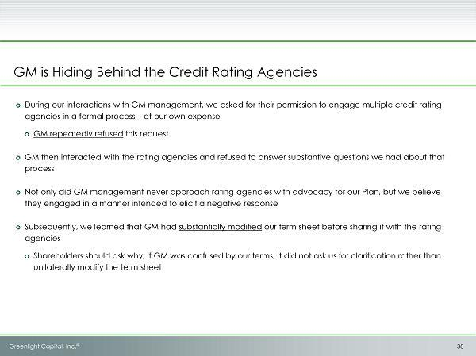

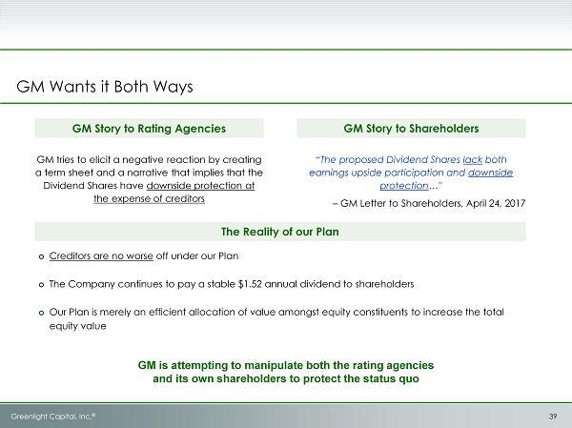

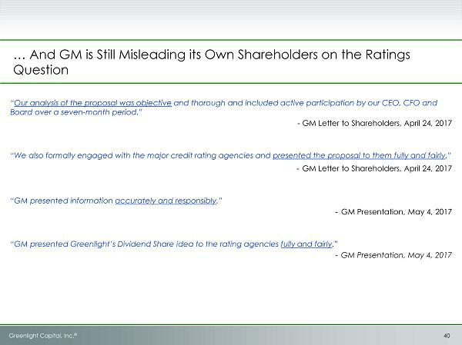

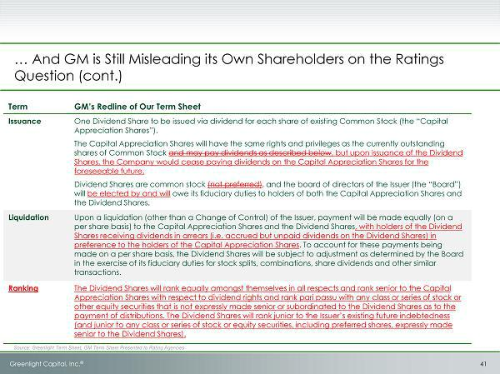

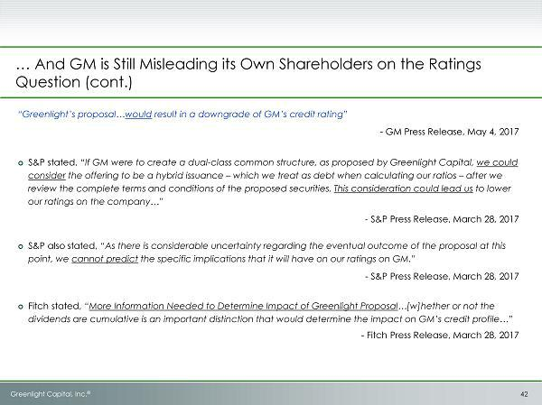

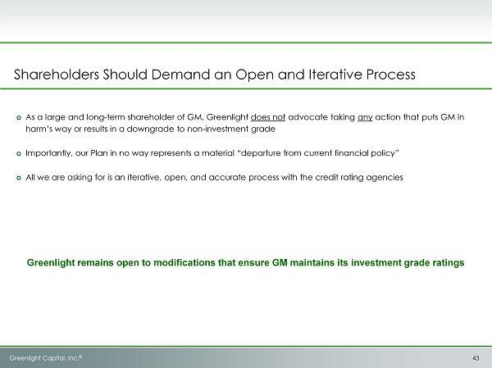

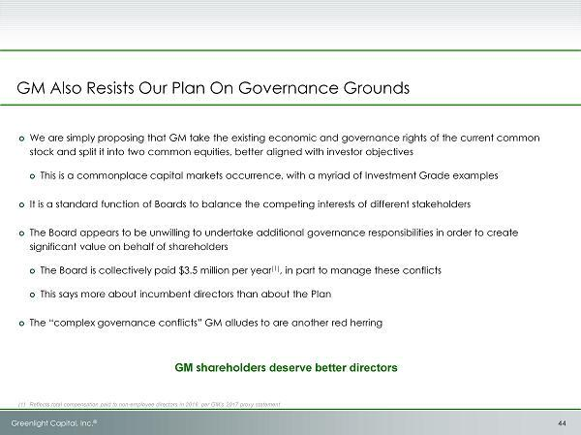

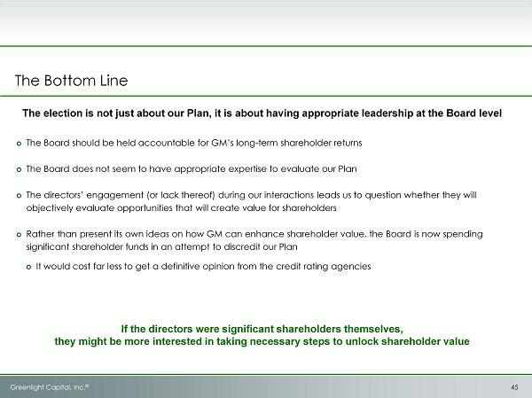

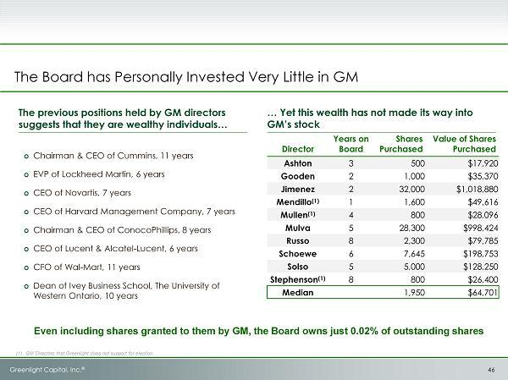

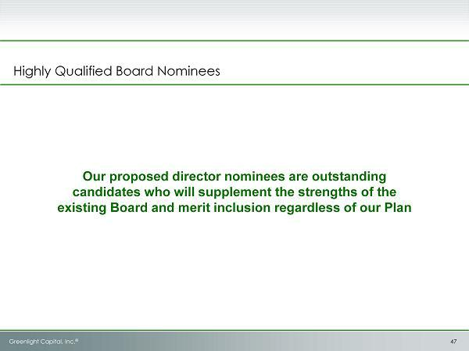

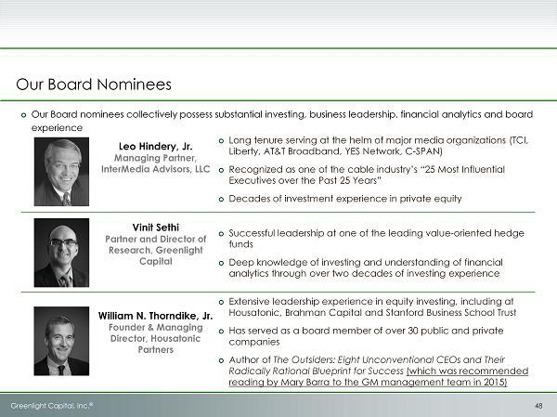

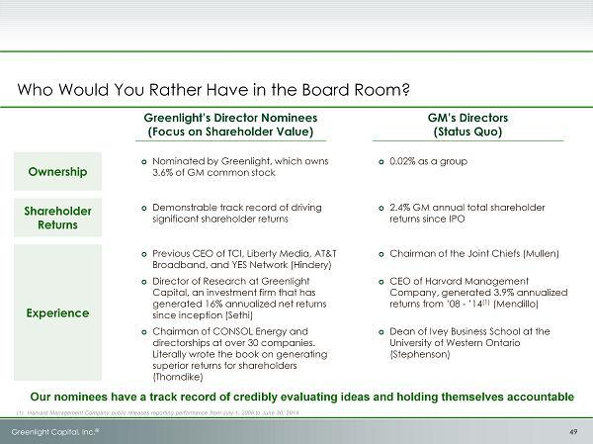

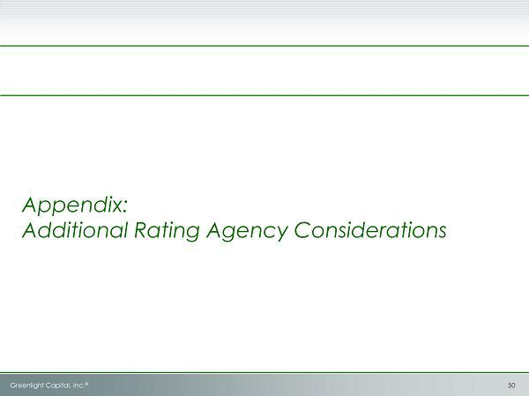

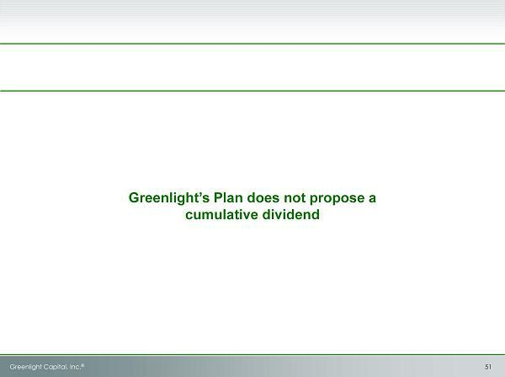

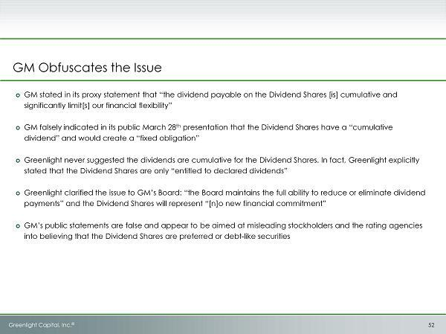

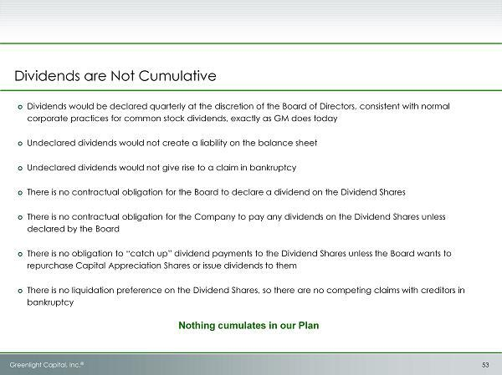

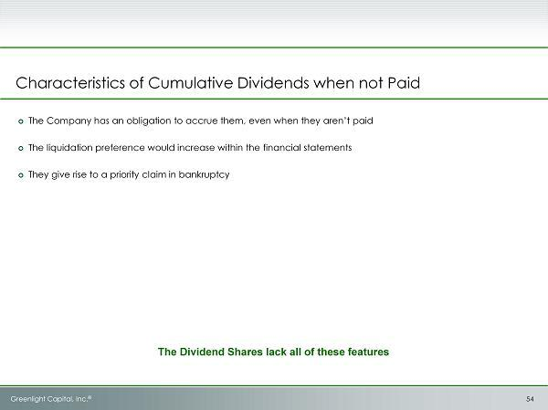

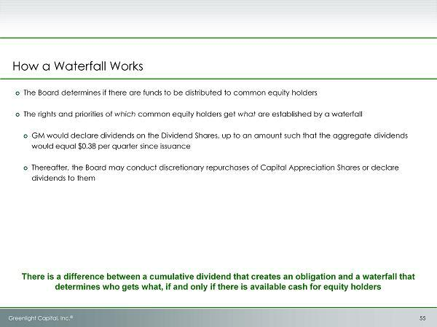

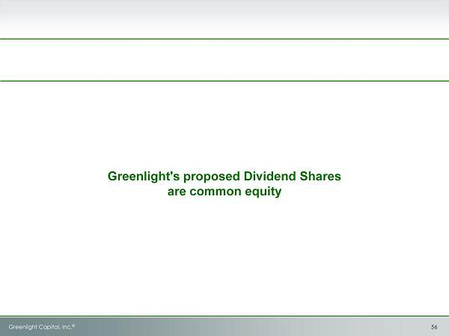

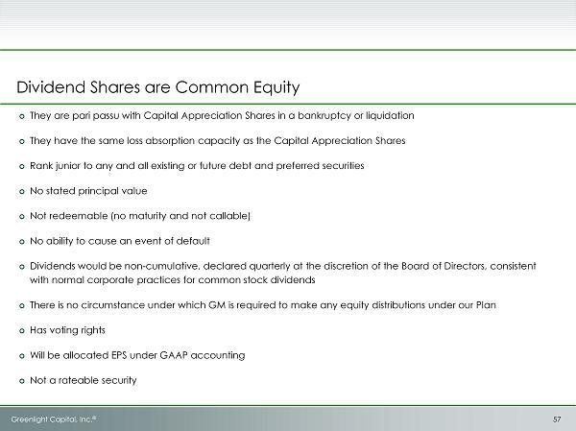

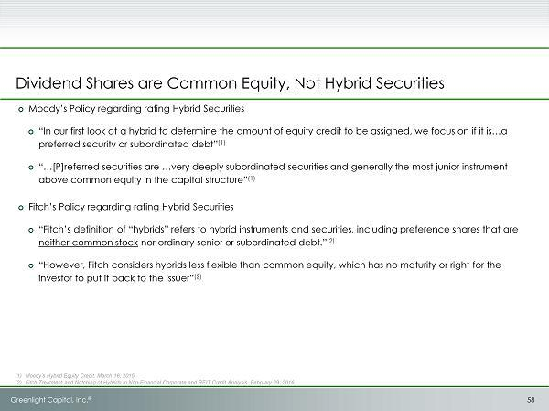

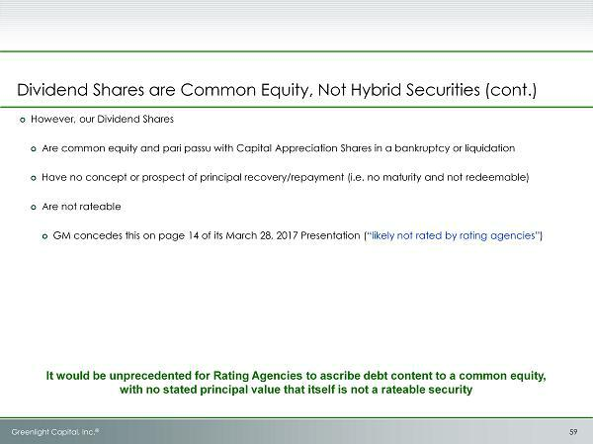

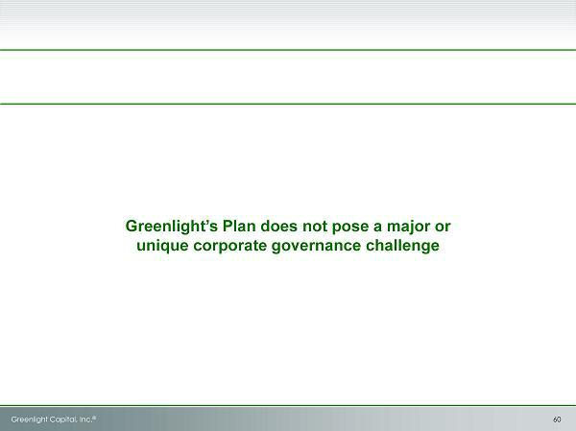

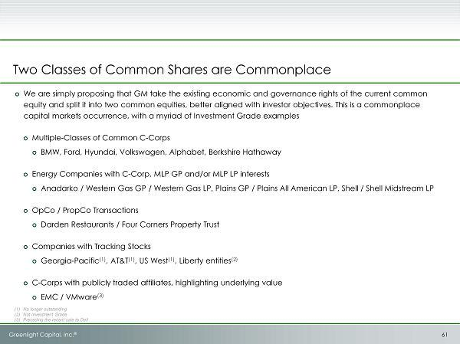

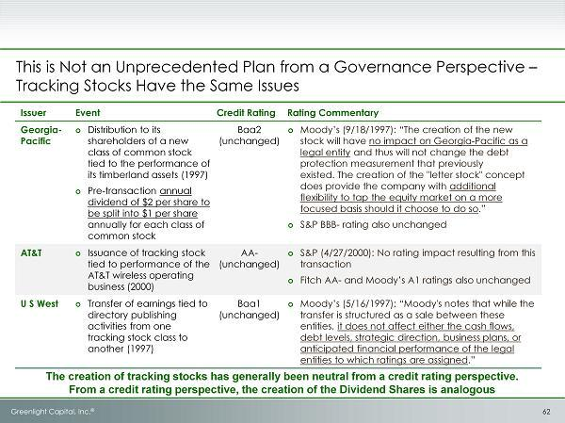

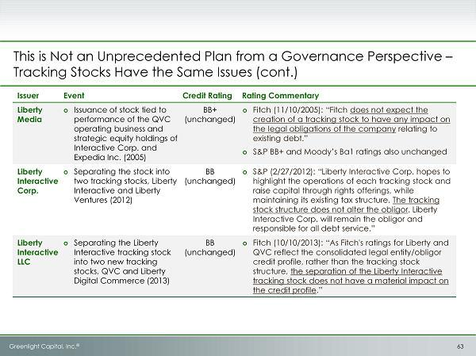

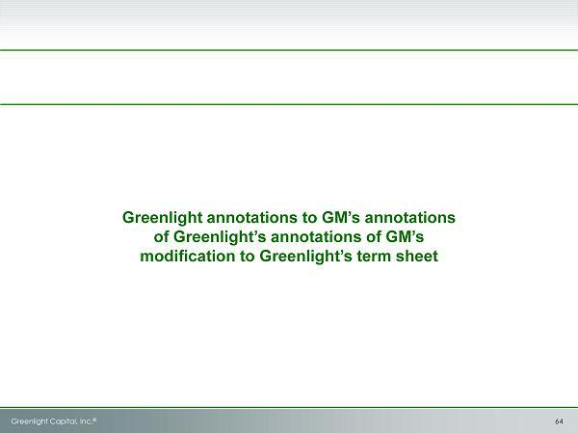

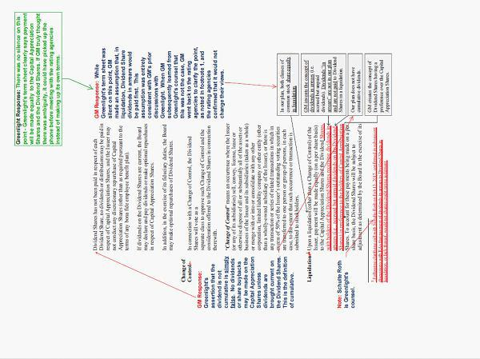

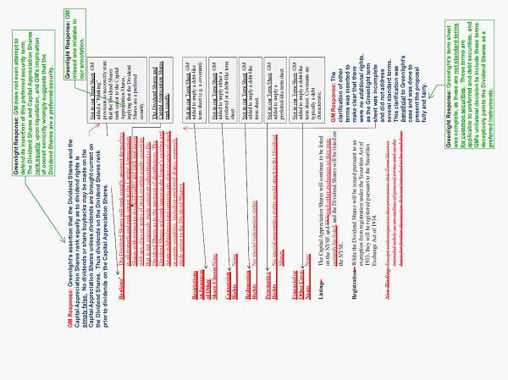

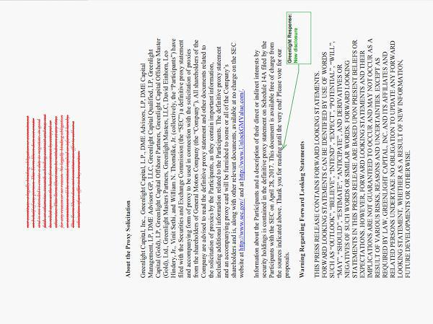

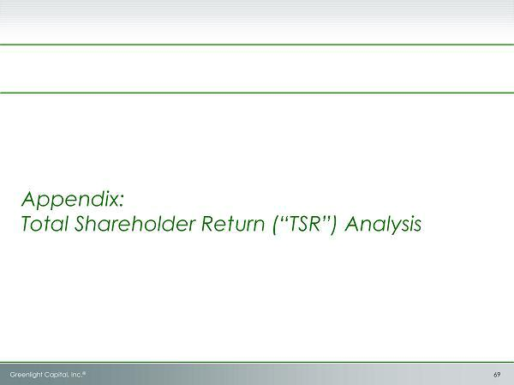

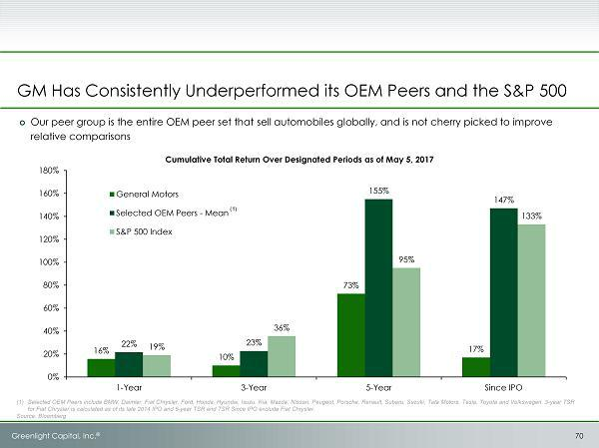

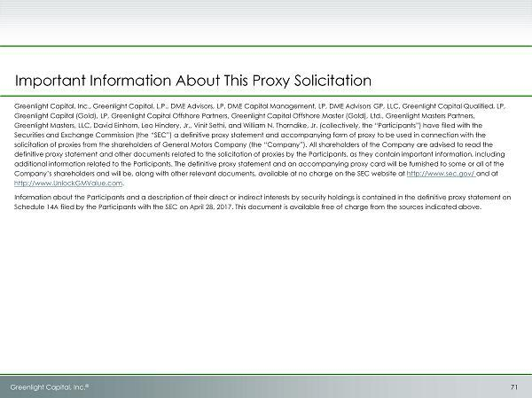

Exhibit 3

Transcript of Video Presentation

DAVID EINHORN

* * *SLIDE #1* * *

Hi, I'm David Einhorn, the president and portfolio manager of Greenlight Capital. I want to welcome you to our webcast today, where we're going to go through our reasoning for why GM can unlock a lot of value by adopting a proposal that we're recommending. We're also making some suggestions for changes to the board of directors that we think will improve GM's future and we appreciate your attention as we work through our analysis.

* * *SLIDE #2* * *

This is our disclaimer, you're welcome to read it at your leisure.

* * *SLIDE #3* * *

Greenlight Capital, as a background, is a value-oriented, research-driven investment management firm. We're long-term shareholders in the General Motors Company, or GM. We're currently the fifth largest public holder, we own 3.6% of the common stock. Our interests are aligned with yours.

I want to begin by explaining our thesis for owning GM. We think that GM is a terrific company that generates attractive cash flows and profits. It's particularly well situated in North America, where it has a leading market position in a highly profitable truck, SUV, and crossover markets, which are taking share from the less-profitable sedan business.

We think the company has upcoming a multi-year period of strong new product introductions, which will drive price and mixed benefits, which will lead to even higher profits. GM also has a strong and valuable business in China, which is still a growth market. There are parts of GM that are losing money today, and those earnings drags can be removed or fixed.

GM has demonstrated success in doing thought already in Europe, Russia, Australia, Korea, Thailand, and Indonesia. And there's opportunity for further earnings growth by fixing or closing or changing the unprofitable parts of GM. Finally, we think that investors are overestimating the risk to GM in a down cycle.

We think that the business has become much more a variable cost than the market appreciates, and we believe that earnings will hold up better than many suspect, even in a downturn. We think that the company is well situated to prosper, as the industry develops into its new technological areas of electrification, autonomous driving, and ride sharing. As a result of all of those things, we think GM is significantly undervalued.

* * *SLIDE #4* * *

Rather than waiting for an eventual down cycle to demonstrate the fundamental strength of its business, we think GM should pursue constructive steps to fix its substantial undervaluation.

* * *SLIDE #5* * *

I want to go over some of the reasons why we've become active in this stock as opposed to our normal role as a passive market participant. The stock of GM has really done lousy. Since its IPO almost seven years ago, shareholders have earned a total return of just 17%, or about 2% per year. And this is in the middle of a bull market where the average of its peers has gone up 147% and the average company in the S&P 500 has returned 133%.

Operations have done well, but GM has done a poor job on its capital structure. A few years ago, GM responded to public pressure from its shareholders and began a share repurchase program and announced its much-touted capital allocation framework.

Now, when presented with an idea to unlock billions of dollars of shareholder value, or our plan, GM's management team and board retreated into the "not invented here" mentality and retained financial advisors to discredit rather than evaluate the idea. We believe that the management team then misrepresented the plan to the credit-rating agencies. GM's other objections to our plan indicate a lack of basic corporate finance, and capital market understanding that is harming shareholders. We think, as a result, in addition to adopting our plan, GM's board needs to be enhanced to ensure it has the critical capital markets expertise and a willingness to maximize shareholder value.

* * *SLIDE #6* * *

We think that GM stock is not fairly valued today. The stock is cheap, and you must agree if you own it. The current PE multiple is just 5.4 times, which makes it the lowest in the entire S&P 500, and among the lowest of all global automotive manufacturers. The dividend yield of 4.5% is very high, but it's exceptionally high when you consider that GM only pays out 24% of its profits as dividends, which means as a practical matter, GM's dividend is not respected in the market.

* * *SLIDE #7* * *

To review, the operating performance of the company overall has been great. You can see that the EBIT has grown substantially since the IPO, and the guidance for 2017 is for another strong year.

* * *SLIDE #8* * *

But shareholders have done not so great. Here's the graph outlining how the shares have performed relative to both the auto peers and the S&P 500.

* * *SLIDE #9* * *

You can see on this slide that GM is the lowest multiple stock in the S&P 500. If you glance down the left side of the page, you'll see the Ford Motor Company, which is GM's closest competitor, trades at what is still not a rich multiple of 7.2 times. The difference between 5.4 times and 7.2 times, though, is substantial.

If we just had Ford's PE multiple, GM stock would be in the mid-40s. And on the right, you can see simply a comparison between

GM and global auto peers. Here, the company trades, on average, at about a 40% discount to the average of the other companies
that it competes with on a global basis.

* * *SLIDE #10* * *

This slide on the left shows that there's really nobody else who pays out this little and still yields this much. As I said a minute ago, the market doesn't respect GM's dividend. Nonetheless, GM has made strong public commitments to maintain the dividend through the cycle. Here are three quotes where the company has repeatedly said that it intends to pay the dividend even in a downturn. And GM is prepared to do this.

* * *SLIDE #11* * *

Here is a slide from a GM presentation from last year. You can see that basically $5 billion, or almost two years of dividends, have been set aside out of the liquidity calculation in order to pay dividends if there were a period where GM was not creating cash or profits.

* * *SLIDE #12* * *

We believe that there is a solution to unlock the value that does not affect GM's underlying operations or its financial flexibility. Our proposal is for GM to distribute, on a tax-free basis, a second class of common stock that we call the "dividend shares." The dividend shares would be entitled to today's dividend, or $1.52 per year. The dividend shares would trade separately from the existing common stock.

The existing common stock, which we call the "capital appreciation" shares would be entitled to the rest of the earnings, and all of GM's future growth. Creating two classes of common stock will unlock GM's value by forcing the market to appropriately value and respect the dividend and to give credit for GM's earnings potential.

* * *SLIDE #13* * *

Here is our proposal depicted graphically. On day one, shareholders in the tax-free distribution would receive the dividend shares, which we've labeled here as "GMD." And they would continue to own the capital appreciation shares, which we've labeled as "GM." Essentially, on day one, after the distribution, everybody has the exact same thing that they had. They have the same amount

of dividend, they have the same amount of voting, but they have two different pieces of paper. You don't need to do anything to maintain your exact position, however, if you have a preference for more income, you might decide to buy more income shares, and if you have a preference for more share repurchase and other kinds of growth, you would maintain or increase your holdings in the capital appreciation shares.

But, most importantly, by having two different ways to invest in GM's opportunity, in the investors would be attracted into General Motors whether through the dividend shares or through the capital depreciation shares. And we believe those new investors would drive up the overall value of the company.

* * *SLIDE #14* * *

We believe that our structural solution will lead to being GM being more appropriately valued in the capital markets. The dividend shares, which will be attractive to yield-oriented investors should yield, we believe, between 7 and 9%. The capital appreciation shares will be valued on a PE multiple basis, supported by projected earnings per share.

On a conservative basis, we value them at GM's current depressed PE multiple, however, we believe the multiple may expand from the current levels because equivalent stock buybacks applied to the reduced market capitalization of the capital appreciation shares will cause faster EPS growth. I'll go through that in some detail in a few slides.

* * *SLIDE #15* * *

This slide shows the proposed shares of the two different structures, the dividend shares and the capital appreciation shares. The dividend shares would be received as a tax-free distribution, one each for every GM share you have outstanding. It will be a separate class entitled to declare dividends of $1.52 per share, the same as GM's current dividend.

The company could repurchase shares if it wanted to, though we would not expect it to. These shares would have 1/10th of a share of a vote and they would vote separately as a class in a change of control transaction. We think they would have appeal to income-focused investors, and yield between 7% and 9% a share, which yields a share price of about $17 to $22 each, where we think it would trade.

The capital appreciation shares would continue their holding of existing GM stock. It will be a separate class of common stock entitled to earnings in excess of declared dividends on the dividend shares. Here, dividends would be permitted, but would not be expected. The primary beneficiary of repurchases once all dividends have been paid to the dividend shares would be the capital appreciation shares. Each one would have on vote on all matters and will be attractive to traditional equity investors of growth and value orientation, valued primarily on price/earnings multiple.

We think you could have a faster earnings growth rate as a result of the share repurchases, which would reduce the share count. We value them at $26 to $38 each. So on a combined basis, we value the dividend shares and the capital appreciation shares at $42 to $60 each.

Our plan does not affect GM's corporate strategy, but it will improve its financial flexibility. We're not advocating for any change to GM's capital allocation policy, including capital devoted to balance sheet cash, dividends, or share repurchases. We believe our solution will lower GM's cost of capital and improve its access to capital. Simultaneously, our solution will enhance value for shareholders and attract new investors to GM. We believe our plan will unlock between $13 and $40 billion of shareholder value through appropriate valuation of GM's dividend and earnings potential.

* * *SLIDE #17* * *

The new structure is relatively simple to implement. From a structural basis, there's only a few things that need to be done. The GM dividend shares will be listed on the New York Stock Exchange and the existing common stock will remain outstanding under the same ticker symbol. There will be no tax consequences or accounting consequences of concern.

It will require a charter amendment to authorized a second class of common stock approved by a majority shareholder vote. As a practical matter, we think it's important that GM maintain its credit rating. GM will need to meet formally with the rating agencies, because we think it's important for GM to maintain its credit rating. When it does so, it needs to do what's known as "advocate" for the plan to tell the rating agencies that the new structure, what it actually is, and explain how it's consistent with GM's stated financial policy and superior from a capital markets perspective. To date, GM has not done that. It has refused to explain the merits of the plan, and simply given the rating agencies a misrepresentation of our term sheet.

Our plan as we've proposed it, specifically structured to have no negative impact on GM's credit rating, and we think with an appropriate presentation to the credit rating agencies, should have no adverse impact on GM's credit rating.

* * *SLIDE #18* * *

I want to spend a few minutes talking about the value of the two different classes of stock once they're distributed through our proposal. First, I'm going to start with the dividend shares, which I want to compare to other equities that trade primarily on a yield basis.

We found two different types of equities where this is generally true. The first are master limited partnerships, which are flow-through entities, which generally pass on all the earnings involved

to shareholders. Master limited partnerships in general with a triple-B rating, which is what GM's rating is, yield about 6 to 6.5%. And high-quality junk issuers with double-B ratings yield about 7.5 to 8.5%. The main difference between MLPs and what we're proposing is that MLP dividends are variable, so they're more dependent on the underlying company's financial performance, which gives them both more upside and more downside than what we're suggesting.

A second type of entity that trades in the market that is very similar to what we're proposing are so-called "propcos" and triple-net REITs. These are companies which receive fixed streams of payments from particular companies as a portion of those companies' profits in order to pay rent. Those rents are then passed on, and investors value them based on their yields.

Generally speaking, yields in these areas are about 5-6%. We think that the GM dividend shares would need a yield than propco shares because the propco shares have some ability to grow over time, while the GM dividend shares would receive only a steady stream of payments. As we take that into account--

* * *SLIDE #19* * *

--another thing we wanted to look at in valuing the dividend shares is the current 5.5% yield to maturity on GM's 30-year senior unsecured notes. The senior notes, obviously, are "senior" to the GM dividend shares. They also have a slightly shorter duration as the dividend shares have no maturity date.

And they also eventually have a final payment, whereas the GM dividend shares have no liquidation preference. As a result of those three differences, the GM dividend shares need to yield more than a bond investor would receive, and we show a bridge here with two potential sets of assumptions.

The more aggressive assumption starts with the 5.5% bond yield, adds 25 basis points, or 0.25% for the fact that the security has no maturity, 1% for its subordination and the risk that the dividends are less likely to be paid, and finally, another 0.25% due to the fact that there is no final payment or there's no liquidation preference in the case of a change of control or a bankruptcy. This yields implied total yield for the dividend securities at 7%. The right side is the same bridge, it just uses more conservative assumptions, and yields a conclusion of about 9%. This is, obviously, a premium to both the NLPs and the propcos that we talked about on the prior slide.

* * *SLIDE #20* * *

We believe our solution will lead GM to being more fairly valued in the capital markets. The dividend shares will be attractive to yield investors. Our work indicates that they will trade at a 7-9% yield, and as you look at the math on that, that implies between $16.89 and $21.71 per share.

* * *SLIDE #21* * *

Now I want to talk about the value of the capital appreciation shares. We believe they'll be valued on a PE multiple basis, and we value them conservatively in our base case at GM's current depressed 5.4 times 2017 PE. However, planned buybacks would buy more capital appreciation shares than today's common stock due to the reduced absolute share price.

* * *SLIDE #22* * *

So let's go through some of the math on that. The table on slide 22 shows that GM would have buyback capacity between 2017 and 2018 of $12.4 billion. Already, this year in 2017, the company has said it would buy back $5-billion worth of stock, next year, there should be a little bit more because there will be free cash flow or a lack of a cash burn from the European divestiture, and the company said once the European business is sold, there will be $2 billion available for buybacks.

Adding that together between the two years is how we get to the $12.4 billion that would be available for the buybacks. Now, GM has said that Greenlight's proposal would not increase value for shareholders. Now, they've never shared their valuation with us or with the investing public. So it's very hard to understand where they're getting their math to support that conclusion. However, for the moment, let's presume that GM's claim is accurate.

* * *SLIDE #23* * *

This slide shows the impact of $12.4 billion of share repurchases over the next two years under three different scenarios. The scenario on the left is the status quo that's just GM as it is now doing what it's doing. The middle column assumes that GM is right for the sake of discussion, that the Greenlight plan would not unlock any value.

So what we've done here is we've taken out $19 per share for the GM dividend shares and come up with an implied valuation for the capital appreciation shares of $14.77. The third column reflects what we would call our low case, or our base case, where the capital appreciation shares initially trade at the same PE as GM stock does today, just post-distribution.

You can see the impact of the smaller market capitalization in the three different scenarios. In the status quo case, the $12.4 billion would be enough to repurchase 24% of the stock outstanding. Ultimately, that would yield $7.57 of earnings per share in 2019, leaving the stock at a 4.5 PE on those earnings.

In the implied value case of $14.77, 55% of the stock would be repurchased. Even after taking out the dividends, you would still have $6.5 billion of net income in 2019, and on the reduced share count, that would imply $9.39 for the remaining GM capital appreciation shares, which means that they were effectively being valued at only 1.6 times earnings. Now, in our base case, there's enough money at $12.4 billion to repurchase 32% of the stock. And working down

the table using the same math, you can see that the earnings per share in 2019 would be $6.20, or 4.1 times. Both of the earnings on the right columns are after the dividend shares, so whatever value you want to place on the capital appreciation shares is in addition to whatever value you have on the dividend shares.

* * *SLIDE #24* * *

When you look at this math, you have to see that GM is wrong. The value of the shares should go up under our plan. The market simply won't let GM buy back 55% of the capital appreciation shares in less than two years at 1.6 times earnings. The market probably won't let GM buy back 32% of the capital appreciation shares at 4.1 times either. Which is why we think in the base case it's likely that we will have multiple expansion and even higher values than what we are showing at the low end of our range.

* * *SLIDE #25* * *

A more effective buyback will accelerate the EPS growth and result in a higher PE. Here, we wonder what will happen if the capital appreciation shares trade all the way up towards a pure multiple of some of the lower multiple companies in the industry like Nissan, Ford, Hyundai, and Mazda are about seven times. You get about $33 dollars for the capital appreciation shares. In order to achieve a more premium multiple of, say, eight times, you'd have $37.84 for the capital appreciation shares.

* * *SLIDE #26* * *

The combined value of the dividend shares and the capital appreciation shares leads to a significant price appreciation compared to the current share price of $33.77. And here we're showing a table of the total value that would be delivered to GM shareholders under our plan, ranging from $42.45 to $59.55, or 26% to 76% up side.

* * *SLIDE #27* * *

We think one of the most attractive parts of our plan is that it's minimally invasive to GM. You get a lot of value for very little change. GM is able to implement its exact current operational strategy as we don't require any change in its operations. It also leaves its communicated financial policy intact relative to capital allocation priorities previously communicated by management.

They've wanted to maintain an investment-grade balance sheet, a lot of cash to pay dividends in a downturn, to invest in their business, to pay $1.52 a share in dividends, to return all additional free cash flow to shareholders after those dividends, and then share repurchase $5 billion of stock. None of that is affected in our plan.

* * *SLIDE #28* * *

So why are management and the board rejecting an idea that doesn't change the business, unlocks significant value, and increases strategic and financial flexibility?

* * *SLIDE #29* * *

We think that the opposition that they've explained for the reasons they're against our plan are meritless. We've presented our idea to management and the company's financial advisors last year in September and October. We believe the idea was rejected as a result of a "not invented here" culture, coupled with the belief that it was unprecedented.

This led to flawed assumptions and analysis put forward by the company's financial advisors designed to discredit, rather than evaluate our idea. GM's management and the board laid out the following objections to our plan. First, they said it does not address the fundamental factors driving GM's valuation. Essentially, they're saying if it doesn't solve all of our problems, why do something that only solves some of our problems? The second objection is that it would result in a loss of GM's investment-grade credit rating.

I've mentioned that before, and I'm going to talk about that some more in a moment. Third, that it's unprecedented and could result in a lower share price. I already showed why this is rather unlikely. GM has never provided any math to support the view that you would have a lower share price. And, finally, that it creates governance conflicts. I'll come back to that in a few minutes.

* * *SLIDE #30* * *

GM says that the fundamental factors driving GM's valuation are not addressed by Greenlight's proposed financial engineering. We, obviously, disagree. But this leads to a broader question: What is GM doing proactively to address its persistent low valuation?

* * *SLIDE #31* * *

GM is literally waiting for the next down cycle. Their attitude is that nothing can be done about the undervalued share price for several more years because investors need to witness the company's performance in the next downturn before they can adapt a more favorable attitude toward the stock.

GM is comfortable with the status quo, and the resultant undervaluation of the stock. Our view is different. We think that long-term shareholders shouldn't have to be so patient. We believe our plan will unlock the latent value immediately. We think GM should proactively address its inefficient capital structure.

* * *SLIDE #32* * *

This slide depicts some of GM's spin to convince shareholders to vote for the status quo. They talk about their strong track record of value creation and sustainable long-term value for shareholders, a board with the expertise necessary to drive shareholder value, delivering higher growth and higher value for shareholders.

The problem with all of this language is that since GM has been public for seven years, none of these things have happened. That GM thinks that shareholders have been rewarded demonstrates that change is needed. They've also used the following language regarding our plan to scare shareholders.

Would lead to a loss of GM's investment credit rating, risky financial engineering experiment. Greenlight's proposal to eliminate the dividend on your existing common stock. This one is particularly egregious, it's false. The moment you have a distribution under our plan, you'll have a dividend share and you'll have a capital appreciation share and you'll have the same dividend that you do today. And, finally, that it would pose serious risks for the value of your investment. They give no analysis explaining why the shares would fall. The math supports our proposal.

* * *SLIDE #33* * *

I want to address their comment that our proposal is simply an experiment in financial engineering. A few years ago, we proposed Apple distribute "iPrefs" to its shareholders to reduce its cost of capital, unlock shareholder value within the context of existing constraints set by the management at the board.

At the time, Apple had $137 billion in cash, no debt, traded at a seven PE. Their capital return constraints at the time were that the majority of the cash was held offshore, there was a strong corporate philosophy to not incur indebtedness. After studying our idea, Apple's management chose not to pursue the issuance of iPrefs, however, instead, it compromised on one of its previous constraints and in April 2013, began accessing the fixed-income market by issuing debt, allowing it to significantly increase the release of capital to shareholders.

In the four years since then, Apple's issued $100 billion in low-cost debt, and returned over $200 billion to shareholders through share repurchases and dividends. Apple's created significant value for continuing shareholders by retiring almost 25% of its shares at an average of $97 each, which has contributed to its 154% return since our proposal. Apple successfully reduced its high cost of capital, and now has a more reasonable 13-times PE multiple net of cash. On behalf of shareholders, after our efforts, Apple solved its cost of capital conundrum.

* * *SLIDE #34* * *

Today, we believe GM has too high a cost of capital and can do something about it. The benefits of having a lower cost of capital are real. Having more access to capital, here you'll have two securities instead of one, which means GM has two different ways to raise funds if it needs them for growth, for acquisitions, for investment.

It creates an incremental investment capacity better access to capital allows the company to pursue whatever strategy it needs to at a lower cost to shareholders. And, finally, having a greater market cap junior to debt securities is actually a cushion to debtholders and is one reason why we believe that our proposal is actually credit positive. Instead of waiting for the next down cycle, we think GM should be working to lower its cost of capital.

* * *SLIDE #35* * *

And these thoughts are not just hypothetical. GM needs to make investments in new technologies for electrification, for autonomous driving, for ride sharing, including having a currency for acquisitions. Last year, GM bought Cruise Automation. Half of the purchase price was paid for in very cheap stock. A higher-valued stock would allow GM to pursue opportunities like this, which are essential for GM's strategic future with less dilution for shareholders.

Finally, something like the GM dividend shares could be a great way to fund the pension without levering the balance sheet or adding enormous fixed charges. Improving on the lowest valuation in the S&P 500 will reduce shareholder pressure to leverage the balance sheet to drive common equity returns. And that's an important point. Our proposal allows GM to keep all of its cash, all of its financial resources available under its current strategy to pursue whatever challenges and opportunities it faces.

* * *SLIDE #36* * *

Let's come back to the credit rating issue. GM's management seems pleased obtaining negative credit-rating commentary to avoid dealing with our plan. But as shareholders, you should be outraged.

* * *SLIDE #37* * *

GM has been either unable or unwilling to understand the essence of our plan. Accordingly, it has been unable or unwilling to accurately explain the plan to the credit-rating agencies. If we, or frankly pretty much any Fortune 100 management team, were explaining this plan to the agencies, we'd have no problem obtaining comfort that GM would remain an investment-grade credit following the implementation of the plan.

The reasons are quite simple: The plan represents no change to or departure from GM's existing financial policy. The new security being created is an unratable common stock, which means that it's not a hybrid. It also doesn't create a large fixed-charge burden. The plan merely represents an efficient structure of the claims among equity holders.

* * *SLIDE #38* * *

In evaluating our proposal, we think GM has hid behind the credit-rating agencies rather than fairly and objectively sought their opinion as to the impact on GM's creditors. During our interactions with management, we asked for permission to engage the multiple credit-rating agencies directly in a formal process at our own expense. GM has repeatedly refused this request.

GM then interacted with the rating agencies and refused to answer substantive questions we had about that process. Not only did they never approach the rating agencies with advocacy for our plan, but we believe they engaged in a manner intended to elicit a negative response. Subsequently, we learned that GM had substantially modified our term sheet before sharing it with the rating agencies. Shareholders should ask why if GM was confused by our terms, it did not ask us for clarification, rather than unilaterally modify the term sheet and give it to the rating agencies.

* * *SLIDE #39* * *

Interestingly, GM is telling one story to the rating agencies and a different story to GM shareholders. To the rating agencies, they've emphasized that the dividend shares have down-side protection at the expense of creditors. This is one of the key reasons why the rating agencies have concern.

But to the shareholders, they say, quote, "The proposed dividend share slack both earnings up side participation and down side protection." The reality of our plan is the creditors are no worse off post distribution. GM has no legal obligation to make any payment to any equity holder ever. The only thing our plan does, it decides if and only if there's money to be distributed to equity holders, who gets what. Dividend shareholders would receive $1.52 in annual dividends, and capital appreciation shareholders would receive the rest, whether through dividend or through share repurchase. Our plan is merely an efficient allocation of value among equity constituents to increase the total value.

* * *SLIDE #40* * *

And here are some quotes from GM to the shareholders about the rating question that we think are quite misleading. They say that the analysis and the proposal was objective and thorough and included active participation by the CEO, CFO, and board over a seven-month period. They formally engaged with the major credit-rating agencies and presented the proposal to them fully and fairly.

GM presented the information accurately and responsibly. GM presented Greenlight's dividend share idea to the rating agencies fully and fairly. If the purpose was to present our plan fully, fairly, and objectively, you have to ask, "Why did they feel the need to modify the term sheet?"

* * *SLIDE #41* * *

Rather than work collaboratively with us, GM made 13 changes to our term sheet. The goal was, clearly, to convince the rating agencies that the dividend shares were debt or hybrid or had large fixed charges or cumulative obligations or that they were senior to the capital appreciation shares.

None of those things are true. But GM changed our terms sheet to lead the rating agencies to the incorrect conclusion. I'm not going to belabor the changes. There's three of them that are highlighted on this particular slide that are the most important.

* * *SLIDE #41* * *

And GM also overstates what the rating agencies have actually said. In their press release, they say, "Greenlight's proposal would result in a downgrade of GM's credit rating." But when you look at what the credit-rating agencies have actually said in their press releases, S&P said, "If GM were to create a dual-class common structure, as proposed by Greenlight Capital, we could consider the offering to be a hybrid issuance, which we'd treat as debt when calculating our ratios."

"After we review the complete terms and conditions of the proposed securities, this consideration could lead us to a lower rating on the company." They also stated, "As there is considerable uncertain regarding the eventual outcome of the proposal at this point, we cannot predict the specific implications that it will have on our rating on GM." Fitch was even more ambiguous. They said, "More information needed to determine the impact of Greenlight proposal. Whether or not the dividends are cumulative is an important distinction that would determine the impact on GM's credit profile."

Moody's for its part, demonstrated the lowest level of understanding of our proposal, thinking it creates a large fixed-charge obligation, and is a significant departure from GM's financial policy. A better presentation by management with advocacy should help Moody's understand that neither of those things are true. Altogether, when GM concludes, summarily, that our idea would result in a downgrade of GM's credit rating, it is overstating the risk.

* * *SLIDE #42* * *

Shareholders should demand an open and iterative process. We are large, long-term shareholders of GM. We don't advocate taking any action that puts GM in harm's way or results in the downgrade to a below-investment-grade credit rating. Importantly, our plan in no way represents a material departure from financial policy. All we're asking for is an iterative, open, and accurate process with the credit-rating agencies. Notably, the agencies did not go through a formal committee process.

This could be done at relatively low cost with GM's consent and were they to do so, with our participation, we would know once and for all where the credit-rating agencies stand. Should that process happen, and it was determined that small modifications to our plan would better protect GM creditors, we would be open to making those kinds of modifications because the goal here is to unlock the most value possible without doing any harm to any of GM's constituents.

* * *SLIDE #43* * *

GM also objects to our plan on corporate governance grounds. What we're simply proposing is that GM take the existing economic and governance rates of the current common stock and split it into two common equities better aligned with investor objectives. This is commonplace in capital markets occurrence with a myriad of investment-grade examples. It is a standard function for boards to balance the competing interests of different stakeholders, be they regulators, customers, suppliers, workers, management, creditors, or equity holders.

Here, the board appears unwilling to undertake additional governance responsibilities in order to create significant value on behalf of shareholders. Now, this board's paid $3.5 million a year to manage these conflicts. I think their unwillingness to do so says more about the incumbent directors than it does about the plan. We think that this corporate governance issue, the fact that they raise it in this fashion, simply means that we need different directors who are willing and able to engage in the basic responsibility of directors.

* * *SLIDE #44* * *

The bottom line is this election for the board is not just about our plan, it's about having appropriate leadership at the board level. The board has not shown a willingness to hold anyone accountable for GM's long-term poor shareholder performance. The board does not seem to have appropriate expertise to evaluate our plan, and their engagement, or lack thereof, during our interactions leads us to question whether they will objectively evaluate other opportunities that could create value for shareholders.

Rather than present its own ideas on how GM can enhance shareholder value, the board is now spending significant funds in an attempt to discredit our plan. It would cost far less to get a definitive opinion from the credit-rating agencies. If the directors were significant shareholders themselves, they might be more interested in taking necessary steps to unlock shareholder value. But the truth is--

* * *SLIDE #45* * *

--despite large amounts of director pay, this board has bought very little GM stock. I'd highlight three directors in particular, Ms.

Mendillo, Mr. Mullen, and Ms. Stephenson. These are the three directors that we seek to replace with our own nominees.

* * *SLIDE #46* * *

We've proposed three director nominees who are outstanding candidates who will supplement the strengths of the existing board, and they merit inclusion on the board of directors regardless of our plan.

* * *SLIDE #47* * *

Our three director nominees are Leo Hindry, Jr., Vinit Sethi, and William N. Thorndike, Jr. Leo has run large, successful companies for decades. He created huge value with John Malone at major media organizations like TCI Liberty, AT&T, YES Network, and CSPAN. Vinit has been a partner of mine and is our director of research.

He's been here about 20 years. He's an incredible investor, and he has about the best knowledge and understanding of financial analysis, capital allocation, capital asset pricing theory of anybody I know. And he would be a huge addition to a company that's challenged to figure out the best way to optimize its capital structure. And Bill Thorndike is a man who essentially wrote the book on capital allocation in his book, The Outsiders, which I would commend everybody to come and read.

* * *SLIDE #48* * *

:
So the question you have is: Who would you rather have in the boardroom? Some directors nominated by shareholders with enormous economic stake in the company, with a demonstrable record of driving shareholder value and corporate returns through a large number of large corporations and over many years of investing, or a group that has minimal share holdings, has presided over seven years of minimal returns to GM shareholders, and has much less experience making investments, operating companies, or serving on boards?

Our nominees have a track record of credibly evaluating ideas and holding themselves accountable. Thank you for listening to this presentation. In addition to what I've gone through already, we have an appendix with supplemental materials, analysis, and evidence supporting our proposal and our directors. We ask you to vote for the proposal and the directors. If you do so, we're confident you'll make a lot more money on your GM investment.

* * *END OF TRANSCRIPT* * *

