SEC Form 3
FORM 3 | UNITED STATES SECURITIES AND EXCHANGE COMMISSION
 | Washington, D.C. 20549
 | Washington, D.C. 20549 |  | OMB APPROVAL
 | INITIAL STATEMENT OF BENEFICIAL OWNERSHIP OF
 | INITIAL STATEMENT OF BENEFICIAL OWNERSHIP OF |  | OMB Number: | 3235-0104
 | SECURITIES |  | Estimated average burden
 | SECURITIES |  | hours per response: | 0.5

Filed pursuant to Section 16(a) of the Securities Exchange Act of 1934
or Section 30(h) of the Investment Company Act of 1940
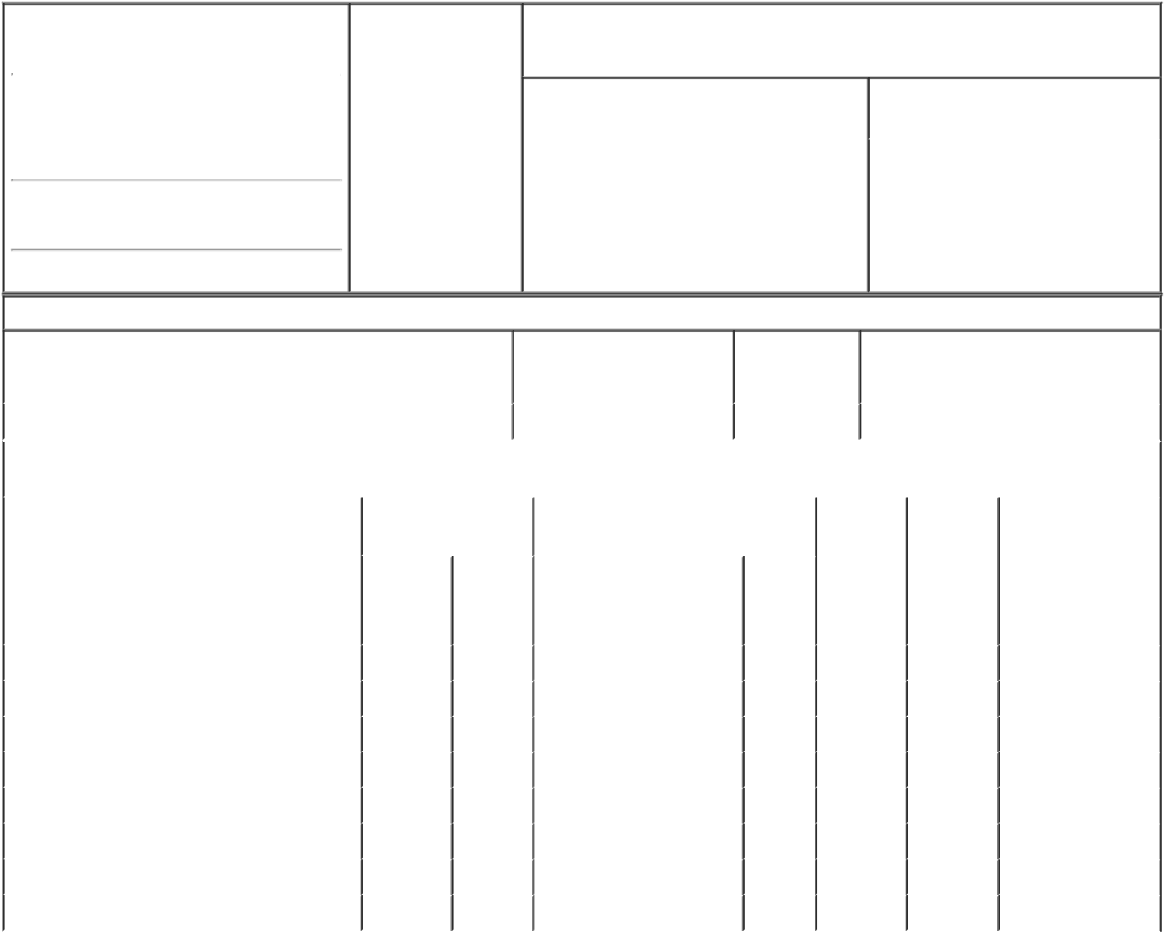

1. Name and Address of Reporting Person* |  |  |  |  |  | 2. Date of Event
 |  | Boler-Davis Alicia S |  |  |  | Requiring Statement
 |  |  |  |  |  | (Month/Day/Year)
 |  |  |  |  |  | 06/07/2016
 |  | (Last) | (First) |  | (Middle)
 |  | 300 RENAISSANCE CENTER

M/C: 4820C23-D24

(Street)

DETROIT MI 48265-3000

3. Issuer Name and Ticker or Trading Symbol

General Motors Co [ GM ]

4. Relationship of Reporting Person(s) to Issuer |  |  | 5. | If Amendment, Date of Original Filed
(Check all applicable) |  |  | (Month/Day/Year)
 | Director | 10% Owner
X | Officer (give title | Other (specify
X | Officer (give title | Other (specify | 6. | Individual or Joint/Group Filing (Check
X | below) | below) | 6. | Individual or Joint/Group Filing (Check
 | below) | below) | Applicable Line)
 | Executive Vice President
 |  |  |  | X Form filed by One Reporting Person

Form filed by More than One
Reporting Person

(City) (State) (Zip)

Table I - Non-Derivative Securities Beneficially Owned

1. Title of Security (Instr. 4) | 2. Amount of Securities | 3. Ownership | 4. Nature of Indirect Beneficial Ownership
 | Beneficially Owned (Instr. 4) | Form: Direct (D) | (Instr. 5)
 |  | or Indirect (I)
 |  | (Instr. 5)

 | Common Stock |  |  |  | 10,531 | D
 |  |  | Table II - Derivative Securities Beneficially Owned
 |  | (e.g., puts, calls, warrants, options, convertible securities)
 | 1. Title of Derivative Security (Instr. 4) |  | 2. Date Exercisable and |  | 3. Title and Amount of Securities |  | 4. | 5. | 6. Nature of Indirect
 |  |  | Expiration Date |  | Underlying Derivative Security (Instr. 4) |  | Conversion | Ownership | Beneficial Ownership
 |  |  | (Month/Day/Year) |  |  |  | or Exercise | Form: | (Instr. 5)
 |  |  |  |  |  |  | Price of | Direct (D)
 |  |  |  |  |  | Amount | Price of | Direct (D)
 |  |  |  |  |  | Amount | Derivative | or Indirect
 |  |  |  |  |  | or | Security | (I) (Instr. 5)
 |  |  |  |  |  | Number
 |  |  | Date | Expiration |  | of
 |  |  | Exercisable | Date | Title | Shares
 | Restricted Stock Units⁽¹⁾⁽²⁾ | (1) |  | (1) | Common Stock | 58,191 | (1) | D
 | Restricted Stock Units⁽³⁾⁽⁴⁾ | (3) |  | (3) | Common Stock | 735 | (3) | D
 | Restricted Stock Units⁽³⁾⁽⁵⁾ | (3) |  | (3) | Common Stock | 4,010 | (3) | D
 | Restricted Stock Units⁽³⁾⁽⁶⁾ | (3) |  | (3) | Common Stock | 9,023 | (3) | D
 | Salary Stock Units⁽⁷⁾⁽⁸⁾ | (7) |  | (7) | Common Stock | 1,152 | (7) | D
 | Salary Stock Units⁽⁷⁾⁽⁹⁾ | (7) |  | (7) | Common Stock | 1,066 | (7) | D
 | Salary Stock Units⁽⁷⁾⁽¹⁰⁾ | (7) |  | (7) | Common Stock | 939 | (7) | D
 | Employee Stock Option⁽¹¹⁾ | (11) |  | (11) | Common Stock | 196,573 | 31.32 | D
 | Explanation of Responses:

- The Restricted Stock Units ("RSUs") reported in this item were awarded under the General Motors Company 2009 Long-Term Incentive Plan (the "2009 GMLTIP"). Each RSU represents a right to receive one share of the Company's Common Stock upon settlement. The RSUs do not have an expiration or exercise date or carry a conversion or exercise price. RSUs are settled when they vest provided that all the conditions in the 2009 GMLTIP have been satisfied.

- The RSUs reported in this item were awarded on March 31, 2014 pursuant to the 2009 GMLTIP and will vest on March 31, 2017, provided that the Reporting Person remains continuously employed through the vesting date.

- The RSUs reported in this item were awarded under the General Motors Company 2014 Long-Term Incentive Plan (the "2014 GMLTIP"). Each RSU represents a right to receive one share of the Company's Common Stock upon settlement. The RSUs do not have an expiration or exercise date or carry a conversion or exercise price. RSUs are settled when they vest provided that all the conditions in the 2014 GMLTIP have been satisfied.

- The RSUs reported in this item were awarded on June 11, 2014 pursuant to the Company's 2014 GMLTIP and will vest on February 13, 2017, provided that the Reporting Person remains continuously employed through the vesting date.

- The RSUs reported in this item were awarded on February 11, 2015 pursuant to the Company's 2014 GMLTIP. Of these RSUs, 2,005 will vest on February 11, 2017, and 2,005 will vest on February 11, 2018, provided that the Reporting Person remains continuously employed through the vesting date.

- The RSUs reported in this item were awarded on February 10, 2016 pursuant to the Company's 2014 GMLTIP. The RSUs will vest annually in three equal installments beginning on February 10, 2017 pursuant to the terms of the GMLTIP. Upon vesting, each RSU will be settled by delivery of one share of the Company's Common Stock.

- Salary Stock Units ("SSUs") are awarded under the General Motors Company Salary Stock Plan. Each SSU is the economic equivalent of one share of the Company's Common Stock. Grants of SSUs are fully vested when made and will be settled in three equal, annual installments beginning one year after the date of grant. The GMSSP gives the employee the option of having a settlement made by delivery of Stock or of cash in an amount equal to the fair market value of the Stock as of the applicable anniversary date of the SSUs' grant. Under the GMSSP, the fair value of the Stock is the average of the high and low trading prices for the Stock as reported on the New York Stock Exchange, on which it is listed, on the date of the transaction. SSUs do not have an exercise or expiration date or an exercise or conversion price.

- The SSUs reported in this item were granted on June 30, 2013 and will be settled on June 30, 2016.

- The SSUs reported in this item were granted on September 30, 2013 and will be settled on September 30, 2016.

- The SSUs reported in this item were granted on December 31, 2013 and will be settled on December 31, 2016.

- The stock options were granted on July 28, 2015 under the 2014 GMLTIP and vest as follows: 40% on February 15, 2017; 20% on February 15, 2018 upon meeting or exceeding the median Total Shareholder Return ("TSR") of the original equipment manufacturers, other than GM, as of the grant date in the Dow Jones Automobiles and Parts Titan 30 Index ("OEM Peer Group") for the period July 28, 2015 through December 31, 2017; 20% on February 15, 2019 upon meeting or exceeding the median TSR of the OEM Peer Group for the period July 28, 2015 through December 31, 2018; and 20% on February 15, 2020 upon meeting or exceeding the median TSR of the OEM Peer Group for the period July 28, 2015 through December 31, 2019.

Remarks:

/s/ Robert W. Boyle, Jr., | 06/17/2016

Attorney-In-Fact for Ms.
Boler-Davis

** Signature of Reporting Person Date

Reminder: Report on a separate line for each class of securities beneficially owned directly or indirectly.

* If the form is filed by more than one reporting person, see Instruction 5 (b)(v).

- Intentional misstatements or omissions of facts constitute Federal Criminal Violations See 18 U.S.C. 1001 and 15 U.S.C. 78ff(a). Note: File three copies of this Form, one of which must be manually signed. If space is insufficient, see Instruction 6 for procedure.
Persons who respond to the collection of information contained in this form are not required to respond unless the form displays a currently valid OMB Number.



