SEC Form 3
FORM 3 | UNITED STATES SECURITIES AND EXCHANGE COMMISSION
 | Washington, D.C. 20549
 | Washington, D.C. 20549 |  | OMB APPROVAL
 | INITIAL STATEMENT OF BENEFICIAL OWNERSHIP OF
 | INITIAL STATEMENT OF BENEFICIAL OWNERSHIP OF |  | OMB Number: | 3235-0104
 | SECURITIES |  | Estimated average burden
 | SECURITIES |  | hours per response: | 0.5

Filed pursuant to Section 16(a) of the Securities Exchange Act of 1934
or Section 30(h) of the Investment Company Act of 1940
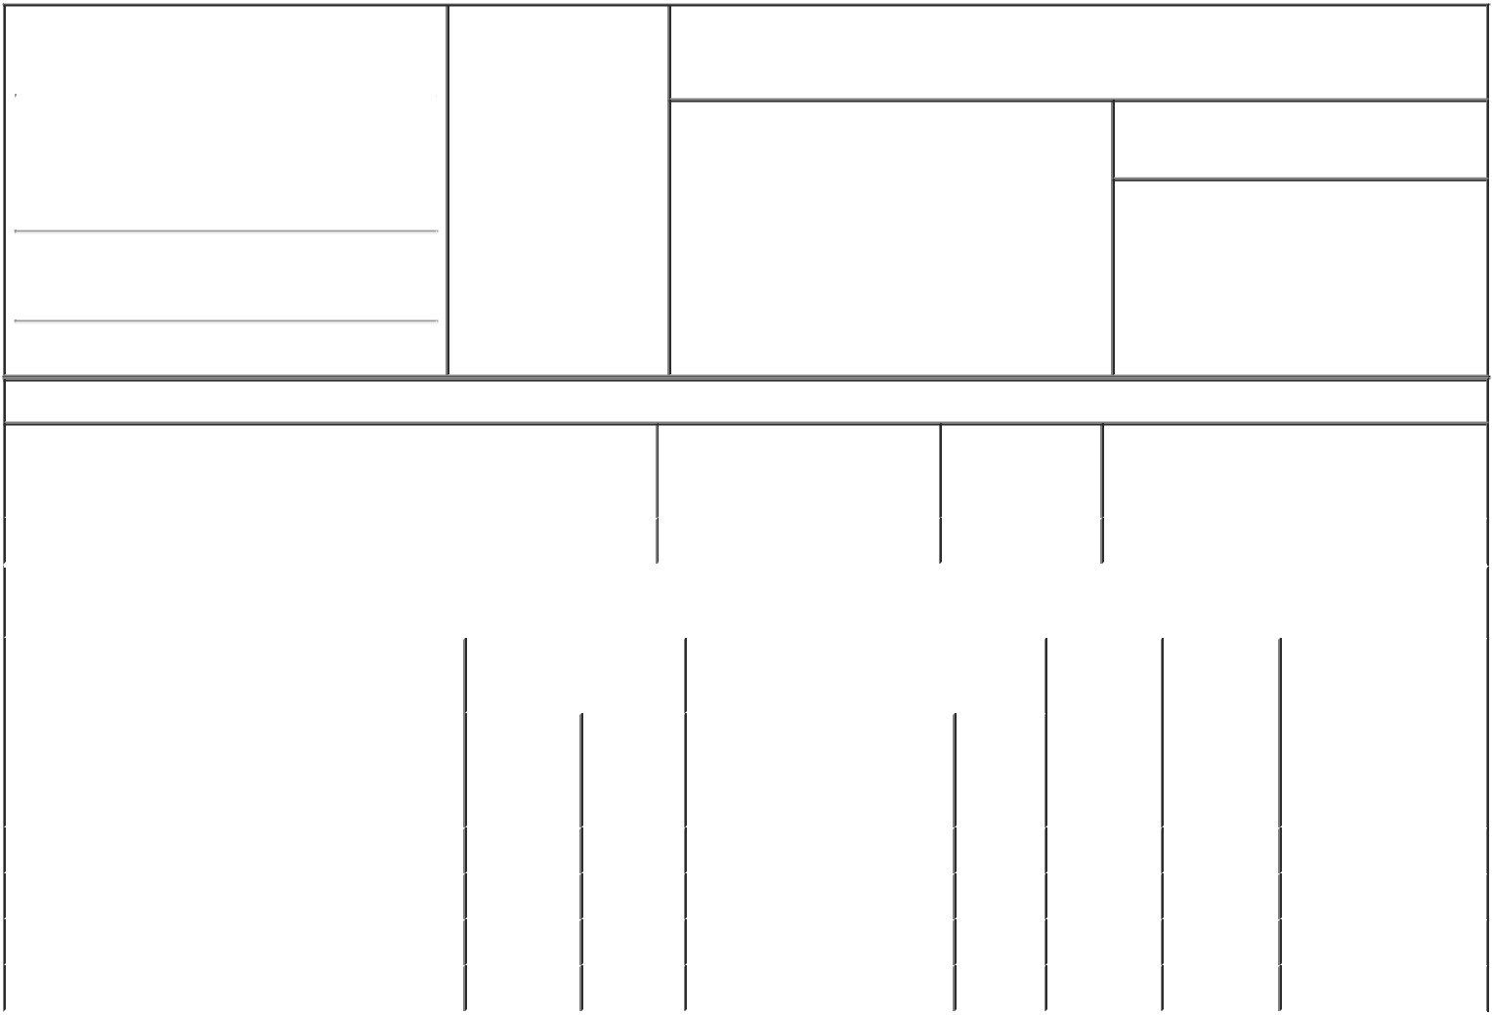

1. Name and Address of Reporting Person* |  |  |  | 2. Date of Event
 |  | Suryadevara Dhivya |  | Requiring Statement
 |  |  |  | (Month/Day/Year)
 |  |  |  | 09/01/2018

3. Issuer Name and Ticker or Trading Symbol

General Motors Co [ GM ]

(Last) (First) (Middle)

300 RENAISSANCE CENTER

M/C: 482-C23-A68

(Street)

DETROIT MI 48207

- Relationship of Reporting Person(s) to Issuer (Check all applicable)

 | Director | 10% Owner
X | Officer (give title | Other (specify
X | below) | below)

Executive Vice President & CFO

- If Amendment, Date of Original Filed (Month/Day/Year)

- Individual or Joint/Group Filing (Check Applicable Line)

- Form filed by One Reporting Person

Form filed by More than One Reporting Person

(City) (State) (Zip)

Table I - Non-Derivative Securities Beneficially Owned

1. Title of Security (Instr. 4) | 2. Amount of Securities | 3. Ownership | 4. Nature of Indirect Beneficial Ownership
 | Beneficially Owned (Instr. 4) | Form: Direct (D) | (Instr. 5)
 |  | or Indirect (I)
 |  | (Instr. 5)

 | Common Stock |  |  |  | 25,617 | D
 |  |  | Table II - Derivative Securities Beneficially Owned
 |  | (e.g., puts, calls, warrants, options, convertible securities)
 | 1. Title of Derivative Security (Instr. 4) |  | 2. Date Exercisable and |  | 3. Title and Amount of Securities |  | 4. | 5. | 6. Nature of Indirect
 |  |  | Expiration Date |  | Underlying Derivative Security (Instr. 4) |  | Conversion | Ownership | Beneficial Ownership
 |  |  | (Month/Day/Year) |  |  |  | or Exercise | Form: | (Instr. 5)
 |  |  |  |  |  |  | Price of | Direct (D)
 |  |  |  |  |  | Amount | Price of | Direct (D)
 |  |  |  |  |  | Amount | Derivative | or Indirect
 |  |  |  |  |  | or | Security | (I) (Instr. 5)
 |  |  |  |  |  | Number
 |  |  | Date | Expiration |  | of
 |  |  | Exercisable | Date | Title | Shares
 | Restricted Stock Units⁽¹⁾ | (2) |  | (2) | Common Stock | 2,210 | (2) | D
 | Employee Stock Option (Right to Buy)⁽³⁾ | (3) |  | 02/28/2025 | Common Stock | 113,883 | 31.32 | D
 | Employee Stock Option (Right to Buy)⁽⁴⁾ | (4) |  | 06/07/2027 | Common Stock | 36,898 | 34.34 | D
 | Employee Stock Option (Right to Buy)⁽⁵⁾ | (5) |  | 02/13/2028 | Common Stock | 22,193 | 41.4 | D
 | Explanation of Responses:

- The RSUs were awarded on February 10, 2016 and will vest on February 10, 2019. Each RSU represents a right to receive one share of the Company's Common Stock upon settlement.

- The RSUs do not have a conversion or exercise price, or a date on which they are exercisable or expire.

- The Stock Options were granted on July 28, 2015. 60% of the options have vested. 20% vest on February 15, 2019 upon GM meeting or exceeding the median Total Shareholder Return ("TSR") of the original equipment manufacturers, other than GM, as of the grant date in the Dow Jones Automobiles and Parts Titan 30 Index ("OEM Peer Group") for the period July 28, 2015 through December 31, 2018; and the remaining 20% will vest on February 15, 2020 upon GM meeting or exceeding the median TSR of the OEM Peer Group for the period July 28, 2015 through December 31, 2019.

- The Stock Options were granted on June 7, 2017 and began being settled in three equal, annual installments on February 14, 2018.

- The Stock Options were granted on February 13, 2018 and will vest annually in three equal installments beginning February 13, 2019.

Remarks:

/s/ Tia Y. Turk, Attorney-in- |  |  | 09/11/2018
Fact for Ms. Suryadevara
** Signature of Reporting Person |  |  | Date

Reminder: Report on a separate line for each class of securities beneficially owned directly or indirectly.

* If the form is filed by more than one reporting person, see Instruction 5 (b)(v).

- Intentional misstatements or omissions of facts constitute Federal Criminal Violations See 18 U.S.C. 1001 and 15 U.S.C. 78ff(a). Note: File three copies of this Form, one of which must be manually signed. If space is insufficient, see Instruction 6 for procedure.
Persons who respond to the collection of information contained in this form are not required to respond unless the form displays a currently valid OMB Number.



