UNITED STATES
SECURITIES AND EXCHANGE COMMISSION
Washington, D.C. 20549
SCHEDULE 14A
Proxy Statement Pursuant to Section 14(a) of the Securities
Exchange Act of 1934
☑ Filed by the Registrant ☐ Filed by a Party other than the Registrant

Check the appropriate box:
☐ |  | Preliminary Proxy Statement
☐ |  | CONFIDENTIAL, FOR USE OF THE COMMISSION ONLY (AS PERMITTED BY RULE 14a-6(e)(2))
☐ |  | Definitive Proxy Statement
☑ |  | Definitive Additional Materials
☐ |  | Soliciting Material under ss.240.14a-12
GENERAL MOTORS COMPANY
300 Renaissance Center, Detroit, Michigan 48265
(Name of Registrant as Specified In Its Charter)
(Name of Person(s) Filing Proxy Statement, if other than the Registrant)

Payment of Filing Fee (Check all boxes that apply):
☑ |  | No fee required
☐ |  | Fee paid previously with preliminary materials
☐ |  | Fee computed on table in exhibit required by Item 25(b) per Exchange Act Rules 14a-6(i)(1) and 0-11

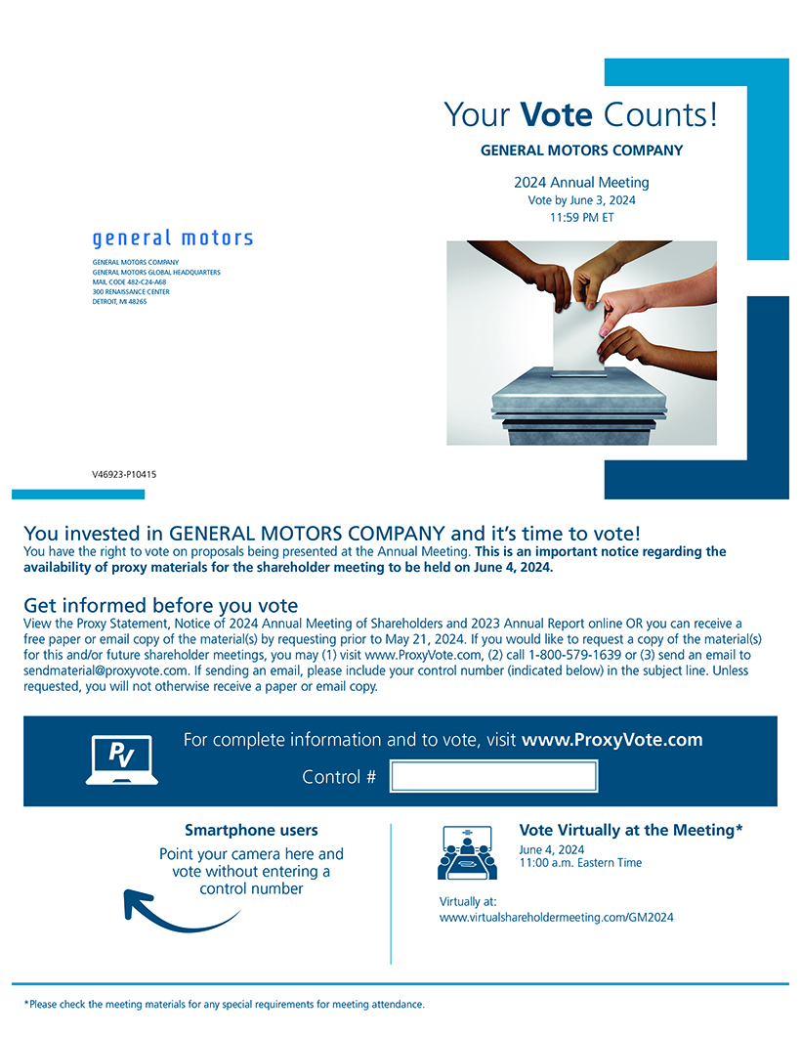
GENERAL MOTORS COMPANY GENERAL MOTORS GLOBAL HEADQUARTERS MAIL CODE 482-C24-A68 300 RENAISSANCE CENTER DETROIT, MI 48265 Your Vote Counts! GENERAL MOTORS COMPANY 2024 Annual Meeting Vote by June 3, 2024 11:59 PM ET V46923-P10415 You invested in GENERAL MOTORS COMPANY and its time to vote! You have the right to vote on proposals being presented at the Annual Meeting. This is an important notice regarding the availability of proxy materials for the shareholder meeting to be held on June 4, 2024. Get informed before you vote View the Proxy Statement, Notice of 2024 Annual Meeting of Shareholders and 2023 Annual Report online OR you can receive a free paper or email copy of the material(s) by requesting prior to May 21, 2024. If you would like to request a copy of the material(s) for this and/or future shareholder meetings, you may (1) visit www.ProxyVote.com, (2) call 1-800-579-1639 or (3) send an email to sendmaterial@proxyvote.com. If sending an email, please include your control number (indicated below) in the subject line. Unless requested, you will not otherwise receive a paper or email copy. For complete information and to vote, visit www.ProxyVote.com Control # Smartphone users Point your camera here and vote without entering a control number Vote Virtually at the Meeting* June 4, 2024 11:00 a.m. Eastern Time Virtually at: www.virtualshareholdermeeting.com/GM2024 *Please check the meeting materials for any special requirements for meeting attendance.

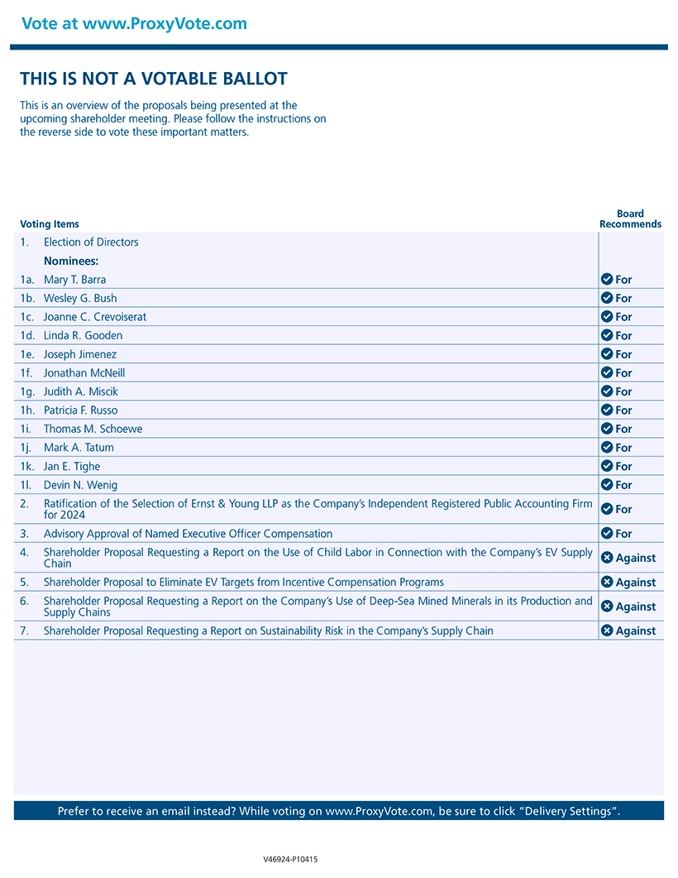
Vote at www.ProxyVote.com THIS IS NOT A VOTABLE BALLOT This is an overview of the proposals being presented at the upcoming shareholder meeting. Please follow the instructions on the reverse side to vote these important matters. Board Voting Items Recommends 1. Election of Directors Nominees: 1a. Mary T. Barra For 1b. Wesley G. Bush For 1c. Joanne C. Crevoiserat For 1d. Linda R. Gooden For 1e. Joseph Jimenez For 1f. Jonathan McNeill For 1g. Judith A. Miscik For 1h. Patricia F. Russo For 1i. Thomas M. Schoewe For 1j. Mark A. Tatum For 1k. Jan E. Tighe For 1l. Devin N. Wenig For 2. Ratification of the Selection of Ernst & Young LLP as the Companys Independent Registered Public Accounting Firm for 2024 For 3. Advisory Approval of Named Executive Officer Compensation For 4. Shareholder Proposal Requesting a Report on the Use of Child Labor in Connection with the Companys EV Supply Against Chain 5. Shareholder Proposal to Eliminate EV Targets from Incentive Compensation Programs Against 6. Shareholder Proposal Requesting a Report on the Companys Use of Deep-Sea Mined Minerals in its Production and Against Supply Chains 7. Shareholder Proposal Requesting a Report on Sustainability Risk in the Companys Supply Chain Against Prefer to receive an email instead? While voting on www.ProxyVote.com, be sure to click Delivery Settings. V46924-P10415

