Table of Contents

UNITED STATES

SECURITIES AND EXCHANGE COMMISSION
Washington, DC 20549-1004

FORM 8-K

CURRENT REPORT

PURSUANT TO SECTION 13 OR 15(d) OF

THE SECURITIES EXCHANGE ACT OF 1934

Date of Report (Date of earliest event reported) September 14, 2011

GENERAL MOTORS COMPANY

(Exact Name of Registrant as Specified in its Charter)

001-34960

DELAWARE

27-0756180

(Commission

File Number)

(State or other jurisdiction of

incorporation)

(I.R.S. Employer

Identification No.)

300 Renaissance Center, Detroit, Michigan

48265-3000

(Address of Principal Executive Offices)

(Zip Code)

(313) 556-5000

(Registrant’s telephone number, including area code)

Not Applicable

(Former name or former address, if changed since last report)

Check the appropriate box below if the Form 8-K filing is intended to simultaneously satisfy the filing obligation of the registrant under any of the following provisions:

- Written communications pursuant to Rule 425 under the Securities Act (17 CFR 230.425)

- Soliciting material pursuant to Rule 14a-12 under the Exchange Act (17-CFR 240.14a-12)

- Pre-commencement communications pursuant to Rule 14d-2(b) under the Exchange Act (17 CFR 240.14d-2(b))

- Pre-commencement communications pursuant to Rule 13e-4(c) under the Exchange Act (17 CFR 240.13e-4(c))

Table of Contents

TABLE OF CONTENTS

ITEM 8.01 Other Events

Signature

Index to Exhibits

Presentation Webcast Charts Dated September 14, 2011

Table of Contents

ITEM 8.01 Other Events

On September 14, 2011, Mr. Nick Reilly, President GM Europe, conducted a webcast presentation hosted by UBS to provide an update on General Motors Company European financial and operating strategy. The presentation related thereto is attached as Exhibit 99.1.

 |  |  |  |  | EXHIBITS
Exhibit |  | Description |  |  |  |  | Method of Filing
 | 99.1 |  |  | Charts
Exhibit | 99.1 |  | Presentation |  |  |  | Attached as Exhibit
 |  | Dated September 14, 2011

Table of Contents

SIGNATURE

Pursuant to the requirements of the Securities Exchange Act of 1934, the Registrant has duly caused this report to be signed on its behalf by the undersigned hereunto duly authorized.

 |  |  | GENERAL MOTORS COMPANY
 |  |  | (Registrant)
Date: September 20, 2011 | By: /s/ Nick S. Cyprus
 |  |  | Nick S. Cyprus
 |  |  | Vice President, Controller and Chief Accounting Officer

Exhibit 99.1
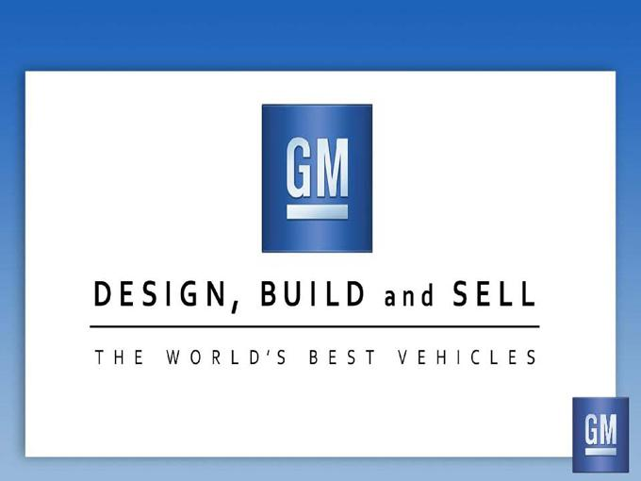

DESIGN, BUILD and SELL THE WORLD’S BEST VEHICLES

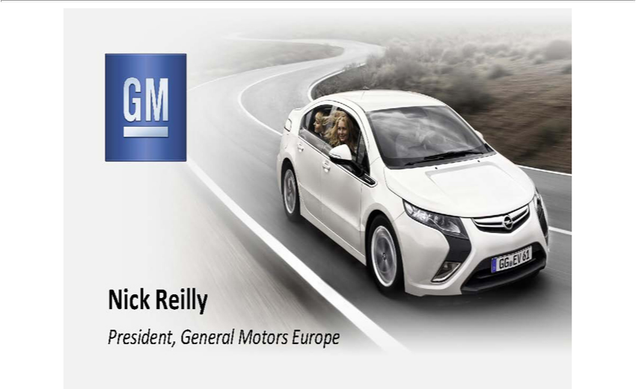

Nick Reilly President, General Motors Europe

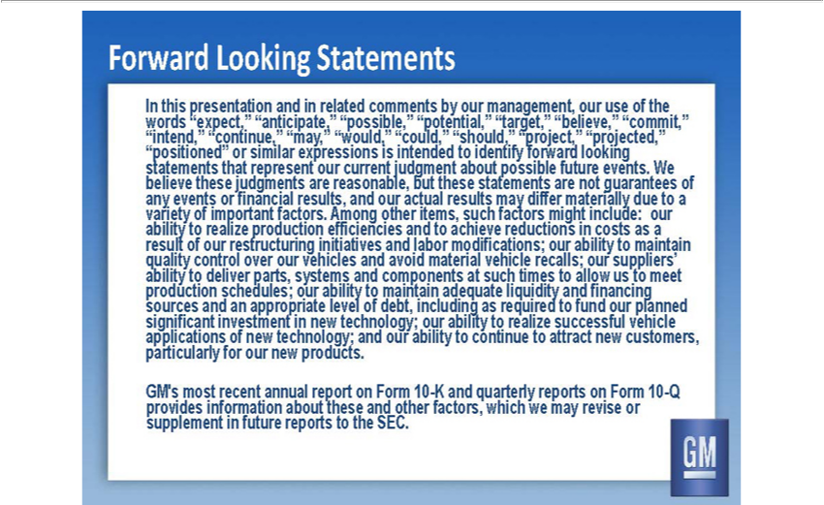

Forward Looking Statements In words this presentation “expect,” and in related “anticipate,” comments by our management, “possible,” our use of the “intend,” “continue,” “may,” “would,” “positioned”
statements | th t represent our or current similar judgment | expressions possible future events is . We any believe events these or judgments financial results, are reasonable, and our actual but these results
statements | differ are materially not guarantees due toaboutof variety ability to of realize important production factors. efficiencies Among other and items, to achieve such factors reductions might in include:
sts as ourmayquality result of our restructuring control initiatives over and labor our modifications; vehicles our ability and to maintain ab lity production to deliver schedules; parts, systems our ability and to
components maintain adequate at such liquidity times |  | and allow financing us to meet sources significant and investment an appropriate in new level technology; of debt, including our ability as to required
annual about report these on and Form other 10 -factors, |  | K and quarterly which we reports may revise on Form or 10-Q supplementcontinuefuture reports to the SEC.
realize successful to fund our vehicle planned parti ularly applications for of our new new technology; products and . our ability to |  |  | to attract new customers, GM’s provides most information recent

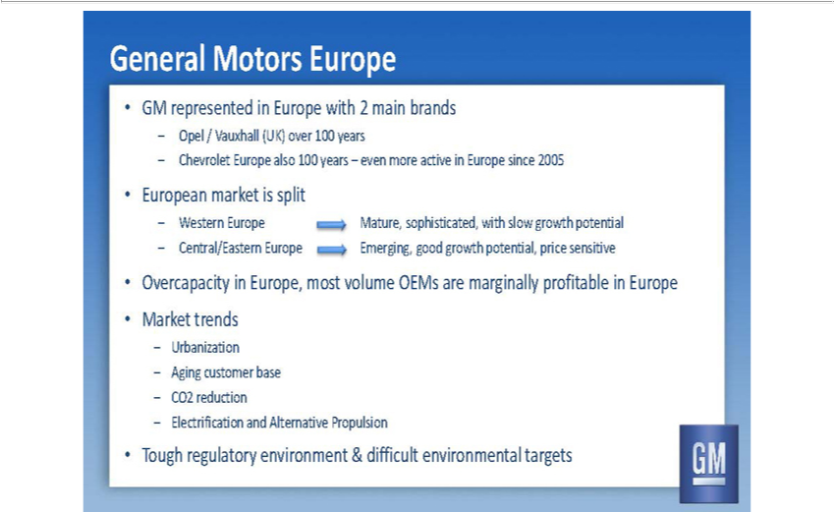

General Motors Europe •GM represented in Europe with 2 main brands – Opel_{Central/Eastern}Vauxhall(UK) over 100 years – Chevrolet Europe also 100 years – even more active in Europe since 2005 •European _{market} is

split – Western Europe Mature, sophisticated, with slow growth potential – Europe Emerging, good growth potential, price sensitive •Overcapacity in Europe, most volume OEMs are ginally profitable in Europe •Market trends – Urbanization – Aging customer base – CO2 reduction – Electrification and Alternative Propulsion •Tough regulatory environment & difficult environmental targets

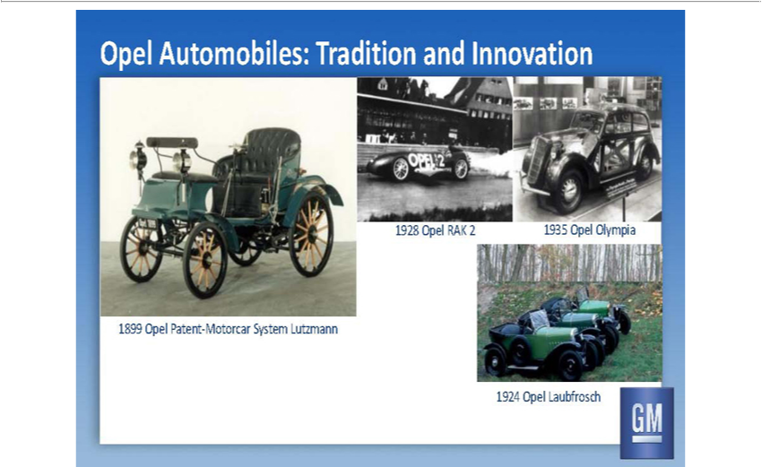

Opel Automobiles: Tradition and Innovation 1899 Opel Patent-Motorcar System Lutzmann 1928 Opel RAK 2 1935 Opel Olympia 1924 Opel Laubfrosch

Opel / Vauxhall in Europe • Headquartered in Rüsselsheim, Germany • 41,000 employees in Europe

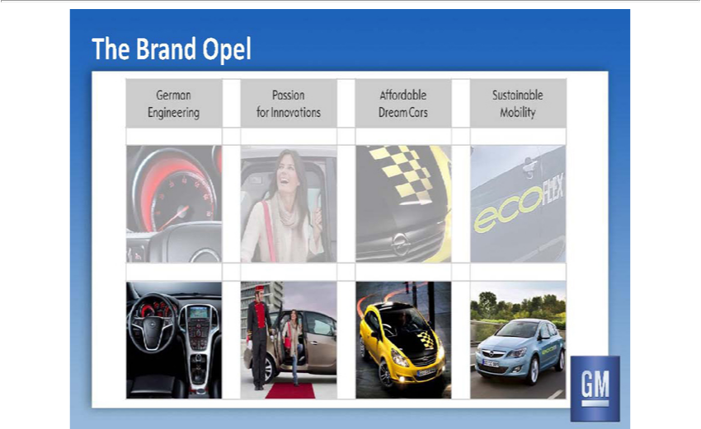

The Brand Opel German Engineering Passion for Innovations Affordable Dream Cars Sustainable Mobility

Opel / Vauxhall Award-Winning Products •Over 40 prizes for Insignia •Over 25 prizes for Astra •Over 10 prizes for Ampera •Over 20 prizes for Meriva

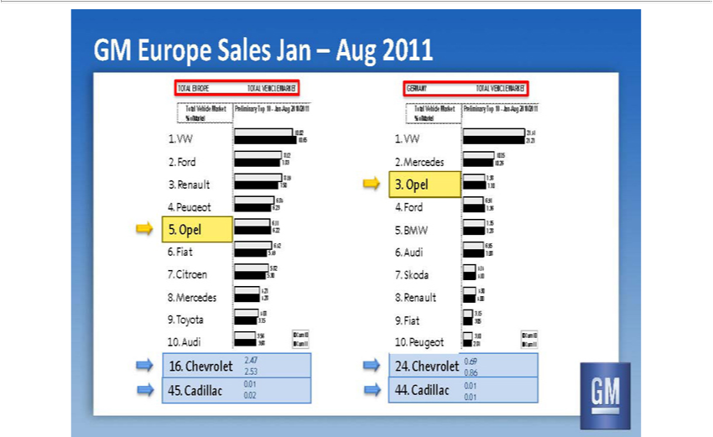

GM Europe Sales Jan –Aug 2011 TOTAL EUROPE TOTAL VEHICLE MARKET Total Vehicle Market Preliminary Top 10—Jan-Aug |  |  |  |  |  | 1 % of Market 1. VW Cum 10 Cum 11 Max10.02 1. VW % of
Market 3.56 3.68 4.23 |  | 10.65 4.07 | 3.75 .68 2. | Ford 4.27 4.28 8.12 4.92 | 2. Ford % of Market 5.82 5.30 7.83 6.70 6.42 5.49 7.38 3. Renault2010/2016.6.22 8.19 7.16 3. Renault % of Market 6.84 6.23 7.50 7.86 8.19
7 50 | 9 42 4. Peugeot 8.12 7.83 6.84 9.34 4. Peugeot % of Market 10.02 |  |  |  | 106.65 .23 12.24 5. Opel/Vxh 6.11 5. Opel % of Market 6.22 6. Fiat 6.42 | . Fiat % of Market 5.49 7. Citroen 5.82 7. Citroen % of Market
5 30 | 8. Mercedes 4.27 | 8. Mercedes % of Market 4.28 9. Toyota 4.07 9. |  |  | oyota % of Market 3.75 10. Audi 3.56 Cum 10 10. Audi % of Market 3.68 Cum 11 . 16. Chevrolet 2.47 % of Market 2.53 45. Cadillac
0.01 | 45. Cadillac % of Market 0.02 GERMANY TOTAL VEHICLE MARKET Total Vehicle Market Preliminary Top 10—Jan-Aug 2010/2011 % of Market16. VW Cum 10 Cum 11 Max 21.41 . VW % of
Market 3.10 2.81 3.56 |  | 21.27 3.15 | 3.05 3.62 2. | Mercedes 4.30 10.4 75 .00 .94 2. Mercedes % of Market 4.14 10.26 4.10 4.76 6.95 7.08 8.15 3. Opel 7.735 .38 7.28 8.45 3. Opel % of Market 6.91 7.70 7.36 8.46
7 38 | 7 70 8.86 4. Ford | 10 6.75 91 | 10.26 12.36 | 4. Ford % of Market 217 .41 .36 21.27 24.62 5. BMW 7.35 5. BMW % of Market 7.28 6. Audi 6.95 6. Audi % of Market 7. 7. Skoda 4.14 7. Skoda % of Market
. . ³⁰ 08
04 0110 %8 RenaultofMarket4. .018. Renault % of Market 4.00 9. Fiat 3.15 9. Fiat % of Market 3.05 10. 10 Peugeot . Peugeot 3.10 Cum 10 % of Market 2.81 Cum 11 24.24 Chevrolet . .69 % of Market 0.86 44.44 Cadillac .

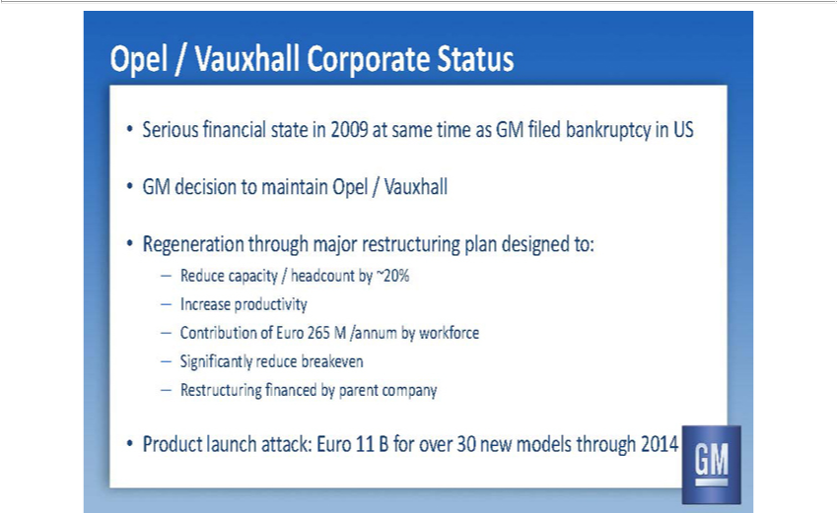

Opel / Vauxhall Corporate Status •Serious financial state in 2009 at same time as GM filed bankruptcy in US •GM decision to maintain Opel / Vauxhall •Regeneration through major restructuring plan designed to: — Reduce capacity / headcount by ~20% — Increase productivity — Contribution of Euro 265 M /annum by workforce — Significantly reduce breakeven — Restructuring financed by parent company •Product launch attack: Euro 11 B for over 30 new models through 2014

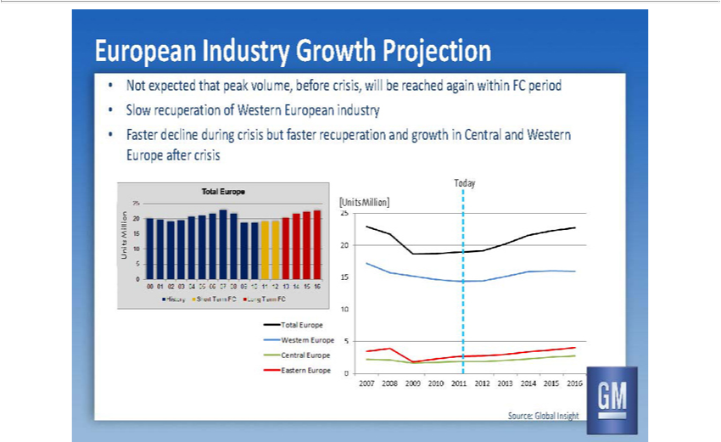

European Industry Growth Projection • Not expected that peak volume, before crisis, will be reached again within FC period • Slow recuperation of Western European industry • Faster decline during crisis but faster recuperation and growth in Central and Western Europe after crisis [Units Million] Today Source: Global Insight

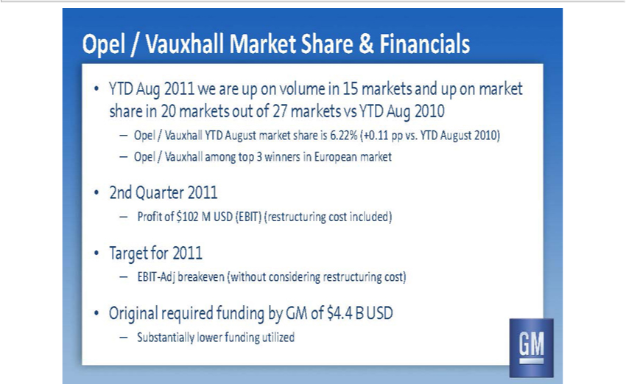

Opel / Vauxhall Market Share & Financials • YTD Aug 2011 we are up on volume in 15 markets and up on market share in 20 markets out of 27 markets vs YTD Aug 2010 — Opel / Vauxhall YTD August market share is 6.22% (+0.11 pp vs. YTD August 2010) — Opel / Vauxhall among top 3 winners_{funding}European market • 2nd Quarter 2011 — Profit of $102 M USD (EBIT) (restructuring cost included) • Target
for 2011 — EBIT-Adj breakeven (without considering restructuring cost) • Original required by GM of $4.4 B USD — Substantially lower funding utilized

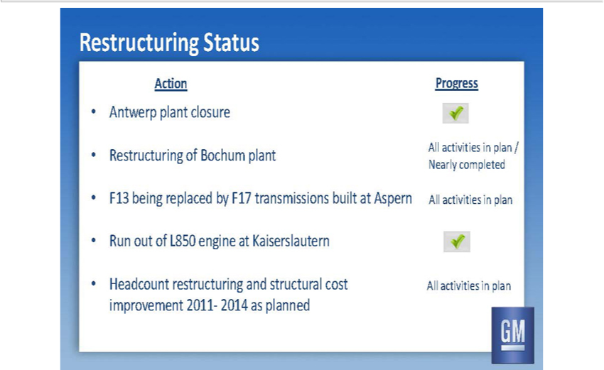

Restructuring Status Action Progress • Antwerp plant closure • Restructuring of Bochum plant All activities in plan Nearly completed • F13 being replaced by F17 transmissions built at Aspern All activities in plan • Run out of L850 engine at Kaiserslautern • Headcount restructuring and structural cost All activities in plan improvement 2011- 2014 as planned

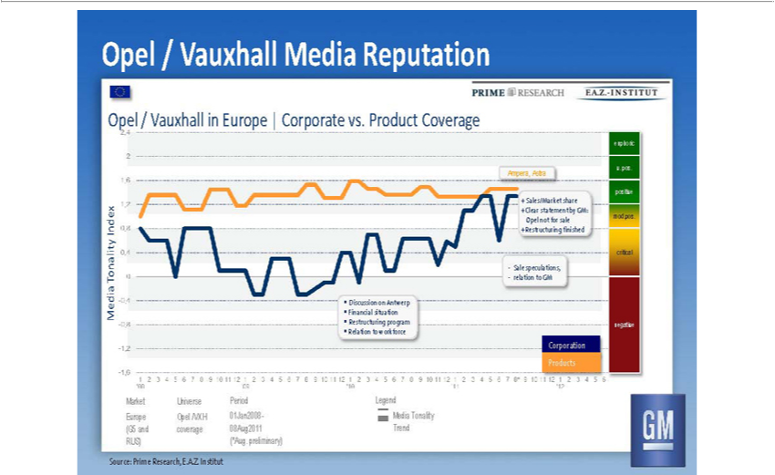

Opel / Vauxhall Media Reputation Opel / Vauxhall in Europe | Corporate vs. Product Coverage

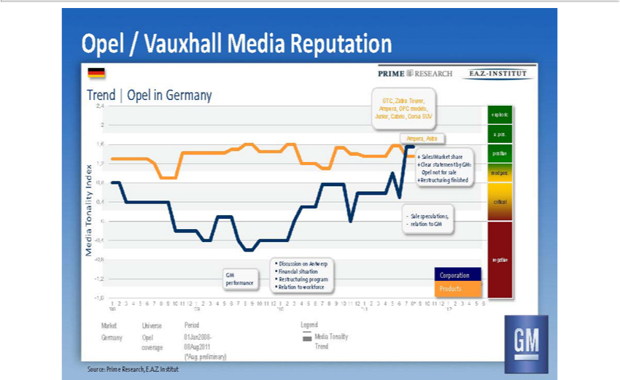

Opel / Vauxhall Media Reputation Trend | Opel in Germany

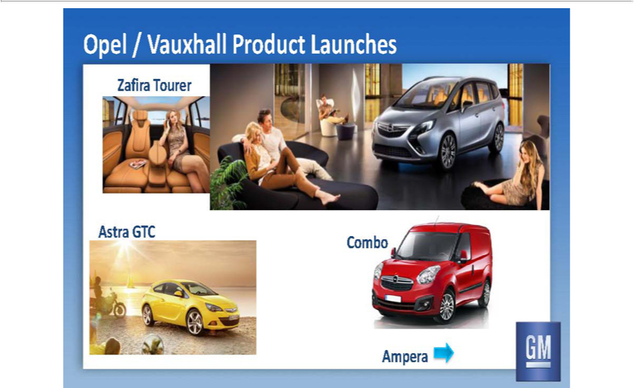

Opel / Vauxhall Product Launches

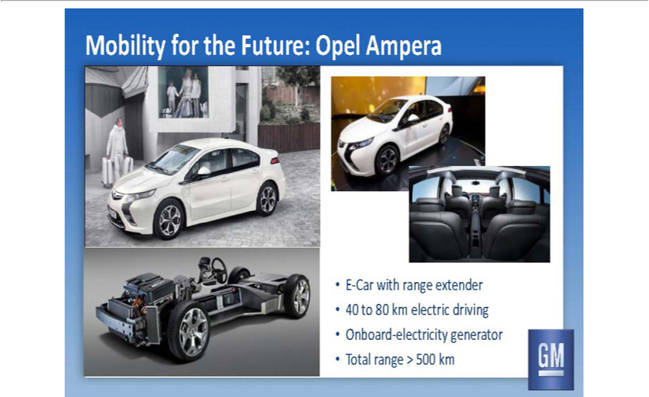

Mobility for the Future: Opel Ampera •E-Car with range extender •40 to 80 km electric driving •Onboard-electricity generator •Total range > 500 km

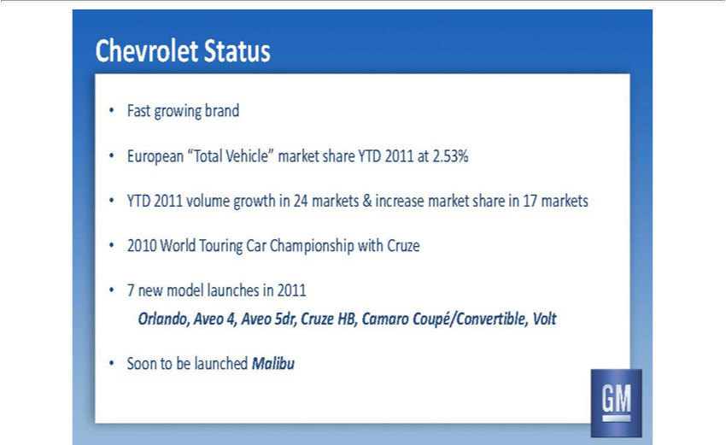

Chevrolet Status • Fast growing brand • European “Total Vehicle” market • YTD 2011 volume growth in 24 markets & increase market share in 17 markets • 2010 World Touring Car Championship with Cruze • 7 new model launches in 2011 Orlando, Aveo 4, Aveo 5dr, Cruze HB, Camaro Coupé/Convertible, Volt • Soon to be launched Malibu

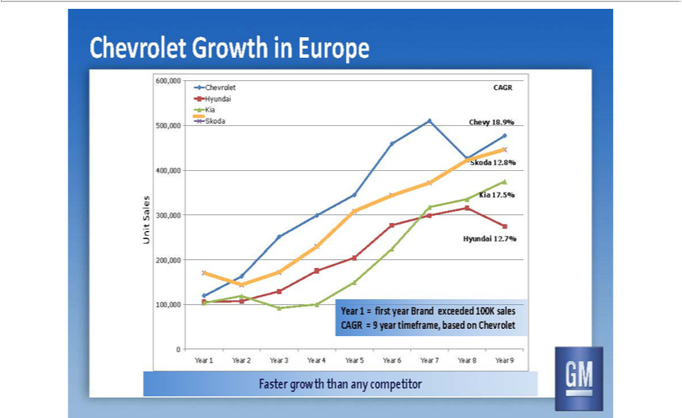

Chevrolet Growth in Europe Faster growth than any competitor

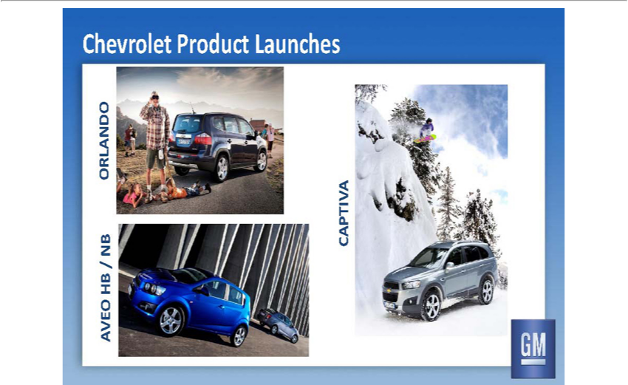

Chevrolet Product Launches

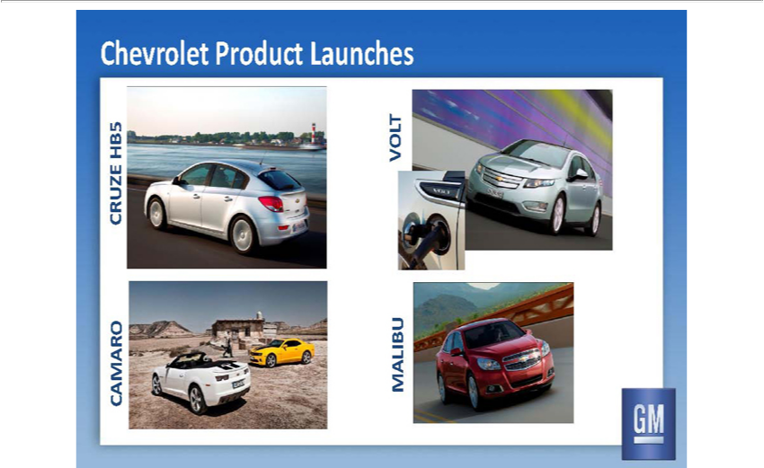

Chevrolet Product Launches

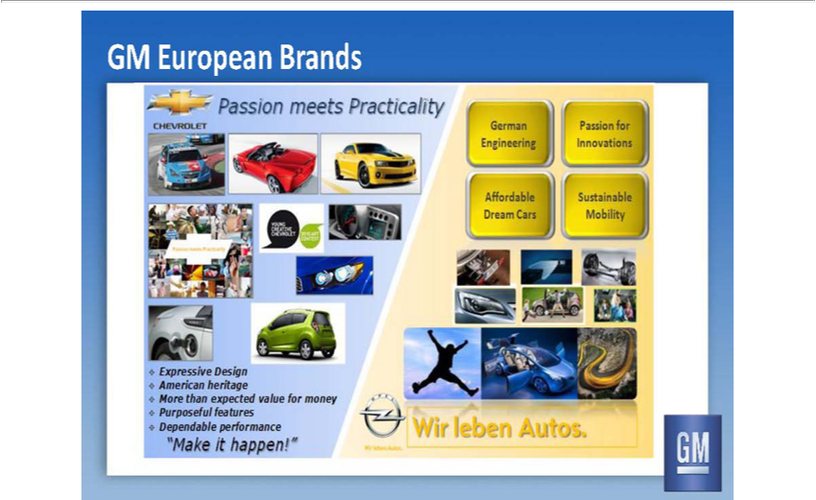

GM European Brands

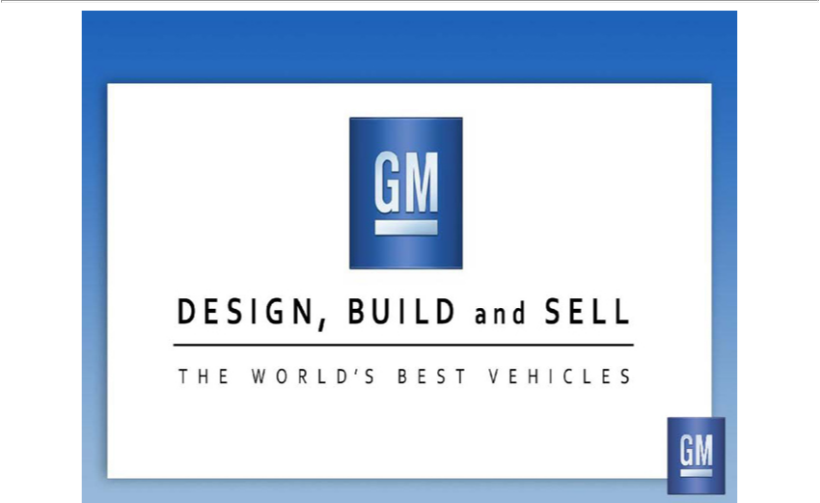

DESIGN, BUILD and SELL THE WORLD’S BEST VEHICLES

