UNITED STATES SECURITIES AND EXCHANGE COMMISSION
Washington, DC 20549
___________________

FORM 8-K
___________________

CURRENT REPORT
Pursuant to Section 13 or 15(d) of
the Securities Exchange Act of 1934

Date of Report (Date of earliest event reported): April 25, 2023
___________________
GENERAL MOTORS COMPANY
(Exact name of registrant as specified in its charter)
__________________
Delaware |  |  | 001-34960 |  |  |  |  |  | 27-0756180
(State or other jurisdiction of incorporation) |  |  | (Commission File Number) |  |  |  |  |  | (I.R.S. Employer Identification No.)
 |  |  | 300 Renaissance Center, |  |  |  |  |  |  |  |  |  |  |  | Detroit, |  |  | Michigan |  |  |  |  |  |  |  |  | 48265 |  |  |  |  |  |  |  |  | -3000
(Address of principal executive offices) |  |  |  |  |  |  |  |  |  |  |  |  |  |  |  |  |  |  |  |  |  |  |  |  |  |  | (Zip Code)

(313) 667-1500
(Registrant's telephone number, including area code)

Not Applicable
(Former name or former address, if changed since last report)
__________________

Check the appropriate box below if the Form 8-K filing is intended to simultaneously satisfy the filing obligation of the registrant under any of the following provisions:
☐ |  |  |  |  |  | Written communications pursuant to Rule 425 under the Securities Act (17 CFR 230.425)
☐ |  |  |  |  |  | Soliciting material pursuant to Rule 14a-12 under the Exchange Act (17 CFR 240.14a-12)
☐ |  |  |  |  |  | Pre-commencement communications pursuant to Rule 14d-2(b) under the Exchange Act (17 CFR 240.14d-2(b))
☐ |  |  |  |  |  | Pre-commencement communications pursuant to Rule 13e-4(c) under the Exchange Act (17 CFR 240.13e-4(c))
Securities registered pursuant to Section 12(b) of the Act:
Title of each class |  |  | Trading Symbol(s) |  |  | Name of each exchange on which registered
Common Stock, $0.01 par value |  |  | GM |  |  | New York Stock Exchange
Indicate by check mark whether the registrant is an emerging growth company as defined in Rule 405 of the Securities Act of 1933 (§230.405 of this chapter) or Rule 12b-2 of the Securities Exchange Act of 1934 (§240.12b-2 of this chapter). Emerging growth company ☐
If an emerging growth company, indicate by check mark if the registrant has elected not to use the extended transition period for complying with any new or revised financial accounting standards provided pursuant to Section 13(a) of the Exchange Act. ☐

ITEM 2.02 Results of Operations and Financial Condition

On April 25, 2023, General Motors Company (GM) issued a news release and supplemental materials on the subject of its 2023 first quarter consolidated earnings. The news release and supplemental materials are attached as Exhibit 99.1 and Exhibit 99.2.

Charts furnished to securities analysts in connection with GM's 2023 first quarter earnings release are available on GM's website at www.gm.com/investors/earnings-releases.html.

ITEM 9.01 Financial Statements and Exhibits

EXHIBIT
Exhibit |  |  | Description
Exhibit 99.1 |  |  | News Release Dated April 25, 2023
Exhibit 99.2 |  |  | Financial Highlights Dated April 25, 2023
Exhibit 104 |  |  | Cover Page Interactive Data File (embedded within the Inline XBRL document)

SIGNATURE

Pursuant to the requirements of the Securities Exchange Act of 1934, the registrant has duly caused this report to be signed on its behalf by the undersigned hereunto duly authorized.

 |  |  |  |  |  | GENERAL MOTORS COMPANY (Registrant)
 |  |  | By: |  |  | /s/ CHRISTOPHER T. HATTO
Date: April 25, 2023 |  |  |  |  |  | Christopher T. Hatto, Vice President, Global Business Solutions and Chief Accounting Officer

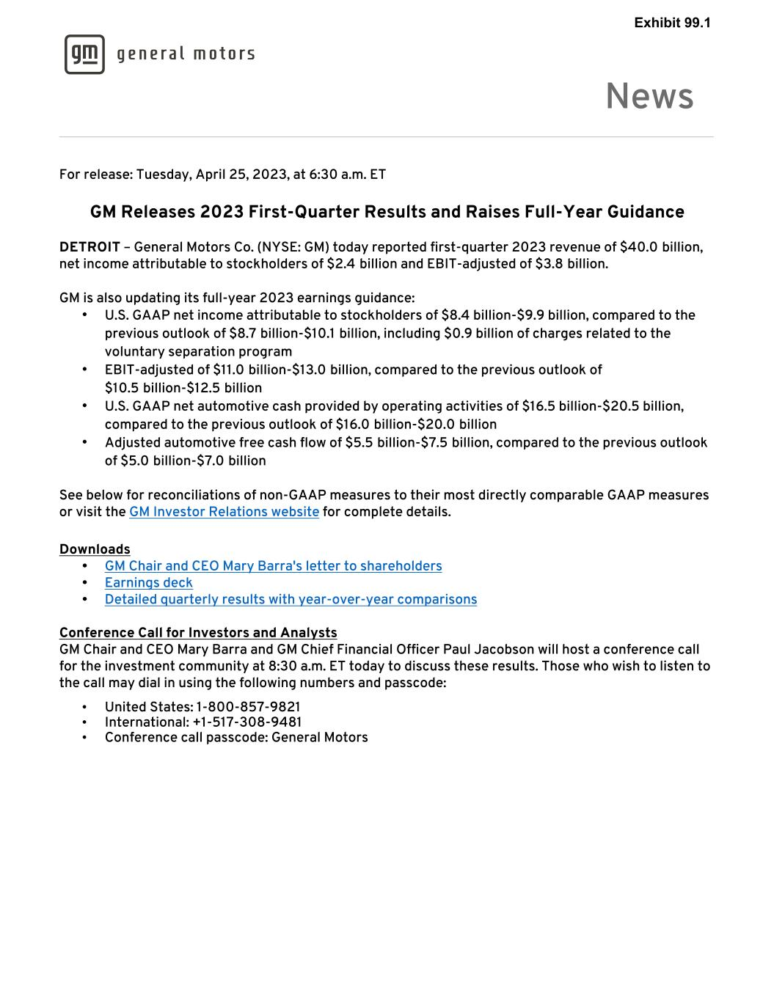

For release: Tuesday, April 25, 2023, at 6:30 a.m. ET GM Releases 2023 First-Quarter Results and Raises Full-Year Guidance DETROIT – General Motors Co. (NYSE: GM) today reported first-quarter 2023 revenue of $40.0 billion, net income attributable to stockholders of $2.4 billion and EBIT-adjusted of $3.8 billion. GM is also updating its full-year 2023 earnings guidance: • U.S. GAAP net income attributable to stockholders of $8.4 billion-$9.9 billion, compared to the previous outlook of $8.7 billion-$10.1 billion, including $0.9 billion of charges related to the voluntary separation program • EBIT-adjusted of $11.0 billion-$13.0 billion, compared to the previous outlook of $10.5 billion-$12.5 billion • U.S. GAAP net automotive cash provided by operating activities of $16.5 billion-$20.5 billion, compared to the previous outlook of $16.0 billion-$20.0 billion • Adjusted automotive free cash flow of $5.5 billion-$7.5 billion, compared to the previous outlook of $5.0 billion-$7.0 billion See below for reconciliations of non-GAAP measures to their most directly comparable GAAP measures or visit the GM Investor Relations website for complete details. Downloads • GM Chair and CEO Mary Barra's letter to shareholders • Earnings deck • Detailed quarterly results with year-over-year comparisons Conference Call for Investors and Analysts GM Chair and CEO Mary Barra and GM Chief Financial Officer Paul Jacobson will host a conference call for the investment community at 8:30 a.m. ET today to discuss these results. Those who wish to listen to the call may dial in using the following numbers and passcode: • United States: 1-800-857-9821 • International: +1-517-308-9481 • Conference call passcode: General Motors News Exhibit 99.1

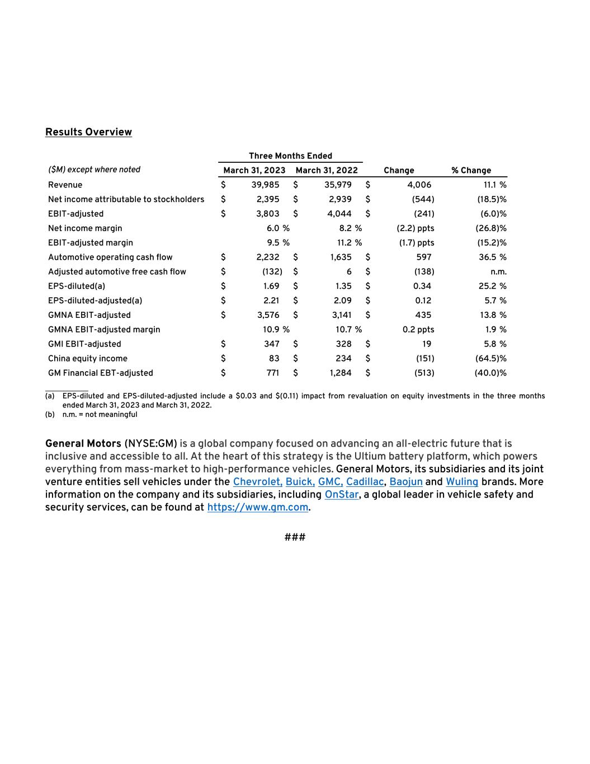
Results Overview Three Months Ended ($M) except where noted March 31, 2023 March 31, 2022 Change % Change Revenue $ 39,985 $ 35,979 $ 4,006 11.1 % Net income attributable to stockholders $ 2,395 $ 2,939 $ (544) (18.5) % EBIT-adjusted $ 3,803 $ 4,044 $ (241) (6.0) % Net income margin 6.0 % 8.2 % (2.2) ppts (26.8) % EBIT-adjusted margin 9.5 % 11.2 % (1.7) ppts (15.2) % Automotive operating cash flow $ 2,232 $ 1,635 $ 597 36.5 % Adjusted automotive free cash flow $ (132) $ 6 $ (138) n.m. EPS-diluted(a) $ 1.69 $ 1.35 $ 0.34 25.2 % EPS-diluted-adjusted(a) $ 2.21 $ 2.09 $ 0.12 5.7 % GMNA EBIT-adjusted $ 3,576 $ 3,141 $ 435 13.8 % GMNA EBIT-adjusted margin 10.9 % 10.7 % 0.2 ppts 1.9 % GMI EBIT-adjusted $ 347 $ 328 $ 19 5.8 % China equity income $ 83 $ 234 $ (151) (64.5) % GM Financial EBT-adjusted $ 771 $ 1,284 $ (513) (40.0) % __________ (a) EPS-diluted and EPS-diluted-adjusted include a $0.03 and $(0.11) impact from revaluation on equity investments in the three months ended March 31, 2023 and March 31, 2022. (b) n.m. = not meaningful General Motors (NYSE:GM) is a global company focused on advancing an all-electric future that is inclusive and accessible to all. At the heart of this strategy is the Ultium battery platform, which powers everything from mass-market to high-performance vehicles. General Motors, its subsidiaries and its joint venture entities sell vehicles under the Chevrolet, Buick, GMC, Cadillac, Baojun and Wuling brands. More information on the company and its subsidiaries, including OnStar, a global leader in vehicle safety and security services, can be found at https://www.gm.com. ###

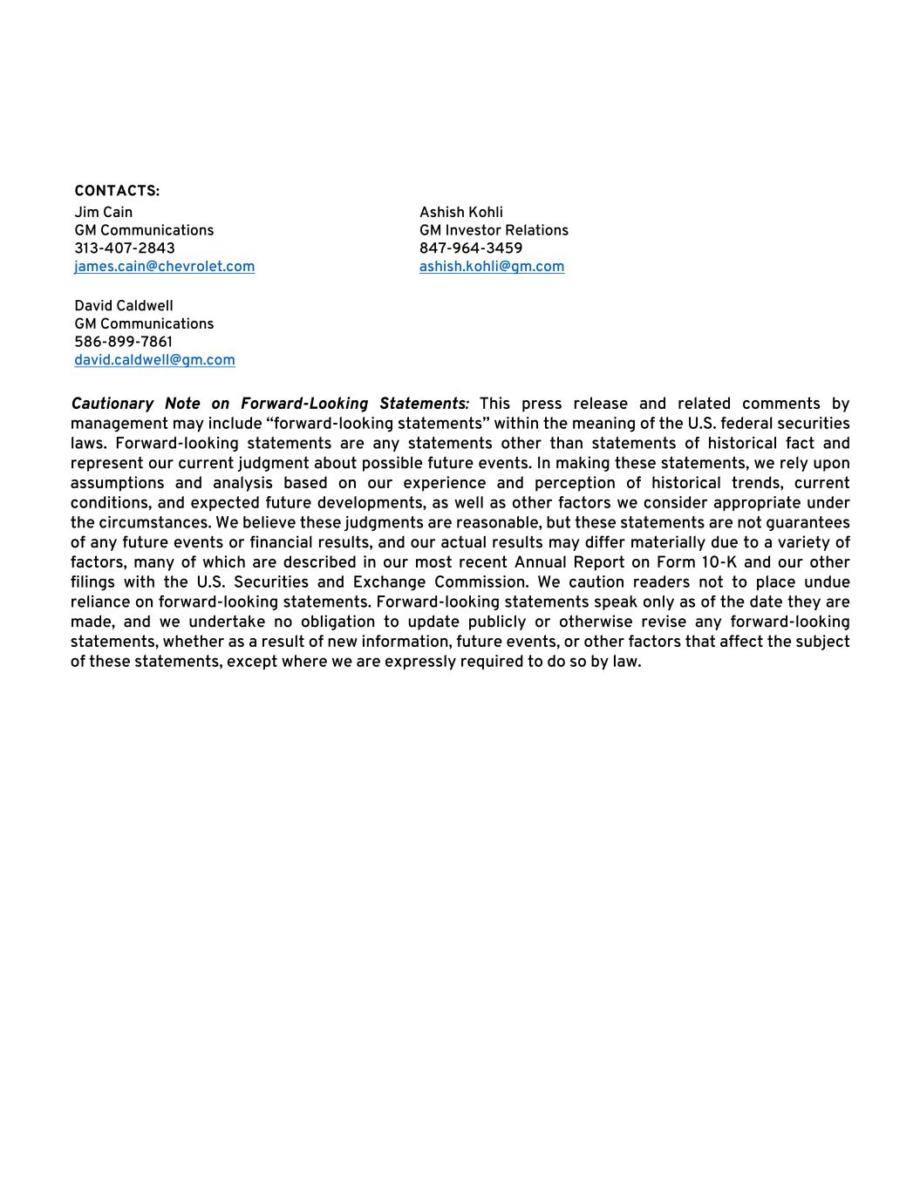
CONTACTS: Jim Cain GM Communications 313-407-2843 james.cain@chevrolet.com Ashish Kohli GM Investor Relations 847-964-3459 ashish.kohli@gm.com David Caldwell GM Communications 586-899-7861 david.caldwell@gm.com Cautionary Note on Forward-Looking Statements: This press release and related comments by management may include “forward-looking statements” within the meaning of the U.S. federal securities laws. Forward-looking statements are any statements other than statements of historical fact and represent our current judgment about possible future events. In making these statements, we rely upon assumptions and analysis based on our experience and perception of historical trends, current conditions, and expected future developments, as well as other factors we consider appropriate under the circumstances. We believe these judgments are reasonable, but these statements are not guarantees of any future events or financial results, and our actual results may differ materially due to a variety of factors, many of which are described in our most recent Annual Report on Form 10-K and our other filings with the U.S. Securities and Exchange Commission. We caution readers not to place undue reliance on forward-looking statements. Forward-looking statements speak only as of the date they are made, and we undertake no obligation to update publicly or otherwise revise any forward-looking statements, whether as a result of new information, future events, or other factors that affect the subject of these statements, except where we are expressly required to do so by law.

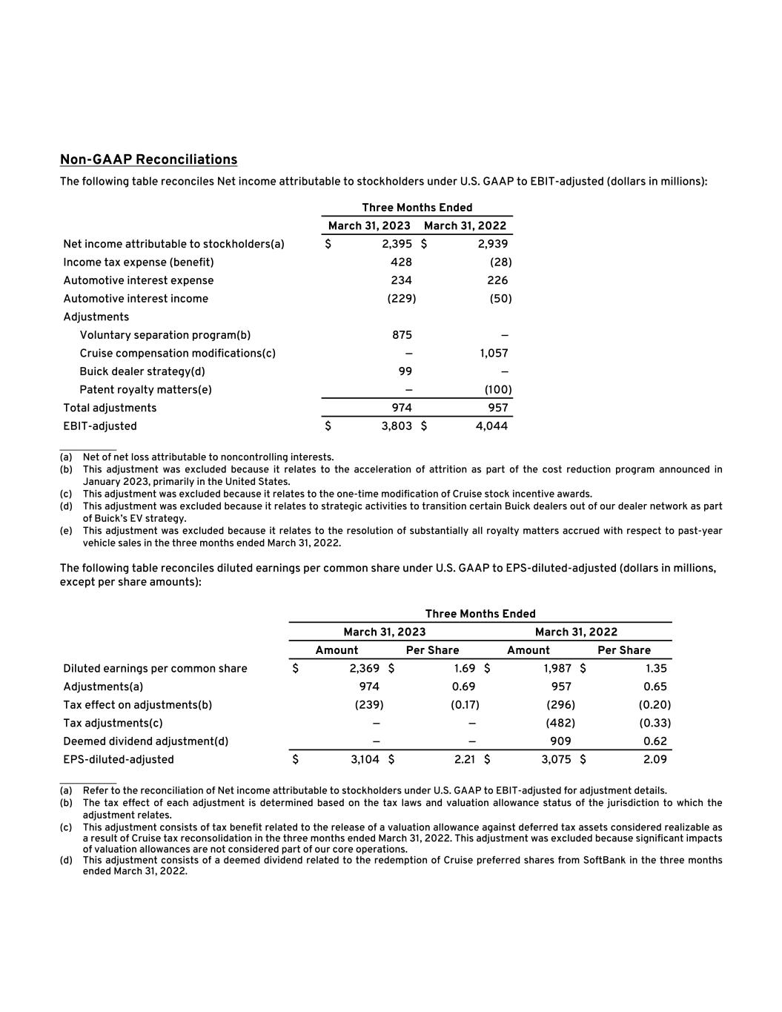
Non-GAAP Reconciliations The following table reconciles Net income attributable to stockholders under U.S. GAAP to EBIT-adjusted (dollars in millions): Three Months Ended March 31, 2023 March 31, 2022 Net income attributable to stockholders(a) $ 2,395 $ 2,939 Income tax expense (benefit) 428 (28) Automotive interest expense 234 226 Automotive interest income (229) (50) Adjustments Voluntary separation program(b) 875 — Cruise compensation modifications(c) — 1,057 Buick dealer strategy(d) 99 — Patent royalty matters(e) — (100) Total adjustments 974 957 EBIT-adjusted $ 3,803 $ 4,044 __________ (a) Net of net loss attributable to noncontrolling interests. (b) This adjustment was excluded because it relates to the acceleration of attrition as part of the cost reduction program announced in January 2023, primarily in the United States. (c) This adjustment was excluded because it relates to the one-time modification of Cruise stock incentive awards. (d) This adjustment was excluded because it relates to strategic activities to transition certain Buick dealers out of our dealer network as part of Buick’s EV strategy. (e) This adjustment was excluded because it relates to the resolution of substantially all royalty matters accrued with respect to past-year vehicle sales in the three months ended March 31, 2022. The following table reconciles diluted earnings per common share under U.S. GAAP to EPS-diluted-adjusted (dollars in millions, except per share amounts): Three Months Ended March 31, 2023 March 31, 2022 Amount Per Share Amount Per Share Diluted earnings per common share $ 2,369 $ 1.69 $ 1,987 $ 1.35 Adjustments(a) 974 0.69 957 0.65 Tax effect on adjustments(b) (239) (0.17) (296) (0.20) Tax adjustments(c) — — (482) (0.33) Deemed dividend adjustment(d) — — 909 0.62 EPS-diluted-adjusted $ 3,104 $ 2.21 $ 3,075 $ 2.09 __________ (a) Refer to the reconciliation of Net income attributable to stockholders under U.S. GAAP to EBIT-adjusted for adjustment details. (b) The tax effect of each adjustment is determined based on the tax laws and valuation allowance status of the jurisdiction to which the adjustment relates. (c) This adjustment consists of tax benefit related to the release of a valuation allowance against deferred tax assets considered realizable as a result of Cruise tax reconsolidation in the three months ended March 31, 2022. This adjustment was excluded because significant impacts of valuation allowances are not considered part of our core operations. (d) This adjustment consists of a deemed dividend related to the redemption of Cruise preferred shares from SoftBank in the three months ended March 31, 2022.

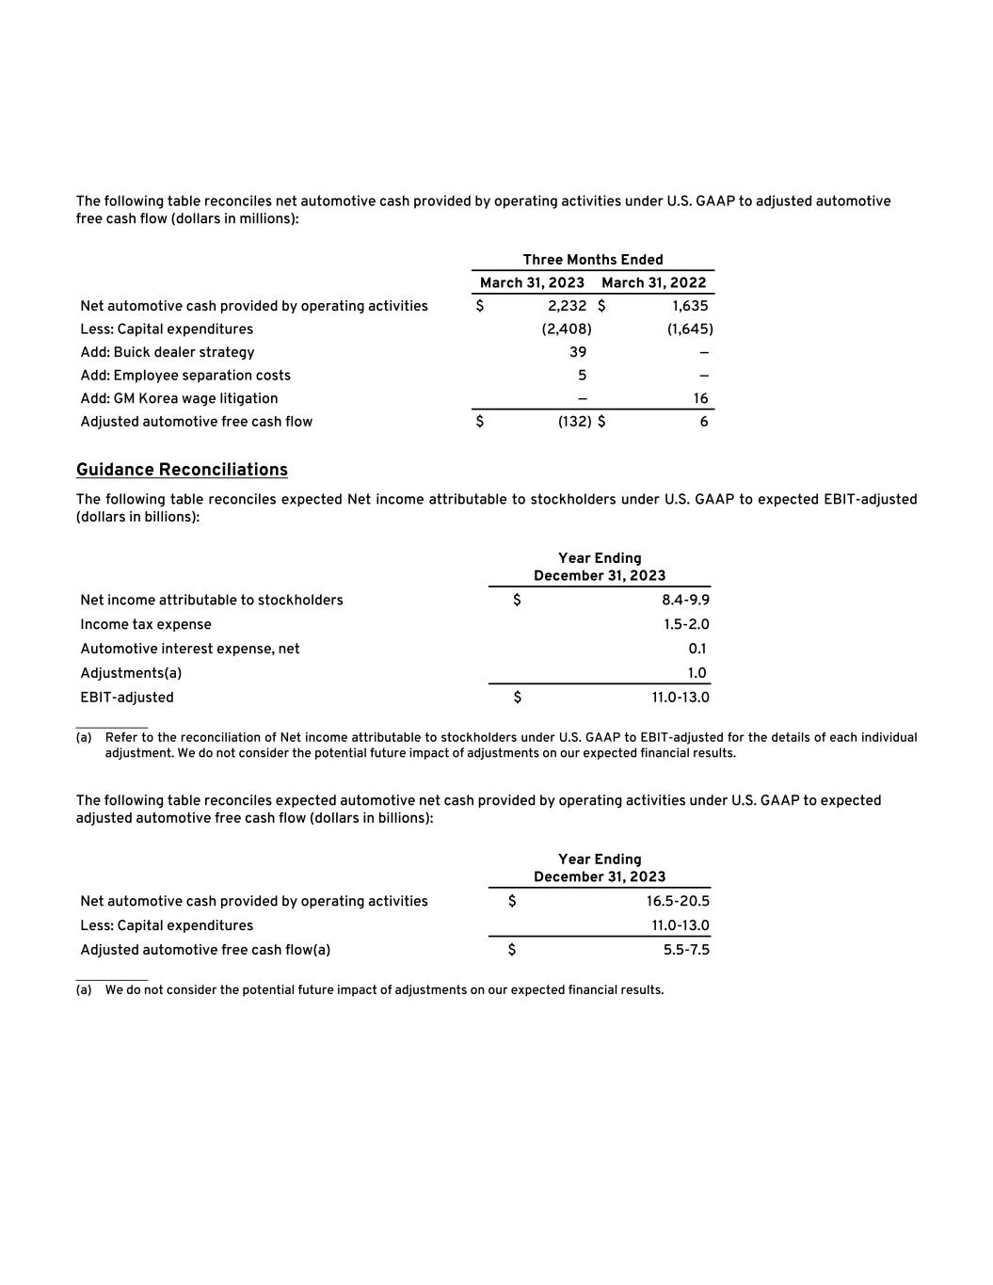
The following table reconciles net automotive cash provided by operating activities under U.S. GAAP to adjusted automotive free cash flow (dollars in millions): Three Months Ended March 31, 2023 March 31, 2022 Net automotive cash provided by operating activities $ 2,232 $ 1,635 Less: Capital expenditures (2,408) (1,645) Add: Buick dealer strategy 39 — Add: Employee separation costs 5 — Add: GM Korea wage litigation — 16 Adjusted automotive free cash flow $ (132) $ 6 Guidance Reconciliations The following table reconciles expected Net income attributable to stockholders under U.S. GAAP to expected EBIT-adjusted (dollars in billions): Year Ending December 31, 2023 Net income attributable to stockholders $ 8.4-9.9 Income tax expense 1.5-2.0 Automotive interest expense, net 0.1 Adjustments(a) 1.0 EBIT-adjusted $ 11.0-13.0 __________ (a) Refer to the reconciliation of Net income attributable to stockholders under U.S. GAAP to EBIT-adjusted for the details of each individual adjustment. We do not consider the potential future impact of adjustments on our expected financial results. The following table reconciles expected automotive net cash provided by operating activities under U.S. GAAP to expected adjusted automotive free cash flow (dollars in billions): Year Ending December 31, 2023 Net automotive cash provided by operating activities $ 16.5-20.5 Less: Capital expenditures 11.0-13.0 Adjusted automotive free cash flow(a) $ 5.5-7.5 __________ (a) We do not consider the potential future impact of adjustments on our expected financial results.

Exhibit 99.2

General Motors Company and Subsidiaries
Supplemental Material1
(Unaudited)
General Motors Company's (GM) non-GAAP measures include: earnings before interest and taxes (EBIT)-adjusted, presented net of noncontrolling interests; earnings before income taxes (EBT)-adjusted for our General Motors Financial Company, Inc. (GM Financial) segment; earnings per share (EPS)-diluted-adjusted; effective tax rate-adjusted (ETR-adjusted); return on invested capital-adjusted (ROIC-adjusted) and adjusted automotive free cash flow. GM's calculation of these non-GAAP measures may not be comparable to similarly titled measures of other companies due to potential differences between companies in the method of calculation. As a result, the use of these non-GAAP measures has limitations and should not be considered superior to, in isolation from, or as a substitute for, related U.S. GAAP measures.

These non-GAAP measures allow management and investors to view operating trends, perform analytical comparisons and benchmark performance between periods and among geographic regions to understand operating performance without regard to items we do not consider a component of our core operating performance. Furthermore, these non-GAAP measures allow investors the opportunity to measure and monitor our performance against our externally communicated targets and evaluate the investment decisions being made by management to improve ROIC-adjusted. Management uses these measures in its financial, investment and operational decision-making processes, for internal reporting and as part of its forecasting and budgeting processes. Further, our Board of Directors uses certain of these, and other measures, as key metrics to determine management performance under our performance-based compensation plans. For these reasons, we believe these non-GAAP measures are useful for our investors.

EBIT-adjusted EBIT-adjusted is presented net of noncontrolling interests and is used by management and can be used by investors to review our consolidated operating results because it excludes automotive interest income, automotive interest expense and income taxes as well as certain additional adjustments that are not considered part of our core operations. Examples of adjustments to EBIT include, but are not limited to, impairment charges on long-lived assets and other exit costs resulting from strategic shifts in our operations or discrete market and business conditions, and certain costs arising from legal matters. For EBIT-adjusted and our other non-GAAP measures, once we have made an adjustment in the current period for an item, we will also adjust the related non-GAAP measure in any future periods in which there is an impact from the item. Our corresponding measure for our GM Financial segment is EBT-adjusted because interest income and interest expense are part of operating results when assessing and measuring the operational and financial performance of the segment.

EPS-diluted-adjusted EPS-diluted-adjusted is used by management and can be used by investors to review our consolidated diluted EPS results on a consistent basis. EPS-diluted-adjusted is calculated as net income attributable to common stockholders-diluted less adjustments noted above for EBIT-adjusted and certain income tax adjustments divided by weighted-average common shares outstanding-diluted. Examples of income tax adjustments include the establishment or reversal of significant deferred tax asset valuation allowances.

ETR-adjusted ETR-adjusted is used by management and can be used by investors to review the consolidated effective tax rate for our core operations on a consistent basis. ETR-adjusted is calculated as Income tax expense less the income tax related to the adjustments noted above for EBIT-adjusted and the income tax adjustments noted above for EPS-diluted-adjusted divided by Income before income taxes less adjustments. When we provide an expected adjusted effective tax rate, we do not provide an expected effective tax rate because the U.S. GAAP measure may include significant adjustments that are difficult to predict.

ROIC-adjusted ROIC-adjusted is used by management and can be used by investors to review our investment and capital allocation decisions. We define ROIC-adjusted as EBIT-adjusted for the trailing four quarters divided by ROIC-adjusted average net assets, which is considered to be the average equity balances adjusted for average automotive debt and interest liabilities, exclusive of finance leases; average automotive net pension and other postretirement benefits (OPEB) liabilities; and average automotive net income tax assets during the same period.

Adjusted automotive free cash flow Adjusted automotive free cash flow is used by management and can be used by investors to review the liquidity of our automotive operations and to measure and monitor our performance against our capital allocation program and evaluate our automotive liquidity against the substantial cash requirements of our automotive operations. We measure adjusted automotive free cash flow as automotive operating cash flow from operations less capital expenditures adjusted for management actions. Management actions can include voluntary events such as discretionary contributions to employee benefit plans or nonrecurring specific events such as a closure of a facility that are considered special for EBIT-adjusted purposes.

________

1 Certain columns and rows may not add due to rounding.

1

General Motors Company and Subsidiaries
Supplemental Material
(Unaudited)
The following table reconciles Net income attributable to stockholders under U.S. GAAP to segment profit (loss) (dollars in millions):
 |  |  |  |  | Three Months Ended
 |  |  |  |  |  |  |  |  | March 31, 2023 |  |  |  |  |  | March 31, 2022
Net income attributable to stockholders(a) |  |  |  |  |  |  |  |  | $ | 2,395 |  |  |  |  | $ | 2,939
Income tax expense (benefit) |  |  |  |  |  |  |  |  | 428 |  |  |  |  |  | (28)
Automotive interest expense |  |  |  |  |  |  |  |  | 234 |  |  |  |  |  | 226
Automotive interest income |  |  |  |  |  |  |  |  | (229) |  |  |  |  |  | (50)
Adjustments
Voluntary separation program(b) |  |  |  |  |  |  |  |  | 875 |  |  |  |  |  | —
Cruise compensation modifications(c) |  |  |  |  |  |  |  |  | — |  |  |  |  |  | 1,057
Buick dealer strategy(d) |  |  |  |  |  |  |  |  | 99 |  |  |  |  |  | —
Patent royalty matters(e) |  |  |  |  |  |  |  |  | — |  |  |  |  |  | (100)
Total adjustments |  |  |  |  |  |  |  |  | 974 |  |  |  |  |  | 957
EBIT-adjusted |  |  |  |  |  |  |  |  | 3,803 |  |  |  |  |  | 4,044
Operating segments
GM North America (GMNA) |  |  |  |  |  |  |  |  | 3,576 |  |  |  |  |  | 3,141
GM International (GMI) |  |  |  |  |  |  |  |  | 347 |  |  |  |  |  | 328
Cruise |  |  |  |  |  |  |  |  | (561) |  |  |  |  |  | (325)
GM Financial(f) |  |  |  |  |  |  |  |  | 771 |  |  |  |  |  | 1,284
Total operating segments |  |  |  |  |  |  |  |  | 4,133 |  |  |  |  |  | 4,428
Corporate and eliminations(g) |  |  |  |  |  |  |  |  | (330) |  |  |  |  |  | (383)
EBIT-adjusted |  |  |  |  |  |  |  |  | $ | 3,803 |  |  |  |  | $ | 4,044
__________
(a)Net of net loss attributable to noncontrolling interests.
(b)This adjustment was excluded because it relates to the acceleration of attrition as part of the cost reduction program announced in January 2023, primarily in the United States.
(c)This adjustment was excluded because it relates to the one-time modification of Cruise stock incentive awards.
(d)This adjustment was excluded because it relates to strategic activities to transition certain Buick dealers out of our dealer network as part of Buick’s EV strategy.
(e)This adjustment was excluded because it relates to the resolution of substantially all royalty matters accrued with respect to past-year vehicle sales in the three months ended March 31, 2022.
(f)GM Financial amounts represent EBT-adjusted.
(g)GM's automotive interest income and interest expense, legacy costs from the Opel/Vauxhall Business (primarily pension costs), corporate expenditures and certain nonsegment specific revenues and expenses are recorded centrally in Corporate.

2

General Motors Company and Subsidiaries
Supplemental Material
(Unaudited)
The following table reconciles diluted earnings per common share under U.S. GAAP to EPS-diluted-adjusted (dollars in millions, except per share amounts):
 |  |  |  |  | Three Months Ended
 |  |  |  |  |  |  | March 31, 2023 |  |  |  |  |  | March 31, 2022
 |  |  |  |  |  |  |  |  |  |  |  |  | Amount |  |  |  |  |  | Per Share |  |  |  |  |  | Amount |  |  |  |  |  | Per Share
Diluted earnings per common share |  |  |  |  |  |  |  |  |  |  |  |  | $ | 2,369 |  |  |  |  | $ | 1.69 |  |  |  |  | $ | 1,987 |  |  |  |  | $ | 1.35
Adjustments(a) |  |  |  |  |  |  |  |  |  |  |  |  | 974 |  |  |  |  |  | 0.69 |  |  |  |  |  | 957 |  |  |  |  |  | 0.65
Tax effect on adjustments(b) |  |  |  |  |  |  |  |  |  |  |  |  | (239) |  |  |  |  |  | (0.17) |  |  |  |  |  | (296) |  |  |  |  |  | (0.20)
Tax adjustments(c) |  |  |  |  |  |  |  |  |  |  |  |  | — |  |  |  |  |  | — |  |  |  |  |  | (482) |  |  |  |  |  | (0.33)
Deemed dividend adjustment(d) |  |  |  |  |  |  |  |  |  |  |  |  | — |  |  |  |  |  | — |  |  |  |  |  | 909 |  |  |  |  |  | 0.62
EPS-diluted-adjusted |  |  |  |  |  |  |  |  |  |  |  |  | $ | 3,104 |  |  |  |  | $ | 2.21 |  |  |  |  | $ | 3,075 |  |  |  |  | $ | 2.09
________
(a)Refer to the reconciliation of Net income attributable to stockholders under U.S. GAAP to segment profit (loss) for adjustment details.
(b)The tax effect of each adjustment is determined based on the tax laws and valuation allowance status of the jurisdiction to which the adjustment relates.
(c)This adjustment consists of tax benefit related to the release of a valuation allowance against deferred tax assets that are considered realizable as a result of Cruise tax reconsolidation in the three months ended March 31, 2022. This adjustment was excluded because significant impacts of valuation allowances are not considered part of our core operations.
(d)This adjustment consists of a deemed dividend related to the redemption of Cruise preferred shares from SoftBank Vision Fund (AIV M2) L.P. (SoftBank) in the three months ended March 31, 2022.

The following table reconciles our effective tax rate under U.S. GAAP to ETR-adjusted (dollars in millions):
 |  |  |  |  | Three Months Ended
 |  |  |  |  |  |  | March 31, 2023 |  |  |  |  |  | March 31, 2022
 |  |  |  |  |  |  |  |  |  |  |  |  |  |  |  |  | Income before income taxes |  |  |  |  |  | Income tax expense (benefit) |  |  |  |  |  | Effective tax rate |  |  |  |  |  | Income before income taxes |  |  |  |  |  | Income tax expense (benefit) |  |  |  |  |  | Effective tax rate
Effective tax rate |  |  |  |  |  |  |  |  |  |  |  |  |  |  |  |  | $ | 2,775 |  |  |  |  | $ | 428 |  |  |  |  | 15.4 |  | % |  |  |  | $ | 2,779 |  |  |  |  | $ | (28) |  |  |  |  | (1.0) |  | %
Adjustments(a) |  |  |  |  |  |  |  |  |  |  |  |  |  |  |  |  | 974 |  |  |  |  |  | 239 |  |  |  |  |  |  |  |  |  |  |  | 1,053 |  |  |  |  |  | 296
Tax adjustments(b) |  |  |  |  |  |  |  |  |  |  |  |  |  |  |  |  |  |  |  |  |  |  | — |  |  |  |  |  |  |  |  |  |  |  |  |  |  |  |  |  | 482
ETR-adjusted |  |  |  |  |  |  |  |  |  |  |  |  |  |  |  |  | $ | 3,749 |  |  |  |  | $ | 667 |  |  |  |  | 17.8 |  | % |  |  |  | $ | 3,832 |  |  |  |  | $ | 750 |  |  |  |  | 19.6 |  | %
________
(a)Refer to the reconciliation of Net income attributable to stockholders under U.S. GAAP to segment profit (loss) for adjustment details. These adjustments include Net income attributable to noncontrolling interests where applicable. The tax effect of each adjustment is determined based on the tax laws and valuation allowance status of the jurisdiction to which the adjustment relates.
(b)Refer to the reconciliation of diluted earnings per common share under U.S. GAAP to EPS-diluted-adjusted for adjustment details.

3

General Motors Company and Subsidiaries
Supplemental Material
(Unaudited)
We define return on equity (ROE) as Net income attributable to stockholders for the trailing four quarters divided by average equity for the same period. Management uses average equity to provide comparable amounts in the calculation of ROE. The following table summarizes the calculation of ROE (dollars in billions):
 |  |  | Four Quarters Ended
 |  |  | March 31, 2023 |  |  |  |  |  | March 31, 2022
Net income attributable to stockholders |  |  | $ | 9.4 |  |  |  |  | $ | 9.9
Average equity(a) |  |  | $ | 68.6 |  |  |  |  | $ | 59.6
ROE |  |  | 13.7 |  | % |  |  |  | 16.7 |  | %
________
(a)Includes equity of noncontrolling interests where the corresponding earnings (loss) are included in Net income attributable to stockholders.

The following table summarizes the calculation of ROIC-adjusted (dollars in billions):
 |  |  | Four Quarters Ended
 |  |  | March 31, 2023 |  |  |  |  |  | March 31, 2022
EBIT-adjusted(a) |  |  | $ | 14.2 |  |  |  |  | $ | 13.9
Average equity(b) |  |  | $ | 68.6 |  |  |  |  | $ | 59.6
Add: Average automotive debt and interest liabilities (excluding finance leases) |  |  | 17.4 |  |  |  |  |  | 16.9
Add: Average automotive net pension & OPEB liability |  |  | 8.6 |  |  |  |  |  | 14.0
Less: Average automotive and other net income tax asset |  |  | (20.9) |  |  |  |  |  | (21.8)
ROIC-adjusted average net assets |  |  | $ | 73.6 |  |  |  |  | $ | 68.8
ROIC-adjusted |  |  | 19.3 |  | % |  |  |  | 20.2 |  | %
________
(a)Refer to the reconciliation of Net income attributable to stockholders under U.S. GAAP to segment profit (loss) for adjustment details.
(b)Includes equity of noncontrolling interests where the corresponding earnings (loss) are included in EBIT-adjusted.

4

General Motors Company and Subsidiaries
Supplemental Material
(Unaudited)
The following table reconciles Net automotive cash provided by operating activities under U.S. GAAP to adjusted automotive free cash flow (dollars in millions):
 |  |  |  |  |  | Three Months Ended
 |  |  |  |  |  |  |  |  |  | March 31, 2023 |  |  |  |  |  | March 31, 2022
Net automotive cash provided by operating activities |  |  |  |  |  |  |  |  |  | $ | 2,232 |  |  |  |  | $ | 1,635
Less: Capital expenditures |  |  |  |  |  |  |  |  |  | (2,408) |  |  |  |  |  | (1,645)
Add: Buick dealer strategy |  |  |  |  |  |  |  |  |  | 39 |  |  |  |  |  | —
Add: Employee separation costs |  |  |  |  |  |  |  |  |  | 5 |  |  |  |  |  | —
Add: GM Korea wage litigation |  |  |  |  |  |  |  |  |  | — |  |  |  |  |  | 16
Adjusted automotive free cash flow |  |  |  |  |  |  |  |  |  | $ | (132) |  |  |  |  | $ | 6

The following tables summarize key financial information by segment (dollars in millions):
 |  |  | GMNA |  |  |  |  |  | GMI |  |  |  |  |  | Corporate |  |  |  |  |  | Eliminations |  |  |  |  |  | Total  Automotive |  |  |  |  |  | Cruise |  |  |  |  |  | GM  Financial |  |  |  |  |  | Reclassifications/Eliminations |  |  |  |  |  | Total
Three Months Ended March 31, 2023
Net sales and revenue |  |  | $ | 32,889 |  |  |  |  | $ | 3,727 |  |  |  |  | $ | 31 |  |  |  |  | $ | — |  |  |  |  | $ | 36,646 |  |  |  |  | $ | 25 |  |  |  |  | $ | 3,343 |  |  |  |  | $ | (29) |  |  |  |  | $ | 39,985
Expenditures for property |  |  | $ | 2,260 |  |  |  |  | $ | 148 |  |  |  |  | $ | — |  |  |  |  | $ | — |  |  |  |  | $ | 2,408 |  |  |  |  | $ | 16 |  |  |  |  | $ | 6 |  |  |  |  | $ | 1 |  |  |  |  | $ | 2,431
Depreciation and amortization |  |  | $ | 1,428 |  |  |  |  | $ | 122 |  |  |  |  | $ | 5 |  |  |  |  | $ | — |  |  |  |  | $ | 1,555 |  |  |  |  | $ | 4 |  |  |  |  | $ | 1,251 |  |  |  |  | $ | — |  |  |  |  | $ | 2,810
Impairment charges |  |  | $ | — |  |  |  |  | $ | — |  |  |  |  | $ | — |  |  |  |  | $ | — |  |  |  |  | $ | — |  |  |  |  | $ | — |  |  |  |  | $ | — |  |  |  |  | $ | — |  |  |  |  | $ | —
Equity income(a)(b) |  |  | $ | (46) |  |  |  |  | $ | 81 |  |  |  |  | $ | — |  |  |  |  | $ | — |  |  |  |  | $ | 34 |  |  |  |  | $ | — |  |  |  |  | $ | 41 |  |  |  |  | $ | — |  |  |  |  | $ | 75
 |  |  | GMNA |  |  |  |  |  | GMI |  |  |  |  |  | Corporate |  |  |  |  |  | Eliminations |  |  |  |  |  | Total  Automotive |  |  |  |  |  | Cruise |  |  |  |  |  | GM  Financial |  |  |  |  |  | Reclassifications/Eliminations |  |  |  |  |  | Total
Three Months Ended March 31, 2022
Net sales and revenue |  |  | $ | 29,456 |  |  |  |  | $ | 3,313 |  |  |  |  | $ | 53 |  |  |  |  | $ | — |  |  |  |  | $ | 32,823 |  |  |  |  | $ | 26 |  |  |  |  | $ | 3,156 |  |  |  |  | $ | (26) |  |  |  |  | $ | 35,979
Expenditures for property |  |  | $ | 1,521 |  |  |  |  | $ | 121 |  |  |  |  | $ | 2 |  |  |  |  | $ | — |  |  |  |  | $ | 1,645 |  |  |  |  | $ | 4 |  |  |  |  | $ | 10 |  |  |  |  | $ | 2 |  |  |  |  | $ | 1,661
Depreciation and amortization |  |  | $ | 1,504 |  |  |  |  | $ | 134 |  |  |  |  | $ | 5 |  |  |  |  | $ | — |  |  |  |  | $ | 1,643 |  |  |  |  | $ | 12 |  |  |  |  | $ | 1,236 |  |  |  |  | $ | — |  |  |  |  | $ | 2,891
Impairment charges |  |  | $ | — |  |  |  |  | $ | — |  |  |  |  | $ | — |  |  |  |  | $ | — |  |  |  |  | $ | — |  |  |  |  | $ | — |  |  |  |  | $ | — |  |  |  |  | $ | — |  |  |  |  | $ | —
Equity income(a) |  |  | $ | 6 |  |  |  |  | $ | 232 |  |  |  |  | $ | — |  |  |  |  | $ | — |  |  |  |  | $ | 238 |  |  |  |  | $ | — |  |  |  |  | $ | 54 |  |  |  |  | $ | — |  |  |  |  | $ | 292
________
(a)Includes Automotive China equity income of $83 million and $234 million in the three months ended March 31, 2023 and 2022.
(b)Equity earnings related to Ultium Cells Holdings LLC are presented in Automotive and other cost of sales as this entity is integral to the operations of our business by providing battery cells for our electric vehicles. In the three months ended March 31, 2023, equity earnings related to Ultium Cells Holdings LLC were insignificant.

5

General Motors Company and Subsidiaries
Supplemental Material
(Unaudited)
Vehicle Sales

GM presents both wholesale and total vehicle sales data to assist in the analysis of our revenue and our market share. Wholesale vehicle sales data consists of sales to GM's dealers and distributors as well as sales to the U.S. Government and excludes vehicles sold by our joint ventures. Wholesale vehicle sales data correlates to GM's revenue recognized from the sale of vehicles, which is the largest component of Automotive net sales and revenue. In the three months ended March 31, 2023, 28.4% of GM's wholesale vehicle sales volume was generated outside the U.S. The following table summarizes wholesale vehicle sales by automotive segment (vehicles in thousands):

 |  |  |  |  |  |  |  |  | Three Months Ended
 |  |  |  |  |  |  |  |  |  |  |  |  | March 31, 2023 |  |  |  | March 31, 2022
GMNA |  |  |  |  |  |  |  |  |  |  |  |  |  |  |  |  | 723 |  |  |  |  |  | 83.7 |  | % |  |  |  | 694 |  |  |  |  |  | 83.5 |  | %
GMI |  |  |  |  |  |  |  |  |  |  |  |  |  |  |  |  | 141 |  |  |  |  |  | 16.3 |  | % |  |  |  | 137 |  |  |  |  |  | 16.5 |  | %
Total |  |  |  |  |  |  |  |  |  |  |  |  |  |  |  |  | 864 |  |  |  |  |  | 100.0 |  | % |  |  |  | 831 |  |  |  |  |  | 100.0 |  | %

Total vehicle sales data represents: (1) retail sales (i.e., sales to consumers who purchase new vehicles from dealers or distributors); (2) fleet sales (i.e., sales to large and small businesses, governments, and daily rental car companies); and (3) certain vehicles used by dealers in their business. Total vehicle sales data includes all sales by joint ventures on a total vehicle basis, not based on our percentage ownership interest in the joint venture. Certain joint venture agreements in China allow for the contractual right to report vehicle sales of non-GM trademarked vehicles by those joint ventures, which are included in the total vehicle sales we report for China. While total vehicle sales data does not correlate directly to the revenue GM recognizes during a particular period, we believe it is indicative of the underlying demand for GM's vehicles. Total vehicle sales data represents management's good faith estimate based on sales reported by GM's dealers, distributors, and joint ventures, commercially available data sources such as registration and insurance data, and internal estimates and forecasts when other data is not available.

6

General Motors Company and Subsidiaries
Supplemental Material
(Unaudited)
The following table summarizes industry and GM total vehicle sales and GM's related competitive position by geographic region (vehicles in thousands):
 |  |  |  | Three Months Ended
 |  |  |  |  |  | March 31, 2023 |  |  |  |  |  | March 31, 2022
 |  |  |  |  |  |  |  |  |  |  |  |  |  | Industry |  |  |  |  |  | GM |  |  |  |  |  | Market Share |  |  |  |  |  | Industry |  |  |  |  |  | GM |  |  |  |  |  | Market Share
North America
United States |  |  |  |  |  |  |  |  |  |  |  |  |  | 3,684 |  |  |  |  |  | 603 |  |  |  |  |  | 16.4 |  | % |  |  |  | 3,402 |  |  |  |  |  | 513 |  |  |  |  |  | 15.1 |  | %
Other |  |  |  |  |  |  |  |  |  |  |  |  |  | 786 |  |  |  |  |  | 103 |  |  |  |  |  | 13.2 |  | % |  |  |  | 693 |  |  |  |  |  | 88 |  |  |  |  |  | 12.7 |  | %
Total North America |  |  |  |  |  |  |  |  |  |  |  |  |  | 4,470 |  |  |  |  |  | 707 |  |  |  |  |  | 15.8 |  | % |  |  |  | 4,095 |  |  |  |  |  | 601 |  |  |  |  |  | 14.7 |  | %
Asia/Pacific, Middle East and Africa
China(a) |  |  |  |  |  |  |  |  |  |  |  |  |  | 5,154 |  |  |  |  |  | 462 |  |  |  |  |  | 9.0 |  | % |  |  |  | 5,745 |  |  |  |  |  | 613 |  |  |  |  |  | 10.7 |  | %
Other |  |  |  |  |  |  |  |  |  |  |  |  |  | 5,547 |  |  |  |  |  | 110 |  |  |  |  |  | 2.0 |  | % |  |  |  | 5,260 |  |  |  |  |  | 123 |  |  |  |  |  | 2.3 |  | %
Total Asia/Pacific, Middle East and Africa |  |  |  |  |  |  |  |  |  |  |  |  |  | 10,701 |  |  |  |  |  | 572 |  |  |  |  |  | 5.3 |  | % |  |  |  | 11,005 |  |  |  |  |  | 736 |  |  |  |  |  | 6.7 |  | %
South America
Brazil |  |  |  |  |  |  |  |  |  |  |  |  |  | 471 |  |  |  |  |  | 71 |  |  |  |  |  | 15.1 |  | % |  |  |  | 405 |  |  |  |  |  | 50 |  |  |  |  |  | 12.4 |  | %
Other |  |  |  |  |  |  |  |  |  |  |  |  |  | 380 |  |  |  |  |  | 34 |  |  |  |  |  | 9.0 |  | % |  |  |  | 389 |  |  |  |  |  | 40 |  |  |  |  |  | 10.3 |  | %
Total South America |  |  |  |  |  |  |  |  |  |  |  |  |  | 852 |  |  |  |  |  | 105 |  |  |  |  |  | 12.4 |  | % |  |  |  | 795 |  |  |  |  |  | 90 |  |  |  |  |  | 11.3 |  | %
Total in GM markets |  |  |  |  |  |  |  |  |  |  |  |  |  | 16,023 |  |  |  |  |  | 1,384 |  |  |  |  |  | 8.6 |  | % |  |  |  | 15,895 |  |  |  |  |  | 1,427 |  |  |  |  |  | 9.0 |  | %
Total Europe |  |  |  |  |  |  |  |  |  |  |  |  |  | 4,012 |  |  |  |  |  | — |  |  |  |  |  | — |  | % |  |  |  | 3,461 |  |  |  |  |  | 1 |  |  |  |  |  | — |  | %
Total Worldwide(b)(c) |  |  |  |  |  |  |  |  |  |  |  |  |  | 20,035 |  |  |  |  |  | 1,384 |  |  |  |  |  | 6.9 |  | % |  |  |  | 19,357 |  |  |  |  |  | 1,427 |  |  |  |  |  | 7.4 |  | %
United States
Cars |  |  |  |  |  |  |  |  |  |  |  |  |  | 719 |  |  |  |  |  | 61 |  |  |  |  |  | 8.4 |  | % |  |  |  | 672 |  |  |  |  |  | 47 |  |  |  |  |  | 7.0 |  | %
Trucks |  |  |  |  |  |  |  |  |  |  |  |  |  | 993 |  |  |  |  |  | 297 |  |  |  |  |  | 29.9 |  | % |  |  |  | 904 |  |  |  |  |  | 287 |  |  |  |  |  | 31.8 |  | %
Crossovers |  |  |  |  |  |  |  |  |  |  |  |  |  | 1,972 |  |  |  |  |  | 246 |  |  |  |  |  | 12.5 |  | % |  |  |  | 1,826 |  |  |  |  |  | 179 |  |  |  |  |  | 9.8 |  | %
Total United States |  |  |  |  |  |  |  |  |  |  |  |  |  | 3,684 |  |  |  |  |  | 603 |  |  |  |  |  | 16.4 |  | % |  |  |  | 3,402 |  |  |  |  |  | 513 |  |  |  |  |  | 15.1 |  | %
China(a)
SGMS |  |  |  |  |  |  |  |  |  |  |  |  |  |  |  |  |  |  |  | 173 |  |  |  |  |  |  |  |  |  |  |  |  |  |  |  |  |  | 263
SGMW |  |  |  |  |  |  |  |  |  |  |  |  |  |  |  |  |  |  |  | 289 |  |  |  |  |  |  |  |  |  |  |  |  |  |  |  |  |  | 350
Total China |  |  |  |  |  |  |  |  |  |  |  |  |  | 5,154 |  |  |  |  |  | 462 |  |  |  |  |  | 9.0 |  | % |  |  |  | 5,745 |  |  |  |  |  | 613 |  |  |  |  |  | 10.7 |  | %
__________
(a)Includes sales by the Automotive China JVs: SAIC General Motors Sales Co., Ltd. (SGMS) and SAIC GM Wuling Automobile Co., Ltd. (SGMW).
(b)Cuba, Iran, North Korea, Sudan and Syria are subject to broad economic sanctions. Accordingly, these countries are excluded from industry sales data and corresponding calculation of market share.
(c)As of March 2022, GM is no longer importing vehicles or parts to Russia, Belarus and other sanctioned provinces in Ukraine.

As discussed above, total vehicle sales and market share data provided in the table above includes fleet vehicles. Certain fleet transactions, particularly sales to daily rental car companies, are generally less profitable than retail sales to end customers. The following table summarizes estimated fleet sales and those sales as a percentage of total vehicle sales (vehicles in thousands):
 |  |  |  |  | Three Months Ended
 |  |  |  |  |  |  |  |  | March 31, 2023 |  |  |  |  |  | March 31, 2022
GMNA |  |  |  |  |  |  |  |  | 177 |  |  |  |  |  | 142
GMI |  |  |  |  |  |  |  |  | 90 |  |  |  |  |  | 71
Total fleet sales |  |  |  |  |  |  |  |  | 267 |  |  |  |  |  | 213
Fleet sales as a percentage of total vehicle sales |  |  |  |  |  |  |  |  | 19.3 |  | % |  |  |  | 14.9 |  | %
North America capacity two-shift utilization |  |  |  |  |  |  |  |  | 96.0 |  | % |  |  |  | 96.2 |  | %

7

General Motors Company and Subsidiaries
Combining Income Statement Information
(In millions) (Unaudited)
 |  |  | Three Months Ended March 31, 2023 |  |  |  |  |  |  |  |  |  |  |  |  |  |  |  |  |  |  |  |  |  |  |  |  |  |  |  |  |  | Three Months Ended March 31, 2022
 |  |  | Automotive |  |  |  |  |  | Cruise |  |  |  |  |  | GM Financial |  |  |  |  |  | Reclassifications/Eliminations |  |  |  |  |  | Combined |  |  |  |  |  | Automotive |  |  |  |  |  | Cruise |  |  |  |  |  | GM Financial |  |  |  |  |  | Reclassifications/Eliminations |  |  |  |  |  | Combined
Net sales and revenue
Automotive |  |  | $ | 36,646 |  |  |  |  | $ | 25 |  |  |  |  | $ | — |  |  |  |  | $ | (25) |  |  |  |  | $ | 36,646 |  |  |  |  | $ | 32,823 |  |  |  |  | $ | 26 |  |  |  |  | $ | — |  |  |  |  | $ | (25) |  |  |  |  | $ | 32,824
GM Financial |  |  | — |  |  |  |  |  | — |  |  |  |  |  | 3,343 |  |  |  |  |  | (4) |  |  |  |  |  | 3,339 |  |  |  |  |  | — |  |  |  |  |  | — |  |  |  |  |  | 3,156 |  |  |  |  |  | (1) |  |  |  |  |  | 3,155
Total net sales and revenue |  |  | 36,646 |  |  |  |  |  | 25 |  |  |  |  |  | 3,343 |  |  |  |  |  | (29) |  |  |  |  |  | 39,985 |  |  |  |  |  | 32,823 |  |  |  |  |  | 26 |  |  |  |  |  | 3,156 |  |  |  |  |  | (26) |  |  |  |  |  | 35,979
Costs and expenses
Automotive and other cost of sales |  |  | 31,716 |  |  |  |  |  | 532 |  |  |  |  |  | — |  |  |  |  |  | (1) |  |  |  |  |  | 32,247 |  |  |  |  |  | 28,222 |  |  |  |  |  | 1,132 |  |  |  |  |  | — |  |  |  |  |  | — |  |  |  |  |  | 29,353
GM Financial interest, operating and other expenses |  |  | — |  |  |  |  |  | — |  |  |  |  |  | 2,613 |  |  |  |  |  | — |  |  |  |  |  | 2,612 |  |  |  |  |  | — |  |  |  |  |  | — |  |  |  |  |  | 1,926 |  |  |  |  |  | — |  |  |  |  |  | 1,926
Automotive and other selling, general and administrative expense |  |  | 2,438 |  |  |  |  |  | 109 |  |  |  |  |  | — |  |  |  |  |  | (1) |  |  |  |  |  | 2,547 |  |  |  |  |  | 2,106 |  |  |  |  |  | 398 |  |  |  |  |  | — |  |  |  |  |  | — |  |  |  |  |  | 2,504
Total costs and expenses |  |  | 34,155 |  |  |  |  |  | 641 |  |  |  |  |  | 2,613 |  |  |  |  |  | (2) |  |  |  |  |  | 37,407 |  |  |  |  |  | 30,328 |  |  |  |  |  | 1,530 |  |  |  |  |  | 1,926 |  |  |  |  |  | (1) |  |  |  |  |  | 33,783
Operating income (loss) |  |  | 2,492 |  |  |  |  |  | (616) |  |  |  |  |  | 730 |  |  |  |  |  | (28) |  |  |  |  |  | 2,578 |  |  |  |  |  | 2,495 |  |  |  |  |  | (1,504) |  |  |  |  |  | 1,230 |  |  |  |  |  | (25) |  |  |  |  |  | 2,196
Automotive interest expense |  |  | 234 |  |  |  |  |  | 3 |  |  |  |  |  | — |  |  |  |  |  | (3) |  |  |  |  |  | 234 |  |  |  |  |  | 226 |  |  |  |  |  | 2 |  |  |  |  |  | — |  |  |  |  |  | (2) |  |  |  |  |  | 226
Interest income and other non-operating income (loss), net |  |  | 354 |  |  |  |  |  | 31 |  |  |  |  |  | — |  |  |  |  |  | 25 |  |  |  |  |  | 409 |  |  |  |  |  | 492 |  |  |  |  |  | (2) |  |  |  |  |  | — |  |  |  |  |  | 27 |  |  |  |  |  | 517
Equity income (loss) |  |  | (20) |  |  |  |  |  | — |  |  |  |  |  | 41 |  |  |  |  |  | — |  |  |  |  |  | 21 |  |  |  |  |  | 238 |  |  |  |  |  | — |  |  |  |  |  | 54 |  |  |  |  |  | — |  |  |  |  |  | 292
Income (loss) before income taxes |  |  | $ | 2,592 |  |  |  |  | $ | (588) |  |  |  |  | $ | 771 |  |  |  |  | $ | — |  |  |  |  | $ | 2,775 |  |  |  |  | $ | 2,999 |  |  |  |  | $ | (1,508) |  |  |  |  | $ | 1,284 |  |  |  |  | $ | 4 |  |  |  |  | $ | 2,779
Income tax expense (benefit) |  |  |  |  |  |  |  |  |  |  |  |  |  |  |  |  |  |  |  |  |  |  |  |  |  |  | 428 |  |  |  |  |  |  |  |  |  |  |  |  |  |  |  |  |  |  |  |  |  |  |  |  |  |  |  |  |  | (28)
Net income |  |  |  |  |  |  |  |  |  |  |  |  |  |  |  |  |  |  |  |  |  |  |  |  |  |  | 2,346 |  |  |  |  |  |  |  |  |  |  |  |  |  |  |  |  |  |  |  |  |  |  |  |  |  |  |  |  |  | 2,807
Net loss attributable to noncontrolling interests |  |  |  |  |  |  |  |  |  |  |  |  |  |  |  |  |  |  |  |  |  |  |  |  |  |  | 49 |  |  |  |  |  |  |  |  |  |  |  |  |  |  |  |  |  |  |  |  |  |  |  |  |  |  |  |  |  | 131
Net income attributable to stockholders |  |  |  |  |  |  |  |  |  |  |  |  |  |  |  |  |  |  |  |  |  |  |  |  |  |  | $ | 2,395 |  |  |  |  |  |  |  |  |  |  |  |  |  |  |  |  |  |  |  |  |  |  |  |  |  |  |  |  | $ | 2,939
Net income attributable to common stockholders |  |  |  |  |  |  |  |  |  |  |  |  |  |  |  |  |  |  |  |  |  |  |  |  |  |  | $ | 2,369 |  |  |  |  |  |  |  |  |  |  |  |  |  |  |  |  |  |  |  |  |  |  |  |  |  |  |  |  | $ | 1,987

8

General Motors Company and Subsidiaries
Basic and Diluted Earnings per Share
(Unaudited)

The following table summarizes basic and diluted earnings per share (in millions, except per share amounts):
 |  |  |  |  | Three Months Ended
 |  |  |  |  |  |  |  |  | March 31, 2023 |  |  |  |  |  | March 31, 2022
Basic earnings per share
Net income attributable to stockholders |  |  |  |  |  |  |  |  | $ | 2,395 |  |  |  |  | $ | 2,939
Less: cumulative dividends on subsidiary preferred stock(a) |  |  |  |  |  |  |  |  | (27) |  |  |  |  |  | (952)
Net income attributable to common stockholders |  |  |  |  |  |  |  |  | $ | 2,369 |  |  |  |  | $ | 1,987
Weighted-average common shares outstanding |  |  |  |  |  |  |  |  | 1,396 |  |  |  |  |  | 1,458
Basic earnings per common share |  |  |  |  |  |  |  |  | $ | 1.70 |  |  |  |  | $ | 1.36
Diluted earnings per share
Net income attributable to common stockholders – diluted |  |  |  |  |  |  |  |  | $ | 2,369 |  |  |  |  | $ | 1,987
Weighted-average common shares outstanding – diluted |  |  |  |  |  |  |  |  | 1,402 |  |  |  |  |  | 1,470
Diluted earnings per common share |  |  |  |  |  |  |  |  | $ | 1.69 |  |  |  |  | $ | 1.35
Potentially dilutive securities(b) |  |  |  |  |  |  |  |  | 22 |  |  |  |  |  | 6
__________
(a)Includes a $909 million deemed dividend related to the redemption of Cruise preferred shares from SoftBank in the three months ended March 31, 2022.
(b)Potentially dilutive securities attributable to outstanding stock options, Restricted Stock Units (RSUs) and Performance Stock Units (PSUs) at March 31, 2023 and outstanding RSUs at March 31, 2022 were excluded from the computation of diluted earnings per share (EPS) because the securities would have had an antidilutive effect.

9

General Motors Company and Subsidiaries
Combining Balance Sheet Information
(In millions, except per share amounts) (Unaudited)
 |  |  | March 31, 2023 |  |  |  |  |  |  |  |  |  |  |  |  |  |  |  |  |  |  |  |  |  |  |  |  |  |  |  |  |  | December 31, 2022
 |  |  | Automotive |  |  |  |  |  | Cruise |  |  |  |  |  | GM Financial |  |  |  |  |  | Reclassifications/Eliminations |  |  |  |  |  | Combined |  |  |  |  |  | Automotive |  |  |  |  |  | Cruise |  |  |  |  |  | GM Financial |  |  |  |  |  | Reclassifications/Eliminations |  |  |  |  |  | Combined
ASSETS
Current Assets
Cash and cash equivalents |  |  | $ | 12,015 |  |  |  |  | $ | 1,860 |  |  |  |  | $ | 4,352 |  |  |  |  | $ | — |  |  |  |  | $ | 18,227 |  |  |  |  | $ | 13,629 |  |  |  |  | $ | 1,519 |  |  |  |  | $ | 4,005 |  |  |  |  | $ | — |  |  |  |  | $ | 19,153
Marketable debt securities |  |  | 9,369 |  |  |  |  |  | 612 |  |  |  |  |  | — |  |  |  |  |  | — |  |  |  |  |  | 9,981 |  |  |  |  |  | 10,760 |  |  |  |  |  | 1,390 |  |  |  |  |  | — |  |  |  |  |  | — |  |  |  |  |  | 12,150
Accounts and notes receivable, net(a) |  |  | 12,872 |  |  |  |  |  | — |  |  |  |  |  | 2,061 |  |  |  |  |  | (1,232) |  |  |  |  |  | 13,702 |  |  |  |  |  | 11,910 |  |  |  |  |  | — |  |  |  |  |  | 2,114 |  |  |  |  |  | (691) |  |  |  |  |  | 13,333
GM Financial receivables, net |  |  | — |  |  |  |  |  | — |  |  |  |  |  | 32,447 |  |  |  |  |  | (165) |  |  |  |  |  | 32,283 |  |  |  |  |  | — |  |  |  |  |  | — |  |  |  |  |  | 33,811 |  |  |  |  |  | (188) |  |  |  |  |  | 33,623
Inventories |  |  | 17,758 |  |  |  |  |  | 1 |  |  |  |  |  | — |  |  |  |  |  | (1) |  |  |  |  |  | 17,758 |  |  |  |  |  | 15,369 |  |  |  |  |  | — |  |  |  |  |  | — |  |  |  |  |  | (2) |  |  |  |  |  | 15,366
Other current assets(b) |  |  | 2,266 |  |  |  |  |  | 409 |  |  |  |  |  | 4,759 |  |  |  |  |  | (553) |  |  |  |  |  | 6,881 |  |  |  |  |  | 2,009 |  |  |  |  |  | 347 |  |  |  |  |  | 4,912 |  |  |  |  |  | (442) |  |  |  |  |  | 6,825
Total current assets |  |  | 54,281 |  |  |  |  |  | 2,882 |  |  |  |  |  | 43,620 |  |  |  |  |  | (1,950) |  |  |  |  |  | 98,832 |  |  |  |  |  | 53,677 |  |  |  |  |  | 3,256 |  |  |  |  |  | 44,842 |  |  |  |  |  | (1,324) |  |  |  |  |  | 100,451
Non-current Assets
GM Financial receivables, net |  |  | — |  |  |  |  |  | — |  |  |  |  |  | 43,731 |  |  |  |  |  | (149) |  |  |  |  |  | 43,582 |  |  |  |  |  | — |  |  |  |  |  | — |  |  |  |  |  | 40,702 |  |  |  |  |  | (112) |  |  |  |  |  | 40,591
Equity in net assets of nonconsolidated affiliates |  |  | 8,818 |  |  |  |  |  | — |  |  |  |  |  | 1,725 |  |  |  |  |  | — |  |  |  |  |  | 10,542 |  |  |  |  |  | 8,511 |  |  |  |  |  | — |  |  |  |  |  | 1,665 |  |  |  |  |  | — |  |  |  |  |  | 10,176
Property, net |  |  | 46,652 |  |  |  |  |  | 107 |  |  |  |  |  | 137 |  |  |  |  |  | — |  |  |  |  |  | 46,895 |  |  |  |  |  | 45,011 |  |  |  |  |  | 98 |  |  |  |  |  | 140 |  |  |  |  |  | — |  |  |  |  |  | 45,248
Goodwill and intangible assets, net |  |  | 2,890 |  |  |  |  |  | 728 |  |  |  |  |  | 1,350 |  |  |  |  |  | — |  |  |  |  |  | 4,968 |  |  |  |  |  | 2,877 |  |  |  |  |  | 727 |  |  |  |  |  | 1,341 |  |  |  |  |  | — |  |  |  |  |  | 4,945
Equipment on operating leases, net |  |  | — |  |  |  |  |  | — |  |  |  |  |  | 31,848 |  |  |  |  |  | — |  |  |  |  |  | 31,848 |  |  |  |  |  | — |  |  |  |  |  | — |  |  |  |  |  | 32,701 |  |  |  |  |  | — |  |  |  |  |  | 32,701
Deferred income taxes |  |  | 20,147 |  |  |  |  |  | 1,203 |  |  |  |  |  | (674) |  |  |  |  |  | — |  |  |  |  |  | 20,676 |  |  |  |  |  | 20,348 |  |  |  |  |  | 1,108 |  |  |  |  |  | (917) |  |  |  |  |  | — |  |  |  |  |  | 20,539
Other assets |  |  | 8,312 |  |  |  |  |  | 297 |  |  |  |  |  | 1,051 |  |  |  |  |  | — |  |  |  |  |  | 9,661 |  |  |  |  |  | 7,995 |  |  |  |  |  | 322 |  |  |  |  |  | 1,069 |  |  |  |  |  | — |  |  |  |  |  | 9,386
Total non-current assets |  |  | 86,818 |  |  |  |  |  | 2,335 |  |  |  |  |  | 79,169 |  |  |  |  |  | (149) |  |  |  |  |  | 168,173 |  |  |  |  |  | 84,742 |  |  |  |  |  | 2,254 |  |  |  |  |  | 76,702 |  |  |  |  |  | (112) |  |  |  |  |  | 163,586
Total Assets |  |  | $ | 141,098 |  |  |  |  | $ | 5,217 |  |  |  |  | $ | 122,789 |  |  |  |  | $ | (2,099) |  |  |  |  | $ | 267,004 |  |  |  |  | $ | 138,419 |  |  |  |  | $ | 5,510 |  |  |  |  | $ | 121,544 |  |  |  |  | $ | (1,436) |  |  |  |  | $ | 264,037
LIABILITIES AND EQUITY
Current Liabilities
Accounts payable (principally trade)(a) |  |  | $ | 28,870 |  |  |  |  | $ | 212 |  |  |  |  | $ | 1,072 |  |  |  |  | $ | (1,224) |  |  |  |  | $ | 28,931 |  |  |  |  | $ | 27,307 |  |  |  |  | $ | 146 |  |  |  |  | $ | 712 |  |  |  |  | $ | (679) |  |  |  |  | $ | 27,486
Short-term debt and current portion of long-term debt
Automotive |  |  | 586 |  |  |  |  |  | 8 |  |  |  |  |  | — |  |  |  |  |  | (169) |  |  |  |  |  | 425 |  |  |  |  |  | 2,144 |  |  |  |  |  | 13 |  |  |  |  |  | — |  |  |  |  |  | (198) |  |  |  |  |  | 1,959
GM Financial |  |  | — |  |  |  |  |  | — |  |  |  |  |  | 36,585 |  |  |  |  |  | — |  |  |  |  |  | 36,585 |  |  |  |  |  | — |  |  |  |  |  | — |  |  |  |  |  | 36,819 |  |  |  |  |  | — |  |  |  |  |  | 36,819
Cruise |  |  | — |  |  |  |  |  | 2 |  |  |  |  |  | — |  |  |  |  |  | (2) |  |  |  |  |  | — |  |  |  |  |  | — |  |  |  |  |  | 2 |  |  |  |  |  | — |  |  |  |  |  | (2) |  |  |  |  |  | —
Accrued liabilities(b) |  |  | 18,658 |  |  |  |  |  | 592 |  |  |  |  |  | 5,549 |  |  |  |  |  | (555) |  |  |  |  |  | 24,244 |  |  |  |  |  | 18,662 |  |  |  |  |  | 612 |  |  |  |  |  | 6,081 |  |  |  |  |  | (445) |  |  |  |  |  | 24,910
Total current liabilities |  |  | 48,115 |  |  |  |  |  | 815 |  |  |  |  |  | 43,206 |  |  |  |  |  | (1,950) |  |  |  |  |  | 90,185 |  |  |  |  |  | 48,113 |  |  |  |  |  | 772 |  |  |  |  |  | 43,612 |  |  |  |  |  | (1,324) |  |  |  |  |  | 91,173
Non-current Liabilities
Long-term debt
Automotive |  |  | 15,923 |  |  |  |  |  | 6 |  |  |  |  |  | — |  |  |  |  |  | — |  |  |  |  |  | 15,929 |  |  |  |  |  | 15,879 |  |  |  |  |  | 6 |  |  |  |  |  | — |  |  |  |  |  | — |  |  |  |  |  | 15,885
GM Financial |  |  | — |  |  |  |  |  | — |  |  |  |  |  | 61,482 |  |  |  |  |  | — |  |  |  |  |  | 61,482 |  |  |  |  |  | — |  |  |  |  |  | — |  |  |  |  |  | 60,036 |  |  |  |  |  | — |  |  |  |  |  | 60,036
Cruise |  |  | — |  |  |  |  |  | 149 |  |  |  |  |  | — |  |  |  |  |  | (149) |  |  |  |  |  | — |  |  |  |  |  | — |  |  |  |  |  | 112 |  |  |  |  |  | — |  |  |  |  |  | (112) |  |  |  |  |  | —
Postretirement benefits other than pensions |  |  | 4,162 |  |  |  |  |  | — |  |  |  |  |  | — |  |  |  |  |  | — |  |  |  |  |  | 4,162 |  |  |  |  |  | 4,193 |  |  |  |  |  | — |  |  |  |  |  | — |  |  |  |  |  | — |  |  |  |  |  | 4,193
Pensions |  |  | 5,690 |  |  |  |  |  | — |  |  |  |  |  | 7 |  |  |  |  |  | — |  |  |  |  |  | 5,697 |  |  |  |  |  | 5,692 |  |  |  |  |  | — |  |  |  |  |  | 6 |  |  |  |  |  | — |  |  |  |  |  | 5,698
Other liabilities |  |  | 12,456 |  |  |  |  |  | 440 |  |  |  |  |  | 2,422 |  |  |  |  |  | — |  |  |  |  |  | 15,318 |  |  |  |  |  | 11,927 |  |  |  |  |  | 465 |  |  |  |  |  | 2,375 |  |  |  |  |  | — |  |  |  |  |  | 14,767
Total non-current liabilities |  |  | 38,232 |  |  |  |  |  | 595 |  |  |  |  |  | 63,910 |  |  |  |  |  | (149) |  |  |  |  |  | 102,588 |  |  |  |  |  | 37,691 |  |  |  |  |  | 583 |  |  |  |  |  | 62,417 |  |  |  |  |  | (112) |  |  |  |  |  | 100,579
Total Liabilities |  |  | 86,347 |  |  |  |  |  | 1,410 |  |  |  |  |  | 107,116 |  |  |  |  |  | (2,099) |  |  |  |  |  | 192,773 |  |  |  |  |  | 85,804 |  |  |  |  |  | 1,356 |  |  |  |  |  | 106,029 |  |  |  |  |  | (1,436) |  |  |  |  |  | 191,752
Noncontrolling interest - Cruise Stock Incentive Awards |  |  | — |  |  |  |  |  | 271 |  |  |  |  |  | — |  |  |  |  |  | — |  |  |  |  |  | 271 |  |  |  |  |  | — |  |  |  |  |  | 357 |  |  |  |  |  | — |  |  |  |  |  | — |  |  |  |  |  | 357
Equity
Common stock, $0.01 par value |  |  | 14 |  |  |  |  |  | — |  |  |  |  |  | — |  |  |  |  |  | — |  |  |  |  |  | 14 |  |  |  |  |  | 14 |  |  |  |  |  | — |  |  |  |  |  | — |  |  |  |  |  | — |  |  |  |  |  | 14
Additional paid-in capital(c) |  |  | 26,112 |  |  |  |  |  | 187 |  |  |  |  |  | 1,433 |  |  |  |  |  | (1,409) |  |  |  |  |  | 26,323 |  |  |  |  |  | 26,313 |  |  |  |  |  | 90 |  |  |  |  |  | 1,433 |  |  |  |  |  | (1,409) |  |  |  |  |  | 26,428
Retained earnings |  |  | 34,318 |  |  |  |  |  | 1,462 |  |  |  |  |  | 15,538 |  |  |  |  |  | 1 |  |  |  |  |  | 51,318 |  |  |  |  |  | 32,054 |  |  |  |  |  | 1,766 |  |  |  |  |  | 15,429 |  |  |  |  |  | 1 |  |  |  |  |  | 49,251
Accumulated other comprehensive loss |  |  | (6,480) |  |  |  |  |  | — |  |  |  |  |  | (1,298) |  |  |  |  |  | — |  |  |  |  |  | (7,778) |  |  |  |  |  | (6,552) |  |  |  |  |  | (2) |  |  |  |  |  | (1,348) |  |  |  |  |  | — |  |  |  |  |  | (7,901)
Total stockholders’ equity |  |  | 53,962 |  |  |  |  |  | 1,649 |  |  |  |  |  | 15,673 |  |  |  |  |  | (1,407) |  |  |  |  |  | 69,877 |  |  |  |  |  | 51,829 |  |  |  |  |  | 1,855 |  |  |  |  |  | 15,515 |  |  |  |  |  | (1,407) |  |  |  |  |  | 67,792
Noncontrolling interests(c) |  |  | 789 |  |  |  |  |  | 1,887 |  |  |  |  |  | — |  |  |  |  |  | 1,407 |  |  |  |  |  | 4,084 |  |  |  |  |  | 786 |  |  |  |  |  | 1,942 |  |  |  |  |  | — |  |  |  |  |  | 1,407 |  |  |  |  |  | 4,135
Total Equity |  |  | 54,752 |  |  |  |  |  | 3,536 |  |  |  |  |  | 15,673 |  |  |  |  |  | — |  |  |  |  |  | 73,961 |  |  |  |  |  | 52,615 |  |  |  |  |  | 3,797 |  |  |  |  |  | 15,515 |  |  |  |  |  | — |  |  |  |  |  | 71,927
Total Liabilities and Equity |  |  | $ | 141,098 |  |  |  |  | $ | 5,217 |  |  |  |  | $ | 122,789 |  |  |  |  | $ | (2,099) |  |  |  |  | $ | 267,004 |  |  |  |  | $ | 138,419 |  |  |  |  | $ | 5,510 |  |  |  |  | $ | 121,544 |  |  |  |  | $ | (1,436) |  |  |  |  | $ | 264,037
_________
(a)Eliminations primarily include: GM Financial accounts and notes receivable from Automotive of $639 million offset by Automotive accounts payable and Automotive accounts receivable from GM Financial of $457 million offset by GM Financial accounts payable at March 31, 2023; and GM Financial accounts and notes receivable of $495 million offset by Automotive accounts payable and Automotive accounts receivable of $115 million offset by GM Financial accounts payable at December 31, 2022.
(b)Eliminations primarily related to intercompany capital expenditures between Automotive and Cruise for the Cruise Origin.
(c)Primarily reclassification of GM Financial Cumulative Perpetual Preferred Stock, Series A, B and C. The preferred stock is classified as noncontrolling interests in our condensed consolidated balance sheets.

10

General Motors Company and Subsidiaries
Combining Cash Flow Information
(In millions) (Unaudited)
 |  |  | Three Months Ended March 31, 2023 |  |  |  |  |  |  |  |  |  |  |  |  |  |  |  |  |  |  |  |  |  |  |  |  |  |  |  |  |  | Three Months Ended March 31, 2022
 |  |  | Automotive |  |  |  |  |  | Cruise |  |  |  |  |  | GM Financial |  |  |  |  |  | Reclassifications/Eliminations |  |  |  |  |  | Combined |  |  |  |  |  | Automotive |  |  |  |  |  | Cruise |  |  |  |  |  | GM Financial |  |  |  |  |  | Reclassifications/Eliminations |  |  |  |  |  | Combined
Cash flows from operating activities
Net income (loss) |  |  | $ | 2,221 |  |  |  |  | $ | (426) |  |  |  |  | $ | 551 |  |  |  |  | $ | — |  |  |  |  | $ | 2,346 |  |  |  |  | $ | 2,550 |  |  |  |  | $ | (713) |  |  |  |  | $ | 966 |  |  |  |  | $ | 4 |  |  |  |  | $ | 2,807
Depreciation and impairment of Equipment on operating leases, net |  |  | — |  |  |  |  |  | — |  |  |  |  |  | 1,241 |  |  |  |  |  | — |  |  |  |  |  | 1,241 |  |  |  |  |  | — |  |  |  |  |  | — |  |  |  |  |  | 1,223 |  |  |  |  |  | — |  |  |  |  |  | 1,223
Depreciation, amortization and impairment charges on Property, net |  |  | 1,555 |  |  |  |  |  | 6 |  |  |  |  |  | 10 |  |  |  |  |  | — |  |  |  |  |  | 1,571 |  |  |  |  |  | 1,643 |  |  |  |  |  | 12 |  |  |  |  |  | 13 |  |  |  |  |  | — |  |  |  |  |  | 1,668
Foreign currency remeasurement and transaction (gains) losses |  |  | 131 |  |  |  |  |  | — |  |  |  |  |  | 4 |  |  |  |  |  | — |  |  |  |  |  | 135 |  |  |  |  |  | 57 |  |  |  |  |  | — |  |  |  |  |  | — |  |  |  |  |  | — |  |  |  |  |  | 56
Undistributed earnings of nonconsolidated affiliates, net |  |  | (21) |  |  |  |  |  | — |  |  |  |  |  | (41) |  |  |  |  |  | — |  |  |  |  |  | (61) |  |  |  |  |  | (219) |  |  |  |  |  | — |  |  |  |  |  | (54) |  |  |  |  |  | — |  |  |  |  |  | (274)
Pension contributions and OPEB payments |  |  | (236) |  |  |  |  |  | — |  |  |  |  |  | — |  |  |  |  |  | — |  |  |  |  |  | (236) |  |  |  |  |  | (213) |  |  |  |  |  | — |  |  |  |  |  | — |  |  |  |  |  | — |  |  |  |  |  | (213)
Pension and OPEB income, net |  |  | (21) |  |  |  |  |  | — |  |  |  |  |  | — |  |  |  |  |  | — |  |  |  |  |  | (20) |  |  |  |  |  | (300) |  |  |  |  |  | — |  |  |  |  |  | — |  |  |  |  |  | — |  |  |  |  |  | (300)
Provision (benefit) for deferred taxes |  |  | 408 |  |  |  |  |  | (162) |  |  |  |  |  | (200) |  |  |  |  |  | — |  |  |  |  |  | 46 |  |  |  |  |  | 410 |  |  |  |  |  | (795) |  |  |  |  |  | 304 |  |  |  |  |  | — |  |  |  |  |  | (81)
Change in other operating assets and liabilities(a)(c) |  |  | (1,807) |  |  |  |  |  | 69 |  |  |  |  |  | 159 |  |  |  |  |  | (356) |  |  |  |  |  | (1,936) |  |  |  |  |  | (2,292) |  |  |  |  |  | 1,191 |  |  |  |  |  | (1,203) |  |  |  |  |  | (479) |  |  |  |  |  | (2,784)
Net cash provided by (used in) operating activities |  |  | 2,232 |  |  |  |  |  | (514) |  |  |  |  |  | 1,724 |  |  |  |  |  | (356) |  |  |  |  |  | 3,086 |  |  |  |  |  | 1,635 |  |  |  |  |  | (305) |  |  |  |  |  | 1,248 |  |  |  |  |  | (475) |  |  |  |  |  | 2,104
Cash flows from investing activities
Expenditures for property |  |  | (2,408) |  |  |  |  |  | (16) |  |  |  |  |  | (6) |  |  |  |  |  | (1) |  |  |  |  |  | (2,431) |  |  |  |  |  | (1,645) |  |  |  |  |  | (4) |  |  |  |  |  | (10) |  |  |  |  |  | (2) |  |  |  |  |  | (1,661)
Available-for-sale marketable securities, acquisitions |  |  | (416) |  |  |  |  |  | (227) |  |  |  |  |  | — |  |  |  |  |  | — |  |  |  |  |  | (643) |  |  |  |  |  | (2,686) |  |  |  |  |  | (765) |  |  |  |  |  | — |  |  |  |  |  | — |  |  |  |  |  | (3,451)
Available-for-sale marketable securities, liquidations |  |  | 1,929 |  |  |  |  |  | 1,017 |  |  |  |  |  | — |  |  |  |  |  | — |  |  |  |  |  | 2,947 |  |  |  |  |  | 1,180 |  |  |  |  |  | 783 |  |  |  |  |  | — |  |  |  |  |  | (3) |  |  |  |  |  | 1,960
Purchases of finance receivables, net(a) |  |  | — |  |  |  |  |  | — |  |  |  |  |  | (9,106) |  |  |  |  |  | 144 |  |  |  |  |  | (8,963) |  |  |  |  |  | — |  |  |  |  |  | — |  |  |  |  |  | (8,685) |  |  |  |  |  | 496 |  |  |  |  |  | (8,189)
Principal collections and recoveries on finance receivables(a) |  |  | — |  |  |  |  |  | — |  |  |  |  |  | 7,509 |  |  |  |  |  | (228) |  |  |  |  |  | 7,282 |  |  |  |  |  | — |  |  |  |  |  | — |  |  |  |  |  | 6,904 |  |  |  |  |  | (59) |  |  |  |  |  | 6,845
Purchases of leased vehicles, net |  |  | — |  |  |  |  |  | — |  |  |  |  |  | (3,154) |  |  |  |  |  | — |  |  |  |  |  | (3,154) |  |  |  |  |  | — |  |  |  |  |  | — |  |  |  |  |  | (2,990) |  |  |  |  |  | — |  |  |  |  |  | (2,990)
Proceeds from termination of leased vehicles |  |  | — |  |  |  |  |  | — |  |  |  |  |  | 3,264 |  |  |  |  |  | — |  |  |  |  |  | 3,264 |  |  |  |  |  | — |  |  |  |  |  | — |  |  |  |  |  | 3,732 |  |  |  |  |  | — |  |  |  |  |  | 3,732
Other investing activities(b) |  |  | (714) |  |  |  |  |  | — |  |  |  |  |  | — |  |  |  |  |  | 151 |  |  |  |  |  | (563) |  |  |  |  |  | (3,681) |  |  |  |  |  | — |  |  |  |  |  | — |  |  |  |  |  | 3,526 |  |  |  |  |  | (154)
Net cash provided by (used in) investing activities |  |  | (1,609) |  |  |  |  |  | 774 |  |  |  |  |  | (1,493) |  |  |  |  |  | 66 |  |  |  |  |  | (2,262) |  |  |  |  |  | (6,832) |  |  |  |  |  | 14 |  |  |  |  |  | (1,048) |  |  |  |  |  | 3,957 |  |  |  |  |  | (3,909)
Cash flows from financing activities
Net increase (decrease) in short-term debt |  |  | (25) |  |  |  |  |  | — |  |  |  |  |  | (143) |  |  |  |  |  | — |  |  |  |  |  | (167) |  |  |  |  |  | 10 |  |  |  |  |  | — |  |  |  |  |  | 712 |  |  |  |  |  | — |  |  |  |  |  | 722
Proceeds from issuance of debt (original maturities greater than three months) |  |  | 1 |  |  |  |  |  | 33 |  |  |  |  |  | 11,486 |  |  |  |  |  | (33) |  |  |  |  |  | 11,487 |  |  |  |  |  | 1 |  |  |  |  |  | — |  |  |  |  |  | 10,684 |  |  |  |  |  | — |  |  |  |  |  | 10,685
Payments on debt (original maturities greater than three months) |  |  | (1,535) |  |  |  |  |  | (5) |  |  |  |  |  | (10,590) |  |  |  |  |  | 3 |  |  |  |  |  | (12,127) |  |  |  |  |  | (42) |  |  |  |  |  | — |  |  |  |  |  | (10,783) |  |  |  |  |  | (1) |  |  |  |  |  | (10,827)
Payment to purchase common stock |  |  | (369) |  |  |  |  |  | — |  |  |  |  |  | — |  |  |  |  |  | — |  |  |  |  |  | (369) |  |  |  |  |  | — |  |  |  |  |  | — |  |  |  |  |  | — |  |  |  |  |  | — |  |  |  |  |  | —
Issuance (redemptions) of subsidiary preferred stock(b) |  |  | — |  |  |  |  |  | 131 |  |  |  |  |  | — |  |  |  |  |  | (131) |  |  |  |  |  | — |  |  |  |  |  | — |  |  |  |  |  | 1,350 |  |  |  |  |  | — |  |  |  |  |  | (3,474) |  |  |  |  |  | (2,124)
Dividends paid(c) |  |  | (126) |  |  |  |  |  | — |  |  |  |  |  | (509) |  |  |  |  |  | 450 |  |  |  |  |  | (185) |  |  |  |  |  | — |  |  |  |  |  | (14) |  |  |  |  |  | (59) |  |  |  |  |  | — |  |  |  |  |  | (73)
Other financing activities |  |  | (218) |  |  |  |  |  | (75) |  |  |  |  |  | (31) |  |  |  |  |  | — |  |  |  |  |  | (324) |  |  |  |  |  | (160) |  |  |  |  |  | (30) |  |  |  |  |  | (37) |  |  |  |  |  | (7) |  |  |  |  |  | (235)
Net cash provided by (used in) financing activities |  |  | (2,271) |  |  |  |  |  | 84 |  |  |  |  |  | 213 |  |  |  |  |  | 290 |  |  |  |  |  | (1,685) |  |  |  |  |  | (192) |  |  |  |  |  | 1,306 |  |  |  |  |  | 517 |  |  |  |  |  | (3,483) |  |  |  |  |  | (1,852)
Effect of exchange rate changes on cash, cash equivalents and restricted cash |  |  | 25 |  |  |  |  |  | — |  |  |  |  |  | 29 |  |  |  |  |  | — |  |  |  |  |  | 54 |  |  |  |  |  | 41 |  |  |  |  |  | — |  |  |  |  |  | 53 |  |  |  |  |  | — |  |  |  |  |  | 93
Net increase (decrease) in cash, cash equivalents and restricted cash |  |  | (1,623) |  |  |  |  |  | 344 |  |  |  |  |  | 472 |  |  |  |  |  | — |  |  |  |  |  | (807) |  |  |  |  |  | (5,348) |  |  |  |  |  | 1,015 |  |  |  |  |  | 769 |  |  |  |  |  | — |  |  |  |  |  | (3,564)
Cash, cash equivalents and restricted cash at beginning of period |  |  | 13,746 |  |  |  |  |  | 1,526 |  |  |  |  |  | 6,676 |  |  |  |  |  | — |  |  |  |  |  | 21,948 |  |  |  |  |  | 14,774 |  |  |  |  |  | 1,584 |  |  |  |  |  | 7,183 |  |  |  |  |  | — |  |  |  |  |  | 23,542
Cash, cash equivalents and restricted cash at end of period |  |  | $ | 12,123 |  |  |  |  | $ | 1,870 |  |  |  |  | $ | 7,148 |  |  |  |  | $ | — |  |  |  |  | $ | 21,141 |  |  |  |  | $ | 9,426 |  |  |  |  | $ | 2,600 |  |  |  |  | $ | 7,953 |  |  |  |  | $ | — |  |  |  |  | $ | 19,978
_________
(a)Includes reclassifications of $0.2 billion and $0.5 billion in the three months ended March 31, 2023 and 2022 for purchases/collections of wholesale finance receivables resulting from vehicles sold by GM to dealers that have arranged their inventory floor plan financing through GM Financial.
(b)Includes reclassifications of $3.5 billion in the three months ended March 31, 2022 for redemption of Cruise preferred shares from SoftBank and Automotive investment in Cruise.
(c)Eliminations include dividends of $0.5 billion issued by GM Financial to Automotive in the three months ended March 31, 2023.

11

