UNITED STATES

SECURITIES AND EXCHANGE COMMISSION

Washington, D.C. 20549

SCHEDULE 14A

Proxy Statement Pursuant to Section 14(a) of the Securities

Exchange Act of 1934

☑ Filed by the Registrant ☐ Filed by a Party other than the Registrant

Check the appropriate box:
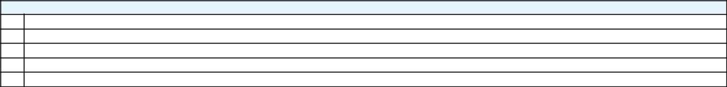

- Preliminary Proxy Statement

- CONFIDENTIAL, FOR USE OF THE COMMISSION ONLY (AS PERMITTED BY RULE 14a-6(e)(2))

- Definitive Proxy Statement

- Definitive Additional Materials

- Soliciting Material Pursuant to ss.240.14a-12

GENERAL MOTORS COMPANY

(Name of Registrant as Specified In Its Charter)

(Name of Person(s) Filing Proxy Statement, if other than the Registrant)

Payment of Filing Fee (Check the appropriate box):
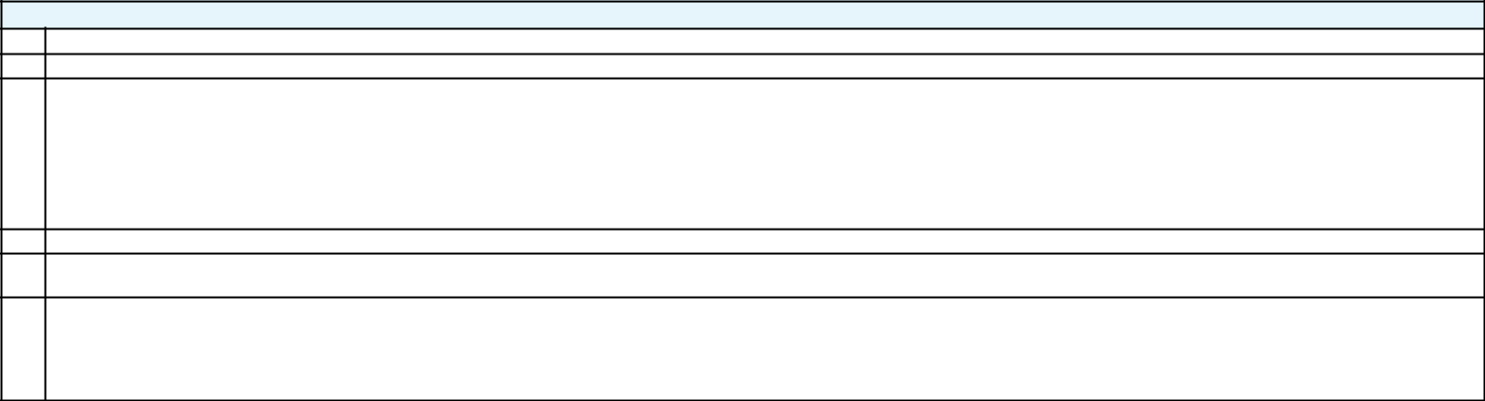

- No fee required.

- Fee computed on table below per Exchange Act Rules 14a-6(i)(4) and 0-11.

  - Title of each class of securities to which transaction applies:

  - Aggregate number of securities to which transaction applies:

  - Per unit price or other underlying value of transaction computed pursuant to Exchange Act Rule 0-11 (set forth the amount on which the filing fee is calculated and state how it was determined):

  - Proposed maximum aggregate value of transaction:

  - Total fee paid:

- Fee paid previously with preliminary materials.

- Check box if any part of the fee is offset as provided by Exchange Act Rule 0-11(a)(2) and identify the filing for which the offsetting fee was paid previously. Identify the previous filing by registration statement number, or the Form or Schedule and the date of its filing.
  - Amount Previously Paid:

  - Form, Schedule or Registration Statement No.:

  - Filing Party:

  - Date Filed:

G E N E R A L M O T O R S

Dear Fellow Shareholder:

You face an important decision about the future value of your investment in General Motors.

Your strong, highly experienced Board of Directors has overseen the successful implementation of a transformational plan that has driven three years of record results⁽¹⁾ at GM and, through our disciplined capital allocation framework, we expect to deliver approximately $25 billion to shareholders from 2012 through the end of 2017.

Each of your highly qualified directors brings unique experiences that are particularly beneficial to GM. Collectively, we believe your directors represent the best mix of expertise, qualifications and skills to advance GM’s business strategy and serve the interests of all shareholders by driving long-term value creation. Important facts about the full Board include:

- Nine of eleven directors are independent, plus Chairman and CEO Mary Barra and Joseph Ashton, former UAW leader appointed by UAW Trust.

- Each of our directors brings broad and deep experience in the management of large, complex, global organizations, and a track record of extraordinary leadership with specific expertise in related manufacturing industries, complex financial and accounting matters, risk management and security matters, global government relations, public policy and regulatory matters, technology and innovation and marketing.

- Average tenure is four years and three new directors have joined within the past two years, bringing their fresh perspectives to your Board.

- 45% of directors are women and 55% are men.

Please take some time to learn more about your directors by reviewing their outstanding qualifications on the following pages.

Now, just as we are focused on managing your company through a period of unprecedented industry disruption and transformation, hedge fund Greenlight Capital is asking you to replace three of these outstanding individuals with three of its own hand-picked candidates.

The Governance and Corporate Responsibility Committee and full GM Board follow an established process to fully consider the skills, experience and qualifications required for the Board to effectively oversee GM’s strategic needs in this period of rapid change. The Committee and Board use a carefully constructed matrix to determine any areas where additional skills or experience are needed, and to assess candidates. When we considered the qualifications of the Greenlight nominees, your Board concluded that Greenlight’s candidates do not bring individual skills, experience or expertise that would enhance the effectiveness of the Board as a whole.

In addition, Greenlight is urging the election of its candidates specifically to support what we view as a high-risk proposal to create a dual-class share structure that would eliminate the dividend on your existing common stock and transfer it to a new, untested and unprecedented security that Greenlight refers to as “Dividend Shares.”

Greenlight’s Dividend Shares proposal has the potential to disrupt our progress and undermine our performance. In our view, a vote for any of the Greenlight candidates would represent an endorsement of that high-risk proposal to the detriment of your GM investment.

Your Board Possesses the Right Set of Skills and Experience Required to Continue to Advance GM’s Progress. To Protect the Value of Your Investment in GM, Please Vote FOR ALL of Your Board’s Nominees on the WHITE Proxy Card and AGAINST the Greenlight Proposal Today.

Sincerely,
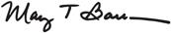

Mary T. Barra

Theodore M. Solso

Chairman & Chief Executive Officer

Independent Lead Director


If you have questions about how to vote your shares, or need additional assistance,
please contact the firm assisting us in the solicitation of proxies:

INNISFREE M&A INCORPORATED

Shareholders Call Toll-Free: (877) 825-8964 Banks and Brokers Call Collect: (212) 750-5833

REMEMBER: We urge you NOT to vote using any green card sent to you by

Greenlight, as doing so will revoke your vote on the WHITE proxy card.

(1) Represents core operating performance (i.e., adjusted for major recall campaigns)

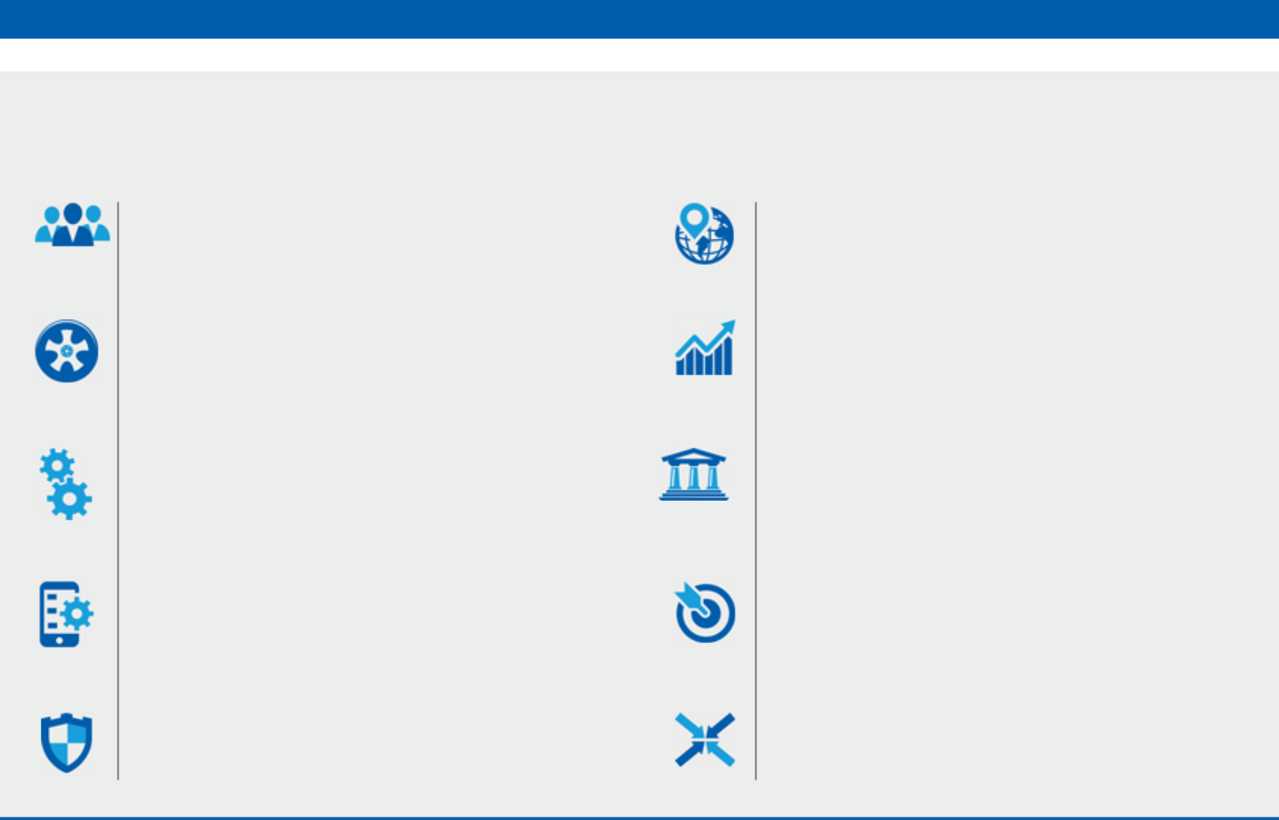
Combined Skills and Experience of Your General Motors Board

Senior Leadership

Significant leadership experience over an extended period, as CEO, CFO or comparable position; extraordinary leadership qualities; and the ability to identify and develop those qualities in others.

Industry

Leadership in automotive or related industry. Expertise in key businesses and proven knowledge of key customers and risks associated with the business.

Manufacturing

Experience in managing significant manufacturing operations.

Technology

Understanding of technology and innovation through academia or industry experience.

Risk Management

Relevant risk management experience and oversight.

Global

Global business and cultural experience.

Finance

Expertise in complex financial and accounting matters.

Government

Knowledge of global government relations, public policy and regulatory matters.

Marketing

Marketing experience, including digital marketing, brand and product awareness; social media experience.

Diversity

Diversity of perspective, professional experience, age

and background, such as gender, race, ethnicity and country of origin.

Your Board’s Skills & Experience
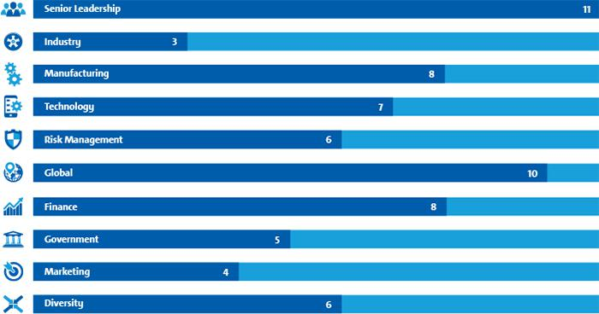

Meet Your Board Of Directors
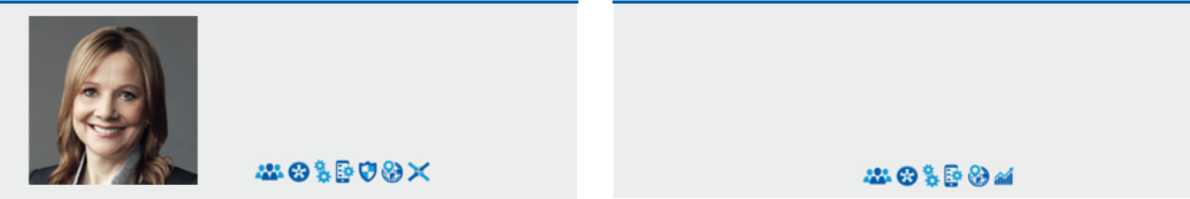

Mary T. Barra

Chairman &

Chief Executive Officer,

General Motors Company

- In-depth knowledge of the company and the global automotive industry

- Extensive leadership, strategic planning, operating and business experience and a deep understanding of the company’s strengths, weaknesses, risks and challenges

- Deep understanding of GM’s corporate culture and strategic direction

- Ability to focus the Board’s oversight and drive the most efficient execution of GM’s strategic plan and vision for the future

- Demonstrated leadership and management skills coupled with strong engineering background and extensive experience in global product development

- Previous leadership experience in purchasing and supply chain, human resources and manufacturing engineering

- Valuable knowledge of governance matters facing large public companies

Theodore M. Solso

Independent Lead Director,

General Motors Company

and Retired Chairman &

Chief Executive Officer,

Cummins, Inc.

- Experience and insight into the complexities of managing a major global organization, including the importance of vehicle and workplace safety

- Background leading a company through strong financial performance and shareholder returns, international growth and business restructuring

- Past leadership in emissions reduction technology and related environmental activities, corporate responsibility, diversity and human rights issues

- Extensive experience in manufacturing and engineering of diesel engines and compliance with challenging emissions laws and regulations

- Ability to contribute significantly to Board deliberations regarding GM’s global product development strategies

- Valuable insight into advancing the business priorities of operations in South America based on previous experience in serving as U.S. Chairman of the U.S.-Brazil CEO Forum

- Deep understanding of global markets and business operations and corporate responsibility and experience as a lead director of other large, global public companies, particularly in the areas of finance, accounting and corporate governance

Joseph J. Ashton |  | Linda R. Gooden
Retired Vice President, |  | Retired Executive Vice President,
United Auto Workers |  | Information Systems &
 |  | Global Solutions,
 |  | Lockheed Martin Corporation
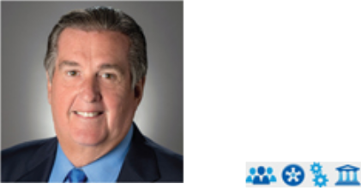


- Experience in organizing campaigns and contract negotiations with major manufacturing and technology companies in a variety of industries, during his career with the U AW

- Deep understanding of how labor strategy can affect a company’s financial success

- Expertise in areas such as manufacturing processes, pension and health care costs, government relations, employee engagement and training and plant safety

- Knowledge of labor relations matters relevant to GM’s ongoing labor considerations and commitment to industry leadership in global workplace safety

- Nomination to the GM Board designated by the VEBA Trust

- Strong leadership capability demonstrated through her various senior leadership positions at Lockheed, including experience in business restructuring, finance and risk management

- Significant operations and strategic planning expertise and an extensive background in information technology (“IT”) and cybersecurity

- Valuable perspective to Board deliberations regarding GM’s IT function and various technology systems and processes, including those related to mobility and autonomous vehicles

- Past leadership in expanding IT capabilities beyond government customers to international and commercial markets

- Experience as a director at other large, global public companies, particularly in the areas of finance, audit, strategic investments, acquisitions, divestitures and technology and innovation

Meet Your Board Of Directors
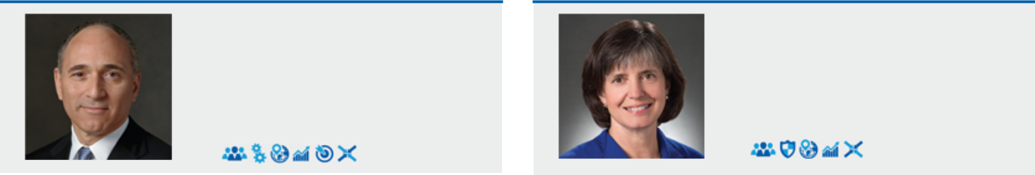

Joseph Jimenez

Chief Executive Officer,

Novartis AG

- Significant international and operational leadership, strategic planning and business and finance experience

- Long track record in consumer businesses, which enables him to bring a consumer orientation and valuable insight to Board deliberations regarding our strategy to enhance the customer experience and earn customers for life

- Business restructuring expertise and past experience executing significant business transformations and innovations at both Heinz and Novartis, which has enabled him to make significant contributions to our Board’s ongoing evaluation of the structure of our global business

- Prior experience as a director of another large, global public company, including service on its governance and finance committees
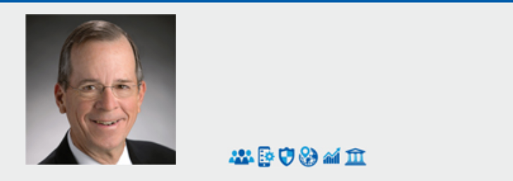

Admiral Michael G. Mullen

Former Chairman,

Joint Chiefs of Staff

- Extensive senior leadership experience gained over 43-year career in the U.S. military, culminating in appointment and Senate confirmation as Chairman of the Joint Chiefs of Staff – highest ranking military officer under two U.S. Presidents

- Four Four-Star assignments in the U.S. Navy, including:

  - Chief of Naval Operations (2005-2007), equivalent of the Navy’s chief executive officer (320,000 personnel)

  - Vice Chief of Naval Operations (2003-2004), equivalent of the Navy’s chief operating officer

  - Deputy Chief of Naval Operations (2001-2003), equivalent of the Navy’s chief financial officer ($115 bn annual budget)

- Led U.S. armed forces during a critical period of transition, including overseeing two active war zones and rapid development and deployment of innovative technologies and new methodologies for effective 21st century military solutions

- Deep experience leading change in complex organizations, strategic planning, budget policy, risk and crisis management, executive development and succession planning, diversity implementation, cybersecurity and technical innovation

- Significant contributions to our Board as Chairman of the Risk Committee and Member of the Audit Committee and proactive strategic counsel regarding geopolitical risks and opportunities, succession planning, diversity, accountability, crisis management, public policy, safety culture, cybersecurity and autonomous vehicles, all of which are important to the oversight of GM’s strategic initiatives in a period of rapid change

- Additional experience as a director of another large public company and in overseeing all of its highly sensitive security management requirements

Jane L. Mendillo

Retired President &

Chief Executive Officer,

Harvard Management

Company

- Strong senior leadership and risk management experience, as well as capital markets expertise, brings a unique financial and shareholder perspective from her over 30 years managing globally diverse portfolios in the endowment and investment management field

- Currently serves as a director and member of the audit committee of Lazard, one of the world’s leading global financial advisory and asset management firms, and member of the board of advisors of The Baupost Group, a leading hedge fund manager with $27bn under management

- As President and CEO of Harvard Management Company (“HMC”), the world’s largest university endowment with approximately $36bn under management, successfully managed through the financial crisis, significantly repositioned the endowment, and reestablished a world- class investment platform to support Harvard’s future educational and research goals

- Related background having established an investment office and delivered substantial growth through a period of rapidly changing market conditions, as the Chief Investment Officer of Wellesley College

- Deep and innovative institutional experience in investments in public and private companies, including leading pioneering investments in private timberland for Harvard, crisis management, coverage of the steel and insurance industries among others as an equities analyst and strengthening HMC’s commitment to sustainable investment by signing on to the United Nations-supported Principles for Responsible Investment (PRI), the first university endowment in the United States to join the organization

- Served as chair of Partners Healthcare Investment Committee overseeing $10bn in assets and on the Yale University Investment Committee, which oversees the investment of the Yale endowment

- Significant contributions to the Board’s oversight of GM’s strategic initiatives and as Member of the Audit Committee, particularly the evaluation of GM’s disciplined capital allocation framework and its financial policies and transactions and varied financial and risk management issues

Meet Your Board Of Directors


James J. Mulva

Retired Chairman &

Chief Executive Officer,

ConocoPhillips

- Thirty-nine years of experience in the energy industry, first at Phillips Petroleum Company and then ConocoPhillips

- Domestic and international senior management experience, overseeing mergers and acquisitions, business restructurings and negotiated joint ventures, and strategically repositioning ConocoPhillips to compete in an increasingly challenging and highly competitive industry

- Global strategic manufacturing expertise and keen risk and safety management experience, enabling him to make a significant contribution to Board deliberations in these and other important areas

- Additional in-depth background in finance and his experience as a director of other large, global public companies

Patricia F. Russo

Chairman,

Hewlett Packard

Enterprise Company

- Demonstrated leadership and proven business acumen, as the CEO of highly technical, global, complex companies

- Experience with a wide range of issues, including mergers and acquisitions, technology disruptions and business restructuring, as she led Lucent’s recovery through a severe industry downturn and later a merger with Alcatel

- Valuable experience in connection with a highly complex business restructuring transaction, as leader of the Hewlett-Packard Company board of directors in connection with its split into two public companies

- Extensive global experience in corporate strategy, finance, sales and marketing, technology and leadership development

- Significant expertise in corporate governance and executive compensation gained from her robust service on boards and board committees of other large, global public companies

Thomas M. Schoewe |  | Carol M. Stephenson, O.C.
Retired Executive Vice President |  | Retired Dean,
& Chief Financial Officer, |  | Ivey Business School,
Wal-Mart Stores, Inc. |  | The University of
 |  | Western Ontario



- Extensive financial expertise, corporate leadership and operational experience through positions held as chief financial officer of large multinational, consumer-facing companies

- Demonstrated leadership in corporate finance offering key skills, including financial reporting, accounting and control, business planning and analysis and risk management

- Experience with large-scale, transformational information technology implementations at Wal-Mart and Black & Decker Corporation, which provide valuable insight to our IT organization

- Previous and current board positions at public companies involved with home building, security and investments provide exposure to diverse industries with unique challenges enabling him to make a significant contribution to our Board across a broad range of issues facing the company

- Diverse perspectives and senior leadership experience acquired during a 30 year career in telecommunications and technology industry and 10 years as Dean of Ivey Business School, one of Canada’s premier business schools

- Expertise in key areas related to GM’s ongoing transformation, including marketing, operations, strategic planning, technology development and financial management

- As CEO of Lucent Canada, Lucent’s market share tripled in Canada despite an industry downturn during tenure

- Experience on the boards of several top Canadian companies provides our Board with a broad perspective and deep insight on matters affecting the business interests of GM and GM Canada, as well as current geopolitical challenges related to North American trade

- Provides valuable perspective and insight on matters that affect GM and GM Canada’s bottom-line

  - Served from 2005 to 2009 on the GM of Canada Advisory Board, which provides advice and counsel on matters affecting the business interests of both GM and GM of Canada and serves to promote a better understanding within Canada of their needs and role in the economy

  - Canada continues to be a significant market for GM. For 2016, total sales in Canada represented approximately 7% of North American sales

  - Canada increasingly significant with respect to technology, in light of GM facility in Kitchener/Waterloo and its importance relative to potential changes from NAFTA

- Experience serving on the compensation and governance committees of other public companies contributes to ongoing enhancement of policies and practices, including program of direct director engagement with shareholders, which she helped to initiate



If you have questions about how to vote your shares, or need additional

assistance, please contact the firm assisting us in the solicitation of proxies:

INNISFREE M&A INCORPORATED

Shareholders Call Toll-Free: (877) 825-8964

Banks and Brokers Call Collect: (212) 750-5833

REMEMBER: We urge you NOT to vote using any green card sent to you by

Greenlight, as doing so will revoke your vote on the WHITE proxy card.

Forward Looking Statements: This document may include forward-looking statements. These statements are based on current expectations about possible future events and thus are inherently uncertain. Our actual results may differ materially from forward-looking statements due to a variety of factors, including: (1) our ability to deliver new products, services and experiences that attract new, and are desired by existing, customers and to effectively compete in autonomous, ride-sharing and transportation as a service; (2) sales of full-size pick-up trucks and SUVs, which may be affected by increases in the price of oil; (3) the volatility of global sales and operations;

- aggressive competition, including the impact of new market entrants; (5) changes in, or the introduction of novel interpretations of, laws, regulations or policies particularly those relating to free trade agreements, tax rates and vehicle safety and any government actions that may affect the production, licensing, distribution, pricing, or selling of our products; (6) our joint ventures, which we cannot operate solely for our benefit and over which we may have limited control; (7) compliance with laws and regulations applicable to our industry, including those regarding fuel economy and emissions; (8) costs and risks associated with litigation and government investigations; (9) compliance with the terms of the Deferred Prosecution Agreement; (10) our ability to maintain quality control over our vehicles and avoid recalls and the cost and effect on our reputation and products; (11) the ability of suppliers to deliver parts, systems and components without disruption and on schedule; (12) our dependence on our manufacturing facilities; (13) our ability to realize production efficiencies and cost reductions;

- our ability to successfully restructure operations in various countries; (15) our ability to manage risks related to security breaches and other disruptions to vehicles, information technology networks and systems; (16) our ability to develop captive financing capability through GM Financial; (17) significant increases in pension expense or projected pension contributions; (18) significant changes in the economic, political, and regulatory environment, market conditions, and foreign currency exchange rates; and (19) uncertainties associated with the consummation of the sale of Opel/Vauxhall to the PSA Group, including satisfaction of the closing conditions. A further list and description of these risks, uncertainties

and other factors can be found in our Annual Report on Form 10-K for the fiscal year ended December 31, 2016, and our subsequent filings with the Securities and Exchange Commission. GM cautions readers not to place undue reliance on forward-looking statements. GM undertakes no obligation to update publicly or otherwise revise any forward-looking statements.

Important Additional Information Regarding Proxy Solicitation: General Motors Company (“GM”) has filed a definitive proxy statement and form of WHITE proxy card with the U.S. Securities and Exchange Commission (the “SEC”) in connection with the solicitation of proxies for GM’s 2017 Annual Meeting. GM, its directors and certain of its executive officers may be deemed participants in the solicitation of proxies from shareholders in respect of the 2017 Annual Meeting. Information regarding the names of GM’s directors and executive officers and their respective interests in GM by security holdings or otherwise is set forth in the definitive proxy statement. Details concerning the nominees of GM’s Board of Directors for election at the 2017 Annual Meeting are included in the definitive proxy statement. BEFORE MAKING ANY VOTING DECISION, INVESTORS AND SHAREHOLDERS OF THE COMPANY ARE URGED TO READ ALL RELEVANT DOCUMENTS FILED WITH OR FURNISHED TO THE SEC, INCLUDING THE COMPANY’S DEFINITIVE PROXY STATEMENT AND ANY SUPPLEMENTS THERETO AND ACCOMPANYING WHITE PROXY CARD, BECAUSE THEY CONTAIN IMPORTANT INFORMATION. Investors and shareholders can obtain a copy of the definitive proxy statement and other relevant documents filed by GM free of charge from the SEC’s website, www.sec.gov. GM’s shareholders can also obtain, without charge, a copy of the definitive proxy statement and other relevant documents filed by GM by directing a request by mail to GM Shareholder Relations at General Motors Company, Mail Code 482-C23-D24, 300 Renaissance Center, Detroit, Michigan 48265 or by email to shareholder.relations@gm.com, by calling GM’s proxy solicitor, Innisfree M&A Incorporated, toll-free at 1-877-825-8964, or from the investors section of GM’s website, http://www.gm.com/investors.

For more information, please visit www.GMProxy.com.

